# WHITE PAPER TO THE NRC DECADAL SURVEY

# SUB-PANELS

**Thermal Protection System Materials for Sample Return Missions**

By

**Todd White – NASA Ames Research Center**

650 604-4144 Todd.R.White@nasa.gov

**Co-Authors:** Helen Hwang, Don Ellerby, Matt Gasch, Robin Beck, Jeremy Vander Kam,   
Ethiraj Venkatapathy (NASA Ames Research Center)

**Co-Signers (44 individuals from 15 organizations):** Aaron Brandis, David Driver, Kristina Skokova (Analytical Mechanics Associates, Inc.); Douglas Adams, Kenneth Hibbard (Johns Hopkins Applied Physics Laboratory); Amanda Brecht, David Hash, Dean Kontinos, Milad Mahzari, Megan MacDonald, Mary Kathleen McGuire, Suman Muppidi, Harry Partridge, Scott Sandford, Margaret Stackpoole, Michael J. Wright, Kerry Zarchi (NASA Ames Research Center); Michele Chaffey, Mary Litwinski (Boeing); Mark Lippold, Steven Violette (Fiber Materials, Inc.); Natasha Johnson, Conor Nixon, Melissa Trainer (NASA Goddard Space Flight Center); David Atkinson, Kevin Baines, Tibor Balint, Bernard Bienstock, James Cutts, Jeffery L. Hall, Siddharth Krishnamoorthy, Kim Reh, Eric Slimko, Linda Spilker (NASA Jet Propulsion Laboratory); Adam Amar, Stan Bouslog, Gerald Lebeau, Steven Rickman (NASA Johnson Space Center); Ye Lu (Kent State University); Alicia Dwyer-Cianciolo, N. Ronald Merski, Michelle Munk (NASA Langley Research Center); Jarvis Songer (Lockheed Martin Space); Manish Mehta (NASA Marshall Space Flight Center); Paul Byrne (North Carolina State University); Matthew Kelly (Peraton); Martha Gilmore (Wesleyan University)

## ABSTRACT

*This white paper from the Thermal Protection System (TPS) community to the NRC Decadal Survey Sub-Panels provides an overview of TPS materials needed for future Sample Return (SR) missions. We consider the capability of heritage TPS material used by recent SR missions and identify appropriate materials for future SR missions. A prime conclusion is that the current TPS materials, if properly maintained, offer good low-density solutions for lower velocity (<13.5 km/s) sample return missions without planetary protection back-contamination concerns. Furthermore, missions that have a larger capsule, a higher entry speed (>13.5 km/s), or back-protection concerns will leverage recently developed mid-density TPS materials. To maintain NASA’s Sample Return capabilities in the coming decade, we recommend that NASA continue to invest in sustainment of relevant TPS materials, as well as ground-test facilities, predictive entry modeling, and flight instrumentation.*

## TPS and Sample Return Missions

NASA and the international community have had several sample return missions in the last 20 years, including the Genesis, Stardust [1, 2], and Hayabusa missions. As of this writing, the JAXA Hayabusa 2 mission will return samples from asteroid Ryugu in late 2020, and the OSIRIS-REx mission will return surface material from the asteroid Bennu in 2023. SR missions (Lunar Basin Sample Return, Comet Surface Sample Return) were prioritized, though not selected, in the past decadal survey [3], and NASA has recently funded a pre-decadal study for a mission that includes sample return from Ceres. NASA is also undertaking a Mars Sample Return (MSR) campaign to return samples cached by the Perseverance rover, with the goal of returning Martian samples to Earth in the 2030s. Examples of Sample Return configurations are shown below in Figure 1.

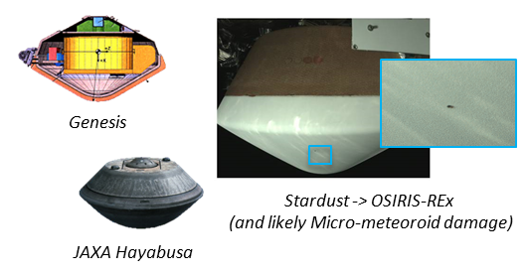

Figure 1. Previous Sample Return Capsule Configurations

All these past and future SR missions require a re-entry vehicle, or capsule. SR capsules rely on TPS to endure the extreme heat and pressures created during hypersonic flight through the atmosphere. Minimizing the weight and cost of TPS materials, while ensuring the integrity and reliability of the capsule, is a continuing challenge for the entry systems community.

As such, NASA continues to require TPS materials and entry system design capabilities for SR missions. These capabilities require specialized expertise and unique capabilities. This includes accurate aerothermal environment prediction, thermo-structural modeling and analysis of complex integrated elements, high-temperature instrumentation, and arc jet testing of TPS for development through flight qualification. Once developed, it is essential to maintain this expertise and capabilities between potentially infrequent missions. Past experience with Carbon Phenolic, AVCOAT, and PICA materials have shown that maintenance is needed both inside and outside of NASA. The *Sustaining Mature Thermal Protection Systems Crucial for Future In-Situ Planetary Missions* white paper [4] further describes the challenges of continued sustainment TPS and entry systems technologies.

SR capsules are typically on the order of 0.5m – 1.4m diameter, ranging from 20kg to 120kg, with the first robotic SR re-entry (Genesis) being an exception at ~1.8m and 210kg. Past re-entry velocities were at 11 km/s to ~13 km/s, resulting in high heat rates, which means ablative TPS materials are required for forebody heatshields. Future SR missions continue to be proposed at re-entry velocities ranging from 11.5 to 15 km/s. As re-entry speeds increase, so do the environments (heat flux, pressure, shear) the TPS must withstand.

An additional challenge exists for SR missions with backward planetary protection requirements from Category V (Earth return) restricted destinations, or destinations of unknown indigenous life forms. [5] Missions that plan to return un-sterilized payloads from Mars, Enceladus, Europa, and other destinations may have additional reliability requirements for the TPS around their SR capsules. These may be expressed as: 1) Designs that minimize possible failure modes such as elimination of TPS seams or interfaces, 2) Restrictions which constrain mission design, such as smaller landing footprint, longer free-flight time, or populated area avoidance, 3) Demonstrated robustness to degraded or damaged TPS state such as a micro-meteoroid or orbital debris impact as shown on OSIRIS-REX in Figure 1 above, or 4) additional verification constraints. These additional requirements may drive selection of denser and more robust materials or additional test and predictive physics model development related to off-nominal re-entry scenarios that have been considered too unlikely to address in previous missions. As of this writing, Mars Sample Return appears the likely first candidate mission to address these constraints.

Table 1 presents a comparison of stagnation point environments for several scenarios, based on the 60o sphere-cone OSIRIS-REx / Stardust shape capsule. The vehicle mass (57 kg), diameter (0.8m), and entry flight path angle ( = -8°) are held constant, and re-entry velocity varied.

**Table 1.** Representative Stagnation Point Design Environments for Sample Return Missions



Table 1 provides a quick guide to understanding the strong influence of re-entry velocity on the parameters that drive TPS selection and mass. Additionally, vehicle size, cone angle, mass, and entry flight path angle greatly influence these values as well. Furthermore, steeper entry flight path angles (e.g.  < -15° or steeper) may shift the peak environments away from the stagnation point and onto flank positions that experience higher turbulent heating and elevated surface shear.

## CURRENT CAPABILITY: TPS for Sample Return Missions

### Materials

The most-recently used materials for NASA SR missions have been Advanced Carbon-Carbon (ACC) on Genesis and Phenolic Impregnated Carbon Ablator (PICA) on Stardust and OSIRIS-REx. JAXA has employed a high-density Carbon Phenolic for its Hayabusa, Hayabusa 2, and upcoming Martian Moon Exploration (MMX) capsules. NASA recently developed and matured the mid-density HEEET 3D-woven material as a mass-efficient material after it identified issues in manufacturing capability for heritage Carbon Phenolic. [6]

Table 2 lists the capabilities of currently available TPS materials for SR heatshield and backshell, where heating and pressure environments are much lower. It should be noted that some TPS materials have been omitted from the table that are a) at TRL less than 3, b) have not been actively maintained or demonstrated recently, c) are developed outside of the United States, or d) are developed without widely available performance data.

**Table 2.** Candidate TPS materials for Sample Return Missions





Table 2 also shows TPS material suitability for the SR capsule conditions described in Table 1 (0.8m diameter, 60o sphere-cone SR capsule of 57 kg entering at  = -8o), with 13.5 km/s included as a convenient dividing line. Applicability is a combination of:

* Maximum demonstrated capability as a function of peak heat rate and pressure for heatshield candidates,
* Performance versus peak heat rate for backshell candidate materials.

Materials are scored as either capable, potentially capable, or not capable; additionally, it is noted if a material could work but is a heavier TPS solution relative to other options. Several low-density materials are available for the < 13.5 km/s category, though the > 13.5 km/s category has far fewer options. The most-robust material, high-density Chop-Molded Heritage Carbon Phenolic (CP), has not been produced or used in flight since the 1980s. NASA Ames held two workshops (FY10 and FY11) concerning the supply chain issues with respect to CP and proposed the development work required to qualify a new rayon-based carbon fiber as well as a proposed alternate, more sustainable, material to CP. Ultimately NASA deemed the restart of CP as not sustainable. Instead, NASA invested in the Heatshield for Extreme Entry Environment Technology Project (HEEET) that led to the development of an alternate material system to CP for NASA’s missions with extreme entry environments. HEEET has replaced the capability once provided by Heritage Carbon Phenolic and HEEET’s tailorable design is more mass efficient than CP for SR missions. HEEET, and the lower-density PICA, are shown in Figure 2, at SR heatshield relevant sizes.

 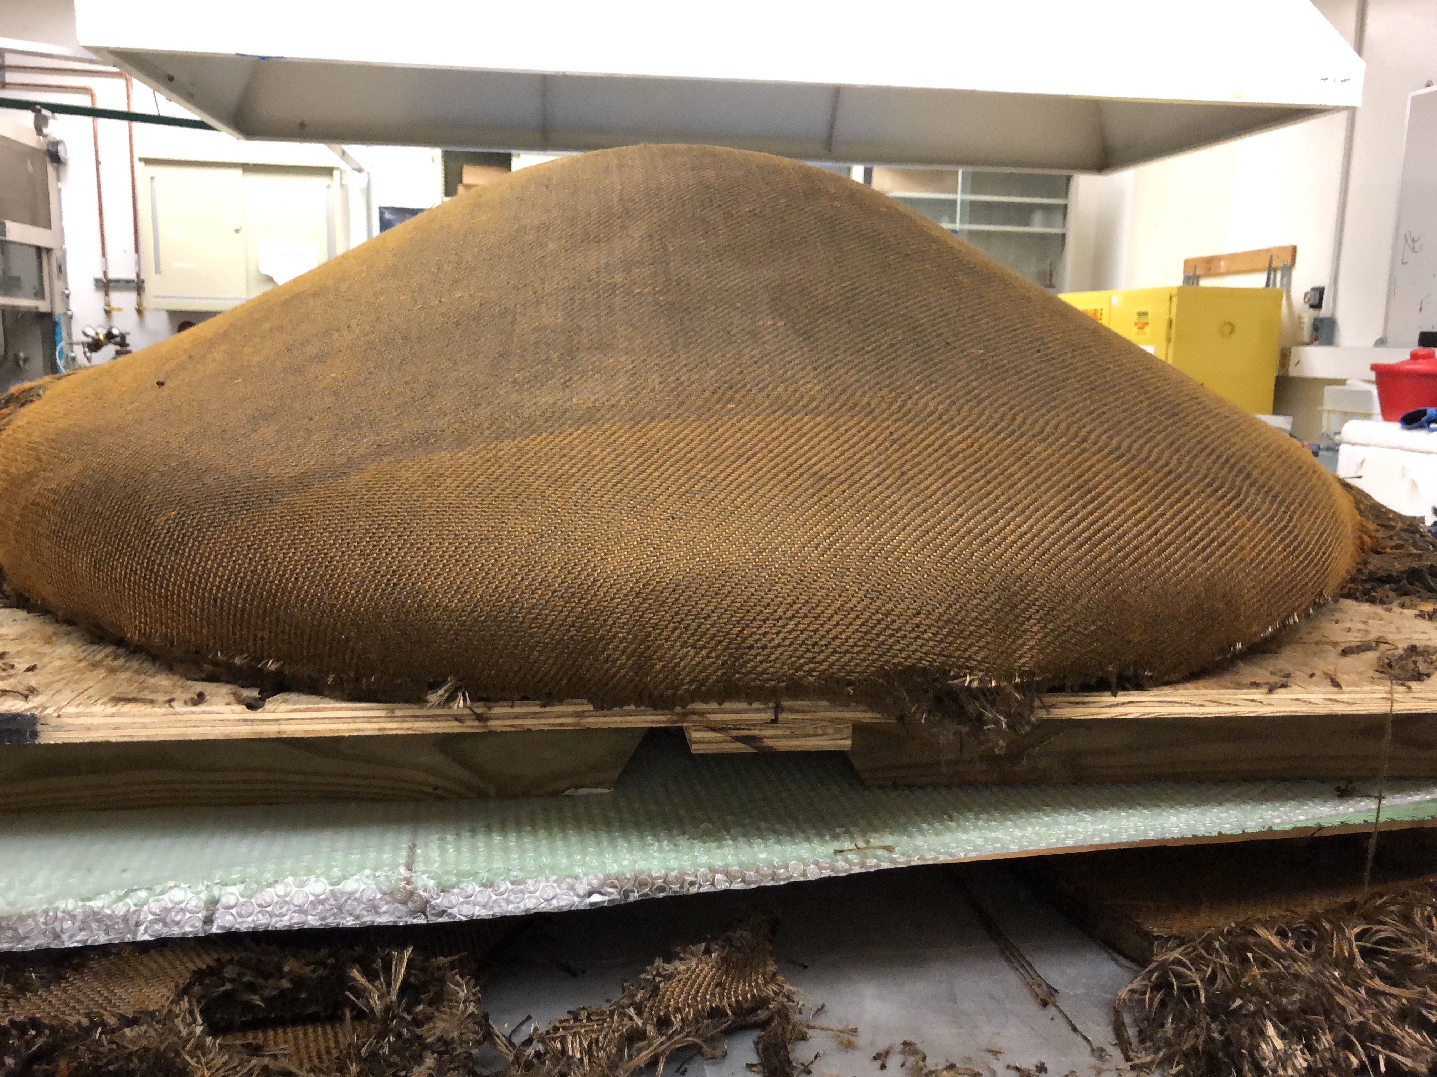 

Figure 2. Low and Mid-Density Carbon Ablators for Sample Return Missions: PICA Single Piece Prior to Machining, Un-infused HEEET Insulation Layer Single Piece, and Tiled HEEET Engineering Test Unit.

A range of low-density materials are available for SR capsule backshell protection. Table 2 reflects material capabilities for usage over the entire backshell, including regions of reattaching flow with moderate heat fluxes and shear forces. However, backshell material selection may be driven by other system-level engineering decisions, such as detailed backshell attachment fixtures and overall integration.

### Ground Test Facilities

A mainstay of TPS development for the past several decades has been the high-enthalpy arc jet facilities at Ames Research Center, Arnold Engineering and Development Center (AEDC), and Boeing Large Core Arc Tunnel (LCAT) [7]. These facilities with power capabilities from 10 to 60 MW provide the largest test article or the highest heating capability possible and have proven to be indispensable for TPS development work as well as qualification of flight hardware. In addition to arc jet facilities, the Laser Hardened Materials Evaluation Laboratory (LHMEL) facility at the Air Force Research Laboratory at Wright Patterson Air Force Base allows TPS materials to be tested to estimate the level of heat flux required to initiate char spallation. A more thorough discussion on ground test facilities needs relevant for entry vehicle missions can be found in the *Ground Test Facilities for Future Atmospheric Entry* white paper. [8]

For heatshield TPS material qualification at combined pressure and heatflux, the Ames Interaction Heating Facility (IHF) is the most relevant. Figure 3 shows relevant IHF facility envelopes in black for most relevant nozzle configurations for SR testing (9”, 6”, and 3”). These envelopes are co-plotted against the pressure and heatflux flight envelopes of the 11.5 km/s – 15 km/s examples in Table 1. For entries < 13.5 km/s, the 6” IHF nozzle offers testing that conservatively bounds pressure and heatflux. For entries > 13.5 km/s, the newer IHF 3” nozzle is relevant, though with increasing over-testing required in stagnation pressure. [9] Though not shown, heavier capsules at steeper entries may easily exceed even the 3” IHF nozzle maximum heatflux.

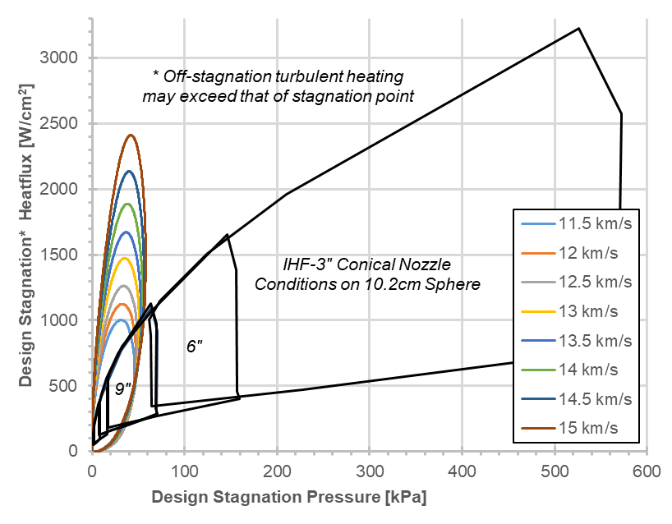

**Figure 3.** Example Sample Return Pressure and Heating Envelopes   
and IHF Arc Jet Facility Envelopes

## CHALLENGES & OPPORTUNITIES

### Instrumentation and Remote Observation

NASA has identified the importance of planning for and gathering in-flight entry vehicle performance data to benefit future entry missions [10, 11]. Recent EDL flight data from Mars (MEDLI) and Earth (Orion’s Entry Flight Test 1) have been valuable for designing future missions [12], even at different planetary destinations than where the data was captured. In-situ TPS temperatures and external vehicle pressure measurements are key to improving predictive capabilities and potentially reducing future mission risk profiles, and potentially reducing TPS masses. SR capsules are typically more constrained in power, volume, and mass than other entry vehicles (such as those to Mars or Crewed Earth missions), which can make in-situ engineering instrumentation challenging. As an alternative, airborne observation and pre- and post-examination of the capsules have proven useful for understanding both the Stardust and Hayabusa SR capsules.

### Predictive Techniques and Experimental Facilities

Accurate entry environment predictions and ground-testing for SR missions are challenging, and frequently carry large uncertainties and design margins. However, predictive and experimental shock-tube techniques for characterization of heatshield and backshell radiative heating have improved enormously since the mid-2000s. [12] Some of these investments have already contributed to recent SR missions, such as the analysis of anticipated OSIRIS-REx’s backshell entry environments. [14] For more demanding entries (either >13.5 km/s or more massive vehicles), further maturation is needed for predictive capabilities that incorporate the fully-coupled effects and interaction of TPS pyrolysis products into the boundary layers and surrounding highly ionized radiating flowfields. This is especially true for accurately predicting potential consequences of damaged TPS for high-reliability missions

### Materials and Ground Test Facilities

Recent history has shown that having written material specifications does not guarantee that manufacturers can resurrect past TPS manufacturing to deliver consistent, quality products. For example, during the Orion TPS Advanced Development Project, NASA attempted to resurrect Apollo’s heritage material, Avcoat. This process took many years, was expensive, and ultimately resulted in a material that, while acceptable, was not identical to the heritage material. This is because over time, staff involved in fabrication change and many important process steps are not documented. All TPS materials are at risk of attrition if not required for a mission for a decade or more and no steps are taken to sustain its technology and associated assembly and test facilities. This is particularly the case for complex integration steps, or where large, single piece TPS components are needed.

## RECOMMENDATIONS

Category V unrestricted SR missions in the coming decade have suitable TPS materials available. Vehicles of ~60kg or less re-entering at speeds < 13.5 km/s are possible with current low-density TPS material solutions and associated predictive and test capabilities, due to past NASA technology investments and other non-SR missions. More massive or faster (> 13.5 km/s) SR missions have mid-density TPS material solutions, also due to recent NASA investments in the mid-density HEEET material. However, for both low and mid-density TPS materials, NASA and industry capabilities must be maintained.

A SR mission with planetary protection back-protection concerns (Category V restricted) may feature prominently in the next decade with MSR. This will likely require a robust TPS material solution and mature analysis and testing capabilities.

To prepare for any SR mission in the coming decade and beyond we recommended that NASA:

**For TPS Materials:**

1. Ensure the fabrication of heatshield TPS materials for SR missions is maintained by conducting regular manufacturing assessments at SR scale (~1m or larger).
2. Expand the capability of HEEET by developing single piece construction heatshields (including a loom upgrade) for high-speed or high reliability SR missions.

**For TPS test facilities:**

1. Maintain or expand NASA’s ability to accurately test in highly energetic environments at existing arc jet facilities. To enable higher mass, faster (>13.5 km/s) or high reliability SR capsules, this should include testing at higher heat fluxes (≥ 4000 W/cm2), and in high-shear configurations corresponding to turbulent environments.

**For Predictive Model Development & Entry Flight Data:**

1. Continue to invest in and improve design and analysis tools, such as aerothermal CFD, radiation predictions, and coupled ablative material response models, needed to verify material response and qualification test conditions. This is particularly crucial for prediction of off-nominal events for high-reliability Category V restricted missions.
2. Prioritize low-cost miniaturized EDL instrumentation for inclusion on all future SMD entry vehicles, including SR capsules. Flight data from other destinations such as Venus or the Outer Planets may benefit SR missions that use the same materials, albeit at different conditions. Additionally, fund remote observation of SR capsule entry for un-instrumented capsules such as OSIRIS-REx.

**In conclusion,** many of the above recommendations are cross-cutting and will also benefit missions with entry vehicles to other solar system destinations (Mars, Venus, and the Outer Planets). Finally, the TPS community requests continued participation in Sample Return and other future atmospheric entry mission studies commissioned by the Decadal panels, in order to advise on potential mission constraints and TPS material feasibility and performance.

## REFERENCES

[1] Barrow, K., et al., “Sample Return Primer and Handbook”, JPL D-37294, 2007.

[2] Willcockson, W., “Stardust Sample Return Capsule Design Experience”, JSR Vol 36, No. 3, 1999.

[3] National Academies, “Vision and Voyages for Planetary Science in the Decade 2013-2022”, 2011.

[4] Venkatapathy, E., et al., “Sustaining Mature Thermal Protection Systems Crucial for Future In-Situ Planetary Missions”, White paper for the planetary decadal survey 2023-2032.

[5] Kminek, G., et al., “COSPAR’s Planetary Protection Policy”, https://cosparhq.cnes.fr/assets/uploads/2019/12/PPPolicyDecember-2017.pdf

[6] Ellerby, D., et al., “Woven Thermal Protection System Based Heatshield for Extreme Entry Environments Technology (HEEET),” presented at National Space and Missile Materials Symposium, Bellevue, WA, June 24-27, 2013.

[7] NASA Office of Chief Engineer, “Evaluation of the NASA Arc Jet Capabilities to Support Mission Requirements”, SP-2010-577, 2010.

[8] MacDonald, M., et al., “Ground Test Facilities for Future Atmospheric Entry”, White paper for the planetary decadal survey 2023-2032.

[9] Terrazas-Salinas, I., “Test Planning Guide for NASA Ames Research Center Arc Jet Complex and Range Complex”, A029-9701-XM3 Rev. F, 2020.

[10] NASA Discovery AO Program Library, “Entry, Descent and Landing (EDL) Instrumentation Engineering Science Investigation (ESI) Goals and Objectives”, 2019.

[11] NASA New Frontiers Fourth AO Program Library, “Entry, Descent and Landing (EDL) Instrumentation Engineering Science Investigation (ESI) Goals and Objectives”, 2016.

[12] Santos, J., et al., “Entry, Descent, and Landing Instrumentation”, White paper for the planetary decadal survey 2023-2032.

[13] Brandis, A., et al., “Validation of High Speed Earth Atmospheric Entry Radiative Heating from 9.5 to 15.5 km/s”, AIAA 2012-2865.

[14] Johnston, C., et al., “Features of Afterbody Radiative Heating for Earth Entry”, AIAA 2014-2675.