ELECTROMAGNETIC SOUNDING OF THE LUNAR INTERIOR FROM ARTEMIS III. R. E. Grimm¹, G.T. Delory², J.R. Espley³, P. Chi⁴, W. Farrell³, H. Haviland⁵, C. L. Johnson^{6,7}, ¹Southwest Research Institute, 1050 Walnut St. #300, Boulder, CO 80302 (grimm@boulder.swri.edu); ²Heliospace Corp., Berkeley; CA ³Goddard Space Flight Center, Greenbelt, MD; ⁴Univ. of California, Los Angeles; ⁵NASA Marshall Space Flight Center, Huntsville, AL; ⁶Univ. of British Columbia, Vancouver, BC; ⁷Planetary Science Institute, Tucson, AZ.

Introduction. Electromagnetic (EM) sounding of the Moon has given insights on the temperature profile [1-4], maximum core size [5,6], and bulk iron content [7]. New EM sounding [8] can improve our knowledge of the primary thermal and compositional evolution of the Moon as well as its secondary, lateral differentiation manifested as the Procellarum KREEP Terrane (PKT). These objectives can be accomplished through improved instrumentation and coverage, both of which can be implemented by the Artemis III mission.
EM Sounding. Time-varying natural or artificial EM fields induce eddy currents in planetary interiors, whose secondary EM fields are detected at or above the surface. These secondary fields shield the deeper interior according to the skin-depth effect, so that EM fields fall to 1/e amplitude over depth δ (km) = 0.5/√σf, where σ is the conductivity and f is the frequency. EM sounding exploits the skin-depth effect by measuring the complex impedance Z over a range of frequencies to reconstruct resistivity over a range of depths [9,10]. Natural EM signals in both the solar wind and magnetotail facilitate sounding (Fig. 1). The observation duration will limit sounding depth and within the Artemis III mission the deep mantle and possibly core may be investigated. Two separate quantities are always required to determine the impedance (e.g., Ohm’s Law Z=V/I). Two practical implementations for lunar and planetary exploration are the magnetic transfer function and the magnetotelluric method.
Magnetic Transfer Function (TF). This approach compares the magnetic field spectrum of a distant reference (the source field) to that at the planetary surface (source + induced field). For the Moon, the Explorer 35 satellite and the Apollo 12 surface magnetometer (Fig. 1) were used, respectively. In a special case of the TF, the source field is known a priori: quasi-static soundings of the lunar core exploit a near-parallel field in the magnetotail. EM sounding of the Galilean satelites similarly used the analytical description of the time-varying source field formed by the orbital motion of the satellites through Jupiter’s static magnetic field [e.g., 11]. A corollary is that a single magnetometer without auxiliary constraints cannot perform EM sounding.
The TF approach can still be useful for the Moon, but there are several obstacles to optimum implementation. First, a magnetometer-equipped orbiter is required. An apoapsis of at least several lunar diameters is preferred to capture the source field in all configurations, but dayside confinement of the induced response in the solar wind [e.g., 7,12] should allow this source to be characterized even from low altitude. This nonetheless burdens the resources required for EM sounding. Second, the TF becomes inaccurate at frequencies greater than several mHz, where the wavelengths of the sources in the plasma become comparable to the lunar circumference. This causes higher harmonics to be excited, which requires additional modeling of the incompletely constrained plasma waves [13]. The conductivity profile at Apollo 12 has been best recovered for depths >400 km, using frequencies <1 mHz [1,2].
Magnetotelluric method (MT). Here the surface electric field is used as the constraint for the surface magnetic field [e.g., 14,15]. A complete sounding can be performed from a single surface station without an orbiter. Because there is no “upstream” measurement, MT is largely insensitive to source-field structure introduced by plasma [8]. Therefore, higher frequencies can be accurately measured compared to the TF and internal lunar structure resolved to as shallow as ~100 km.
In a terrestrial MT experiment, magnetometers are placed near a central recording station, whereas the electric field is determined from the voltage between widely spaced electrodes (Fig. 2). Two orthogonal electrode pairs (and the magnetic-field components orthogonal to them) are used to to determine a tensor impedance, from which anisotropic conductivity can be determined.
Larger source strengths, lower noise levels, and longer integration times allow compact fluxgate magnetometers to replace the large induction coils used on Earth. These factors, and the more resistive lunar interior, also imply that a 10-20 m baseline is sufficient to characterize the electric fields. We have developed a spring mechanism to deploy electrodes from a robotic lander. The circuitry used to measure the voltage difference employs techniques commonly used in space plasma physics [16]. This Lunar Magnetotelluric Sounder (LMS) is scheduled for flight in 2023 under NASA’s Commercial Lunar Services Program (CLPS).
Synergy with other instruments. EM sounding, specifically MT, is one of four core experiments (along with seismology, heat flow, and laser-reflectance geodesy) on the International Lunar Network [17] and Lunar Geophysical Network [18] mission concepts. Heat flow and EM sounding are particularly synergistic, as the effects of composition on the temperature profiles produced by each can be separated by performing the experiments jointly. The LISTER heat-flow probe [19] is co-manifested with LMS for the 2023 CLPS mission.
Artemis III. The Apollo 12 site is well within the PKT, so the electrical conductivity profile there may not be representative of the bulk Moon. A landing site near the south pole is within the Feldspathic Highland Terrane (FHT) and could provide an excellent measuremement of the background, which would in turn constrain models for the formation of the PKT. With a robust determination of the mantle temperature profile, joint EM sounding and heat-flow measurements could recover the radionuclide content of the thick, primary crust. It may be necessary to correct the temperature profile for latitude, which could provide a test of models for true polar wander [e.g., 20]. If a magnetometer-equipped orbiter is available such as the THEMIS-ARTEMIS satellites or on Gateway, MT and TF can be compared at low frequencies and a search for signatures of the core carried out at ultralow frequencies.
An astronaut-deployed MT instrument could have better performance than a robotically-deployed experiment due to the larger possible footprint (Fig. 2). A larger, standard-sized spacecraft fluxgate magnetometer would increase SNR at low frequencies, and the addition of flight-qualified searchcoil magnetometers would provide the maximum bandwidth for the shallowest sounding. Rather than needing a mast or boom, magnetometers could simply be placed away from central power and processing (i.e., noise) sources (Fig. 1). Astronauts could simply unreel the electrode cables to 50 m or more, well within demonstrated capabilities for set-up of surface experiments (Fig. 3) and offering a simple approach to further increasing SNR. MT on Artemis III would complement a heat-flow experiment [21], could be part of a larger geophysical package [22], or be incorporated into a large ALSEP-style suite [23].
Acknowledgements: REG funded by NASA Contract 80MSFC20C0024 (LSITP).
References: [1] Dyal, P. et al. (1976). Proc. Lunar Sci. Conf 7th, 3077. [2] Hood L.L. and C.P. Sonett (1982) GRL 9, 37. [3] Khan A. et al. (2006) EPSL, 248, 579. [4] Grimm R. (2013) JGR, 118, 768. [5] Hood L.L. et al. (1982) JGR, 87, 5311. [6] Shimizu H. et al. (2013) Icarus, 222, 32. [7] Dyal P. et al. (1974) RGSP, 12, 568. [8] Grimm R. and Delory G. (2012) ASR, 50, 1687. [9] Constable, S. (2007) Geomagnetism. In Treat. Geophys., (ed. G. Schubert), Ch. 5.07, 237. [10] Spies, B.R., and F.C. Frischknecht (1991) in EM Meth. Appl. Geophys., Vol. 2 (ed. M.S. Nabighian) Soc. [11] Khurana K.K. et al. (1998) Nature, 395, 777. [12] Sonett C.P. (1982) RGSP, 20, 411. [13] Sonett C.P et al. (1972) Proc. 3rd Lunar Sci. Conf., 2309. [14] Vozoff, K. (1991) in EM Meth. Appl. Geophys., Vol. 2 (ed. M.S. Nabighian) Soc. Explor. Geophys., Tulsa, p. 641. [15] Simpson F. and Bahr K. (2005) Practical Magnetotellurics, Cambridge, 254 pp. [16] Bonnell J.W. et al. (2008) Space Sci. Rev., 141, 303. [17] Cohen B. et al. (2009) LPSC 40th, #2021. [18] Neal C.R. et al. (2020) Decadal Survey PMCS. [19] Nagihara S. et al. (2019) LPSC 59th, #1557. [20] Siegler M. et al. (2016) Nature 531, 480. [21] Siegler et al., this volume. [22] Panning et al., this volume. [23] Neal et al, this volume.

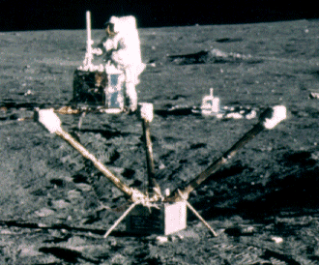
Fig. 1. Apollo 12 astronaut Pete Conrad works at the ALSEP central station. The Lunar Surface Magnetometer (LSM) is in the foreground. AS12-47-6921.

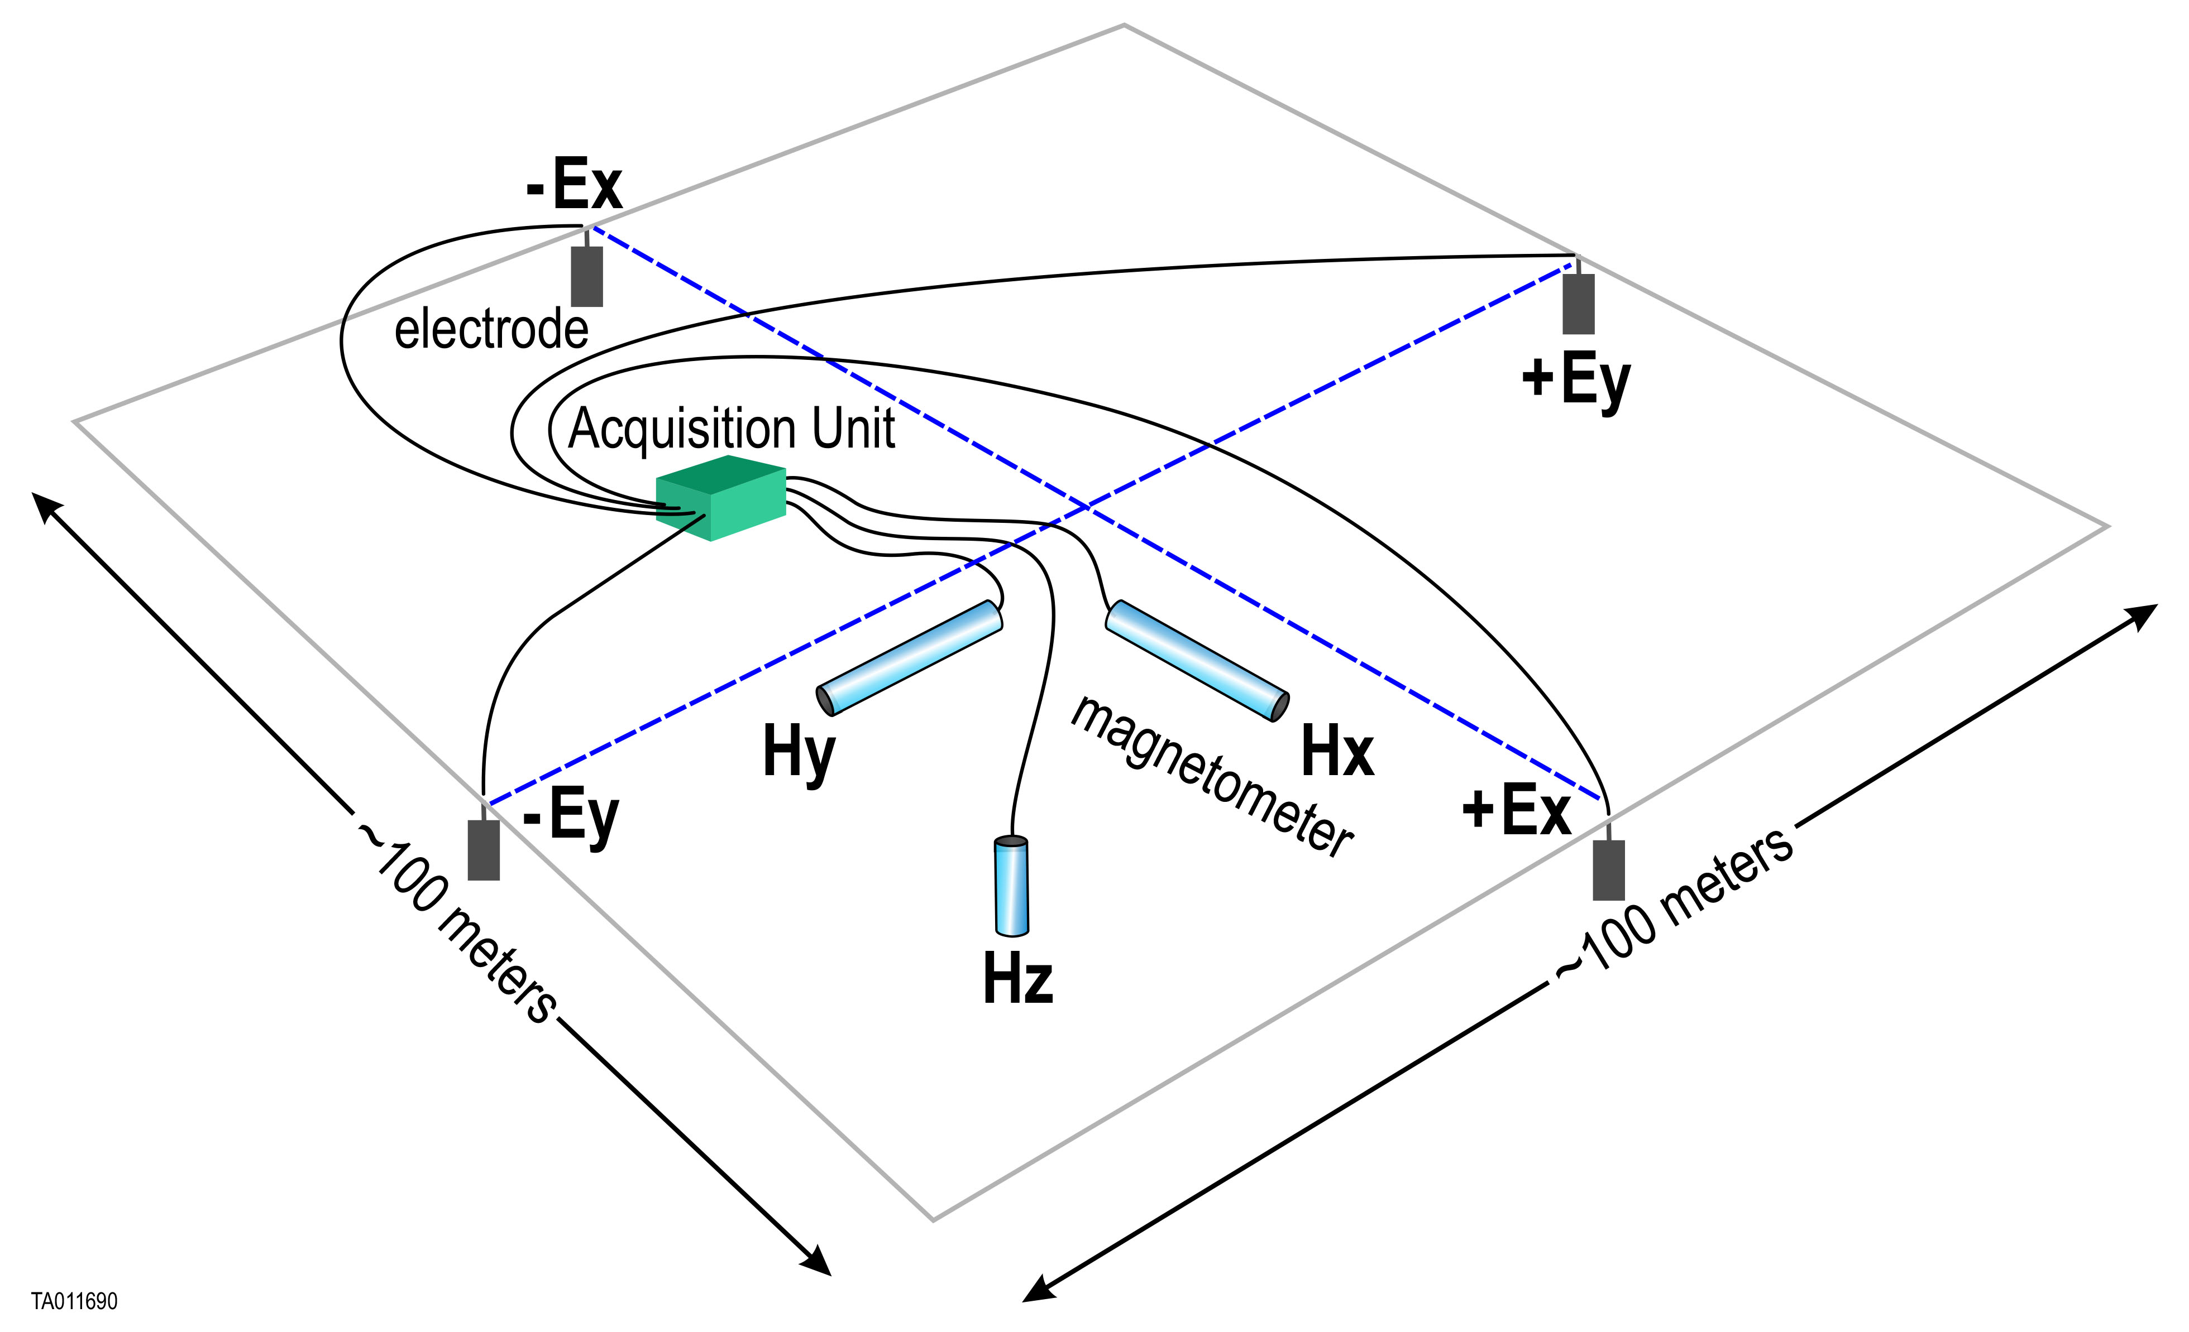
Fig. 2. Schematic magnetotelluric (MT) experiment. Magnetometer(s) are centralized (like LSM), but electric field is measured using orthogonal voltage probes (electrodes) on large baselines. CLPS Lunar Magnetotelluric Sounder (LMS) ballistically deploys electrodes to ~20 m, but astronaut deployment to 100 m would be robust and yield larger signals.

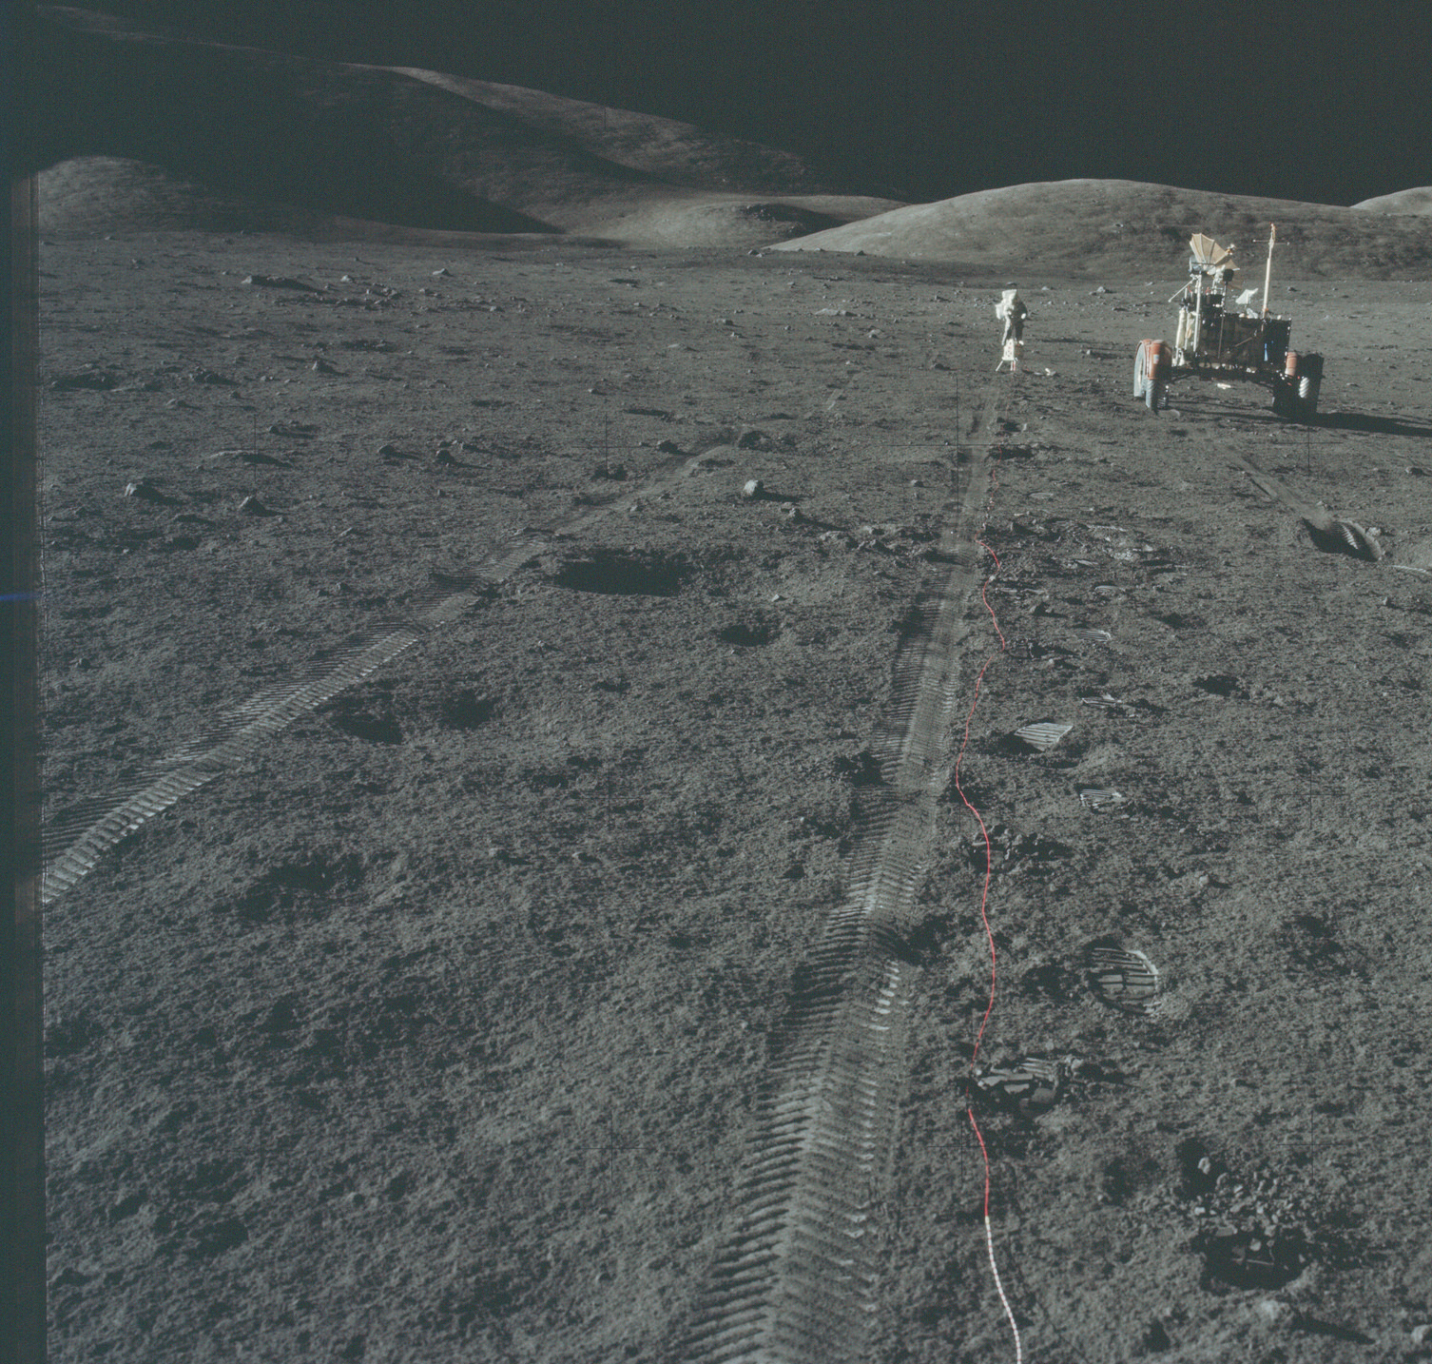
Fig. 3. Apollo 17 astronaut Jack Schmitt deploys an antenna for the Surface Electrical Properties (SEP) experiment. Analogous operations are required for MT. AS17-134-20436.

