Characterizing Terminator Space Weather with Artemis III

Heidi Haviland, William Farrell, Jasper Halekas, Andrew Poppe (TBC), Emily Willis, Victoria Coffrey, Dennis Gallagher, Ghee Fry

The solid surface of the Moon interacts directly with dynamic space plasmas and solar illumination which drive active electrodynamic processes (Delory, 2010). These processes contribute to charging, electrostatic dust lofting, surface weathering. In addition, solar wind ions implant within the dayside regolith. This results in hydrogenation, hydroxylation, and possible hydration during the reprocessing of regolith producing H, H₂, methane and possibly water (Farrell et al., in review). This solar wind-surface interaction is sub-cycle of hydrogen/water/volatile cycles experienced at the Moon which includes micrometeoroid impacts (e.g., Benna et al., 2019), and volatiles ejected from permanently shadowed regions (PSR) (e.g., Farrell et al 2015) or by space weathering of crater central peaks (e.g., Klima et al., 2013). The poles provide direct opportunity to study the lunar terminator, where the dayside and nightside potentials can be several 10s V difference, which has been proposed to cause electrostatic dust lofting (Farrell et al., 2007). In addition, solar wind flow being horizontal at the poles, enables topology such as mountains or crater walls to be an obstacle to the flow which generates local mini-wake phenomena (Farrell et al., 2008). Tribocharging, the buildup of charge due to moving on the surface, is especially a concern in regions without photoemission. A detailed characterization of lunar surface plasma, along with its driving space weather, is important for basic research (NASA, 2007), possible hazards identification for robotic and human operation (NASA, 2020), and provides context for correctly interrupting induced fields for EM sounding (Grimm et al, this issue). Measurements at the lunar surface provide the best opportunity to definitively resolve key open questions. While there are several interesting areas for plasma physics investigations enabled by the Artemis missions, we focus here on surface charging and the solar wind-surface sub cycle of the on-going volatile processes. This white paper discusses open plasma physics questions that can be addressed by the Artemis III 2024 mission which will send astronauts to the lunar surface within six degrees of the south pole. We begin with a brief review beginning with Apollo-era investigations, and then discuss solar inputs to plasma populations and ongoing surface processes. Plasma physics science objectives are stated, along with a brief discussion of the instruments required for these investigations, and Artemis astronaut deployment options.
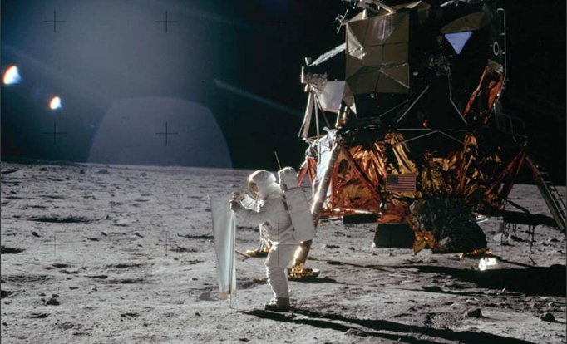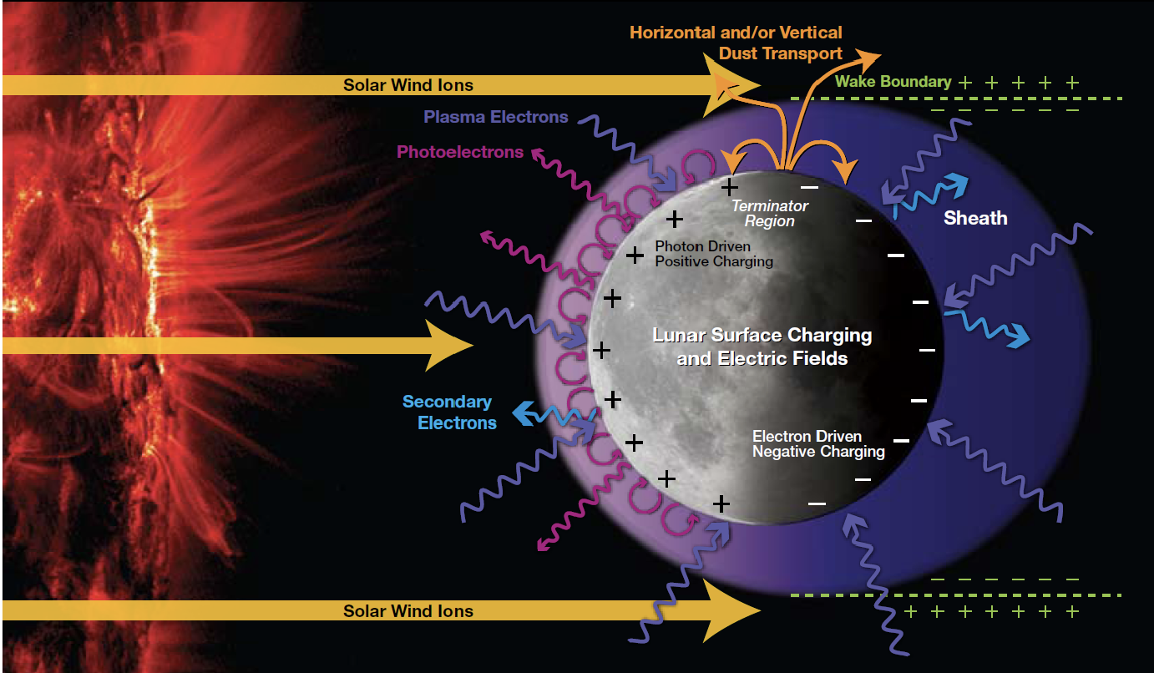
Figure 1. (a) Apollo 11 solar wind composition experiment [NASA]. (b). Day and nightside plasma environments at the Moon when immersed in the solar wind [GSFC, UCB].
Apollo experiments provided the first plasma measurements at the surface of the Moon. The Solar Wind Composition experiment (Fig.1a) detected solar material, the A17 LACE mass spectrometer provided observations of Ar, He, and Ne ions (Hoffman et al., 1973), and the ALSEP SIDE instrument measured surface potentials (Freeman & Ibrahim, 1975). In lunar orbit, Apollo 15, 16, subsatellites, Explorer 35, Lunar Prospector, Kaguya, LADEE, LRO, and ARTEMIS missions provided valuable contributions towards characterizing the electromagnetic plasma and dust environments with varying solar conditions, including extreme events (Farrell et al., in review). However, surface plasma densities and temperatures need to be measured with modern instruments to constrain simulations of plasma processes (NASA, 2007). Ideally, this would consist of measurements in the solar wind dayside and nightside, at the terminator, and within the magnetosphere including magnetosheath, magnetotail lobes, and plasma sheet.
For approximately 75% of its orbit, the surface is exposed to the free streaming solar wind, consisting of hot protons and cold electrons. The dayside lunar surface absorbs these particles, and photoemission dominates charging the surface a few volts positive . A current layer has been proposed on the dayside, at or within the surface, confining induced magnetic fields (see Sonett, 1982 for review); however, this layer has yet to be detected. While on the nightside of the Moon, a vacuum cavity forms, generating current systems and a trailing plasma wake structure. In dark, plasma depleted regions, the surface potential is a few hundred volts negative depending on solar zenith angle. Solar energetic particle events can cause extreme charging up to several thousand volts negative. The Moon also traverses the Earth’s magnetotail in the remaining portion of its orbit, experiencing sheath, calm lobes, and intense plasma sheet environments. The electrical conductivity of the lunar regolith is very small, in contrast to the highly conducting plasma. For a review, see Halekas et al 2010. In addition, the electromagnetic environment of the lunar surface has been used to measure interior electrical conductivity. We note the characterization of surface plasma provides important context for the correct interpretation of these induced fields, especially within the nightside wake cavity (Fuqua Haviland et al., 2019).
Plasma physics science objectives:
- How are plasma surface processes at the polar terminator related to external drivers, including solar radiation, meteoritic influx, and solar wind plasma.
- What is the lateral potential difference across the terminator? Does this vary vertically above the surface?
- Is this potential difference responsible for dust lofting?
- Do surface observations verify simulations which predict a standing plasma double layer over/around terminator?
- Under what circumstances does charging by the lunar surface plasma pose a threat to human and robotic operations? What are the spatiotemporal surface charging and discharging plasma, especially in shadowed, plasma-depleted regions?
- Do water molecules migrate from midlatitudes to the poles?
- How does the plasma-sputtering of ice in PSR crater floors contribute to volatile cycles?
- Does the predicted dayside current layer exist at or just above the lunar surface?
Instruments: Measurements at the surface should include ion and electron energy distribution, density and temperatures, electric and magnetic fields and dust properties. Potential sensors include an electron electrostatic analyzer (ESA), an ion ESA with mass composition, electric field instruments, fluxgate magnetometers, and dust detectors.
Artemis enabling deployment: With the aid of astronauts this instrument suite could take data at several points within the landing site and could include observation of lunar dawn. Lateral observations provide characterization of across the terminator. The potential differences could also be measured vertically extending up from the surface to 2-3m. This scale size would be of value in characterizing the dayside photoelectron sheath and possible current layer at or near the surface that has not been previously detected.
Conclusions. The surface of the Moon is full of interesting plasma and electrodynamic processes that warrants further observation with the Artemis 2024 mission. Astronaut deployment provides the opportunity for multiple measurement locations characterizing the landing site plasma laterally and vertically. Moreover, the Moon is one of several airless bodies in our Solar System which include asteroids, moons, and Mercury; increased knowledge of plasma processes at the lunar surface improves understanding of airless bodies in general (Halekas et al., 2010). There is an opportunity for simultaneous surface-orbit observations with the twin THEMIS-ARTEMIS satellites (Angelopoulos, 2011) measuring plasma and fields currently in orbit around the Moon.

References:
Angelopoulos, V. (2011). The ARTEMIS Mission. Space Science Reviews, 165(1), 3–25. https://doi.org/10.1007/s11214-010-9687-2
Benna, M., Hurley, D. M., Stubbs, T. J., Mahaffy, P. R., & Elphic, R. C. (2019). Lunar soil hydration constrained by exospheric water liberated by meteoroid impacts. Nature Geoscience, 12(5), 333–338. https://doi.org/10.1038/s41561-019-0345-3
Delory, G. T. (2010). Electrical Phenomena on the Moon and Mars. In Proceedings ESA Annual Meeting on Electrostatics (pp. 1–18).
Farrell, W. M., Halekas, J. S., Horanyi, M., Killen, R. M., Grava, C., Szalay, J. R., et al. (n.d.). The Dust, Atmosphere, and Plasma at the Moon, 1–92.
Farrell, William M., Stubbs, T. J., Vondrak, R. R., Delory, G. T., & Halekas, J. S. (2007). Complex electric fields near the lunar terminator: The near-surface wake and accelerated dust. Geophysical Research Letters, 34(14), 3–7. https://doi.org/10.1029/2007GL029312
Farrell, William M., Stubbs, T. J., Delory, G. T., Vondrak, R. R., Collier, M. R., Halekas, J. S., & Lin, R. P. (2008). Concerning the dissipation of electrically charged objects in the shadowed lunar polar regions. Geophysical Research Letters, 35(19), 1–5. https://doi.org/10.1029/2008GL034785
Freeman, J. W., & Ibrahim, M. (1975). Lunar electric fields, surface Potential and Associated Plasma Sheaths. The Moon, 14(1), 103–114. https://doi.org/10.1007/BF00562976
Fuqua Haviland, H., Poppe, A. R., Fatemi, S., Delory, G. T., & de Pater, I. (2019). Time‐dependent hybrid plasma simulations of lunar electromagnetic induction in the solar wind. Geophysical Research Letters, 46(46), 4151– 4160. https://doi.org/10.1029/2018GL080523
Halekas, J. S., Saito, Y., Delory, G. T., & Farrell, W. M. (2010). New views of the lunar plasma environment. Planetary and Space Science. https://doi.org/10.1016/j.pss.2010.08.011
NASA. (2007). Heliophysics Science and the Moon: Potential Solar and Space Physics Science for Lunar Exploration.
NASA. (2020). SLS-SPEC-159 CROSS-PROGRAM DESIGN SPECIFICATION FOR NATURAL ENVIRONMENTS (DSNE) Rev H.
Sonett, C. P. (1982). Electromagnetic induction in the Moon. Reviews of Geophysics and Space Physics, 20(3), 411–455. https://doi.org/10.1029/RG020i003p00411

