State of the Profession Considerations:
NASA Langley Research Center Capabilities/Technologies for Autonomous
In-Space Assembly and Modular Persistent Assets

John T. Dorsey
(757)-864-3108
john.t.dorsey@nasa.gov
Structural Mechanics and Concepts Branch
NASA Langley Research Center, Hampton, VA, 23681, USA

William (Bill) R. Doggett and Gillian McGlothin
Structural Mechanics and Concepts Branch
NASA Langley Research Center, Hampton, VA, 23681, USA

Natalia Alexandrov, B. Danette Allen, Meghan Chandarana, John Cooper, Lisa Le Vie,
Jim Neilan, Javier Puig-Navarro, Walter Waltz
Autonomous Integrated Systems Research Branch
NASA Langley Research Center, Hampton, VA, 23681, USA

Jason Neuhaus
Simulation Development and Analysis Branch
NASA Langley Research Center, Hampton, VA, 23681, USA

- Introduction
The Planetary Science and Astrobiology community is now at a tipping point where they can conceive of the next space-based observatory sharing key characteristics of Earth-based observatories: 1) very large apertures (greater than 15 meters), 2) very long life times (greater than 50 years), and 3) cost efficiency (instrument upgrades, expanding observatory capabilities, servicing and repairs). These revolutionary observatories will be made possible by embracing the persistent asset paradigm and taking advantage of In-Space Assembly (ISA) and Orbital Servicing, Assembly and Manufacturing (OSAM) capabilities. ISA has been proposed for, and studied as a means for achieving large systems in space for decades. More recently, additional benefits of in-space operations have been recognized by NASA, other government agencies and commercial space companies and thus OSAM is being actively pursued at a national level.
Successfully implementing OSAM into next generation revolutionary observatories requires integrating expertise and technologies in Modular Space Structures, Assembly Operations, Autonomy and Modeling/Simulation. The purpose of this white paper is to provide the Planetary Science and Astrobiology Decadal Survey community a brief summary of the extensive integrated OSAM technologies and expertise that has been developed and is resident at the NASA Langley Research Center (LaRC). With this background, it is hoped that the community will become confident enough to embrace and consider ISA and OSAM as viable options for architecting the next observatory. Although this paper will focus on the extensive set of LaRC OSAM capabilities and technologies, it is recognized that complementary capabilities in robotic servicing and automation/robotics are being developed at other NASA centers, other government agencies and commercial space companies.

2. Modular Structures and Structural Assembly Operations
Since the 1960s NASA has considered space missions which require structures that are considerably larger than what can fit inside available launch vehicle payload shrouds and thus, can only be achieved using ISA. These space structures include large support trusses for orbiting space stations, reflectors for deep-space science and earth environmental studies, and large spacecraft for manned missions to Mars and the Moon. Two early examples are shown in Figure 1: a concept for a large space reflector, and a communications satellite.
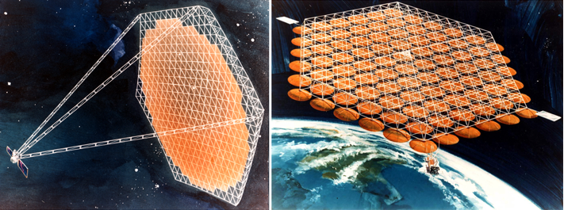Figure 1. Early NASA Concept for a Large Space Reflector and Communication Satellite.
LaRC ISA efforts began in the early 1980s investigating Space Station Freedom (SSF) assembly using astronaut Extra Vehicular Activity (EVA), Figure 2. Extensive research and development resulted in validated structural and assembly infrastructure hardware as well as efficient assembly operations concepts. Two other important outcomes validated by the work were: 1) the ability to accurately predict the final (as-built) structural performance a priori, and 2) the assembly efficiency achieved by co-designing the structural concept and assembly approach while including the capabilities of the agents and infrastructure involved in the assembly.
The LaRC SSF truss hardware versatility was demonstrated by successfully scaling the 2-inch diameter hardware down to 1-inch diameter and using that hardware for two ISA telescope aperture support truss applications. The first involved designing, fabricating and assembling a 14-meter-diameter offset parabolic radiometer (Figure 3) reflector support truss (and associated assembly tools) that was based on a telescope concept developed during the Large Deployable Reflector program. The assembled truss geometry successfully matched the offset parabolic shape of the 20-meter mirror surface. Second, a 2-ring curved tetrahedral truss, 4 meters in diameter was assembled, with the assembled structure achieving a measured root-mean-square (RMS) surface precision of ~ 0.0719 mm (0.00283 inches). ⁶
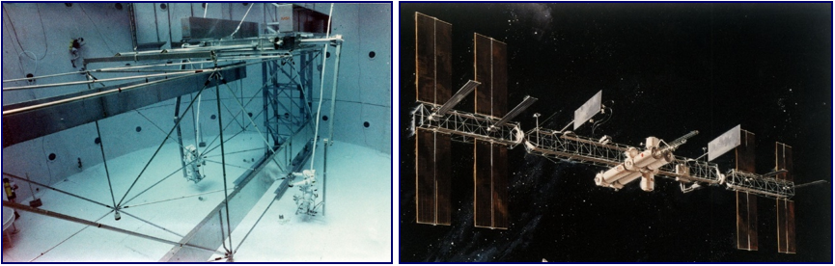
Figure 2. 5-meter Space Station Cubic Truss.
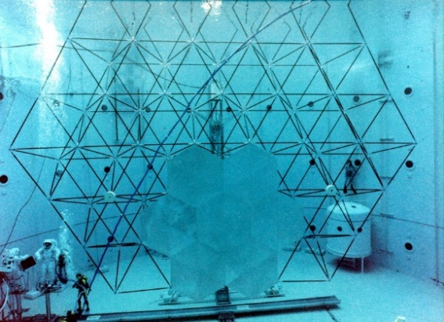
Figure 3. Astronaut Assembled 14m Precision Segmented Reflector Truss.
The LaRC Automated Structures Assembly Laboratory (ASAL) developed automated approaches for truss structure assembly. A planar tetrahedral truss structure, consisting of 102 structural elements covered with 12 simulated telescope reflector panels, was assembled using a supervised autonomy approach (Figure 4). The same system and hardware were also used to build a beam, illustrating the versatility of the hardware and software system. Thus, with a small set of common elements, it is possible to build a variety of structural geometries. While the main focus of the research was on automated assembly, the resulting 102-member structure achieved an RMS surface accuracy of ~0.14 mm (0.00551 inches).
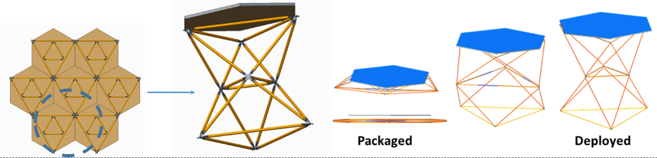
Figure 5. Assembly of TriTruss Collapsible Modules.
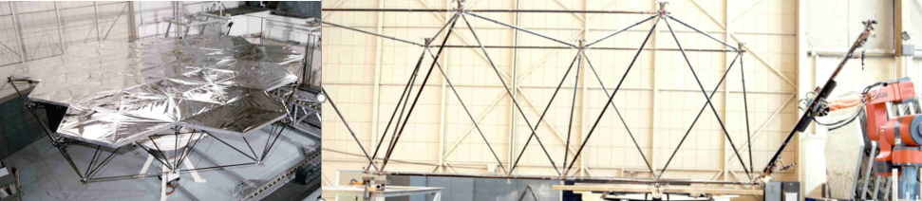
Figure 4. Automated Structures Assembly Laboratory.
For large space telescopes, one of the most challenging components to assemble is the large primary aperture, which must provide a stable wave front to the instruments with nanometer precision over 10’s of hours of observation. LaRC recently developed the TriTruss structural module (Figure 5) to enable efficient ISA and high structural efficiency and precision for aperture support and metering structures.
Astronauts and robots are two types of agents typically used to perform OSAM operations and LaRC has extensive experience using both for ISA. The Assembly Concept for Construction of Erectable Space Structures (ACCESS – Figure 6) experiment was launched on the Orbiter Atlantis on Nov. 26, 1985. The objectives of ACCESS were to: 1) evaluate an assembly line technique for effective use of astronauts as space construction workers, 2) provide on-orbit data to correlate with assembly rates and techniques developed in neutral buoyancy simulations, 3) gain on-orbit EVA construction experience, and 4) evaluate assembly, handling, repair, and maintenance of a large space structure in support of SSF development.
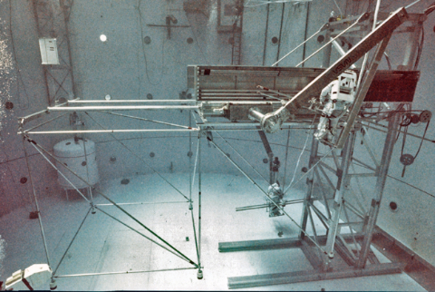
Figure 7. Mobile Transporter Used for Astronaut Positioning in Neutral Buoyancy Testing.

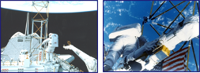
Figure 6. ACCESS Shuttle Flight Experiment (EVA Assembly).

A Mobile Transporter (MT) concept, based on previous work-station construction fixtures, was developed as an EVA aid for SSF assembly. The SSF truss would be assembled out of the Space Shuttle cargo bay using the MT as a construction base. To demonstrate this concept LaRC developed a 1-g version of the MT and evaluated 1-g and simulated 0-g assembly of the 5-meter bay SSF truss structure in 1988 (Figure 7).
The Tendon-Actuated Lightweight In-Space MANipulator (TALISMAN) is a new robotic agent for performing long-reach operations. This long reach arm uses a series of tension members (nominally cables) for both structural stiffening as well as joint actuation. Figure 8 depicts the TALISMAN arm grappling a spacecraft and maneuvering it within reach of small dexterous robotic arms. Compared to state-of-the-art in-space manipulators, such as the Shuttle Remote Manipulator System and the Space Station Remote Manipulator System, a TALISMAN with equivalent stiffness in the plane of the cables provides an order of magnitude reduction in mass and nearly an order-of-magnitude reduction in packaging volume.
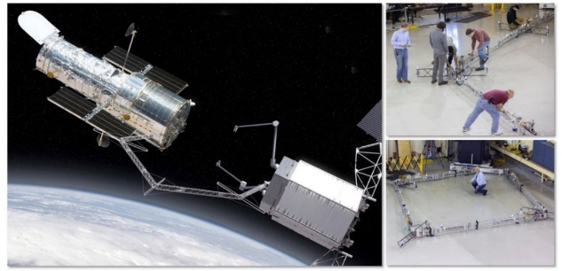
Figure 8. Tendon-Actuated Lightweight In-Space MANipulator.
The most recent OSAM activity at LaRC, Precision Assembled Space Structures (PASS), will develop and demonstrate (in the laboratory) the technologies required to autonomously assemble modular, high-precision and stiffness structural modules to achieve a 20-meter-diameter offset parabolic primary aperture (Figure 9). PASS will use TriTruss structural modules (Figure 5) that are deployed from their packaged state autonomously using a robotic arm. Then two robotic arms will cooperatively and autonomously position and assemble the TriTrusses to complete a 3-ring aperture. Integrated modeling and simulation will be used to plan the sequence of operations and then receive sensor data feedback to validate successful assembly.
Figure 9. 20-Meter-Diameter Primary Aperture.

3. Automation and Robotics
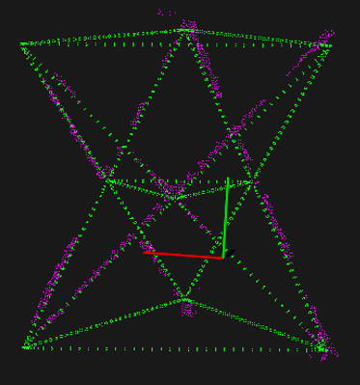
NASA LaRC has a long and rich history of developing, launching, and operating complex automated systems. Applying this extensive knowledge and experience will be critical for achieving an integrated OSAM capability. Autonomy often involves a multi-objective decision-making problem that has uncertain or incomplete information. Complex decision-making in real-world systems is often intractable because it requires repeated expensive high-fidelity function evaluations. Alternatively, optimization with low-fidelity surrogates may not yield practical results. LaRC has developed rigorous optimization methods using variable-fidelity models that yield high-fidelity results with reduced computational cost. Quantifying complex system trustworthiness requires practical system operational risk estimation at all scales. Risk estimation, in turn, is a function of system uncertainties. LaRC is developing comprehensive methods to synthesize and quantify uncertainties during system operations.
Figure 10. Truss module detection from point cloud data.
Assembly agents must know their own position and orientation (their state) with respect to a global coordinate system as well as the relative position and orientation of local objects, such as assembly components and other assembly agents. Successful solutions to state estimation require metrology, sensing, and situational awareness (SA). Perception is a foundational component of SA: it is the ability to recognize and classify objects of interest such as structural modules, assembly joints/nodes, or other agents. LaRC has theoretical and practical expertise with image recognition systems, convolutional neural networks (CNNs), fiducial markers, and radio frequency identification (RFID). Figure 10 illustrates a technique developed at LaRC to detect TriTruss modules from point cloud data coming from a 3D camera. In addition to awareness of the world around them, assembly agents must be able to monitor their health and status to reduce the reliance on human operators. LaRC has developed anomaly detection for flight system telemetry streams that could be used to provide this capability.
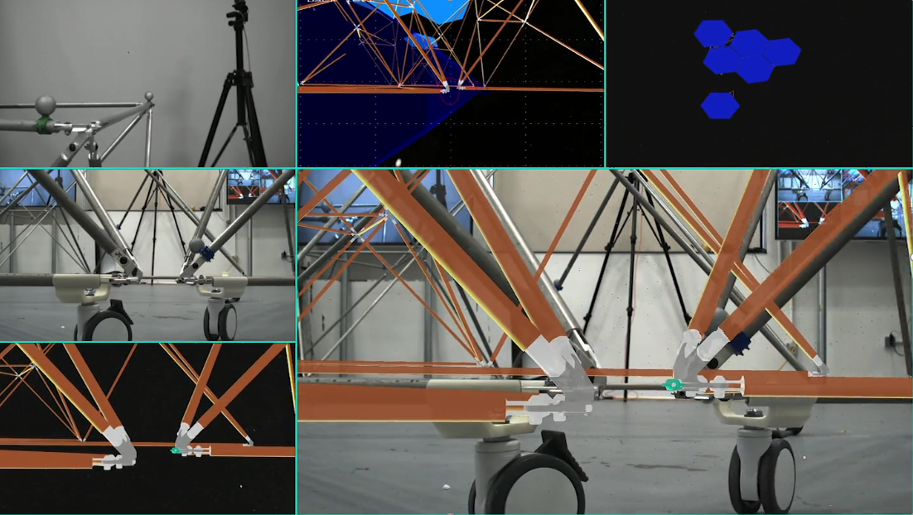
Figure 11. Mixed-reality hardware-in-the-loop simulation for in-space assembly test and evaluation.
Validation and verification (V&V) can be used to reduce risk. V&V for autonomous systems is an unsolved research problem but will likely combine formal methods, stability margins, and Monte Carlo methods, followed by software- and hardware-in-the-loop testing and evaluation (T&E). LaRC has in-house mixed-reality modeling and simulation testbed experience that enables these methods and approaches to be implemented in a multi-agent distributed framework. An example of a distributed simulation is shown in Figure 11, where hardware is located in one LaRC building and the space environment is generated in a simulation in a different facility across the center.
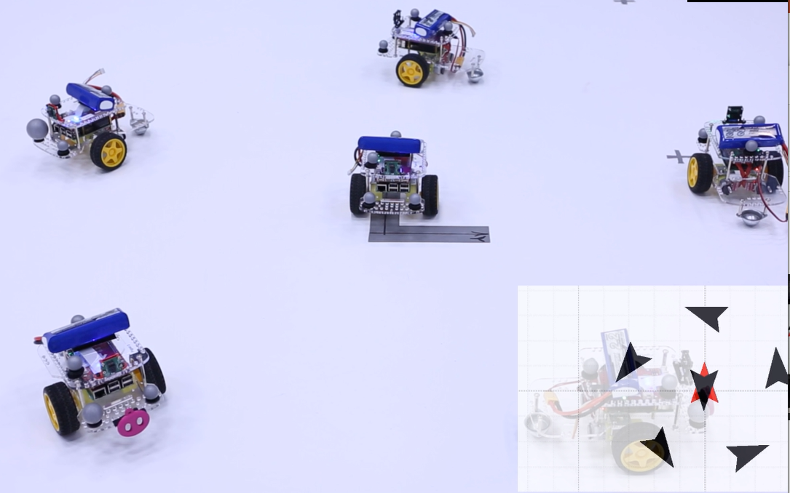Figure 12. Optimal area coverage using a swarm of ground vehicles.
Safe assembly operations require every agent to be capable of collision-free mobility. LaRC is currently comparing and evaluating various stochastic trajectory generation methods in addition to creating in-house solutions capable of temporal- and spatial-coordination. A guidance algorithm to optimally explore an area using a swarm of ground vehicles was developed and implemented at LaRC and associated hardware trials are shown in Figure 12. LaRC has created autonomous control methods for several internally developed robots including the TALISMAN. Hardware-in-the-loop testing, shown in Figure 13, has validated the TALISMAN control system.
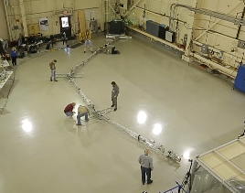Figure 13. Hardware-in-the-loop testing of TALISMAN control system.
Assembly agents must also perform tasks in the presence of, or in collaboration with, other agents (multi-agent). LaRC’s Assemblers project has developed trajectory generation methods for a multi-agent system. The Assemblers project is also developing mission management methods to allocate tasks optimally to minimize either assembly time or energy usage in the face of scarce resources.

4. Modeling and Simulation
Fully validating persistent asset structural performance and assembly operations is very costly and time consuming due to both the large scale of the envisioned concepts and changes in the asset size/mass/geometry that occur during both initial assembly and periodic updates. Validated Modeling and Simulation (ModSim) methods will be required to ensure confidence in the predicted performance of these large evolving persistent assets during: initial assembly, periodic operations to add and remove modules, and the system operational lifetime. State of the art for these ModSim systems involves developing custom and often proprietary software specific to a single customized point solution. However, in order to enable OSAM and persistent assets, LaRC is developing modular software components and individually validating them with laboratory test results. These same modular software components can then be compiled into a toolbox and used for: designing new system architectures, planning assembly operations, and evaluating supervisory and decision-making tools and software used during assembly operations.
The Langley Standard Real-time Simulation in C++ (LaSRS++) software framework has been used at LaRC for over 20 years to develop simulations using modular and reusable software components.,, LaSRS++ can be quickly and efficiently used to add technologies to the OSAM architecture design space by providing predictive validation of new OSAM architectures and operations. Currently, LaSRS++ is being applied to designing large spacecraft system architectures and predicting the architecture’s in-space performance using simulation. For ISA applications, LaSRS++ uses mission validated 6-degree-of-freedom equations of motion. Full dynamics-based solutions for simple rotational and translational joint motions are also currently being modeled. The Dymore software package is being evaluated and integrated to model complex structural responses (e.g. TALISMAN cables).^{12,,} Kinematic based solutions are also available, but are lower fidelity due to similar mass properties of the assembly agents and spacecraft structure.
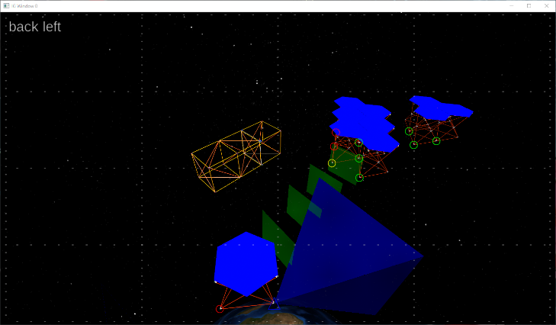
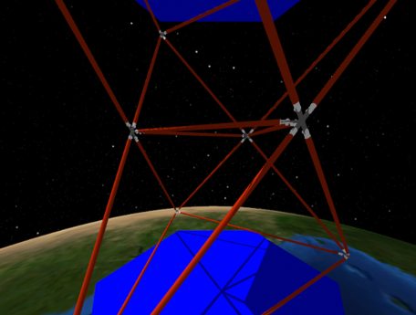
High-fidelity visual systems, used to show all of the persistent asset components in the space environment (including realistic lighting and shadows, Figure 14), can be combined with planned autonomous agent trajectory data and conceptual metrology system data, including simulated sensors and fiducials (Figure 15). These visualizations can help to inform both the sensor/metrology hardware design (during early spacecraft system design), as well as high-fidelity simulations of the system performance in space. LaRC is also examining applying and integrating additional visualization sensor simulations, such as millimeter wave radar (MMWR), forward looking infrared (FLIR), and light detection and ranging (LIDAR) systems.,
Figure 14. Tri-Truss with Lighting/Shadows.
Figure 15. Metrology and Trajectory Data.
5. Concluding Remarks
Successfully implementing OSAM into next generation revolutionary observatories requires integrating expertise and technologies in modular space structures, assembly operations, autonomy, and modeling/simulation. LaRC OSAM technologies/capabilities have been presented to inform the Planetary Science and Astrobiology Decadal Survey community of the robust and mature existing capability to support an OSAM based architecture for their next observatory. LaRC Structures and Assembly capabilities enable: a modular telescope architecture, high-performance structural modules, and robotic assembly techniques. LaRC Autonomy capabilities ensure that the robotic assembly will be accomplished in a safe and robust manner and only require humans in a supervisory role. The LaRC toolbox of Modeling and Simulation capabilities that is calibrated using module-level ground testing, will ensure that the performance of the fully assembled observatory, a very large zero-g system that will never be assembled/tested in a gravity environment, meets all performance requirements when it enters into service. Integrating all three LaRC capabilities and including embedded metrology, will enable servicing, repair, instrument upgrades (and/or replacement) while ensuring a very long lifetime for the observatory and providing a return-on-investment that is substantially greater than the initial cost. Further confidence will be achieved as OSAM technologies are validated in a new LaRC OSAM laboratory that allows large-scale collaborative testing of modular hardware, simulation software and algorithms, and autonomous agents.

References

Doggett, W. R., et.al., “Persistent Assets in Zero-G and on Planetary Surfaces: Enabled by Modular Technology and Robotic Operations,” Presented at the AIAA Space 2018, Orlando, FL, 17 – 19 September 2018, Available as AIAA 2018-5305.
Belvin, W. Keith, Dorsey, John T., and Watson, Judith J., “Technology Challenges and Opportunities for Very Large In-Space Structural Systems,” Presented at the International Symposium on Solar Energy from Space, Toronto, Canada, Sept. 8 – 10, 2009.
Arney, D., et. al., “Space Science and Technology Partnership Forum: In-Space Assembly Data Collection and Analysis”, Presented at the AIAA Space 2018, Orlando, FL, 17 – 19 September 2018, Available as AIAA 2018-5308.
Watson, J. J., et.al., "A history of astronaut construction of large space structures at NASA Langley Research Center." Aerospace Conference Proceedings, 2002. IEEE. Vol. 7. IEEE, 2002.
Bush, Harold G., et al. "Design and fabrication of an erectable truss for precision segmented reflector application." Journal of Spacecraft and Rockets 28.2 (1991): 251-257.
Wu, K. C. et.al., "Analytical and photogrammetric characterization of a planar tetrahedral truss." (1990).
Edberg, Stephen J., et al. "SIM PlanetQuest science and technology: a status report. "Techniques and Instrumentation for Detection of Exoplanets III. Vol. 6693. International Society for Optics and Photonics, 2007.
Heard, W. L., Jr.; et al.: Results of the ACCESS Space Construction Shuttle Flight Experiment, presented at the AIAA Space Systems Technology Conference, June 9-12, 1986, San Diego, Ca.
Doggett, W. R., et.al., “Development of a Tendon-Actuated Lightweight In-Space Manipulator (TALISMAN),” Presented at the 42nd Aerospace Mechanisms Symposium, NASA Goddard Space Flight Center, May 14 – 16, 2014.
Cooper, J. R. (2020). Optimal Multi-Agent Search and Rescue Using Potential Field Theory. AIAA Scitech 2020 Forum (p. 0879). Orlando, FL: American Institute of Aeronautics and Astronautics.
Moser, J., Cooper, J., Neilan, J., Chapin, W., Glassner, S., & Komendera, E. (2019). A Reinforcement Learning Approach for the Autonomous Assembly of In-Space Habitats and Infrastructures in Uncertain Environments. 70th International Astronautical Congress. Washington, DC: International Astronautical Federation.
LaSRS++ - An object-oriented framework for real-time simulation of aircraft, Richard Leslie, David Geyer, Kevin Cunningham, Patricia Glaab, P. Kenney and Michael Madden, AIAA 98-4529.
Measuring Reuse in a Simulation Framework, Madden, Michael M, Journal of Aerospace Computing, Information, and Communication Vol 1, August 2004, pp. 320-340.
NASA Langley Research Center’s Simulation-To-Flight Concept Accomplished Through the Integration Laboratories of the Transport Research Facility, Martinez, Debbie, Davidson, Paul C., Kenney, P. Sean, Hutchinson, Brian K. AIAA 2004-4934.
Modeling Rotorcraft Dynamics with Finite Element Multibody Procedures, Mathematical and Computer Modeling, 33, pp 1113-1137, 2001. Olivier A Bauchau, Carlo L. Bottasso, Yuri G. Nikishkov.
www.dymoresolutions.com
eXternal Vision System Development and Testing for X-59 Low Boom Flight Demonstrator, Randall E. Bailey, Steve Williams, Kemper Kibler, Jarvis J. (Trey) Arthur III, AIAA 2020-3087.
Assessing Dual-Sensor Enhanced Flight Vision Systems to Enable Equivalent Visual Operations, Lynda Kramer, Timothy Etherington, Kurt Severance, Randall E. Bailey, Steven P. Williams, Stephanie J. Harrison, AIAA, 11 September 2017 Journal of Aerospace Information Systems Volume 14, Issue 10.

