NDE Methods and Capabilities Handbook – Resources for the Composites NDE Community

Patricia A Howell
NASA Langley Research Center
Hampton, VA 23681
Abstract
Composite structures are often difficult to inspect due to the anisotropic nature of the material systems and the range of flaws and defects that can arise in the manufacturing process. NASA’s Advanced Composites Project, a public-private partnership between government, universities and industry, sought to address improved methods, tools, and protocols to reduce the development and certification timeline for composite materials and structures. The rapid inspection of composites was one of the three focused research areas of the project. One deliverable of the project was to develop an NDE Methods and Capabilities Handbook. This Handbook provides a publicly available guidance document that facilitates the selection of appropriate NDE techniques and provides recommended protocols for detecting and characterizing common flaw types in solid laminate carbon fiber reinforced polymer composite (CFRP) structures. The Handbook seeks to reduce the time required to develop qualified inspection processes for composite aircraft structures during the development, certification, and manufacturing phases by providing a reference that helps minimize trial and error and provides guidance on best practices, techniques, and settings, for specific flaw types and geometries. Techniques include, but are not limited to ultrasound, laser based ultrasound, infrared thermography, and x-ray CT. Flaw types include, but are not limited to porosity, delaminations, voids, Automated Fiber Placement (AFP) defects and impact damage. The Handbook contains details such as inspection parameters, data analysis techniques, inspection efficiency and limitations. This paper describes key Handbook activities with examples of the techniques and flaw types examined by the Advanced Composite Consortium members. Availability to the NDE community of the fabricated NDE standards as well as the raw data collected on the standards by the Consortium members is discussed.
Introduction
In the Advanced Composites Project (ACP), the National Aeronautics and Space Administration (NASA) has collaborated with members of the aerospace industry to reduce the timeline to develop and certify composite structure for commercial and military aeronautic vehicles. NASA and industry have identified three focus areas, or technical challenges, as having major impact on the current certification timeline. One focus area, Technical Challenge #2 (TC2) − Rapid Inspection, addressed increasing the inspection throughput (i.e., parts or area on a part inspected per unit time) by the development of more efficient quantitative and practical inspection methods, data management methods, models, and modeling tools. One of the objectives in TC2 was to develop tools for rapid quantitative characterization of defects. Traditional methods of nondestructive evaluation (NDE) used for isotropic materials such as metals are sometimes not adequate, or require substantial modification, for composite applications. This is a contributing factor to the cost and complexity of developing new structural composites. Additionally, the defects of interest in composite materials are significantly different from metals.
Therefore, under the ACP TC2, NASA initiated a survey of the current state-of-practice (SoP) in the aerospace industry for the NDE of composite structural components. This assessment attempted to determine what factors most influence the NDE process for composites. This effort spanned the fixed-wing, rotary-wing, and propulsion segments of the aircraft industry and solicited input from a corresponding cross-section of the aviation industry. Critical defect types, current inspection methods, NDE data exchange methods, processes and methods suitable for automation or improvement, and other issues associated with the inspection and certification of composite aerospace structures were identified. Based on the results of this assessment, NASA procured from the ACP industry partners a set of composite specimens (standards) that contain a range of controlled defects representing those typically found in aerospace composite structures. Defect types included those created in the manufacturing process such as varying amounts of porosity, varying degrees of fiber waviness, and inserts representing delaminations. In addition to the composite specimens, the industry partners also provided details on the fabrication procedures and confirmed the results.
NASA then conducted a process of inter-laboratory, round-robin testing of these standards among the members of the NASA Advanced Composites Consortium (ACC). The ACC is a public-private partnership to advance knowledge about composite materials, reduce the certification timeline, and improve the performance of future aircraft. The NDE techniques to be used in the round-robin testing include, but are not limited to, ultrasound (UT), laser-based UT, thermography, and X-ray Computed Tomography (XCT). The NDE Methods and Capabilities Handbook documents the SoP, the manufacturing and validation of the NDE standards, and the results of the round-robin testing.
Scope
The intent of this NDE Methods and Capabilities Handbook is to create a publicly available guidance document that can facilitate the selection of appropriate NDE techniques for specific types of composite aircraft structures. It provides recommended protocols to quickly establish inspection procedures for these methods for detecting and characterizing common flaw types in complex composite structures. It includes an NDE guidance matrix that provides an applicability rating for NDE techniques as they apply to given flaw types. This Handbook also contains details that lead to the applicability rating including, but not limited to; specimen details, inspection parameters, data analysis techniques, inspection efficiency (speed and cost), and limitations. Additionally, details of the implementation of an online database that will serve as a repository for, and provide industry and academia access to, the NDE data collected during the round-robin testing are included. The data and specimens utilized in the development of the handbook will be available to the NDE community. Details of how to request the standards and the data can be found at http://nde.larc.nasa.gov.

This handbook also facilitates the understanding of the limitations of current state-of-the-art NDE methods for the inspection of common defect types in composite materials. It is not a comprehensive guide to NDE, nor is it a complete inspection manual for all types and geometries of composite structures. As such, it serves as a starting point for developing practical inspection methods and protocols that must be tailored to specific applications. While the NDE performance results discussed in this handbook include an array of state-of-the-art and emerging NDE techniques, new techniques are being rapidly developed. Further, the authors recognize that each NDE technique itself has a wide range of inspection parameters. Variations in these parameters can lead to results that vary widely from the results presented here, even on the same specimen. In addition, hardware variations and approaches to data analysis can impact the inspection results. Finally, the authors recognize that, in addition to conventional NDE techniques, the field of Structural Health Monitoring (SHM) is continuing to advance at a rapid pace. While closely related to NDE, this handbook does not include any SHM techniques.
The data contained in this Handbook are from the 87 NDE standards fabricated by our industry partners using one of three material systems. Forty-six of the standards used an IM7/8552 or IM7/8552-1 material system with the fibers being either uni-directional, braided, woven, or slit-tape. Ten standards used BMS 8-276 material system and eight used T-800SC Triaxial Braid [0/+60/-60] with 3M AMD-825. The geometries produced include 21 flat panels, 10 S-curved panels, 9 wedges, 8 radius corner standards, 8 rotorcraft blade-spar tubes, 4 step, and 4 flange standards. While this is a reasonable cross-section of materials found in the aerospace industry today, it is by no means comprehensive of all the material systems currently in use. The authors recognize that the performance of any particular NDE technique is material system specific; therefore, the results presented in this handbook may not be directly applicable to other composite materials.
Finally, the standards used to create this handbook have only a limited range of real and simulated defect types. The specimens include 27 with various types of simulated delaminations, 21 with varying amounts of porosity, 11 with automated fiber placement (AFP) tow defects, 9 with fiber defects, 1 with foreign object debris, and 18 with impact damage. There are also multiple ways of creating any of these defect types in an NDE standard. For example, delamination/disbond NDE standards can be fabricated using a number of different well-known methods,. For this handbook, a majority of the delamination specimens were fabricated by hand layup, with Polytetrafluoroethylene (PTFE or Teflon™) inserts added at various locations throughout the thickness. Most of the circular co-cured inserts are 0.25-inch-diameter (0.635 cm) PTFE film. A few inserts are 0.1- to 1-inch-diameter (0.254 cm to 2.54 cm) PTFE film. In some geometries, the manufacturer used rectangular and square PTFE strips in place of circular film. In addition, a number of specimens had 0.25-inch-diameter (0.635 cm) flat-bottom holes (FBHs) added after cure. To simulate internal disbonds more accurately, some of the FBHs were subsequently back-filled with cured epoxy. That standards made using a different technique will produce results that differ from those discussed in this handbook requires noting.

Arrangement of the handbook
The handbook is meant to be a reference document, and consequently there is significant redundancy in information. The intent is to keep all relevant information in one place rather than sending the reader to multiple sections of the document. The handbook contains the major sections delineated as follows:
Section 1. Contributing Authors: The core team of ACP Consortium members as well as additional contributors from industry, government and universities.
Section 2. Introduction: Description of the ACP, where this handbook fits in the project, and details of the industry survey that resulted in the development of this handbook.
Section 3. NDE Guidance Matrix: A Matrix that provides an applicability rating for NDE techniques as they apply to given flaw types. An example of a portion of the guidance matrix is shown in Figure 1.
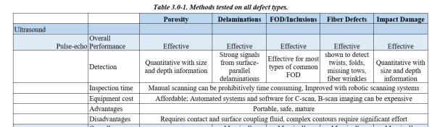
Figure 1. Example section of a portion of the NDE Guidance Matrix table from Section 3 of the handbook.
Section 4. Inspection Guidance by Flaw Type: Guidance on inspection of typical composite defect types is discussed in this section. Effective, Marginally Effective, and Ineffective inspection technologies for each defect type are reviewed in detail, with advantages and disadvantages for each inspection technique tabulated for easy reference. An emphasis is placed on basic, widely applied NDE techniques. This section begins with working definitions of each of the defect types examined, followed by inspection guidance for each flaw type. An example of flaw type is shown in Figure 2. Inspection guidance of various methods is shown in Figure 3, and specifically inspection guidance using X-ray CT for detection of delaminations is shown in Figure 4.

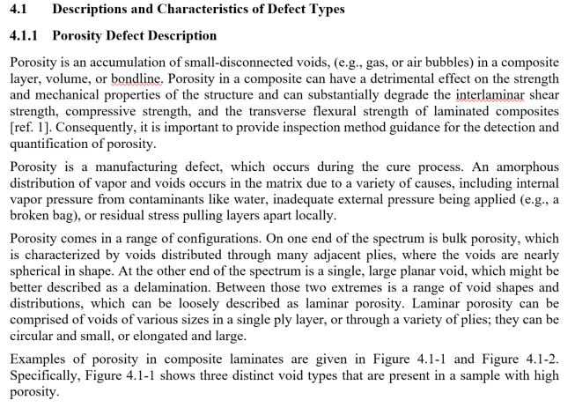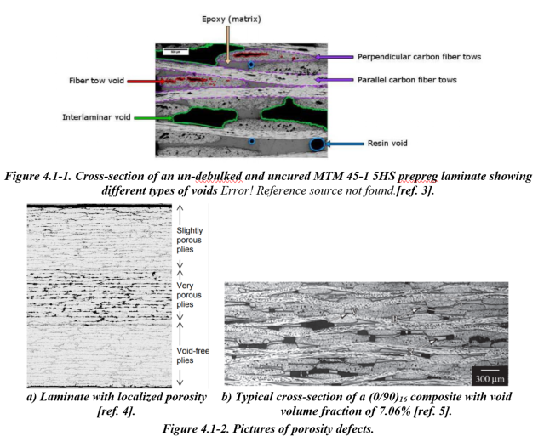
Figure 2. Example from Section 4, Inspection Guidance by Flaw Type: Descriptions and Characteristics of Defect Types: Porosity Defect Description
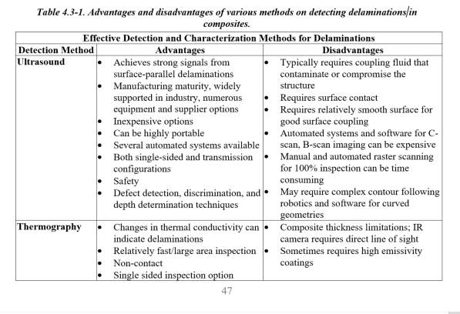
Figure 3. Example from Section 4, Inspection Guidance by Flaw Type: Delamination Inspection Guidance: Delamination Detection and Characterization: Portion of Executive Summary Table

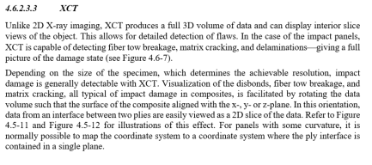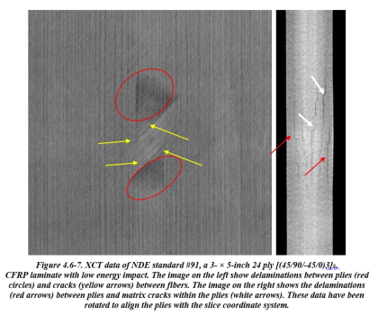
Figure 4. Example from Section 4, Inspection Guidance by Flaw Type: Impact Damage Inspection Guidance: Impact Damage Inspection Technologies: X-ray CT

Section 5. Inspection Technology Summaries and Capabilities: This section of the handbook is organized by inspection technology. Each NDE technique includes a brief technical explanation of the physics of the technique. It also covers some of the specifics important to the inspection of solid laminate CFRP composites. The intent of this section is to facilitate determining which NDE technique might work for a specific inspection application and which will not, where to start and what to consider (from the perspective of the physics of the technique), and how the energy interacts with composites. Predominately discussed are the techniques used to inspect each of the NDE standards developed for the ACP. However, also included are well known NDE techniques that are not typically used for inspection of CFRP composites, why they are not used, and the kind of composites for which that technique might be more suitable.
Example from Section 5
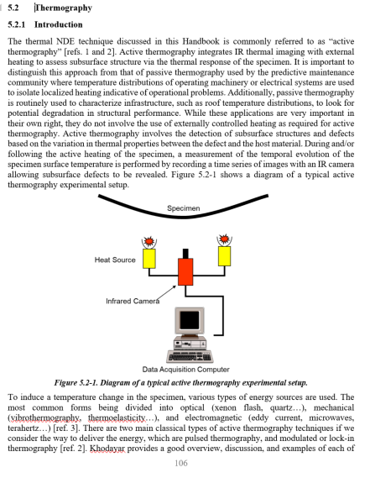
Figure 5. Example from Section 5, Inspection Technology Summaries and Capabilities: Thermography
Section 6: Further Reading: This section contains other documents of interest regarding inspection of composites, including materials on qualification and recommended practice, FAA advisory circulars, guidance, and policy, Society of Automotive Engineering documents, and DOT and FAA sponsored research reports.
Appendix A: Survey: NASA Advanced Composites Project NDE – State of the Practice Report
Appendix B: Overview of Standards: Photos and Descriptions: Consortium members fabricated 87 composite laminate standards with representative defect types typical in a manufacturing environment based on the results of the survey discussed in Appendix A. These defects are positioned within both flat panels and geometrically complicated locations and include defects ranging from delaminations and porosity to Automated Fiber Placement (AFP) tow defects and impact damage. Descriptions and photographs are detailed in this appendix, organized by defect type.
Example from Appendix B
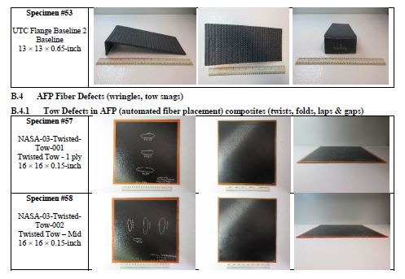
Figure 6. Example from Appendix B: Overview of Standards – Photos and Descriptions.

Appendix C: Round-robin test matrix: Details of the standards each consortium member tested and the NDE technologies applied by each are included in this appendix.
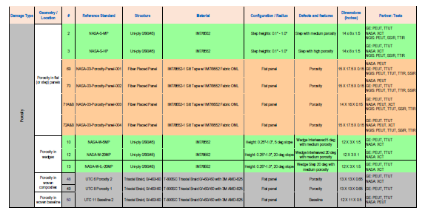
Figure 7. Example from Appendix C: Portion of Round-robin test matrix with specimen details with partners involved and technologies tested.
Appendix D: Manufacturing and Design Documents and Validation Reports: Each consortium company chose or was assigned standards to fabricate based on manufacturing capabilities. Appendix D details the manufacturing information for each type of standard as fabricated and organized by partner.
Appendix E: Individual Test Reports: Results of each inspection by each consortium member for each standard tested are contained in Appendix E. Included are the equipment used, settings, parameters, and examples of results.
Example from Appendix E
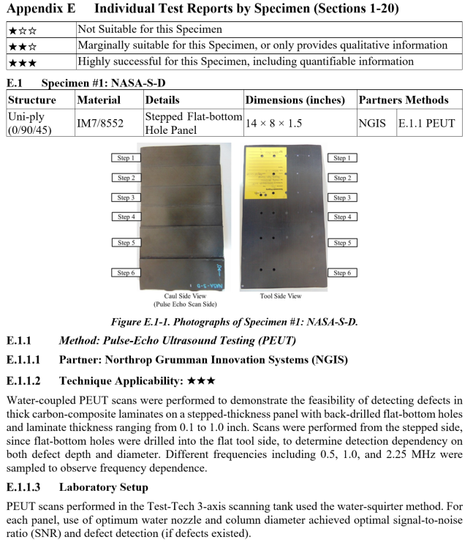
Figure 8. Portion of Appendix E: Individual Test Report for Specimen #1
Conclusions
NASA has published the NDE Methods and Capabilities Handbook, NASA/TM-2020-220568 as a product of the ACP, a multiyear collaboration between NASA, the aerospace industry, universities, and other government agencies. This Handbook is a guidance document that facilitates the selection of appropriate Nondestructive Evaluation (NDE) techniques and provides recommended protocols for detecting and characterizing common flaw types in complex composite structures. It seeks to reduce the time required to develop qualified inspection processes for composite aircraft structures during the development, certification, and manufacturing phases by providing a reference that helps minimize trial and error and provides guidance on best practices, techniques, and settings, for specific flaw types and geometries. The intent is to give an unbiased assessment of the technologies for different inspection needs⎯not to recommend any particular technology for a particular inspection requirement.
To facilitate the development of the handbook, the team designed and procured, from the ACP Advanced Composite Consortium (ACC), a set of composite specimens (standards) that contain a range of controlled defects representing those typically found in aerospace composite structures. These standards were inspected by the ACC partners in a round-robin test procedure. These standards, as well as select raw data from the round-robin testing, are available to the NDE community in a Standards Library. Details of how to request the standards and the data can be found at http://nde.larc.nasa.gov.

Techport, “Advanced Composites Project, Advanced Air Vehicles Program, Aeronautics Research Mission Directorate (ARMD),” NASA Langley Research Center, Project Status Report, URL: https://techport.nasa.gov/view/13280, 2016, p. 9.
Austin, S., 2017, “Advanced Composite Consortium (ACC),” from http://www.nianet.org/advanced-composite-consortium-acc/
DiMondi, V., 1980, Interlaminar Flaw Propagation Mode II (No. CCM-80-18), DELAWARE UNIV NEWARK CENTER FOR COMPOSITE MATERIALS.
Waddell, M.C., 2013, Comparison of Artificial Delamination Methods for use with Nondestructive Testing, Summary Report 2013, UNSW@ADFA.

