When the Eyes Don’t Have It:

Autonomous Control of Deep Space Vehicles for Human Spaceflight
Julia M. Badger and David M.A. Hollaway
NASA Johnson Space Center, Houston, Texas, 77058, USA
Jacobs Engineering Group, Houston, Texas, 77058, USA
Elizabeth M. Taylor
NASA Ames Research Center, Mountain View, California, 94035, USA
NASA has been charged with expanding human presence into the solar system. The next phase of exploration will focus on learning how to develop and sustain habitats on the moon for eventual missions to Mars. The Gateway Lunar Orbiting Platform (G-LOP) is a modular spacecraft being built for cis-lunar orbit and offers a true deep space environment for gaining experience for human missions to Mars. The mission concept for Gateway involves long uncrewed periods between missions; therefore, Gateway requires increased self-reliance to separate the spacecraft from Earth-bound control and oversight. This complicates the human-in-the-loop (HITL) concept and requires major adjustments to the traditional automation human-computer interaction paradigm. This paper discusses the design, development, and verification of complex human-computer interactions with the autonomous systems managers which will control the Gateway spacecraft.
- Nomenclature
ASM = Autonomous System Manager (VSM, MSM, or SM)
ASMA = Autonomous System Manager Architecture
FDIR = Fault Detection, Isolation and Recovery
FSW = Flight Software
GPC = Gateway Portable Computer
HCI = Human-Computer Interaction
HIP = Human Interface Panel
HITL = Human-in-the-Loop
ISS = International Space Station
L-C = Locus of Control
LoA = Levels of Automation
LOSA = Loss of Situational Awareness
MSM = Module Systems Manager
SA = Situational Awareness
SM = Systems Manager
VSM = Vehicle Systems Manager
- Introduction
NASA’s plan for human exploration involves using the moon as a gateway to human missions to Mars and other potential deep space missions. With the exception of the limited Apollo program more than a half-century ago, experience with crewed deep space missions is limited. The next phase of human space exploration will focus on how to develop and sustain habitats on the Moon for an eventual mission to Mars. The Gateway Lunar-Orbiting Platform (Gateway) space vehicle is a station in cislunar space that will serve as a staging area for both the lunar and Martian missions. Gateway offers a true deep space environment to gain experience for human deep space missions and is the first crewed spacecraft and first workplace permanently stationed at the Moon (Figure 1).

Previous and current experience in operating the International Space Station (ISS) may be leveraged for sustained human presence in space; however, operation of the ISS in low earth orbit has required legions of ground control support which send hundreds of commands daily to operate the station. The mission concept for Gateway involves long uncrewed times between missions and requires increased self-reliance for safe operations during reduced and delayed communications to and from Earth, moving human operators to more mission goal attainment roles.

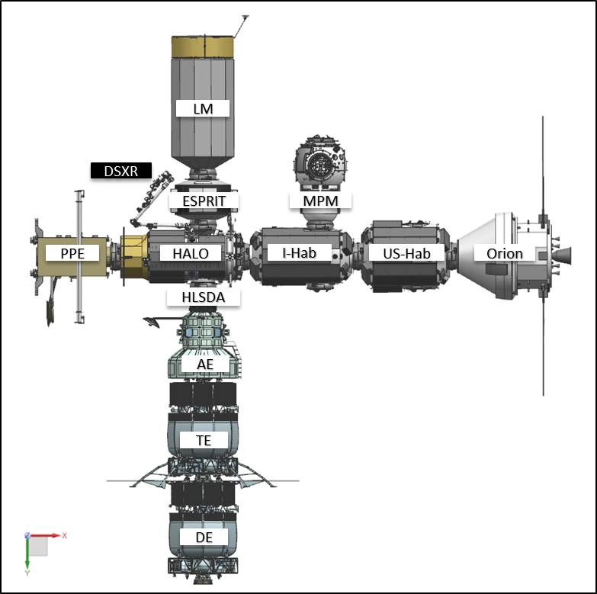

Figure 1 Gateway Lunar-Orbiting Platform

Gateway is the first human spacecraft that is periodically tended by humans and is expected to largely be able to autonomously operate when it is not. In the context of Gateway, autonomy is defined as the ability to separate a spacecraft (and its flightcrew) from Earth-bound control and oversight. Thus, Gateway is the first permanent, habitable presence in cislunar space, with no predecessor to rely on. Because the vehicle is autonomous in operation for most of the time, this presents particular difficulties in human-computer interaction (HCI) and human operator situational awareness (SA).
- Autonomous Systems Management
- Overview
Management of Gateway will rely on autonomous functionality vehicle-wide for both nominal and off-nominal operations. This is achieved by the Autonomous System Management Architecture (ASMA). This architecture features distributed, hierarchical autonomy, based on the incremental integration of the Gateway Vehicle systems. The levels of the hierarchy are controlled by system managers, as shown in Figure 2. The Vehicle System Manager (VSM) tops the hierarchy to control the vehicle as a system of systems at the Gateway Level. Module System Managers (MSM) manage the systems within each module at the Module Level. The subsequent levels represent various systems, subsystems, components, and devices within each module that may have system managers. The ASMA includes human operators as functional components of the system.

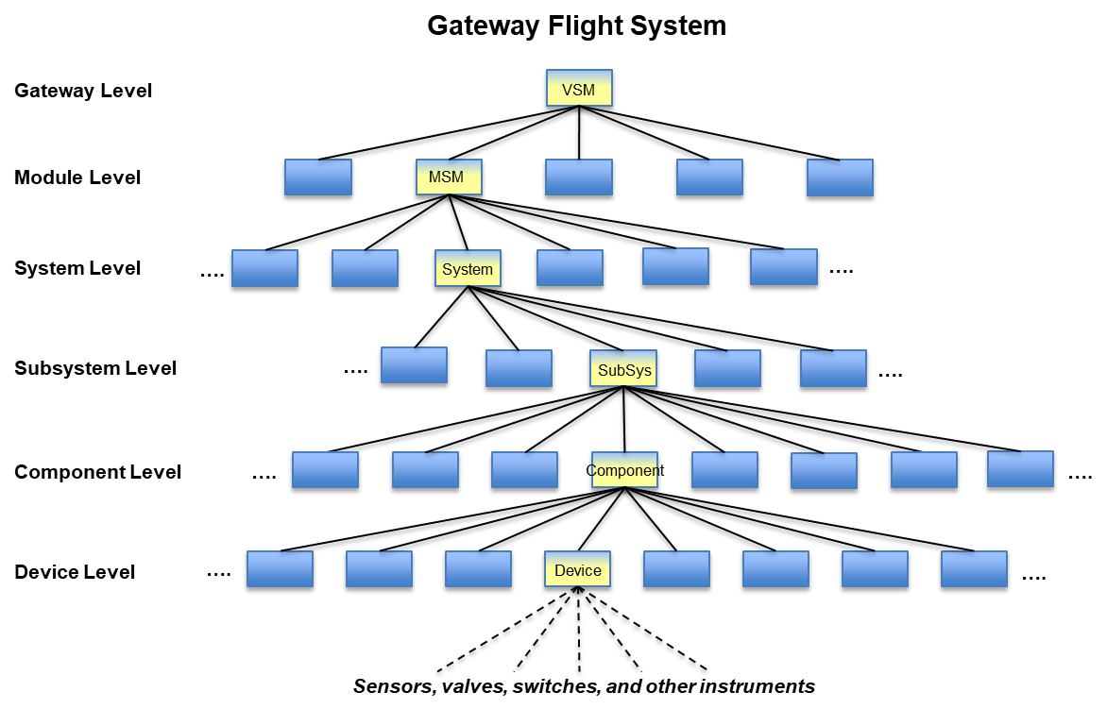
Figure 2 Gateway Autonomous System Management Architecture (ASMA) Diagram
The Vehicle Systems Manager (VSM) is at the highest level of the ASMA and it has a highly integrated view of the spacecraft. The VSM is responsible for:
1. The execution and management of the Gateway Mission Plan according to the Mission Timeline, bounded by constraints;
2. Performing vehicle operation analysis and adjusting vehicle behavior accordingly to meet mission objectives;
3. Managing telemetry bandwidth based on the current flight phase, vehicle mode, operational state, and flight configuration:
4. Assessing, managing, and coordinating use of Gateway resources and consumables throughout the vehicle, depending upon the current state of operation;
5. Managing active faults at the Gateway level, adjusting the Mission Plan and Mission Timeline based on the consequential impacts of the fault, and analyzing trends to identify potential faults and failures at the vehicle level;
6. Supporting the integration of human operator (flightcrew and ground control) roles by providing integrated emergency, warning, caution, and advisory (EWCA) alerting to human operators; supporting human operator analysis, decision-making, diagnosis, and system interrogation; and performing response selection, planning and execution through consequence guidance;
7. Coordinating and monitoring operations that span across multiple Gateway modules; including refueling operations, EVR operations, IVR operations, ECLS operations, etc; and
8. Providing inputs to module-level operation which require information on mission context, or on Gateway assembly configuration, or on ongoing operations.
Thus, the four functions of the Gateway VSM are Timeline Mission Management and Execution, Resource Management, Fault Management, and Vehicle Control and Operation.

B. Human Operator Control Authority

Human operators who have the restricted access and authorization for command and control of Gateway both on the ground and onboard must remain in ultimate control of Gateway. Human Operators maintain control by enabling and inhibiting automated control at various levels:
1. Full VSM-managed control with human guidance – this is the nominal control configuration where vehicle control will reside with VSM, module control will reside with MSMs, and system control will reside with SMs. Human operators will guide this control across the hierarchy through inputs to the overall mission timeline, definition of system parameters, etc. Human operators are always able send commands that affect any portion of the vehicle with the understanding that the vehicle, module, and system managers can also configure and command those items.
2. Partial VSM-managed control, partial human-managed control – if human operators disable a function(s) of VSM, then the human operators assume control of managing the associated capabilities. The automation will no longer respond when disabled, and the human operators will be fully responsible for the associated function. As part of the transition to partial control, VSM will provide the human operator with any identified consequences of the action.
3. Full human-managed control – if VSM is not active or controlling for any reason (e.g. prior to initial activation or due to a failure), a fully-staffed ground control team should assume vehicle control and monitoring. The independent modules would continue to be managed by MSMs, but vehicle-wide management would be assumed by the ground control team to manage resources, operations, and faults.
Figure 3 shows the control authority for the Gateway ASMA:
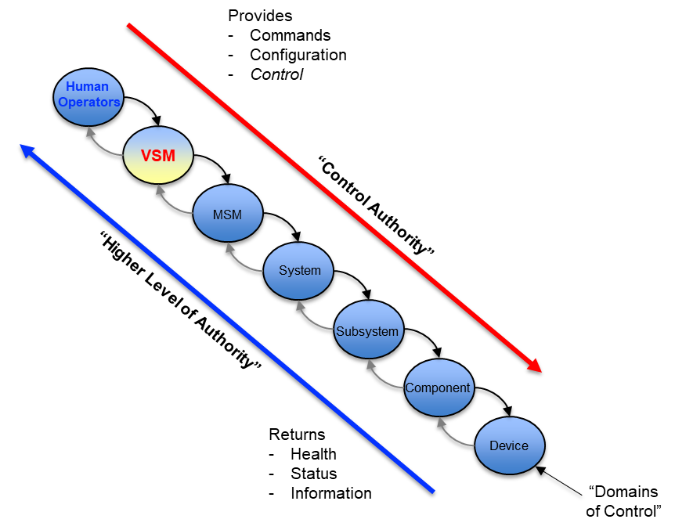
Figure 3 Gateway Control Authority

Modules and systems can be similarly controlled by human operators. When VSM is active, even if some functions are disabled, all commanding to the vehicle will go through VSM. Figure 4 depicts the notional ASMA configuration of Gateway during the initial phase of operations.

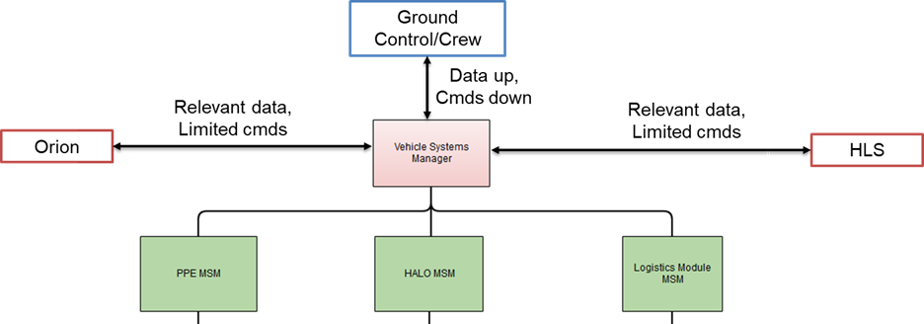
Figure 4 Notional ASMA Configuration in Initial Phase of Operations
Human operator interaction with the VSM will be through commanded inputs. However, the relationship of the flightcrew to the VSM is two-fold. In addition to being a guidance and control source, the flightcrew can also be seen as a resource or a system for VSM-management. Their presence of the flightcrew onboard the Gateway will drive VSM to operate the vehicle differently even without explicit human operator commanding or input.
The VSM will perform command validation for every command received from human operators. Commands to the VSM may be valid or invalid based on its Instance State as well as the Mode and Configuration of the vehicle. Only valid commands are executed. Command responses will be sent to the sender in telemetry with the status of the command. Priority between human operators and conflicting commands will be resolved by VSM.
C. Human Operator Responsibilities
Across all systems, Human Operators are ultimately responsible for the management of each system whether through direct commanding of devices and components without automated assistance or through uplinked guidance to the various system managers. This guidance for the system managers includes the following:
1. Creation and maintenance of commands, scripts, tasks, goals, and timelines associated with:
a. System activation and checkout;
b. System reconfiguration;
c. System operational state or mode transitions;
d. System safing and recovery;
e. Device management – input/output, activation, and deactivation; and
f. System and device-specific actions (e.g. solar panel deploy/retract);
2. Sending commands, tasks, goals and timelines to the VSM for execution;
3. Defining operational constraints and limits (e.g. operational boundaries, reserve margins, minimum configurations, etc.; and
4. Monitoring telemetry and data to identify degrading trends and system faults, allowing for effective and timely detection, isolation, and recovery actions.
D. Locus of Control

When the spacecraft is uncrewed, the VSM controls Gateway with periodic monitoring and intervention by human operators in a Mission Control Center (MCC). When Gateway has a flightcrew onboard, human operators (crew or ground) may intervene in operations more frequently, but the VSM will perform the same continuous functions and remain in control of the vehicle through its four functions.
Locus of Control (L-C) refers to the entity that maintains logical control of the Gateway. In most cases, this entity will be the Gateway VSM, but in certain circumstances, that may not be possible. There will be scenarios where a transition of control is necessary, such as failure of a supporting system, loss of VSM functionality, or a planned transition to support mission objectives. This section describes those types of scenarios, what is required to transition control, and when the transition is to take place.
Note that human operator L-C, nominal commanding, and manual control of a specific function or system are not the same. L-C refers to control of the vehicle as a whole. Nominal commanding allows a human operator to send individual commands to affect a specific outcome (e.g. turning on a light), and manual control of a function or system results in higher-level automation being disabled. Manual control is described in more detail in Section IV.
The VSM is dependent on supporting systems to provide power, thermal maintenance, network connectivity, avionics components, etc. The VSM will have at least single redundancy for its critical functions. If a VSM fails or detects a condition preventing full control of the Gateway, a backup VSM will be transitioned to primary with synchronized or checkpointed data when possible. This fail-over transition behavior is assumed to have happened and failed, leaving the vehicle with no functioning VSM. Failure of a VSM to recover to primary within a prescribed time period will induce an L-C transition.
Upon full failure of a critical VSM function, human operators will be alerted to prepare for a potential L-C transition. If no human operators are available to accept the L-C, the L-C will automatically transition to the Power and Propulsion Element (PPE) Module System Manager (MSM). Because VSM roles are at the vehicle level, note that all functions will continue as commanded on the module levels throughout any transfer of L-C. Humans having L-C means that they carry the responsibility for any vehicle-level commanding and configuration. For the PPE MSM, L-C does not include any vehicle-level commanding, but includes actions from the PPE that increase the likelihood and ability for the L-C to be transferred to a human (i.e., autonomously attempt to re-acquire communication with the Earth), depending on the length of time that the PPE MSM holds L-C. During any uncommanded transition away from a VSM L-C, the module hosting the VSM(s) may react to try to recover the VSM(s).
The nominal and off-nominal locus of control transitions center on four entities. The nominal locus of control for Gateway resides with the VSM, and all nominal transitions are the transfer of locus of control to the VSM, either during a fault or recovery of the Gateway from some off-nominal state. Figure 5 shows possible L-C transitions.

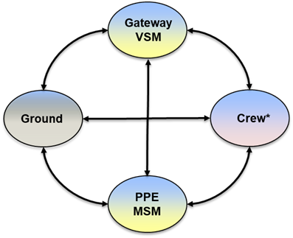
Figure 5 Possible Locus-of-Control (L-C) Transitions

L-C transitions may be explicitly commanded by a VSM or a human operator. There are many ways in which a transition of L-C may be executed. For example, a “transition by attrition” may occur when human operators assume enough Control Authority (defined as direct operations of control points), forcing an L-C transition. A more typical scenario will be a VSM application-level defined transition of L-C. As described above, failures and recoveries will initiate an L-C transition. Table 1 shows L-C transition conditions and outcomes.

TABLE 1
GATEWAY LOCUS-OF-CONTROL (L-C) TRANSITIONS
 | TO
FROM |  | VSM | PPE MSM | GROUND | CREW
FROM | VSM | Invalid | VSM failure, uncrewed, and loss of signal. | VSM failure, with loss of signal; may also be used for prognosis or research as necessary. | VSM failure while crewed and loss of signal; crew involvement at lower levels for engagement and situational awareness building; training/proficiency.
FROM | PPE MSM | Initial integration; recovery of VSM (certain conditions). | Invalid | Acquisition of signal while VSM failure; MSM fails. | Failure of both MSM and VSM while crewed (assumes loss of signal).
FROM | GROUND | VSM recovery; release of manual state. | VSM failure, uncrewed, and loss of signal. | Invalid | VSM failure while crewed and loss of signal; may be used for autonomy testing or research.
FROM | CREW | VSM recovery; release of manual state. | Lack of effective control authority (e.g., busy or incapacitated). | Acquisition of signal during VSM failure; lack of effective control authority. | Invalid

An important consideration in L-C transitions is the ability of human operators to gain enough situational awareness (SA) and understanding to positively affect the vehicle. This may be achieved by communicating the appropriate information, including uncertainty calculations, and keeping the human operators informed in the Gateway's operation throughout nominal and off-nominal operations. The ability of human operators to analyze data from low-level systems and subsystems will be essential to enable the acquisition of SA.
Human operators have the option of directly controlling each component of the ASMA but this would be in an extreme off-nominal situation as the cognitive resources required to have situational awareness of each operational state of the ASMA would be overwhelming. When a human operator assumes manual control of the VSM (or PPE MSM, when it holds the locus of control), it signifies a transition of the locus of control typically to the command initiator (ground or crew). The human operator would be required to follow a process to ensure that conditions are appropriate and constraints are met before transitioning L-C back to the VSM. Given these conditions and constraints will be configurable during this timeframe, appropriate testing and monitoring will be required as part of the hand-off procedure. Entry to direct human control provides the option to set a timer that allows an L-C transition to the VSM (if available) or the MSM (if necessary) upon a period of no interaction with the human operator (dead man function).
Ground-based human operators are the first choice for the recovery of the failed redundant VSM applications. If no contact with the ground is established, the flightcrew or the PPE MSM will transition to control of the vehicle. There are only a certain set of conditions that will allow the automatic transition of L-C from the PPE MSM to the VSM; in all other cases, the recovery of the VSM will involve human operator L-C support. These certain conditions could include the rebooting of the processor(s) that host(s) the VSM, though design of the integration of the VSM with the avionics and avionics software architecture ensures that an L-C transition does not occur due to a reboot event. Note that failure of VSM and PPE MSM during uncrewed and loss of signal events is at least three failures deep for critical functions, and so is not considered.

- Human-Computer Interactions (HCI)
A. Human in the Loop (HITL)
The model presented in Figure 6, adapted from Meister’s Human Factors: Theory and Practice, is one depiction of how human operators and automated systems such VSM interact [3]. Environmental influences such as theological, physical, and regulatory, have been added. The Human-in-the-Loop (HITL) model is divided into the human system which represents the human operator, and the machine system which represents VSM which is designed to multiply or enhance human performance through the control of Gateway processes. The model illustrates a typical information flow between the human and computer components of VSM and depicts information transfer (input-output points) between the operator and the system when human operators have input or control authority. The model also incorporates the technological environment, such as level of automation (LoA) in which the information transfer occurs. The HCI model is used in the design of interfaces between human operators and VSM by defining what information must be communicated between the human operator and the particular system state and how this communication is to be accomplished.

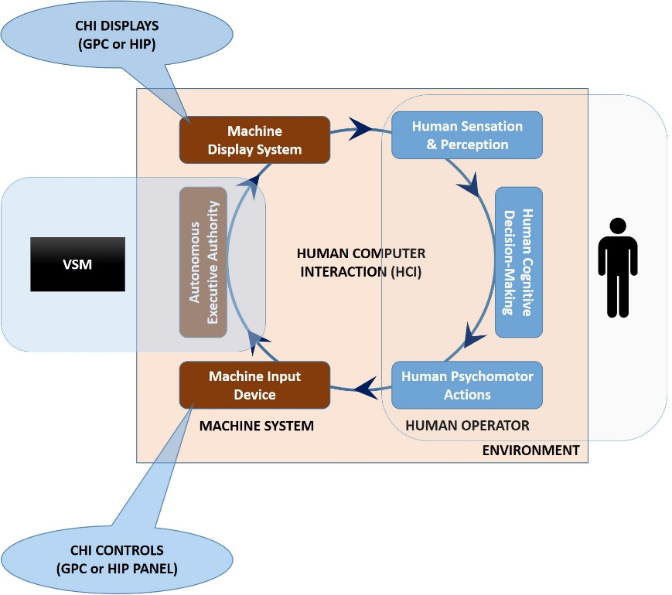
Figure 6 Human-Computer Interaction (HCI) Model

Situational Awareness (SA) is the perception of environmental elements and events with respect to time or space, the comprehension of their meaning, and the projection of their future status. Since it is impossible for human operators to maintain complete situational awareness of all systems operating aboard Gateway, many of these monitoring and controlling tasks are delegated by function analysis to VSM. However, human operators must maintain situational awareness of critical tasks to be effective in intervening should an automated system experience an anomaly, fault, or failure.
In normal spacecraft operations from Mercury to Orion, the flightcrew maintains SA because they are actively in the control loop even when the flight regime is highly automated such as launch. The systems are also monitored continuously my mission control ground personnel. Gateway, however is a different paradigm as the autonomy provided by the Autonomous Systems Managers like the VSM are designed to
B. Computer-Human Interface (CHI)
The flightcrew interacts with the VSM using a Computer-Human Interface CHI) (see Figure 7). The CHI consists of two control systems: The Gateway Portable Computer (GPC) and the Human Interface Panel (HIP). The GPC is a COTS laptop computer used by the flightcrew to control Gateway and achieve mission goals.
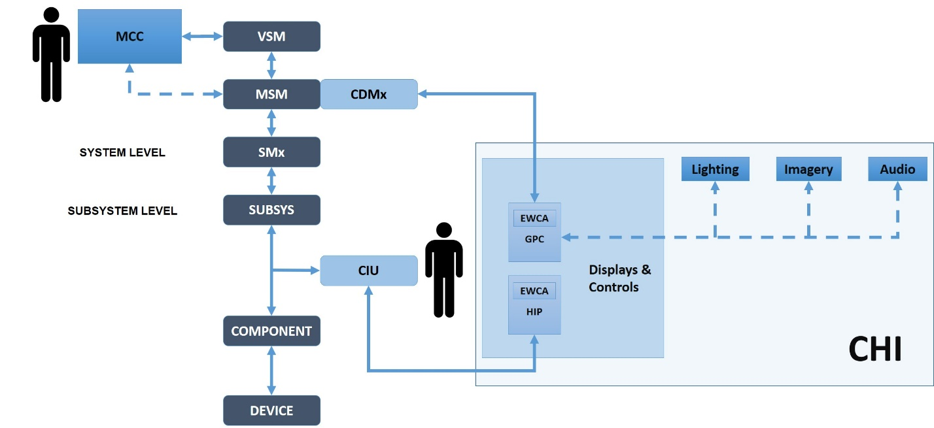
Figure 7 Computer-Human Interface (CHI)
Because Gateway will operate in in cislunar space, the GPCs are subject to soft errors such as bit flipping from radiation. Moreover, there is always a potential for a common cause or Byzantine failure which would fail all instances of the VSM on the spacecraft. To mitigate this potential hazard, a hardwired Human Interface Panel (HIP) allows limited commanding of the spacecraft in the absence of VSM or a GPC. In addition to commanding, both the GPC and HIP provide Emergency, Warning, Caution, and Advisory (EWCA) alerts to the flightcrew and allow human operator input to the autonomous systems managers for fault containment and corrective actions.
The GPC communicates with VSM through a Crew Display Manager (CDM) located in each of the spacecraft’s modules. Conversely, the HIP communicates through a subsystem Crew Interface Unit (CIU) and communicates directly with a component or device. Both the GPCs and the HIP are nodes on the Time Triggered Ethernet (TTE) data communications network. In the event of a total VSM failure while uncrewed, ground control can communicate through a redundant data path to the HALO module’s MSM.
C. Levels of Automation (LoA)
Automation describes the implementation or actuation of a function, operation, or process by automatic means where the human operator is minimally incorporated in, or excluded from, the control loop as the function is allocated to the machine’s autonomous executive with or without some level of human supervisory control [1]. Conversely, autonomy, in the context of Gateway, is the ability to separate the vehicle and crew from Earth-bound control and oversight using automation. To provide autonomy to Gateway, Levels of Automation (LoA) are established in accordance with a function allocation (dividing tasks between the automation and human operators in accordance with at design schema). Thus, LoA is the level of automatic control of the vehicle’s systems, subsystems, components, or devices which ranges from full manual control without or minimal autonomous executive support, to full autonomous operation with the human operator minimally incorporated into the control loop [2]. The Autonomous System Managers (ASM) of Gateway (VSM, MSM, and SM) use various automation to provide autonomy to the vehicle through levels of automation assigned to each task and is, thus, task dependent.
The level of automation for a given task takes the following into consideration: situational awareness, response time criticality, task complexity, operational hazards, operator workload, vigilance and monitoring requirements, and the hazard of unengaged operators. Incorporating the correct level of automation for a task will allow the human operator to maintain enough situational awareness to correctly respond to a fault after the VSM returns the system to its most functional state or to intervene if the automation fails, and prevent the system from entering a compromised or degraded state as a result of automation error.
Generally, VSM design utilizes six (0-5) levels of automation ranging from full manual control without or minimal machine support, to full automation with the human operator minimally incorporated in the loop. Figure 8 presents the topology of responsibility allocation presented by a quaternary division of action attributes:

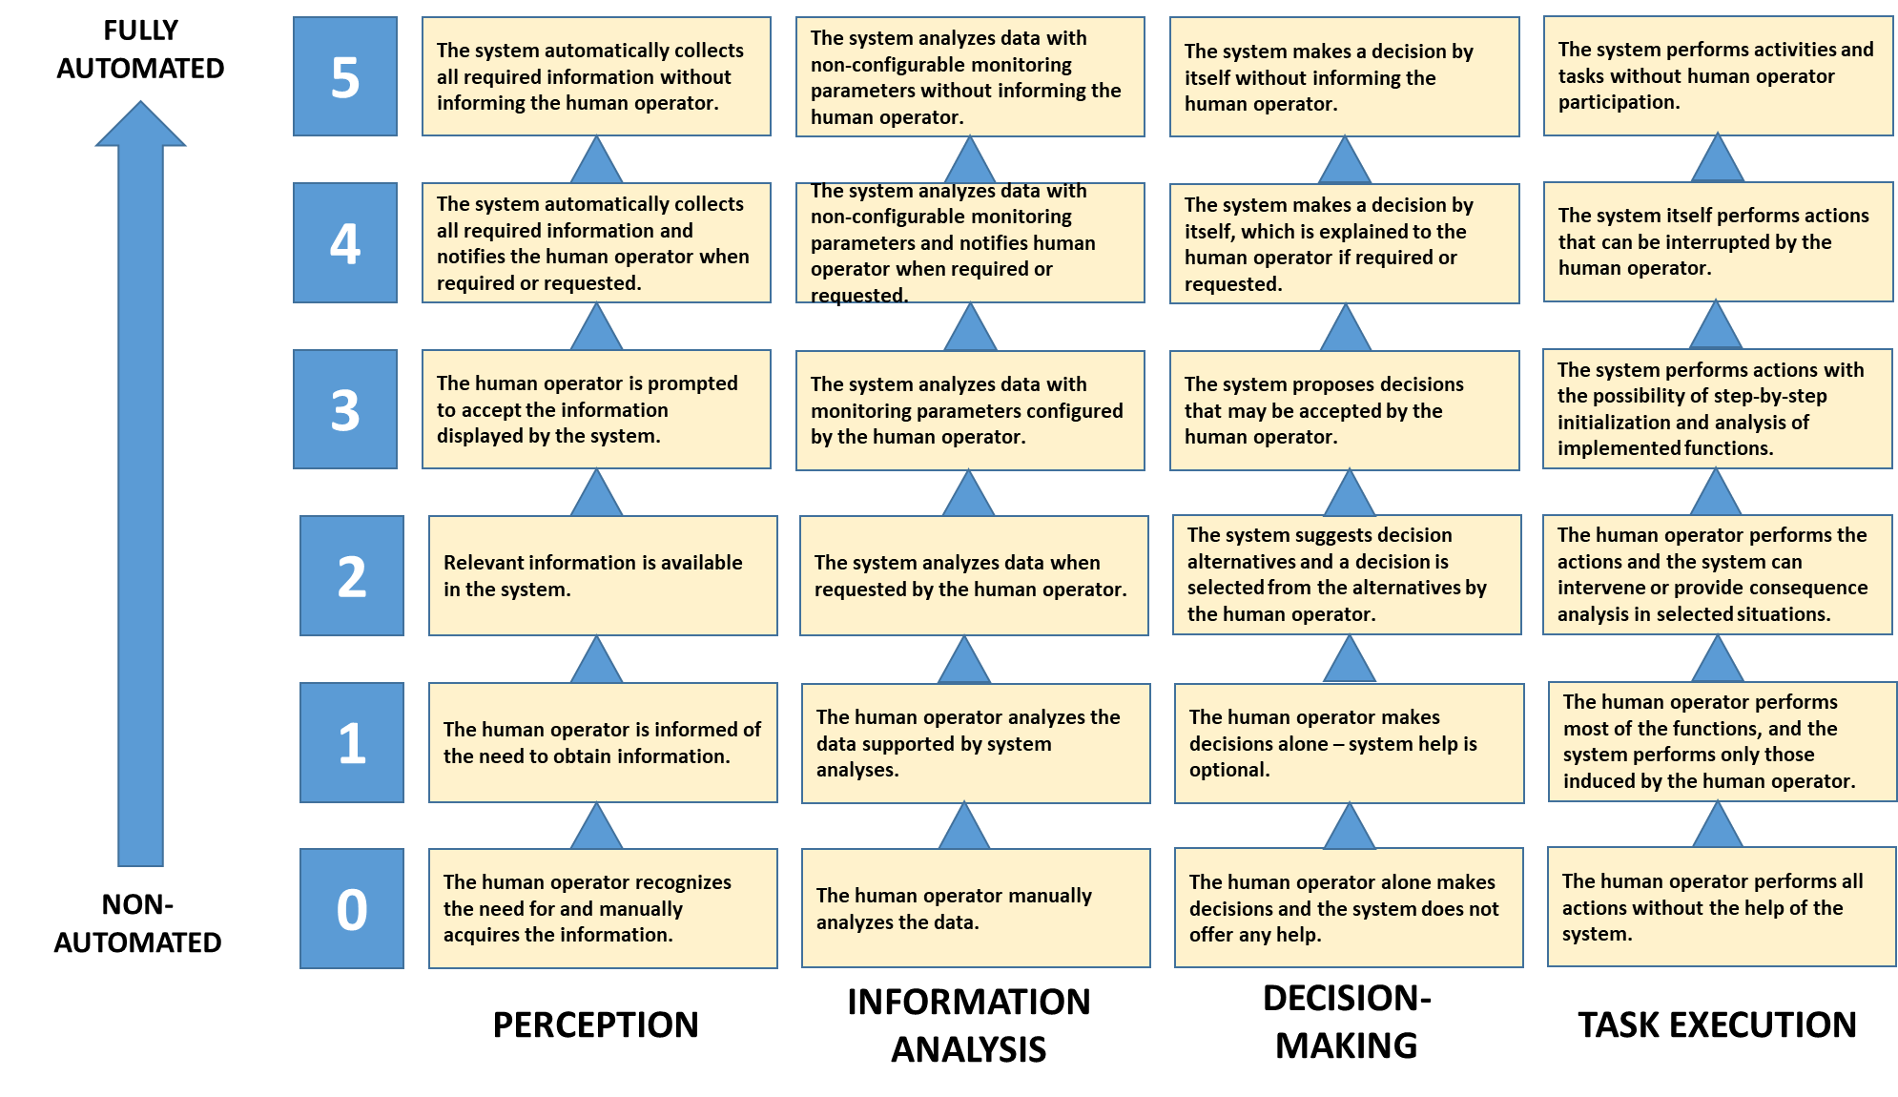

Figure 8 Levels of Automation (LoA) Topology
Level 0 is considered manual (no automation) because all tasks are allocated to the human operator even though the task may be machine executed. Conversely, Level 5 is considered fully automated, without human interaction, because all tasks are allocated to VSM. The other levels contain various amounts of interaction between the human operator and the VSM.
The extent of the assistance offered to the human operator by the automation is characterized by four dimensions of performance (Perception X_{P}, Information Analysis X_{IA}, Decision-Making X_{DM}, and Task Execution X_{TE}). Perception is the determination that a gap exists between the current state and the goal state by retrieving information. Information analysis is the examination, cleansing, transforming and modeling of selected data with the goal of obtaining information to support decision-making. [2].
Decision-making is the cognitive process by a human operator or algorithmic process of an autonomous executive resulting in the selection of a course of action among several alternative possibilities based on the analysis of information. Lastly, task execution is the performance of a discrete unit of work by a human operator or machine actuator or effector. Figures 9 through 12 show the dimensions of performance and allocation between the human operator and VSM.

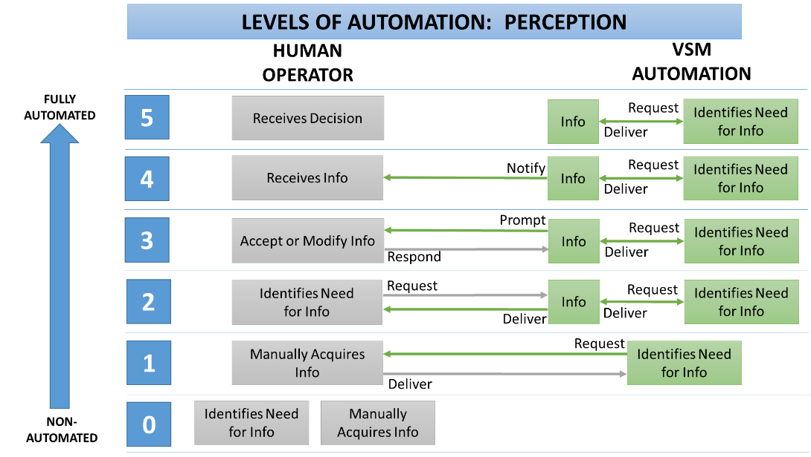

Figure 9 Perception Dimension of Performance

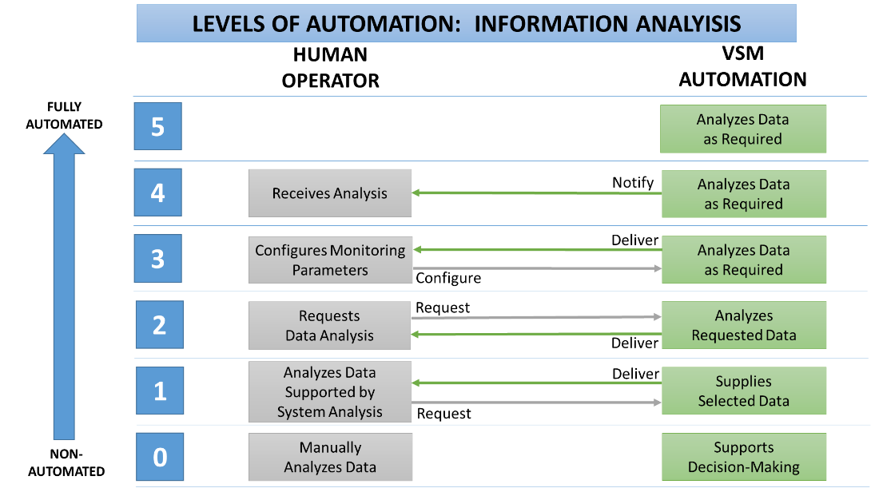

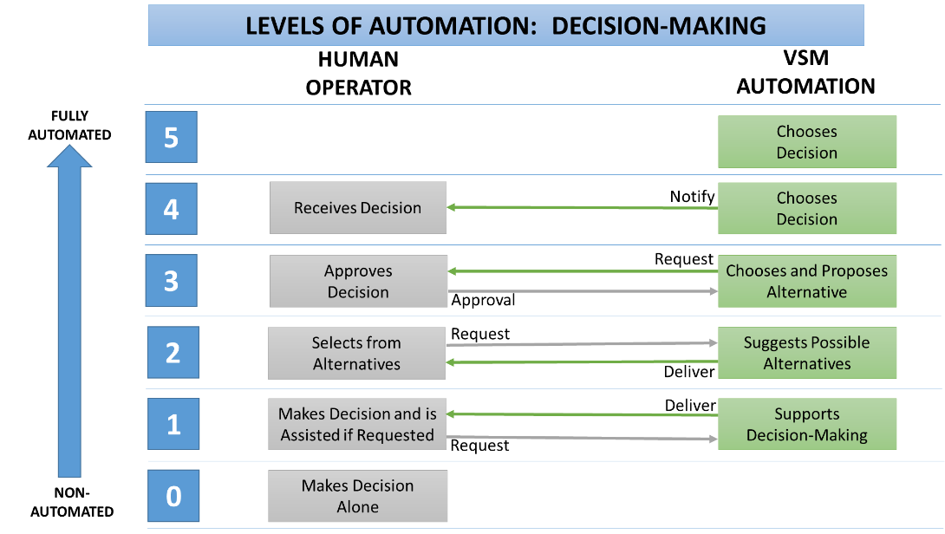
Figure 11 Decision-Making Dimension of Performance
Figure 10 Information Analysis Dimension of Performance

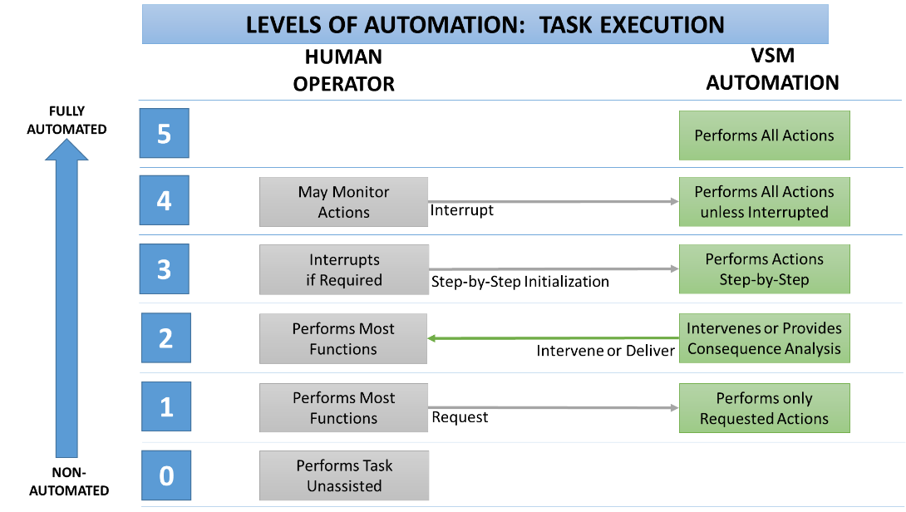

Figure 12 Task Execution Dimension of Performance

Different levels of automation are expected to have different effects on goal state attainment as well as human operator cognitive workload, arousal, performance, and situational awareness [4]. For example, choosing a level of automation near the middle of the spectrum (LoA ≥1≤3) can improve human operator performance while maintaining situational awareness, even as system complexity and task criticality increases [2]. Understanding that automation resides along a continuum from manual to fully automated allows the system designer to manipulate the VSM level of automation to best fit the allocation between system and human operator.
B. Direct Human Commanding
It is axiomatic that human operators must remain in control of the Gateway; therefore the VSM allows for a change in control authority from VSM to the human operator for manual control of a system, subsystem, component, or device (the desired equipment); note that this is not a locus-of-control (L-C) change, but only a change in the control authority for that particular equipment as ASMs remain in control of all systems and functions from which control authority has not been transferred to a human operator. In this scenario, the control authority is changed at the SM-level. All ASM will continue to send telemetry, and the VSM will continue to provide EWCA alerts, decision-aiding, and consequence guidance based on the data provided by the element in manual control. Changes to control authority could be used to control functionality, conduct testing, perform calibration, or for fault recovery.
Placing the desired equipment in manual control requires a two-step command from the human operator to inhibit the automation. VSM will check constraints and provide consequence guidance to the human operator; the human operator is required to override any constraint before the equipment is place in manual control. If the automation is inhibited indefinitely, the human operator must enable the automation controlling the equipment, which will return the equipment to autonomous control.
If the automation is inhibited for a time certain, VSM will examine the mission timeline for applicable constraints prior to returning the equipment to autonomous control. If VSM determines that constraints prohibit the return of the component to autonomous control, VSM will generate an advisory or caution alert to the human operator that a constraint is not satisfied for return of the component to autonomous control by system managers. VSM will provide the consequences of returning to autonomous control given the operational or health state of the equipment.
C. Automation Bias
In normal spacecraft operations from Mercury to Orion, the flightcrew maintains SA because they are actively in the control loop even when the flight regime is highly automated such as launch. The systems are also monitored continuously my mission control ground personnel. Gateway, however is a different paradigm as the autonomy provided by the ASM are designed to operate the spacecraft for long periods uncrewed. Thus, unlike the ISS which is continuously crewed, the Gateway will have the flightcrew arrive and start immediate mission operations without much time to interact with the automated control systems. The human is brought into the control loop generally when there is a fault or failure, or some other off-nominal event that requires a replanning of the mission timeline or human supervisory control because the issue is beyond the capabilities of the ASMA to resolve.
Reliability in automation has a large effect of a system’s efficacy. If the reliability is low, incorporating the automation may lead to less effective system results than a system without automation or to an unintended increase in human operator workload and inducing a negative automation bias. Conversely, if the reliability is high, incorporating high levels of automation can provide assistance to the human operator by increasing performance and reducing workload. If the human is removed from the control loop by highly reliable automation, a positive automation bias may result, significantly increasing complacency, reducing situational awareness, and preventing the human operator from intervening effectively in the event of an automation error or failure [1]. Therefore, the possible effects of automation reliability on human operator positive and negative automation biases is considered in the design and implementation of ASMA (see Figure 13).
A negative automation bias develops when the human operator does not place sufficient trust in the automation due to low perceived reliability. If the human operator places too little trust in the automation, then workload will increase while the operator verifies or reworks the tasks previously completed by the automation. In some circumstances, the human operator may circumvent, override, or disconnect the automation all together. Negative automation bias has the unintended consequence of improving human proficiency in the task because it must be checked or performed manually on a frequent basis.

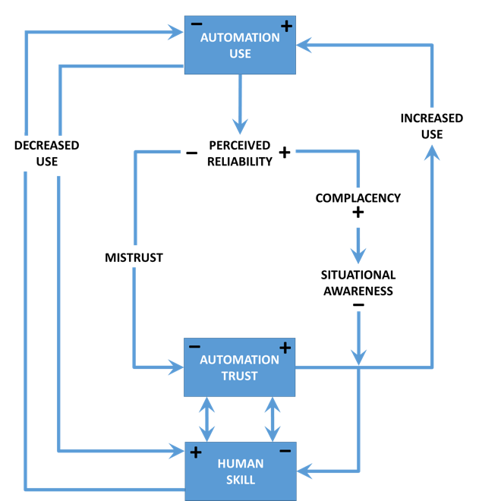

Figure 13 Automation Trust, Complacency, Situational Awareness, and Human Performance [1]

Conversely, a positive automation bias develops when the human operator places excessive trust in the automation due to perceived high reliability. If the human operator places excessive trust in the automation, the some tasks may be incorrectly executed without the knowledge of the operator that the goal state was not reached (loss of situational awareness). Positive automation bias has the unintended consequence of causing a skill decay in performing the task because the task is manually performed infrequently [1].
Generally, an automation designer would seek to balance the automation by inserting requirements for human supervisory control to maintain situational awareness by the system’s human operators. In the context of Gateway, this is not as desirable as it may seem. High automation trust in the safety and capabilities of the ASMs is required to operate the Gateway and this is at the risk of complacency and expense of situational awareness. To prevent the untoward effects compliancy and loss of situational awareness (LOSA), VSM provides adaptive decision-aiding and consequence guidance to human operators.

D. Decision-Aiding, Consequence Analysis, and Adaptive Guidance
1. Decision-Aiding and Consequence Guidance
A challenge for autonomous systems is providing enough situational awareness to the human operators to exercise supervisory control when required for crew or vehicles safety, or to achieve mission goals, during critical task execution. A critical task is any task requiring performance, either human or autonomous, which if not accomplished in accordance with system design requirements or intent, will most likely have adverse effects on crew safety, or vehicle or system reliability, efficiency, redundancy, or efficacy. A task is also considered critical whenever the system design characteristics demand human performance which approaches or may exceed the limits of human capabilities (e.g. human performance functions and tasks are too demanding, information presented to the operator is inadequate to meet human performance requirements, appropriate information displayed may not be timely perceived, or controls provided cannot be effectively operated) and thereby significantly contributes to risk to crew, vehicle, or mission.
Human operators must not be so reliant on automation that they cannot safely recover from emergencies, upsets, or anomalous behavior, nor operate the system if the automation fails (e.g. the positive automation bias results in a complete loss of situational awareness). During critical task execution, human operators must be part of the operational flow and not relegated to being a resolver of faults and failures. Thus, the VSM identifies when human supervisory control is appropriate and provides opportunities to exercise this control. Conversely, the VSM is also capable of executing the timeline in the absence of required human supervisory control, even if the timeline execution is sub-optimal without human operator response. One major way that VSM provides opportunities to increase human operator situational awareness and to exercise human supervisory control in the execution of critical tasks is through decision-aiding and consequence guidance.
Decision-aiding is the process of the autonomous executive assisting the human operator in the selection of the best course of action among several or many possibilities based on the analysis of information. Consequence analysis is the prediction of possible results or effects or an action or condition by hypotheses testing or consequence mapping of actions to system operational and health states as well as goal states. Decision-aiding and consequence analysis is designed to prevent the system from upsetting or exhibiting emergent behavior due to human error and will be capable of planning a strategy to address a major problem or guide a complex process. Decision-aiding and consequence guidance makes the ASMA error resistant.
When human operators are confronted with a problem, they must generate possible hypotheses (what is wrong?) and select from a number of possible actions (what do I do?). This information processing model of decision-making is presented in Figure 14.

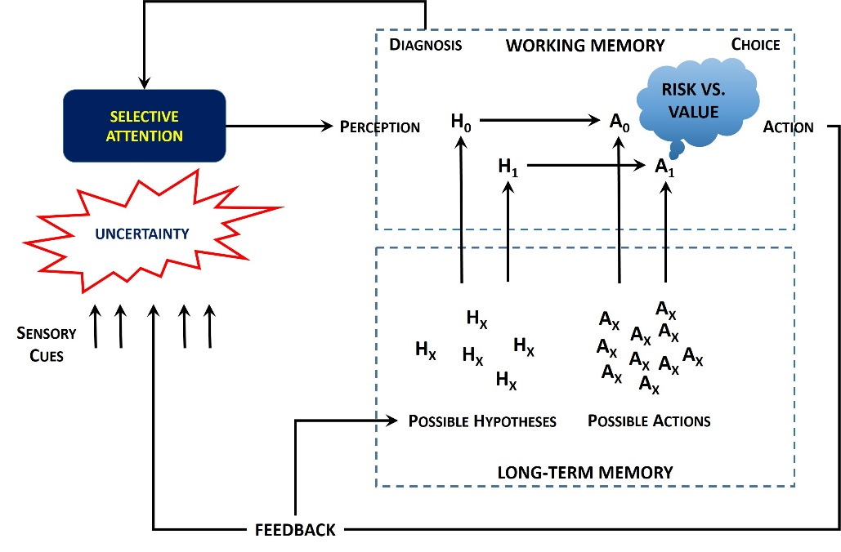

Figure 14 Information Processing Model of Human Decision Making (Adapted from [1] and [5])

To aid the human operator in making a decision, the VSM provides a filtered number of options to focus the operator’s attention on the most viable actions to achieve the goal state based on its analysis of the fault, failure, or off-nominal condition, or the human operator’s intentions signified by the goal state. These possible options are presented in a recommended prioritization scheme based on consequence analysis when more than one alternative action is available. Thus, the VSM prevents a trial and error problem solving approach or negative heuristic decision making based on faulty mental models. Moreover, the VSM aids the human operator in situational awareness by providing consequence guidance on each possible action, allowing the operator to choose the most appropriate and safe action to achieve the goal state.
2. Adaptive Guidance
The criticality of any task or activity can change dramatically, depending upon the current situation. Task loading, performance, errors, and deviations from intent may be used as indicators to determine when human operators may require assistance from automated decision aiding and consequence guidance. Setting threshold levels for these parameters allows the VSM to provide adaptive assistance to human operators to reduce error and improve mission safety, efficacy, and efficiency. For example, if the number of errors made by a human operator in a specified time increases past a setpoint, the level of automation may be automatically increased by VSM unless overridden by the human operator.
- Verification and Validation of Human-Computer Interactions (HCI)
1. Requirements for Verification and Validation
Human-Computer Interaction (HCI) involves the methodologies by which a human operator and the computer automation communicate information and by which control is commanded, including areas such as information presentation, displays, displayed information, formats and data elements, command modes and languages, input devices and techniques, dialogues, interaction and transaction modes, timing and pacing of operations, salient feedback, error diagnosis, prevention and tolerance, prompting, querying, queuing, task performance aiding, decision aiding, and consequence guidance. Human-computer interaction is discussed in terms of usability, often referred to as the user experience (UX) through the user interface (UI).
Usability is a core issue in HCI. ISO/IEC 25010 defines usability as “the extent to which a product can be used by specified users to achieve specified goals with effectiveness, efficiency, and satisfaction in a specified context of use [6]:
a. Effectiveness requires that the human operator achieve the goal state with accuracy;
b. Efficiency requires that the goal state be achieved with minimal resources in terms of time, physical effort, and cognitive load; and
c. Satisfaction requires that the human operator feel comfortable and have trust in the automated system, meaning that the system obeys mental models of the human operators and promotes affective properties such as automation trust.
If a spacecraft automated control system does not have the properties of effectiveness, efficiency, and satisfaction, it will be complicated to use, error prone, may lead to human error mishaps, and human operators will have to invent improvised workarounds or worse, will develop a negative automation bias and disable it.
ISO/IEC 25010 provides a quality in use model applicable to complete human-computer systems and supports specification and evaluation of software and software-intensive systems like VSM (see Figure 15). The quality in use model is tailored for the Gateway VSM as a spacecraft control system. The quality model defines four characteristics related to outcomes of human interaction with the system: effectiveness, efficiency, satisfaction, and safety. The quality in use of a system characterizes the impact that the product (system or software product) has on the human operator. It is determined by the quality of the software, hardware, and operating environment, and the characteristics of the use of a system like the Gateway VSM.

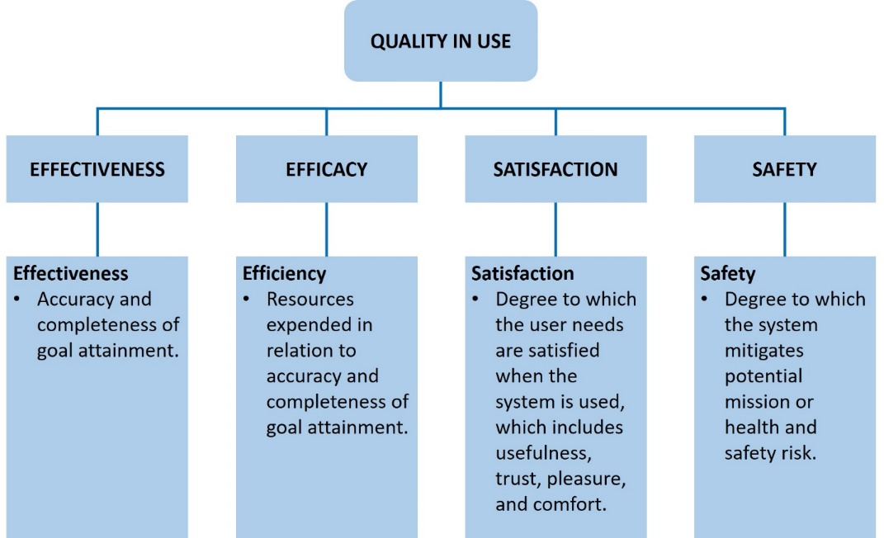
Figure 15 HCI Quality In Use Model

In operating a complex automated system such as VSM, there may be considerable gulfs of execution (how do I do it?) and gulfs of evaluation (what happened when I did it?) which promote human error. Bridging the gulfs of execution and evaluation depend on the mental model of the human operator, which is a set of expectancies regarding what human input actions are required to accomplish certain steps to reach a goal state and what computer actions will result given these inputs. Mental models are important mechanisms for acquiring situational awareness when a human operator is required to suddenly intervene in an automated process. The mental model tells a human operator how to combine disparate pieces of information about the system’s operational and health states, how to interpret the significance of that information, and how to develop reasonable projections of what will happen in the future. While some of this depends on the design of the computer-human interface (CHI), much of it depends on the actions of VSM to inputs from the human operator. As a consequence, a good mental model will help prevent errors and improve performance, particularly in situations the human operator has not encountered before.
Moreover, human operator interaction with automation should not result in an increase in cognitive load. Cognitive load refers to the amount of working memory resources used when performing a task. Working memory is important for reasoning and the guidance of decision-making and behavior. In humans, there is limited amount of working memory, and the higher the cognitive load in a task, the more likely the human operator is to use a heuristic shortcut (best guess based on previous experience or mental model) to make a decision, and the higher the probability that a human error will occur. Time pressures, feedback delays, reliability of incoming information, and queries from automation for information combine to increase attention and cognitive resource demands on the human operator that negatively affects performance. Knowledge-based behavior (as opposed to skill- or rule-based) has been shown to have the greatest potential for human error in systems operation. As knowledge-based behavior increases, human cognitive load increases and may exceed the mental capacity of the human operator, especially under duress or emergency conditions. Consequently, knowledge-based problem solving can result in channelized attention and loss of situational awareness, resulting in human error hazards from improper operation.
2. Human Factors for Verification and Validation of Spacecraft Human-Computer Interactions
There are myriad of human factors tools that have been developed to test human-computer interactions. The proposed tools which may be used for verification and validation of the Gateway VSM include:
a. Heuristic evaluation;
b. Hierarchical Task Analysis (HTA);
c. Systemic Human Error Reduction and Prediction Approach (SHERPA);
d. NASA Task Load Index (NASA-TLX); and
e. Situational Awareness Global Survey Index (SAGAT).
These tools proved the capability of measuring the potential for human error and cognitive overload.

2. Spacecraft Computer Usability Survey Index (SCUSI)
One additional technique under development is the Spacecraft Computer Usability Survey Index (SCUSI). The SCUSI is a new methodology designed by the VSM autonomous design team and Exponent, Inc. cognitive neuroscience. SCUSI is adapted from the Software Usability Measurement Inventory (SUMI) psychometric, non-parametric methodology for measuring software usability but adapted to spaceflight operations. SCUSI divides the human-computer interaction (HCI) into 14 domains which are based on the VSM HCI requirements. A questionnaire with 70 attitude statements (5 for each domain) is administered to human operators (crew and ground) which rate each of the domains using a five-point Likert scale. The responses are statistically analyzed for in-group differences using the Kruskal-Wallis H Test, and between group differences using the Mann-Whitney U Test. There is a free response section that is qualitatively analyzed. There should be no statistical difference for any domain in-group and between groups. If there is a statistical difference, that domain is reevaluated for verification and validation.
- Conclusion
With the exception of the Apollo missions in the late 1960’s to the early 1970’s, human spaceflight has been limited to low earth orbit. Extensive experience in human habitation in space has been gained by decades of operations of the ISS. The Gateway Lunar Orbiting Platform will provide the next step in human spaceflight by providing a space in cislunar space that will serve as a staging area for both the lunar and martian missions. Gateway offers a true deep space environment to gain experience for human deep space missions and is the first crewed spacecraft and first workplace permanently stationed at the Moon. Because the Gateway is uncrewed for most of the time, an Autonomous System Management Architecture (ASMA) is developed to control the spacecraft. The principle vehicle control component of the ASMA is the Vehicle Systems Manager (VSM). The VSM has many complex human-computer interactions which are designed to provide autonomous control while also providing the ability to bring the human operators rapidly into the control loop with situational awareness to allow intervention in the event of an automation or equipment failure. The VSM provides task-dependent levels of automation which are adaptive depending on the requirements for human supervisory control. To ensure that human operators remain in control of the spacecraft, the VSM provides the capability for direct human commanding. To reduce the probability of human error, the VSM provides robust decision-aiding, consequence analysis, and adaptive guidance to the human operators. Lastly, a battery of human factors evaluation tools are selected to verify and validate the efficiency, efficacy, and safety of VSM-human operator interactions. A new psychometric, non-parametric methodology for measuring software usability for spaceflight operations is under development.

Acknowledgments
The authors would like to acknowledge the team responsible for the design and implementation of the Gateway Vehicle Systems Manager (VSM): Gordon Aaseng, Felix Balderas, James Caravajal, Chase Coelho, Jim Dabny, Mike Goza, Ian Graves, Brian Hicks, Kimble Houck, Teems Lovett, Paul Lotz, Aaron Ma, Steve Merschat, Anand Patel, Vineeth Phillip, Pavan Rajagopal, Alexa Ramby, David Swartout, Neil Townsend, and Mickey Whitzer. It takes a village.

References
[1] Wickens, C.D., Lee, J.D., Liu, Y, and Gordon Becker, S.E., An Introduction to Human Factors Engineering, 2nd ed., Pearson Education, Inc., Upper Saddle Row, NJ, 2004, Chapters 7, 15 and 16.
[2] Billings, C.E., Aviation Automation: The Search for a Human Centered Approach, Lawrence Erlbaum Associates, Mahway, NJ, 1997, Chapter 10.
[3] Meister, D., Human Factors: Theory and Practice, Wiley-Interscience, New York, 1971.
[4] Sgobba, T., Kanki, B, Clervoy J.F., and Sandal, G.M., Space Safety and Human Performance, Butterworth-Heinemann, Cambridge, MA, 2018, Chapter 10.
[5] Wickins, C.D. and Holland, J.G., Engineering Psychology and Human Performance, 3rd ed., Prentice-Hall, Upper Saddle Row, NJ, 2000, Chapter 8.
[6] ISO/IEC 25010:2011 Systems and Software Engineering – Systems and software Quality Requirements and Evaluation (SQuaRE) – System and software quality models.

Gateway Autonomy/VSM System Manager, Robotics and Intelligence for Human Spacecraft.
Gateway VSM Human Systems Integrator, Robotics and Intelligence for Human Spacecraft.
Gateway Deputy VSM Manager, Robotics and Intelligence for Human Spacecraft.

