SLS Evolution: Comparing Configurations
Using System Exergy
Terry Haws, Joshua Zimmerman, and Michael Fuller
Northrop Grumman Space Systems, Brigham City, Utah 84302

Dr. Michael Watson
NASA Marshall Space Flight Center, Huntsville, AL 35812

A human mission to the moon and Mars is the stated space exploration goal of the United States and the international community. To achieve these goals, NASA is developing the Space Launch System (SLS) and the Orion crew capsule as key elements in the architecture for missions to the moon and Mars. SLS will continue to evolve, adding capability that will further aid the missions to the moon and Mars. This paper examines the various configurations of SLS using energy analysis.

Introduction
Human exploration beyond low earth orbit (LEO) has been a long-term goal of the United States and the international community since the end of the Apollo program. The current administration of the United States has further emphasized the importance of beyond earth orbit (BEO) missions, with Space Policy Directive #1 directing NASA to return to the moon followed by crewed missions to Mars [1]. To achieve this goal, NASA has been developing the Orion crew capsule and Space Launch System (SLS) as key elements in the architecture designed to advance human spaceflight from our current capability in LEO to eventually landing humans on Mars [2]. This ambitious exploration campaign is being undertaken using an incremental approach.
The initial steps have already begun, with research being carried out in LEO at the International Space Station. The next steps push into cislunar space in 2021 with the launch of the first SLS and Orion spacecraft. SLS and Orion will enable the delivery of crewed missions to the Lunar Orbital Platform – Gateway. The Gateway will enable research into technologies and procedures for living farther away from Earth. The initial pieces of the Gateway – the power and propulsion element (PPE) and the habitation and logistics outpost (HALO) – are currently being built [3].
With the Gateway in place to act as a staging ground, the next step is to the lunar surface. Lunar surface missions staging from the Gateway would enable exploration of multiple locations, as well as refueling and sample processing facilities [4]. These missions would provide practice in living and thriving on the surface of another celestial body, lessons that would eventually be useful to Mars surface missions.
Building on the earlier steps, we would finally have the experience to begin initial human forays into the Martian system. The initial mission will be a human orbital mission with attendant systems to allow for direct human exploration of the Martian moon Phobos, as well as the telerobotic exploration of the Martian surface, utilizing either prepositioned robotic assets or assets that are brought along with the crew. Future missions to the Martian system will involve the buildup of a permanent infrastructure on the Martian surface to enable long-term human exploration of the planet.
This approach is supported by the heavy-lift capability of SLS, necessary to deliver the large components required to live in space, land on the moon, and eventually travel away from Earth’s vicinity.
A comprehensive assessment of planned SLS evolution and why those elements are needed has been developed. As the topic is too extensive for a single review, two papers have been coordinated: one describing the SLS evolution and performance, and this one using energy analysis to verify both the need and the viability.

SLS Evolution
SLS is the keystone heavy lift vehicle for the lunar and Mars campaign. SLS consists of a liquid oxygen/ liquid hydrogen powered core with two solid rocket boosters, designed and built by Northrop Grumman Space Systems. The SLS boosters are based on the reusable/redesigned solid rocket motor (RSRM) design built for the Space Shuttle, using many of the same technologies, including the heritage steel cases. The core is powered by the Aerojet Rocketdyne built RS-25, initially using remaining Space Shuttle main engines followed by non-reusable versions of that engine. The initial Block 1 configuration includes the Interim Cryogenic Propulsion Stage (ICPS), a liquid oxygen/liquid hydrogen stage powered by a single RL-10 engine based on the Delta IV cryogenic second stage. The vehicle is topped by a 5.4-meter fairing in the cargo configuration.
The first mission of Block 1, labeled Artemis I, is currently scheduled to launch in late 2021 for an uncrewed test flight around the moon and back [5]. A crewed mission will follow in 2023 [6].
After the initial launch of SLS, SLS will continue to evolve, shown in Figure 1. The steps in the evolution are described here.

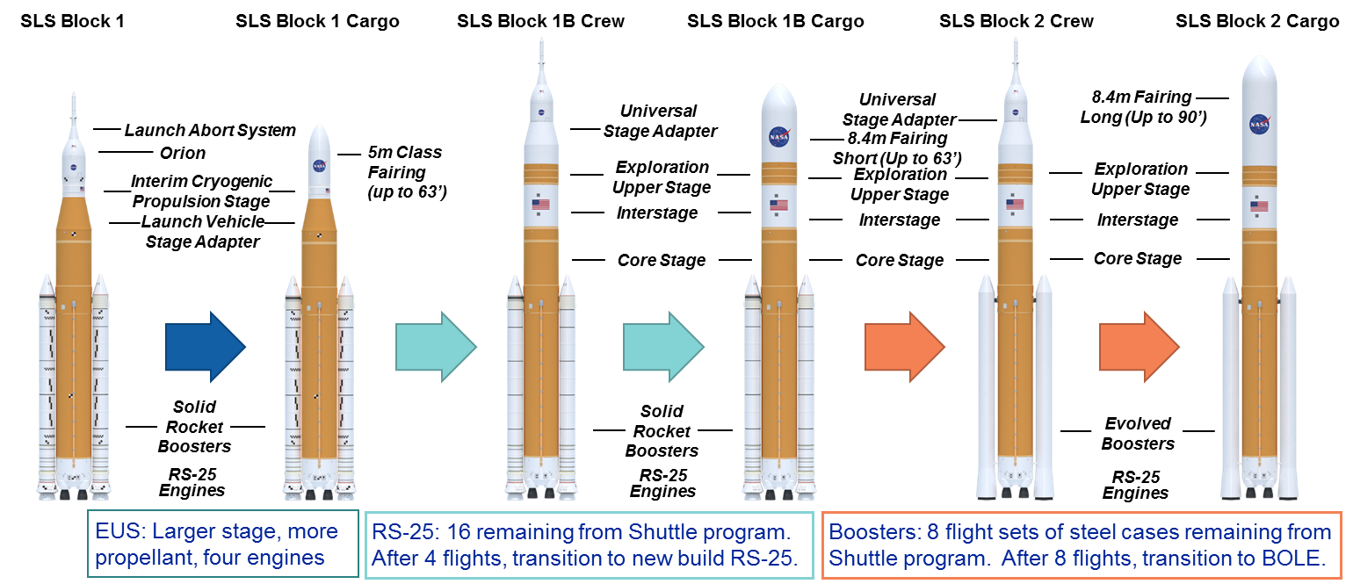
Figure 1. Evolution of SLS

The Exploration Upper Stage (EUS), designed and built by Boeing, is the next evolution in the development of the SLS. It is prepared for a multi‐mission role with accommodations for mission modification kits and variable propellant loading capability. The EUS is a 250,000 lb. stage to be powered by four RL10‐C engines built by Aerojet Rocketdyne. With increased propellant and engine power, the EUS increases the capability of SLS compared to the Block 1 vehicle and is more optimized for the performance of the core and booster stages. The increased capability allows the EUS to contribute to both getting to orbit and departing from orbit.
This more powerful configuration of SLS is known as Block 1B. The addition of the EUS gives SLS added payload capability, especially for BEO missions. In its cargo configuration, the Block 1B adds a much larger 8.4-meter fairing, greatly increasing the volume available to deliver payload. The more capable SLS Block 1B vehicle with the EUS will first fly in 2024 [6].
As stated earlier, the core is powered by four Aerojet Rocketdyne produced RS-25 engines – the same engines that powered the Space Shuttle. There are sixteen engines available from the Shuttle program [7]. After four SLS missions have used up the sixteen available engines, the engine manufacturer will restart production on an improved RS-25. This future engine will feature a simplified designed, new manufacturing technologies to reduce time and cost, and higher thrust [8].
The current SLS boosters are built by Northrop Grumman and are improvements to the RSRM designed and built for the Space Shuttle. The selected SLS architecture removed systems necessary for booster recovery and reuse that were employed during NASA’s Space Shuttle program. At the time, this meant that eight flight sets of hardware (steel cases, structures, etc.) were available for use before parts and processes would need to be redesigned, requalified, and rebuilt.
Northrop Grumman is currently studying Booster Obsolescence and Life Extension (BOLE) of the SLS Boosters [9]. The study is looking to replace obsolete materials, and include technologies to improve the manufacture and performance of the boosters, with upgrades to the propellant and liner system. This program is NASA’s plan to continue use of the current SLS system through redesigned hardware that can be produced to support missions for the foreseeable future.
The BOLE boosters are built on the back of heritage SLS technologies combined with insertion of discreet enhancements for operations efficiency and performance. Many of these technologies have been successfully employed in fielded systems such as Titan Solid Rocket Motor Upgrade, CASTOR®, and Graphite-Epoxy Motor (GEM) programs, and will be used on Northrop Grumman’s OmegATM vehicle [9].
With the addition of the BOLE boosters, SLS becomes the Block 2 configuration, capable of even more performance.

Comparing Vehicle Capability
That the evolving configurations of SLS are improving payload capability can be seen from trajectory model results. Analyzing the configurations using system exergy analysis provides for further insights.
System exergy is the thermodynamic property that combines the laws of conservation of energy, conservation of mass, and entropy [10]. Exergy analysis relies on basic principles, demonstrated by the fact that both the rocket equation and orbital energy equations can be derived from the exergy balance equation [10].
At its heart, the exergy balance equation is a statement of the maximum useful work that can be extracted from a system. For a launch vehicle, it looks at the propulsion energy available and removes the useful work performed, leaving the energy that was destroyed in the form of losses (atmospheric, gravity, heating, pointing, etc.). Therefore, something with low exergy does a poor job of converting energy into work. Comparing exergy input to exergy output provides a measure of efficiency, which can then be used to compare different launch vehicles.
This is especially useful in comparing launch vehicles that are significantly different from each other. SLS Block 1, for example, has no upper stage, as the ICPS acts only as an in-space stage. This is quite different than SLS Block 1B, where the EUS acts both as the upper stage to get to orbit and as the in-space stage for departure from LEO.
Using exergy analysis, this paper compares and contrasts SLS Block 1, Block 1B, and Block 2 configurations. This analysis will provide insights into the strengths and weaknesses of the various configurations.

Representing the Results
Looking at exergy efficiency results requires some explanation. System exergy includes both energy uses and energy losses. As such, exergy is path dependent and the trajectory is an important input for launch vehicle system analysis. Trajectory results are typically displayed as a function of time. Plotting trajectory against time helps coordinate and analyze important sequences of events. When considering exergy efficiency, it is more instructive to plot launch vehicle ascent against velocity. Vehicle kinetic energy is a major component of the exergy relationship, allowing the plot of the function against a velocity as a key parameter. Note, that in orbital trajectories, where the velocity essentially loops (speeds up and slows down in elliptical orbits) plotting against time provides a more consistent basis to see effects sometimes hidden in the velocity loops.
Figure 2 shows a representative exergy vs. ideal velocity plot for the SLS Block 1B configuration, from launch through trans-lunar injection (TLI). Before launch, no energy has been lost, so efficiency is essentially 1. After lift-off, the engines are burning propellant, turning the stored propellant energy into kinetic and potential energy. Losses also start to build up as the vehicle pushes against gravity and through the atmosphere, reaching a local minimum at maximum dynamic pressure.
At booster jettison, Figure 2 shows a sudden drop in efficiency. This is the result of the energy put into the booster mass, which is then jettisoned. This loss of vehicle energy in the expended boosters is a loss in exergy of the system [10]. The loss at core jettison is even larger, as the mass of the core is carried even higher (in both altitude and velocity), accounting for even more loss to the system exergy.
The final efficiency occurs at the end of the plotted line, after TLI burn, representing the payload on its way toward the moon. Overall, a significant portion of the exergy of the system is lost in trying to deliver payload to the moon – one of the problems of launching from a planet surface with significant gravity and an atmosphere. The final efficiency can be compared between different vehicle configurations, showing which vehicle makes the best use of its system exergy.

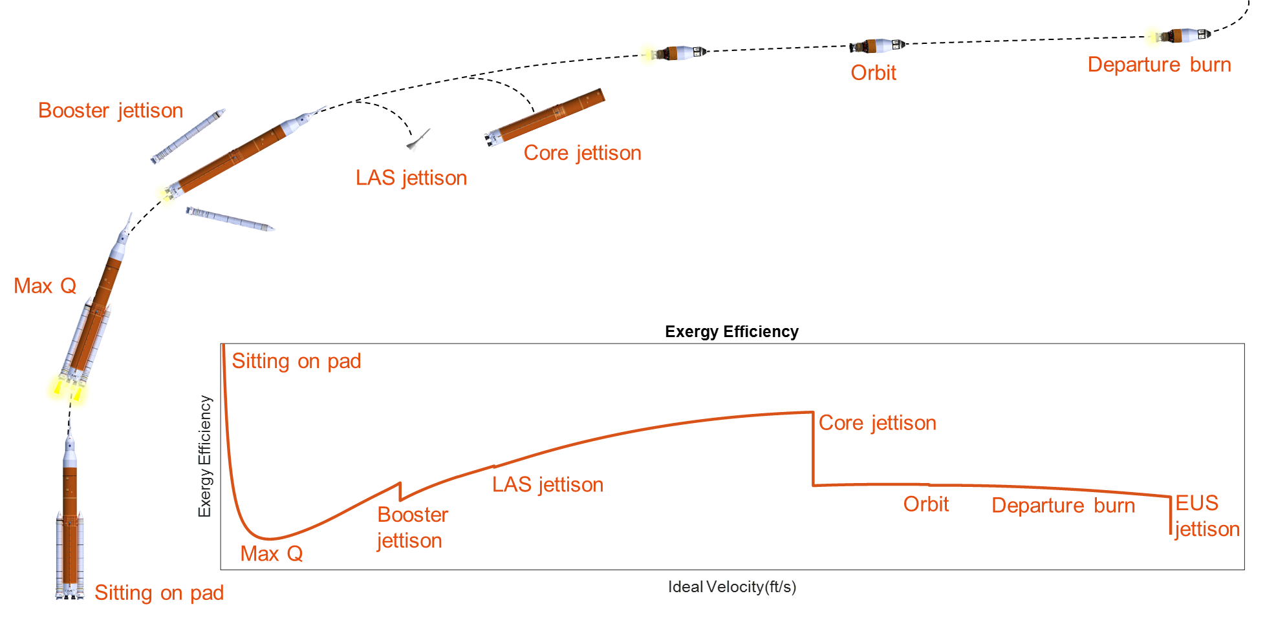
Figure 2. Representative Exergy Results for SLS Block 1B Configuration through TLI

Results
Figure 3 compare SLS Block 1 to Block 1B crew configurations from launch through TLI. As described above, Block 1 carries the ICPS as the in-space stage. This means that the core inserts the ICPS and Orion into orbit. This can be seen in Figure 3, as the loss due to core jettison happens at a higher ideal velocity and results in a much larger loss.

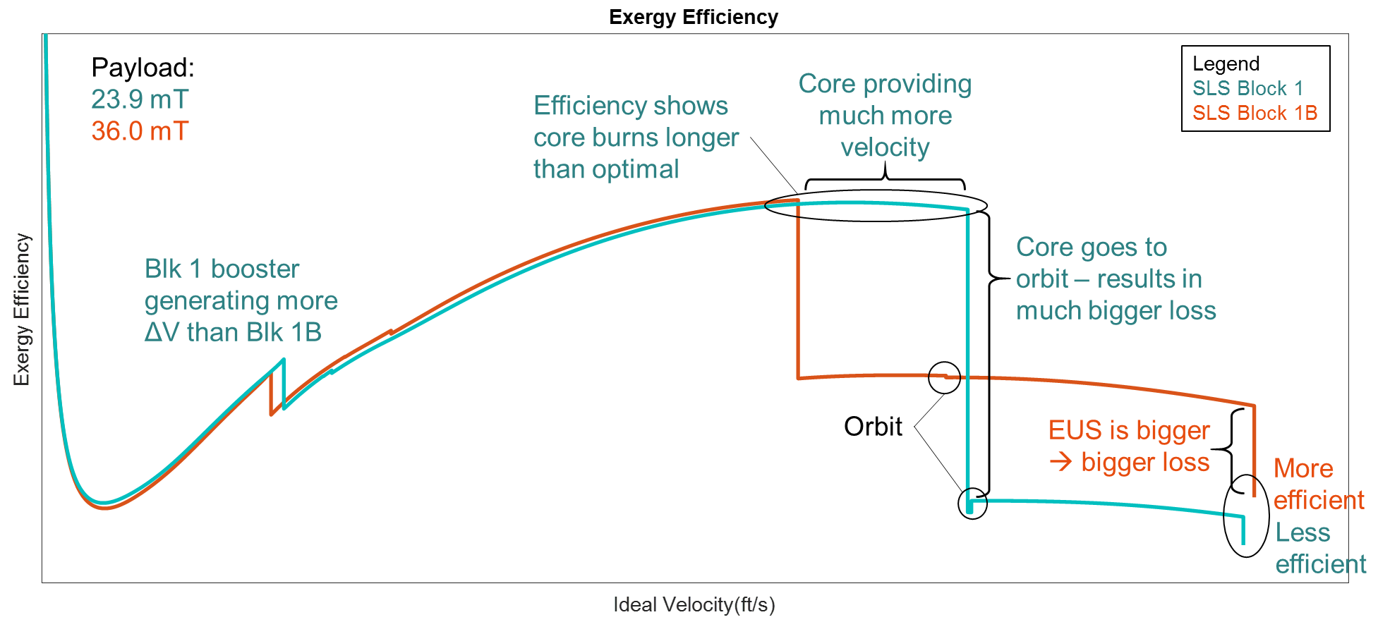
Figure 3. Comparing SLS Block 1 and Block 1B Crew Configuration System Exergies

Other items of note in Figure 3: the same boosters are generating more velocity and are a bit more efficient on Block 1 than on Block 1B. This is due to the core vehicle being lighter on Block 1. The core stage is carried almost to orbit for the Block 1 vehicle, while the Block 1B vehicle separates the core stage much earlier. This earlier separation of the core stage is a significant improvement in the efficiency of the system. The jettison of the EUS causes more loss than the jettison of the ICPS, as the EUS is larger.
Looking at the final efficiencies, Block 1B is significantly more efficient than Block 1. Block 1 is hampered by its design, basically a one-and-a-half stage to orbit system with the ICPS being under powered. The two-and-a-half stage Block 1B is a more efficient means of getting to orbit and then to TLI with the EUS being more properly sized for the mission.
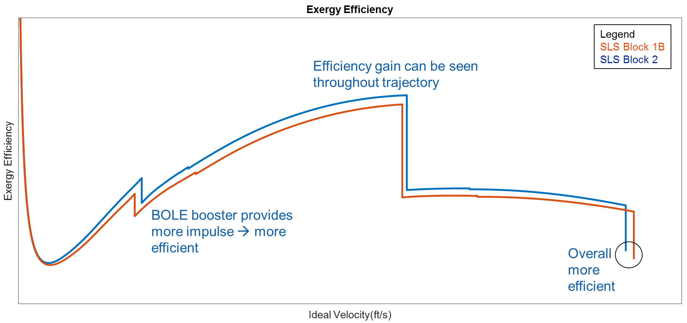
Figure 4. Comparing SLS Block 1B and Block 2 Crew Configuration System Exergies
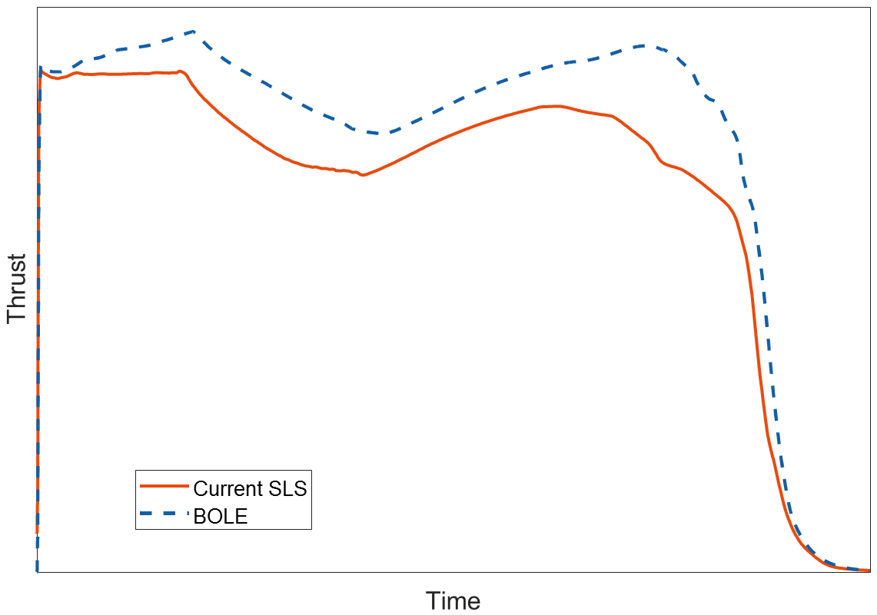
Figure 4 compares the SLS Block 1B and Block 2 crew configurations, from launch through TLI. The difference between Block 1B and Block 2 is the evolution of the boosters from the original shuttle-derived steel case boosters to the BOLE developed boosters. Figure 5 shows the differences in thrust vs. time for the baseline and BOLE boosters. As Figure 5 shows, the BOLE booster generates more impulse, which is important in the early phases of a launch for getting the vehicle moving and up through the atmosphere. Figure 4 shows the importance of the increased impulse. By the time the boosters are jettisoned, Block 2 is going faster and has higher efficiency than Block 1B. That increased efficiency then remains basically constant through the rest of the trajectory, resulting in a more efficiency vehicle at the end of burn.
Figure 5. Comparing Thrust vs. Time for SLS and BOLE [9]
Figure 6 compares Block 1B missions to different destinations: a lunar mission, a mission directly to Jupiter (C₃ = +83 km²/s²), and a mission directly to Saturn (C₃ = +105 km²/s²).
Figure 6 shows that efficiency through booster jettison is very similar. By core burnout, the outer planet missions have higher efficiencies due to their smaller payloads. But since the core is a greater percentage of the vehicle mass at core burnout, the exergy loss due to core jettison is greater for the outer planet missions.
Departing directly for Jupiter or Saturn means the EUS imparts much more velocity, giving the payload the departure velocity it needs. The increased departure velocity can be seen in Figure 6. Since it is the same vehicle, the plot shapes are similar. But from an exergy standpoint, the outer planet missions are less efficient than just going to the moon.
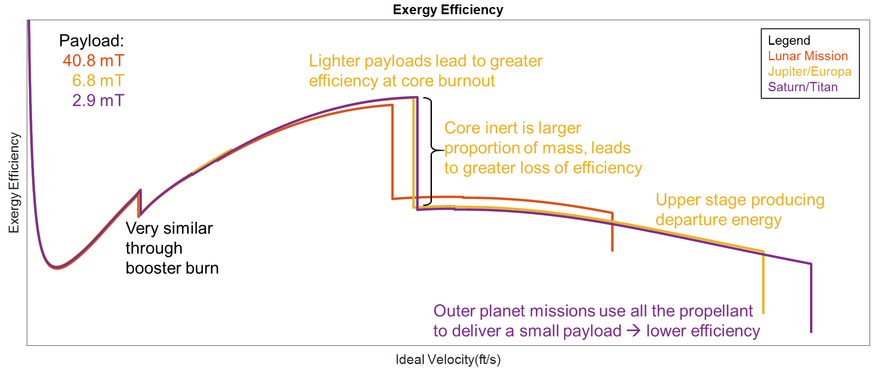
Figure 6. Comparing SLS Block 1B Missions

Figure 7 compares Block 1, Block 1B, and Block 2 cargo configurations, departing directly for a Europa mission (C₃ = +83 km²/s²). The payloads for this mission are also shown in Figure 7. The trends are similar to what was seen in Figure 3 and Figure 4. With its limited ICPS, Block 1 is much less efficient, capable of carrying only a 1.1 mT payload. Block 2 is most efficient, thanks to its improved boosters. This is seen both in the efficiency plot and in the increase in payload over Block 1B.
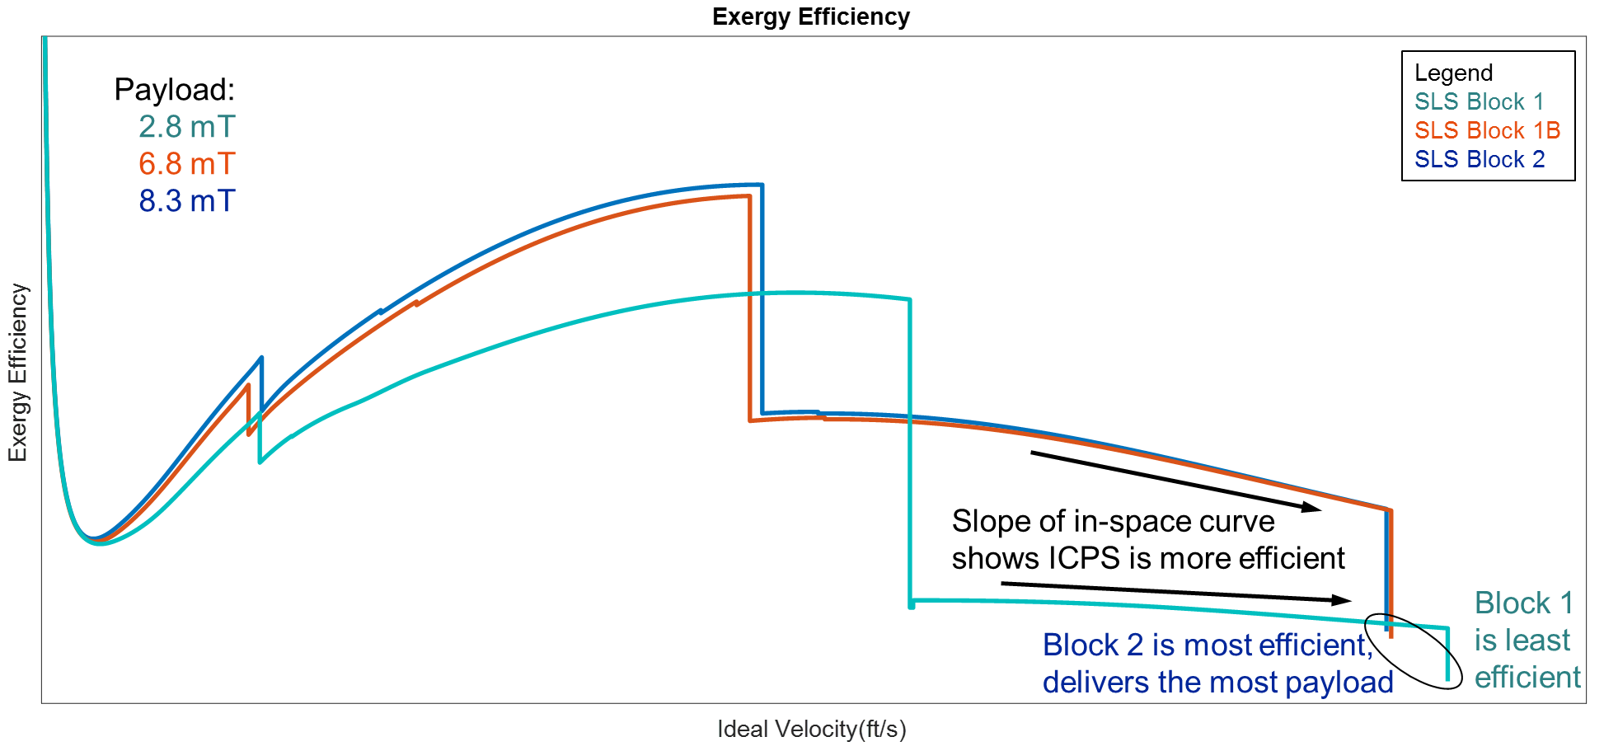
Figure 7. Comparing SLS Configurations to Europa

A previous study looked at improving the capability of SLS Block 1 for outer planet missions by adding a solid kick stage on top of the ICPS [11]. That study showed that adding a STAR 48B – the kick stage that helped deliver the Parker Solar Probe [12] and the New Horizons spacecraft [13] – increased the payload delivered by Block 1 to Europa from 1.1 to 2.7 mT. Figure 8 compares the efficiencies of Block 1 and Block 1 with STAR 48B to Europa (C₃ = +85 km²/s²).
Figure 8 shows the interplay between the major configuration choices represented by the two configurations. On one hand, the Isp of ICPS (465 sec) [14] is significantly higher than the STAR 48B (292.1 sec) [15]. On the other hand, separating a spent stage is more efficient as the stage mass does not have to be accelerated to the full departure velocity of the payload and more of the kick motor energy is imparted to the final separated payload to Jupiter. Figure 8 shows that using the kick stage is more efficient, and it also delivers additional payload. Adding a kick stage is thus shown to be an efficient method of delivering payloads for these missions.

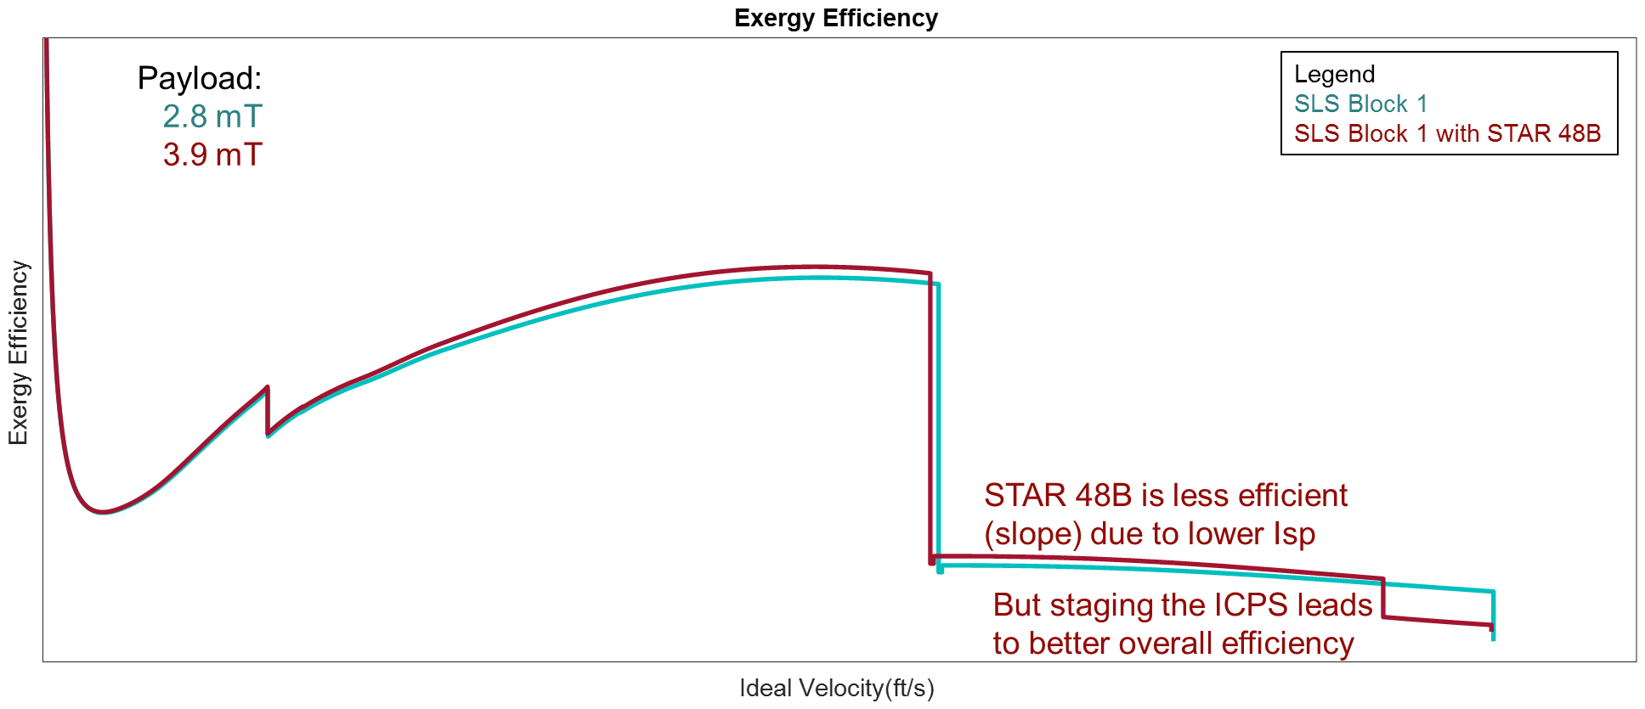
Figure 8. Comparing SLS Block 1 Configurations to Europa

Conclusions
System exergy analysis was used to look at SLS configurations and missions. Several conclusions can be gleaned from the results.
- Having an upper stage (Block 1B) is more efficient than not having an upper stage (Block 1).
- Adding booster impulse and reducing case mass (Block 2) increases system efficiency.
- Staging, while causing a big drop in efficiency, helps overall system efficiency. Staging sooner is better.
- Adding a kick stage is more efficient than using only the upper stage to do the departure burn, providing more payload mass at slightly higher efficiency, even with the mass penalty of the kick stage, seen at the separation drop from the ICPS.
- Exergy efficiency allows for an assessment of staging, bringing together the effects of the staged elements’ mass and Isp. This provides an integrated assessment of these factors, providing a clear indication of the advantages and the specific source of these advantages.
- Exergy analysis also indicates where the optimum cut off of a stage is, pointing to future improvements in vehicle configurations. Figure 6 and Figure 7 show that efficiency rolls off the longer the EUS stage burns. The peak in the EUS portion of the exergy efficiency curve is near low earth orbital insertion. The stage loses efficiency as it burns after that, due to the gravitational effects relating to the size of the stage and thrust of the engines.
- Higher thrust engines are indicated for the EUS, shown by the slope in these plots.
- Similarly, the ICPS is more efficient as an in-space, having a much flatter exergy efficiency curve. The engine is better tuned to the mass of the stage and payload in this case.
- Efficiency and payload capability appear to be correlated.

Admittedly, many of these conclusions would be considered obvious. System exergy provides an integrated thermodynamic approach to assess the launch vehicle as a fully integrated system, integrating the various performance parameters in a single relationship. This allows the specific efficiency of the system to be calculated. With calculated efficiency accounting for all system factors, different launch vehicles can now be compared with an objective assessment of their performance. By thus establishing the integrating physics relationship for the launch vehicle, system exergy opens the door to clear evaluations of launch vehicle options and provides a much more concise guidance of their design and analysis.

References
- NASA, “New Space Policy Directive Calls for Human Expansion across Solar System”, 11 December 2017, [Online] Available: https://www.nasa.gov/press-release/new-space-policy-directive-calls-for-human-expansion-across-solar-system.
- NASA, “The Great Escape: SLS Provides Power for Missions to the Moon”, 15 November 2019, [Online] Available: https://www.nasa.gov/exploration/systems/sls/to-the-moon.html .
- Avaition Week, “NASA Seeks Commercial Lunar Cargo Partners”, 28 August 2019, [Online] Available: https://aviationweek.com/space-exploration/nasa-seeks-commercial-lunar-cargo-partners.
- NASA, “Moon to Mar Overview”, 5 April 2019, [Online] Available: https://www.nasa.gov/topics/moon-to-mars/overview.
- Urrutia, D. “NASA Still Aiming for 2024 Moon Landing despite SLS Megarocket Delays,” Space.com, 5 March 2020 [Online] Available: https://www.space.com/nasa-2024-moon-landing-sls-megarocket-delays.html.
- Clark, S., “NASA will likely add a rendezvous test to the first piloted Orion space mission,” Spaceflight Now, 20 May 2020. [Online] Available: https://spaceflightnow.com/2020/05/18/nasa-will-likely-add-a-rendezvous-test-to-the-first-piloted-orion-space-mission/
- Aerojet Rocketdyne, “RS-25 Engine”, [Online] Available: https://www.rocket.com/space/liquid-engines/rs-25-engine
- NASA facts, “Space Launch System RS-25 Core Stage Engines”, 24 November 2015, [Online] Available: https://www.nasa.gov/sites/default/files/atoms/files/sls_rs25_engine_fs_508.pdf
- Tobias, M. E., Griffin, D. R., McMillin, J. E., Haws, T. D., and Fuller, M. E. “Booster Obsolescence and Life Extension (BOLE) for Space Launch System (SLS),” IEEE Aerospace Conference 2020, Big Sky, MT, 2020.
- Watson, M. D., “System Exergy: System Integrating Physics of Launch Vehicles and Spacecraft,” Journal of Spacecraft and Rockets, Vol. 55, No. 2, p. 451-461.
- Haws, T. D. and Fuller, M. E. “SLS Block 1B and Block 2 with Kick Stages for Outer Planet Missions and Beyond,” IEEE Aerospace Conference 2020, Big Sky, MT, 2020.
- NASA, “Parker Solar Probe,” 27 February 2020, [Online] Available: https://nssdc.gsfc.nasa.gov/nmc/spacecraft/display.action?id=2018-065A
- NASA, “New Horizons Pluto Kuiper Belt Flyby,” 27 February 2020, [Online] Available: https://nssdc.gsfc.nasa.gov/nmc/spacecraft/display.action?id=2006-001A
- Aerojet Rocketdyne, “RL10 Engine”, [Online] Available: https://www.rocket.com/space/liquid-engines/rl10-engine
- Northrop Grumman, “Propulsion Products Catalog,” July 2020, p. 103. [Online] URL: https://www.northropgrumman.com/wp-content/uploads/NG-Propulsion-Products-Catalog.pdf

Staff Propulsion Engineer, Launch and Missile Defense Systems, terry.haws@ngc.com, AIAA Senior Member
Principal Propulsion Engineer, Launch and Missile Defense Systems, joshua.zimmerman@ngc.com
Senior Manager, Business Development, Launch and Missile Defense Systems, mike.fuller@ngc.com, AIAA Senior Member
Systems Engineer, Systems Engineering Office, michael.d.watson@nasa.gov, AIAA Member

