Solar Polar Imager Concept
Dan Thomas, Mike Baysinger¹, Steve Sutherlin, Quincy Bean and Keith Clements
NASA-MSFC, Advanced Concepts Office, Huntsville, AL, 35812, USA
Ken Kobayashi
NASA-MSFC, Science and Technology Office, Huntsville, AL, 35812, USA
Jay Garcia, Leo Fabisinski and Pete Capizzo
Jacobs Space Exploration Group, Huntsville, AL, 35806, USA
During late 2019 and early 2020, the Advanced Concepts Office design team at NASA’s George C. Marshall Space Flight Center (MSFC) completed a concept study for a Solar Polar Imager (SPI) mission. The goal of the study was to perform a preliminary design of the spacecraft bus containing a minimum set of science instruments and supporting subsystems. The science goal of the SPI mission is to better understand the Sun and the heliosphere by observing the Sun from a high heliographic latitude. A highly inclined orbit (of 75°) allows helioseismology observations from a high latitude, providing measurements in the high latitude regions for the first time. The orbit also allows measurements of the photospheric magnetic fields in the polar regions, as well as direct measurements of the heliospheric magnetic field and solar wind. The high latitude gives the spacecraft a unique top-down view of coronal mass ejections (CMEs) that could affect space weather around Earth and allow the velocity and directions of these CMEs to be better quantified. Solar sail technology is chosen as the propulsion option necessary to deliver the spacecraft to a heliocentric circular orbit at 0.48 AU and an inclination of 75°. The sail area is restricted to 7000 m², the maximum size that can be developed in the near term. The sail is also assumed to rotate at 1 rpm to avoid buckling of the supporting booms. The total launch mass is 349 kg, which consists of 233 kg for the SPI Bus, 52 kg for the solar sail and deployment mechanisms, and 64 kg for the Spin-up Bus/launch vehicle payload adapter. Dropping the Spin-up Bus after sail deployment, the characteristic acceleration of the sail is about 0.22 mm/s². The resulting total mission time is just over 13 years, which includes a 3-year duration at the 75° inclination.
- Nomenclature
a_{c} = sail characteristic acceleration
AMT = Active Mass Transfer
BOL = Beginning of Life
C3 = Earth-departure energy (i.e. square of the hyperbolic excess speed)
CCSDS = Consultative Committee for Space Data Systems
CG = Center of Gravity
EELV = Evolved Expendable Launch Vehicle
EOL = End of Life
FSu = factor of safety, ultimate
FSy = factor of safety, yield
GM = gravitation parameter of gravity center
GN&C = Guidance, Navigation, & Control
Ixx = mass moment inertia about the x-axis
Iyy = mass moment inertia about the y-axis
Izz = mass moment inertia about the z-axis
MGA = mass growth allowance
RCD = Reflectivity Control Device
rpm = revolutions per minute
SPI = Solar Polar Imager concept
TRL = Technology Readiness Level
r = spherical coordinate radial position
φ = spherical coordinate angular position (measured counterclockwise from X axis to spacecraft position projected onto X-Y plane)
ψ = spherical coordinate angular position (minimum angle from X-Y plane to spacecraft position)
v_{r} = velocity in r direction
v_{φ} = velocity in φ direction
v_{ψ} = velocity in ψ direction
α = sail cone angle
α_{c} = sail cone angle during cranking
β = sail clock angle
β_{c} = sail clock angle during cranking

- Concept Overview
During late 2019 and early 2020, the Advanced Concepts Office design team at NASA’s George C. Marshall Space Flight Center (MSFC) completed a concept study for a Solar Polar Imager (SPI) mission. The goal of the study was to perform a preliminary design of the spacecraft bus containing a minimum set of science instruments and supporting subsystems. Solar sail technology was chosen as the propulsion option necessary to deliver the spacecraft to a heliocentric circular orbit at 0.48 AU and an inclination of 75°. The sail area was restricted to 7000 m², the maximum size that could be developed in the near term. The 52 kg mass of the sail, support structure, and deployment mechanisms was also provided. The sail was also assumed to rotate at 1 rpm to avoid buckling of the supporting booms.
The SPI spacecraft is assumed to be the primary payload on the launch vehicle which has yet to be selected, along with the launch date. Figure 1 shows a typical SPI, solar sail trajectory for a sail characteristic acceleration of 0.3 mm/s². The characteristic acceleration is a performance metric for a sail and is the maximum thrust acceleration that can be achieved at a radial distance of 1 AU from the Sun, with the sail perpendicular to the sunlight. The trajectory begins with an Earth departure energy of zero and a zero inclination (with respect to the ecliptic plane), which was chosen to provide conservative transfer time estimates. Once the spacecraft reaches 0.48 AU, the spacecraft begins the inclination “cranking” phase, whereby the sail continuously increases the inclination while maintaining a constant distance from the Sun. Also providing a conservative time estimate, the desired orbital inclination of 75° was assumed to be with respect to the ecliptic plane instead of the solar equator. The Sun’s rotational axis is tilted 7.25° to the ecliptic. With a proper selection of launch date, the solar sail need only crank to an ecliptic inclination of 67.75°. After achieving the desired inclination, the sail is not jettisoned but continues to change the inclination within the polar region and assists with momentum unloading of the reaction wheels.

Fig. 1 Typical solar sail mission trajectory from Earth (C3 = 0) to 0.48 AU and 75 deg inclination. Sail characteristic acceleration = 0.3 mm/s2.

The science goal of the SPI mission is to better understand the Sun and the heliosphere by observing the Sun from a high heliographic latitude. The highly inclined orbit allows helioseismology observations from a high latitude, providing measurements in the high latitude regions for the first time. The orbit also allows measurements of the photospheric magnetic fields in the polar regions, as well as direct measurements of the heliospheric magnetic field and solar wind. The high latitude gives the spacecraft a unique top-down view of coronal mass ejections (CMEs) that could affect space weather around Earth and allow the velocity and directions of these CMEs to be better quantified. The science instruments chosen for this task are listed in Table 1, along with corresponding specifications. This list was based on previous work [1] and was revised to a minimum set of instruments that would benefit the most from a high heliographic latitude vantage point. The instruments consist of a Doppler and Stokes Imager, White Light Coronagraph, Magnetometer, Plasma Spectrometer, Faraday Cup, and a Radio and Plasma Wave Package. To conserve power and reduce solar array size, these instruments are dormant during the inward spiral to 0.48 AU. Scientific observations begin with the cranking phase and continue for the remainder of the mission.

Table 1 SPI Science Instrument Information
Instrument Suite | Doppler & Stokes Imager | Corona-  graph | Magnetic Field Probe | Solar Wind Composition Analyzer & Electron Spectrometer |  | Radio & Plasma Wave Package
Instrument Subsystem | Instrument | Instrument | Sensor | Plasma Spectrometer | Faraday Cup | Electric Antenna | Search Coil Magnetometer | Electronics
Field of View | ~1.5x1.5 deg | 16 deg | n/a | 60 deg  half-width | 30 deg  half-width | 2 pi | n/s
Pointing Accuracy | 0.5 deg of Sun center | ~2 arcmin of Sun center | n/a |  |  | none | none
Pointing Knowledge | < 20 arcsec | < 20 arcsec | ~ 0.1 deg | ~0.1 deg
Pointing Stability | 20 arcsec over 10 sec | < 7 arcsec over 1 sec | n/a
Power | 37 W | 15 W | Sensors  0.3 W x 2  Electronics  2 W | 3.5 W | 4.2 W | 0.3 W x 3 | 1.8 W | 13 W
Data Volume | 75 kbps | 40 kbps | 0.6 kbps | 0.2 kbps | 0.2 kbps | 5 kbps
Mass | 15 kg | Instrument  8 kg  Electronics  2 kg | Sensors  0.15 kg x 2  Electronics  1.2 kg  Boom  2 kg | 1.41 kg | Instrument  2.1 kg  Electronics  2.1 kg | 1.4 kg x 3 | 1 kg | 5 kg
Dimensions | Instrument  80x30x30 cm Electronics  30x20x20 cm |  |  |  |  | Antenna Element  6 m each  (stowable)

The major goal of the mission is for the spacecraft to get into a greater than 75° inclination orbit and observe the Sun from that orbit. However, the ability to start observations sooner is also desirable. During the preliminary design, the following three scenarios were considered:

- No science observation during spiral & cranking phases; once in 75-degree orbit, the sail is jettisoned and the science observing phase begins.
- Start science observation during spiral or cranking phase; once in 75-degree orbit, the sail is jettisoned, and science observation continues.
- Start science observation during spiral or cranking phase and continue science observation throughout the remainder of the mission. The sail is never jettisoned.

The major considerations for each scenario are:

- Scenario A reduces science returns and adds risk; no science is done until 6+ years into the mission, and any spacecraft failure or instrument failure will result in no science returns from the mission.
- Because the sail is rotating, Scenarios B and C require a de-rotated, 3-axis stabilized science instrument platform or a fully 3-axis stabilized bus.
- A solar sail equipped with Reflectivity Control Devices (RCDs) can be used to offload angular momentum from the reaction wheels. Scenarios A and B require the spacecraft to operate without the sail, and therefore need propulsion systems for angular momentum offloading.

Based on these considerations, scenario C was chosen as the baseline. Further, we assumed that due to the possible non-uniformities of the solar sail, the sail may precess by an order of 1°. As a consequence, a spacecraft connected to a rotating sail via a 1-axis de-rotation mechanism cannot meet the pointing requirements of the science instruments. Therefore, the SPI Bus design consists of 2 sections: the fine-pointing science bus and the lower bus, as shown in Fig. 2 (in the launch, stowed configuration). The fully deployed spacecraft is shown in Fig. 3 and Fig. 4. Note the 10 m “exclusion zone”, which was designed into the sail to allow the full extension of the solar arrays and to reduce thermal and electromagnetic interference between the sail and science instruments. The main spacecraft bus (i.e. SPI Bus) consists of two parts: the science bus and the lower bus. All science instruments are located in the science bus, which is attached to the lower bus via a freely rotating gimbal mechanism (locked at launch with the shown orange cones). This allows fine pointing of the remote sensing instruments using reaction wheels. The avionics components are contained in the lower bus, which is canted at 35.3°. This is desirable due to the constant sail cone angle during the cranking phase of the mission. The entire SPI Bus is mounted on a de-spin platform which negates the rotation of the sail. Below this, the solar sail and deployment mechanisms are stowed in a compact canister. Finally, the launch vehicle adapter has been designed to include the propulsion and controls necessary to achieve the desired spacecraft attitude after launch and to assist with the sail deployment and spin. This element is dropped after the sail is fully deployed. The total launch mass is 349 kg, which consists of 233 kg for the SPI Bus, 52 kg for the solar sail and deployment mechanisms, and 64 kg for the Spin-up Bus/launch vehicle payload adapter. The mass details are given in Table 2.

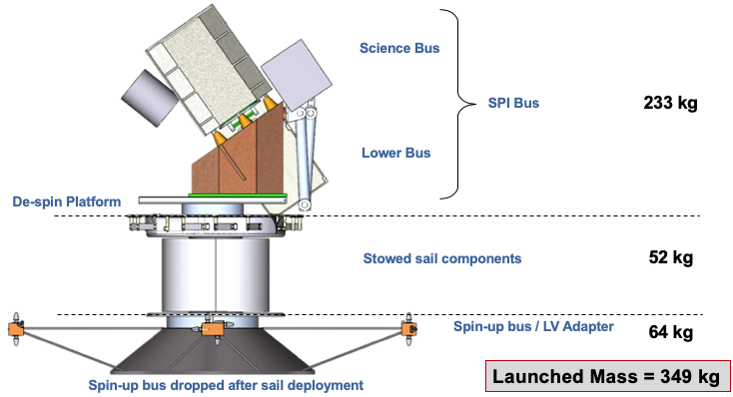
Fig. 2 Solar Polar Imager spacecraft components in stowed configuration.

Fig. 3 Fully deployed Solar Polar Imager.

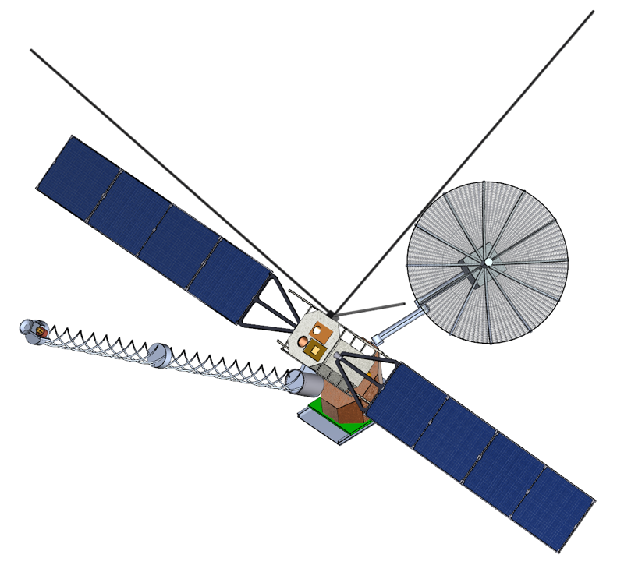
Fig. 4 Fully deployed Solar Polar Imager bus.

Table 2 SPI masses for SPI Bus (i.e. science and lower buses) and Spin-up Bus
Subsystem | SPI Bus Masses (kg) |  |  | Spin-up Bus Masses (kg)
Subsystem | Basic | Growth | Predicted | Basic | Growth | Predicted
Structures | 49.94 | 20% | 59.93 | 28.78 | 20% | 34.54
Thermal | 29.97 | 25% | 37.46 | 1.16 | 25% | 1.45
Power | 16.92 | 25% | 20.72 | 7.80 | 20% | 9.36
Avionics | 35.26 | 22% | 37.97 | 3.75 | 10% | 4.13
GN&C | 2.96 | 3% | 3.05 | 0.01 | 3% | 0.01
Science Instrument | 44.10 | 51% | 66.43 | 0.00 | 0% | 0.00
Propulsion | 0.00 | 0% | 0.00 | 9.17 | 4% | 9.51
Mechanisms | 6.74 | 3% | 6.94 | 1.63 | 3% | 1.68
Non-prop Fluids | 0.00 | 0% | 0.00 | 0.26 | 0% | 0.26
Burnout Mass | 185.88 | 25% | 232.50 | 52.57 | 16% | 60.94
Propellant |  |  | 0.00 |  |  | 3.28
Total Mass | 185.88 | 25% | 232.50 | 52.57 | 15% | 64.22

Table 3 shows the implications of mass on the mission phase times. The initial study goal for the sail characteristic acceleration was 0.3 mm/s². After several iterations towards a minimum mass design, the final results led to a sail performance of 0.22 mm/s², factoring in the mass margins for the spacecraft subsystems. The resulting total mission time is 13.1 years, which includes three years of polar observations. This time may be reduced with a judicious selection of launch date, such that advantage is taken of the 7.25° difference between the Sun’s equator and the ecliptic plane. Also, allowing the sail to perform inclination changes during the inward spiral will further reduce the cranking phase time. Finally, with the relatively low launch mass, the launch vehicle may be able to not only reduce the inward spiral by providing a high Earth departure energy but also provide a significant initial heliocentric inclination. At the 0.22 m/s² characteristic acceleration, every degree of inclination saved results in a 0.1-year reduction of cranking time.

Table 3 Transfer and total mission times for characteristic accelerations of 0.22 mm/s², 0.26 mm/s², and 0.30 mm/s².
Mission Phase | Transfer Times (years)
Mission Phase | 0.22 mm/s²  (with mass margin) | 0.26 mm/s²  (no mass margin) | 0.30 mm/s²  (initial assumption)
Inward Spiral | 2.6 | 2.2 | 1.9
Cranking | 7.5 | 6.4 | 5.5
Total Time to 75 deg | 10.1 | 8.6 | 7.4
Time On-station | 3.0 | 3.0 | 3.0
Total Mission Time | 13.1 | 11.6 | 10.4

- Mission Analysis
This section includes the mission analysis trades performed for the Solar Polar Imager concept. Due to the spacecraft masses not being know a-priori, minimum time trajectories were generated over a range of sail characteristic accelerations, a_{c}, which is a measure of sail performance and represents the thrust acceleration that the sail generates at 1 AU from the Sun with the sail plane oriented perpendicular to the solar direction. For each case, the sail departs Earth with a C3 = 0 (and zero inclination) and performs an inward spiral to the 0.48 AU solar distance. At this point, the inclination “cranking” phase of the mission begins, where the sail increases the orbital inclination at a constant radius from the Sun. Note, any non-flat and other non-ideal effects are assumed to be factored into the characteristic acceleration.
The differential equations modeling the sail trajectory are given by:
 | $$\frac{dr}{dt} =v_{r}$$  $$\frac{dϕ}{dt} = \frac{v_{ϕ}}{r⋅cos\left(ψ\right)}$$  $$\frac{dψ}{dt} = \frac{v_{ψ}}{r}$$  $$\frac{dv_{r}}{dt} = \frac{{v_{ϕ}}^{2}+ {v_{ψ}}^{2}}{r} - \frac{GM}{r^{2}} + \frac{a_{c}{r_{e}}^{2}\cos^{3}\left(α\right)}{r^{2}}$$  $$\frac{dv_{ϕ}}{dt} = -\frac{v_{r}v_{ϕ}}{r}+\frac{v_{ϕ}v_{ψ}tan\left(ψ\right)}{r} + \frac{a_{c}{r_{e}}^{2}\cos^{2}\left(α\right)sin\left(α\right)sin\left(β\right)}{r^{2}}$$  $$\frac{dv_{ψ}}{dt} = -\frac{v_{r}v_{ψ}}{r} - \frac{{v_{ϕ}}^{2}tan\left(ψ\right)}{r} + \frac{a_{c}{r_{e}}^{2}\cos^{2}\left(α\right)sin\left(α\right)cos\left(β\right)}{r^{2}}$$ | (1)
where r_{e} is 1 AU. The sail control angles are shown in Fig. 5. The direction normal to the sail (away from the Sun) is denoted by $\hat{n}$. The sail cone angle (α) is measured from the radial direction to the sail normal, and the clock angle (β) is the clockwise angle from the ψ axis to the projection of $\hat{n}$ in the φ-ψ plane. The orientation of the r-φ-ψ spherical coordinates with respect to the heliocentric cartesian coordinates is shown in Fig. 6.

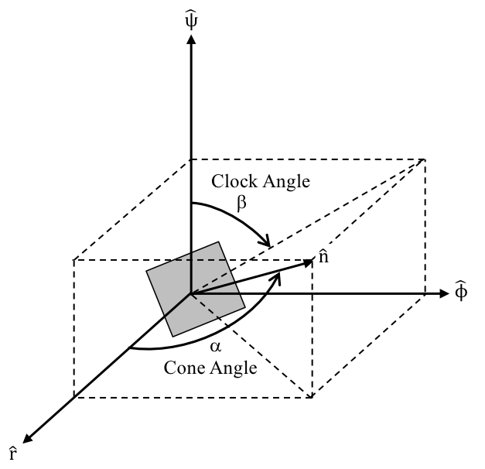
Fig. 5 Solar sail orientation in spherical coordinates, showing sail normal ($\hat{n}$), cone angle (α) and clock angle (β).

Fig. 6 Spherical coordinates (r, φ, ψ) shown in relation to the cartesian system (X, Y, Z).

Pontryagin’s Maximum Principle [2] is used to derive expressions for the cone and clock angles that result in minimum time transfers. Given the above state equations, the minimum time Hamiltonian is:
 | $$H=P_{r}\frac{dr}{dt}+P_{ϕ}\frac{dϕ}{dt}+P_{ψ}\frac{dψ}{dt}+P_{v_{r}}\frac{dv_{r}}{dt}+P_{v_{ϕ}}\frac{dv_{ϕ}}{dt}+P_{v_{ψ}}\frac{dv_{ψ}}{dt}$$ | (2)
where the P_{i} variables are the co-state variables (i.e. Lagrange multipliers) associated with each state variable and are governed by the following differential equations:
 | $$\frac{dP_{i}}{dt}=-\frac{δH}{δx_{i}}$$ | (3)
The optimal controls for the minimum time inward spiral between 1 and 0.48 AU are produced by taking the partial derivatives of the Hamiltonian with respect the cone and clock angles and setting equal to zero:
 | $$tan\left(α\right)=\frac{-3P_{v_{r}}+\sqrt{9{P_{v_{r}}}^{2}+8\left({P_{v_{ϕ}}}^{2}+{P_{v_{ψ}}}^{2}\right)}}{4\sqrt{{P_{v_{ϕ}}}^{2}+{P_{v_{ψ}}}^{2}}}$$  $$tan\left(β\right)=\frac{P_{v_{ϕ}}}{P_{v_{ψ}}}$$ | (4)
For this preliminary study, only 2D transfers between Earth and 0.48 AU are considered. Therefore, the ψ components are set to zero, and β is set to 270 deg [instead of using the β given by equation (4)]. Along with targeting a final radial distance of 0.48 AU at the end of the inward spiral, the desired final radial velocity and its derivative are zero. This results in an equation for the final v_{φ} and also represents the value that must be maintained during the cranking phase:
 | $$v_{ϕ}= \sqrt{\frac{GM-a_{c}{r_{e}}^{2}\cos^{3}\left(α_{c}\right)}{r}-{v_{ψ}}^{2}}$$ | (5)
where α_{c} is the cone angle maintained during the cranking phase. Following Ref. [3], the cranking cone angle is held constant at a value that maximizes the rate of inclination change:
 | $$α_{c}=\tan^{-1}\left(\frac{1}{\sqrt{2}}\right)$$ | (6)
The clock angle, on the other hand, is not constant during cranking. Taking the derivative of equation (5) and substituting expressions from equation (1), along with enforcing a zero radial velocity, results in the following control law for the clock angle during cranking:
 | $$β_{c}=\tan^{-1}\left(-\frac{v_{ψ}}{v_{ϕ}}\right)$$  $$if v_{ψ}<0: β_{c}=β_{c}+π$$  $$if v_{ψ}=0: β_{c}=2π$$ | (7)
Using the relations outlined above, minimum time transfers are computed for both the inward spiral and cranking phases over a range of sail characteristic accelerations (see Fig. 7). The total time to 75° for the initial study goal of 0.3 mm/s² is 7.4 years. The 0.22 and 0.26 mm/s² data points represent the final study results with and without margin, respectively. The total time assuming mass margins is 10.1 years, while the result without mass margin is 8.6 years. Please note that the total mission time includes an additional 2-to-3 years. Another important performance aspect for the solar sail is how quickly the orbital inclination can be increased at 0.48 AU. This is shown in Fig. 8. Figure 9 shows the orbital element histories for the characteristic accelerations of interest. Note that the eccentricity when the sail first reaches 0.48 AU is not zero. This is a consequence of targeting the transverse velocity given by equation (5), which is lower than the circular velocity for a Keplerian orbit. This allows a circular orbit to be maintained while the sail pushes away from the Sun. Figure 9 shows example cone and clock angle histories for the 0.3 mm/s² case. The sail cone angle follows the optimal cone angle law [equation (4)] from Earth to 0.48 AU. Afterwards, the cone angle is held constant at 35.3 deg [equation (6)], which is locally optimal for increasing the orbital inclination. Conversely, the clock angle is constant at 270 deg during the inward spiral and then follows equation (7) for the cranking phase.

Fig. 7 Solar sailing times from Earth departure (C3 = 0, inclination = 0) to a 75 deg inclination at 0.48 AU over a range of characteristic accelerations. Separate inward spiral and cranking phases are shown along with the total time to reach 75 deg.

Fig. 8 Solar sail inclination cranking rates versus characteristic acceleration at 0.48 AU.

Fig. 9 Solar sail orbit parameters from Earth departure (C3 = 0) to 0.48 AU orbit with a 75 deg inclination. Sail characteristic accelerations (ac) = 0.22, 0.26, and 0.3 mm/s².

Fig. 10 Sail cone and clock angle histories from Earth departure (C3 = 0) to 0.48 AU orbit with a 75 deg inclination (for example characteristic acceleration = 0.3 mm/s²).

AGI Systems Tool Kit was used to determine communication access times, or more specifically the outage durations, between the sail and Earth for the a_{c} = 0.3 mm/s² case. Table 4 list the access results from Earth to 0.48 AU. For this preliminary study, a “dummy” launch data of 09/23/2018 is assumed, and the only eclipsing body between the sail and Earth is the Sun (worst-case). Results are given for Sun-avoidance angles ranging from 0 – 4 degrees (4 degrees chosen for this study). Only a single outage occurs during the inward spiral and lasts up to 12.25 days for the 4 deg. Sun avoidance angle. Table 5 gives the worst-case communication outages for the cranking phase, which occur at the beginning of that phase. During cranking, the worst-case outage is 6.12 days. Afterwards, the access outages decrease as the inclination increases.

Table 4 Sail to Earth communication outages during inward spiral to 0.48 AU (for a_{c} = 0.30 mm/s²).
Sun Avoidance Angle  (deg) | Begin Access Date  (UTCG) | End Access Date  (UTCG) | Access Duration  (days) | Access Outage  (hrs)
0 | 09/23/2028 00:00 | 03/22/2030 06:55 | 545.2887 | 31.97
0 | 03/23/2030 14:53 | 08/12/2030 00:53 | 141.4164 | 31.97
1 | 09/23/2028 00:00 | 03/21/2030 09:56: | 544.4144 | 73.45
1 | 03/24/2030 11:23 | 08/12/2030 00:53 | 140.5623 | 73.45
2 | 09/23/2028 00:00 | 03/19/2030 21:17 | 542.8875 | 146.91
2 | 03/26/2030 00:12 | 08/12/2030 00:53 | 139.0283 | 146.91
3 | 09/23/2028 00:00 | 03/18/2030 08:41 | 541.3623 | 220.40
3 | 03/27/2030 13:05 | 08/12/2030 00:53 | 137.4916 | 220.40
4 | 09/23/2028 00:00 | 03/16/2030 20:07 | 539.8384 | 293.92

Table 5 Worst-case Sail to Earth communication outages during beginning of cranking phase (for a_{c} = 0.30 mm/s².
Sun Avoidance Angle  (deg) | Worst-case Outage  (hrs)
0 | 20.37
1 | 36.71
2 | 73.42
3 | 110.12
4 | 146.82

- Spacecraft Design Specifics
The goal of the study was to perform a preliminary design of a spacecraft bus to carry the required science instruments and communicate the collected data back to Earth. Figure 11 shows the overall, fully deployed spacecraft (without the sail). A launch vehicle has yet to be selected for this mission. Therefore, the spacecraft was designed to fit within a typical 4 m EELV shroud with a standard 1.66 m interface. As mentioned above, the entire SPI Bus sits on top of a platform that rotates at 1 rpm in the direction opposite of the sail spin. The SPI Bus is split into two sections: the lower bus and the science bus. As the name implies, the science bus contains the science instruments along with the reaction wheels (and mechanisms) required for fine pointing. The solar arrays are also attached to this bus to allow stowage with the thermal arrays, which are split between both the science and lower buses. To minimize the pointing mechanism power requirements and masses, the top of the lower bus (on which the science bus is attached) is canted at a 35.3° angle. This angle is equal to the sail cone angle and allows the science bus to point towards the Sun with small movements from that direction. Details of the internal component placements in both buses are shown in Fig. 12, and the fine-pointing mechanism concept is shown in Fig. 13. Other spacecraft details are given in the following subsections for each of the design disciplines.

Fig. 11 Fully deployed Solar Polar Imager spacecraft (sail not shown)

Fig. 12 Internal views of the SPI Science Bus and Lower Bus

Fig. 13 Science bus fine-pointing mechanism

- Structures
Structural analyses of the Solar Polar Imager primary structures are required to show that strength, stability, and stiffness requirements meet those stipulated by NASA and by the launch vehicle Payload Users Guide. As is typical of most payloads, the driving strength load cases are related to the Earth launch/ascent portion of the mission. Once in space, applied loads become extremely small and do not play a role in spacecraft sizing. The structural analysis (and optimization) focuses on the following components which make up the spacecraft but does not include analysis of the solar sail deployment structure: the Spin-up Bus, the lower bus, and the science bus. The sail and deployment structure are assumed to have a mass of 52kg and was vendor provided. The following ground rules and assumptions are followed:

Table 6 Ground rules and assumptions for SPI structural analyses.
Property | Value
Strength and Stability | All primary structure will be designed to meet strength and stability requirements as stated in NASA-STD 5001B
Launch Vehicle | Assume Falcon 9 launch vehicle
Payload Type | Assume Solar Polar Imager is the primary payload
Loads | Consistent with Falcon 9 lightweight payload (< 4000lb)
Materials | Assume all metallic construction using 2000 series aluminum and Hexcel aluminum core
Factor of Safety | FSu = 1.4 (Consistent with NASA STD5001B)  FSy = 1.25 (Consistent with NASA STD5001B, Prototype)
Payload Stiffness | First Cantilever lateral mode > 8Hz (Per Falcon 9 PUG)  First Axial mode > 30Hz (Per Falcon 9 PUG)
Secondary Structures | Assume secondary structure mass is equivalent to 20% of the primary structure mass

After performing the CAD design of the SPI components in Pro Engineer, the resulting step files were loaded into MSC Patran, which was used as a pre-processor to create the SPI finite element model. This, in turn, was imported into MSC Nastran to model the structural loads and determine required masses. Collier Research Hypersizer was used to optimize the structural design and minimize the masses. All subsystem components, including the science instruments, are assumed to be rigid and are modeled using stiff shell (CQUAD4/CTRIA3) or CBAR elements with calculated material densities. Each subsystem component is accurately placed in the model to reflect the final CAD design. Subsystem components are attached to the primary structure using Nastran Multi Point Constraint definitions (MPC’s). Mechanisms, such as launch, locks are modeled using either MPC’s or massless, stiff CROD elements. Model load paths are carefully defined to represent the desired degrees of freedom at all interfaces. Note that strength /stability analysis is only performed for the launch/ascent configuration. In-space loads are very low and do not affect structural sizing in any way.
The SPI finite element model includes many discrete subsystem definitions internal and external to bus structures. Figures 14 and 15 depict all subsystems included in the model. By placing individual subsystem components discretely in the model, realistic assembly level masses and mass inertias can be calculated. All subsystem mass values are assumed to be the predicted (i.e. post-margin) values.

Fig. 14 SPI finite element model (external view)

Fig. 15 Internal component layout in SPI finite element model (science and lower bus structures omitted for clarity).

Model loads and constraints assume the Solar Polar Imager is mounted to an adapter on a Falcon 9 core stage (assumed for worst-case loads). Inertial loads were obtained from section 4.3.1.2 in the Falcon 9 Payload Users Guide [5]. The stress analysis is based on several worst on worst quasi-static load sets applied to the Solar Polar Imager launch configuration. In all, a total of eight load cases were applied to the SPI assembly with the lateral load (XZ Plane) rotated in 45-degree increments as shown in Table 7 below. Figure 16 depicts a typical load/constraint set. The SPI structures and mechanism masses, computed using the tools and the assumptions stated above, are given in Table 8. The corresponding masses for the Spin-up Bus is given in Table 9.

Table 7 Applied inertial loads during launch.
Subcase | Applied Inertial G Loads
Subcase | X | Y | Z
101 | 3.000 | -8.5 | 0.000
102 | 2.121 | -8.5 | 2.121
103 | 0.000 | -8.5 | 3.000
104 | -3.000 | -8.5 | 0.000
105 | -2.121 | -8.5 | -2.121
106 | 0.000 | -8.5 | 3.000
107 | 2.121 | -8.5 | -2.121
108 | -2.121 | -8.5 | 2.121

Fig. 16 Typical loads and constraints.

Table 8 Mass summaries for SPI Bus structures and mechanisms.
Subsystem |  |  |  | Qty | Unit  Mass  (kg) | Basic  Mass  (kg) | MGA  (%) | MGA  (kg) | Predicted  Mass  (kg)
1.0 | Structures |  |  |  |  | 49.94 | 20% | 9.99 | 59.93
 | 1.1 | Science Bus |  | 1 | 18.49 | 18.49 | 20% | 3.70 | 22.19
 | 1.2 | Lower Bus |  | 1 | 19.32 | 19.32 | 20% | 3.86 | 23.19
 | 1.3 | Gimbal Mount |  | 1 | 4.56 | 4.56 | 20% | 0.91 | 5.47
 | 1.4 | Secondary Structures |  | 1 | 7.56 | 7.56 | 20% | 1.51 | 9.08
8.0 | Mechanisms |  |  |  |  | 6.74 | 3% | 0.20 | 6.94
 | 8.1 | Spin-up Bus Separation |  | 1 | 3.94 | 3.94 | 3% | 0.12 | 4.06
 | 8.2 | Slew Bearing and Motor |  | 1 | 2.80 | 2.80 | 3% | 0.08 | 2.88

Table 9 Mass summaries for Spin-up Bus structures and mechanisms.
Subsystem |  |  |  | Qty | Unit  Mass  (kg) | Basic  Mass  (kg) | MGA  (%) | MGA  (kg) | Predicted  Mass  (kg)
1.0 | Structures |  |  |  |  | 28.78 | 20% | 5.76 | 34.54
 | 1.1 | Spin-up Bus |  | 1 | 23.99 | 23.99 | 20% | 4.80 | 28.78
 | 1.4 | Secondary Structures |  | 1 | 4.80 | 4.80 | 20% | 0.96 | 5.76
8.0 | Mechanisms |  |  |  |  | 1.63 | 3% | 0.05 | 1.68
 | 8.1 | SPI Bus Separation |  | 1 | 1.63 | 1.63 | 3% | 0.05 | 1.68

- Thermal Control
A simplified thermal model of the Solar Polar Imager (SPI) spacecraft, including all the major vehicle elements (spacecraft bus, solar arrays, radiator panels, high gain antenna and solar sail), has been constructed and the analysis performed using Thermal Desktop with RadCAD and SINDA/FLUINT. The model is made up of a combination of finite-difference native shapes (rectangles, cylinders, etc.) and finite-element entities. Key ground rules and assumptions are taken from available information and shown in Table 10. These form the basis for this thermal design.

Table 10 Ground rules and assumptions for SPI structural analyses.
Property | Value
Thermal control approach | Passive thermal control techniques utilizing high-TRL technologies such as MLI, heaters, thermostats, space radiators, heat pipes, and thermal coatings, to maintain spacecraft bus, subsystems and instruments.
Hot Case Solar Distance | 0.48 AU
Cold Case Solar Distance | 1.00 AU
Hot Case sail orientation | 35.3° from SPI nadir
Cold Case sail orientation | 40.0° from SPI nadir
Sail anti-Sun surface coating | Black Chromium (ε = 0.4)
Remote-sensing Instrument sensors thermal control | All located internal to the Science Bus and require heat rejection support. Operating temperature assumed to be 20°C.
DSI sensor aperture | 1 x 6.0 cm diameter
In-situ Instrument sensors thermal control | All located external to the Science Bus, designed for the Solar thermal environment and conductively isolated from the Science Bus.
Remote-sensing and In-situ Instrument electronics thermal control | All located internal to the Science Bus and require heat rejection support. Operating temperature assumed to be 20°C.
Nominal instrument operation | All simultaneous
Input power values | From SPI Avionics List
Coldplate dimensions | From SPI Avionics List

Hot and cold cases have been defined which represent the environmental and operational thermal extremes found in the SPI mission. The cold case occurs at the beginning of the mission, at a solar distance of 1.0 AU with the spacecraft power in cruise mode. Cold case temperatures for the spacecraft bus and internal components are maintained at no less than 253 K (278 K for the DSI tunable filter). The hot case occurs upon arrival 0.48 AU with spacecraft power in science mode. Hot case temperature limits for the spacecraft bus and internal components are maintained at no more than 293 K. Steady-state solutions have been generated, since the spacecraft remains in these conditions and in fixed orientation for relatively long periods of time.
The hot case is the sizing case for the thermal design. Hot case conditions determine such features as MLI configuration, external thermal materials and coatings, and radiator panel size, placement and orientation. The cold case is the sizing case for the power design. Cold case conditions are imposed on the hot case thermal design, and the required heater power to maintain cold case temperatures is predicted. Significant makeup heat is required due to the colder environment and the lack of instrument power dissipation in cruise mode.
The Science Bus instrument section and Lower Bus subsystem section are enclosed in high-temperature multi-layer insulation (MLI), composed of multiple layers of embossed double-aluminized Kapton with an outer layer of single-aluminized Kapton (aluminum coating in the second-surface position). Other spacecraft elements, such as radiator panels, high-gain antenna and solar sail booms and deployment housing are covered with low-absorptivity white paint. Many smaller spacecraft elements are covered with low-absorptivity white paint, high-temperature MLI or other thermal coatings, as necessary. The solar sail itself consists of a thin polyimide film with a vacuum-deposited aluminum coating on the sunward surface and a black chromium coating on the anti-sun surface. There is a 10.0 m diameter opening at the center of the sail in which the SPI Bus is situated, providing reduced reflected and re-radiated loads and increased view to space.
Collection and transport of waste heat loads from internal instrument and subsystem components is accomplished with networks of heat pipes and heat-pipe-embedded cold plates. Environmental heat loads are conducted along the walls of both the instrument and subsystem sections of the SPI Bus, with collection and transport done by networks of heat pipes bonded to the floor of both sections. A temperature gradient exists along the length of both sections and predicted temperatures are therefore averages. The mass trade of added wall thickness versus complete coverage of the structural walls with additional heat pipes was considered in selecting this approach. Rejection of combined waste and environmental heat loads is performed by heat pipe radiator panels, one set each located on the exteriors of the science and lower buses and oriented edge-to-Sun.
SPI Bus temperatures can be maintained within required limits with this thermal design concept. Hot case and cold case results are shown in Table 10. A temperature gradient exists along the length of both sections, and predicted temperatures are therefore averages. A plot of predicted spacecraft bus temperatures for the hot case is shown in Fig.17. The SPI vehicle hot case temperatures are shown in Fig. 18. The thermal control predicted masses for the SPI Bus and Spin-up Bus are given in Table 12 and Table 13, respectively.

Table 11 Ground rules and assumptions for SPI structural analyses.
 | Hot Case | Cold Case
Solar Distance | 0.48 AU | 1.00 AU
SPI Power | Science mode | Cruise mode
Instrument Coldplate Temperatures (K) | 292 | 253
Subsystem Coldplate Temperatures (K) | 291 | 253
Instrument Section Avg Temperature (K) | 293 | 253
Subsystem Section Avg Temperature (K) | 293 | 253
Heater Input Power (W) | 0 | 310
Sensor Input Power (W) | 10 | 10

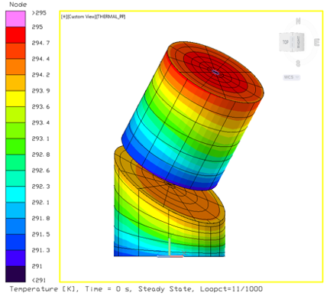
Fig. 17 Spacecraft bus hot case temperatures.

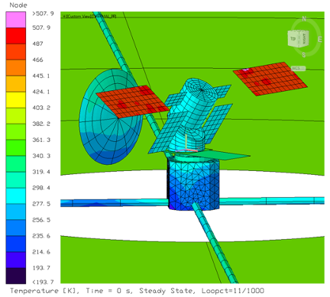
Fig. 18 SPI hot case temperatures.

Table 12 Mass summaries for SPI Bus thermal control components.
Subsystem |  |  |  | Qty | Unit  Mass  (kg) | Basic  Mass  (kg) | MGA  (%) | MGA  (kg) | Predicted  Mass  (kg)
2.0 | Thermal |  |  |  |  | 29.97 | 25% | 7.49 | 37.46
 | 2.1 | Instrument MLI |  | 1 | 0.40 | 0.40 | 25% | 0.10 | 0.50
 | 2.2 | Instrument Cold Plates |  | 1 | 7.90 | 7.90 | 25% | 1.98 | 9.88
 | 2.3 | Instrument Heat Pipes |  | 1 | 2.77 | 2.77 | 25% | 0.69 | 3.46
 | 2.4 | Instrument Radiators |  | 2 | 1.24 | 2.48 | 25% | 0.62 | 3.10
 | 2.5 | Instrument Heaters |  | 1 | 0.60 | 0.60 | 25% | 0.15 | 0.75
 | 2.6 | Instrument Temp Sens |  | 1 | 0.05 | 0.05 | 25% | 0.01 | 0.06
 | 2.7 | Subsystem MLI |  | 1 | 0.37 | 0.37 | 25% | 0.09 | 0.46
 | 2.8 | Subsystem Cold Plates |  | 1 | 4.80 | 4.80 | 25% | 1.20 | 6.00
 | 2.9 | Subsystem Heat Pipes |  | 1 | 2.15 | 2.15 | 25% | 0.54 | 2.69
 | 2.10 | Subsystem Radiators |  | 2 | 4.20 | 8.40 | 25% | 2.10 | 10.50
 | 2.11 | Subsystem Heaters |  | 0 | 0.00 | 0.00 | 25% | 0.00 | 0.00
 | 2.12 | Subsystem Temp Sens |  | 1 | 0.05 | 0.05 | 25% | 0.01 | 0.06
 | 2.13 | AMT MLI |  | 0 | 0.50 | 0.00 | 25% | 0.00 | 0.00

Table 13 Mass summaries for Spin-up Bus thermal control components.
Subsystem |  |  |  | Qty | Unit  Mass  (kg) | Basic  Mass  (kg) | MGA  (%) | MGA  (kg) | Predicted  Mass  (kg)
2.0 | Thermal |  |  |  |  | 1.16 | 25% | 0.29 | 1.45
 | 2.1 | Spin-up Bus MLI |  | 1 | 0.61 | 0.61 | 25% | 0.15 | 0.76
 | 2.2 | Spin-up Bus Heaters |  | 1 | 0.50 | 0.50 | 25% | 0.13 | 0.63
 | 2.3 | Spin-up Bus Temp Sens |  | 1 | 0.05 | 0.05 | 25% | 0.01 | 0.06

- Avionics
For this study, the avionics discipline includes components for command and data handling (C&DH), communications, and other spacecraft electrical systems not covered in other subsystems. The ground rules and assumptions that guided the avionics design are listed in Table 14.

Table 14 Avionics subsystem ground rules and assumptions.
Property | Value | Comments
Command and Data Handling
Flight Computer and C&DH | To provide all spacecraft functions  including data management, navigation, and control
TRL and Heritage | Use high TRL components with flight heritage where possible
Instruments | Electronics to be provided with instruments | Instruments to supply electronics required to process data. S/C to store and format data for downlink
Data Rates and Durations | 280 kbps continuous data collection includes all instruments and S/C data (raw data). Downlink at least once per day.  Total data for 24 hours, 24 Gbits (raw data) | Assume 275 kbps total instrument data continuous  Lossy compression 1:4 possible if needed
Data Overhead & Margin | With 30% data overhead, ~32Gbits/24hr (4 GB/day) | per CCDSD formatting
Data storage | 14 days of non-volatile memory storage, for sun outage time.  (Science data to be selective over outage times to meet downlink rates, consider data compression) | 450Gbits raw data (56GB) over 14 days  Solar Cruiser provided 64GB
Environments | Deep space radiation environment, 12 year minimum life | Kon-Tiki 20 krad TID
Redundancy | Class C - No redundancy required | Fault tolerance desired if minimal impact
Flight Computer and C&DH | To provide all S/C functions  Including data management, navigation, and control | Instruments to supply electronics required to process data. S/C to store and format data for downlink
Communications
Uplink/Downlink Rates | Use DSN for communications  X-band, 10 Mbps downlink rate max  2 uplink rate minimum  No comm possible during sun exclusion periods (4 deg) | Polaris transponder, to have heritage from NEA Scout and Solar Cruiser (25kbps down, 2kbps up, at 2.5Mkm. Uplink violume150kb/contact).  Limited data rates per NTIA
Link Budget Margin | 3 dB margin, minimum
Comm Ops | Store and forward data strategy. No real time data.  Downlink data at least once per day  Antenna gimbaling allowed during observation times  Earth departure stage to perform comm until separation | Bus is constantly de-spinning and translating  NEN and TDRSS used during launch & departure
Navigation and Tracking | DSN ground station tracking during link times

The avionics in the spacecraft is divided into two functional sections: the spacecraft avionics and the science instruments. Physically, the spacecraft avionics cards are combined into one stack in the Lower Bus, while the individual instrument avionics are located int the Science Bus (the gimbaled portion). This arrangement allows for optimal data bus management, power distribution across the cards, and thermal management of the avionics stack. It also minimizes cable mass. The spacecraft stack will perform all command and data handling for the spacecraft, along with the data storage and downlink operations for the science instruments. It consists of a Single Board Computer (SBC) for flight control, a processor board for data management and formatting of instrument data, a digital I/O board and an analog I/O board, three memory storage boards, a reaction wheel controller/driver board, an antenna gimbal controller/driver board, and the avionics stack power supply board. That’s 10 boards total for the spacecraft avionics box. The science instrument electronics will perform the science data collection and processing, including analog to digital conversion, characterization, filtering, buffering, and data compression if needed.
The spacecraft avionics was baselined on Space Micro’s suit of avionics boards (see Figure 19, Space Micro Integrated Avionics Box breakout diagram). The formfactor used is PCI104S, which is very small and low mass. Space Micro avionics has flight heritage on USAF ORS-1, June 2011. The flight control board is a Proton 400k SBC. The latest and most advanced in their product line. It’s a 32-bit dual core processor, at 1 GHz, with 4800MIPS. It is rated to 100krad TID. The Instrument Processing board is based on the Proton 200 DSP, also with proven fight heritage. The reaction wheel controller board and antenna gimbal board are based from the Proton 300 board. These boards will require motor drive circuits along with control circuits. The digital I/O board provides 16 RS-422 lines, 36 discrete signal lines, 16 LVDS lines. The analog I/O board provides 42 single ended lines, 6 differential lines, and 12-bit A/D conversion. The memory boards provide 8 GBytes each, for a total of 24 GBytes of on-board memory storage. This allows for over 14 days of mission data storage during communications sun outage times, as shown later in the communications data analysis. The 14-day requirement comes from mission analysis, which shows a maximum 12.3-day outage at a sun avoidance angle of 4 degrees. Finally, the power supply board provides all the condition voltages needed for the avionics stack (3.3V, 5V, +/-12V, with regulation to within 2% and 40mV maximum ripple) and includes EMI/EMC filtering to MIL-STS-461C/D. Figure 19 includes the mass and power of the individual boards, with a total box mass of 2.05 kg and 64 W of power.

Fig. 19 Space Micro integrated avionics box breakout diagram.

For the science and spacecraft telemetry communications, the Deep Space Network (DSN) will be used to downlink data, with the assumption of at least one downlink per day. The communications strategy will be to store and forward data. There will be no real time data downlinks, except for the sail deployment where some real time video should be possible. No spacecraft pointing maneuvers will be provided for communication links, since the science instruments need to point continuously to the sun. So, an antenna gimbal mechanism and boom will be required to achieve ground links. Since the earth can be in any direction relative to the spacecraft during the mission, the antenna needs to be able to point in any direction. Even around or behind the SPI bus. A 2-axis gimbal unit is placed at the mount of the antenna to the boom, while the boom itself needs 3-axis of gimbal. Antenna gimbaling is allowed during science observations so that communications can be achieved when needed. The worst-case communication distance is 240M km. This distance is a major parameter in determining the communications system. The link budget analysis (later in this section) shows the necessity of using Ka-band to achieve the high data rates required for the volume of generated science data.
For spacecraft initialization and check out, the first ground contact will be to the Near Earth Network (NEN). DSN policy is to not communicate to spacecraft below a geosynchronous orbit (GEO). These lower orbits are not considered deep space, and the three DSN ground station will not have a continued field of view as expected for deep space missions. Spacecraft separation from the launch vehicle upper stage will occur below 200 km. Immediately after the autonomous detumble maneuvers (as described in the GN&C section) it will be desirable to contact ground and obtain a status of the spacecraft health and determine the state vector (attitude, velocity, range, position) through a number of ground contacts. These communications links will most likely begin well below GEO, and potentially continue out to 400,000 km. That is about a 15-hour time period. Afterwards, the sail deployment should begin. At this distance, communications can be switched over to the DSN. This is highly desirable since video of the sail deployment will generate large data volumes, which can be downlinked to DSN in much shorter times than to the NEN (even real time). With the sail deployment taking up to 8 hours, a very low video rate of sail deployment will be necessary.
Communications to NEN ground stations will be in X-band. Most NEN ground stations do not support Ka-band. Medium Gain X-band patch Antennas (MGA) will be used to link with the NEN. Patch antennas provides 180 degrees of view, so no spacecraft pointing maneuvers are required for critical navigation and status uplinks and downlinks. Patch antennas are small and low mass (150 g each), while providing good gain (12 dBi X-band from EnduroSat). Four X-band patch antennas are placed on the SPI bus. Two are forward facing on the pointing portion of the bus, while the other two are on the aft section of the SPI bus. With the antennas canted slightly, full spherical coverage should be possible. However, during actual sail deployment, it is assumed that Earth will be hidden from these antennas by the sail until the deployment is completed. Afterwards, the 10 m opening in the sail around the SPI bus will allow a view of Earth (for both the X-band patch antennas and the Ka-band pointing dish antenna). Since communications during sail deployment is highly desirable, including the desire for real time video feedback of the deployment process, it is necessary to place an addition X-band patch antenna on the aft of the de-spin bus. This antenna should always have an unobstructed view of earth during sail deployment. Four antenna switches are required to accommodate these 5 different patch antennas.
The data requirements for the study were provided by the science team in a table listing nominal data rates required for each instrument (see Table 1). The total science data generated is approximately 275 kbps. Added to this data volume is 2.5 kbps of spacecraft telemetry, and then 30% margin per CCSDS formatting and recommendations. It was a study ground rule that data be downlinked at least once every 24 hours. A preliminary link budget showed that this raw uncompressed data volume with margin (~32 Gbits/day) would be excessive on all accounts: antennas size, RF power, DSN time, and memory storage. At 1 Mbps downlink rate, it would take 9 hours of DSN time per day. This daily DSN time seems unreasonable for both mission cost and scheduling of DSN time. Therefore, the option to compress the data 1:4 with losses (with science team buy-in) was chosen. With compression, the science data rate is reduced to 68.7 kbps, giving a 24-hour data volume of 6 Gbits/day. Including the spacecraft telemetry and 30% margin, the new daily total comes to 8 Gbits/day (see Table 15, Data Rate Analysis). The assumption is made that data is continuously generated during science observation times, and this data needs to be stored and managed by the spacecraft bus for the periodic downlinks to ground. With 8 Gbits of data generated over a 14-day communication blackout, the total storage requirement is 112 Gbits (14 GB). Therefore, two Space Micro 8 GB memory boards are selected. A third board is added for contingency and memory redundancy. The boards are only 150 g each, so the mass impact of additional storage is minimal.

Table 15 Data rate analysis results. Spacecraft telemetry data rate scaled from Solar Cruiser.
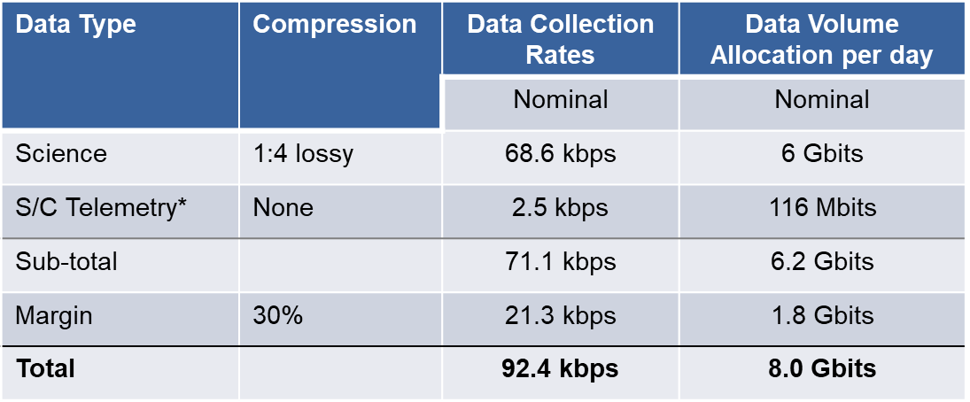

For the science and spacecraft telemetry downlink analysis, the worst-case distance of 240M km was used. The DSN 34-meter dish ground antennas have a G/T of 65 in Ka-band, which significantly reduces the communications system size and mass (compared to X-band requirements). Therefore, Ka-band is chosen for the primary communications system on SPI. The DSN 70-meter dish was not considered for this mission due to cost impacts, and the 34-meter dishes were deemed sufficient. The 70-meter antennas are also planned to be decommissioned sometime in the near future, to be replaced with 34-meter dish arrays. Several link budget trades were done between antenna size, RF power, and data downlink rates, and it was determined that a data rate of 1 Mbps is sufficient to downlink all the data once per day. At this rate, 2.2 hours of DSN time is required per day, which seems reasonable. Higher data rates, like 2 Mbps, would require less DSN time but larger antennas and more RF power. DSN cost becomes less efficient with lower link times because of minimal setup cost per link periods. The optimal sweet spot for this mission occurs using a 2-meter dish, requiring 38 watts of RF power, at a rate of 1 Mbps. The 2-meter dish is a deployable mesh antenna that is scaled from JPL's 0.5 m antenna, developed for CubeSat concepts [6]. Figure 20 shows the general diagram of the communications system.

Fig. 20 Communications Diagram.

The camera selected for observing sail deployment is the GOM Space C1U Nanocam, the same camera to be used on the Solar Cruiser. It has a 185° field of view and has a 35 mm lens with a 4.5 cm/pixel resolution at 29 meters). Two cameras are required and are located on the SPI bus 180º apart to achieve full sail coverage. This and other electronics components are shown in Fig. 21, including the launch locks between the SPI Science and Lower buses as well as the de-spin motor and slip ring between the solar sail and the SPI Bus. Tables 16 and 17 list the avionics masses for the SPI and Spin-up buses. Note the addition of a wireless communications box to control (and receive status from) the RCDs used to control the sail attitude and for momentum unloading of the reaction wheels (the RCDs will be discussed later in the GN&C section).

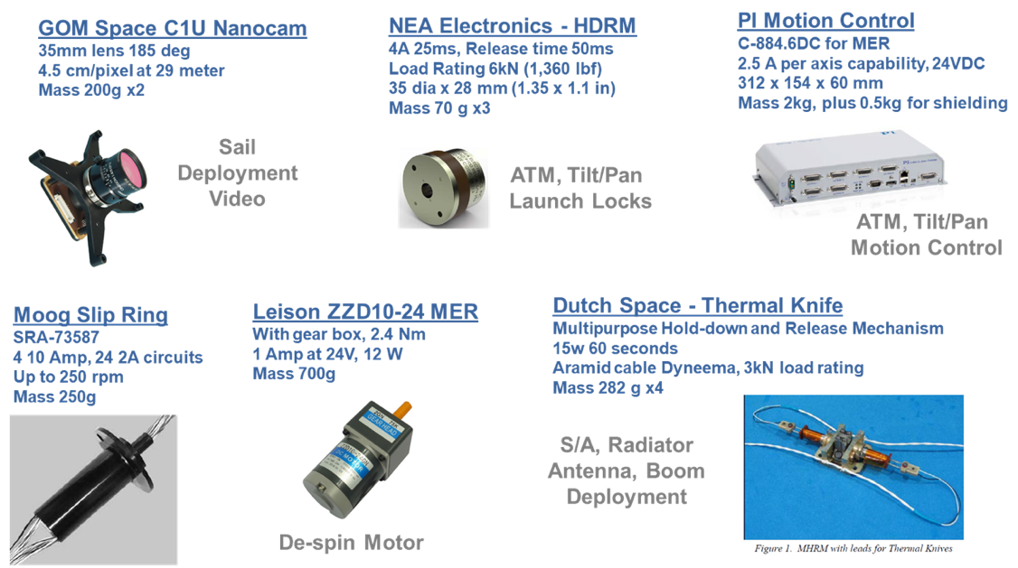
Fig. 21 Other avionics components.

Table 16 Mass summaries for SPI Bus avionics components.
Subsystem |  |  |  | Qty | Unit  Mass  (kg) | Basic  Mass  (kg) | MGA  (%) | MGA  (kg) | Predicted  Mass  (kg)
4.0 | Avionics |  |  |  |  | 35.26 | 8% | 2.71 | 37.97
 | 4.1 | Avionics Box |  | 1 | 2.05 | 2.05 | 3% | 0.06 | 2.11
 | 4.2 | Translation Controller |  | 1 | 2.50 | 2.50 | 10% | 0.25 | 2.75
 | 4.3 | Instrumentation |  | 1 | 1.00 | 1.00 | 12% | 0.12 | 1.12
 | 4.4 | Avionics Cabling |  | 1 | 3.00 | 3.00 | 25% | 0.75 | 3.75
 | 4.5 | Ka-band Dish Antenna |  | 1 | 6.00 | 6.00 | 10% | 0.60 | 6.60
 | 4.6 | Ka Boom & Pointing Mech |  | 1 | 5.00 | 5.00 | 3% | 0.15 | 5.15
 | 4.7 | Ka Transponder |  | 1 | 3.20 | 3.20 | 3% | 0.10 | 3.30
 | 4.8 | Ka TWTA and Pre-Amp |  | 1 | 3.55 | 3.55 | 3% | 0.11 | 3.66
 | 4.9 | Ka Diplexer |  | 1 | 0.50 | 0.50 | 10% | 0.05 | 0.55
 | 4.10 | X-band Patch Antenna |  | 4 | 0.15 | 0.60 | 3% | 0.02 | 0.62
 | 4.11 | X-band Transceiver |  | 1 | 0.40 | 0.40 | 3% | 0.01 | 0.41
 | 4.12 | X-band Diplexer |  | 1 | 0.30 | 0.30 | 5% | 0.02 | 0.32
 | 4.13 | X-band RF Antenna switch |  | 3 | 0.10 | 0.30 | 3% | 0.01 | 0.31
 | 4.14 | Wi-fi Transceiver |  | 1 | 0.75 | 0.75 | 10% | 0.08 | 0.83
 | 4.15 | Coax Cables, misc. |  | 1 | 0.50 | 0.50 | 25% | 0.13 | 0.63
 | 4.16 | Deployment and Hold-down |  | 1 | 2.54 | 2.54 | 3% | 0.08 | 2.62
 | 4.17 | Motors and Actuators |  | 1 | 2.20 | 2.20 | 3% | 0.07 | 2.27
 | 4.18 | Avionic Heaters |  | 1 | 0.87 | 0.87 | 15% | 0.13 | 1.00

Table 17 Mass summaries for Spin-up Bus avionics components.
Subsystem |  |  |  | Qty | Unit  Mass  (kg) | Basic  Mass  (kg) | MGA  (%) | MGA  (kg) | Predicted  Mass  (kg)
4.0 | Avionics |  |  |  |  | 3.75 | 10% | 0.38 | 4.13
 | 4.1 | Avionics Box |  | 1 | 1.18 | 2.05 | 3% | 0.06 | 4.1
 | 4.2 | Instrumentation |  | 1 | 0.50 | 0.50 | 12% | 0.06 | 4.2
 | 4.3 | Avionics Cabling |  | 1 | 1.00 | 1.00 | 25% | 0.25 | 4.3
 | 4.4 | Avionic Heaters |  | 1 | 0.05 | 0.05 | 15% | 0.01 | 4.4
 | 4.5 | X-band Patch Antenna |  | 1 | 0.15 | 0.15 | 3% | 0.00 | 4.5

- Guidance, Navigation, & Control (GN&C)
The primary requirements of the GN&C subsystem are:
- Determine the attitude and rates of the sail and bus.
- Control of the attitude and rates of the sailcraft to within the requirements specified by the on-board instruments.
The ground rules and assumptions governing the GN&C design are given below in Table 18.

Table 18 GN&C ground rules and assumptions.
Property | Value | Comments
Location Accuracy | 150m | DSN Accuracy
Coarse Pointing Control | RCDs
Fine pointing control for instruments | Reaction wheels
Tip-off rate damping/despin | 10 deg/s per axis | Based on P-Pod Deployer SLS Ride Share Specifications
Solar Sail Spin Rate | 1 RPM | Necessary for structural stability
CP to CM Distance | 1 m | Nominal cm/cp offset for NMP ST5 Geostorm Warning Mission (similarly sized sail)
Characteristic Acceleration | 0.3 mm/s^2
Volume, Mass, MOI | Sail area : 7000 m^2 (83.6 x 83.6 m) will dominate inertias. Uniform density assumed for MOI calculations. Bus mass = 140 kg, Sail mass = 52 kg. | Sail mass info from Andy Heaton
Maximum Slew Rate | 10 deg/day
Pointing Accuracy | 2 arcmin (0.03 deg) | Fine pointing for camera
Pointing Stability | 20 arcsec (0.0056 deg) over 10 seconds | Requirement from DSI
Pointing Knowledge | 10 arcsec (0.003 deg) relative to Sun center | Requirement from coronagraph. 10-arcsec Sun Sensor required, star tracker may be lesser accuracy.

The GNC subsystem has some challenges for the Solar Polar Imager mission. The large sail and high spin rate lead to a large amount of angular momentum stored in the sail. This removes traditional attitude control actuators (RCS thrusters or reaction wheels) from the trade space for controlling the sail attitude. To do coarse steering of the vehicle, reflectivity control devices (RCDs) will be used. The baseline design uses only RCDs for control of the sail; however, active mass transfer (AMT) can be added if a decrease in RCD area is necessary or for redundancy in the system. For fine pointing requirements associated with the science instruments, reaction wheels will be used on the Science Bus (which is freely rotating with respect to the Lower Bus).
Before doing any GN&C sizing, estimates of the spacecraft bus and solar sail inertias must be calculated. For this first pass, uniform mass distributions are assumed. The bus and solar sail mass and dimension assumptions are shown in Table 19. The bus is assumed to be a rectangular prism, and the sail is assumed to be a square flat plate.

Table 19 Pre-study SPI-Bus and sail dimensions and mass assumptions.
SPI Bus
Mass: m_{bus} | 140 kg
Length: L_{bus} | 1.25 m
Side Width: w_{bus} | 0.8 m
Sail
Mass: m_{sail} | 52 kg
Side Length: L_{sail} | 83.6 m

The mass moments of inertia are then approximated using the following expressions:

 | Sail (neglecting thickness)  $$Ixx= \frac{1}{12}m_{sail}\left({2*L}_{sail}^{2}\right)$$  $$Iyy=Izz= \frac{1}{12}m_{sail}\left(L_{sail}^{2}\right)$$  Bus  $$Ixx=\frac{1}{12}m_{bus}({2*w}_{bus}^{2})$$  $$Iyy=Izz=\frac{1}{12}m_{bus}{(L}_{bus}^{2}+w_{bus}^{2})$$ | (8)

Table 20 shows the inertias for the different configurations. The deployed configuration assumes a distance of [0.5, 2, 0] meters for input to the parallel axis theorem. A factor of 2 is also applied to the bus component of the inertia in the deployed configuration. This is to make up for the fact that the uniform mass distribution assumption is likely not the most accurate. The sail inertia is so large that the bus inertia doesn’t drive any sizing requirements.

Table 20 Mass moment of inertias.
Configuration | Ixx (kg·m²) | Iyy/Izz (kg·m²)
Stowed | 20.48 | 35.24
Deployed | 60,820 | 30,370

When the sail is deployed, the Lower Bus will be de-spun through a motor at the sail/bus interface. For attitude knowledge of the sail, the Lower Bus will contain a coarse sun sensor and a star tracker. The Science Bus will have a star tracker and a more precise sun sensor for fine attitude knowledge. An Inertial Measurement Unit (IMU) will also be included for more accurate rate measurements.
For this study, coarse pointing of the sail is accomplished with RCDs, although AMT may be included as an option in future design trades (initial estimates give a required translation of 21.5 cm). This section covers the details of computing the required number of RCDs, area per unit, and the required RCD input powers and masses. The torque required to change the sails attitude at a given rate is given by:

 | $$τ= Hω$$ | (9)

The maximum assumed sail slew rate for the mission is 10 deg/day. For a total angular momentum of 6369 kg·m²/s, the required torque to be generated by the RCDs is 0.0129 Nm. The angular momentum will slowly shift away from the roll (or spin) axis due to slewing the vehicle and external disturbances. Because of this momentum shift/dissipation, the RCDs will have to maintain the spin rate of the sail, as well.
The assumed configuration of the RCDs is shown in Fig. 22 below. As the sail spins, the RCDs will turn on/off based on the sail roll angle. The necessary force needed by each RCD to generate 0.0129 N-m of torque is calculated below. This calculation assumes RCDs #1 and #4 have a moment arm of 30 m, and RCDs #2 and #3 have a moment arm of 40 m. Applying these assumptions, the force required per RCD is 9.214e-05 N. The area required per RCD to produce this force is computed by assuming that the pressure acting on each RCD (at 0.48 AU) for a perfect reflector is 4.0e-05 Pa. Applying a reflectivity of 0.5 results in a required area of 4.6 m² per RCD. For 8 total RCDs, this leads to 36.9 m² of total RCD area. The areal density of 0.017 kg/m² for the RCD technology. This results in a total required RCD mass of 0.627 kg. Similarly, a power density of 5 W/m² is assumed, which leads to a total power requirement of 184 W. These RCD sizing results and power requirements are summarized in Table 21.

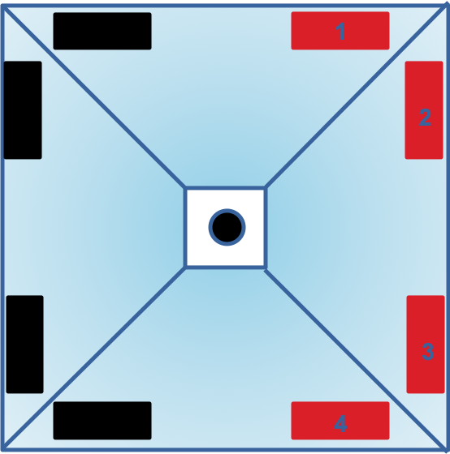
Fig. 22 RCD placement for sail attitude control.

Table 21 RCD sizing results and power requirements.
Quantity | Value
RCD Area (per unit) | 4.6 m²
Total RCD Area | 36.9 m²
Total RCD Power | 184 W
Total RCD Mass | 0.627 kg

This fine pointing of the Science Bus is accomplished with reaction wheels. The only disturbance affecting the bus is solar radiation pressure (SRP), which is on the order of 1e-07 N of force. Assuming a center of pressure offset of 0.5 m, the torque due to SRP is 5e-08 Nm. The only other torques is due to a small amount of friction in the free-rotating connections between the Science Bus and Lower Bus. To overcome these small torques, a 100 Nms reaction wheel was chosen. Periodically, the wheels will need to be de-saturated. The platform can press against the hard limits of the connection joints to unload momentum to the sail.
The Spin-up Bus is required to dampen the tip-off rates after launch vehicle separation, along with maintaining the spacecraft attitude and assisting with spin control prior to and during sail deployment. The bus will have a star tracker and IMU for attitude and rate determination, respectively. Tipoff rates of 10 deg/s are assumed in each axis, and the corresponding angular momentum values to be negated are listed in Table 22. The propellant mass associated with damping these tip-off rates to zero is calculated by the following equation:

 | $$M_{p}=\frac{∆H}{{gI_{sp}r}_{thr}}$$ | (10)

Where $∆H$ is the change in angular momentum of the vehicle, $g$ is the acceleration due to gravity at Earth's surface (9.81 m/s²), $r_{thr}$ is the thruster moment arm (assuming the same moment arm for each thruster), and $I_{sp}$is the specific impulse of the thrusters. Assuming an $I_{sp}$ of 230 sec and $r_{thr}$ of 1.75 m, the total propellant required to negate the tipoff rates is 0.01 kg. This is well within the tank capability and will not be a driver for design.

Table 22 Momentum values due to tip-off rates after launch vehicle separation.
Axis | Momentum (N·m·sec)
Roll | 3.57
Pitch | 6.15
Yaw | 6.15

For structural stability, the sail needs to spin at 1 rpm. In the fully deployed configuration, the roll inertia is 60,820 kg·m². This leads to an angular momentum of 6369 kg·m²/s. In order to achieve this change in angular momentum, the Spin-up Bus thrusters must provide an equal impulse. Using Eq. 10 above, the propellant required to achieve this angular momentum is 1.61 kg. The propellant required for attitude control during the 1 rpm spin-up phase is difficult to determine without a high-fidelity simulation. Therefore, for this stage of the design process, a 50% margin on top of the 1.6 kg required for deployment is added. The sum of the propellants mentioned above is 2.43 kg. An additional 35% margin is added, which brings the total Spin-up bus propellant requirement to 3.28 kg (see Table 23 below).

Table 23 Spin-up Bus propellant requirements.
Action | Prop Mass (kg)
Damp Tip-Off Rates | 0.01
Spin Bus/Deploy Sail | 1.61
Attitude Control | 0.81
Spin-up Bus Propellant Requirement | 2.43
35% Margin | 0.85
Total Propellant Requirement | 3.28

High TRL and low mass GN&C components are chosen for the SPI Bus and Spin-up Bus. The selected components and masses are summarized in Tables 24 and 25.

Table 24 Mass summaries for SPI Bus GN&C.
Subsystem |  |  |  | Qty | Unit  Mass  (kg) | Basic  Mass  (kg) | MGA  (%) | MGA  (kg) | Predicted  Mass  (kg)
5.0 | GN&C |  |  |  |  | 2.96 | 3% | 0.09 | 3.05
 | 5.1 | Reaction Wheels |  | 3 | 0.35 | 1.05 | 3% | 0.03 | 1.08
 | 5.2 | Nano Star Tracker |  | 1 | 1.30 | 1.30 | 3% | 0.04 | 1.34
 | 5.3 | IMU |  | 1 | 0.007 | 0.01 | 3% | 0.00 | 0.01
 | 5.4 | Sun Sensor |  | 1 | 0.60 | 0.60 | 3% | 0.02 | 0.62

Table 25 Mass summaries for Spin-up Bus GN&C.
Subsystem |  |  |  | Qty | Unit  Mass  (kg) | Basic  Mass  (kg) | MGA  (%) | MGA  (kg) | Predicted  Mass  (kg)
1.0 | GN&C |  |  |  |  | 0.012 | 3% | 0.012 | 0.012
 | 5.1 | Sun Sensor |  | 1 | 0.005 | 0.005 | 3% | 0.00 | 0.005
 | 5.2 | IMU |  | 1 | 0.007 | 0.007 | 3% | 0.00 | 0.007

- Spin-up Bus Propulsion
To save on mass, a simple monopropellant hydrazine blowdown system was selected for the Solar Polar Imager mission (see Fig. 23 below). No chemical propulsion components are required on the SPI Bus, so the hydrazine system is located only on the Spin-up Bus. The system has two main functions: to provide attitude control for the spacecraft prior to solar sail deployment, and to spin-up the sail during solar sail deployment. A total of sixteen 4 N thrusters are configured into four pods, each containing four engines. The propellant is stored in a single Titanium alloy (Ti-6Al-4V) tank with an elastomeric diaphragm that provides a physical barrier between the hydrazine propellant and the helium pressurant.

Fig. 23 Spin-up Bus propulsion system schematic.

The thrusters chosen are Aerojet Rocketdyne MR-111C, 4 N thrusters. The thrust range for the MR-111C is 1.3-5.3 N with a corresponding feed pressure of 35-200 psi and specific impulse of 215-229 seconds. The thrusters are equipped with embedded heaters for the valves and catalyst beds, which operate while the thrusters are in standby mode. The heaters' combined power draw is about 5.4 W per thruster. The thruster valve is a dual seat, normally closed solenoid valve and draws 8.3 W to open. The MR-111 family of thrusters has extensive flight heritage, so very little qualification should be required for this mission. Note that the components chosen for this design, including those listed below, may be replaced with components from other vendors during future design iterations. The components were chosen primarily to compile accurate mass and power estimates.
The propellant tank is the Rafael PEPT 230, which has a 6-liter volume and a diameter of 230 mm. It is currently qualified for a 4.5-liter propellant capacity, which is more than enough for this application. The maximum expected operating pressure (MEOP) is 400 psi. The shell material of the tank is titanium alloy (Ti-6Al-4V) and has an elastomeric diaphragm (EPZ-63 or EPN-40) that provides a physical barrier between the hydrazine propellant and the helium pressurant. It has flight heritage in low Earth orbit (LEO) so may require further qualification for deep space.
The fill/drain valves for the propellant and pressurant are VACCO ¼" fill/drain valves. They have an operating pressure 400 psi and are compatible with both hydrazine and helium. The isolation valve is a VACCO normally closed positive isolation valve. Functionally, it is similar to a pyro-valve but uses a frangible seat rather than pyrotechnics, thereby reducing downstream shock loads and debris. The current concept of operations does not have a need to close off the propellant tank from the thrusters after spin-up operations. If future design cycles show that the tank needs to be closed off from the thrusters at a point in the mission after the isolation valve opened, then a latch valve can easily be added to the design or the isolation valve can be replaced altogether. The feed lines are assumed to be 7.7 m of Ti-6Al-4V tubing. The tubing chosen is ¼" diameter, 22-gauge tubing.
The tank pressures and engine performance characteristics at the beginning and end of the Spin-up bus mission are listed in Table 26. These affect not only the propellant mass required to accomplish the mission but also the required pressurant mass. The total propulsion system mass is summarized in Table 27. The system dry and usable propellant masses are 9.51 kg and 3.28 kg, respectively. Adding the 0.15 kg of unusable propellant along with the 0.11 kg of tank pressurant, the total system wet mass at launch is 13.05 kg.

Table 26 BOL and EOL propulsion system characteristics.
 | Beginning of Life | End of Life
Tank Pressure (psi) | 400 | 210
Thrust (N) | 4.8 | 2.9
Specific Impulse (s) | 227 | 221

Table 27 Mass summaries for Spin-up Bus propulsion system.
Subsystem |  |  |  | Qty | Unit  Mass  (kg) | Basic  Mass  (kg) | MGA  (%) | MGA  (kg) | Predicted  Mass  (kg)
7.0 | Propulsion |  |  |  |  | 9.17 | 4% | 0.34 | 9.51
 | 7.1 | Propellant Tank |  | 1 | 1.30 | 1.30 | 3% | 0.04 | 1.34
 | 7.2 | Thrusters |  | 16 | 0.33 | 5.28 | 3% | 0.16 | 5.44
 | 7.3 | Propellant Filter |  | 1 | 0.18 | 0.18 | 3% | 0.01 | 0.19
 | 7.4 | Fill / Drain Valve (Prop) |  | 1 | 0.28 | 0.28 | 3% | 0.01 | 0.28
 | 7.5 | Fill / Drain Valve (Gas) |  | 1 | 0.28 | 0.28 | 3% | 0.01 | 0.28
 | 7.6 | Isolation Valve |  | 1 | 0.23 | 0.23 | 3% | 0.01 | 0.23
 | 7.7 | Feed Lines |  | 1 | 0.44 | 0.44 | 25% | 0.11 | 0.55
 | 7.8 | Misc. Hardware |  | 1 | 1.20 | 1.20 | 0% | 0.00 | 1.20
9.0 | Non-propellant Fluids |  |  |  |  | 0.26 | 0% | 0.00 | 0.26
 | 9.1 | Residual Hydrazine |  | 1 | 0.15 | 0.15 | 0% | 0.00 | 0.15
 | 9.2 | Gaseous Helium |  | 1 | 0.11 | 0.11 | 0% | 0.00 | 0.11
7.0 | Propulsion |  |  |  |  | 3.28 | 0% | 0.00 | 3.28
 | 10.1 | Hydrazine |  | 1 | 3.28 | 3.28 | 0% | 0.00 | 3.28

- Power
The power subsystems provide electrical power to the Spin-up Bus and the SPI Bus (including the science instruments). Power is also provided to the active components on the solar sail, although the on-sail film arrays that power the RCDs were not analyzed in this study. Table 28 details the power-related ground rules and assumptions for the study. Most are self-explanatory and are included to facilitate replication of the power system analyses in future studies of this design. However, a few deserve special mention:

- The mission trajectory will take the vehicle from Earth (at 1 AU) to a heliocentric orbit at 0.48 AU. Detailed analysis of the radiation environment at 0.48 AU is beyond the scope of this study - we have assumed that all solar radiation (solar electromagnetic irradiance, solar particle density, etc.) is simply four times the radiation seen at 1 AU.
- Upon release from the launch vehicle, the Spin-up Bus will awaken and control the spacecraft until the solar arrays are deployed. Power must be provided during this phase to stabilize the craft, start the sail spin-up, orient the entire vehicle, and deploy the arrays. We have ground-ruled 1 hour to accomplish this. Afterward, the solar arrays will provide all power, and the spin up bus will be discarded.
- The solar arrays will warm up considerably as the spacecraft approaches the maximum solar irradiance at 0.48 AU. As this occurs, the arrays will become less efficient at converting light to electrical power. In order to calculate this loss of efficiency, assumptions must be made regarding the design of the solar cells. For purposes of this study, Spectro lab XTJ solar cells are used.
- A packing factor of 1.3 is used to estimate the mass and volume of the battery from the mass of the comprising battery cells. This results in a total cells mass of 1 kg. The battery mass, when packaged and ready for integration, is 1.3 kg.

Table 28 Ground rules and assumptions for SPI power systems.
Property | Value
Power Subsystem Function | Switched conditioned power to all spacecraft bus and payload circuits
Bus Voltage | 28V Nominal
Grounding | Common ground across spacecraft bus and payload.
External Interfaces | None
Overload Protection | Provided to all switched loads
Fault Tolerance | No fault Tolerance - Consistent with Risk Class C
Component maturity | TRL 6-9 by PDR
Radiation environment | 4X Solar Radiation
Solar irradiance at 1AU AM0 | 1367W / m2
Pre-deployment power time | 1 hr
Initial Solar Array de-rate | 10%
Solar Array Coverage Coefficient | 0.9
Solar Array Yearly Degradation | 4%
Solar Cell Absorptance (Front) | 0.90
Solar Cell Emittance (Front) | 0.85
Solar Array Back Panel Emittance | 0.95
Solar Cell Reference (for thermal performance) | Spectrolab XTJ
Minimum Solar Distance | 0.48 AU
Secondary Battery Cell Packing Factor | 1.3
Secondary Battery Charge/Discharge Efficiency | 95%
Energy storage depth of discharge | 75% Max
Cable loss (size-to) | 1%

There are two distinct power systems provided here - one for the Spin-up Bus, and one for the main SPI spacecraft bus. The Spin-up Bus is powered by lithium-ion batteries, while the main SPI Bus is powered by solar arrays. The main challenge in the design of the arrays is the change in solar irradiance as we travel from Earth at 1 AU to our final heliocentric orbit at 0.48 AU. At 1AU, the solar irradiance is 1367 W/m². Because the thermal system is designed to reject the enormous heat loads at 0.48AU, it will reject so much heat at 1AU that heaters are needed to prevent the bus from getting too cold. At 0.48AU, these heaters will be off, but the arrays themselves will be too hot to function without some sort of thermal protection.
To meet the requirements at both 1 AU and 0.48 AU, two different types of solar panels are needed. At 0.48 AU, the bus will be powered by special solar array panels that have 50% of their panel area covered with highly reflective gold coating. The coated areas reflect 95% of the light that strikes them. This increases the effective reflectance of the panel and results in a lower steady state temperature. Of course, it also reduces the effective photovoltaic area of the panel by 50%. This is more than offset, however, by the increase in irradiance which corresponds to a higher converted power. To provide extra power for the heaters at 1 AU, additional conventional solar array panels (without reflectors) are provided. As the spacecraft approaches 0.48 AU, these panels will overheat and ultimately fail, but by the time they do, the heaters will no longer be needed, and these panels will be electrically disconnected from the power system.
The power electronics is integrated with the avionics system. The Space Micro Proton X suite has been chosen as a representative small avionics and power system. The Proton X is a “Slice” system, and the edges of each card together with 2 end caps form the enclosure that houses the avionics. A power management board (to interface the solar arrays) and four power distribution boards are added to the power system.
Table 29 details the SPI Bus power requirements during the separate phases of the mission. Note that during the cruise phase, the thermal power decreases from 320 W to 75 W at 0.6 AU, which is a result of the lower heating requirements as the spacecraft approaches the Sun. This reduction continues as the solar distance decreases to 0.48 AU, where the heater power requirement is 50W. At that point, the science instrumentation is turned on, and the overall power requirement is increased by 94.3 W. When the Sun is within 4º of the spacecraft-Earth line, no communication is possible, so the communications equipment is powered down during those times. Given the required power levels, the gold-coated arrays are sized at 1.7 m², which produce the required 540 W at 0.48 AU, greater than 432 W at 0.6 AU, and 245 W at 1 AU. The conventional arrays, sized at 2 m², produce the remaining power requirement of 458 W at 1 AU. The corresponding total power mass is 20.72 kg and is summarized in Table 30, which also includes the four power-switching boards and the required harnesses.

Table 29 SPI Bus power requirements during mission.
Subsystem | Power (W)
Subsystem | Cruise  (1 AU) | Cruise  (0.6 AU) | Science | Comm Out
C&DH, Instrumentation | 84.3 | 84.3 | 84.3 | 84.3
Communications | 52 | 52 | 164 | 5
Controllers | 43 | 43 | 23 | 23
GNC | 26 | 26 | 26 | 26
Propulsion | 14 | 14 | 14 | 14
Thermal | 320 | 75 | 50 | 50
Science | 1 | 1 | 94.3 | 3
Total | 540.3 | 295.3 | 415.6 | 165.3
30% Growth Allowance | 162.09 | 88.59 | 124.68 | 49.59
Design Power | 702.39 | 383.89 | 540.28 | 214.89

Table 30 Mass summaries for SPI Bus Power System.
Subsystem |  |  |  | Qty | Unit  Mass  (kg) | Basic  Mass  (kg) | MGA  (%) | MGA  (kg) | Predicted  Mass  (kg)
3.0 | Power |  |  |  |  | 16.92 | 22% | 3.80 | 20.72
 | 3.1 | Reflective Solar Panel |  | 2 | 3.40 | 6.80 | 20% | 1.36 | 8.16
 | 3.2 | Non-Reflective Solar Panel |  | 2 | 3.90 | 7.80 | 20% | 1.56 | 9.36
 | 3.3 | Array Control Board |  | 1 | 0.20 | 0.20 | 20% | 0.04 | 0.24
 | 3.4 | Power Switch Board |  | 4 | 0.18 | 0.72 | 20% | 0.14 | 0.86
 | 3.5 | Harnesses |  | 1 | 1.40 | 1.40 | 50% | 0.70 | 2.10

The Spin-up Bus is powered entirely by lithium-ion batteries, discharged to a depth of 75%. Power must be provided for the following operations:

- propellant thermal management and thruster catalyst heating
- propulsive de-tumble maneuver after launch vehicle separation
- propulsive attitude control prior to and during sail deployment
- solar array deployment.

One hour is allocated for these operations. The power required by each subsystem during this time is given below in Table 31. A total of 153.4 W·hrs of energy is required. Due to the discharge depth assumption of 75%, the total battery capacity is increased to 204.5 W·hrs. The total power system mass, containing four secondary batteries and system harness) is 4.13 kg (see Table 32).

Table 31 Spin-up Bus power requirements during mission.
Subsystem | Power
Avionics | 30
Propulsion | 68
Thermal | 20
Total | 118
30% Growth | 35.4
Design Power | 153.4

Table 32 Mass summaries for SPI Bus Power System.
Subsystem |  |  |  | Qty | Unit  Mass  (kg) | Basic  Mass  (kg) | MGA  (%) | MGA  (kg) | Predicted  Mass  (kg)
3.0 | Power |  |  |  |  | 3.75 | 10% | 0.38 | 4.13
 | 3.1 | Secondary Battery |  | 4 | 1.75 | 7.00 | 20% | 1.40 | 8.40
 | 3.2 | Harness |  | 1 | 0.80 | 0.80 | 20% | 0.16 | 0.96

- Conclusion
The Solar Polar Imager study resulted in a preliminary design of a spacecraft bus that is transported from Earth heliocentric radius of 0.48 AU, taking advantage of solar sail technology. The bus carries remote-sensing and in-situ science instruments that begin solar observations at 0.48 AU and continue through the high solar latitudes achieved by the propellant-less solar sail. The total mass of the SPI Bus (Science Bus and Lower Bus) is 285 kg after margin. The 7000 m² sail requires 2.6 years to deliver the spacecraft to 0.48 AU and another 7.5 years for the cranking phase to the 75º inclination (again, ecliptic inclination was chosen for conservatism). The total polar observation time is 2 years with a potential add-on of 1 year. This gives a total mission time of 13.1 years.
There are concerns with performance degradation of the photovoltaics of the long durations at 0.48 AU. Glass coatings may reduce degradation and lower the array temperatures. Updated, higher-fidelity thermal modeling is also suggested to assess the degradation of all materials and coatings in the harsh thermal environment, especially the RCD elements. Regarding the RCD control scheme, a full 6-DOF analysis is required, with updated sail and spacecraft mass properties, to fully assess the RCD control authority and investigate the potential benefits of an AMT table.
There are options to decrease the total mission time, other than increasing the sail size and/or decreasing the SPI Bus mass. The science goal is to observe the Sun and take measurements at 75º from the equator, not ecliptic. Therefore, a judicial selection of launch date can take advantage of the 7.25º difference between the Sun's equator and the ecliptic plane, requiring a final ecliptic inclination of only 67.75º. Also, allowing the sail to increase the orbital inclination on the inward spiral will further reduce the cranking phase time. Finally, with a relatively low launch mass of 349 kg, the launch vehicle may be able to provide a high Earth-departure energy, which may include a significant initial heliocentric inclination. At the current sail characteristic acceleration of 0.22 mm/s², every degree of inclination saved results in a 0.1 year reduction of cranking time.

Acknowledgments
The authors would like to thank Les Johnson (NASA MSFC, ST03) and David McKenzie (NASA MSFC, ST13) for providing the opportunity to work on this study and for readily sharing their knowledge of solar sails and the science instruments required to achieve the mission goals. Andy Heaton (NASA MSFC, EV42) and John Carr (NASA MSFC, ES44), and Dana Turse (Roccor, LLC) were also instrumental in their guidance on solar sail sizing and control methodologies.

References
[1] Appourchaux, T., et. al., “POLAR Investigation of the Sun – POLARIS”, Experimental Astronomy, Vol. 23, Issue 3, pp. 1079-1117, March 2009.
[2] Pontryagin, L. S., Boltyanskii, V. G., Gamkrelidze, R. V., and Mischenko, E. F., The Mathematical Theory of Optimal Processes, Them Macmillan Company, New York, NY, 1964.
[3] Wie, B., “Thrust Vector Control Analysis and Design for Solar-Sail Spacecraft”, Journal of Spacecraft and Rockets, Vol. 44, No. 3, May-June 2007.
[4] Wie, B., “Thrust Vector Control Analysis and Design for Solar-Sail Spacecraft”, Journal of Spacecraft and Rockets, Vol. 44, No. 3, May-June 2007.
[5] SpaceX, “Falcon User's Guide”, April 2020, URL: https://www.spacex.com/media/falcon_users_guide_042020.pdf [retrieved 17 September 2020].
[6] Sauder J., et. al., “Ultra-Compact Ka-Band Parabolic Deployable Antenna for RADAR and Interplanetary CubeSats”, 29th Annual AIAA/USU Conference on Small Satellites, Logan, UT, August 8-13, 2015.

AST, Aerospace Flight Systems, Advanced Concepts Office (ED04).
AST, Propulsion Systems &Technologies, Advanced Concepts Office (ED04).
Aerospace Engineer, Advanced Propulsion Technologies, Advanced Concepts Office (ED04), AIAA Professional Member.
GNC Engineer, Control Systems Design and Analysis Branch (EV41).
Research AST, Solar and Solar Terrestrial Studies, Heliophysics and Planetary Science Branch (ST13).
Senior Stress Engineer, Advanced Concepts Office (ED04).
Senior Engineer, Advanced Concepts Office (ED04).
Avionics Design Engineer, Advanced Concepts Office (ED04).
Johnson, Les., Personal Communication, November 15, 2019.
Johnson, Les., Personal Communication, January 27, 2020.
https://omniweb.gsfc.nasa.gov/coho/helios/plan_des.html.

