CELA NextGen 2020
Abstract
Marshall Space Flight Center
Advanced Concepts Office

Date: 26 August 2020

Authors: Sarah Triana

Contents
I. Abstract 3

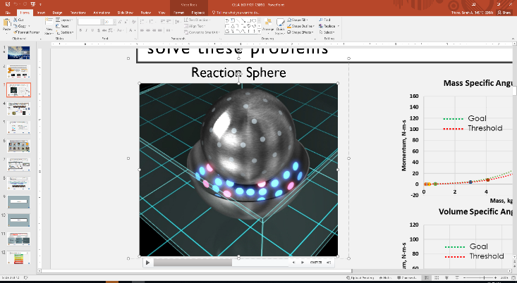
Abstract
Figure 1. RS
Creating a new technology development is hard! But, experience can be the best teacher. Through our journey in maturing CELA, a frictionless, direct-drive Reaction Sphere (RS) (Figure 1), lessons our team learned have given us valuable insights that can help you on your own technology development journey. CELA (Correlated Electromagnetic Levitation Actuator), like all state-of-the-art starts, is a technology development project. This idea started by addressing a problem posed in a classroom setting, and has morphed into its current state today. At first, the problem was to create a novel separation system. Then, as often happens with new ideas, there was a bump in the road: CELA did not align with stakeholder priorities. So, we had to pivot. The team learned that the funding organization was more excited about an Attitude Control System solution than a Separation System solution. CELA then became a Reaction Wheel. Through more pivots, the technology development advanced into a RS. This example shows that the process for maturing an idea is just as important as the technology itself. Other aspects of the process include finding funding sources, conducting research, obtaining patents, engaging partners, and finally creating systems to keep you on track and pointed in the right direction. Going through this process will teach you many valuable lessons: you never know when an idea will arrive, you will experience rejection, and you will learn a lot about your own strengths and weaknesses. The importance of this is not to teach you to give up, but to teach you to keep going, and to learn what works and what does not work in order to set yourself up for success.

