ORACLES:
Optimized Rational Algorithm for Conjecture of Long-term Exploration of Space
Robert B. Adams, Natasha Justice Liston-Beck, Glen Doughty
NASA Marshall Space Flight Center, Huntsville, Alabama, 35812, USA
Joel B. Mozer
HQ United States Space Force, Colorado Springs, Colorado, 80914, USA
ORACLES is a joint venture between the United States Space Force (USSF) and the National Aeronautics and Space Administration (NASA) to develop a model for future space exploration, commercialization, and expansion. Following the success of qualitative future scenario exploration during the Space Futures Workshops (SFW), ORACLES aims to produce a quantitative means of evaluating these same factors. This model considers the social, economic, and political environment and determines possible inflection points; that is, the most crucial investments in technologies, infrastructure, and policy for the support and protection of U.S. and allied space assets. The development of ORACLES is in its infancy, with front end interfaces constructed for discussion and debate before the overall algorithm is finalized. Comments are highly encouraged as the team wishes to gain the broadest level of perspectives before continuing with development.
- Introduction
The premise of the Space Futures Workshops (SFWs) [1] is that the future of space exploration is dependent on critical decisions made today and in the near future. The SFWs also indicated metrics by which potential futures could be evaluated. These metrics are the number of people living and working in space, the space-based economy, and the influence wielded by various political and economic entities due to their exploits in space. Figure 1 illustrates the conclusions of the first SFW as developed by the numerous experts involved in the study. The diagram compares projected futures according to the metrics of evaluation described above by examining scenarios of different combinations of U.S. success in space economy, population, and influence. The Space Futures Workshops serve as a starting point for ORACLES development as well as a direction and end-goal for the project. ORACLES aims to complement qualitative future scenario exploration with a quantitative model.
The authors have started development of this Unity-based analytical model that can evaluate the myriad possibilities and indicate which outcomes are more likely. The model is called Optimized Rational Algorithm for the Conjecture of Long-term Exploration of Space or ORACLES. This model is a collaboration between the United States Space Force and the National Aeronautics and Space Administration. It is currently in the earliest stages of development.
ORACLES is structured around the assumption that many actors will make various decisions to commit time and resources developing their space-oriented portfolio. As mentioned above these investments will have results that can be measured in population, economy, and influence. ORACLES assumes that these decisions can be categorized as either which technologies are developed, what infrastructure is constructed both on Earth and in-space, and what political and commercial policies are enacted to guide and encourage space exploration. These possible paths are jointly referred to as investments.
As a predictive model, ORACLES is intended to be used by decisionmakers at NASA, USSF, and other governmental organizations to make the best-informed decisions regarding future investments in space technologies, infrastructures, and policies. ORACLES stated objectives are to:
- Create a program that allows estimation of political, economic, and social consequences of space-future related decisions both on Earth and in space.
- Store data from subject matter experts on numerous options for infrastructure development, technological research, and both corporate and governmental policies.
- Create visualizations for the interdependencies and outcomes of different decisions.
- Calculate probabilistic outcomes using unique artificial intelligence (AI) by iterating through all included scenarios.
- Allow teams of users to simulate scenarios by interacting as different entities and decisionmakers to evaluate both the model itself and potential investments.

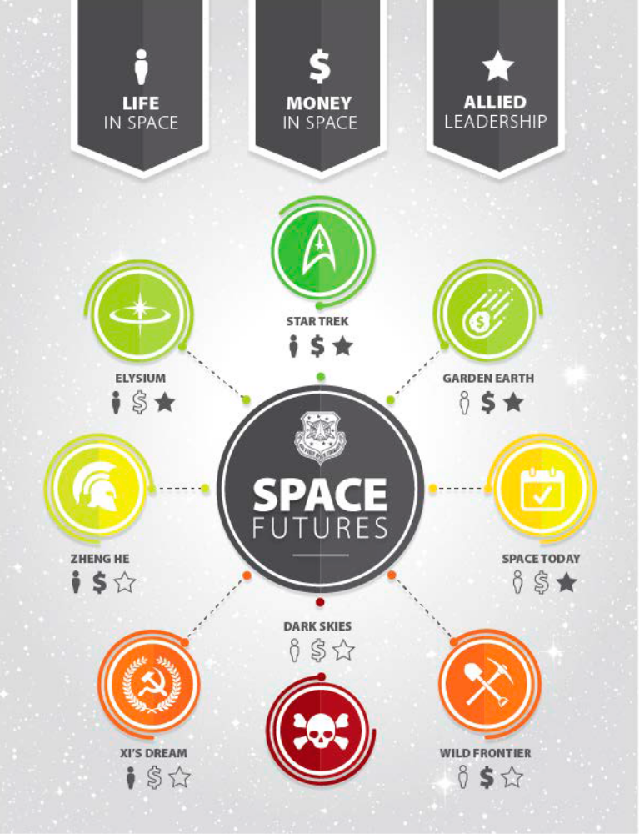
Figure 1 - Possible futures as determined by the Space Futures Workshop [1]
Despite the name, ORACLES is intended to be a framework to organize discussion on future investments in space, not the definitive answer to what will happen in the future. After all, the advice from the oracles of antiquity required interpretation from wise leaders armed with a complete set of facts. ORACLES collects information and opinion from numerous experts, organizes said information into quickly understandable possibilities, and points out areas that require further consideration and exploration.
In order to achieve these diverse objectives, the ORACLES team selected the Unity Real Time Development Platform for its versatility with three-dimensional spaces, C# functionality, and ease of developing complex systems and user interfaces. This project relies on strategic planning principles and the analytical and predictive models that have come before. ORACLES also benefits from the clear communication and ease of data visualization found in 4X strategy games.
The following three sections of this article detail the primary use modes for the ORACLES program. The first section is the database entry mode. The structure of ORACLES requires a robust collection of data on investments in order to function with a high level of accuracy and serve as a comprehensive decision-making tool. The database mode organizes input from various experts in their field on the resources needed and potential benefits for various investments in space. The multi-user mode is to be used for training, testing, and strategic planning. Here, humans are actively participating in decision making, as humans are still ascendant over artificial intelligence (AI) in finding and exploiting illogical loopholes and other inconsistencies. Finally, the automated scenario iterates using AI through numerous variations to find the investments which give an outsized result, otherwise known as inflection points. These three options are available on the splash screen as shown in figure 2.

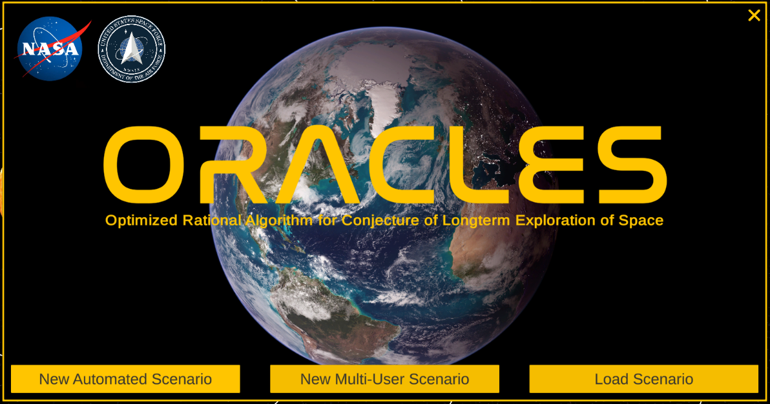
Fig. 2 Launch Screen
- Database Entry
In database entry mode Subject Matter Experts (SMEs) are asked to suggest and make cost, schedule, risk, and future implication assessments for potential technologies, infrastructure, and policies (collectively called investments) related to space futures. The SMEs will be guided through the development of these inputs using the Integrated Programmatic Formulations Tools (IPFT). This set will utilize mature cost estimating tools and relationships, mature technology readiness level estimate algorithms, mature schedule development algorithms, and mature technical design choice methods and databases. Together these tools will create a representative Program Plan that will be used in ORACLES for programmatic refinement and integrated outcome evaluation. Since multiple technologies will be developed simultaneously in some ORACLES evaluation simulations the tools set will have the capability to evaluate interdependencies and cross-programmatic issues.
Even the best developed predictions are not accepted as fact. The IPFT will allow SMEs to override the cost schedule and technical aspects as necessary when some concepts are outside of the scope covered by IPFT. Inputs to ORACLES may then be further randomized and extrapolated using the Monte Carlo Method in order to be give as comprehensive and unbiased results as possible. The inputs of multiple SMEs, as well as vetting between SMEs, further addresses potential outlier data.
The database entry screen for infrastructure (fig. 3) shows a mockup of an SME inputting data for a solar-thermal propelled orbital transfer vehicle (OTV). The SME is required to make estimates for both minimum and maximum construction, and use timelines, and costs. Furthermore, the program considers the reduced costs of creating and operating a second or third unit of the same infrastructure by asking for these estimates. The timeline panel in the top right of the screen is based on the NASA System Engineering Handbook’s project life cycle which accounts for all phases of a project, from pre-design through development, construction, use, and eventual closeout.
The SME also estimates values for infrastructure capabilities. These inputs will greatly differ across projects but draw from several categories. The SMEs are asked to predict a series of outcomes aligned with the three axes from the SFWs: population in space, economy, and influence. These are further broken down to account for the different ways a project may contribute to any one of these results. Population is categorized by the working population, dependent population, and tourist population associated with the infrastructure investment. Economics considers the transfer of wealth between spacefaring entities, as well as commercial or governmental entities on Earth. Economic flows are broken down by goods and services offered and paid for, production of resources, accumulation, and distribution in order to understand the potential direct results of an infrastructure on the constructing entity. Finally, influence is categorized as either hard or soft power. Hard power is the direct projection of power or force in specific regions of space such as low Earth orbit (LEO) or the lunar surface. Soft power is estimated as a metric of the number of scientific papers and associated exploration miles and other effects that are a result of the infrastructural investment.

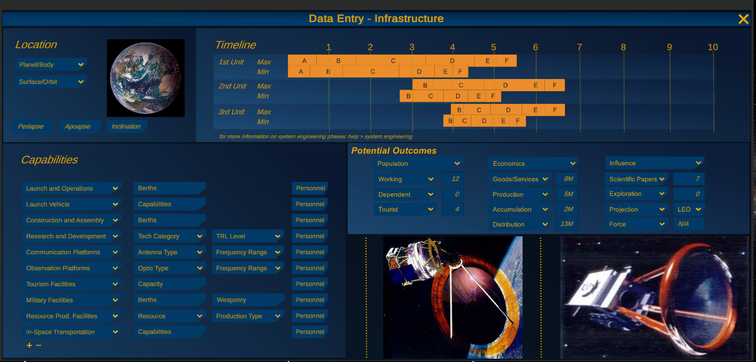
Fig. 3 Database entry screen for infrastructure projects

The database entry screen for policy investments follows a similar vein as the infrastructure screen by again asking for ranges of estimated inputs and resulting outcomes. Experts are asked to plan and approximate the goals of specific policies. In this example policy, NASA and its commercial and governmental collaborators are investing in a policy with the goal to support solar thermal technology development and the construction of multiple orbital transfer vehicles. Policy goals may or may not be directly related to specific technologies and other investments as in this example; however, policies are likely to affect entity relationships and flow of money and resources related to different projects regardless of their stated involvements.
For each participating or investing entity for a given policy, the SMEs will estimate a range of possible contributions and subsequent renumeration for their involvement. These estimates all factor into the likelihood of an entities’ participation in the policies or projects and the resulting outcomes. The SMEs are again asked to approximate the potential outcomes of these policies according to the population, economy, and influence metrics required for evaluation and comparison.
In addition to the potential outcomes panel which is duplicated from the database entry for infrastructure investments, the policy screen includes a breakdown of outcomes specific to each affected entity (fig. 4, bottom right). This is particularly important for gauging the effects on entities not directly involved in the policy or related projects. In this example of an OTV collaboration policy, any non-participating governmental entity is likely to lose influence in both LEO and the lunar orbits and surface, and a non-participating commercial entity is likely to suffer a loss in space-produced GDP. These will be factored into the evaluating algorithm in future phases of this project.

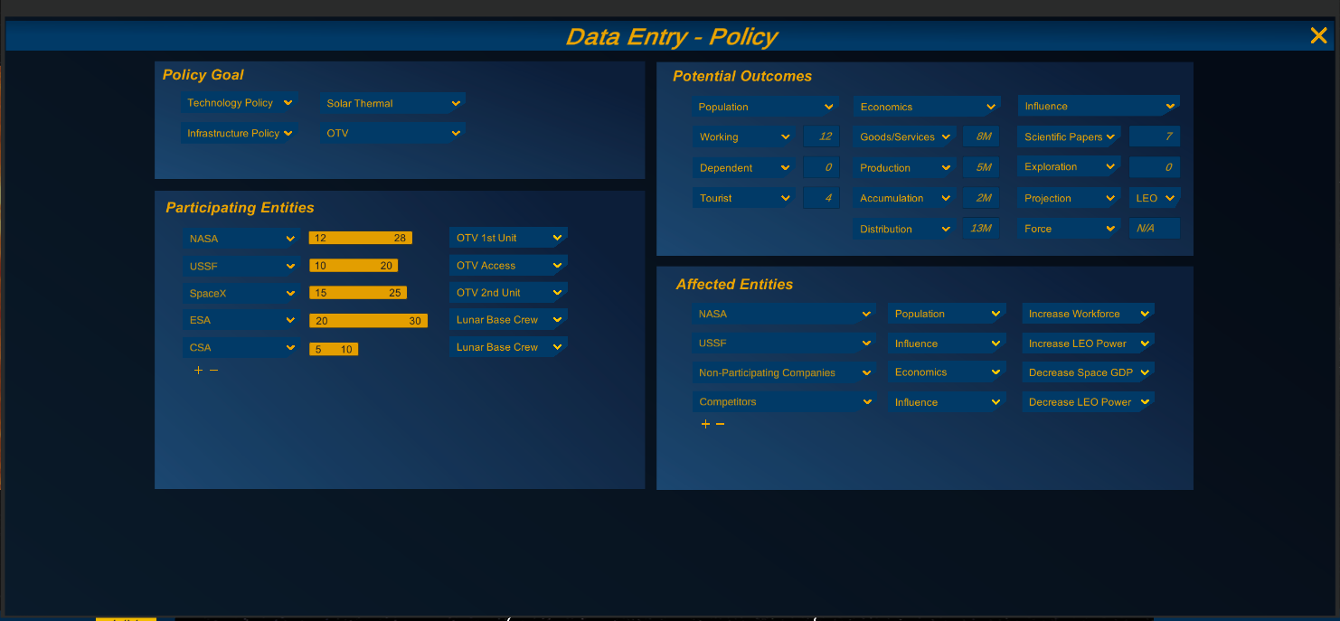
Fig. 4 Database entry screen for policy options

A future panel is expected for investments in technology development. The panel will build on the 3D representation of technology development as seen in the next section.
The creation of this detailed database will be an ongoing process along with the use of the ORACLES program itself. We understand that new technologies are constantly being developed and that no matter how accurate the model is at one point, things will change. ORACLES acknowledges this in its very structure by not tying itself to a static database and incorporating the data accessibility and manipulation within the frontend of the program. Furthermore, ORACLES can in this way serve as a repository for potential projects and policies. By hosting this nearly complete and adaptable collection of information, it becomes a consolidated resource for those invested in the future of space exploration.
- Multi-User Scenario
Following the creation of a robust database, ORACLES may be used in one of two ways. The first option for use is as a multi-user decision-making tool which progresses in annual rounds from 2020 to 2060. Each user makes decisions as an entity, such as NASA, USSF, other countries’ space programs, and commercial companies. The users progress funding projects in each category: technology, infrastructure, and policy. Once all the users have made their choices, the program determines how successful each project has been for the year through the random variables on cost and schedule. Each user gets a screen readout of their projects success/failure, informing them on what investments to make next year.
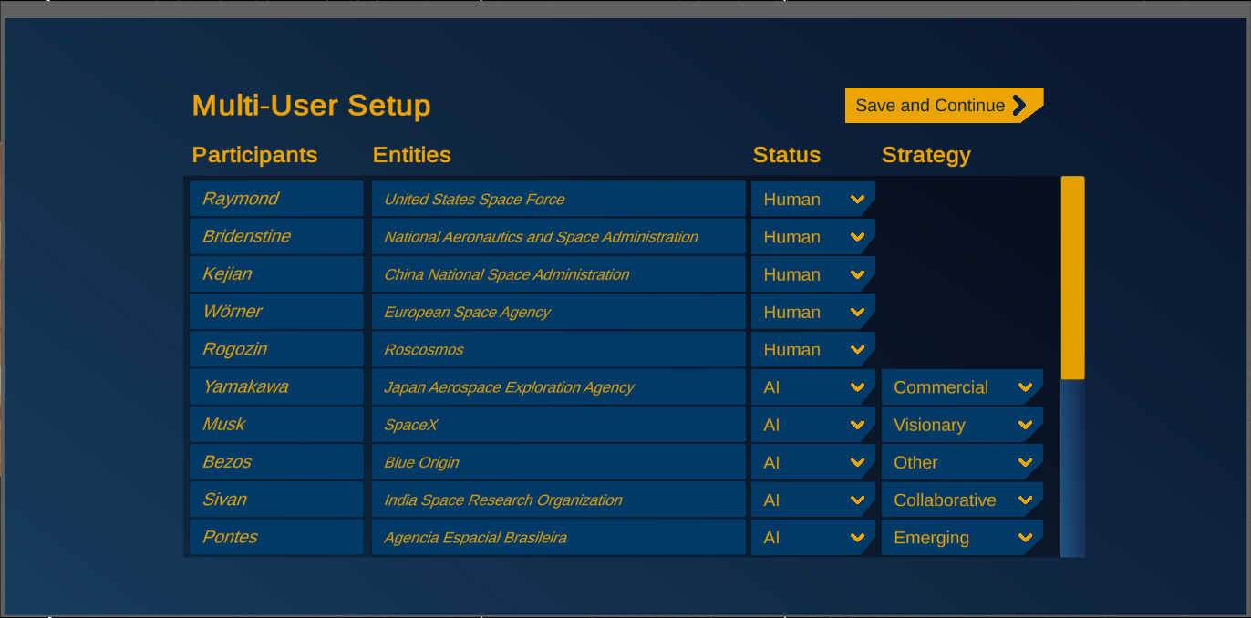
Fig. 5 Multi-User setup screen for an interactive scenario

User Interface
The user interface (UI) of this mode of ORACLES is an essential element for the clear communication of the complex information embedded in the decision-making process. ORACLES prefers clean visual representations over difficult to process numbers, charts, and text. While all of this is certainly included in the program and provided to users on-command, ORACLES endeavors to provide as much information at-a-glance as possible.
The main screen therefore hosts a three-dimensional visualization of the inner solar system which is fully navigable and may be set at either a visible (fig. 6) or accurate scale to encourage ease of use and complete understanding. The outer solar system is also included in the model but is not a primary focus of many near-future space projects and the program must be zoomed-out substantially in order to see these planets.
In the bottom right-hand corner of the screen are three buttons which allow the user to turn on and off visualizations of the current year’s results according to population, economy, and influence.

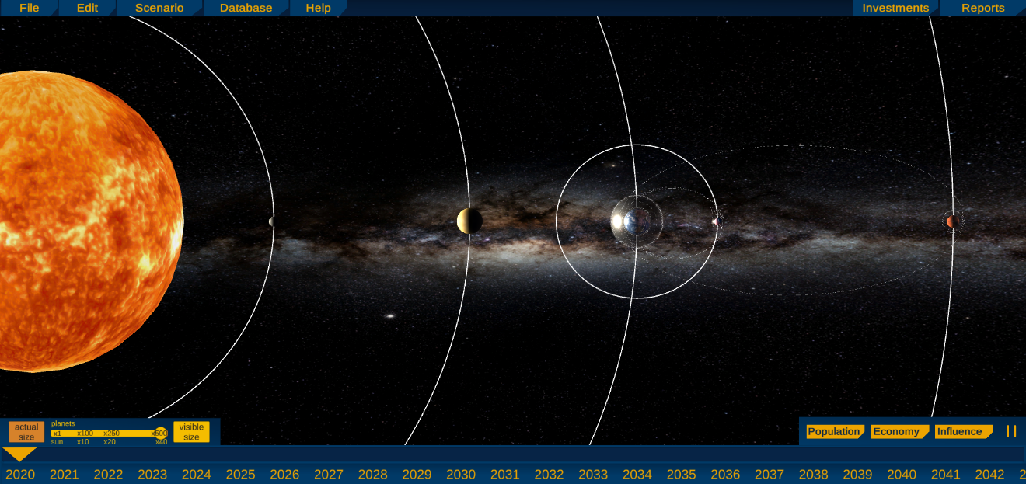
Fig. 6 Main Screen user interface showing the inner solar system and relevant orbits.

Continuing the trend of three-dimensional visualization, rather than simply listing the satellites, space stations, and planetary or lunar bases, ORACLES includes representations of this activity for each year according to the active projects by all participating entities. Figure 7 shows an example of a possible future 2031 where the Lunar Gateway station is active and OTVs serve to ferry people and resources between Earth and the Moon. Each of these orbits or bases may be clicked on to open more details about the project and related infrastructures, technologies, and policies.

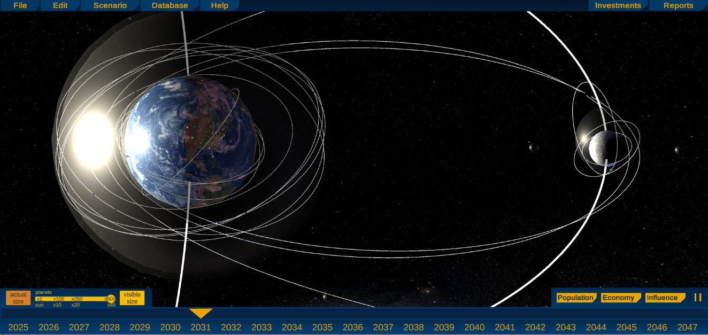
Fig. 7 Visualization of orbits, projects, and space traffic by year

The interface can be further zoomed in on a planet to show ground infrastructure by entity. In figure 8 we see several entities and locations of ground facilities in Europe and Asia (top) and North America (bottom).

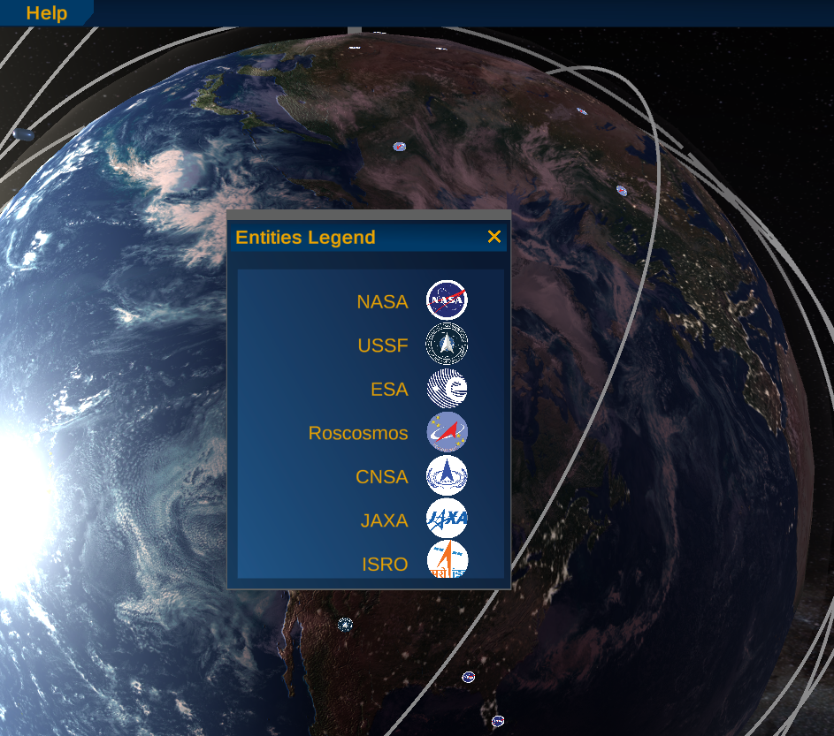
Fig. 8 Legend of entities included in the simulation, note the icons shown on the Earth’s surface as specific infrastructural locations such as NASA’s Kennedy Space Center and Roskosmos’s Star City, Moscow

Investments
The following section covers the selection screens for participants in the multi-user scenario. The technology tree (fig. 9) breaks down the vast number of technologies that both NASA and USSF may be involved in developing according to more specific project categories. These are organized according to NASA’s Technology Taxonomy. Once a user selects a subcategory for more detailed examination, a three-dimensional graph (fig. 10) that charts the relationships between Technology Readiness Levels (TRLs), project categories, and levels of system complexity.

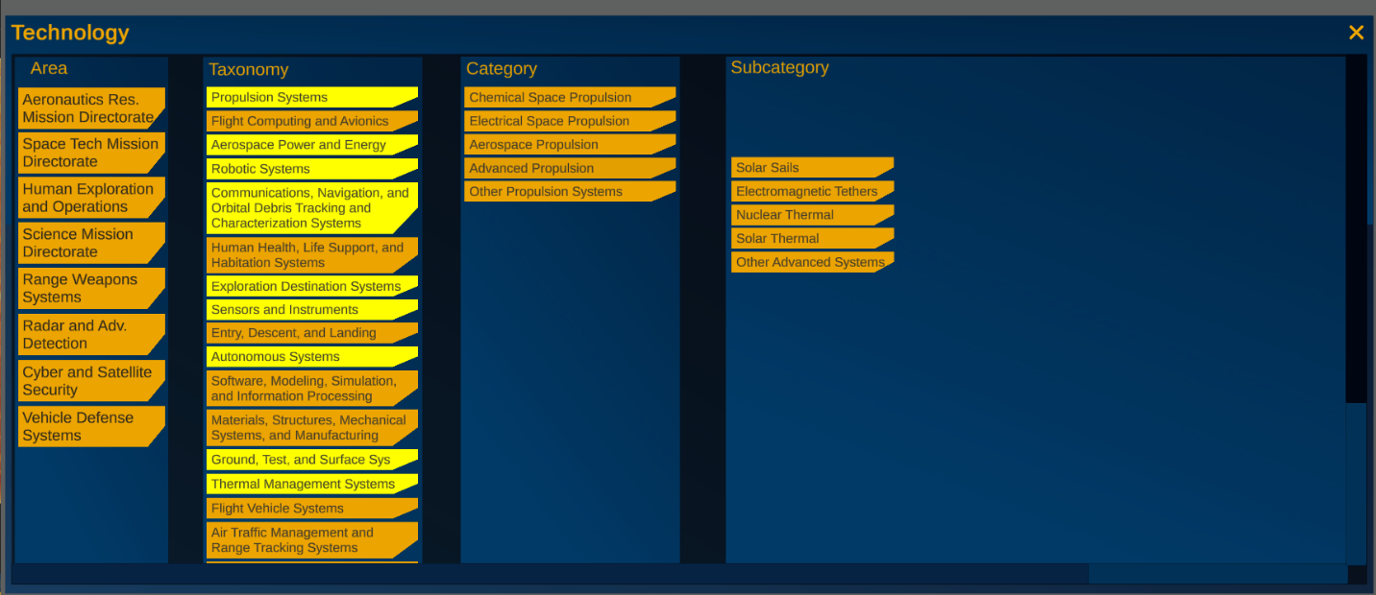
Fig. 9 Technology “Tree” for user investment, showing the flow from project areas through NASA’s defined Technology Taxonomy into specific categories and subcategories

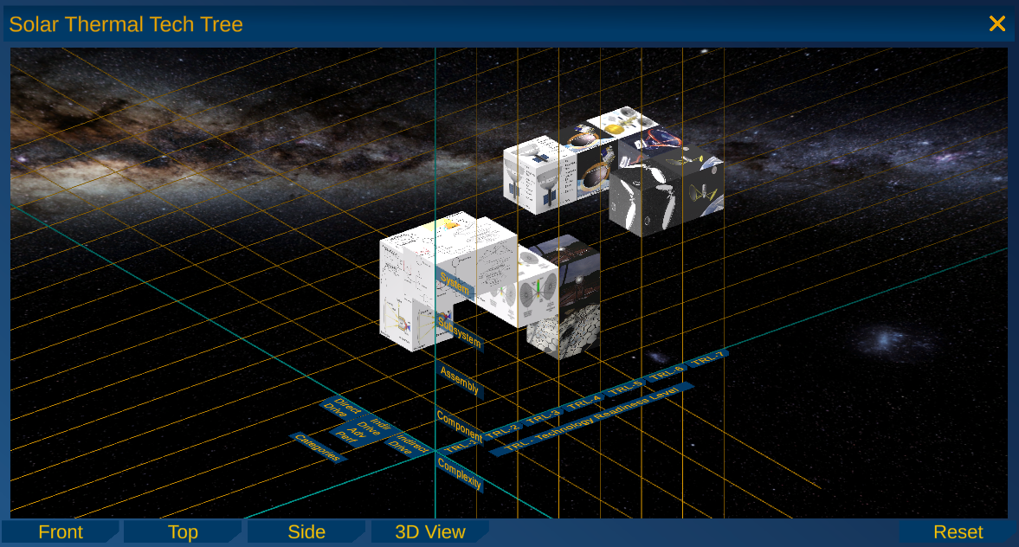
Fig. 10 Technology graph for a specific subcategory, in this example, solar thermal propulsion

Technology Readiness Levels are standard use across the industry and are reviewed in several sources. The NASA Systems Engineering Manual[2] is the authoritative source on TRLs. Suffice it to say that TRL 1 represents an idea, potentially on the back of a napkin, and TRL 7 is reached when a technology has been demonstrated as working in its relevant environment (space for the current discussion). Figure 10 does not illustrate TRLs 8 and 9, as that is usually vehicle specific and not part of a technology development program.
Complexity levels are integrated with TRLs to indicate the process of developing component technologies into a complete system. In the example, components such as collectors and heat exchangers are developed at the component level and then integrated at the assembly and subsystem level until they are mature enough to be combined in a complete solar thermal subsystem.
Finally, the technology development roadmap is segmented in its third axis by category. Most technologies have multiple paths resulting in slightly different complete concepts with different capabilities. Here the solar thermal concept is divided into three categories: an indirect drive where the propellant is heated through a heat exchanger that also absorbs reflected sunlight, a direct drive where the propellant absorbs the incoming sunlight without an intermediary, and an advanced indirect drive option conceived here for illustrative purposes.
Each technology development block represents the effort needed to take one component, assembly, subsystem or system, for a given category, up one TRL. Each block can be clicked pulling up a window with more specific information.
This graph is meant to be explored and examined from multiple viewpoints (fig. 11) in order to accurately compare technologies and understand the necessary investments to progress a technology from one TRL level to the next or to integrate different components into assemblies. Each technology “box” may be clicked on to bring up more detailed information, and the axis labels are selectable as well in order to highlight particular sections (fig. 12).

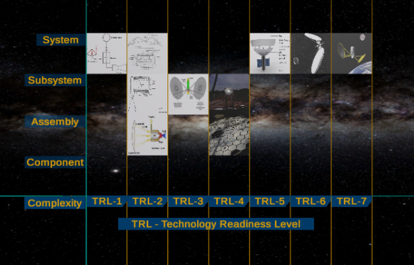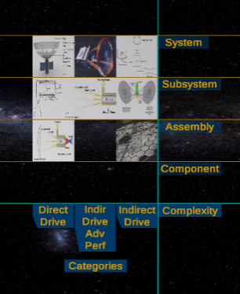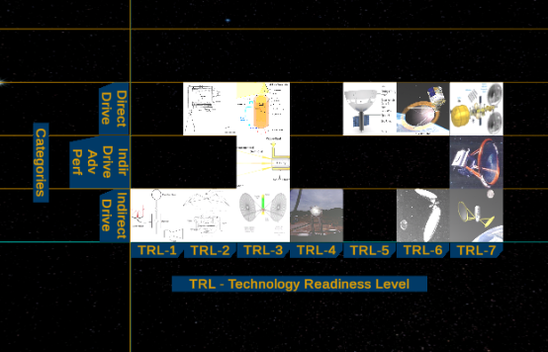
Fig. 11 Different views of the 3D graph allow the user to compare technologies across two of the three axes

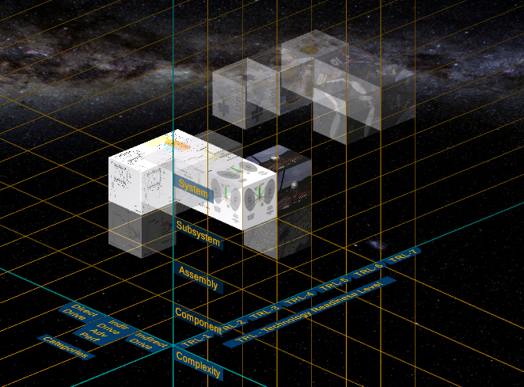
Fig. 12 Highlighting different rows and columns focuses on specific categories, complexities or TRLs

The infrastructure screen (figure 13) illustrates to the user the pertinent data on building a new component for a space program. Here we see our solar thermal Orbital Transfer Vehicle (OTV) example. The data collected from SMEs on OTVs is processed and used to calculate the schedule and cost for a first unit, as well as the expected outcomes in terms of population, economy, and influence.

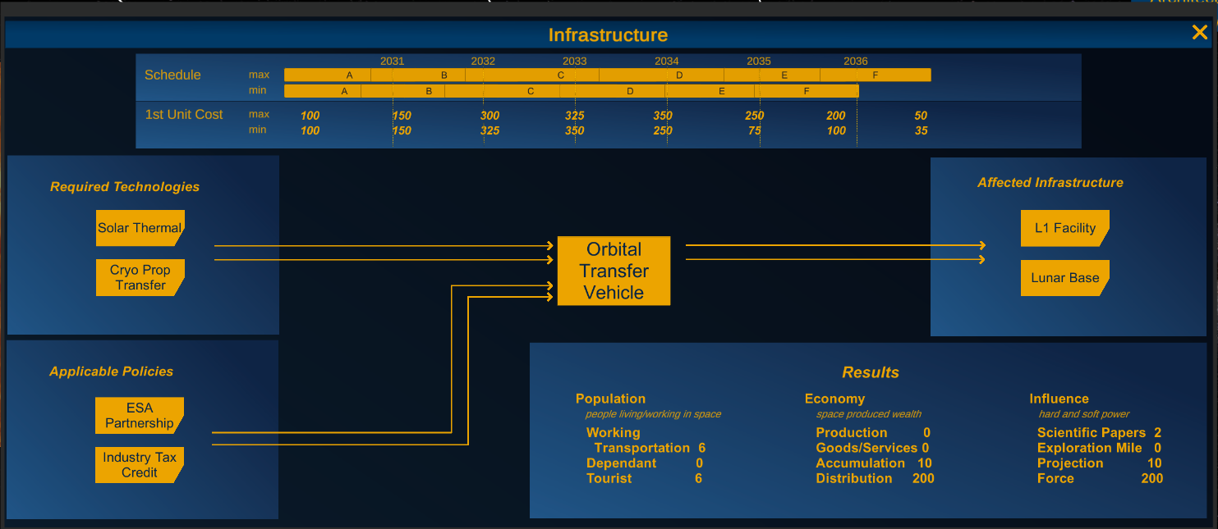
Fig. 13 Infrastructure screen for users to select and specify their investments for each year of the simulation

Users can click on the help button and access helpful information to assist in decision-making. Figure 14 shows a screenshot from the NASA Systems Engineering Handbook [3] that defines each of the phases of development for a project as shown in the cost and schedule portion of figure 13.

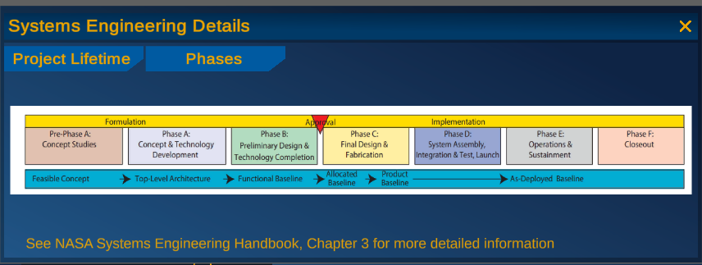
Fig. 14 Graphic representation from NASA Systems Engineering Handbook, Ch 3 regarding project lifetime phases. This information is used in the schedule of fig. 13

When an infrastructure component is completed it can be integrated into an architecture and used to complete various missions. In figure 15 the Solar Thermal OTV is being integrated into movement of people and supplies from Earth to the Lunar Gateway. The architecture screen anticipates integration of ground assets such as launch and assembly facilities and communications assets both on the ground and in-space networks.
The authors believe that some of the most influential investments may come from policy. Figure 16 illustrates how a partnership to develop solar thermal technology would be passed through the entity’s decision making system. Here the entity is the U.S. Government, the House of Representatives and Senate are illustrated. For other entities their government or corporate structure would be represented here.

Scenario Results
At the end of each year, users receive the project status screen (fig. 17). The upper project panel includes a list of all technology and infrastructure investments and their current progress. For technologies, this specifies the budget put towards each aspect of the research. The infrastructures section covers the difference between the expected project phase and costs for this year and the actual phase and cost as evaluated by ORACLES.
The budget panel at the bottom of the screen details the exact spending of an entity on all TRL levels and the projects therein, as well as the infrastructure investment costs per area: aeronautics, science, exploration, and military. Any areas for which an entity has gone over-budget are marked in red.

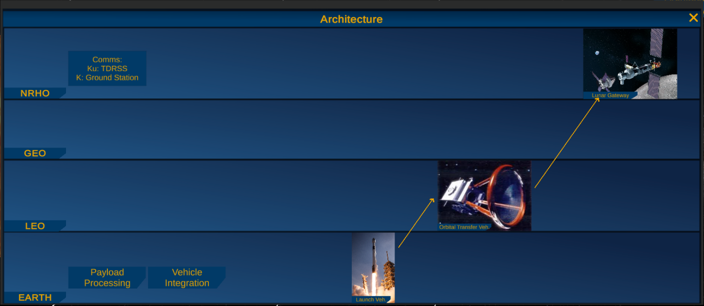
Fig. 15 Architecture investment screen, mockup of different infrastructure projects which combine to produce a cohesive architecture

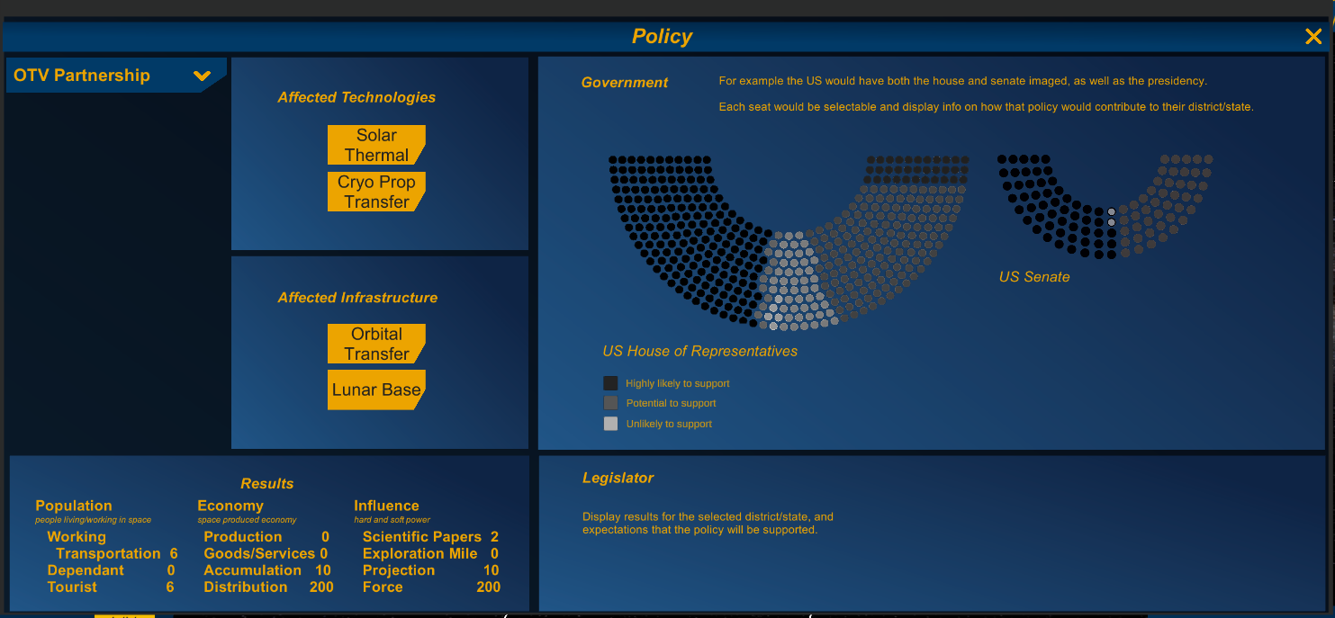
Fig. 16 Policy screen for users to select yearly investments in commercial and governmental policies

The project status screen does not cover every important aspect of an entities investments but is intended to serve as an overview for a user between simulation years. ORACLES will require further reports and results screens as the program develops in order to represent information about policy outcomes and entity’s relations. Many of these results are also included in the main user interface as three-dimensional visualizations described in section A.

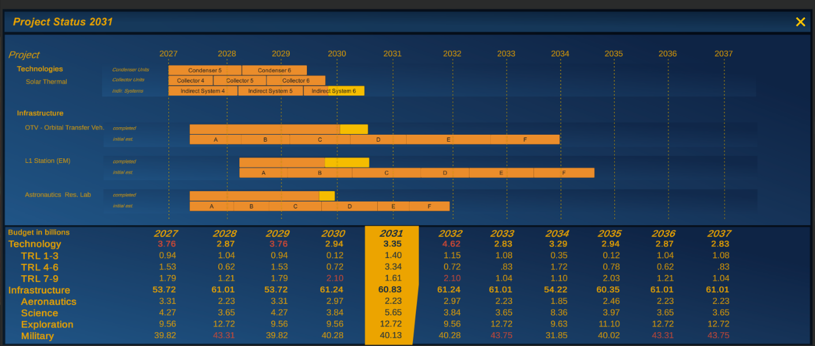
Fig. 17 Project Status screen mockup

- Automated Scenario and Evaluation Methodology
The automated scenario system has not yet had an interface mockup. The authors anticipate a screen allowing a setup of entities and their particular AI strategies. Other factors such as starting points for the simulation and potential ground rules would be reflected here. Another screen would show the progress through each year and the results for each AI entity. At completion the program would produce another interface showing the inflection points, that is investments that produced the greatest effect in terms of population, economy and/or influence.
The Multi-User Scenario will allow for interactive evaluations ranging from cooperative to highly competitive development scenarios. ORACLES would use mathematical and economic game theory to structure the cooperative or competitive activity. Types of analysis could include zero-sum, perfect information, combinatorial, discrete, continuous, evolutionary, and stochastic. These types of simulation could be combined to evaluate different aspects of the simulation.
- Conclusion
The ORACLES project has just started, and the authors anticipate significant modification and growth to the ORACLES concept, as well as the interfaces based on subject matter expert feedback. The authors wish to collect as much input from the community as is reasonably possible before development of the ORACLES back-end. It is our hope that ORACLES will eventually prove to be a worthy government developed and owned tool for moderating the discussion of investments and goals in space, and that decision makers will find its results worthy of consideration.

Acknowledgments
The authors acknowledge the nearly 100 contributors to the Space Futures Workshops. Their work is the impetus to the ORACLES model. Furthermore, we’d like to express our appreciation to Bryan Winterling and Kimberly Gonzalez, who along with Ms. Liston-Beck, created the acronym and name – ORACLES. May this program prove worthy to its inspiring moniker.

References

[1] Air Force Space Command “The Future of Space 2060 and Implications for U.S. Strategy: Report on the Space Futures Workshop,” Air Force Space Command, Distribution A, September 2019.
[2] National Aeronautics and Space Administration, NASA System Engineering Handbook, NASA SP-2016-6105 Rev2, p. 211.
[3] National Aeronautics and Space Administration, NASA System Engineering Handbook, NASA SP-2016-6105 Rev2, p. 8.

AST Engineer, Propulsion Systems and Technologies, AIAA Associate Fellow
Unity Development Intern, Propulsion Systems and Technologies, AIAA Student Member
AST Engineer, Propulsion Systems and Technologies.
Chief Scientist, United States Space Force, AIAA Senior Member

