Magnetically Levitated Space Mechanisms

Samuel A. Howard, Ph.D.
Christopher DellaCorte, Ph.D.
NASA Glenn Research Center

Mike .J. Dube
NASA Langley Research Center, Ph.D

Larry Hawkins
Calnetix Technologies

Space mechanisms can be loosely defined as any mechanical component or assembly that moves and operates in a space environment. As such, space mechanisms include such mechanical systems as deployable solar arrays, linear actuators, rotary actuators, motors, gear systems, etc. One of the basic components of many space mechanisms are bearings, and because bearings inherently experience wear over time, rotating space mechanisms have a finite life expectancy. In addition, some space mechanisms have suffered from premature wear, which can jeopardize the success of a mission. For these reasons, there is always a search for better, longer-life bearing solutions for space mechanisms.
Rolling element bearings have long and deep space mechanism heritage and are often the first choice in mechanism design. However, for some applications that demand extremely long life or operation where contamination from lubricants (oil and grease) are a concern, magnetic bearings are a potential solution. Magnetic bearings are a relatively recent development that is making significant inroads in large terrestrial machine applications like pipeline pumps and compressors. A few magnetic bearing reaction wheels have been flown, but the technology has not yet gained wide-spread adoption in space, primarily due to concerns regarding cost, mass and reliability. However, in response to various rolling element bearing failures in space mechanisms, the NESC Mechanical Systems Team has supported the concept of developing magnetic bearing technology for space mechanisms beginning in 2012.
The NESC sponsored an in-depth study of the current state-of-the-art in magnetic and other bearing technologies to identify the key pros and cons of each technology. A near term potential application considered was the ammonia cooling pump on the ISS which had suffered failure due to wear of its carbon bushings. The NESC study identified the areas where an investment in magnetic bearing technology would be needed to address shortcomings for space mechanisms and concluded that there are no significant technical hurdles that could not be overcome. The review of bearing technologies was eventually published as a NASA TM (Howard 2019).
The NESC-sponsored study inspired a recent demonstration application for magnetic bearings which is expected to set precedent for future space applications of the technology. A magnetic bearing air blower has been designed, built, tested and in August 2020, was delivered to NASA MSFC for use in the next generation Carbon Dioxide Removal Assembly (CDRA) aboard the ISS. The current CDRA blower utilizes foil air bearings. Magnetic bearings offer improved resistance to debris in the air stream and the ability to endure vacuum operation which can occur during operational anomalies. To accomplish this ISS-funded demonstration project, in 2017, NASA issued a Request For Information (RFI) seeking design concepts for a CDRA blower. Magnetic levitation was submitted by industry as a potential design that could meet all of the system requirements. A procurement phase for the magnetic bearing blowers was initiated in early 2018. The magnetic bearing blower (explained in more detail in Hawkins 2020) is now undergoing system level ground testing and is scheduled to be used as the heart of the 4BMS CDRA system. Successful launch and operation on-orbit stands to open the door to many future applications of magnetic bearing space mechanisms in future NASA missions and was given its initial push by the NESC. This work was performed at GRC.

Howard, S.A., DellaCorte, C., and Dube, M.J., “Magnetic Levitation for Long-Life Space Mechanisms: Technology Assessment and Remaining Challenges,” NASA/TM-2019-220052.
Hawkins, L., Filatov, A., Khatri, R., DellaCorte, C., Howard, A., “Design Of A Compact Magnetically Levitated Blower For Space Applications,” ASME Turbo Expo, Paper GT2020-15090, September 2020, London (Virtual).

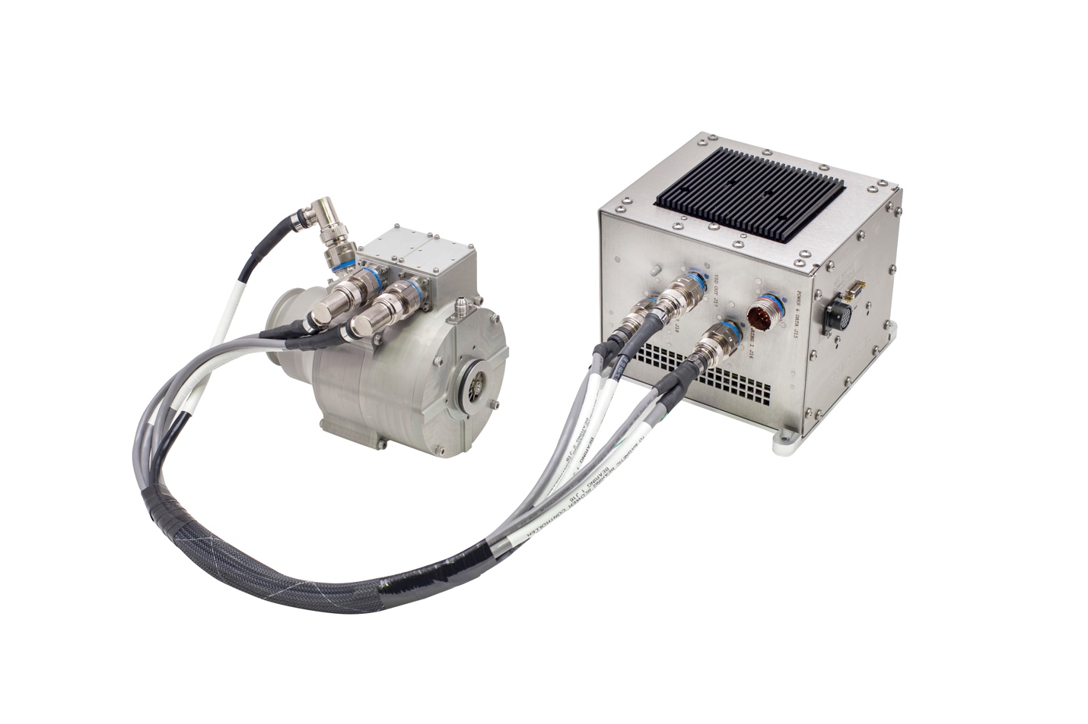
Magnetic Bearing CDRA Blower and Controller
Source: Calnetix Technologies

