Cambridge Urban Development
Quantifying Changes in Urban Albedo with NASA Earth Observations to Reduce Urban Heat Island Effect in Cambridge, Massachusetts


Technical Report
Final Draft – August 6th, 2020

Nicole Ramberg-Pihl (Project Lead)
Sophie Barrowman
Liam Bhajan
Olivia Cronin-Golomb

Advisors
Dr. Cedric Fichot, Boston University (Science Advisor)
Dr. Medhi P. Heris, University of Colorado (Science Advisor)
Dr. Kenton Ross, NASA Langley Research Center (Science Advisor)

1. Abstract
The urban heat island (UHI) effect occurs when urban areas have temperatures that are warmer on average than the surrounding suburban and rural regions. Low albedo surfaces traditionally found in urban landscapes, such as dark asphalt and rooftops, absorb solar irradiance and reemit heat, which contributes to the UHI effect. Cambridge, Massachusetts, part of the Boston metropolitan area, expects severe impacts on human health, infrastructure, and local environmental features due to increasing urban heat. The Massachusetts – Boston NASA DEVELOP team partnered with the City of Cambridge Community Development Department and the American Geophysical Union’s Thriving Earth Exchange to inform ongoing planning and heat mitigation efforts. High Resolution Orthoimagery (HRO) and National Agriculture Imagery Program (NAIP) scenes were analyzed in conjunction with ancillary datasets to assess changes in rooftop albedo between 2008 and 2018. Aqua Moderate Resolution Imaging Spectroradiometer (MODIS) data were used to determine nighttime land surface temperature (LST) between 2003 and 2019. Lastly, temperature anomalies were calculated using seasonally averaged nighttime LST values obtained from Aqua MODIS to display ‘hot spots’ for summers between 2004 and 2019. On average, albedo increased by 0.12 across the city, with the majority of positive change in commercial areas. Analysis of mean summer nighttime LST between 2003 and 2019 revealed a non-significant increase in temperature, although temperature anomaly maps demonstrated that Cambridge was warmer on average than rural areas. These results were incorporated in the interactive Cambridge Urban Heat Dashboard, which allows users to explore temporal trends in albedo.
Key Terms
urban heat island, albedo, land surface temperature, climate, preparedness, remote sensing, ArcGIS Dashboard

2. Introduction
2.1 Background Information
The Urban Heat Island (UHI) effect occurs when urban environments experience warmer temperatures compared to surrounding suburban and rural areas (Shmaefsky, 2006). This temperature difference can range from 5 to 11°C and is often attributed to traditional features of the urban landscape, such as impervious surfaces and surfaces with low reflectivity that absorb solar irradiance and emit heat (Patz, Campbell-Lendrum, Holloway, & Foley, 2005; Shmaefsky, 2006). The impacts of increased urban heat include heat-related mortality, poor air quality, and increased energy consumption as community members attempt to cool buildings (Fallmann, Forkel, & Emeis, 2016; Gago, Roldan, Pacheco-Torres, & Ordóñez, 2013; Patz et al., 2005). These impacts are exacerbated by extreme variation in regional temperature and climate change. During heat waves, documented mortality rates are three times higher in urban centers than in non-urban areas (Tan et al., 2010). Furthermore, these effects can disproportionally affect vulnerable populations based on age, income, and race due to their limited adaptive capacity (Vargo, Stone, Habeeb, Liu, & Russell, 2016; Voelkel, Hellman, Sakuma, & Shandas, 2018).

Albedo, measured on a unitless scale between 0 and 1, is the proportion of incident solar radiation reflected by a surface and is a key factor in UHI management (Ban-Weiss, Woods, & Levinson, 2015). In urban areas, low albedo, or low reflectivity, materials are commonly used in infrastructure; these include dark asphalt used in roads and roofing materials. These materials store heat, absorbing solar irradiance during the day and emitting it during the night (Peng, Piao, Ciais, Friedlingstein, & Ottle, 2012). Rooftops make up approximately 20% to 25% of city landscapes, and previous studies have utilized remote sensing techniques to evaluate the albedo of different roofing materials (Ban-Weiss & Levinson, 2015; Mackey et al., 2012). To track temperature differences between urban and non-urban locations, remote sensing is used to assess changes in daytime and nighttime land surface temperature (LST) in cities across the globe (Polydoros, Mavrakou, & Cartalis, 2018). Common strategies for mitigating the impacts of increased urban heat include increasing rooftop albedo, installing green roofs, and switching to cool pavement (Gago et al., 2013). Increasing the presence of vegetation, commonly denoted as green spaces, throughout an urban area is another common strategy (Oliveira, Andrade, & Vaz, 2011).

The City of Cambridge, Massachusetts, spans approximately 18 square kilometers (7 square miles) and is part of the greater Boston metropolitan area (Figure 1). By 2030, experts expect Cambridge will experience warmer than average temperatures, more heatwaves, and triple the number of abnormally warm days above 32°C (90°F) per year (City of Cambridge, 2015). According to the US Census Bureau, the estimated population of Cambridge in 2010 was approximately 100,000 residents with a population density of 16,469 residents per square mile. Considering that over 60% of the city consists of impervious surfaces and accounting for the anticipated effects of climate change, urban heat poses a threat to the livelihoods of Cambridge residents.

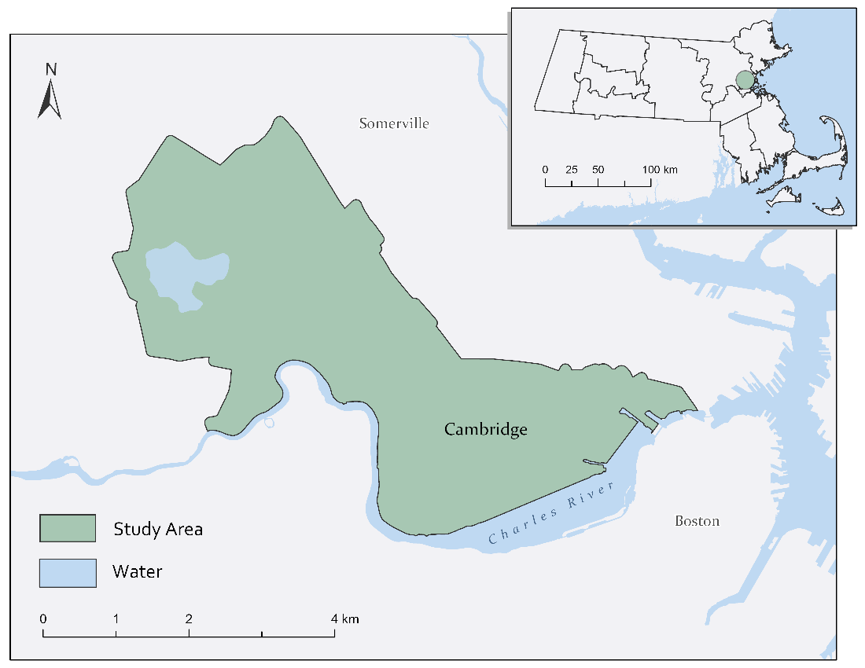
Figure 1. Study area map showing the City of Cambridge’s border with a 75-meter buffer added to ensure coverage of all Cambridge buildings. The inset map shows the location of Cambridge in Massachusetts.

This project aimed to understand the variation and spatial distribution of urban heat and assess the potential effects of local environmental initiatives aimed at increasing albedo to reduce the impact of UHIs. The Summer 2020 Massachusetts – Boston DEVELOP team calculated rooftop albedo for three distinct years: 2010, 2014, and 2018. The team also constructed a nighttime LST record for the summer months of June, July, and August from 2003 to 2019 and produced temperature anomaly maps using seasonally averaged summer nighttime LST from 2004 to 2019.

2.2 Project Partners & Objectives
This project represents a unique partnership between the Massachusetts – Boston team, the City of Cambridge Community Development Department, and the American Geophysical Union’s Thriving Earth Exchange (TEX). Similar to the NASA DEVELOP National Program, TEX strives to connect scientists and community leaders to address environmental challenges. John Bolduc and Drew Kane, Environmental and Land Use Planners for the City of Cambridge Community Development Department, are currently involved with the city’s “Climate Change Preparedness and Resilience Plan” which includes actions to reduce the impacts of urban heat in Cambridge, but currently does not discuss urban albedo. The partners were looking to understand how rooftop albedo contributes to urban heat within their city.

To inform the City of Cambridge’s ongoing mitigation efforts, the DEVELOP team used remote sensing techniques to measure and analyze changes in rooftop albedo between 2008 and 2018. The team also constructed a nighttime LST record during the summer months of June, July, and August between 2003 and 2019. Finally, the team created maps that displayed temperature anomalies or ‘hot spots’ within the city compared to the surrounding non-urban environment for summer months between 2004 and 2019. The team input these results into an interactive Cambridge Urban Heat Dashboard to help visualize spatial and temporal patterns in albedo and urban heat. The tools generated from this project will help our partners and the larger Cambridge community evaluate their progress in reducing urban heat.

3. Methodology
3.1 Data Acquisition
Google Earth Engine (GEE) was used to access and download data from Aqua Moderate Resolution Imaging Spectroradiometer (MODIS), MYD11A.006 MODIS/Aqua Land Surface Temperature and Emissivity Daily Global 1km data (Table 1). Additional datasets included USDA National Agriculture Imagery Program (NAIP) aerial imagery at 1 m resolution and USGS High Resolution Orthoimagery (HRO) at 0.15 - 0.3 m resolution, both downloaded from EarthExplorer (Table 1). The City of Cambridge Buildings shapefile provided by the City of Cambridge contained building footprints used for isolating rooftop NAIP and HRO pixels while calculating albedo for 2010 and 2018. The MassGIS Building Structure (2D) shapefile provided this information for 2013. The team also obtained a City of Cambridge Neighborhood Boundaries shapefile from the City of Cambridge, which was included in albedo calculations as well as the dashboard for comparison of albedo values at a neighborhood scale. The City of Cambridge provided City of Cambridge Tree Canopy data from 2014 as well as City of Cambridge Impervious Surface data from 2010 which were included in the dashboard to allow visual comparison between tree canopy cover, impervious surface, and albedo values. Lastly, the Metropolitan Area Planning Council Municipal Boundaries shapefile containing 101 municipality boundaries surrounding Boston, Massachusetts, was provided by the City of Cambridge and included in the dashboard to provide a visual comparison of nighttime temperature anomalies at the municipal level.

Table 1
Earth observations and imagery utilized in data processing.
PLATFORM | SENSOR | Product ID | DATES | PURPOSE | SOURCE
NAIP | Aerial Imagery  (4 Bands: Red, Green, Blue, Near-infrared) | /10.5066/F73X84W6 | 2010, 2014, 2018 | Calculate building level albedo values | EarthExplorer
HRO | Aerial Imagery  (4 Bands: Red, Green, Blue, and Near-infrared) | /10.5066/F7QN651G | 2008, 2013, 2018 | Calculate building level albedo values | EarthExplorer
Aqua | MODIS | MYD11A.006 MODIS/Aqua Land Surface Temperature and Emissivity Daily Global 1km | Each June, July, and August from 2003 to 2019 | Retrieve nighttime land surface temperature | GEE

3.2 Data Processing
3.2.1 Rooftop Albedo
To understand how rooftop albedo changed throughout the study period, the team first selected three distinct years to investigate (Table 2). These periods were chosen based on the availability of the NAIP, HRO, and building shapefile data for each time period. Each scene from the NAIP and HRO imagery contained red, blue, green, and near-infrared bands that, when combined, captured the extent of the study area. The HRO scenes were mosaicked to make one continuous raster in ArcGIS Pro using the WGS_1984_UTM_Zone_19N projection, 16-bit unsigned pixel type, and ‘Maximum’ mosaic operator. The ‘Maximum’ mosaic operator was used as a precaution to ensure that actual satellite measurements would be selected over ‘nodata’ pixels present in any overlapping sections of the borders between scenes. The same process was used for the NAIP imagery. The team clipped and masked both the mosaicked NAIP and HRO imagery to the extent of the study area. Additionally, the pixel cells of the HRO imagery were resized to match the spatial resolution of the NAIP imagery using the nearest-neighbor resampling technique because it is a simple process that preserves the original data. Each band of the resulting HRO and NAIP raster images was exported as an IMG file to be further processed in Python. Each building shapefile was prepared for analysis in Python by first creating a unique building ID field and then rasterizing the shapefile based on that unique ID. Any non-building pixels were removed by reclassifying ‘nodata’ pixels as zeros and filtering them out.

Table 2
Rooftop albedo study periods with corresponding imagery and building shapefile dates.
TIME PERIOD | HRO DATE | NAIP DATE | BUILDING SHAPEFILE DATE
1 | 2008 | 2010 | 2010
2 | 2013 | 2014 | 2011
3 | 2018 | 2018 | 2018

Rooftop albedo calculations were processed using Python code provided by Dr. Mehdi Heris (University of Colorado) that combined the preprocessed HRO and NAIP imagery for each time period with the corresponding building raster file (Table 2). The scikit-learn preprocessing library was used to scale each band of the HRO and NAIP imagery to a value between 0 and 1. Albedo was calculated for every pixel in the raster from the scaled HRO and NAIP imagery bands using Equation 1 from Vanino et al. (2018):

$\text{Albedo} \left[\text{unitless}\right] \text{=} \left(\text{0.17*B1}\right)\text{-}\left(\text{0.13*B2}\right)\text{+}\left(\text{0.33*B3}\right)\text{+(0.54*B4)}$ (1)

where B1 refers to the scaled band 1 (red), B2 refers to the scaled band 2 (green), B3 refers to the scaled band 3 (blue), and B4 refers to the scaled band 4 (near-infrared).

The resulting albedo measurements for the HRO and NAIP pixels were aggregated based on the pixels’ unique building IDs. The median (50th percentile) value and 80th percentile value of the pixels with the same building IDs were used as final proxies for rooftop albedo. The team used the median and 80th percentile value as opposed to the mean as they would be less sensitive to potential effects of very high and very low albedo measurements from small objects on rooftops. The 80th percentile value was used to try to account for shadows caused by the angle of the sun when the images were collected. The final albedo measurements of each building were combined into a table, mapped, and exported for use in the Cambridge Urban Heat Dashboard.

3.2.2 Aqua MODIS Nighttime LST Record
The team created a summer nighttime LST record for the period of 2003 to 2019. Nighttime LST was retrieved from Aqua MODIS by modifying previously written GEE code from the 2020 Spring AZ – Tempe Philadelphia Health & Air Quality Project (Nisbet-Wilcox, Samuel, Spencer, & Wagner, 2020). The team gathered data for our study region for June, July, and August, as well as averaged summer LST for each year in our study period. Pixels that either contained no LST data due to clouds or had an error of >3 Kelvin (indicated by QC night quality indicators) were removed (Nisbet-Wilcox, Samuel, Spencer, & Wagner, 2020). Before exporting the data, LST values were converted from Kelvin to Fahrenheit. The rasters were then imported into ArcGIS Pro and clipped to the study region for final visualization.

3.2.3 Temperature Anomaly Maps
Temperature anomaly maps were created for the City of Cambridge from 2004 to 2019. The Massachusetts – Boston DEVELOP team modified existing methods developed by the 2019 Fall LaRC New York City Urban Development team (Harrison, Robertson, Garcia Falcon, & McCardle, 2019) to calculate temperature anomalies for the City of Cambridge using the Aqua MODIS nighttime LST product. The team gathered seasonally averaged summer (June, July, and August) LST data for a subsection of eastern Massachusetts that was larger than the Cambridge study region for each year in our study period. Pixels that either contained no LST data due to clouds or had an error of >3 Kelvin (indicated by QC night quality indicators) were removed (Nisbet-Wilcox, Samuel, Spencer, & Wagner, 2020). Before exporting the data, LST values were converted from Kelvin to Fahrenheit. The team then imported the data into Python. Using the fiona and rasterio packages, the team masked imagery to the subsection of eastern Massachusetts. This area included urban, suburban, and rural areas, which normalized the temperature anomalies across the landscape. Seasonally averaged summer nighttime LST values were extracted from each pixel contained in the subsection of eastern Massachusetts. These values were used to calculate the mean nighttime LST for the study region, which was then subtracted from the LST value for each pixel in the image. The team then created a new raster that contained values reflecting the ‘difference from the mean’ or temperature anomalies for each pixel. Pixels with a positive value represented ‘hot spots’ while those with negative values represented ‘cool spots’ across the landscape. These rasters were imported into ArcGIS Pro and clipped to the expanded region of eastern Massachusetts for final visualization and included in the Cambridge Urban Heat Dashboard.

3.3 Data Analysis
3.3.1 Rooftop Albedo
Mean, minimum, and maximum albedo for each year of the analysis were calculated on both a city-wide and neighborhood-wide scale (Figure A1). The city and neighborhood absolute albedo changes were calculated by subtracting the mean 2008 albedo from the mean 2018 albedo. The team converted the absolute albedo change to percent area albedo change by first classifying buildings that experienced a large amount of albedo change as those that shifted from less than or equal to 0.6 albedo in 2008 to greater than or equal to 0.8 albedo in 2018. There are no generally accepted thresholds for high or low albedo within the scientific community. The team chose these thresholds because they provided a wide enough margin for visualizing change while remaining confident that the change observed was not a result of potential error propagation. The team then calculated the area of each building footprint in ArcGIS Pro and used Equation 2 to calculate percent albedo area change in each neighborhood:

$\text{100 * }\left(\frac{\text{Area of Changed Buildings in the Neighborhood}}{\text{Total Area of Buildings in the Neighborhood}}\right)$ = % Albedo Area Change (2)

3.3.2 Aqua MODIS Nighttime LST Record
Using R, the team conducted a linear regression analysis to test whether seasonally averaged summer nighttime LST in Cambridge changed between 2003 and 2019. The Shapiro-Wilks test was used to check normality of the data and residuals. Data met the assumptions of linear regression analysis. Visual inspection of model diagnostic plots also indicated that residuals met assumptions of normality and homoscedasticity. The team also tracked pixel-level change in seasonally averaged summer nighttime LST for each neighborhood in Cambridge over the study period (Figure A2). Maps were visually inspected to assess spatial patterns in nighttime LST throughout the city.

3.3.3 Temperature Anomaly Maps
The team calculated the mean temperature anomaly of Cambridge, normalized to eastern Massachusetts, for each year in our study period. Using Python, rasters were masked to the Cambridge study area, allowing the team to calculate the mean temperature anomaly value for the entire city. Maps were visually inspected to identify visible patterns in nighttime temperature anomalies within Cambridge and across the larger portion of eastern Massachusetts.

4. Results & Discussion
4.1 Analysis of Results
4.1.1 Albedo Results
Comparing the distribution of the NAIP and HRO albedo results revealed that the NAIP results had a higher magnitude albedo than the HRO results. Additionally, the NAIP distribution had a second peak in the high albedo range (Figure 2). This combination indicated that the NAIP imagery was oversaturated. Oversaturation occurs when the sensor used to record the reflected radiance is not sensitive enough to record variation in extremely high reflected values. The team did not attempt to correct this phenomenon in the analysis due to time constraints. Therefore, the team decided to move forward with only the HRO results for the analysis.

Visual inspection of the original true color HRO revealed shadows next to taller objects on the rooftops and only one side of steepled roofs. This indicated that the sun was not directly overhead when the images were collected, which would result in artificially low albedo measurements in shadowed areas. This phenomenon was qualitatively captured when comparing the magnitude of the 50th percentile albedo distribution to the 80th percentile distribution (Figure 2). The 50th percentile distribution was skewed towards the lower albedo values while the 80th percentile values were more normally distributed. The 50th percentile was also more leptokurtic than the 80th percentile distribution, indicating that the 50th percentile albedo proxy measured less of a range of albedo values. The patterns of the distribution indicated that the 80th percentile proxy should be used over that 50th percentile albedo proxy.

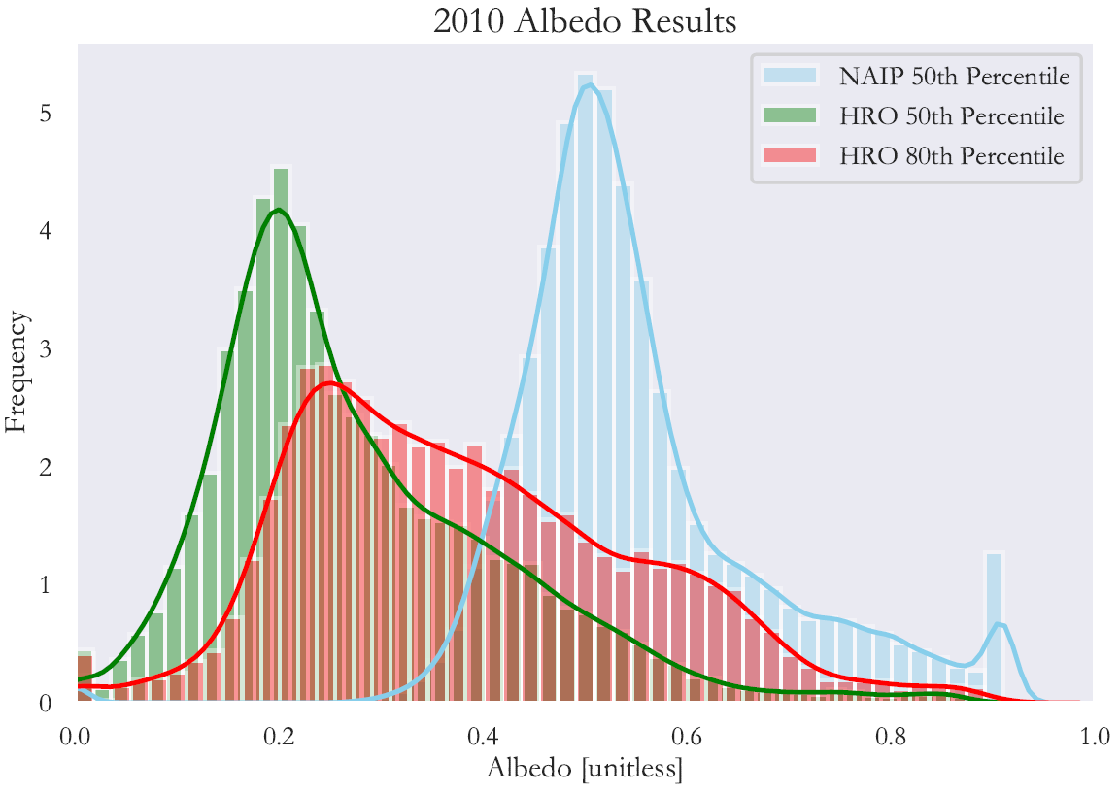
Figure 2. Distribution of the 2010 50th percentile albedo values derived from the NAIP and HRO imagery as well as the 80th percentile values derived from HRO imagery.

Each year of the albedo 80th percentile HRO results was mapped to its respective building footprints throughout the Cambridge study area for 2018 (Figure 3), as well as 2008 (Figure A3) and 2013 (Figure A4).
The buildings were symbolized based on the albedo value and each map was symbolized at the same scale to compare potential differences in the results. The calculated rooftop albedo values matched the visual brightness of the respective rooftops in the true-color imagery, increasing our confidence in the results.

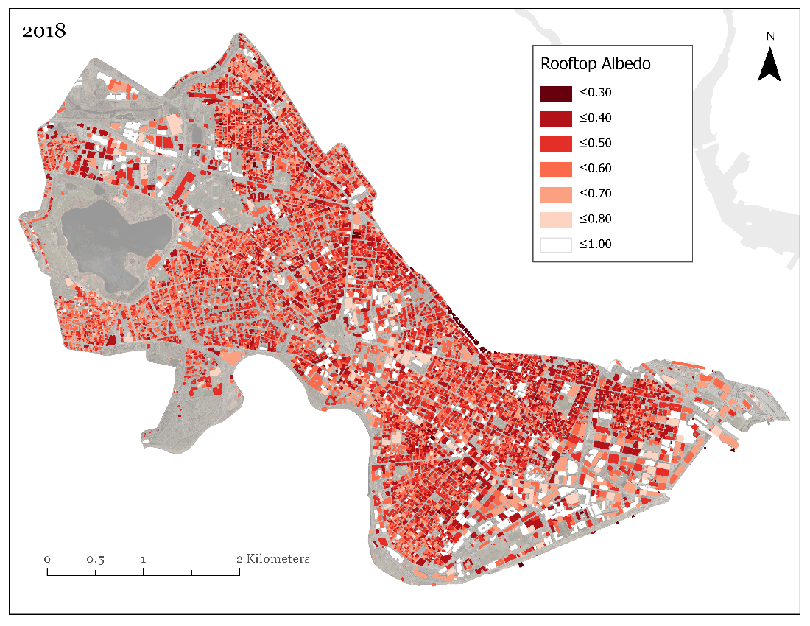
Figure 3. Map of Cambridge rooftop albedo using the 80th percentile HRO proxy results for 2018. High albedo values, symbolized by lighter-colored buildings, reflected more incoming solar radiation which theoretically reduced the amount of heat trapped in the city. Building rooftops with low albedo values were represented by dark red and absorbed more of the incoming solar radiation, likely increasing urban heat.

The majority of positive change in albedo from 2008 to 2018 was found in non-residential areas, with an average albedo increase of 0.12 across the city (Figure 4). Furthermore, each neighborhood in Cambridge experienced an increase in albedo between 2008 and 2018 (Table A1, Figure A5). By 2018, the Area 2/MIT neighborhood had the highest albedo while the Wellington-Harrington neighborhood had the lowest albedo value. The Area 2/MIT neighborhood experienced the greatest amount of albedo change with an increase of 0.19. The Wellington-Harrington neighborhood experienced the lowest amount of change with an increase of 0.10 (Table A1, Figure A5). When converted to albedo building area percent change, Area 2/MIT still experienced the greatest amount of change with a 25% increase. Strawberry Hill experienced the least amount of change with a 0.8% increase (Table A1, Figure A5). Buildings with larger rooftops were more frequently defined as experiencing large amounts of albedo change according to our predefined thresholds.

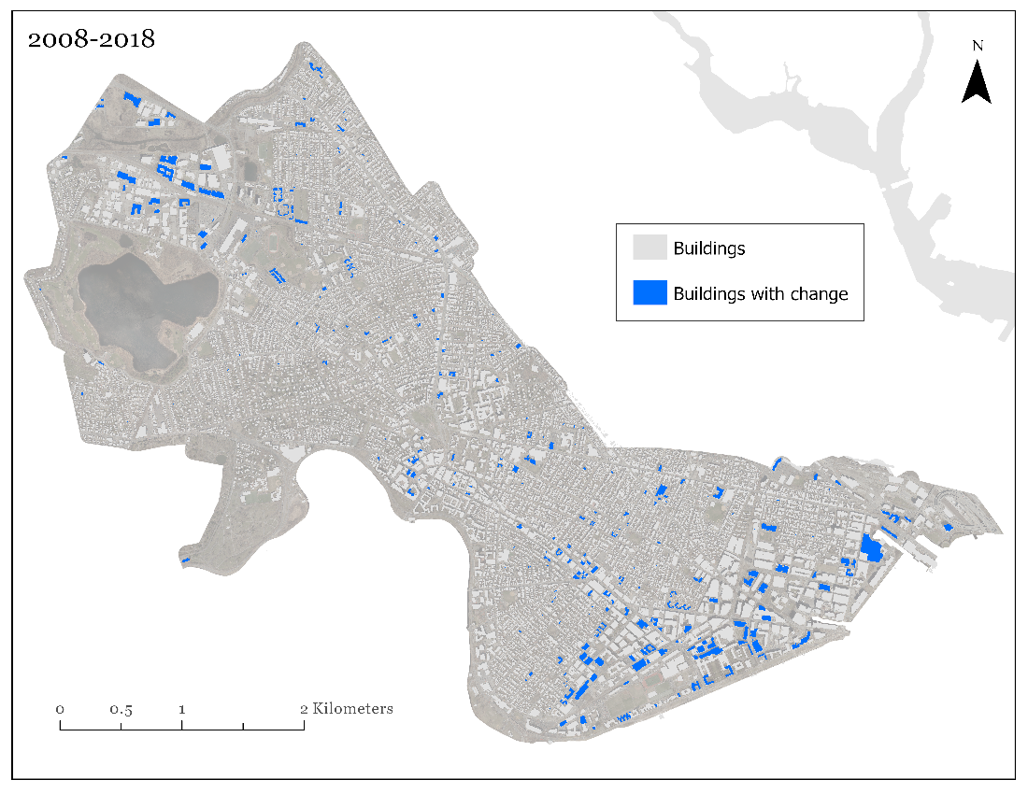
Figure 4. Buildings with large positive albedo change from 2008 to 2019. Those that have an albedo value of less than or equal to 0.6 in 2008 and greater than or equal to 0.8 in 2018 are shown in blue. Buildings that did not satisfy this criterion are shown in grey.

4.1.2 Nighttime Temperature Record Results
Results of our regression analysis show that mean summer nighttime LST demonstrated a nonsignificant increase between 2003 and 2019 (F_{(1,15)} = 3.36, p = 0.087, R² = 0.18; Figure 5). Further comparison of mean summer nighttime LST from 2003 to 2010 and 2011 to 2019 revealed an increase in temperature of 0.57 °F. Visual inspection of the nighttime LST maps revealed that the western portion of Cambridge appears to be consistently cooler than other portions of the city, even when the overall mean temperature for the city varies from year to year (Figure A6).

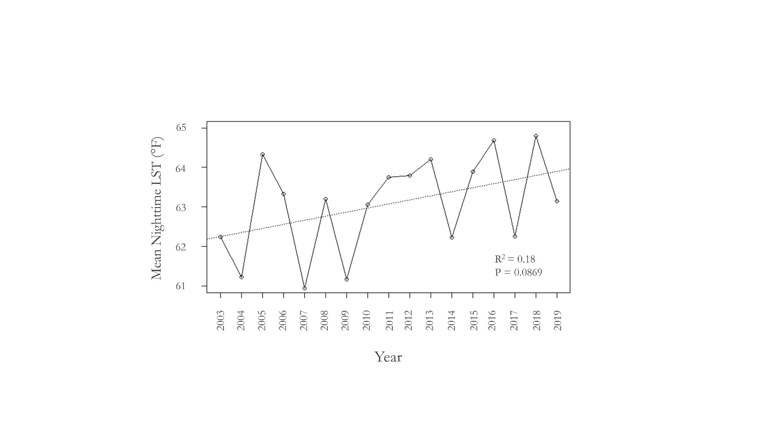
Figure 5. Mean Nighttime LST °F averaged over the summer months of June, July, and August for Cambridge between 2003 and 2019. Trendline displays a nonsignificant increase in mean temperature over time. Regression statistics, R² value, and p-value are displayed in the lower righthand corner.

4.1.3 Temperature Anomaly Results
The team found that the average temperature for the entire region of eastern Massachusetts was 60.2 °F. Compared to the larger region of eastern Massachusetts, visual inspection of the temperature anomaly maps revealed that Cambridge experienced higher than average temperatures compared to surrounding rural communities and thus appeared as a ‘hot spot’ compared to rural areas (Figure 6). Spatial distribution of temperature anomalies within Cambridge showed lower differences in temperature or ‘cool spots’ on the western side of Field Pond compared to other portions of the city. Temporally, the team found that Cambridge demonstrated a positive mean temperature difference of 2.89 °F between 2004 and 2019 (Figure A7).

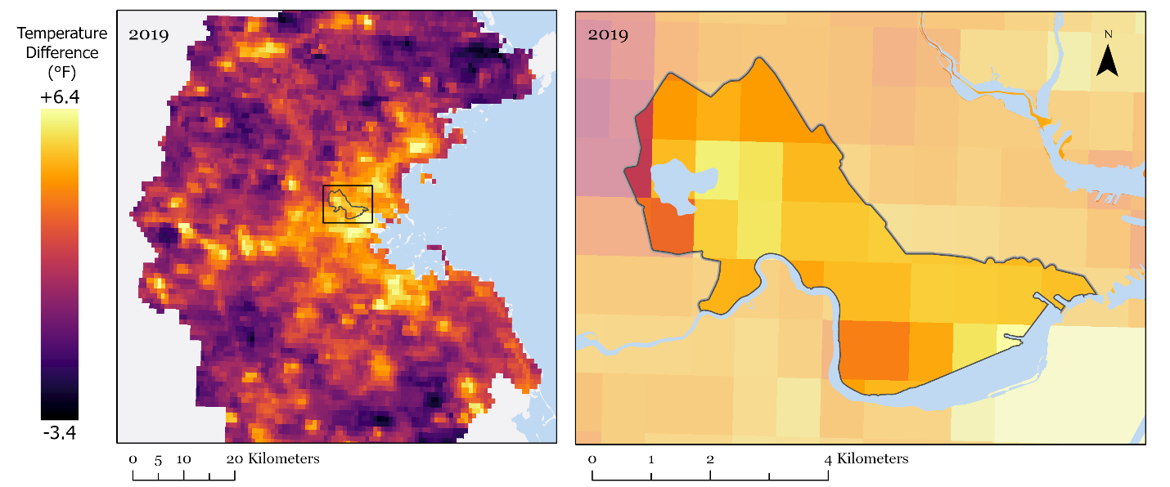
Figure 6. The left panel shows temperature differences from mean nighttime temperature (60.2 °F) for eastern Massachusetts for the combined months of June, July, and August 2019. Brighter shades of yellow represent positive temperature anomalies, or areas warmer than the mean called 'hot spots.’ Darker shades of purple represent negative temperature anomalies, or areas colder than the mean, called 'cool spots'. The right panel displays an enlarged image of Cambridge, an urban area characterized by colors that fall on the higher end of the color bar range than the rural areas that tend to fall on the lower end of the color bar range.

4.2 Errors and Uncertainty
One potential source of error for the project was that solar zenith angle and viewing angle of the camera were not taken into account, for either HRO or NAIP imagery. Given that the sun was not directly overhead during image collection, shadows were present next to objects on both rooftops and the sides of steepled roofs opposite the direction of the sun. When not accounted for, these shadows can result in artificially low albedo values. The angled view of the camera was also a source of uncertainty in that the sides of buildings occasionally overlapped with building footprints. The inaccuracies resulting from this depended on the angle of the sun since one building side could be in shadow while another side could be illuminated. Although these inaccuracies were present in both the NAIP and HRO imagery, the NAIP imagery contained more shadows and had a wider camera angle. Additionally, the distribution of the albedo results from the NAIP imagery indicated oversaturation, as previously discussed (Figure 2). Since the HRO imagery was not oversaturated and more precisely aligned with building footprints, the team determined that the HRO results were more
accurate and decided to move forward reporting HRO results.

An additional source of error in our albedo analysis was that the shapefile and imagery dates did not always align. Thus, the final albedo results may have included buildings that were demolished or constructed between the time when the image was captured and when the building shapefile was created. Finally, it is important to note that LST values do not translate directly into air temperature. Although there is a strong relationship between LST and air temperature, these variables have different physical meanings and varying responses to atmospheric conditions. Comparing nighttime LST values derived from MODIS to in situ air temperature data would have provided an accuracy estimate for utilizing LST values as a proxy for air temperature. Due to time constraints, the team was not able to conduct such an accuracy assessment.

4.3 Future Work
Future work could strive to include validation steps for both albedo and temperature results using in situ data. These data could be collected from temperature probes on buildings spanning a range of both rooftop brightness and materials throughout the Cambridge study area. The City of Cambridge could further evaluate the accuracy of these albedo results by experimentally applying UHI mitigation strategies to designated rooftops and then utilize in situ data to validate if such changes are identifiable in satellite-derived results. The collection of in situ and satellite-derived albedo over an extended timeframe could help to characterize long-term changes resulting from urban development. This would allow the City of Cambridge to further assess the effectiveness of their current mitigation strategies and even improve upon them. Future projects could also work to improve the albedo results by correcting the oversaturation in the NAIP imagery. This would allow the albedo results from NAIP imagery to be statistically comparable with the HRO albedo results. The ability to compare the results from both sources of imagery would provide insights into additional sources of error contained within the images themselves or within the albedo proxy that would otherwise remain unnoticed. Future teams could also improve the interpretation of spatial and temporal trends in albedo and temperature by comparing the results of this work with tree canopy cover and impervious surfaces across Cambridge. Additionally, combining these environmental variables with the Social Vulnerability Index previously generated by the City of Cambridge could provide insight into which communities may be most affected by urban heat within the city.

5. Conclusions
The findings of the Cambridge Urban Development project reinforce the importance of mitigation efforts put forth by the City of Cambridge as they work to reduce the impacts of urban heat. Our work showed that the majority of positive change in albedo from 2008 to 2018 was found in non-residential areas, with an average albedo increase of 0.12 across the city. This overall positive increase is encouraging, as it indicates that buildings are shifting away from low albedo roofing material and towards more reflective, high albedo materials. Given that mitigation efforts are ongoing, the importance of being able to monitor and detect shifts in albedo as well as temperature is crucial in reducing the impacts of urban heat. Comparison of mean summer nighttime LST from 2003 to 2011 and 2011 to 2019 revealed an increase of 0.57°F, with a nonsignificant increase between 2003 to 2019. Additionally, Cambridge temperature anomalies normalized to a portion of eastern Massachusetts demonstrated a positive mean temperature difference of 2.89°F between 2004 to 2019. The fact that Cambridge experienced warmer nighttime temperatures than rural areas over the last 16 years is important as it demonstrates the ability of the urban landscape to retain heat compared to rural areas. The end products from this project will provide the City of Cambridge with a methodology to visualize changes in rooftop albedo and nighttime LST over time. Specifically, these results were included in the interactive Cambridge Urban Heat Dashboard that allows users to explore spatial and temporal trends in albedo over time. This, combined with the long-term temperature record, will allow the City of Cambridge to assess the effectiveness of urban heat reduction strategies. Ultimately, these tools will help the city adapt to the impacts of UHIs affecting communities in Cambridge.

6. Acknowledgments
We would like to thank our NASA DEVELOP Fellow, Celeste Gambino, for her guidance throughout the Summer 2020 term. We would also like to thank our Science Advisors, Dr. Cedric Fichot from Boston University, Dr. Mehdi Heris from the University of Colorado, and Dr. Kenton Ross from the NASA DEVELOP National Program for their contributions to the project. Lastly, we would like to thank our partners, John Bolduc and Drew Kane from the City of Cambridge, Community Development Department, and Julia Jeanty from the American Geophysical Union, Thriving Earth Exchange.

Any opinions, findings, and conclusions or recommendations expressed in this material are those of the author(s) and do not necessarily reflect the views of the National Aeronautics and Space Administration.

This material is based upon work supported by NASA through contract NNL16AA05C.

7. Glossary
Albedo – The proportion of incident solar radiation that is reflected by a surface, measured between 0 (absorbs all incident radiance) and 1 (reflects all incident radiance)
HRO – High Resolution Orthoimagery is collected at 1 m resolution through contracts USGS has with other public and private agencies. The data is then orthorectified and distributed via the USGS EROS Center.
LST – Land Surface Temperature, which differs from air temperature, the radiative “skin” temperature of the land derived from solar radiance. “Skin” refers to the topmost surface e.g. bare soil, tree canopy, rooftop, etc.
MODIS – Moderate Resolution Imaging Spectroradiometer. A sensor on the Aqua satellite.
NAIP – National Agriculture Imagery Program (NAIP) run by the U.S. Department of Agriculture's Farm Service Agency. Collected during the agricultural growing season at 0.3 m resolution and then orthorectified.
Remote Sensing – Gathering information at a distance, typically remote sensing gathers information about the Earth through the use of sensors on satellites.
Urban Heat Island – The phenomenon where urban environments experience warmer temperatures compared to surrounding suburban and rural areas.
Urban Heat – Warmer temperatures created by the urban environment, often due to a lack of vegetation that would otherwise provide shade and cooling through evapotranspiration, high proportion of low albedo surfaces, and density of buildings that create and trap heat.

8. References
Ban-Weiss, G. A., Woods, J., & Levinson, R. (2015). Using remote sensing to quantify albedo of roofs in seven California cities, Part 1: Methods. Solar Energy, 115, 777–790. https://doi.org/10.1016/j.solener.2014.10.022

Fallmann, J., Forkel, R., & Emeis, S. (2016). Secondary effects of urban heat island mitigation measures on air quality. Atmospheric Environment, 125, 199–211. https://doi.org/10.1016/j.atmosenv.2015.10.094

Gago, E. J., Roldan, J., Pacheco-Torres, R., & Ordóñez, J. (2013). The city and urban heat islands: A review of strategies to mitigate adverse effects. Renewable and Sustainable Energy Reviews, 25, 749–758. https://doi.org/10.1016/j.rser.2013.05.057

Harrison, S., Robertson, J., Garcia Falcon, L., & McCardle, B. (2019). New York City Urban Development: Mapping Hotspots using NASA Earth Observations to Inform Future Green Initiatives in New York City. NASA DEVELOP National Program. Langley, VA.

HRO, 2010, 2014, 2018. High Resolution Orthoimagery, United States Geological Survey (USGS). DOI number: /10.5066/F73X84W6
NAIP, 2008, 2013, 2018. National Agriculture Imagery Program, United States Department of Agriculture’s Farm Service Agency (FSA). DOI number: /10.5066/F7QN651G
NASA Goddard Space Flight Center, Ocean Ecology Laboratory, Ocean Biology Processing Group. Moderate-resolution Imaging Spectroradiometer (MODIS) Aqua {MYD11A.006 MODIS/Aqua Land Surface Temperature and Emissivity Daily Global 1km} Data; NASA OB.DAAC, Greenbelt, MD, USA. doi:10.5067/MODIS/MYD11A1.006.

Nisbet-Wilcox, Samuel, M., Spencer, N., & Wagner, C. (2020). Philadelphia Health and Air Quality: Assessing Land Surface Temperature, Vegetation Cover, and Compounding Vulnerability Factors to Identify High Priority Areas for Cooling Initiatives in Philadelphia, Pennsylvania. NASA DEVELOP National Program. Langley, VA.

Oliveira, S., Andrade, H., & Vaz, T. (2011). The cooling effect of green spaces as a contribution to the mitigation of urban heat : A case study in Lisbon. Building and Environment, 46(11), 2186–2194. https://doi.org/10.1016/j.buildenv.2011.04.034

Patz, J. A., Campbell-Lendrum, D., Holloway, T., & Foley, J. A. (2005). Impact of regional climate change on human health. Nature, 438(7066), 310–317. https://doi.org/10.1038/nature04188

Peng, S., Piao, S., Ciais, P., Friedlingstein, P., & Ottle, C. (2012). Surface Urban Heat Island Across 419 Global Big Cities. https://doi.org/10.1021/es2030438

Polydoros, A., Mavrakou, T., & Cartalis, C. (2018). Quantifying the trends in land surface temperature and surface urban heat island intensity in Mediterranean cities in view of smart urbanization. Urban Science, 2(16), 16. https://doi.org/10.3390/urbansci2010016

Shmaefsky, B. (2006). One Hot demonstration: The urban heat island effect. Journal of College Science Teaching, 35(7), 52.

Tan, J., Zheng, Y., Tang, X., Guo, C., Li, L., & Song, G. (2010). The urban heat island and its impact on heat waves and human health in Shanghai, 1850, 75–84. https://doi.org/10.1007/s00484-009-0256-x

Vanino, Silvia, Nino, P., De Michele, C., S.F., D’Urso G., Di Bene, C., Pennelli, B., Vuolo, F., Farina R., Pulighe, G., & Napoli, R. (2018). Capability of Sentinel-2 data for estimating maximum evapotranspiration and irrigation requirements for tomato crop in central Italy. Remote Sensing of Environment, 215, 452-470. http://doi.org/10.1016/j.rse.2018.06.035.

Vargo, J., Stone, B., Habeeb, D., Liu, P., & Russell, A. (2016). The social and spatial distribution of temperature-related health impacts from urban heat island reduction policies. Environmental Science and Policy, 66, 366–374. https://doi.org/10.1016/j.envsci.2016.08.012

Voelkel, J., Hellman, D., Sakuma, R., & Shandas, V. (2018). Assessing vulnerability to urban heat: A study of disproportionate heat exposure and access to refuge by socio-demographic status in Portland, Oregon. International Journal of Environmental Research and Public Health, 15(4). https://doi.org/10.3390/ijerph15040640

9. Appendix

Table A1.
The neighborhood breakdown of HRO-derived albedo statistics for each year of the study period: 2008, 2013 and 2018.
Neighborhood | Mean 2008 | Mean 2013 | Mean 2018 | Min 2008 | Max 2008 | Min 2013 | Max 2013 | Min 2018 | Max 2018 | Building Area Change %
The Port | 0.444 | 0.507 | 0.574 | 0.017 | 0.867 | 0.171 | 0.883 | 0.167 | 0.896 | 5.92
Neighborhood Nine | 0.382 | 0.435 | 0.512 | 0.029 | 0.882 | 0.224 | 0.896 | 0.200 | 0.887 | 4.40
Area 2/MIT | 0.461 | 0.573 | 0.652 | 0.000 | 0.879 | 0.263 | 0.874 | 0.000 | 0.893 | 25.37
Riverside | 0.425 | 0.472 | 0.547 | 0.053 | 0.877 | 0.229 | 0.883 | 0.212 | 0.891 | 3.64
Cambridgeport | 0.411 | 0.472 | 0.547 | 0.079 | 0.871 | 0.234 | 0.868 | 0.182 | 0.898 | 11.77
Mid-Cambridge | 0.410 | 0.465 | 0.539 | 0.018 | 0.877 | 0.159 | 0.884 | 0.178 | 0.891 | 4.89
Wellington-Harrington | 0.393 | 0.455 | 0.494 | 0.047 | 0.888 | 0.187 | 0.886 | 0.156 | 0.890 | 5.44
East Cambridge | 0.452 | 0.530 | 0.592 | 0.000 | 0.910 | 0.160 | 0.878 | 0.000 | 0.895 | 13.90
Agassiz | 0.465 | 0.508 | 0.568 | 0.040 | 0.884 | 0.241 | 0.873 | 0.160 | 0.940 | 2.30
Cambridge Highlands | 0.398 | 0.476 | 0.539 | 0.000 | 0.878 | 0.263 | 0.896 | 0.000 | 0.901 | 12.69
Strawberry Hill | 0.456 | 0.486 | 0.575 | 0.046 | 0.900 | 0.271 | 0.899 | 0.222 | 0.869 | 0.80
West Cambridge | 0.415 | 0.459 | 0.525 | 0.030 | 0.900 | 0.188 | 0.877 | 0.217 | 0.897 | 1.79
North Cambridge | 0.433 | 0.489 | 0.570 | 0.008 | 0.884 | 0.218 | 0.891 | 0.127 | 0.895 | 13.67

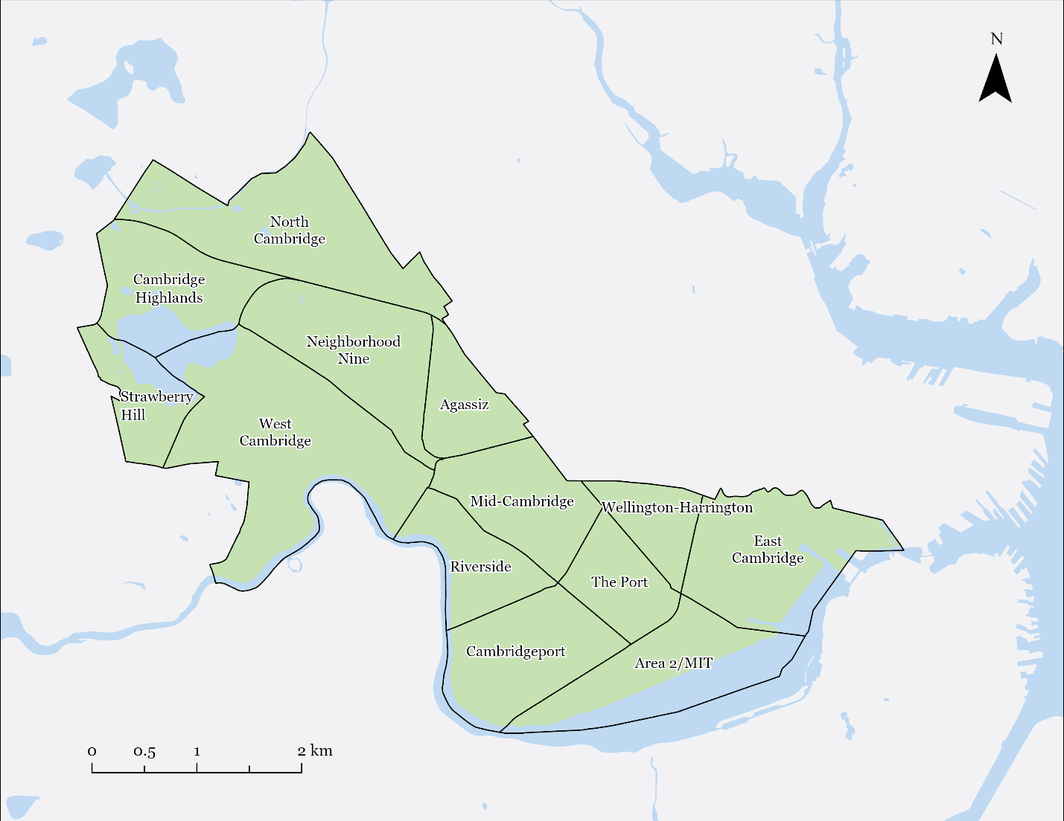
Figure A1. Neighborhood boundaries for the City of Cambridge, Massachusetts.

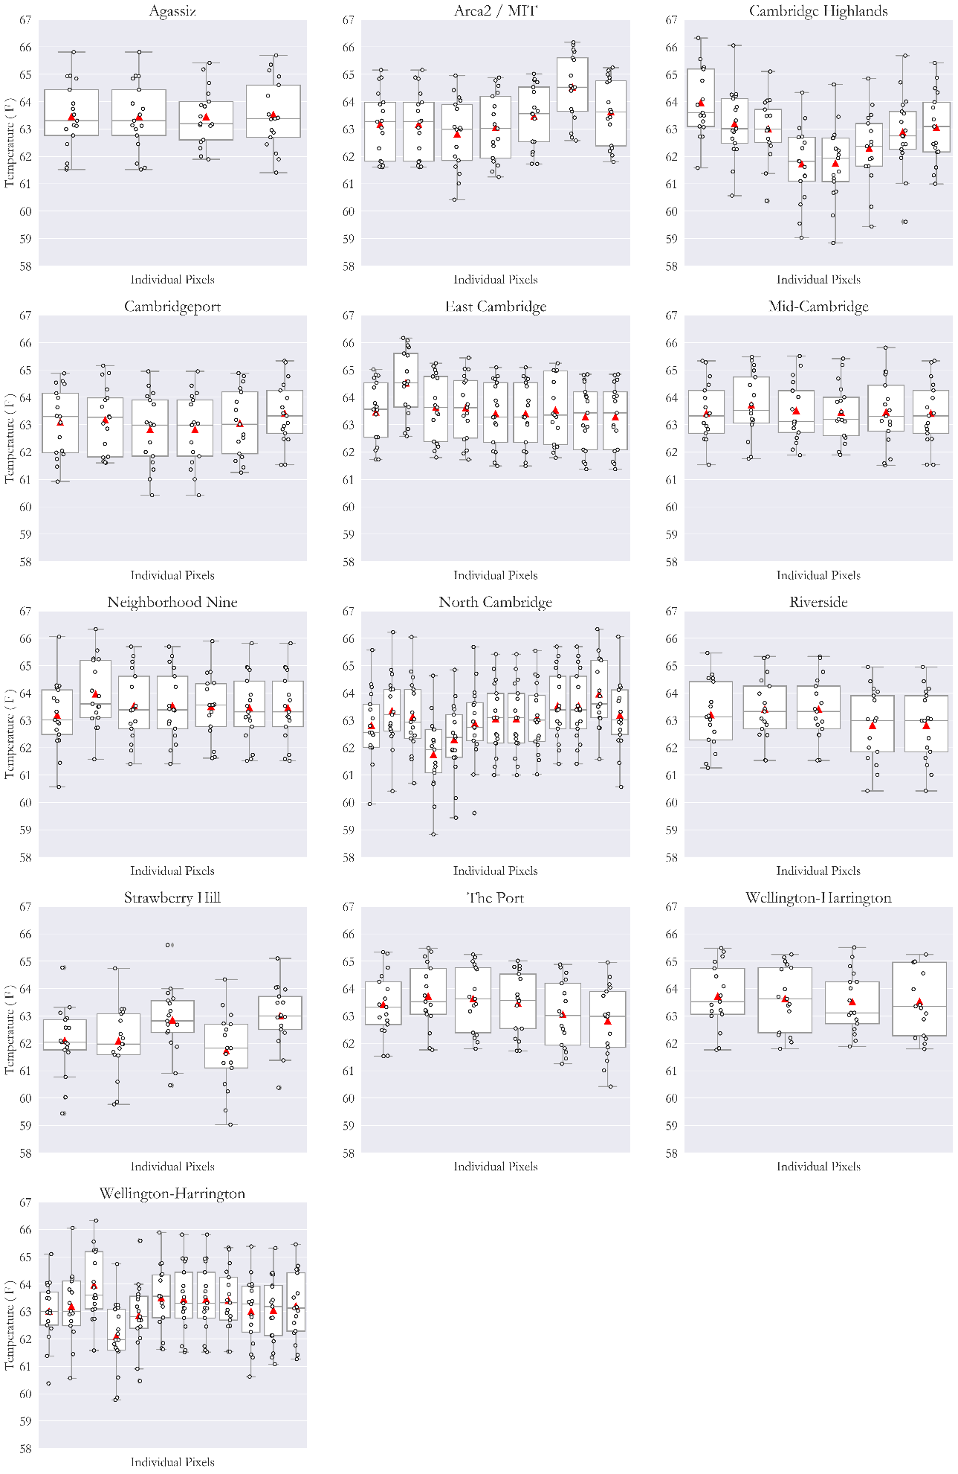
Figure A2. The figure tracks the annual nighttime LST temperature averaged over the summer months of June, July, and August at the neighborhood level in Cambridge based on the number of pixels that overlap. For each neighborhood, each pixel that is located within its boundary is represented by a box-plot. The red triangle represents the mean whilst the grey horizontal line represents the median. The annual individual summer nighttime LST temperature values are represented by a white circle with a black outline. Each box-plot features this 16-point spread of values that corresponds to the time period of the study 2004-2019.

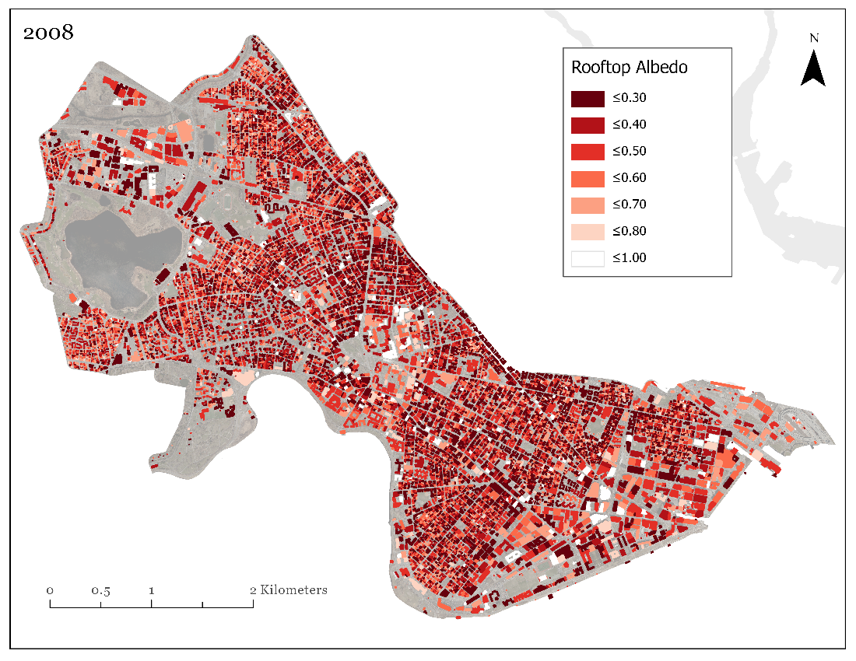
Figure A3. Final rooftop albedo results for 2008 based on the HRO for the full extent of Cambridge.

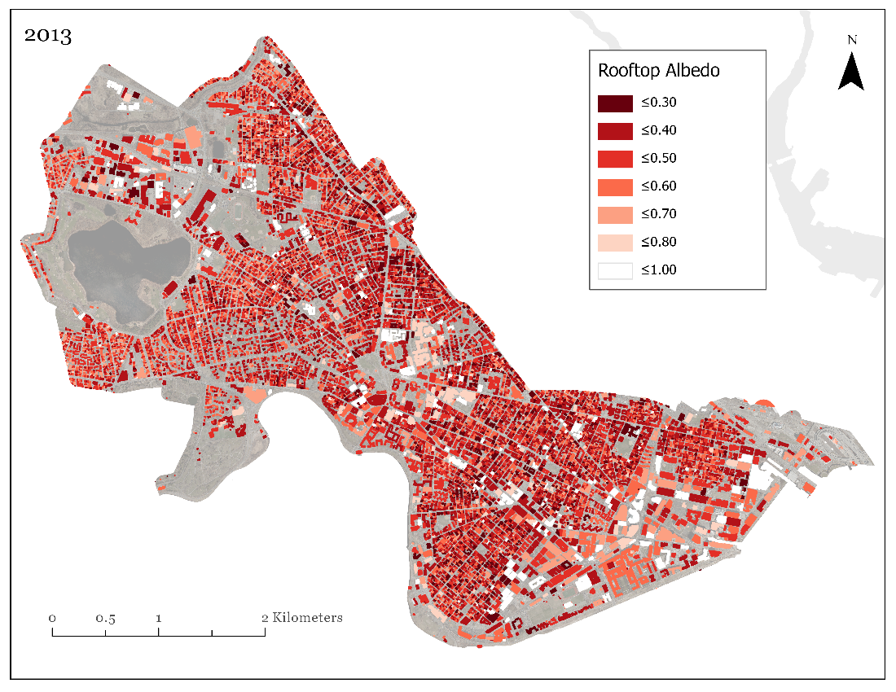
Figure A4. Final rooftop albedo results for 2013 based on the HRO for the full extent of Cambridge.

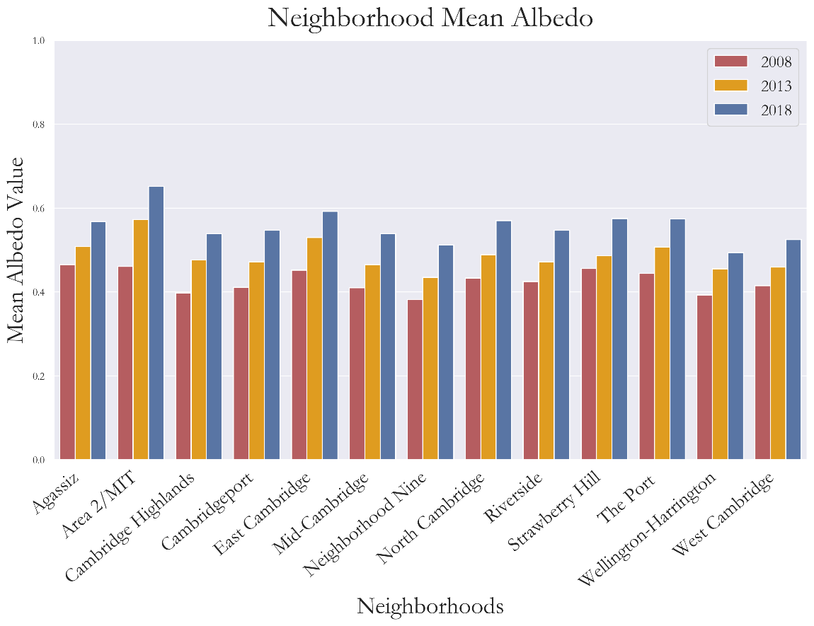
Figure A5. Bar chart of average neighborhood-albedo for each year of our analysis (2008, 2013 and 2018) derived from the 80th percentile rooftop albedo proxy.

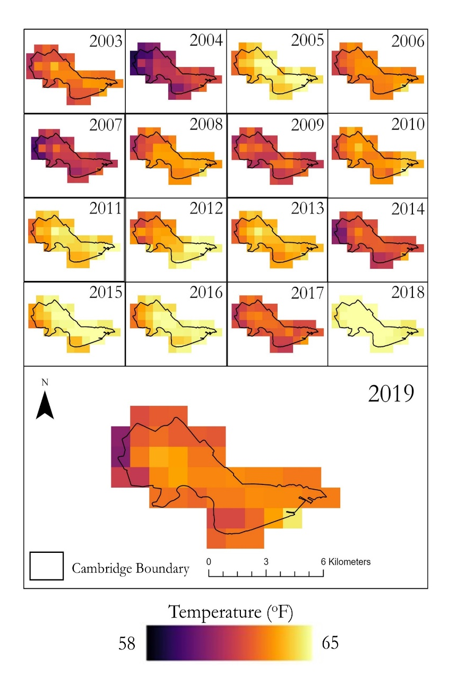
Figure A6. Seasonally averaged summer nighttime LST (ºF) in the City of Cambridge for 2003 to 2019. Darker colors represent cooler temperatures while lighter colors represent warmer temperatures.

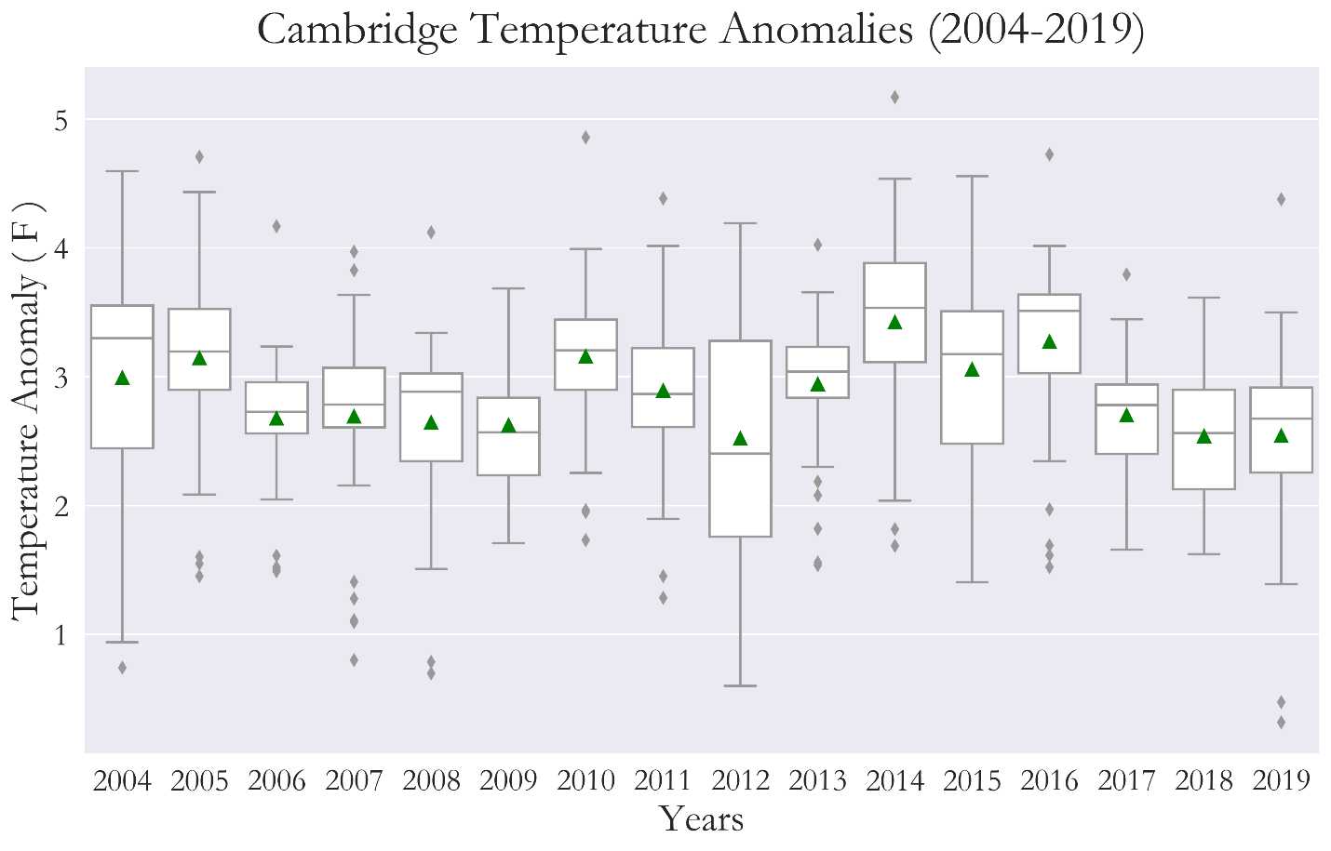
Figure A7. Box-plots to visualize the range of temperature anomalies each year from 2004 to 2019 in the study area. The median of each year is represented by the grey horizontal line whilst the mean is represented by the green triangle. The upper and lower range of the temperature anomalies per year are represented by the upper and lower bound respectively. Outliers are symbolized as grey diamonds.

