Presenting Model-Based Systems Engineering Information to Non-Modelers

Jeffrey R. Cohen, MS, P.E. , Sarah Arai, Ph.D., Tatyana Rakalina, Emily Griffin, Jared Heiser, Michelle Urbina, MS, Kerry M. McGuire, Ph.D., David Rubin, MS, PMP, Alex J. Seigel, Alay Shah, Sandhya Ramachandran, Anusha Dixit, Jennifer Legaspi, MS, Jennifer A. Mindock, Ph.D., Jorge Bardina, Ph.D., Melinda J. Hailey, MSN, RN
NASA Johnson Space Center
2100 NASA Parkway
Houston, TX, 77058
Corresponding Author: jeffrey.r.cohen@nasa.gov

Abstract:
NASA’s Human Research Program’s (HRP) Exploration Medical Capability (ExMC) Element adopted Systems Engineering (SE) principles and Model Based Systems Engineering (MBSE) tools to capture the system functions, system architecture, requirements, interfaces, and clinical capabilities for a future exploration medical system. There are many different stakeholders who may use the information in the model: systems engineers, clinicians (physicians, nurses, and pharmacists), scientists, and program managers. Many of these individuals do not have access to MBSE modeling tools or have never used these tools. Many of these individuals (clinicians, scientists, even program managers) may have no experience with SE in general let alone interpreting a systems model. The challenge faced by ExMC was how to present the content in the model to non-modelers in a way they could understand with limited to no training in MBSE or the Systems Modeling Language (SysML) without using the modeling tool. Therefore, from the model, ExMC created an HTML report that is accessible to anyone with a browser. When creating the HTML report, the ExMC SE team talked to stakeholders and received their feedback on what content they wanted and how to display this content. Factoring in feedback, the report arranges the content in a way that not only directs readers through the SE process taken to derive the requirements, but also helps them to understand the fundamental steps in an SE approach. The report includes links to source information (i.e., NASA documentation that describes levels of care) and other SE deliverables (e.g., Concept of Operations). These links were provided to aid in the understanding of how the team created this content through a methodical SE approach. This paper outlines the process used to develop the model, the data chosen to share with stakeholders, many of the model elements used in the report, the review process stakeholders followed, the comments received from the stakeholders, and the lessons ExMC learned through producing this HTML report.

Introduction and Background

The Challenge
The National Aeronautics and Space Administration (NASA) Human Research Program (HRP) is made up of five elements including the Exploration Medical Capability (ExMC) element. The ExMC element’s mission is to “advance medical system design and risk-informed decision making for exploration beyond low Earth Orbit”. As part of this mission, ExMC is charged with defining medical system foundations, as described below, for varying levels of care which are defined in the NASA Space Flight Human-System Standard [1].
These medical system foundations do not specify the next generation medical system for exploration programs. Rather, they provide a starting point for exploration programs to evaluate medical system requirements when developing their own medical systems, based on the required level of care. Foundations are more than just models. A medical system foundation encompasses the medical system foundation model, the Concept of Operations (ConOps), the Accepted Medical Condition List (AMCL), the clinical capabilities, medical resources, medical system requirements, NASA standards and historical reference requirements documents, and the HTML report.
ExMC SE chose to follow a Model Based Systems Engineering (MBSE) paradigm when developing the medical system foundation rather than a traditional, document-centric approach. The model provides a shared view of the needs, environment, and requirements. However, many of the stakeholders are not familiar with MBSE techniques, tools, or languages. Making the information available to these stakeholders in a manner that they understand, and in a readily accessible format, was the primary challenge of this development effort.
This paper explains how ExMC built the model for the Medical System Foundation for Level of Care IV: Short-Duration Lunar Orbit (this is the appropriate Level of Care for such missions, and is genericized in this paper as the “Medical System Foundation”). It shows how the team presented the Medical System Foundation information in an HTML report so that stakeholders not proficient using the modeling tool are able to access the information. The first part of this paper provides the background of the organization and task. It addresses the stakeholders, communication of the Medical System Foundation information among stakeholders, and the process followed by ExMC when developing the Medical System Foundation. The second part of the paper addresses the specifics of the HTML report used for presenting the Medical System Foundation, the process for reviewing and updating the HTML report, and lessons learned in creation of the HTML report.

The Stakeholders
For many organizations, Systems Engineers (SE) are the primary stakeholders for the model or other SE documents. An SE team, using MBSE tools, develops models to understand the requirements and behavior of a system. The information ExMC develops is not intended for a specific exploration program or mission, but to provide a starting point for understanding what a medical system for a specific level of care requires. Specific programs will use this starting point to tailor the requirements for program-specific or mission-specific medical systems. Therefore, the Medical System Foundation has stakeholders both internal to ExMC (for developing the Foundation) and external to it (tailoring the Foundation to develop specific medical systems).
For the Medical System Foundation, few stakeholders are SEs with modeling experience. In fact, the Medical System Foundation is used by stakeholders with a variety of different backgrounds. Each stakeholder group, internal and external, uses the Medical System Foundation for a different purpose and can be found at any level of an organizational chart [2]. While there are many additional types of stakeholders, this paper focuses on the stakeholders that will have substantial interactions with the Medical System Foundation, either by developing it or by using its content. These stakeholders fall into three general classes: clinicians, engineers, and mission management.
In this paper, we use the term “clinicians” to refer to stakeholders who specialize in the health and wellness of the flight crew. Clinicians refer to physicians, nurses, and pharmacists. The internal clinician stakeholders are part of the ExMC Clinical & Science Team (CST) that identifies medical conditions of concern during a mission, the capabilities of a medical system required for managing those conditions, and the resources (i.e., medical equipment, supplies, pharmaceuticals, software, and data) required in the medical system [M]. ExMC clinicians help develop the Medical System Foundation in conjunction with the ExMC SEs and are responsible for its clinical content.
Many of the external clinician stakeholders are part of the Space Medicine Operations team that is responsible for the primary healthcare of the crew. They oversee the healthcare and medical training for the crew during pre-flight training, during the mission and after the space flight. They can use the Medical System Foundation as a guide when determining the requirements and medical content for program-specific or mission-specific medical systems.
“Systems Engineers” refer to both the internal ExMC SEs and the SEs responsible for developing the spacecraft and medical system equipment. The ExMC SEs define the medical scenarios, architecture, interfaces, and requirements for the Medical System Foundation. While not all ExMC SEs develop the model, all contribute to or use the Medical System Foundation content.
SEs external to ExMC design the spacecraft-specific medical system or equipment. These stakeholders can tailor the Medical System Foundation to meet the needs of their unique environment and mission requirements. They do not define their system to meet the needs of the Medical System Foundation, but rather use the Foundation as a guide for starting their work.
“Mission management” stakeholders are the decision makers who set the mission constraints such as mass, volume, and power. They consider trade study analyses on the medical system. The analyses help them define an acceptable level of risk and make the final decision of acceptance of a design or waivers of requirements.

The Issue: Communicating
Like many SE projects, the Medical Systems Foundation represents the subject matter experts’ (SME) knowledge of the domain, problems that occur in the domain, and the technical solutions required to avoid or ameliorate problems that occur. In ExMC, the CST clinicians are the SMEs. It is the responsibility of the SEs to assemble the SE information in a way that facilitates communication among the clinical teams, engineering teams, and mission management. The model captures the information in one place to bridge the communication gap and create a common vision of the medical system for all stakeholders.
Understanding what stakeholders consider helps one understand their concerns, and therefore, present relevant information in a consumable manner. SE team members talked with each stakeholder group to understand their needs. Below is a summary of questions that each stakeholder group considers. These needs drove what content to have in the model and what to have in the HTML report.

Figure 1 - Considerations for Clinicians, Engineers, and Mission Management
In addition to addressing stakeholder concerns, Medical System Foundation information must be accessible to each stakeholder Few stakeholders have the modeling tool, MagicDraw™, installed locally. Even fewer have access to the server on which the model is stored. Fewer still have the training in MBSE and in SysML required for understanding the particulars of the model. The issue, therefore, is how to present the critical information from the Medical System Foundation to each of these stakeholder groups.

The Process
Developing the Medical System Foundation required the ExMC team to follow a systematic, repeatable process to develop and detail the Foundation’s components. These components include:
- The ConOps Document
- Refined ConOps Scenarios
- Accepted Medical Conditions List (AMCL)
- Clinical Capabilities List
- Medical System Architecture
- Medical System Requirements, including hyperlinks to standards (i.e., NASA-STD-3001 volumes 1 and 2, and the Interpretation of NASA-STD-3001 Levels of Care for Exploration Medical System Development), and historical documents (i.e., the International Space Station (ISS) Medical Operations Requirements Document, ISS Medical Kit Project Requirements and Verification Document)
- Medical System Resources and Candidate Medical System Master Equipment List (MEL)
- Medical System Foundation Model
- HTML Report showing the Medical System Foundation information
ExMC CST clinicians are the SMEs on the medical domain activities; the ExMC SEs are the SMEs for the Systems Engineering activities. However, ExMC SEs and ExMC CST worked closely in a participatory way to develop all these artifacts and to provide feedback on how best to present the information in the HTML report. By engaging the ExMC CST, the ExMC SE team encouraged the ExMC CST to buy in to the use of MBSE to develop the communication tool.

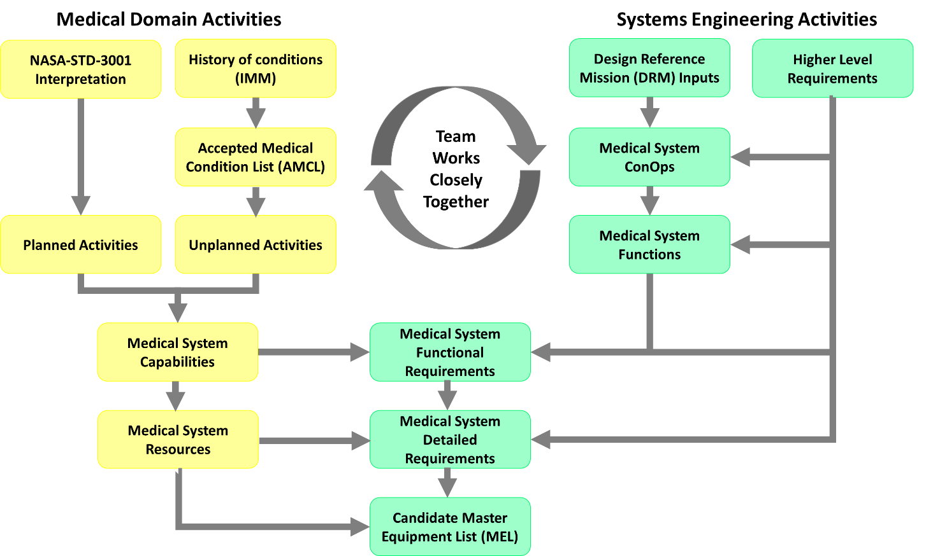
Figure 2 - ExMC CST and SE worked closely to develop the Medical System Foundation artifacts and to determine how to present them.
ExMC SE chose to use the Object Management Group’s (OMG) Systems Modeling Language (SysML) for the representation and Dassault Systèmes’ MagicDrawTM as the modeling tool. SysML is commonly used for MBSE. A model provides visual representations of the system. The language constructs of SysML provide diagrams for showing various elements of the systems, such as the structure of a system, the system’s behavior, and the system’s interactions with its environment. Furthermore, connecting elements in the model provides insight to the stakeholders into the effects of a change in one element on the others. For example, changing the behavior of an element by adding an action on an activity diagram will likely result in adding a system function and subsequently adding a requirement.
ExMC uses the model as the single source of information about the Medical System Foundation. All derived and refined work resides in the model. The model includes hyperlinks to external documents such as the ConOps, the AMCL, and the standards and historical documents. The HTML report provides access to this information without requiring the stakeholder to use the modeling tools or have access to the full model.
The SE team followed the SE Engine stated in NASA 7123.1B [4] and tailored this process to the Medical System Foundation project. Below is the process flow taken by the ExMC team. Most of the process steps are performed iteratively with consultation, inputs, and comments from the stakeholders to improve the artifacts. The primary process workflow was as follows:
- Create the ConOps – The ExMC SE team created the ConOps document that identifies stakeholder needs, system goals, system objectives, and mission constraints based on NASA’s health standards and definitions of levels of care.
- Develop scenarios – The ExMC SE team and CST jointly developed a set of representative medical scenarios that define key aspects of the medical system or a stakeholder concern. Short-text narrative scenarios describe the interactions among the crew, ground medical personnel, equipment, and supplies.
- Create an activity diagram for each scenario – For each scenario, the ExMC SE modeling team developed an activity diagram that refined the scenario and identified the functions performed by the major system parts. CST members consulted with the modelers before refining the scenario and confirmed each activity diagram when it was complete. Note that these activity diagrams, while housed in the model, were also included in the ConOps document.
- Refine needs – The CST further refined the clinical needs outlined in the ConOps by evaluating planned activities (e.g., routine medical care) and unplanned activities (e.g., treating injuries, diagnosing illnesses). Along with epidemiologic evidence, CST derived a predicted list of medical conditions, the AMCL, around which to design the medical system.
- Derive capabilities and resources – From the AMCL and the list of scenarios, CST derived the medical system capabilities and the medical system resources necessary to prevent, diagnose, and treat the conditions. SEs on the modeling team imported the medical conditions, medical capabilities, medical resources, and the relationships among them into the model.
- Define the system architecture – From the capabilities and knowledge of spaceflight environments, the SEs defined the medical system architecture and interfaces.
- Derive requirements – From the ConOps, medical system functions, medical capabilities, NASA standards, and historical requirements, the ExMC SE requirements team derived the functional and non-functional requirements at Level 4. Requirements levels are defined as:
  - Level 1 – Agency-level requirements, including NASA standards
  - Level 2 – Program-level requirements
  - Level 3 – Vehicle System-level (e.g., the vehicle or habitat system) requirements
  - Level 4 – Vehicle Subsystem-level (e.g., medical system) requirements
  - Level 5 – End Item-level (i.e., a medical resources) requirements
- Trace requirements – SEs on the modeling team entered the requirements into the model and completed the requirement traces to parent requirements. SEs also traced clinical capabilities to Level 4 requirements.
- Stakeholders review requirements – The extended ExMC team reviewed the requirements.
- Create the model elements – The SE modeling team created the diagrams, tables, and matrices necessary for displaying Medical System Foundation information. These visualizations of the data promote common understanding among stakeholders.
- Create the HTML report – The SE modeling team created an HTML report of the Medical System Foundation.
- Review the report and iterate – The extended ExMC team reviewed and provided feedback on the report. Their findings are discussed in the HTML Report Review and Acceptance section, below.

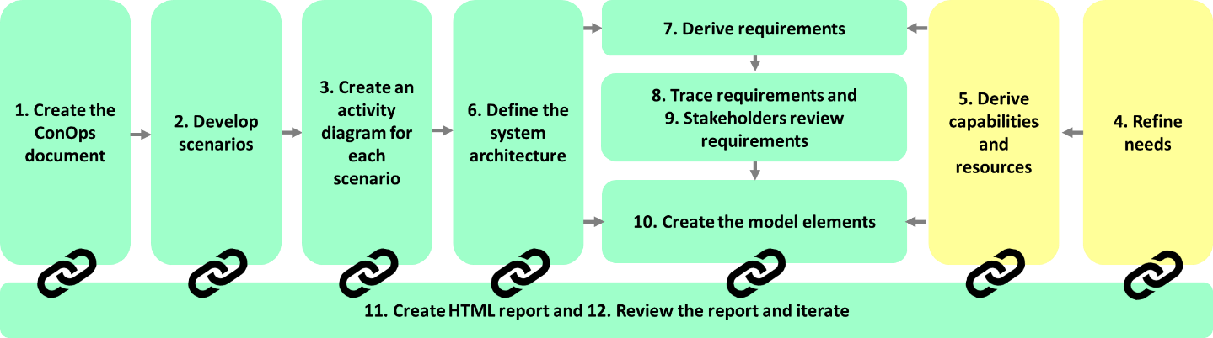
Figure 3 - Medical System Foundation components and the general process flow. Green items are led by SE, yellow items are led by CST.

Presenting the Medical System Foundation

Choosing the Presentation Method
ExMC SE decided that producing a custom HTML report to present the Medical System Foundation information to the stakeholders allowed for flexibility in design and ease of stakeholder access. Stakeholders access the HTML report via a standard web browser (e.g., Chrome, Microsoft Edge, Safari) without requiring the Dassault Systèmes’ MagicDraw™ software or a license. To aid stakeholders understanding of the SE process, the information is organized and presented to guide the stakeholder through the development process, from source documents (i.e., the ConOps, NASA standards, and the AMCL) to outputs (e.g., the requirements, the Medical System Master Equipment List ).
In coming to the decision about what to present and how to present it, the ExMC SE team considered the following concepts:
- The stakeholder should not be required to have specialized tools installed.
- The presentation of the Medical System Foundation information should lead the stakeholder to the appropriate part of the report without requiring the stakeholder to understand the organization of the model.
- The Medical System Foundation information presented should not differ from the model information presented in the SysML model. It should be generated directly from the model.
- The presentation of the Medical System Foundation should help non-modeler stakeholders understand the SE development process.
The SE modeling team considered several approaches for presenting the Medical System Foundation:
- Producing printed or PDF versions of traditional SE documents (e.g., System Requirements Specification, System Design Document) directly from the model
- Using an out-of-the-box report to generate an HTML representation of a document from the modeling tool showing model artifacts such as the IEEE 1233 style Systems Requirement Specification or a “whole model” report
- Generating a custom HTML report using custom diagrams that integrate model elements with hyperlinks to external documents.
Regarding option 1, the ExMC SE team considered generating traditional SE documents from the model that could either be printed or stored electronically in a Portable Document Format (PDF) file. The MagicDraw™ Report Wizard, a tool included with MagicDraw™ for generating documents from the MagicDraw™ models, would be able to generate versions of all diagrams, tables, and matrices. However, the diagram size would be limited to standard paper sizes such as letter or ledger. Printing complex diagrams or tables with many rows or columns may require a font size that is too small to read. Furthermore, controlling copies of printed documents or distributed files would be difficult. Stakeholders often store copies of documents locally, making it impossible to ensure a stakeholder did not use an outdated version. Using an old version may lead one to make incorrect assumptions about the medical system that may affect crew health.
Next, the ExMC SE team considered option 2. The MagicDraw™ Report Wizard includes out-of-the-box templates for generating HTML reports of the model. These standard reports include images of all diagrams, tables, and other model elements. Stakeholders accessing the reports do not require MagicDraw™ installed on their computers; the report displays in a standard web browser such as Chrome, Firefox, or Safari. The report files are housed on a server. The modeling team generates a new HTML report whenever the model information changes, ensuring that stakeholders view the latest information. However, these standard reports were designed to present model data. Stakeholders need to understand SysML concepts and the model’s organization to find needed information. Reports generated using the out-of-the-box templates did not sufficiently promote understanding nor did they show the model’s organizational structure.
The ExMC SE modeling team decided to use option 3 the MagicDraw™ Report Wizard custom templates for creating reports directly from the MagicDraw™ model. The custom templates generate HTML reports that include only the model elements the modeler selects. The modeler also chooses the default diagram that displays when the report opens as the “landing page”. The MagicDraw™ Report Wizard also includes a feature to generate non-SysML standard diagrams, the “content diagrams” that contain text and hyperlinks to other model elements or to documents outside the model. Using content diagrams with a custom HTML report provides the SE modeling team with the ability to group and display content in multiple ways within the same report, giving the team the flexibility to present the same information differently, depending on how the stakeholder wants to consume the data. The ability to customize the order of links to artifacts on content diagrams also provides a means for the SE modeling team to show the SE process.

The HTML Report
The main parts of the HTML report are described in further detail below. They include:
- Landing Page
- Medical System Content Diagram
- Medical System Requirements Content Diagrams
- Medical System Requirements Trace Relation Maps
- Medical System Relation Maps.

The Landing Page
A content diagram is used for the landing page when a stakeholder first opens the model. Similar to a main menu or a home page, the landing page is the first page of the HTML report and is shown in Figure 4. The landing page shows the architecture of the medical system in context to the greater environment in a block diagram in the main frame of the page, providing hyperlinks to the medical system content described in the Medical System Content Diagram section below and to the medical system requirements levied on other systems via other content diagrams, such as the Wellness System Content Diagram and the Data System Content Diagram, that are not described in this paper. At the top right, the landing page identifies the version of the HTML report and the date it was created. Text describing the report and the diagram are provided in sections called “About this HTML Report” and “About this Diagram” to the left of the architecture block diagram. Toward the bottom of the page, links to a “Glossary” and” Acronyms” lists are provided to aid the user in understanding the modeled content. Finally, on the left-hand side of this page, and all pages throughout the HTML Report, a “Containment” and “Diagrams” navigation is present as an artifact of the HTML report. The navigation can be used to move through the HTML report in an un-guided manner.
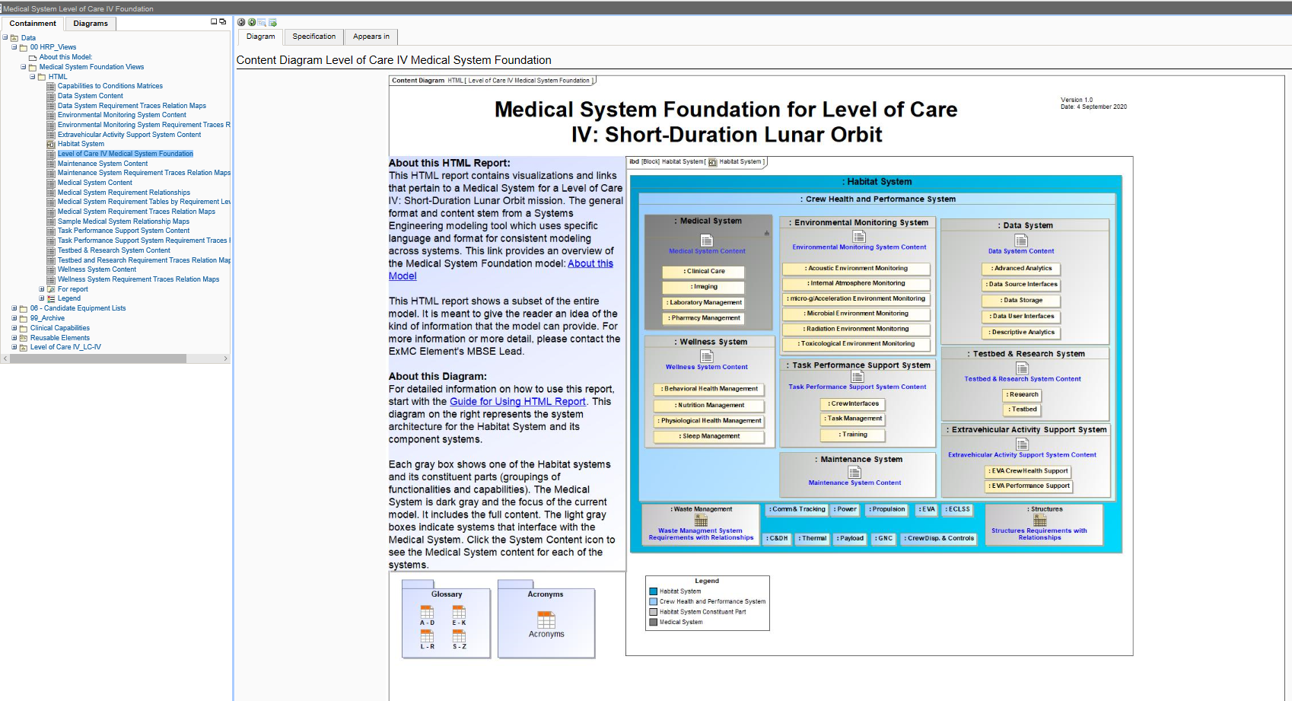
Figure 4 - Medical System Foundation Model Landing Page

Medical System Content Diagram
Most medical system stakeholders want to see the medical system requirements, requirement traces, and/or clinical content. These stakeholders click on the Medical System Content link on the landing page, as shown in Figure 5. This link opens the Medical System Content Diagram.
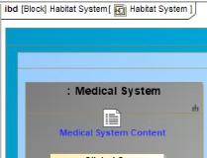
Figure 5 - Close up of the link in blue text on the Landing Page to the Medical System Content
The Medical System Content diagram, shown in Figure 6, helps stakeholders visualize the SE development process. The boxes in the top row (Concepts of Operations, Standards and Historical References, and Medical System Conditions) show the high-level system vision and scope documents. With the exception of the Scenarios hyperlink, hyperlinks in these boxes open documents that define the top-level requirements. These documents reside in the team’s document management system outside of the model. The Scenarios hyperlink opens a diagram with hyperlinks to the scenario activity diagrams (visual representations of the ConOps).
Boxes in the middle section of the diagram (Medical System Functions, Medical System Requirements, and Medical System Capabilities) link to the content used to derive the requirements and to the requirements themselves. As the arrows indicate, the SE team derived the Medical System Requirements from the functions, capabilities, and standards.
The bottom row of boxes contain links to the resulting output: the Medical System Architecture and Interfaces, the Medical System Master Equipment List, and the Medical System Resources.
The columns group the artifacts by discipline. The left column contains hyperlinks to related ConOps artifacts. The middle column provides hyperlinks to requirements-related artifacts. The right column contains medical domain artifacts.
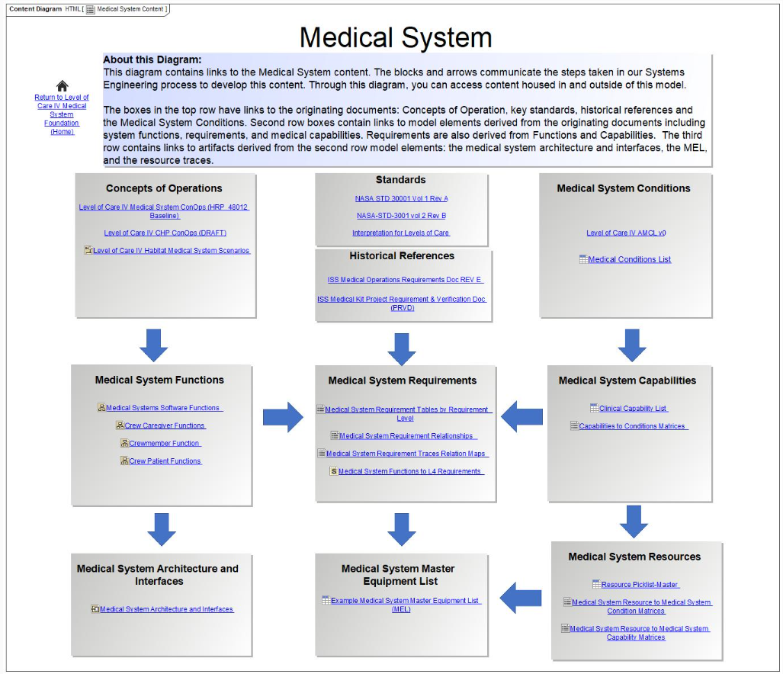
Figure 6 - Medical System Content Diagram

Medical System Requirements Content Diagrams
In the middle of the Medical System Content diagram, the Medical System Requirements block contains four hyperlinks, two of which link to content diagrams depicting sets of requirements tables. Within both diagrams, the hyperlinks to the requirements tables are organized by the requirement levels described in the process flow. The hyperlink “Medical System Requirements Tables by Requirement Level” links to the Medical System Requirements Tables diagram shown in Figure 7 and shows a “requirements only” view. The tables in this diagram are lists of requirements and include the requirement identifier, requirement text, and the requirement rationale. The hyperlink “Medical System Requirement Relations” provides access to the Medical System Relationship Tables diagrams, depicted in Figure 8. The tables in this diagram are lists of requirements and include the requirement’s traces to higher level requirements and other model elements (such as functions and capabilities), in addition to the requirement identifier, requirement text, and requirement rationale.
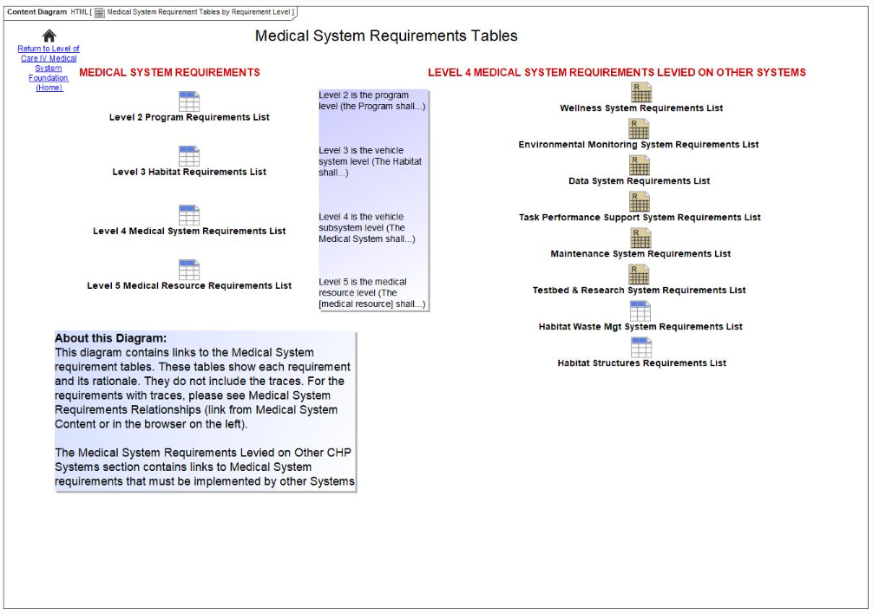
Figure 7 - Medical System Requirements Tables

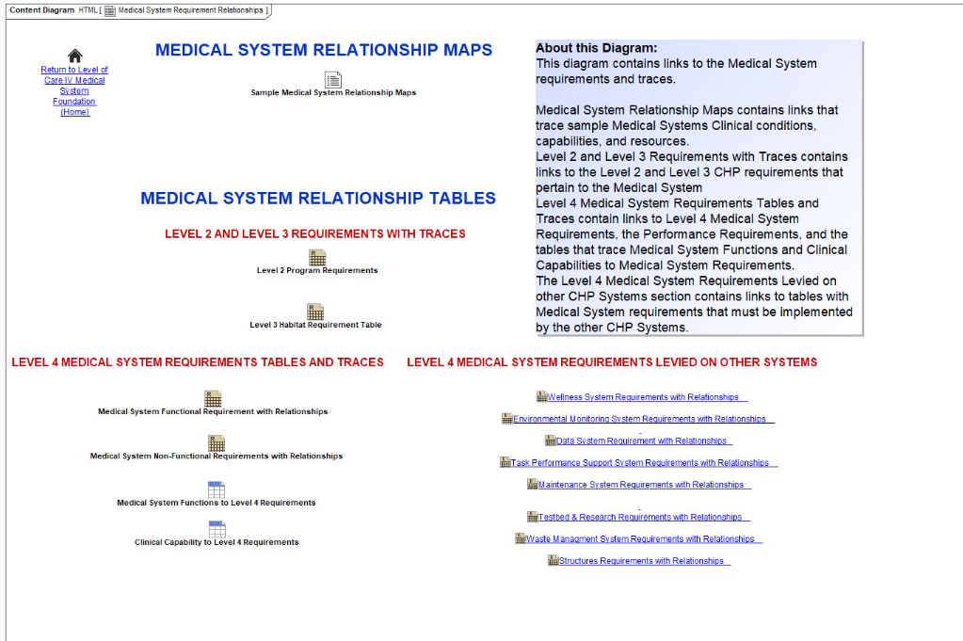
Figure 8 - Medical System Relationship Maps and Tables

Medical System Requirements Trace Relation Maps
Maintaining the bidirectional traceability among requirements is considered a key capability and a best practice for systems development [5,6]. In the Medical System Foundation model, various SysML stereotyped relationships were created that represent the traceability among requirements at different levels. In the model, the trace relationships exist as part of the requirement’s specification. Initially, the modeling team created tables in the model that show the requirement and its upstream traces. Both the clinicians and the ExMC SEs responsible for deriving requirements found the tables difficult to use and asked for a visualization of the traces. MagicDraw™ provides a non-standard SysML diagram, a “Relation Map”, that visually depicts the traces and was used in the HTML report to show the traces for all Level 4 requirements (Figure 9).
Stakeholders access these diagrams by selecting the “Medical System Requirement Trace Relation Maps” hyperlink on the Medical System Content diagram and then selecting the hyperlink associated with the requirement under consideration.
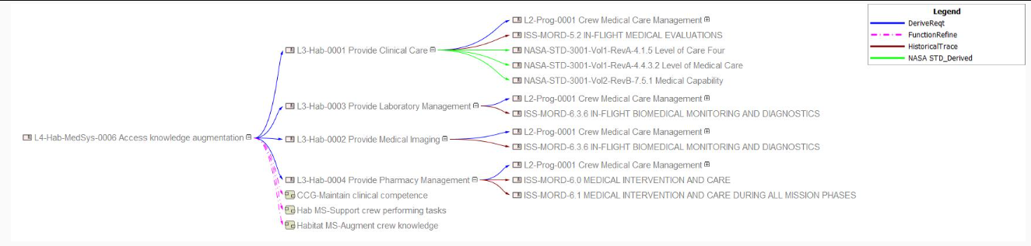
Figure 9 - Example of a Relation Map that shows the end to end requirement traceability of a Level 4 Medical System Requirement

Medical System Relation Maps
The Medical System Relation Maps are similar to the Medical System Requirements Trace maps. Instead of showing the relationships among requirements, relation maps show the relationships among the clinical conditions (medical diagnoses or symptoms), clinical capabilities (actions provided by a caregiver to address conditions), and medical resources (tangible and intangible assets for the diagnosis, treatment, prevention, or limitation of a given condition).
The CST provides the model source data for the clinical conditions, clinical capabilities, clinical resources, and the relationships among them. As they investigate capabilities to prevent, diagnose, or treat conditions, the clinicians use the relationships to identify what resources apply to which conditions. Initially, the clinicians used the Medical System Foundation model matrices to show the relationships. The clinicians found the matrix too large and cumbersome to use effectively and asked for a better, graphical way to see the relationships.
Due to the volume of information, the HTML report only shows representative maps. Figure 10 shows the Sample Medical System Relationship Maps content diagram that provides links to the representative relation maps and can be found in the Medical System Requirements Relations content diagram. Figure 11 is an example of a relation map that can be accessed through the resource to capability “Dental explorer/probe” link shown in Figure 10.
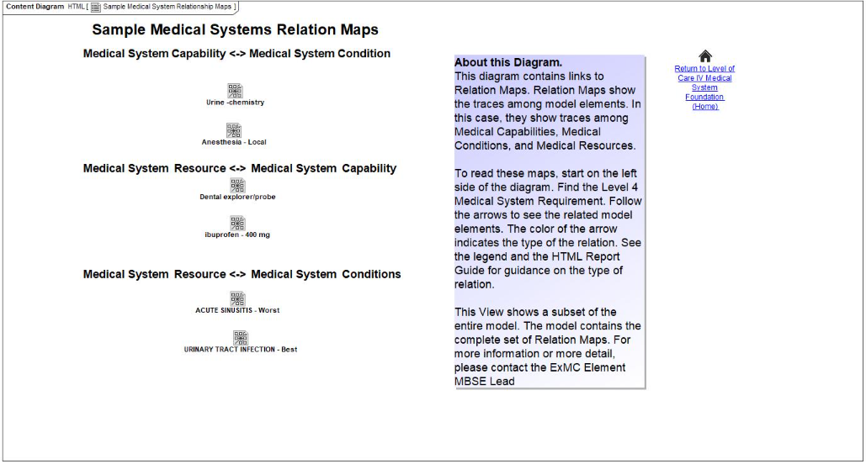
Figure 10 - Sample Medical System Relation Maps

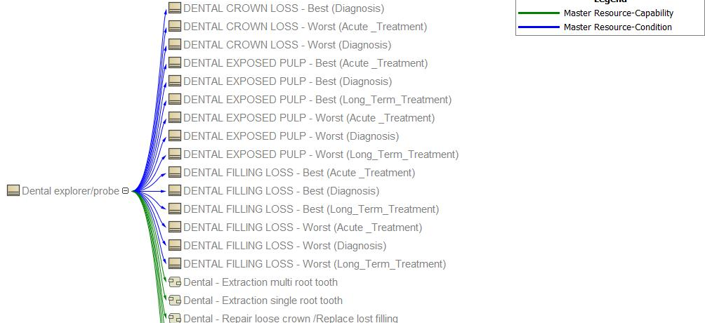
Figure 11 - Relation Map for Dental Explorer/Probe Example

HTML Report Review and Acceptance
The SE and CST used aspects of the HTML report as a communications tool throughout development of the Medical System Foundation. Within the SE team, the SEs responsible for requirements development reviewed HTML views of requirements tables to confirm the correctness of the requirements and the requirements traces. CST clinicians used the HTML report matrices, tables, and relation maps when reviewing the relationships among clinical conditions, clinical capabilities, and resources.
Before formally releasing the HTML Report, the SE modeling team presented the HTML report and the accompanying user guide to the extended ExMC team for review and comment. The reviewers included engineers, scientists, clinicians, and management. The findings fell into several categories:
- Spelling or grammatical issues
- Requests for clarification to the text or to the user guide for Using HTML Report
- Requests to improve navigation – for example, the addition of HTML hyperlinks to the landing page can be found in Figure 12.
- Requests to change model content, including requests to see either more or less information on a diagram or to change the diagram’s format – for example, reviewers requested freezing the header rows and columns similar to what is possible in Microsoft Excel. This is not possible in MagicDraw™.
- Questions about the way that SysML and MagicDraw™ display information – for example, MagicDraw™ displaying the type of a diagram before its name (e.g., “Content Diagram Medical System Content” instead of the preferred “Medical System Content”) or the stereotype in guillemets. This is also not possible to change in MagicDraw™.
- Problems with HTML links that did not open due to the size of the image – for example some tables and images were so large that they would not load quickly. In this case, tables and images were made smaller by reducing the number columns or rows in tables or by reducing the resolution of an image, and in some cases, large matrices were broken up into a series of smaller matrices. An example of the before and after can be seen in Figure 13.
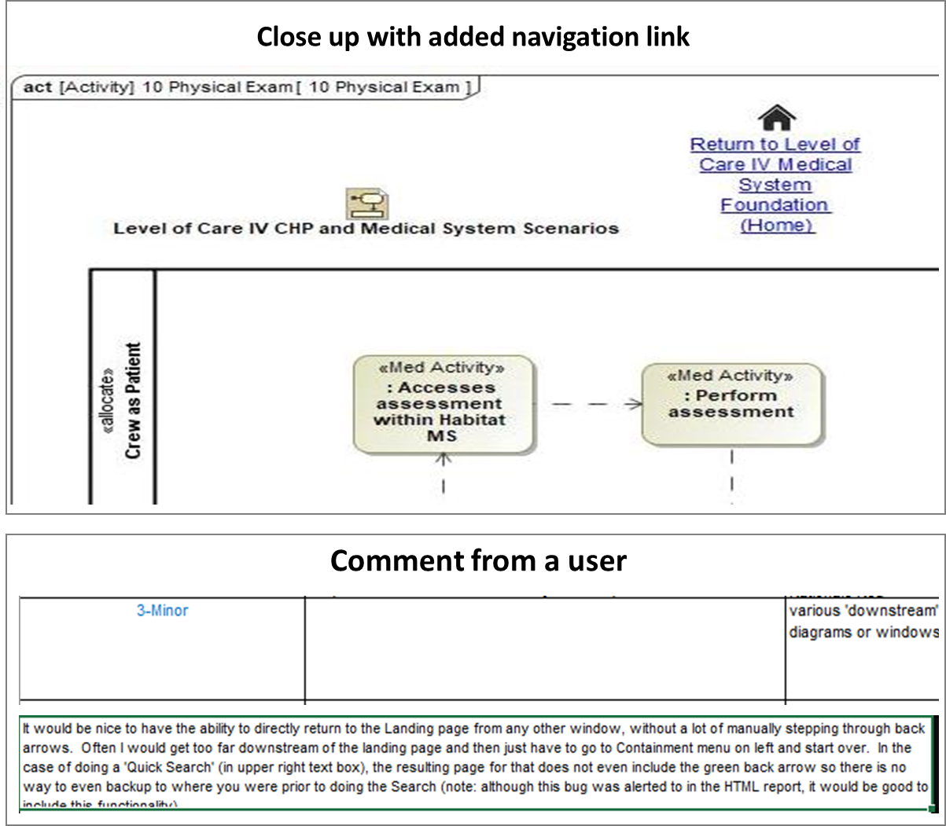
Figure 12 - A close-up of the added link back to the landing page. This was added by request in response to a comment that stepping through using back arrows or using the ‘Quick Search’ did not allow quick navigation to the Landing Page. The added link under the home symbol improves navigation for the users.
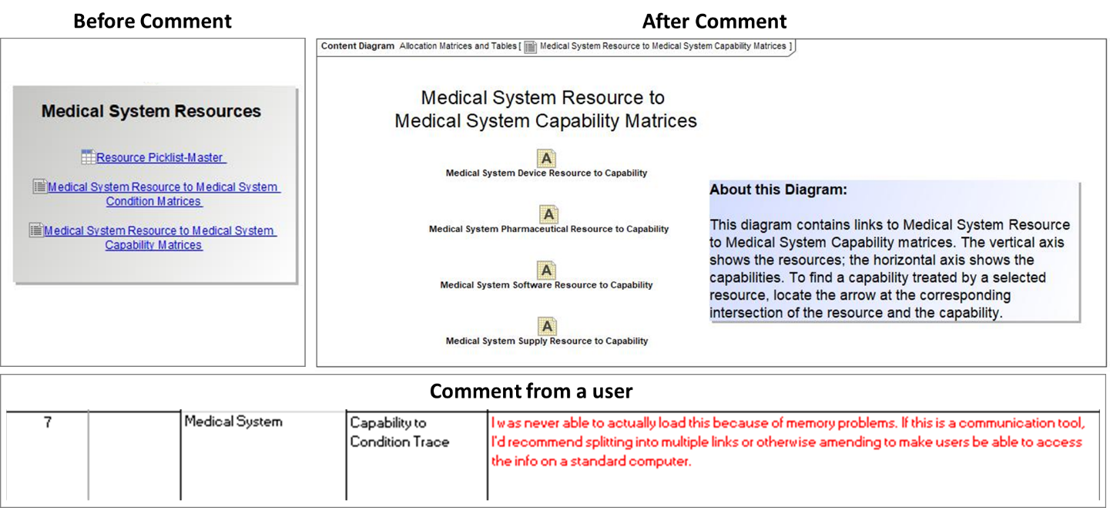
Figure 13 - Before and after of the Medical System Resources to Medical System Capability Matrices in response to a comment indicating that computer memory limitations prevented large matrices from loading. They recommended that matrices were split to improve communication. The SE modeling team created several, smaller tables to ease the issue and created links to them as shown above.
We accepted 92 findings from the reviewers. Of those findings, 45 were implemented as part of the baseline resulting from this review; the remaining 47 will be implemented over the next year. Many of these changes require modifications to requirements or clinical data that require inputs from groups other than the ExMC SE modeling team.

Moving Forward and Lessons Learned
- Perform Human Factors Analysis – Early findings commented on the colors used on the landing page, the location of data and links on the landing page, and the arrangement and naming of links on the Medical System Content page. Some of the usage issues that non-modelers experienced may have been avoided by employing human factors when this content was being designed. Going forward, a human factors analysis of the HTML report will be performed to gain better insight into usability and drive changes based on the resulting recommendations.

- Get feedback from stakeholders early and often – Since stakeholders are the consumers of the information, the information needs to be presented in a manner that the stakeholders consume easily. Often, the ways of presenting information that made the most sense to modelers are not in line with how the stakeholders use the information. The SE modeling team made sharing drafts and concepts with two primary stakeholder groups (the CST clinicians and the ExMC SEs responsible for deriving the requirements) as part of their normal, participatory workflow. One example shows the value of this sharing. The model presents relationships among clinical conditions, clinical capabilities, and medical resources in tables and matrices. Clinicians found the matrices too large for practical use. During a feedback review, an SE made a relation map and shared it with the team in real-time during the meeting. The clinicians made a few minor suggestions, and the new presentation of those relationships was accepted. Going forward, the SE team will reach out to more stakeholders to obtain and incorporate their feedback when creating the model content.

- Keep tables and matrices small – Members of the SE modeling team use computers with faster processors and more memory than many of the non-modeling users. While some of the larger tables and matrices would open on the modelers’ computers, they would not open on the non-modelers’ computers. The solution to this dilemma was to reduce the size of the matrices. Instead of creating one large table, a collection of smaller tables that present the information was created.

- Create custom tables – MagicDraw™ includes several types of tables as part of the out of the box SysML profile. These tables save the modeler time if the table has the appropriate columns. Generic tables allow the modeler to add additional columns and to customize those columns. For future projects, the ExMC SE modeling team expects to use generic tables instead of the out-of-the-box tables.

- Use Relation Maps – The SEs responsible for requirements development utilized text-based tables or matrices to analyze the trace relationships; however, the clinicians found it much easier using a visual representation via the relation maps.

- Be tool agnostic – With the HTML report, the priority is being able to visually convey information to the stakeholders. It is important to select tools that can address this priority. The ExMC SE team is considering other tools as well as import/export compatibility between tools. For example, Tableau is a tool designed to create visualizations from databases that might generate preferred visualization formats.

Conclusion
The HTML report of the Medical System Foundation model presented the SysML model information in a way that was accessible to non-modeler stakeholders. The non-modeler stakeholders did not need access to the model, the modeling tools, or an understanding of SysML. The custom content diagrams provided context for accessing the model elements that the stakeholders needed. It provided context for the medical system within the greater domain and provided a map through the SE development process. Additional user feedback will be incorporated in the next version of the HTML Report as better insight into the stakeholders’ needs are identified.

References
[1] NASA Space Flight Human-System Standard Volume 2: Human Factors, Habitability, and Environmental Health Revision B, 3001, National Aeronautics and Space Administration, Washington D.C., February 12, 2015. [Online]. Available: https://www.nasa.gov/sites/default/files/atoms/files/nasa-std-3001_vol_2_rev_b.pdf
[2] J. Mindock et al., “Systems Engineering for Space Exploration Medical Capabilities,” American Institute of Aeronautics and Astronautics SPACE and Astronautics Forum and Exposition, Orlando, FL, USA, 2017, [Online]. Available: https://arc.aiaa.org/doi/10.2514/6.2017-5236
[3] R. Blue, D. Nusbaum, E. Antonsen, “Development of an Accepted Medical Condition List for Exploration Medical Capability Scoping,” National Aeronautics and Space Administration, Washington D.C., July 2019. [Online]. Available: https://ntrs.nasa.gov/citations/20190027540
[4] NASA Procedures and Guidelines, NPR 7123.1B, Office of the Chief Engineer National Aeronautics and Space Administration, Washington D.C., April 18, 2013.
[5] NASA. “NASA Systems Engineering Handbook,” NASA/SP-2016-6105 Rev2, 2016.
[6] Hofmann, Hubert F., Kathryn M. Dodson, Gowri S. Ramani, and Deborah K. Yedlin. Adapting CMMI® for Acquisition Organizations: A Preliminary Report, CMU/SEI-2006-SR-005. Pittsburgh: Software Engineering Institute, Carnegie Mellon University, 2006, pp. 338–400
[7] NASA Space Flight Human-System Standard Volume 1 Revision A, 3001, National Aeronautics and Space Administration, Washington D.C., February 12, 2015. [Online]. Available: https://www.nasa.gov/sites/default/files/atoms/files/nasa-std-3001-vol-1a-chg1.pdf
[8] M. Urbina, “Medical System Concept of Operations for Mars Exploration Mission-11,” National Aeronautics and Space Administration, Washington D.C., April 2019, HRP 48021, April 2019, [Online]. Available: https://ntrs.nasa.gov/citations/20200001715
[10] Exploration Medical Capability Element. “Medical System Foundation for Level of Care IV Short-Duration Lunar Orbit: Context, Process, and Project History. National Aeronautics and Space Administration, Washington D.C., September 2020.
[11] A. Hanson et al., "A Model-Based Systems Engineering Approach to Exploration Medical System Development," 2019 IEEE Aerospace Conference, Big Sky, MT, USA, 2019, pp. 1-19, doi: 10.1109/AERO.2019.8741864.
[12] J. R. Amador et al., "Enabling Space Exploration Medical System Development Using a Tool Ecosystem," 2020 IEEE Aerospace Conference, Big Sky, MT, USA, 2020, pp. 1-16, doi: 10.1109/AERO47225.2020.9172751.

In SysML, a guillemet “«»” is used to denote a stereotype. Stereotypes are used to assign specialized properties to model elements in a specific domain.

