Integration of Advanced Structures and Materials Technologies for a Robust Lunar Habitat
Lauren Bowling  NASA NIFS Intern  NASA Langley Research Center  6 West Taylor St., MS 226  Hampton, VA 23681  laursbowl@gmail.com | Bryce Horvath  Aerospace Engineer  NASA Langley Research Center  1 North Dryden St., MS 451  Hampton, VA 23681  bryce.l.horvath@nasa.gov | Christopher Wohl  Senior Research Materials Engineer  NASA Langley Research Center  6 West Taylor St., MS 226  Hampton, VA 23681  c.j.wohl@nasa.gov

Abstract— NASA’s Artemis program plans to have a sustainable lunar base deployed on the Moon by 2028. The base calls for a foundation surface habitat that can support a crew of four members for a minimum mission duration of 28-days. The lack of a magnetic field and significant lunar atmosphere extends the lifetime of secondary radiation emitted from metallic structures, which is a health hazard for exposed astronauts. Integration of non-metallic structural materials into surface habitat design may alleviate some of these concerns. Additionally, it is favorable for the structure to be collapsible for transportation to optimize payload volume, mass efficiency, and monetary constraints. As a result, inflatable structures are being investigated due to their improved packing efficiency at launch, optimal mass-to-volume ratio, and large surface area that can efficiently disperse structural loads and heat. Currently, only two inflatable airlocks have been deployed in space. Thus, there is a significant need to advance technologies associated with inflatable structures to provide greater options for future missions, i.e., Artemis and beyond. This study focused on the inflatable lunar habitat applications of emerging NASA Langley Research Center (LaRC) technologies and their required development steps to become space qualified. The Bowling Habitat architecture was generated from 13 of these NASA LaRC technologies, five of which were deemed critical, five determined as enhancing technologies, and three were classified as transformational technologies for the Artemis program. To address the payload constraints, the study also considered a tentative timeline that aligned with the current Artemis schedule for transporting the Bowling Habitat to the Moon. Ultimately, the Bowling Habitat mainly addressed the structural needs of an inflatable lunar habitat, meaning that major areas pertaining to the life-style aspects of the habitat must be improved. Areas include, but are not limited to, hard connection points, the monitoring of human health, and extra radiation protection for solar proton events.

Table of Contents
1. Introduction 1
2. Background 2
3. Timeline 3
4. Bowling Habitat Architecture 4
5. Gap Analysis 6
6. Conclusions 11
References 11
1. Introduction
Long duration lunar exploration, such as that defined in NASA’s Artemis program [1], will require emerging technologies to overcome the lunar surface extreme environment. Although accessing the International Space Station is costly and requires extensive planning, access to the lunar surface will present significantly greater costs, planning activities, and transit time. Beyond these challenges, an extended lunar presence will require much more consideration regarding habitat and infrastructure. Launch vehicle payload volume and mass constraints significantly impact the type of habitat that can be transported to the Moon, making it extremely unlikely that a rigid habitat with sufficient volume for crew and mission duration will be able to fit within a nominal payload capacity [2]. Therefore, alternative structures are being investigated for a lunar habitat. Inflatable habitats are of interest because of their optimal mass to volume ratio. Inflatable structures offer a significant packing advantage compared to rigid structures because they can be folded during transportation and can be used multiple times, meaning that they theoretically could be located at multiple spots throughout their life-cycle on the Moon [2]. Additionally, inflatables are inherently strong due to their large surface area that can be used to disperse structural loads and have favorable dynamic loading because motion is not harmonic under constant internal pressures; with this reasoning, inflatable habitats also offer thermal advantages due to their large surface areas, relative to smaller, rigid concepts [2]. Lastly, inflatables can be constructed to inflate into numerous shapes, however, it is important to consider the net habitable volume (NHV) of the shapes; typically, cylinders offer the best NHV ratio [3].
This presentation will provide a further evaluation of emerging technologies integrated into inflatable structure applications for lunar habitats; specifically, how on-going research at NASA Langley Research Center (LaRC) can be applied to and improve these inflatable structures. Gap analysis was then utilized to explain the current status of those emerging technologies and the gaps they close. Lastly, the Bowling Habitat was designed, to include the new technologies and to accommodate the Artemis transportation schedule.
2. Background
Lunar Environment
Since the Moon lacks a significant atmosphere and strong magnetic field, it cannot protect the astronauts from hazards in the same manner the Earth does. Specifically, it exposes astronauts to the space vacuum, micrometeoroid and orbital debris (MMOD), radiation, and lunar dust [2]. The vacuum of space results in essentially no pressure on the lunar surface, therefore the habitat must be able to maintain an internal maximum pressure up to 14.7 psi. The easiest way to accomplish this is by including a gas retention layer, known as the bladder, within the inflatable fabric, that limits the diffusion and effusion of gases [4]. With no MMOD protection for the inflatable habitat, there is a risk of losing structural integrity and pressure if the bladder is penetrated. Therefore, materials chosen for the MMOD protection must be tough enough to break the MMOD apart and be accompanied by a material that can absorb the particles’ vapors [5]. Moreover, sensors can be included within the inflatable fabric that can monitor both the MMOD impacts to the structure as well as radiation exposure of the astronauts and other health aspects. There are three types of natural radiation that astronauts could be exposed to on the Moon, galactic cosmic rays (GCR), solar proton events (SPE), which are known as solar flares, and neutron radiation. The best way to protect against GCR and SPE are materials with a high concentration of hydrogen as hydrogen’s low electron density significantly decreases the chance of a scattering event [6]. Finally, lunar dust, which is classified as the fine lunar regolith particles, is extremely abrasive, toxic, and electrostatically charged [7]. Materials used for lunar dust protection must have some degree of abrasion resistance, be inert and corrosion resistant, and exhibit an intrinsic resistance to lunar dust adhesion to minimize lunar dust entering the habitat. Lunar dust entering mechanical systems, embedding in relatively soft materials, or entering the astronaut’s respiratory system could cause catastrophic failures and significant health problems [2].
An inflatable lunar habitat will require many subsystems to support sustainable human life on the Moon; at a minimum there must be an inflation system, a form of thermal control for the habitat, an environmental life control and support system (ECLSS) that can revitalize water and air, an airlock to support extravehicular activities (EVAs), and a reliable power source [5]. Although the south pole of the Moon, the purposed landing site for the Artemis missions, receives a constant stream of sunlight, there are some areas, such as the interior of craters that have extended periods without illumination. Interiors of craters do offer some radiation protection for the habitat, making them a possible habitation site. However, these craters would require heavy batteries to store energy during shadowed periods, if a solar array is used as the power generation method [2].

Current Inflatable Architectures
Currently, only two inflatable structures have been deployed in space; the first being the Russian Volga airlock on the Voskhod 2. Using an inflatable here was out of necessity because the Voskhod spacecraft was unable to properly function in vacuum [8]. The Volga airlock was designed and deployed within a nine-month period in the mid-1960s. In the 1990s, the NASA TransHab program’s purpose was to design an inflatable transit habitat to Mars; which ultimately contributed to the second inflatable structure in space [9]. In 2016, the Bigelow expandable activity module (BEAM) was deployed and is still on-board the International Space Station (ISS) today. The main purpose of the BEAM was to confirm that inflatables can withstand the harsh space environment through testing and monitoring its internal conditions a few times throughout a year [10].
Current inflatable concepts are either entirely inflatable or have a rigid core with inflatable extremities and include an inflatable fabric that offers MMOD protection, thermal insulation, a bladder, and minimal radiation and lunar dust protection. Some concepts offer radiation protection by being located in natural lava tubes or having thick layers of regolith placed on top of the habitat [2]. Although lava tubes are natural formations on the Moon as a result of the Moon’s initial formation and difference in cooling rates, there exists little knowledge on their structural integrity and logistics as to how the habitats will be sustainable there. Additionally, having regolith covers around the habitats is extremely labor intensive and a high heath risk for the astronauts during the initial lunar settlements. Both of these natural radiation protection options potentially become viable once there is enough infrastructure on the Moon. Moreover, current habitat architectures offer radiation protection within the inflatable fabric scheme, special protective clothing for astronauts to wear, and smaller, heavily protected shelters within the habitat for SPE. Likewise, many architectures utilize air-tight zippers to combine multiple inflatable structures. However, lunar dust can inhibit the zippers and prevent their air-tight seal from functioning properly, which could be catastrophic [11]. Lastly, many architectures assume solar arrays, with batteries, as the primary power source.
NASA plans to utilize the commercial lunar payload service (CLPS) program and the human landing systems (HLS) for delivering cargo, experiments, and astronauts to the lunar surface; this means that the habitat size is restricted to fit within these payloads [12]. As an example, Blue Origin’s Blue Moon lander has a soft-land payload of 3,600 kg and a top deck cargo bay of 7 m [13]. Blue Origin is also working on developing a Blue Moon stretched tank cargo lander that will be able to soft-land 6,500 kg [13]. In 2009, NASA completed a concept design of a minimum functionality habitation (MFH) element to send to the lunar surface; it was comprised mainly of a rigid structure but had an inflatable thermal control chimney [14]. Based on its master equipment list (MEL), the habitat was estimated to be approximately 5,649 kg [14]. Therefore, the original MFH would fit on the Blue Moon stretched tank lander, but not the current version, and it is unknown when the larger version will become space certified, making it important to design a habitat that will fit on the 3,600 kg payload lander. More inflatable structures can be incorporated into the MFH architecture along with emerging technologies to reduce mass. There are two major areas in which the mass can be reduced, the first being the rigid habitat structure, more specifically, it’s gas retention structure, MMOD protection, and thermal control, which in total account for approximately 21% of the MFH’s wet mass. As mentioned, a majority of these elements were assumed to be rigid and replacing them with an inflatable element could drastically reduce their mass contributions, while maintaining the structural integrity. The second area that contributes a significant amount of mass is the SPE shelter that was comprised of a polyethylene water wall, which required an extra 2,000 kg of water and additional pumps within the habitat continuously circulating water throughout the walls. Altogether, the SPE shelter was 40% of the wet mass. Materials that provide superior radiation shielding have a large hydrogen content, which is the reason that polyethylene and water were chosen as shielding materials [6]. Nonetheless, polyethylene has a greater hydrogen content than water and does not require the extra maintenance equipment, meaning that the polyethylene water wall can be replaced by a simple polyethylene, or comparable material wall. As mentioned, using a thick layer of lunar regolith on the habitat is a strenuous and health-hazardous job for astronauts, so using polyethylene or comparable material with high hydrogen content may provide superior lunar radiation protection [2]. Additionally, in the MFH’s MEL, there were many smaller mass-bearing aspects that could potentially be sent up separately to the Moon or be assembled on the Moon by recycling and repurposing of components of expended descent modules. These areas include the flooring elements in both the airlock and habitable areas and basic furniture such as ladders, tables, and stools.

3. Timeline
Artemis Base Camp
The Artemis program architecture calls for a foundational surface habitat (FSH) on the Moon by 2028, amplifying the need for lunar habitat technology development. Beyond the FSH, Artemis also describes landing a lunar terrain vehicle (LTV) and a habitable mobility platform that encourages long-duration EVAs in the same timeframe [15]. In one iteration, the FSH was specified to support a crew of up to four astronauts with the ability for expansion as the Artemis program grows [15]. The LTV will encourage EVAs, whereas the habitable mobility platform will be used for long-duration EVAs. In February 2020, NASA issued a request-for-information for an LTV less than 500 kg that can support two donned astronauts and withstand the lunar environment and its surface [16]. The annual college level design challenge, RASC-AL, used the same LTV constraints as the request-for-information for their LTV category of the competition; the University of Puerto Rico, Mayagúez proposed the exploration multi-purpose rover for expanding surface science (EMPRESS) and placed first overall [17]. There is an additional exploration rover planned to go to the lunar surface named VIPER, the Volatiles Investigating Polar Exploration Rover, with plans to further investigate the water and ice on the Moon’s surface [18]. Other than the LTV, limited advances have been made with the habitable mobility platform or the foundation surface habitat.
Artemis Transportation Schedule
As mentioned, the CLPS and HLS programs will deliver cargo, experiments, and astronauts to the Moon in the current Artemis plans. At the time this paper was written, there were 13 CLPS providers that have landers with a range of payload capacities (Table 1) [12]. There have been two CLPS missions scheduled to take place in July 2021 in which the United Launch Alliance’s Vulcan Centaur rocket along with the Peregrine lander will take 11 payloads, and the SpaceX Falcon 9 Rocket coupled with the Nova-C lander will take five payloads to the Lacus Mortis crater and Oceanus Procellarum dark spot on the Moon, respectively [12]. A third mission will be in 2022, sending Masten Space Systems to the south pole of the Moon with eight payloads and nine instruments [12].

Table 1: The 13 CLPS providers and their lander(s) with expected payload capacity [20-32].
Company | Lander | Payload (kg)
Astrobotic Technology | Peregrine | 264
 | Griffin | 475
Blue Origin | Blue Moon | 3,600
Ceres Robotics | Minikhod Rover | 10
 | Marsokhod | 30
Deep Space Systems | Small Lunar Lander | 120
Draper | Artemis-7 | 14
Firefly Aerospace | Genesis | 85
Intuitive Machines | Nova-C | 100
Lockheed Martin Space | McCandless | 1000
Masten Space Systems | Masten’s Xl-1 | 100+
Moon Express | MX-1 | 30
 | MX-2 | 30
 | MX-9 | 500
Sierra Nevada Corporation | TBA | TBA
SpaceX | Starship | 90,700+
Tyval Nano-Satellite Systems | TBA | TBA

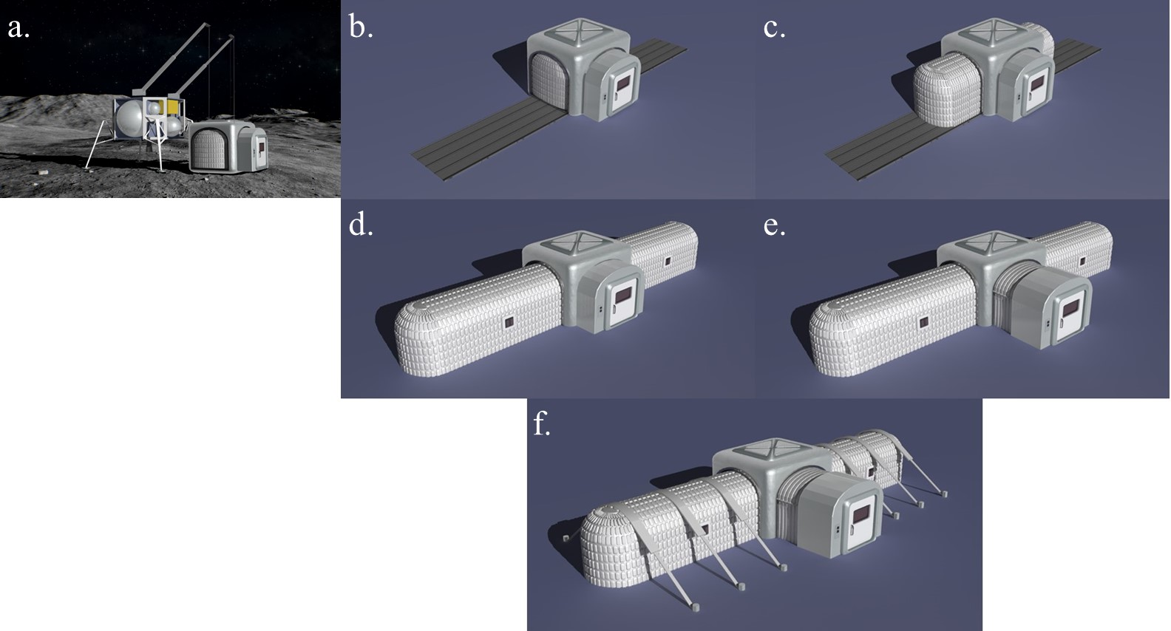
Based on the NASA explorations planned for calendar years 2021 through 2030, there will be at least two CLPS opportunities per year, except for 2027 and 2028 where there will be one and three respectively [33]. Additionally, as mentioned, the VIPER rover will be sent to the south pole of the Moon in late 2023 via the Griffin lander [18]. Additionally, a surface power object model, which could be a nuclear reactor, will be sent to the lunar surface in 2027. Finally, in 2028, the mobility habitat and foundation surface habitat will be sent to the Moon. Throughout the missions in-situ resource utilization (ISRU) opportunities are to be explored.
Figure 1: The notional un-loading (a) and deployment process of the Bowling Habitat, demonstrating the deployable friction barrier (b), inflatable arms (c-d), multichambered inflatable airlock (d), and guy line supports (f).
Image Credit: NASA LaRC

4. Bowling Habitat Architecture
The Bowling Habitat design is a combination of current inflatable architecture concepts with several emerging technologies being developed at NASA LaRC. The design features a rigid core that stores the inflatable extremities during transport which are inflated when on the Moon. The arms are designed to mimic a general cylindrical shape with rounded edges to reduce stress concentrations. There is no minimum volume requirement per person per time for a lunar habitat, beyond that required to perform any planned function within the habitat. Therefore, the Bowling Habitat’s usable volume was based off of the ISS’s habitable volume of 388 m³, per person (minimum of three people) per month (average deployment is six months), which was then multiplied by four persons and one month, yielding the volume of at least 86 m³ [34]. This required both inflatable arms to have dimensions of approximately 2.5 m tall by 7 m long, contributing 70 m³ of volume to the habitat, which leaves about 16 m³ left for the rigid core. It is important to minimize the size of the rigid core because it will be the location of the SPE shelter, which contributes to a significant portion of the entire habitat’s mass. However, it is also important to have a rigid core so that it offers hard connection points for the inflatable structures, communication devices, and technologies on the lunar surface, as well as acting as another element that protects astronauts from an inflatable arm failure. A rigid core also facilities the transportation and un-loading of the habitat by protecting the inflatable portions.
Deployment Sequence
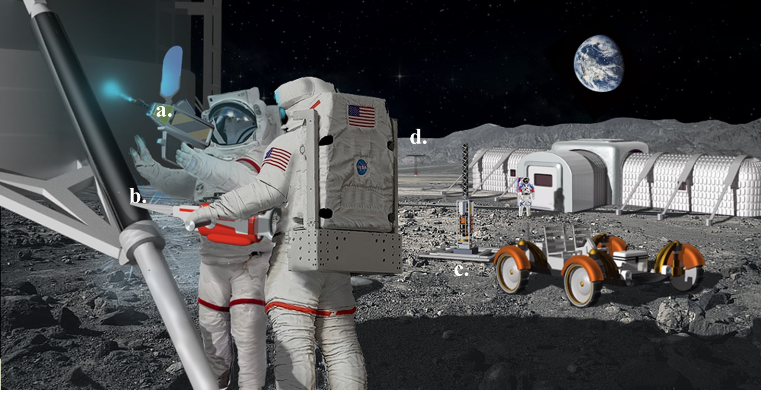
Deployment of a lunar habitat is complex. As an example, a six-step process will be described, although there are a myriad of other sequences that could be envisioned for other inflatable lunar habitat concepts. The first step is un-loading the habitat from the lander. In Figure 1a, Blue Origin’s Blue Moon lander was depicted, however the habitat should be compatible with many different landing systems. It is important to mention that the means by which the habitat will be transferred from the landing site to habitation site has not been determined yet. Once the habitat is at the habitation site, a friction barrier will be deployed to protect the bottom of the inflatable material from lunar regolith during the arms’ deployment (Figure 1b). The friction barrier is comprised of a material that utilizes stored elastic energy to deploy instead of an external power source. In the third step (Figure 1c), the inflatable arms extend onto the friction barrier with the inflatable fabric that provides that habitat with both structural primary support and environmental protection. Once the arms are fully inflated in step four (Figure 1d), a multichambered airlock begins to inflate (Figure 1e). A multichambered airlock is required for a lunar habitat because it allows multiple redundancies in the removal of lunar dust from the entering astronauts. To complete the deployment of the Bowling Habitat, guy lines are extended to the lunar surface (Figure 1f). Guy lines were included to provide lateral stability to the habitat. The guy lines must be made out of a lightweight and strong material.
Figure 2: A conceptual image of the Bowling Habitat landing site, demonstrating repurposing of the descent module (a-b), additive manufacturing technologies (c), and a nuclear reactor (d).
Image Credit: NASA LaRC
Landing Site
Many technologies will be dispersed throughout both the landing and habitation site to aid in outfitting for the habitat. Since descent modules have no secondary purpose on the Moon once they have successfully landed and all of their cargo has been removed, portions of them can be reused for furniture within the habitat [35]. The module’s flat, metal outer walls can be used as floorboards within the airlock and habitat, whereas its composite legs can be used for assembling basic furniture, such as tables, ladders, and stools (Figure 2). This requires tools for manipulating metals and composites to be at the habitation site by the time the habitat arrives so that it can be quickly furnished and finished. Additionally, additive manufacturing technologies would be useful on the lunar surface because they can manufacture components on-demand. Specifically, to compliment the descent module floorboards, floor joists can be produced on the Moon via additive manufacturing materials that are lightweight and can withstand the loads of floorboards and furniture placed on top, such as carbon-fiber reinforced polymers (CFRP). Lastly, the power source will be located somewhere external from the habitat. For the Bowling Habitat, a nuclear power source will be used because an object model is in the Artemis plans and it does not require connection to the habitat until the habitat is ready to be deployed. This saves mass and volume in the habitat’s payload and can provide energy regardless of solar radiation intensity and duration,

Internal Configurations
Similar to the landing site, numerous technologies will be in the interior of the Bowling Habitat as well. Although the layers of the inflatable fabric are not directly seen by the astronauts, it is important to note that there are multiple layers of various fabrics within the InFLEX scheme, not only the two layers as shown in Figure 3. As previously mentioned, metallic floorboards and CFRP joists will be generated via repurposing of the descent module. Two additional LaRC technologies were integrated into the interior of the Bowling Habitat, the first being habitat health sensors incorporated into the inflatable fabric (Figure 3). When coupled with software, these sensors can alert the astronauts that an impact or penetration event occurred and provide a general location of the potentially compromised area. The last technology featured in the interior of the Bowling Habitat is a ceramic lunar dust coating (Figure 3). These coatings can be applied to rigid components of the habitat to protect the component from the abrasive and charged characteristics of lunar dust, beyond protection from every-day wear from the astronauts. The coating would be most effective on the airlock and habitat floors, as well as any external rigid connections between inflatable arms. One technology not addressed in this work is the mechanism by which the inflatable arms will connect with the deployed friction barrier. These mechanisms will not need to be utilized for multiple connection-disconnection cycles which suggests that mechanisms utilized for similar connections that have space flight heritage could be readily adapted for this use.
Figure 3: Conceptual image of an inflatable structure demonstrating multiple layers of fabric (a), floorboards and joists generated from repurposed materials (b-c), habitat health sensors within the inflatable fabric (d), and ceramic coatings on rigid elements (e).
Image Credit: NASA LaRC

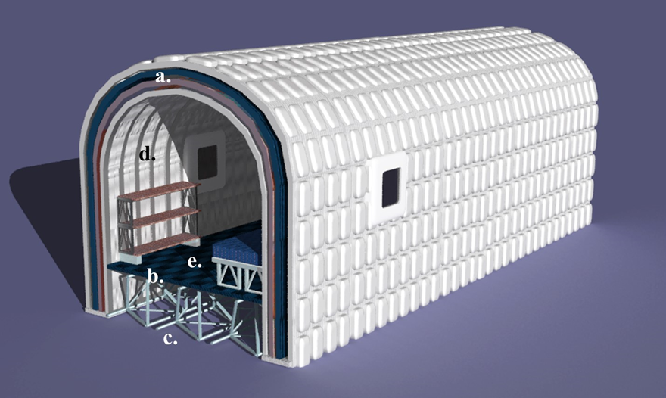
5. Gap Analysis
Technology Readiness Levels
For technologies to be space flight certified, a requirement for their incorporation into a lunar habitat’s architecture, they must have a technology readiness level (TRL) of at least eight. NASA has pre-determined qualifications for each of the nine TRL levels and in order to increase in TRL, the technology must have completed the requirements of the level completely [36]. The definition for TRL 8 is that the “actual system is ‘flight qualified’ through test and demonstration [in its operational environment and platform]”; therefore, for a technology to be classified as TRL 8 it must have completed and passed in its service environment and platform testing [36]. Many of the current technologies integrated into the Bowling Habitat are in levels 2-4. A TRL 2 can be assigned to a technology when a general idea of how the technology will function has been developed [36]. The technology progresses to TRL 3 when the critical function of the technology has been demonstrated, a “proof of concept” activity [36]. Lastly, a TRL 4 means that the technology was validated in a laboratory environment in which it demonstrated basic functionality [36].
Improvement Steps
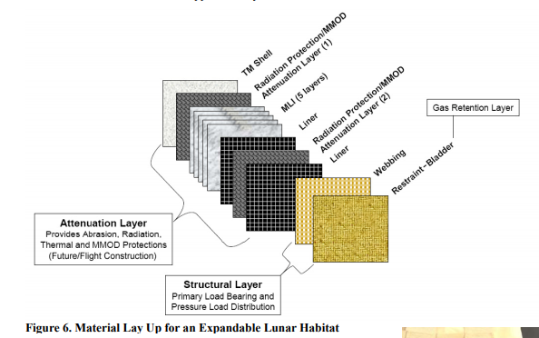
The improvement steps for an inflatable lunar habitat have been ranked into three categories to identify the habitat elements that are the most crucial to a sustainable deployment of the habitat. The first ranking is “critical technologies”; these are necessary for the completion of mission goals. Critical technologies offer a significant risk-reduction and can often contribute heavily to multiple mission architectures. The second tier for ranking is the “enhancing technologies” category in which these technologies significantly improve mission performance, but the mission does not depend on them to operate. Often, enhancing technologies are improvements to existing technology, whether it be via safety, reliability, or cost, and can contribute to multiple areas within the mission architecture. The last category is “transformational technologies”. Transformational technologies are revolutionary technologies that give future related missions new capabilities that would further improve the mission performance. These technologies may offer solutions to complex problems that require multiple technological iterations and a significant time to successfully develop. These technologies also have the greatest risk of not being fully advanced through the TRL scale. If implemented successfully, transformational technologies will significantly and beneficially impact the mission in terms of cost, safety, and technological reliability.
Critical Technologies
Intelligent Flexible Material Fabric—The intelligent flexible material (InFLEX) program was a collaborative effort between ILC Dover and NASA Langley from 2006 to 2010, with the main purpose being to develop improved capabilities for inflatable structures for exploration missions [7]. From this program, two Engineering Design Units (EDU) were prototyped with a significant amount of structural testing. The InFLEX material provides basic protection for the astronauts from the lunar atmosphere; it has atmospheric retention, structural integrity, MMOD, thermal and minimal radiation protection. To maintain pressure, a fire-resistant urethane coated Vectran fabric was integrated as the bladder layer; the urethane coating provides the bladder with impact and abrasion resistance, while maintaining the diffusion properties of the Vectran [34]. Double coating the fabric can increase durability and enhance diffusion properties. Additionally, InFLEX enables multiple redundancies of bladder layers and is the innermost layer to the habitat (Figure 4). The next layer within the InFLEX layering scheme is the restraint layer, which carries a majority of the structural load and hoop stresses of a cylindrical habitat. InFLEX has an open-net webbing and a coated fabric, the bladder, which then also works as distributing the pressure stresses among the webbing. Vectran 12K and 24K were used for both the webbing and coated layer because of their high strength-to-weight ratio. The combination of the bladder and restraint layer make up the structural layers of the InFLEX scheme (Figure 4).
The next layer within InFLEX is the thermal micrometeoroid cover (TMC) layer, labeled as the attenuation layer in Figure 4, which serves as thermal insulation, MMOD and radiation protection, and puncture resistance. Additionally, this layer is removable from the X-HAB. The outermost layer, the TM shell, serves as one of the many radiation protection layers and MMOD resistance. MMOD layers break apart high velocity particles and then allow foam to absorb the vapors released [34]. The TMC layer also has multi-layer film insulation (MLI) with spacers in between the layers to decrease the thermal conductivity of the layers. The materials that would make-up the TMC were never chosen, but a mock-up was made for demonstration purposes. Based on current status, InFLEX is at a TRL of three since there was a proof-of-concept, but the materials were not entirely validated in a laboratory environment.
Figure 4: The proposed layering scheme of the InFLEX fabric, comprising of a structural (innermost) and attenuation (outermost) layer [34].
Habitat Health Accelerometers—One of the InFLEX program’s main goals was to find an effective and efficient way to incorporate sensors into the fabric. A majority of these sensors were used to monitor human health. Extending this approach, monitoring the status of the habitat can be done using accelerometers set to detect high frequencies from MMOD impacts or penetrations [37]. Limiting the accelerometers to higher frequencies will help mitigate the interference of human voices or other electronics with the impacts. Coupling the accelerometers with software that can model the structure of the habitat, the area of the habitat in which the frequency came from can be identified and help determine if there was damage to the inflatable, if it needs to be repaired, or if the habitat needs to be evacuated [37]. Technology similar to this have been in use on the ISS, the accelerometers’ service environment, which gives it the maximum TRL of nine.
Deployable Friction Barrier—If the habitat deployment sequence requires the inflatable material to be in direct contact with the lunar surface, a friction barrier is required in order to further protect the material from the abrasive lunar dust. Utilizing deployable materials that utilize stored elastic energy to deploy, rather than a power source, offers a friction barrier that is low in mass and power consumption. Candidate material systems are bis-maleimides (BMI) and epoxies which are a space-grade thermosetting polymer [38]. Its current testing focuses on the response to long-term effects of constant stress, known as creep. In addition to the stress of the habitat residing on top of the BMI barrier, the packaging of the barrier can also induce creep. The main space application that this material is being considered for is composite booms to support solar arrays, resulting in the deployable BMI material being classified at a TRL of three.
Boron-Nitride Nanotube Guy Lines—Boron-nitride nanotubes (BNNT) are particularly interesting because they are 100 times stronger than steel, yet 1/6th the weight, as well as inert and resistant to corrosion [39]. Due to these properties, they would be optimal for structural support in the habitat. Current research is being conducted through a collaboration between NASA LaRC and Rice University to develop a way to turn BNNT into yarn, which can then be used to make BNNT fabric [40]. There are two ways that BNNT can add a support structure to the habitat, the first being guy lines, similar to a camping tent, which externally supports the structure. BNNT could also be integrated into a composite and used as internal ribbing of the habitat. An additional use of the BNNT could be neutron radiation shielding [41]. The current architectures are attempting to protect against both GCR and SPE radiation, meaning that the material selection process seldom considers the third type of radiation, neutron radiation. BNNT is an optimal material for this because boron is one of the best neutron shielding elements due to its low electron density. Since BNNT yarn is in early development stages, it was assigned a TRL of two.
Lightweight External Inflatable Airlock (LEIA)—Originally designed to be the airlock for the Lunar Gateway, a proposed lunar orbiting space station that will serve as base for astronauts when doing lunar expeditions [3]. A traditional space station airlock has two chambers, the first being the equipment lock, the larger of the two chambers which is where the astronauts don and doff. The other chamber, the crew lock, is just big enough to fit two donned astronauts and is where they exit to begin their EVAs. LEIA was designed to be an inflatable crew lock [3]. The basis of the design is to have a pre-built truss covered by fabric that can be compressed for transport and expanded for EVAs. However, as this airlock was designed for lunar orbit, the LEIA design must be modified to address lunar gravity and dust before it can be used for a lunar habitat. Multiple chambers can be introduced within the airlock, with each chamber being another opportunity to mitigate lunar dust intrusion into the livable space of the habitat. The LEIA provides the basis of the airlock design for a lunar habitat; however, considering the original application space was in lunar orbit requiring significant modification for use on the lunar surface, this technology was assigned a TRL of two.
Enhancing Technologies
Trusselator—The trusselator is a technology developed through collaboration between Tethers Unlimited and NASA Langley. It was designed as an on-orbit, autonomous, continuous-forming, additive manufacturing tool that would generate CFRP trusses [42]. The trusselator fabricates trusses on-demand using CFRP material provided in standard industry roll packaging. When prototyped and tested, the trusselator prototype produced a 10 m long truss in 1 g that was able to maintain its structural integrity when supporting both its own weight, and a scientist standing on it [42]. Based on this analysis, it is anticipated that these structures could be used as lunar habitat floor joists. Multiple trusselator-generated trusses would lay horizontally across the inflatable portions of the habitat, supporting all of the floorboards, humans, and furniture placed on top. This would save mass and volume in the habitat’s payload, so long as the CFRP and trusselator have been delivered to the Moon prior. Since the trusselator is aimed to be used either in a micro- or partial gravity environment, the testing done is qualified as a laboratory environment, yielding a TRL of four.
Electron Beam Gun—Researchers at NASA Langley are working on utilizing an electron beam in two ways; as a wire additive manufacturing instrument that would be used to fix minor things in-space, or as a device that can cut and then weld pieces of metal together in-space [43]. Typically, this technology requires a high vacuum level environment to operate. The vacuum of space will be utilized on the lunar surface providing an optimal service environment for the electron beam gun [43]. An electron beam instrument has already been fabricated at NASA Langley, which allows the technology to be tested in a laboratory environment; however, it has not been tested in hand-held form, which is how it would be used in the initial lunar habitat, resulting in a TRL of four.
Lunar Dust Ceramic Coatings—In addition to a deployable friction barrier and the LEIA to help mitigate the effects of lunar dust on the habitat, ceramic coatings can be implemented along the rigid aspects of the habitat, such as on the floors throughout the habitat and on connections between the inflatable portions and rigid components. Ceramic materials are ideal for this purpose because they exhibit high strength, durability, and erosion resistance. The ceramic currently being investigated for this application is metal aluminum-boride (MAB), which is produced as a powder, therefore not keen for any sort of in-space manufacturing [44]. However, little research has been done on this material as a coating, meaning that there has been no proof-of-concept yet, only a formulated concept. Additionally, since MAB is planned to be used on the floorboards that will be manufactured on the Moon, a method to apply it in-situ is required, which results in a TRL assignment of two.
Re-purposable Composites—ISRU is the concept that NASA will use resources and materials found on the Moon to generate items necessary for mission success such as water, silicon solar panels, regolith cement, and more [2]. After multiple Artemis missions and cargo deliveries to the Moon, the Moon’s surface will have numerous, descent modules that have fulfilled their mission requirements. Therefore, to embrace ISRU, the re-purposeful composite study aims to construct parts, specifically the legs, of the descent module with a re-purposable composite that can be utilized to benefit the habitat once the descent module has landed [32]. Possible secondary uses for this material that do not require re-shaping of the legs include ladders, solar array supports, stools, benches, or simple tables [32]. Materials for this composite are still being researched. The composite system must be able to meet the performance requirements for the lander as well as their intended secondary use. Ideally, a composite system will be identified with material properties comparable to state-of-the-art composites generated with Hexcel® IM7 carbon fiber, whether they be discontinuous, continuous, or woven fibers [32]. Since a material has not been chosen yet, re-purposable composites were assigned a TRL of two.
Kilopower Reactor Using Stirling Technology—The Kilopower reactor using Stirling technology (KRUSTY) is an alternate option for a lunar power source and is being developed at NASA Glenn Research Center. It is a nuclear reactor with a 235U core that uses a Stirling engine to convert the heat to electricity [45]. The Artemis program has already planned to send a large power system to the Moon’s surface before the habitat, meaning that KRUSTY already fits into the transportation schedule. This is also beneficial in that the nuclear reactor must be safely installed before astronauts arrive so that they are not exposed to another source of radiation. It is possible that additional technology may be needed to act as radiation protection if KRUSTY cannot logistically be placed a sufficient, protective distance away or depth. KRUSTY is currently being tested on Earth, giving it a TRL of five because the testing has not been completed yet.
Transformational Technologies
Cassegrain reflectors—A Cassegrain reflector can be used toward enabling lunar habitation through its ability to sinter lunar regolith [46]. The main element of its design is a parabolic dish that collects solar energy and focuses it on an area of regolith. Regolith sintering can be utilized to prepare landing pads for descent modules potentially reducing the dust plume generated by landing vehicles. Cassegrain reflectors could also be used to secure regolith on top of habitats to act as additional radiation protection. The Cassegrain reflector system is not required for the basic establishment of a lunar habitat and has a TRL of three.
ASSEMBLERS—The ASSEMBLERS is an on-going project at NASA LaRC focused on designing autonomous Stewart platforms (hexapods) that can do both long and short reach manipulations [47]. The Stewart platforms can be stacked on top of one another so that they can accommodate a wide range of jobs on the Moon [47]. Currently, the hexapods require a foundation beneath them to function and have an estimated payload of 182 kg [47]. Nonetheless, these manipulators could be used for moving habitats and configuring lunar cities in the future. Basic prototyping of the hexapods was postponed due to COVID-19, resulting in a TRL of three.
Robot Swarms—Since it is anticipated that these habitats may go long durations without a human occupant, it would be ideal to have a technology in place for habitat maintenance and monitoring. One approach is use of robot swarms on the lunar surface and within the habitat. Software is being developed for the communication methods between these swarms of robots and humans; specifically, the benchmarks for when robots should convey important information to humans, when robots should converse with other robots, or when they do not have to report information to humans, are being developed [48]. Once these communication methods are developed, robots will be partially self-sufficient on the Moon and will be able to keep humans informed on the status of the structures and technologies on the Moon. Since this technology is not being tested on robot swarms yet, it was assigned a TRL of three.
Implementations and Revisions
With so many technologies involved in the lunar habitat, there is a large chance that some of the technologies will not have a TRL of eight by the time the habitat needs to be transported to the surface of the Moon. The major penalties of technologies not being ready would be mass and volume, which can range from minimal, mild, or substantial penalties. The rank of the penalty was qualitatively determined based on the possible alternatives’ relative mass and volume to the original intended technology. For example, if the original technology had a large mass and volume and its alternative also has a large mass and volume, the penalties would be minimal because a minimal amount of mass and volume would have to be reassigned to accommodate the alternative technology.
Critical Technologies
Intelligent Flexible Material Fabric—If the InFLEX fabric cannot be used in the inflatable lunar habitat, there will be a substantial mass penalty because the InFLEX fabric incorporates many of the required protections against the lunar environment. If an alternative inflatable fabric consisting of only the structural layer is used, additional mass and volume will be required to transport the thermal control, MMOD and radiation protection to the lunar surface. Additionally, if the ability to have an inflatable structure is lost, the habitat would have to become a rigid structure, which will require a significant redesign of the habitat and could substantially increase the mass and reduce the volume.
Habitat Health Accelerometers—Since habitat health monitoring accelerometers are being used on the ISS, there is a low risk that they will not be incorporated within the inflatable fabric used for the lunar habitat. Nonetheless, mass and volume penalties are both minimal, but the exclusion of these sensors could be catastrophic if an alternative technology is not used [39]. The mass and volume penalties are minimal for similar reasons; sensors themselves have minimal mass and volume, so their exclusion in the payload will not significantly change the available mass or volume. An alternative to these sensors is weaving BNNT fabric into the inflatable layer scheme because BNNT is piezoelectric, meaning that it would release a charge when penetrated, which could then be tracked with complimentary software [41]. BNNT are extremely light, and would therefore not significantly impact the payload mass or volume.
Deployable Friction Barrier—If the deployable friction barrier does not have the TRL required for space travel, the mass penalty ranges from minimal to substantial. Many alternative friction barriers exist, or there could simply be no friction barrier in the habitat design; however, this poses a threat for the habitat to become significantly damaged during deployment. Another option would be to include an exterior layer on the inflatable fabric to specifically mitigate lunar dust abrasion, which would cause a mild mass penalty. Alternatively, the habitat could be equipped with a rigid platform that extends for inflatable portions to inflate onto. However, this option introduces a substantial mass penalty and uncertainties to the habitat, such as the mechanical system and connections to the habitat. These three alternatives all range in volume, making the volume penalty range from minimal to substantial as well.
Boron-Nitride Nanotube Guy Lines—Not choosing BNNT as the support structure for the inflatable habitat would have either mild or substantial penalties for both mass and volume. An alternative use for BNNT could be utilization for inflatable ribs that many of the current inflatable architectures use. Another option would be having rigid ribbing throughout the inflatable, but this would cause both substantial mass and volume penalties because rigid materials cannot be folded up to transport, which significantly increases the amount of volume required within the payload.
Lightweight External Inflatable Airlock (LEIA)—There are two ways to consider the mass and volume penalties for the multichambered inflatable airlock. First, if the number of chambers within the airlock were decreased, there would be no mass or volume penalty; this would actually save mass and volume. However, similar to the habitat health accelerometers, failure to incorporate this technology could be catastrophic due to the increased risk of potentially toxic lunar dust inhalation. Second, failure to make the airlock inflatable would have mild to substantial mass and volume penalties as the airlock would require at least some portions to be rigid.
Enhancing Technologies
Trusselator—If the trusselator cannot be transported to the Moon, there could be both mild mass and volume penalties. Not using trusselator generated floor joists would require floor joists to be included in the habitat’s payload; however, there exist lightweight, strong materials alternatives, such as aluminum, that could be fabricated into floor joists. The volume penalty would also be mild because the floor joists, consisting of rectangular prisms, can be tailored to fit the payload vehicle.
Electron Beam Gun—Although the electron beam gun and trusselator are technologies being used to construct the floor, the mass and volume penalties for not implementing the electron beam gun are both substantial. Again, it is planned to repurpose elements of the descent modules, meaning that no mass or volume in the initial payload is dedicated toward transporting the floor. Floorboards are similar to the floor joists in that the floorboards can be constructed to fit inside of a specific payload, but the floorboards require a substantially greater amount of material in terms of thickness, width, and height, yielding a greater mass and volume penalty than the trusselator.
Lunar Dust Ceramic Coatings—The impact on mass and volume of not integrating ceramic coatings ranges from negligible to substantial depending on related technologies and other materials considerations. If the multi-chambered airlock is deemed suitable for prevention of lunar dust habitat infiltration, the ceramic coating on the floor could be unnecessary, at least with respect to protection from lunar dust-instigated wear. If floor and connection protections are desired, but the ceramic coating technology is not space qualified yet, the only alternative would be to provide a floor and connection protective cover that would also have to be inert and abrasion resistant. This coating could be relatively heavy and require a larger payload volume than the ceramic coating, potentially yielding substantial penalties for both mass and volume.
Re-Purposable Composites—If re-purposable composites are not available for ISRU on the lunar surface the volume penalty would be substantial. The mass penalty could range from mild to substantial based on the amount of furniture chosen for the mission. The furniture could purposely be made out of a lighter material, but nonetheless, there would be a substantial volume penalty, even if the furniture could be efficiently stowed for launch, simply due to the amount of furniture that would be needed.
Kilopower Reactor Using Stirling Technology—Although it is not planned for KRUSTY to be sent up with the habitat, if KRUSTY is not space qualified by the time that it would need to be sent to the Moon, mass penalties would range from minimal to substantial. Alternatives to KRUSTY would be another power source that does not require integration with the habitat, or a source that would require connection to the habitat and batteries. If the power source was installed before the habitat arrives, there would be no mass penalty. However, there would be a substantial penalty if the power source must be transported with the habitat. A similar argument can be made for volume penalties.
Transformational Technologies
As mentioned, all of the transformational technologies are not required for an initial sustainable lunar habitat; rather, they are technologies that can improve the living qualities of the Moon once a secure lunar presence is made. Therefore, there exist no penalties if these technologies are not at TRL 8 by the time an inflatable lunar habitat is launched.
6. Conclusions
Both a concept design for an inflatable lunar habitat and a gap analysis of developing-applicable LaRC technologies were produced. The habitat was able to incorporate 13 technologies to address current lunar environment protection needs, habitat requirements put in place by NASA, and the structural requirements needed for a sustainable lunar habitat. Through utilizing InFLEX fabric and habitat health accelerometers, the habitat provides thermal and atmospheric control as well as MMOD and radiation protection, while monitoring the status of the habitat itself. The InFLEX material coupled with BNNT guy lines provide the structural integrity of the habitat. Deployable friction barriers, ceramic coatings, and a multi-chambered airlock mitigate the effects of lunar dust on both the structure and the human health, through either abrasion resistance or redundancies for lunar dust removal. A nuclear reactor will be able to provide constant, reliable power to the habitat compared to alternative options such as solar arrays. Additionally, through ISRU more mass can be saved by using descent modules already on the lunar surface to construct basic furniture, floorboards, and floor joists. Once NASA is ready to begin building a community on the lunar surface, Cassegrain reflectors, ASSEMBLERS, and robot swarms can be used to help build and maintain them. Nonetheless, there are many more gaps that must be addressed before 2028 and the foundation surface habitat reaches the lunar surface; these gaps include, but are not limited to, hardware, fluid ventilation and pumping, power connections, life-style needs, and extra radiation protection.

References
[1] “NASA’s Lunar Exploration Program Overview,” NASA, 15-Sep-2020. [Online]. Available: https://www.nasa.gov/sites/default/files/atoms/files/artemis_plan-20200921.pdf. [Accessed: 08-Oct-2020].
[2] H. Benaroya, “Lunar habitats: A brief overview of issues and concepts,” Reach, vol. 7-8, pp. 14–33, 2017.
[3] D. Litteken, D. Calderon, C. Gaytan, M. O'Donnell, K. Shariff, and M. Sico, “Design of a Microgravity Hybrid Inflatable Airlock,” NTRS NASA, Mar. 2020.
[4] J. Hinkle, A. Dixit, J. Lin, K. Whitley, J. Watson, and G. Valle, “Design Development and Testing for an Expandable Lunar Habitat,” AIAA SPACE 2008 Conference & Exposition, Spetember 9-11, 2008, San Diego, CA.
[5] K. J. Kennedy and S. D. Capps, “Designing Space Habitation,” AIAA SPACE 2000 Conference & Exposition, September 19-21, 2000, Long Beach, CA.
[6] D. Cadogan, C. Scheir, A. Dixit, J. Ware, J. Ferl, E. Cooper, and P. Kopf, “Intelligent Flexible Materials for Deployable Space Structures (InFlex),” SAE Technical Paper Series, 2006.
[7] D. Eberhard Grun, Mihaly Horanyi, Zoltan Sternovsky, “The Lunar Dust Environment.” Planetary and Space Science, 2011, 59, 1672-1680.
[8] Inflatable technology: using flexible materials to make large structures," Proc. SPIE 10966, Electroactive Polymer Actuators and Devices (EAPAD) XXI, 1096603 (13 March 2019)
[9] Kriss J. Kennedy, “Lessons from TransHab: An Architect’s Experience.” AIAA Space Architecture Symposium, October 10-11, 2002, Houston, Texas, 6105.
[10] Y. Kim, C. Choi, K. Kumar, C. Kim, “Hypervelocity impact on flexible curable composites and pure fabric layer bumpers for inflatable space structures.” Composite Structures, 2017, 176, 1061-1072.
[11] D. Cadogan and C. Scheir, “Expandable Habitat Technology Demonstration for Lunar and Antarctic Applications,” SAE Technical Paper Series, 2008.
[12] G. Daines, “Commercial Lunar Payload Services,” NASA, 14-Mar-2019. [Online]. Available: https://www.nasa.gov/content/commercial-lunar-payload-services. [Accessed: 22-Jun-2020].
[13] T. Malik, “Jeff Bezos Unveils Blue Origin's Dream Team to Land NASA Astronauts on the Moon,” Space.com, 22-Oct-2019. [Online]. Available: https://www.space.com/jeff-bezos-blue-origin-artemis-moon-lander-team.html. [Accessed: 22-Jul-2020].
[14] J. Lin, C. Knoll, J. Hinkle, B. Bishop, B. Murach, L. Bell, O. Bannova, and H. Everett, “Lunar Surface Systems Concept Study: Minimum Functionality Habitation Element,” AIAA SPACE 2009 Conference & Exposition, September 14-17, 2009, Pasadena, California.
[15] C. Warner, “NASA Outlines Lunar Surface Sustainability Concept,” NASA, 25-Mar-2020. [Online]. Available: https://www.nasa.gov/feature/nasa-outlines-lunar-surface-sustainability-concept. [Accessed: 07-Jul-2020].
[16] “Lunar Terrain Vehicle (LTV) Request for Information,” beta.SAM.gov, 2020. [Online]. Available: https://beta.sam.gov/opp/46cd587dcba34a8e96792f26d3c7a8d8/view. [Accessed: 25-Jun-2020].
[17] D. Hill, “Winners of NASA's 2020 RASC-AL Competition,” NASA, 18-Jun-2020. [Online]. Available: https://www.nasa.gov/feature/students-develop-innovative-lunar-exploration-concepts-in-nasas-artemis-competition/. [Accessed: 25-Jun-2020].
[18] R. Chen, “VIPER,” NASA, 09-Jan-2020. [Online]. Available: https://www.nasa.gov/viper. [Accessed: 25-Jun-2020].
[19] M. Wall, “Private Company Orbit Beyond Drops Out of 2020 NASA Moon-Landing Deal,” Space.com, 30-Jul-2019. [Online]. Available: https://www.space.com/nasa-drops-orbit-beyond-moon-landing-contract.html. [Accessed: 05-Aug-2020].
[20] “ASTROBOTIC,” Astrobotic. [Online]. Available: https://www.astrobotic.com/. [Accessed: 22-Jun-2020].
[21] “Blue Moon,” Blue Origin. [Online]. Available: https://www.blueorigin.com/blue-moon/. [Accessed: 22-Jun-2020].
[22] “Rovers,” Mars And Moon. [Online]. Available: https://www.ceresrobotics.com/rovers. [Accessed: 22-Jun-2020].
[23] “Commercial Lunar Payload Services,” Deep Space Systems. [Online]. Available: https://www.deepspacesystems.com/clps. [Accessed: 22-Jun-2020].
[24] “Commercial Lunar Payload Services (CLPS),” Draper. [Online]. Available: https://www.draper.com/business-areas/space/clps. [Accessed: 22-Jun-2020].
[25] LordFirefly, “Genesis,” Firefly Aerospace. [Online]. Available: https://firefly.com/genesis/. [Accessed: 22-Jun-2020].
[26] “Nova-C,” Intuitive Machines. [Online]. Available: https://www.intuitivemachines.com/lunarlander. [Accessed: 22-Jun-2020].
[27] “McCandles Lunar Lander,” Lockheed Martin. [Online]. Available: https://www.lockheedmartin.com/en-us/products/mccandless-lunar-lander.html. [Accessed: 22-Jun-2020].
[28] “XL-1,” Masten Space Systems. [Online]. Available: https://www.masten.aero/xl1. [Accessed: 22-Jun-2020].
[29] “REDEFINE POSSIBLE,” Moon Express Inc. [Online]. Available: https://moonexpress.com/. [Accessed: 22-Jun-2020].
[30] “Space Exploration: Gateway, Moon & Mars: Sierra Nevada Corporation,” SNC. [Online]. Available: https://www.sncorp.com/what-we-do/space-exploration-gateway-moon-mars/. [Accessed: 22-Jun-2020].
[31] B. Dunbar, “Starship User’s Guide,” SpaceX, 01-Mar-2020. [Online]. Available: https://www.spacex.com/media/starship_users_guide_v1.pdf. [Accessed: 08-Oct-2020].
[32] B. Dunbar, “Tyvak Nano-Satellite Systems Lander Concept,” NASA, 18-Nov-2019. [Online]. Available: https://www.nasa.gov/image-feature/tyvak-nano-satellite-systems-lander-concept. [Accessed: 22-Jun-2020].
[33] H. Weitering, “NASA has a plan for yearly Artemis moon flights through 2030. The first one could fly in 2021.,” Space.com, 12-Feb-2020. [Online]. Available: https://www.space.com/nasa-artemis-moon-landing-timeline-2021-budget.html. [Accessed: 23-Jul-2020].
[34] M. Garcia, “International Space Station Facts and Figures,” NASA, 28-Apr-2016. [Online]. Available: https://www.nasa.gov/feature/facts-and-figures. [Accessed: 10-Jul-2020].

[35] Internal discussion with E. Siochi, NASA Langley Research Center.
[36] B. Dunbar, “Technology Readiness Level,” NASA, 06-May-2015. [Online]. Available: https://www.nasa.gov/directorates/heo/scan/engineering/technology/txt_accordion1.html. [Accessed: 22-Jul-2020].
[37] Internal discussion with E. Madaras, NASA Langley Research Center.
[38] Jin Ho Kang, Keith L. Gordon, Robert G. Bryant, W. Keats Wilkie, Sheila A. Thibeault, Jeffrey A. Hinkley, Juan Fernandez, Charlotte Brandenburg, Evin Hill, Nina Arcot, and Ray Peterson, “Viscoelastic characteristics of polymers for deployable composite booms,” paper submitted to special issue of Advances in Space Research at the 5th ISSS (International Symposium on Solar Sailing) February 2020.
[39] “Lightweight, Ultra-Strong Nanotubes to Transform Industry,” Nasa.gov, 27-May-2016 [Online]. Available: https://spinoff.nasa.gov/Spinoff2016/t_3.html [Accessed 05-Oct-2020].
[40] D. Marincel et al., “Scalable Purification of Boron Nitride Nanotubes via Wet Thermal Etching.” Chem. Mater. 2019, 31, 1520-1527.
[41] S. Thibeault et al., “Nanomaterials for Radiation Shielding.” MRS Bulletin, 2015, 40, 836-841.[42] Internal discussion.
[42] Internal discussion with B. Grimsley, NASA Langley Research Center.
[43] R. Hafley et al., “Electron Beam Freeform Fabrication in the Space Environment,” 45th AIAA AeroSpace Science Meeting, January 8-11, 2007, Reno, Nevada, 5152.
[44] S. Gupta and M. Dey, “Novel MAB Phase-based Nanolaminates Suit High Performance Applications,” Adv. Mater. Processes. 2019, 177 (2), 22-26.
[45] M. A. Gibson, D. I. Poston, P. Mcclure, T. Godfroy, J. Sanzi, and M. H. Briggs, “The Kilopower Reactor Using Stirling TechnologY (KRUSTY) Nuclear Ground Test Results and Lessons Learned,” 2018 International Energy Conversion Engineering Conference, July 9-11, Cincinnati, Ohio, 2018.
[46] A. Colozza, et al. “Cassegrain Solar Concentrator System for ISRU Material Processing.” 50th AIAA Aerospace Sciences Meeting, January 9-12, 2012, Nashville, Tennessee, 4046.
[47] J. Cooper, et al. “Assemblers: A Modular, Reconfigurable Manipulator for Autonomous in-Space Assembly,” AIAA Ascend, November 16-18, 2020, Virtual, 4132.
[48] J. Thangavelautham. “Autonomous Robot Swarms for Off-World Construction and Resource Mining,” AIAA Scitech 2020 Forum, January 6-10, 2020, Orlando, FL, 0795.

