**Customer Avionics Interface Development and Analysis Development Activity Tracking System**

Tara Conti

Kennedy Space Center

Major: Computer Science

OSTEM Intern Program Fall 2020

Date: 02 NOV 2020

Customer Avionics Interface Development and Analysis Development Activity Tracking System

Tara Conti

University of Southern California, Los Angeles, California, 90007

# The Customer Avionics Interface Development and Analysis (CAIDA) Development Activity (DA) Tracking System is a Microsoft Access Database that tracks, organizes, and analyzes data about DAs from the work management tool. The CAIDA DA Tracking System takes data imported from the work management system. Once in the system, the data is filtered to generate each DA’s Asset. From there, many different queries are run on the data and their results are imported into forms to create graphs to get and display a wide range of metrics. These graphs are automatically updated with each new data import and over time. They can be easily exported for use in presentations, documents, etc. Additionally, the system is highly customizable and can be added upon to include more data members, generate new graphs, and much more.

# Nomenclature

CAIDA = Customer Avionics Interface Development and Analysis

DA = Development Activity

NC = Non-Conformance

ECR = Engineering Change Request

TT = Trouble Ticket

SQL = Structured Query Language

ICPS = Interim Cryogenic Propulsion Stage

OPS = Operations

SW = Software

SHADE = Space Launch System High-Fidelity All Digital Emulator

SOCRRATES = Software Only Crew Exploration Vehicle Risk Reduction Analysis and Test Engineering Simulator

# Introduction

Currently, the Customer Avionics Interface Development and Analysis (CAIDA) team uses the work management system to hold and track Development Activities (DAs). DAs include non-conformances (NCs), engineering change requests (ECRs), and trouble tickets (TTs). A NC is anything that causes a requirement in software to fail, an ECR is a request to generate new requirements or modify existing ones, and a TT is issued when a piece of hardware needs to be replaced. The work management system holds a wide range of information on each of these DAs, including, but not limited to, a description, the name of the submitter, the activity type, and the current state of the DA. Originally, data was exported from the work management system into an Excel spreadsheet where it was manually inspected and analyzed to get graphs and metrics. However, over the past few months of my internship, I have developed the CAIDA DA Tracker, a Microsoft Access Database that streamlines this process.

# System Overview and Approach

The CAIDA DA Tracking System has four main parts: Tables, Queries, Macros, and Forms. The tables hold data in spreadsheets that can be modified and queried. The queries are run in Structured Query Language (SQL). They can modify current data in the tables, add new data to them, or parse the tables to select certain data members and count them for graphs. The macros allow multiple queries to be run at once and in a particular order. The forms hold graphs of the queries to create visual representation of the data.

The goal of this system is to eliminate manual editing of the data and to streamline the data analysis process. This is successful because the user simply uploads the data from the work management system and runs a macro to set up. Then, all the graphs automatically populate. This gets rid of the issue of having to edit certain parts of the raw data manually and makes it easy to export graphs.

# How to Use the System

## Work Management System Query

The first step in setting up the CAIDA DA Tracking System is running a query in the work management system to get all the pertinent data. Figure 1 illustrates the exact query to create. The query must also display the following data members: id, Reference_Doc_ID, Headline, Submitter.fullname, Activity_Type, Constraint_Release, Constraint_Milestone, State, Impact, Submit_Date, Assessing_Date, Reviewed_Date, Assigned_Date, In_Work_Date, Resolved_Date, Closed_Date. Once it is created, the query must be run and then exported to an Excel Spreadsheet.

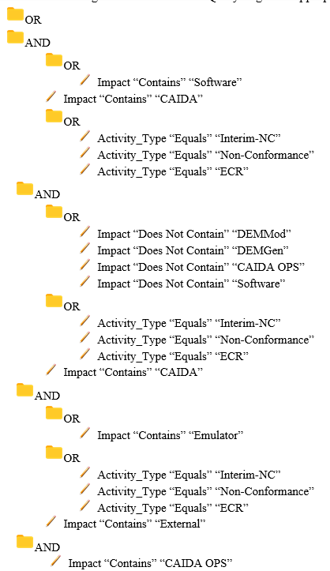

**Figure 1. Work Management System Query**

## Uploading Data

Next, the user must upload the Excel Spreadsheet to the CAIDA DA Tracking System in Microsoft Access. Then, they run the ‘Prepare Data’ Macro. This will transfer the data just uploaded in Raw Data to Main Table. It will also shorten the Dates in Raw Data and convert them to the Data/Time type and filter the Assets to be Hardware, ICPS (Interim Cryogenic Propulsion Stage), Legacy SW (Software), OPS (Operations), SHADE (Space Launch System High-Fidelity All Digital Emulator), SOCRRATES (Software Only Crew Exploration Vehicle Risk Reduction Analysis and Test Engineering Simulator), or Software. After this all the forms will be automatically updated with the newest data.

## Impact

After detailing the steps to set up and use the CAIDA DA Tracking system it is clear to see how simple the process is. There is no need for a user to manually look through the data to make changes; the system does it for you, all at once and automatically. This not only helps speed up the process for the CAIDA team, but it also eliminates any human error in accidently inputting or editing the data incorrectly.

# Tables

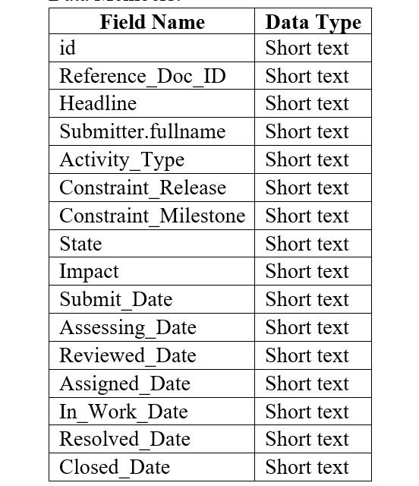

**Figure 2. Raw Data Table Field Names and Data Types**

## Raw Data

The Raw Data table holds the data directly imported from the work management tool. The goal of this table was to make importing from the tool simple as there is no need to manually edit the data before uploading it. It must have the data members specified in Figure 2 with those exact Field Names and Types. If importing from the work management tool, the data members should automatically match those of the table. The id data member holds a unique id that identifies the DA. The Headline data member holds a brief description of the issue. The Submitter.fullname data member holds the full name of who submitted the DA. The Activity_Type data member holds which kind of DA it is (NC, ECR, or TT). The Constraint_Release and Constraint_Milestone data members hold information regarding when the DA should be completed. The State data member holds what stage of processing the DA is in (Submitted, Assessing, Reviewed, Assigned, In Work, Resolved, or Closed). The Impact data member holds which system the DA is a part of. The Submit_Date, Assessing_Date, Reviewed_Date, Assigned_Date, In_Work_Date, Resolved_Date, and Closed_Date data members hold the date that the DA reached each State respectively.

## Main Table

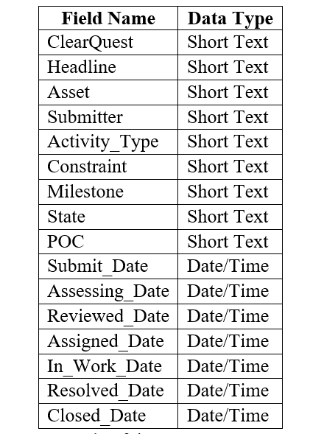

**Figure 3. Main Table Field Names and Data Types**

The Main Table holds data that is edited and streamlined from the Raw Data. Through a series of queries, the Raw Data is modified to fill the Main Table and to make later calculations and graphs easier to calculate and understand. The Main Table will always have the Field Names and Data Types listed in Figure 3. The work management tool data member holds the unique id. The Headline data member holds a brief description of the issue. The Asset data member holds the edited Impact from Raw Data. The Impact is filtered and edited to be Hardware, ICPS, Legacy SW, OPS, SHADE, SOCRRATES, or Software. The Submitter data member holds the full name of who submitted the DA. The Activity_Type data member holds which kind of DA it is (NC, ECR, or TT). The Constraint and Milestone data member hold information regarding when the DA should be completed. The State data member holds what stage of processing the DA is in (Submitted, Assessing, Reviewed, Assigned, In Work, Resolved, or Closed). The Submit_Date, Assessing_Date, Reviewed_Date, Assigned_Date, In_Work_Date, Resolved_Date, and Closed_Date data members hold the date that the DA reached each State respectively. These dates are converted from Short Text in Raw Data, to Data/Time to make calculations simpler.

## Status Table

The Status Table has two data fields: work management tool (Short Text) and Status (Short Text). It is intended to be manually modified by the user to make notes on DAs. It has a work management tool data member that holds the unique id that matches those in the other tables. It also has the Status data member. This is where the user can manually type in notes to keep track of the status of the DA and hold pertinent information.

# Queries

## Update Queries

Update queries are those that modify the contents of a table when they are run. An example of an update query is shown in Figure 5. It utilizes the SQL keyword ‘UPDATE’ to modify a table.



**Figure 5. Set Assets: OPS Query**

The CAIDA DA Tracking System has nine Update Queries that are ran in the Macro ‘Prepare Data’. These queries work together to get the data from its raw form in the work management system to a streamlined form ready for calculations and display. The ‘Update Dates’ query shortens every date in the Raw Data table to get rid of the time stamp on the end of the String. The ‘Fill Main Table’ query takes the data from Raw Data to fill Main Table and converts the dates from String to Date/Time. The ‘Set Assets: Hardware’ query updates the Assets in Main Table to ‘Hardware’ if the Asset contains ‘CAIDA’ and does not contain ‘DEMMod’, ‘DEMGen’, ‘CAIDA OPS’, or ‘Software’. The ‘Set Assets: ICPS’ query updates the Assets in Main Table to ‘ICPS’ if the Asset contains ‘ExternalICPS’. The ‘Set Assets: OPS’ query (displayed in Figure 5) updates the Assets in Main Table to ‘OPS’ if the Asset contains ‘OPS’. The ‘Set Assets: SHADE’ query updates Assets in Main Table to ‘SHADE’ if the Asset contains ‘ExternalSLS’ or ‘SHADE’. The ‘Set Assets: SOCRRATES’ updates Assets in Main Table to ‘SOCRRATES’ if the Asset contains ‘ExternalOrion’ or ‘SOCRRATES’. The ‘Set Assets: Software’ query updates Assets in Main Table to ‘Software’ if the Asset contains ‘CAIDA’ and ‘Software’.

## Select Queries

Select queries are those that grab data from a graph. It can also run calculations on data members and store the results, count the number of data members that meet a requirement, and other similar tasks. An example of a select query is shown in Figure 6. It utilizes the SQL keyword ‘SELECT’ to grab a particular data member from a table.

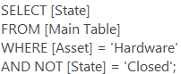

**Figure 6. Get All Hardware DAs Query**

* + 1. *Select Queries on All the Data*

The CAIDA DA Tracking System has five DAs run on all the data, without filtering it by any data member. The ‘Get All Activity Types’ query gets the number of open DAs for each Asset. The ‘Get All Milestones’ query gets the Milestones of all open DAs, grouped by their Asset. The ‘Get All Open DAs’ query gets the Assets of all open DAs. The ‘Get States of All Open DAs’ query gets the States of all open DAs. The ‘Get Average Days Between Submit and Closed’ query gets the average number of days between the Submit_Date and Closed_Date, grouped by Asset.

* + 1. *Select Queries Filtered by Asset*

The CAIDA DA Tracking System has three queries for every Asset, where only data with that particular Asset is collected. The ‘Get All Hardware Activity Types’, ‘Get All ICPS Activity Types’, ‘Get All Legacy SW Activity Types’, ‘Get All OPS Activity Types’, ‘Get All SHADE Activity Types’, ‘Get All SOCRRATES Activity Types’, and ‘Get All Software Activity Types’ queries get the Activity Types of the open DAs with the respective Asset. The ‘Get All Hardware DAs’, ‘Get All ICPS DAs’, ‘Get All Legacy SW DAs’, ‘Get All OPS DAs’, ‘Get All SHADE DAs’, ‘Get All SOCRRATES DAs’, and ‘Get All Software DAs’ queries get the States of the open DAs with the respective Asset. The ‘Get All Hardware Milestones’, ‘Get All ICPS Milestones’, ‘Get All Legacy SW Milestones’, ‘Get All OPS Milestones’, ‘Get All SHADE Milestones’, ‘Get All SOCRRATES Milestones’, and ‘Get All Software Milestones’ queries get the Milestones of the open DAs with the respective Asset.

* + 1. *Select Queries Filtered by Week*

The remaining queries in the CAIDA DA Tracking System collect data based on week. This included filtering data by the current week, the previous week, or weeks over time. The ‘Get Activity Types from Last Week’ query gets the Activity Types of DAs with a Submit_Date in the week before the current week. The ‘Get Activity Types from This Week’ query gets the Activity Types of DAs with a Submit_Date in the current week. The ‘Get Assets from Last Week’ query gets the Assets of the DAs with a Submit_Date in the week before the current week. The ‘Get Assets from This Week’ gets the Assets of the DAs with a Submit_Date in the current week. The ‘Get DAs Closed Over Time’ query gets the total number of DAs closed before the given date for the past ten weeks. The ‘Get DAs Submitted Over Time’ gets the total number of DAs submitted before the given date for the past ten weeks. The ‘Get DAs Submitted/Closed Over Time’ combines the Get DAs Closed Over Time and Get DAs Submitted Over Time queries to get both the number of DAs submitted and closed for the past ten weeks. The ‘Get Last 10 Weeks’ gets the date of Friday for each of the past ten weeks. The ‘Get Number of Assigned DAs This Week’ gets the number of DAs with an Assigned_Date in this week. The ‘Get Number of Closed DAs This Week’ query gets the number of DAs with a Closed_Date in this week. The ‘Get Number of Submitted DAs This Week’ query gets the number of DAs with a Submit_Date in this week. The ‘Get States from Last Week’ gets the States of the DAs with a Submit_Date in the week before the current week. The ‘Get States from This Week’ query gets the States of the DAs with a Submit_Date in the current week. The ‘Get Submitted/Assigned for This Week’ query gets the count of Assets with a Submit_Date or Assigned_Date in the current week, grouped by State. The ‘Get Submitted/Assigned/Closed for This Week’ gets the count of Assets with a Submit_Date, Assigned_Date, or Closed_Date in the current week, grouped by State, using the ‘Get Submitted/Assigned for This Week’ query. The ‘Get Weekly Activity Types’ query gets the Activity Types of DAs within nine weeks of the current date, grouped by Week. The ‘Get Weekly Average Days Between Submit and Closed’ gets the average number of days between the Submit Date and the Closed Date, grouped by Week. The ‘Get Weekly Average Days in States’ query gets the average number of days between each state for the past ten weeks. The ‘Get Weekly Number of Assigned DAs with Assets’ query gets the count of DAs and their Asset where the State is ‘Assigned’ and the Assigned Date is within nine weeks of the current date, grouped by Week. The ‘Get Weekly Number of Closed DAs with Assets’ query gets the count of DAs and their Asset where the State is ‘Closed’ and the Closed Date is within nine weeks of the current date, grouped by Week. The ‘Get Weekly Number of Submitted DAs with Assets’ query gets the count of DAs and their Asset where the State is ‘Submitted’ and the Closed Date is within nine weeks of the current date, grouped by Week.

# Forms (Graphs)

## All Data Graphs

There are a number of graphs that are ran on all the data (unfiltered by Asset) that are utilized to illustrate overarching trends of all the DAs. The Activity Types of Open DAs graph (Figure 7) is a bar graph that displays the number of DAs with each Activity Type (ECR, NC, TT) grouped by their Asset. The Activity Types of Open DAs 2 (Figure 8) graph is a pie chart that displays the number of DAs with each Activity Type, not grouped by any factor. The All Open DAs (Figure 9) graph is a pie chart that displays the number of DAs with each Asset. The States of All Open DAs (Figure 10) graph is a bar chart that displays the number of DAs in each State, grouped by their Asset. The Weekly Metrics form (Figure 11) holds the Activity Types of Open DAs 2 graph, the DAs Submitted, Assigned, or Closed This Week graph, and the All Open DAs graph. It was created to hold some of the most important graphs so that the CAIDA team can easily export this data to be presented weekly.

## Asset Graphs

Correlating to their queries above, each Asset has three graphs to illustrate its data. The Hardware Activity Types (Figure 12), ICPS Activity Types, Legacy SW Activity Types, OPS Activity Types, SHADE Activity Types, SOCRRATES Activity Types, and Software Activity Types graphs are pie charts that display the number of each Activity Type (ECR, NC, TT) that DAs with the specified Asset have. The Hardware Milestones (Figure 13), ICPS Milestone, Legacy SW Milestones, OPS Milestones, SHADE Milestones, SOCRRATES Milestones, and Software Milestones graphs are pie charts that display the number of each Milestone that DAs with the specified Asset have. The Hardware States (Figure 14), ICPS States, Legacy SW States, OPS States, SHADE States, SOCRRATES States, and Software States graphs are bar graphs that display the number of DAs with the specified Asset in each State.

* 1. **Last/This Week Graphs**

The CAIDA DA Tracking System has a number of graphs that collect data only from the current week or the previous week. The Activity Types of DAs Submitted Last Week (Figure 15) graph is a bar chart that displays the number of Activity Types with a Submit_Date in the previous week from the current date. The Activity Types of DAs Submitted This Week graph is a bar chart that displays the number of Activity Types with a Submit_Date in the current week and is visually similar to the Activity Types of DAs Submitted Last Week graph. The Assets of DAs Submitted Last Week (Figure 16) graph is a bar chart that displays the number of DAs with each Asset with a Submit_Date in the previous week from the current date. The Assets of DAs Submitted This Week graph is a bar chart that displays the number of DAs with each Asset with a Submit_Date in the current week and is visually similar to the Assets of DAs Submitted Last Week graph. The DAs Submitted, Assigned, or Closed This Week (Figure 17) graph is a bar chart that displays the number of DAs with a Submit_Date, Assigned_Date, or Closed_Date in the current week. The States of DAs Submitted Last Week (Figure 18) graph is a bar chart that displays the number of DAs in each state with a Submit_Date in the previous week. The States of DAs Submitted This Week graph is a bar chart that displays the number of DAs in each state with a Submit_Date in the current week.

* 1. **Weekly Over Time Graphs**

The remaining graphs in the CAIDA DA Tracking System are displayed over the past ten weeks to show trends over time. The Average Number of Days Between States (Figure 19) graph is a bar graph that shows the average number of days between each State for DAs with a Submit_Date the past ten weeks. The DAs Submitted and Closed Over Time (Figure 20) graph is a line graph that displays the total number of Submitted DAs and the total number of Closed DAs over the past ten weeks. The DAs Assigned Per Week (Figure 21) graph is a bar graph that displays the number of DAs with each Asset with an Assigned_Date within the past ten weeks. The DAs Closed Per Week graph is a bar graph that displays the number of DAs with each Asset with a Closed_Date within the past ten weeks and it is visually similar to the DAs Assigned Per Week graph. The DAs Submitted Per Week graph is a bar graph that displays the number of DAs with each Asset with a Submit_Date within the past ten weeks and it is visually similar to the DAs Assigned Per Week graph.

* 1. **Figures**

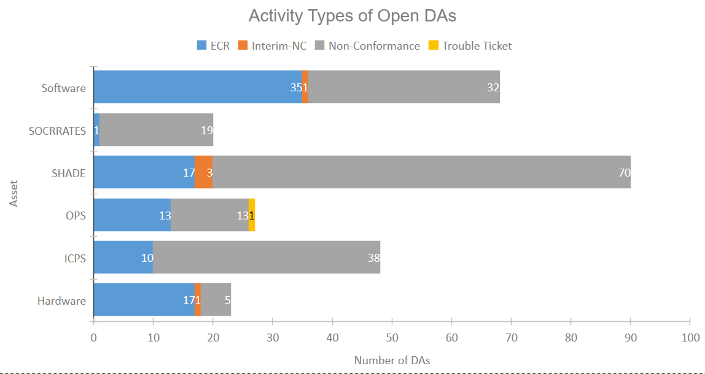

**Figure 7. Activity Types of Open DAs**

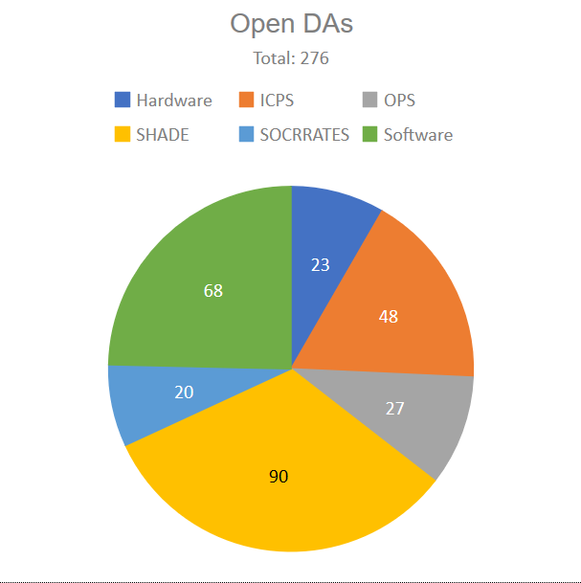

**Figure 9. All Open DAs**

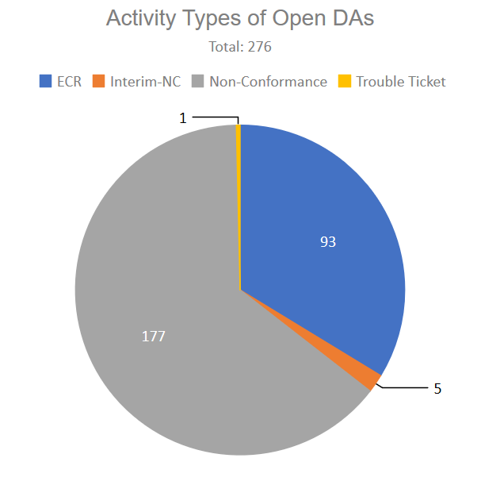

**Figure 8. Activity Types of Open DAs 2**

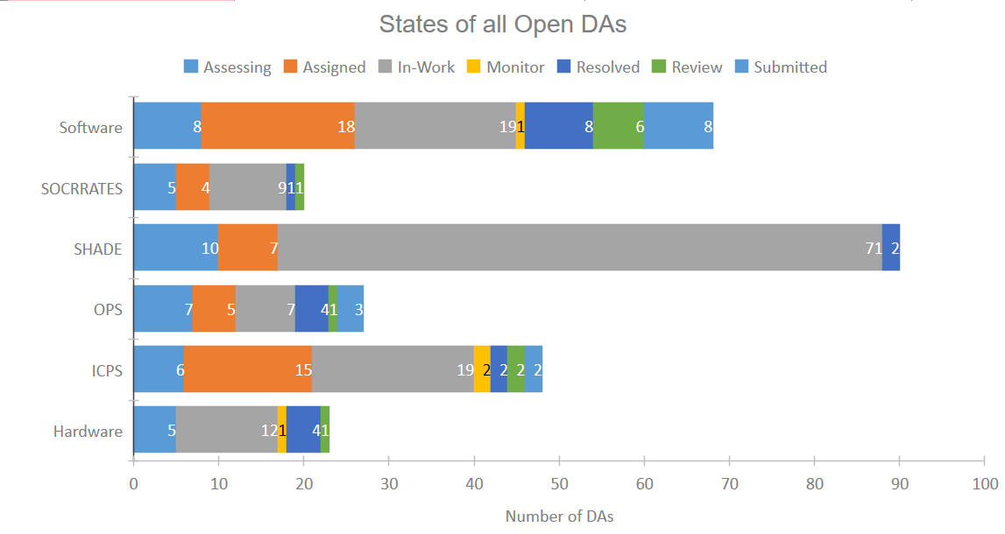

**Figure 10. States of All Open DAs**

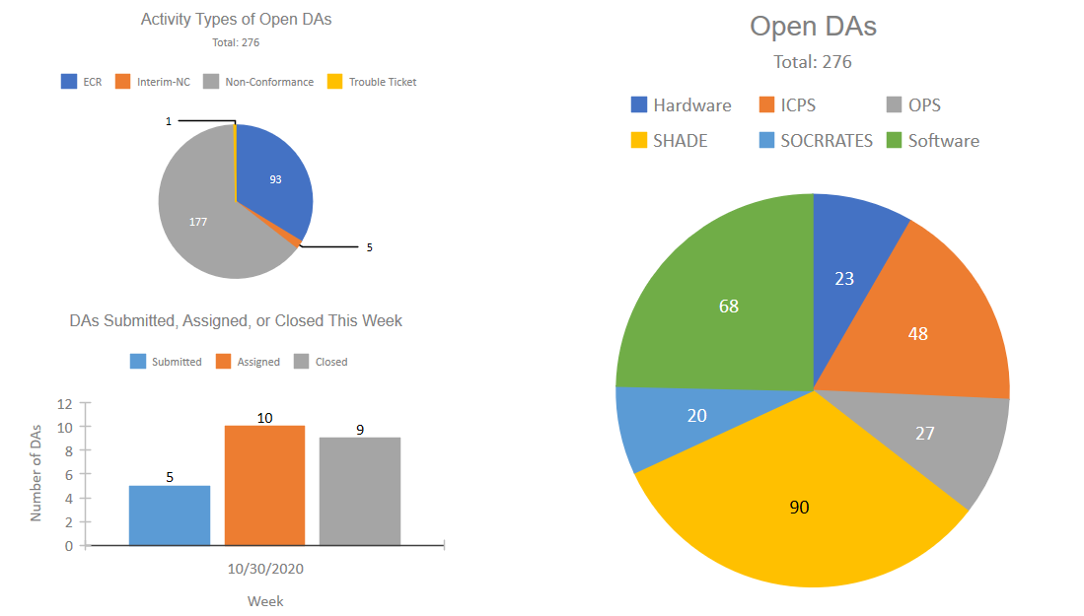

**Figure 11. Weekly Metrics**

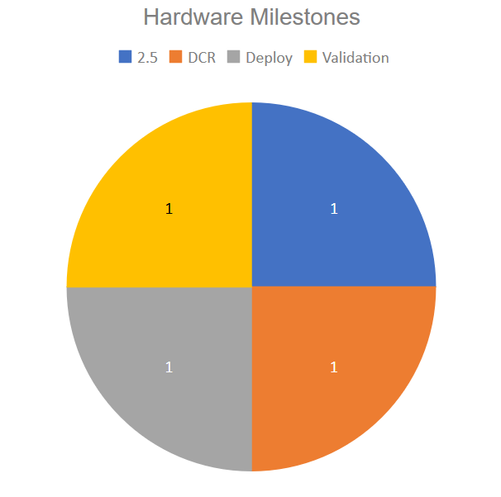

**Figure 13. Hardware Milestones**

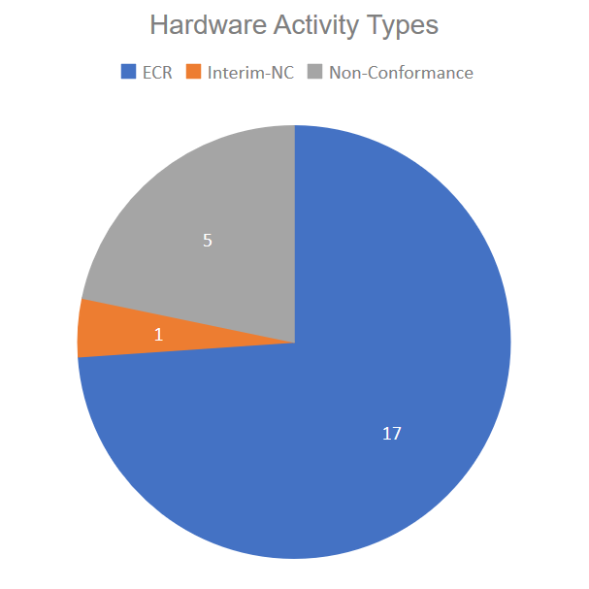

**Figure 12. Hardware Activity Types**

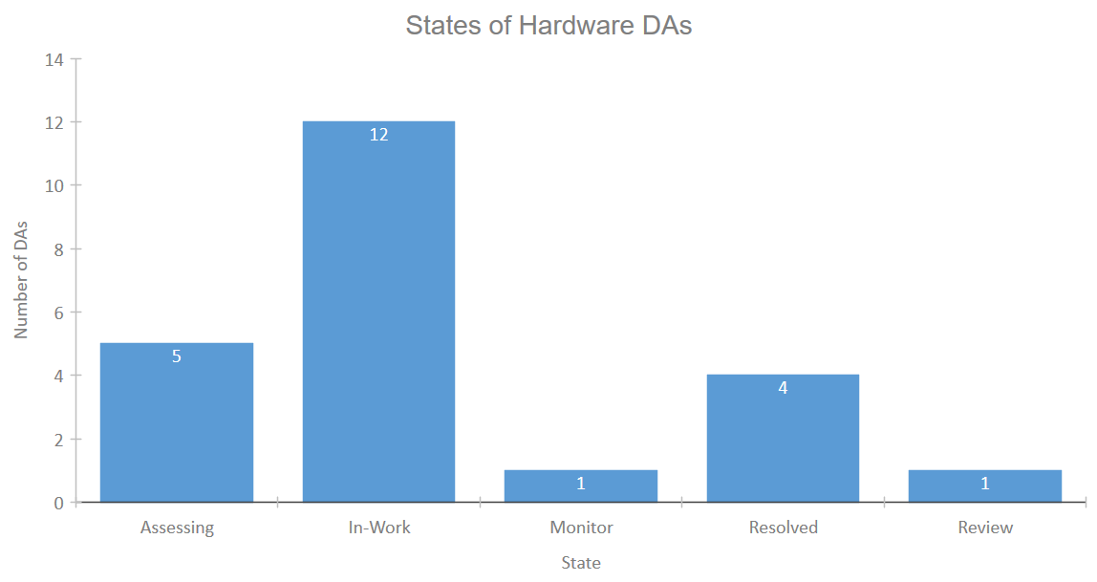

**Figure 14. Hardware States**

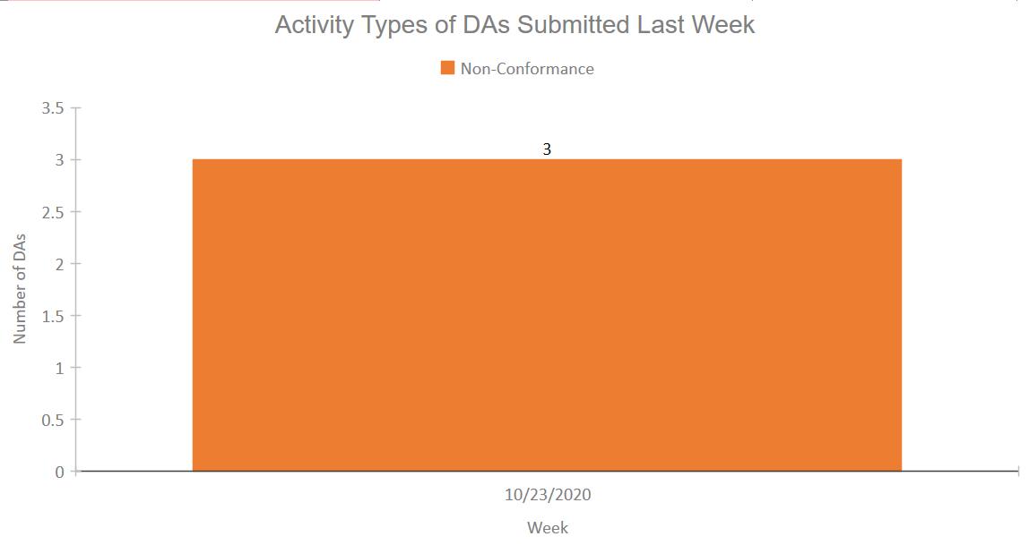

**Figure 15. Activity Types of DAs Submitted Last Week**

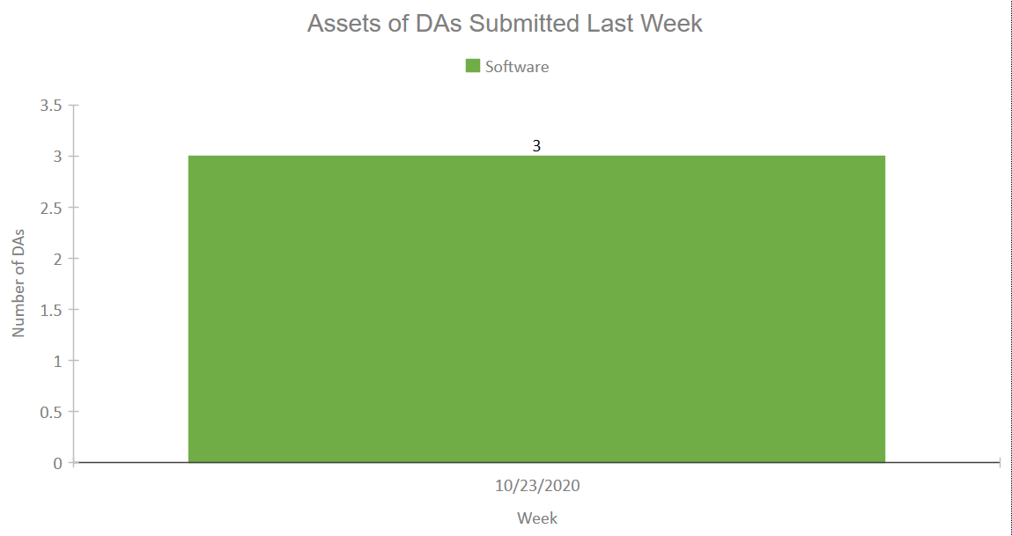

**Figure 16. Assets of DAs Submitted Last Week**

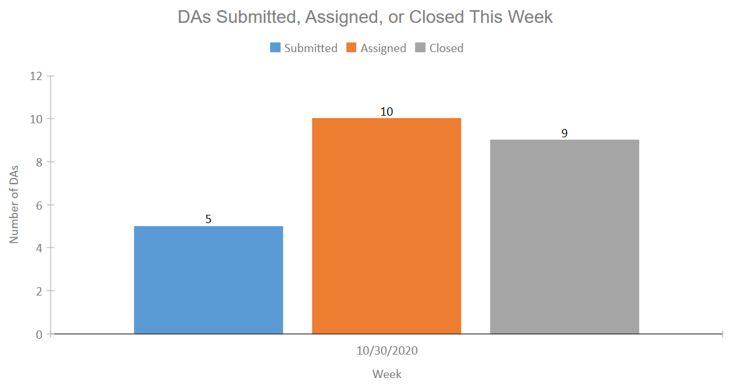

**Figure 17. DAs Submitted, Assigned, or Closed This Week**

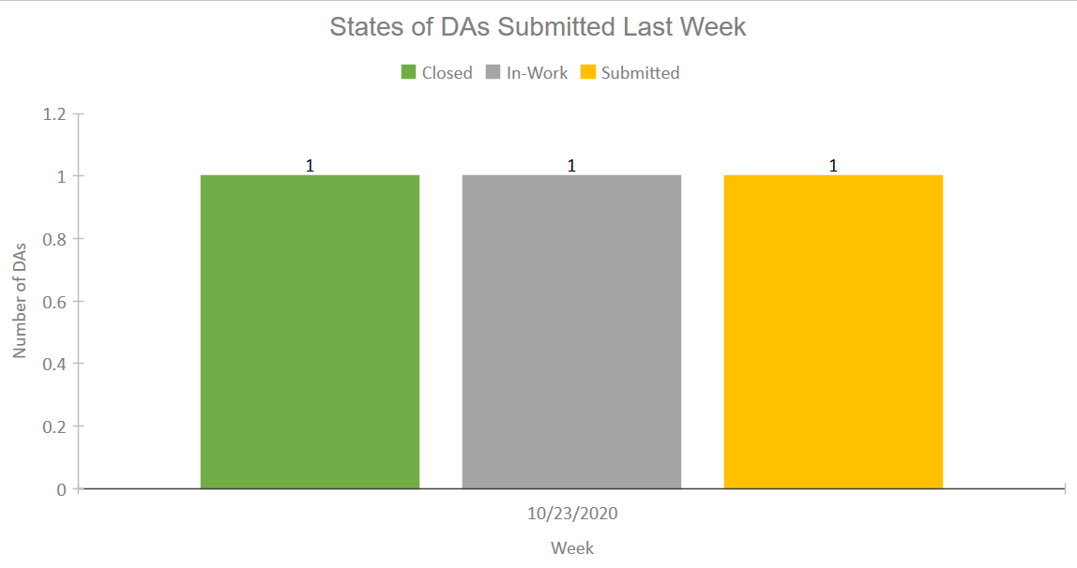

**Figure 18. States of DAs Submitted Last Week**

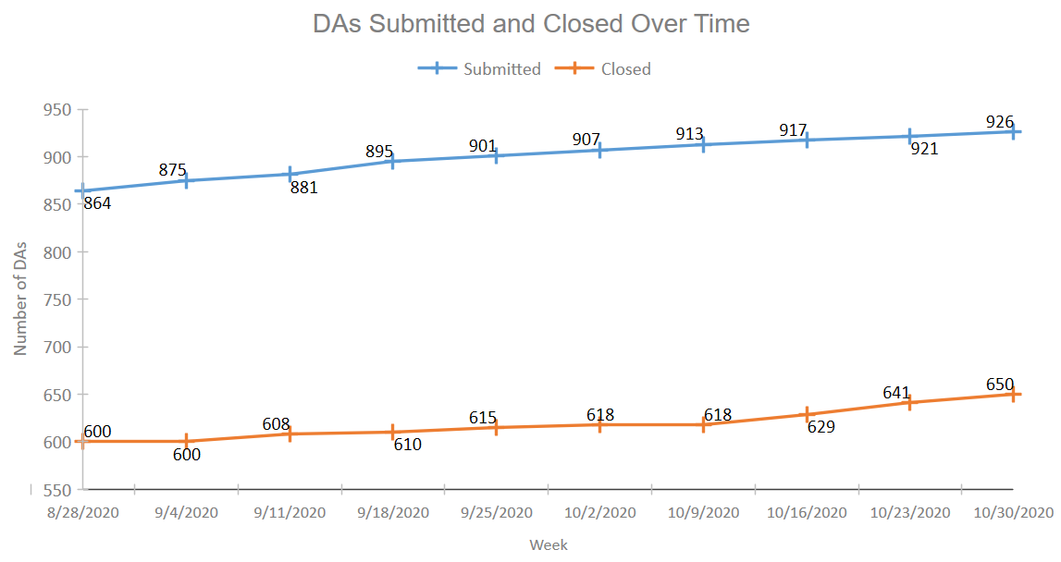

**Figure 20. DAs Submitted and Closed Over Time**

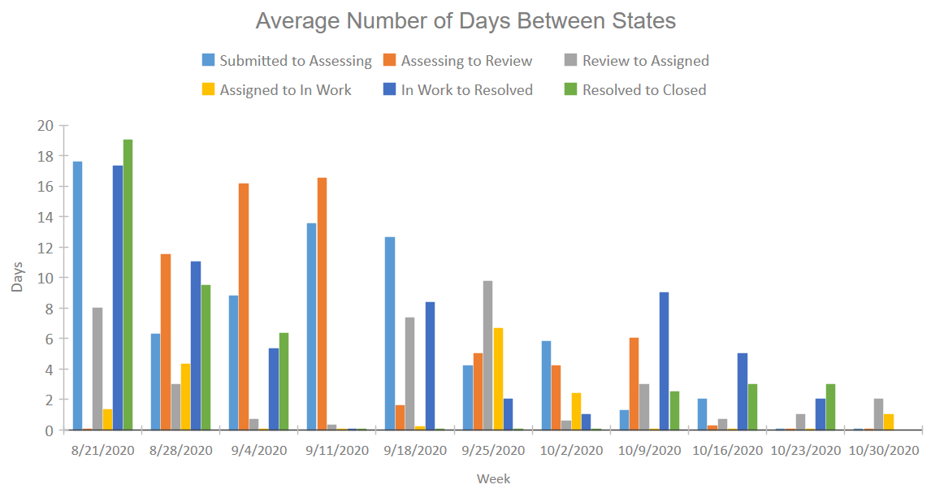

**Figure 19. Average Number of Days Between States**

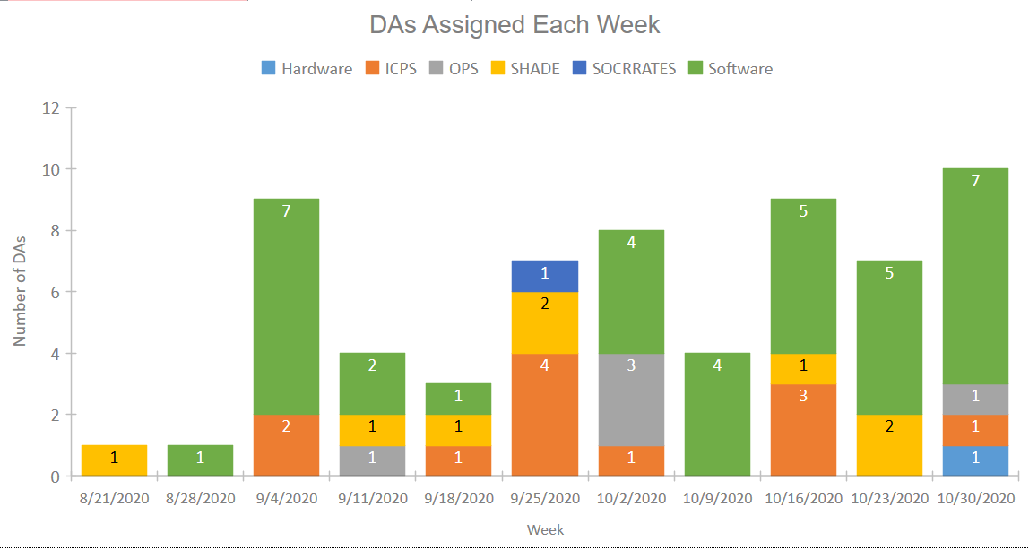

**Figure 21. DAs Assigned Each Week**

# Conclusion

The CAIDA DA Tracking System successfully streamlined the process of analyzing DA data from the work management system for the CAIDA team. Its simple and automatic uploading process is quick and devoid of human error. Its extensive number of queries and graphs helps to visualize a wide range of data. Additionally, the system can easily have new queries and graphs added to it to satisfy new analytics or new data members.

I have documented a few goals to improve the CAIDA DA Tracking System in the future. One idea is to somehow automatically upload the data from the work management system, without the need for the user to manually export and import it. This would make the process even faster and easier for the user. Another idea would be to help improve readability. With the vast number of queries and graphs, it is easy for the user to get lost or be unsure where to look for certain data. This could be solved by creating some sort of application or web page that displays the graphs clearly and allows the user to search for the graph or data members they want to examine. Overall, the CAIDA DA Tracking System was able to improve a process and has a large amount of customizability to fit the changing needs of the CAIDA team.

1. **Acknowledgements**

I would like to thank my technical mentor, Walter Wehner, for his help and direction throughout this project. I would also like to thank the Kennedy Space Center Education Office, including Kathleen Wilcox and Gwendolen Gamble, for guiding me and my fellow interns through our internships. Lastly, I would like to thank Jill Giles and Stephen Aument for their support and assistance throughout the internship.

# References

Microsoft Corporation, 2016. Microsoft Access, Available at: https://office.microsoft.com/access.

Microsoft Corporation, 2016. Microsoft Excel, Available at: https://office.microsoft.com/excel.