AIAA paper 2021-

Effect of Electronic Shot Noise on Dynamic Measurements Using Optical Techniques: Examples from Rayleigh scattering and Unsteady PSP

J. Panda
NASA Ames Research Center, Moffett Field, CA 94035

ABSTRACT
Electronic shot noise is an unavoidable reality in all optical techniques that depend on measuring light intensity. For steady-state, time-averaged measurements the impact of shot noise can be easily reduced by increasing the exposure time, or by averaging over multiple-exposures. That is not the case for unsteady measurements, where time histories of light intensity variations need to be created either by high-speed photography (unsteady PSP) or via photoelectron counting (spectrally resolved Rayleigh scattering) over short time durations using a photo-multiplier tube (PMT) and photon counting electronics. Electronic shot noise introduces a fixed amount of random error, which can overwhelm the light intensity variation caused by turbulent fluctuations. Spectrum computed from such time series shows a fixed noise floor that is independent of the number of data points in the time series. For a fixed optical system, where the collected power of the luminescent light (uPSP), or the scattered light (Rayleigh) is fixed, one needs to resort to special techniques to obtain enough signal-to noise ratio (SNR). For the uPSP application it is shown that averaging of the adjacent pixels improves SNR; although this may lead to a sacrifice of spatial resolution. A second means is to increase the exposure time, which leads to a lowering of the frequency range. For the Rayleigh application, improvements of SNR can be achieved via two different cross-correlation based approaches. The first involves measuring the light intensity using two PMTs using short, contiguous gates; thereby, creating two time-series of data. The second one involves collecting one long time-series of data using one set of measurement device, followed by an odd-even splitting into two time series. When the two time-series are cross-correlated, and a power spectrum is calculated, a significant reduction in the shot noise floor can be achieved. Examples from measurements of density and velocity fluctuations spectra from two different Rayleigh setup are presented to demonstrate the process.

Nomenclature:
U: velocity | ε: Percentage error due to shot noise
T: temperature | f: frequency of turbulent fluctuations
ρ: density | σ: standard deviation
P: pressure | < >: Expected value
N: no of photoelectrons measured over one gated time
$\overline{N}$: expected value, i.e. the long-time average of counts | Acronym
h: Plank’s constant | SNR: Signal to noise ratio
ν: frequency of light | rms: root-mean-square
n: no of gates, or camera frames, points in a time-history | PSP: pressure sensitive paint
t: time | uPSP: unsteady pressure sensitive paint
N_{CCD}: count from individual camera pixels | PMT: Photo-multiplier Tube
D: Diameter | SNR: signal to noise ratio
x: stream-wise direction | psd: power spectral density
y: cross-stream direction
k₁, k₂, b: Calibration constants | Subscript/superscript:
F: Fourier transform | sh: shot noise
S: spectral density | *: complex conjugate

- INTRODUCTION
Measurement of unsteady fluctuations in velocity, temperature, density, and pressure in practical high velocity and high temperature flows has remained an outstanding challenge in aerodynamic measurement techniques. Such fluctuations are created by flow turbulence and are responsible for drag, sound generation, flutter and vibro-acoustic response of aero-space vehicles, and combustion and mixing in energy-conversion devices. Although many aircraft and spacecraft fly at supersonic to hypersonic velocities, and supersonic wind tunnels are in existence for nearly a century, experimental tools that can measure unsteady fluctuations of the gas properties are either rare or non-existent. Recent progress in the particle-based and particle-free optical techniques makes time-averaged measurement possible, but when it comes to the unsteady turbulence statistics such as spectra, space-time correlation, and even a reliable measurement of the standard deviation of fluctuations the number of available tools shrinks to a few: such as, uPSP^{1, 2, 3}, molecular Rayleigh scattering based techniques⁴⁻⁸, Laser-Doppler Velocimetry⁹, Particle Image velocimetry¹⁰ etc. – each applicable to its own niche, and each with its own limitations. A common challenge in all such technique is how to deal with the unavoidable electronic shot noise, which cause poor SNR in all unsteady data obtained via optical means. The problem exacerbates as one moves from the high-intensity particle-based techniques, such as PIV, to the weaker molecular scattering-based Rayleigh/Raman methods. The goal of this paper is to describe various statistical properties of the shot noise, their impact on the measured data, and means to take advantage of these properties to improve SNR. Examples are provided from multiple tests conducted using uPSP and molecular Rayleigh technique. The propagation of the shot noise in the high-intensity particle scattering techniques such as PIV and laser-Doppler velocimetry are not discussed in detail although some of the methodologies described are expected to be applicable to them.

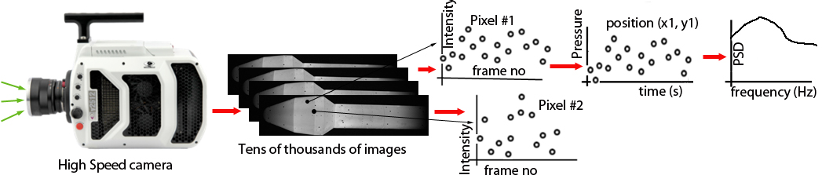
Fig 1. Creation of time-series data using a high-speed camera.

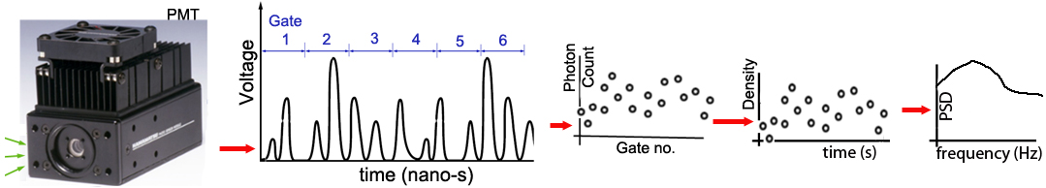
Fig 2. Creation of time-series data using a Photo-multiplier tube and photon-counting electronics.

A fundamental need for dynamic measurements is to create time-histories of variation of the desired physical quantities such as P, T, U, ρ. They are either causally related to the intensity of the measured light, such as pressure in uPSP application, and density in Rayleigh/Raman based applications, or are derived via fitting model functions to multiple measurements of light intensity. The latter involve applying model for Doppler shift (velocity measurement) or thermal broadening (temperature measurement using Rayleigh) or of rotational Raman line shapes (Raman scattering) etc. For particle-based techniques like LDV it’s the modulation of the light intensity due to the passages of particles through a series of fringes formed in the prob-volume is of interest, For PIV it’s the bright spots due to particles and their shift in consecutive laser pulses is of interest. In all such cases the measurement of light energy over a short time duration is the first step. Shot noise is an uncertainty associated with the measurement of light intensity itself. It is an unavoidable noise introduced during conversion of photons to photoelectrons. Therefore, any flow quantities derived based on the light intensity measurement carries this inherent uncertainty. In a time-series data, such as that needed for the unsteady measurements, the uncertainty appears as a random noise in the individual data points and is independent of the length or duration of the time-series data. Shot-noise reduction poses the biggest challenge in unsteady measurements using optical techniques.
Measurements of the light intensity variations are conducted either using a high-speed camera (LDV, PIV, Filtered Rayleigh scattering, Fluorescence-based techniques, molecular tagging etc.) or via photoelectron counting (spectrally resolved Rayleigh, some LDV). For the former a CCD or CMOS pixel converts the light energy into a photo-count, which is read by the camera circuitry. For the latter, individual photoelectrons emitted by a photocathode are counted over a series of short-duration, contiguous gates to create the time series. Figures 1 and 2 schematically shows the procedures. For a camera-based system of fig 1 the scattered or fluorescent light from a 2-D area (such as a laser sheet or the painted surface of a model) is collected using a high-speed camera. The net charge accumulated by every pixel, via conversion of photons to photoelectrons over the exposure time of a frame, is measured and passed as counts via the camera circuitry. Shot noise is generated during the accumulation of the charges. Another important noise in the camera-based system is generated during the read-out of the charges and is appropriately called as the read noise. Read noise is absent in PMT based systems making them more suitable for lower intensity scattering techniques. Typically, many thousands of camera images are collected for unsteady measurements. The post-processing involves reading the images, stacking them in time, followed by registering the images to account for any camera vibration. For particle-based systems such as PIV the 2-D images are processed to extract histories of pressure fluctuations from many points on the image area. Figure 1 is more appropriate for techniques such as filtered Rayleigh, uPSP etc. where the count history from each individual pixel is extracted, providing time histories of the fluctuating scattered/fluorescent light from many points on the imaging area. Subsequently, the count histories are converted to physical parameters such as pressure, density, velocity, temperature using model functions or calibration constants.
In the PMT based systems (fig 2) scattered light from a point in the flow field is collected and send to a photocathode which emits photoelectrons. Shot noise can be thought of as the randomness in the emission of such photoelectrons. The photoelectrons are amplified by a series of dynodes creating a series of photon pulses, which are subsequently counted by discriminator-counter electronics. The counting is performed over a series of contiguous gates. The duration of the gates is similar to the exposure time of a camera. The time-history of the counts represents fluctuations in the scattered light intensity, which in turn is converted into time history of fluctuations in P, T, U, ρ via calibration constants or by application of model functions. Because in both the camera and the PMT-based systems shot noise is introduced at the very beginning, it is an unavoidable reality.
It is worth pointing out that the electronic and other random noise sources in the traditional, non-optical, measurement devices are typically much lower than the huge burden created by shot noise in optical techniques. The traditional techniques provide high SNR data much more easily than the optical counterpart. For example, in a hot-wire anemometer the total electrical noise is typically less than 2mV, while the signal level caused by the unsteady velocity variations can be of the order of a Volt. Therefore, an SNR of 500 is easily achievable. The traditional condenser microphones or piezo-electric microphones used to measure pressure fluctuations have dynamic range of 80dB or higher. In a linear scale that translate into a SNR of 10,000, which is extremely difficult to obtain via optical measurement techniques. Nevertheless, these traditional devices have many other limitations, such as inapplicability in high-speed, and heated flows (hot-wire), a limited number of point measurements (microphones), and general intrusiveness to the flow. The optical techniques do not suffer from such limitations.
- PROPERTIES OF SHOT NOISE
In the following, at first, we will consider the effect of shot noise when the light energy to be measured is unvarying, i.e., when the scattering experiment is conducted in a steady flow without any turbulent fluctuations. We will graduate to the measurement of the fluctuating light energy later in section IIc. The expected number of photoelectrons resulting from a steady light source creating incident light energy E on a photodetector with quantum efficiency ε is given by the following:
$\overline{N}=\frac{ϵE}{hν}$ (1)
To determine the energy of the incident light, these photoelectrons need to be counted. As mentioned earlier photoelectron counting system of fig 2 directly measures the number of photoelectrons over a time-duration, known as the gate time. Individual pixels of a camera (fig 1) accumulate the photoelectrons over the exposure time of the camera. The accumulated charge is read by the electronics associated with each pixel and is expressed as a count N_{CCD}. In addition to the shot noise N_{CCD} contains other noise components such as read noise. When the count values are large, read noise becomes negligible, and N_{CCD} becomes directly related to the number of photoelectrons via a gain factor k that can be obtained from the camera manufacturer:
$N_{CCD}=kN$ (2)
In either way any measurement of light power can be expressed as the arrival rate of the photoelectrons, which will be used for the following discussion.

IIa. Basics of Shot Noise
Even when the incident light power is steady, the randomness of the conversion to photoelectrons do not produce a steady stream, but a random distribution controlled by Poisson’s statistics:
$N=\frac{{\overline{N}}^{N}e^{-\overline{N}}}{N!}.$ (3)
For unsteady measurements, a series of such individual measurements need to be performed, creating a time-history N_{i}, I =1, 2, … n. A direct consequence of the Poisson’s distribution is that the variance of the time-history, which is the variance of the undesirable shot noise, is the expected value, or the mean count:
$σ_{sh}^{2}=\sum_{i=1}^{n}{\frac{{\left(N_{i}-\overline{N}\right)}^{2}}{N_{i}-1}}= \overline{N}$ (4)Therefore, the standard deviation, or rms of the shot noise is the square-root of the expected value:
$σ_{sh}= \sqrt{\overline{N}}$ (5)
For time-averaged steady-state measurements, typically the physical parameter such as pressure in PSP and gas density in Rayleigh and Raman techniques are directly related to the mean count. For such instances, a steady-state, signal-to-noise ratio can be defined by the following simple ratio:
${SNR}_{steady}=\frac{\overline{N}}{\sqrt{\overline{N}}}= \sqrt{\overline{N}}$ (6)
Alternatively, one can define a percentage random error contribution as the following:
$ϵ=\frac{100 \sqrt{\overline{N}}}{\overline{N}}=\frac{100}{\sqrt{\overline{N}}}$ (7)
Clearly, to increase SNR, i.e., to improve the measurement accuracy one needs to collect as large number of photoelectrons as possible. Besides utilizing faster optics and higher-power lasers or light sources, and higher quantum efficiency detectors, a straight-forward path for a fixed optical set-up is to increase the total time-duration of measurement. For a camera-based measurement system such as time-averaged PSP this is achieved by increasing the exposure time of each frame and/or by summing counts from greater no of frames. For PMT based system such as Rayleigh an increase in the time-duration of the photo-electron counting improves the measurement accuracy.

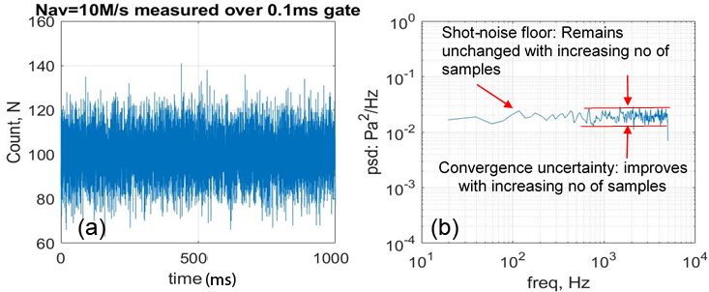
Fig. 3. (a) A sample time-series data of photo-electron counts created from a PMT-based system at no-flow condition; (b) power-spectrum of the time-series

IIb. Unsteady measurements from steady, quiescent flows without turbulent fluctuations:
For unsteady measurement one needs to perform the same collection of photoelectrons but over a shorter time duration, which can drastically reduce the number of photoelectrons collected in every data point leading to a vast increase in the random error. The higher the desired frequency to resolve, the shorter is the exposure time of the camera or the gate time for photoelectron counting, and higher is the percentage error in the individual measurements. For example, consider an optical setup that can provide ±1% error in time-averaged measurement due to an effective summing of photoelectrons over one second duration, When expanded to resolve 0-10kHz frequency range, the individual data points will have a whopping ±141% random error. These numbers are attained by the application of equation (7) and the Nyquist criteria, and by assuming that the shot noise is the sole contributor to the noise. If the optical system can be improved via higher power laser and a more efficient collection system to ±0.1% error from the same one second averaging time, then the error in the individual measurements in the unsteady data is reduced to ±14%. However, such an improvement will require a 100-fold increase in the laser power or collection efficiency – a difficult feat to achieve. Therefore, for most applications the individual data points in a time series measured by the optical technique will have large random uncertainties.
Typically, the time-series data is used to extract different statistics such as the standard-deviation, power-spectrum etc. Another problem with the unsteady measurement is that the shot noise contribution cannot be lowered by increasing the number of data points (samples) in the time series, because once a converged statistics is reached the variance of the time-history is independent of the number of data points n:
$σ_{sh}^{2}=\frac{1}{n}\sum_{i=1}^{n}{{\left(N_{i}-\overline{N}\right)}^{2}}= \overline{N}$ (8)
In other words, the shot noise contribution to the estimation of variance cannot be lowered by increasing the number of frames (camera-application) or the number of samples (gates - PMT application). When such a time series is used to calculate power-spectrum S(f) the high noise-floor from the shot-noise can easily drown the physical content. Returning to the example of measurement in a steady flow without any turbulent fluctuation, figure 3(a) shows an expected time series from an optical measurement technique. Despite no fluctuations in the flow the time-series of the measured scattering intensity is full of random noise. Such high level of noise content cannot be found from data collected by a hot-wire or by a microphone. that is far higher than seen in the non-optical techniques. The power-spectrum of fig (3b) is calculated from the time-series of fig 3(a). Fig 3(b) shows a flatline with superimposed randomness. Now, the area under the power spectrum is the variance of the time series, which is independent of the no of samples n:
$σ_{sh}^{2}=\sum_{j=1}^{m}{{psd}_{j}}∆f m:no of frequency bands in power spectrum$ (9)
Therefore, it can be said that shot-noise floor in the power-spectral estimate cannot be lowered by increasing the sample size. The only improvement is a better convergence of the spectrum, i.e., the ripples on the flat line is reduced. Because the optical techniques convert photo electron counts to physical parameters the shot-noise floor is converted to a high noise floor in the spectra of physical parameters such as P, ρ, U, T.

IIc. Joint statistics of shot noise and turbulent fluctuations for measurement is unsteady flows:
The discussion above is for steady level of scattered light collected from quiescent flows. When the scattering intensity fluctuates due to the presence of turbulent fluctuations or other unsteadiness in the flow the standard deviation of the measured time-series follows a joint statistic given by the Mandel's formula (Saleh & Teich [10]). Namely the variance of the photon count $σ_{N}^{2}$ is a sum of the variance of shot noise $σ_{shot}^{2}$ and that of the light power fluctuation due to turbulence ${ σ}_{turb}^{2}$:
$σ_{N}^{2}=σ_{shot}^{2}+σ_{turb}^{2}$ (10)
Physically, spectral content from the turbulence floats over the shot-noise floor and can be seen when the physical content is either a good fraction or higher than the shot-noise floor. For such measurements one can define a different SNR. SNR for unsteady measurements:
${SNR}_{unstdy}=\frac{σ_{turb}}{σ_{shot}}$ (11)
For many situations $σ_{shot}$ can be very high, leading to a low SNR_{unstdy}. SNR for turbulence measurements using optical technique is expected to be small – unless a shot-noise reduction technique is applied.

- Methods of reducing shot-noise impact

For a fixed optical system where maximum possible scattering or luminescent intensity, and the collection efficiency is reached the following options can be pursued to farther improve SNR.
IIIa. Method A: light collection from a larger probe volume or over longer time duration^{1, 2, 3}.
The goal in both approaches is to collect a larger number of photoelectrons N per frame or gate. Since the random error in the individual data points is proportional to √N both approaches lead to improvements in the SNR of the individual data points. The option of using a larger probing area to improve SNR is useful for both the camera and the PMT based systems; it is of particular interest for uPSP application, an example of which will be provided in a subsequent section. Placement of the camera closer to the model, along with an appropriately selected shorter focal length lens, brighter lamp intensity, larger pixel area and higher quantum efficiency camera help to improve the amount of light gathered. However, all have their practical limits. Besides, the total gathered light can saturate the bit-depth of the camera. For a fixed setup a good option is to “bin” the adjacent pixels leading to a summing of the light collected by a group of sensors. To avoid saturation binning can be done in the post-processing after the high-resolution images are read by a computer. The total number of collected photoelectrons is proportional to the number of pixels n_{bin} used for binning.
Unfortunately, the longer exposure time or gate time equates to a proportional decrease in the resolved frequency range Δf, and an increase in the probing area/volume leads to a decrease in spatial resolution Δx. There is a balance between accuracy of measurement and the desirable spatial resolution. The standard deviation of the shot noise is expected to follow the following relationship:
$\frac{σ_{sh}Δx}{\sqrt{Δf}}=\text{constant.}$ (12)
The value of the above constant can be lowered by increasing lamp brightness, using fast optics and higher quantum efficiency camera, and by increasing the paint luminescence (by conducting the experiment at higher static pressure). The desirable spatial resolution can be found from the size of the turbulent eddies corresponding to the highest resolved frequency obtainable from the camera frame rate.

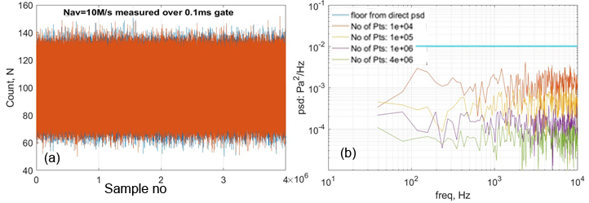
Fig. 4. (a) Two time-series of photo-electron counts created by measuring the same light by two PMT-based systems, no-flow condition; (b) comparison of auto-spectra of one time series, and cross-spectra between the two time-series calculated using an increasing number (indicated) of sampling points.

IIIb. Method B. By taking advantage of a property: shot noise from two sensors are uncorrelated^{4, 5}
This method can be applied to both the camera and the PMT based systems, but is of more interest for the latter, where very long samples of data can be easily acquired. For techniques such as Rayleigh scattering where the scattering intensity is weak, the random error in the individual data points can be very high - swamping the desired fluctuations in the physical quantity. In such cases spectral calculations provide a better path to improve SNR. For spectral calculation the time-series data is segmented into smaller overlapping blocks, Fourier transformation is performed on each block, finally spectra from all such segments are averaged. It’s the last part – averaging over all segments – which can be used to our advantage. Note that a direct calculation of the power-spectrum, as shown in fig 3(b) above does not lead to any reduction of the shot-noise impact. Instead a path based on the cross-spectral estimation needs to be followed. An interesting property of electronic shot noise is that two sensors measuring the same light produce shot-noise that are completely uncorrelated. If the scattered light from a quiescent flow, without any physical fluctuations, is measured by two PMTs creating two time-series of counts N_{1i} and N_{2i}, i = 1, 2, ... n then the following holds:
$\left\langle N_{1i} \left(t\right)\right.\left.N_{2i}\left(t\right)\right\rangle →0, as n→∞ for quiescent flow$ (13a)
In the presence of the physically correlated fluctuations the above calculation converges to the autocorrelation of the desired physical correlation. For example, in density measurement via Rayleigh technique:
$\left\langle N_{1i} \left(t\right)\right.\left.N_{2i}\left(t\right)\right\rangle →\frac{\left\langle ρ \left(t\right)\right.\left.ρ\left(t\right)\right\rangle }{k_{1} k_{2}}0, as n→∞ for turbulent flow$ (13b)
The k₁ and k₂ are the calibration constants for the two phot-detectors to convert photoelectron counts to density. To implement this procedure, in the PMT based systems, the collected light needs to be split into two parts and measured by two sets of PMT and photon-counting electronics. For a camera-based systems time-series created from two adjacent pixels need to be cross-correlated. An important requirement is the need for a very large number of samples in the time-series to achieve sufficient reduction in the shot-noise floor. This is illustrated in figure 4, where the two time-series are produced by two PMTs each producing photon counting of 10M/s (fig 4a) due to scattered light arriving from a quiescent flow. If a direct power-spectrum is calculated from each of these time-series then the spectral floor would be ~10⁻² count²/Hz, which is entirely due to the randomness introduced by the shot noise. However, if the time-series are cross-correlated then the floor in the cross-spectral magnitude lowers. The extent of lowering is dependent on the length of the time series. Figure 4(b) shows a reduction of the shot noise floor to 7x10⁻⁵ when 4M points from each of the time-series is used for the calculation – a reduction of the shot noise floor by more than a factor of 100.
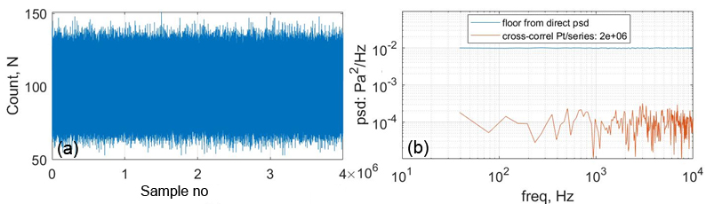
Fig. 5. (a) One long time-series created by a PMT-based system, no-flow condition; (b) comparison between auto-spectrum of the entire series and cross-spectrum calculated by odd-even splitting of the time-series.

IIIc. Method C. By taking advantage of a property: shot noise N from the same sensor but at two different time intervals are completely uncorrelated^{6, 7, 8}
This method is also very similar to the one described above but have an added advantage of reduced hardware requirement. Instead of using two sets of opto-electronics to analyze the collected light only one set becomes sufficient. Since the shot noise generated in any two adjacent data points is completely random and uncorrelated, the time-series of the measured data is split into two via separating the odd and the even data points: N_{2i-1} and N_{2i}, i = 1, 2, ... n_{pts}/2. For scattering from quiescent flows without any unsteadiness the following holds:
$\left\langle N_{2i-1}(t)\right.\left.N_{2i}(t)\right\rangle →0, as n_{pts}→∞ for quiescent flows$ (14a)
Like before, in the presence of the physically correlated fluctuations the above calculation converges to the desired autocorrelation of the physical parameter. For example, in density measurement via Rayleigh technique:
$\left\langle N_{2i-1}(t)\right.\left.N_{2i}(t)\right\rangle →\frac{\left\langle ρ \left(t\right)\right.\left.ρ\left(t\right)\right\rangle }{k_{1}^{2}}0, as n_{pts}→∞ for turbulent flows$ (14b)
Here k₁ is the calibration factor. For PMT based application the collected light is measured by a single PMT and the odd and even data points are separated leading to two long time series. Each series is segmented, Fourier transformed, cross-correlated, and averaged to produce the final cross-spectral magnitudes. Figure 5 shows an example from a quiescent flow where gated photon counting produced the 4M points long time-series of fig 5(a). Figure 5(b) compares a directly calculated power spectrum with the one obtained via splitting and cross correlating the two. A factor of 100 reduction in the noise floor is seen in this plot. Just like the procedure above a very long time-series of data is needed to obtain sufficient reduction of the noise floor. An additional downside is that the effective sampling rate become half of the original time-series leading to halving of the resolved frequency range.
- Example of shot noise reduction via pixel binning in uPSP application.
The example is from a uPSP measurement of pressure fluctuations in a bluff-body wake reported by Panda¹, and Roozeboom et al². Another interesting example that could not be included to limit the size of this paper is of Panda et al³. The test was conducted in the 14”X14” test section of a small, high-subsonic wind tunnel in the Fluid Mechanics Laboratory of NASA Ames research Center (fig 5a). A part of the wind tunnel floor was replaced by a flush mounted aluminum plate. A solid aluminum block of size 2” (height) x 2” (wide) x 1” (long) was mounted at an off-center position. The pressure fluctuations on the plate was created by flow separation and the periodic vorticity in the wake of the cuboid bluff body. A 7 11/16” (long) x 4 3/16” (wide) part of the plate was coated with PtTFPP-based porous polymer paint manufactured by Innovative Scientific Solutions, Inc. (ISSI) (fig 5b). In addition to PSP six dynamic pressure sensors were mounted on the plate. The example presented is from the tunnel free-stream Mach number of 0.46 (U = 524ft/s).
PSP was applied on the plate and on the aluminum block. For the “lifetime” mode of operation, the paint was excited by continuous light at a nominal 396nm wavelength, produced from two high powered ISSI LM4X-DMHP lamps. The luminescence emitted by the PSP was measured with a Phantom v2011 high-speed camera, equipped with a 1200X800 pixel, 12-bit resolution CMOS chip. To isolate the luminescence frequencies from the incident UV radiation a notch filter in 570nm to 700nm range was placed in front of the camera. A total of 16542 images were recorded at a frame rate of 2000/s. The camera internal memory was capable of holding 16542 frames, the selected frame rate was a compromise between the length of the time record and the frequency range to be resolved. The light intensity progressively fell over the time of image collection. This drop in the intensity had to be accounted for. Data from the dynamic pressure transducers (Kulite) was acquired at a higher sampling rate of 30720/s using a 24bit A/D converter in a separate personal computer.

(a) | 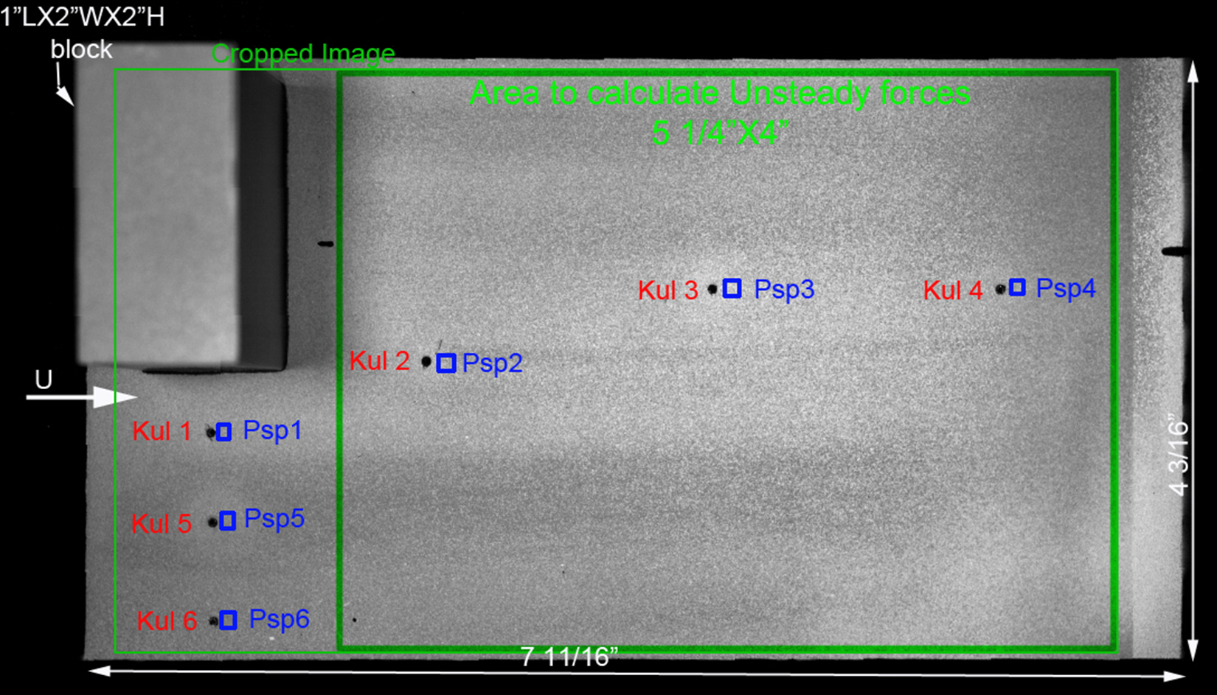(b)
Fig 6. (a) uPSP setup in a high-subsonic wind tunnel; (b) Photograph of the test article from PSP camera showing the cuboid at the leading edge of a PSP painted surface on the wind tunnel floor. The dynamic pressure sensors are marked as Kul1, Kul2 etc. The corresponding PSP patches used for calibration and comparison are marked as Psp1, Psp2, etc.

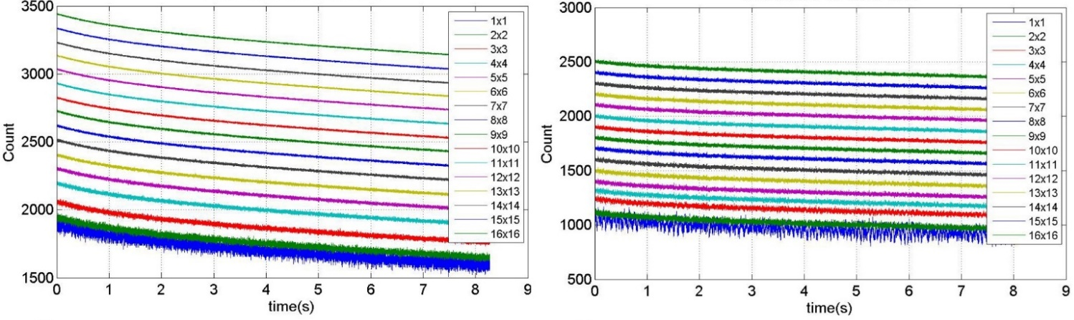
- (b)
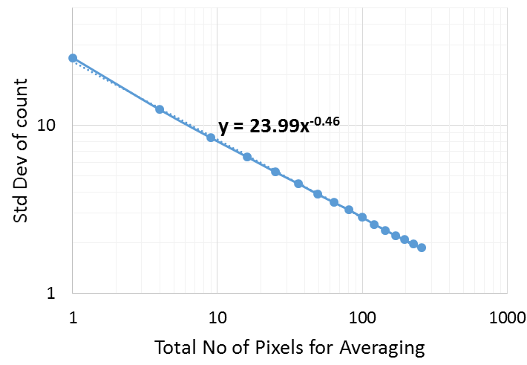(c) | 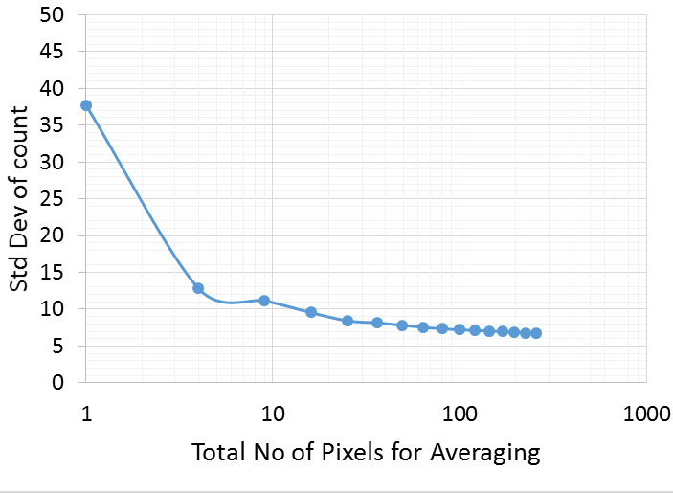(d)
Fig 7. Reduction in electronic shot noise via averaging over increasing number of pixels. (a) Time trace of counts from a single pixel (bottom most, 1x1 in legend) and from averaging over increasing number of indicated pixels. Individual traces are shifted by 100; no-flow, M= 0, images: (b) Same as part a but for M=0.46; (c) standard deviation of the count for no flow condition; (d) same as part c, but for M=0.46.

To examine the extent of noise contribution, at first, images obtained from the no-flow condition were examined (figs 7a and 7c). The bottom most plot of fig 7(a) shows time evolution of the count from a single pixel. Since there were no physical pressure fluctuations, the measured fluctuations were artifact of the camera noise. The fall in the average intensity with time was due to the falling brightness of the UV lamp described earlier. The lamps were incapable of producing high frequency fluctuations of present interest. Figure 7(a) also show progressively improved smoothening of the time histories caused by averaging over increasing number of pixels. Figure 7(c) provides a quantitative measure via calculation of standard deviation σ of the count fluctuations. Note that the standard deviation was calculated after de-trending the time signal to remove the effect of lamp decay. That the standard deviation very closely follows a $\sqrt{n_{bin}}$relation is telltale of electronic shot noise as the primary noise source. When the flow was turned on, the test article was subjected to physical fluctuations in pressure, and the shot noise was simply added to the actual fluctuations. Figures 7(b) and 7(c) show that the averaging over adjacent pixels makes the standard deviation to approach the true value. Note that the standard deviation values keep on lowering even when very large number of pixels are averaged. This may be attributed to averaging out the actual contributions from the smaller turbulent eddies.
For the present work, the amplitudes of pressure fluctuations were relatively large, and an average over 8x8 (=64) pixels were found to be sufficient to make the noise floor non-identifiable in the power spectra. Power spectra of pressure fluctuations measured by dynamic pressure sensors and by corresponding PSP pixels are compared in fig. 8 (a-e). Good correspondence seen over the entire frequency range and for all five sensors proves excellent dynamic response of PSP over the frequency range of interest. Flow physics-wise, the hump centered around 420 Hz was due to the periodic vortex shedding by the bluff cuboid, and the very low frequency fluctuations are due to the “breathing” of the separation bubble.
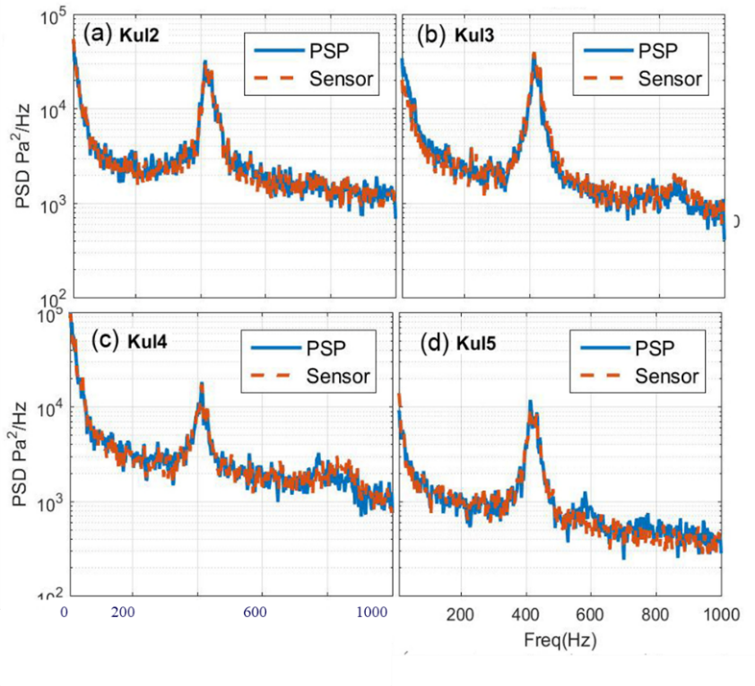
Fig 8. Comparison of spectra measured by indicated dynamic pressure transducer and the corresponding PSP pixel.
- Examples From Rayleigh scattering Applications
Rayleigh scattering is an inelastic (same frequency as that of an incident laser beam, except for the Doppler shift caused by the moving molecules) scattering by gas molecules (O₂ N₂ and others in air). The intensity of scattered light due to molecular scattering at ambient pressure is far lower than that from the luminescence of uPSP paint. While time-averaged measurements can be performed using a camera, but the short time duration of light acquisition needed for unsteady measurements require either a high-power pulsed laser and a camera or, a CW laser and PMT bases light detection system. The latter is a proven technique to provide measurements of fluctuation spectra in terms of gas density, velocity, temperature and turbulent shear stresses. The following examples are from the PMT based spectrally resolved Rayleigh technique, which has a proven track record of providing spectral measurements of turbulent density, velocity, temperature and shear stresses in high-speed flows.

Fig. 9. Schematic of a Rayleigh scattering setup around a high-speed jet to measure spectra of density fluctuations. The setup uses a two-PMT system to reduce shot noise impact (from Panda & Seasholtz [4]).
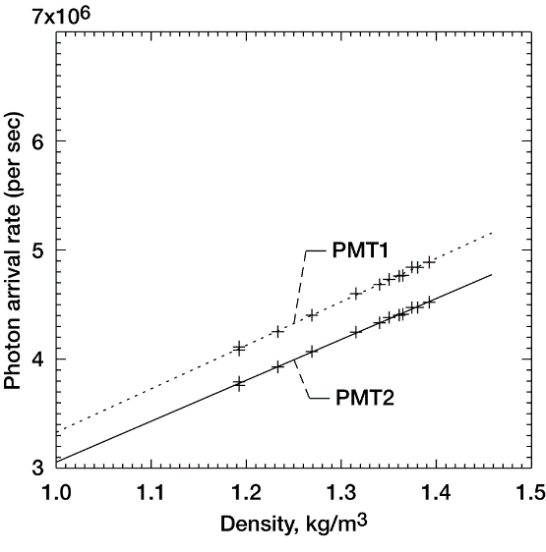  Fig. 10. Density calibration of the PMT-based density measurement system of Fig 8 (from Panda & Seasholtz [4]). | 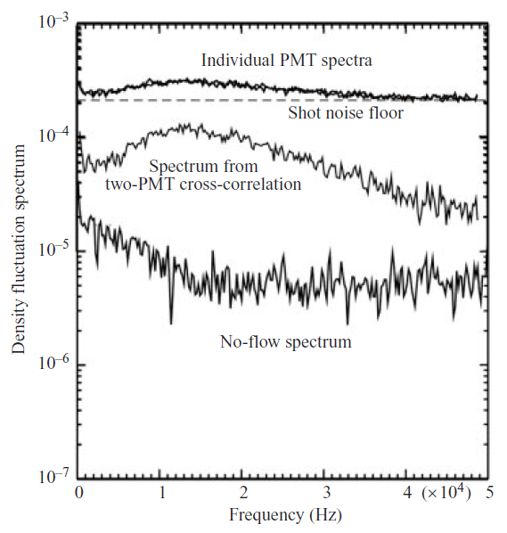  Fig. 11. Improvements in the measurement of the density fluctuations system using the two-PMT cross-correlation technique. Data for the upper two curves are from M1.8 jet at y/D=0.48 and x/D=2.4 (from Panda & Seasholtz [4]).

Va. Example of method II: Shot-noise reduction via measuring scattered light by two sensors and calculating cross-correlation^{4, 5}
For a fixed optical system, applied to a fixed molecular composition gas (such as air), the intensity of scattered light is proportional to the number density of gas molecules and in turn, is related to the local air density (ρ). The present example is from a Rayleigh setup^{4, 5} from NASA Glen Research Center, where the collected light intensity was measured using photomultiplier tubes and photon counting electronics. The number of photoelectrons (N) counted over a time interval Δt can be expressed as:
$N = kρ Δt$, (15)
where k is a proportionality constant to be determined through calibration. Figure 9 shows a schematic of the free air jet facility and the Rayleigh scattering setup that used a continuous wave (CW) laser beam focused to a point in the flow, with the molecular scattered light collected and measured using two PMTs. The green laser light (532-nanometer wavelength) from a CW, single frequency, frequency-doubled Neodymium Vanadate (Nd:YVO₄) laser was transferred to the jet vicinity by a 0.365mm core diameter, multi-mode optical fiber and focused to a probe volume. Light scattered by the air molecules were collected at an 85° scattering angle and focused on the face of another 0.55 mm core diameter multi-mode optical fiber. The combination of focusing and imaging optics makes the probe volume length of 1.03 mm. The complete transmitting and receiving optics were mounted on a x-y traverse that allowed the probe volume to be moved automatically over a plane. The scattered light, collected by the receiving fiber, was transmitted to a quiet neighboring room away from the noisy environment. Here the collected light was collimated and then split into two equal part parts by a thin-film beam splitter. Each of the beams was refocused into individual photomultiplier tubes. The counting was performed over a series of contiguous gates of specified time intervals. The maximum number of gates that can be used at a time was 16384. Usually multiple sets of data were collected and passed on to a Personal Computer.
The success of a Rayleigh scattering system depends on the use of clean, particle free air, minimization of stray scattered light and providing a stable, vibration free environment for some optical components. The primary jet was supplied with unheated, compressed air filtered to remove all dust particles. A clean co-flow through a coaxial nozzle of 200-mm diameter surrounded the primary jet. An external air filter and air handling system were installed to produce this co-flow. The coaxial flow ensured dust-free air for the entrained flow. However, a few particles were unavoidable. The calibration was performed in the unheated plume of a convergent nozzle operated in the Mach number range of 0 to 0.99. At each operating condition the photon arrival rate was counted over a second duration and the jet density is calculated using isentropic relations. Subsequently, a straight line was fitted through the data to determine the proportionality constants k₁ and b.
$N = (k_{1}ρ+b)Δt$ (16)
The additional constant b is needed to account for the room light and stray scattered laser light. Figure 10 shows sample calibration curves. Since two counters were used, two sets of calibration constants k₁, b₁ and k₂, b₂ were calculated.
The simultaneous photoelectron counting produced two series of data N₁(t) and N₂(t). As expected, the time-history data was found to have very high level of shot-noise due to few number of photons collected over the short duration of the individual gates. However, the calculations of the fluctuation spectra of air density using the cross-correlation approach reduced the impact of the shot noise. The average counts from each of the time series were subtracted: N'₁(t) = N₁(t) - N_{1av}, N'₂(t) = N₂(t) - N_{2av} and a cross-correlation:
$\overline{N'_{1}N'_{2}}(τ) = \int_{-∞}^{∞}{N'_{1}(t)N'_{2}(t+τ)dt},$ (17)
attenuated the shot noise contribution. Following cross spectral density function was used
$F_{N'_{1}N'_{2}}(f) = \int_{-∞}^{∞}{\overline{N'_{1}N'_{2}}(τ) e^{-i2πfτ}}dτ$ $= F(N'_{1})⋅F^{*}(N'_{2})$ (18)
to calculate the density fluctuation spectra:
$S_{ρ'^{2}}(f) = \frac{F(N'_{1})⋅F^{*}(N'_{2})}{a_{1}a_{2}(Δt)^{2}}$ (19)
Usually a long record of either 262,144 (for higher Mach number jets) or 524,288 (low Mach number jets) data was made from multiple segments of 16384 data strings. The latter is the maximum number of contiguous counts delivered by the photon counters. Two such records were collected from two PMTs. The Welch method of modified Periodograms was used to calculate the cross-spectral density. Each long record was divided into small segments of 512 data points. The adjacent segments were overlapped by 50%. The modified periodograms of corresponding segments from the two PMTs were calculated and then used to determine local estimates of cross-spectral density. All local estimates were averaged to obtain the final cross-spectral density.
Figure 11 shows the outcome and improvements attainable using cross-spectrum over the straightforward calculation of power spectrum. The gate time used in the photon-counting process was 10 microseconds. Following the Nyquest criterion, fluctuations up to 50kHz could be resolved. The topmost plot of fig 10 shows spectra of the individual PMT signals. The improvement caused by cross correlating the two PMT signals is also shown in the middle plot. The density fluctuation spectrum is better defined; the improvements are especially prominent at the high frequency end. The cross-correlation process cannot eliminate noise from the density spectra; it lowers the noise floor. The convergence error from finite number of data points used and other electronic noise determine the final floor. An estimate of this noise floor is shown in the bottom plot of fig 11. The data was from a no-flow condition, where the jet was turned off but the clean co-flow was present. Since there are no density fluctuations the spectral content is mostly due to the residual noise. The passage of occasional particles produces an additional contribution at the low frequency end, seen as a small ramp in fig 11. All spectral plots ought to be compared with the no-flow baseline, because the part above the baseline is truly the desired spectrum. The comparison shows that at the high frequency end the measured fluctuations approach the residual noise floor. In addition to the noise base, the density spectra have a random uncertainty, the extent of which is visible in the randomness superimposed on the basic spectral shape.

Vb. Example of method III: By splitting the time-series into odd-even parts and performing cross-correlation
The technique was first applied by Mercier et al [6] and Mercier [7], for the measurement of density fluctuations spectra using Rayleigh scattering. The example described her is from a recent setup to measure velocity fluctuations spectra from a free jet reported by Panda & Nguyen [8]. The setup also used the molecular Rayleigh technique, where the scattered light from a 0.4mm long probe volume in a supersonic free jet was collected and analyzed to determine fluctuations spectra in velocity, temperature and density. In order to determine the flow velocity and temperature, the Rayleigh scattered light needed to be spectrally analyzed using a high-resolution Fabry-Perot interferometer. The moving gas molecules create Doppler shift of the incident laser light. The spectroscopic arrangement was used to determine such shifts within the gated time of each measurement. A series of such instantaneous velocity data was used to determine the fluctuation spectrum. The optical setup is more complex compared to that used for the density measurement. To create two such spectroscopic setup for the cross-correlation based approach of the previous section would have created a significant increase in cost and labor. The approach of splitting data from a single time-series results in a significant savings in time and money.

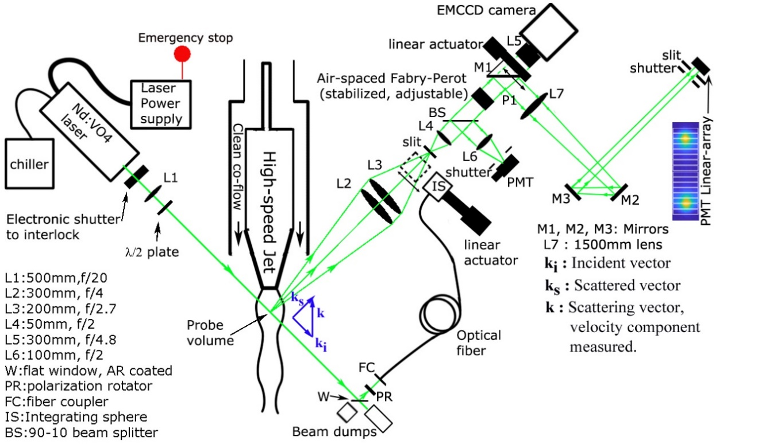
Fig 12. Schematic of the optical setup to measure time-averaged, and unsteady fluctuations of velocity, temperature, density from a high-speed jet (from Panda & Nguyen [8]).

The central elements of the optical setup (fig. 12) was a CW laser beam that passed through the clean-air stream, a Fabry-Perot interferometer to perform optical spectroscopy in order to determine the Doppler shift, and a linear array of PMT to measure the intensity distribution in the fringe produced by the Fabry-Perot. Turbulent velocity and temperature fluctuations created corresponding changes in the Doppler-shifted frequency of the scattered light. The combination of a narrow line-width CW laser and a stabilized Fabry-Perot was able to track the fluctuations in the scattered-light frequency. Such fluctuations manifested as changes in the diameter and the width of the Airy fringes created by the interferometer.
The 532 nm, 6.5W, incident laser had a very narrow linewidth of 5MHz, suitable to measure small Doppler shift from the air flow. The molecular scattered light from ~1mm length of the beam was collected using a pair of lenses and passed through a slit before collimation. The collimated beam is then passed through air-spaced, planar, 30mm diameter, 90 % reflectivity mirrors of a Fabry-Perot interferometer with a free-spectral range of 8GHz. The stabilized FPI used a closed-loop control to correct for the extraneous environmental factors such as thermal drift, vibration and noise. This was particularly beneficial for long-duration data collection. There were two different paths for the light out of the Fabry-Perot to follow. When the 45° turning mirror is retracted (using a linear actuator) the light was imaged through a 300mm focal length fringe-forming lens on a low-light, cooled, EMCCD camera. The camera setup provided measurements of time-averaged velocity within ±7m/s and temperature within ±5K accuracies from shock-containing supersonic flows. The individual data points of the unsteady measurements are expected to have higher uncertainties due to shorter exposure time. For unsteady measurements the turning mirror was placed on the light path to turn the light from the Fabry-Perot towards the PMT linear-array via fringe forming lens L7 and turning mirrors M2 and M3. The lens system ultimately magnified the small probe volume to the total length of the PMT array. The PMT array provided by Hamamatsu had 16 anodes spaced 1mm apart, each of dimension 0.8mm x16mm. The width was sufficient to allow the Rayleigh probe volume to be imaged on the array face. The direct-imaging setup made an efficient use of the scattered light. A small, unheated, supersonic jet facility was built to validate the Rayleigh setup. The 10mm-diameter convergent nozzle was supplied with clean, oil- and particle-free air. To reduce particle contamination via entrainment of the ambient air a clean, co-flowing stream was created via a second blower connected to a HEPA® filtration system.
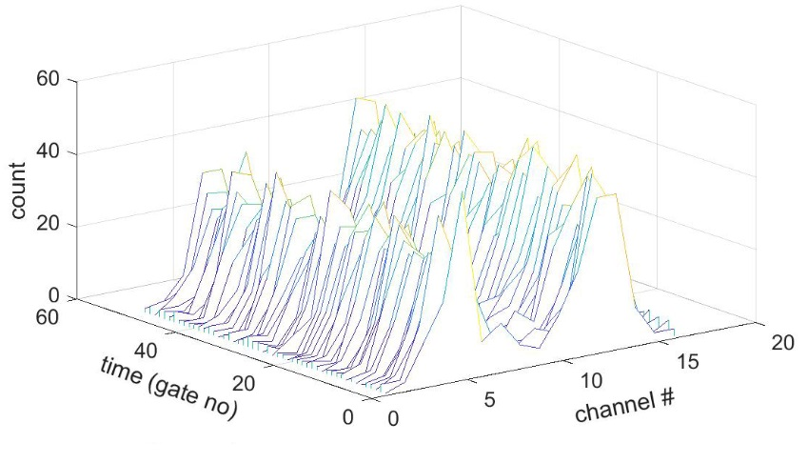
Fig. 13. Typical time variation of the Rayleigh image measured by the PMT-array, gate duration = 200micro-s, U=200m/s, T =278K (from Panda & Nguyen [8]).

A 16-channel discriminator-counter was used to perform synchronous photon counting over short duration gates from all 16 channels of the PMT (fig 13). The duration time of the gates represented the effective sampling rate. To obtain a reasonable frequency resolution the gate duration needed to be short, which in turn led to fewer number of photo-electron counts, and an increase of the shot-noise contribution. Figure 13 shows a waterfall plot of the instantaneous count distributions measured in the present setup. The count distributions were found to vary significantly from gate to gate, indicating large contributions from shot noise. For the present work a calibration-based procedure was used to extract instantaneous velocity from the individual distribution of the count distribution. Data from the linear array were grouped into two: the inner eight PMT and the outer 8 PMT. The counts in these two groups were added, and the variation of the added sums were determined from flows with known velocity. The inner group showed a monotonic increase, and the outer a monotonic decrease with increasing velocities. A ratio between the two counts was used to determine instantaneous velocity from the individual measurements. The summing of counts from groups of eight PMT served an important purpose of reducing contributions from electronic shot noise. The individual measurement of instantaneous has large random error (fig 14c). However, when such a time series is used to determine power spectrum via the route of cross-correlation, the associated averaging process significantly lowers the noise floor. Towards this end, the time-series was split into two parts by separating every other data point; each part was Fourier transformed, followed by a calculation of cross-spectrum. The odd and the even no of points in this series were split to create two series: U_{2j-1} and U_{2j} (i = 1, 2, …. n/2). The average values from each of the time series were subtracted: U/_{j} = U_{2j-1} - U̅, U/_{k}= U_{2i} - U̅₂ and a cross spectral density$S_{U_{j}^{/}U_{k}^{/}}$ was calculated from individual Fourier transform,$F_{U_{j}^{/}}, F_{U_{k}^{/}}$ at discrete frequency bands $f_{l}$:
$$\left|S_{U_{j}^{/}U_{k}^{/}}\left(f_{l}\right)\right|=\frac{2}{n^{2}}\left|F_{U_{j}^{/}}\left(l\right) .F_{U_{k}^{/}}^{*}\left(l\right) \right| (16)$$
The superscript * in the above equation indicates complex conjugate. Note that the effective sampling rate is reduced by a factor of two because the two time-series were created by choosing alternate data points from the same time-series. This can be thought of as doubling of the gate time ∆t. The one-sided power-spectrum was calculated as following:
$$S_{U^{/2}}\left(f_{l}\right)=\frac{S_{U_{j}^{/}U_{k}^{/}}\left(f_{l}\right)}{{\left(2∆t\right)}^{2}} (17)$$
Such power spectrum needs to be calculated over many blocks of contiguous data and averaged. An existing problem with the 16-channel photo-electron counting is that a limited number of contiguous gates of data can be received at a time, due to poorly understood limitations in the data transferred rate. For shorter gate-duration, e.g. 10micro-s, only 1000 gates of continuous data can be acquired. About 400 such series was collected for the spectra shown in fig 14, which is from a screeching M1.2 jet.
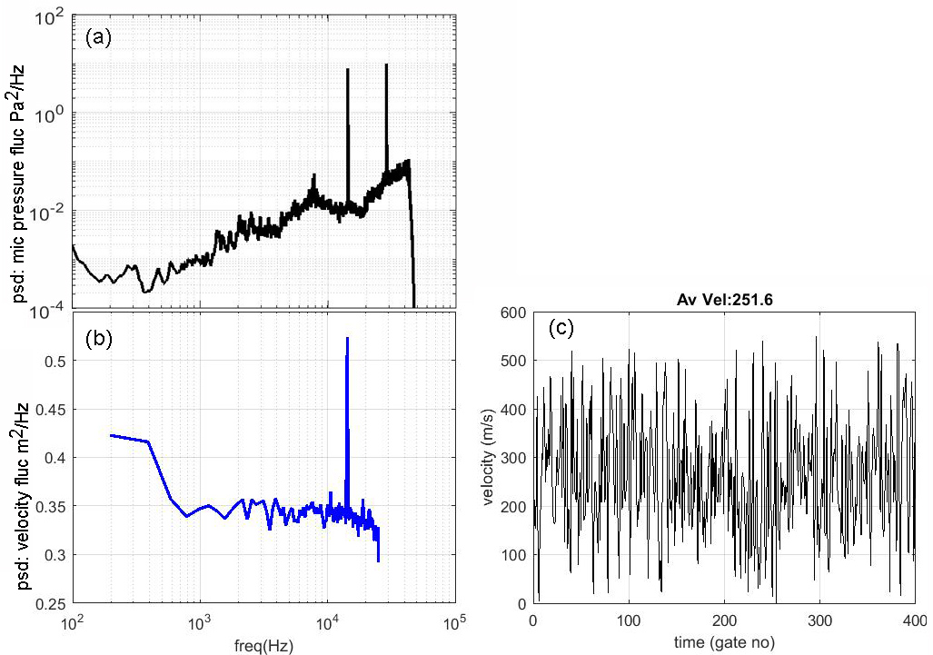
Fig 14. Comparison between (a) sound pressure fluctuations using a microphone 90˚ to the jet axis and, (b) velocity fluctuations spectra from the same M1.2 screeching jet, X/D=2, r/D=0.5; (c) time history of velocity fluctuations (from Panda & Nguyen [8]).

Figure 14 shows the necessary validation from a screeching jet. A ¼ inch condenser microphone was placed in the far-field of the jet to identify the screech peaks. Fig 14(a) shows acoustic spectrum with distinct peaks at 14.5 kHz and at a harmonic frequency of 29 kHz. A velocity fluctuations spectrum from the same jet obtained using the present technique is shown in fig 14(b), where the sharp peak at 14.5 kHz clearly showed the presence of organized turbulent structures at the same frequency. The second peak at 29 kHz could not be measured due to the limited bandwidth (gate-time) used to acquire data. Nonetheless, the correspondence between the acoustic fluctuations and the velocity fluctuations provided the desired validation of the present measurement technique.

VI. SUMMARY AND CONCLUSION

Electronic shot noise appears due to the random conversion of photons into photoelectrons by a photo-sensor. It is an unavoidable reality of all measurements of light intensity. Because the light intensity values are either directly converted to physical parameters such as pressure or density, or are used in association with physical models to determine parameters such as velocity and temperature, the shot noise also affects such measurements. For steady-state, time averaged measurements shot-noise level is drastically reduced by collecting light over a long duration (increasing the time of exposure) or by averaging over multiple shorter exposures. None of these options are available for dynamic, unsteady measurements. Non-optical measurement techniques such as microphone sensors or hot-wire anemometry do not carry the additional burden of shot noise. However, such traditional methods have known limitations particularly in high-speed flows, where optical techniques have made significant inroad. This paper gives example from uPSP and Rayleigh scattering where the impact can be directly evaluated due to a linear relationship between light intensity and respectively, pressure and density. However, once understood such relationships are not difficult to determine for physical variables that require models (such as Doppler shift, thermal broadening) to be applied to the measured light intensity.
For the dynamic, unsteady measurements one needs to create a time history by either taking a large number of frames at a short exposure time, or by using a photo-multiplier tube and a multi-scalar/average that performs photoelectron counting on a series of short-duration gates. The former is the case for uPSP applications, and the latter for the Rayleigh scattering based techniques. The short exposure time, or the short gate duration, limits the number of photons available for the individual measurements; thereby adding a fixed amount of random error. Because this random error is proportional to the square root of the number of the collected photons, the fewer the photoelectrons the larger is the percentage of random error in each data point. Shot-noise makes individual data points of the time-series highly error prone. The difficulty with the unsteady measurement is that the shot noise contribution cannot be lowered simply by increasing the sampling size, i.e., the number of frames (camera-applications) or the number of gates (PMT applications). That’s because the variance of the shot-noise statistics is independent of the number of samples. A common data processing step is to determine power-spectrum of turbulence fluctuations. Since the individual instances of measurement carry high level of uncertainty, the noise floor of the spectral data becomes very high, which can easily swamp the actual physical content.
The obvious first step is to increase the laser or lamp power, and to use the fastest collection optics possible. Yet there is a limit on the available resources. For a fixed optical system where the intensity of the luminescent light (uPSP), or the scattered light (Rayleigh) is fixed, one needs to resort to special techniques to obtain sufficient signal-to noise ratio (SNR). Three different methods of reducing the shot-noise contribution are discussed in this paper. The first method is applicable to a camera-based system, such as uPSP where photoluminescence from the pressure-sensitive paint is imaged using a high-speed camera. It is shown that summing of counts from adjacent pixels, i.e., binning pixels during post-processing, results into a reduction of shot noise. Example from an experiment is provided to show that averaging over increasing number of pixels: 2x2, 3x3 …. 8x8 progressively reduces the standard deviation of measured fluctuations to a plateau which is the desired physical value. Binning also lowered the noise floor in the power-spectrum of pressure fluctuations to bring out the actual physical content. Excellent match between spectra measured by uPSP and dynamic pressure transducers can be obtained via this binning process. The obvious disadvantage of this approach is a lowering of the spatial resolution.
The second method to reduce shot-noise contribution is to use one its properties: shot-noise produced by two different photo-sensors are statistically uncorrelated. Examples of this approach are shown from Rayleigh scattering based measurement of density fluctuations spectrum in high-velocity jets. In such setups Rayleigh scattered light from a probe volume is collected and directly measured using two photo-multiplier tubes and photon counting electronics. The intensity of the scattered light is directly proportional to the gas density. The counting is performed over a series of short duration gates to create a long time series. It is shown that the power-spectrum of density fluctuations calculated directly from this time series has such a high noise floor that the actual spectral content is hardly discernable. However, when the same scattered light is split into two parts using a beam splitter, measured using two sets of PMT and photon-counters, and subsequently the two time-series of data are cross-correlated, the shot noise floor is reduced drastically. An improvement of SNR by a factor of 100 can be achieved if 4M long data points can be measured for each set. Cross-correlation based noise rejection is a slow process that needs long time-series of data and requires a long acquisition time.
The third method to reduce shot-noise takes advantage of another property: shot-noise produced by the same photo-sensor but at two different time instances are completely uncorrelated. Example of this approach is shown from measurements of velocity fluctuations spectra in under-expanded screeching jets. The advantage of this third method over the second one above is that only one set of sensors and photon-counting electronics can provide similar reduction of the shot-noise. In this method two different time-series are generated from the measured single sequence of counts by separating the odd and the even counts into two groups. Cross correlating the two sequences leads to a similar lowering of the noise floor, and the emergence of the desired spectral content of the physical quantity. The downside of this method is that the effective sampling rate is halved (i.e., the gate time doubled), resulting into the same halving of the range of resolved frequencies. However, the method is particularly suitable for spectral measurements of velocity and temperature, where optical frequencies of the scattered light need to be resolved using spectroscopes - the need for a second set of the opto-electronics hardware is eliminated.

Reference
1. Panda, J., Roozeboom, N. H. & Ross, J. C., “Wavenumber-Frequency Spectra on a Launch Vehicle Model Measured via Unsteady Pressure-Sensitive Paint,” AIAA J., 57(5), pp. 1801-1817, 2019, doi: https://doi.org/10.2514/1.J057449
2. Roozeboom N. H., Diosady L. T., Murman S. M., Burnside N. J., Panda J. and Ross J. C., “Unsteady PSP Measurements on a Flat Plate Subject to Vortex Shedding from a Rectangular Prism,” 54th AIAA Aerospace Sciences Meeting, AIAA Paper 2016-2017, 2016.
3. Panda, J. “Experimental Verification of Buffet Calculation Procedure using unsteady Pressure-Sensitive Paint,” AIAA J. Aircraft, vol.54, no 5, pp.1791-1801, DOI: 10.2514/1.C033917, 2017
4. Panda, J. & Seasholtz, R. G. “Experimental investigation of density fluctuations in high-speed jets and correlation with generated noise,” J Fluid Mechanics, 2002, vol. 450, pp. 97-130.
5. Seasholtz, R.G. & Panda, J. “Rayleigh scattering diagnostic for simultaneous measurements of dynamic density and velocity,” 2000, AIAA paper 2000-0642.
6. Mercier, B., Castelain, T., Jondeau, E. & Bailly, C., “Density Fluctuations Measurement by Rayleigh Scattering Using a Single Photomultiplier,” AIAA J., 56(4), 2018, doi: 10.2514/I.J056507.
7. Mercier, B., “Développement d’une méthode de mesure de la masse volumique par diffusion Rayleigh appliquée à l’étude du bruit de jets, et contribution à l’étude du screech dans les jets supersoniques sous détendus,” Ph.D. thesis, 2017-LYSEC61, École Centrale de Lyon, 2017.
8. Panda, J. & Nguyen, M., “Progress in Interferometric Rayleigh Scattering to Measure Fluctuations Spectra of Velocity and Temperature in High Speed Flows,” AIAA paper 2020-0300, Jan. 2020.
9. Adrian, R., & Earley, W. L. “Evaluation of LDV performance using Mie scattering theory.” In Ill Univ Dep Theor Appl Mech TAM Rep, 1975.
10. PIV paper
11. Saleh, B. E. A. & Teich, M. C., “Fundamentals of Photonics,” John Wiley & Sons, 1991, DOI:10.1002/0471213748.
12. Locke, R. J., Wernet,M, P, & Anderson, R. C. ”Rotational Raman-Based Temperature Measurements in a High-Velocity Turbulent”, NASA/TM—2017-219504/REV1

