Astrophysics
CubeSat Platform Enables an Inexpensive Space Telescope
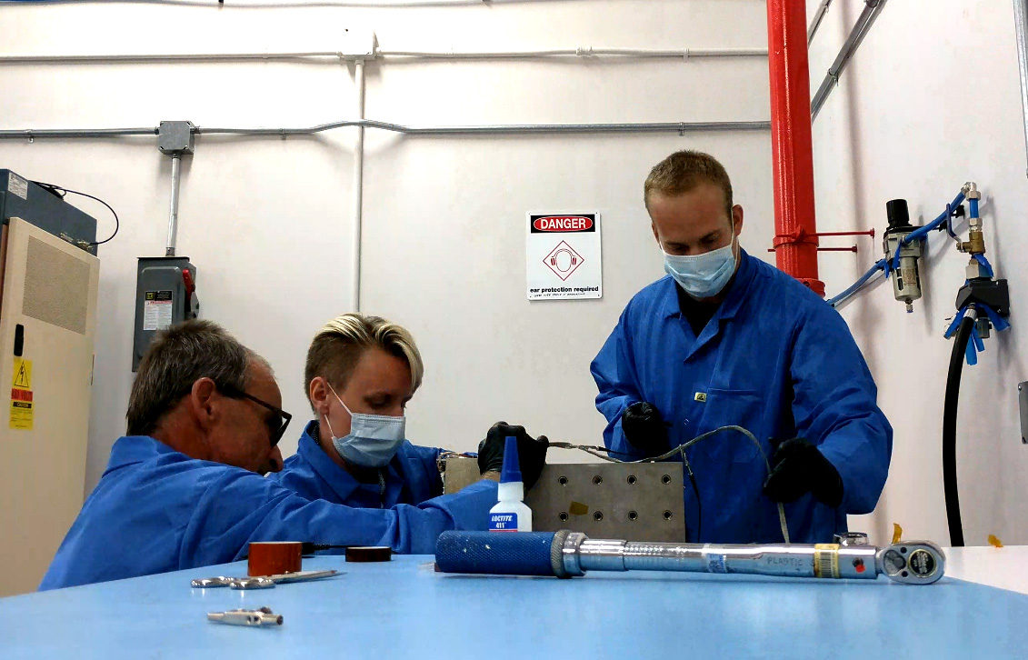
Members of the HaloSat team during vibration testing at Wallops Flight Facility. From left to right: Tom Johnson, Anna Zajczyk, and Daniel LaRocca. (Photo by Daniel LaRocca)
Project: HaloSat – A CubeSat to study the hot Galactic halo

Sponsoring Organization:
Astrophysics Division‘s Astrophysics Research and Analysis Program (APRA)

Project Lead: Prof. Philip Kaaret, University of Iowa

Snapshot: To enable lower cost space-based astronomical observatories, NASA is promoting use of miniature satellites known as CubeSats and instruments built from commercial off-the-shelf components.

Key terms: CubeSat, X-ray, X-ray detector, galaxies, Milky Way
Space telescopes have historically been expensive to plan, build, and launch. The Astrophysics Division of NASA’s Science Mission Directorate is now leveraging the development of small spacecraft known as CubeSats by universities and industry to enable capable and reliable platforms with well-focused goals, rapid development times, and affordable costs.
X-rays do not penetrate Earth’s atmosphere. This atmospheric barrier keeps us safe, but requires X-ray telescopes to be launched on satellites so they can operate above Earth’s atmosphere. The difficulties of building instruments that operate in the radiation and vacuum environment of space, the expense of spacecraft and rocket launches, and the cost of the extensive engineering and testing required all drive up the price of space-based telescopes. Technology development by academia, industry, and NASA has helped to bring those prices down.
In 1999, Jordi Puig-Suari (California Polytechnic State University) and Bob Twiggs (Stanford University) realized that by having their students build small satellites in standard sizes, they could decouple the design and construction of a small satellite, now called a CubeSat, from a specific rocket launch opportunity. Because their small, standardized CubeSats would fit any rocket, this practice enabled them to build a CubeSat and then wait until a rocket with a bit of spare launch capacity was available to hitch a ride to space. NASA picked up on this idea and instituted the CubeSat Launch initiative (CSLI) that organizes rides to space for CubeSats built by NASA Centers and programs, educational institutions and non-profit organizations. CSLI is like a carpool to space; it enables effective use of the extra capacity available on NASA rocket launches.
This innovation provided an inexpensive way to get small satellites into orbit, but early CubeSats were not considered suitable for science missions because they were unreliable and had limited capabilities. These problems were solved when a commercial industry grew around the CubeSat standard. Private companies invested in high-quality systems for CubeSats, then recouped their costs by selling lots of copies to many different customers. Today’s commercial CubeSats are reliable and capable.
The final step to enabling inexpensive space telescopes was to increase NASA’s risk tolerance for this type of mission. The Astrophysics Research and Analysis (APRA) program enables researchers to build CubeSats with NASA funds, but without the rigorous requirements of larger, more complex missions. This factor is key to keeping CubeSat mission costs low.
HaloSat is the first astrophysics-focused and competitively selected CubeSat mission funded by NASA’s Astrophysics Division. HaloSat’s scientific goal is to find where the hot gas surrounding our Milky Way galaxy lies by mapping X-ray emission across the whole sky. This mission will help us understand how matter cycles in and out of galaxies and whether a significant fraction of the normal matter in the universe is in the form of hot gas associated with individual galaxies. HaloSat is designed to be sensitive to diffuse X-ray emission – X-ray emission that extends over large parts of the sky. The ‘figure of merit’ for diffuse emission is equal to the telescope area times the field of view. HaloSat has a very small telescope area, but a very large field of view (about 10 degrees), which makes it competitive with major X-ray observatories regarding its specific goal to study diffuse X-ray emission.
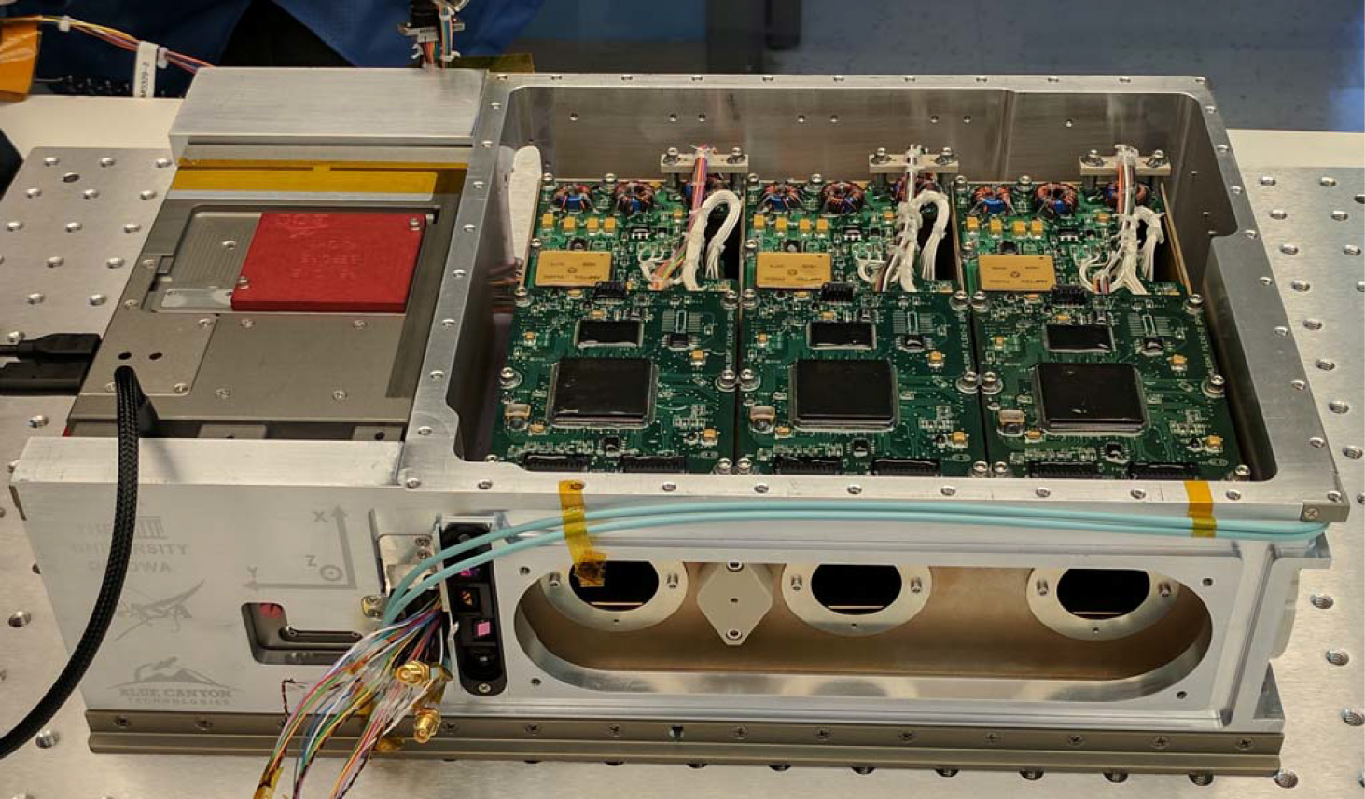
HaloSat with its top cover removed. The aluminum structure conforms to the CubeSat standard. The tan box on the left is the CubeSat avionics package from BCT. The science instrument built at the University of Iowa is on the right with the electronic circuit boards on top and the X-ray apertures at the front. (Photo by Daniel LaRocca)
HaloSat measures approximately 10 x 20 x 34 cm before its solar array is unfurled and has a mass of 12 kg, meeting the CubeSat standard. HaloSat uses a spacecraft bus built by Blue Canyon Technologies (BCT) that provides a radio to communicate with the ground, star trackers and reaction wheels to point the spacecraft, and power and control systems to run onboard systems. The bus was bought for a cost far below what it would have taken to build one from scratch because BCT sells numerous nearly identical busses. The X-ray detectors, which have an energy range from 400 to 7000 electron volts (eV), (as a comparison, the energy range of visible light is 2-3 eV), were bought from Amptek, Inc., again, at a fraction of the cost that would be required to develop similar detectors.
The HaloSat mission was developed on a rapid timescale, less than 2.5 years from the start of funding in January 2016 to launch on the Orbital-ATK OA-9 International Space Station (ISS) resupply mission on May 23, 2018. HaloSat was deployed from the ISS on July 13, 2018, and after proper commissioning, began science operations in October 2018. The cost of HaloSat from its start to the end of the first year of operations was less than $4M—a fraction of the cost of small satellites, which typically cost several hundred million dollars.
HaloSat has now surveyed the entire sky and is still operating more than two years since deployment. HaloSat is also providing a myriad of learning opportunities for upcoming scientists and engineers. The HaloSat project has directly trained several students and early-career scientists and engineers including two postdoctoral research scientists, now both working at NASA/GSFC; one graduate student who is now a postdoc at Penn State University; two more graduate students who currently analyze X-ray data; a host of undergraduates, including one now in the graduate program at the University of California, Berkeley; and several engineering students now working in industry.
In its short lifetime, HaloSat has made important contributions to astronomical research. HaloSat has measured the total X-ray luminosity of the Vela supernova remnant and mapped the structure of the the X-ray halo in the southern galactic sky. Astronomers have used data from HaloSat to study the "North Polar Spur," which is a shell of X-ray emission energized by a powerful explosion near the galactic center and the "Cygnus Superbubble"—a region of X-ray emission associated with the local spiral arm of the galaxy. HaloSat is expected to re-enter Earth's atmosphere in late 2020.
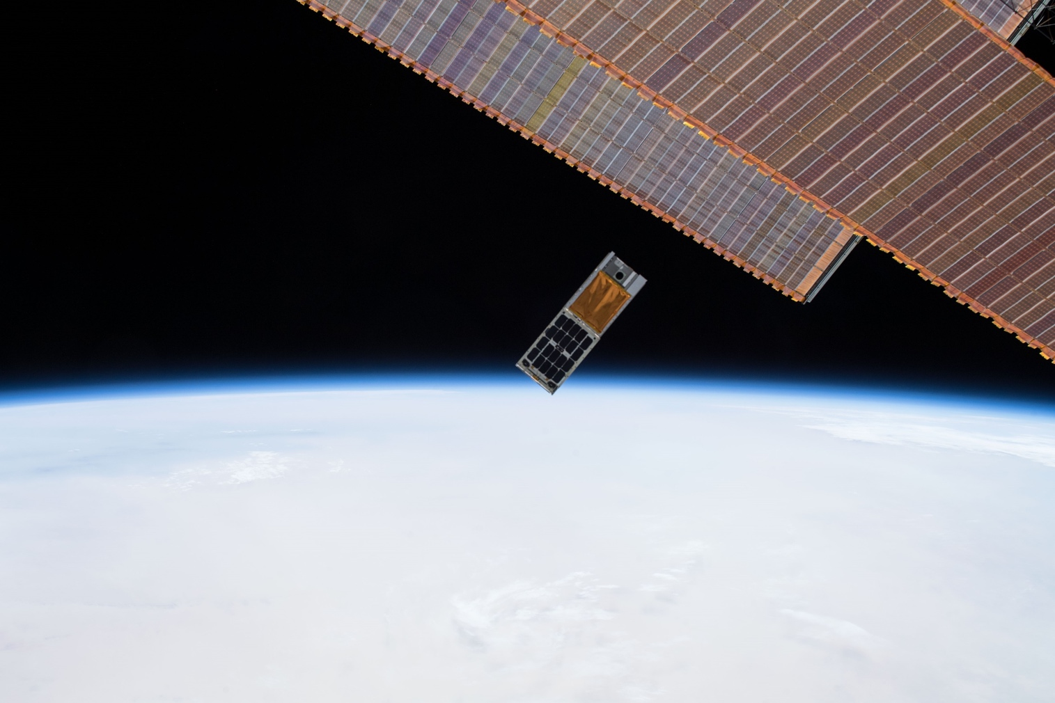
HaloSat just after deployment from the International Space Station (ISS). HaloSat is seen just below the ISS solar arrays.

Far-Infrared Detectors: Superconductivity Enables New Astrophysical Discoveries
Project: Ultrasensitive Far-Infrared Bolometers for Space Astrophysics

Sponsoring Organization:
Astrophysics Division’s Cosmic Origins and Strategic Astrophysics Technology Programs

Project Lead: Dr. C. Matt Bradford, NASA Jet Propulsion Laboratory, California Institute of Technology

Snapshot: The far-IR is a powerful but relatively unexplored spectral band that can enable study of the birth and infancy of galaxies. NASA missions with super-cooled telescopes have the potential for orders of magnitude improvement in sensitivity, but detector improvements are needed to fully capitalize on these new platforms. A JPL team is combining micromachining and superconductivity technologies to make the world’s most sensitive far-IR bolometers.

Key terms: detector, telescope, spectrometer, transition-edge sensor.
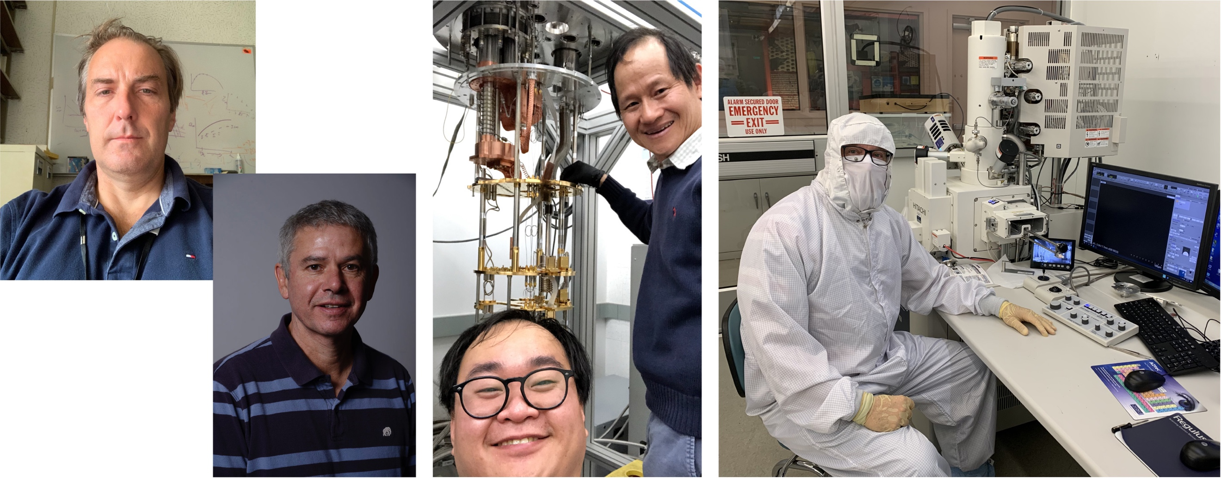
The far-IR bolometer team at JPL. From left to right: Matt Bradford, Pierre Echternach, Howard Hui and Hien Nguyen (shown with the test cryostat) and Matt Kenyon (in the microdevices lab).
Superconducting detectors are the key to unlocking the secrets of the universe hidden outside the visible band.
The universe is approximately 13.7 billion years old, and astronomers know that galaxies have existed for the vast bulk of this time, at least the last 13.3 billion years. Beginning as small dwarf systems, galaxies have grown, evolved, and merged over time to create the variety we see today. The interior of galaxies is where much complexity in the universe arises: it is where stars form, evolve, and die, forging and distributing the elements necessary for planets, chemistry, and life.
Most of our information about the history of galaxies’ contents is based on measurements in the visible spectral band, for which Earth’s atmosphere is transparent and commercially produced detectors operate with good sensitivity. However, in the last two decades, initial measurements in the far-infrared (or far-IR, defined here as light with wavelengths between 20 to 500 microns) collected by NASA’s Spitzer and the European Space Agency’s (ESA) Herschel space telescopes have shown us that across cosmic time, most of the power from the active interiors of galaxies has emerged in the far-infrared, not the visible waveband. This is because galaxies are inherently dusty; dust absorbs the visible wavelength light and re-radiates the energy in the far-IR. The result is that on average, the visible -wavelength signals from galaxies do not originate in the cores of galaxies’ active regions, but in their exterior skins. A meaningful study of the inner workings of galaxies throughout cosmic history must include a technique which overcomes dust obscuration.
Far-IR spectroscopy may be the best tool nature gives us for this purpose. Far-IR radiation is largely unimpeded by dust, and the spectral features in the far IR both measure the redshifts, thus the look back times (the time it takes light from a distant object to reach Earth), and carry information about galaxies’ heavy-element contents and their stellar and black hole energy sources. While astronomers have demonstrated the use of far-IR spectroscopy for detailed studies of active sites in our own Milky Way galaxy and nearby galaxies, instruments sensitive enough to reach back in cosmic time with spectroscopic measurements were not yet available.
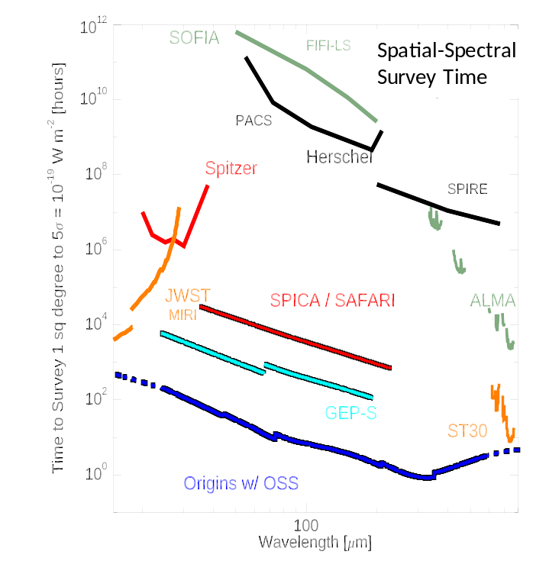
Figure 1. Far-IR spectroscopy measurement time (lower is faster). The figure covers 13 orders of magnitude. The lower curves in red, cyan and blue show potential missions with actively cooled telescopes designed for far-IR spectroscopy. The black and green curves at the top show the current state of the art with warm telescopes. ALMA (extant) and ST30 (concept) are ground-based telescopes; they show where observations from the ground become possible as the atmosphere becomes more transparent toward longer wavelengths.
A revolutionary advance is now on the drawing board for NASA’s far-IR astronomers as presented in Figure 1. The key combination is a large cryogenically cooled space telescope and a sensitive far-IR spectrograph. In the far-IR, cooling the telescope to a few degrees above absolute zero is comparable to waiting for the Sun to go down in the visible waveband on a moonless night: the background light which stymies observations goes down by a factor of about a million. NASA’s Spitzer Space Telescope was cooled to below four degrees Kelvin on orbit in its cold phase from 2003 to 2009, and performed flawlessly, demonstrating the basic feasibility of a cold telescope. Spitzer, however, had a modest 85-centimeter diameter mirror, and did not have far-IR spectroscopic capability.
A larger cryogenic telescope presents an engineering challenge, but not a technological one, and a range of mission options are now under study. ESA and the Japan Aerospace Exploration Agency (JAXA) are considering the Space Infrared Telescope for Cosmology and Astrophysics (SPICA) mission featuring a 2-meter telescope and instruments, which could include US participation. In the US, NASA has commissioned studies of both a probe-class mission--the 2-meter Galaxy Evolution Probe—and a 5.8-meter flagship called Origins. All of these concepts are now under consideration by the panels developing the National Academies of Science, Engineering and Medicine’s 2020 Astrophysics Decadal Survey.
The only technological impediment to sensitive far-IR space astrophysics is detector performance. Unlike the visible and even the near-infrared bands, in the far-IR there are few commercial or industrial applications, so detector systems must be developed entirely by the science community. Far-IR detector systems do exist and have been used in a limited fashion by the Herschel telescope. However, achieving the potential capability shown in Figure 1 would require detector arrays with pixels that are 100-1000 times more sensitive than those flown previously, and the most ambitious concepts like Origins would require arrays consisting of 10-100 times more pixels.
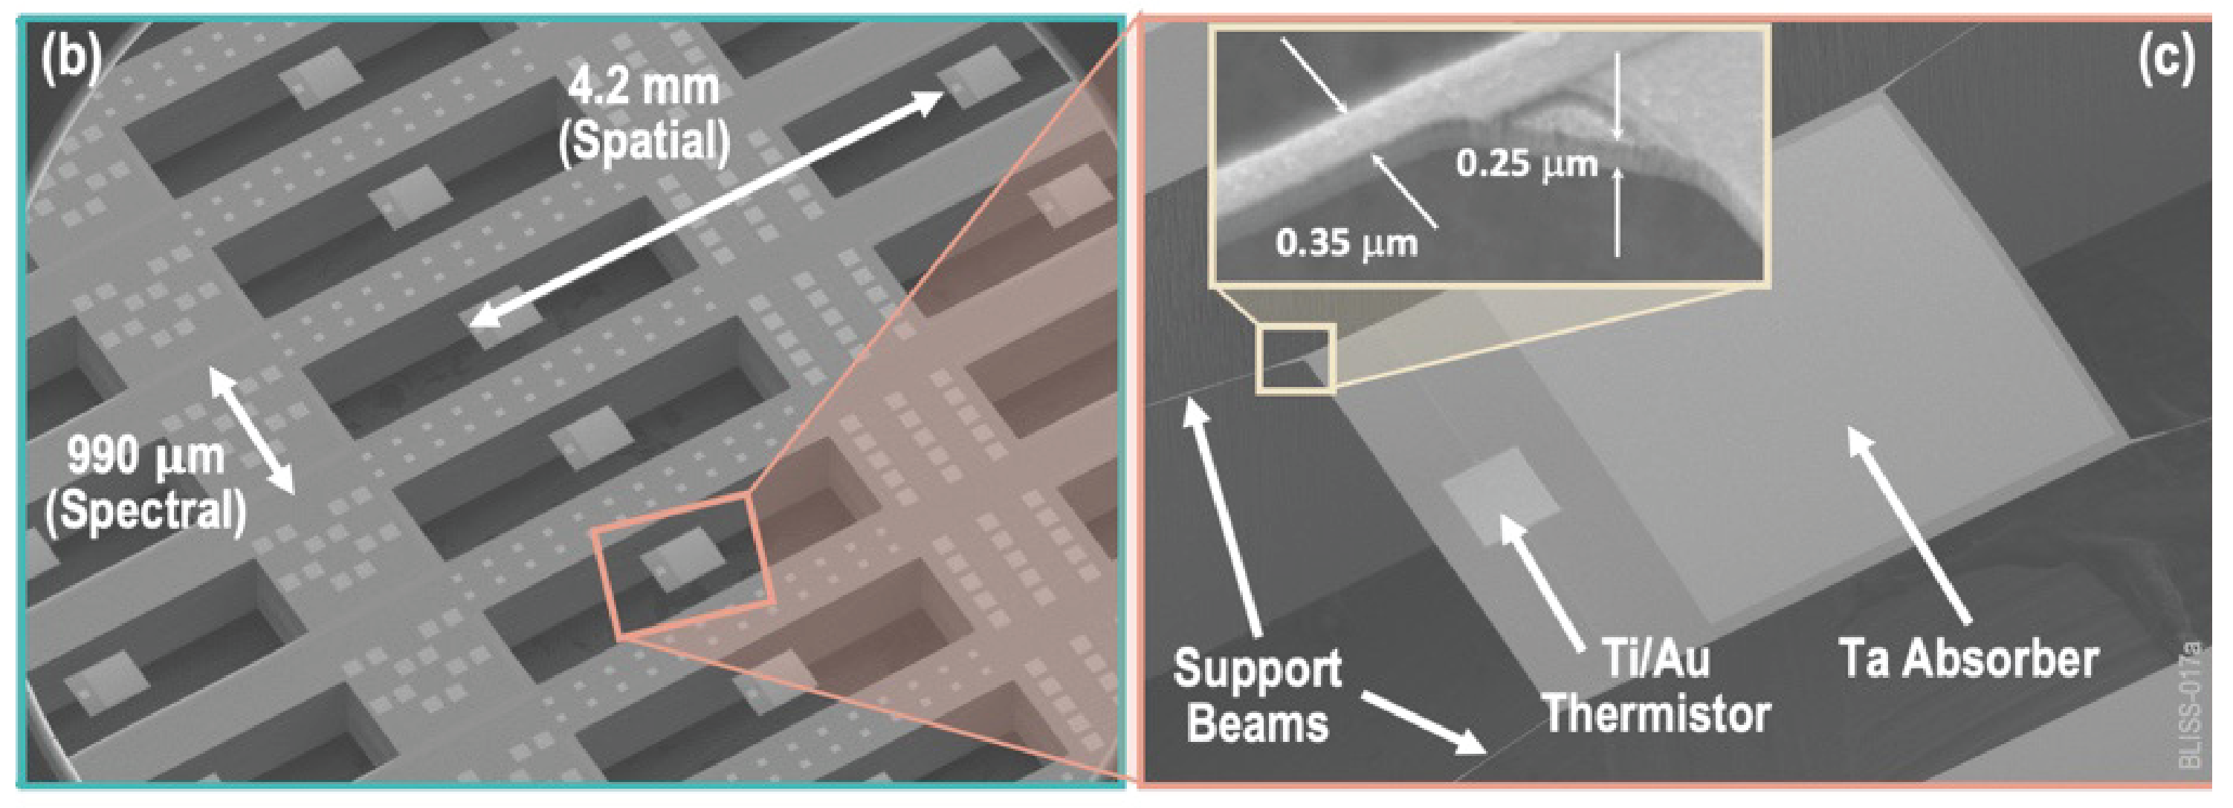
Figure 2. Recent bolometer implementation in the JPL microdevices lab. To achieve the exquisite sensitivities required for far-IR spectroscopy, the thermal conductance G (Watts/Kelvin) must be reduced by factors of hundreds from previous devices, which can be accomplished using carefully micromachined silicon nitride beams.
A group at JPL is working to meet these requirements using superconducting detectors. Basic thermodynamic considerations require that any sensitive far-IR detector be cooled to below one degree Kelvin, prohibiting the use of most semiconducting electronics that could be employed for multiplexing and amplification. Superconducting electronics are a natural alternative, given the availability of low-noise superconducting quantum interference device (SQUID) current amplifiers, and the ability to produce high-quality radiofrequency and microwave resonators in thin film superconducting metal—a technology also used in quantum computing experiments. By coupling each detector pixel to a single resonator, and arraying resonators at different frequencies, a single RF or microwave readout circuit can access up to 1000-2000 pixels, each independently biased and read out with a its own Alternating Current (AC) tone. Operating many (50-100) such readout circuits in parallel enables about 100,000 total pixels—the number envisioned by the Origins mission concept.
The JPL team is developing superconducting transition-edge-sensed (TES) bolometers that both meet the Origins sensitivity requirement and use this readout approach. A bolometer consists of an island thermally isolated from a base, which is cooled to a stable low temperature a fraction of a degree above absolute zero. As the schematic in Figure 2 shows, light absorbed on the island elevates the temperature of the island above that of the base, and the temperature is measured with a temperature-sensitive resistor. Bolometers have been used for decades in astrophysics and cosmology, and in the last 15 years, virtually all bolometers use a superconductor that is biased on the edge of its superconducting transition as the temperature sensitive resistor, giving rise to the name TES bolometer. Such devices are the state-of-the-art detectors for ground-based microwave background experiments as well as X-ray spectroscopy.
To improve the sensitivity of the bolometer for far-IR space applications, its electrical response to absorbed power must be increased, which requires a smaller thermal conductance as well as a lower temperature than used in previous experiments. To minimize the thermal conductance, the JPL team uses the approach shown in Figure 2; an island of silicon nitride is suspended with four long and narrow legs from the silicon wafer substrate.
In addition to coupling the bolometers to a resonator-based readout system, the JPL team has made a number of improvements in the devices themselves in the last year, which are now yielding fruit in initial measurements. First, they developed a titanium-gold superconducting bilayer technology to create the temperature-sensitive resistor. By adjusting the ratio of titanium and gold, team members can tune the transition temperature reliably, and have found that the devices have a sharp transition generally (Figure 3, left).
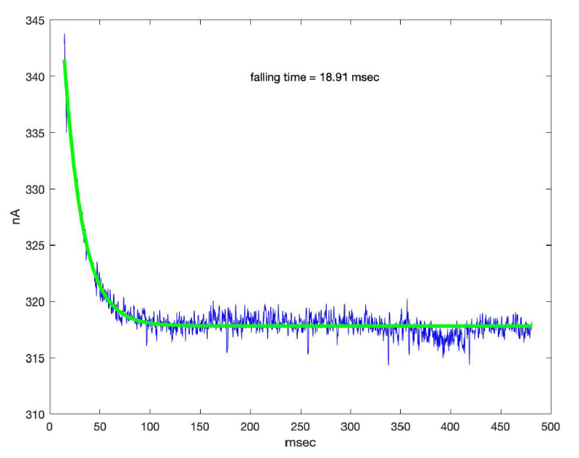
Falling time = 18.91 msec
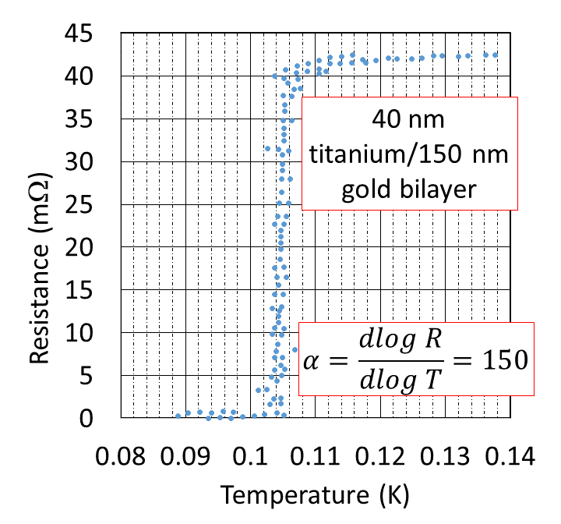
Figure 3. Measurements from JPL’s new ultrasensitive bolometers. Left: the temperature sensitive resistor used in our new fabrication—a titanium-gold bilayer—transitioning at 105 mK. Right: the speed of a bolometer biased onto this transition; time constants as low 19 ms meet the requirements for near-term mission concepts.
Second, the team developed a wet-release fabrication method to eliminate stray heat capacities and thermal conductances that have plagued similar devices in the past. A wet release is a major challenge for micromachining these delicate structures, but the JPL fabrication process shows high yield (>90%) in subarrays like those shown in Figure 2. Moreover, measurements using the new frequency-based readout indicate these devices are ten times faster than those of the previous generation and meet the requirements for mission concepts under consideration, such as SPICA. The thermal conductance of these new devices also appears to be below the sensitivities required for Origins that are shown in Figure 1. The JPL team plans to confirm these measurements and conduct additional sensitivity measurements as well as a frequency-domain multiplexing demonstration in the coming year.
The research was carried out at the Jet Propulsion Laboratory, California Institute of Technology, under a contract with the National Aeronautics and Space Administration (80NM0018D0004).

Earth Science
Prototype Ozone Monitoring Instrument Gets Its First Look at The Sun
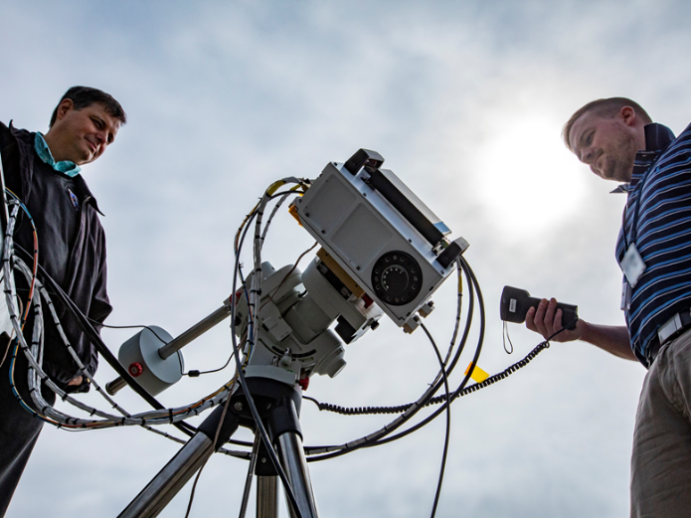
Charles Hill, left, and John Leckey with the Stratospheric Aerosol and Gas Experiment (SAGE) IV Pathfinder instrument during Sun-look testing at NASA's Langley Research Center.
Credits: NASA/David C. Bowman
A prototype of an instrument that could one day extend NASA's data record on the recovery of Earth's ozone layer recently got its first glimpse of the Sun. A team at NASA's Langley Research Center in Hampton, Virginia, took the Stratospheric Aerosol and Gas Experiment (SAGE) IV Pathfinder onto the roof of one of the center's buildings to conduct Sun-look tests.
The SAGE IV Pathfinder makes measurements of ozone and tiny atmospheric particles called aerosols by looking at the light from the rising or setting Sun as it passes through Earth's atmosphere — a technique called solar occultation. Prior to being brought outside, SAGE IV Pathfinder had undergone months of testing in a lab, but the Sun-look tests are critical to instrument development.
Project: Stratospheric Aerosol and Gas Experiment (SAGE) IV Pathfinder

Sponsoring Organization:
Earth Science Division‘s Instrument Incubator Program (IIP)

Project Leads: Charles Hill and Rob Damadeo, NASA Langley Research Center

Snapshot: The miniaturized SAGE IV Pathfinder instrument may one day enable a constellation of small satellites to continue and enhance atmospheric ozone monitoring.

Key terms: Ozone, aerosols, CFCs, solar occultation
"There's nothing like getting out and taking a look at the Sun, which is extremely bright in comparison to anything we can produce in the laboratory," said Charles Hill, co-principal investigator for SAGE IV Pathfinder.
A full-blown SAGE IV mission would be a significant new chapter in the SAGE story, which began in the late 1970s and continued through the following decades. The data collected on SAGE I and the following instrument SAGE II, were critical to the discovery of Earth's ozone hole and the creation of the 1987 Montreal Protocol, an international treaty that banned the use of chlorofluorocarbons (CFCs). CFCs were used as refrigerants and in aerosol spray cans and are significant contributors to stratospheric ozone depletion.
While ozone in the troposphere—the lowest part of the atmosphere—has negative effects on the air we breathe, ozone in the stratosphere—the layer of the atmosphere that begins around six miles above the surface—is vital for life on Earth. By absorbing most of the Sun's harmful UV rays, stratospheric ozone acts as Earth’s sunscreen and helps protect people from skin cancer, cataracts, and immune system suppression, and prevents crops from being damaged.
SAGE III, which launched to the International Space Station in 2017, is monitoring the recovery of the ozone layer, determining effects on the stratosphere from events such as volcanic eruptions and extreme wildfires, and measuring the levels of stratospheric nitrogen dioxide and water vapor.
SAGE IV is in a prototype state and unlike its washing-machine-sized predecessors would fit neatly within the confines of a CubeSat that is not much bigger than your average shoebox. That reduction in size, which results from using an improved measurement technique that images the entire Sun rather than looking at only a small portion of it, will make SAGE IV more cost effective.
“For this type of measurement, keeping the data record continuous and validating new instruments against what’s already there is critically important,” said Rob Damadeo, the other co-principal investigator. The idea is to ensure overlap of new instruments with existing instruments. “That way when the old one drops off, the new one takes over and you keep stepping along like that,” explained Damadeo.
The team envisions a time when a small constellation of SAGE IV CubeSats would eventually orbit Earth. This scenario would simultaneously expand the measurements to more of the globe and reduce the time between observations of any location from a month down to a week.
That future is still aspirational for now, though. The SAGE IV team is working hard to finalize designs for a spaceflight-qualified instrument, and exploring opportunities to move beyond prototype status to continue these important measurements.
The Sun-look tests took place in early March, just as concerns about COVID-19 began forcing widescale closures around the U.S. Those circumstances required the team to end testing a few weeks before they were finished, but they're looking forward to completing testing, analyzing the data, and moving the project into its next phase.
"We're planning for it," said Mike Obland, SAGE IV project manager. "We're actively planning for a return and how to optimize our time and finish our critical testing safely when we get back."
SAGE IV Pathfinder involves partnerships with the private sector and is funded by the Instrument Incubator Program in the Earth Science Technology Office, which is part of the Earth Science Division in NASA’s Science Mission Directorate. Additional funding comes from Langley's Science Directorate. Funding for some of the instrument's telescope technology is being advanced through NASA's Small Business Innovation Research program.

Planetary Science
A Small Satellite With Planetary Ambitions
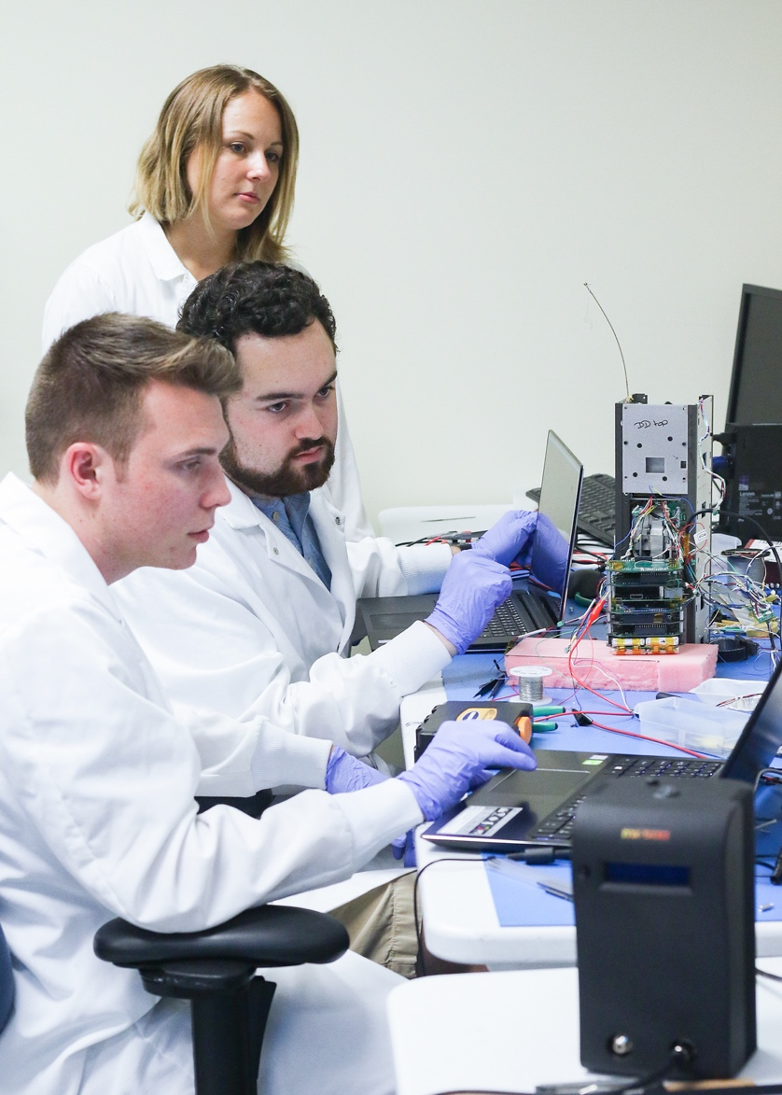
Undergraduate students Clayton White (left) and Jonathan Kessluk, and graduate student Stephanie Jarmak, test the Q-PACE electronics. (Credit: University of Central Florida)
A NASA-sponsored team at the University of Central Florida (UCF) has built a small satellite designed to study how tiny particles collide and aggregate in microgravity. The spacecraft, called the CubeSat Particle Aggregation and Collision Experiment, or Q-PACE, has been integrated onto Virgin Orbit’s LauncherOne space vehicle, and is scheduled for launch no earlier than December 8, 2020. Q-PACE is part of NASA’s Educational Launch of Nanosatellites (ELaNa) program. The mission was selected in 2015 as part of NASA’s Small Innovative Missions for Planetary Exploration (SIMPLEx) Program.
The first steps of planet formation involve the formation of centimeter-scale objects through collisional aggregation of dust particles. These centimeter-scale objects, dubbed pebbles, then agglomerate into asteroid-sized objects called planetesimals aided by gravitational instabilities within the protoplanetary nebula. The same collisional processes also take place in the rings of Saturn and the other giant planets, controlling the rate of spreading of the rings and the formation of clumps and moonlets within the rings. Q-PACE will take advantage of the microgravity environment in low-Earth orbit, which allows particles to collide at low speeds (from less than a mm/s to several cm/s), to study the transition between bouncing, sticking, and fragmentation of aggregates. Q-PACE will capture information about thousands to tens of thousands of collisions between different types of particles to enable better understanding of the formation of pebbles and the collisional evolution of swarms of pebbles.
Project: CubeSat Particle Aggregation and Collision Experiment, or Q-PACE

Sponsoring Organization:
Planetary Science Division‘s Small Innovative Missions for Planetary Exploration (SIMPLEx) program

Project Lead: Dr. Joshua Colwell, University of Central Florida

Snapshot: Q-PACE will capture video of thousands of gentle collisions between particles in microgravity to understand the earliest steps in planet formation.

Key terms: microgravity, planet formation, planetesimals, planetary rings, collisions, CubeSat, protoplanetary disk
The 3U (10 x 10 x 30 cm) Q-PACE CubeSat carries a small Experiment Test Chamber (ETC) containing particles of various sizes, densities, materials, and shapes, ranging from micron-sized silicate dust to centimeter-sized quartz spheres. The ETC also includes a collection of chondrules, small pieces of meteorites that are some of the first solids to have formed in the gaseous nebula that became our solar system. While in Earth orbit, the ETC will be shaken at various speeds and along all three axes to induce collisions between the particles. The particles will be backlit in the ETC, and the experiments will be recorded on video by a COTS camera powered by a $35 Raspberry Pi microcontroller with custom radiation spot shielding. Data will be recorded at 90 frames per second to enable precise tracking of the particles during collisions. After the ETC is shaken, the resulting motion of the particles will be recorded until motion stops. Preliminary experiments suggest this entire process will take less than five minutes.
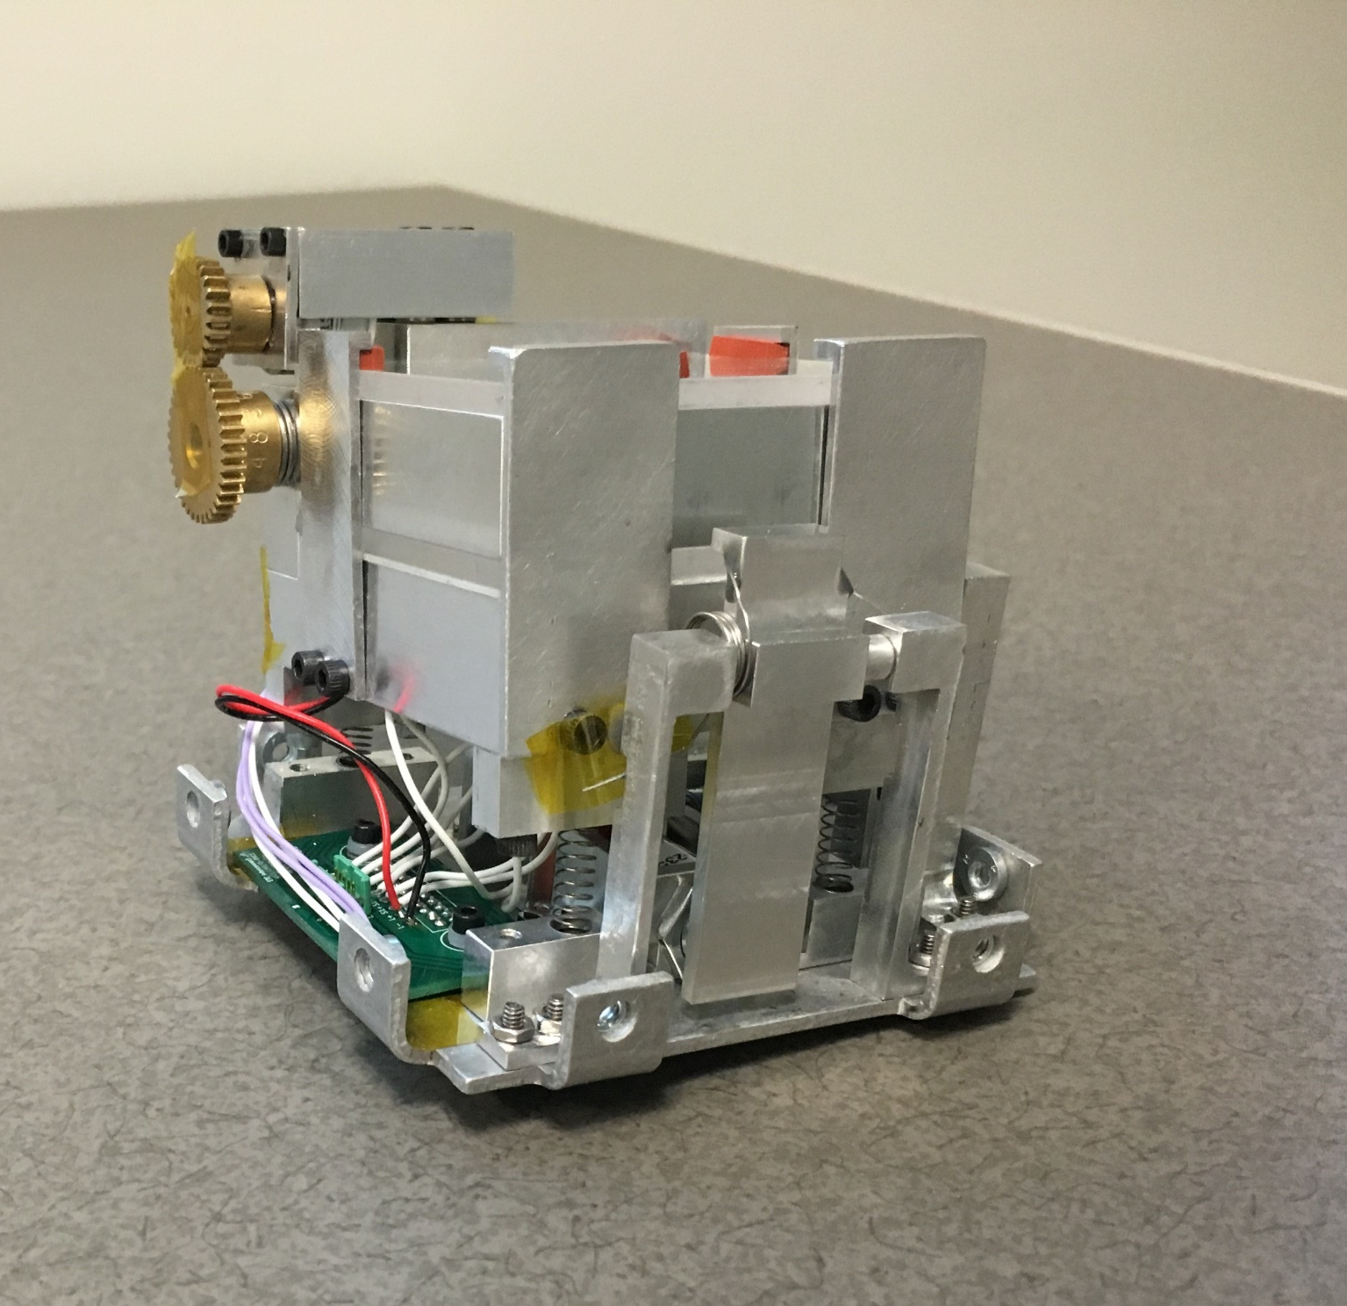The Q-PACE Experiment Test Chamber (ETC)
The ETC is the heart of Q-PACE and engineering the experiment to fit in the small CubeSat form factor was a significant challenge. UCF students iterated the ETC design and developed several prototypes to obtain the final product.
The Q-PACE mission will last up to three years, providing the opportunity to study adhesion and fragmentation events that happen only rarely, such as near-simultaneous collision of three or more particles. The mission will proceed over several phases with the introduction of different types of particles into the ETC, beginning with large solid spherical particles, and finishing with aggregates of micron-sized dust and chondrules. The large number of collisions to be recorded by Q-PACE over the course of the mission will enable a probabilistic description of collisional outcomes in the protoplanetary disk.
The small spacecraft will be powered by the Sun. Solar panels will charge batteries to power the test chamber, onboard camera, spacecraft control, and communications back to ground stations at the University of Central Florida (UCF) and the University of Arkansas. Because of the large volume of video data to be generated, Q-PACE will use data compression and multiple downlinks to complete an experiment. Both undergraduate and graduate students at UCF were heavily involved in the design and construction of Q-PACE, under the direction of Principal Investigator Joshua Colwell, Co-Investigators Julie Brisset and Addie Dove, and systems engineer Doug Maukonen. Larry Roe at the University of Arkansas and Jürgen Blum at the Technical University of Braunschweig complete the Q-PACE science team.
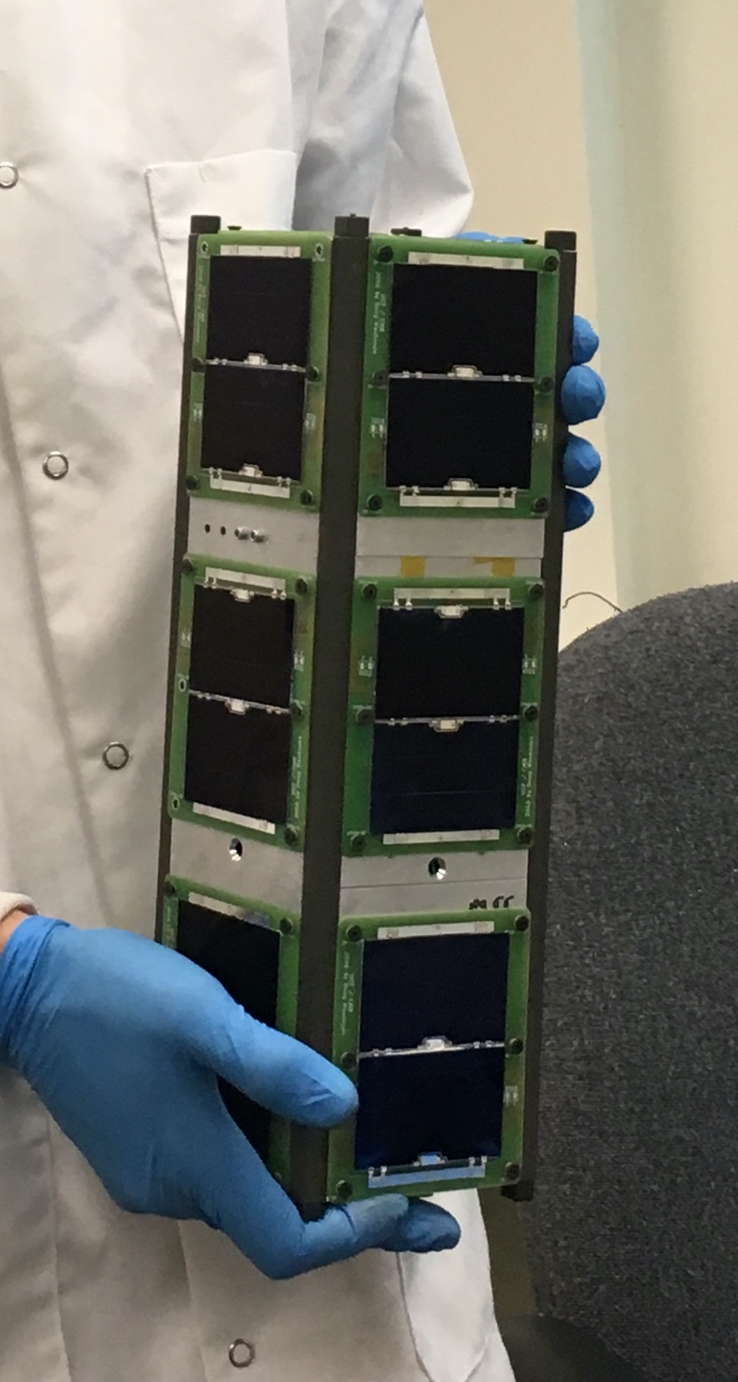
The Q-PACE satellite, ready for environmental testing, is powered by batteries charged by solar panels. (Credit: University of Central Florida)

Biological and Physical Sciences
Quantum Technologies Take Flight
Project: Cold Atom Lab (CAL)

Sponsoring Organization:
Biological and Physical Sciences Division (BPS)

Project Lead: Kamal Oudrhiri, Jet Propulsion Laboratory, California Institute of Technology

Snapshot: Interferometry of atomic matter-waves has been demonstrated for the first time in orbit, opening the door for precision quantum sensing for both fundamental and applied physics applications ranging from tests of general relativity to planetary geodesy.
Key terms: quantum gases, atom interferometry, equivalence principle, inertial navigation, gravity science
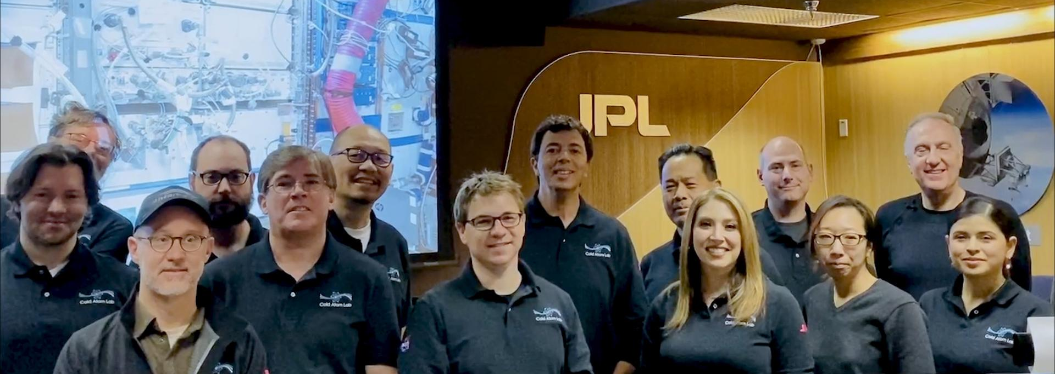
In January 2020, a team at the NASA Jet Propulsion Laboratory worked remotely with astronauts on the International Space Station to upgrade hardware on the Cold Atom Lab, adding atom interferometer capabilities.
A recent upgrade to NASA’s Cold Atom Lab has enabled atom interferometry on the International Space Station (ISS), forming the basis of a new generation of exquisitely precise quantum sensors that scientists can use to explore the universe. Applications of these spaceborne quantum sensors include tests of general relativity, searches for dark energy and gravitational waves, spacecraft navigation and drag referencing, and gravity science, including planetary geodesy—the study of a planet's shape, orientation, and gravity field.
The wave-particle duality of matter is a cornerstone of quantum mechanics. First hypothesized by Louis De Broglie in 1924, it postulates that every particle or quantum object can be described as either a particle or a wave, depending on how we measure the properties of the object.
A natural consequence of the wave-like nature of quantum matter is that it can simultaneously exist in more than one place. When experimentalists measure the particle location, the simultaneous paths taken by the particle “collapse” to a single traceable trajectory. Quantum interferometry starts with particles in the same lowest energy state and then puts some of them in the first excited state and measures the phase difference between these two groups after they traverse a region of interest. Matter-wave interferometers have been experimentally demonstrated on Earth with numerous types of particles, including electrons, neutrons, atoms, antimatter, and even biomolecules.
Over the last few decades, technology advancements have enabled cooling of atoms to temperatures below 1 microKelvin to form a fifth (purely quantum) state of matter called a Bose-Einstein condensate (BEC), making ultracold atom interferometers using this unique matter a leading candidate for future precision sensing of inertial forces. Analogous to high-precision optical interferometers (such as the Laser Interferometer Gravitational-Wave Observatory [LIGO], which recently detected gravitational waves using highly stable optical waves), atom interferometers with BECs utilize extremely pure, low-velocity quantum gases to achieve high-precision, phase-sensitive measurements of fundamental forces including gravity. They also promise to deliver unprecedented acceleration and rotation sensitivity for inertial navigation. In fact, such atom interferometers are shown to be sensitive enough to detect variations in a gravitational field, and thus could be used to map the interior density of planets.
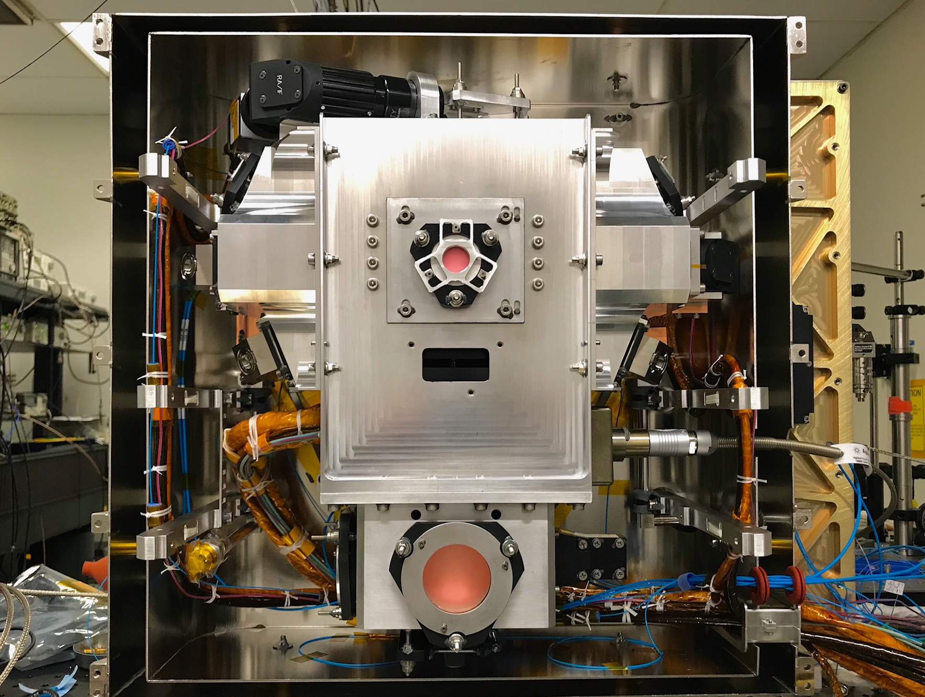
Figure 1: View of the atom interferometry-capable Science Module inside two layers of magnetic shields during the pre-launch build/testing phase at JPL.
Achieving atom interferometry in space had been a long-sought goal of NASA and the fundamental physics community. “The promise of very low temperature gases and effectively limitless free-fall time for space-based atom interferometry is expected to open a new regime of precision for inertial force and rotation measurements that could revolutionize both contemporary gravity science and spacecraft navigation capabilities in the near future,” said Dr. Jason Williams, a Principal Investigator for atom interferometry studies onboard ISS.
In May 2020, atom interferometry with an ultracold BEC of rubidium atoms was demonstrated for the first time on an orbiting platform. This experiment was realized by NASA’s multi-user Cold Atom Lab (CAL), which has been operating onboard the ISS since 2018. In January 2020, CAL received a Science Module capable of atom interferometry (pictured in Fig. 1) as part of an on-orbit upgrade. For the May 2020 demonstration, a laser pulse acted as the beam splitter for an atomic wave packet (as illustrated in Fig. 2). Subsequent laser pulses then recombined the atoms and mixed them to produce an interference pattern which was read out by taking pictures of atoms occupying the spatially separated outputs. This demonstration of matter-wave interferometry in space heralds a future in which space-based quantum sensors become a widely used tool for scientific exploration of the universe. Applications of the new technology include tests of general relativity, searches for dark energy and gravitational waves, spacecraft navigation, and prospecting for subsurface minerals on the moon and other planetary bodies.
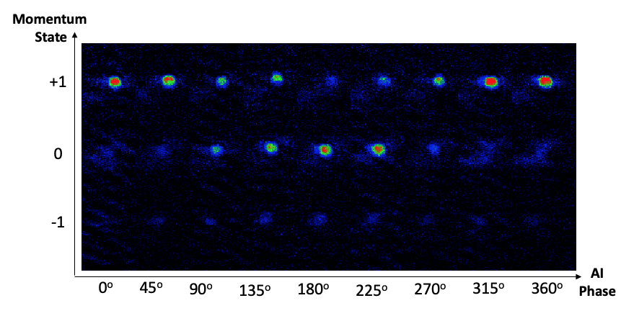
Figure 2: Data from CAL’s first atom interferometer fringe is shown. Here, three precisely timed laser pulses are used to split and recombine the atoms to conduct interferometry of the atomic matter-waves. The output momentum state of the atoms is varied between +1 and 0 (with some leakage to -1) by shifting the phase of the laser frequency during the third pulse.

The research was carried out at the Jet Propulsion Laboratory, California Institute of Technology, under a contract with the National Aeronautics and Space Administration (80NM0018D0004). Images courtesy of NASA/JPL-Caltech. Designed and built at JPL, Cold Atom Lab is sponsored by the Biological and Physical Sciences (BPS) Division of NASA's Science Mission Directorate at the Agency's headquarters in Washington DC and the International Space Station Program at NASA's Johnson Space Center in Houston, Texas.

Learn more about Cold Atom Lab at https://coldatomlab.jpl.nasa.gov/
Just how cold are the atoms in Cold Atom Lab? Find out at https://www.jpl.nasa.gov/news/news.php?feature=7311
To learn more about the Cold Atom Lab’s recent upgrade visit https://www.jpl.nasa.gov/news/news.php?feature=7660

