AGU 2020
Primary Author: Jenny Wood
Coauthors: Kaylin Bugbee, Jeanné le Roux, Camille Woods, Sam Ayers, Brad Baker, Emily
Foshee, Ankur Shah, Rahul Ramachandran
Session: Recent Advancements in Earth Science Data Discovery and Metadata Stewardship Practices
Session ID: IN035

Title: Automated Metadata Scoring Approaches for Earth Observation Data

Abstract: The Common Metadata Repository (CMR) contains metadata records describing NASA’s Earth observation data products which are archived across 12 data centers also known as Distributed Active Archive Centers (DAACs). To ensure that NASA’s data is discoverable, accessible, and usable, the Analysis and Review of CMR (ARC) Team, located at Marshall Space Flight Center, assesses the quality of these metadata records. The ARC team currently uses a combination of automated and manual methods to check metadata records for quality dimensions such as completeness, correctness, and consistency. In addition to these quality assessments, the team is currently exploring various metadata scoring methods in order to provide normalized results across the twelve DAACs. This method is conducted by using automated methods to assess metadata fields and then provide a numeric score, or grade, based on the analysis. To implement this process, two different approaches have been theorized and are currently being explored by the ARC team. This presentation will describe ARC's two proposed methodologies in more detail, and the pros and cons to using these metadata scoring methods.

Poster Content:

- Background Information

The Analysis and Review of the Common Metadata Repository (CMR) team, also known as ARC, performs quality assessments of metadata records that describe NASA's collection of over 8,000 Earth observation data products. A combination of automated and manual approaches are utilized to assess records for correctness, completeness, and consistency, in order to ensure that NASA's data is discoverable, accessible, and usable to end users. In support of this effort, the ARC team is currently exploring various metadata scoring methods as a means to provide a consistent, and ideally automated, quantitative metric of metadata quality. Two different metadata scoring approaches have been theorized and are currently being explored by the ARC team. This presentation describes the two approaches and offers preliminary results from testing each method on a subset of previously assessed metadata records.

- Techniques from Other Organizations
The ARC team began by reviewing techniques used by other organizations in order to draw inspiration for their own metadata scoring module. The team was most influenced by the following methods:

1. National Oceanic and Atmospheric Administration (NOAA)
- NOAA's Completeness Rubric V2 assesses metadata elements for completeness (Milan, 2017)
- Evaluates a mixture of required and conditional fields that align with 10 categories
- Each element gets a score of 0 or 1
- Results are displayed in a table (see image below) (NOAA, 2004)
- Total score is displayed as a percentage
- Operates on ISO metadata
- Standards were determined by the NOAA Metadata Working Group and evolved from Ted Habermann's first NOAA rubric (Milan, 2017)
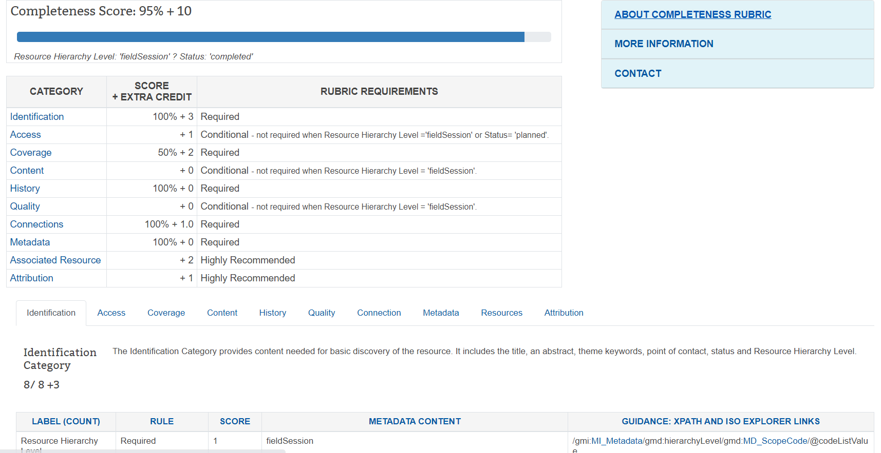
2. The Beyond Data Discovery: Shared Services for Community Metadata Improvement Project (MetaDIG) (Habermann, 2019)
- Automated checks for metadata completeness and metadata and data congruency aligning with 4 categories (Jones, 2016)
- Assesses a mixture of required and optional fields
- Each category is scored and expressed as a percentage
- A Metadata Quality report is provided including a hierarchy of messages: Passed, Warning, Failed, and Informational (see image below)
- Operates across dialects
- Collaboration among Data Observation Netword for Earth (DataONE), the HDF group, and the National Center for Ecological Analysis and Synthesis (Jones, 2016)
- Standards based on the FAIR principles

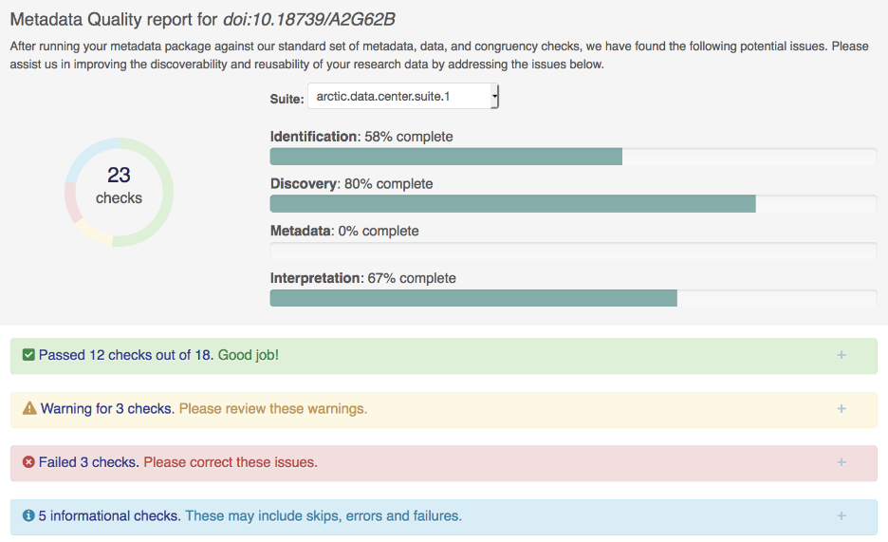

- Method 1: Integrate existing ARC metrics

ARC conducts metadata quality assessments using a tool called the CMR Metadata Curation Dashboard. Using the tool, the team evaluates each metadata element for correctness, completeness, and consistency. Each element is then assigned a color within the dashboard to show the priority of any findings.
In the team's first approach of metadata scoring, colors assigned within the dashboard are extracted using web scraping. Then, a score is calculated based on the extracted colors and displayed in a table.
The figure below illustrates ARC's priority matrix and the corresponding scoring method.
Priority Category | Justification | Points Earned
Red = High Priority Findings | High priority findings are concerned with completeness, accuracy and accessibility, and are required to be addressed by the data provider.  E.g. Broken data access links, outdated/incorrect information, use of invalid keywords, missing required fields | -1
Yellow = Medium Priority Findings | Medium priority findings emphasize consistency and completeness. It is strongly encouraged that these be addressed.  E.g. no link descriptions, inconsistent labeling of resources | 0
Blue = Low Priority Findings | Low priority findings include additional information that may be provided to make the metadata more robust or complete, but likely has minimal impact to the user experience.  E.g. updating links to https, providing spatial keywords | 0.75
Green = No findings | Elements flagged green are free of findings. Green flagged elements require no action on behalf of the data provider. | 1
Score calculation:
score = [(1g -1r + 0y + 0.75b) / T] *100
Variables:
g = number of green fields
r = number of red fields
y = number of yellow fields
b = number of blue fields
T = total number of fields
The advantages and disadvantages of using this method for metadata scoring are summarized in the chart below.
Advantages | Disadvantages
Uses existing ARC metrics | Since APIs currently do not exist in the CMR dashboard, this method relies on web scraping. If the site’s html changes, this could cause issues moving forward.
Operates across all CMR supported dialects | Relies heavily on the manual efforts of ARC team members
Output table provides record identifier and its associated metadata score | Output table does not indicate which fields are red, yellow, blue, etc., since the dashboard provides this type of detailed summary

The thumbnail below demonstrates the execution of the Method 1 script:
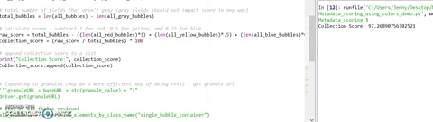

- Method 2: Applying the ‘Common Framework for Earth-Observation Data’
This approach is based on the "Common Framework for Earth-Observation Data", which was developed by the Committee on Environment, Natural Resources, and Sustainability of the National Science and Technology Council. This document outlines a set of suggested standards for data (Common Framework, 2016). It focuses on data management in the following categories:
- Data Search and Discovery Services
- Data-Access Services
- Data Documentation
- Compatible Formats and Vocabularies
In the team's second approach of metadata scoring, ARC restructured the categories as follows, combining 'Data Documentation' and 'Compatible Formats and Vocabularies' into one group 'Data Usability':
- Data Discovery
- Data Accessibility
- Data Usability
The team used the Common Framework standards to identify metadata elements that align with the restructured categories. Then, a series of automated checks were developed to perform on the metadata. These 15 checks are summarized in the table below.
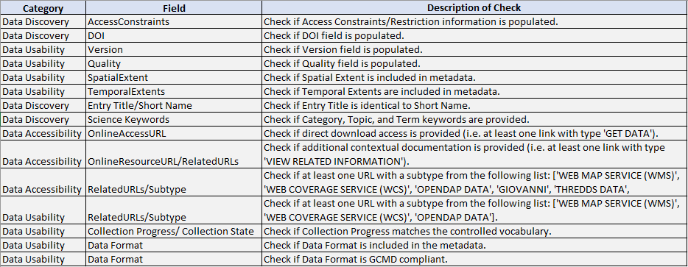
For each field that meets the criteria, 1 point is earned. Then, a score is calculated using the following method:
score = (s / 15) * 100
Variables:
s = sum of all points earned
Results are displayed in a spreadsheet with a summary report that provides record identifiers and their associated metadata scores. The spreadsheet also includes a detailed report for each record providing additional information on fields that passed or failed.
The advantages and disadvantages of using this method for metadata scoring are summarized in the chart below.
Advantages | Disadvantages
Fully automated | Does not score components that need a manual check (e.g. quality of abstract, accuracy of keywords, etc.)
Operates across all CMR supported dialects
Offers both a summary report (i.e. record id and its associated metadata score) and a detailed report for each record (i.e. fields that passed or failed)

The thumbnail below demonstrates the execution of the Method 2 script:
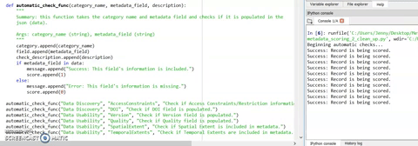

- Preliminary Results
Following ARC's initial assessment, metadata records are then updated and reevaluated. Metadata scoring provides an opportunity to show quantitative metrics for metadata quality improvement through this process. While the metadata scoring methods are an ongoing effort, the team was able to produce some preliminary results. ARC scored and averaged a subset of previously assessed metadata records across multiple data centers to produce the following results.

Method 1 Results:

As seen in the graph above, Method 1 produces an initial average score of 59%. Following updates based on ARC's initial assessment, the average score increased to 88%.

Method 2 Results:

The graph above illustrates that Method 2 produces an initial average score of 64%. Following updates based on ARC's initial assessment, the average score increased to 85%.
Both methods were tested on the same subset of metadata records, and they both show quantitative improvements in metadata quality, thus achieving the team's preliminary goal. Method 1 exhibits an increase of almost 30%, while Method 2 indicates an increase in nearly 20%. The differences in these two results originate from the way their respective scores are calculated. Method 1, for example, assesses all metadata elements within a record (which can sometimes include over 100 fields), and scores are weighted based on color composition. In contrast, Method 2 evaluates the same 15 fields for each metadata record, scoring elements as 0 or 1. Since this is an ongoing effort, further development and experimentation is necessary to accurately determine which method works best for the team's uses and NASA's broader metadata community.
- Next Steps
Although the team was able to produce some results, this experiment is still ongoing. A few items that ARC would like to explore moving forward are listed below:
- Currently, the scripts are only scoring collection-level (dataset-level) metadata records. ARC would like to expand these scoring methods to also assess granule-level (file-level) metadata records.
- Method 2 is providing a score of 0 or 1 for each element. In the future, the team would like to experiment with weighting scores for more important fields (i.e. abstract, data format, etc.)
- Method 1 relies on manual metadata reviews to produce a score. Moving forward, the team would like to experiment with machine learning to make the method more automated.

References:
1. Common Framework for Earth-Observation Data. (2016). Committee on Environment, Natural Resources, and Sustainability of the National Science and Technology Council. https://obamawhitehouse.archives.gov/sites/default/files/microsites/ostp/common_framework_for_earth_observation_data.pdf

2. Habermann, T. (2019, September 27). MetaDIG recommendations for FAIR DataCite metadata. DataCite. https://blog.datacite.org/metadig-recommendations-for-fair-datacite-metadata/

3. Jones, M. (2016, October 24). MetaDIG Engaging Scientists in the Improvement of Metadata and Data [PowerPoint slides]. figshare. https://figshare.com/articles/MetaDIG_Engaging_Scientists_in_the_Improvement_of_Metadata_and_Data/4055808

4. Milan, A. (2017, May 23). Assessing the Robustness of ISO with the NOAA Metadata Rubric [PowerPoint slides]. NOAA National Centers for Environmental Information. https://fgdc.gov/metadata/events/iso-metadata-summit-2017/noaametadatarubric-milanchristensen-2017isotools.pdf

5. NOAA. (2004). Completeness Rubric for: HEN04-2 from Newport, RI to Norfolk, VA on the USNS Henson along the Northeast US Atlantic continental margin from 2004-09-25 to 2004-10-21 [Rubric/Table]. NOAA National Centers for Environmental Information. https://data.noaa.gov/metaview/page?xml=NOAA/NESDIS/NGDC/MGG/Cruise/iso/xml/HEN04-2.xml&view=rubricv2/recordHTML&header=none

