ISEE System Technical Report

Darryl A.J. Minor
NASA Kennedy Space Center
Academic Major: Science & Mathematics Education PhD
Fall Internship
10/27/2020

Nomenclature
KSC = Kennedy Space Center
ISEE = Immersive Simulations and Engineering Environment
NASA = National Aeronautics and Space Administration
OTC = Over the Counter
GR = Growth Rate

Introduction
The Immersive Simulations and Engineering Environment (ISEE) Laboratory at Kennedy Space Center is a tool used to assist with operation simulation, for Human Factors operation activities, assisting future missions. The simulations created are important because they ensure that simulated operations are performed for customers, to assist with requirements. Simultaneously, each simulation will allow stakeholders to determine any and all risk associated with the Human Factors involved in a specific assignment. My internship consists of multiple project elements. The first of which, was to assist the Integrations branch chief in developing a growth rate algorithm proof. The integral part of this project, involved learning to powerup and perform the operational procedures of the ISEE lab, capturing and creating characters used in the CAD model virtual environment. In doing so, this led to use the software to model and 3D print screw cap structures for mock-up. The structures will be used to manipulate weight change out used in mock-up design and construction. These structures will also be used in future mock-up models constructed in the lab.
Objectives
In chronological order of completion, listed below are my objectives for the semester.
- Mathematical growth rate algorithm
  - Develop a growth rate algorithm and apply it to collected data.
  - Explain the growth rate formula, and how it’s derived.
  - Show transition steps from the current data to the presented data.
  - Explain reasoning behind new growth rate & proof conclusion.

- ISEE Operational Procedure
  - To develop an understanding, utilizing ISEE in NASA mission projects.
  - Learn how to use ISEE as a tool.
  - Know the physical layout of the environment in relation to ISEE operation software.
  - Learn how to operate and capture characters and objects

- Developing ISEE Weight Container
  - Design and create a weight structures utilizing free Over the Counter (OTC) software.
  - Develop instructional procedure.

Approach

After viewing the initial data set, I decided on a quantitative statistical approach. Finding averages spanning from 2011 – 2019 and comparing those averages to the current working data, a discrepancy was uncovered. The original task given was to derive a growth rate algorithm that can be applied across a given data set population. Starting with a basic statistical growth rate formula;
(Present – Past)/Past = GR
A growth rate (GR) is a rate at which a population has grown from the previous year.
Past = Any previous year’s population count
Present = The present population count
Using the above GR formula, across the previous ten years of data given,
- Per ethnic category, plug in your “present” data (which will remain constant). Then your “past” data will come from 2011. Solve for the GR.
- Average the GR over the past ten years per category.
- Compare your averages to the total number to receive accurate percentages.

The results determined that the current rate is flatlined between 4.8% & 5.2% while the other categories fluctuate regularly.

After noticing the flatline, we realized that a new growth rate formula must be derived to achieve optimum growth.
We then derived the formula below from the formula we used above.
Future = AHR(1+growth rate)
- Future = Future Rate
- AHR = Any Year’s Rate
Next we figured out a proper growth rate using awarded degree rate data.
Reasoning behind using awarded degree rates as the growth rate stands, because we want to grow based on the best qualified candidates. Also, a growth rate based on current awarded degree rates of graduates keeps rates from flatlining.
Once a new growth rate was achieved, we then went back over the years to determine how the growth should have looked across the given dataset.
We found that over the past ten years, with a proper growth rate algorithm to factor into the next year’s rate from the previous, the flatline disappeared. After reviewing the final data set, I shifted my approach to prove by contradiction. Beginning with a standard statistical growth rate algorithm, I derived a new growth rate based on the given variables. In applying the growth algorithm to the given data, it was proven that the branch chief’s current method was optimum.

2.
Procedural operations of the ISEE lab is not a small task, one mistake could cause the system to produce errors in the building of the virtual character. To begin, I first familiarized myself with the ISEE lab to learn the principles of its operation and how to maintain it. Key points of collaboration include human factors at KSC.
The ISEE lab operates a data pipeline composed of two main segments:

- a. Motion capture software and cameras observe reflective balls placed on a technician’s motion capture clothing and feed this data into motion capture software. The software constructs a cartesian location of each dot in the environment and labels them to create a skeleton. This skeleton is passed as an output into the next piece of software.

- b. Human simulation software- The position data from the skeleton is used to animate a virtual character that roughly replicates the geometry and mass of the technician. Computer aided design (CAD) models of spacecraft components required for an operation are loaded into the virtual environment as well. Using the location data of the technician’s head, a view of the virtual environment is rendered onto their VR helmet. As they perform operations in the environment, the software can analyze shear and compression stresses at various points on their body to ensure safety.

After diving into the software operational manuals of each system, I achieved the skills to perform virtual (virtual/virtual) operations as a technician and assist human factors and customers with their analysis.

3.
After assisting as a technician with human factors virtually, it was uncovered that there was a weakness of the ISEE models. Since each respective model is made of mostly wire, they are practically weightless. This discovery led to utilize software to model and 3D print screw cap structures.
The structures will be used to manipulate weight change out, used in mock-up design and construction. These containers will also be used in future mock-up models constructed in the lab.
To begin, I unacquainted myself with the given software to design a 3D model. After locating the software manual and tracking down the default keymap, I was able to familiarize myself with the operational keys and menu shortcuts.
Next I found video documentation on steps to create a screw and bolt on an older version of the software. With meticulous research and intuition, I developed the screw cap container along with detailed documentation on modeling within the system.
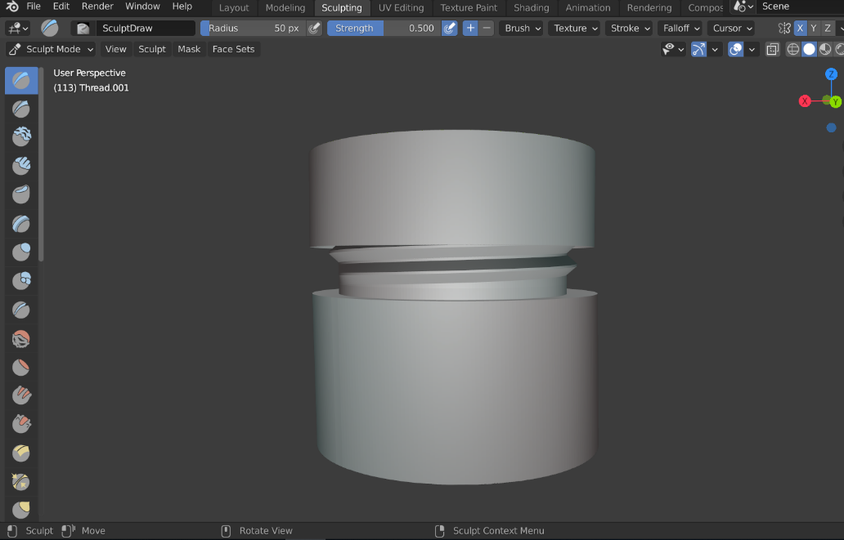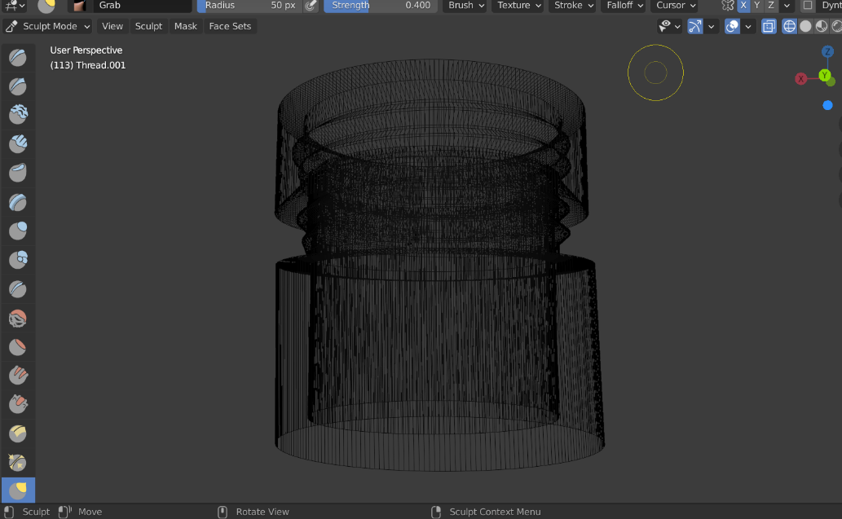
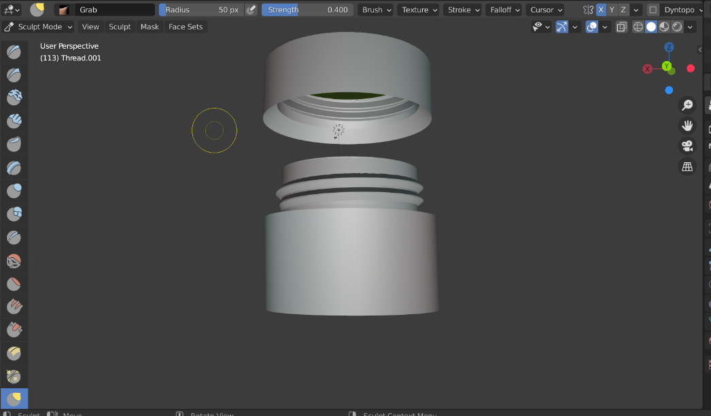
Conclusion
All in all, working with the EGS ISEE team was an intuitive, challenging, and priceless experience; in which I learned a great deal about both leadership and computer engineering. I want to express extreme appreciation for my mentor Deon Williams, Dr. Gena Henderson, the ISEE team, the KSC Education office, and NASA KSC for this amazing opportunity. I will be profoundly enhanced and forever grateful because of your guidance. Thank you

