Supplementary material

Quantification of the Land Surface and Brown Ocean Influence on Tropical Cyclone Intensification Over Land

Jinwoong Yoo¹, Joseph A. Santanello², Marshall Shepherd³, Sujay Kumar²,
Patricia Lawston¹, and Andrew M. Thomas³

- University of Maryland (ESSIC)/NASA Goddard Space Flight Center
- NASA Goddard Space Flight Center
- University of Georgia

The entire modeling framework of this study consists of two phases; 1) the physics and BC ensemble study and 2) the land/soil moisture perturbation experiments. Due to the page restrictions and to retain conciseness, the manuscript retains only the core parts of the land/soil moisture perturbation experiments. To complement the manuscript, specific motivating questions for the NU-WRF/WRF model simulation experiment design (see Table 5) are addressed here. Also, this supplementary material contains descriptions of extra data sets that were examined for the study as well as the results of the first phase of the experiment: the physics and BC ensemble study.
- Motivating questions for the NU-WRF/WRF model simulation experiment
- Physics and BC ensemble Experiments. Determine Optimal NU-WRF Physics for TS Kelvin Case Study
- Comparison of default WRF tropical vs. NU-WRF physics; Tropical vs. Control
Results of a model simulation of TCs can be influenced by many factors that construct each simulation such as Initial Conditions (ICs), Boundary Conditions (BCs), model physics, sea surface temperature (SST) update options, number of vertical model layers, as well as the choice of coupled model components such as land surface models (LSMs). To address the impacts of the IC/BC datasets on the TC Kelvin hindcast, three global (re)analysis data were utilized in the WRF simulations: GDAS, MERRA2, and ERA-I (Table S1).
In the physics and BC ensemble study, the main purposes are trifold: 1) the comparison of the NU-WRF physics against the community WRF model physics settings for tropical simulations; 2) the assessment of the impact of LIS spinup and online coupling to the WRF atmospheric model; and 3) the evaluation of the IC/BC datasets for the case study of TC Kelvin. Therefore, for example, the comparison of #1 Control vs. #2 Tropical, #5 noLIS vs. #6 Tropical_noLIS, as well #7 ERAI vs. #8 ERAI_Tropical can address the differences between the NU-WRF and the WRF tropical physics options. At the same time, the performance of the LIS spinup can be evaluated using #1 Control vs. #2 Tropical, and #5 noLIS vs. #6 Tropical_noLIS. In addition, comparing #1 Control to #3 M2, #4 M2G and #7 ERAI simulations will yield insight as to the impact of IC/BC data.
- Determination of specific NU-WRF physics impacts; MP vs. Rad vs. LIS vs. All
In Part II of the physics and BC ensemble study, the key question is which Goddard physics options are most influential on storm track when they are compared to the community WRF tropical physics suite. This question is important because the understanding of the sensitivity of physics schemes can shed light on which factors should be closely examined in the next phase of the experiment. For the sensitivity tests, each physics option(s) in the community WRF tropical physics schemes is replaced by each corresponding Goddard physics option(s) (one physics option per experiment to isolate the effects), and their performance is compared to #6 Tropical_noLIS. The GDAS data is used for the IC/BCs in these experiments. The five cases include #9 MP case where only the WSM6 microphysics option from the WRF tropical suite was replaced by the Goddard 4ICE scheme; #10 Rad case where only the RRTMG shortwave and longwave radiation scheme from the WRF tropical suite were replaced by the Goddard 2017 radiation scheme; #11 PBLSFC case where only the YSU PBL option and the MM5 similarity surface parameterization from the WRF tropical suite were replaced by the MYNN2 scheme; #12 Rad3ICE case where both the microphysics scheme and the radiation option from the WRF tropical suite were replaced by the Goddard 3ICE microphysics scheme and the Goddard 2017 radiation scheme; and #13 Rad4ICE case where both the microphysics scheme and the radiation option from the WRF tropical suite were replaced by the Goddard 4ICE microphysics scheme and the Goddard 2017 radiation scheme (Table S1).
- Land/soil moisture perturbation experiments
In the land/soil moisture perturbation experiments of our study, the authors explore the storm sensitivity to variations in modelling components such as soil moisture, soil texture, model physics, and surface latent/heat flux. Variations in soil moisture condition range from extreme (no latent heat flux; #18 LHzero, no sensible heat flux; #19 SHFzero), to pseudo-climatological dry and wet (#15 SMdry and #14 SMwet), to fully saturated at soil type’s maximum (#16 SMsat), to a quasi-aqua planet condition (#17 SMaqua). Three different soil texture configurations are compared using the NCEP/FAO soil texture (#1 Control), the ISRIC soil texture (#22 ISRIC) and a constant soil texture of clay over land (#21 Clay). These permutations of surface moisture, moisture fluxes, and soil type were designed to isolate and control for the specific impacts of the land surface conditions on TC track and intensity.
- Impact of initial soil moisture; Control vs. SMdry, SMwet vs. SMdrytropic, SMwettropic
For the pseudo-climatological dry and wet cases, the 5-year LIS spinup result driven by the GDAS data is used to determine the dates and times of the driest and wettest soil moisture contents, respectively, in the top soil layer of the Noah land surface model. Due to the 5-year spinup period these minimum and maximum soil moisture values may not represent the full spectrum of soil moisture range over the simulation domain region. However, it is assumed that their departures from the real climatology should not be severe as to nullify the experiment design and they would represent climatologically wet and dry values. For the pseudo-climatological dry (#15 SMdry) and wet (#14 SMwet) cases, only soil moisture values for the entire four soil layers are “transplanted” from the driest and wettest time stamps of the LIS spinup results, respectively, for the NU-WRF model initialization for each case while the soil temperature values are remained intact from the LIS spinup. The driest and wettest time stamps in the LIS spinup are 6 September, 2017 at 12 UTC and 8 February, 2017 at 18 UTC, respectively. In addition, the same soil moisture settings of the #15 SMdry and the #14 SMwet cases are applied with the WRF tropical physics suite for #24 SMdrytropic and #23 SMwettropic experiments to test the model sensitivity to the model physics options under the changed soil moisture conditions.
- Impact of latent heat flux; Control vs. LHzero, SHFzero, and LSHFzero
Extreme cases of a) no latent heat flux, b) no sensible heat flux, and c) no latent and sensible heat fluxes from land surface are included in our WRF-LIS coupled simulations. These cases are realized by suppressing each flux to zero only over the land within the NU-WRF model code while these fluxes from the ocean allowed. The result can provide a good and clear estimate of the land surface flux contributions to the post-landfall TC intensity change as well as its track. Regardless of the modification, the land surface model maintains the latent/sensible heat flux(es) accounted continuously for its soil layer energy balance, minimizing the impact for the subsurface layer energy balance.
3) Impact of saturated/inundated soil; Control vs. SMsat, SMaqua
As another extreme cases, both saturated soil surface and inundated land surface are imagined, where soil moisture in the entire column is modified to be a fixed value either at their maximum saturated value which is determined by each soil type for the saturated soil cases (#16 SMsat) or at 1 for the inundated land surface case (#17 SMaqua). These soil moistures are fixed/replaced through the entire simulation period of 4 days. SMsat is considered as a potential maximum soil moisture availability with the limiting factor of soil type and porosity. Similarly, SMaqua represents a quasi-aqua planet condition where unlimited amount of soil moisture is available for evaporation. Note that the topography of the model domain, however, remains the same as control, and thus is not a full aqua planet representation in that only the moisture component is accounted for, while the land itself remains fixed. These SMaqua setting may be able to address flooded land surface conditions and/or standing water, which also occurred during TC Kelvin.
- Impact of soil texture; Control vs. ISRIC, Clay
It is also interesting to test the model sensitivity to the soil texture options since previous studies (e.g., Emanuel et al. 2008) speculated that the hot sandy soil in the northern Australia yielded latent heat fluxes large enough to sustain the “agukabams” when soil moisture condition is met. The global hybrid STATSGO/FAO soil texture map by NCAR (in spatial grid resolutions of 30-second for CONUS and 5-minute elsewhere; https://ral.ucar.edu/solutions/products/wrf-noah-noah-mp-modeling-system) is the default soil texture option within the NU-WRF (including WRF and LIS). Optionally, LIS provides the International Soil Reference and Information Center (ISRIC) soil texture data at 250 m grid resolution (Hengl et al. 2015, 2017), which is used for #22 ISRIC experiment. LIS users can also choose a constant value for soil texture over land. Since sandy-like soil texture is prevalent over the model simulation domain in the two soil texture datasets provided, the constant soil texture of clay (#21 Clay) is selected for the comparison purpose (Figure 2). For the #21 Clay and #22 ISRIC experiments, 5-year LIS spinups were conducted separately using the GDAS data as the meteorological forcing with the ISRIC soil texture data and with the constant soil texture of clay, respectively.

- Additional observation datasets
In addition to the Kelvin’s track data from the BoM, a few other track observation datasets were compared in this study for the reference of our model simulations. The latest version of the International Best Track Archive for Climate Stewardship (IBTrACS) data were obtained (Knapp et al. 2010; Xu et al. 2017), which contains records only from 06 UTC 16 February to 00 UTC 18 February, 2018 (Fig. S1). Table S2 shows that while the pressure and track records generally agree well, the maximum wind speed by the BoM was underestimated compared to wind speed estimates from both IBTrACS and the Cooperative Institute for Meteorological Satellite Studies (CIMSS) TC satellite analysis dataset (SATCON Wind; Fig. S1b; Table S2; Herndon et al. 2018; http://tropic.ssec.wisc.edu/real-time/satcon/archive/2018/201810S.html). The Digital Dvorak intensity estimate (Dvorak 1984) of TC Kelvin and its associated intensity warning time series agree well with the storm intensity trend of the CIMSS TC SATCON dataset (see http://rammb.cira.colostate.edu/products/tc_realtime/products/storms/2018SH10/DGTLDVOR/2018SH10_DGTLDVOR_201802180000.GIF). This discrepancy between the BoM and the IBTrACS can be partly due to the difference in the wind speed average method using 10-minute average winds employed by the BoM and 1-minute average winds by Joint Typhoon Warning Center (JTWC) which the IBTrACS adopted for Kelvin (Thompson 2018).
Regardless of these relative differences in the magnitude of wind speed, the temporal trend and signal of post-landfall intensification are consistent across all these estimates, which is the focus of this study. Thus, the BoM storm track data was used in this study because only this data provides the storm track and intensity records even after the landfall of Kelvin. The relative underestimates of storm intensity in the BoM data was accounted for by referring to those in the IBTrACS and the initial version of the CIMSS TC SATCON dataset when analyzing modeling results.
Figure S2 shows 16 km grid resolution microwave-based Total Precipitable Water (TPW) composite imagery (combining the information from three Advanced Microwave Sounding Units (AMSU) on NOAA satellites and five Special Sensor Microwave Imagers (SSMI) on Department of Defense satellites) over Australia and Southeast Asia during the TC Kelvin at 194735 UTC 17 February (top) and at 104255 UTC 18 February (bottom). These remote-sensed imagery of TPW resemble very closely the distributions of TCW in the ERA5 reanalysis dataset in Figure 6, confirming the location of the ITCZ by the equatorial band of high TPW.

- Results of the first phase of the experiment: the physics and BC ensemble study.
1. Sensitivity of TC Kelvin to Model Physics, Initialization, and Boundary Conditions
The physics and BC ensemble experiments were designed to determine optimal combinations of model physics and IC/BC to establish a control run for the main BO experiment. Before exploring the BO effect, addressed here briefly are results of our physics and BC ensemble experiments which include the simulation cases of Control, Control_noLIS, Tropical, Tropical_noLIS, M2, M2G, ERAI, and ERAI_Tropical (Refer to Table S1 Part I for their physics options). As can be seen in Fig. S3, the NU-WRF physics performed better than the community WRF model’s tropical suite physics settings in reproducing both storm track and intensity. The WRF tropical suite physics options (i.e., Tropical and Tropical_noLIS) yielded larger track errors (90.1 and 92.1 km, respectively) compared to the counterpart, NU-WRF physics (i.e., Control and Control_noLIS) with 43.2 and 51.6 km, respectively. Also, with the exception of ERAI_Tropical, the WRF tropical suite cases (i.e., Tropical and Tropical_noLIS) did not reproduce the main intensification near the landfall during the night of 17 February (Fig. S3b). Landfall timings were closely related to the poor intensity forecasts of these cases: Tropical and Tropical_noLIS made early landfall (about 9 hours earlier than the observation record) compared to others (see red dots marked for landfall times in Fig. S3b). It is notable that Control, Tropical and Tropical_noLIS presented the signature of the second intensification inland on 19 February.
The impacts of the LIS spinup and coupling were not significant in this analysis. The simulations of Control_noLIS and Tropical_noLIS were driven by the GDAS (i.e., GFS FNL) general circulation model (GCM) data, and they are not coupled with LIS. However, they produced similar track and intensity trends compared to their counterparts, Control and Tropical, respectively. It is considered that the GDAS data demonstrates suitable performance in managing the hydrothermal conditions of the soil layers via the default Noah LSM within the GCM (Ek et al. 2003) since there was not a large deviation in initial soil moisture from the coarse global analysis versus the high resolution LSM spinup for this particular location and date.
The evaluation of IC/BC data from MERRA2, GDAS, and ERA-I revealed that the GDAS was the best suited for the TC Kelvin case. The MERRA2 simulations (i.e., M2 and M2G) had some issues with dynamics and errors in storm center location at the initial time of the simulation (see Fig. S3a), which produced quite significant track and intensity errors from the early stages. On the other hand, the simulated storms driven by the ERA-I dataset (i.e., ERAI and ERAI_Tropical) made too slow translations compared to both observations and the other simulations, resulting in delayed landfalls that were about 8 hours later than the observation record (Fig. S3b) and much slower moving storms that did not penetrate far enough inland by the end of simulation at 00 UTC on 20 February (Fig. S3a). In contrast, the GDAS-driven NU-WRF physics simulations (i.e., Control and Control_noLIS) produced fairly consistent results with observations both in the storm track and intensity.
Five additional simulations were conducted in the physics and BC ensemble experiment to isolate the impacts of the Goddard physics options on TC track and intensity compared to the WRF tropical suite (i.e., Tropical_noLIS). They include the simulation cases of MP, Rad, PBLSFC, Rad3ICE, and Rad4ICE (Refer to Table S1 Part II for their physics options and supplementary material for the details). The mean track errors were 58 km for MP, 94.9 km for Rad, 107.8 km for PBLSFC, 28.7 km for Rad3ICE, and 40.2 km for Rad4ICE. From this result, it can be inferred that the Goddard 4ICE microphysics scheme, the Goddard 2017 radiation scheme, and the MYNN2 PBL-SFC scheme impacted TC track accuracy most in that order, and that the combination of the Goddard 4ICE microphysics scheme and the Goddard 2017 radiation scheme explains most of the improvement of the NU-WRF physics scheme over the WRF tropical suite. For the intensity forecast, the Rad and the PBLSFC did not reproduce the main intensification of the Kelvin near its landfall similar to the Tropical_noLIS, while all the cases with the Goddard 4ICE or 3ICE microphysics scheme were able to reproduce it. Interestingly, the Rad and the PBLSFC made very early landfalls, similar to Tropical_noLIS, more than 9 hours earlier compared to the observation while others (i.e., MP, Rad3ICE, and Rad4ICE) made their landfall only slightly earlier (i.e., less than 6 hours) than the observation record (see also red dots in Figure S4b). Therefore, it is concluded that the Goddard 4ICE (or 3ICE) microphysics scheme plays the most critical role in realistic simulations of landfalling TC Kelvin. It is speculated that the Goddard 4ICE microphysics including hail, which improves the simulation of the fall velocities of frozen condensates, may have resulted in the better performance over the WSM6 microphysics scheme without the hail processes (Hong and Lim 2006; Van Weverberg et al. 2013; Lang et al. 2014). As such, the most optimal combination of driving data and physics is the GDAS IC/BC data with NU-WRF physics. The control run uses these options plus initialization with LIS spin up and LIS coupling. Although LIS had only a marginal impact on performance in the physics and BC ensemble experiments, LIS is used as a component of the modeling framework since LIS offers many advanced methods such as soil moisture data assimilation for our future study.

References
Dvorak, V., 1984: Tropical cyclone intensity analysis using satellite data. NOAA Technical Report NESDIS 11, 47 pp. [Available from NOAA/NESDIS, 5200 Auth Rd. Washington DC, 20233].
Ek, M. B., K. E. Mitchell, Y. Lin, E. Rogers, P. Grummann, V. Koren, G. Gayno, and J. D. Tarplay, 2003: Implementation of the Noah land-use model advances in the NCEP operational mesoscale Eta model. J. Geophys. Res., 108, 8851, https://doi.org/10.1029/2002JD003296.
Emanuel, K. E., J. Callaghan and P. Otto, 2008: A Hypothesis for the Redevelopment of Warm-Core Cyclones over Northern Australia. Mon. Wea. Rev., 136, 3863-3872.
Hengl T., G. B. M. Heuvelink, B. Kempen, J. G. B. Leenaars, M. G. Walsh, K. D. Shepherd, et al., 2015: Mapping Soil Properties of Africa at 250 m Resolution: Random Forests Significantly Improve Current Predictions. PLoS ONE, 10(6): e0125814. doi:10.1371/journal.pone.0125814
———, J. Mendes de Jesus, G. B. M. Heuvelink, M. Ruiperez, M. Kilibarda, A. Blagotic, et al., 2017: SoilGrids250m: Global gridded soil information based on machine learning. PLoS ONE, 12(2): e0169748. doi:10.1371/journal.pone.0169748.
Herndon, Derrick and C. S., Velden, An update on the CIMSS SATellite CONsensus (SATCON) tropical cyclone intensity algorithm. Conference on Hurricanes and Tropical Meteorology, 33rd, Ponte Vedra, FL, 16-20 April 2018. Boston, MA, American Meteorological Society, 2018, Abstract 284.
Hong, S. and J. Lim, 2006: The WRF Single-Moment 6-Class Microphysics Scheme (WSM6). J. Korean Meteo. Soc., 42, 129-151.
Knapp, K. R., M. C. Kruk, D. H. Levinson, H. J. Diamond, and C. J. Neumann, 2010: The International Best Track Archive for Climate Stewardship (IBTrACS): Unifying tropical cyclone best track data. Bull. Amer. Meteor. Soc., 91, 363–376.
Lang, S., W.‐K. Tao, J.‐D. Chern, D. Wu, and X. Li, 2014: Benefits of a 4th ice class in the simulated radar reflectivities of convective systems using a bulk microphysics scheme, J. Atmos. Sci., 71, 3583-3612.
Thompson, D. 2018: You’ve probably not heard of the Brown Ocean Effect – until now. WeatherOps, https://blog.weatherops.com/youve-probably-not-heard-of-the-brown-ocean-effect-until-now (Accessed August 12, 2019).
Van Weverberg, K., and Coauthors, 2013: The role of cloud microphysics parameterization in the simulation of mesoscale convective system clouds and precipitation in the tropical western Pacific. J. Atmos. Sci., 70, 1104–1128, doi:https://doi.org/10.1175/JAS-D-12-0104.1.
Xu, G., T. J. Osborn, and A. J. Matthews, 2017: Moisture transport by Atlantic tropical cyclones onto the North American continent. Clim. Dyn. 48, 3161–3182. doi: 10.1007/s00382-016-3257-6.

Figures

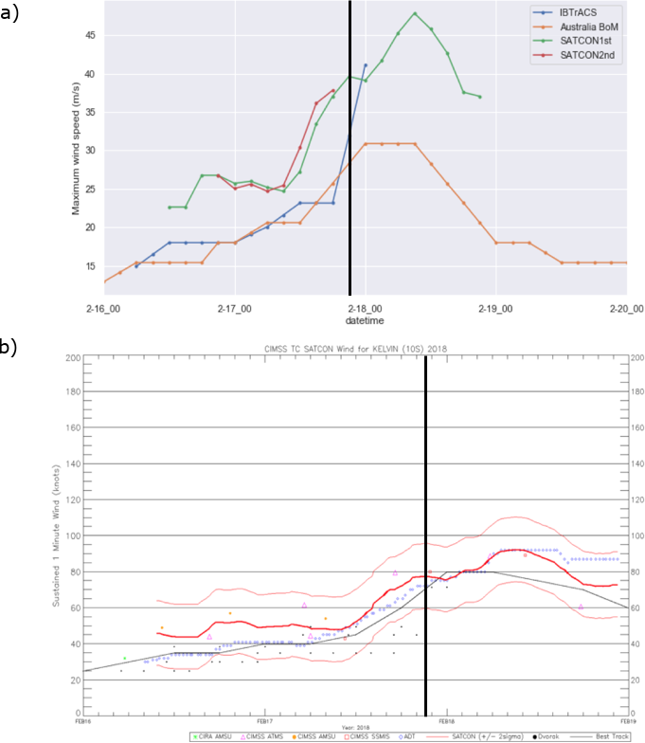

Figure S1. a) Maximum wind speed [m/s] of TC Kelvin from IBTrACS, Australian Bureau of Meteorology (BoM), and the CIMSS tropical cyclone intensity consensus (SATCON) by multiple satellites which is shown in (b) (Source: http://tropic.ssec.wisc.edu/real-time/satcon/archive/2018/201810S.html).. Note that missing data in the 3-hourly data in the Australian BoM dataset was filled with the linear interpolation method using the 6 hourly data. Also note that the 3 hourly SATCON 1st data in a) was reconstructed using the mean values of the SATCON data in b) while the 3 hourly SATCON 2nd data in a) was constructed by interpolating the SATCON history file that was obtained from the SATCON data archive webpage at http://tropic.ssec.wisc.edu/real-time/satcon/archive/2018/201810S.html. Black vertical line in each panel represents the landfall time at February 17 at 21 UTC.

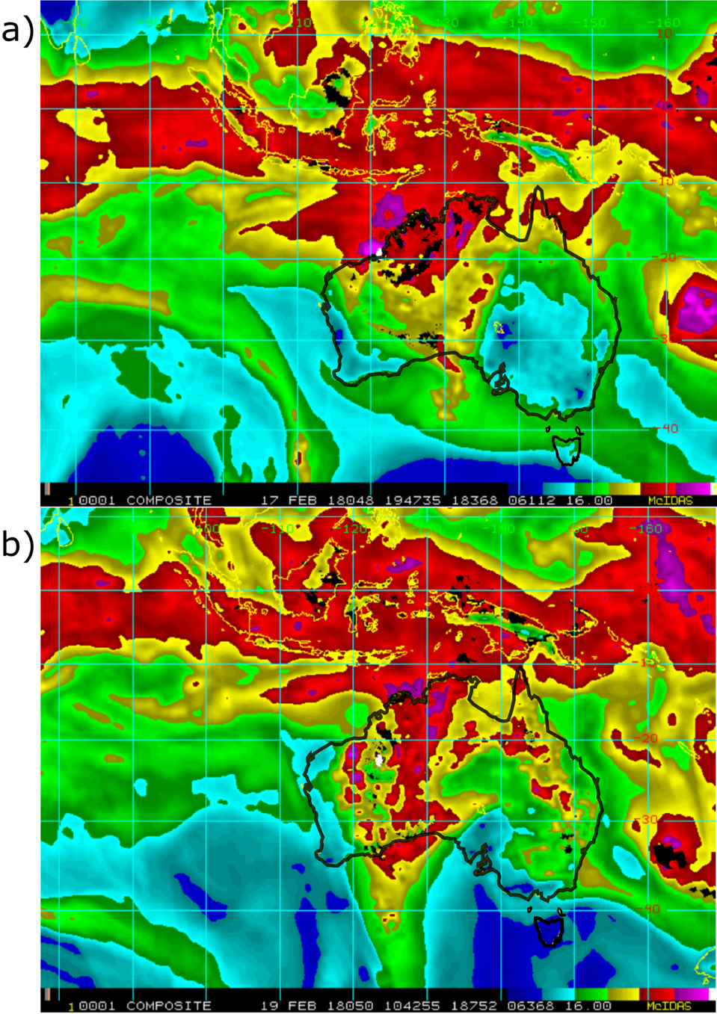

Figure S2. 16 km microwave-based Total Precipitable Water (TPW) composite imagery (combining the information from three Advanced Microwave Sounding Units (AMSU) on NOAA satellites and five Spectral Sensor Microwave Imagers (SSMI) on Department of Defense satellites) of TC Kelvin on February 17 at 194735 UTC (top) and February 19 at 104255 UTC (bottom) (image from http://rammb.cira.colostate.edu/products/tc_realtime/archive.asp?product=16kmtpwp&storm_identifier=SH102018).

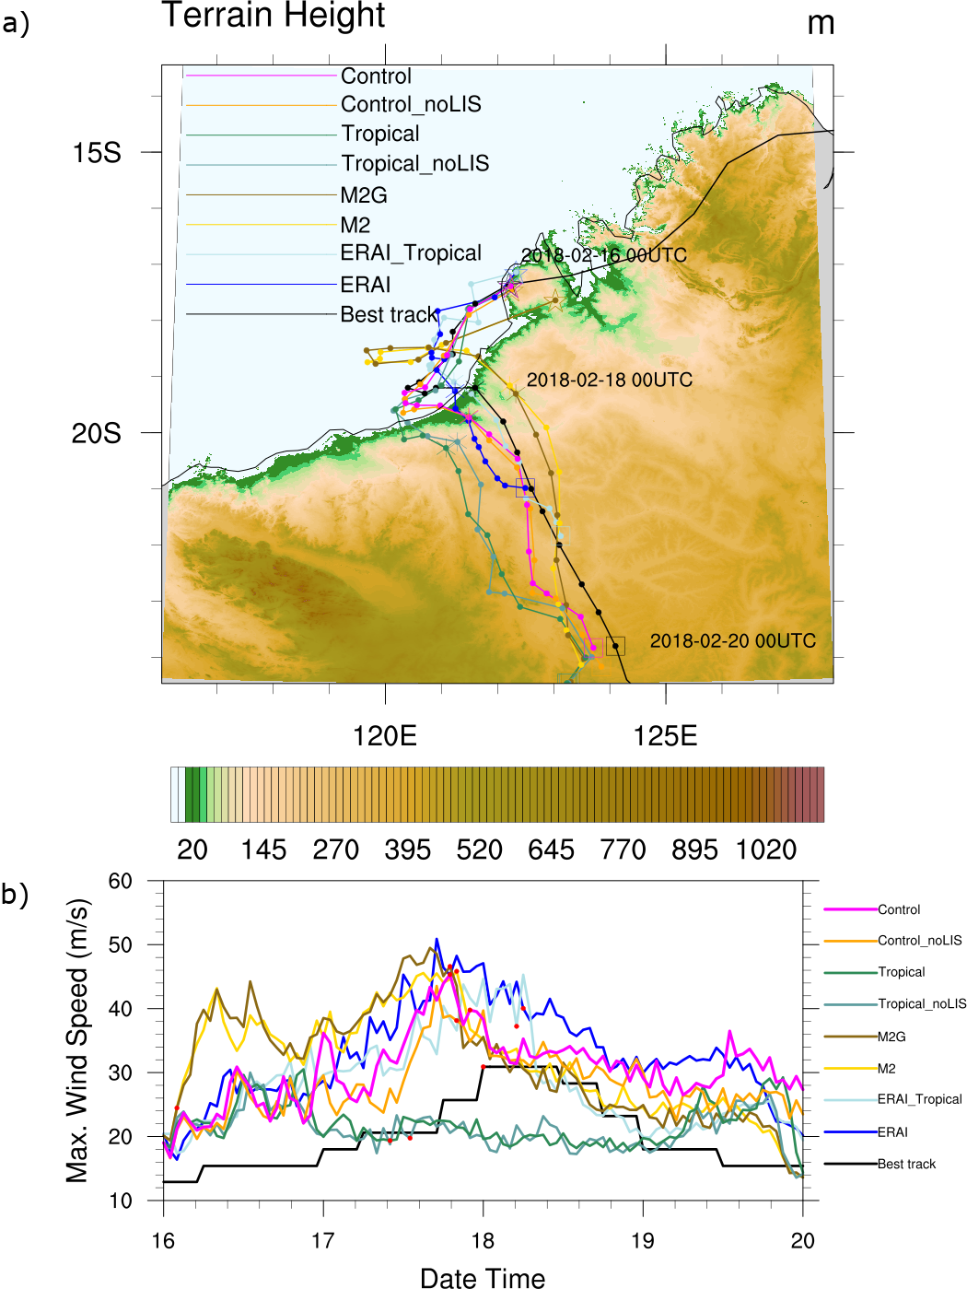

Figure S3. a) 6-hourly track analysis composite of TC Kelvin simulations in the physics and BC ensemble study Part I, b) Hourly maximum wind speed analysis composite of TC Kelvin simulations in the physics and BC ensemble study Part I (Refer to Table S1). Labels in legend are consistent with simulation IDs in Table S1. Black line represents the observed track of Kelvin by the Australian Bureau of Meteorology (here, labelled as “Best track”). Storm’s 6-hourly center locations were plotted with filled circles only for the simulation period (February 16-20, 2018). The initial (final) locations of the simulated storm centers are marked with stars (squares) along with their annotations for the times. Red dots represent the time when the storm moved from ocean to land (i.e., landfall).

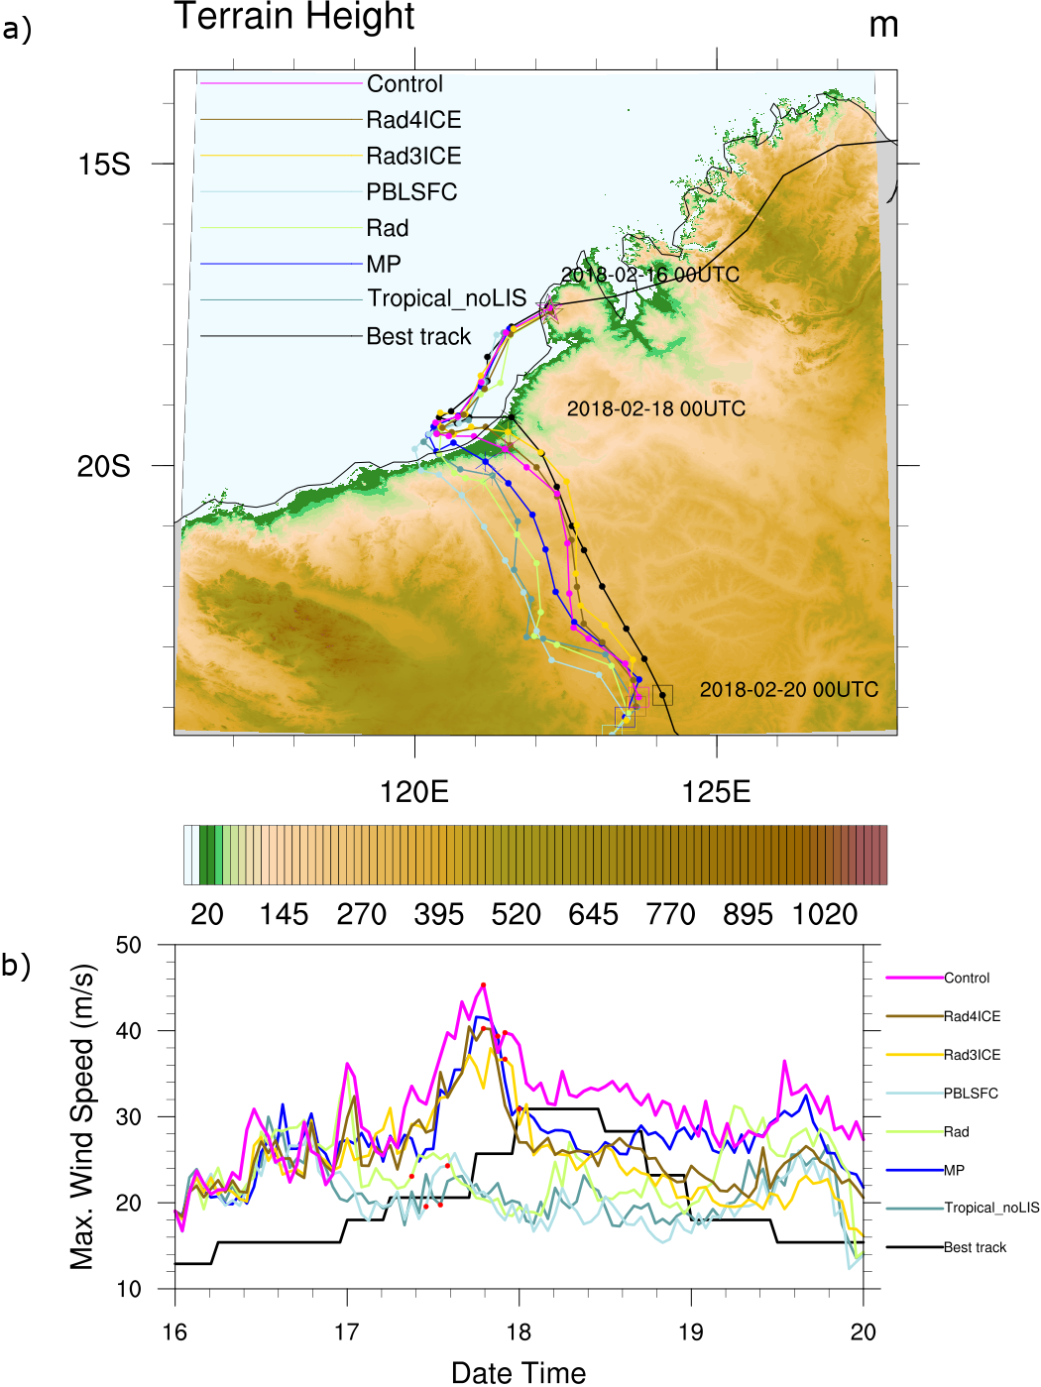

Figure S4. As in Figure S3 but for Part II in the physics and BC ensemble study. Note that the #1 Control case is also plotted for the reference while the #6 Tropical_noLIS is playing the role of the “control” to the other cases in Part II.

Tables
Table S1. NU-WRF model experiment configurations for physics and BC ensemble study (Part I and II) and the land/soil moisture perturbation experiments
Physics and BC ensemble Experiment Part I. Comparison of NU-WRF physics vs. default WRF tropical suite: Control vs. Tropical
# | Simulation ID | Simulation Composition Name | IC/BC | Spinup (Forcing) | Physics | mp | radiation | pbl | sfclay | surface
1 | Control | NUWRF(GDAS)-LIS(GDAS) | GDAS | LIS(GDAS) | NUWRF | Goddard 4ICE | Goddard 2017 | MYNN2 | MYNN2 | Noah3.6
2 | Tropical | WRF(GDAS)-LIS(GDAS) | GDAS | LIS(GDAS) | WRF-Tropical | WSM6 | RRTMG | YSU | MM5 Simil. | Noah3.6
3 | M2 | NUWRF(MERRA2)-LIS(MERRA2) | MERRA2 | LIS(MERRA2) | NUWRF | Goddard 4ICE | Goddard 2017 | MYNN2 | MYNN2 | Noah3.6
4 | M2G | NUWRF(MERRA2)-LIS(GDAS) | MERRA2 | LIS(GDAS) | NUWRF | Goddard 4ICE | Goddard 2017 | MYNN2 | MYNN2 | Noah3.6
5 | Control_noLIS | NUWRF(GDAS) | GDAS | N/A | NUWRF | Goddard 4ICE | Goddard 2017 | MYNN2 | MYNN2 | Noah3.6
6 | Tropical_noLIS | WRF(GDAS) | GDAS | N/A | WRF-Tropical | WSM6 | RRTMG | YSU | MM5 Simil. | Noah
7 | ERAI | NUWRF(ERA-I) | ERA-I | N/A | NUWRF | Goddard 4ICE | Goddard 2017 | MYNN2 | MYNN2 | Noah
8 | ERAI_Tropical | WRF(ERA-I) | ERA-I | N/A | WRF-Tropical | WSM6 | RRTMG | YSU | MM5 Simil. | Noah
Physics and BC ensemble Experiment Part II. Goddard Physics Option Sensitivity Simulation
# | Simulation ID | Physics Sensitivity Simulation Composition Name | IC/BC | Spinup (Forcing) | Physics | mp | radiation | pbl | sfclay | surface
6 | Tropical_noLIS | WRF(GDAS) | GDAS | N/A | WRF-Tropical | WSM6 | RRTMG | YSU | MM5 Simil. | Noah
9 | MP | WRF(GDAS)_Goddard-4ICE | GDAS | N/A | hybrid | Goddard 4ICE | RRTMG | YSU | MM5 Simil. | Noah
10 | Rad | WRF(GDAS)_Goddard-2017 | GDAS | N/A | hybrid | WSM6 | Goddard 2017 | YSU | MM5 Simil. | Noah
11 | PBLSFC | WRF(GDAS)_MYNN2 | GDAS | N/A | hybrid | WSM6 | RRTMG | MYNN2 | MYNN2 | Noah
12 | Rad3ICE | WRF(GDAS)_Goddard-2017/3ICE | GDAS | N/A | hybrid | Goddard 3ICE | Goddard 2017 | YSU | MM5 Simil. | Noah
13 | Rad4ICE | WRF(GDAS)_Goddard-2017/4ICE | GDAS | N/A | hybrid | Goddard 4ICE | Goddard 2017 | YSU | MM5 Simil. | Noah
Land/soil moisture perturbation experiments. Storm sensitivity to land surface fluxes by soil moisture, soil texture, surface flux settings
# | Simulation ID | Soil Moisture Sensitivity Simulation Composition Name | IC/BC | Spinup (Forcing) | Physics | mp | radiation | pbl | sfclay | surface
1 | Control | NUWRF(GDAS)-LIS(GDAS) | GDAS | LIS(GDAS) | NUWRF | Goddard 4ICE | Goddard 2017 | MYNN2 | MYNN2 | Noah3.6
14 | SMwet | NUWRF(GDAS)-LIS(GDAS)-WET | GDAS | Max_Climatology | NUWRF | Goddard 4ICE | Goddard 2017 | MYNN2 | MYNN2 | Noah3.6
15 | SMdry | NUWRF(GDAS)-LIS(GDAS)-DRY | GDAS | Min_Climatology | NUWRF | Goddard 4ICE | Goddard 2017 | MYNN2 | MYNN2 | Noah3.6
16 | SMsat | NUWRF(GDAS)-LIS(GDAS)-Saturated | GDAS | LIS(GDAS) | NUWRF | Goddard 4ICE | Goddard 2017 | MYNN2 | MYNN2 | Noah3.6
17 | SMaqua | NUWRF(GDAS)-LIS(GDAS)-aqua | GDAS | LIS(GDAS) | NUWRF | Goddard 4ICE | Goddard 2017 | MYNN2 | MYNN2 | Noah3.6
18 | LHzero | NUWRF(GDAS)-LIS(GDAS)-NoLHF | GDAS | LIS(GDAS) | NUWRF | Goddard 4ICE | Goddard 2017 | MYNN2 | MYNN2 | Noah3.6
19 | SHFzero | NUWRF(GDAS)-LIS(GDAS)-NoSHF | GDAS | LIS(GDAS) | NUWRF | Goddard 4ICE | Goddard 2017 | MYNN2 | MYNN2 | Noah3.6
20 | LSHFzero | NUWRF(GDAS)-LIS(GDAS)-NoLHF-NoSHF | GDAS | LIS(GDAS) | NUWRF | Goddard 4ICE | Goddard 2017 | MYNN2 | MYNN2 | Noah3.6
21 | Clay | NUWRF(GDAS)-LIS(GDAS)-All_Clay | GDAS | LIS(GDAS) | NUWRF | Goddard 4ICE | Goddard 2017 | MYNN2 | MYNN2 | Noah3.6
22 | ISRIC | NUWRF(GDAS)-LIS(GDAS)-ISRIC_Soil_Texture | GDAS | LIS(GDAS) | NUWRF | Goddard 4ICE | Goddard 2017 | MYNN2 | MYNN2 | Noah3.6
23 | SMwettropic | WRF(GDAS)-LIS(GDAS)-WET | GDAS | Max_Climatology | WRF-Tropical | WSM6 | RRTMG | YSU | MM5 Simil. | Noah3.6
24 | SMdrytropic | WRF(GDAS)-LIS(GDAS)-DRY | GDAS | Min_Climatology | WRF-Tropical | WSM6 | RRTMG | YSU | MM5 Simil. | Noah3.6

Table S2. Storm intensity record comparison among the observations by Australia, IBTrACS (USA), and CIMSS TC SATCON
Date Time | Australia  PRESSURE  [mb] | IBTrACS PRESSURE [mb] | PRESSURE US/Aus  [%] | Australia WIND  [m/s] | Australia  WIND  [kts] | IBTrACS  WIND  [kts] | WIND  Aus/US  [%] | WIND  US/Aus  [%] | CIMSS TC SATCON  Initial  [kts] | CIMSS TC SATCON Final  [kts]
2/16/18 0:00 | 999 |  |  | 12.9 | 25.08
2/16/18 6:00 | 998 | 1004 | 100.60 | 15.4 | 29.94 | 29 | 103.22 | 96.88
2/16/18 12:00 | 995 | 1000 | 100.50 | 15.4 | 29.94 | 35 | 85.53 | 116.92 | 44
2/16/18 18:00 | 995 | 998 | 100.30 | 15.4 | 29.94 | 35 | 85.53 | 116.92 | 52
2/17/18 0:00 | 994 | 996 | 100.20 | 18 | 34.99 | 35 | 99.97 | 100.03 | 50 | 48.67
2/17/18 6:00 | 990 | 994 | 100.40 | 20.6 | 40.04 | 39 | 102.67 | 97.40 | 49 | 48.00
2/17/18 12:00 | 988 | 991 | 100.30 | 20.6 | 40.04 | 45 | 88.98 | 112.38 | 53 | 59.00
2/17/18 18:00 | 978 | 990 | 101.23 | 25.7 | 49.96 | 45 | 111.01 | 90.08 | 72 | 73.50
2/18/18 0:00 | 975 | 970 | 99.49 | 30.9 | 60.06 | 80 | 75.08 | 133.19 | 76
2/18/18 6:00 | 975 |  |  | 30.9 | 60.06 |  |  |  | 88
2/18/18 12:00 | 977 |  |  | 28.3 | 55.01 |  |  |  | 89
2/18/18 18:00 | 983 |  |  | 23.2 | 45.10 |  |  |  | 73
2/19/18 0:00 | 990 |  |  | 18 | 34.99
2/19/18 6:00 | 990 |  |  | 18 | 34.99
2/19/18 12:00 | 995 |  |  | 15.4 | 29.94
2/19/18 18:00 | 996 |  |  | 15.4 | 29.94
2/20/18 0:00 | 996 |  |  | 15.4 | 29.94

