Some Remaining Challenges in Aerospace Structures

Kenneth R. Hamm, Jr.,
NASA Ames Research Center, Mountain View, California,
Kauser S. Imtiaz
NASA Johnson Space Center, Houston, Texas,
and
Ivatury S. Raju
NASA Langley Research Center, Hampton, Virginia,

Paper for the Session Honoring Dr. Steve Engelstad
At the 62th AIAA/ASCE/AHS/ASC Structures, Structural Dynamics,
and Materials Conference,
SciTech, January 11-15, 2021

Category: Structures (STR)

ABSTRACT
The science behind analyzing and building structures was laid out by legendary scientists such as Euler, Bernoulli, Gauss, Timoshenko and many others. The 20th century saw the birth of aviation and space travel, which required more advances in understanding structural behavior. The constraints on aerospace structures relative to weight, durability, performance, and damage tolerance are enormous and in many instances, in competition with each other. Performance requirements driven by other disciplines: aerodynamics, thermal behavior, pressure containment, extreme stability, are now the norm in high performance aerospace structures.

This paper explores the current trends in structures and makes the case for continued investments in structures: The authors highlight the current trends as:

- Failure to make continued research and development in the Strucutres discipline a high priority. Investment into advancing basic understanding of structural mechanics phenomena and behavior (design/analysis/test) has waned in recent years.
- An assumption by those outside the discipline that structures is a relatively mature, well understood technology and techniques currently in use are able to predict performance reasonably well.
- Lack of mentoring of younger engineers in recent years, due to loss of older experienced mentors, and oversubscription of experienced personnel on critical development programs. Expert analysts and designers understand how advanced structures behave and how to adequately design them, but many junior engineers may not possess this knowledge.
- The advancements in computing engines and software are allowing users who have little or no background in engineering mechanics to perform analyses and post-process the results of these analyses. As such, the trend of blind acceptance of analyses and lack of critical, physics-based, assessment of results, are two significant problems of today. More training and mentoring of junior engineers is needed to assure that lessons and knowledge from past experience is not lost.

Introduction

The history of civilization is often written in structures that earlier generations produced. The Pyramids of Egypt, ruins of Greek temples, or marvels of Roman engineering continue to awe and inspire to this day. Medieval gothic churches are wonders of design and construction. Most all of these early structures were built using rules of thumb or knowledge handed down over centuries, gained from the experience of building, experiences of failure, and rebuilding until a stable structure resulted. There was no scientific method for the design or evaluation of structural systems other than building and hope they remained standing.

As modern science and technology developed and progressed post Renaissance, scholars began to undertake studies of structures to determine how they worked and to understand the physics behind their behavior. This led to the classical methods we have today as well as to the numerical approximations and methods we currently use to evaluate many advanced structures, undreamt of earlier.

This may lead one to believe that the study of Structures is a mature technology, and that further advancement and research is unnecessary. However, many physical aspects of structural behavior, as well as the underlying mechanics, are still not well understood. Many techniques and methods of current practice are derived from phenomenological observations and the application of empirical fits to test data. These empirical “laws” are then used as the basis for design or assessment of a structural system, much like the old rules of thumb. Quite often this process ignores or glosses over the lack of a detailed physical understanding of the actual physics-based process. As a result, designs can end up either overly conservative or un-conservative depending on the situation and the ability of empirical relationships to mimic the actual behavior. New or significantly enhanced testing may be required when a new structural concept or application shows a new behavioral phenomenon.

This paper demonstrates several areas where lack of behavioral understanding requires further research. The paper is organized as follows: After a brief historical background, the current state of the art and areas that need further research are discussed. The paper also discusses the need for mentoring and training as well as some current trends that need to be curbed and better practices that should be encouraged.

Historical Background

Throughout history some very beautiful, very large, and awe-inspiring structures were built. The main objectives of these structures were that they should be durable, stable, and functional, with no regard given to weight. Structures like the Pyramids, the Coliseum, and medieval Gothic churches were all constructed before the advent of scientific based methods of design/analyis. Many times failure or collapse occurred, leading to a change in construction method to support a weak area but without any real understanding of why the failure or collapse occurred.

Even though geometry and mathematical developments date back to ancient times¹⁻², the science of understanding structural behavior did not really begin until the 1600s when Gallileo published his last work on mechanics³. He suggested that beam and column behavior was related to cross section (both size and shape) and length. He suggested tests to determine failure loads for tensile members and beams (Figure 1).

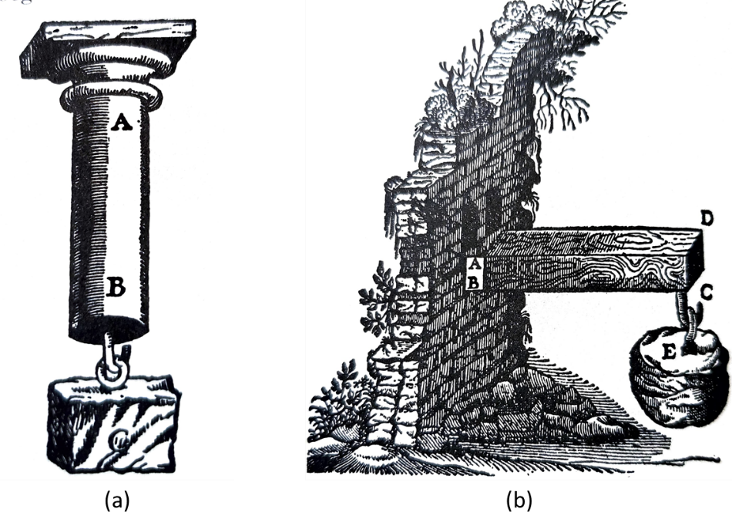

Figure 1. Gallileo’s Tension and Bending Tests

Other work followed, most notably by Hooke, who developed theories of spring behavior, and by Bernoulli(s) and Euler, who worked on derivation of elastic curve representations of bending behavior and the ideas of using virtual displacements to study deformation and stress. A more formal mathematical basis for classical structural mechanics was put forward by Lagrange in the late 1700s. More advanced understanding came in the early 19th century with theories for arches and truss behavior. These became fundamental to the development of iron and steel structures during the early industrial revolution, mostly associated with railway construction. Notable scientists such as Navier, Coulomb and others were very much involved with these developments. Later studies by Saint Venant, Mohr, Cauchy, Timoshenko and others⁴ led to the development of true Elasticity Theory.

Classical theories, while vitally important, found difficulty with the newer complex structures of the 20th century. The advent of aircraft and space travel created the need for light weight structures. These 20th and 21st century structures are complex and use many newer materials. For these types of structures classical solutions that satisfy the governing differential equations exactly at every point and that also satisfy boundary conditions, are not always possible for most practical problems with complex domains.

Timoshenko⁵⁻¹⁰ documented progress made by structures researchers in his series of books and monographs and brought the state of the art up to date by about 1950. Timoshenko showed that classical methods were inadequate to analyze complex structures with interactions of environments and loadings. New analysis methods were needed to design, analyze, and build these structures.

Newer, numerical based methods came into play by the 1950s. The development of these numerical methods was accelerated due to the advent of high-speed computers. The finite element method (FEM) was born in this environment. The first paper on FEM appeared in 1956¹¹ and simultaneous developments in the US and Europe¹² accelerated the acceptance and application of this method. The method grew by leaps and bounds¹³⁻²⁰ and became the workhorse of structural analysis methodologies, a position it maintains to the present day.

Finite element analysis systems have made astounding progress in advancing the modeling, analysis, and visualization of complex structures and structural components. Several decades ago, a sophisticated three-dimensional (3D) model of a structural component would have taken an experienced engineer several months to model, analyze, and provide interpretation of results. That same analysis can now be performed in a few days thanks to advancements in computer hardware, software, and integration of tools by commercial software developers. Data can now be transferred with speed and accuracy from Computer Aided Design (CAD) drawings to Finite Element models. Multiple loading conditions and iterations can be performed and optimization of the design can be achieved early in the design phase. Figure 2 shows recent examples of complex models of aerospace structural components.

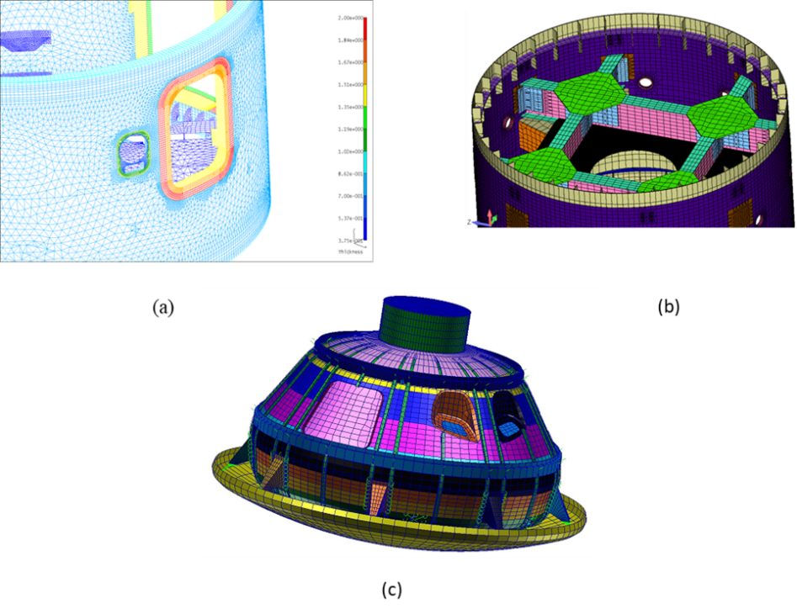
Figure 2. Examples of Complex Structural Models
(a) Reinforced cutout, (b) Complex internal structure, (c) Orion Crew Module
Numerical methods can now address complexities and non-linearities once ignored or dealt with via conservative assumptions. Finite Element software codes can now address multi-physics scenarios; problems involving structure-fluid interaction, crack propagation, cryogenic and re-entry thermal extremes, processing effects of welding, and additive manufacturing can now be analyzed with remarkable accuracy. Other examples of complex deformable space structures include deployable, inflatable, and shape changing structures that can now be assessed with current software tools. These technology advancements lead to the ability to perform multidisciplinary analyses of structural systems with complex interactions between and among differing physical effects such as aerodynamics, thermal performance, material property variations, and non-linear effects which were not possible several decades ago. Figure 3 illustrates the current interactions of structures with many other technical disciplines.

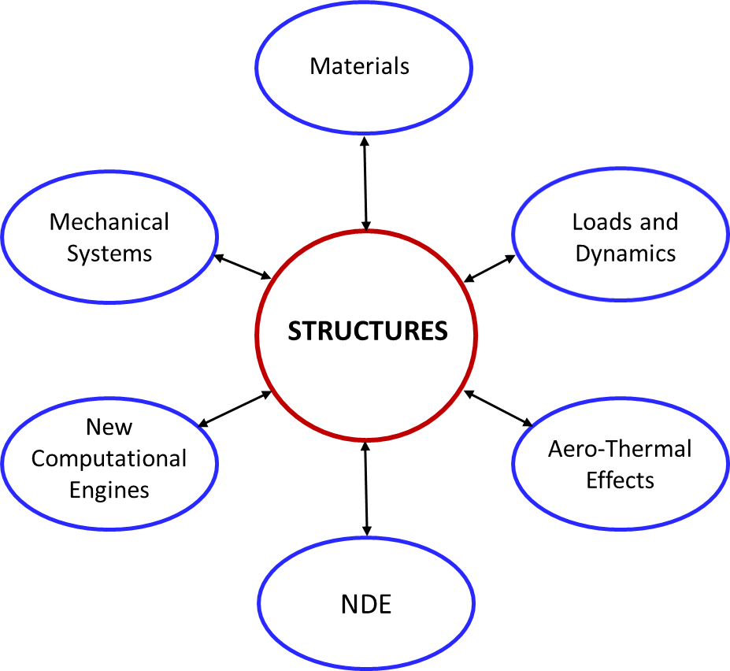
Figure 3. Complex Interactions between Structures and other Disciplines

The current-day general-purpose, commercially available software packages such as NASTRAN, Marc, ABAQUS, ANSYS, ADAMS, ADINA, etc., enable sophisticated analyses with complex 3D models to be performed very efficiently and rapidly. Pre-processing (model creation and analysis set-up) and post-processing (results visualization) can now be performed with increasingly efficient tools. Early-career engineers of today are very proficient in the use of modern computers, computing engines, and these complex software packages. They are increasingly efficient at developing complex models of aerospace components and are able to manipulate the general-purpose programs quite well.

Current State of the Art and the Remaining Challenges

The advancements outlined above may lead one to believe that Structures is a mature technology – ‘all structures problems are solved’ - and that further advancements and research are unnecessary. One of the reasons for this perception is the availability of highly advanced and tested general purpose programs for structural analysis such as NASTRAN, ABAQUS, and ANSYS. However, with advanced features comes the complexity in using these programs correctly and efficiently. Having excellent problem solving tool(s) at one’s disposal is a definite advantage, having the skills to use these tools correctly and appropriately is equally important in order to solve today’s difficult problems. Apparently, many critics of structures research forget this basic premise.

Detailed examination of the structures discipline shows that there are many areas still in need of rigorous research to arrive at physics-based methodologies and associated education and training. The following list identifies some of the most important.

- Fracture Mechanics: Current fracture behavior methods are still based on observed phenomena and empirical curve fits to coupon level fracture data. Fracture Mechanics needs several important breakthroughs. There is need for physics–based theories instead of phenomenological/curve fit methodologies currently used. Paris’ law of crack propagation is based on curve fitting of test data to determine the parameters used in analysis (Figure 4)²¹. Also needed is a clearer definition of boundaries of applicability between Linear Elastic Fracture Mechanics (LEFM) and Elastic Plastic Fracture Mechanics (EPFM). EPFM methods need more refinement to allow ease of use, similar to those currently available for LEFM. Finally, a better way of accounting for mixed-mode fracture predictions is needed. Current assumptions are that most behavior is governed by Mode-I, or that Mode-I envelopes Mode-II and Mode-III. Mixed mode type behavior needs comprehensive studies to fully understand behavior and crack propagation in these other regimes. Combined mode criteria using strain energy, interaction-type equations are used in the nuclear and piping industries and are available in EPRI or API documents but are usually not applied in aerospace applications.

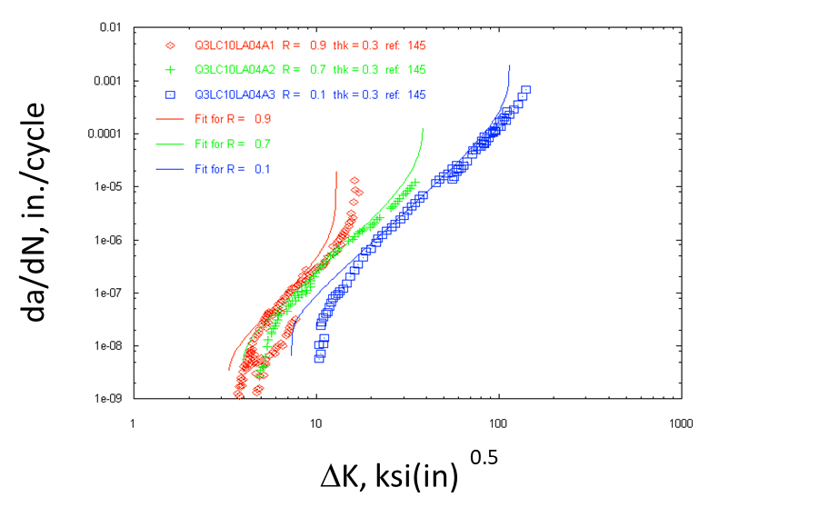
Figure 4. Typical fit to data for da/dN vs. ΔK (Paris’ Crack Growth Law)

- Composite Materials: Current methods use simple rule of mixture relationships to arrive at bulk properties, treating fiber and reinforcement separately. The transition area of the fiber to matrix bond is not well understood or modeled effectively, (Figure 5), even though these interphase areas are many times the sites of initial flaws and failures observed in structures. The current trend is to perform extensive testing every time there is a change in fiber and/or matrix or material lot in order to determine material allowables, which is both expensive and time consuming. There have been tests performed to develop databases of properties, such as the FAA AGATE program, but these are usually limited to specific fiber/resin combinations and do not always keep pace with currently produced systems. Alternative methods to predict behavior of the composite are urgently needed. Crack propagation modeling, failure simulation, and analysis methods have made significant progress in recent years but still have difficulty with prediction of progressing failure (e.g. matching how the failure propogates through the laminates).

Figure 5. Typical Composite Material Cross Section²²

- New Materials: Advances in other closely related disciplines create new problems/opportunities for aerospace structures research. For example, new materials (functionally graded materials, carbon nanotubes, additive manufacturing materials) require understanding of failure modes and the boundaries of these failure modes, etc. The need for new analysis approaches and the type and amount of data necessary for this understanding, affects the ability to determine the ultimate performance of the parts produced.

Other types of advance materials also show promise but require much more research and study to bring them into everyday use. Carbon nanotubes have been under development for many years, but only recently have been produced in significant quantities and length scales that may allow their use in structural parts. Studies underway are attempting to determine which methods of production are most advantageous for producing higher strength materials and also attempting to quantify the processing variables that most affect properties. Additional work is needed to quantify failure mechanisms. Most likely, new techniques in strucural analysis will be needed to allow their use in production of aerospace parts.

- Manufacturing and Processing Methods: New materials and manufacturing methods are constantly being introduced and used in the aerospace industry. Many times these have the potential to be lighter weight, more cost effective, higher strength, or more durable than previously used material systems or methods. The concern with these newer materials and methods for the structural engineer is to accurately simulate material behavior and properties, and to make accurate life predictions. In many cases these new processing methods and materials do not have significant test data to anchor calculations. For example, Additive Manufacturing (AM) has come into widespread usage over the past few years. This processing method allows for buildup of complex geometric parts, which may have been impossible to produce using traditional machining or processing methods. But additive manufactured parts are highly dependent on the processing method used to create them. Each different method results in a material system with inherent properties that are different from another method used to produce the same part. How the structural engineer and analyst take this into account is still an evolving process. To determine an accurate set of properties, an expensive series of A-basis or B-basis tests may need to be performed for each type of AM process used and each type of material used. Comprehensive studies of failure scenarios associated with each type of AM material and processing method are also needed. Currently, many of the structures produced are assumed to behave like castings with the associated voids and porosity inherent in those type of materials. But not all methods produce AM parts with material morphology like castings. This is especially true of 3D printed plastic or composite parts. Though much easier to produce, plastic parts have usually been limited to non-structural applications or secondary structures.

NASA has spent considerable time developing an AM standard outlining the amount of testing and validation needed to use a new material or AM process for production of critical spacecraft parts²⁸. Failure mode testing is a vital part of the knowledge base needed to advance AM into more mainstream applicability. Therefore, additional testing and research is needed if AM is to become more widely accepted for aerospace parts.

- New Applications: As the barriers of our current technology are crossed, new challenges arise. For example, consider hypersonic flight and re-entry vehicles. There is an urgent desire to reduce vehicle mass by using materials that can perform both as structural members and as thermal protection. Investigation of such high temperature materials, especially those that undergo phase transitions or chemical reactions, as happens with ablating materials, requires models that can incorporate these thermal effects and translate them into structural material changes as the vehicle heats. This is a complex multi-physics-based interaction which is difficult or impossible to test at full scale. How does one make predictions of full scale behavior from sub-scale coupon-like tests? New analytical and experimental methodologies need to be developed and validated for problems such as these.

- Lack of Physics-Based Theories: In many situations phenomenonlogical theories have been formulated but they are NOT validated. An example is the prediction of stress rupture life of composite overwrapped pressure vessels (COPV). The phenomenon of stress rupture is known but a physics-based methodogy of prediction does not exist. Test validation of life would take 20 to 30 years. Current work performs tests on strands of fibers of a COPV, builds models for the prediction of life of these strands, develops and validates a theory, and then makes the leap to estimating full COPV stress rupture life.

- New Test Methods: New test methods are needed to ensure validation of modeling/theories developed for new problems encountered. Test methods involve development of test procedures, test specimens, instrumentation etc. All these involve new research. Many times during a test a new phenomenon is observed. An example is the crack closure phenomenon that was observed during early fatigue tests. Results such as these open up new questions and new directions, leading to new research²³.

Additionally, long term structural behavior is usually simulated with short term tests that attempt to accelerate life. Tests with higher stress levels, elevated temperatures, or exposure to a more severe environment, are used to account for time related degradation. Even though these types of simulation are believed to be conservative, the physical phenomena associated with accumulating damage over time is not well understood and knowledge as to how well these short term tests account for longer term effects is not well known.

- Incorporation of Research Advancements: As abilities and methods progress and understanding of structural behavior increase, changes to older methods or practices are also needed. To illustrate this, consider what happened with shell bucking knock down factors (SBKF). Recognizing that theoretical values for buckling of shells were exceed by as much as a factor 2 (the discrepances were traced due to manufacturing anamolies in the fabrication of the shells), a NASA Special Publication (SP) was developed during the 1960s²⁴. In this document, a set of knock down factors were suggested for use in the design of cylindrical shells, based on tests and methods available at the time.

Since the 1960s, analytical capabilities and computing power have changed dramatically. Exploiting the new analytical capabilities and computing power, new research was initiated and the SBKF were updated. The updated knockdown factors are expected to result in an order of magnitude in weight savings for shell structures in launch vehicles.

- Computational Advances: As computing power (speed and memory) has increased, analysts realized that comprehensive simulation of time-dependent processes was possible. Commercial software programs such as LS-DYNA and ABAQUS-Explicit provide tools for solving time-dependent analyses. However the types of time stepping solution routines found in these programs are highly dependent on the integration of time step and mesh size. A basic rule is to use a mesh size that corresponds to a length equal to the speed of sound in the modeled material multiplied by the time step. This prevents stress wave effects from propagating unstably through an analysis mesh, leading to incorrect simulation results²⁵. This can lead to large and unwieldy meshes that take hours/days/weeks to run to completion even with current day computers using multiple processors. Many modelers simplify the analysis by only using fine mesh in the areas of concern and assuming a “rigid” mesh behavior in areas of less concern using a Component Mode Synthesis type approach²⁶. This implies that one is able to determine which areas of the structure will be more important to the solution and requires expertise on the part of the engineer/analyst to implement correctly. Tuning of correct parameters for solution control and validating of a correct solution can only be accomplished via comparison with test results, an issue that is often overlooked by proponents of these advanced codes. And higher order derived output results (such as stress) are much more difficult to determine accurately than lower order direct results (such as acceleration at the center of gravity). Users and reviewers of these types of codes and methods must have significant expertise and understand the limitations of both the codes used and of the analyses performed. Validation with test results is vital and must also be performed in order to understand if the solution is providing accurate simulation of the structural behavior desired²⁷.

- Multi-Discipline Interactions: Another aspect of strucutral engineering is interaction with other disciplines. As can be seen from the above items, many of the challenges associated with advancing structural understanding are inter-related. There is a great desire to model physics-based phenomena where effects of numerous disciplines can be combined together into one overall analysis product. Effects such as thermo-structural behavior where properties radically change in different temperature regimes is one example. Materials may not only lose strength with increasing temperature, they may erode away completely as occurs in thermal protection systems and entry vehicles. Aerodynamics may produce loads which cause changes to geometry as the structure deforms, leading to changes in aerodynamics. Friction heating due to airflow may lead to thermal-structural effects. All these are inter-related and affect each other.

Until recently, each of these type of effects was treated separately. Aerodynamicists determined loads, which were transferred to structural engineers, who in turn developed deflections and stresses. Aerodynamicists may also have delivered information to thermal engineers who produced temperature predictions, who then flowed this information back to structural engineers who developed load cases with temperature effects included. The interaction of these different disciplines was not fully integrated.

However, recognition of these new and complex interactions has led to a situation where identification and prediction of more complex and potentially interacting failure modes has become necessary. As more interacting effects are included in analyses, along with the desire for more efficient structures - accomplished many times by elimination or reduction of conservative safety factors - the identification of true failure modes and how they propagate has become more and more critical but also much more difficult. Unless engineers are able to predict these interactions accurately and design against them, there is an increasing likelihood that some new and unforeseen form of failure mode will be missed. Whether that be from some non-linear compounding effect of an outside environment (aerodynamic loading, dynamic behavior, thermal effects), or from some inherent behavior of an advanced material such as a composite material or additively manufactured item, it is vitally important to have usable failure data for all possible environments and usage conditions to effectively design safe and reliable parts.

Now with newer techniques the ability to perform highly integrated analyses is becoming more widespread. For example, with the advent of multi-physics codes such as Sierra Mechanics³³ and Comsol³⁴, interaction effects between and among various disciplines may soon be realized. However, analysts will probably need additional training and expertise to effectively use such techniques, especially when implementing effects from outside their main discipline. Analysts using a more integrated physics based approach would need knowledge of other disciplines, in addition to their own, in order to fully incorporate the advantages of inter-disciplinary physics-based approaches.

- Up-to-Date Training: The expertise of engineers needs to be current to be able to confront new challenges. Many times there will not be any precedents to look up or follow. Examples of current technologies that engineers need to understand include: Nonlinear analyses, which should not only be seen as a series of solutions of linear problems, building block approaches to test and analysis used to develop confidence in analysis predictions, and successful implementation of Verification and Validation (V&V) methods to complex structural systems.

- Mentoring: Proper mentoring of the next generation of structural mechanics practitioners must be provided by the experts in these areas before they leave the field. But current work trends tend not to emphasize mentoring and the volume of work that current experts are asked to handle leaves little time for formal or even informal mentoring. One needs to understand whether advanced models are telling you the correct things and only through exposure to knowledge of older, more experienced personnel can this be achieved. Limitations of models have to be well understood in order to provide accuracy and confidence in solution results.

Additionally, verification and validation of any model is the ultimate test of its usefulness. Comparison against test data provides anchoring that allows the analyst to identify coverage areas for a particular model and identify the bounds where the model begins to fail. Useage of a model outside its coverage area can lead to incorrect interpretation of results and potential failure of a structural system.

Illustrative Examples

Two lessons from the past lead to realization that if the structural engineers do not understand or cannot predict a failure mode, they will not be able to design against it.

The first lesson comes from the Aloha-airline accident of April 1988; Flight 243 had a major inflight failure. The aircraft, a Boeing 737 with over 89,000 flights (75,000 flights is the design life of a B-737), was flying in an aggressive marine enviornment and as a result of the many short flights between islands, accumulating many fatigue cycles each day due to the frequent take-offs and landings. In this case, the top half of a section of the fuselage separated from the rest of the fuselage, killing one flight attendant and injuring many passengers (Figure 6). Multiple small cracks initiated from each of the rivets along the fuselage lap-splice joints. Some of these cracks linked up, resulting in a much longer crack (Figure 7), which then grew faster and linked up with other, smaller cracks. This domino effect caused the top of the fuselage to rip apart in flight.

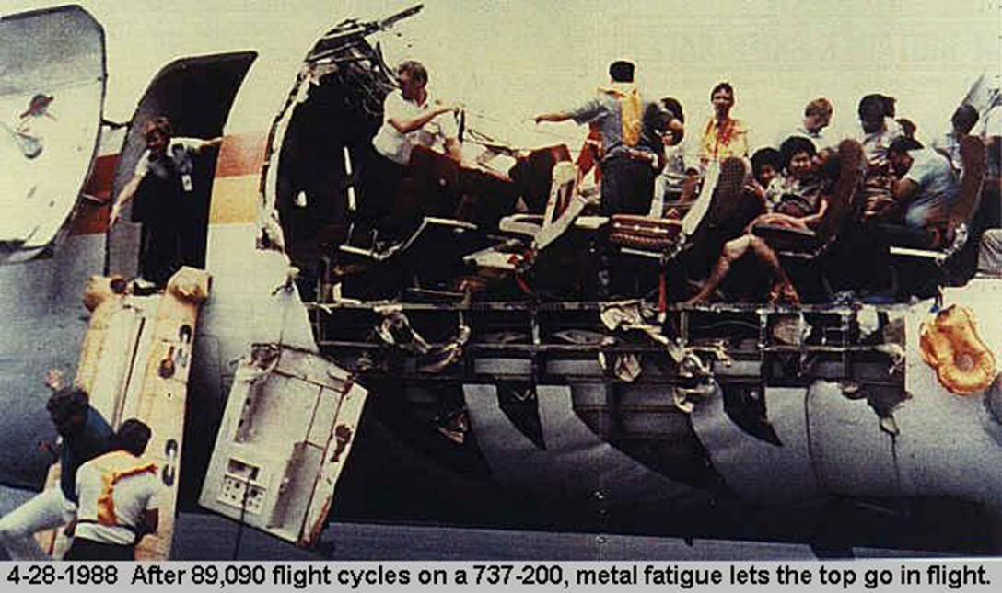
Figure 6. Aloha Airlines Flight 243 Failure

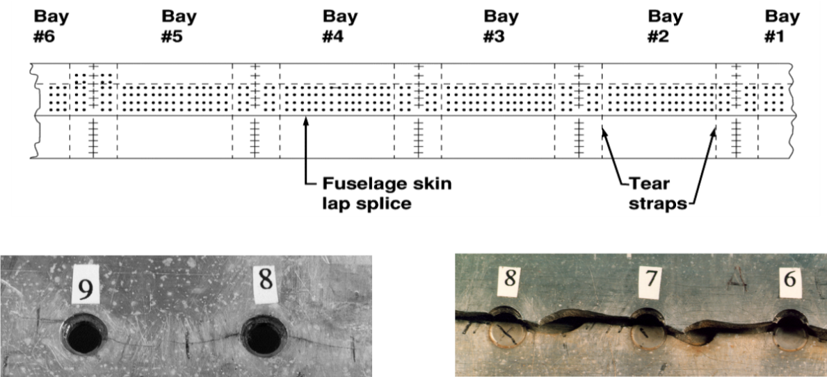
Figure 7. Multi-Site Damage Crack Propogation

The terms wide-spread fatigue damage (WFD), multi-site damage (MSD), and multi-element damage (MED) did not exist in the fracture mechanics vernacular before 1988. This type of multi-site damage and linking up of cracks was not forecasted/predicted by researchers, manufacturers, analysts, regulators, and others. As a result, several programs on aging aircraft were started by the FAA, Air Force, and NASA soon after this accident and research into extending the life of an aging fleet was addresssed along with methodologies to mitigate this type of failure²⁹⁻³¹.

The second example is the Space Shuttle Columbia accident which occurred on February 1, 2003. During ascent, a large piece of insulating foam was liberated from the bi-pod region of the external tank and impacted a carbon-carbon panel of the wing leading edge. This impact resulted in a large hole on the panel. During re-entry, hot plasma was able to enter this breech and melt the structure that was exposed to these high temperatures, causing breakup of the Orbiter and loss of crew. Again, the ability of lightweight insulating foam to cause major structural damage was not deemed a plausible failure mode before this accident. A test conducted as part of the accident investigation at Southwest Research Institute identified this failure mode as very plausible (Figure 8) ³².

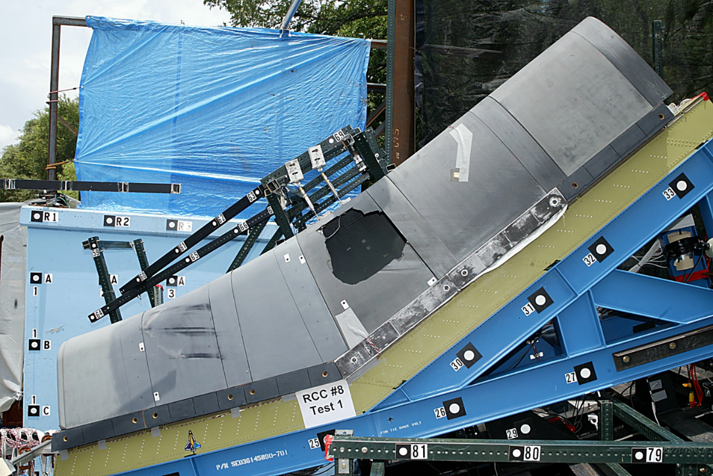
Figure 8. Ground Test of Shuttle Carbon-Carbon Wing Leading Edge Panels

Concluding Remarks

Many times during past decades, the comment, “Structures is a mature technology and why does structures research need consistent funding?” has been heard. The perception that structures as a discipline is mature and has reached a plateau and does not need consistent research funding is driven by the fact that many general-purpose programs (GPPs) such as NASTRAN, ANSYS, ABAQUS – to name a few – exist along with associated software for mesh generation and visualization. These tools are widely available and can be used not only by experts, but by early career engineers, to analyze and obtain solutions to a multitude of advanced problems.

As has been shown, there are still many areas in structural mechanics where advanced simulation may or may not provide the correct physics of a problem. As more and more non-linear and multi-physics aspects of problems are included in engineering models, the need for mentoring and training of practitioners needs to be improved and increased. The advancement of computing engines and interactive software with built in solution capabilites does not always allow one to apply correct solutions or interpret results correctly, especially if the users of these packages lack a solid background in structural mechanics. Blind acceptance of the quality and proper interpretation of results from complex analyses are two significant problems that face the structural mechanics commuity today. This trend is alarming and has been worsening in recent years³⁵.

The authors have attempted to show that many areas of structures are not mature and continued investment is still warranted. As has been discussed, there are many important areas where the ability to perform an analysis is not backed up by sufficient theory. Structural behavior may be modeled empirically but the extent and limits of these empirical assumptions may not be known or need to be extended. New and complex interactions between and among disciplines are only now becoming possible. Issues associated with these interactions and the consequent complex failure modes that may arise, need to be researched and investigated.
As pointed out earlier, there is a further issue that is caused by the GPPs. The GPPs are well used by many in engineering disciplines. Their widespread success is also leading to a major concern associated with their popularity: namely, GPPs can be used by those who have little or no background in Engineering Mechanics or structural analysis methodologies. This may lead to incorrect results and interpretations when inherent built-in assumptions and the limitations of the programs are not understood.
The paper has outlined many issues that still need to be resolved and problems that need further research: Some of these are:
- Many life and other prediction methodologies that are in current standard practice are phenomenological - effectively are curve fits to data. Physics-based methodologies need to be developed.
- New materials require understanding of material behavior and implementation into structures analyses models.
- Vehicles for new missions pose new loading, environment, and other issues (many times interacting) that need to be modeled and analyzed.
- Metholdogies for Verification and Validation of complex systems are immature and need further research.
- New test methods are needed for new materials, loadings, environmental issues, and new failure scenarios, including development of long term failure predictions from short term tests.
- Comprehensive simulation of time-dependent problems is still difficult and expensive.

Finally, mentoring the next-generation engineers and providing training is of utmost importance. As the newer materials and structural analysis methods are developed, the next generation engineers need to learn all the classical methods, numerical methods, and keep up with the state–of-the art of developments. While this appears to be a high mountain to scale, good mentoring and training will provide tools for these young engineers to succeed.

REFERENCES
1. Bernstein, P. L., Against the Gods – The Remarkable story of Risk, John Wiley & Sons, Inc., New York, 1996
2. Stewart, I., Significant Figures – The Lives and Work of Great Mathematicians, Basic Books, 2018

3. Galileo Galilei, Dialogues Concerning Two New Sciences (Translated from the Italian and Latin into English by Henry Crew and Alfonso de Salvio), Macmillan, New York, 1914.

4. Timoshenko, S. P., History of Strength of Materials, Dover Publications, New York, 1983.

5. Timoshenko, S. P., Vibration Problems in Engineering, Von Nastrand Book Company, 1928, 1955

6.Timoshenko, S. P., Strength of Materials, Parts I and II, Von Nostrand Company, 1956

7. Timoshenko, S. P.,and Woinowsky-Krieger, S., Theory of Plates and Shells, 2nd Edition, McGraw-Hill Book Company, New York, 1959.

8. Timoshenko, S. P., and Goodier, J. N., Theory of Elasticity, McGraw-Hill Book Company, 1970

9. Timoshenko, S. P., and Gere, J. M., Theory of Elastic Stability, McGraw-Hill Book Company, 1961
10. Timoshenko, S. P., and Young, D. H., Engineering Mechanics, McGraw-Hill Book Company, 1983.

11. Clough, R. W., Turner, M. J., Martin, H. C., and Topp, L. C., “Stiffness and deflection analysis of complex structures,” Journal of the Aeronautical Sciences, 1956

12. Argyris, J. H., and Kelsey, S. W., Energy Theorems and Structural Analysis, Springer, 1960

13. Zienkiewicz, O. C., and Taylor, R. L., The Finite Element Method, Vols. 1 and 2, Fourth Edition, McGraw Hill Publishers, 1989

14. Cook, R. D., Malkus, D. S., and Plesha, M. E., Concepts and Applications of Finite Element Analysis, Third Edition, John Wiley & Sons, 1989

15. Crisfield, M. A., Nonlinear Finite Element Analysis of Solids And Structures, - Volume 1, John Wiley & Sons, Chichester, 1991

16. Hinton, E., (Ed.), NAFEMS: Introduction to Nonlinear Finite Element Analysis, NAFEMS, Glasgow, UK, 1992

17. MacNeal, R. H., Finite Elements: Their Design and Performance, Marcel Dekker, Inc., 1994

18. Bathe, K. J., Finite Element Procedures, Prentice-Hall, Englewood Cliffs, NJ, 1996

19. J. N. Reddy, An Introduction to Nonlinear Finite Element Analysis, Oxford University Press. New York, 2004.

20. T. Belytschko, T., W. K. Liu, B. Moran, B., and K. I. Elkhodary, Nonlinear Finite Elements for Continua and Structures, Second Edition, John Wiley & Sons, 2013.

21. Broek, D., Elementary Engineering Fracture Mechanics, Martinus Nijhoff Pub., Dordrecht/Boston/Lancaster, 1986.

22. Jones, R. M., Mechanics of Composite Materials, Hemisphere Publishing Co., London, 1975.

23. J. C. Newman, Jr., and W. Elber (Eds): Mechanics of Fatigue Crack Closure, ASTM STP 982, 1988

24. Peterson, J. P.; Weingarten, V. I.; and Seide, P., Buckling of Thin-Walled Circular Cylinders, NASA Space Vehicle Design Criteria, NASA SP-8007, September 1965 (Revised August 1968)

25. Courant, R., Friedrichs, K., and Lewy, H., On the Partial Difference Equations of Mathematical Physics, (Translated by Phyllis Fox), United States Atomic Energy Commision, 1956.

26. Tusha, W., and Spanos, J., Reduced Order Component Models for Flexible Multibody Dynamic Simulations, 28th Aerospace Sciences Meeting, Reno, NV, AIAA-90-0062, 1990.

27. Hallquist, J. O., LS-DYNA Theory Manual, Livermore Software Technology Corp., Livermore, CA, 2006.

28. National Aeronautics and Space Administration, NASA-STD-6030, Additive Manufacturing Requirements for Crewed Spaceflight Systems (Draft), 2019.

29. Dawicke, D. S. and Newman, J. C., Jr., “Analysis and Prediction of Multiple-Site Damage (MSD) Fatigue Crack Growth,” NASA TP-3231, August 1992.

30. Harris, C. E., Newman, J. C., Jr., Piascik, R. S. and Starnes, J. H., Jr., “Analytical Methodology for Predicting Widespread Fatigue Damage Onset in Fuselage Structure,” Journal of Aircraft, Vol. 35, No. 2, 1998, pp. 307-317.
31. Dawicke, D. S. and Newman, J. C., Jr., “Residual Strength Predictions for Multiple Site Damage Cracking using a Three-Dimensional Finite Element Analysis and a CTOA Criterion,” Fatigue and Fracture Mechanics: 29th Volume, ASTM STP 1332, T. L. Panontin and S. D. Sheppard, Eds., 1999, pp. 815-829.
32. Anonymous, “Columbia Accident Investigation Board Report” Vol. 1, August 2003, Washington, DC.
33. Sandia National Laboratory, Sandia Report SAND 2011-7597, Sierra Solid Mechanics 4.22 User Guide, Albuquerqueque, NM, 2011.

34. COMSOL Inc., COMSOL Multiphysics Reference Manual, www.comsol.com, 2019.

35. Raju, I. S., Knight, N. F., and Shivakumar, K. N., Some observations on the current state of performing finite element analyses, Paper presented at the 56th AIAA SciTech Conference, 5-9 January, Kissimmee, FL, AIAA 2015-2070, 2015.

NESC Chief Engineer at NASA Ames Research Center, Associate Fellow AIAA, Member ASME
NASA Technical Fellow for Structures, Associate Fellow AIAA
Distinguished Research Associate, Durability, Damage Tolerance, and Reliability Branch, Fellow AIAA, Fellow ASME, Member ASCE

