Path to Open Science: A Data Perspective

Rahul Ramachandran, Kaylin Bugbee
NASA/MSFC

Kevin Murphy
NASA/HQ

Open Science Definition

Science is both a body of knowledge as well as a systematic method of knowing something.

Open Science is a "collaborative culture enabled by technology that empowers the open sharing of data, information, and knowledge within the scientific community and the wider public to accelerate scientific research and understanding" (Ramachandran, Bugbee & Murphy 2020).



Image attribution - https://www.pexels.com/photo/abstract-art-blur-bright-373543/

Drivers for More Open Science
Science has, in some measure, been open since the 1700s, but the following drivers have pushed Science to become more open.
- Rapid technology advancements have enabled new workflows that make Science more efficient and created new mediums for sharing knowledge with other scientists and the broader community.
- The rapid increase in data volume and velocity have disrupted the scientist's traditional analytic workflows and the corresponding data management practices required for working with data.
- Accessibility to new data has opened opportunities to tackle complex, interdisciplinary science problems that span domain boundaries. Solving these complex problems demands collaboration across traditionally siloed scientific communities and the convergence of different types of expertise, knowledge, and resources.

Open Science Focus Areas
- Increasing the accessibility to Science
  - Science as a way of thinking
    - Encouraging broader and more inclusive participation in all scientific research stages is crucial for emerging open science activities.
    - Making research results understandable and comprehensible to the general public using new communication avenues, tools, and formats.
  - Science as a body of knowledge
    - Providing equitable access to the scientific body of knowledge, including data, software, research publications, and all other supporting materials.
- Making the research process and knowledge dissemination efficient
  - New cyberinfrastructure to support the science process
    - Developing cyberinfrastructures that free a researcher from the constraints of limited local resources by providing access to computing and storage resources along with a complementary suite of tools and services to enable large scale, data-intensive research, high throughput processing, and modeling capabilities
  - Enable collaborations
    - Designing new platforms that seamlessly enable scientific collaboration from many geographically distributed contributors who perform a variety of tasks.
- Understanding Scientific Impact
  - New quantitative metrics to comprehensively understand the impact of scientific contributions both to academia and the broader public.

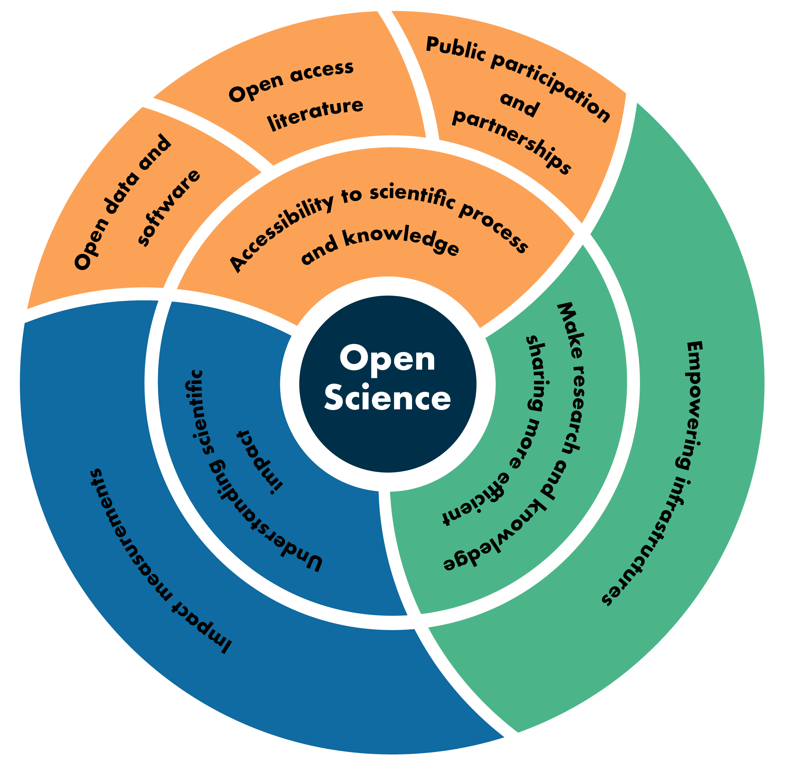

Role of Data Programs to Enable Open Science
- Improve accessibility to Science
  - Support data collection activities, scientific challenges, hackathons, and other events that are open to the public
  - Increase public awareness of the value of the data collected to advance Science and humanity
  - Develop open data and open source software policies and by ensuring those policies are enforced.
  - Provide citations and DOIs for both data and software
- Enabling efficient research processes and knowledge dissemination
  - Invest in developing open-source software that supports implementing enabling collaborative cyberinfrastructures by leveraging current technology advances such as cloud computing.
  - Have collaboration as a core feature to allow the sharing of both code and data.
- Understanding Scientific Impact through Data System Measurements
  - Develop impact measurements for all first-class research objects within the data system, including data, software, documentation, services, and users that go beyond traditional metrics.

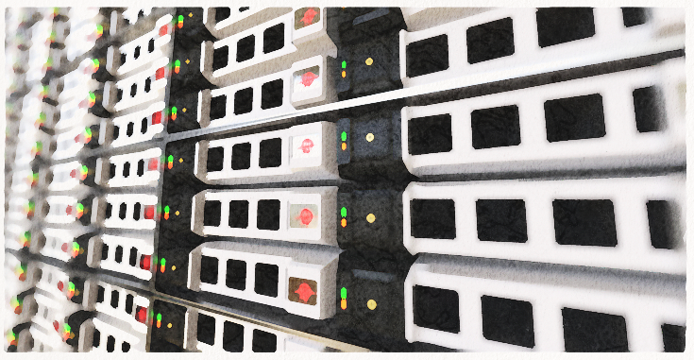
Image attribution - https://www.pexels.com/photo/modern-office-building-325223/

Challenges for Data Programs
- Reluctance to accept citizen science data as scientifically legitimate from both within the science community.
- Open access to data introduces possibilities for data misuse
- Selecting an appropriate open source software license is confusing and often overwhelming to researchers.
- Provide green repositories to support free and open access to journal articles related to data and software.
- Data systems' evolution will require data centers to move beyond merely functioning as a data archive to instead serving as knowledge centers for the scientific community.
- Shifting from legacy systems to cloud-native systems in a cost-optimal manner is a non-trivial task.

Responsibilities for Individual Researchers

Individual researchers can be advocates for open Science by adopting these best practices>
- Make their data available in an open repository and in a non-proprietary, standardized format.
- Create a digital object identifier (DOI) for their data and provide clear licensing information along with use constraints.
- Make software and code open source using a community adopted license that encourages reuse.
- Contribute to the community development of open source software, libraries, code, and tools
- Publish peer-reviewed articles should be to gold journals when possible. If a reputable gold journal is not available, researchers should make sure their publishers allow self-publishing in a green repository.
- Actively engage the broader public by starting or supporting science blogs, citizen science projects, hack-a-thons or sharing results on social media.
- Cite data, software, and documentation whenever possible but especially in journal articles.


Image attribution - https://www.pexels.com/photo/two-women-looking-at-the-code-at-laptop-1181263/

