KSC Integration Office Documentation and Support
Ana C. Arvelo Serrano
Kennedy Space Center
Major: Information Systems within Business Administration
NASA Internships and Fellowships (NIF) Fall Session
Date: 10/11/2020

KSC Integration Office Documentation and Support
Ana C. Arvelo Serrano
University of Puerto Rico, Mayagüez Campus – Mayagüez, PR, 00682

Nomenclature
AA-I = Mail code for the KSC Integration Office
AAIRS = Audit and Assurance Information Reporting System
ALR = Audit Liaison Representative
ALT = Audit Liaison Team
COVID = Coronavirus Disease 2019
IT = Mail code for the Information Technology and Communications Services directorate
GAO = Government Accountability Office
KTI = Kennedy Technical Instructions
OIG = Office of Inspector General
MSD = Mission Support Directorate
PX = Mail code for the Communications and Public Engagement directorate.
RTS = Return to Site

This report details the process of document management within the KSC Integration Office throughout my internship in the fall term of the year 2020. During this term, I was mentored by Felix A. Soto-Toro and my main objective was to support the Audit Liaison Representatives (ALR) in their documentation processes. I worked alongside the members of the KSC Integration Office to streamline the auditing process in order to facilitate the interchangement of documents and communication between auditors and our agency. My approach to this situation was to document the events of each audit in a report, which would be updated weekly every Monday following a specific format. As support I was required to gather, organize, and release data relevant to current audits in an online server for ALRs to use across the entire NASA Agency.

Introduction
W
ith the modernization of systems within Kennedy Space Center (KSC) and its various organizations, documentation for audits has become an exhaustive process. KSC organizations follow different approaches regarding nomenclature. To tackle this, the documents are accepted into the KSC Integration Office, then the filenames and contents are formatted correctly. The KSC Integration Office is shown in Figure 1, as it illustrates the organization chart of the KSC Executive Team. Our office ensures that the precise date of submission is identified clearly for auditors to generate a time frame. The importance of formatting stems from the need of uniformity in the structure of the Agency.
This process has previously been applied in stages, but the distance between buildings in the campus and factors related to physically working at the Center would serve as interrupting factors. Now, because of COVID-19 administrative tasks at NASA, including audits, are done via telework. Efficient teleworking practices have been key components to the success of this approach. This allows for easier interaction between organizations, and better preparation when it comes to organizing data and documentation. My approach includes creating Kennedy Technical Instructions (KTI) that are uploaded and stored in the NASA/KSC TechDoc System database. There, they are available to all employees within KSC for easy reference. Each KTI has a specific numbering and title related to its contents. Older KTIs that counted with related information were updated to fit current standards by myself, overseen by my supervisor. The current versions were uploaded to TechDoc as well. With this in hand, the KSC Integration Office can perform better in audits by supporting the KSC organizations in referring to the updated or created KTIs.

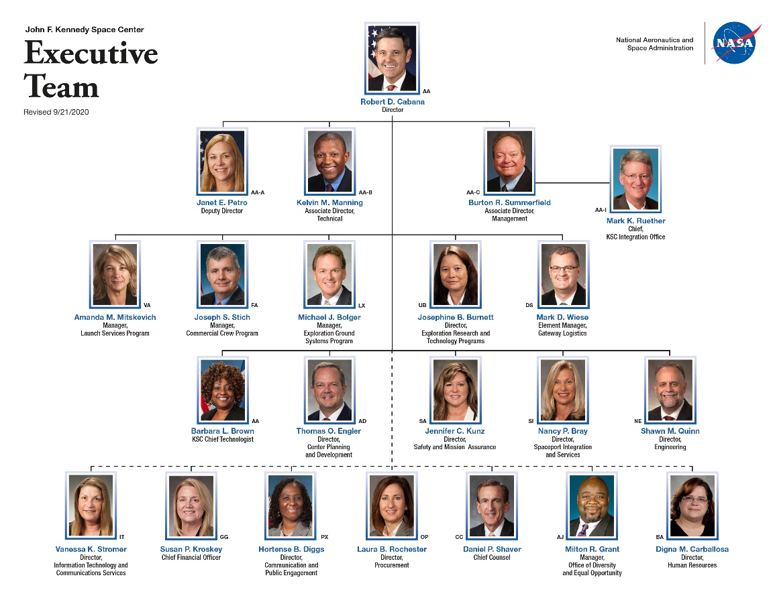
Figure 1: KSC Organization Chart. The KSC Integration Office (AA-I), in which I am interning,
is supervised by Mark K. Ruether.

Educational Achievements
The biggest factor in my internship was my involvement with the auditing process. NASA is audited internally by the Office of Inspector General (OIG), and externally by the Government Accountability Office (GAO). During the current teleworking phase of the Center, the process for audits has altered, counting with an entrance conference, audit meetings, and finally an exit conference.₁ The data concerning the topics of discussion, the organization being audited, and the date of audit is stored in the Audit and Assurance Information Reporting System (AAIRS). AAIRS is divided by internal and external offices and can generate reports. These generated reports serve as input for manually updated weekly audit reports.

Weekly Audit Reports are generally drafted by the resident ALR, my mentor Felix A. Soto-Toro, and later sent to NASA Headquarters Mission Support Directorate (MSD) Audit Liaison Team (ALT) ALRs. Moreover, I was given the task to update, draft, and send these reports to all ALRs. As I was a newcomer to the process, I was also tasked with documenting the process and creating a set of instructions for future ALRs to use once hired to the position.₂ Figure 2 & Figure 3 depict some of the screen shots generated in the KTI. Other KTIs and instructions I have drafted include documents related to the KSC Integration Office regarding the use of Microsoft Word Macros and PowerPoint Macros.₃ These are uploaded into TechDoc for future use and reference.

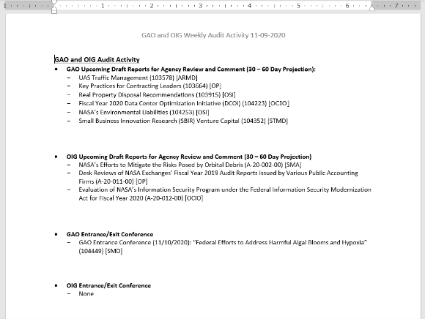
Figure 2: Screen capture of latest Weekly Audit Report
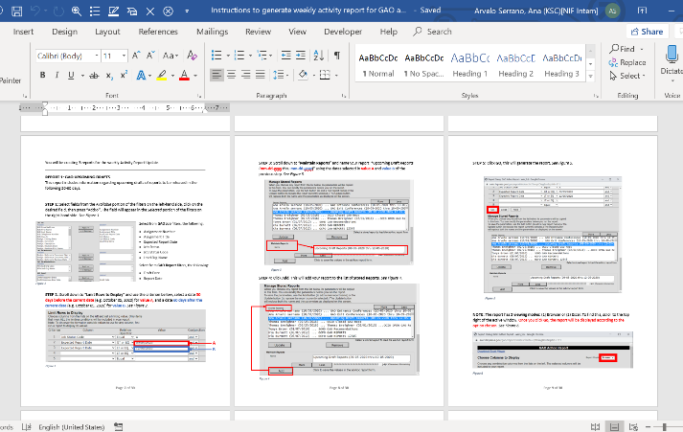
Figure 3: Screen capture of Weekly Audit Activity Generation Instructions

Because of COVID-19, insight from members of the office regarding their telework concerns is routinely collected in surveys. The results of these surveys are used to create work plans that better fit the new working-from-home lifestyle. I created a survey with questions relating to the various stages of the Return to Site (RTS) strategy and published it in the KSC Integration Office SharePoint site with a duration of two weeks. Once the survey expired, I recollected the data and created presentations with graphical data of the results to display to the office leadership, and thus participated in the creation of future work plans.

A leave calendar was created by myself and my supervisor, to keep track of the people out of office during the fall term of the year. This document was drafted in Microsoft Excel, managed with a macro, and posted in the KSC Integration Office SharePoint Site.₄ Employees of the KSC Integration Office can access the document using a library method, in which the document needs to be ‘checked out’, edited, then ‘checked in’. This keeps track of the changes applied. An example of the calendar can be seen in Figure 4.
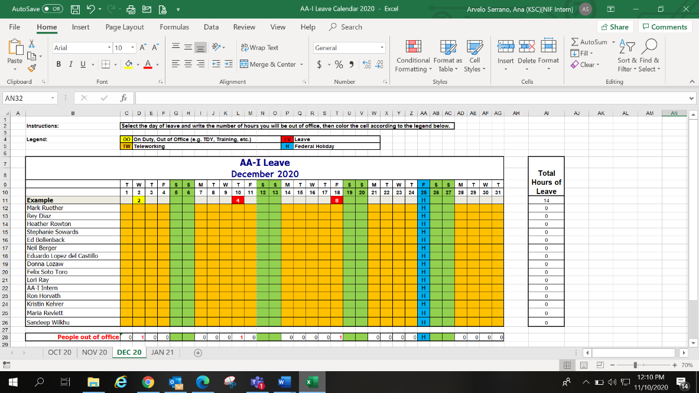
Figure 4: Screen capture of Annual Leave Planner spreadsheet

Throughout my internship, I was able to interact with other organizations within KSC by conducting business reviews. Business reviews included organizing one-on-one meetings with people working in organizations outside the KSC Integration Office. One of the organizations that I supported was the Information Technology and Communications Services directorate (IT), where I worked alongside various teams to give insight on local applications used in KSC, current Virtual Reality technology used for astronaut training, and daily use of equipment for telework. Other business reviews were conducted in the Communications and Public Engagement directorate (PX), where I was able to receive orientation related to a future career in NASA, current outreach projects for NASA Centers, and even international relations. I was given the opportunity to work alongside the press office in recording a publishing an episode the YouTube series “Inside KSC!”, published online on October 23rd, 2020, and placed in KSC Internal Communicator Homepage. Figure 5 shows a screen capture of this activity.

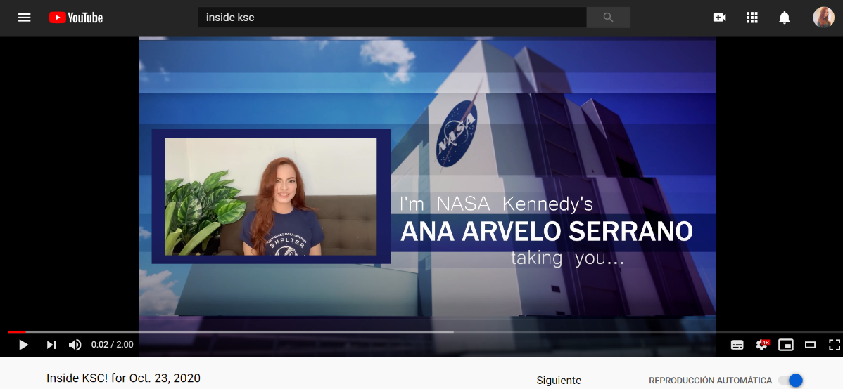
Figure 5: Screen capture of Inside KSC!

Results
Results of my work can be shown in the graphical presentations sent to the KSC Integration Office Leadership regarding the RTS Survey (see Figure 6 & Figure 7). Through this experience, I was able to take part in the planning of future NASA work. As COVID-19 cases fluctuate, studies regarding the availability of a workforce to return to the physical workplace will continue to be held.

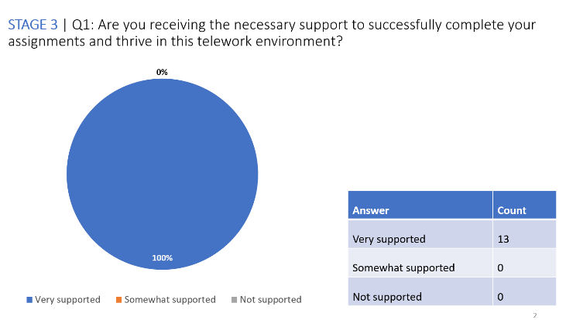
Figure 6: Graphical representation of a survey question
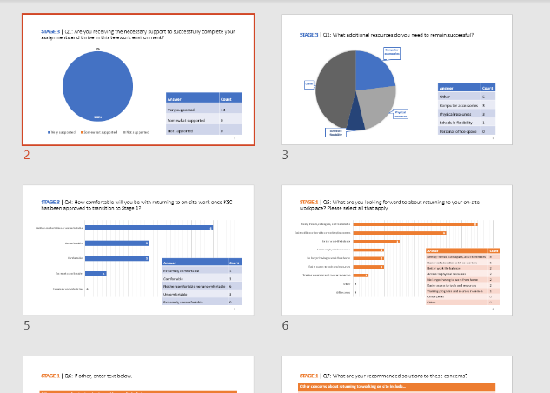
Figure 7: More graphs within the presentation

Conclusion
As an intern in the fall term for 2020, my main responsibility included supporting ALRs in the auditing process by documenting and uploading instructions of the newly adapted digital audit process as reference for future use. I was also able to aid the KSC Integration Office by adding interactive elements to their SharePoint site for team members to record their presence in the office as well as their telework status. Overall, I was able to streamline current processes, maximizing efficiency and allowing for clear and consistent communications between KSC organizations. Lastly, KSC gave me the opportunity to represent their image by working with their Press Site office and marketing teams in outreach events, and thus contribute to the NASA mission. Table 1, (see Appendix), shows in detail the activities I participated in while interning at KSC.

Appendix
Table 1: Intern Activities
# | EVENT
1 | Session dates
2 | Agency-Wide OSTEM Internship Orientation Briefings
3 | KSC OSTEM Internship Orientation
4 | Connecting OSTEM Interns- KSC Employee Resources Group
5 | Overview of NASA & KSC Organizations / Mission  POC: Felix A. Soto Toro
6 | Submit updated MS Word version of abstract to Mentor  POC: Felix A. Soto Toro
7 | SATERN Training Courses Refresher
8 | Overview of Audit Processes and Standards  POC: Felix A. Soto Toro
9 | Review Business Management Processes  POC: Felix A. Soto Toro
10 | KCMC Council  POC: Rey Diaz
11 | SATERN Training Courses Refresher
12 | Management Review KSC  POC: Rey Diaz
13 | Completed Project Plan (1st Deliverable)
14 | Federal Holiday (Labor Day - Monday)
15 | Overview of Customer Feedback Processes  POC: Lori Ray
16 | Familiarize with Business World webpage and its needs  POC: Eduardo Lopez del Castillo
17 | Review Business Management documents (outside AA-I2)  Human Resources (POC: Mai Miller)
18 | Brown Bag – Enrichment Activity – “Veggie Overview”
19 | Review Business Management documents (outside AA-I2)  Communication and Public Engagement (POC: Lester Morales)
20 | Job shadow with Directives Manager  POC: Donna Lozaw
21 | Support Directives Manager  POC: Donna Lozaw
22 | Virtual Tour of KSC Facilities
23 | Review Business Management documents (outside AA-I2)  Engineering Directorate (POC: Juan Gordon)
24 | Brown Bag – Enrichment Activity –  “Pathways Overview”
25 | Modify Business World webpage  POC: Eduardo Lopez del Castillo
26 | Support Directives Manager  POC: Donna Lozaw
27 | Support Directives Manager  POC: Donna Lozaw
28 | Review Business Management documents (outside AA-I2)  Launch Services Program (POC: Jackie Leclaire)
29 | Brown Bag – Enrichment Activity –  “Exploration Ground Systems Overview”
30 | Modify Business World webpage  POC: Eduardo Lopez del Castillo
31 | Support Business Systems Manager  POC: Rey Diaz
32 | Review Business Management documents (outside AA-I2)  IT and Communications Services (POC: Carolyn Staton)
33 | Job shadow with Opportunity for Improvement Manager  POC: Ed Bollenback
34 | Support office’s Opportunity for Improvement Manager  POC: Ed Bollenback
35 | Job shadow with KSC Integration Office’s Chief  POC: Mark Ruether
36 | Job shadow with office’s Lead Internal Auditor  POC: Lori Ray
37 | Support office’s Lead Internal Auditor
38 | Federal Holiday (Columbus Day - Monday)
39 | Modify Business World webpage  POC: Eduardo Lopez del Castillo
40 | Review Business Management documents (outside AA-I2)  EGS (POC: Lisa Matthews)
41 | Job shadow with Business Processes Manager  POC: Neil Berger
42 | Support Business Processes Manager  POC: Neil Berger
43 | Record “Inside KSC” episode  POCs: John Sackman & William “Bill” Kallus
44 | Modify Business World webpage  POC: Eduardo Lopez del Castillo
45 | Midterm performance appraisal  POC: Felix A. Soto Toro
46 | Support Business Document Systems Manager
47 | Support Program Project Coordinator
48 | Provide a MS Word version of abstract to Mentor for review and approval PRIOR to uploading to e-DAA system
49 | Support Audit Liaison Representative
50 | Review Business Management documents (outside AA-I2)  Gateway Logistics Element Office (POC: Stacie Turner)
51 | Upload Final Technical Report to STI (e-STRIVES) for organization approval (2nd Deliverables)
52 | Federal Holiday (Veteran’s Day - Wednesday)
53 | Modify Business World webpage  POC: Eduardo Lopez del Castillo
54 | Support Business Processes Manager  POC: Neil Berger
55 | Support Audit Liaison Representative  POC: Felix A. Soto Toro
56 | Support Business Processes Manager  POC: Neil Berger
57 | Federal Holiday (Thanksgiving Day - Thursday)
58 | Modify Business World webpage  POC: Eduardo Lopez del Castillo
59 | Review Business Management documents (outside AA-I2)  Human Resources (POC: Mai Miller)
60 | Support Audit Liaison Representative  POC: Felix A. Soto Toro
61 | Modify Business World webpage  POC: Eduardo Lopez del Castillo
62 | Virtual AA-I2 Photo Day (During Staff Meeting)
63 | Support Audit Liaison Representative  POC: Felix A. Soto Toro
64 | Outreach Support
65 | Final Presentation: Showcase to AA-I2 Staff
66 | Farewell by AA-I2 staff
67 | Final performance appraisal
68 | Return NASA Assets via Postal Service
69 | Last day

Acknowledgments
My special thanks are extended to the KSC Integration Office Staff, as well as my mentor Felix A. Soto-Toro, and my supervisor Rey Diaz. Their teamwork and support were paramount throughout my internship in NASA KSC and are very appreciated.

References
₁ Ray, L. (2020, May 01). KDP-T-1136_Audit-Summary. Retrieved from KSC TechDoc: https://tdksc.ksc.nasa.gov/servlet/dm.web.Fetch?did=910011&rev=$latest
²Lopez del Castillo, E. (2020, November 11). KTI-1470.1_DOCTYPE-ABBREV-LIST. Retrieved from KSC TechDoc: https://tdksc.ksc.nasa.gov/servlet/dm.web.Fetch?did=960790&rev=$latest
³Burger, N. (2020, October 28). KTI-1470.1_AutoLink_Instructions. Retrieved from KSC TechDoc: https://tdksc.ksc.nasa.gov/servlet/dm.web.Fetch?did=971956&rev=$latest
₄ Soto-Toro, F. A. (2020, October 28). KTI-1640_Agency-ALR-POCs. Retrieved from KSC TechDoc: https://tdksc.ksc.nasa.gov/servlet/dm.web.Fetch?did=967442&rev=$latest

Intern, Integration Office (AA-I), KSC, University of Puerto Rico, Mayagüez Campus.

