Visualizations to Aid Decision-Making in the ACCP Value Framework
Christopher A. Jones, Marie L. Ivanco, and Shaun A. Deacon
NASA Langley Research Center, Hampton, VA, 23681
The Aerosols, Clouds, Convection, and Precipitation Value Framework is used to introduce structure, transparency, and traceability into the decision-making process for a study formulating and assessing potential observing system concepts to respond to the 2017-2027 Decadal Survey for Earth Science and Applications. Within the Value Framework, visualizations play an important role in presenting information and structuring conversations around that information. This paper describes three guiding principles that were applied to the design of the visualizations of the Value Framework, presents examples of visualizations that serve at least one of several functions (structuring communication, facilitating elicitation and aggregation of data, and summarizing complex information), and identifies lessons learned from the development and implementation of those visualizations. The guiding principles and lessons learned have not only contributed to the success of the Value Framework and the ACCP study, but also can be applied in other decision-making activities.
- Introduction
NASA’s priorities for Earth Science are informed by the 2017-2027 Decadal Survey for Earth Science and Applications from Space of the National Academies of Sciences, Engineering and Medicine [1]. That document recommended twenty-two targeted observables, of which five Designated Observables are identified as priorities for implementation. Two of the five are Aerosols, and Clouds, Convection, and Precipitation. NASA is undertaking a study (the Aerosols, Clouds, Convection, and Precipitation, or ACCP, study) to enable the formulation and assessment of alternatives from which to down-select and recommend for addressing these two Designated Observables. The potential observing system concepts are intended to be responsive to the thirty-four science objectives associated with both Designated Observables in the Decadal Survey, making the assessment of performance with respect to these science objectives a critical goal of the study. For each alternative, the study team is assessing observing system concept cost and risk. Additionally, stakeholders within NASA have identified application and programmatic objectives that are being assessed in the study.
The ACCP study involves multiple NASA centers and other agencies, and bridges two communities that have historically not collaborated this early in the mission lifecycle. In this context of the study’s multiple objectives and multiple stakeholders, heuristic-based approaches are insufficient to assess candidate observing system concepts due to the complexity of the decision problem. For the ACCP study, this complexity in assessment is such that absent a structured approach that permits understanding of the steps leading to a decision, the decision risks being made on an incomplete basis, wherein certain stakeholders may focus on only the part of the decision that is most directly relevant to them. To address this risk, the authors designed a Value Framework to introduce structure, transparency, and traceability in the decision-making process. The framework is built on decision science methods (the parts of the Value Framework that exist independent of a specific decision problem, such as best practices for defining objectives and alternatives or techniques for aggregating input from multiple stakeholders) and tailored processes (the parts of the Value Framework that are collaboratively developed between the designers of the Value Framework and the stakeholders of the specific decision problem, such as the selection of the decision science methods most suited to the problem or the techniques for facilitating and documenting conversations effectively and impartially) that together enable the study team to formulate and assess alternatives that respond to the study’s objectives. This framework establishes a consistent and common language across stakeholders who often have conflicting value systems, enables productive conversations, and acts as a documenting mechanism.
The communication of information and ideas between participants is central to any effective decision-making activity. While prose and numeric data both have their place in effective communication, visualizations play an important part not only in presenting information, but also in structuring conversations around that information. Indeed, visualizations have always been a component of human communication, tracing back to the earliest paintings on a cavern wall [2]. For this paper, the authors define a visualization as a representation of information and ideas in a form that conveys that information more rapidly and accessibly than prose or tabulated data alone would do. Hegarty observes that “all types of visual displays are external representations, and therefore store information externally, freeing up working memory resources for other aspects of thinking” [2]. In complex decision-making problems, it is necessary to intentionally consider design and purpose for visualizations, as relying on only the most readily familiar forms of communication risks not adequately supporting the decision [3]. Further, this complexity magnifies the need to consider the design and purpose of visualizations from an integrated perspective, rather than in isolation [4]. The authors took an integrated approach based on several guiding principles that reflected this need for intentionality. To do so, they identified which of three functions each of the visualizations in the ACCP Value Framework served: it structures communication about a method or process, it facilitates the elicitation and aggregation of data, or it summarizes complex information to enable analysis.
Section II of the paper describes the guiding principles that were used in designing these visualizations. Section III presents several visualizations associated with each of the three functions and how each visualization leverages one or more of the guiding principles. Section IV considers the value of rapidly developed visualizations in sustaining progress in the study. Section V identifies several lessons learned from the development and implementation of the visualizations. Section VI summarizes the key conclusions from this paper.
- Guiding Principles of Visualization Design
The visualizations described below, as well as others used throughout the Value Framework, were designed and developed following several guiding principles. The first of these emerges from one of the objectives of the Value Framework team: to facilitate and document conversations among stakeholders by providing a structured, traceable, and transparent approach. The Value Framework is the set of processes and methods chosen to achieve this objective. From this, it may be observed that the Value Framework does not exist to be a rigid quantitative arbiter that decides among alternatives; rather, it exists to foster collaboration among stakeholders, and to enable decision makers to make decisions. Padilla et al. found that “visualizations that have greater cognitive fit produce faster and more effective decisions”, whereas “when the viewer is forced to mentally transform the visualization to match their mental schema, processing steps are increased, which may increase errors [or] time to complete a task [4].” This requires an awareness on the part of the visualization’s designers of the mental schema of the visualizations intended audience, and a need to strike a balance between crafting a novel visualization and using conventions that are recognized by the audience [5]. Any visualization, whether a diagram of a process or a summary of assessment data, must facilitate conversations that advance the study’s goals. If the intended audience does not use the visualization, then it has failed, even if its designers find it beautiful. How an audience uses a visualization can evolve over time as needs change; therefore, how well a visualization responds to this guiding principle can also shift throughout the study. Thus, it is the use that the audience gets from the visualizations, at the time of use, that determines whether it succeeds.
A second guiding principle results from the multitude of stakeholders, each with their own value systems. For a given audience of stakeholders and corresponding information to be conveyed, any visualizations developed for their use must have the appropriate level of fidelity. The appropriate level of fidelity depends on the information those stakeholders need to do their job successfully. Too little detail relative to the appropriate level for that audience can undermine the justification of a conclusion and prevent the audience from sufficiently exploring the results. On the other hand, too much detail (or appearance of detail) relative to the appropriate level for that audience can muddle messaging or even undermine the credibility of the entire approach. Research shows that the level of fidelity of a visualization impacts its usefulness: while users express preferences for visualizations that are complex and high fidelity, experiments have shown that complexity can lead to increased error or response time in processing the visualization [6]. Thus, in the design and development of each visualization, it is necessary to consider the audience and the data in choosing what level of detail to show. Further, the designer must curb the desire for excessively high fidelity to instead produce visualizations that minimize the processing effort required to use them.
The third guiding principle reflects the desire for effective communication throughout the study by way of the Value Framework. Both the study process and the content of the study are complex, and stakeholders desire to have access to the abundance of information in considering decisions. However, in designing visualizations, the purpose of the visualization must be considered, and the resulting design should be simple enough to present only the information immediately relevant to that purpose. Visualizations that rely on Type 1 processing [4], the fast and automated decision-making processes, enable decision-making more easily, and visualizations that are focused on a single purpose more easily enable that kind of processing. In doing this, the designers ease communication for the intended audience by focusing a visualization around a purpose, rather than overloading the visualization with too much information; as Kosslyn notes, visualizations “should present no more or no less information than is needed by the user” [7]. These guiding principles are summarized in Table 1.

Table 1: The guiding principles of visualization design in the ACCP Value Framework.
1st | Visualizations should be helpful in supporting conversations; if they are not used by the intended audience, they have failed.
2nd | Visualizations should be tailored to an appropriate level of fidelity, which depends on the information that is needed by the intended audience to do their job successfully.
3rd | Visualizations should have a simple and clear purpose that decomposes complexity by isolating and focusing on individual dimensions of a conversation.
- Three Functions of Visualizations in the ACCP Value Framework
In designing the visualizations of the ACCP Value Framework, the authors applied the above guiding principles. Thus, some of the visualizations evolved through iteration to be more useful to the relevant audience, all were tailored to the appropriate level of fidelity for the intended audience, and each was centered around a specific purpose. With these guiding principles in mind, each of the visualizations described below serves at least one of several functions: it structures communication about a method or process, it facilitates the elicitation and aggregation of data, or it summarizes complex information to enable analysis.
- Structuring communications
Conveying the concept of value was an important early objective for the authors. For the members of the study to accept and use the Value Framework to support the formulation and assessment of the alternative observing system concepts, the authors needed to convey clearly what value is and is not. Without a common language used by all study stakeholders, there was a risk of conflating value, defined by the authors as the relative worth of the benefits associated with an alternative with respect to its associated costs and risks, with similar but distinct ideas such as benefit, payoff, or cost-to-benefit ratio.
The initial visualization attempt represented it as an equation, intending to convey that value was the ratio of the components of benefit (science, applications, and programmatic) to cost with respect to risk; see Figure 1. In presenting value this way, members of the study team focused on the implied existence of an explicit equation of value that would combine quantifications of all five components into a single metric. This ran contrary to the authors’ intent, which was to convey that while value had multiple components that were interrelated, value was intentionally not aggregated into a single score for several reasons. By aggregating into a single score, one risks losing the ability to discriminate what components are having the greatest impact on the resulting score. Second, combining the uncertainty of each component of value into a single score magnifies the uncertainty around the resulting score. Finally, a reduction of the description of an alternative to a single number risks stakeholders anchoring cognitively on that number, and struggling (consciously or unconsciously) to update their judgment if that number changes.
The authors’ second attempt still used a functional form, but included language explicitly calling out the desire not to combine the components; this still caused confusion. The authors, through the lens of systems analysis, were accustomed to working with high-level or notional concepts; the atmospheric scientists who were a key set of stakeholders were accustomed to rigorous mathematical expressions. The third attempt, the Value Wheel in Figure 2, abandoned an algebraic expression for a purely visual one, and served well throughout the remainder of the study. The arrival at the Value Wheel represents the manifestation of the first and third guiding principles: it was the transition to a visualization that was conceptual rather than mathematical that best resonated with the intended audience, and thus allowed for the focus to be on the author’s intended purpose of conveying the definition of value.

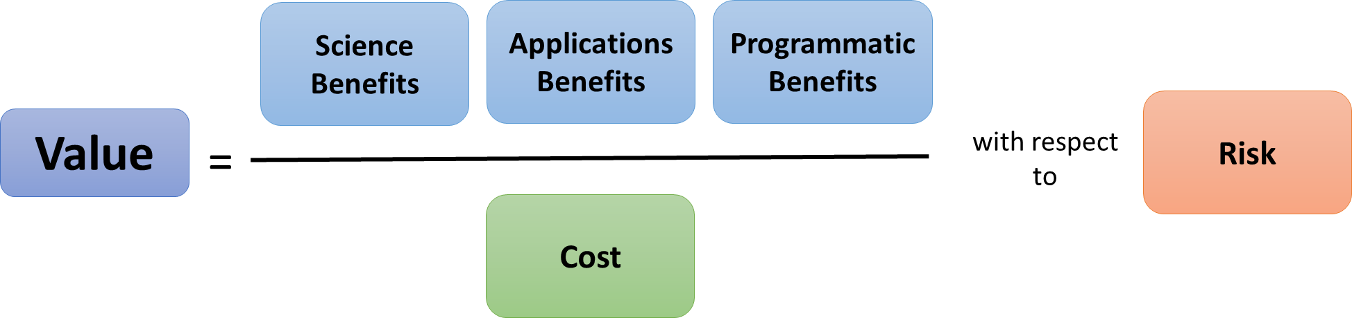
Figure 1: Initial visualization for defining value in the ACCP study.
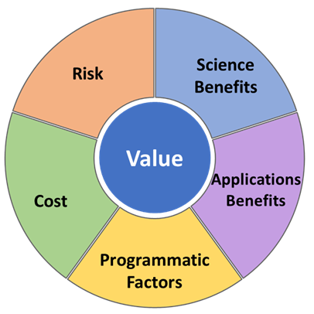
Figure 2: The Value Wheel, illustrating the five components of value in the ACCP study.
Of particular interest to the study participants was the definition of science benefit [8]. The science benefit for a science objective depends on its associated Geophysical Variables, which are the measurable factors that define a geophysical phenomenon and determine its behavior [9], and two sets of scores: the Utility, or how important a Geophysical Variable is to addressing a Science Objective assuming the Geophysical Variable is measured perfectly; and the Quality, or how often the architecture meets the uncertainty targets for the retrieved Geophysical Variable defined in the study’s Science Traceability Matrix. The authors initially developed a graphical representation of this concept, intended to demonstrate the distinction between Utility, which is architecture-independent, and Quality, which depends on an architecture, as well as the different ways quality scores might be obtained via existing literature, observing system simulation experiments (OSSE), or expert judgment elicitation. This representation, shown in Figure 3, was highly abstract and not easily comprehended. Contrary to the third guiding principle, this visualization attempts to convey numerous ideas at once, at a time when the authors were still working with the study team to define what each of the individual ideas was and how it would be implemented. Thus, there were too many inferential leaps to make in this single visualization relative to the existing basis of understanding at that time in the study, and the visualization failed to achieve the author’s purpose of communicating the integrated relationship of Utility and Quality.
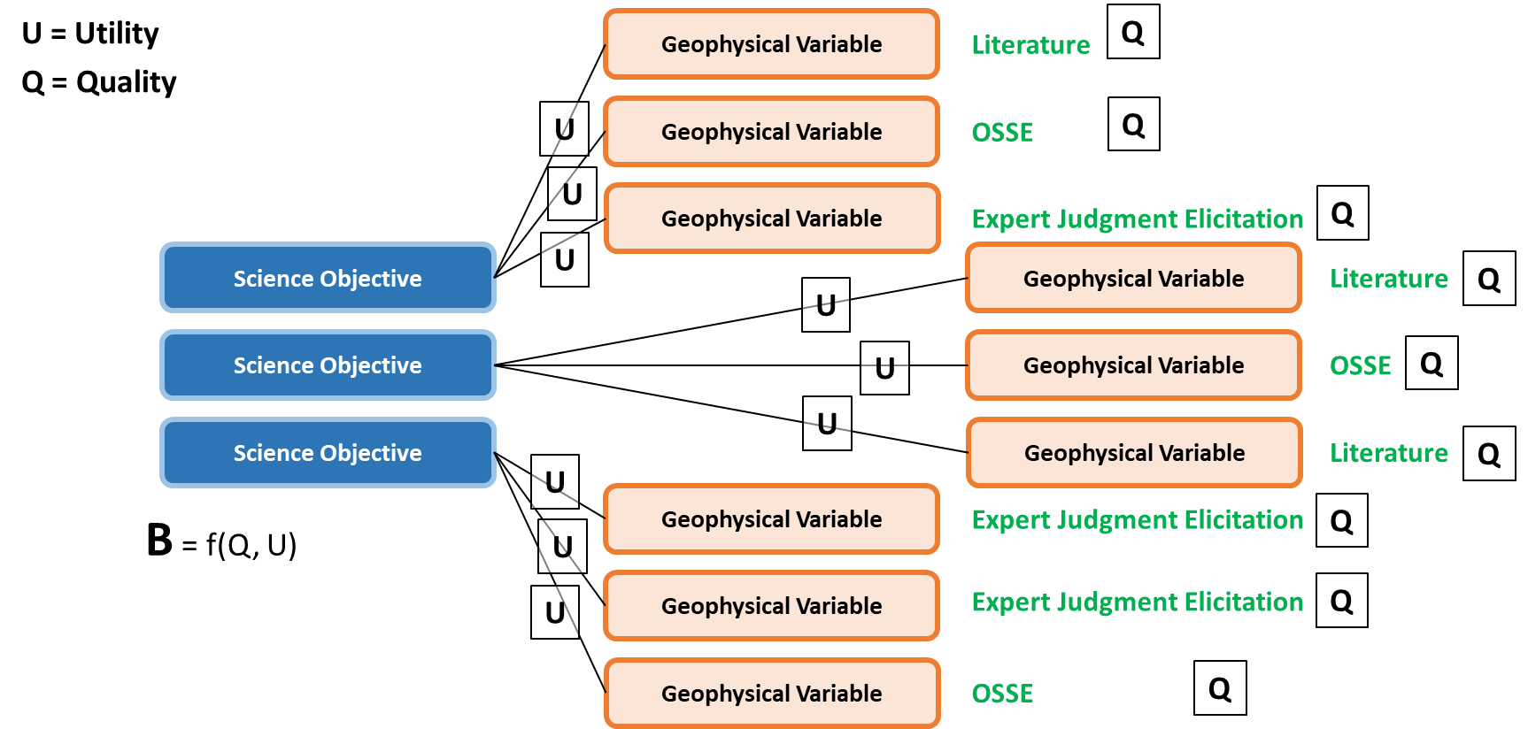
Figure 3: Initial form of the decomposition of science benefit into a combination of Utility and Quality.
Subsequently, the authors iterated with another member of the study team to depart from the dense and conceptual approach and instead develop an applied example that was accessible to all, regardless of background. The resulting analogy was based on preparing a hamburger, wherein the Geophysical Variables were ingredients, the Utility was how important that ingredient is to the burger, and the Quality was the quality of a given ingredient relative to the best possible. This analogy, shown in Figure 4, was easily digested by both the science team as well as those being introduced to the concept for the first time, including international partners and members of industry and academia; it became a standard part of future messaging. Drawing on the first guiding principle, the visualization was tailored to more easily convey the underlying ideas to the intended audience, and it also addressed the violation of the third guiding principle by the original implementation. Korhonen and Wallenius remark that “where the decision maker is an essential part of the solution process, this [tailoring to the audience] may be even more important. For example, in interactive approaches, the decision maker is asked to react to graphical representations. A wrong illusion provided by a graph may lead to an undesirable final solution” [10].

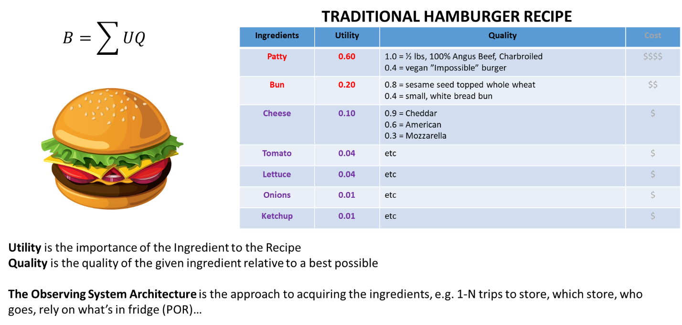
Figure 4: The burger analogy for defining science benefit and its components.
In the first year of the study, the study team developed over fifty candidate architectures. Each architecture consisted of one or more space platforms, each of which had as many as seven instruments. The many architectures and their associated spacecraft were tracked in a large spreadsheet, which presented several challenges: the multitude of architectures and instrument options necessitated scrolling through dozens of rows and columns, it was necessary to scan for the occasional checkmark that mapped an instrument to an architecture, and it was difficult to get an intuitive feel for the resulting mass of the associated spacecraft. The authors anticipated that a visual representation of each architecture that summarized the chosen instruments, their relative capability, and the spacecraft mass would facilitate subsequent assessments of the architectures. The authors developed a series of diagrams summarizing key details of each architecture, using consistent coloring and positioning to denote where to find information on instrument type and performance, mission parameters, and spacecraft mass; see Figure 5 for a notional example. The diagrams allowed the science team to quickly review and visually compare the key characteristics of each architecture when performing assessments of the architectures. By adhering to the second guiding principle, these diagrams reached a balance by providing enough information to enable those assessments without suggesting too great a degree of architecture development.
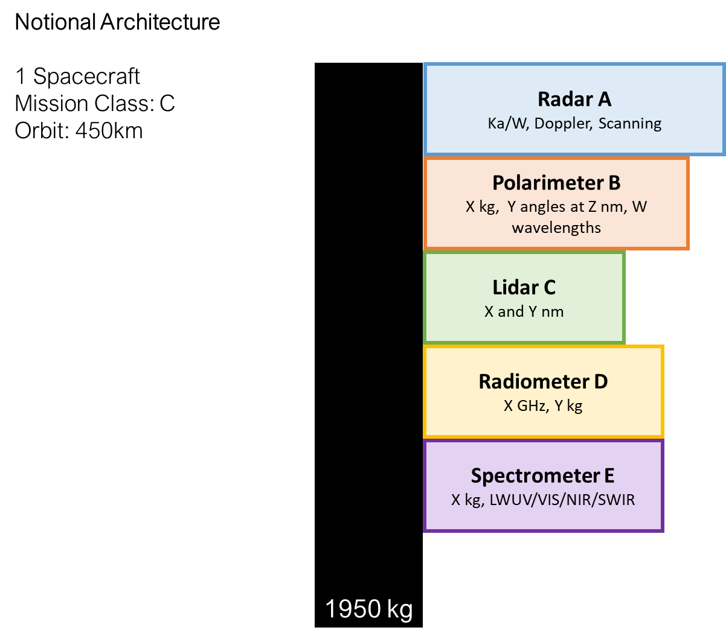
Figure 5: Architecture diagram showing which instruments are included and key details about the architecture.

- Facilitating elicitation and aggregation of data
Throughout the Value Framework, there often existed a need to integrate input from different experts to support decision making. Eppler and Bresciani state that “managers often cannot rely on their own expertise alone. They need input from a wide spectrum of specialists and thus at times struggle to integrate knowledge from different sources and use it for idea generation, decision making, or planning” [11]. The Utility scores that constitute a part of the Science Benefit were developed through a consensus-building process among experts. The authors developed a modified Delphi method to accelerate the consensus-building process and reduce the number of cycles required to converge while also increasing transparency and traceability of the scores [12]. The first step of this process required each expert to submit their own Utility score for each Geophysical Variable on a five-point Likert scale, as well as any comments on the rationale for their score. The authors developed a survey for each of the study’s eight Science Objectives, developed in the Science Traceability Matrix based on the thirty-four objectives from the Decadal Survey, to facilitate this step; see Figure 6 for an example of one of the surveys. In applying the third guiding principle to create a straightforward scale and a clean form for each Science Objective, the design allowed respondents to focus on the information needed to enable the assessment without overwhelming them with the quantity of responses needed in the totality of the activity. This approach succeeded where others might have failed relative to the guiding principles. A monolithic form that included the scoring for all eight Science Objectives would have risked overwhelming users and violating the third principle, particularly when asked to evaluate the same Geophysical Variable multiple times as it applied to different Science Objectives. Similarly, while providing a collaborative spreadsheet would have reduced the burden on the authors to postprocess submissions, it would have risked being too difficult to collaboratively edit with multiple users from different locations.
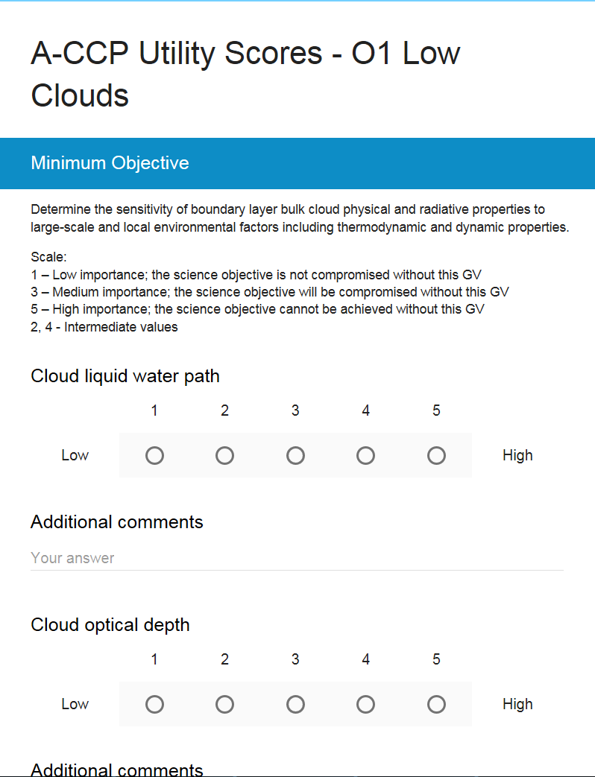
Figure 6: Survey for Utility scores for each Geophysical Variable for the Low Clouds Objective.
After this initial step was completed for the eight Science Objectives by each participating expert, the individual scores from each expert were aggregated in several ways. Figure 7 shows an example of the layout of the aggregation spreadsheet that was used to facilitate subsequent group discussions. For each Geophysical Variable, the experts were provided with the mean across all experts, a plot showing the scores (from one to five, with five corresponding to a full-height bar) from all the experts, and then individual scores and comments by each expert. Here, the second guiding principle still applied: the appropriate level of detail to provide was greater than in other visuals, because the information from the aggregated expert responses was available for review and analysis without any indication that there was only one definitive answer for a Utility score.
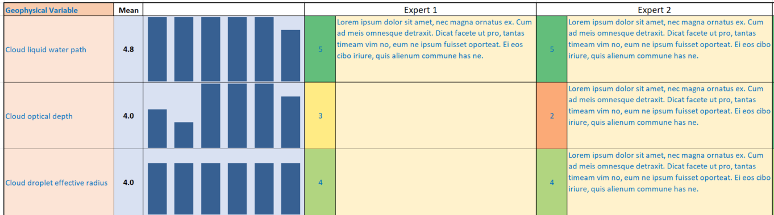
Figure 7: Scores and comments from each expert for each Geophysical Variable's Utility score.
A second summary visual, shown in Figure 8, collected the means and spreads of all the Geophysical Variables for a Science Objective on a single plot, allowing for quick visual inspection of both which variables had low or high consensus and the group’s initial average Utility of all Geophysical Variables. By providing these visualizations ahead of the review meeting, the authors enabled the experts to review the evaluations of their colleagues and become familiar with the variables that would require discussion. Where Figure 7 provided a high level of detail, Figure 8 was based on the third guiding principle in developing a straightforward representation of the data resulting from the individual elicitations while responding to the challenge of easily conveying the existence of clusters or outliers in the data [10].

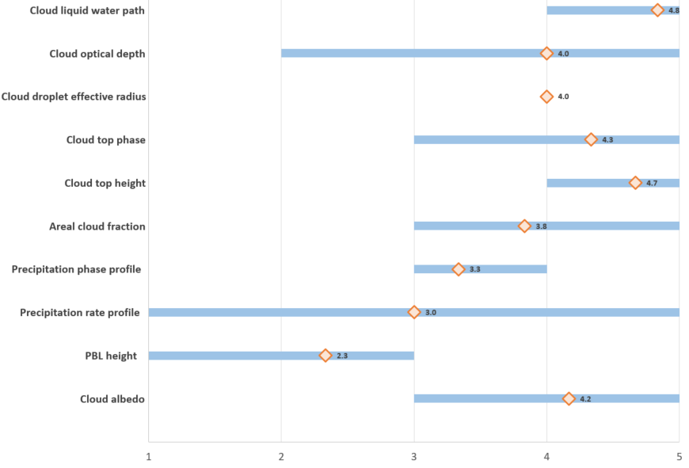
Figure 8: Summary plot of Utility scores illustrating the mean (orange diamond) and spread (blue bar) for each Geophysical Variable.
- Summarizing complex information
For each architecture, the five components of value for an architecture were collected into a “baseball card” that summarized key data and findings. The design of this baseball card evolved significantly over the course of the study. Figure 9 shows an early concept, with summary data on the cost and risk assessments of the architecture in the top half of the baseball card. The lower left quadrant was used to illustrate the Science Benefit scores as well as flags for tracking whether the architecture addressed all the Geophysical Variables at the desired minimum levels of Quality. The lower right quadrant included the assessment of Applications Benefit and key findings around Programmatic Factors. Each area of the baseball card was also linked to further detail (for example, each Science Benefit score led to the Utility and Quality scores associated with that Science Objective’s Geophysical Variables) to enhance the traceability of the assessments. Thus, a user could examine the summary level of the components of value while having easy access to the details that supported each part of the assessment. This facilitated collaboration from the wide variety of stakeholders, each with their own backgrounds and value systems, in the ACCP study. Eppler and Bresciani summarize this result by stating “the power of visualization to enable effective and seamless collaboration (especially across disciplinary boundaries) even exceeds its potential to improve communication” [11].

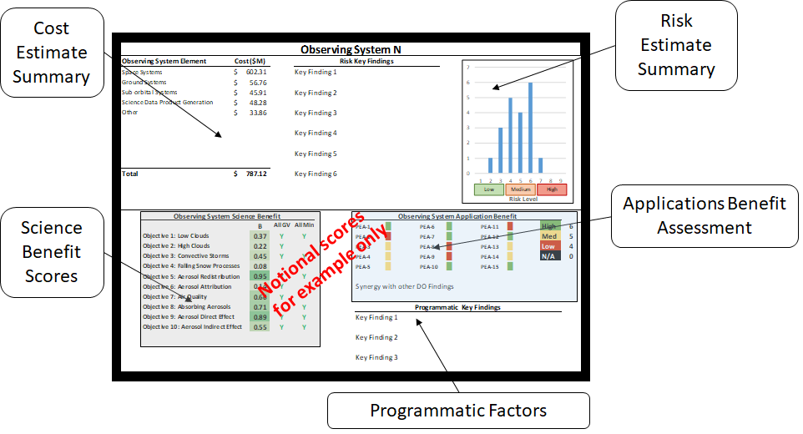
Figure 9: Early concept of the baseball card summarizing the five components of value for an architecture.
Figure 10 shows the current concept. The location of the identified components of value were reorganized to emphasize the Science Benefit scores, now located in the top-left quadrant of the baseball card. The output of the assessment of the Science Benefit is of significant interest to the majority of the stakeholders of the ACCP mission. Locating this information in the section of the baseball card made this information more easily accessible to users, who predominantly use a left-to-right written system in their working language. It also reflected the recognition that the layout of information impacts how well the complexity of that information is managed by the audience; Parker and DeBusk observe that “images and graphical representations can reduce cognitive load and increase the efficient processing of information” [13]. The Applications Benefit scores and the output of the assessment of the Programmatic Factors were relocated to the top half of the baseball card, collocating the output of the assessment of the various Benefits in the top half of the card, while the output of cost and risk are now collocated to the bottom half. As the study progressed, the assessment approaches were refined for the components of value and thus the chosen visualizations were updated to be responsive to these changes. The Science Benefit scores are now reported at the Science question level, and a bar graph conveys the changes in scores over the lifetime of the mission, as segments are launched and decommissioned. The Application Benefit section includes more descriptive names for the fifteen Potentially Enabled Applications, and the color scheme is now monochrome to convey degrees of positive performance as opposed to the traffic light color scheme, which could imply failure or a negative impact. Programmatic Factors now include quantitative assessments, instead of the originally intended narratives. The cost assessment is more granular, providing cost estimates at the level of the NASA Work Breakdown Structure. The output of the Risk assessment was also updated, now including specific risk elements identified by the assessment team, and scoring provided in terms of the traditional Likelihood and Consequence metrics used in the NASA 5 x 5 risk matrix. The traffic light color scheme is applied to the output of the Risk assessment to convey the risk level of each element. Finally, two sections were added to the baseball card: descope options are now included, with a brief description of each option in prose, and a visualization of the projected reserves is now displayed in a column format.

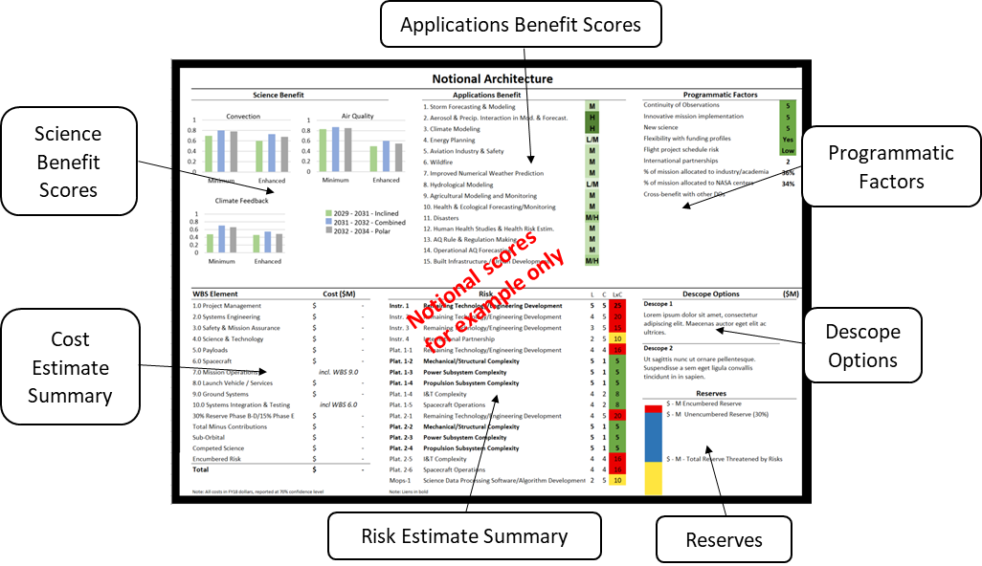
Figure 10: Current concept of the baseball card summarizing the five components of value for an architecture.
The progression from the initial concept in Figure 9 to the current concept in Figure 10 represents a unification of the three guiding principles: the changes were tailored to serve the study stakeholder needs, it balanced providing sufficient summary detail without being overwhelming, and it emphasized simplicity of design to allow for compact communication of the components of Value in a single view. These baseball cards summarize assessments performed by multiple teams, over the course of a year and a half, and aggregate information derived from many simulations, expert judgement elicitations, and reconciliation discussions. They represent the visual culmination of a tremendous amount of work performed by the study team and the final instantiation of a product that is the result of many iterations and refinements.
- The Value of Speed
In contrast with the long development timeline of the baseball card and the many people involved in its creation and refinement, the authors also engaged in multiple rapid visualization developments throughout the study. For these, speed of execution trumped quality and there was a preference for timely drafts rather than polished but delayed products. These were typically executed in real-time during a discussion, either with the use of a mapping software that was visible to all via projection, or simply with a whiteboard. The functions of these visualizations were the same as those outlined earlier for products that required more careful planning and execution: they structured communication, they facilitated the elicitation of opinions and their aggregation, and they articulated complex information.
During the first meeting among many of the study’s stakeholders to discuss the approach, the authors recognized the need for a visualization that could bridge the communities of scientists and engineers that were coming together for the first time in-person to plan the study’s execution. The authors worked with representatives from several of the disciplines within the study team to create a white-board diagram of the proposed study process, with an emphasis on the key milestones and down-select filters that would control the progress towards a final set of architectures. The creation of the diagram revealed and clarified many questions that were previously hidden, and the final presentation of the diagram to the assembled study team structured the conversation and enabled convergence on the next steps for the study.
The initial meeting to develop candidate architectures was the first time the study team worked to combine information about potential instruments and platforms with the current understanding of the science and applications objectives. For this formulation activity, the team split into separate meetings based on the needs of the individual science communities, with the aerosols in one meeting and the clouds, convection, and precipitation in the other. There was no overarching guidance for how to explore the trade space in a consistent fashion between the two meetings, and thus a risk that the outputs of those discussions would not be easily reconciled when the full team reconvened. Recognizing this, the authors split up between the two meetings, collaboratively communicating and developing a common visualization format that would support consistent results that could be combined. Thus, rather than face a potentially lengthy post-processing effort to reconcile the results, the combined team was able to integrate results in real-time to arrive at a set of candidate architectures that could respond to both science communities’ needs. This enabled convergence during the face-to-face meeting, rather than delaying the decision-making process with an additional cycle of post-processing and reconciliation.
- Lessons Learned
The design, development, and implementation of the visualizations of the Value Framework led to several lessons learned. Although these lessons derive from specific examples, they can be generalized for use in other visualization designs to aid decision-making.
Experience through refinement taught the authors that representing Value graphically as a wheel, rather than as an algebraic equation, made the concept more tractable for the scientists and engineers of the study team. From this refinement, and discussion with members of the study team, the authors learned that using too mathematical an explanation for a concept that was not intended to be purely quantitative produced unintended implications that distracted from the core message for the intended audience. It was through application of the first guiding principle that the design of the visualization was matched to the appropriate lens for the audience. A further step to consider in future visualization development is an emphasis on visualizations that can be tailored to individual needs, given that different personality traits and expertise will yield different degrees of resonance with a given visualization [14].
Similarly, there was an iteration in the arrival at the visualization that conveyed the concepts of Utility and Quality as constituents of Science Benefit. Here, the iteration was driven not solely by the authors, as was the case with the arrival at the Value wheel, but through collaboration with one of the study scientists. The version that was ultimately used, and that best conveyed these concepts, was refined by the intended beneficiary of the visualization. Thus, an earlier collaboration might have avoided wasted effort by the authors, as it was once the authors collaborated with the target audience that they were able to jointly develop a visualization that better resonated with that audience.
On multiple occasions, the authors recognized an emerging need for a visualization to support an ongoing effort or conversation in the study. In a trade-off between developing something quickly that was effective but imperfect, relative to expending more time to craft a more precise representation, the authors found that the ability to do the quick design enabled conversations that would be delayed pursuing perfection. This rapid development and implementation allowed the authors to be responsive to needs in the moment and facilitate decisions throughout the study. Thus, cultivating the ability to quickly create a visualization that provides value, even if it is not optimized, allows for aid to decision-making that can sustain progress. The authors recognized that having access to and using the right tools would enable them to achieve this rapid development and implementation. Further, they found that often much of the good from presenting an imperfect product comes from the act of enabling the conversation, as opposed to coming only from the quality of the product. By embracing this tension, they were able to provide valued support even when the imperfections were subject to scrutiny.
- Conclusion
The application of the visualization guiding principles (being responsive to the audience, tailoring fidelity to both the audience and the available data, and maintaining simplicity and focus) enable the design and implementation of visualizations that support the Value Framework’s introduction of structure, transparency, and traceability to the ACCP Study. The examples described in this paper cover a diverse range of uses from facilitating conversations about process to aggregating data across the study’s objectives. The lessons learned from the Value Framework visualizations have not only contributed to the success of the Value Framework and the ACCP study but can also be applied in other decision-making activities.

References
- National Academies of Science, Thriving on Our Changing Planet: A Decadal Strategy for Earth Observation from Space, National Academies Press, 2018.

- Hegarty, M., “The Cognitive Science of Visual-Spatial Displays: Implications for Design”, Topics in Cognitive Science, 2011 3: 446-474, https://doi.org/10.1111/j.1756-8765.2011.01150.x.

- Zhang, K., “Using visual languages in management”, Journal of Visual Languages and Computing, Volume 23, Issue 6, 2012, pages 340-343.

- Padilla, L., Creem-Regehr, S. H., Hegarty, M., and Stefanucci, J., “Decision Making with visualizations: a cognitive framework across disciplines”, Cognitive Research: Principles and Implications, 3:29, 2018, https://doi.org/10.1186/s41235-018-0120-9.

- Zeller, S., and D. Rogers, “Visualizing science: How color determines what we see”, Eos, 101, 2020, https://doi.org/10.1029/2020EO144330.

- Hegarty, M., “Choosing and Using Geospatial Displays: Effects of Design on Performance and Metacognition”, Journal of Experimental Psychology: Applied, 18(1):1-17, 2012.

- Kosslyn, S. M., Graph design for the eye and mind. New York: Oxford University Press, 2006.

- Ivanco, M. L., Jones, C. A., “Assessing the Science Benefit of Space Mission Concepts in the Formulation Phase,” 2020 IEEE Aerospace Conference, 2020.

- Committee on a Framework for Analyzing the Needs for Continuity of NASA-Sustained Remote Sensing Observations of the Earth from Space, Continuity of NASA Earth Observations from Space: A Value Framework, National Academies Press, 2015.

- Korhonen, P. and Wallenius, J., “Visualization in the Multiple Objective Decision-Making Framework” in: Branke J., Deb K., Miettinen K., Słowiński R. (eds) Multiobjective Optimization. Lecture Notes in Computer Science, vol 5252. Springer, Berlin, Heidelberg, 2008, https://doi.org/10.1007/978-3-540-88908-3_8.

- Eppler, M. and Bresciani, S., “Visualization in management: From communication to collaboration. A response to Zhang”, Journal of Visual Languages & Computing, Volume 24, Issue 2, 2013, Pages 146-149, ISSN 1045-926X, https://doi.org/10.1016/j.jvlc.2012.11.003

- Ivanco, M. L., Jones, C. A., and Deacon, S. A., “A Modified Delphi Method to Accelerate Consensus Building in Expert Judgment Elicitation”, INFORMS Annual Meeting, 2020.

- Parker, C., DeBusk, K., “Supporting Complex Decisions Through Selection of Appropriate Graphical Layout”, in: Stephanidis C. (eds) HCI International 2016 – Posters' Extended Abstracts. HCI 2016. Communications in Computer and Information Science, vol 617. Springer, Cham., 2016, https://doi-org.proxy.lib.odu.edu/10.1007/978-3-319-40548-3_11.

- Conati, C., Carenini, G., Hoque, E., Steichen, B., and Toker, D., “Evaluating the Impact of User Characteristics and Different Layouts on an Interactive Visualization For Decision Making”, Eurographics Conference on Visualization (EuroVis) 2014, Volume 33, Number 3.

Aerospace Engineer, Space Mission Analysis Branch, AIAA Member
Aerospace Engineer, Space Mission Analysis Branch, AIAA Member
Aerospace Engineer, Space Mission Analysis Branch, AIAA Member

