GEOS-Carb III: Delivering a mature, physically consistent set of flux and concentration products o in support of carbon monitoring
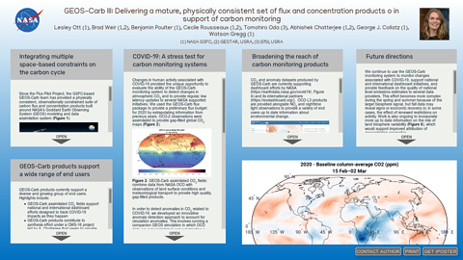
Lesley Ott (1), Brad Weir (1,2), Benjamin Poulter (1), Cecile Rousseaux (1,2), Tomohiro Oda (3), Abhishek Chatterjee (1,2), George J. Collatz (1), Watson Gregg (1)
(1) NASA GSFC, (2) GESTAR, USRA, (3) EfSI, USRA

PRESENTED AT:

INTEGRATING MULTIPLE SPACE-BASED CONSTRAINTS ON THE CARBON CYCLE

Since the Flux Pilot Project, the GSFC-based GEOS-Carb team has provided a physically consistent, observationally constrained suite of carbon flux and concentration products built around NASA's Goddard Earth Observing System (GEOS) modeling and data assimilation system (Figure 1).
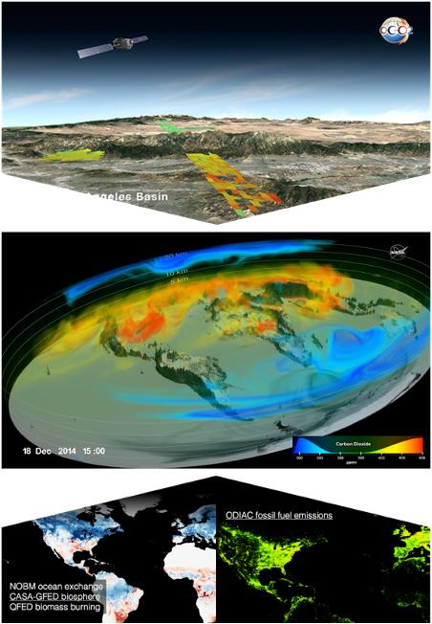

Figure 1.Schematic of the GEOS-Carb carbon monitoring system.
This includes fire and net ecosystem exchange estimates from the CASA-GFED3 model (constrained by MODIS LAI and burned area), ocean-atmosphere exchange from the NASA Ocean Biogeochemical Model (NOBM), and high-resolution information about fossil fuel emissions from the Open-source Data Inventory for Anthropogenic CO₂ (ODIAC). These fluxes are integrated in the GEOS atmospheric general circulation model, which assimilates space-based CO₂ measurements from OCO and GOSAT, providing a high-quality, 4-dimensional view of atmospheric carbon concentrations that is compatible with NASA existing Modern-Era Retrospective analysis for Research and Applications, Version 2 (MERRA-2) climate reanalysis.

GEOS-CARB PRODUCTS SUPPORT A WIDE RANGE OF END USERS
GEOS-Carb products currently support a diverse and growing group of end users. Highlights include:
- GEOS-Carb assimilated CO₂ fields support national and international dashboard efforts designed to track COVID-19 impacts as they happen
- GEOS-Carb products contribute to synthesis effort under a CMS-16 project led by A. Chatterjee that seeks to provide coherent and sustained CMS science team engagement with global stakeholders the Global Carbon Project and the Inegrated Global Greenhouse Gas Information System (IG³IS)
- The GEOS-Carb system is also used to support the OCO Science Team, providing gap-filled L3 data products
- CASA-GFED data support NOAA's CarbonTracker inverse modeling system (Jacobson et al., 2020) and modeling teams throughout the OCO Science Team (Crowell et al., 2019)
- Contributions to engagement of state level stakeholders led by Dr. George Hurtt
- GEOS-Carb flux data have supported evaluation of airborne data collected during NASA's ABoVE campaign (Sweeney et al., 2020)
- Integration of GEOS-Carb flux products into GEOS forecasting models has provided experimental forecast support for NASA's ACT-America 2019 field campaigns.
- Data constrained flux ans concentration fields are being used as a benchmark for Earth system model development (collaboration with NASA GISS)
- ODIAC emissions support both global-scale studies, serving as a standard dataset in the OCO model intercomparison, and regional to local scale efforts, including the Indianapolis Flux Experiment (INFLUX), the Fluxes of Atmospheric Greenhouse‐Gases in Maryland (FLAGG-MD), and Tokyo-megacity project.
- GEOS-Carb 4D concentration data provide boundary conditions for higher resolution regional models (Tao et al., 2019)

COVID-19: A STRESS TEST FOR CARBON MONITORING SYSTEMS
Changes in human activity associated with COVID-19 provided the unique opportunity to evaluate the ability of the GEOS-Carb monitoring system to detect changes in atmospheric CO₂ and to provide regular, low latency updates to several NASA supported initiatives. We used the GEOS-Carb flux package to provide a preliminary flux budget for 2020 by extrapolating information from previous years. OCO-2 observations were assimilated to provide gap-filled global CO₂ maps (Figure 2).
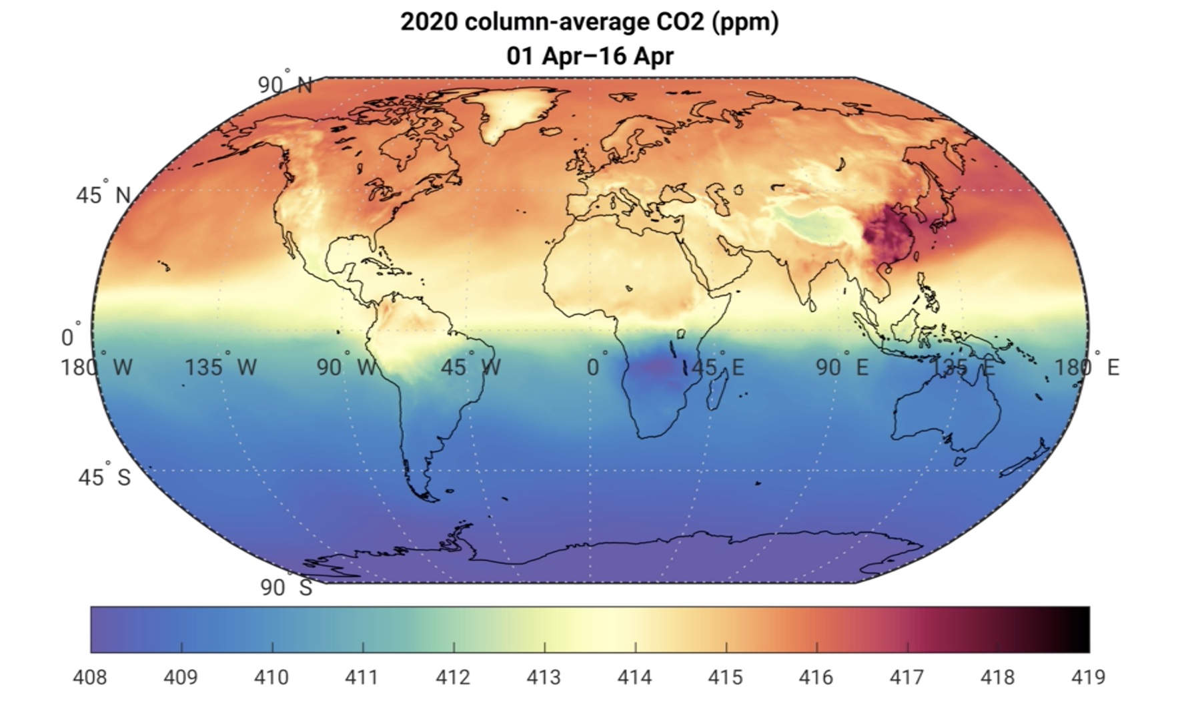
Figure 2. GEOS-Carb assimilated CO₂ fields combine data from NASA OCO with observations of land surface conditions and meteorological transport to provide high quality, gap-filled products.

In order to detect anomalies in CO₂ related to COVID-19, we developed an innovative anomaly detection approach to account for circulation anomalies. This involves running a companion GEOS simulation in which OCO data are not assimilated and substracting a mean of typical years from 2020 values from both the assimilation and reference runs. The difference between the 2020 anomaly observed by OCO and that produced by simulations using extrapolated fluxes represents the 'flux-driven anomaly shown in the slide show (right).

Early in the year, CO₂ anomalies highlight the role of climate-driven changes in land fluxes including variability related to the Indian Ocean Dipole, which contributed to hot, dry conditions over Australia and wet, favorable growing conditions in Africa and India. In early April, COVID-19 related emissions decreases are evident over the world's largest economies. A comparison with a GEOS simulation that incorporates low latency carbonmonitior.org emissions estimates (Figure 4) shows that the satellite estimated anomaly generally compares well with the estimate based on activity data, highlighting the ability of OCO data to provide a meaningful evaluation of emissions estimates.

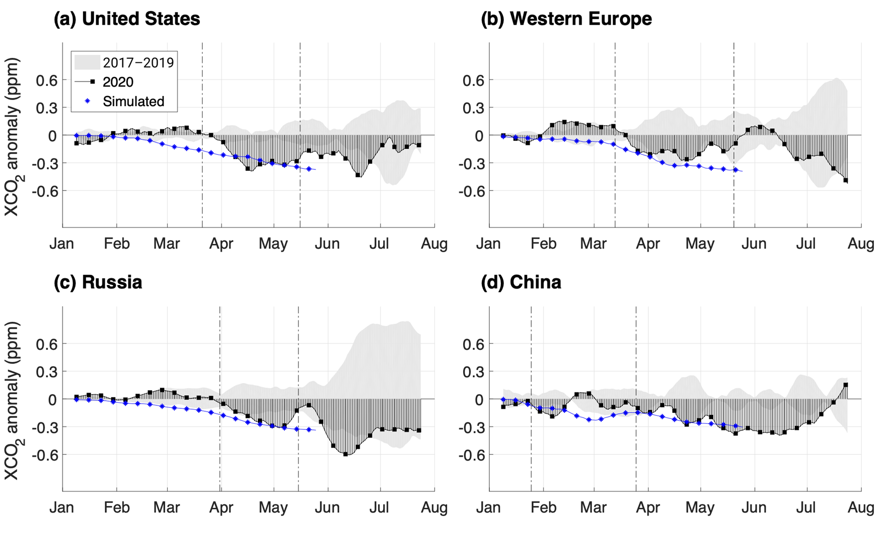
Figure 3. Time series showing CO₂ anomalies for 2020 (black) and typical years (2017-19, grey shading). GEOS-Carb CO₂ data are also compared an independent GEOS simulation that assumed emissions decreases based on activity data (blue).

BROADENING THE REACH OF CARBON MONITORING PRODUCTS
CO₂ and anomaly datasets produced by GEOS-Carb are currently supporting dashboard efforts by NASA (https://earthdata.nasa.gov/covid19/, Figure 4) and its international partners (https://eodashboard.org/). OCO L3 products are provided alongside NO₂ and nighttime light observations to provide a variety of end users up to date information about environmental change.
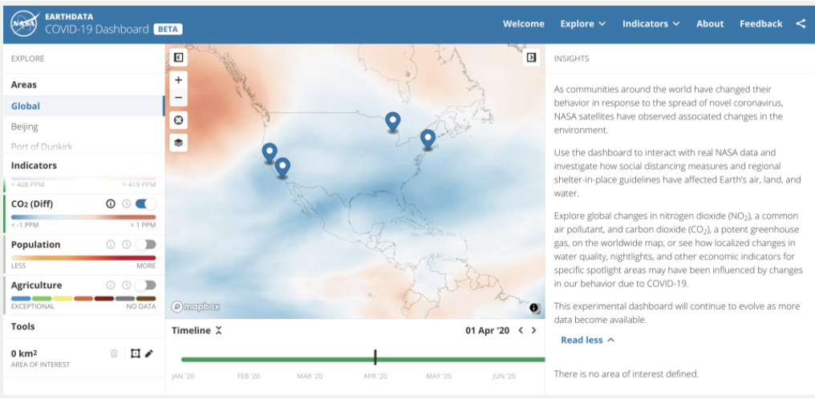
Figure 4. Snapshot of NASA's COVID-19 dashboard highlighting CO₂ anomalies from the GEOS-Carb monitoring system.

In addition, we've implemented a new visualization tool (Figure 5) that highlights our carbon reanalysis (https://fluid.nccs.nasa.gov/carbon/). Currently, we include spatial maps of CO₂ with a plan to extend to CO and CH₄ and to include multi-day carbon 'datagrams' over locations of interest (e.g. cities, observing sites).
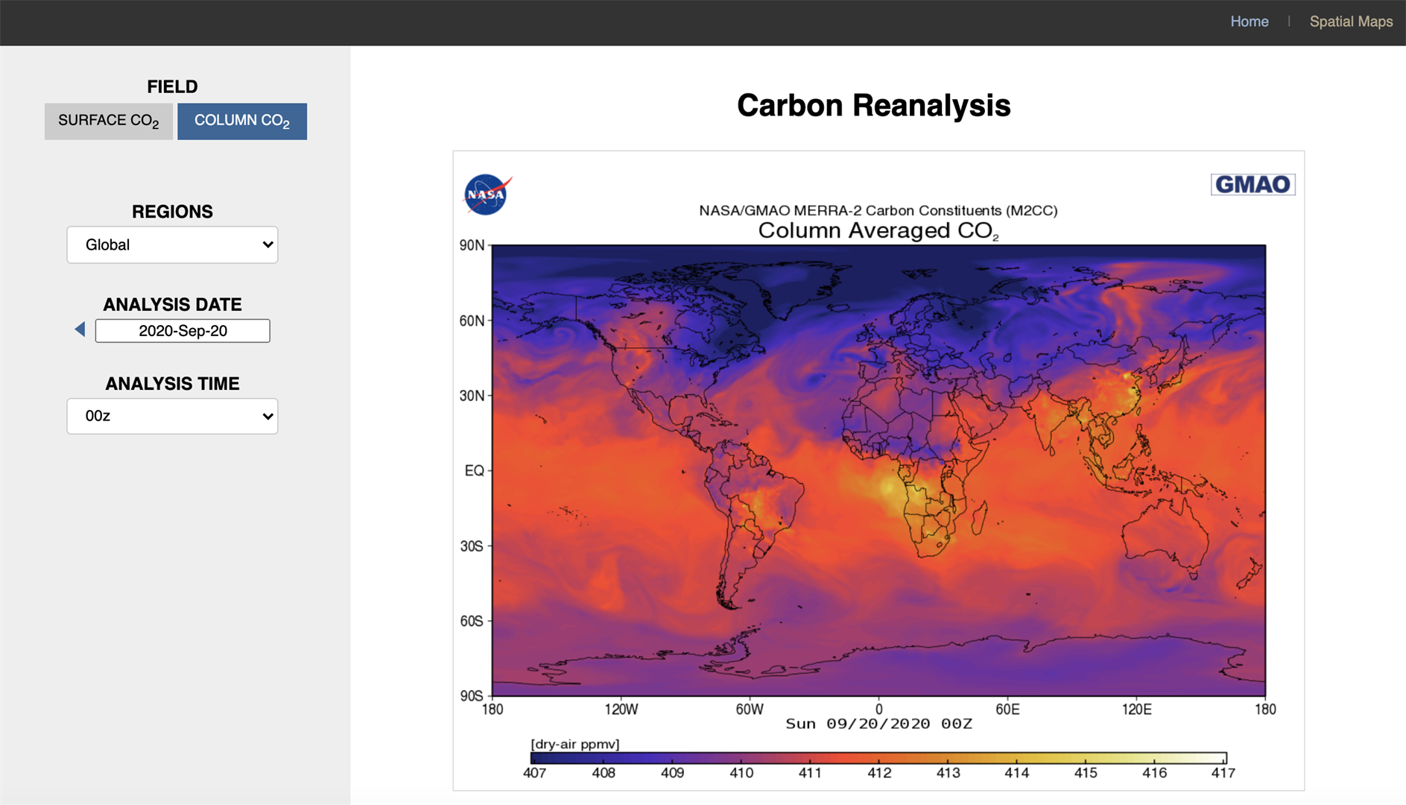
Figure 5. Snapshot of GEOS-Carb viewer based on GMAO's Framework for Live User-Invoked Data (FLUID).

FUTURE DIRECTIONS
We continue to use the GEOS-Carb monitoring system to monitor changes associated with COVID-19, support national and international dashboard initiatives, and provide feedback on the quality of national level emissions estimates to several data providers. This effort becomes more complex during the spring and summer because of the larger biosphere signal, but fall data may reveal signs or economic recovery or, in some cases, the effect of renewed restrictions on activity. Work is also ongoing to incorporate more up to date information on the role of land biosphere variability (Figure 6), which would support improved attribution of concentration anomalies.
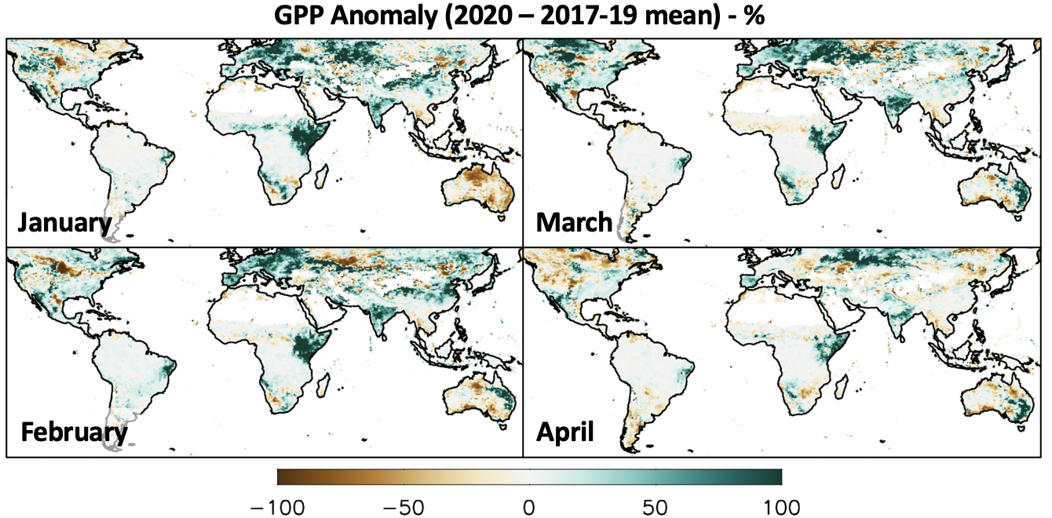
Figure 6. Observationally derived GPP anomalies based on FluxSat data (Joiner and Yoshida, 2020), which uses MODIS reflectance data to upscale flux tower observations of GPP and can provide information about land flux variations in close to real time.

