Test Capabilities of the NASA Langley Direct-Connect
Supersonic Combustion Test Facility with Historical Perspective

Diego P. Capriotti

Hypersonic Air-breathing Propulsion Branch
NASA Langley Research Center
Hampton, VA

ABSTRACT

In 1969, a combustion-heated direct-connect test facility was assembled at the NASA Langley Research Center to conduct basic research in ramjet and scramjet propulsion systems. The facility was initially used in assessing the mixing, ignition, flame holding, and combustion characteristics of various ramjet and scramjet combustors. Over the years, the facility was updated and modified to conduct increasingly longer and more complicated tests. Today, the facility is known as the Direct Connect Supersonic Combustion Test Facility and is part of the NASA Langley Scramjet Test Complex. More recently, the facility has been used by external customers to test fuel-cooled and uncooled, flight-like test articles. Tests have been conducted at ramjet flight conditions for up to 15 minutes of continuous operation. Even though the facility is nearly 50 years old, it remains a viable and useful tool in the support of various U.S. hypersonic programs.

Introduction/Purpose
The Langley Direct-Connect Supersonic Combustion Test Facility (DCSCTF) is used to test ramjet and scramjet test articles in flows with stagnation enthalpies duplicating that of flight at Mach numbers up to eight. Results of the tests are typically used to assess the mixing, ignition, flame holding, and combustion characteristics of the test articles. The facility operates directly connected to the test article with the entire facility test gas passing through the test article. The test article may exhaust freely (into the test cell), or to the atmosphere above the roof of the building using an air-ejector. The stagnation enthalpy necessary to simulate high-speed flight is achieved through hydrogen-air combustion with oxygen replenishment to obtain a test gas with the same oxygen mole or mass fraction as atmospheric air. The flow at the exit of the facility nozzle typically simulates the flow entering the isolator or combustor of a ramjet or a scramjet in flight. Various fuels may be supplied to the ramjet or scramjet test articles including, gaseous hydrogen, gaseous hydrocarbons, and liquid hydrocarbons. A 20/80-percent mixture of silane/hydrogen (by volume) is available for use as an ignition source. During the last several years, the facility has been called upon repeatedly by external customers to conduct long-duration tests of flight-like, fuel-cooled ramjet test articles.

Facility Layout
As shown in Figure 1 below, the DCSCTF is located in a 16- by 16- by 52-ft test cell with forced-air ventilation in Building 1221D, Room 124 at the NASA Langley Research Center (LaRC). Test air is supplied from a bottle field containing approximately 100,000-lb_{m} of air at a nominal pressure of 600-psi, see Figure 2 below. The 600-psi bottle field may be refilled continuously during a test using the nearby 5000-psi bottle field, thereby allowing for a steady delivery of high-pressure air to the facility for long-duration testing.

Gaseous hydrogen is supplied from 60,000 ft³ tube trailers at a maximum pressure of 2400 psia and is regulated to 700 psia prior to entering the test cell. Similarly, oxygen is also supplied from tube trailers at a maximum pressure of 2400 psia and is regulated to 1000 psia prior to entering the test cell. Nitrogen is supplied from a 1000 ft³ storage tank at a nominal pressure of 3500 psia regulated to 230 psia for purge operations. A separate supply of ultra clean nitrogen using a rack with sixteen K-bottles is used for purging of the facility oxygen system.

A water pump located in the basement of the facility flows up to 700 GPM of treated and filtered water (50 micron) at pressures up to 540 psi. Typically, this water is used to cool the facility vitiated heater, supersonic nozzle and any water-cooled test article components. City water at a nominal pressure of 65 psia is also available for the cooling of smaller test article components or instruments and is sometimes injected into the facility exhaust system to cool the exhausted test gas.

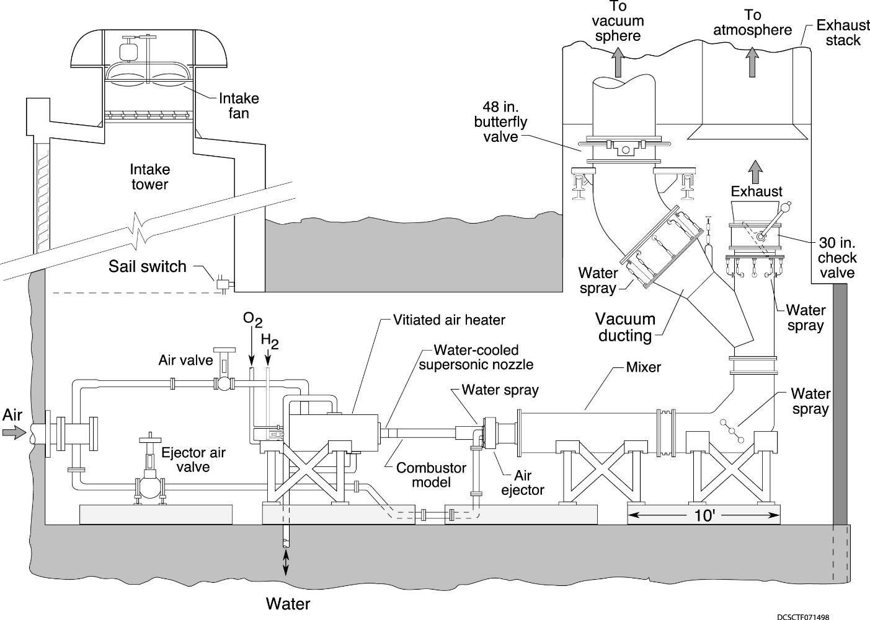
Figure 1: Schematic of the Test Cell, B1221D, R124.

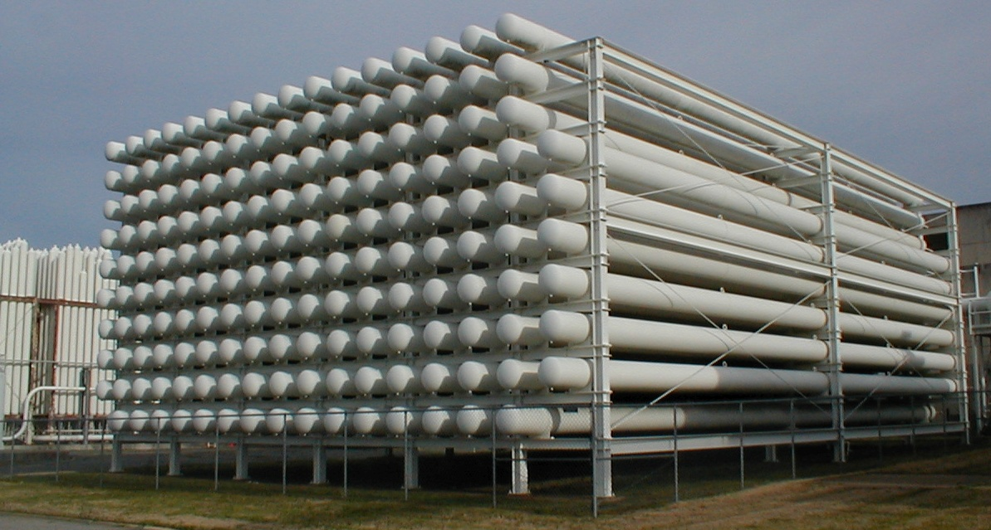
Figure 2: 600 psi air (horizontal) bottle field in foreground,
5000 psi (vertical) bottle field in background on far left.
Facility Combustion Heater
The DCSCTF uses a water-cooled hydrogen/air combustion heater with oxygen replenishment to generate the high-enthalpy test gas required for the testing of ramjet and scramjet engines. A schematic of the heater is shown in Figure 3. The liner of the combustion chamber is made of copper with an inner diameter of nine inches and a length of four feet. During the operation of the facility heater, oxygen is injected from 12 in-stream injectors and premixed with the air before hydrogen is added to the flow. The hydrogen is injected into the air and oxygen mixture from 12 in-stream injectors centered in holes located in a baffle or mixing plate upstream of the water-cooled combustor section. Ignition of the gas mixture is achieved using an electric-spark-activated hydrogen and oxygen torch igniter. The primary contaminant in the test gas is water vapor, which varies from a small amount at low flight Mach number conditions to as much as 30% (by volume) at Mach 7 conditions. A small amount of nitric oxide is also present in the test gas at conditions above Mach 7.
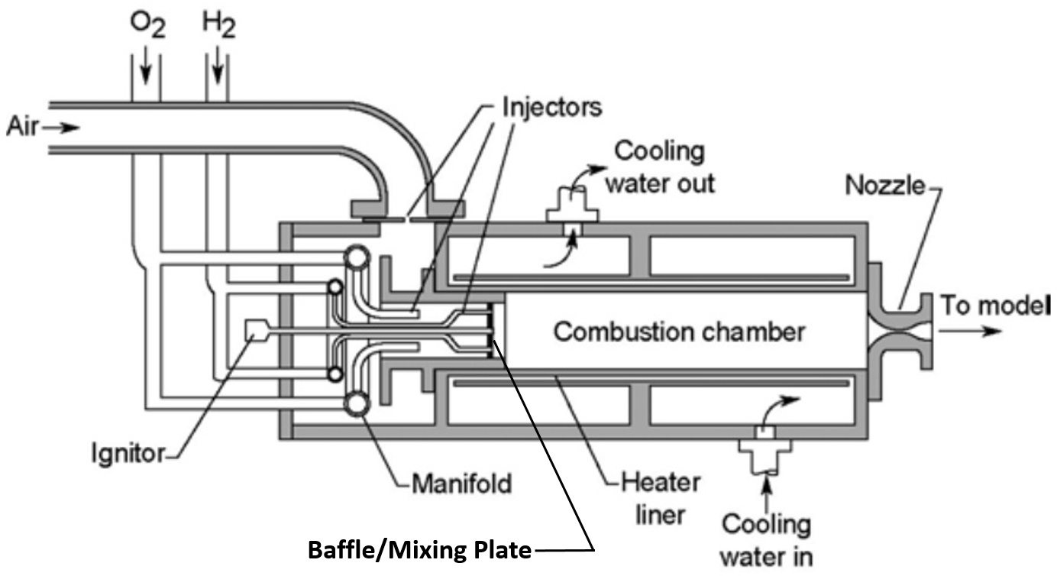
Figure 3: Schematic of the facility hydrogen-air heater with oxygen replenishment.

The facility heater was initially constructed without a mixing or baffle plate having the oxygen and hydrogen injectors coplanar at one axial station (see reference 1 for the original design of the facility heater). The heater functioned passably in this manner but displayed a somewhat nonuniform total temperature profile most likely due to inadequate mixing of the three streams, see Reference 2. To improve the mixing of the three streams, a baffle plate was added, and the hydrogen injectors were extended downstream. The baffle plate now separates the upstream cold portion of the heater, which contains the air and oxygen injection, from the downstream hot portion of the heater, which contains the hydrogen injection and combustion. In this manner, the air and oxygen are forced to travel through the space between the twelve square hydrogen injectors that are inserted into the twelve round holes in the baffle plate. For proper mixing of the three streams, the pressure drop across this mixing plate is generally kept to 10-20%. Facility personnel select a proper combination from available mixing plates and hydrogen injectors to create the desired pressure drop for different test points using facility design curves.

A heater flow quality study was conducted during 1998 (Reference 3), which included the examination of the facility nozzle exit flow field using various measurement techniques along with accompanying computational simulations. A silane-seeded laser-sheet visualization revealed an unmixed region or cold spot at the exit of the facility nozzle, coincident with the location of the facility igniter. Apparently, cold air and oxygen were leaking into the hot portion of the heater by passing through a small gap between the igniter and the mixing plate. A conical sleeve was built and installed on the igniter to seal the gap between the igniter and the mixing plate. The resulting flow field was much improved, see Reference 3.

The facility heater test point is uniquely defined by the three mass flow rates (air, hydrogen, and oxygen), the facility nozzle throat area, and the total pressure achieved during the combustion process. The hydrogen and oxygen injectors are fixed, therefore, the flow rates are controlled simply by the setting of the supply pressures while the air flow rate is set by facility personnel using a control valve. The hydrogen and oxygen injectors and the air valve may operate choked or unchoked. Choked operation of the air, hydrogen, and oxygen systems is preferred for better control, but is not always possible at higher flow rates and pressures. Currently, the facility heater operates at one test condition per test. Modifications are underway to control the hydrogen and oxygen supply pressures using a newer Programmable Logic Controller (PLC) such that the supply pressures and hence the flow rates can be changed during a test. The same PLC is also being modified to control the air control valve and hence the mass flow rate. Once the modifications are complete, the heater will be able to modulate the test point during a test by approximately two flight Mach numbers. As an example, the heater will be able to start a test at a simulated flight Mach number of four and smoothly transition to a flight Mach number of five and six by using the PLC to control the three flow rates. Even though the simulated flight Mach number can be changed during a test, the facility nozzle exit (aerodynamic) Mach number will remain approximately constant as the nozzle geometry is normally fixed and the variation of the aerodynamic Mach number with facility total temperature is small.

Facility Nozzles
Many customers bring supersonic nozzles along with the test article when they come to test at the DCSCTF. The facility does however maintain five rectangular, water-cooled supersonic nozzles that can be used for testing. Each nozzle has straight sidewalls, hence a constant width, and contoured horizontal walls. The nozzles are described in Table 1 below.

Table 1: Available facility supersonic nozzles.
Design Mach  number | Nozzle Throat |  |  | Nozzle Exit
Design Mach  number | Width | Height | Area | Width | Height | Area
[-] | [inches] | [inches] | [inches²] | [inches] | [inches] | [inches²]
1.7 | 3.46 | 1.07 | 3.702 | 3.46 | 1.52 | 5.259
2.0 | 3.46 | 0.846 | 2.927 | 3.46 | 1.52 | 5.252
2.1 | 5.208 | 1.477 | 7.692 | 5.208 | 2.88 | 15.000
2.65 | 5.208 | 0.831 | 4.328 | 5.208 | 2.88 | 15.000
2.70 | 6.69 | 0.356 | 2.382 | 6.69 | 1.5 | 10.035

Test Conditions
The total temperature of the facility combustor is not measured directly due to the harsh conditions present within the facility heater. Instead, during testing the facility total temperature is calculated using the choked nozzle equation combined with equilibrium thermodynamic curve fits of parameters that vary with the facility total temperature and fuel-to-air ratio (see Reference 4). The calculation of the facility total temperature described in Reference 4 uses an iterative process, but it can also be solved directly by using the quadratic equation. The quadratic equation solution is programmed into the facility data acquisition system to display in real-time the facility total temperature and heat loss. Post-test calculations using a quasi-one-dimensional equilibrium computer program (from Reference 5) are also typically performed. These quasi-one-dimensional calculations are used to determine the total enthalpy of the test gas and the nozzle exit conditions. The below table describes some selected test conditions that have been used with the nozzles described earlier. Shown in the table is the simulated flight (enthalpy) Mach number, facility stagnation pressure, temperature, and enthalpy, along with the facility mass flow rate. Also shown in the table are the flow field conditions at the exit of the facility nozzle: the aerodynamic Mach number, static pressure and temperature, and the dominant test gas mole fractions.

Table 2: Nominal facility test conditions.
Flight  Mach | Stagnation conditions |  |  | Mass  flow | Nozzle exit conditions
Flight  Mach | P₀ | T₀ | H_{t0} | Mass  flow | Mach | P | T | Mole fractions
[-] | [psia] | [deg.R] | [BTU/lbm] | [lb_{m}/s] | [-] | [psia] | [deg.R] | N2 | O2 | H2O | NO
3.0 | 80.9 | 1056 | 263 | 4.84 | 1.77 | 14.7 | 658 | .733 | .21 | .049 | 0
4.0 | 79.2 | 1531 | 397 | 3.88 | 1.76 | 14.7 | 983 | .690 | .21 | .059 | 0
5.0 | 76.9 | 2084 | 574 | 3.17 | 1.75 | 14.7 | 1389 | .638 | .21 | .095 | 0
3.5 | 101.6 | 1379 | 351 | 4.16 | 2.05 | 11.9 | 772 | .713 | .21 | .068 | 0
4.0 | 124.1 | 1529 | 397 | 4.79 | 2.04 | 14.7 | 869 | .691 | .21 | .091 | 0
5.0 | 119.8 | 2084 | 574 | 3.89 | 2.02 | 14.7 | 1240 | .638 | .21 | .145 | 0
6.0 | 115.8 | 2685 | 793 | 3.25 | 2.01 | 14.7 | 1667 | .573 | .21 | .210 | 0
7.0 | 112.3 | 3293 | 1054 | 2.78 | 1.99 | 14.7 | 2124 | .491 | .21 | .291 | .002
8.0 | 109.3 | 3889 | 1358 | 2.43 | 1.98 | 14.7 | 2595 | .398 | .21 | .381 | .004
4.0 | 98.4 | 1542 | 397 | 9.98 | 2.14 | 10.0 | 839 | .708 | .21 | .074 | 0
5.0 | 94.8 | 2103 | 574 | 8.08 | 2.12 | 10.0 | 1201 | .655 | .21 | .127 | 0
6.0 | 91.4 | 2721 | 793 | 6.73 | 2.10 | 10.0 | 1625 | .598 | .21 | .185 | 0
6.0 | 244.6 | 2719 | 793 | 10.1 | 2.65 | 10.5 | 1285 | .597 | .21 | .186 | 0
7.0 | 233.3 | 3363 | 1054 | 8.54 | 2.62 | 10.5 | 1684 | .529 | .21 | .253 | .002
7.5 | 389.6 | 3780 | 1290 | 7.21 | 2.70 | 15.0 | 1905 | .425 | .21 | .358 | .004

Facility Exhaust System
During 1991, as part of a minor Construction of Facilities (CoF) upgrade, an intercooled three-stage steam ejector along with a 70-foot diameter vacuum sphere were constructed outside of the DCSCTF (Test Cell #2) and the Combustion-Heated Scramjet Test Facility (CHSTF, or Test Cell #1). The steam ejector and sphere were designed to service both facilities, but not simultaneously. A photograph of the steam ejector and sphere shortly after construction was completed is shown in Figure 4. The photograph shows the fenced courtyard area where the (vertical) steam ejector, sphere, and tube trailers are housed. The vacuum exhaust ducting leading from the two test cells to the vacuum sphere is also visible along the roof of the building. Prior to the installation of the steam ejector and vacuum sphere, downstream aspiration of test articles in both facilities was conducted using supersonic axial air ejectors. The air ejectors use the motion of supersonic cold air to create suction at the exit of the test articles. Typically, these air ejectors require a large amount of airflow, approximately six times the facility test gas flow rate to achieve good aspiration. The construction of the steam ejector and sphere was used to decrease the overall air usage and to create better altitude simulation, mostly for the CHSTF. During 2011, after twenty years of operation, the steam ejector was found to be leaking due to severe corrosion at numerous locations. Repairs to the steam ejector were considered cost-prohibited and therefore, the DCSCTF returned to using the air ejector for testing. By this time, the CHSTF had been retired. Since 2011, testing in the DCSCTF has transitioned to longer and longer tests of flight-like, fuel-cooled or uncooled test articles. The air ejector is well suited for this type of testing, as using the sphere would have limited the test time to a few minutes whereas the air ejector can operate nearly continuously using the relatively large 600-psi bottle field shown in Figure 2.

The facility air ejector has the capability of lowering the exhaust pressure to approximately 3 psia using up to 100 lb_{m}/second of cold air flow. During the last five years, the air ejector has operated continuously during tests lasting from 2 to 15 minutes at nominal flow rates from 30 to 50 lb_{m}/second. The air ejector has an inner diameter of 8.75-inches, which limits the amount of flow expansion that a test article can use. Facility personnel are discussing the construction of a larger air ejector with a 10 or 12-inch inner diameter to accommodate test articles with larger exit areas.

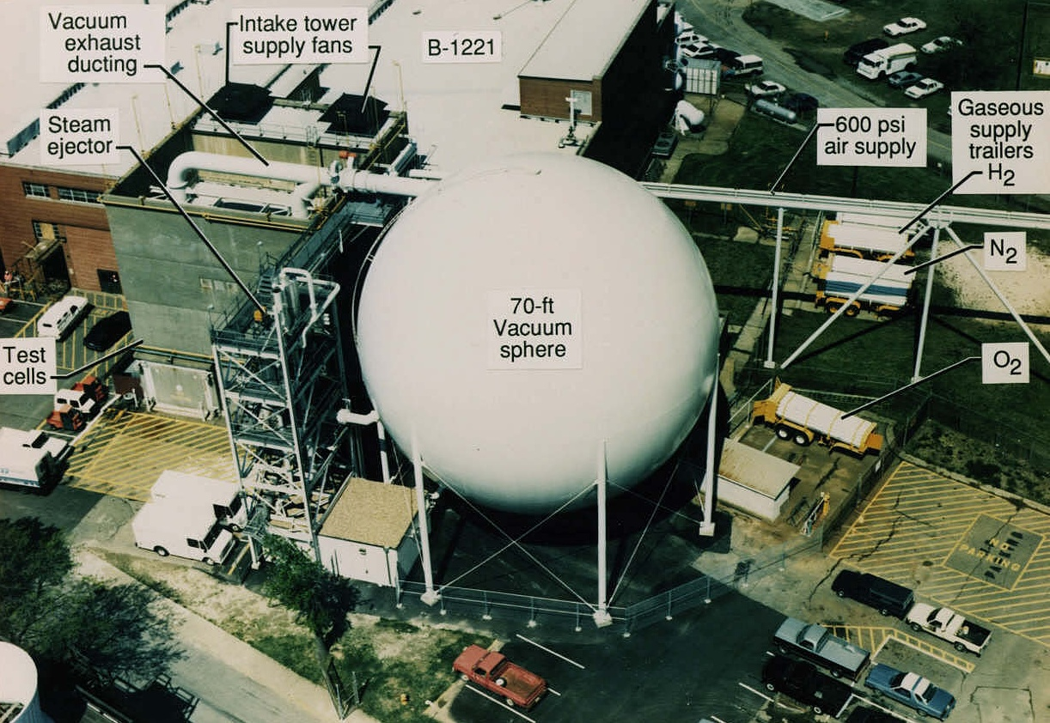
Figure 4: Aerial view of the courtyard area behind the two test cells, c1991.
Fuel Systems
Two dedicated hydrogen fuel systems are available for use in delivering gaseous hydrogen fuel to the test article. Each system has a manually controlled pressure regulator and an electro-mechanically controlled pneumatically operated isolation valve. Each fuel system includes a standard ASME sharp-edged orifice plate for metering of the fuel. The hydrogen supply for each of these systems is the same tube trailer(s) mentioned earlier and is thereby limited to a maximum supply pressure of 700 psia.

A liquid hydrocarbon fuel delivery system (originally installed during 2003) supplies unheated JP fuels to test articles at pressures up to 1100 psia and flow rates up to 10 GPM. Originally, the system was installed and used to deliver unheated and heated JP fuels. More recently, the heated-fuel capability of the system has been removed due to the excessive complexity of the system and lack of need. The increased construction of flight-like, fuel-cooled test articles using 3-D printing technology has decreased the need for a heated liquid fuel system. The test requirements have shifted to delivering room-temperature fuel to the test article for long-duration testing such that the test article can achieve thermal equilibrium. The existing liquid fuel system utilizes two nitrogen-pressurized tanks with a total volume of approximately 100 gallons to supply the JP fuel, a direct-drive servo valve (Moog D634) to modulate the flow, a 5 or 10 GPM turbine flow meter to meter the flow, and a PLC to control the system.

Two auxiliary fuel systems using K-bottles for fuel storage are also available for use. The K-bottles and primary isolation valves are located just outside the test cell while the pressure regulators and final isolation valves are located inside the test cell. Typically, 10-12 foot long 0.25-inch or 0.5-inch stainless tubing is used to connect the systems to the test articles. The systems do not have any fixed mass flow measurement capabilities. Typically, flow measurement capabilities are installed specific to test article requirements. These two systems are typically used to supply silane, a pyrophoric mixture of hydrogen and monosilane (SiH₄), 80/20 by mole. Silane is used as an ignition aid or source. These two systems are not limited to silane use only; they may be reconfigured to supply any fuel or gas that is available in a standard K bottle at pressures up to 2400 psia.

An ethylene fuel delivery system originally constructed during 1995 for use by the CHSTF is also available for use by the DCSCTF. The system utilizes a tube trailer to deliver ethylene (or any gaseous fuel supplied in a tube trailer) to both test cells using a dedicated 1.5-inch line, at a maximum pressure of 700 psia. The system was used by the CHSTF during the late 1990s, but has not been used by either facility since. The system is available for use by the DCSCTF if needed.

Data Acquisition and Instrumentation
The data acquisition system (DAS) for the DCSCTF consists of a commercially available Pacific Instruments hardware and software package along with a Pressure System Incorporated (PSI) 8400 electronic sensing pressure system (ESP). The DAS includes the Pacific Instruments signal conditioner, amplifier and multiplexer capable of supporting 48 strain gauge instruments (typically pressure transducers), 192 thermocouples, and 32 voltage channels (typically flow meters). The 8400 PSI system can measure up to 256 static pressures using eight 32-port modules at pressures up to 100 psia, and up to 250 psia using six 16-port scanners. Nonintrusive laser-based diagnostics have been used in the DCSCTF such as coherent antistokes Raman spectroscopy (CARS) and tunable diode laser absorption spectroscopy (TDLAS). Additional optical systems such as schlieren and shadowgraph, and infrared thermography (using a Flir model SC4000 camera) are also available. The facility does not have a thrust stand. Test data are visualized on two computers during testing and are typically reduced on a UNIX workstation. A secure operating mode is available for classified projects.

Tests Conducted
When the direct-connect facility was first constructed (1969) and during the following 30 years, the facility was used extensively for basic research in supersonic combustion, mostly by NASA personnel. References 6 to 8 summarize and provide a very good historical record of the research conducted by the Hypersonic Airbreathing Propulsion Branch from the 1960s through the 2000s using the direct-connect facility as well as the other facilities operated by branch personnel. However, during the last twenty years, the role of the DCSCTF changed; the facility is now being used to conduct more tests for external customers and less tests for internal NASA personnel. This section will highlight some of the tests conducted during the last twenty years. Some tests were proprietary to external customers and thus will not be discussed in detail.

During 2003, the DCSCTF was used in support of the NASA I^{STAR} program (Integrated Systems Test of an Air-breathing Rocket), see Reference 9. Using the newly constructed heated liquid fuel delivery system, the facility was used to test the Injector Characterization Rig (ICR) at simulated flight Mach numbers of 3.5 and 5.0 (Reference 10). A photograph of the ICR installed in the facility is shown in Figure 5; the view is looking downstream. The test article is supported using all-thread rods attached to the overhead (blue) I-beams. The entrance of the test article is bolted directly to a facility two-dimensional, water-cooled, Mach 2 nozzle. The nozzle, in turn, is bolted directly to the end flange of the facility vitiated heater. The test article shown in Figure 5 is approximately twelve feet long and protrudes into the 30-inch exhaust duct through a custom-made steel plate, which was bolted to the blue end-flange. In this manner, thermal expansion of the test article was accommodated for by allowing the test article to slide in and out of the 30-inch duct. This test utilized the 70-foot vacuum sphere for downstream aspiration, not the air ejector. Also shown in the below image are the hot-gas valves (in red), which controlled the delivery of the heated or unheated JP7 fuel to the various fuel injector stations on the test article. These were the first tests that utilized the heated liquid fuel delivery system and were very successful.

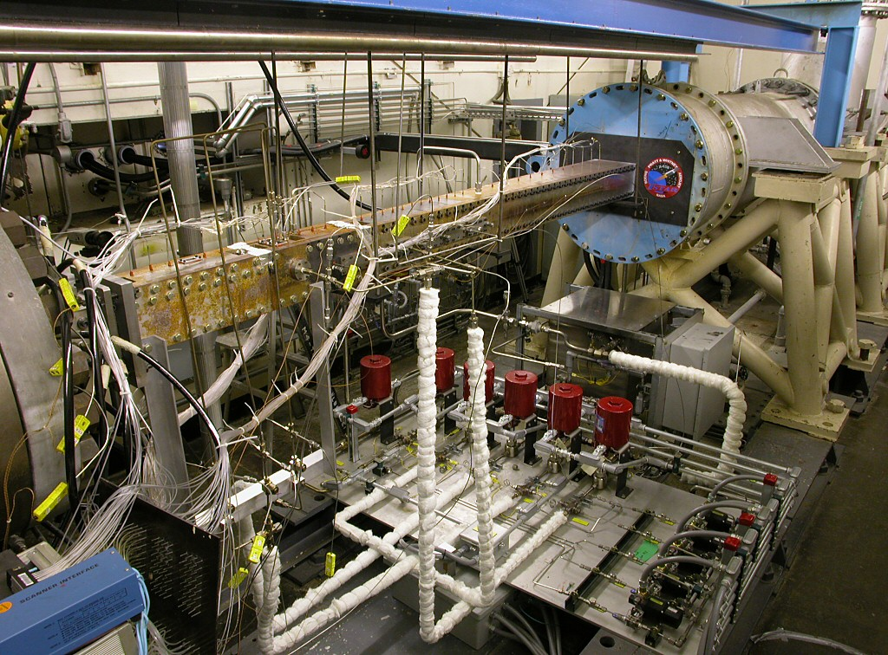
Figure 5: NASA I^{STAR} ICR test article installed in the DCSCTF, 11/2003.
During 2005 and 2006 the facility was used to test a new engine design for an external customer at simulated flight conditions of Mach 4 and Mach 5 using heated and unheated JP10 and JP7 fuels, see Reference 11. Figure 6 is a distorted panoramic photograph of the test article installed in the facility. This was the first time that a round test article was installed in the facility and the first time that a customer brought their own facility nozzle to the DCSCTF. The figure below shows (left-to-right), the facility vitiated heater, a water-cooled supersonic nozzle, a heat-sink isolator, a heat-sink fuel-injector block, and a heat-sink combustor, all constructed of copper. Also tested, but not shown in the photograph, was a fuel-cooled combustor made of inconel. The round test article was hung from the overhead blue I-beams using all-thread rods. Two separate test entries were conducted at nominal Mach 4 and 5 flight conditions. More than 100 tests were conducted using heated and unheated JP7 and JP10 fuels for a total test time of nearly two hours. The most interesting and important finding from these tests was that room-temperature JP fuel could be injected into the cold engine and ignited allowing the fuel-cooled combustor to heat up from room temperature to a steady state hot condition in a relatively short time.

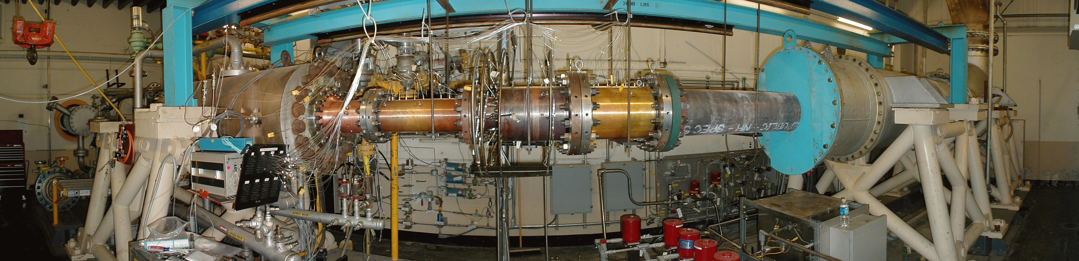Figure 6: Round JP-fueled test article installed in the DCSCTF (test gas flow is left-to-right), 4/2006, taken from Reference 11.
From 2008 to 2012, the DCSCTF supported the Fundamental Aerodynamic Program’s Hypersonics Project (FAP, see Reference 12) with the testing of the Durable Combustor Rig (DCR). The DCR is a versatile, two-dimensional, hydrogen-fueled test article comprised of two different water-cooled nozzles (M2.1 and M2.65), a water-cooled isolator and fuel-injector block and uncooled combustor and nozzle, all constructed of copper. During 2008, numerous tests were conducted at Mach 5, 6, and 7 flight conditions to investigate the ignition and combustion characteristics of the DCR using hydrogen fuel. Computer simulations of the DCR were also conducted using NASA LaRC’s VULCAN-CFD computer code (Viscous Upwind ALgorithm for Complex Flow ANalysis), Reference 13. Analyses of the acquired data and comparison to the computer simulations were reported in several publications, see References 14-18. Figure 7 below shows the DCR when it was first installed in the facility; the major components of the installation are (left-to-right) the facility vitiated heater, the water-cooled facility nozzle, the water-cooled isolator and fuel injector blocks, the heat-sink combustor and nozzle, and the downstream exhaust piping. The DCR was installed in the facility from early 2008 through the fall of 2012 executing nearly 400 tests.

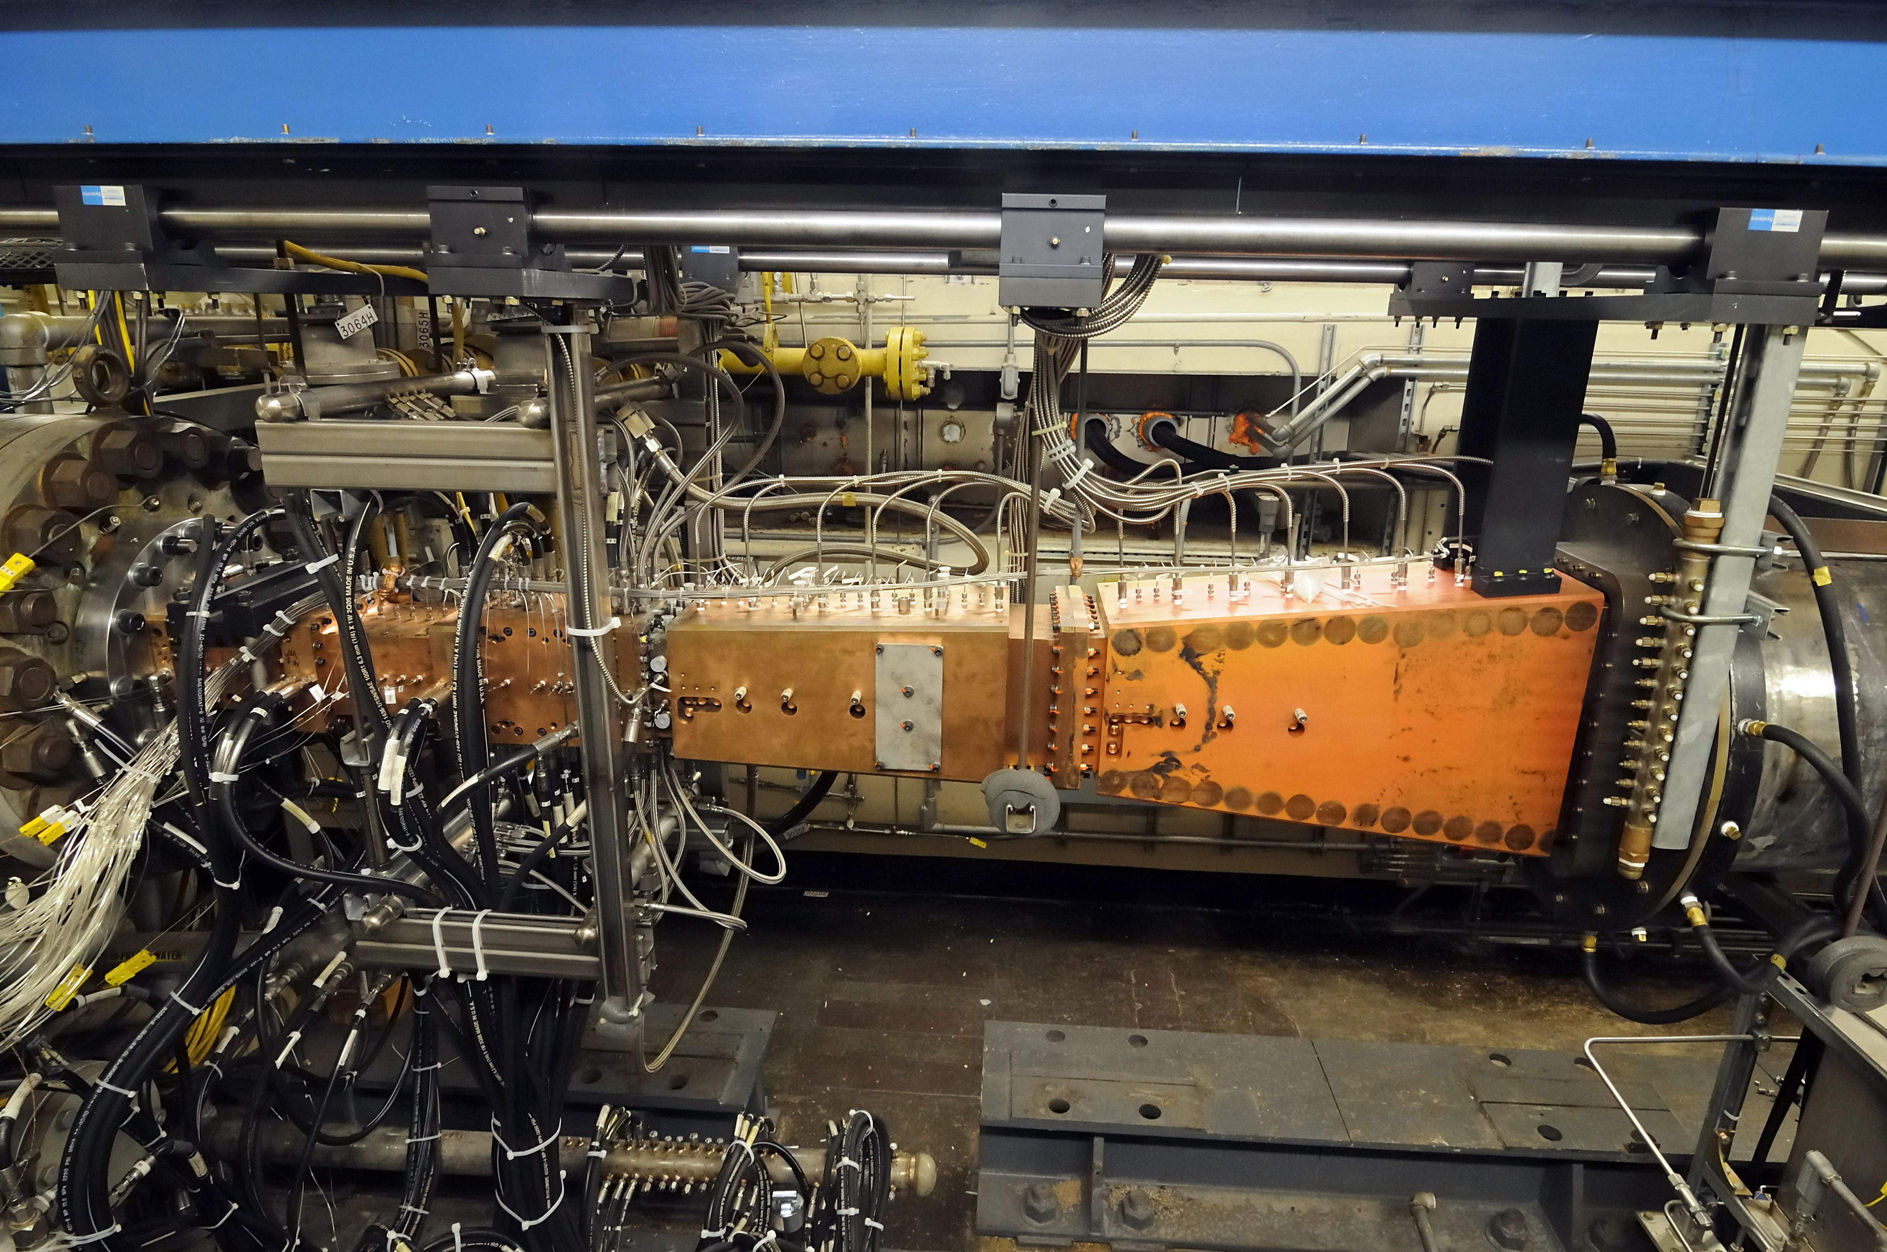
Figure 7: Durable Combustor Rig installed in the DCSCTF (test gas flow is left-to-right), 3/2008.

During the fall of 2009 a longer DCR isolator was installed containing optical access ports in support of velocity, temperature and mass flux measurements using a TDLAS system, see Figure 8. The photograph shows the longer DCR isolator with transmitting optics above the sidewall windows and receiving optics below. Windows along the top and bottom walls were also utilized, but are not easily visible in the below photograph. Measurements were made by personnel from Stanford University and compared well with computer simulations of the flow field (see Reference 19).

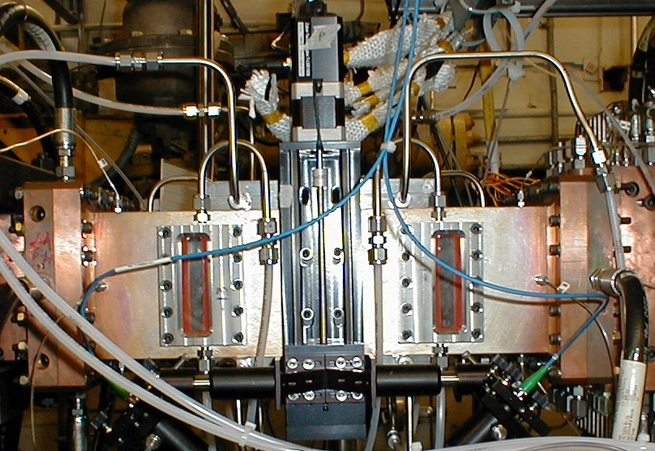
Figure 8: Mass-flux sensors being installed on the longer DCR isolator, 9/2009.
During 2012, in cooperation with students from the University of Virginia, a Tunable Diode Laser Absorption Tomography (TDLAT) experiment was installed at the exit of the DCR combustor (see Figure 9). The goal of the test program was to use TDLAS measurements with tomographic image reconstruction to determine two-dimensional spatially resolved distributions of temperature and species concentration. Five telecommunication lasers were mounted on a rotating ring at the exit of the DCR combustor and conducted line-of-sight (LOS) measurements at the combustor exit. The path-integrated LOS measurements were used to construct a two-dimensional image of the flow field at the exit of the combustor. The procedure is similar to how a medical CAT scan uses multiple x-rays to create a multidimensional image. The results of the TDLAT measurements indicated that the technique is useful in making nonintrusive measurements in a hot, combusting flow field (see References 20 and 21).

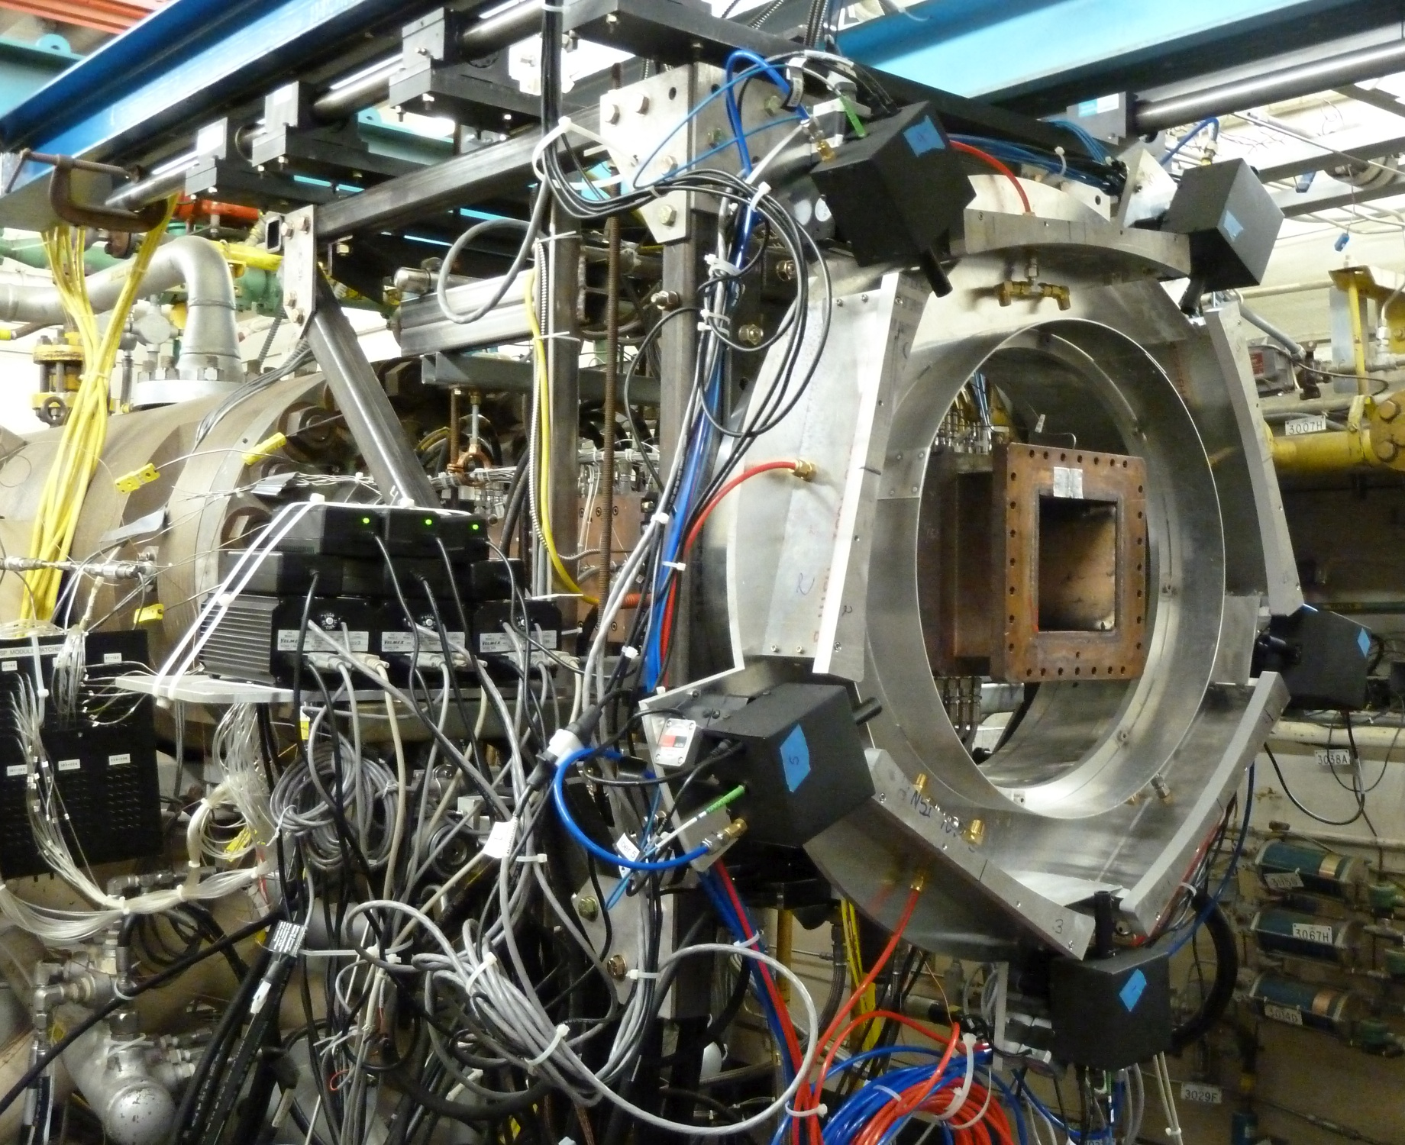
Figure 9: UVA TDLAT system being installed at the exit of the DCR combustor, 3/2012.

Also, during 2012, the DCSCTF was used to support the Hypersonic International Flight Research and Experimentation program (HIFiRE) for the University of Queensland, Australia (see Reference 22). Ceramic Matrix Composite (CMC) panels made of carbon/carbon-silicon carbide and carbon/carbon were constructed by the German Aerospace Center (DLR) for the University of Queensland. The panels were mounted and tested downstream of the DCR combustor using a four-sided fixture that used one of the panels as the upper wall, with half-inch steel plates comprising the other three walls (see Figure 10). Each panel was tested at least three times, each test lasting 45-seconds at nominally Mach 6 flight conditions with upstream hydrogen fuel injection and combustion at a nominal equivalence ratio of one. The tests were conducted in an open-jet arrangement where the exhaust from the test article was aspirated by the air ejector that was mounted downstream of the test article but not connected to the test article. The dimensions of the CMC panels were measured, weighed and the panels were photographed before and after testing. Infrared and visible light cameras were used to image the backside of the panel during the tests. Despite the harsh heat loads imposed on the panels that caused the panels to glow and the steel sidewalls to melt, the panels were unscathed by the tests (see Figure 11 and References 23-26).

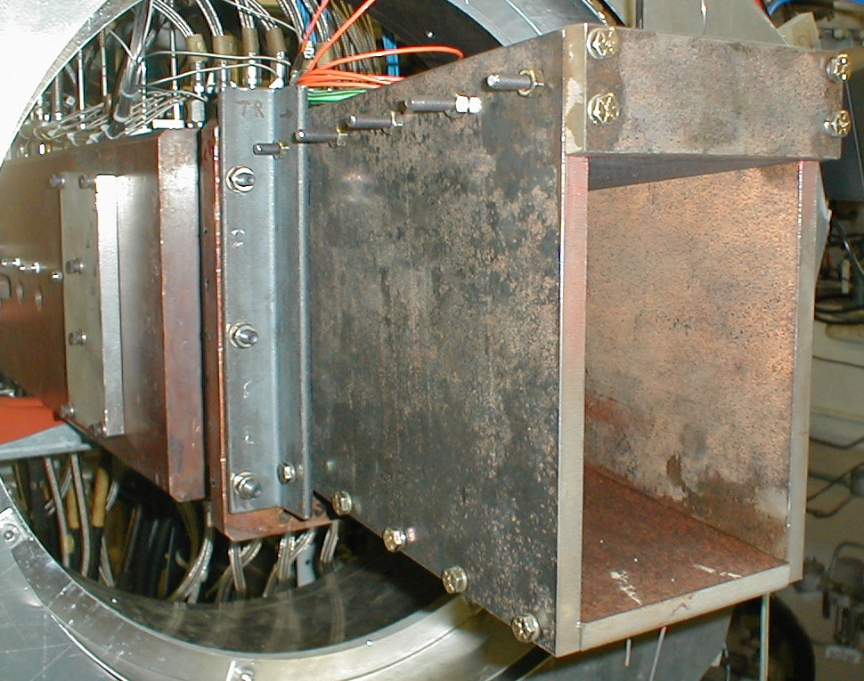
Figure 10: Composite panel mounted as the top wall downstream of the exit of the DCR combustor, 6/2012.

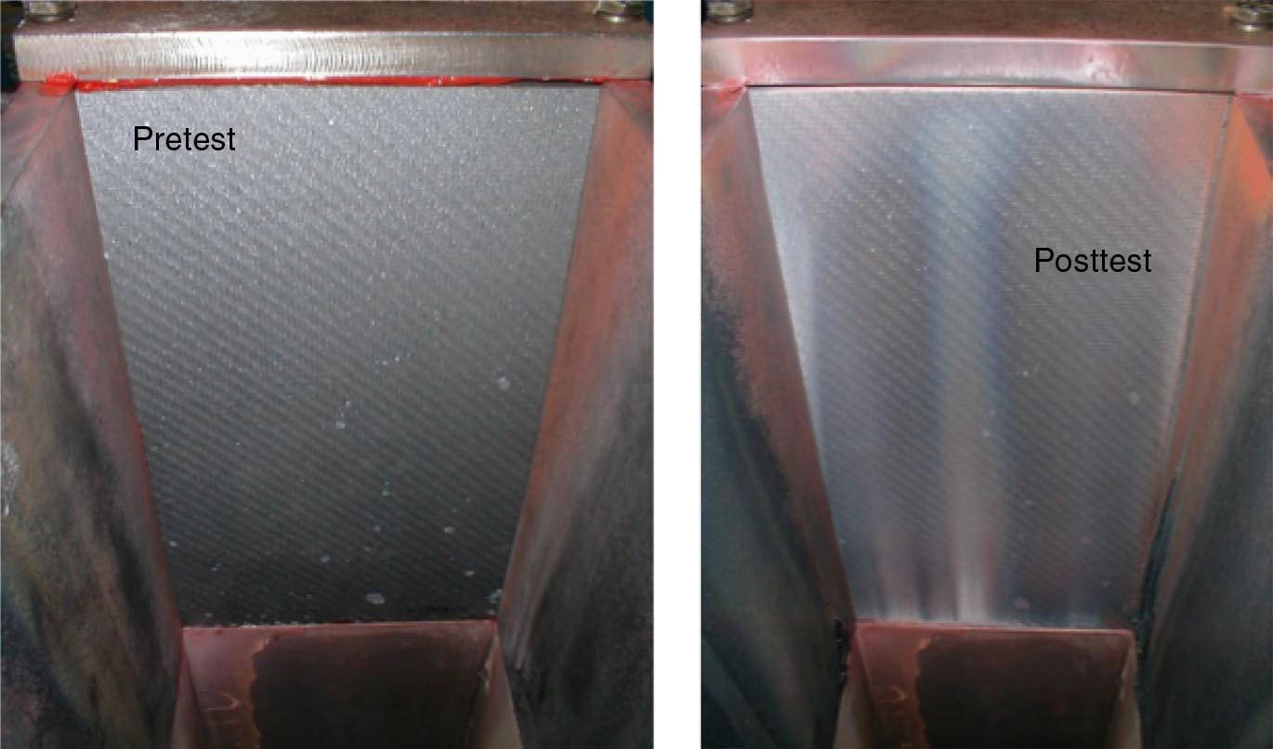
Figure 11: Pre- and post-test photographs of DLR C/C-SiC panel (looking upstream), 8/2012.

Early during 2012, the DCSCTF was used to test a fuel-cooled CMC panel in a cooperative effort with personnel from the NASA LaRC Structural Mechanics and Concepts Branch. A flat panel constructed of a SiC/SiC material with twelve embedded niobium-1% zirconium alloy (Nb-1%Zr) tubes and manifolds was installed within a water-cooled copper holder downstream of the DCR combustor, see Figure 12 (panel) and Figure 13 (installation). Gaseous hydrogen fuel at room temperature and at pressures up to 700 psia was supplied to the CMC panel. The fuel entered the upstream manifold, traveled through the twelve tubes embedded within the CMC panel, and was collected at the rear manifold. From the rear manifold, the (now) heated hydrogen was delivered to the DCR fuel injectors where it was injected into the flow path and burned. Fuel equivalence ratios were limited to only 0.5 due to a large pressure drop across the heat exchanger. The open top of the three-sided duct allowed for imaging of the panel during testing using infrared (IR) and visible light cameras, as seen in Figure 13. In total, fourteen runs were conducted using the fuel-cooled CMC panel at test conditions simulating flight at Mach 5 and 6 for a total test time of six minutes. After the last test, cracks in the CMC panel were observed and testing was stopped to inspect the panel. Since the cracks in the panel were concentrated at each end of the panel near the manifolds, it is believed that the panel cracked due to the niobium substructure or the copper holder (or both) preventing the panel from expanding thermally. A post-test hydro test of the panel showed that the niobium tubing and manifolds did not leak despite the cracks in the CMC material.

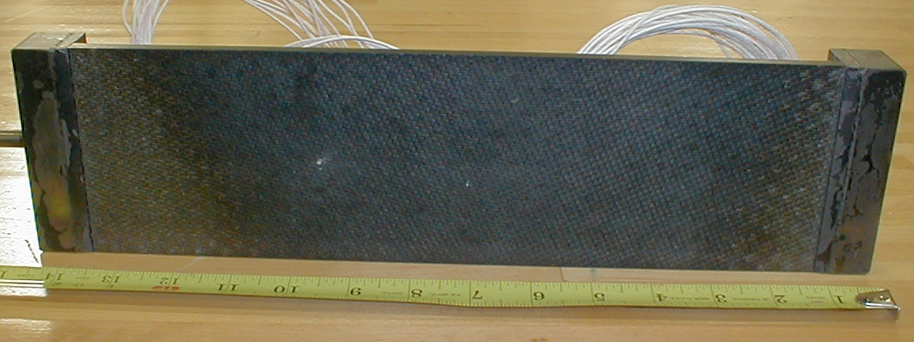
Figure 12: CMC panel/heat exchanger with rectangular supply and return manifolds at ends, 8/2011.

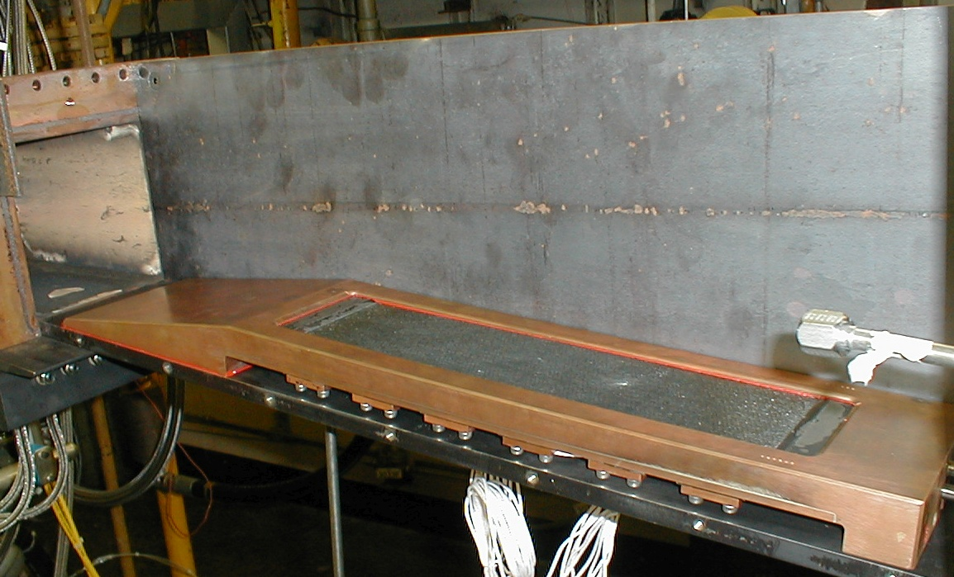
Figure 13: CMC panel mounted in water-cooled copper holder at exit of DCR combustor, left sidewall was removed for viewing, flow is left-to-right, 9/2011.

From 2015 to 2019, the DCSCTF was used exclusively by DoD contractors to test and evaluate different flight-like test articles. Multiple tests of fuel-cooled and uncooled components were conducted at ramjet flight conditions lasting up to 15 minutes.

During the latter part of 2019, calibration tests commenced of a mass flow plug (MFP) in support of ramjet engine programs for the United States Air Force (USAF). The MFP is shown installed in the DCSCTF in Figure 14. Shown in the figure (left-to-right) are the end of the vitiated heater, a water-cooled supersonic nozzle, a heat-sink isolator, a black heat-sink pipe, and the translating plug assembly. The MFP contains a hydraulic-actuated, water-cooled, copper conical plug that translates forward and backward during testing. Also included within the MFP flow path are numerous pressure and temperature measurements. The goal of the tests is to determine the mass flow rate through the MFP device as a function of plug position (or flow area) and measured total pressure and temperature for a variety of facility test points. Once calibrated, the MFP can be installed at the exit of a ramjet or scramjet test article and be used to measure the mass flow rate captured by the test article while in a free-jet test facility. Calibration tests of the MFP in the DCSCTF were underway when the NASA LaRC was closed due to the Covid-19 pandemic on March 18th, 2020. Tests were completed on November 5th, 2020.

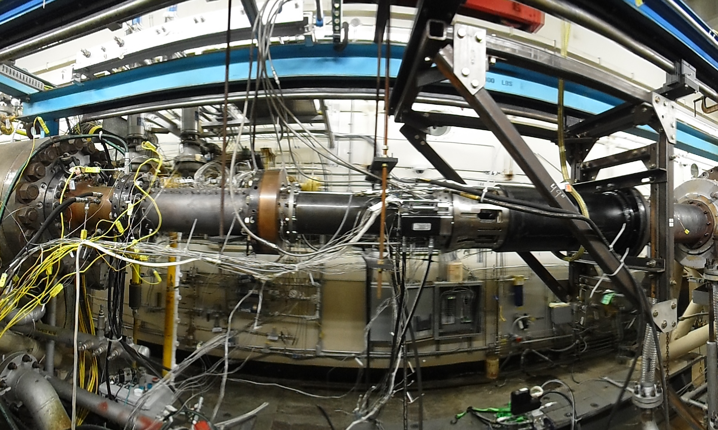
Figure 14: Mass Flow Plug installed in the DCSCTF, 2/2020.

Conclusion
Since the 1970s, the Direct-Connect Supersonic Combustion Test Facility at the NASA Langley Research Center has contributed to the state of the art in the field of hypersonic propulsion. Over the years, the facility has been used to test various ramjet and scramjet test articles for both internal and external customers. Although old, the facility has been updated and modified to conduct increasingly complicated and relevant tests. In the recent past, the facility has been used extensively by the USAF and DoD contractors to test fuel-cooled and uncooled, flight-like ramjet test articles for up to 15 minutes of continuous operation. The facility is currently available for use by all internal and external customers. Knowledgeable facility personnel are available to assist with the test planning and execution that will ensure a successful test campaign.

Contact Information
Hubert (Bert) Senter
Scramjet Test Complex Facility Manager
Mail Stop 167
NASA Langley Research Center
12 Langley Boulevard
Hampton, VA 23681-2199
(757)864-5249
hubert.h.senter@nasa.gov
REFERENCES
- Engineering Analyses and Design Calculations of NASA – Langley Research Center Hydrogen-Air-Vitiated Heater with Oxygen Replenishment. Technical Memo No. 173, General Applied Science Laboratories, Inc., 1974. (Available as NASA CR-132381)
- Russin, W.R.: Performance of a Hydrogen Burner to Simulate Air Entering Scramjet Combustors. NASA TN D-7567, February 1974.
- Springer, R.R.; Cutler, A.D.; Diskin, G.S.; and Smith, M.W.: Conventional/Laser Diagnostics to Assess Flow Quality in a Combustion-Heated Facility. AIAA Paper 1999-2170, June 1999.
- Andrews, E.H.; Torrence, M.G.; Anderson, G.Y.; Northam, G.B.; and Mackley, E.A.: Langley Mach 4 Scramjet Test Facility. NASA TM 86277. February 1981.
- Auslender, A.H.: Scramjet Analysis Techniques, JANNAF 40th CS/28th APS/4th MSS/22nd PSHS Joint Subcommittee meeting, Charleston, SC, June 2005
- Northam, G.B.; and Anderson, G.Y.: Supersonic Combustion Ramjet Research at Langley. Presented at the 24th AIAA Aerospace Sciences meeting, January 6-9, 1986, Reno, NV. AIAA Paper 86-0159
- Rogers, R.C.; Capriotti, D.P.; Guy, R.W.: Experimental Supersonic Combustion Research at NASA Langley. Presented at the 20th AIAA Advanced Measurement and Ground Testing Technology Conference, June 15-18, 1998, Albuquerque, New Mexico. AIAA Paper No. 98-2506.
- Northam, G.B.; Andrews, E.; Guy, W.; Pellett, G.L.; Drummond, P.; Cutler, A.D.; and Rock, K.: An Overview of Hypersonic Propulsion Research at NASA Langley Research Center. Presented at the 20th Anniversary Meeting and the Eighth Symposium on Propulsion System for Reusable Launch Vehicles, Japan Society for Aeronautical and Space Sciences, March 7th, 2007, Sendai, Japan.
- Faulkner, R.: Integrated System Test of an Airbreathing Rocket (ISTAR), Presented at the 10th AIAA/NAL-NASDA-ISAS International Space Planes and Hypersonic Systems and Technologies Conference, April 24-27, 2001, Kyoto, Japan. AIAA Paper No. 2001-1812.
- St. Clair, R.W.; Elvander, J.E.; Morrison, C.Q.; Bulman, M.J.; Hoxie, S.S.; and Salvador, C: Results of JP-7 Fueled Ramjet Injector Characterization Testing for the Integrated system test of an Airbreathing rocket (ISTAR), JANNAF 2004
- Gettinger, C.; Philpott, J.; Blevins, J.D.;Webster, H.; Guinan, D.; and Capriotti, D.: Direct-Connect Testing of a Hydrocarbon Fueled Circular Scramjet Combustor at Mach 4 and Mach 5 Equivalent conditions, JANNAF 41st CS/29th APS/23rd PSHS Joint Meeting, San Diego, CA, December 2006.
- Auslender, A.H.; Suder, K.L.; and Thomas, S.R.: An Overview of the NASA FAP Hypersonics Project Airbreathing Propulsion Research. AIAA Paper 2009-7277, October 2009
- Baurle, R. A.: VULCAN-CFD Home Page, NASA Langley Research Center, 2020, https://vulcan-cfd.larc.nasa.gov/
- Gaffney, R.L.: CFD validation calculations of the Durable Combustor Rig. Presented at the 43rd JANNAF CS / 31st APS / 25th PSHS Joint Subcommittee Meeting, December 2009, La Jolla, CA
- Drozda, T.G.; Capriotti, D.P.; and Gaffney, R.L.: Modeling and Simulation of Mach 6 Tests of NASA's Durable Combustor Rig With Vulcan. Presented at the 58th JANNAF Propulsion Meeting, April 18-22, 2011, Arlington, Virginia.
- Gaffney, R.L.; Drozda, T.G.; and Capriotti, D.P.: Numerical simulations of the NASA Durable Combustor Rig at Mach 5 Conditions. Presented at the 45th JANNAF Combustion Subcommittee Joint Meeting, December 3-7, 2012, Monterey, California.
- Capriotti, D.P.: Performance of NASA’s Heavy-Weight Durable Combustor Rig at Mach 6 and 7 Flight Conditions. Presented at the 58th JANNAF Propulsion Meeting, April 18-22, 2011, Arlington, Virginia.
- Capriotti, D.P.; and DePiro, M.J.: Testing of the Durable Combustor Rig in the NASA Langley Direct Connect Facility. Presented at the 45th JANNAF Combustion Subcommittee Joint Meeting, December 3-7, 2012, Monterey, California.
- Chang, L.S.; Strand, C.L.; Jeffries, J.B.; Hanson, R.K.; Diskin, G.S.; Gaffney, R.L.; and Capriotti, D.P.: Supersonic Mass Flux Measurements via Tunable Diode Laser Absorption and Non-Uniform Flow Modeling. Presented at the 49th AIAA Aerospace Sciences Meeting, January 4-7, 2011, Orlando, Florida. Also published in the AIAA Journal, Vol. 49, No. 12, December 2011.
- Busa, K.; Ellison, E.; McGovern, B.; McDaniel, J.; Diskin, G.; DePiro, M.; Capriotti, D.; and Gaffney, R.: Measurements on NASA Langley Durable Combustor Rig by TDLAT: Preliminary Results, 51st AIAA Aerospace Sciences Meeting including the New Horizons Forum and Aerospace Exposition, Aerospace Sciences Meeting, (AIAA Paper 2013-0696), January 7-10, 2013, Grapevine, Texas.
- Busa, K.; McDaniel, J.; Diskin, G.; DePiro, M.; Capriotti, D.; and Gaffney, R.: Spatially Resolved Temperature and Water Vapor Concentration Distributions in Supersonic Combustion Facilities by TDLAT. Presented at the 45th JANNAF Combustion Subcommittee Joint Meeting, December 3-7, 2012, Monterey, California.
- Bowcutt, K.; Paull, A.; Dolvin, D.; and Smart, M.: HIFiRE: An International Collaboration to Advance the Science and Technology of Hypersonic Flight. Presented at the 28th International Congress of the Aeronautical Sciences, September 23-28, 2012, Brisbane, Australia.
- Glass, D.E.; Capriotti, D.P.; Reimer, T.; Kütemeyer, M.; and Smart, M.: Testing of Refractory Composites for Scramjet Combustors. Journal of Propulsion and Power, (DOI 10.2514/1.B36147), June 20th, 2016.
- Glass, D.E.; Capriotti, D.P.; Reimer, T.; Kütemeyer, M.; and Smart, M.: Testing of DLR C/C-SiC and C/C for HIFiRE 8 Scramjet Combustor, 19th AIAA International Space Planes and Hypersonic Systems and Technologies Conference, AIAA Aviation, (AIAA 2014-3089), June 16-20, 2014, Atlanta, Georgia.
- Glass, D.E.; Capriotti, D.P.; Reimer, T.; Kütemeyer, M.; Smart, M.: Testing of DLR C/C-SiC for HIFiRE 8 Scramjet Combustor. 7th European Workshop on Thermal Protection systems and Hot Structures, April 8-10, 2013, Noordwijk, The Netherlands.
- Glass, D.E.; Capriotti, D.P.; Smart, M.: Test of DLR C/C-SiC in NASA Langley DCR for HIFiRE 8 Combustor. Presented at the 37th Annual Conference on Composites, Materials, and Structures, January 28-31, 2013, Cocoa Beach, Florida.

