Exploring Multimodal Interactions in Human-Autonomy Teaming Using a Natural User Interface
Lisa R. Le Vie, Bryan A. Barrows,
B. Danette Allen, and Natalia Alexandrov
NASA Langley Research Center, Hampton VA, 23681, USA
The creation of a multimodal, natural user interface to facilitate multi-agent interaction is essential to establishing trust among human and machine teammates in multi-agent systems. Trust is being researched, along with trustworthiness, as a path to certification of autonomous systems by the Autonomy Teaming and TRAjectories for Complex Trusted Operational Reliability (ATTRACTOR) project at NASA. The Autonomous Mission Experimental Logistics Interactive Assistant (AMELIA) is a natural user interface that enables multimodal interaction and is designed for rapid mission planning. AMELIA is an intelligent system that considers the user’s preferred communication strategies, as well as the time-critical aspect of the multi-agent system decision-making process. Twenty-four participants planned a multi-agent search and rescue mission, with the aid of an intelligent assistant. The results show that while the combined use of touch and speech was faster than speech alone, the single modality, touch, was still the most efficient. Future research should investigate additional input technologies.
- Nomenclature
AMELIA = Autonomous Mission Experimental Logistics Interactive Assistant
ATTRACTOR = Autonomy Teaming and TRAjectories for Complex Trusted Operational Reliability
CAS = Convergent Aeronautics Solutions
CRM = Crew Resource Management
DRM = Design Reference Mission
GAN = Generative Adversarial Network
HAT = Human Autonomy Teaming
HAT-S = Human Automation Trust Scale
HINGE = Human Informed Natural-language GANs Evaluation
NUI = Natural User Interface
SAR = Search and Rescue
SUS = System Usability Scale

- Introduction
NASA’s Convergent Aeronautics Solutions (CAS) project, Autonomy Teaming and TRAjectories for Complex Trusted Operational Reliability (ATTRACTOR), aims to establish a basis of certification of autonomous systems, including the roles of trust and trustworthiness. The Human Machine Interface (HMI) team seeks to create an intuitive, multimodal interface, which uses natural user interactions to establish trust and facilitate multi-agent interactions. Search and Rescue (SAR) is ATTRACTOR’s design reference mission (DRM). SAR missions are led by a human commander who has multiple autonomous assets, human or machine, each capable of sensing, perceiving and planning. The team is tasked with searching an area of interest using ground or air vehicles, which may be manned or unmanned. This type of operation necessitates a human-machine interface to communicate both mission objectives and status updates. The goal of the HMI activity was to improve mission performance and efficiency, and to enable trust of the system, by creating a human-machine team that works together through reliable, context-aware communication. The larger goal of human-machine teaming is to create a paradigm where cooperative performance is greater than either humans or machines alone.
Previous work, [1-3] sought to discover a machine-preferred input modality that would result in better image generation by the Generative Adversarial Network (GAN) for the target description tasks at the beginning of the mission. The Human Informed Natural-language GANs Evaluation (HINGE) demonstrated how, using classical machine learning techniques, freeform description input from human teammates can be encoded for use in SAR missions. This work investigated the human’s input into the machine, one side of the bi-directional communication loop. It is also, however, necessary to consider the machine side of the bi-directional communication loop.
The current work, Autonomous Mission Experimental Logistics Interactive Assistant (AMELIA), sought to better understand the individual differences in communication preferences and information sharing between humans and machine teammates throughout the mission planning stage from the machine side. The HMI team considered different aspects of communication strategies and information sharing between human-human teams [4-6] and applied those to the current research looking at human-machine teams. The communication strategies studied in the AMELIA work included: how human operators share information with the system, how and when they accept assistance from the system, what information they want from the system, and how the system can share that information in a more individualized/personalized way. The intention is that this research will pave the way towards a human-machine interface that will enable trust of the system, allow quantification of the human’s trust in the system, and further the trustworthiness of the system as a whole. Lee and See, [7, p. 51] define trust as “the attitude that an agent will help achieve an individual’s goals in a situation characterized by uncertainty and vulnerability.” Ultimately, human-machine communication should be efficient, easily understood by both human and machine teammates, require little training on the part of the human, and result in a productive human-machine collaboration.
- Background
When interacting with machines, humans feel more comfortable using a variety of modalities to communicate. Natural User Interfaces (NUI) allow users to communicate naturally and give access to multiple input modes and multiple styles of interaction. These include, but are no longer limited to speech, touch, gestures, keyboard, mouse, and eye tracking. [8] Multimodal interactions facilitate easier and more intuitive communication, offer improved error handling and efficiency, and provide greater precision in visual spatial tasks. Studies also show that no one single modality can provide a natural interaction experience and the variety of inputs both support users’ preferred interaction style and allow for greater expressive and transparent dialogue. [9, 10]
Although text input was determined to be preferable over speech for target descriptions within the ATTRACTOR HMI development in that specific experiment [1], it was still necessary to consider speech as an input modality in interface design due to its ease of use and the natural inclination to use it along with other communication modalities simultaneously. Speech-based, natural language interfaces allow users to communicate with machines in a way that is natural and intuitive, even during remote operations. Studies show they are efficient, convenient and can increase satisfaction, usability and situation awareness. [11, 12]
Therefore, the HMI team began to consider bi-directional, multimodal communication from the machine side. Most communications from machine to humans are scripted and typically the same for all users. Amazon’s “Alexa”, Apple’s “Siri”, Google’s “Galaxy” and Microsoft’s “Cortana” are all progressing in their capabilities. However, when a user asks Alexa to play a piece from a well-known composer, for instance saying, “Alexa, play Beethoven Symphony number 9,” the response usually follows a pattern of repeating back the information in some way. “Playing Symphony’s no 9, Volume 3, by Ludwig Van Beethoven from Spotify.”∗ This was the second attempt, the first attempt was, “Alexa, play Beethoven’s 9th Symphony,” which brought forth an answer that contained a litany of composers, musicians, symphonies, before finally playing the song from Amazon Music, when all that was requested was to play the song. These responses highlight the potential frustrations that users have when giving a machine a command easily understood by other humans. Many applications repeat back the request in similar ways. Aviation Crew Resource Management (CRM) and other critical applications (e.g., space missions, nuclear plants and health care settings) require this repeat back of information before performing the request to reduce errors. It is not always preferred by people in more common, everyday situations. [13] The ability for a system to adapt to a user’s preferences for communication strategies may be an important factor in enabling trust and improving efficiency in performance [14].
The idea of self-adaptive intelligence led to the development of AMELIA, a mission planning data collection tool with the dual purpose of studying multimodal interactions within the AMELIA interface, along with a study of the preferred communication strategies of the users experiencing the system. The goal is to emulate the communication strategies inherent in the majority of human-human communications.
- Study Design
Human-computer interaction research indicates that speech and touch are the most naturally interactive and unconstrained modalities at the moment. [9, 15] Therefore, the AMELIA interface was designed to integrate speech and touch as input modalities for the mission planning phase of a SAR mission. The application is housed on a 2-in-1 tablet-laptop, with both speech recognition and touch screen capabilities. The GUI design and machine learning incorporated within rely on the Python scripting language. This allows the system to be portable for remote and on-the-spot mission planning. During the study, participants were asked to interact with AMELIA via touch only, speech only, and speech and touch combined. Their interactions and use of the interactive assistant was recorded and correlated with other subjective measures obtained during the experiment.
- Participants
Twenty-four participants, aged 18-74, were recruited via an email campaign from November 2019 through February 2020. Eleven females and thirteen males participated. Their education levels ranged from “some college” to a doctorate level education. All participants had at least some familiarity with touch screen use, and nearly all had speech recognition experience with other applications and technologies.
- Procedures
AMELIA combines multimodal input technologies (speech and touch) with natural language speech recognition, to aid in planning a simulated SAR mission. AMELIA uses machine learning to assist the user with planning. Each participant is assigned the role of “Mission Commander” and instructed to arrange five virtual drone assets equally throughout an area of interest where a missing sensor is thought to be located. This same activity is then repeated for each of the four scenarios. Participants were randomly assigned an order for the first three scenarios: “touch only”, “speech only” and “positional touch with speech”. The “positional touch with speech” modality option allowed a “put this here” approach to placing the assets, but lacked the full touch capabilities in order to encourage the use of both speech and touch together. Each input modality variation was demonstrated prior to that scenario’s run. All participants then ended with a final timed scenario where all touch and speech capabilities were available for use. For the speech scenarios, the participants were instructed to use the prompt “Amelia” before any command. An AMELIA Helper was also added to the interface to aid the participants in placing the drone assets. The AMELIA Helper would suggest drone placement or movement based on the placement of other drones via a text box on the right side of the interface. (See Fig. 1) Participants could either tap the Yes or No buttons during any scenario other than the speech scenario, or speak “Yes”, or “No” (with the prompt) during any scenario other than the touch scenario. This interaction was recorded for data analysis.

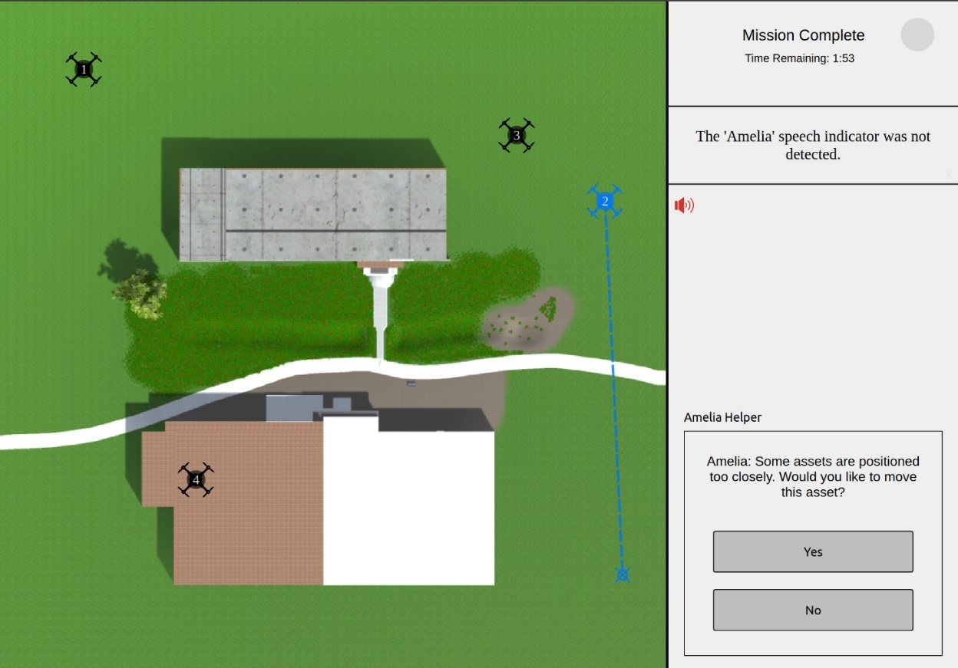
Fig. 1. AMELIA interface during a time trial.

After each scenario, participants were given a System Usability Scale (SUS) [16], and after the final scenario, participants were asked to fill out a Human Automation Trust Scale (HAT-S) [17] and a Communication Strategies questionnaire. Participants were also asked to take a free online personality assessment and share their resulting personality type with us.
- Results

Descriptive Analysis
Participants were timed for each scenario. The average time to complete the touch scenario was 42 seconds (min = 10, ma = 93). Speech took an average of 259 seconds (min = 46, max = 727), while the positional touch with speech scenarios took an average of 127 seconds (min = 32, max = 382). After each participant had run through the first three scenarios listed above, in randomized order, they were given a final scenario with all capabilities of touch and speech turned on. This final scenario took, on average 64 seconds (min = 11, max = 362). (See Fig. 2)

Fig. 2. AMELIA Elapsed Run Time per Modality.

The use of the AMELIA Helper was also recorded during the scenarios each time the participant responded with touch or speech to the suggestions. In the Touch scenario, the AMELIA Helper was not used at all. The average use during the Speech scenario was 2.3 interactions (min = 0, max = 10), while the use during the Positional Touch with Speech scenarios and the full capability were 1.08 (min = 0, max = 6), and 0.54 9(min = 0, max = 4), respectively. (See Fig. 3)

Fig. 3. Use of AMELIA Helper across Modality.

System Usability Scale

Participants were asked to fill out a System Usability Scale (SUS) after each scenario. The SUS is a 10 item questionnaire that uses a five-point Likert Scale from Strongly Agree to Strongly Disagree. The scoring is seen as a reliable measure of usability. [16] Participants rated the Touch user interface at 87 (Excellent), the Positional Touch with Speech user interface at 78 (Good) and the Speech interface at 62 (Ok/Fair).

The assumption of sphericity was not violated (Mauchly’s Test of Sphericity, p > .05). There was a significant main effect of modality on usability ratings, [F(2, 46) = 16.79, p < .001, partial η² = .422]. Follow-up Bonferroni adjusted pairwise comparisons indicated the Speech condition (M = 62.20, SD = 20.94) had significantly lower usability ratings than both the Touch condition (M = 87.08, SD = 14.61, p < .001) and Positional Touch with Speech condition (M = 78.12, SD = 16.52, p = .016). Additionally, the Positional Touch with Speech condition had significantly lower ratings than the Touch condition (p = .035).

Human Automation Trust Scale

The HAT-S survey was conducted at the end of the study to aid in understanding trust between humans and AMELIA. This questionnaire included 12 questions, five related to distrust concepts and seven related to trust concepts. These were rated on a 7 point Likert scale. (1 = not at all, and 7 = extremely) [17]. For the questions relating to system distrust (deceptive, underhanded behavior, suspicion, wariness and harmful actions of the system) the average of those scores was 1.76, which may point to a low level of distrust for the system. Furthermore, the questions that related to system trust averaged 4.35 out of 7, across the seven questions. Further work in this area is ongoing.

Communication Strategies

Finally, a questionnaire to determine an individual’s communication strategy was given. This questionnaire sought to determine the amount of information each participant desired (maximum vs. minimum), as well as the informational style (tactical/strategic/analytical/empirical) of the information available. Additionally, it was hoped that this information could be correlated to personality and then used to train the system to adapt to the individual’s preferred communication strategy. Unfortunately, it was determined that there was not enough data to conclusively find any correlations between personality type and communication strategies. Further research into communication strategies are being explored and future studies are planned to gather more data in this research area.

Future Work
Utilizing bi-directional communication to improve teaming between the user and system would improve team performance and allow for greater human-machine trust. [18] Furthermore, the addition of other input technologies to broaden the natural user interaction dynamic needs to be better understood. This includes, but is not limited to, the integration of eye tracking and gesture recognition. This work is being transitioned into the Autonomous System’s research thread under the NASA Transformative Tools and Technologies (TTT), Revolutionary Aviation Mobility Subproject and also aligns with work being done in the area of Advanced Air Mobility.

Acknowledgments
The authors would like to thank the Autonomous Integrated Systems Research Branch, the ATTRACTOR team, and the experiment participants for their support.

References

[1] Barrows, B.A., Le Vie, L.R., Meszaros, E.L., Ecker, J.E. and Allen, B.D., 2020. "Analyzing Natural Language Context in Human-Machine Teaming using Supervised Machine Learning." In AIAA Scitech 2020 Forum, p. 1113. 2020.
doi:10.2514/6.2020-1113
[2] Meszaros, E. L., Le Vie, L. R., Last, M. C., Barrows, B. A., Smith, M., & Allen, B. D. "Evaluating Communication Modality for Improved Human/Autonomous System Teaming." In AIAA Scitech 2019 Forum, p. 2204. 2019.
doi:10.2514/6.2019-2204
[3] Le Vie, L. R., Last, M. C., Barrows, B., & Allen, B. D. "Towards Informing an Intuitive Mission Planning Interface for Autonomous Multi-Asset Teams via Image Descriptions." 2018 Aviation Technology, Integration, and Operations Conference. 2018.
doi:10.2514/6.2018-4013
[4] Fischer, U., and Orasanu, J. "Say it again, Sam! Effective communication strategies to mitigate pilot error.” In Proceedings of the 10th international symposium on aviation psychology, pp. 362-366. Ohio State University Columbus, 1999.
[5] Fischer, U., McDonnell, L., and Orasanu, J. "Linguistic correlates of team performance: Toward a tool for monitoring team functioning during space missions." Aviation, space, and environmental medicine 78.5 2007: B86-B95.
[6] Tausczik, Y. R., & Pennebaker, J. W. "Improving teamwork using real-time language feedback." In Proceedings of the SIGCHI Conference on Human Factors in Computing Systems, pp. 459-468. 2013.
doi:10.1145/2470654.2470720
[7] Lee, J. D., & See, K. A. "Trust in automation: Designing for appropriate reliance." Human factors 46, no. 1 2004: pp. 50-80.
doi:10.1518/hfes.46.1.50.30392
[8] Fernandez, R.A.S., Sanchez-Lopez, J.L., Sampedro, C., Bavle, H., Molina, M. and Campoy, P. "Natural user interfaces for human-drone multi-modal interaction." In 2016 International Conference on Unmanned Aircraft Systems (ICUAS), pp. 1013-1022. IEEE, 2016.
doi: 10.1109/ICUAS.2016.7502665
[9] Oviatt, S., Cohen, P., Wu, L., Duncan, L., Suhm, B., Bers, J., Holzman, T., Winograd, T., Landay, J., Larson, J. and Ferro, D. "Designing the user interface for multimodal speech and pen-based gesture applications: state-of-the-art systems and future research directions." Human-computer interaction 15, no. 4, p. 263-322. 2000.
doi:10.1207/s15327051hci1504_1
[10] Cauchard, J. R., E, J. L., Zhai, K. Y., & Landay, J. A. "Drone & me: an exploration into natural human-drone interaction. "Drone & me: an exploration into natural human-drone interaction." In Proceedings of the 2015 ACM international joint conference on pervasive and ubiquitous computing, pp. 361-365. 2015.
doi: 10.1145/2750858.2805823
[11] Meszaros, E. L., Chandarana, M., Trujillo A., and Allen, B. D., "Speech-Based Natural Language Interface for UAV Trajectory Generation," 2017 International Conference on Unmanned Aircraft Systems (ICUAS), Miami, FL, USA, 2017, pp. 46-55.
doi: 10.1109/ICUAS.2017.7991401
[12] Hocraffer, A., & Nam, C. S. “A meta-analysis of human-system interfaces in unmanned aerial vehicle (uav) swarm management,” Applied Ergonomics, vol. 58, pp. 66–80, 2017.
doi: 10.1016/j.apergo.2016.05.011
[13] Gross, Benedict. "Crew Resource Management–A Concept for Teams in Critical Situations." 2014.
doi:10.4324/9781315258997
[14] Chancey, E. T., Politowicz, M. S., Le Vie, L. R., “Enabling Advanced Air Mobility Operations through Appropriate Trust in Human-Autonomy Teaming: Foundational Research Approaches and Applications,” In AIAA Scitech 2021 Forum (not yet published)
[15]Porta, M. "Human–computer input and output techniques: an analysis of current research and promising applications." Artificial Intelligence Review 28, no. 3, p. 197-226. 2007.
doi:10.1007/s10462-009-9098-5
[16] Brooke, J. "SUS-A quick and dirty usability scale." Usability evaluation in industry 189.194 1996: 4-7.
doi:10.1145/965105.807503
[17] Jian, J.-Y., Bisantz, A. M., & Drury, C. G. “Foundations for an empirically determined scale of trust in automated systems.” International Journal of Cognitive Ergonomics, 4(1) 53-71. 2000.
doi: 10.21236/ada370937
[18] Task Group HFM-247 “Human-Autonomy Teaming: Supporting Dynamically Adjustable Collaboration” NATO, TR-HFM-247, March 2020.

Aerospace Research Engineer, Autonomous Integrated Systems Research Branch, NASA, AIAA Member
Aerospace Research Engineer, Autonomous Integrated Systems Research Branch, NASA, AIAA Member
Senior Technologist (ST) for Intelligent Flight Systems, NASA, AIAA Associate Fellow
Research Mathematician, Autonomous Integrated Systems Research Branch, NASA, AIAA Associate Fellow
∗ Actual transcript from the researcher’s interaction with Alexa.

