Operational Experience with the Electromagnetic Position Sensor (EPS) for the NASA 6-inch MSBS
T. D. Schott and D. E. Cox
NASA Langley Research Center, Hampton VA 23681
A Magnetic Suspension and Balance System (MSBS), originally developed in 1969, has been recommissioned at NASA Langley and is being used to explore dynamic test techniques for planetary entry capsules. A critical component of this system is the Electromagnetic Position Sensor (EPS) which provides non-contact position measurement for control of the actively suspended model. The sensor’s operation is similar to a Linear Variable Differential Transformer (LVDT). However the EPS has a much larger gap and smaller core than traditional LVDTs and therefore it requires specialized driving and processing circuitry. This paper describes the history of this sensor system, its mechanical and electrical design, and the efforts to improve signal conditioning circuitry.
- Nomenclature
AM = Amplitude Modulation
BPF = Band-Pass Filter
DC = Direct Current
EPS = Electronic Position System
HPF = High-Pass Filter
LPF = Low-Pass Filter
LVDT = Linear Variable Differential Transformer
MSBS = Magnetic Suspension and Balance System
Q = Quality Factor
RG174 = Coaxial cable electrical specification
TSP = Twisted Shielded Pair

- Background

The Magnetic Suspension and Balance System (MSBS) was originally developed by the Massachusetts Institute of Technology (MIT) in the late 1960s [1] and is sized to support models in a 6 inch test section of a low-speed wind tunnel. The balance provides a means to hold an aerodynamic model in a wind tunnel test section, offsetting gravity and drag forces, while allowing the rotation and plunge motion to be driven by aerodynamic forces. High speed cameras can capture this motion and provide a time history that can be fit with aerodynamic models having a non-linear dependence on rotational rates and inflow angles. This type of testing is useful in that sting effects do not interfere with the evolution of the aerodynamic wake, and it has the potential for improving dynamic derivative estimation for blunt body planetary entry capsules.

A critical component of the system is a non-contact Electromagnetic Position Sensor (EPS). The sensor’s operation is similar to a Linear Variable Differential Transformer (LVDT), however it operates over a much larger gap than traditional LVDTs and therefore it requires specialized driving and processing circuity. The position sensor signal conditioner provides DC position feedback to a digital controller for maintaining model stability. The EPS uses a series of excitation and pickup coils whose transmission path is coupled by the position of the suspended model. The original, unaltered MIT EPS transducer coil assembly is still in use, while the signal-conditioning electronics have undergone redesign and repackaging. The analog processing requires demodulation and filtering of amplitude modulation (AM) signals generated from 5 of the 7 pairs of coils wound on the cylindrical coil form. When a magnetic or electrically conductive slug is present inside the coil form (referred to as the “cage”), the position signal generated is proportional to the magnitude of coupling between pick-up coil pairs. The excitation coils are a Helmholtz pair, and along with the Axial pickup coils and ferromagnetic model core, form a linear variable differential transformer (LVDT).

The original MIT electronics were designed in the mid to late 1960’s using the best components of the time. It was largely discrete circuitry with the exception of Teledyne/Nexus “brick” operational amplifiers (op-amp) and modular filters. The EPS components were mounted on aluminum boxes installed in a hinged steel box that allowed access to the circuit boards from the rear (Figure 1). The magnetic suspension and balance system had 5 degrees-of-freedom and required 5 channels of circuitry to comprise the analog feedback and control system. The system was designed for flexibility with pull-out drawers mounted in a 19-inch rack. The modules were interconnected via shielded cables with “phone” plugs and jacks. The housings were custom aluminum units and much of the circuitry was built on fiberglass “vector board.” All of the modules shared a single power/signal ground with the aluminum case.

While providing convenient flexibility, the design had reliability issues mainly due to aging, corrosion etc. During the late 1980’s when Langley Research Center (LaRC) operated the MSBS, simply moving a cable or compensation system drawer would cause intermittent perturbations to a floating model. This concern and a general desire to take advantage of modern integrated circuit (IC) components gave motivation for updating the system.

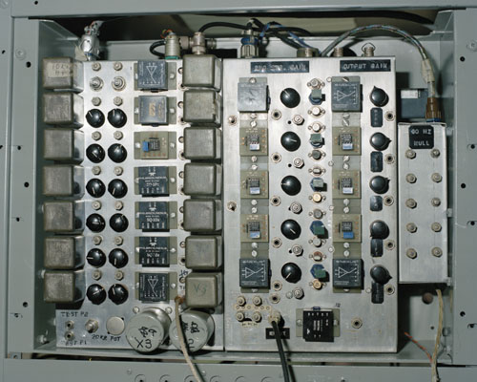
Fig. 1 MIT EPS original electronics chassis.

The Langley approach largely followed the MIT design with the exception of some rearranging of operations. Figure 2 is a remake of MIT’s EPS block diagram published by Stephens [1]. Prior to each preamp stage is a single pole 6 kHz RC passive high pass filter (HPF) in series with a 10 kHz modular LC HPF. The output of each preamp stage had a modular 20 kHz band pass filter (BPF) followed by a transistor buffer. The modular filters are the metal cans on the left side of the photo in Figure 1. The magnet drive amplifiers were driven by 3-phase 440 V AC rectifiers so harmonics of 60 Hz noise were pervasive throughout the system. A 60 Hz nulling stage with variable phase shifting was required to cancel out this line noise. Design details can be found in Appendix B of [1].

Figure 3 is a block diagram of the LaRC updated signal flow [2]. The input of each preamp stage included a single pole 6 kHz RC passive HPF. New printed circuit boards (PCB) were designed and fabricated largely following the original MIT concept with upgraded modern integrated circuits (IC) of the era. However, the PCB and chassis layout, grounding, and shielding were not optimal and some post fabrication modifications were required. Additionally, the MIT design’s versatility required a host of adjustment potentiometers (pots), most of which were placed on the chassis front panel a considerable distance from the circuitry, a significant variation from the MIT design. Consequently, a multitude of cables were required to make the connections and a questionable choice of RG174 coaxial cable was used for that purpose. As a result, the unit was finicky, sensitive to contact with potentiometers, and did not allow for routine operation of the MSBS control system.

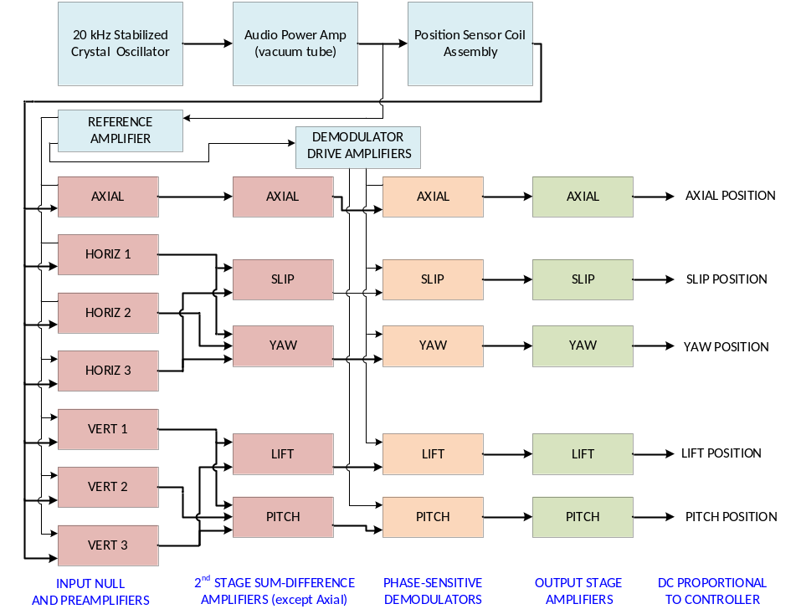
Fig. 2 MIT EPS electronics block diagram.
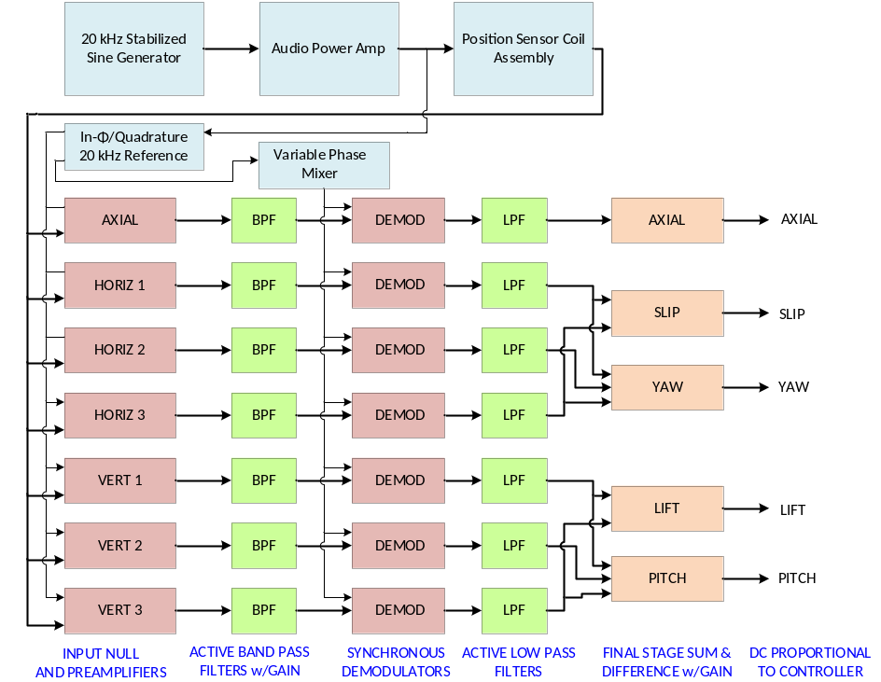
Fig. 3 LaRC EPS electronics block diagram (1988).
- Present Configuration
A general block diagram of the positioning system is shown in Figure 4. The 20 kHz reference signal is generated by a Krohn-Hite 4402B RC sinewave oscillator which produces the 20 kHz reference sine wave for the Model 7500 audio power amplifier and the EPS analog signal conditioner. The EPS cage primary coil pair is excited by the power amplifier providing sufficient current to develop 100 V_{PP} across the primary coils. The peak voltage is boosted by a series capacitor at the amplifier output that forms a series resonant circuit with the primary coil inductance. There is a 30 Watt 0.5-ohm resistor in series with the capacitor to soften the peak voltage to protect the cage primary wiring. Additionally, there is a bi-polar transient diode which begins clipping after exceeding 100V_{PP}. This is roughly half of the excitation used in the past [1, 2]. This protection was added because of the unknown condition of the encapsulated transducer assembly’s 50 year-old wiring. The secondary coils for each degree of freedom are pairs connected in series. Each pair has one lead connected to the power supply common inside the EPS signal conditioner. The other lead of each pair carries the modulated 20 kHz position signal to the appropriate PCB for amplification and demodulation. Proportional DC signals are produced as a final output to the system computer.
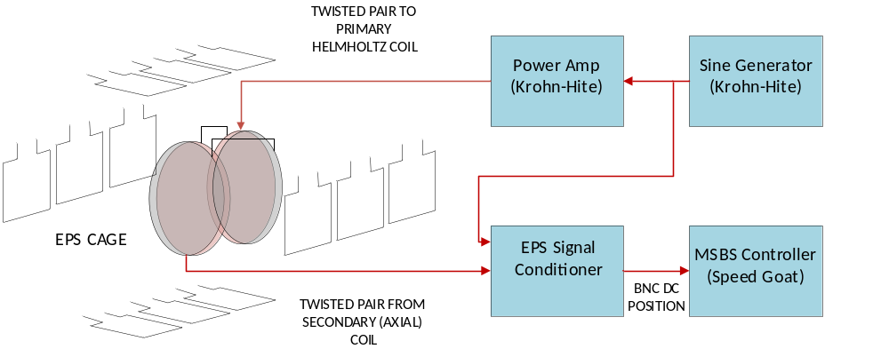
Fig. 4 Electromagnetic Position Sensor (EPS) and control system simplified block diagram (Axial).
A. EPS Transducer Coil Assembly Description
Figure 5 is an illustration of the transducer coil assembly and is a reproduction of figures originally published in [1] and [3]. There is a discrepancy in the original figures, however, since there is an implied common connection to the secondary coils with the transducer coil assembly itself. When the unit was returned to LaRC it was quickly discovered that each secondary coil pair is brought out of the assembly on a vintage 14-pin Winchester connector. The EPS Gnd notation in Figure 5 indicates that the common connection is actually in the signal conditioner chassis.

The excitation coils are a Helmholtz pair that is driven by a power amplified 20 kHz sine wave and wound adjacent to a pair of secondary pickup coils that are wound electrically opposed. This gives the familiar LVDT signal polarity reversal while crossing through center.

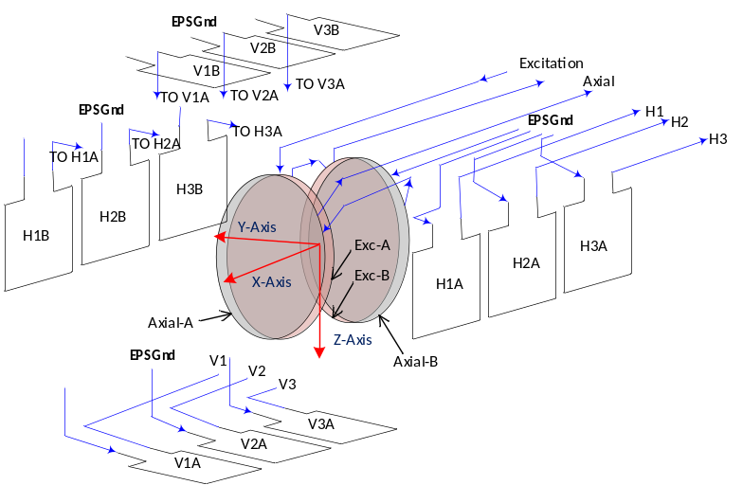
Fig. 5 Transducer Coil Assembly wiring layout.
There are two coil pairs each for vertical and horizontal model position sensing. The two center pairs, denoted by H2 and V2, are not currently used since pitch and yaw sensing is no longer a requirement. Coil V1B is wired in series to V1A and together with V3B in series with V3A, produce the vertical position signals. Likewise, H1B in series with H1A and H3B in series with H3A produce the horizontal position signals. An electrically conductive core causes coupling more strongly to either coil pair depending on its position away from symmetric center. The induced voltages are fed to the signal conditioner and differentially amplified, resulting in signal magnitudes and phase dependent on model position inside the assembly. Figure 6 is a photograph of the transducer assembly removed from the magnetic balance with a calibration fixture and steel ball.
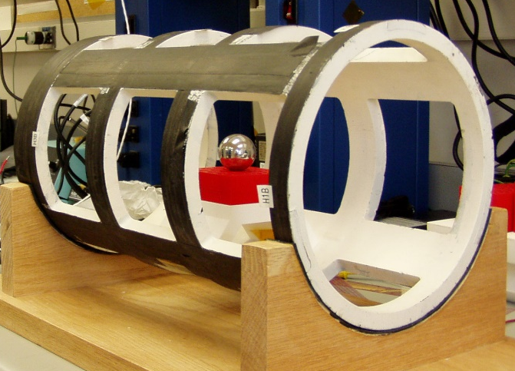
Fig. 6 Transducer Coil Assembly.
A 3-D printed prototype coil form for an experimental duplicate unit is complete but time has not allowed the installation of the coils. Stephens described the type of wire used to wind the secondary coils but did not specify the American Wire Gage (AWG) of the Litz wire used for the primary windings[1]. In order to confirm details regarding the windings and the actual physical size and nuances of the coil form for the purpose of reproducing it, the Nondestructive Evaluation Sciences Branch at LaRC performed tomographic X-ray analysis of the cage. Strategic inspection of certain image slices revealed twist in the primary windings, indicating Litz wire, and provided a range of nominal diameter. Recovered EPS build drawings so far have not precisely matched some aspects of its construction. The analysis also found documentation discrepancies in routing of the wire to the individual secondary loops. For example, Figure B.2. of [1] suggests that the loop wiring runs methodically along symmetric chases along the length of the transducer assembly. Careful inspection of Figure 7 showing the one end of the cage, reveals that not to be the case. The channel running vertically in the background of the image is void of any wiring. The concentric windings of one of the primary coils (light) and one secondary Axial coil (dark) just above can be seen in the figure along with secondary rectangular loops.

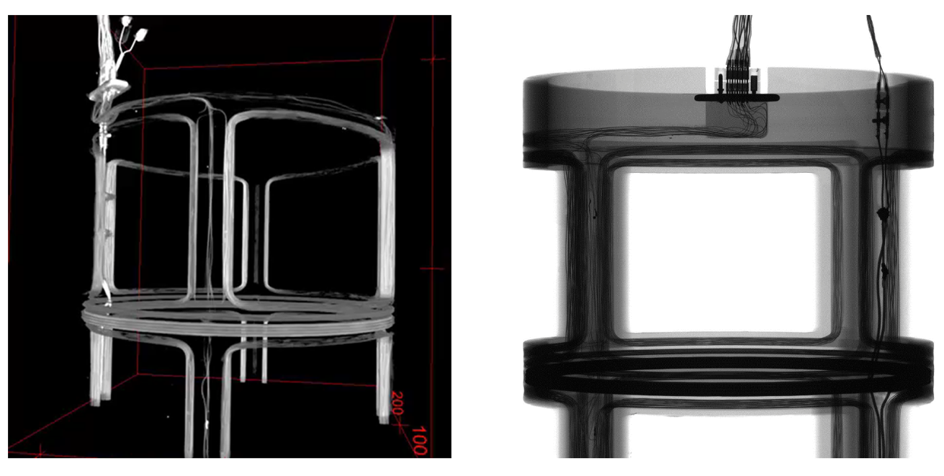

Fig. 7 X-ray of transducer coil assembly.

B. Analog Signal Conditioner Description
The signal conditioner accepts the induced voltages produced by the transducer coil assembly and performs amplification, filtering, and demodulation producing DC position voltages proportional to wind tunnel model position. The signal conditioner uses the same PCBs built at LaRC in the late 1980s. The circuit boards were recently diagnosed, modified, and installed into a new aluminum chassis box with mu-metal lining. Because the current purpose of the MSBS is the study of blunt body planetary entry shapes, the control of pitch and yaw is no longer useful. Therefore, the electronics that would produce those position signals were not installed. The block diagram of the present signal conditioning electronics is shown in Figure 8.

The input stage of each signal conditioning PCB has a 6 kHz passive LPF (not shown) with op-amp follower. All op-amps are the still viable OP27. The signal is then brought into an inverting amplifier with a variable gain, nominally set to 10X. In-phase and quadrature reference signals are buffered by followers and mixed in through potentiometers at the amplifier summing junction for pre-model nulling. The signal is then fed to a 2nd-order band pass filter with a gain of 6 then rectified using an AD630 synchronous demodulator[4]. The resulting ripple is smoothed using a 100 Hz 2nd-order LPF for use by the system controller.

The EPS signals are brought into the signal conditioner chassis over twisted shielded pair (TSP) through a 15-pin D-sub connector. The TSPs are connected to a custom backplane that provides the interconnections to each PCB. Figure 9 shows the interior of the signal conditioner with the front of the chassis at left. There are five PCBs for signal conditioning; one for Axial and two each for Vertical and Horizontal channels. The PCB farthest away produces the 20 kHz reference and quadrature signals. A plethora of coaxial cables were eliminated by adding two additional PCBs for the position signal nulling and gain pots, which are visible to the lower left in Figure 9. The two parallel PCBs are located behind and orthogonal to the front panel and allowing access to the trim-pots. The nulling and gain adjustment pots are mounted to the edges of the two parallel boards with the adjustment screws just accessible by protruding through the front panel. The two PCBs are mounted by headers connecting to the backplane. The nominal ±15 V power is supplied by an external vintage HP linear power supply.

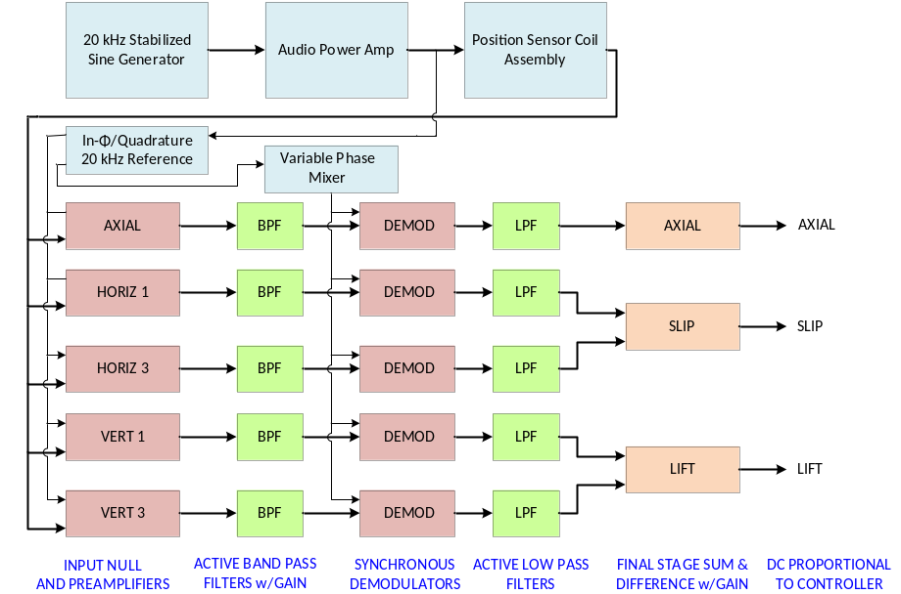
Fig. 8 Block diagram of signal conditioner present configuration.

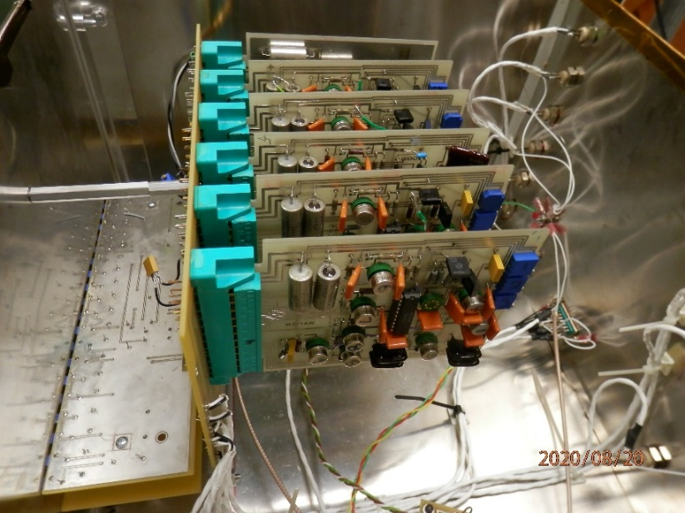
Fig. 9 EPS Signal Conditioner interior view.

C. Additions to the Signal Conditioner
The MSBS position control system has been hampered by the noisy environment created by switching power supplies. One of the most invasive problems is 51 kHz noise spikes produced by gradient amplifiers used to power the drive magnets. Although the noise was largely rejected by the position signal demodulators, considerable effort was put forth to investigate its reduction. Fortunately, the amplifier manufacturer designed in the ability to synchronize the switching frequency of multiple units, making the noise narrow band. The noise showed up most strongly on the axial EPS channel and its entry path was never clear. Several steps were taken to mitigate the problem including the design and fabrication of two additional PCBs installed on the front of the axial channel signal path. One is an AC coupled instrumentation amplifier (IA) with a gain of 2 used to take advantage of its common mode rejection and differential input stage and is shown in the schematic of Figure 10[5]. The bottom op-amp in the figure is an active shield driver connected to the shield of the axial channel input cable TSP. The input stage includes passive common and differential mode filtering. The circuit eliminates the need for the passive HPF and follower stage on the original PCB. Although the design has advantages over the original single-ended input stage, its effect on the 51 kHz noise was negligible. The noise was most likely being coupled into the EPS axial secondary windings by the axial control drive coils located concentrically nearby.

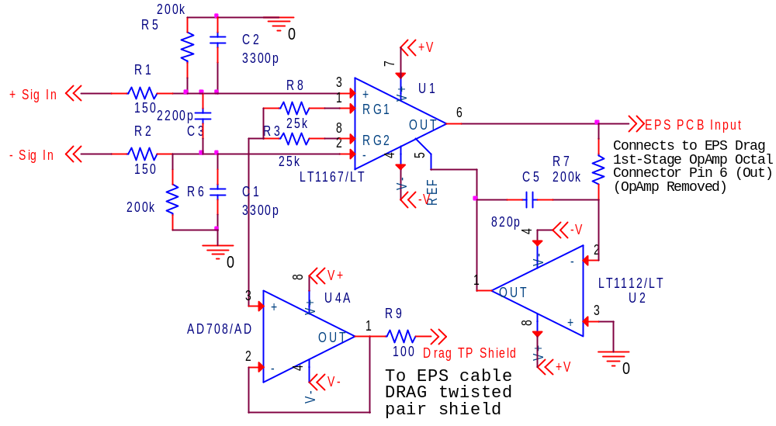
Fig. 10 EPS Axial channel input stage.

A more successful, second PCB was designed to suppress the 51 kHz noise on the Axial channel. A two-stage active biquadratic (biquad) band reject, or notch, filter was designed and found to be very effective in controlling the 51 kHz noise. The prototype PCB was connected in series following the new input stage. The circuit is based on TLE2072 field effect transistor (FET) dual surface mount op-amps. The prototyping was tedious, requiring repeated trial-and-error changing out of surface mount resistors and pot adjustments in order to dial in the center frequency. The filter behaves much like a Twin-T using cancellation at the output stage. Figure 11 is a plot of laboratory data taken using a sine generator for the input signal. Most of the attenuation was accomplished by the first stage (-43 dB) and, in hindsight, was not worth the extra complexity of a tandem stage. The final Q is 17.
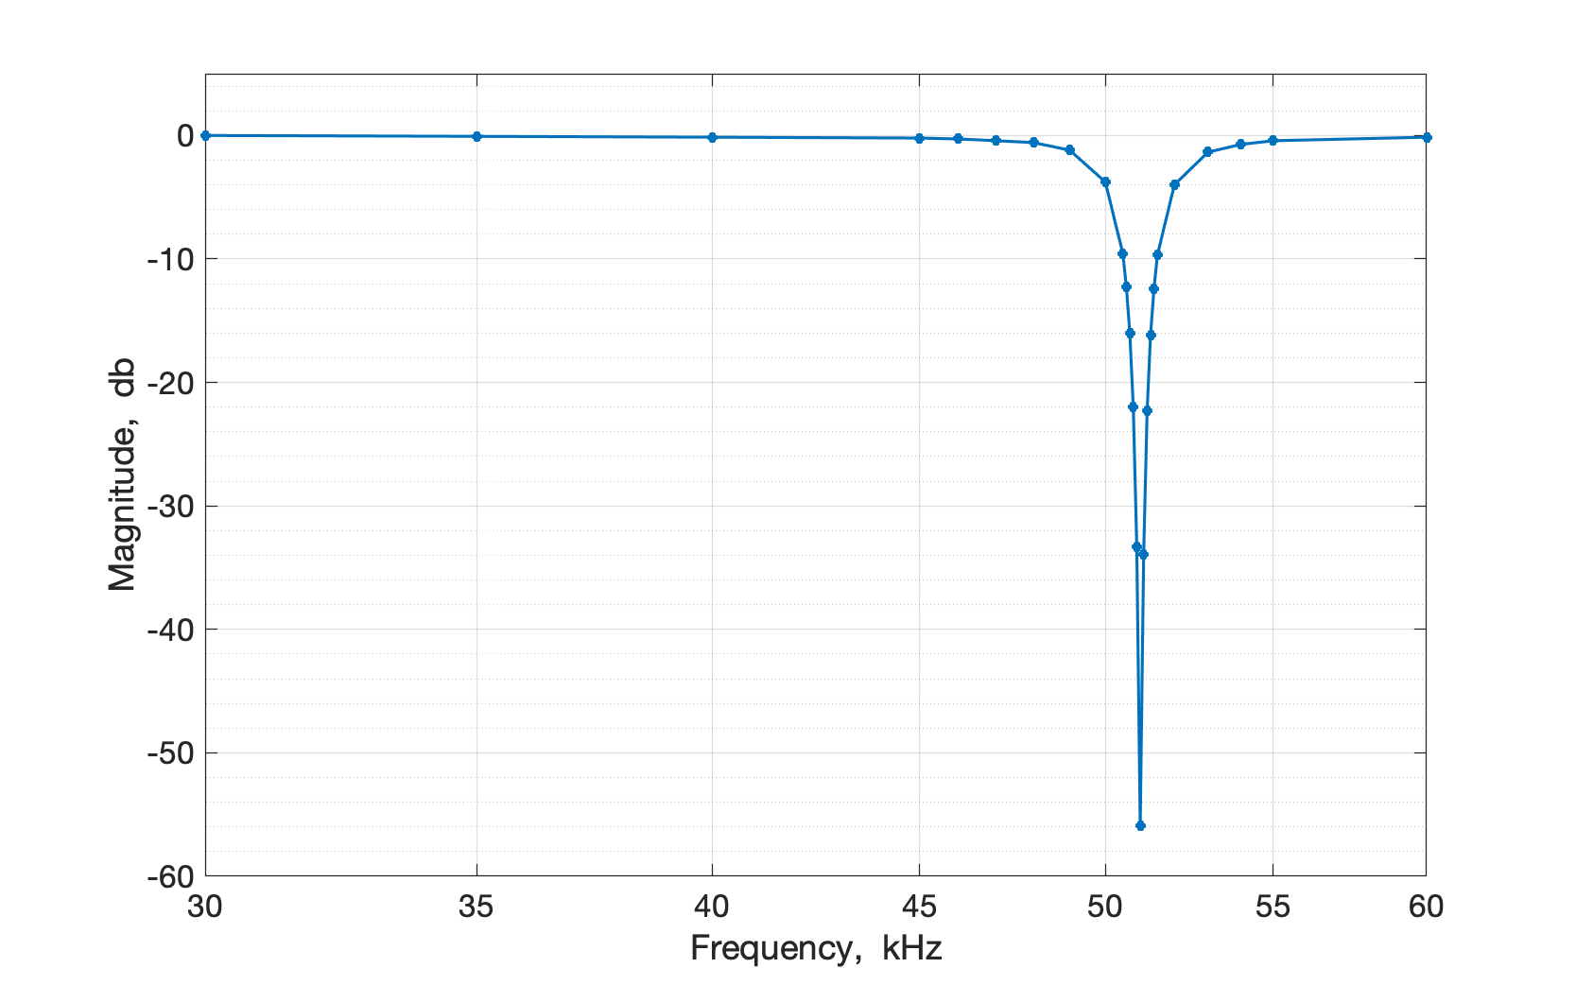
Fig. 11 51 kHz notch filter response.
- EPS Operation

The EPS electronics, on their own, are fairly stable once an ample amount of warm-up time (~1 hour) is established. The transducer coil assembly, however, is temperature sensitive and causes significant drift during MSBS operation. This was much less an issue during the first LaRC experience in 1990 since the drive magnet cooling system was essentially open-loop provided with a continuous supply of building air conditioning cooling water. The present configuration is limited to a closed loop recirculating system with a heat exchanger and ~80-gallon holding tank that approaches 100° F during extended operations. Consequently, frequent tweaking of trim-pots are required to re-null the unit between wind tunnel runs.

The heart of the analog circuitry is the Analog Devices AD630 synchronous demodulator integrated circuit (IC) used for demodulation of the AM EPS signals. Each PCB has its own phase mixing circuit for the demodulator 20 kHz reference signal, shown at left in the schematic of Figure 12. Adjustment of this phase using trim-pots on each PCB is critical to the proper operation of the unit. And because the Lift and Slip demodulated signals are summed at the final output stage, the two channels (V1, V3 and H1, H3) must be matched to give equal amplitudes with model displacement. These adjustments are tedious, requiring static equidistant placement of the model off-center while monitoring the output of the AD630s on an oscilloscope. The band pass filtered modulated EPS signals are brought into the modulation input and the phase reference signal is connected to the carrier input[4]. The circuit works remarkably well considering the lack of ground plane on the 2-layered PCBs. Figure 13 is an example of the modulation input and the output signals. The plot shown is Axial channel data taken from an oscilloscope with the EPS powered up and a model positioned downstream in the test section. The model core is a neodymium permanent magnet, which works well with the MSBS and for which the AD630 reference phase is set. Because of compromise used in the phase adjustment between the pairs of vertical and horizontal channel PCBs, roughly 90%-95% DC rectification results when the phase is properly aligned.
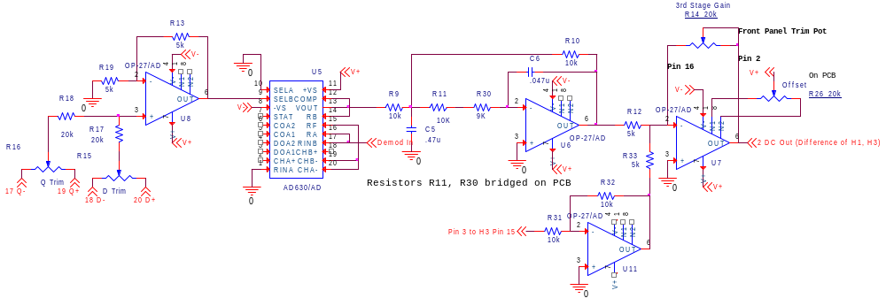
Fig. 12 Demodulation, LPF, and summing circuit.
Figure 14 is a plot of oscilloscope data using a steel ball bearing for which the demodulator reference phase is not properly aligned. This is an example of the phase shift caused when changing model core materials. The steel ball is in the approximate position as the neodymium magnet used in the data presented in Figure 13. The demodulator reference signal is nearly at 90° to the demodulated position signal resulting in poor rectification and a minimal DC output signal. The MSBS cannot levitate under this condition. The spikes on the demodulator output signals could be a result of the lack of PCB ground plane.

Fig. 13 EPS Axial channel downstream data plot.

Fig. 14 EPS Axial channel demodulated signal plot using steel ball (poor rectification).

A PSPICE simulation was recently performed on the demodulator 20 kHz BPF circuit used on each EPS signal conditioner PCB. Figure 12 is the circuit with the 1V_{PP} swept sine source modeled in Orcad schematic capture. As previously described, the BPF shown is the preceding circuit in the signal path of the demodulator input. A plot of the simulation results is shown in Figure 16. The resulting response is typical of a Butterworth design with upper and lower -3dB frequencies resulting in a filter Q of 2, which was the reported design Q described in [2].

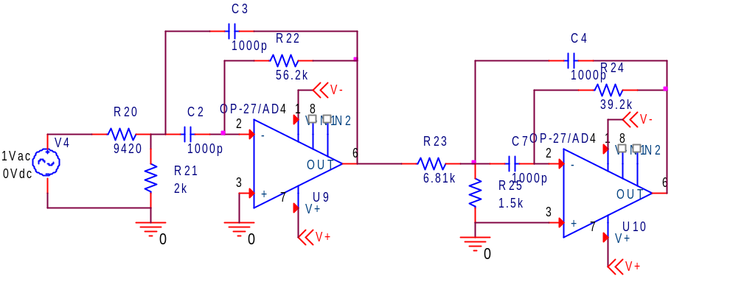
Fig. 15 Demodulator BPF schematic used in simulation.

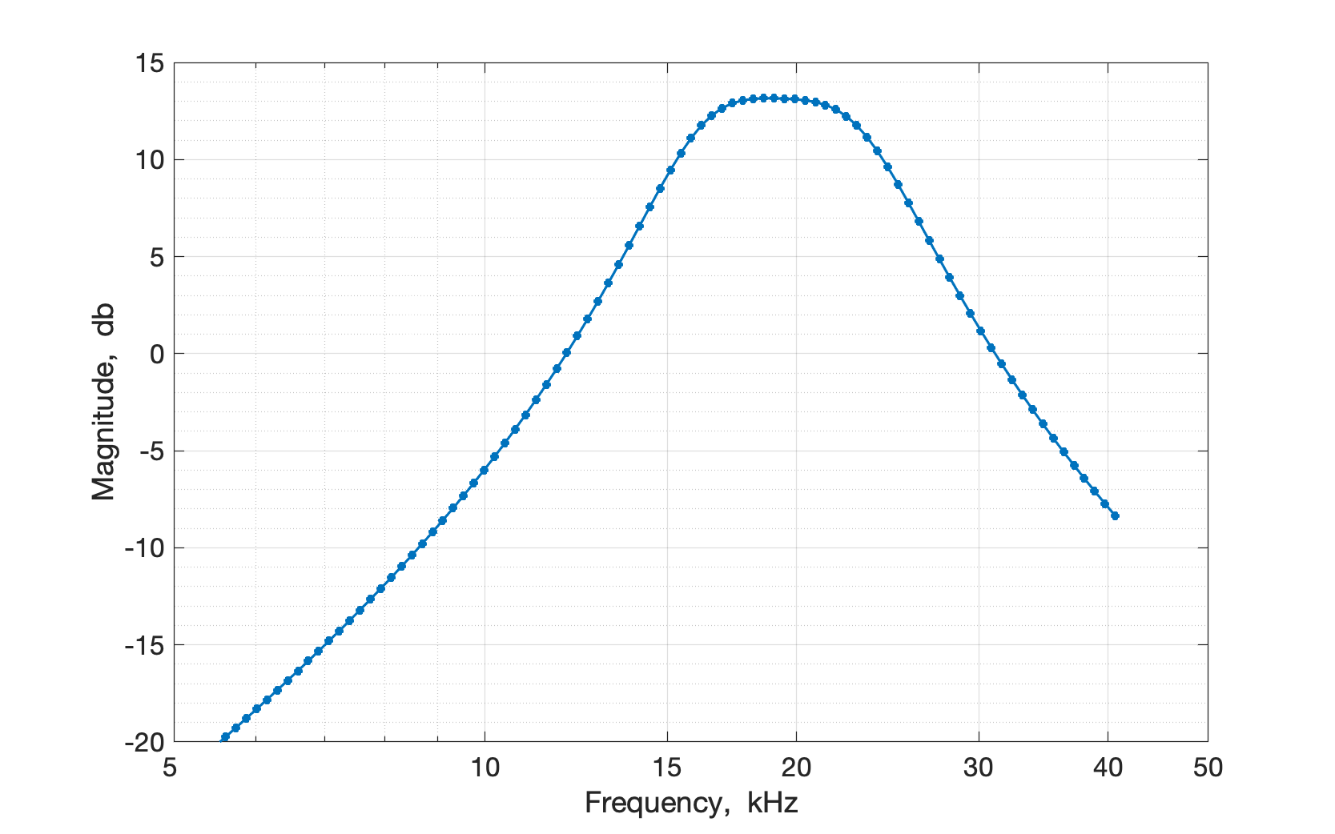
Fig. 16 Plot of demodulator BPF PSPICE simulation.

A calibration experiment was performed to validate the performance of the EPS system. The conductive target for this set of tests was a steel ball, ¾ inch in diameter. It was held in position by a set of plastic mounts which allowed repeatable spacing at ½ inch intervals in the X, Y, and Z axes of the tunnel. Data was averaged for 5 seconds at each of the 125 positions to reduce the effect of noise on the calibration. The on-axis displacement results are shown in Figure 17, along with the linear sensitivity in each axes. These are the calibration values which are used by the control system to stabilize the model.
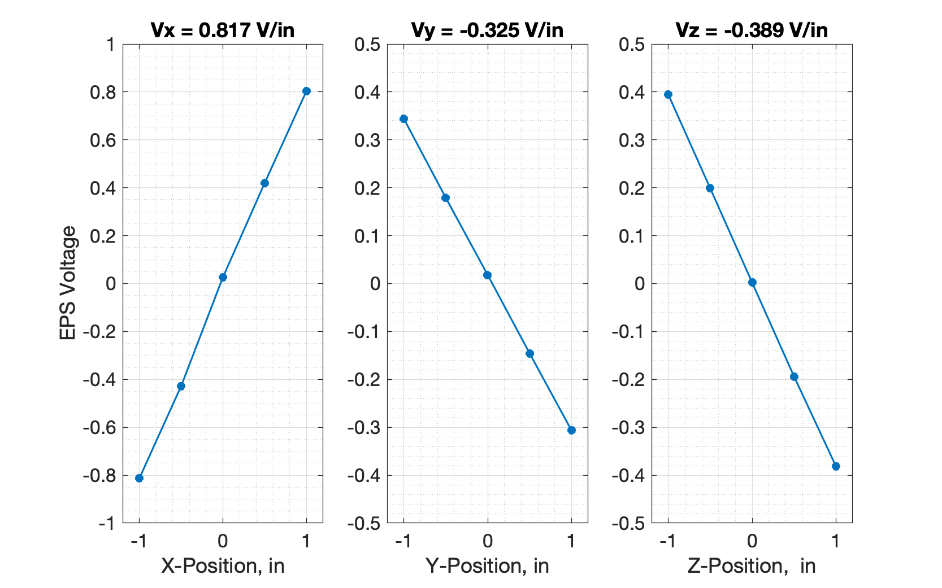

Fig. 17 On-Axis response of the EPS and calibrated sensitivities

There is some off-axis coupling between the degrees of freedom, in particular when the model is above or below the center-plane of the test section. Figure18 shows the Z-axis voltage for motion of the model in the X and Y plane. Although it remains well decoupled at the center-plane, for positions above and below this point curvature can be seen in the resulting surface fit. This curvature is repeatable, and could be removed with a non-linear calibration, however this was not necessary to achieve adequate control of the suspended model. This calibration error has minimal impact on test results as data for the determination of aerodynamic parameters is independent of the EPS, using a camera system and postprocessing algorithms for both the position and orientation time histories.

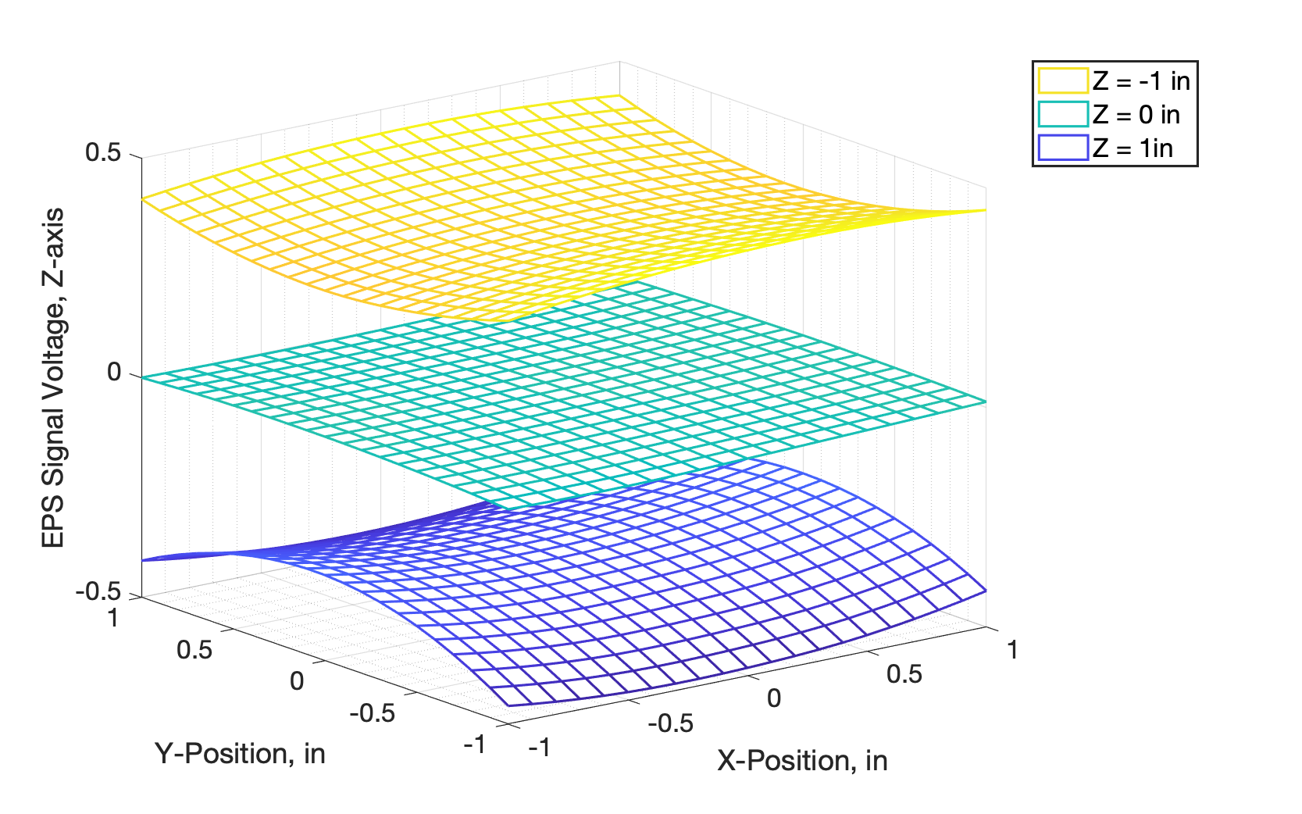
Fig. 18 Off-Axis response surface for X,Y positions at three different heights

Conclusion
The 6-inch MSBS EPS signal conditioner was recovered, returned to LaRC in 2015 after over 20 years of storage. The unit was successfully refurbished and was instrumental in the recommissioning of the MSBS low-speed wind tunnel. Together with the original MIT transducer coil assembly, it reliably supported wind tunnel runs on a routine basis. An updated description and historical analysis of the original MIT EPS was presented along with a detailed comparison with the existing system. Calibration results of the EPS using sophisticated modern software showed very good linearity and repeatability.

Since the MSBS was returned to operation, an on-going study of the EPS transducer coil assembly was conducted, in order to build a replica in the event of damage to the original unit and to understand the design for future sensor applications. Details of the construction of the transducer assembly either lost over 50 years of time, or never before reported, were revealed using modern tomographic X-ray analysis performed at LaRC.

References

[1] Stephens, T., “Design and Construction, and Evaluation of a Magnetic Suspension Wind Tunnel” NASA CR-66903, 1969.
[2] Daniels, T. S., Tripp, J. S., “Improvements to an Electromagnetic Position Sensor,” Instrument Society of America International Symposium, Paper # 88-0708, Albuquerque N. M., 1988.
[3] Stephens, T., “An Electromagnetic Remote Model Position Sensing System for Wind Tunnels with Particular Application to Magnetic Suspension Wind Systems,” Second International Symposium on Magnetic Suspension, Department of Aeronautics and Astronautics, University of Southampton, United Kingdom, 1971.
[4] AD630 Balanced Modulator/Demodulator Data Sheet, Analog Devices
[5] Linear Technology LT1167 Data Sheet, Analog Devices

AST, Remote Sensing Branch, B1202/MS468.
Research AST, Dynamic Systems and Control Branch, B1232/MS308.

