Achieving Equilibrium for Dense, Integrated Vehicle Navigation
Mahyar R. Malekpour
NASA Langley Research Center, Hampton, Virginia 23681
Drone usage has proliferated in recent years with many applications that have market-changing potential. Applications that include parcel delivery, wildlife protection, precision farming, law enforcement, and industrial inspection, just to name a few. In this paper, the term drone is used to mean both Unmanned Aerial Vehicle and small Unmanned Aircraft System vehicles. Flight infrastructure can currently only support a few thousand aircraft flying over the United States National Airspace System (NAS) at any given time. A delay at one airport sends ripple effects through the system, causing more delays and missed connections. Once regulations and safety policies are put in place to allow for the widespread use of unmanned drones, the number of aircraft in the NAS is expected to skyrocket to millions, potentially congesting the airspace resulting in possible separation violations. In air traffic control, separation is the concept of keeping an “ownship” aircraft outside a minimum distance from “intruder” aircraft to reduce the risk of the aircraft colliding, as well as preventing accidents due to secondary factors, such as wake turbulence. Maintaining proper separation is a safety critical property for drones in the airspace. This paper addresses separation in time and in distance for high volume corridors (en-route) and lanes (on ground). The requirements and necessary conditions for maintaining proper separation and reaching maximum throughput for a given corridor/lane are addressed assuming unidirectional corridors/lanes where an aircraft arrives from one side and departs from the opposite side. Simulation results are presented that show the presented solution guarantees a set of drones to reach the equilibrium state by adjusting their speed based on their distance to the aircraft in front of them. The equilibrium state is defined as a state when a set of n aircraft moving at a relatively constant speed and uniform spacing from each other in a congested system. A congested system is defined as a state when the aircraft cannot move at their maximum allowed speed. Unlike existing centralized and pre-planned approaches, the proposed solution is fully distributed and enables autonomous aircraft to decide to adjust their speed and distance with respect to the preceding aircraft, dynamically. Simulation results are presented that assess the feasibility of the approach using a large number of drones and evaluate the scalability of the proposed solution.

Nomenclature
UAV = Unmanned Aerial Vehicle
sUAS = Small Unmanned Aircraft System
NAS = National Airspace System
NASA = National Aeronautics and Space Administration
FAA = Federal Aviation Administration
ATM = Air Traffic Management
ACC = Adaptive Cruise Control
CACC = Cooperative ACC
V2V = Vehicle-to-Vehicle

Introduction
Drone usage has been on the rise in recent years with many applications that have market-changing potential. Applications that include parcel delivery, wildlife protection, precision farming, law enforcement, and industrial inspection, just to name a few. Once the Federal Aviation Administration (FAA) regulations and safety precautions are put in place to allow unmanned drones in the United States National Airspace System (NAS), the number of these drones is expected to be increase to thousands. In this paper, the term drone is used to mean both Unmanned Aerial Vehicle (UAV) and small Unmanned Aircraft System (sUAS) vehicles.
Drone navigation approaches are typically based on following a pre-flight path from one point to another with waypoints along the way. For multiple drones in a shared airspace, the path for each drone is predetermined to avoid any conflict with other paths with provisions made to detect and avoid obstacles along the way¹. This approach for path planning is predominantly centralized and predetermined, and although this approach seems like a safe and reliable way to handle multiple drones in the airspace, it does not necessarily eliminate off-nominal events that result in deviation from the original plan. Pre-planning routes and scheduling paths for a small to moderate number of drones is a manageable task performed by a central authority. Scaling this approach to thousands of drones while anticipating off-nominal conditions is too complex of a task for a central authority to complete. Providing distinct and safe paths in real-time for a large number of drones is computationally too expensive to account all possible scenarios. Dynamic path planning has its own set of challenges. As Kaplan et al. reported in their dynamic air-traffic model approach, the ability to maintain a required separation between aircraft decreases as the number of aircraft in the volume increases². Even with certain assumptions about the coming obstacles, it is still required to keep track of the primary and subsequent collision avoidance maneuvers necessary to maintain a specified distance between all aircraft. Simulation results showed that the number of collision avoidance moves increased exponentially with the number of aircraft in the volume.
Although pre-planned and dynamic routing for very large number of drones flying in the NAS outside the city limits is theoretically possible, the author envisions a need for designated flight corridors (highways in the sky) within the urban canyons to ensure safe navigation of very large number of drones. The choice of what corridors to fly through, however, may be either pre-assigned to individual drones or decided along the way as a drone transitions from one corridor to another. Furthermore, if the goal is to accommodate a large number of drones in the NAS, the only viable approach would be for the airborne vehicles to operate autonomously and manage their navigation onboard, that is, locally, while abiding by the FAA regulations and conforming to the designated corridors leading to their destination. This approach also has its own set of issues.
Navigation of drones through a given corridor is similar to movement of cars on a ground-based highway. Vehicles on roads and highways are highly susceptible to unpredictable speed changes with sudden deceleration resulting in traffic jams, possible accidents, and the undesired effect of further delays in the traffic flow; a behavior that is more prevalent as the number of vehicles increases beyond a threshold. Likewise, as the number of drones in a corridor increases beyond a threshold, the corridor will have similar problems that need to be managed, key among them maintaining a safe minimum distance between the vehicles. As discussed in detail in the following section, aircraft spacing has been studied for decades^{3,4}. Vehicle spacing on highways has also been studied for decades with primary focus on platooning to improve fuel efficiency of heavy-duty trucks⁵. This paper addresses spacing issues for a given corridor and various number of vehicles while abstracting away physical mechanics of vehicle movement. Although the focus of this paper is drones in the NAS, the term corridor means a highway in the sky as well as a ground-based highway and the term vehicle could mean drones or cars. In the context of this study, a system is defined as a corridor with a given length and a number of vehicles navigating through it. This paper is a study of a proposed approach that guarantees to keep a safe separation between the vehicles in a given system.
Background on related work is presented in Section II. A solution is described in Section III. Simulation results are presented in Section IV. Concluding remarks and future works are outlined in Section V.

Background
The FAA is predicting a substantial increase in the number of revenue passenger miles flown over the next two decades⁶. This increase could strain the current air traffic system if improvements are not made. To help increase the efficiency of arrivals, new procedures, such as Optimized Profile Descents, have been implemented at a number of sites. However, these procedures are often not used during periods of peak traffic due to the lack of precision scheduling and spacing tools⁷, resulting in sub-optimal arrival operations⁴. The National Aeronautics and Space Administration (NASA) has been developing technologies that are expected to increase the use of efficient arrival procedures during periods of peak traffic. The goal of NASA’s first Air Traffic Management (ATM) Technology Demonstration (ATD-1) is to accelerate the implementation of mature NASA technologies, enabling aircraft to use speed control to remain close to their OPDs during periods of peak traffic⁸.
Swieringa et al.’s effort led to a study of string stability of the ASTAR-12 algorithm as reported in⁴, where several aircraft following each other during arrival into an airport, are said to form a string. A string is said to be stable if the spacing error does not grow as a function of string position, ensuring that small perturbations early in the string do not develop into unacceptable behavior later in the string. They also noted that long strings of aircraft could exhibit unstable string behavior if the control algorithm is not designed properly. Their analysis of the ASTAR-12 spacing algorithm determined that the algorithm is string stable and acceptable for strings of moderate length. However, they noted degradation in its performance as a function of string position. This work, in part, emphasized the need to investigate string stability further and possibly offer a different solution that not only scales to strings with thousands of aircraft, but also guarantees stability of the string regardless of its size.
Another area where string stability has been studied is on ground-based highways, in particular, in platoons of vehicles traveling with a common goal. The advent of Cruise Control has been one of the fundamental instruments in this effort. Adaptive Cruise Control (ACC) and Cooperative ACC (CACC), have been vital in increasing performance of platooning of heavy-duty vehicles on highways to maintain a pre-set gap between the vehicles⁵. CACC, which uses inter-vehicle communication, also known as vehicle-to-vehicle (V2V) communication, is expected to realize safe driving at inter-vehicle distances shorter than that are possible under ACC⁵. Omae et al. acknowledge that when the controller uses inter-vehicle distance and relative velocity information, heavy-duty vehicles may lose string stability in some circumstances due to their slow-response acceleration characteristics⁵. Nonetheless, ACCs are considered the first step of automation, and their market penetration rate is expected to rise, along with the interest of researchers worldwide to assess their impact in relation to traffic flow and stability.
Although CACC controller guarantees stability among heavy-duty vehicles in a platoon⁵, the spacing problem between vehicles that are not cooperating with each other, that is, all vehicles on a highway not part of the platoon, has not received the attention it needs. Similarly, ACC systems do not address the stability problem at the highway level. Since the precision spacing of aircraft in-trail, or in the terminal airspace, is based on time-schedule and communication between the aircraft, whether directly with each other or indirectly via a central air traffic management system, it is effectively analogous to managing a platoon of aircraft, and, similar to CACC, it too does not address the aircraft spacing or string stability beyond the platoon of aircraft. A detailed analysis of whether ASTAR-12 and ACC algorithms can be extended to vehicles not part of a platoon is beyond the scope of this paper and left for future work.
The solutions reported by Swieringa et al. and Omae et al. are shown to reach stability in the platoons^{4,5}. However, Gunter et al. reported that their assessment of the string stability of seven 2018 model year ACC equipped vehicles that are widely available in the US market showed that none of the ACC are string stable⁹. This finding also reaffirms the need for a new look at this problem.
Platoon and CACC are designed for vehicles operating at a given speed for better throughput with the lead vehicle operating at a certain speed, which is determined beforehand. In contrast, the presented solution in this paper does not make such assumptions. In other words, vehicles do not: (1) follow a leader in trying to match its speed as in a platoon, (2) try to achieve or maintain a pre-specified intervehicle spacing, (3) share their data with each other (no V2V communication), (4) operate based on a time schedule, and (5) have to be homogeneous. The vehicles are assumed to be equipped with sensors to determine their distance from the vehicle in front them. Although the vehicles adhere to a maximum speed limit set for the corridor, their eventual speed, when the system reaches equilibrium, is not predetermined and is not known to the vehicles beforehand; it is simply a function of the length of the corridor and number of the vehicles in the corridor. With minimal information at a vehicle, the presented solution guarantees that all vehicles will eventually operate at an equilibrium which is defined as traveling at a relatively constant speed and similar distances with respect to each other with traffic flowing steady and smoothly.

Proposed Solution
The approach presented in this section is an intuitive look at the string problem and focuses on the string stability not at a platoon level but at the system level. Several simplifying assumptions are made within this analysis: details of physical mechanisms of a vehicle are simplified; and the string problem is abstracted to a system with a set of vehicles navigating in a specified corridor from point A to point B, where the vehicles enter from one end and exit from another at a steady rate, that is, a single one-way corridor. Thus, the system is modeled as a straight line where a new vehicle enters from one end and exits from the opposite end. To maintain the number of vehicles in the system a constant, the rate of vehicles entering/exiting the corridor is kept constant by introducing a new vehicle in the corridor within a given time after another vehicle exits the corridor. Furthermore, for simulation purposes, to reduce repeated memory allocation/deallocation for the vehicles entering/exiting the corridor, the exiting vehicle is reintroduced back in the system. Thus, the system is modeled logically as a circle with a set of vehicles.
The presented solution is described in algorithmic and discrete domain and is also analyzed in the discrete domain which helps with direct transition of pseudo-code to simulation, implementation, and ease of analysis. Expressing this approach in the real domain is left for future work. Since the system is being studied in its totality, stability is also defined differently here.
The following parameters are used in describing the solution:
- H is the total length of the corridor,
- N_{i}, a vehicle,
- l ≥ 0, length of a vehicle,
- S > 0 and a constant, maximum speed of vehicles,
- d_{safe} ≥ 0, minimum safe intervehicle distance,
- d_{i-1,i}(t) ≥ 0, distance between N_{i-1} and N_{i}, where N_{i-1} is in front of N_{i},
- n, number of vehicles, n < H/(l+ d_{safe}),
- k, gain factor, k > 1, and
- d_{i}(t) ≥ 0, the distance N_{i} moves at time t, d_{i}(t) = min((d_{i-1,i}(t)- d_{safe})/k, S).

Assumptions
- Vehicles are equipped with sensors that are accurate and have no delay.
- All vehicles execute the proposed algorithm.
Requirements
- Safety: At all times, the intervehicle spacing, d_{safe}, is maintained.

The Algorithm
The algorithm as executed by N_{i}, for all i:
while (true)
{
d_{i-1,i}(t-1) = Loc_{i-1}(t-1) - Loc_{i}(t-1) // expected value ≥ d_{safe}
d_{i}(t) = min((d_{i-1,i}(t-1) - d_{safe})/k, S) // expected value ≥ 0
Loc_{i}(t) = Loc_{i-1}(t-1) + d_{i}(t), for all i // expected value ≥ d_{safe}
}

Definitions:
Vehicle: A drone or a car.
Corridor: A one-way corridor in the sky, or a single-lane ground-based road, with a given length.
System: A corridor with a given number of vehicles.
Congested: A system is said to be congested when N_{i} cannot navigate at the maximum allowed speed S. More formally, when ceiling(H/(l+S)) ≤ n < H/(l+d_{safe}). For example, given l = 4, S = 10, and H = 200, n ≥ 15 will result in a congested corridor. For a congested system, at equilibrium, d_{i-1,i}(t) = (H - n(d_{safe}+l))/n ± ε/2, where 0 < ε << 1.
Threshold,
n_{threshold}: The upper bound on the number of vehicles that can navigate at their maximum allowed speed. That is, the value of n above which the system is said to be congested. More formally, when n_{threshold} = ceiling(H/(l+S)).
Sparse State: A state when the number of vehicles is at or below the n_{threshold}.
Steady State: In a non-congested system, n < n_{threshold}, when the vehicles navigate at the maximum allowed speed, S, and at constant spacing from each other but potentially at different intervehicle spacing, the system is said to be in steady state. More formally, when n ≤ floor(H/(l+S)).
Equilibrium
State: When n vehicles in a congested system navigate at a relatively constant speed and uniform intervehicle spacing from each other, the system is said to be in equilibrium state. In equilibrium state, the intervehicle spacing is given by:
d_{i-1,i}(t) = (H - n(d_{safe}+l))/n ± ε/2, where 0 < ε << 1.

How the Algorithm Works
As time increments discretely, at one tick intervals, t-1, t, t+1, t+2, …, i.e., ∆t = 1, a vehicle computes the amount it can move ahead based on its local knowledge of its previous distance to the vehicle in front of it and the maximum speed it is allowed to move making sure it does not violate the minimum intervehicle safe spacing. Thus, the delayed reaction reflects the inherent delay had the physical mechanics of vehicle been explicitly modeled. The global gain factor k, a constant, controls the rate at which the system reaches equilibrium. Different values of k are discussed in the following section.

Simulation
Results of MATLAB simulations are presented in this section. Simulation is the first step in determining feasibility of this approach before pursuing the next step of attempting a formal proof of the solution, which is left for future work. To faithfully depict simultaneous activities of the vehicles, the simulator executes the following three steps in succession:

1. For all vehicles, determine their intervehicle distances
d_{i-1,i}(t) = Loc_{i-1}(t-1) - Loc_{i}(t-1) // expected value ≥ d_{safe}

2. For all vehicles, determine the distance a vehicle can safely move
d_{i}(t) = min((d_{i-1,i}(t-1) - d_{safe})/k, S) // expected increment value ≥ 0

3. For all vehicles, update the new location of the vehicles
Loc_{i}(t) = Loc_{i-1}(t-1) + d_{i}(t) // expected value ≥ d_{safe}

For visual purposes, a congested system with H = 200, l = 0, S = 10, d_{safe} = 4, k = 2, and n = 20 is simulated. Fig. 1 depicts the vehicles that at random initial positions in the corridor and Fig. 2 is the vehicles after the system reached equilibrium with vehicles positioned at roughly equidistance from each other navigating at the same speed. When visualization is not a concern, larger number of vehicles, up to one thousand, have been simulated. The horizontal axis is time and vertical axis is for visual purposes and each circle represents a vehicle.

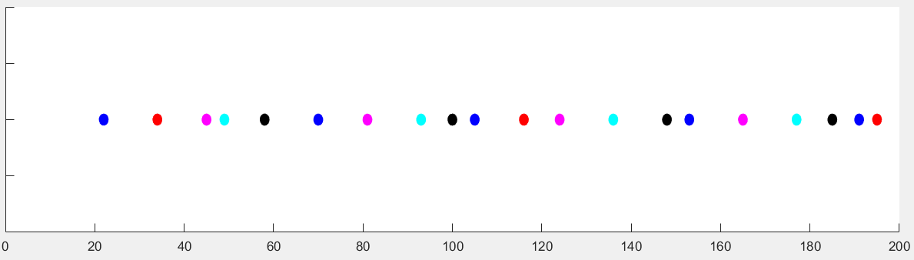
Fig. 1. Random start

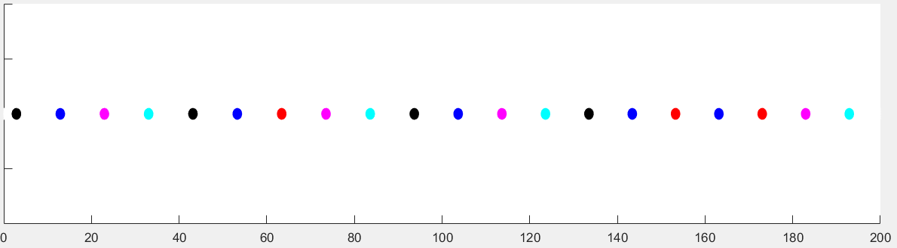
Fig. 2. At equilibrium

Fig. 3 is a plot of maximum differences of the intervehicle distances at any time t. Fig. 4 is a plot of the distances of vehicles to the vehicle in front at any time t. The horizontal axis represents time, from the initial state until the system reaches equilibrium, and the vertical axis is the distances as time progresses. From these figures, the intervehicle distances decreases exponentially and the system reaches equilibrium asymptotically. In these examples, with maximum allowed speed, S = 10, if the system were not congested, the intervehicle distances would be 10 (note that x = vt, with ∆t = 1 and S = 10, x = 10). For the congested case, the limit is x = 10 – ε, where ε = 0.25. Thus far, simulations of systems with different number of vehicles and initial random starting positions of the vehicles have shown that the proposed solution is scalable and always brings a congested system to an equilibrium and when the system is not congested, it always reaches the steady state; thus, proving feasibility of pursuing a formal analysis of the proposed solution in the future. Determining the amount of time it takes for a given system to reach equilibrium is also left for future work.

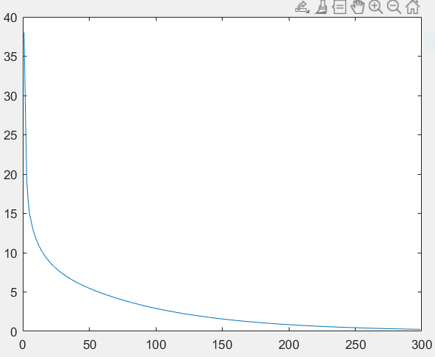  Fig. 3. Maximum intervehicle distances | 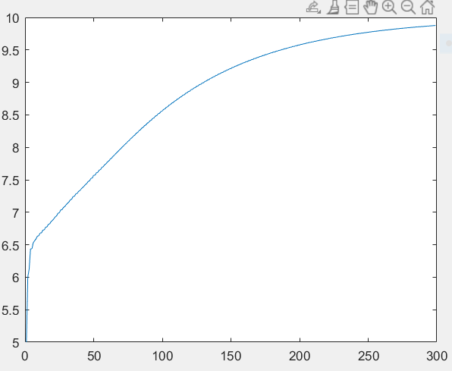  Fig. 4. Distance to front vehicle
The plots in the above figures are for k = 2, the default value. Figures 5 through 10 are the simulation results of various values of k for congested systems of twenty vehicles from random initial positions of the vehicles. Although, for all these values the system reaches equilibrium, as shown in Figures 7 and 8, k = 2 results in the fastest time to reach that state.

Fig. 5. k = 1.5 | Fig. 6. k = 1.5
Fig. 7. k = 2.0 | Fig. 8. k = 2.0
Fig. 9. k = 3.0 | Fig. 10. k = 3.0

Conclusion
With drone usage proliferating with many applications, the number of drones in the NAS is expected to skyrocket to thousands, potentially congesting the airspace resulting in possible separation violations. Maintaining proper separation is safety critical for drones in the airspace. This paper addressed separation in time and in distance for high volume corridors (en-route and on ground). The requirements and necessary conditions for maintaining proper separation and reaching maximum throughput for a given corridor were addressed assuming unidirectional corridors where an aircraft arrives from one side and departs from the opposite side. Analogy was made between navigation of drones through a given corridor and movement of cars on a ground-based highway. An intuitive solution was presented that, unlike existing centralized and pre-planned approaches, is fully distributed and the vehicles autonomously decide to adjust their speed and distance with respect to the preceding aircraft, dynamically, and with only the local knowledge of their distance to the vehicle in front of them. Simulation results showed the presented solution guarantees the vehicles reach an equilibrium state in a congested system. An equilibrium state and congested system were defined. Preliminary results thus far confirmed that the proposed solution, regardless of the initial state of the system and positions of the vehicles, always results in equilibrium where the traffic flows smoothly and at optimum rate. Simulation results also confirmed scalability of the proposed solution to any system of n vehicles and the feasibility of the approach for pursuing formal analysis that is left for future work. Analytically determining the amount of time it takes for a given system to reach equilibrium is also left for future work. Simulation showed that when the system is not congested, it always reaches the steady state. The gain factor, k, of the proposed solution was analyzed and its optimum value for reaching equilibrium in a congested system was determined. Future work also includes: (1) formal analysis of stability of the solution, (2) further analysis of the proposed solution beyond the steady state and equilibrium, and (3) expanding the model of the system and the vehicles to more accurately represent practical scenarios.

References
¹ Balachandran, S., Muñoz, C., Consiglio, M., Feliú, M., Patel, A.: Independent Configurable Architecture for Reliable Operation of Unmanned Systems with Distributed On-Board Services, Proceedings of the 37th Digital Avionics Systems Conference (DASC 2018), London, England, UK, 2018.
² Kaplan, C., Oran, E., Alexandrov, N., Boris, J.: The Monotonic Lagrangian grid for fast air-traffic evaluation, 48th AIAA Aerospace Sciences Meeting Including the New Horizons Forum and Aerospace Exposition 4 - 7 January 2010, Orlando, Florida.
³ Krishnamurthy, K., Bryan Barmore, B., Bussink, F.: Airborne precision spacing in merging terminal arrival routes: a fast-time simulation study, 6th USA/Europe Air Traffic Management R&D Seminar, 2005.
⁴ Swieringa, K. A.: The String Stability of a Trajectory-Based Interval Management Algorithm in the Midterm Airspace, 15th AIAA Aviation Technology, Integration, and Operations Conference. 2015.
⁵ Omae, M., Fukuda, R., Ogitsu, T., Chiang, W.: Spacing Control of Cooperative Adaptive Cruise Control for Heavy-Duty Vehicles, 7th IFAC Symposium on Advances in Automotive Control, The International Federation of Automatic Control, September 4-7, 2013.
⁶ Babbitt, R.: FAA Aerospace Forecast: Fiscal Years 2011-2031, US Department of Transportation Federal Aviation Administration Aviation Policy and Plans, 2010, pp. 2011–2031.
⁷ Robinson, J., Kamgarpour, M., Benefits of continuous descent operations in high-density terminal airspace under scheduling constraints, 10th AIAA Aviation Technology, Integration, and Operations (ATIO) Conference, Fort Worth, TX, 2010, pp. 13–15.
⁸ Baxley, B., Swenson, H., Prevot, T., Callantine, T.: NASA’s ATM technology demonstration-1: Integrated Concept of arrival operations, Digital Avionics Systems Conference (DASC), 2012 IEEE/AIAA 31st, IEEE, 2012, pp. 3B1–1.
⁹ Gunter, G., Gloudemans, D., Stern, R. E., McQuade, S., Bhadani, R., Bunting, M., Monache, M. L. D., Lysecky, R., Seibold, B., Sprinkle, J., Piccoli, B., Work, D. B.: Are Commercially Implemented Adaptive Cruise Control Systems String Stable?, arXiv Preprint arXiv:1905.02108 [cs], 2019.

