Tracking 2020 decreases in carbon dioxide due to the COVID19 pandemic in NASA’s GEOS modeling system: implications for space-based carbon monitoring
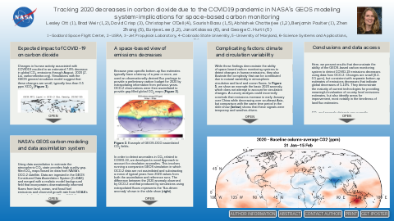
Lesley Ott (1), Brad Weir (1,2), David Crisp (3), Christopher O'Dell (4), Sourish Basu (1,5), Abhishek Chatterjee (1,2), Benjamin Poulter (1), Zhen Zhang (5), Eunjee Lee (1,2), Jana Kolassa (6), and George C. Hurtt (5)
1-Goddard Space Flight Center, 2-USRA, 3-Jet Propulsion Laboratory, 4-Colorado State University, 5-University of Maryland, 6-Science Systems and Applications, Inc.
PRESENTED AT:

EXPECTED IMPACT OF COVID-19 ON CARBON DIOXIDE
Changes in human activity associated with COVID19 resulted in an estimated 7.8% decrease in global CO₂ emissions through August, 2020 (Z. Liu, carbonmonitor.org). Simulations with the GEOS general circulation model suggest that these changes are small, typically less than 0.5 ppm XCO₂ (Figure 1).
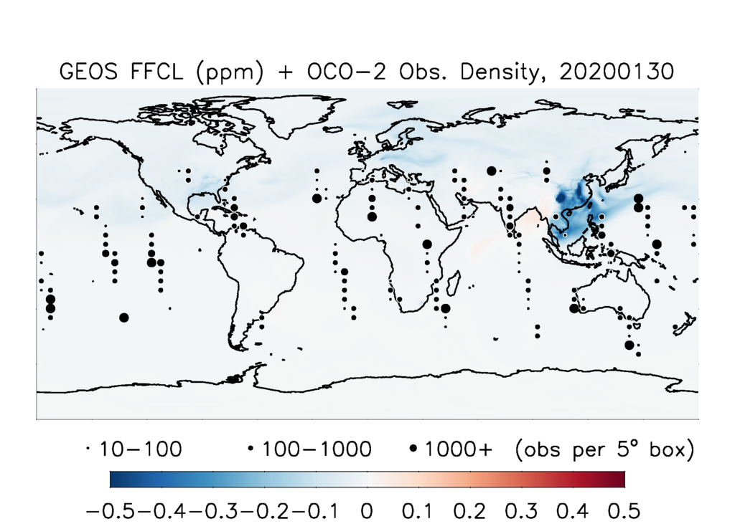
Figure 1. GEOS simulation of XCO₂ change due to 2020 FF reductions on January 30, 2020. OCO-2 observation density is indicated by circles of different sizes
Detecting changes in CO₂ from analysis of satellite swath data is challenging because of gaps in coverage and the fact that emissions can change drastically over the course of weeks or even days as administrative restrictions are imposed. Here, we use a unique approach based on data assimilation to quantify the impact of COVID-19.

NASA'S GEOS CARBON MODELING AND DATA ASSIMILATION SYSTEM

Using data assimilation to estimate the atmospheric CO₂ state provides high quality gap-filled CO₂ maps based on data from NASA's OCO-2 satellite. Data are ingested in the GEOS Constituent Data Assimilation System (CoDAS) and merged with a realistic model background field that incorporates observationally informed fluxes from land, ocean, and fossil fuel emissions and observed growth rate from NOAA's network of surface stations. When OCO-2 observations are not available, the CoDAS benefits from vegetation greenness, ocean color, nighttime lights, and weather observations to create high-quality products that can be compared against a variety of non-coincident surface and aircraft data.

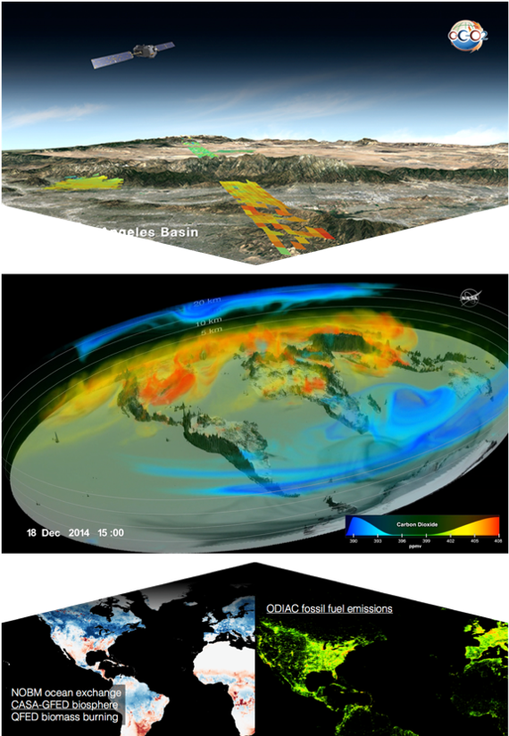

Figure 2. Schematic of the GEOS based data assimilation system used to assimilate OCO data.

A SPACE-BASED VIEW OF EMISSIONS DECREASES

Because year-specific bottom-up flux estimates typically have a latency of a year or more, we used an observationally-derived flux package to provide a preliminary carbon budget for 2020 by extrapolating information from previous years. OCO-2 observations were then assimilated to provide gap-filled global CO₂ maps (Figure 3).
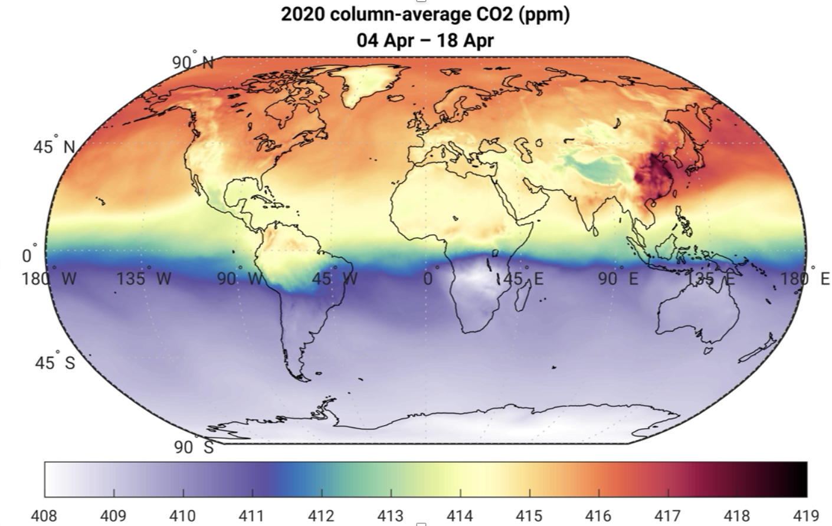
Figure 3. Example of GEOS-OCO assimilated CO₂ fields.

In order to detect anomalies in CO₂ related to COVID-19, we developed a novel approach to account for circulation anomalies. This involves running a companion GEOS simulation in which OCO-2 data are not assimilated and substracting a mean of typical years from 2020 values from both the assimilation and reference runs. The difference between the 2020 anomaly observed by OCO-2 and that produced by simulations using extrapolated fluxes represents the 'flux-driven anomaly' shown in the slide show (right).

Early in the year, CO₂ anomalies highlight the role of climate-driven changes in land fluxes including variability related to the Indian Ocean Dipole, which contributed to hot, dry conditions over Australia and wet, favorable growing conditions in Africa and India. In early April, COVID-19 related emissions decreases are evident over the world's largest economies. A comparison with a GEOS simulation that incorporates low latency carbonmonitior.org emissions estimates (Figure 4) shows that the satellite estimated anomaly generally compares well with the estimate based on activity data, highlighting the ability of OCO data to provide a meaningful evaluation of country-level emissions estimates.
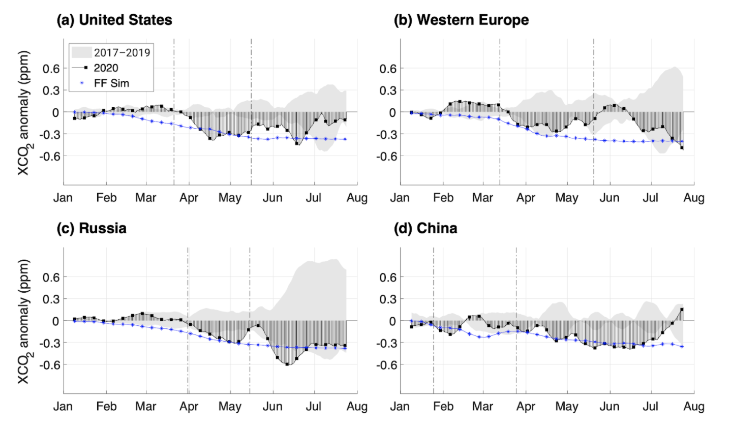
Figure 4. Time series showing CO₂ anomalies for 2020 (black) and typical years (2017-19, grey shading). GEOS-OCO CO₂ data are also compared an independent simulation that assumed emissions decreases based on activity data (blue, Figure 1).

The largest disagreement between the carbonmonitor emissions estimates and concentration changes observed by OCO-2 is related to the timing and magnitude of emissions reductions over China, which manifest over Chine during February-March and over the United States 1-2 weeks later. This suggests that uncertainty in law latency estimates of Chinese emission reductions during COVID-19 may be underestimated by current methods.

COMPLICATING FACTORS: CLIMATE AND CIRCULATION VARIABILITY
While these findings demonstrate the ability of space-based carbon monitoring systems to detect changes in human emissions, they also illustrate the complexity that can be contributed due to natural variability in atmospheric circulation and land and ocean fluxes. In Figure 5, we show an example the basic 2020 anomaly, which does not attempt to account for circulation changes. A cursory analysis could incorrectly conclude that emissions increase in early January over China while decreasing over southeast Asia, but comparison with the same time period in the slide show (below) shows that these signals were temporary and weather-driven.
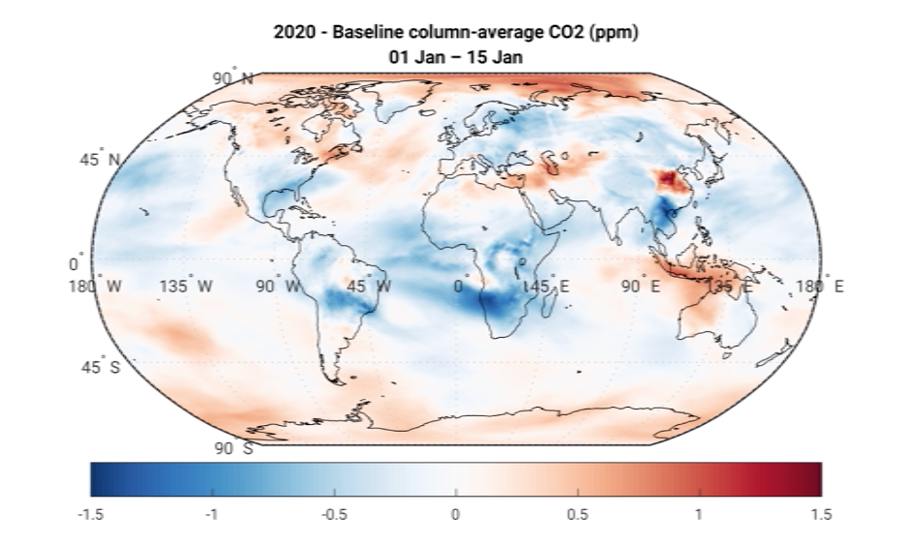
Figure 5. 2020 - multi-year mean (2017-2019) change in XCO₂ from January 1-15.

Land flux anomalies in 2020 also exerted a strong influence on CO₂ concentrations, most notably related to the record-breaking Indian Ocean Dipole in the early part of the year. While these influences are evident in satellite observations of CO₂ (see slide show) and vegetation (Figure 6), differentiating their influence froom changes in human emissions remains challenging because of the lack of near-real time information on land-atmosphere fluxes. This information is critically important in understanding the evolution of CO₂ changes over India, where low values were observed well before lockdowns (March 25).
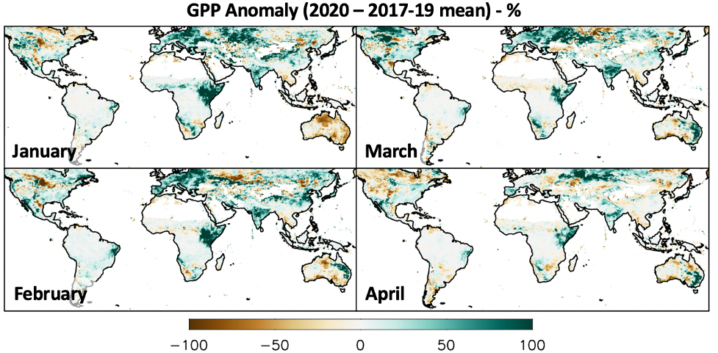
Figure 6. Observationally derived gross primary production anomalies based on FluxSat data (Joiner and Yoshida, 2020), which uses MODIS reflectance data to upscale flux tower observations.

More work is needed to provide timely model-based estimates of land flux in support of future carbon monitoring efforts. For this reason, the analysis presented here focuses mainly on changes during the northern hemisphere winter and spring, when biospheric influences are likely to be smallest.

CONCLUSIONS AND DATA ACCESS

Here, we present results that demonstrate the ability of the GEOS-based carbon monitoring system to detect COVID-19 emissions decreases using data from OCO-2. Changes are small (0.2-0.5 ppm), but consistent with separate bottom-up estimates of emissions decreases that indicate global decreases of 5-10%. They demonstrate the maturity of current technologies for providing meaningful evaluation of country level emissions estimates, but also identify areas for improvement, most notably in the timeliness of land flux estimates.

CO₂ and anomaly datasets are currently supporting dashboard efforts by NASA (https://earthdata.nasa.gov/covid19/, Figure 7) and its international partners (https://eodashboard.org/). OCO L3 products are provided alongside NO₂ and nighttime light observations to provide a variety of end users up to date information about global environmental change.
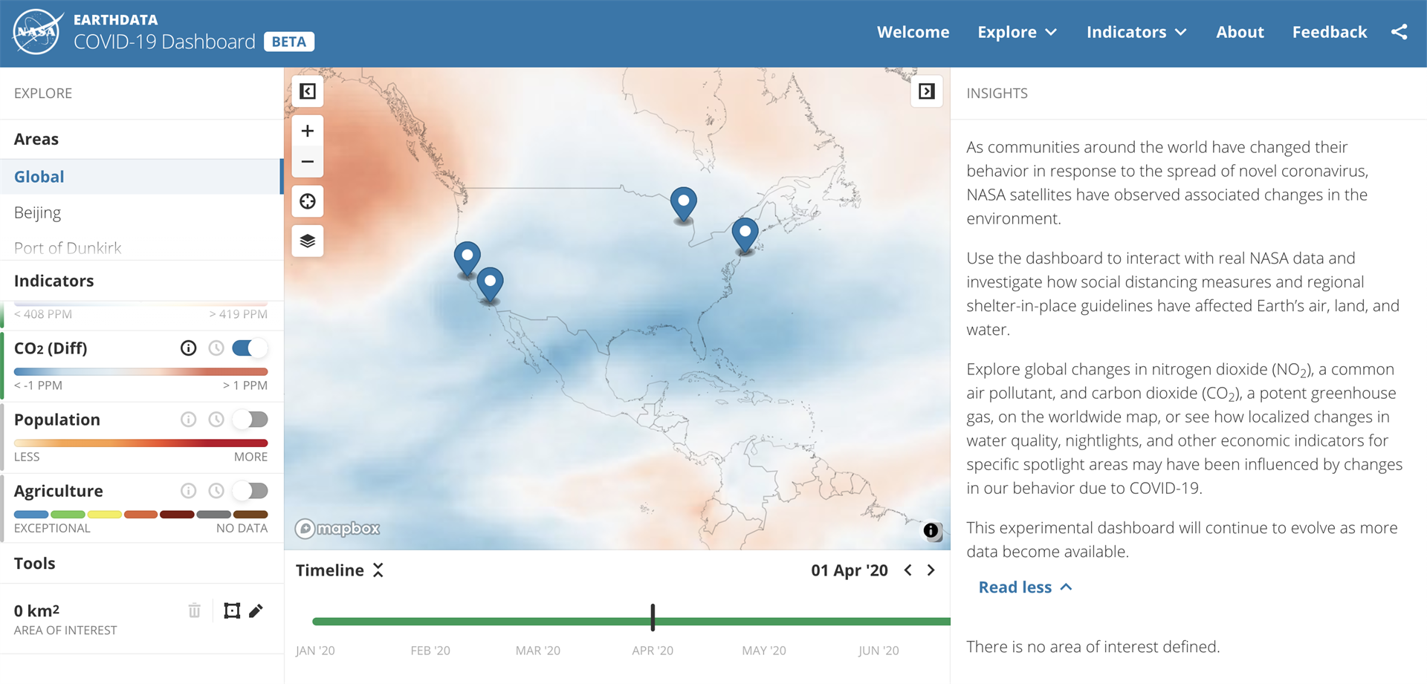
Figure 7. Snapshot of NASA's COVID-19 dashboard highlighting CO₂ anomalies.

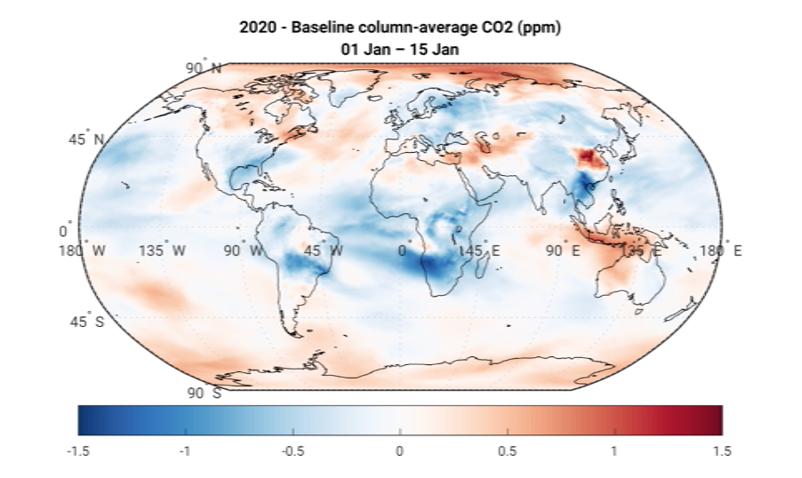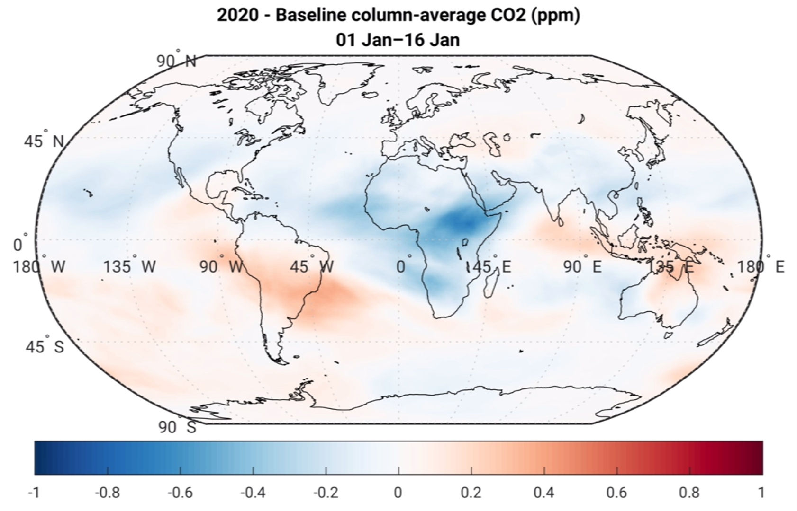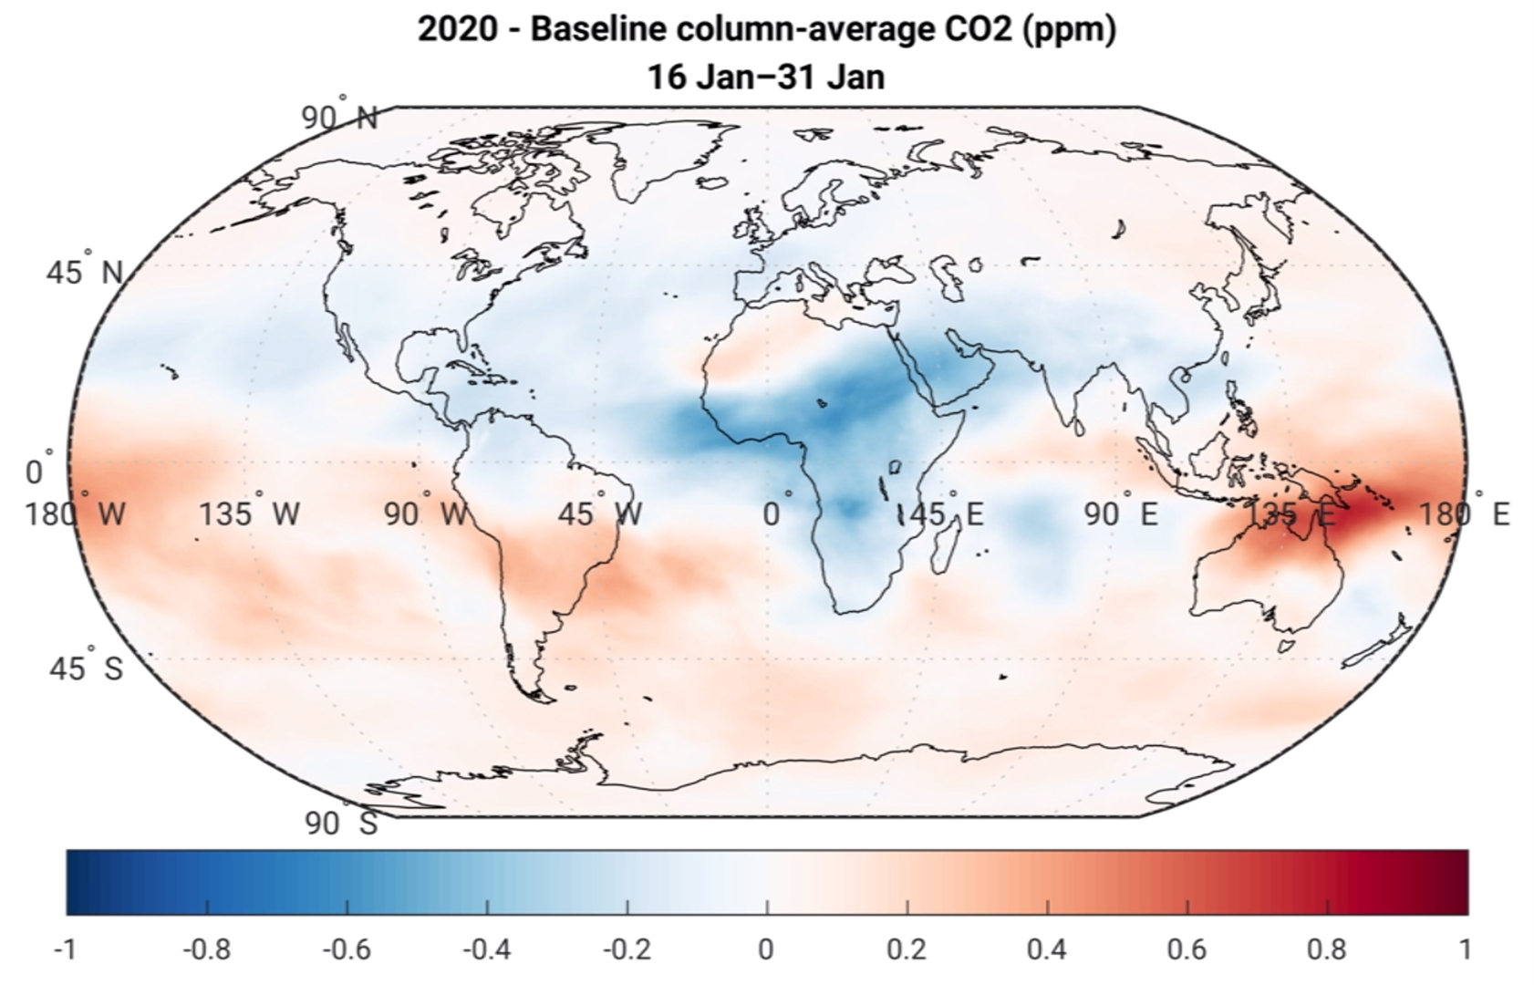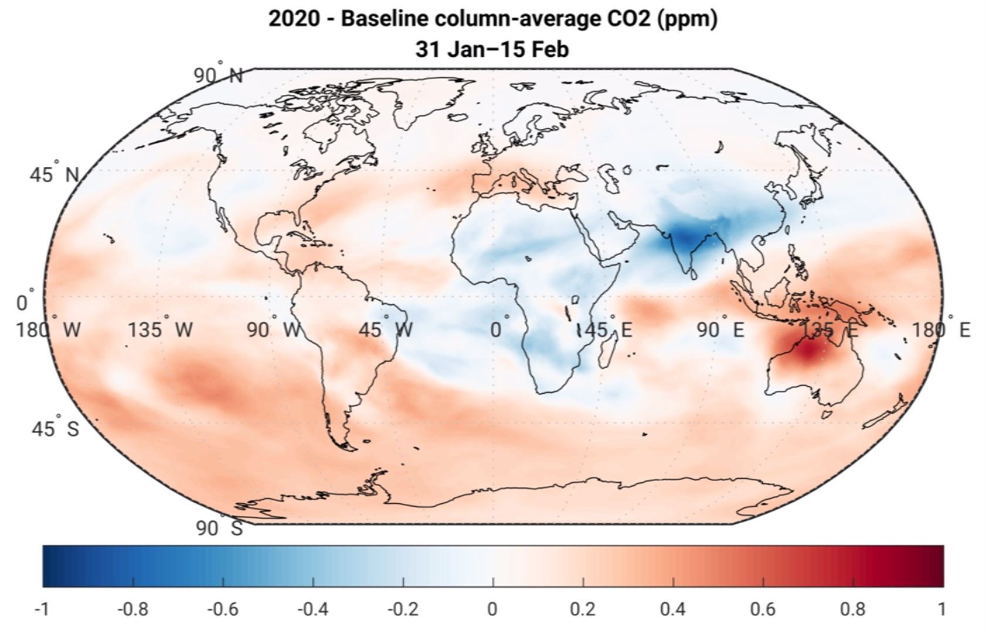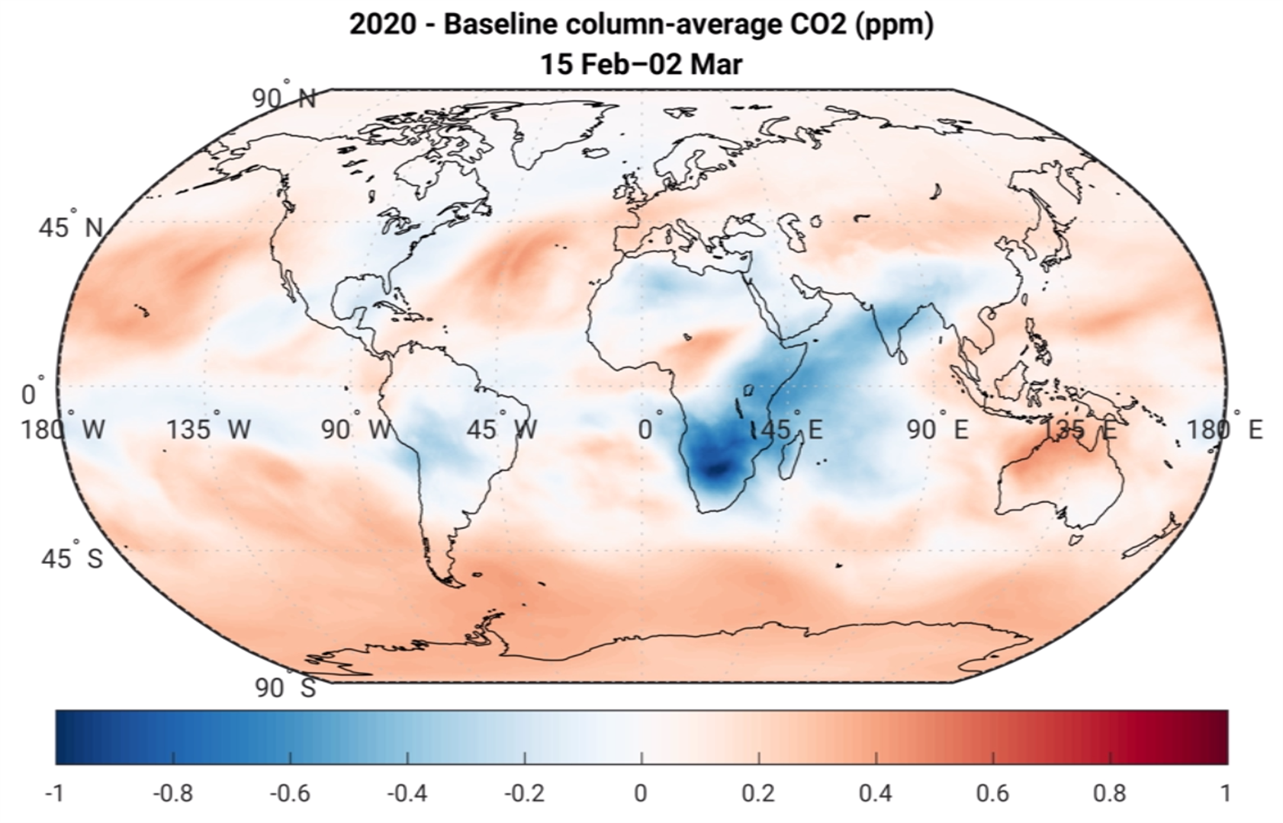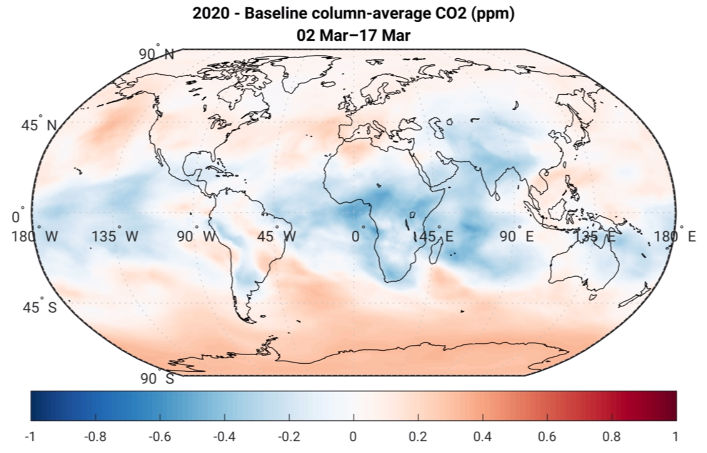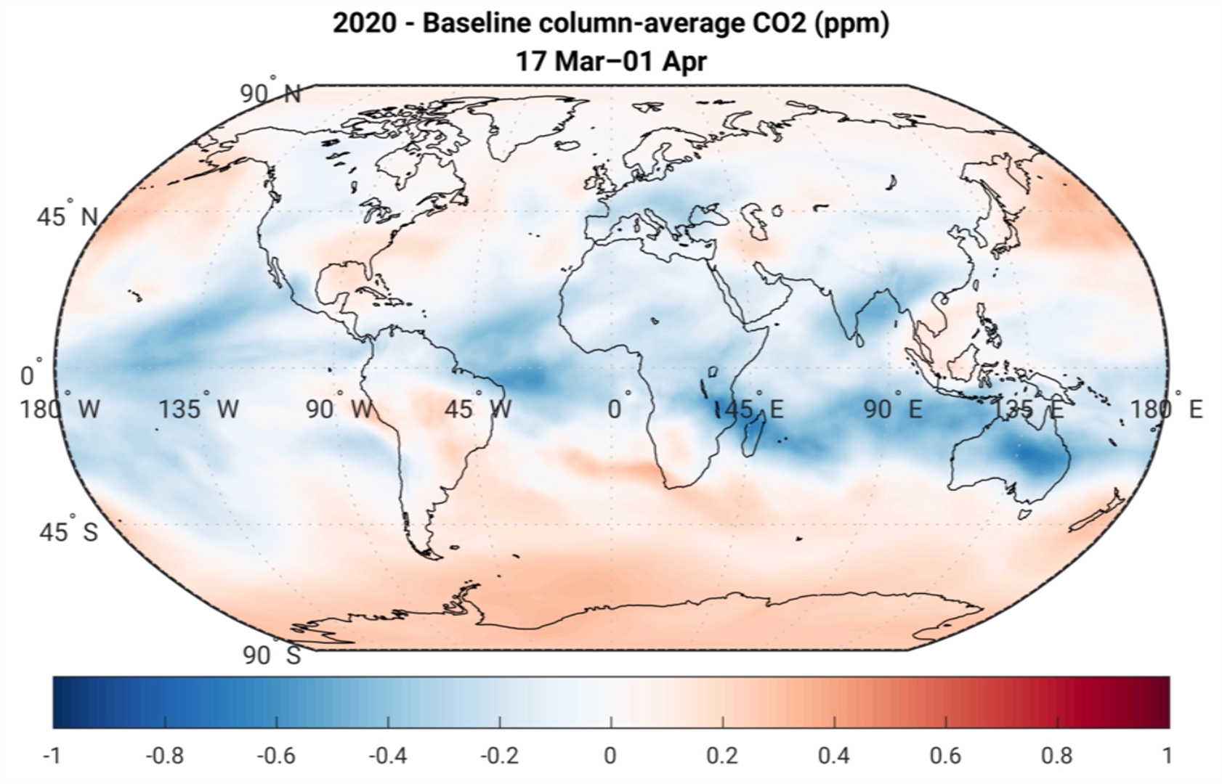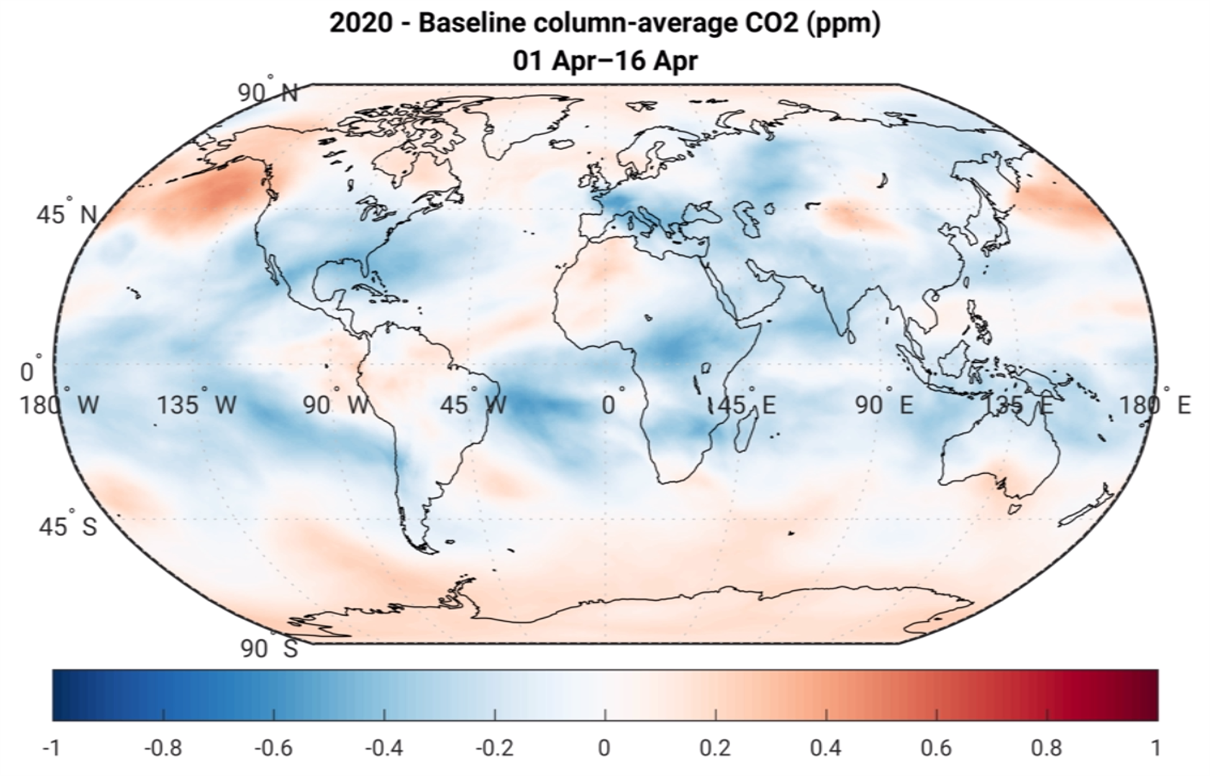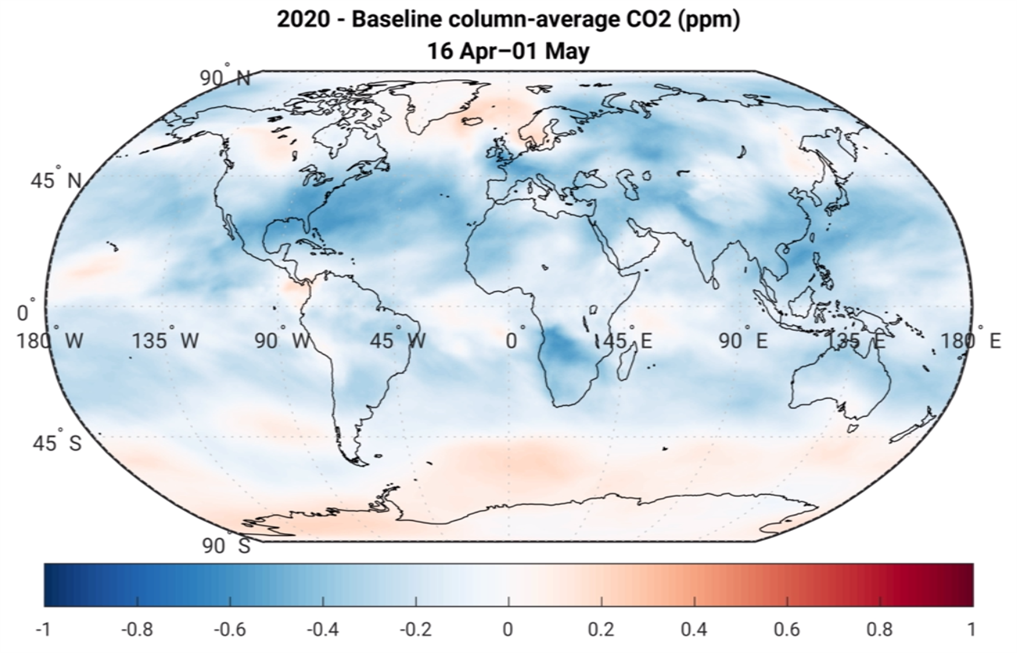

AUTHOR INFORMATION
Lesley Ott¹, Brad Weir^{1,2}, David Crisp3, Christopher O'Dell4, Sourish Basu1,5, Abhishek Chatterjee1,2, Benjamin Poulter1, Zhen Zhang5, Eunjee Lee1,2, Jana Kolassa6, and George C. Hurtt5

ABSTRACT
The COVID19 pandemic led to abrupt, worldwide changes in human activity and related emissions of air pollutants and greenhouse gases that are unprecedented in modern times. NASA satellites have demonstrated their ability to observe some of these impacts, particularly in relation to short-lived gases like nitrogen dioxide (NO2), which is emitted primarily from transportation. Bottom-up analyses of carbon dioxide (CO2) emissions suggest that the growth of atmospheric CO2 has also slowed, but differences are much more subtle than for NO2 because of the lifetime of atmospheric CO2 and sectoral differences in emission reductions.

Estimates of CO2 from NASA’s Orbiting Carbon Observatory 2 (OCO-2) provide a unique view of COVID19 impacts, but observed changes in the column-average CO2 can be difficult to interpret because of gaps in spatial coverage. Assimilating these data into the Goddard Earth Observing System (GEOS), an integrated Earth system model with an advanced Constituent Data Assimilation System (CoDAS), helped to reveal changes in CO2 that are consistent with separate, bottom-up analyses of emissions reductions. Both indicate that from February-April of 2020, the growth in CO2 over Europe, North America, and Asia was roughly 0.3 ppm less than during the previous four years. Anomalies derived from gap-filled GEOS OCO-2 CoDAS products contribute to a joint effort by the world’s space agencies to track COVID19 impacts on the Earth system (https://eodashboard.org).
However, attribution of these changes is complicated by interannual variability in atmospheric circulation and the influence of climate on ocean and land carbon sinks. We discuss these results from the perspective of space-based carbon monitoring, which has received considerable support over the past decade from NASA. Our results demonstrate the accomplishments of current sensors and data assimilation systems, but also highlight challenges in providing high quality, low latency information to the public. In particular, understanding and attributing CO2 changes during 2020 requires year-specific information about land and ocean fluxes, which is often delayed for months or even years. We discuss current limitations and potential solutions to address these lags, which would support more reliable and timely space-based carbon monitoring.

