ATTRACTOR: Toward Trustworthy and Trusted
Autonomous Systems

B. Danette Allen and Natalia M. Alexandrov
NASA Langley Research Center, Hampton, VA, 23681, USA
Javier Puig-Navarro
National Institute of Aerospace, Hampton, VA, 23666, USA
The question of what it means and what it takes for an autonomous system to consider another autonomous system justifiably trustworthy must be addressed by all who seek to integrate intelligent machine agents into real-world operations. A satisfactory answer to this question is an essential component in accepting autonomous machine decision-making in safety-critical and time-critical environments, such as aviation. Historically, simulation platforms for test and evaluation of complex systems have proven to be effective in assessing performance and contributing to decisions on the fitness of systems to operate in current general and commercial aviation airspace. Moreover, simulations have informed the definition of safety-critical constraints. However, as machine systems progressively take on responsibilities for decision-making traditionally supplied by humans, simulations require enhancement. Mixed reality simulation that integrates real-world platforms and data or high-fidelity simulation data in a
sim-to-flight paradigm provides insight into agent interaction and the rationale behind autonomous agent decision-making as well as the capacity for seamless integrated implementation, testing, and operation of systems. Strong simulation capabilities are especially important in the presence of algorithms that hold great promise in decision-making yet increase the uncertainty in the system.
Autonomy Teaming and TRAjectories for Complex Trusted Operational Reliability (ATTRACTOR) is a subproject of NASA’s Convergent Aeronautics Solutions (CAS) Project. ATTRACTOR’s objective is to build a basis for understanding trust and trustworthiness in multi-agent autonomous teams, and thus to inform future certification of safety-critical and time-critical autonomous systems in aviation. Because the concepts of trust and trustworthiness must be addressed in a context, ATTRACTOR has chosen Search and Rescue (SAR) in dynamic and unstructured environments, with emphasis on search, as its design reference mission (DRM). During dynamic planning and execution of trajectory-based operations, autonomous agents determine their trajectories given an assigned mission or missions and call for assistance from an appropriate teammate when needed. This experience along with the attendant human-machine and machine-machine interactions, serve as a platform for developing approaches to identifying and measuring trustworthiness and increasing trust. In this paper, we give an overview of some of ATTRACTOR’s research and development activities, findings, and ongoing work.
- Nomenclature
AI = Artificial Intelligence
Ai = Autonomy Incubator
GPS = Global Positioning System
ISA = In-Space Assembly
LIDAR = Light Detection and Ranging
NAS = National Airspace System
O₃ = Ozone
OV = Operational Viewpoint
SLAM = Simultaneous Localization and Mapping
UAS/UAV = Unmanned Aerial System/Vehicle
SAR/SARUC = Search And Rescue / Search And Rescue Under the Canopy
- Introduction
Unmanned Aerial Systems (UAS) show great promise for increasing the efficacy, efficiency, and pace of tasks and operations that are beneficial for society. Firefighters [1], first responders [2], law enforcement [3], and search and rescue (SAR) personnel [4, 5] are already seeing the benefit of tele-operated UAS for advance scouting. In this context, UAS reach previously unachievable Points of View (POVs) providing increased situational awareness, and thus performance. From its inception as NACA in 1915 to NASA in 1958, and still today, NASA has worked to address societal challenges for the benefit of humanity [6]. On our way to Low Earth Orbit (LEO), the moon, and now Mars, NASA has advanced the state of the art and practice in unmanned, robotic, and human-machine systems.
Whether employed at NASA or any other public service or protection organizations, these robotic systems are an extension of human teams, as opposed to a self-sufficient augmentation of the team. These systems are capable of self-navigation, independent decision-making, and bear responsibility for delegated authority. As humans seek to partner with robotic systems, viewing these as collaborating agents within a team holds potential to advance machine autonomy capabilities. However, with increased machine authority comes the need to ensure safety for humans and their environments, both technological and natural. System trustworthiness represents safety and performance assurance and must be thoroughly understood and designed for, especially in safety-critical domains. Two significant efforts at NASA Langley Research Center (LaRC) have paved the way for informing and supporting this paradigm shift, the Autonomy Incubator and the ATTRACTOR project.
- ATTRACTOR Origins - A Look Back
ATTRACTOR originates from two efforts: The Autonomy Incubator and a LaRC Independent Research and Development (IRAD) project, “A System for Time-Critical Human-Machine Decision Making.” The IRAD project focused on fundamental research in posing correct and complete decision-making problems for shared understanding in joint decision-making in human-machine interactions. The work also explored directions in explainable AI (XAI) [7]. The Autonomy Incubator (Ai) at LaRC was established in the spring of 2014 to prepare the center workforce to meet the autonomy challenges anticipated in science, space exploration, and aeronautics as the NASA mission directorates looked to enable new missions: Artemis [8] pushing the boundaries of human exploration to the Moon and on to Mars; On-Orbit Servicing, Assembly and Manufacturing (OSAM) for persistent platforms in space [9]; pollution measurements in historically inaccessible areas [10]; and the integration of UAS into our everyday lives [11]. These are missions of increasing complexity, distance, pace, and challenging accessibility. Building on decades of experience and success in the design, fabrication, and integration of safe and reliable automated systems for space and aeronautics, the LaRC Ai aimed to bridge the chasm between automation and autonomy [12] and build systems capable of
    - sensing and perceiving their environments;
    - assessing their state;
    - making decisions in the face of uncertainty and/or with incomplete information;
    - acting on those decisions and;
    - learning from that experience.
By design, the Ai identified and executed a three-year technical goal of “safe reliable resilient mobility and manipulation in dynamic, unstructured, and data-deprived environments.” focused on a challenge problem that embodied autonomy and science goals.
- Science Mission
NASA LaRC and the Ai selected a challenge problem to exercise the characteristics of an autonomous system in a domain of interest to NASA, specifically NASA earth science. Historically, atmospheric measurements in cluttered and remote environments are collected remotely. For instance, in-situ airborne measurements in urban areas or under a forest canopy are difficult due to location, proximity to people, and platform compatibility. Small UAS (sUAS) make these historically inaccessible areas accessible and have been critical in demonstrating the feasibility of an autonomous science mission [13]. The mission showed that a sensor could be placed at and recovered from a location specified in real time by a scientist, without the aid of external position information, and comprised two sorties: one for sensor placement via “targeted landing”, the other for sensor recovery via “precision landing.” The notional flight paths for both are shown in Figure 1 where the ownship is in blue, and an intruding UAS is shown in yellow. The depicted flight paths are notional, since the onboard avionics and software determined the route dynamically in flight. Unmapped obstacles were intentionally inserted into the flight environment. During the placement sortie, the ownship UAV encountered a stationary utility pole and, using onboard detect-and-avoid (DAA) capabilities, replanned its path and continued the mission. On the return flight, after sensor drop-off, an intruding UAV crossed the path of the ownship and, once again, the ownship dynamically replanned and avoided the moving obstacle. This multi-sortie mission was executed multiple times at the LaRC CERTAIN range [14] without the need for human intervention.

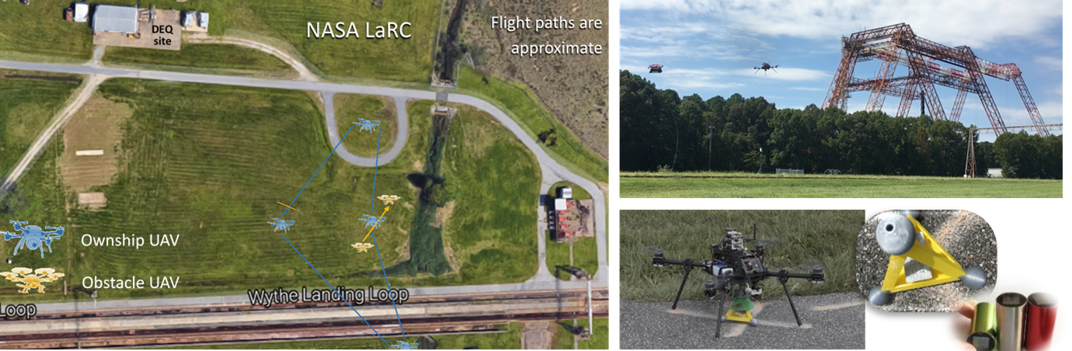
Figure 1: Autonomy Incubator Science Mission
Left: Operational Flight Area and Flight Paths at NASA LaRC
Right: UAV detect-and-avoid encounter (top) and UAV Sensor Capture (left) and sensor payload (right)

- OWLETS
The Ai extended its reach in the summer of 2017 over the Chesapeake Bay in Virginia for the first ever in-situ ozone measurement over the land-water transition (Figure 2). Ozone Water-Land Environmental Transition Study (OWLETS) [15, 16] provided the earth science community with high-resolution vertical ozone (O₃) profiles simultaneously over land and water. Various air quality measurements were acquired using a novel combination of two ozone LIDARs, multiple UAVs equipped with O₃ sensors, and surface sensors to correlate and characterize the water-land differences in O₃. This combination of observations provided a 4D view of O₃ concentrations, which helped to provide feedback to air quality forecast models as well as future satellite remote sensing systems. OWLETS was an important step towards a persistent monitoring presence made possible through autonomous operations.



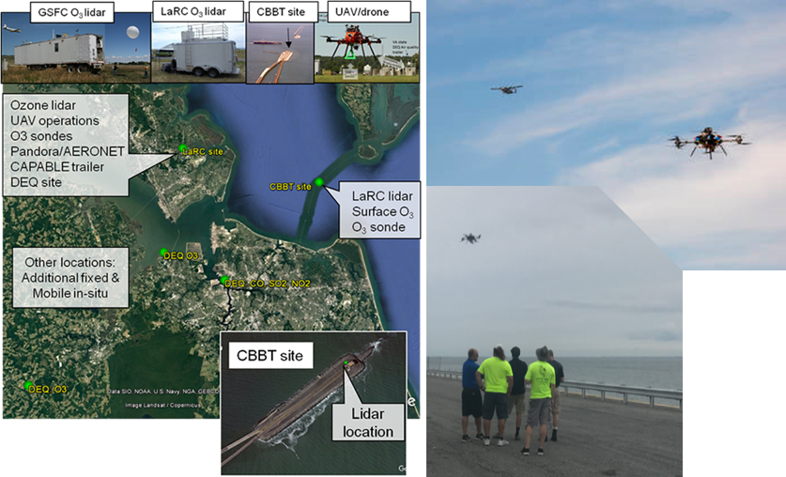
Figure 2: OWLETS Ozone Data Collection Sites [17]
Left: OWLETS science location measurements, platforms, and sensors
Right: NASA’s C-23 Sherpa and “Hive” UAVs collect O₃ data simultaneously at different altitudes over LaRC
Middle: The Ai team monitors UAV operations from one of the islands on the Chesapeake Bay Bridge-Tunnel
- ADAMA
Autonomous Distributed Atmospheric Measurement Acquisition (ADAMA) was designed to show the feasibility of missions with large numbers of agents (see Figure 3). Over 100 CICADA micro-UAVs [18] were released from four heavy-lift small UAV aerial systems for collecting in-situ meteorological data [19]. It successfully demonstrated that over a hundred micro-UAVs could be dropped from four larger UAVs, glide to a specified area of interest, and autonomously collect data in the atmospheric boundary layer. The swarming-like behavior enabled the simultaneous collection of data in 3D, without the need for pilot input. ADAMA successfully collected real-time meteorological data within a target area defined by a single GPS waypoint. Data collected for each CICADA included wind speed/direction, temperature, pressure, humidity, and altitude.
Obstacle UAV

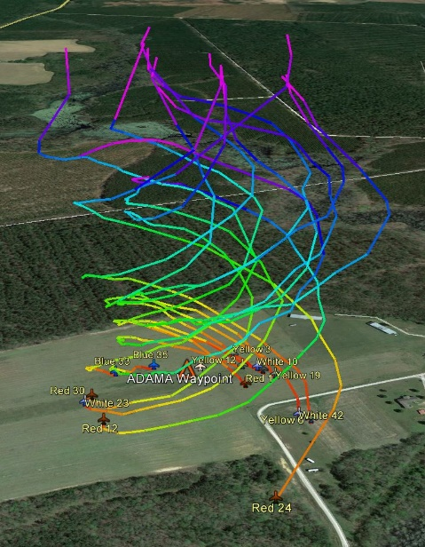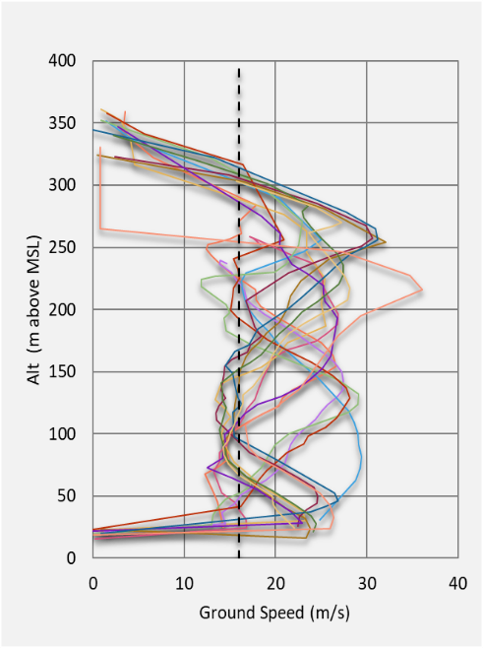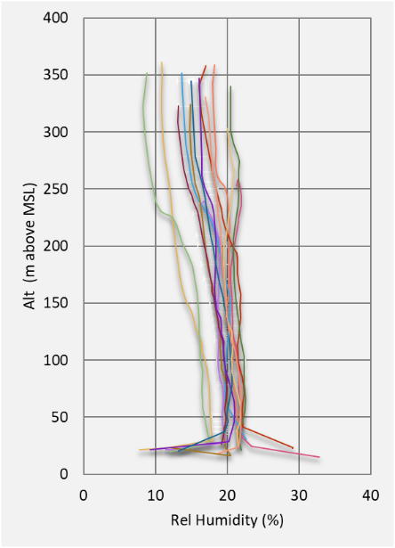
Figure 3: Micro-UAV Flight Paths, Ground Speed, and Humidity from the ADAMA Mission [19]
- Lessons Learned

The Autonomy Incubator fulfilled its purpose to build a solid foundation for autonomous systems research, development, integration, and flight testing at NASA LaRC. Its focus was fundamental in nature – mature skills in areas such as machine learning, computer vision, autonomous system integration, sUAS platforms, and build a high-performing multidisciplinary team ready to take the next step toward NASA’s strategic goals. Several gaps were identified throughout the lifetime of the AI. The most critical were as follows.
- Building a bridge in the test and evaluation pipeline between desktop R&D and flight tests
- Transitioning from discrete waypoint-based trajectories to a method for continuous trajectory generation
- Moving from single-agent to multi-agent missions and operations
- Building a path to certification by exploring trust and trustworthiness for autonomous systems.
These goals, combined with lessons learned and research directions discovered during the IRAD project, were incorporated into a proposal to NASA’s ARMD Convergent Aeronautics Solutions (CAS) project in the spring of 2017. The Autonomy Teaming and TRAjectories for Complex Trusted Operational Reliability (ATTRACTOR) project [20] began in October 2017 and continued where the Ai and IRAD concluded.
The highly multidisciplinary nature of research conducted in ATTRACTOR is evident from the composition of the ATTRACTOR team. The team comprises researchers and developers from four NASA centers and four universities, bringing expertise in modeling and simulation, intelligent flight systems, complex system analysis and design, optimization and decision-making, robotics, computer vision, machine learning, trajectory management and control, verification and validation (V&V), formal methods for fault tolerance and hardware verification, remote sensing, human-machine teaming, measurement sensor systems, communication and information security, and UAS in the NAS.

- ATTRACTOR Goals and Technologies
The objective of ATTRACTOR [21] was to build a foundation for trustworthiness and trust verification of multi-agent autonomous systems and inform the eventual certification of autonomous systems in aviation. The work comprised the following research components in the operational context of mission-critical planning and execution:
- Continuous parameterizable trajectory generation for real-time planning/replanning, and accurate state estimation [47]
- Effective human-machine teaming with natural interaction(s) to foster trust [23]
- AI explainability (XAI) for clarity in decisions and forensic analysis [24, 25]
- Persistent modeling and simulation, in the context of mission planning and execution [26, 27].
By “informing certification,” we mean acquiring an understanding of when a system is trustworthy and developing computable means to estimate trustworthiness and trust, to eventually inform functional requirements and bounds that contribute to certification.
Exploratory research from the Autonomy Incubator bootstrapped two of these four objectives for ATTRACTOR. Human-Operated Language Intuitive Interface with Gesture Recognition Applied in an Immersive Life-Like Environment (HOLII GRAILLE) and Silhouette-Informed Trajectory Generation [29] yielded partial results along these lines. HOLII GRAILLE [28] created an intuitive interface using voice and gestures to acquire and process human inputs to define a sequence of paths to define a complete trajectory that accomplished the mission goal. ATTRACTOR provided a method to elevate the human up from trajectory creation to supervisory instruction. For example, the instruction to “explore this area” guides the machine intelligence in its trajectory generation while maintaining safe separation with nearby obstacles. For the latter, ATTRACTOR extended the research on autonomous generation of safe, continuously differentiable trajectories, with a focus on challenging scenarios. Indeed, real-time autonomous navigation of sUAS through cluttered environments with safety guarantees poses significant challenges in sensing, computing, systems integration, and decision making [30, 31]. In addition, the algorithms developed and lessons learned within this field have the potential to revolutionize larger scale systems that are of interest to NASA such as the management and integration of UAS in the NAS, and urban mobility to name a few examples.
To further the first objective of ATTRACTOR, the test bed shown in Figure 4 (right) was built to develop and stress coordinated path-planning algorithms, both in simulation and a laboratory environment. The wire maze [29] was chosen as a cost-effective solution due to its portability, ease of reconfiguration, and the capability to create complex scenarios that exemplify some of the challenges in path planning and sensing technologies. The wire maze was also incorporated into ATTRACTOR’s simulation environment [26] for rapid creation of new maze configurations for test and evaluation. In particular, the wire maze in Figure 4 has topological similarities to a cluttered airspace where other vehicle trajectories can be treated as obstacles, but also the cluttered scenario shown in Figure 4 (left). The collapsed building depicted in the figure is an example of a challenging scenario through which a team of sUAS can fly to determine if there are injured people in the building. The information gathered can be used to deploy a rescue team efficiently, and reduce the risk for the people involved in the effort.

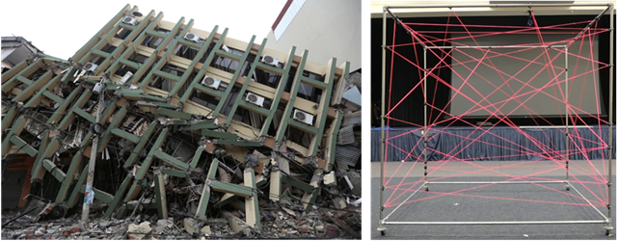
Figure 4: Wire Maze as an analog environment for cluttered building rubble

Beyond the fundamental autonomy technologies, the question of what it means and what it takes for an autonomous system (AS) to consider the decision-making of another AS trustworthy, justifiably, must be asked to successfully build this foundation. Pragmatic answers to this question must be developed within an application context. We begin with the ATTRACTOR Design Reference Mission (DRM) along with Lessons Learned and close with a discussion on trust and trustworthiness in cyber-physical-human (CPH) systems, such as an air vehicle and its associated controllers, both human and software, as embodied in the DRM.

- ATTRACTOR Design Reference Mission (DRM)
To focus the project, the Design Reference Mission (DRM) for ATTRACTOR is a multi-asset search and rescue mission governed by a multi-member team consisting of human and machine operators. A notional sequence of events is shown in Figure 5 where someone or something (person, object, etc.) is lost in a natural area (woods, field, desert, etc.). One or more units consisting of a mission commander and any number of machine assets are tasked to search the area of interest (AOI). Assets may be manned or unmanned, air or ground, human (in green) or machine (in blue). The mission commander communicates the search object and known parameters (expected pace, time “missing”, etc.) to the team. The team will partition the AOIs, determine search strategy and pattern, and set time events for synchronization and energy management. This partitioning could be determined centrally or distributed across team members. Each asset will map the assigned area and share that map with other agents. If any agent identifies the search object, the team or team lead will be notified, and an asset equipped with the appropriate payload will be summoned to confirm the successful search. This asset could be human or machine.

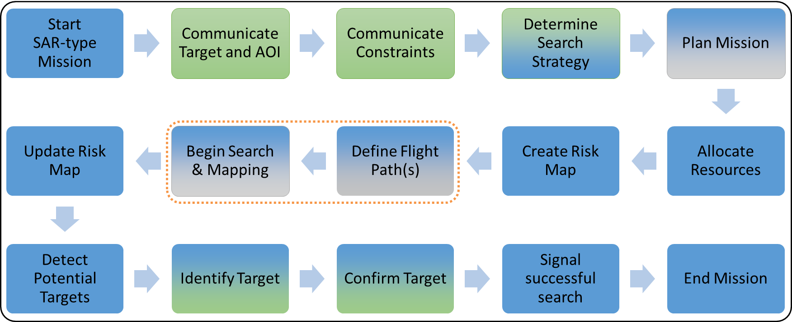
Figure 5: A Notional Sequence of Events for a SAR Mission
Human-centric tasks are in green. Machine-centric tasks are in blue. Teamed tasks are blended.
- Search and Rescue (SAR)
Borrowing heavily from the established procedures used by human Search and Rescue (SAR) teams today for the Mapping and Flight Path steps highlighted in Figure 5, land-based SAR are divided into four strategies [32]:
      - Fast search:
used when the search team arrives at the scene shortly after the target was reported missing and attempts a quick but less informed search to mitigate the risk of the SAR target wandering away from the initial location.
      - Reconnaissance search:
used for analysis of an area where SAR target is likely to be located to obtain essential information about the terrain and inform the SAR strategy.
      - General search:
used once one or multiple search AOIs have been defined; the team attempts to cover the space. It is typically used early in search operations where there is a high degree of urgency.
      - Contact search:
used to explore an area of high probability, although it is usually the concluding stage of a search operation.

ATTRACTOR focused on the general search strategy, which can be tackled with different techniques: parallel sweeps, contour sweeps, and other expanding patterns, to name a few examples from [33]. ATTRACTOR developed an algorithm that autonomously designs an efficient parallel search pattern given a single or multiple AOIs, as depicted in Figure 6 (right). However, the framework was designed to integrate any of the search patterns described in [33], as well as operator-defined patterns. Figure 6 compares general guidance for SAR operations regarding parallel track patterns (left) with the output of the automated coverage pattern software developed for ATTRACTOR (right). To cover large AOIs in a short time, the SAR effort must take advantage of the multiple UAS that the team may have available. To this end, the SAR patterns for different vehicles must be coordinated to ensure good and fast coverage of the AOI, avoid inter-vehicle collisions if their patterns overlap, and also maintain a consistent search front if required. ATTRACTOR’s multi-agent trajectory generation approach is capable of pre-planning and dynamically planning during mission execution to maintain temporal and spatial coordination [34] among all cooperating vehicles involved in the mission.

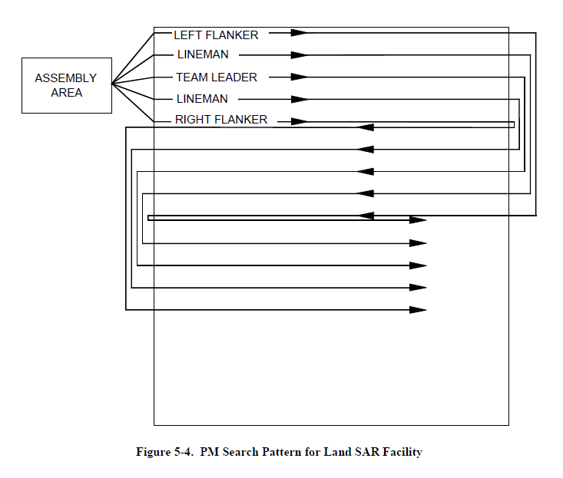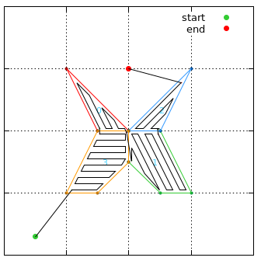
Figure 6: A Parallel-Track Multi-unit (PM) Pattern for a SAR Mission
(left) pattern guidance from [32] and (right) autonomous pattern generation from ATTRACTOR

Figure 7 presents a SAR scenario that highlights the types of spatial, temporal, and coordination constraints that the ATTRACTOR cooperative framework must capture to successfully execute the mission. In Figure 7, a mountainous area where a hiker has disappeared is depicted. The search team is tasked with exploring the area in an efficient manner to gather information and ultimately locate the missing person. The team is equipped with a set of UAS distributed in two airfields, located beyond the top-left and bottom-right sections of Figure 7. Fleet A and B are composed of three UAS scheduled to take off and land at one of the airfields within a temporal window assigned by the local air-traffic control authority. Initially, the members of each fleet will fly in close proximity to each other and will coordinate tightly with its close-proximity neighbors to maintain a consistent search front. To this end, the UAVs exchange information over a communication network to maintain coordination. Meanwhile, fleet A and fleet B will engage in mid-to-far proximity operations. Hence, members of separate fleets need not coordinate tightly with each other until they approach the AOI. At that point, both fleets must start a joint effort to locate the hiker and interact in close proximity. If at least one UAV finds evidence that may lead to the missing person, the fleets may alter their flight plan to further investigate the area and provide detailed information to the rescue team. In this process, the UAS are likely to fly through unstructured cluttered environments such as a cave or underneath the tree canopy. The obstacle information in these scenarios may come from different sources (a database, on-board sensors, or even other UAS) with different levels of uncertainty. The search phase will terminate either when the missing hiker has been found or due to mission constraints (limited range, flight time, lossy communication links, or impassable narrow corridors). Then, both fleets will initiate the return to the corresponding airfield and will land within the temporal windows assigned by the local air-traffic control authority.
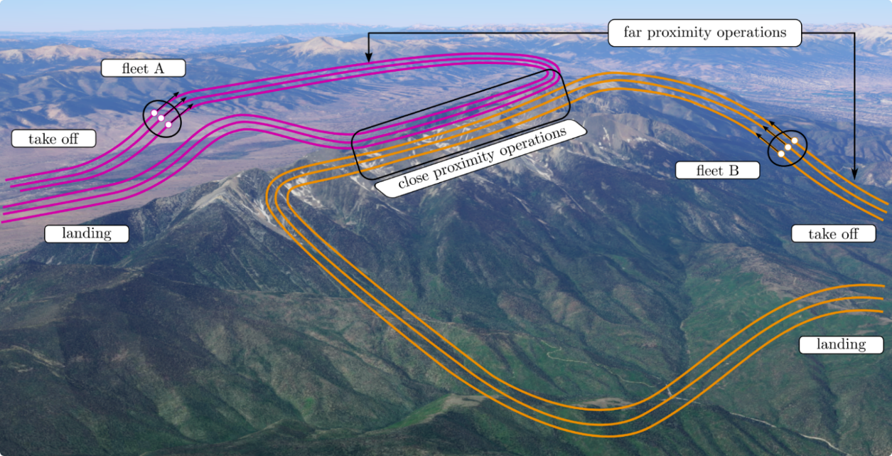
Figure 7: Time-Varying Spatial Coordination for a Contour Search Pattern [34]

- Search and Rescue Under the Canopy (SARUC)
A specific instantiation of SAR, Search and Rescue Under the (tree) Canopy (SARUC), was the focus of an ATTRACTOR collaborative partnership between NASA and MIT [35] that was awarded the 2019 AUVSI XCELLENCE Humanitarian Award [11] for “locating humans and materials lost in challenging and cluttered forest areas.”
SARUC is a multi-robot system for GPS-denied search and rescue under the forest canopy [36] (see Figure 8). Forests are particularly challenging environments for collaborative exploration and mapping, in large part due to the dynamic nature of wooded environments and the tree and brush “clutter” that must be avoided as the forest is explored. Multiple UAVs perform onboard sensing, estimation, and planning. When communication is available, each UAV agent transmits compressed tree-based submaps to other agents for collaborative simultaneous localization and mapping (SLAM). Image detection and semantic classification algorithms were tailored to use groups of trees as a distinctive feature for robust loop closure detection. In addition to onboard navigation for autonomous searching and mapping, the agents are also tasked with detecting people in the environment. Each vehicle agent supporting the SARUC mission must be able to:
- estimate its position, attitude and velocity robustly from onboard sensors instead of GPS, since the tree canopy will interfere with GPS-based estimation;
- locate the obstacles around it, such as trees and the forest floor;
- decide where to search next and plan collision-free trajectories;
- keep track of the vehicle energy state and maintain efficient egress paths;
- share information and vehicle status with other vehicles, and subdivide the search and rescue tasks amongst the team appropriately
- identify semantically relevant objects in the scene, including humans.
The multi-UAV system was validated both in simulation and during real-world collaborative exploration missions at NASA LaRC’s CERTAIN range.

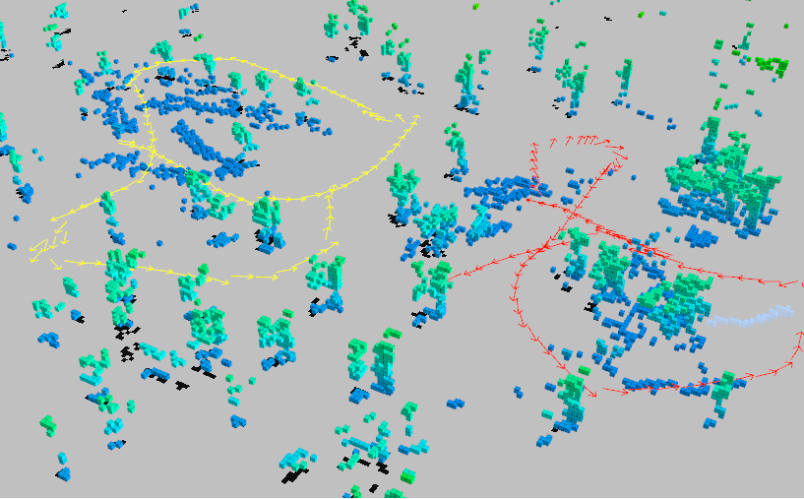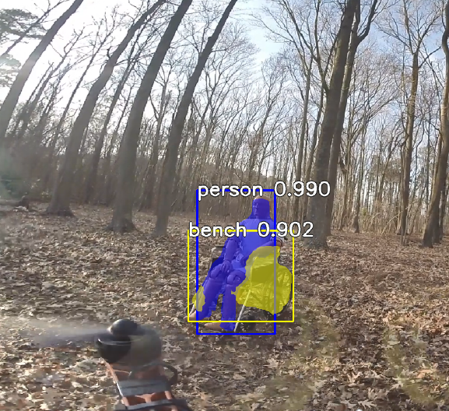
Figure 8: SARUC collaborative exploration of NASA LaRC’s forest by two vehicles [36] and person detection

- Final Demonstration
ATTRACTOR’s final demonstration was designed to show feasibility of the integrated project portfolio in the context of a multi-agent SAR mission. Figure 9 shows the Operational Viewpoint (OV-1) of the mission. A child has been reported missing and first responders believe that s/he has either wandered into nearby woods or an adjacent building. Multiple heterogeneous assets are called in to autonomously scan the area from above, explore the forest, and search the building interior. Both the forest and building interior are cluttered environments so each agent must be able to assess its ability to safety navigate through the environment based on a clutter assessment [37] of the path ahead and its ability to penetrate the clutter.

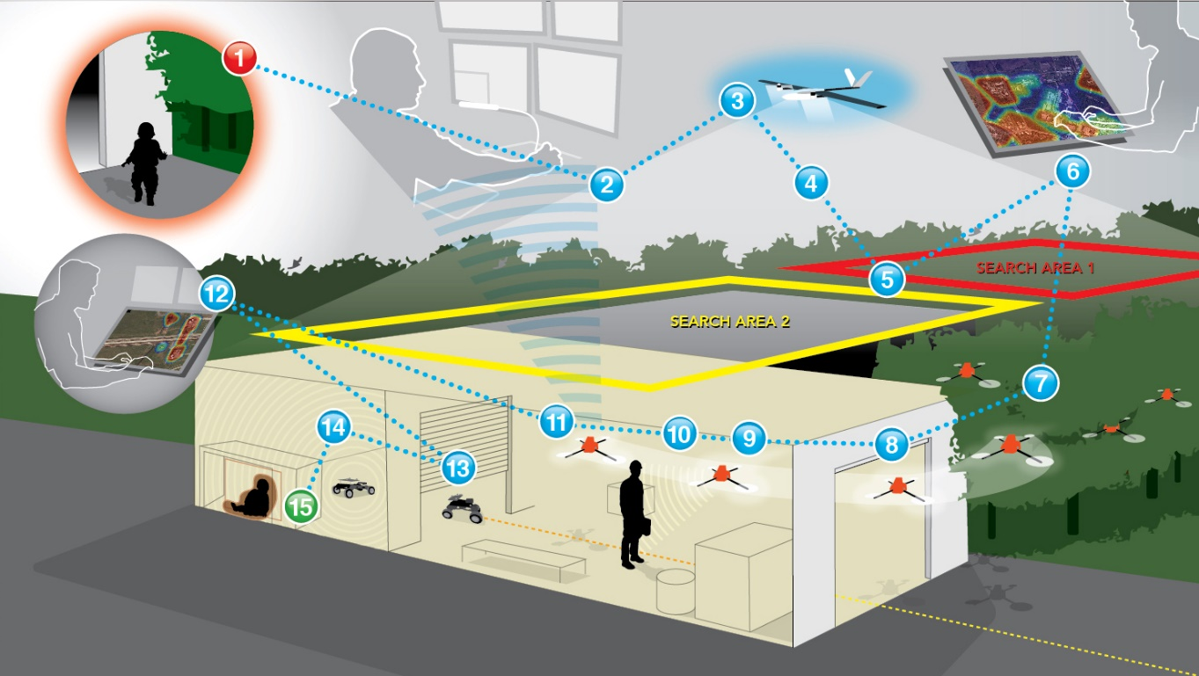
Figure 9: OV-1 for ATTRACTOR's Final Demonstration

The ATTRACTOR OV-1 specifies fifteen steps that are either events or decision-points, most of which are performed by the agent(s) without human intervention:
- A person is reported missing.
- First responders identify search area(s) using last known location and missing person data such as age, mobility, clothing, etc.
- VTOL UAV takes off.
- VTOL UAV captures high altitude video of last known location and surrounding area(s).
- Mission operator identifies a wooded area and a nearby building as areas of interest for an in-situ search.
- An operator uses a touch and speech interface to request a search mission for the exterior and interior of the building of interest with identified risk areas.
- Several UAVs enter the woods to map the area and search for the missing person while additional UAVs search the exterior of the building and monitor the exits.
- A single UAV enters the building interior through a partially open bay door.
- The interior drone navigates through rooms cluttered with equipment and/or furniture.
- While moving through the room, the UAV observes a person, but identifies they are not the missing person of interest and continues its search.
- The interior drone alerts the mission operator that it is too large to proceed through a small opening inside the building.
- The mission operator instructs the rover to search beyond the partially open bay door.
- The rover enters the building and searches beyond the partially opened bay door.
- The rover searches the area using its onboard sensors (LIDAR, camera, etc.) and locates the missing person under a desk.
- The rover signals that the lost child has been found and all participants stand down.
Several dress rehearsals and subsystem flight tests were conducted but the integrated flight test was delayed indefinitely due to the COVID pandemic. The ATTRACTOR team is hopeful that we will be able to conduct the final flight demonstration when on-site work at NASA LaRC is once again permitted.
- Lessons Learned
ATTRACTOR confirmed that the problem under consideration (a basis for certification for autonomous systems) is enormously complex; much more than a complicated physical artefact. Lessons learned were numerous:
- To achieve understanding of practical import, the problem must be considered in all its complexity.
Definitive answers to the integrated problem cannot be achieved in a short time.
- The investigation allowed us to truly understand the state of the art and focus research directions.
- The most potentially impactful solutions lie at cross-disciplinary boundaries.
- Reliable perception remains an open research problem.
- Realistic uncertainty quantification and propagation is the crux of establishing assured autonomy.
- Computational tractability remains a pervasive problem.
- An extendable persistent simulation environment is critical for test and evaluation of AI and machine learning algorithms as well as understanding interactions between autonomous agents.
ATTRACTOR confirmed the importance of investigating a complex system from the idea to implementation and physical validation around a meaningful design reference mission. Even if the DRM is simplified, physical experimentation is immensely useful for identifying erroneous or impractical assumptions in methods and tools.
- ATTRACTOR Trust and Trustworthiness
During the ATTRACTOR feasibility study, we have examined the question of what it means and what it takes for an autonomous system (AS) to consider the decision-making of another AS trustworthy, justifiably. A satisfactory answer to this question is an essential component in accepting autonomous machine decision-making in safety-critical and time-critical environments, such as aviation.
Trust in multi-agent interactions, including human-machine interactions, is an active multidisciplinary area of research with numerous perspectives. See, for instance, Cofta [38] and references therein for a comprehensive overview. In our discussion, we distinguish between trustworthiness and trust. The former is a property of the cyber-physical-human (CPH) system, such as an air vehicle and its associated controllers, both human and software. Intuitively, it is the property of a CPH, ensuring that the system performs as intended and abstains from the unintended actions. Trust is a property of the system’s user or participant, be it a human or another CPH. By “trust” we mean the degree of willingness to accept direction or advice from another participant of the system. The participant then follows by acting on the direction or advice; hence the notion of actionable trust. Our aim is to eventually develop computable criteria usable for system design and real-time operations, as well as to make use of appropriate existing ones, to promote actionable and justifiable trust within a heterogeneous team of participants.
Trustworthiness and justified actionable trust, together, produce a reliable CPH system.
Traditional development of reliable engineering systems adheres to well-known and highly successful practices of robust and fault-tolerant design, including validation and verification (V&V) and other disciplines aimed at assuring maximum system safety. Although much of the traditional design-for-safety practice remains universally valid, a number of fundamental assumptions on which it rests become problematic when applied to contemporary systems governed by autonomous machine decision-making.
In traditional system design, boundaries of a system, its environment, and its operational domain are well defined. For instance, a safe operational envelope for maintaining vehicle control is known; operation outside its boundaries may lead to predictable loss of control. In a contrasting example, a technical system that relies on computer vision as one of its information sources will contain a perception component based on machine learning (ML) algorithms for object recognition and classification. Although ML is simply data fitting, amenable to statistical analysis, its safe operational envelope may be hard or impossible to define. For example, miniscule changes of a few pixels, invisible to a human eye, may cause an image to be dramatically misclassified. Moreover, it may be impossible to predict which small changes will result in faulty behavior, making the definition of a predictably safe operational envelope problematic. A variety of monitoring and redundancy techniques will be necessary to address this problem.
Another salient feature of modern computational systems is self-modification during operations. A high degree of adaptability is not only desirable but may be required in autonomous systems operating independently of external control, in the absence of traditional predictability. Adaptability implies the ingestion of new data and real-time updating of the governing models during the operation of an autonomous agent. However, traditional V&V considers models fixed at the time of V&V. One could conceivably fix a computational model following training, conduct V&V, and disallow self-modification during operation. This, however, may defeat the purpose of required adaptability. Continually adapting systems necessitate a reconsideration of V&V.
In general, system participants accept direction from others or grant decision-making authority to others when they expect a positive outcome from actions based on that direction or decision-making authority. Expectation of a good outcome implies the ability to predict outcomes with enough accuracy. Predictability of a successful outcome in the face of uncertainty is the main means of ensuring system reliability. Traditional concepts of predictability require reconsideration in systems that may modify their models during operations.
One of the chief contributors to uncertainty in aerospace and airspace systems operations is system complexity. To maximize predictability, design of the current airspace operations is based on maintaining complexity manageable by teams of human controllers (see, for example, [39, 40]). The advent of autonomous decision-making systems requires re-examination of risks associated with their use [41].
In multi-agent systems, regardless of the amount of contributing information about the system state and associated uncertainties, as well as the number of participants, only one decision becomes actionable. That is, in the end, one decision causes action. Can an autonomous agent be trusted with authority to make that decision? We believe that to answer the question one should consider fundamental sources of unpredictability. Gell-Mann’s summary of fundamental unpredictability [42] serves as a nice résumé for identifying uncertainty sources in the context of complex adaptive systems in general. We re-state Gell-Mann’s sources of unpredictability in the context of a complex operational domain:
- The coarse graining for the operational domain with all its accidents. In our case, the operational domain includes the physical space within which operation occurs, and all its contents, with all statics and dynamics, as well as other agents in the domains that continually change the environment. Coarse graining means that in considering the system, we necessarily consider it at resolutions that disregard phenomena of import to the functioning of the system.
- The probabilistic character of all the accidents (branches of histories of all elements that contribute to the domain) of the operational domain in the future.
- Ignorance on the part of a given agent of the outcomes of most of the accidents that have already occurred, together with the exacerbation of the resulting unpredictability by amplification mechanisms. A software error made months ago or a crack in an engine housing that made its appearance the other day may lead to unpredictable cascading failures.
- Approximations and limitations on accuracy imposed by the available models and computational tools.

Arguably, the salient difference between trustworthiness of human and machine decision-making is in the need and agreement to accept the underlying phenomena implicitly or explicitly. When the ultimate system controllers are human (e.g., an airline pilot or an air traffic controller), they are accepted as trustworthy, following training, satisfactory performance on a series of tests, and periodic refreshment of skills and improvement of training. Neither pilots, nor their instructors are aware of all the biological and informational mechanisms that govern a pilot’s behavior. Nonetheless, experience shows that, on average, training and testing yields trustworthy human operators in appropriate contexts. Thus, we arrive at the conclusions about human trustworthiness for piloting an aircraft based on just a tip of the iceberg of a sentient biological agent’s complexity. We license a pilot, usually successfully, by relying on implicitly assumed and often unknown mechanisms.
In the case of machine decision-making, we must be aware of all mechanisms and associated uncertainties in their operation explicitly. This is, arguably, the main technical difficulty in arriving at a trustworthy AS for complex decision-making: in designing and coding intelligent machine agents, we are not attempting to duplicate the “machinery” of a human decision maker, just the decision-making capacity enhanced by computational ability of a machine; however, it is, perhaps, the entire biological complexity of a physical human that yields the capacity to adapt and make a right decision in a difficult technical environment. Nonetheless, the need for explicit modeling and design of a machine decision maker remains.
Throughout the professional lifetime of human controllers, they are monitored, and their trustworthiness is reassessed, especially in safety-critical domains. Continual monitoring and reassessment of trustworthiness would also be required for autonomous decision makers.
During the lifetime of ATTRACTOR, our investigation of trust and trustworthiness took two directions. All computational and experimental components of ATTRACTOR contributed to various aspects that feed into trustworthiness of the system. For instance, trajectory management [34, 43] comes with an analysis of assured realizability of computed trajectories. Adaptive Stress Testing [44] aims at uncovering algorithmic errors in system software. The objective of anomaly detection [45] is to catch precursors to undesirable system conditions before they happen.
The second direction of inquiry was a comprehensive and explicit analysis of the sources of uncertainty and ensuing risk in decision-making, of which trustworthiness and trust are functions. A detailed analysis is to appear in upcoming publications. Here, we note a sample of observations, each of which points to numerous gaps and research directions:
- Every action of an autonomous agent or system is preceded by a decision, either pre-programmed or computed in real time. Every decision in the system can be formalized as a multiobjective optimization problem under uncertainty. Propagation of uncertainties in decision and environment variables to the uncertainty in the resulting decision can thus be quantified by considering formal decision-making expressed as optimization.
- Basic concepts of dependable computing [46] apply to autonomous decision-making.
- Trust in human decision makers in not necessarily rational: the onset or withdrawal of trust is an ad hoc event, not clearly understood, often even by the person who experiences trust. In safety-critical systems, we need rational trust. That is, trust must be granted only to trustworthy systems, although at times even a not clearly trustworthy action may be taken when no other option is available. Because aviation domain is safety-critical, trustworthiness is the primary goal.
- A necessary condition for belief in trustworthiness, whether in human-machine or machine-machine interactions, is to know that the agent solving a problem for you solves the right problem, that is, that you share your mental models. One of the lines of research in the wake of ATTRACTOR is the development of formalizable shared mental models.
- Both trust and trustworthiness involve uncertainty and risk thresholds. In human interactions, the thresholds may be difficult to detect. In human-machine and machine-machine interactions, uncertainty and risk thresholds are unavoidable and must be set by the system users. However, in safety-critical domains, thresholds alone cannot serve as criteria for acceptance or rejection of a decision. For instance, if a threshold of certainty in recognizing a human crossing the street is 80%, does 79.9% make it safe to say that a human is not crossing the street? What additional reasoning assures satisfactory decision-making?
- Subjectivity in setting the thresholds is inevitable.
- Trustworthiness is usually associated with predictability. However, in complex realistic environments, predictability may be impossible to achieve to the desired degree. Algorithms must be adaptable instead. How much adaptability can be built into an algorithm a priori and how much can an algorithm be allowed to change in real time?
- Trustworthiness encompasses correct functionality, reliability, robustness, resilience, dependability. These, in turn, imply safety, security, integrity, maintainability, and other properties of the system. While these concepts are well defined, their explicit definition and quantification must take place in specific application contexts.
Following the completion of the ATTRACTOR feasibility study, research continues along the outlined directions.
- Conclusions
The ATTRACTOR project completed successfully in 2020 by presenting its feasibility assessment of “a safety critical, autonomous multi-agent system in the context of mission planning and execution with analyzable trajectories, enabled by explainable AI (XAI), efficient multi-agent interaction, and persistent modeling and simulation.” ATTRACTOR had two overarching feasibility questions:
- Will the system work reliably and safely?
- Will the users trust the system justifiably?
The ATTRACTOR team has developed a cyber-physical-human system (CPHS) for trajectory-based, mixed-reality, multi-agent missions. To provide context for the development, Search and Rescue (SAR) has served as the design reference mission (DRM). ATTRACTOR comprises the following components: trajectory planning and management; navigation in challenging environments; persistent mixed-reality modeling and simulation; human-machine teaming and interaction; visual recognition and XAI; testing and evaluation; anomaly detection; metrics and models of trust and trustworthiness; technology integration; and demonstrations in simulation and flight. Most components have been integrated into the CPHS. Both the system and contributing components were found to be feasible.
- ATTRACTOR Transition – A Look Forward
The system, components, and lessons learned from ATTRACTOR are being transitioned to ongoing and future missions across NASA mission directorates and to external stakeholders. This section gives a sample of transition activities.
Unmanned Cloud Assessment Research and Environmental (UCARE) modeling, a follow-on to ADAMA, will further NASA’s cloud science initiatives by again releasing CICADA micro-UAVs but from an altitude sufficiently high for the CICADAs to travel through the cumulus cloud layer. We hope to marry the search capability from ATTRACTOR and the science measurements from the AI and ADAMA to design and execute a data-driven ozone experiment where multiple agents generate trajectories to cooperatively explore an area of interest in search of a pollutant source. Once found, the mission will shift from search to persistent observations as the agents circle the pollutant source and collect data in its surrounding area. See Figure 10.

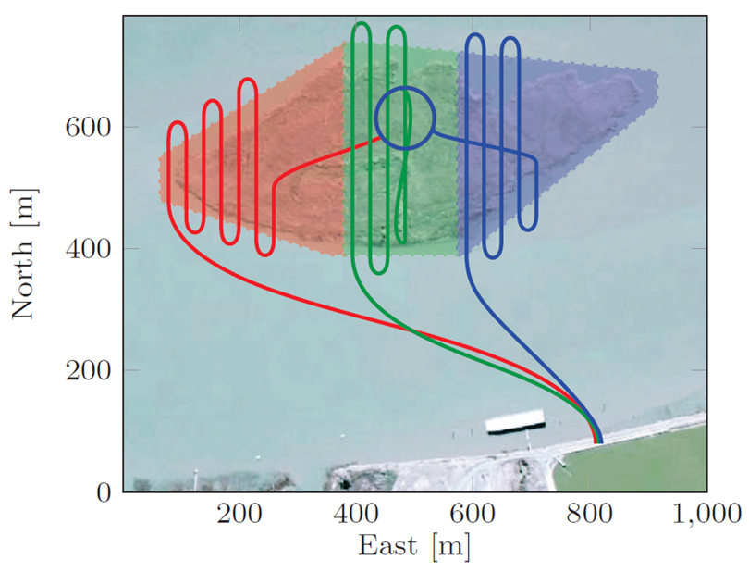
Figure 10: Leveraging ATTRACTOR for a data-driven science mission.

The ATTRACTOR DRM of Search and Rescue proved not only a fruitful development and test platform, but also attracted attention of an operational rescue organization, Lifesaver International [5]. Lifesafer engages in rescue of children and adults who have wondered from home due to various conditions, such as severe autism or dementia. Their current operations rely on remotely controlled flights, based on detecting radio signals from a bracelet worn by a person who suffers from wandering. Unfortunately, the patient may remove the bracelet, and the search can only proceed to the last location of the bracelet. Lifesaver became interested in ATTRACTOR because of the capability for visual search, as well as search in cluttered environments. Technology transfer has been delayed due to COVID-19 but is planned to resume with return to the Center.
Research in trust and trustworthiness of autonomous systems cuts across all domains. Developments in aeronautic systems seamlessly apply to space systems. NASA is participating in a multi-agency Space Trusted Autonomy partnership aimed at identifying and addressing common gaps in achieving justifiable trust in human-machine teams. ATTRACTOR lessons learned and workforce are contributing to the effort.
NASA’s future science observatory and platform missions will be bigger and more powerful than current systems. For example, the James Webb Space Telescope will be the largest, most powerful and complex space telescope ever built and launched into space [48] with its primary mirror diameter of approximately 6.5 meters. Already, astrophysicists are thinking about the future of space autonomy and envisioning the need for future large segmented telescopes that will exceed the fairing size of today’s launch vehicles. In-Space Assembly (iSA) is the process of robotically assembling space telescopes in space rather than deploying them from single launch vehicle. ISA is a modular multi-launch approach that operates within a rocket’s volume and weight/mass constraints by launching the components of a large structure in multiple, smaller launch vehicles, allowing for much larger persistent structures. Large persistent platforms such as 20-meter segmented telescope [49] will be placed in deep space where humans will not be able to teleoperate robots’ arms or directly attach hardware. NASA LaRC is installing an ISA Facility to design, develop, and test structures and robotics for autonomous ISA. Figure 11 shows a partially assembled 20 meter segmented telescope in the ISA Test Facility and a robot arm grasping a “tri-truss” component.

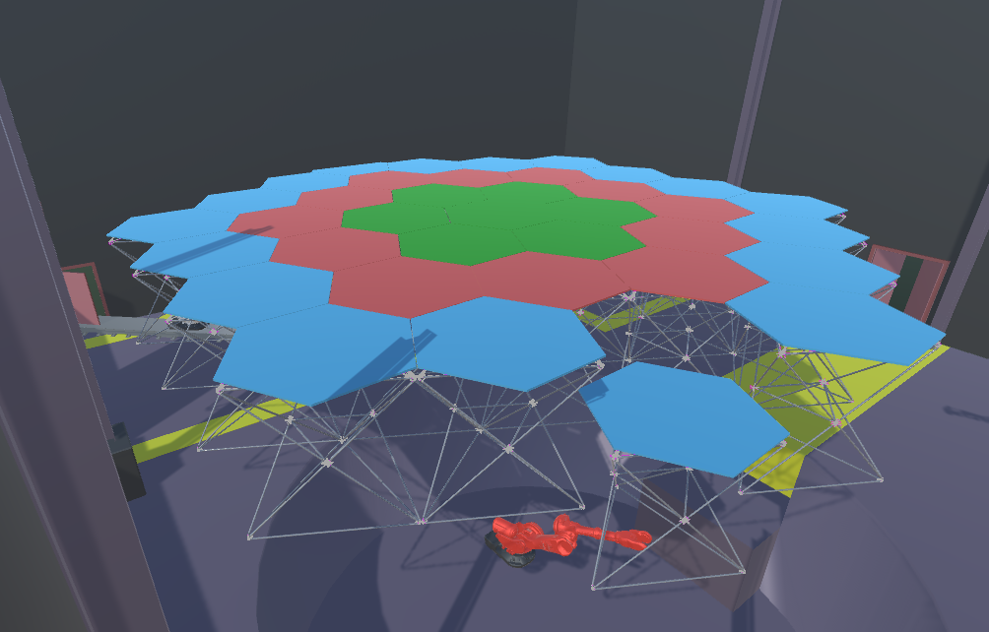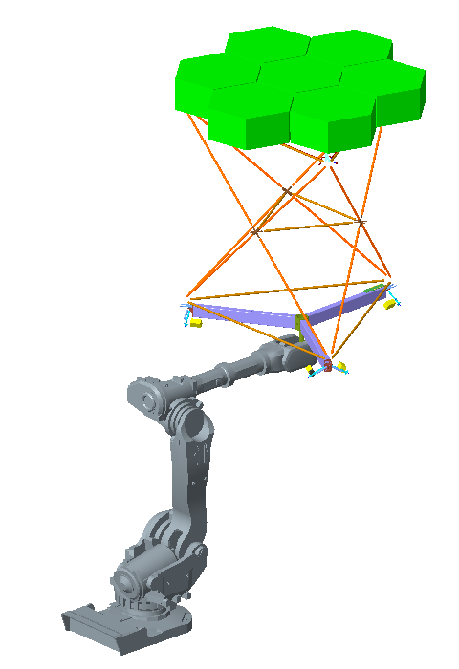
Figure 11: Rendering of NASA LaRC's ISA Test Facility and robot arm grappling a “tri-truss”

Robotic arms will not only assemble the space telescope, they will also perform maintenance, add payloads, and exchange truss structures. This means that a robot arm(s) must be capable of navigating through any number of exterior trusses to access the truss that needs repair or replacement. Autonomous assembly is critical to ISA and ATTRACTOR’s advances in trajectory planning in and through cluttered environments ports from SARUC to Space as shown in Figure 12. Because of the autonomy’s “permeable boundaries” between application domains, we can leverage the wire maze “clutter” navigation capability for ISA. Zooming in on the wire maze exposes a series of crossed wires that could be any linear structure, such as struts or tubing – perhaps struts in a tri-truss. Zooming out, the tri-truss is one of seven center modules that has been identified for action. Because the trajectory generation algorithm is platform-agnostic, the approach used for continuous analyzable trajectories through building rubble and an analog wire maze can be used for ISA. Using virtual- and mixed-reality simulations [26, 27] will enable technology readiness level maturation and eventually take ISA to deep space for persistent exoplanet observations.

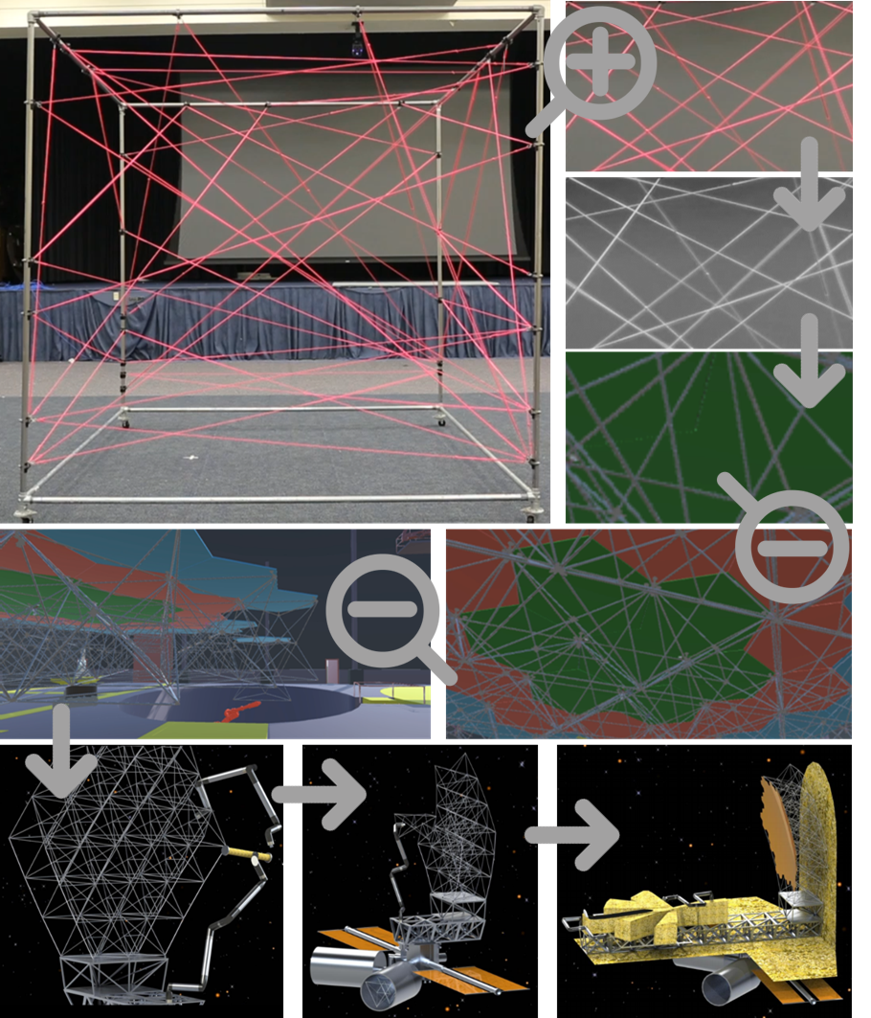
iSAT [30]
Figure 12: Leveraging ATTRACTOR for In Space Assembly

Much remains to be done in developing computational models of trustworthiness, for use during large-scale system design and in real time, during operations. The two use cases require different levels of fidelity and uncertainty quantification and propagation for risk estimation that informs each decision. The work will continue, applied to specific contexts, within ARMD’s AOSP/System Wide Safety (SWS) project. The development of correctness requirements and safe operational envelopes for machine learning algorithms is important and timely, as is tractability of real-time computations during operations.
In this paper, we have touched only on a sample of current and future research directions in ATTRACTOR. A more detailed description can be found in ATTRACTOR proceedings [50].

Acknowledgments
The authors would like to thank the Convergent Aeronautics Solutions (CAS) Project of the NASA ARMD’s Transformative Aeronautics Concepts Program (TACP) for supporting this work via ATTRACTOR. We also thank Andrew Thornton and the Media Solutions Branch for creating the ATTRACTOR logo (Figure 13) and final flight demonstration storyboard (Figure 9). Finally, we thank the entire ATTRACTOR team for bringing creativity, passion, and expertise to everything we do.
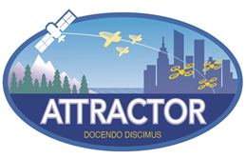
Figure 13: ATTRACTOR logo

References
[1] https://www.firerescue1.com/fire-products/drones/articles/first-responders-use-heat-seeking-drones-in-deadly-tornado-aftermath-h1z5L9uGNuZllXRD/
[2] https://www.dhs.gov/science-and-technology/news/2020/04/02/snapshot-first-responders-assess-drones-search-and-rescue-missions
[3] https://www.pilotonline.com/news/article_9744bf73-9691-537e-bf6a-b7c36eb515b0.html
[4] https://www.wtkr.com/2016/08/05/project-lifesaver-demonstrates-new-tool-for-search-and-rescue-in-chesapeake/
[5] https://projectlifesaver.org/
[6] NASA 2018 Strategic Plan, https://www.nasa.gov/sites/default/files/atoms/files/nasa_2018_strategic_plan.pdf
[7] Alexandrov, N., “Explainable AI Decisions for Human-Autonomy Interactions”, 17th AIAA Aviation Technology, Integration, and Operations Conference, AIAA AVIATION Forum, AIAA 2017-3991
[8] https://www.nasa.gov/topics/moon-to-mars
[9] William Doggett, “Architecture Options for Creation of a Persistent Platform Orbital Testbed”, AIAA ASCEND 2020, AIAA 2020-4130, Nov 2020. https://doi.org/10.2514/6.2020-4130
[10] THRIVING ON OUR CHANGING PLANET: A Decadal Strategy for Earth Observation from Space, Committee on the Decadal Survey for Earth Science and Applications from Space, ISBN 978-0-309-46757-5, DOI 10.17226/24938, The National Academies Press, Washington DC, 2018.
[11] NASA ARMD Strategic Implementation Plan, https://www.nasa.gov/aeroresearch/strategy.
[12] Allen, D., Cross, C., Tran, L Motter, M., Neilan, J., Qualls, G., Rothhaar, P., Trujillo, Crisp, V., “Towards Safe Robust Autonomous Operations”, Aviation 2015, Dallas, TX.
[13] B. Danette Allen and Loc D. Tran, James H. Neilan , Anna C. Trujillo, Benjamin N. Kelley, A. Kyle McQuarry, Matthew P. Vaughn, Ralph A. William , and Vicki K. Crisp, “An Autonomous Unmanned Science Mission”, Aviation AIAA 2017.
[14] https://www.nasa.gov/feature/langley/blazing-the-trail-of-urban-traffic-management/
[15] John T. Sullivan, Timothy Berkoff, Guillaume Gronoff, Travis Knepp, Margaret Pippin, Danette Allen, Laurence Twigg, Robert Swap, Maria Tzortziou, Anne M. Thompson, Ryan M. Stauffer, Glenn M. Wolfe, James Flynn, Sally E. Pusede, Laura M. Judd, William Moore, Barry D. Baker, Jay Al-Saadi, and Thomas J. McGee, “The Ozone Water–Land Environmental Transition Study: An Innovative Strategy for Understanding Chesapeake Bay Pollution Events”, Bulletin of the American Meteorological Society, Volume 100, Issue 2, February 2019.
[16] John T. Sullivan, T. Berkoff, M. Pippin, T. Knepp, G. Gronoff, T. J. McGee, L. Twigg, J. Schroeder, W. Carrion, B. Farris, M. Kowalewski, L. Nino, E. Gargulinski, L. Rodio, P. Sanchez, A. Atwater, D. Davis, S. Janz, L. Judd, S. Pusede, G. M. Wolfe, R. M. Stauffer, J. H. Flynn III, J. Munyan, W. Moore, J. Dreessen, D. Salkovitz, T. Hanisco, D. Blake, N. Abuhassan, A. Cede, M. Tzortziou, B. Demoz, S. Tsay, B. Holben, R. Swap, J. Szykman, D. Allen, and J. Neilan, “Overview of the 2017 OWLETS: Summary of Observations and Initial Results”, 9th Annual American Meteorological Society (AMS), Austin TX, 2018.
[17] https://www-air.larc.nasa.gov/missions/owlets/index.html
[18] CICADA: Close-in Covert Autonomous Disposable Aircraft, US Naval Research Laboratory (NRL), https://www.nrl.navy.mil/tewd/organization/5710/5712/research/CICADA.
[19] Edward E. Adcock, B. Danette. Allen, James H. Neilan, Matthew P. Vaughn, Ralph A. Williams, Zachary R. Johns, Brian E. Duvall and Nicholas H. Rymer, “Autonomous Distributed Atmospheric Measurement Acquisition (ADAMA) – A Multi-Agent sUAS Mission”, AIAA 2020-2200, AIAA SciTech 2020, Orlando, FL, January 2020. https://doi.org/10.2514/6.2020-2200
[20] NASA TACP CAS ATTRACTOR, https://www.nasa.gov/press-release/nasa-selects-three-aeronautics-teams-to-explore-ambitious-ideas
[21] Alexandrov, Natalia, “Computational Models of Trustworthiness and Trust in Autonomous Cyber-Physical-Human Systems”, AIAA SciTech, January 2021.
[22] Puig-Navarro, J., Hovakimyan, N., Alexandrov, N., and Allen, B. Danette., “Silhouette-informed trajectory generation through a wire maze for UAS,” 2018 Aviation Technology, Integration, and Operations Conference, 2018, p. 3845.
[23] Lisa R. Le Vie, Bryan A. Barrows, B. Danette Allen, and Natalia Alexandrov, “Exploring Multimodal Interactions in Human-Autonomy Teaming Using a Natural User Interface”, AIAA SciTech, January 2021.
[24] James E. Ecker, Benjamin N. Kelley, and B. Danette Allen, “Synthetic Data Generation for 3D Mesh Prediction and Spatial Reasoning During Multi-Agent Robotic Missions”, AIAA SciTech, January 2021.
[25] Loc Tran et al., “Enhancing Neural Network Decision-Making with Variational Autoencoders (VAE)”, AIAA SciTech, January 2021.
[26] Benjamin N. Kelley and Matthew P. Vaughan, “A Distributed Simulation-to-Flight Framework to Support Investigating Trust/Trustworthiness in Multi-Agent Systems”, AIAA SciTech, January 2021.
[27] Matthew P. Vaughan and Benjamin N. Kelley, “Bootstrapping Multi-Agent Unmanned Aerial Vehicle (UAV) System Integration Using Ground-Based Assets: Lessons Learned”, AIAA SciTech, January 2021.
[28] Meghan Chandarana, E. L. Meszaros, and B. Danette Allen, “A Planning Pipeline for Large Multi-Agent Missions”, The Twelfth International Conference on Advances in Computer-Human Interactions (ACHI), 2019.
[29] Puig-Navarro, J., Hovakimyan, N., Alexandrov, N., and Allen, B. Danette., “Silhouette-informed trajectory generation through a wire maze for UAS,” 2018 Aviation Technology, Integration, and Operations Conference, 2018, p. 3845.
[30] Canny and J. Reif, “New Lower Bound Techniques for Robot Motion Planning Problems”, Annual Symposium on Foundations of Computer Science, Los Angeles, CA, USA, October 1987.
[31] K. P. Valavanis, “Unmanned Aircraft Systems Challenges in Design for Autonomy”, International Workshop on Robot Motion and Control, Wasowo, Poland, July 2017.
[32] National Search and Rescue Manual, Australian Government, Australian Maritime Safety Advisory, https://natsar.amsa.gov.au/documents/NATSAR-Manual/2017AustralianNationalSARManual.pdf, Feb. 2017.
[33] United States National Search and Rescue Supplement to the International Aeronautical and Maritime Search and Rescue Manual, https://www.dco.uscg.mil/Portals/9/CG-5R/manuals/Natl_SAR_Supp.pdf, May2000.
[34] Puig-Navarro, J., Hovakimyan, N., and Allen, B. Danette “A Cooperative Trajectory Generation Framework for Cluttered Environments”, AIAA Aviation Technology, Integration, and Operations Conference, 2019.
[35] Yulun Tian, Katherine Liu, Kyel Ok, Loc Tran, Danette Allen, Nicolas Roy, and Jonathan P. How, “Search and Rescue under the Forest Canopy using Multiple UAS”, International Symposium on Experimental Robotics (ISER), 2018.
[36] Yulun Tian, Katherine Liu, Kyel Ok, Loc Tran, Danette Allen, Nicholas Roy, and Jonathan P. How, “Search and Rescue under the Forest Canopy using Multiple UAVs”, The International Journal of Robotics Research (IJRR), vol. 39, 10-11: pp. 1201-1221, First Published June 24, 2020.
[37] John R. Cooper and B. Danette Allen,” Clutter Assessment for an Autonomous Multi-Agent Search Mission”, AIAA SciTech, January 2021.
[38] Cofta, P., Trust, Complexity and Control: Confidence in a Convergent World, Wiley, Chichester, England, 2007
[39] Sridhar, B., Sheth, K., and Grabbe, S., “Airspace Complexity and its Application in Air Traffic Management”, 2nd USA/Europe Air Traffic Management R&D Seminar, Orlando FL, 1998
[40] Kopardekar, P., Magyartis, S., “Dynamic Density: Measuring and Predicting Sector Complexity”, 21st Digital Avionics Systems Conference, Irvine CA, 2002
[41] Frost, S.A., Goebel, K., and Celaya, J., “A Briefing on Metrics and Risk for Autonomous Decision-Making in Aerospace Applications”, Infotech@Aerospace 2012, 19-21 June 2012, Garden Grove CA, AIAA-2012-2402
[42] Gell-Mann, M., “Fundamental Sources of Unpredictability”, Conference on Fundamental Sources of Unpredictability, Santa Fe Institute, March 1996
[43] J. Puig - Navarro; N. Hovakimyan; N. Alexandrov; B. D. Allen; Silhouette-Informed Trajectory Generation through a Wire Maze for UAS, AIAA Aviation 2018
[44] Lee, Ritchie, Javier Puig-Navarro, Adrian K. Agogino, Dimitra Giannakoupoulou, Ole J. Mengshoel, Mykel J. Kochenderfer, and B. Danette Allen. Adaptive Stress Testing of Trajectory Planning Systems. In AIAA Scitech 2019 Forum, p. 1454. 2019
[45] Kamalika Das; David L. Iverson; Vijay Janakiraman; Nikunj Oza; Incorporating Human Knowledge in Autonomous Systems through Machine Learning, AIAA Aviation 2018
[46] Knight, J.: Fundamentals of Dependable Computing for Software Engineers, Routledge; 1st edition (January 12, 2012)
[47] Javier Puig-Navarro et al., “Spatial and Temporal Deconfliction of Trajectories in the Presence of Uncertainties”, AIAA SciTech, January 2021.
[48] https://www.jwst.nasa.gov/
[49] Mukherjee, Siegler, & Thronson, “The Future of Space Astronomy Will Be Built”, 2019 International Aeronautical Congress, Washington DC, October 2019. https://exoplanets.nasa.gov/internal_resources/1375/
[50] Alexandrov, Natalia M.; Allen, B. Danette, Eds.: “Proceedings of the ATTRACTOR Feasibility Study”,
NASA TM 2021-X [in production].

Senior Technologist (ST) for Intelligent Flight Systems, AISRB; AIAA Associate Fellow.
Senior Researcher, AISRB; Acting Convergent Aeronautics Solutions (CAS) Liaison, AIAA Associate Fellow.
Visiting Researcher, AISRB; AIAA Student Member.

