Adaptation of Metal Additive Manufacturing Processes for the International Space Station (ISS)
Tracie Prater¹, Dmitry Luchinsky², Vasyl Hafiychuk², Kevin Wheeler², Phillip Hall¹, Frank Ledbetter³, Christopher Roberts¹, Alicia Carey², Patrick F. Flowers²
1. NASA Marshall Space Flight Center
Huntsville, AL, US
2. NASA Ames Research Center
Mountain View, CA, US

3. NASA Marshall Space Flight Center (MIPPS SME contract)
Huntsville, AL, US

4. Made in Space
Jacksonville, FL, US

ABSTRACT
The In-Space Manufacturing (ISM) project at NASA Marshall Space Flight Center, in a partnership with the company, Made in Space, has previously investigated 3D printing of polymer materials on-orbit. In recent years, the project has begun exploring the potential for metal additive manufacturing (AM) on future space missions to reduce logistics and enable point-of-use manufacturing for sparing and repair. This paper provides an overview of constraints for demonstrating a manufacturing process on the International Space Station (ISS) as well as information on previous trades of available metal AM processes and their potential for in-space use. There are currently two processes in development as payloads for an ISS technology demonstration: wire+arc additive manufacturing (the Vulcan payload from Made in Space, Inc.) and bound metal additive manufacturing (the Fabrication Laboratory from Techshot, Inc). An update on both of these systems, key results to date, and future development efforts will be presented. Relevant modeling work, performed by NASA Ames Research Center, to evaluate operation of certain aspects of the bound metal AM process in a microgravity environment will also be summarized.

Keywords: in-space manufacturing, additive manufacturing, metals
Corresponding author: Tracie Prater (tracie.j.prater@nasa.gov)
DOI: (will be filled by SAMPE)

INTRODUCTION

The current International Space Station (ISS) logistics model is heavily dependent upon Orbital Replacement Units (ORUs) for system-based repair and maintenance. This approach to logistics support poses a significant challenge for extended human operations in space, especially for missions beyond Low Earth Orbit (LEO) where timely resupply or abort in the event of emergency would not be feasible. An on-demand manufacturing capability would significantly reduce mission risk and logistical requirements while enabling Earth independent human spaceflight. A previous logistics analysis of ISS found that approximately 13,000 kg of spares are maintained on-orbit on ISS, with an annual spares upmass of about 3,200 kg (1,260 kg for corrective maintenance and 1,930 kg for preventive maintenance and consumables). In addition, about 18,000 kg of spares are stored on the ground, ready to fly if needed. The expected spares which will be used on ISS in a given year based on historical incidences of system failures (mean time between failures) is 450 kg, which corresponds to only 3.4 percent of the total spares available on ISS [1]. Based on cumulative probability, the incidence of failures will only increase with longer duration missions and additional sparing must be incorporated into mission planning to account for this. Even after twenty continuous years of ISS operations unexpected failures still occur, and, due to the stochastic nature of these failures, it is difficult to predict what particular set of spares will meet mission requirements for probability of sufficiency (POS) as mission length increases. The probability of sufficiency is the likelihood that the number of spares available on a mission can cover all maintenance requirements during a given period [2]. The unprecedented challenges associated with prepositioning of spares on long endurance, long duration missions (where cargo resupply opportunities are limited, a quick abort may not be an option, and storage space may severely constrained relative to ISS) are key drivers for an on-demand manufacturing approach to sparing and repair.

In 2014, the In-Space Manufacturing (ISM) project at NASA Marshall Space Flight Center, in partnership with Made in Space, Inc., flew the first 3D printer for polymers to ISS through a small business innovative research (SBIR) contract. The 3D printing in zero G technology demonstration mission produced 55 parts of Acrylonitrile Butadiene Styrene (ABS) in its two rounds of operations from 2014-2016. These specimens consisted mostly of mechanical test coupons to evaluate properties of materials (tensile, flexural, and compression strength) produced in microgravity. The results of flight specimen testing were compared against specimens manufactured with the printer prior to its launch to ISS. The complete results of the mission are published in reference Prater et al. [3]. Ultimately it was concluded that there were no engineering significant effects on materials produced with the fused filament fabrication process in microgravity relative to operation in a 1g environment. Differences noted in flight and ground specimens during testing were attributable to slight variations in process settings and build to build variability. Building upon this initial demonstration, Made in Space developed a second-generation multi-material system for 3D printing of polymers, known as the Additive Manufacturing Facility (AMF). NASA uses this printer for fabrication of functional parts (non-load bearing components with no consequences of failure) for use onboard ISS and additional materials characterization investigations. AMF is a commercial ISS facility with multiple customers outside of NASA [4].

In 2016, the ISM project began to look across ISS systems to determine which parts, based on history of failure and frequency of replacement, would represent good candidates for on-demand spare manufacturing on space missions. The current part database consists of over 800 parts from environmental control and life support systems (ECLSS), crew tools, the ISS medical toolkit, communications systems, power systems, and other payloads. While some parts use polymeric materials (or could potentially be manufactured from polymeric materials if launch constraints are removed), the most common metal materials in ISS systems are Aluminum, steel, and Titanium alloys. The frequency of use of metal parts drives the need for metal manufacturing systems on future space missions. The part database also helps to define requirements for future ISM metal manufacturing platforms, including feedstock materials, achievable feature resolution and tolerances, build rates, and the size of the build volume. A recent analysis found that approximately 50% of ECLSS spares could be manufactured in a build volume measuring 150 mm x 150 mm x 150 mm [5]. However, this analysis considers part volume only and no other attributes relevant to manufacturability. There is also a trade between building a part using its heritage geometry versus redesigning the part for a specific manufacturing process and platform. The ability to redesign a part for AM and/or decompose a larger part into an assembly will necessarily increase the fraction of spares which can be manufactured at the point of use on space missions.

In 2017, the ISM project began pursuing metal manufacturing capabilities for demonstration on ISS. The crewed, microgravity environment of ISS imposes unique constraints for manufacturing systems. These include the scalability of hardware: systems are limited to a peak power draw of 2000 W and can occupy a maximum volume of 0.45 cubic meters (in the form factor of an EXPRESS –EXpedite the PRocessing of Experiments to Space Station – rack). Specific payload requirements can be found in reference [6]. Safety is a pre-eminent concern for operation of manufacturing systems on ISS and many metal manufacturing processes generate metal particulate and/or chips if the process requires machining to achieve a finished part. Crew interaction with systems is generally limited to feedstock or printhead changeout (as an ORU) and part removal. Systems must be remotely commanded from earth. Ideally there would be a range of feedstock materials which can be manufactured within the same processing capability (for example, a system capable of manufacturing with multiple metals). The incorporation of different classes of material for manufacturing (metals, polymers, ceramics) within the same system is also a goal. Based on the part database, the metal manufacturing systems for ISM should also have the ability to produce complex features, generate accurate parts relative to the original part design, and attain a surface finish commensurate with machining processes. The process must also be able to operate in microgravity, which requires an understanding of the physics of the deposition in the absence of buoyancy driven convection and the impact of this different thermal environment on material outcomes. The management of heat in the absence of natural convective cooling will be a challenge for many metal processes, but particularly those which involve melting and resolidification of metal. Thus, it is important to understand these phenomena and develop process parameters which account for the lack of natural convection on ISS. Feedstock form, life, and storage are also key considerations.

In the past 4 years, the ISM project has worked with several companies and payload developers to evaluate potential solutions or on-demand manufacturing of metals on ISS. Processes considered included hybrid wire+arc additive manufacturing, ultrasonic additive manufacturing [7], bound metal additive manufacturing, and metal ingot manufacturing with a computer numeric control (CNC) milling capability. Approaches to produce higher strength polymers, including polyether ether ketone (PEEK) and composite feedstocks, have also been explored in complementary efforts under the NASA SBIR program [8, 9]. Other trade studies considered laser powder bed fusion, electron beam deposition, additive friction stir deposition, kinetic metallization, chemical vapor deposition, and Joule printing.

The On-Demand Metal Manufacturing (ODMM) element of the ISM project was established in 2020 to pursue the commercial development of hybrid (additive-subtractive) manufacturing prototype unit(s) for demonstration of metal AM processes onboard the ISS. Two distinct approaches are being considered at present:

(1) A fully integrated system using bound metal additive manufacturing, by Techshot, Inc., to produce titanium (Ti6Al4V) parts

(2) a Wire-Arc Additive Manufacturing (WAAM) system, by Made in Space, Inc., (MIS). The WAAM process is compatible with multiple metal alloys in the form of welding wire and feedstock downselect for the flight demonstration will be based on material testing results. A single metal material will be demonstrated during initial flight operations.

The two systems are referred to as Techshot Fabrication Laboratory (FabLab) and MIS Vulcan. The primary goal of ODMM is to bring the aforementioned on-demand manufacturing systems to a flight demonstration for ISS, where the feasibility of manufacturing metal parts in low-gravity can be demonstrated. This work aligns directly with NASA’s 2020 Technology Taxonomy for TX 12, “Materials, Structures, and Manufacturing” [10].

The ODMM project objectives are as follows:

- Design, build, and demonstrate on-demand manufacturing approaches in microgravity for metal parts.
- Deliver to ISS flight-certified, on-demand manufacturing systems.
- Demonstrate the manufacture of metal parts in a microgravity environment on ISS.
- Evaluate parts made on ISS against parts produced on the ground.
- Develop physics-based models to predict processing parameters and material outcomes under low-gravity conditions for metals.

HYBRID AM SYSTEMS IN DEVELOPMENT FOR ISS
The In-Space Manufacturing (ISM) project is currently working with two industry partners to develop capabilities for 3D printing of metals which can be demonstrated on the International Space Station (ISS). The majority of spare parts identified as candidates for on-demand manufacturing are metallics. Based on a materials frequency analysis from NASA’s Materials and Processes Technical Information System (MAPTIS), which catalogs materials used in spaceflight hardware, the most frequently used materials in ISS systems are Aluminum Alloys. Stainless Steels, and Titanium. Thus, demonstration of metals manufacturing on ISS significantly enhances the state of the art for in-space manufacturing and broadens its infusion potential as an alternative to prepositioning of spares on long duration exploration missions.

Vulcan from Made in Space
The Vulcan manufacturing system from Made in Space (MIS), which is one element of the ODMM portfolio, was initially developed under phase I, II, and II-E NASA Small Business Innovative Research contracts from 2017-2020. Vulcan uses a variation of directed energy deposition (DED) AM referred to as wire arc additive manufacturing (WAAM), which relies on an electric arc as a heat source and wire as a feedstock to build up a part layer by layer. The deposition process occurs in an enclosed chamber with an inert shielding gas. Welding-based AM has a relatively fast deposition rate relative to other additive manufacturing processes. Due to the nature of the welding-based AM process, the as-printed part requires machining to produce surface features or achieve fine tolerances. For this reason, Vulcan has an integrated subtractive manufacturing system to allow for milling of the resultant part to produce near net shapes, making Vulcan a hybrid additive and subtractive manufacturing system (Figure 1). Debris generated during subtractive machining or fumes/spatter during welding is fully captured by an environmental control unit. This wire-fed AM process is compatible with many metallics available in the form of welding wire, but feedstock material selection is often driven by weldability. A comprehensive review of WAAM processes in general and characteristic outcomes with various materials can be found in reference [11].

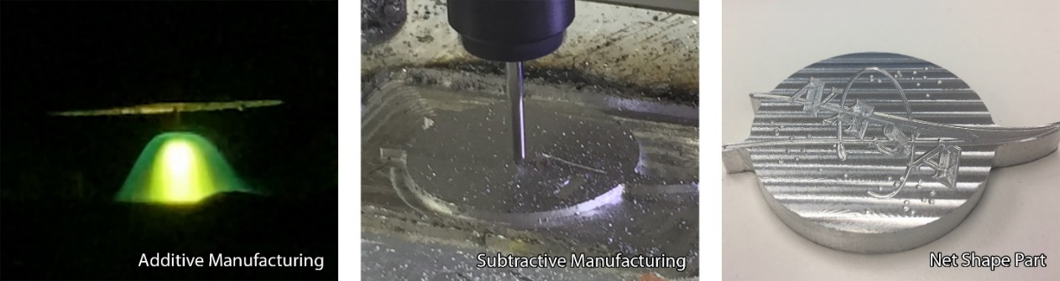

Figure 1. Example of the additive manufacturing (let) and subtractive manufacturing (middle) hybrid process utilized by Vulcan to generate net-shape parts (right). Image from Made in Space.

The Vulcan system is designed to operate in microgravity; it is also designed to be highly efficient in resource utilization, which is a goal for inclusion in future spaceflight missions. In prior work, MIS developed and demonstrated the subsystems for Vulcan, including an arc welding system for deposition of metal material, a Computer Numeric Control (CNC) mill with automated changeout of tools via a carousel, a chip capture system (tested on a previous parabolic flight opportunity to verify capture of chips in a short microgravity time constant), an iris clamp (provides a grounding path for welding operations, holds the build plate, and fixtures the part), and a robotic gripper (reorients the part as needed for machining and separation from the build plate). Vulcan can also manufacture with polymer materials using the fused filament fabrication (FFF) process, previously demonstrated on ISS beginning in 2014, with changeout of the metal manufacturing head as an orbital replacement unit. Work within the past year defined a concept of operations and requirements for the integrated ISS-compatible system, matured the design of the system to an engineering design unit (EDU), and performed preliminary testing of the EDU, which integrates all subsystems. Figure 2 shows an overall concept for Vulcan and a specimen manufactured with subsystems.

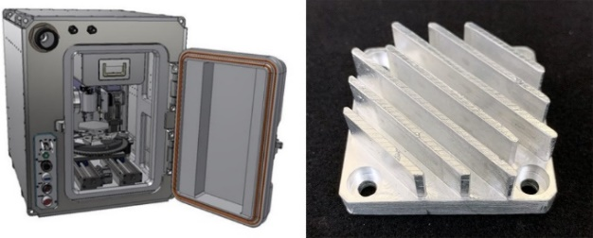

Figure 2. Vulcan system design (left) and a heat sink manufactured as a demonstration sample (right). Image from Made in Space.

A separate but parallel effort to Vulcan developed an in-process monitoring system, known as AMARU, to observe the manufacturing process as it occurs and potentially identify defects in deposited material. While developing the capability for production of spares on space missions is one challenge, another pre-eminent challenge is verifying that the parts produced meet requirements for use in their intended environment. The ability to ensure production of parts with repeatable quality is critical for ISM implementation on future missions. There are essentially two approaches to ensure consistency in the parts and the manufacturing process:
1) a traditional qualification and certification approach for AM (which may be difficult for ISM to implement due to constraints on crew time, crew skill sets, and equipment size, power, and safety limitations). This approach typically relies on production of witness specimens, produced alongside the build, which are then destructively tested and full volumetric inspection of the part through X-ray computed tomography (CT).
2) online quality control (i.e. process monitoring, where in situ monitoring of process signals provides information about the quality of the part).

In the AMARU effort, MIS selected and installed a high dynamic light range weld camera for real-time monitoring of the weld process, installed and calibrated a camera for top-down layer imaging of parts as they are manufactured, and created machine learning software for grading weld quality (Figure 3). Operator in the loop classification of images provides training data for the machine learning algorithms, which can be further refined based on these and other inputs, such as post-process materials characterization.

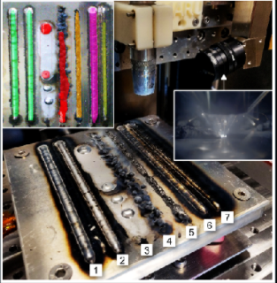

Figure 3. Training AMARU using weld beads deposited at various process parameters. AMARU is designed to provide a real-time classification of layer quality and inform in situ adjustments to the manufacturing process. Image from Made in Space.

The flight hardware for the Vulcan mission is expected to be compatible with a double locker on the ISS. It will include the following five subsystems: 1) the weld head manufacturing subsystem, 2) a polymer additive manufacturing subsystem, 3) a CNC machining subsystem, 4) a robotic gripper and iris clamp to facilitate automated manipulation and refixturing of the part during machining, and 5) an environmental control unit for management and capture of fumes and chip debris. The payload will also incorporate a command and data handling capability for remote commanding. The system will be operated on ISS with limited crew interaction. In addition, continued maturation of AMARU has the potential to provide a real-time, automated classification capability for deposited layer quality and enable adaptive process control.

Within the context of a flight demonstration mission, MIS Vulcan would produce “ground truth” specimens and parts (manufactured with the flight unit prior to launch; these specimens and parts will be directly compared with specimens and parts produced on-orbit). Following launch, Vulcan will be installed and activated in an EXPRESS rack on ISS. Vulcan would then produce polymer specimens and, following an ORU replacement of the polymer extruder with the metal deposition system, metal specimens and parts. Specimens will be downmassed to Earth and analyzed via mechanical testing, CT scanning, metallurgy, chemical analysis, and structured light scanning. Results of the testing and comparison with ground-produced specimens will characterize any differences in material outcomes due to operation in microgravity. Based on the findings, the Vulcan system can continue to be matured for on-demand manufacturing in space missions, including lunar surface manufacturing scenarios. These flight results will also help to inform the data that is generated through the AMARU tool as part of future development efforts and assess the approach of online monitoring during hybrid additive manufacturing of parts in the microgravity environment. Modeling of the WAAM process in microgravity to inform parameter selection and operations will also be conducted in parallel with Vulcan development by NASA Ames Research Center.

Fabrication Laboratory (FabLab) from Techshot
In 2017, the ISM project, through NASA’s Advanced Exploration Systems program, issued a phase A Broad Agency Announcement for development of a multi-material Fabrication Laboratory (“FabLab”) for ISS in the form of an EXPRESS rack quad locker. The Techshot FabLab was initially an 18-month effort under this BAA to develop an integrated system for bound metal additive manufacturing, which uses metallic feedstocks with sacrificial polymer binders to produce metallic components. This process is derived from metal injection molding. The variation of the bound metal additive process used in the Techshot FabLab initially extrudes feedstock through a nozzle in the print chamber. Under the phase A work, a Ti-64 filament feedstock was developed by University of Louisville. During the print, a laser line profilometer (LLP) system scans each layer of deposited material and compares it back to the specific layer/geometry in the sliced part file, reporting areas of voids and/or over-deposition of material. Because the as-built part is in a “green-state” (low density), it must be transferred from the print module (in the upper quad locker) to a sintering furnace (in the lower quad locker), where a thermal de-bind profile removes the polymer material and a sintering process to consolidate the remaining metal. If necessary, the part is then transferred back into the print module for finish machining with an end mill. The prototype system developed in phase A is pictured in Figure 4.

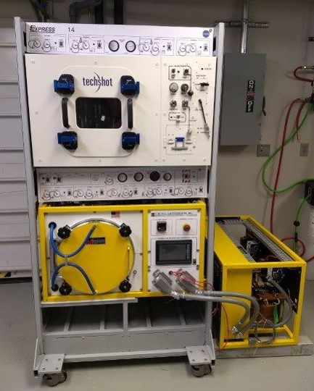

Figure 4. Image of Techshot FabLab prototype. Image from Techshot.

Currently, the bound metal additive manufacturing process for FabLab has been optimized for production of Ti-64 specimens. In previously published results by University of Louisville and NASA, optimal metal powder content for the filament feedstock was found to be 59% by volume. Results of part sintering studies with the filament demonstrated a relationship between Oxygen content of the starting powder and the characteristic diameter of the metal particles (coarse or fine), which was determined based on a statistical distribution. Sintered density for the filament was reported as 97.2 +/- 0.5% for the fine powder and 94.2 +/- 0.1% for the coarse powder relative to wrought. Plots showing ultimate tensile strength (UTS) of the fine powder and coarse powder filaments (at optimum sintering protocols) and percent elongation are shown in Figure 5 [12]. As expected, based on mechanical testing results, fine powder samples exhibit brittle fracture while coarse powder samples show a ductile fracture with the presence of fine dimples.

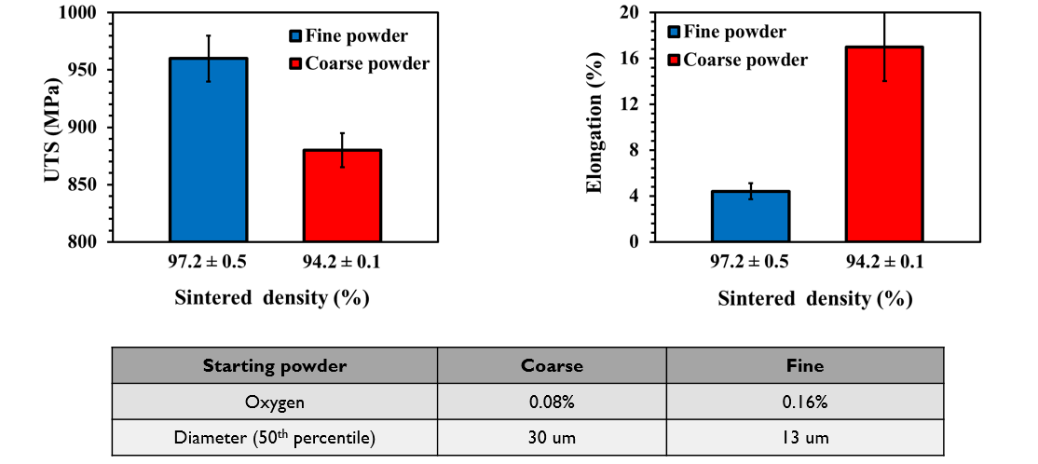

Figure 5. Results of filament development work from University of Louisville [12].

Five representative parts produced with the FabLab prototype are shown in Figure 6. These parts underwent structured light scanning to compare the as-manufactured geometry to the CAD model and assess process capabilities for tolerances and feature resolution. While initial material testing and part production was with Ti-64, with the proper feedstock and processing parameters, the FabLab material capability could be expanded to include additional metallics, polymers, and/or electronic inks.

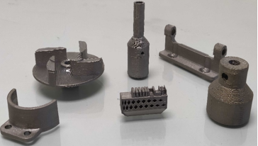

Figure 6. Representative parts printed with the Techshot Fabrication Laboratory ground-based prototype facility.

The FabLab flight system will consist of two primary subsystems that will utilize the ISS EXPRESS rack payload volume. The FabLab will include additive and subtractive (surface and feature finishing) manufacturing subsystems, a thermal de-binding and sintering subsystem, and an automated inspection/verification subsystem. The command and data handling system will allow for the FabLab to be operated from Techshot’s Payload Operations Control Center at their facility. Optimally, the only crew interaction with the facility will be to install the system, change feedstock, and move a print between subsystems. As with other ISS technology demonstrations under ISM, the flight unit will be used to manufacture ground specimens prior to launch, which correspond to specimens to be produced on-orbit during flight operations. These specimens serve as the baseline for comparison with microgravity manufactured materials. FabLab will be installed on ISS, where it will manufacture specimens for material characterization as well as parts. These specimens will be downmassed, evaluated, and compared with the “ground-truth” specimens by NASA. Results will inform continued development of BMAM for future space missions and technology infusion into platforms beyond low earth orbit.

MATERIAL MODELING OF BOUND METAL ADDITIVE MANUFACTURING IN MICROGRAVITY

Modeling bound metal additive manufacturing processes is a challenging problem [13, 14]. The related physics scales span from atomistic (particulate structure of the filament) through to the mesoscale of whole part dimensions. The complex relationships between various scales and the properties of the final part are well illustrated in reference [15]. To enable prediction of anisotropic shrinkage in this process NASA Ames Research Center developed a unique multi-scale sintering model that includes several numerical methods covering several important scales:

- Molecular dynamics of sintering of metal particles with diameter of tens of nanometers on the time scale of nanoseconds;
- Phase-field methods of sintering metal particles in 2D and 3D on the scale of tens of microns (cross-section or one filament) and time scale of hours;
- Discrete element modeling (DEM) of sintering on the scale of millimeters (sub-models) formed by tens of thousands of particles on time scale of tens of minutes;
- Continuous Finite Element modeling (FEM) of the whole part on the time scale of several hours.
Below we provide brief discussion of the obtained results. An extended analysis and further details of the simulations can be found in [16].

3.1 Estimations based on packing and filling densities
We note that for rough estimation of shrinkage in gravity on Earth one could use a general rule of thumb. According to this rule, samples with particle densities below 64% may undergo initial shrinkage in the direction of gravity until the sample density approaches the limit for random packing $\sim$64%. Further shrinkage will be uniform in all directions. More accurate predictions can be made utilizing the following models.

3.2 Molecular dynamics
At the heart of sintering process is diffusion of atoms at the interface between two particles (Figure 7). Molecular dynamics simulations can provide insight into several diffusion mechanisms including [17]: (i) Surface diffusion; (ii) Lattice diffusion; (iii) Evaporation and condensation from the particle surface; (iv) grain boundary diffusion; (v) lattice diffusion from the grain boundary. In this work we used LAMMPS [18] with the modified embedded atom potential [19] to estimate important sintering parameters including width of the grain boundary and diffusion coefficients. It was shown that the grain boundary width $δ_{gb}\sim 1 μm$ for particles with diameter $∼30 μm$ while the surface diffusion coefficient $D_{surf}$ was estimated to have a value ranging from 8x10⁻¹⁰ m²/s to 1.6x10⁻⁹ m²/s. The obtained parameters were used at the next scale of sintering simulations using a phase-field method.

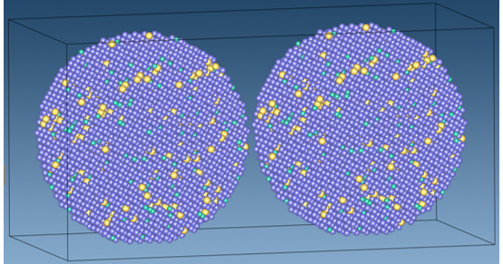

Figure 7. Two interacting particles 20 nm in diameter in MD simulations. The color coding shows Ti (blue), Al (yellow), V (cyan).

3.3 Phase field methods
At the next scale we simulate microstructure evolution in the cross-section of one filament. We used phase-field module in MOOSE Multiphysics to model one of the most non-trivial steps of sintering process that involves transformation of initially separated round particles into dense structure of grains (Figure 8). Using this approach based on results of [20, 21] we modeled sintering of 23 “particles'' with diameter ranging from 1.9 to 4.0 $μm$ in 2D, and 9 particles with diameter ranging from 3.375 to 4.325 $μm$ in 3D. The results of the simulations were used to estimate the value of sintering stress to be a few MPa, and the time scale of sintering to be a few hours in good agreement with experimental observations and numerical estimations based on the kinetic Monte Carlo method. The value of the sintering stress was further used for FEM of the whole part.

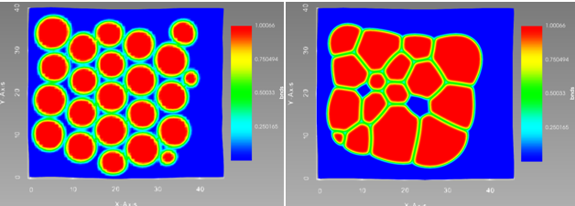

Figure 8. Results of the phase-field simulations of the microstructure evolution for 23 particles, zero gravity, and periodic boundary conditions.

3.4 Discrete element model
To use FEM, we need to provide another important piece of information related to the estimation of the spatial mass distribution. Estimation of this parameter was obtained using DEM in KRATOS Multiphysics [22]. Using this model, we estimated the initial rearrangement of the particles and the corresponding mass redistribution in small sections of the whole part while accounting for the layout of the filaments (Figure 9). The simulation had several thousand particles with diameters of approximately 50 $μm$. We also confirmed our prediction that gravity is the major source of strong non-linear shrinkage and estimated that the initial sintering stress was approximately 0.3 MPa. These data together with estimations of the sintering stress in the phase-field simulations are further applied in the simulations of full-scale continuous models.

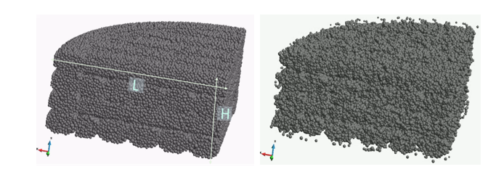

Figure 9. Results of sintering for crossed orientation of the filaments in each layer: (left) initial and (right) final states.

3.5 Full scale FEM
Simulations were developed to predict anisotropic shrinkage of the whole part during debinding and sintering using COMSOL [23, 24]. The simulations were performed as a function of the processing parameters: pressure, temperature, and duration. Two macroscopic models were developed for describing the sintering process. One is based on the Olevsky [13] approach, and the second one was based on swelling (shrinking) the continuum due to concentration of the backbone polymer. Both models show the shrinkage property of the structure as shown in Figure 10. The model can predict anisotropic shrinkage and be utilized to determine the required compensation for the green part geometry. The developed multi-scale approach is unique in the sense that each model is quite complex. Usually, research is focused on only one of these models. Our approach developed the set of models covering the whole spectrum of relevant physical scales coupled to each other (Figure 11).
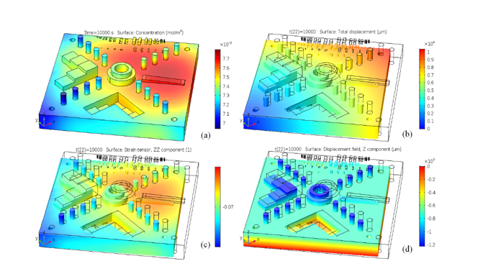

Figure 10. Concentration of the backbone debinder in the sintering part (after sintering) -- (a), Total displacement -- (b), directional strain -- (c) and displacement in vertical direction -- (d). The $β$=10⁻³ m³/kg, initial concentration 10³ mol/m³, diffusion coefficient D=4x10⁻⁶ m²/s, brown part density was taken as 3000 kg/m³, Young modulus 10 GPa, Poisson ratio 0.4.
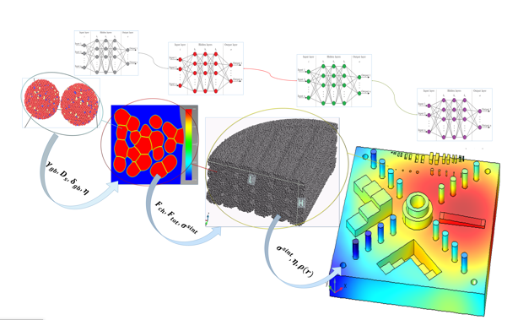

Figure 11. A set of coupled models used in multi-scsle approach. (top-left) to (bottom-right): (i) molecular dynamics; (ii) phase-field; (iii) discrete element model; (iv) finite element model. Each model can be tuned to available experimental data by its own neural network.

3.6 Intelligent AM in space

The performance of this approach depends on many parameters (e.g. sintering stress, diffusion coefficients, viscosity, non-uniformity of the mass distribution etc.) that must be calibrated using experimental data. As a means to incorporate experimental data, we propose to combine the strengths of both data-driven and physics-based methods within an intelligent additive manufacturing in space (IAMS) framework. Conceptually the IAMS involves a hierarchical structure of artificial neural networks that individually tune parameters of sub-models. The tuning uses scientific knowledge encoded as relationships that constrain the parameters of the networks and restricts the solution space to the relevant physics.

PATH FORWARD
NASA’s ISM project, in partnership with commercial companies, seeks to potentially demonstrate two metal AM processes on-orbit by 2025. While ISS serves as the initial testbed for these technologies in a long duration microgravity time constant with crew, the true need and driver for these technologies is longer duration, longer endurance missions where cargo resupply opportunities and the ability to preposition and store a vast reserve of spares is limited. On-demand manufacturing of metals for space missions is a destination agnostic capability. Nearer term mission infusion opportunities include the Lunar Gateway (an orbiting outpost around the moon which serves as a staging point for missions to the lunar surface) and a lunar foundational surface habitat. Some metal AM technologies in the ISM trade space are also scalable for lunar surface construction applications. Incorporation of these technologies into lunar orbital and surface operations is key to enabling lunar sustainability by reducing reliance on earth. With the accompanying development and incorporation of metal recycling technologies and other in situ resource utilization capabilities, it may also be possible to generate feedstock from used metal materials or local resources, thus achieving closed loop manufacturing.
One key technology gap for ISM is development of on-orbit inspection techniques. On earth, certification of additively manufactured parts relies on the production of witness specimens (usually tensile specimens or small cubes) manufactured at the same time as the part. These specimens can then be destructively tested and analyzed to ensure that witness samples are within the family of prior qualification builds and provide evidence that the system remains within previously established control limits. This approach is not readily applicable to an on-orbit scenario currently, as techniques for mechanical testing and metallurgical characterization on space missions have not been developed. Additively manufactured parts that are classified as critical also require full volumetric inspection (via computed tomography). Ultimately a CT capability on a mission would be needed to provide full inspection of a part prior to use in a system where there are high consequences of failure associated with its failure. While the ISM project’s commercial partners are developing in-process monitoring techniques for their metal manufacturing payloads, this in and of itself is not a currently recognized path to part certification for certain classes of parts. Work is ongoing to develop a tailored approach for part certification for ISM on future space missions, but ultimately ancillary capabilities for postprocess inspection (dimensional and internal) are also needed. Intelligent AM approaches and machine learning are also important ancillary techniques
The ISM project advocates for a “Make It, Don’t Take It” approach to sparing and repair on future space missions to reduce logistics and enable sustainable space exploration. There are numerous challenges remaining to implementation and use of AM systems in a mission scenario. The planned ISS demonstrations of these technologies represent the first step toward a future where humans live and work in space, truly untethered from spaceship earth.

References

[1] Owens, A. and de Weck, O. “Systems Analysis of In-Space Manufacturing Applications for the International Space Station and the Evolvable Mars Campaign.” AIAA SPACE. Long Beach, CA, 13-16 September 2016. American Institute of Aeronautics and Astronautics. DOI: 10.2514/6.2016-5394.
[2] Owens, A., de Weck, O. and Stromgren, C, “Supportability Challenges, Metrics, and Key Decisions for Future Human Spaceflight.” AIAA SPACE. Orlando, FL, 12-14 September 2017. American Institute of Aeronautics and Astronautics. DOI: 10.2514/6.2017-5124.
[3] Prater, T., Werkheiser, N. and Ledbetter, F. “Summary Report on the Phase I and Phase II Results from the 3D Printing in Zero-G Technology Demonstration Mission.” NASA Technical Publication 20180002403. National Aeronautics and Space Administration. 2018.
[4] Made in Space, “Additive Manufacturing Facility User’s Guide.” Made in Space. 2016. https://madeinspace.us/wp-content/uploads/2019/07/AMFuserguide-1.pdf
[5] Moraguez, M. and de Weck, O. “Benefits of In-Space Manufacturing Technology Development for Human Spaceflight.” IEEE Aerospace Conference. Big Sky, Montana, 7-14 March 2020. IEEE Aerospace and Electronic Systems Society. DOI: 10.1109/AERO47225.2020.9172304.
[6] “Expedite the PRocessing of Experiments to Space Station (EXPRESS) Rack Payloads Interface Definition Document.” SSP 52000-IDD-ERP, Revision H. National Aeronautics and
Space Administration. 2009.
https://biospaceexperiments.com/index_html_files/2009%20EXPRESS%20Rack%20Payload%20interface%20Definition%20Document.pdf
[7] Friel, R. and Harris, R. “Ultrasonic additive manufacturing – a hybrid production process for novel functional products.” Seventeenth CIRP Conference on Electro Physical and Chemical Machining (ISEM). Leuven, Belgium, 9-12 April 2013. College International pour la Recherche 35
[8] R. Bagwell, “Additive Manufacturing of Fiber-Reinforced PEEK and PEKK for NASA Applications and Custom Medical Devices.” National Space and Missile Materials Symposium. Virtual, 2020.
[9] S. Patankar, S. Sen, F. Thomas, S. Spearing, C. Murphy, M. Keopp, H. Ning, and S. Pillay, “Development of Fiber Reinforced Composite Feedstock for In-Space Manufacturing of High Strength Parts.” National Space and Missile Materials Symposium. Henderson, Nevada, 24-27 June 2019.
[10] “2020 NASA Technology Taxonomy.” National Aeronautics and Space Administration. 2020. https://www.nasa.gov/sites/default/files/atoms/files/2020_nasa_technology_taxonomy_lowres.pdf
[11] Wu, B. “A review of the wire arc additive manufacturing o metals: properties, defects and quality improvement.” Journal of Manufacturing Processes 35 (2018): 127-139. DOI: 10.1016/j.jmapro-2018.08.001
[12] Hill, C., Paramiot, S., Atre, S., Kate, K., et al. ,“Metal fused filament fabrication of Titanium alloy for in-space manufacturing.” National Space and Missile Materials Symposium. Virtual, 2020.
[13] Olevsky, E., Tikare, V. and Garino, T. “Multi-Scale Study of Sintering: A Review.” Journal of the American Ceramic Society 89 (2006): 1914-1922. DOI: 10.111/j.1551-2916.2006.01054.x
[14] German, R., Olevsky, E., Torresani, E. and Hernandez, D. “Sintering experiments under way on International Space Station.” 2018. https://thermalprocessing.com/sintering-experiments-under-way-on-international-space-station/
[15] Vock, S., Klöden, B., Kirchner, A., Weibgärber, B., and Kieback, B. “Powders for powder bed fusion: a review.” Progress in Additive Manufacturing 4 (2019): 383-397. DOI: 10.1007/s40964-019-0078-6.
[16] D. Luchinsky, V. Hafiychuk, K. Wheeler, and T. Prater, “Analysis of nonlinear shrinkage for the bound metal deposition manufacturing using multi-scale approach.” NASA Technical Memorandum. National Aeronautics and Space Administration. 2020 (submitted, publication pending).
[17] Rahaman, M. Sintering of Ceramics. Boca Raton: CRC Press (Taylor & Francis Inc.), 2007.
[18] Plimpton, S. “Fast Parallel Algorithms for Short-Range Molecular Dynamics.” Journal of Computational Physics 117 (1995): 1-19. DOI: 10.1006/jcph.1995.1039
[19] Lee, B., Baskes, M., Kim, H., and Cho, Y. “Second nearest-neighbor modified embedded atom method potentials for bcc transition metals.” Physical Review B 64 (2001): 184102-1 – 184102-11. DOI: 10.1103/PhysRevB.64.184102: 1-11.
[20] Permann, C. et. al, “MOOSE: Enabling massively parallel multiphysics simulation.” SoftwareX, 2020.
[21] Wang, Y. “Computer modeling and simulation of solid-state sintering: A phase field approach.” Acta Materialia. 54 (2006): 953-961. DOI: 10.1016/j.actamat.2005.10.032.
[22] Biswas, S., Schwen, D., and Tomar, V. “Implementation of a phase field model for simulating evolution of two powder particles representing microstructural changes during sintering.” Journal of Materials Science 53 (2017): 5799-5825. DOI: 10.1007/s10853-017-1846-3.
[23] Dadvand, P. Rossi, R., Gil, M., Martorell, X., Cotela, J., Juanpere, E., Idelsohn, S. and Oñate, E. “Migration of a generic multi-physics framework to HPC environments.” Computers & Fluids. 80 (2013): 301-309. DOI: 10.1016/j.compfluid.2012.02.004.
[24] COMSOL, “COMSOL multiphysics reference manual version 5.5.” COMSOL Inc., 2020.

