California & Oregon Ecological Forecasting
Detecting and Forecasting Fog Occurrence, Frequency, and Change to Inform Coast Redwood (Sequoia sempervirens) Habitat Assessments


Technical Report
Final – November 19th, 2020

Zackary Werner (Project Lead)
Anika Berger
Anna Winter
Christopher Tsz Hin Choi

Science Advisors
Dr. Paul Evangelista, Colorado State University, Natural Resource Ecology Laboratory
Dr. Catherine Jarnevich, Colorado State University, Natural Resource Ecology Laboratory
Dr. Tony Vorster, Colorado State University, Natural Resource Ecology Laboratory
Brian Woodward, Colorado State University, Natural Resource Ecology Laboratory
Nicholas Young, Colorado State University, Natural Resource Ecology Laboratory

1. Abstract
Fog and low clouds play an important role in providing moisture to coastal ecosystems. Coast redwood (Sequoia sempervirens) forests are currently distributed along a narrow strip of coastline in California and Oregon and rely on the presence of marine fog for moisture availability during the dry season (June-October). Recent time series analyses presented an uncertain future of fog frequency; however, a decline in fog presence may have adverse effects on the coast redwood habitat. To complement the ongoing work by Save the Redwoods League, a non-profit organization dedicated to coast redwood forest management, the team analyzed hourly fog data from the Geospatial Operational Environmental Satellite 17 (GOES-17) Advanced Baseline Imager (ABI) and daily cloud cover data from the Moderate Resolution Imaging Spectroradiometer (MODIS) aboard the Terra satellite. To explore present day fog longevity, GOES-17 was utilized to map the number of fog hours per day for the 2019 and 2020 dry seasons. The MODIS cloud flag was used to map the presence or absence of daily fog, which was summarized to create a monthly fog frequency dataset and identify trends in fog presence between 2000-2020. Both datasets were used as inputs into the random forest machine learning algorithm to identify climatic drivers of fog presence and longevity over the landscape. The present-day models suggested that daily temperature difference is a driving force behind fog presence and longevity. Trends in fog presence from 2000-2020 indicated great interannual variability. Finally, fog presence was modeled under a 2080 climate projection to shed light on the future of fog presence under a projected warmer climate. Model results projected an overall decline in fog presence during the dry season in the 2080s. Decreased fog presence as a result of increased temperature difference under a warmer climate remains to be a topic of investigation as to the impact on future redwood habitat suitability.
Key Terms
remote sensing, MODIS, GOES, fog, coast redwood (Sequoia sempervirens), California, Oregon

2. Introduction
2.1 Background Information
Recent time series analyses and models have found a reduced fog frequency over the western United States since the early 20th century (Johnstone et al., 2010; O’Brien et al., 2013); however, the future of fog presence and longevity under a warming climate is unknown. This presents a concern, as fog and low stratus clouds can have a profound impact on coastal terrestrial ecosystems. The water transported by marine fog supplies a multitude of ecological benefits. For example, plants directly uptake liquid water from fog via fog drip and fog also reduces temperatures and raises humidity (Azevedo & Morgan, 1974; Dawson, 1998).

The coast redwood (Sequoia sempervirens) is the tallest tree in the world, has a notably long lifespan, and plays a crucial role in mitigating climate change through capturing and transforming carbon dioxide (Noss, 2000). The distribution of coast redwood forests is constrained to areas of relatively high fog frequency, with a narrow range of locations along the coast of California and Oregon. Coast redwood forests are associated with the presence of marine fog and rely on fog for moisture availability during the long dry season (Dawson 1998; Johnstone et al., 2010). It is critical to consider the implications of an altered fog regime on the coastal redwood forests given a projected warmer climate because the presence of fog has significant impacts on both water uptake and carbon balance in coastal redwood ecosystems (Burgess & Dawson, 2004; Simonin et al., 2009). Fog presence sharply decreases ambient atmosphere vapor pressure deficit in coast redwoods, as well as decreases redwood transpiration during both day and night (Burgess & Dawson, 2004; Johnstone et al., 2010). This provides a water conservation mechanism that helps the trees survive in summer drought conditions that are common in the redwood region. Reduced fog presence may affect the climatic suitability of coast redwood habitat, which may result in a shift in the species’ potential habitat.

Both the Geostationary Operational Environmental Satellite (GOES) 17 Advance Baseline Imager (ABI) and the Terra Moderate Resolution Imaging Spectroradiometer (MODIS) have been previously used to investigate fog and low cloud cover, and each satellite presents different advantages. The GOES-17 satellite provides images at very high temporal resolution, with a five-minute cadence, but a relatively coarse spatial resolution of 2-km. MODIS provides high spatial resolution, with band resolutions of 250 meters, 500 meters, and 1000 meters, but a temporal resolution of 1 image per day. Torregrosa et al. (2016) investigated fog hours per day for coastal California between 1999-2009 based on image differencing provided by the 3.6 micrometer and 10.7 micrometer channels of GOES. Rastorgi et al. (2016) explored summer fog frequency of two of the Channel Islands in southern California by converting GOES imagery into albedo values and thresholding those values to distinguish land from clouds. Bendix et al. (2006) developed a fog detection scheme using Terra MODIS, creating fog albedo thresholds as a function of the solar zenith angle. Finally, Francis et al. (2020) estimated fog frequency using the MODIS cloud flag and made a simplifying assumption that all clouds in the study site during the summer months were fog. These fog detection methodologies leverage the fact that fog has a specific spectral behavior that can be detected with several active satellites. Collectively, these analyses represent the methods currently used to detect fog and low cloud cover using GOES and MODIS; however, there is currently no accepted standard method of fog detection using these Earth observations. The research presented from this project expands on the aforementioned satellite-derived fog studies by utilizing the strengths of both MODIS and GOES to create original, recent, and relevant fog datasets both for analysis in this project and for use by other researchers.

2.2 Study Area
Coast redwoods are currently distributed along a narrow band of coast in the northwestern Pacific United States, from ~42°N to 36°N, or from Curry County, Oregon, to Monterey County, California (Johnstone et al., 2010). An expanded area of the current coast redwood distribution was selected for the project study area to explore the potential for coast redwood range expansion. The study area spanned 100 miles north and south from the northernmost and southernmost points of the current redwood distribution, and 50 miles inland from the coast to avoid capturing fog east of the coastal ranges (Figure 1).

Figure 1. Map of the study area (in grey), which extends 100 miles north and south of the current coast redwood distribution (in green) and 50 miles inland from the coast.

The summertime coastal marine fog present in the study area is driven by numerous processes. First, the summer climate of this region is dominated by the North Pacific High, a high-pressure system that is formed from the dry and descending air of the Hadley cell (Taylor et al., 2008). Second, daytime surface heating creates regions of low pressure in inland areas, contributing to the sea-land pressure gradient that drives north-northwest winds along the coast (Taylor et al., 2008). Also, wind-driven upwelling contributes to cooler ocean temperatures along the coast (Reyes et al., 2012). These factors combined with subsidence associated with North Pacific High that leads to a surface temperature inversion, commonly known as the marine layer, contribute greatly to the process of coastal fog formation (Johnstone et al., 2010). When this marine layer is present and relative humidity reaches 100 percent, fog is likely to form and may reach from the surface up to 400-500 meters elevation and travel as far inland as 25-30 miles. Fog is defined as a cloud whose base height occurs at or below 400 meter elevation, and fog as a result of the processes described above is what the team sought to capture with satellite Earth observations across our study area between 2000-2020 (Johnstone et al., 2010). The process of fog formation and dissipation is complex, and this phenomenon is controlled by a combination of several meteorological processes operating at different time scales (Lundquist, et al., 2000). On the daily scale, the amount of solar radiation heating the air and Earth’s surface is critical in determining fog presence, with lower temperatures associated with greater fog presence. Minimum, maximum, and average temperature is related to solar radiation and were therefore included in our analysis.

2.3 Project Partners & Objectives
Save the Redwoods League is the primary non-profit conservation organization tasked with the protection, conservation, and restoration of the coast redwood forests of California and southwestern Oregon. The organization accomplishes this mission by “purchasing redwood forests, regenerating logged forests so they become spectacular havens for future generations, studying how to best protect and restore these global treasures, and introducing people to these magical places” (Save the Redwoods League). This project created a robust, replicable methodology that will build the organization’s capacity to monitor how a changing climate may alter habitat suitability for natural redwood migration.
This project had four primary objectives. The first objective was to create a fog longevity dataset, displaying average hours of fog per day from June-October for 2019 – 2020 utilizing GOES-17 ABI. The second objective was to use the Terra MODIS cloud flag to map the presence or absence of daily fog, and summarize this information to create a monthly fog frequency dataset and identify trends in fog presence between 2000-2020. The third objective was to identify the conditions that drive current fog longevity and presence by modeling the relationship between local topographical and meteorological data and each of the team-created fog datasets. The final objective was to model future fog presence based on projected climate conditions and determine how these future climate conditions may alter terrestrial fog frequency in the summer months, under the assumption that fog has reached land rather than attempting to model fog over the ocean..

3. Methodology
3.1 Data Acquisition and Processing
To create the fog longevity and fog presence datasets, the team accessed and processed GOES-17 ABI and Terra MODIS imagery on Google Earth Engine (GEE). GOES-17 provides a series of images every 5 minutes, which we processed to create a temperature difference index (TDI) in order to classify fog presence (Torregrosa et al., 2016). TDI was created by differencing the shortwave and longwave infrared channels on the ABI. For images taken at night, TDI pixel values less than -5.1 K were classified as fog. For daytime imagery, TDI pixel values greater than 2.0 K were classified as fog. These 5-minute fog classification images were then aggregated into one fog image per day that mapped the number of fog hours per day across the study area. These files were generated from GOES-17 imagery for June – October for 2019 and 2020. July 22nd – July 28th, 2020 were not included in the dataset due to sensor errors experienced by the GOES-17 satellite that prevented the classification of fog. Note that GOES-17 sensors experience documented inaccurate measurements at sunup (~6:00-7:00 AM) and sundown (~6:00-7:00 PM) due to extreme solar angles; thus, fog was not classified during these times (Torregrosa et al., 2016). Therefore, the GOES-derived fog longevity dataset underestimates hours of fog per day on days where fog is present at sunup or sundown.

Next, the second dataset which tracks the history of fog presence was composed of monthly files depicting the number of days fog occurred at each pixel across the study area. Based on the methodology described in Francis et al. (2020), daily Terra MODIS cloud flag images were processed to map potential fog and low cloud cover under the assumption that 75% of clouds in the study region are fog or low clouds (Iacobellis & Cayan, 2013). In an effort to limit the error of classifying high clouds as fog, the team further masked the potential fog and low clouds mapped by the general cloud flag using the MODIS cirrus cloud mask. While this step does not eliminate the aforementioned error, it does limit the error by ensuring that the clouds explicitly mapped as high-level clouds were not erroneously mapped as potential fog and low cloud cover. For simplicity, the phenomenon of potential fog and low cloud cover will hereinafter be termed “fog” when referring to the MODIS-derived data. Each of these daily images of potential fog was summed into monthly files with the pixel values being the number of days of fog occurrence per month for every month between March 2000 and September 2020. Note that only dry season months, June – October, were used for analysis because it is during these months that summertime marine fog represents the majority of clouds that are present and other types of clouds are infrequent.
3.2 Data Analysis
The fog longevity and fog presence datasets were analyzed to better understand past and present fog behavior over the landscape. The fog longevity dataset was used to determine averages for the number of hours of fog per day for each month of the dry seasons of 2019 and 2020. The fog presence dataset was used to provide average information regarding the number of days that experienced fog for each month of the dry season. Furthermore, the MODIS-derived monthly fog presence information was used to provide a pixel-level twenty-year trend analysis for each month of the dry season. To analyze trends, the slope of the rate of change of both fog days per month and fog days per dry season over the past 20 years were created as rasters. The number of days of fog for each month (as well as the entire dry season) at each pixel were plotted over time and fit with a regression line. The slope, p-value, and R² of the regression lines were noted. P-values were mapped and used to determine spatial areas of significant trends.
In addition to the spatial trends and averages, the fog longevity and presence datasets were used to establish a statistical relationship between both fog hours per day and fog days per month with topographic and meteorological variables using the random forest machine learning algorithm in the ‘randomForest’ package in R Studio v1.2.133. The random forest algorithm was chosen for this analysis for its widespread use in statistical modeling, and its demonstrated success in scaling with the volume of information while maintaining statistical efficiency (Biau & Scornet, 2016). The algorithm works by aggregating many decision trees that each take random samples of the data and attempt to partition the data into homogeneous classes, specifying a rule at each node that branches the data into separate classes. The “best split” is the rule that partitions the data into the most homogeneous groups. Rather than splitting each node using the best split from among all variables, in random forest, each node is split using the best split among a subset of randomly chosen predictor variables (Liaw & Wiener, 2002). Introducing this randomness makes random forest a more robust classifier and limits overfitting.
The ‘randomForest’ R package output two metrics to rank the respective importance of the climatic variables in characterizing the dependent variable of fog response (Biau & Scornet, 2016). The percent increase in mean squared error (%IncMSE) plot shows the amount of error introduced to the model when a given variable is not included. The other metric plots the increase in node purity, displaying each variable’s contribution to the model’s ability to split the data into homogenous classes, measured by the Gini Index. These metrics informed the team of which variables were instrumental in explaining the fog response, and the variables with limited explanatory power were removed to create a more parsimonious model. The final models were those that included only the variable combinations which maximized the variance explained.
To investigate each fog phenomenon, the team conducted two groups of modeling experiments. The first group investigated the daily drivers of fog hours per day and utilized the GOES-17 ABI derived fog longevity dataset as a response variable. The second group investigated fog presence on a monthly basis and utilized the Terra MODIS derived fog presence dataset. All experiments in these two groups included the Parameter-elevation Regressions on Independent Slopes Model (PRISM), National Elevation Dataset (NED) and Gridded Surface Meteorological (GRIDMET) datasets as predictor variables to explain the drivers of the fog responses (Table 1).
In order to create consistent and comparable modeling experiments, the team randomly selected 2000 points across the study area as training data for each group. The 2000 points were distributed with a minimum distance between points of 4-km to accommodate the dataset with the coarsest spatial resolution, PRISM. When extracting the sampling data, each raster layer was resampled to the response variable (2-km for the GOES-17 derived fog longevity dataset, and 1-km for the MODIS derived fog presence dataset). For each modeling group, the team conducted a series of tests to determine correlated variables from the predictor datasets. If two variables were correlated above a +/- 0.70, the variable of least importance to the success of the model was removed from the dataset and not considered in the model. Each model was evaluated via the statistical metrics R² and root mean square error (RMSE), and ‘observed vs predicted’ plots.
Table 1
A list of variables utilized in the present-day fog random forest modeling experiment groups
Variable | Type | Source | Unit | Native Resolution | Access
Fog Longevity | Response | GOES-17 | hours/day | 2-km | GEE
Fog Presence | Response | Terra MODIS | days/month | 2-km | GEE
Min Temp. | Predictor | PRISM | °C | 4-km | GEE
Max Temp. | Predictor | PRISM | °C | 4-km | GEE
Avg. Temp. | Predictor | PRISM | °C | 4-km | GEE
Temp. Difference | Predictor | PRISM | °C | 4-km | GEE
Precipitation | Predictor | PRISM | mm | 4-km | GEE
Min. Vapor Pressure Deficit | Predictor | PRISM | hPa | 4-km | GEE
Max. Vapor Pressure Deficit | Predictor | PRISM | hPa | 4-km | GEE
Elevation | Predictor | NED | m | 30-m | GEE
Slope | Predictor | NED | deg | 30-m | GEE
Aspect | Predictor | NED | deg | 30-m | GEE
Distance from Coast | Predictor | N/A | m | 30-m | ArcGIS
Drought | Predictor | GRIDMET | PDSI | 4-km | GEE

Daily PRISM data were used in the fog longevity model experiments and monthly PRISM data were used in the fog presence model experiments. The Palmer Drought Severity Index (PDSI) was not available on a daily scale and not used in the fog longevity model experiments. The variable ‘Temperature Difference’ was created by differencing the minimum and maximum daily temperatures for the daily PRISM data, and the monthly minimum temperature and monthly average of daily maximum temperature for the monthly PRISM data.
In addition to the two groups of fog modeling experiment described above, the team also conducted a third group of random forest modeling experiments to predict fog occurrence in the future via an identical workflow to the aforementioned fog presence experiments. In this experiment, rasters of meteorological variables averaged over a climate normal period from 1980-2010, from ClimateNA, were used to train a model to predict the MODIS-derived fog presence dataset. All ClimateNA data were accessed on the Adapt West Data Portal (https://adaptwest.databasin.org/) at 1-km spatial resolution. The projected climatic predictor variables were limited to minimum, maximum and average temperature and precipitation. We removed average temperature, which was correlated with the other temperature variables, and used the remaining three variables to train the model as predictors of fog presence in this modeling experiment. They then predicted fog presence in days per month for each month of the dry season in ~2080 based on the ClimateNA Representative Concentration Pathway (RCP) 4.5 ensemble projection. These model predictions were evaluated via the statistical metrics R² and RMSE and ‘observed vs predicted’ plots, similar to the present-day models.
Due to the complexity of the relationships between fog, climate and topography, numerous experiments were conducted in each of these three modeling groups with varying predictors, temporal and spatial extents. For simplicity, the results with the least error for the entire study area for the whole dry season of each model group are presented in Section 4. A complete list of modeling experiments and their evaluation metrics are provided in the appendix.

4. Results
4.1 Analysis of results
4.1.1 MODIS-derived fog presence
Over the past 20 years, fog during the dry season is most common along the coast. The Monterey, San Francisco, and Arcata Bays all have expansive areas that experience more than 14 days of fog each month of the summer (Figure 2). These areas are also experiencing a variety of changes in their fog frequency. San Luis Obispo Bay, South Central San Francisco Bay, and a NE portion of Monterey Bay are all areas where the MODIS data suggests fog is increasing with a low confidence (Figure 2). SE Monterey Bay, much of the coastal San Francisco Bay, and expansive portions of both coastal and inland Arcata Bay are areas where the MODIS data suggests fog is decreasing with a low confidence (Figure 2). An area of particular interest for coastal redwoods forest management could be the widespread decreasing fog trend mapped near Eureka. While these negative trends are presented with low confidence, this area should be monitored in the future due to the expansive redwood forest in the region as redwoods here may suffer more from severe drought as their dry season water supply from fog may decrease.

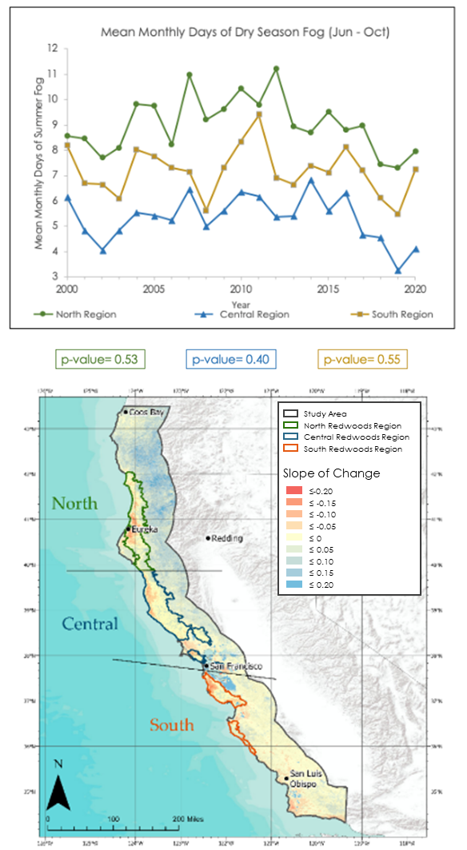
Figure 2. The spatial distribution of the linear trend in average days of fog in the dry season (top). The spatial distribution of the slopes (m) of a linear best fit trend line (y=mx+b) for the 20 years of monthly MODIS data (bottom).
The MODIS data were also used to provide trends of individual dry season months based on known areas of redwood forest. The MODIS fog metrics suggest redwood forests are gradually experiencing less fog in both June and July with low confidence as their rates of change are -0.061 and -0.106, respectively (Appendix Figure A3). In contrast, the 20 years of remotely sensed fog data suggest there is little to no change in its day-to-day fog frequency throughout August (Figure A3). While much of this information is uncertain due to the relatively high error attributed to utilizing the MODIS cloud-flag to detect fog and low cloud cover, these data attempt to shed light on the temporal changes coastal redwood forests may experience over time.

To contribute to the scientific understanding of drivers of fog presence, the team modeled the relationship between fog days per month, climate, and topography with the random forest algorithm. In total, the MODIS fog frequency modeling experiment group was composed of nine experiments (Table 2). The team modeled fog presence within the north, central, and southern regions individually to investigate a lack of stationarity in the relationship between fog response and the predictors across the larger landscape. Depending on the temporal and spatial constraints of each run, the models explained a range of 75% - 81% of monthly fog presence. The model with the highest variance explained is June for the entire study area. The model with the lowest RMSE was the October model for the entire study area. When broken down into regional experiments, the models best explained fog hours in the southern redwood region as it has the greatest variance explained and the least RMSE when compared to the other regional models. In general, the entire dry season model of fog days per month across the whole study area performed with a variance explained of 80.15% and a RMSE of 2.20 fog days per month (Table 2). The subset of predictor variables for each model run are shown in the appendix (Table A1), listed in order of variable importance. All models were run with 100 trees.

Table 2
Prediction accuracy statistics for MODIS current fog presence models
Model Study Area | Time Scale | Subset of Predictor Variables | Variance Explained | RMSE  (Fog days per month)
Entire | Dry Season | M1 | 80.15 | 2.20
Entire | June | M2 | 81.27 | 2.14
Entire | July | M3 | 79.97 | 2.11
Entire | August | M4 | 75.15 | 2.33
Entire | September | M5 | 76.35 | 2.06
Entire | October | M6 | 83.55 | 2.02
North | Dry Season | M7 | 78.51 | 2.30
Central | Dry Season | M8 | 85.27 | 2.20
South | Dry Season | M2 | 75.98 | 1.61

The variable importance plots from the fog presence modeling experiments revealed that daily temperature difference was important in explaining fog days per month and has a clear negative relationship with fog (Figure 3; Figure A1). Other important variables were precipitation and the PDSI drought index (Figure 3). The models indicate precipitation has a positive relationship with fog days per month while PDSI has a negative relationship with fog days per month (Figure A1).

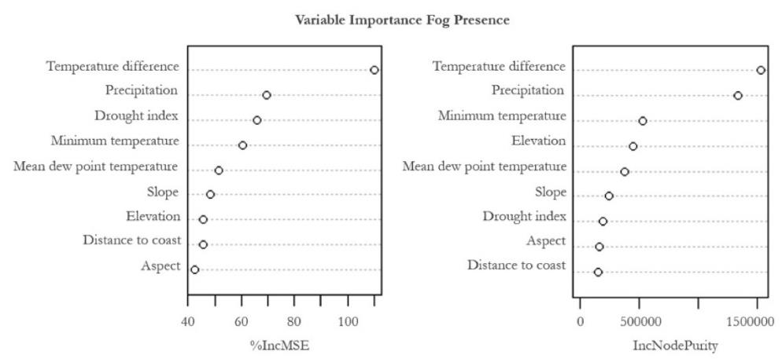
Figure 3. Variable importance plots for the model of fog presence for the entire study area during the dry season (experiment 1 in Table 2) produced by the ‘randomForest’ package in R.

To understand future fog occurrence, MODIS fog days per month were related to 30-year climate normals from ClimateNA. The predictor variables were limited to maximum, minimum, and average temperature and precipitation due to limitations and complexity of predicting future climate. The relationship between these was derived by the random forest algorithm. In total, the projected MODIS fog frequency modeling experiment group was composed of six experiments (Table 3). Depending on the temporal and spatial constraints of each run, the models were able to explain a range of 71% - 83% of monthly fog presence. The model with the highest variance explained was July for the entire study area. The model with the lowest RMSE was the dry season model for the entire study area. In general, the entire dry season model of fog days per month across the whole study area performed with a variance explained of 83.11% and a RMSE of 1.62 fog days per month (Table 3).

Table 3
Prediction accuracy statistics for MODIS projected fog presence models. The definitions for the variables “T-Max”, T-Min”, and “Ppt” are “Temperature Maximum (C°)”, “Temperature Maximum (C°)”, and “Precipitation (mm)”, respectively. All models were run with 5,000 trees.
Model Study Area | Time Scale | Predictor Variables | Variance Explained | RMSE  (Fog days per month)
Entire | Dry Season | T-Max., T-Min., Ppt | 83.11% | 1.62
Entire | June | T-Max, T-Min, Ppt | 81.95% | 1.82
Entire | July | T-Max, T-Min, Ppt | 82.53% | 1.79
Entire | August | T-Max, T-Min, Ppt | 81.95% | 1.82
Entire | September | T-Max, T-Min, Ppt | 79.78% | 1.92
Entire | October | T-Max, T-Min, Ppt | 71.60% | 2.28

These models were then applied spatially to rasters of an ensemble of projected future climate data under the warming scenario of RCP 4.5. The team specifically focused on the month of September, as it is an important month during which redwoods rely on fog for moisture during the dry season (Figure 4). The modeled number of average fog days per month during September as predicted by the random forest model applied to the 2000-2020 climate normals are shown (Figure 4A). This model was applied to projected climate variables in 2080 to predict the average number of fog days per month in September 2080 (Figure 4B), and the changes between current and projected models are shown (Figure 4C). From these results, it was observed that areas with the greatest fog currently, such as the San Francisco Bay Area in the inset of Figure 4C, show the largest decreases in projected future fog. Areas of future fog decline also include northern California and along the southern coast just south of San Luis Obispo. Many inland areas, especially in the southern portion of the study area, appear to increase in projected fog days. Although only September is shown here, a similar analysis for each month of the dry season is presented in the Appendix (Figure A4). These projections all demonstrate a narrowing range of values in fog days when comparing 2000-2020 to 2080, with an increase in minimum fog days and a decrease in maximum fog days (Table A4).
Figure 4: (A) The modeled spatial distribution of average September days of fog for 2000-2020. (B) The spatial distribution of projected average September fog presence in 2080 under the climate scenario RCP 4.5. (C) The difference in September fog presence between the 2080 projection and the modeled 2000-2020 average.
4.1.2 GOES-derived fog longevity
The GOES-derived fog longevity dataset was analyzed to uncover present day trends in dry season fog hours per day. The 2019-2020 data revealed that each pixel experiences on average 5-6 hours of fog each day during the dry season with a standard deviation of 2.6 hours, and the maximum number of fog hours recorded was just greater than 14 hours (Figure 5A). While these metrics generally describe both 2019 and 2020 fog hours, fog hours varied greatly by pixel each year and between regions (Figure 5B).

Figure 5: (A) The spatial distribution of average hours of fog per day during the dry season between 2019 and 2020. (B) The difference in fog hours per day between 2019 and 2020.
In order to better quantify the spatial variability of fog hours per day, the study area was split into regions based upon the current redwood distribution (Table 4). The region within the study area that experienced the most fog days is the southernmost redwoods region with a maximum of 13.02 hours of fog and an average of 5.56 hours of fog per day. This southern region also experienced the greatest variability between years and had an average standard deviation of 2.84 fog hours (Figure 5B, Table 4). The central region experienced the least amount of fog among the redwoods regions (Figure 5B, Table 4). While having only two years of data presents a limitation to interpret these results, the data reveal the incredible interannual variability in dry season fog hours that makes fog dynamics so challenging to understand.

Table 4
GOES-17 derived fog hour statistics for the North, Central, and South redwood regions. Units for the chart are hours.
 | Max | Mean | Median | SD
North | 11.42 | 5.33 | 4.87 | 1.9
Central | 11.08 | 4.13 | 3.68 | 1.67
South | 13.02 | 5.56 | 4.81 | 2.84

To contribute to the scientific understanding of fog dynamics, this project modeled the relationship between fog hours per day, climate, and topography with the random forest algorithm. In total, the GOES fog hours modeling experiment group was composed of nine experiments (Table 5). Depending on the temporal and spatial constraints of each run, the models explained a range of 43% - 59% of fog hours per day. The model with the highest variance explained was June for the entire study area. The model with the lowest RMSE was the October model for the entire study area. When broken down into regional experiments, the models were able to best explain fog hours in the southern redwood region as it has the greatest variance explained and the least RMSE when compared to the other regional models. In general, the entire dry season model of fog hours per day across the whole study area performed with a variance explained of 49.47% and a RMSE of 3.62 fog hours per day (Table 5).

Table 5
Prediction accuracy statistics for GOES fog longevity models. Predictor variables and variable importance for each model run are shown in the appendix (Appendix Table A2)
Model Study Area | Time Scale | Subset of Predictor Variables | Variance Explained | RMSE  (Fog hours per day)
Entire | Dry Season | G1 | 49.47 | 3.62
Entire | June | G1 | 59.06 | 3.55
Entire | July | G2 | 54.53 | 3.61
Entire | August | G3 | 52.24 | 3.52
Entire | September | G2 | 43.37 | 3.51
Entire | October | G4 | 44.67 | 3.11
North | Dry Season | G1 | 48.16 | 3.69
Central | Dry Season | G2 | 49.72 | 3.57
South | Dry Season | G3 | 51.90 | 3.29

The subset of predictor variables for each model run is shown in the appendix (Table A2), listed in order of variable importance. This group of model experiments revealed that of all the predictor variables, temperature difference is the most important when explaining fog hours. Temperature difference was consistently the most important variable across model runs, regardless of the time scale or model study area (Figure 6, Table A2). As the temperature difference increases, fog hours per day decrease (Figure A2). While slope and mean dew point also stand out as important predictors of day-to-day fog hours, the model disagrees in terms of the importance of these variables across the two importance metrics. Partial dependency plots from the fog longevity models reveal that slope and fog hours had a negative relationship and that mean dew point and fog hours had a positive relationship (Figure A2). Aspect and precipitation were generally among the least important variables in the model runs (Table A2), which may be due to the fact that the resolution of the resampled data may be too coarse to capture the changes in aspect within the pixel.

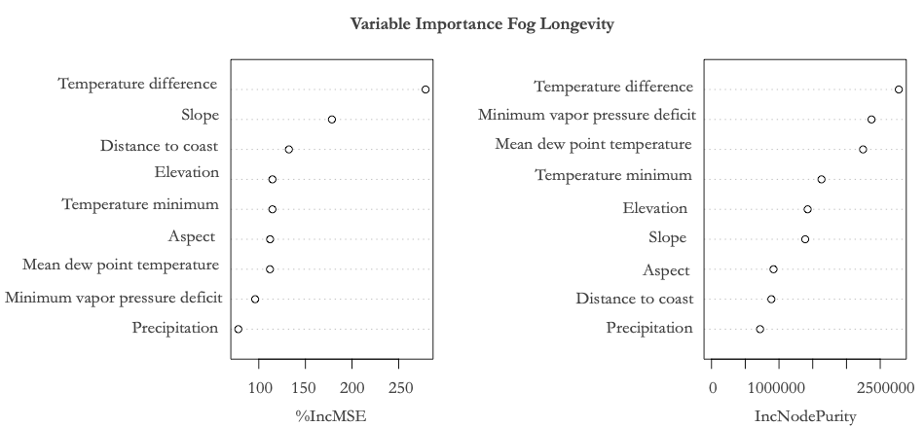
Figure 6. Variable importance plots for the model of fog longevity for the entire study area during the dry season produced by the ‘randomForest’ package in R.

4.2 Future Work
By the end of the term, the team had several suggestions for the next steps of the project. Initially, the team hoped to incorporate fog daily landfall and dissipation time as predictors in the analysis. While not explored during the ten-week term, this information could provide new insights on fog dynamics utilizing the high temporal resolution of GOES data. Additionally, while the GOES-17 data used for this project are cutting edge, the data are only available for 2019 and 2020. The team would like to incorporate the use of GOES-15 and GOES-16 satellites to extend the period of daily analysis and analyze trends in daily fog longevity over a longer period of time. In terms of the modeling fog longevity and presence, results could likely be improved by investigating additional climatic predictor variables and testing different variable combinations in model runs. Furthermore, temperature difference was not incorporated as a predictor variable into the projected fog days model experiments. As this variable was important in other model runs, it would be interesting to incorporate temperature difference into the projected models. Finally, the workflow developed in this project allows the study area to be easily changed. Because of this, the methodology could be adapted to localized areas where fog trends were significant or an entirely new study area altogether. This would facilitate the exploration of the important drivers of fog longevity and presence in other locations.
5. Conclusions
Trends in fog days per month from 2000-2020 varied in significance and reflected great interannual variability of fog. However, areas near Eureka and San Louis Obispo displayed statistically significant decreasing trends during July and October, respectively (Figure A3). Additionally, the trend analysis gives insight into potential changes in fog occurrence during the dry season for particular redwoods regions over the past 20 years. Results indicated with low confidence that the northern redwood region has experienced a decrease in fog during the early dry season months over the past 20 years, while the decrease in fog experienced by the southern redwood region has mainly occurred during late dry season months. Late season fog decrease in the southern region may highlight areas of particular concern, as these are the driest months of the year. These extraordinarily dry conditions may exacerbate water stress in fog-obligate species such as the coast redwood. This work expands on previous studies to include a longer timeframe, greater range of months, and an improvement in fog classification utilizing MODIS that to the team’s knowledge at the time of this study has not been included in previous work.

The methodology that the team developed utilizing GOES-17 expanded the partner’s knowledge on present-day fog behavior in coast redwood regions. The methodology mapped both day and night fog hours for the dry seasons over the past two years, which informed the understanding of which redwoods regions presently experience the greatest and least fog hours per day. This methodology could be utilized by the project partners and other organizations for daily fog monitoring. Prior to this project, the dataset of fog hours per day for the dry seasons of 2019 and 2020 for coastal California did not exist.

The random forest models allowed the team to identify important climatic drivers of fog presence and fog longevity. Temperature difference was consistently related to both fog presence and fog longevity. Fog often forms during the night when ocean temperatures are warm and land surfaces are cool, and fog requires consistent low land surface temperatures to persist over time. With a changing global climate where a trend towards extreme climatic phenomena is becoming more prevalent, this may be a contributing factor towards a shortening fog season in some areas. Drought was also an important variable in fog presence models. With global temperatures projected to rise, drought may become increasingly common in the future. This could have implications for increased stress on redwood trees as a higher PDSI is associated with less fog. Of note, distance to coast did not play a critical role in models of fog longevity. While it was expected that areas closer to the coast would experience greater fog hours per day, this result may be a reflection of our sampling points capturing few high fog points. Projected models of fog presence point to a potential change in the seasonality of fog. Models of fog presences projected to 2080 suggest a decrease in mean fog days as well as a narrowing of the range in fog abundance during the dry season. Areas associated with high fog in the present day are projected to see the greatest change in fog days. As fog plays a critical role as a water source for coast redwoods, this projected potential decrease may have an impact on suitable coast redwood habitat.

The resulting models and trend analyses of this project will assist Save the Redwoods League in informing where conservation and restoration activities and resources should be targeted, considering the many uncertainties about how a changing climate will impact coastal California and Oregon forest communities. Beyond providing guidance to Save the Redwoods League, the results contribute to the scientific understanding of fog occurrence in coastal regions and how future climate conditions may alter terrestrial fog frequency in the summer months. In addition, the methodology that was developed as part of this research may serve as a framework for future fog detection and machine learning-based modeling efforts. Additional work will serve to improve the accuracy and application of fog models and support future work to further understand drivers of daily fog behavior.
6. Acknowledgments
The team would like to thank their science advisors Dr. Tony Vorster and Brian Woodward for regular technical support and guidance throughout the term. Additionally, Dr. Kristen Shive and Laura Lalemond were highly engaged partners that aided immensely in the direction and interpretation of the analysis. Justin Braaten provided excellent advice regarding Google Earth Engine. NASA DEVELOP Colorado – Fort Collins node Fellow Kristen O’Shea aided with administrative guidance as well as technical needs. Thanks also to Dr. Paul Evangelista for node leadership.

Any opinions, findings, and conclusions or recommendations expressed in this material are those of the author(s) and do not necessarily reflect the views of the National Aeronautics and Space Administration. This material is based upon work supported by NASA through contract NNL16AA05C.

7. References
Azevedo, J., & Morgan, D. L. (1974). Fog precipitation in coastal California forests. Ecology, 55(5), 1135-1141. doi: 10.2307/1940364

Bendix, J., Thies, B., Nauss, T., & Cermak, J. (2006). A feasibility study of daytime fog and low stratus detection with TERRA/AQUA-MODIS over land. Meteorological Applications, 13(2), 111-125. doi:10.1017/S1350482706002180

Biau, G., & Scornet, E. (2016). A random forest guided tour. Test, 25(2), 197-227.

Burgess, S. S. O., & Dawson, T. E. (2004). The contribution of fog to the water relations of Sequoia sempervirens (D. Don): Foliar uptake and prevention of dehydration. US. Plant, Cell & Environment, 27(8), 1023-1034. doi: 10.1111/j.1365-3040.2004.01207

Dawson, T. E. (1998). Fog in the California redwood forest: Ecosystem inputs and use by plants. Oecologia, 117(4), 476-485. doi:10.1007/s004420050683

Francis, E.J., Asner, G. P., Mach, K. J., & Field, C. B. (2020). Landscape scale variation in the hydrologic niche of California coast redwood. Ecography, 43(9), doi: 10.1111/ecog.05080

GOES-R Algorithm Working Group. (2017). NOAA GOES-R Series Advanced Baseline Imager (ABI)
Level 2 Cloud and Moisture Imagery Products (CMIP). NOAA National Centers for Environmental Information, accessed 20 September 2020. doi:10.7289/V5736P36

Iacobellis, S.F., & Cayan, D.R. (2013). The variability of California summertime marine stratus: Impacts on surface air temperatures. Journal of Geophysical Research: Atmosphere, 118(16), 9105-9122. doi: 10.1002/jgrd.50652

Johnstone, J.A., & Dawson, T.E. (2010). Climatic context and ecological implications of summer fog decline in the coast redwood region. Proceedings of the National Academy of Sciences, 107(10), 4533-4538. doi: 10.1073/pnas.0915062107

Lundquist, J., & Bourcy, T. (2000). California and Oregon Humidity and Coastal fog. Master’s Thesis, University of California, San Diego.

Noss, R. (2000). The Redwood Forest: History, Ecology, and Conservation of the Coast Redwoods. Washington D.C.: Island Press.

O’Brien, T. A., et al. (2013). Multidecadal simulation of coastal fog with a regional climate model. Climate Dynamics, 40(11-12), 2801-2812. doi: 10.1007/s00382-012-1486

Rastorgi, B., et al. (2016). Spatial and temporal patterns of cloud cover and fog inundation in coastal California: Ecological implications. Earth Interactions, 20(15), 1-19. doi: 10.1175/EI-D-15-0033.1

Simonin, K. A., Santiago, L. S., & Dawson, T. E. (2010). Fog interception by Sequoia sempervirens (D. Don) crowns decouples physiology from soil water deficit. Plant, Cell & Environment, 32(7), 882-892. doi:10.1111/j.1365-3040.2009.01967

Taylor, S.V, Cayan, D. R., Graham, N.E, & Georgakakos. (2008). Northerly surface winds over the Eastern North Pacific Ocean in spring and summer. Journal of Geophysical Research, 113(D2), 1-17. doi:10.1029/2006JD008053

Torregrosa, A., Combs, C., & Pters, J. (2016). GOES-derived fog and low cloud indices for coastal north and central California ecological analyses. Earth and Space Science, 3(2), 46-67. doi:10.1002/2015EA000119

Vermote, E. (2000). MODIS/Terra Surface Reflectance Daily L2G Global 1 km and 500 m SIN Grid,
Version 6. NASA LP DAAC at the USGS EROS Center, accessed 30 September 2020. doi:10.5067/MODIS/MOD09GA.006

Web references:
https://www.savetheredwoods.org/what-we-do/our-work/, accessed 22 September 2020.

Software:
Google Earth Engine - Data collection, image processing, raster generation
R Studio v1.2.1335 - Modeling execution, statistical analyses
Esri ArcGIS v10.8.1 - End product and map generation

8. Appendix A

Table A1
Predictor variables used in MODIS current fog presence models in descending order of importance. The variable of greatest importance is listed first.
 | Model Study Area |  | Entire | Entire | Entire | Entire | Entire | Entire | North | Central | South
 | Time Scale |  | Dry Season | June | July | Aug | Sept | Oct | Dry Season | Dry Season | Dry Season
 | Predictor Variables |  | M1 | M2 | M3 | M4 | M5 | M6 | M7 | M8 | M2
 |  |  | Temp. difference | Precip. | Temp. difference | Precip. | Precip. | Drought index | Temp. difference | Temp. difference | Precip.
 |  |  | Precip. | Temp. difference | Precip. | Drought index | Temp. difference | Precip. | Drought index | Precip. | Drought index
 |  |  | Drought index | Drought index | Slope | Max. vapor pressure deficit | Drought index | Temp. difference | Precip. | Elevation | Temp. difference
 |  |  | Temp. minimum | Elevation | Minimum vapor pressure deficit | Slope | Minimum vapor pressure deficit | Elevation | Minimum vapor pressure deficit | Drought index | Slope
 |  |  | Mean dew point temp. | Temp. minimum | Distance to coast | Minimum vapor pressure deficit | Elevation | Mean dew point temp. | Mean dew point temp | Distance to coast | Temp. minimum
 |  |  | Slope | Slope | Elevation | Distance to coast | Slope | Temp. mean | Elevation | Aspect | Elevation
 |  |  | Elevation | Distance to coast | Drought index | Aspect | Temp. minimum | Slope | Temp. minimum | Minimum vapor pressure deficit | Distance to coast
 |  |  | Distance to coast | Mean dew point temp. | Aspect | Temp. minimum | Aspect | Minimum vapor pressure deficit |  | Temp. minimum  Slope | Mean dew point temp.
 |  |  | Aspect | Minimum vapor pressure deficit |  | Elevation | Distance to coast | Aspect |  | Mean dew point temp. | Minimum vapor pressure deficit

Table A2
Predictor variables used in GOES fog longevity models in descending order of importance. The variable of greatest importance is listed first.
 | Model Study Area |  | Entire | Entire | Entire | Entire | Entire | Entire | North | Central | South
 | Time Scale |  | Dry Season | June | July | Aug | Sept | Oct | Dry Season | Dry Season | Dry Season
 | Predictor Variables |  | G1 | G1 | G2 | G3 | G2 | G4 | G1 | G2 | G3
 |  |  | Temp. difference | Temp. difference | Temp. difference | Temp. minimum | Temp. difference | Temp. difference | Temp. difference | Temp. difference | Temp. difference
 |  |  | Slope | Slope | Minimum vapor pressure deficit | Temp. difference | Slope | Mean dew point temp. | Slope | Mean dew point temp | Mean dew point temp
 |  |  | Distance to coast | Elevation | Slope | Precip. | Minimum vapor pressure deficit | Temp. minimum | Elevation | Distance to coast | Slope
 |  |  | Elevation | Mean dew point temp. | Elevation | Mean dew point temp. | Elevation | Slope | Precip. | Elevation | Distance to coast
 |  |  | Temp. minimum | Minimum vapor pressure deficit | Distance to coast | Slope | Mean dew point temp. | Precip. | Mean dew point temp | Minimum vapor pressure deficit | Minimum temperature
 |  |  | Aspect | Temp. minimum | Mean dew point temp. | Elevation | Distance to coast | Aspect | Aspect | Aspect | Elevation
 |  |  | Mean dew point temp. | Distance to coast | Aspect | Distance to coast | Precip. |  | Temp. minimum | Slope | Aspect
 |  |  | Minimum vapor pressure deficit | Aspect | Precip. | Aspect | Aspect |  | Distance to coast | Precip. | Precip.
 |  |  | Precip. | Precip |  |  |  |  | Minimum vapor pressure deficit

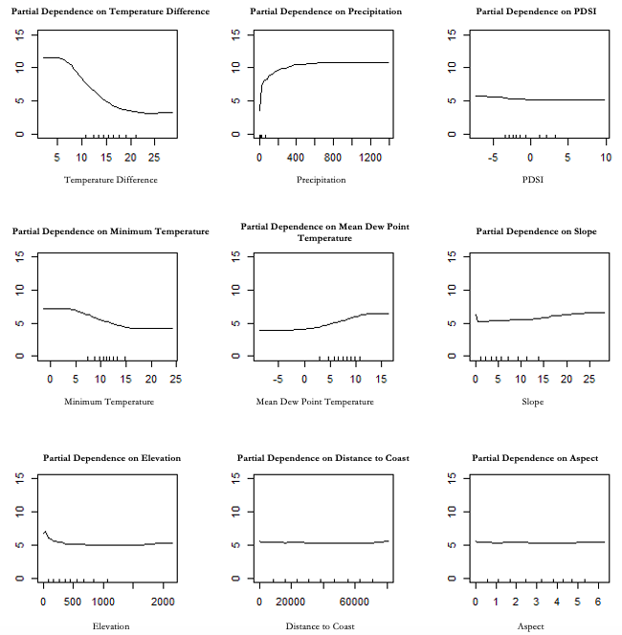
Figure A1. Partial dependency plots for the MODIS current fog presence model over the entire study area for the dry season.

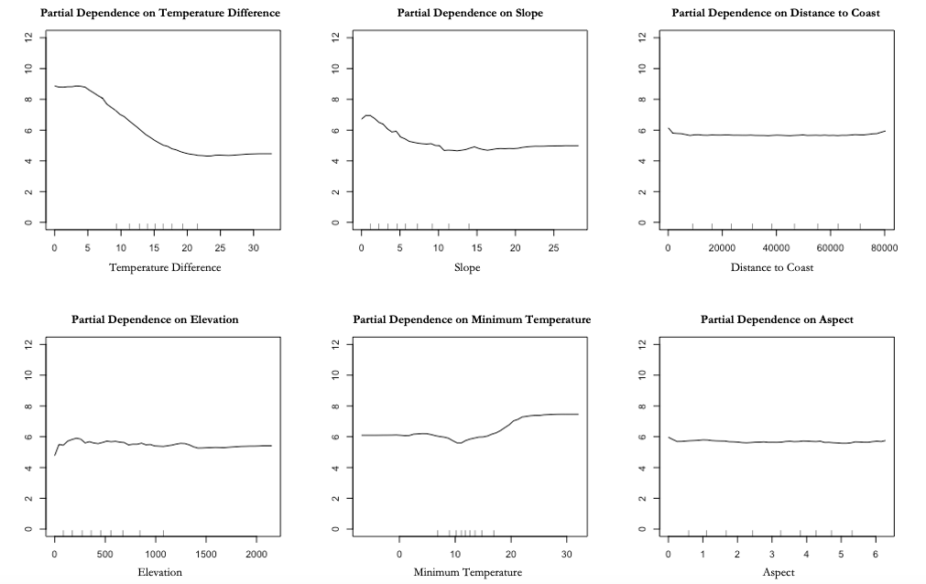
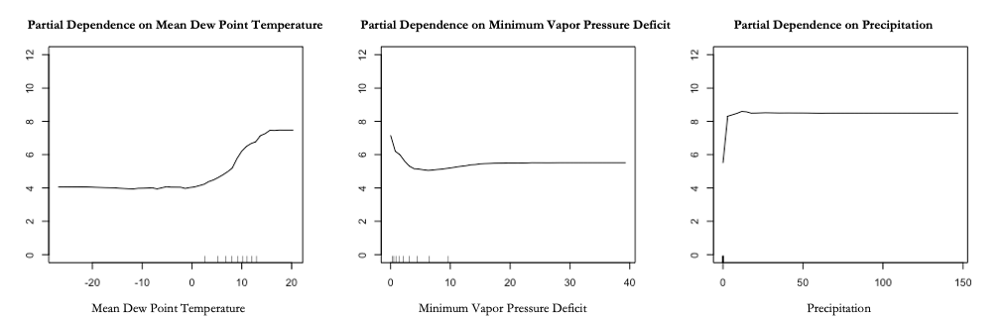

Figure A2. Partial dependence plots the GOES fog longevity model over the entire study area for the dry season.

June | July | August | September | October
Slopes
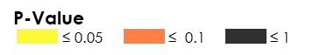
P-values

Figure A3. MODIS-derived slopes of fog frequency change from 2000-2020 for each month (June-October) during the dry season.

June | July | August | September | October
Current Climate Normal
2080 Climate Normal
Difference
Relative Difference
ence
Figure A4. Mean projected monthly fog days using the current climate normal, the 2080 climate normal, the difference between the two projections, and the relative difference between the two projections.

Table A3
Values derived from projected monthly fog days using 2000-2020 climate normals and 2080 climate normals (In reference to Maps A4).
 |  | June | July | August | September | October | Mean
2020 | Min | 1.16 | 1.52 | 1.26 | 1.12 | 0.95 | 1.202
2020 | Max | 18.78 | 17.69 | 18.29 | 18.6 | 18.67 | 18.406
2020 | Range | 17.62 | 16.17 | 17.03 | 17.48 | 17.72 | 17.204
2020 | Mean | 5.69 | 5.68 | 5.66 | 5.69 | 5.69 | 5.682
2020 | Standard Deviation | 3.63 | 3.61 | 3.6 | 3.4 | 3.4 | 3.528
2080 | Min | 1.21 | 1.54 | 1.27 | 1.33 | 1 | 1.27
2080 | Max | 18.43 | 17.31 | 17.2 | 15.39 | 15.85 | 16.836
2080 | Range | 17.22 | 15.77 | 15.93 | 14.06 | 14.85 | 15.566
2080 | Mean | 3.55 | 4.15 | 4.08 | 4.03 | 3.85 | 3.932
2080 | Standard Deviation | 2.49 | 2.35 | 2.21 | 2.05 | 2.14 | 2.248
Difference | Range | 23.36 | 18.47 | 20.33 | 21.13 | 23.25 | 21.308
Difference | Mean | -2.14 | -1.53 | -1.58 | -1.66 | -1.84 | -1.75
Difference | Standard Deviation | 2.35 | 1.96 | 1.99 | 2.4 | 2.56 | 2.252
Relative Difference | Range | 2.57 | 1.8 | 2.14 | 2.88 | 2.46 | 2.37
Relative Difference | Mean | -0.31 | -0.2 | -0.2 | -0.16 | -0.22 | -0.218
Relative Difference | Standard Deviation | 0.25 | 0.21 | 0.24 | 0.36 | 0.32 | 0.276

