An Overview of the NASA LO-DuSST (Lunar Occupancy Dust Surface Separation
Technologies) Project

Christopher J. Wohl¹, Valerie L. Wiesner¹, Keith L. Gordon¹, Glen C. King¹, Lopamudra Das²
Joel A. Schwartz³, Robert S. Kowalczyk³, Andreea Boca³, Ulf Israelsson³, Inseob Hahn³
Sharon K. Miller⁴, and Bruce A. Banks⁴

¹NASA Langley Research Center, Hampton, VA, 23681, USA
²National Institute of Aerospace, Hampton, VA, 23666, USA
³Jet Propulsion Laboratory, California Institute of Technology, Pasadena, CA 91109, USA
⁴NASA Glenn Research Center, Cleveland, OH, 44135, USA
c.j.wohl@nasa.gov

Introduction
Of the issues facing lunar exploration and maintaining an extended lunar presence, lunar dust is possibly the most pervasive.¹ These jagged, chemically reactive, electrostatically charged, sometimes magnetic particles can impact every aspect of lunar surface missions including: abrading extra-vehicular activity (EVA) suits, disrupting lunar vehicle thermal management systems, impeding efficacy of excavation equipment, impacting lunar inhabitant health, among others (Figure 1).² The NASA Artemis program will develop extensive resources on the Moon starting in 2024 and will require advanced technologies to enable a sustained lunar presence. Mitigation of lunar dust adhesion will be central to these efforts and to the success the Artemis program.
Figure 1. Mitigation of lunar dust will be requisite across every aspect of a sustained lunar presence.
The NASA Lunar Occupancy Dust Surface Separation Technologies (LO-DuSST) task, as a part of the broader Lunar Surface Innovation Initiative (LSII) project, seeks to implement synergistic active and passive lunar dust management and mitigation technologies for an array of applications. One such application is protection of power generation capabilities via solar panel arrays. Dust removal for solar arrays will be investigated with multiple techniques, such as piezoelectric-driven vibration, plasma lofting, electron beams and low adhesion coatings. Combinations of these techniques will be investigated to optimize the dust removal process. Electrostatic repulsion in confined geometries and materials to manage high velocity lunar dust wear will also be investigated. Collectively, these active and passive mitigation technologies will facilitate lunar surface operations including occupancy logistics, landing pad operations, power generation, and transportation. Initial efforts within LO-DuSST to advance these active and passive mitigation technologies will be described herein.
Lunar Dust Impact on Solar Panel Arrays
Power generation and storage are critical aspects of space exploration. Retention of these capabilities on the lunar surface will be requisite to enable lunar surface operations. Two important aspects of evaluating the impact lunar dust has on solar panel performance are the sources of illumination and the evaluation of dust adhesion mitigation technologies. A solar panel evaluation laboratory is being outfitted to integrate lunar dust influence and mitigation studies at the NASA Jet Propulsion Laboratory (JPL) capable of addressing both of these aspects.³ To replicate environmental conditions on the lunar surface, the test chamber is designed to provide vacuum conditions, illumination from a Spectrolab X25 solar simulator, and a vacuum ultra-violet (VUV) source (Figure 2). The folding mirror located at the top of the chamber is designed to provide illumination from above the solar panel test article. In addition, the test system design allows the test article to be tilted to simulate the effects of gravity and control the angle of solar incidence.
Both passive and active lunar dust mitigation strategies are planned to be tested on solar cells within the chamber in Figure 2. Piezoelectric technologies have been demonstrated to be effective toward removing Martian simulant contamination and will be evaluated here.⁴ Removal using an electron beam or plasma exposure⁵ (described below) is also planned for evaluation. Reduction of the intrinsic adhesion between simulant particles and the solar cell surface is planned to be included and being investigated independently (described below). This approach is part of an effort to reduce energy consumption and “on-time” of active mitigation strategies.
Figure 2. Solar panel evaluation test chamber.
Lunar Dust Impact on Confined Geometries
Prevention of lunar dust infiltration will be imperative for sensitive or highly confined geometries such as bearings, drive shafts, and other complex mechanisms.⁶ An electrostatic attraction/repulsion technology is being developed to prolong the life of these critical components. An Americium-241 (Am-241) source will be utilized to create an ionization zone within the confined geometry dust infiltration prevention system (Figure 3).⁷ Alpha (α) particle emission from the Am-241 source will impart a charge on dust passing by the α particle source, and the dust will subsequently be drawn to biased collection plates. This will be evaluated in the laboratory in a vacuum by comparing the optical changes (reflected and transmitted light) in microscope slides at the bottom of side-by-side chambers in the presence of finely falling lunar simulant. One chamber will have the alpha particle source and biased collection plates and the second will contain only the biased collection plates. This parallel style of testing will give a quantifiable comparison that will enable verification that charging of the dust in combination with biased plates or surfaces can make it easier to remove or prevent dust from entering a confined space. If successful, the technology could be incorporated to keep dust out of confined spaces through application of an Americium coating or small source near the entrance and biasing nearby surfaces to draw the dust away from the opening.
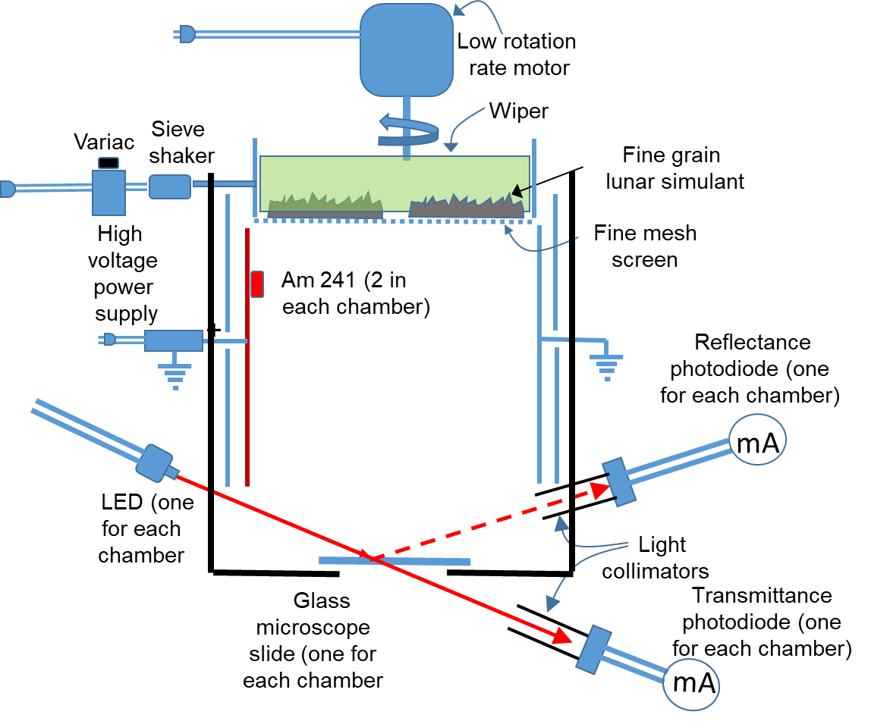
Figure 3. Electrostatic attraction/repulsion test design.

Surface Protection via Dust Lofting
Lunar dust lofting and transport has been observed since the Apollo missions, and earlier to a lesser extent.¹ This behavior has long been associated with charging of lunar dust from either solar illumination or free electrons on the dark side of the Moon. Replicating the process has been extensively studied to uncover fundamental aspects of particulate-plasma interactions and these principles are being applied to evaluate this phenomenon for dust mitigation and removal (Figure 4).⁸ Lofting of particulates arises due to secondary emission and absorption in micro-cavities within clusters of particles present on the interrogated surface. Dust removal efficiency of various surfaces, including space solar panel surfaces with a different coating material (e.g. MgF₂, SiO₂) and spacesuit surface, will be studied further with this technique. Evaluation of the electron beam technique for its flight application will be also performed in the relevant lunar thermal environment at JPL.

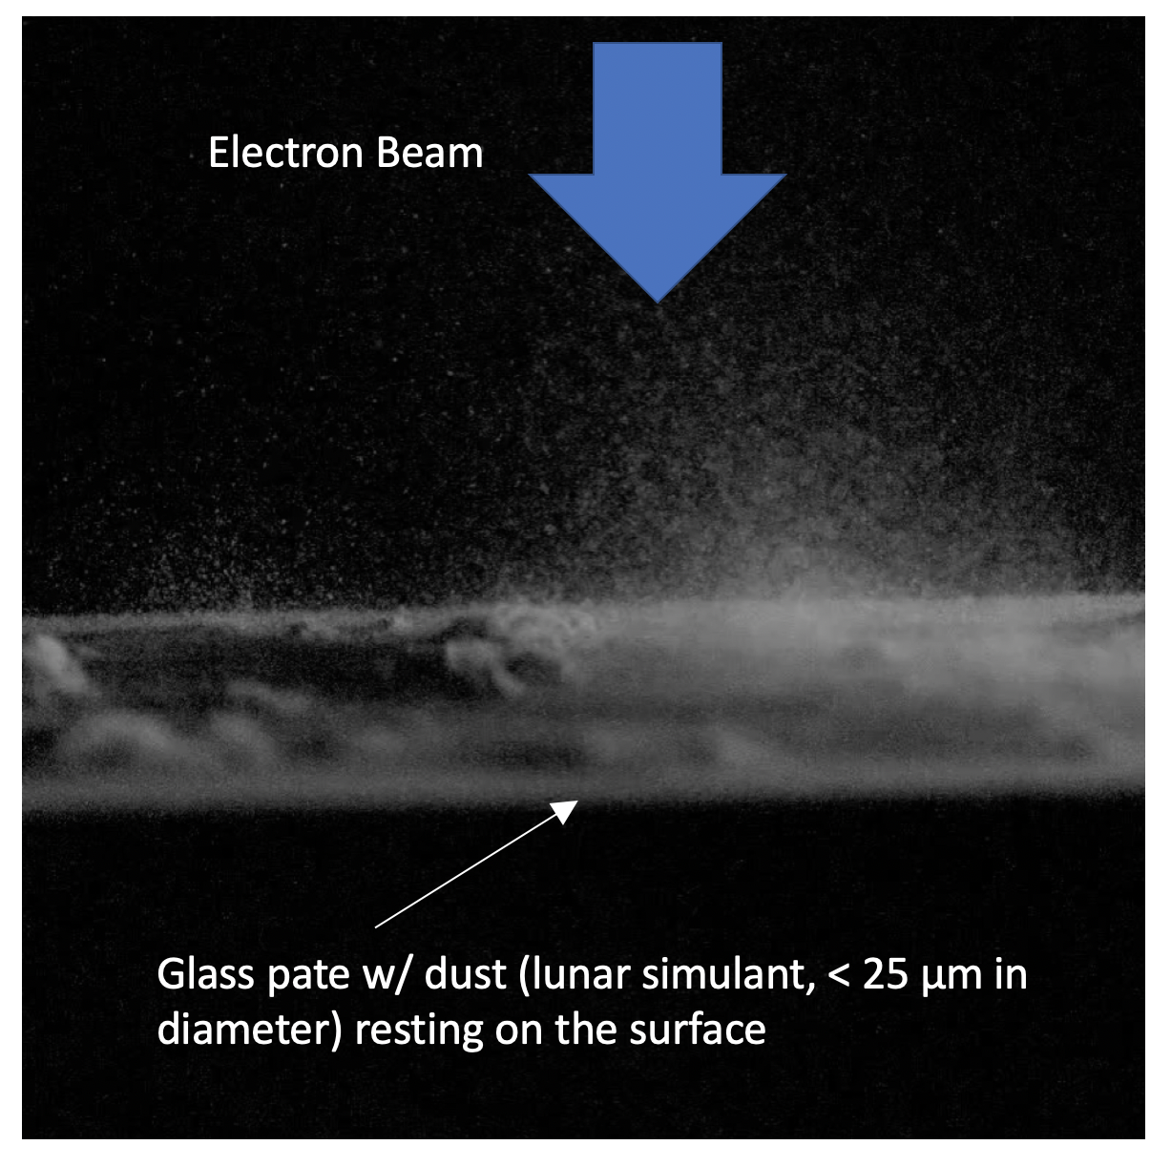
Figure 4. Image of dust lofting as a result of electron beam exposure. Image credit: Prof. Wang, UC-Boulder.
Passive Surface Protection
The previously described active technologies utilize energy to overcome adhesion forces between a particulate contaminant and a surface. Reducing that adhesion force may result in a reduction of requisite energy to remove the contaminating particle. An array of surface chemical and topographical modification techniques have been or will be explored to identify the most promising direction for polymeric, metallic, and ceramic substrates.
Initial results derived from polymeric substrates have indicated that both surface chemical and topographical modifications can reduce the adhesion force of lunar simulant (Figure 5). Inspiration for such surface modifications could be drawn from natural dust adhesion and wear mitigating surfaces, such as the lotus leaf, desert scorpion carapace and sandfish skin. Investigations on some of these biomimetic surfaces have shown significant improvements in adhesion and wear resistance compared to smooth as-is substrates.⁹

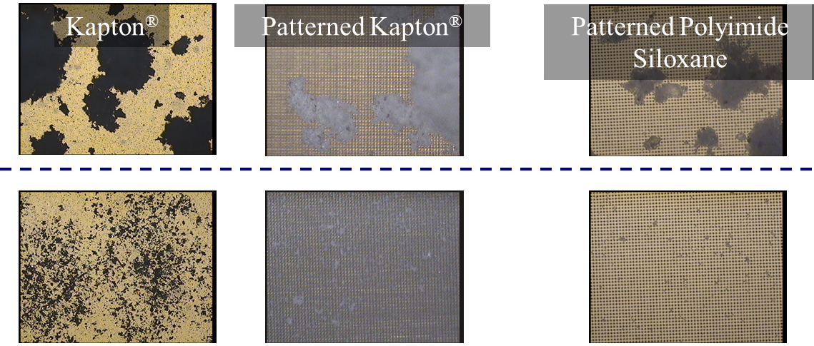
Figure 5. Modification of surface topography and surface chemistry resulted in a reduction in lunar dust simulant retention on contaminated surfaces (upper images) after tilted and tapped (lower images).
In all these experiments, the lunar dust simulant plays a central role. The custom-built dust deposition and adhesion testing setup at NASA Langley is shown in Figure 6. In this system, a uniform monolayer of the dust is deposited onto the substrate by a sieving mechanism. The dust is heated prior to deposition to remove moisture, and a quartz crystal microbalance and digital microscope located in the chamber serve to identify the deposition parameters.
In the adhesion testing chamber, the dusty samples are attached to the tip of a sonic wand, which oscillates and leads to the detachment of the particles which are then gravitationally collected by the optical particle counter (OPC) situated below. The OPC detects the size and counts of the detached particles. A software program developed to interface with the sonic wand and OPC helps control the measurements and analyze the resulting data. A more detailed description of the adhesion force calculations can be found in Reference 10.¹⁰ The efficacy of the tested surface is evaluated by the force required to dislodge 50% of the simulant particles.
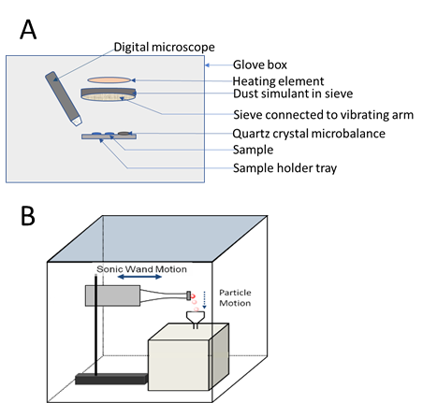
Figure 6. (A) Deposition chamber schematic. (B) Adhesion testing chamber schematic

Lunar Dust Management: Wear Resilience
Dust contamination mitigation is critical but not always possible. Facilities immediately around a landing site will experience very high velocity lunar dust impacts due to plume surface interactions (PSI).¹¹ Lunar dust ejecta from the Apollo 12 lander caused extensive wear on the exterior of Surveyor III which was approximately 180 m away (Figure 7). Thus wear resilient materials will be necessary to protect equipment in these locations.
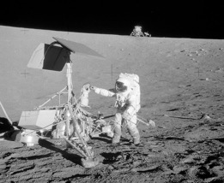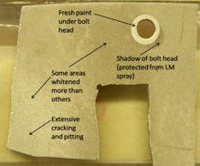
A
B
Figure 7. (A) Apollo 12 astronaut visiting Surveyor III landing site. (B) Surveyor III camera housing recovered during Apollo 12 indicating wear from Apollo 12 plume ejecta. Image credit: NASA.
Commercially available materials with high hardness values, e.g. alumina (Al₂O₃), boron carbide (B₄C), and titanium carbide (TiC) with Mohs hardness values of 9, will be evaluated for wear resilience with respect to lunar simulant. In addition to these more widely available materials, a novel ternary type of ceramic, notably molybdenum aluminum boride (MoAlB), is also being explored for its utility and manufacturability. This material system possesses higher strength and hardness values coupled with lower densities than bulk metallic glasses and superior thermal shock resistance than structural ceramics, making it an attractive system for wear-resilient applications.¹² These materials will be evaluated using established procedures, including ASTM D4060 for abrasion testing, as well as application-driven evaluation techniques utilizing lunar dust simulant.
Conclusions
Ultimately, no one approach will mitigate all of the challenges that lunar dust poses to mission success for any surface-based exploration mission. The active and passive technologies being developed through LO-DuSST will contribute to the suite of mitigation and management technologies that NASA will leverage through the Artemis program and beyond.

Acknowledgements

The authors would like to acknowledge funding for this work through NASA Game Changing Development’s (GCD) Lunar Surface Innovation Initiative (LSII). All images were generated by NASA unless indicated otherwise.

References
- E. Grun, et al., “The Lunar Dust Environment,” Planetary Space Sci. 2011, 59, 1672-1680.
- O. Walton, “Adhesion of Lunar Dust,” NASA Contract Report 2007-214685, National Aeronautics and Space Administration, 2007.
- C.M. Katzner, et al., ”The Effects of Lunar Dust Accumulation on the Performance of Photovoltaic Arrays,” Space Photovoltaic Research and Technology Conference (SPRAT XI), May 7-9, 1991.
- J. Schwarts, et al., “Dust Mitigation for Lunar Surface Solar Arrays,” 2020 Conference on Advanced Power Systems for Deep Space Exploration, October 27-29, 2020.
- T. Flanagan and J. Goree, “Dust Release from Surfaces Exposed to Plasma,” Physics of Plasmas, 2006, 13, 123504.
- M. Hyatt and P. Deluane, “Lunar Dust Mitigation Technology Development,” Space Technology and Applications International Forum, Session E02-Space Colonization, Report E-16717, February 11, 2008.
- D. Malain and P. Kanchana, “Evaluation of Radiation Safety for Ionization Chamber Smoke Detectors Containing AM-241,” J. Phys.: Conf. Ser. 2019, 1285, 012047.
- B. Farr et al., “Dust Mitigation Technology for Lunar Exploration Utilizing an Electron Beam,” Acta Astronautica, 2020, 177, 405-409.
- (a) D. V. Margiotta, et al., “The Lotus Coating for Space Exploraiton: A Dust Mitigation Tool,” Optical System Contamination: Effects, Measurements, and Control 2010, Proceedings Volume 7794, August 1-5, 2010. (b) Z. Han et al., “The Effect of the Micro-structures on the Scorpion Surface for Improving the Anti-Erosion Performance,” Surf. Coat. Technol. 2017, 313, 143-150. (c) H. Huang, et al., “Particle Erosion Resistance of Bionic Samples Inspired from Skin Structure of Desert Lizard, Laudakin Stoliczkana,” J. Bionic Eng. 2012, 9, 465-469.
- C. Wohl et al., “Generation and Evaluation of Lunar Dust Adhesion Mitigating Materials,” 3rd AIAA Atmospheric Space Environments Conference, June 27-30, 2011.
- J. Lane, et al., “Lagrangian Trajectory Modeling of Lunar Dust Particles,” Earth and Space 2008, March 3-5, 2008.
- S. Gupta, et al., “Novel MAB Phase-Based Nanolaminates Suit High Performance Applications,” Adv. Mater. Process 2019, 177(2), 22-26.

