THE DETECTION OF AROMATIC AMINO ACIDS IN CR CHONDRITES SUGGESTS THEY ARE PREBIOTICALLY PLAUSIBLE. A. S. Burton¹, E. L. Berger², A. C. Fox¹ and C. Lee³. ¹NASA Johnson Space Center, Houston, TX, 77058 (aaron.burton@nasa.gov); ²Texas State University – Jacobs JETS contract – NASA Johnson Space Center, Houston, TX 77058; ³Lunar and Planetary Institute / Universities Space Research Association, Houston, TX 77058.

Introduction: Amino acids (AAs) are the building blocks of proteins and are essential for life on Earth. Sources of AAs on early Earth range from exogenous sources such as delivery from extraterrestrial materials (i.e., meteorites, interplanetary dust particles, comets, etc.) to endogenous sources including chemical reactions in hydrothermal vents or atmospheric mixtures [1]. Analyses of AAs of extraterrestrial origin from meteorites and laboratory studies of simulated prebiotic environments revealed that a diverse set of abiotically produced AAs may have been present on early Earth. However only a fraction of these AAs is found within the proteins of living organisms. Of the 22 genetically encoded (proteinogenic) AAs, 20 occur in the standard genetic code (SGC) and are used by nearly all living organisms to build proteins. The universality of this AA alphabet suggests the presence and incorporation of these specific AAs occurred early in the evolution of life.
Combined observational and experimental data on AA abundances in meteorites and laboratory studies suggest that only a subset of modern proteinogenic AAs are synthesized in measurable quantities by theorized prebiotic pathways [2]. Based on these results, many researchers have postulated that protein synthesis occurred in two phases. During the first phase, protein synthesis occurred with a limited AA alphabet, consisting of those AAs that are easily synthesized by prebiotic reactions or those that are abundant in meteorites. During the second phase, new AA biosynthetic pathways evolved thus expanding the AA alphabet to its modern form [3,4]. Statistical studies of AA frequency in a variety of diverse taxa bolster this claim. Several authors have found that “early” AAs decrease in frequency while “late” AAs increase, indicating that late proteinogenic AAs may not have been present in prebiotic environments during early protein synthesis [5-7].
While the chronological order of AA appearance can vary slightly based on the criteria used (i.e., thermodynamic properties versus trends in the genetic code), all methods predict the late arrival of aromatic AAs (Figure 1, Table 1). Examples of abiotic syntheses of phenylalanine, tyrosine, and tryptophan are rare in modern terrestrial environments and have not been easily recreated in laboratory settings [8,9]. Furthermore, aromatic AAs in meteorites have rarely been reported and, where reported, their abundances are significantly lower than abundances of ‘early’ proteinogenic AAs, such as glycine or alanine [10]. If prebiotic chemical reactions cannot produce aromatic AAs in meaningful quantities, an alternate explanation for their incorporation into the SCG is that they are biotic inventions.
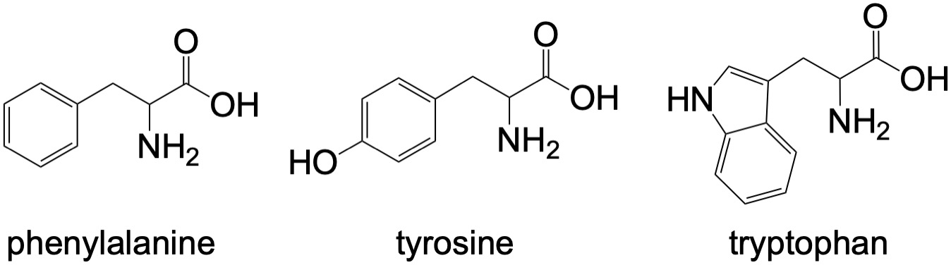

Figure 1. Structures of genetically encoded aromatic AAs used in modern proteins.

Early proteinogenic AAs | Late proteinogenic AAs
Glycine | Lysine
Alanine | Phenylalanine
Aspartic acid | Arginine
Glutamic acid | Histidine
Valine | Asparagine
Serine | Glutamine
Isoleucine | Cysteine
Leucine | Tyrosine
Proline | Methionine
Threonine | Tryptophan

Table 1. The 20 proteinogenic AAs that occur in the SGC, divided into early phase and late phase as proposed by Higgs and Pudritz [2]. Aromatic AAs in bold.
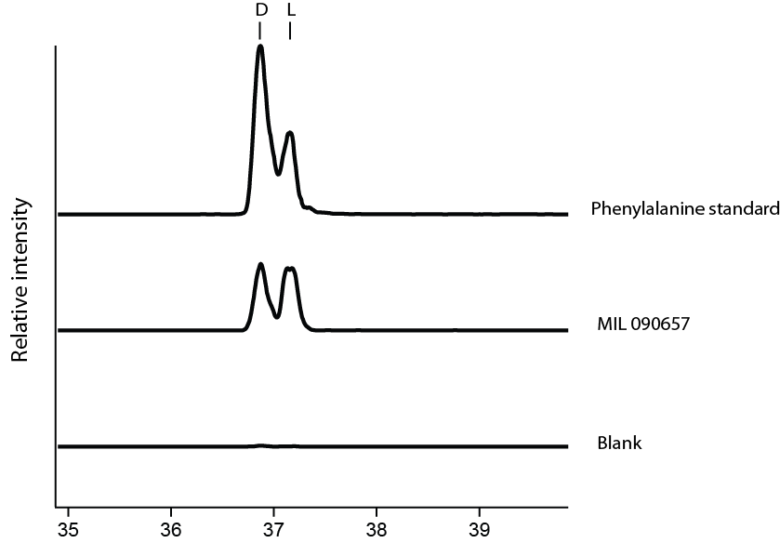
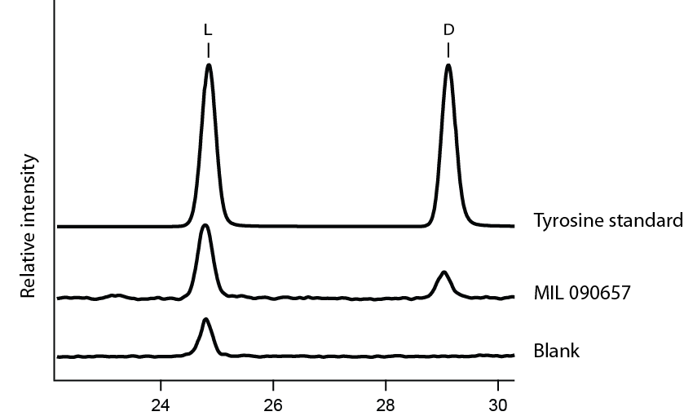
Although not detected in classic simulations of prebiotic chemistry in early Earth’s atmosphere [11,12], abiotic synthesis of proteinogenic aromatic AAs is thermodynamically favored in hot and moderately reducing environments, such as hydrothermal vents [13]. The abiotic production of tryptophan, inferred through the lack of complex mixtures of biopolymers, was recently reported in a modern hydrothermal vent. It has been attributed to Friedel-Crafts reactions catalyzed by an iron-rich saponite clay during the late stages of serpentine hydrothermal alteration [9]. Furthermore, phenylalanine and tyrosine have been identified in several CR chondrites, particularly those of petrologic type 2, which experienced lower temperatures of aqueous alteration on the CR parent body [10,14,15]. Definitive establishment of an extraterrestrial origin for aromatic AAs in meteorite samples, combined with observations or experimental demonstrations of abiotic synthetic pathways in hydrothermal environments would challenge the assumption that these ‘late’ AAs were not available for prebiotic reactions during the origins of life. Here we report on the enantiomeric composition of phenylalanine and tyrosine extracted from the Renazzo-like CR chondrite Miller Range 090657, providing new insights into the potential prebiotic availability of these compounds.
Sample and Analysis Methods: Procedural blank samples were processed in parallel with a crushed meteorite sample (153 mg) that was placed in an ampoule with 1 mL ultrapure water. The ampoules were sealed and placed in an oven at 100 ºC for 24 h. For each sample, the supernatant was removed, divided into two equal aliquots, and dried down in separate vials. One aliquot of each sample was set aside for the analysis of free AAs. The other aliquot was subjected to acid vapor hydrolysis (6N HCl) at 150 ºC for 3 h, to AA precursors to free amino acids (total AA = free + acid-labile). The samples were then purified by cation-exchange chromatography (pre-packed BioRad AG50W X-8 resin) and eluted with aqueous ammonia (2M). The samples were dried down under vacuum, then brought up in water. Aliquots of the sample were derivatized immediately prior to analysis with o-phthaldialdehyde/N-acetyl-L-cysteine (OPA/NAC). Data presented herein are reported from analyses by liquid chromatography–hybrid quadrupole time-of-flight mass spectrometry.
Results: We detected the presence of both D+L- phenylalanine and D+L-tyrosine in extracts of Miller Range (MIL) 090657; these AA were previously reported in the CR chondrites Graves Nunatak (GRA) 95229 and LaPaz Icefields 02342 though not with abundances of individual enantiomers [15]. For phenylalanine in MIL 090657, the enantiomers appear in approximately equal abundance and neither enantiomer is present in the procedural blank (Figure 2). There does appear to be some L-contamination of tyrosine, but after background subtraction, tyrosine also appears to be racemic. Taken together, these findings support an extraterrestrial origin for tyrosine and phenylalanine, providing evidence for the prebiotic availability of these aromatic amino acids.
Acknowledgments: The authors acknowledge support from NASA’s Planetary Science Division and Exobiology Programs. ACF acknowledges support from the NASA Postdoctoral Program through a contract with Universities Space Research Association. We thank the NASA Johnson Space Center and the Meteorite Working Group for allocation of the MIL 090657 sample analyzed in this study.

Figure 2. Extracted ion chromatograms for OPA/NAC-derivatized phenylalanine (top) and tyrosine (bottom) from MIL 090657.

References: [1] Zaia D. A. et al. (2008) Orig. Life Evol. Biosph. 38, 469-488. [2] Higgs P. G. and Pudritz R. E. (2009) Astrobiology 9, 483-490. [3] Trifonov E. N. et al. (2001) J. Mol. Evol. 53, 394-401. [4] van der Gulik P. et al. (2009) J. Theor. Biol. 261, 531-539. [5] Brooks D. J. et al. (2002) Mol. Biol. Evol. 19, 1645-1655. [6] Jordan I. K. et al. (2005) Nature 433, 633-638. [7] Liu X. et al. (2010) BMC Evol. Biol. 10, 1-11. [8] Freeland S. (2010) Wiley-VCH Verlag GmbH & Co. KGaA, Baltimore. pp. 43-75 [9] Ménez B. et al. (2018) Nature 564, 59-63. [10] Cobb A. K. and Pudritz R. E. (2014) Astrophys J. 783, 1-12. [11] Miller S. L. (1957) Proc. Natl. Acad. Sci. U. S. A. 108, 5526-5531 [12] Parker E. T. et al. (2011) Proc. Natl. Acad. Sci. U. S. A. 108, 5526-5531. [13] Amend J. P. and Shock E. L. (1998) Science 281, 1659-1662. [14] Pizzarello S. and Holmes W. (2009) Geochim. Cosmochim. Acta 73, 2150–2162. [15] Pizzarello S. et al. (2012) Proc. Natl. Acad. Sci. U. S. A. 109, 11949-11954.

