SMALL PARTICLE GLOVEBOX EXPERIMENTS – PRELIMINARY RESULTS. C. J. Snead^{1,2}, R. C. Funk¹, K. Righter³. ¹JETS, NASA Johnson Space Center, Houston, TX 77058, USA. (christopher.j.snead@nasa.gov) ²Texas State University, San Marcos, 601 University Dr, San Marcos, TX 78666, USA. ³NASA Johnson Space Center, Mailcode XI2, 2101 NASA Parkway, Houston, TX 77058, USA.

Introduction: A substantial portion of the asteroid samples returned by the HAYABUSA2 [1] and OSIRIS-REx [2] missions will consist of small (sub-mm) components (due to the collection of those particles on the asteroid surface and due to the fragmenting of larger, friable material post-collection). In order to minimize the alteration/oxidation of asteroid regolith, the bulk collections will be stored and curated in nitrogen purged gloveboxes. The processing of small particles in an N₂ glovebox will present challenges that are different from those experienced during lunar and meteorite sample processing. Particles in this size range are susceptible to unpredictable electrostatic charging that can result in sample loss during processing operations. Methods for the handling of sub-mm particles have been well developed for environments with ambient atmospheric conditions and relative humidity (RH) ranges between 40-70% [3]. In such conditions, a number of factors can be successfully employed to minimize the effects of triboelectric charging, including the use of Po-210 sources that neutralize excess charge and the utilization of conductive manipulation tools and sample substrates. However, relative humidity levels above 40% also contribute significantly to dissipation of triboelectric effects. We had not previously investigated our charge mitigation methods in a completely dry, nitrogen-purged environment, or whether they would be sufficient in enabling the successful processing of sub-mm samples. Current glovebox configurations in use in our lunar and meteorite curation laboratories are optimized for the processing of macroscopic samples and tools; these glovebox designs are likely unsuitable for the processing of collections for which the bulk collection is comprised of sub-mm components. Small particle sample preparation requires the use of an optical magnification instrument – typically a stereo binocular microscope with at least 20x magnification. Current glovebox designs are not optimized for the utilization or integration of stereo microscopes; while many current cabinets include microscope viewports that enable the use of small, externally mounted stereo microscopes, the focusing methods (usually involving the use of a lab jack) lack the fidelity and precision required for small particle manipulation and imaging. Working distances of higher (>50x magnification) objective lenses may preclude the external use of a stereo microscope through a viewport; in order to successfully manipulate and image very small (< 20μm) particles, stereo and digital microscope systems that are integrated within the glovebox should be investigated. Finally, ergonomic considerations for small particle work within a glovebox must be considered to minimize risk of injury to sample processors. In order to investigate some of the unknown parameters relating to small particle processing within an N₂ glovebox, we conducted preliminary, qualitative experiments utilizing a small lunar cabinet that was originally used for film development.
Experimental setup: For these experiments, we used a small (~ 36”x21”x12”) glovebox that was originally used for the photographic film development in the lunar curation laboratory. The low-profile dimensions of the cabinet enabled the use of an externally mounted stereo microscope for imaging and visual identification of sub-mm particles.
External equipment: Our imaging system consisted of a Leica M80 stereo microscope equipped with coaxial-mounted Leica IC90 digital camera that was connected via USB to a Microsoft Surface Pro. The two objective lenses used for these experiments were a 0.32x objective (providing a maximum magnification of 19.2x and a 260mm working distance) and a 0.8x objective (providing a maximum magnification of 48x and a working distance of 110mm). An externally mounted L.E.D. gooseneck fiber optic source was used for illumination of the samples (figure 1A).
Internal equipment: we used fragments of asteroid regolith simulant and powdered Allende CV3 meteorite to test our particle imaging and manipulation methods inside our experimental glovebox setup. In addition to these samples, we installed various tools and equipment inside the glovebox, including: a small XY stage, a set of pulled glass needles, pin vise handles to mount the glass needles, a set of fine-tipped tweezers, and several adjustable lab jacks (figures 1B, 2B). A Dino-lite 5MP digital microscope system attached to a wireless transmitter was also installed inside the glovebox. In order to monitor humidity levels during N₂ purging, we also installed an Acurite temperature/humidity monitoring device.
Results: We purged the cabinet with curation grade N₂ for ~18 hours prior to conducting our experiments. In that time, the humidity monitor reading fell from 40% to 16% relative humidity; the minimum range for this particular monitor is 16%, so it is likely that the relative humidity was significantly lower than our recorded reading.

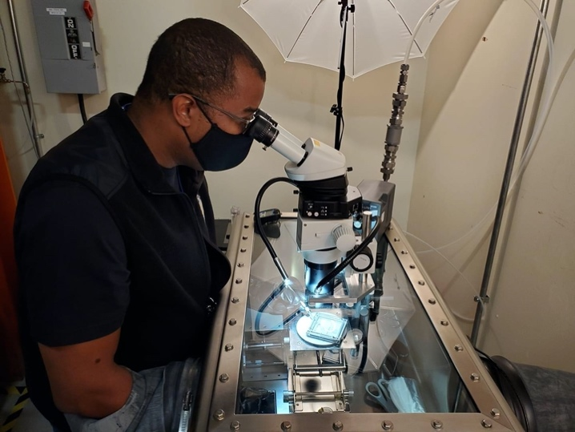
Figure 1. Experimental setup for small particle apparatus, which includes externally mounted stereo microscope, digital camera, and fiber optic illumination system.

Dexterity: Contrary to our expectations, the thick rubber cabinet gloves and positively pressurized environment did not preclude dexterous operations required for small particle processing. We were able to successfully remove 1mm diameter glass needles from their storage boxes and mount them into pin vise handles. We were also able to successfully remove Allende powder from a storage vial and disperse a small volume onto a concavity slide. Perhaps most significantly, we were able to successfully manipulate and transfer particles of asteroid simulant and Allende powder in the 20-50μm size range by hand via pin-vise mounted glass needle.
Triboelectric charging: We did not observe a significant increase in triboelectric charging effects in the extreme low-humidity N₂ atmosphere, as compared to ~40% RH conditions in ambient cleanroom environments. We also did not observe any effects related to local electric fields that caused sample to electrostatically adhere to glass surfaces (even at sample/glass separation distances > 5mm). These were surprising results, considering reports from lunar and meteorite processors of extreme charging conditions causing dust to repel from tools and adhere to viewports. There are several potential explanations to this discrepancy: We suspect that the discrepancy between our results and reports from lunar and meteorite processing is due to the fragmenting and processing of larger samples; the process of fragmentation and frictional interaction between samples, tools and substrates generates excess charge that does not quickly dissipate in insulating materials. In our experiments, samples were already fragmented/subdivided, and great care was taken (as is generally the case in small particle processing) to avoid excess frictional contact between sub-mm particles and substrates. Unfortunately, we have not yet devised a method of measuring the charge on sub-mm samples, so we cannot quantitatively assess the effects of specific sample processing operations on static accumulation.
Working distance: We tested the 0.32x objective and the 0.8x objective on the M80 stereomicroscope. The 0.32x objective provided substantial working distance, allowing us to image the interior bottom of the glovebox through the observation glass; however, the magnification was not sufficient to image smaller (10-50μm) particles that would be targeted for ultramicrotomy sample preparation. The 0.8x objective proved more versatile than the 0.32x; we were able to visually image and capture particles in the 10-20μm range; the working distance of ~4” provided ample room for hand extractions and transfers. Based on our experiments, this microscope configuration, or one with similar magnification and working distance, should be considered for a small particle processing cabinet. A comparably configured Nikon SMZ800N stereo microscope would have the advantage of apochromatic objective lenses for sharper documentation images.
Wireless transmission of images through glovebox: For scenarios in which the physical feedthrough of power and data cables through a glovebox is not feasible, we tested the use of a small digital microscope (Dino-Lite) connected to an internally powered wireless transmitter. Such a system would enable the installation of an imaging system into an existing glovebox without modification. We were concerned prior to testing that the glovebox might act as an efficient faraday cage and shield the signal from reaching the WiFi receiving device. However, we were able to successfully transmit images from the Dino-Lite to an external tablet computer.
Ergonomics: In order to reduce fatigue during hand particle transfers, we utilized two laboratory jacks as forearm supports; these greatly enhanced the precision with which we could target and capture particles of interest. Modified lab jacks specifically designed as forearm supports should be developed and used in future small particle sample cabinets.

References [1] Watanabe S. et al. (2017) Space Sciences Reviews, 208, p. 3-16. [2] Lauretta D. S. et al. (2017) Space Sciences Reviews, 212, p. 925-984. [3] McCubbin, F. M. et al. (2019) Space Sciences Reviews, 215, 48.

