Reversibly Assembled Microparticles for Sustained Applications on the Moon and Mars

Christopher J. Wohl¹, Bryce L. Horvath¹, Peter M. Strohmaier², Sarah E. Gorski², Haley M. Ketteler²,
Alec B. Werner², Nasef A. Junaid², and Sidney L. Eichelberger²

¹NASA Langley Research Center, Hampton, VA, 23681, USA
²NASA Internship, Fellowship, and Scholarship Program, NASA Langley Research Center, Hampton, VA, 23681, USA
c.j.wohl@nasa.gov

Introduction
A sustained presence in any extra-terrestrial environment will require the capability to generate materials, goods, and ultimately vehicles, construction supplies and habitats to be tenable.¹ As an example, NASA, in collaboration with Made In Space, Inc., recently reported the results of extensive research toward enabling 3D printing in space.² The extensive characterization and comparison of 3D printed articles suggested that, overall, articles generated in the International Space Station microgravity environment were comparable to those generated on Earth. The benefit of in-space manufacturing can be increased through utilization of recyclable materials. A recent analysis of a hypothetical 1,100 day round trip mission to Mars determined that significant mass savings and increase in mission probability of success could be achieved through in-space manufacturing with recyclable materials.³ NASA’s project ESPUR (Enabling Sustained Presence Using Recyclables), through support from NASA Langley’s Innovative Research and Development Fund, is investigating novel, polymer-coated, epoxy microparticle systems as an enabling technology to realize in-space manufacturing using recyclable feedstocks (Figure 1).
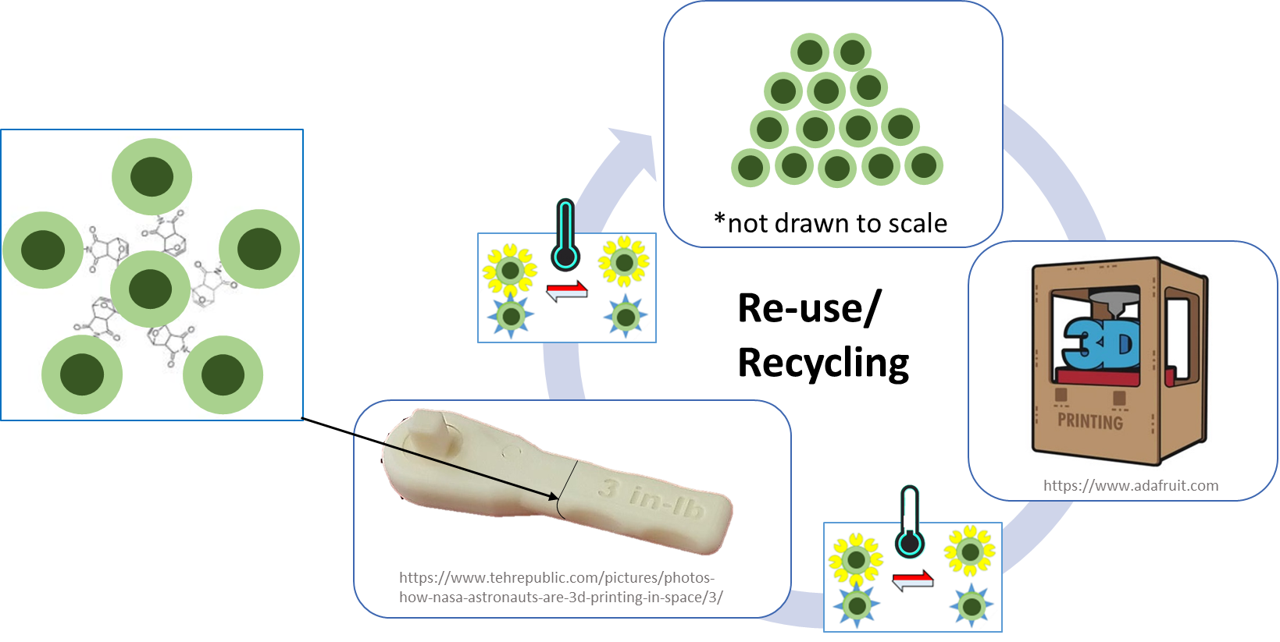
Figure 1. ESPUR reusable feedstock approach.
Building from previously reported results,⁴ further progress toward synthesis of the polymer coating containing click chemical functionalities will be described here. Finite elemental analysis (FEA) has been utilized, in light of scale-free/small world considerations in an effort to identify compositions most likely to yield robust macroscopic geometries. Initial results will be described here. Finally, potential mass savings and life cycle of this recyclable materials technology will be discussed.
Experimental
Materials and methods. All materials were obtained from Millipore Sigma and used as received. Spectroscopic characterization was performed on a Thermo Fisher Scientific Nicolet iS5 FTIR with iD7 ATR attachment and a Bruker 300 Ultra Shield™ using CDCl₃. All ¹H NMR spectra were referenced to the solvent peak at 7.26 ppm. Optical microscopy was performed using a Leica DM8000M. Thermal gravimetric analysis was performed using a TA Instruments TGA Q50 with heating from ambient to 600 °C at 10 °C/min. Glass transition temperatures (T_{g}) were determined using a TA Instruments DSC Q20 with initial heating to 100 °C, followed by cooling to -40 °C and subsequent heating to 100 °C. Heating and cooling rates were 10 °C/min and 50 °C/min, respectively. T_{g} was determined during the second heat cycle. Rheological characterization was performed on an Anton Paar MCR502 using a parallel plate configuration.
All syntheses were performed using flame-dried glassware under a nitrogen atmosphere. For synthesis of the carbonate oligomers (Scheme 1A), a 3-necked flask was outfitted with a mechanical stir rod, an N₂ inlet, and a vigreux column. This was charged with dimethyl carbonate (DMC), neopentylglycol (NPG), and triazabicyclodecene (TBD). The NPG:DMC molar ratio was varied, while the TBD:NPG molar ratio was 0.05 for all syntheses. The flask was placed in an oil bath and heated with stirring to 70 °C under N₂ for approximately 20 h. A Dean-Stark trap was placed below the vigreux column and the oil bath temperature was raised to 130 °C to remove unreacted DMC. The resultant product was transferred to a sample vial for further analysis.
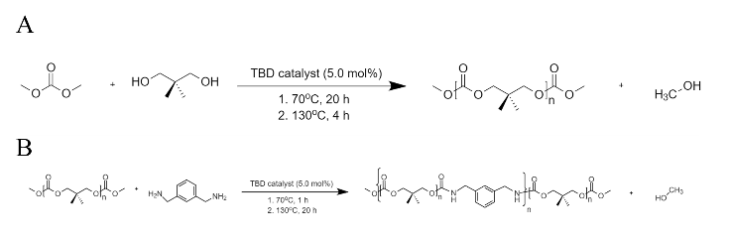
Scheme 1. (A) Synthesis of carbonate oligomer. (B) Copoly(urethane carbonate) synthesis
Copoly(carbonate urethane) (CPCU) synthesis was completed in the same glassware configuration as the carbonate oligomer synthesis (Scheme 1B). For this reaction, the glassware was charged with the carbonate oligomer, m-xylylenediamine, and TBD. Reactants were at stoichiometric equivalence with a TBD molar ratio of 0.05. The flask was placed in an oil bath and heated with stirring to 70 °C for 1 h and to 130 °C overnight. The resultant product was transferred to a sample vial for further analysis.
A hydroxyl-functionalized maleimide derivative was synthesized, based on a literature procedure,⁵ to integrate this click-chemistry functionality into the CPCU material. This three-step reaction process is shown in Scheme 2. For brevity, the reader is referred to the work of Zhang et al., for reaction details.
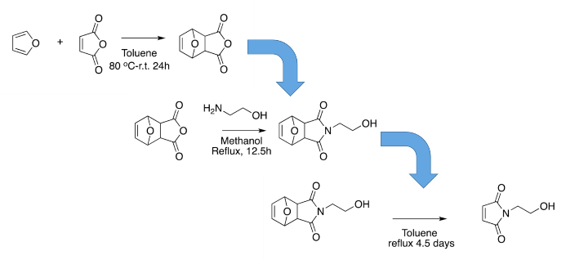
Scheme 2. Maleimide derivative synthesis

Results and Discussion
Polymer Synthesis. Based on previous results,⁴ the nature of the CPCU system has a strong dependence on the molecular weight of the polycarbonate oligomer. A series of polycarbonate oligomers were synthesized at different target molecular weights based on the modified Carothers equation (Eq. 1):
$$DP=\frac{1+r}{1-r}$$ | (Eq.1)
where DP is the degree of polymerization and r is the reactant ratio with the carbonate oligomer in excess.⁶ End-group analysis using ¹H NMR spectra were utilized to determine the actual molecular weight of the synthesized products. The remaining methyl protons derived from the DMC end units were compared to the methylene protons and methyl protons from the NPG monomer. Results from this analysis deviated significantly from values calculated according to Eq. 1 (Figure 2).

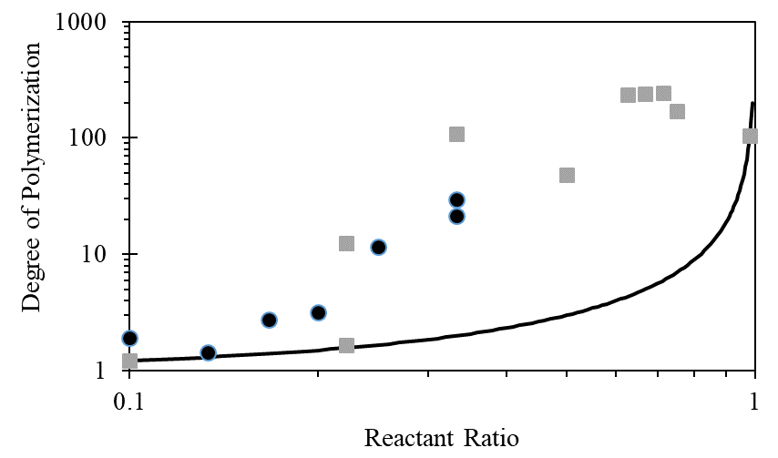
Figure 2. DP values calculated from ¹H NMR end-group analysis and the Carothers equation.
It was observed that when transitioning to NPG:DMC reactant ratios above 0.33, additional ether peaks began to appear in the 3.3-3.5 ppm range. Generation of these ether side reactions has been reported by Sun and Kuckling in similar systems.⁷ Therefore, it was determined that further syntheses would be limited to reactant ratios of 0.33 or less (which limits the polycarbonate oligomer molecular weight to less than approximately 4,500 g/mol) to enable accurate polycarbonate molecular weight determination using ¹H NMR end-group analysis.
One potential additive manufacturing method that could be utilized with these materials is 3D printing. Therefore, the rheological properties of synthesized CPCU materials were determined (Figure 3). As can be seen, the calculated complex viscosity drops precipitously as temperature is increased with a strong dependence on polycarbonate oligomer molecular weight. For reference, the viscosity of polylactic acid (PLA), a very common 3D printing filament material is included.⁷ The generated CPCU materials exhibited comparable viscosity values at much lower temperatures than the processing temperature of PLA filaments.

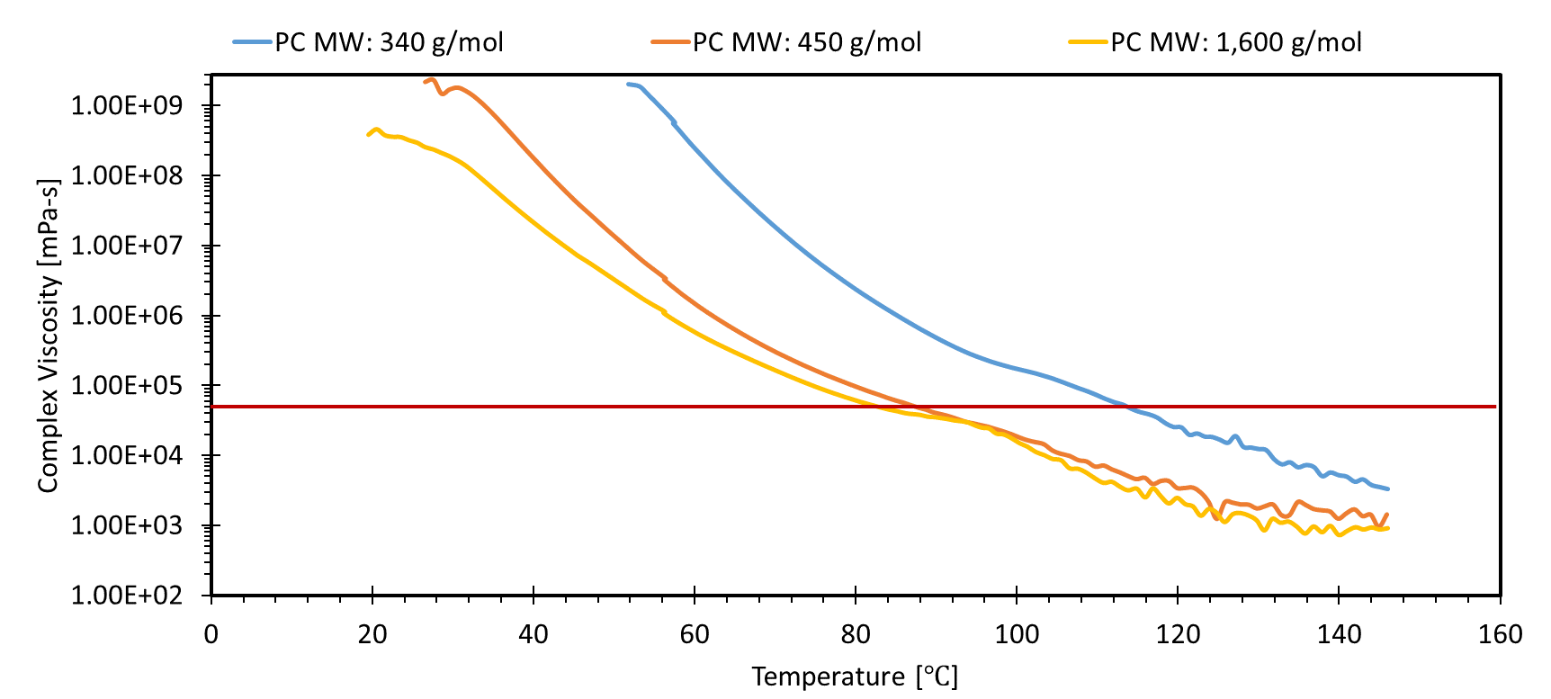
Figure 3. Viscosity of CPCU materials. For comparison, the viscosity of polylactic acid is included (red line).⁸
Maleimide Functionality Synthesis. The reversible, click-chemistry reaction identified as the most straightforward and likely for success in this application was the reaction between furan and maleimide functionalities.⁹ Integration of the furan functionalities is relatively straightforward due to the availability of the naturally-derived furan derivative, furfuryl amine. Results from these reactions will be discussed at the conference. Integration of maleimide functionalities was initially attempted using maleic anhydride. However, after several attempted reactions using polycarbonate oligomers, xylylenediamine, maleic anhydride, and TBD as a catalyst followed by typical reaction chemical imidization reaction conditions,¹⁰ resulted in very low yields and significant side product formation. Therefore, synthesis of a hydroxyl-functionalized maleimide was attempted to eliminate the need to conduct the chemical imidization reaction on the final product. Using a literature procedure,⁴ the hydroxyl-functionalized product was successfully synthesized and integrated into a CPCU system. ¹H NMR spectra of the products from the first two reaction steps are shown in Figure 4. Due to COVID access restrictions at the time of this writing, final spectra for the first and final product could not be included here. These results, as well as the resultant maleimide-containing CPCU system will be described in the material presented at the conference.
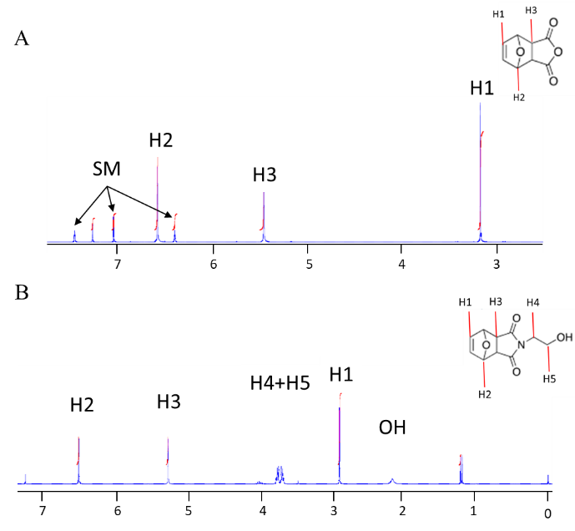
Figure 4. ¹H NMR spectra of hydroxyl-functionalized maleimide intermediates. Contributions from starting material (SM) are including in the spectral assignments.

Finite Elemental Analysis (FEA). Scale-free networks are defined as a network where the degree distribution follows a power law, so even when the network grows, the power law structure will still be the same.¹¹ Generation of these types of networks in material systems often result in unanticipated materials properties. As an example, Beznosyuk et al., utilized Shannon entropy (a method to measure the uncertainty for a series of stochastic events) to calculate the most dynamic state for aggregation of colloidal nanoparticles, i.e., conditions most likely to result in a self-organized critical state.¹² They determined that the greatest networking potential, i.e., greatest topological stability, as indicated by a maximum in the Shannon entropy, was at intermediate particle concentrations, from 50-80%.
FEA was utilized in an effort to apply these principles to the materials technology described here. Research on relatively simple systems consisting of single particles and up to four particles was conducted using Abaqus CAE simulation software. Particles were modeled utilizing nominal epoxy material properties (3.25 GPa elastic modulus and a Poisson ratio of 0.33). The particle diameter was 10 micrometers with a flat region for contact between particles with a contact radius of 0.53 micrometers. Boundary conditions were applied to prevent particle sliding and separation. From these initial simulations, which were conducted at extremely high loads to exaggerate system response, stress concentration at the particle contact area suggests that fracture will occur either within the CPCU coating or at the particle interface.
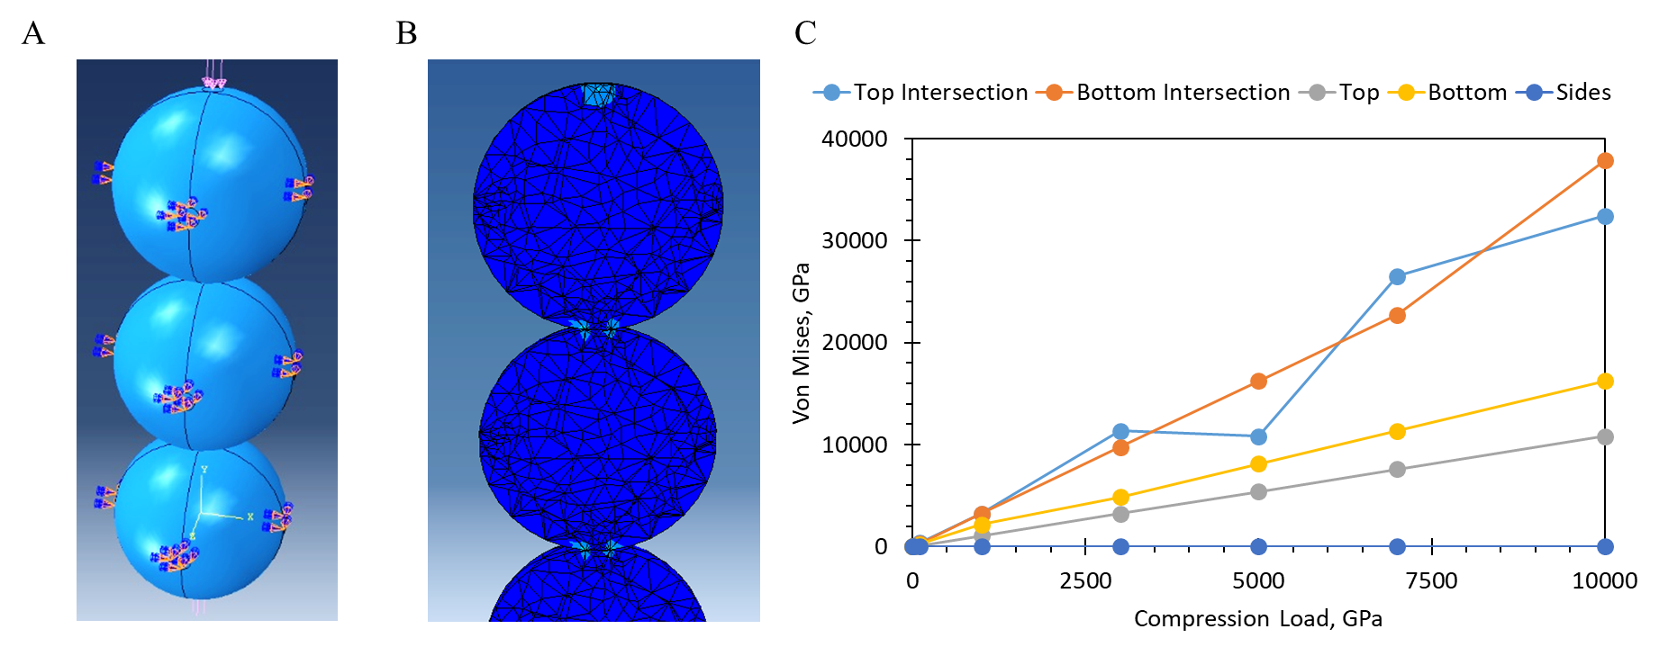
Figure 5. Abaqus simulation images showing the boundary conditions (A) and resultant von Mises stresses (B) after a 1000 GPa compressive load. (C) Von Mises stresses at different locations within the particle string.
Ultimately, FEA will enable greater efficiency toward evaluation of different formulations and orientations of a combination of two different types of particles, each with either maleimide or furan functionalities, relative to a laboratory-based, empirical approach. Relative particle size, particle population composition, and interaction strength will all be evaluated to identify the most likely formulations to exhibit self-organized criticality for generation of robust macroscopic architectures.
ESPUR Material Lifecycle Analysis and Potential Mission Impact. Finally, the potential impact of this material was evaluated for a hypothetical human mission to Mars. The material was assumed to be utilized in the following categories: crew transfer bags, spare parts, secondary structure, radiation protection, and waste canisters. The mission Master Equipment List was examined at key stages throughout the mission to evaluate the use of the material as it is repurposed from one category to the next. To reflect the fact that items constructed using ISM with ESPUR are likely to be less mass efficient on a unit basis than purpose-built items manufactured prior to launch, a penalty was applied to the effectiveness of the material in select categories. This penalty was based on a comparison of anticipated material properties and item usage.
It was found that incorporating sufficient quantities of the material results in a net reduction of mission launch mass, potentially allowing for more payload to be included on the mission. Evaluation of 3D printing techniques suggests that it will be possible to use traditional 3D printing techniques to manufacture parts with this material

Conclusion
Enabling technologies for a sustained extra-terrestrial presence will utilize novel capabilities to overcome challenges associated with available power as well as volume and mass restrictions associated with launch vehicle limitations. The ESPUR technology described here seeks to overcome these limitations and mitigate risk associated with the inability to bring an infinite supply of spare parts. Further, this technology may enable long duration mission astronauts to generate novel articles, resolve unforeseen challenges, and advance exploration practices on-site instead of relying on studies conducted on Earth.

References
- S. Lim, et al., “Extra-terrestrial construction processes – advancements, opportunities, and challenges.” Adv. Space Res. 2017, 60, pp 1413-1429.
- T. Prater, et al., “3D printing in zero G technology demonstration mission complete experimental results and summary of related material modeling efforts.” Int. J. Adv. Manuf. Tech. 2019, 101, 391-417.
- Owens and O.L. de Weck, “Systems analysis of in-space manufacturing applications for the international space station and the Evolvable Mars Campaign.” In AIAA SPACE 2016, Long Beach, CA, 2016.
- C. Wohl, et al., “Toward reversibly assembling polymer-coated epoxy microparticles.” In the 43rd Annual Meeting of the Adhesion Society, Charleston, SC, 2020.
- B. Zhang, et al., “Self-healing, malleable and creep limiting materials using both supramolecular and reversible covalent linkages.” Poly. Chem. 2015, 6, 7368-7372.
- W.F. Su, Step Polymerization. In Principles of Polymer Design and Synthesis, Springer: Berlin, 2013; Vol. 82, pp 111-136.
- J. Sun and D. Kuckling, “Synthesis of high-molecular-weight aliphatic polycarbonates by organo-catalysis.” Royal Soc. Chem. 2016, 7(8), 1642–1649.
- P. Zhu, “Polymer materials via melt based 3D printing: fabrication and characterization.” Thesis, Clemson University, Department of Materials Science and Engineering, 2018. https://tigerprints.clemson.edu/all_theses/2895
- P. Costanzo and F. Beyer, “Thermoresponsive, optically active films based on Diels-Alder chemistry.” Chem. Mater. 2007, 19, 6168-6173.
- K. Watson, et al., “Space environmentally stable polyimides and copolyimides derived from [2,4-bis(3-aminophenoxy)phenyl]diphenylphosphine oxide.” Macromolecules 2002, 35(13), 4968-4974.
- P. Massobrio, et al., “Self-organized criticality in cortical assemblies occurs in concurrent scale-free and small-world networks.” Scientific Reports 2015, 5, 10578.
- S. Beznosyuk, et al., “Informational approach to self-assembling aggregation of colloidal nanoparticles.” Mat. Sci. Eng. C 2009, 29, 884-888.

