Towards Disentangling Lockdown-Driven Air Quality Changes in the Northeastern U.S.

CHRISTIAN BRANEON
NASA Goddard Institute for Space Studies, 2880 Broadway, New York, USA
SciSpace LLC, 6550 Rock Spring Drive, Suite 600, Bethesda, USA
E-mail: christian.v.braneon@nasa.gov

ROBERT FIELD
NASA Goddard Institute for Space Studies, 2880 Broadway, New York, USA
E-mail: robert.field@columbia.edu

EDMUND SETO
Department of Environmental & Occupational Health Sciences, University of Washington, 4225 Roosevelt Way NE, Seattle, USA
E-mail: eseto@uw.edu

KAI CHEN
Department of Environmental Health Sciences, Yale University, P.O. Box 208034, New Haven, USA
E-mail: kai.chen@yale.edu

KATHRYN MCCONNELL
School of the Environment, Yale University, 195 Prospect St, New Haven, USA
E-mail: kathryn.mcconnell@yale.edu

LORRIN ROBINSON
Center for Advanced Communications Policy, Georgia Institute of Technology, 500 10th Street NW, Atlanta, USA
E-mail: lorrin.robinson@cacp.gatech.edu

SAFIYA RICHARDSON
Institute of Health Innovations and Outcomes Research, Feinstein Institutes for Medical Research, Northwell Health, Manhasset, USA
Donald and Barbara Zucker School of Medicine at Hofstra/Northwell, Northwell Health, Hempstead, USA
E-mail: srichard12@northwell.edu

Received: 11/1/20
Revised: 8/5/21

In the absence of preventive therapies or effective treatment for most cases of coronavirus disease 2019 (COVID-19), governments worldwide have sought to minimize person- to-person severe acute respiratory syndrome coronavirus 2 (SARS-CoV-2) transmission through a variety of lock-down measures and social distancing policies. Extreme events like the COVID-19 pandemic present a tremendous opportunity to make quantitative connections between changes in anthropogenic forcing, social and economic activity, and the related Earth system response. In this comment, we examine air quality impacts associated with pandemic response measures in the Northeastern United States.
Dozens of research articles have been published since the onset of the COVID-19 pandemic that study the impact of differing lockdown approaches with regards to local (e.g. Xiang et al. 2020), regional (e.g. Liu et al. 2020), and national (Bekbulat et al. 2020) air quality; global response to this extreme event provides a unique natural experiment (Diffenbaugh et al. 2020). Social distancing policies and lockdown measures include “school and workplace closure, cancellation of public events and gatherings in addition to movement restrictions with public transport closure, and prohibition of internal and international travel” (Papadapoulos et al. 2020). The lockdown measures and social distancing policies employed by state and local governments in the Northeast U.S. in response to increasing SARS-CoV-2 transmission may offer valuable lessons regarding the potential benefits of decarbonization strategies that are likely to improve air
quality and related health outcomes in New York City (Gao et al. 2018; Johnson et al. 2020).
It is difficult to draw meaningful conclusions about the causality of recent air quality changes in the Northeastern U.S. (e.g. monthly NO₂ changes; Figure 1) for a variety of reasons. First, lockdowns are occurring in the context of a well-established trend of decreasing regional air pollution. This must be taken into account when attributing changes in atmospheric composition to COVID-19 lockdowns (Field et al. 2020). Second, current methods for disentangling emissions from meteorological influences on air pollution that average historical data over sequential months lack the temporal granularity to quantify short-term emission changes and account for long-term trends (Goldberg et al. 2020). Third, simultaneous events such as fires, summer breaks in schooling, and holidays (e.g. July 4th) may complicate time series analyses as spikes or dips in emissions may accompany these events (Chen et al. 2020). Lastly, social distancing policies and practices continuously vary in time and space across the Northeast U.S.; proximity to major roads, population density, and other factors influence how social distancing impacts local anthropogenic activities and the associated emissions mix.
Satellite remote sensing is a valuable tool for assessing air quality changes that follow extreme events since ground-based monitoring networks are sparse and often not deployed with environmental health studies in mind (Sorek-Hamer et al. 2016). To estimate the impacts of COVID-19 response measures on air pollution levels in the Northeastern U.S. we used daily gridded Level-3 retrievals from four different instruments on three different NASA Earth Observing System satellites (Figure 2), following a similar analysis over China (Field et al. 2020). These data are publicly available, have low (~2- day) latency, and have at least a 15-year record to provide context for any COVID-19 related changes that occurred. The Atmospheric Infrared Sounder (AIRS) instrument aboard NASA’s Aqua satellite provided carbon monoxide (CO) profiles at a horizontal resolution of 45 kilometers (km). The greatest sources of outdoor CO are vehicles or machinery that burn fossil fuels. We obtained nitrogen dioxide (NO₂) and sulfur dioxide (SO₂) column density measurements at 0.25◦ resolution from the Ozone Monitoring Instrument (OMI) aboard NASA’s Aura satellite. While NO₂ forms as a result of emissions from cars, trucks and buses, power plants, as well as off-road equipment, the largest source of SO₂ in the atmosphere is the burning of fossil fuels by power plants and other industrial facilities. Since aerosol optical depth (AOD) can be considered a proxy for the amount of particulate matter present in the atmospheric column (Gupta et al. 2013), we used AOD data at 1◦ resolution derived from Moderate Resolution Imaging Spectroradiometer (MODIS) sensors.
We examined the period from 2005 to 2020 for which all satellite data were available. For each air pollutant studied, a daily average was calculated over the Office of Management and Budget’s Metropolitan New York statistical area (i.e. New York City and nearby counties in New Jersey, Connecticut, and Pennsylvania). We used March 22nd to June 8th as our lockdown period; this time window was chosen as the New York State Governor’s office issued "New York State on PAUSE" executive order on March 22nd, and Phase 1 of re-opening began on June 8th. After calculating linear trends that begin in 2005 and all subsequent years, we identified different time periods ending in 2019 that demonstrate a strong and consistent increasing or decreasing trend as determined by the variance explained by the trend. We then compared the distribution of daily values in 2020 during the lockdown period to (a) the same period in 2019, (b) the years over which any trend was most consistent, and (c) the expected values for 2020 in the presence of any trend. Bootstrap resampling was used to estimate 95% confidence intervals for all comparisons.
The longer-term analysis showed that 2020 departures during the lockdown period depended on the retrieved quantity and the background period against which 2020 was compared (Figure 2). During the lockdown period, AIRS CO was 5% less than the same period in 2019 (Figure 2a), and 8% less than over 2005 to 2019. During that period, however, there was a decrease of -1 ppbv yr−1. If we take this into account, the observed value in 2020 was not significantly different from what would have been expected from the trend as the estimated 95% confidence intervals spans zero. Qualitatively, the decrease from 2019 to 2020 was similar to that from 2010 to 2011 and from 2016 to 2017, which we attribute to normal interannual variability in transport patterns and local emissions. Therefore, the CO decrease in 2020 is difficult to attribute to the lockdown in the presence of past changes and meteorological noise.
The strongest OMI SO₂ trend identified (Figure 2b) was from 2014 to 2019, but this was not significant nor were any trends beginning in earlier years. Significant reductions in SO₂ occurred earlier (Hidy and Blanchard 2016), and by the start of the OMI record were low enough to preclude further decreases. Regardless, SO₂ in 2020 was not significantly different from 2019 or from 2014 to 2019. The wide ranges in the estimated confidence intervals reflect the low baseline values used when calculating percentage differences.
OMI NO₂ has demonstrated a significant downward trend since 2005 (Figure 2c), similar to that in AIRS CO. NO₂ in 2020 was 20% lower than it was in 2019 and 42% lower than 2005 to 2019 with the latter difference having a narrower 95% confidence interval. 2020 was not significantly different from what would be expected from the trend, but this is more difficult to interpret given the increases and decreases over the length of the record. Despite the strongest trend being since 2005 there has been a flattening since 2015, which suggests a 2020 drop in NO₂ that is greater than what would be expected in the absence of lockdown measures and social distancing policies.
The strongest trend in MODIS AOD was a decrease from 2007 to 2019 (Figure 2d), but this was weak (r² = 0.02) and included year to year changes of either sign. AOD in 2020 was 19% less than in 2019 and 22% less than over 2007 to 2019. As a result of the recent (if slight) decreasing trend, AOD in 2020 was 7% less than what would be expected from the recent trend (2007 to 2019) and the 95% confidence interval spans zero. For other detrending periods we analyzed (e.g. 2012 to 2019), 2020 differences in AOD were not robust. Furthermore, the decrease from 2019 to 2020 was qualitatively similar to that from 2015 to 2016 (and earlier 1-year declines).
The main point to be taken from this analysis is that 2020 changes in atmospheric composition thought to be due to COVID-19 should consider background variability and trends. Our study may be enhanced by integrating finer scale Earth observations (e.g. TROPOMI) as well as atmospheric chemistry modeling to separate meteorological from emissions-related influences on atmospheric composition. To the best of our knowledge, the only US-based studies to consider background trends have been for New York City (Zangari et al., 2020) and Los Angeles (Parker et al., 2021). Over New York, significant decreases in surface measurements of PM_{2.5} and NO² were observed in January through May 2020 relative to the same period during the previous five years. These differences were not significant, however, when adjusted with a linear time lag model accounting for decreasing trends over the antecedent time period.
For public health and urban planning applications (e.g. superblocks, open streets), our results should be interpreted with caution as ground-level exposure to the air pollutants studied is more variable in time and space than the satellite data we used (Kumar 2010) which have lower sensitivity near the surface. As data become available through local initiatives such as the New York City Community Air Survey (NYCCAS), new insights may be drawn regarding short-term reductions in pollutant emissions and the associated changes in air quality. There is also a strong need for local empirical relationships (short-term and long-term) between Earth observations and air pollutants monitored on the ground; New York City based AOD-PM_{2.5} relationships may allow for meaningful applications of satellite data for exposure assessment in urban planning and epidemiological studies. Pandemic response measures can serve to prevent deaths from COVID-19 in the short-term as well as deaths associated with impaired air quality in the long-term if careful attention and resources are committed to disentangling post-lockdown emissions changes from meteorological and social factors.

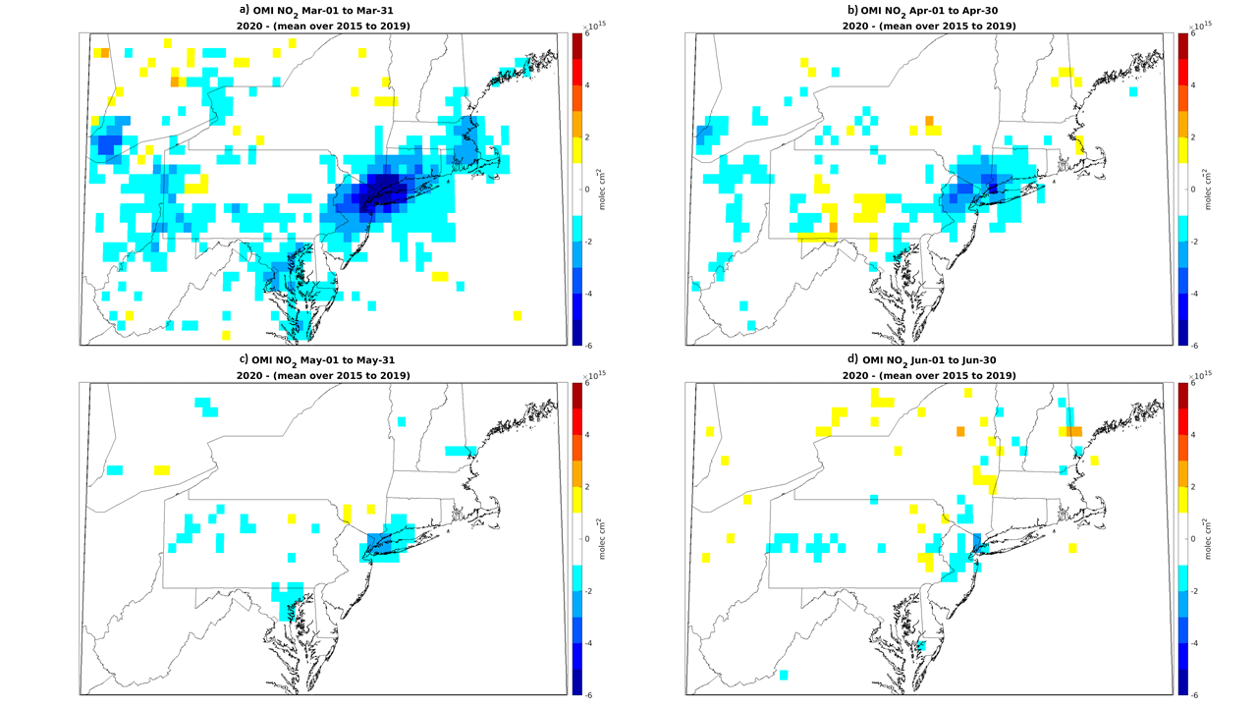

Figure 1. Monthly NO₂ differences during March, April, May and June of 2020 over Northeast U.S.; maps showing OMI tropospheric nitrogen dioxide (NO₂).

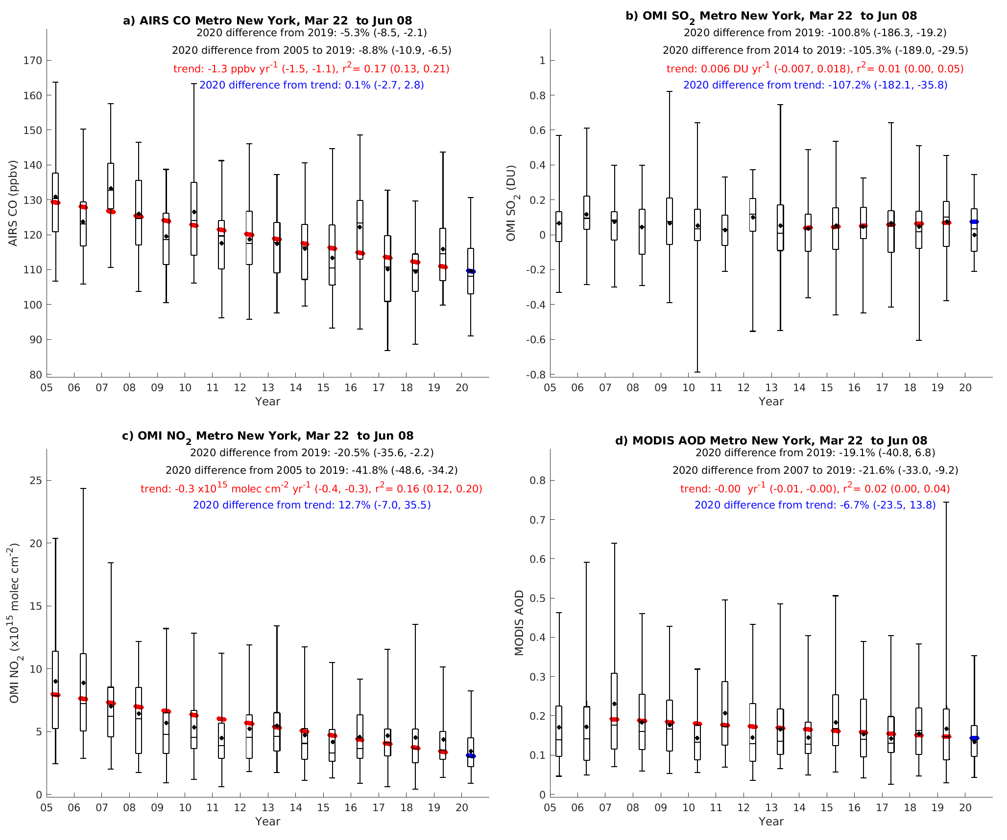

Figure 2. March 22 to June 8 box plots over Metropolitan New York area for a) AIRS CO, b) OMI PBL SO₂, c) OMI tropospheric NO₂ and d) Aqua and Terra MODIS AOD from 2005 to 2020. The black box plots show the median, interquartile range as well as the 2.5th and 97.5th percentiles over all daily mean data. For each variable, the estimated trend is plotted in red over the period during which it was strongest and given in the caption with its coefficient of determination (r²). The percentage differences are given between 2020 and 2019, 2020 and the background period, and 2020 and the predicted value from the trend. 95% confidence intervals for each estimate are given in parentheses.

Acknowledgements
The authors thank N. Stamler and Y. Liu for the exploratory data analysis of New York City Community Air Survey (NYCCAS) and U.S. EPA data that contributed to this article.

References
Bekbulat, B, Apte, JS., Millet, DB., Robinson, AL, Wells, KC., Marshall, JD. et al. (2020). Changes in criteria air pollution levels in the US before, during, and after Covid-19 stay-at-home orders: evidence from regulatory monitors. ChemRxiv.Preprint. https://doi.org/10.26434/chemrxiv.12275603.v9
Chen K., Wang M, Huang C, Kinney PL, Anastas, PT (2020). Air pollution reduction and mortality benefit during the COVID-19 outbreak in China. The Lancet Planetary Health 4(6), e210–e212. https://dx.doi.org/10.1016/s2542-5196(20)30107-8
Diffenbaugh, NS, Field, CB, Appel, EA et al (2020). The COVID-19 lockdowns: a window into the Earth System. Nat Rev Earth Environ 1, pp. 470–481. https://doi.org/10.1038/s43017-020-0079-1
Field, RD, Hickman, JE, Geogdzhayev, IV, Tsigaridis, K and Bauer, SE (2020). Changes in satellite retrievals of atmospheric composition over eastern China during the 2020 COVID-19 lockdowns. Atmos. Chem. Phys. Disc., submitted. doi:10.5194/acp-2020-567
Gao J, Kovats S, Vardoulakis S, Wilkinson P, Woodward A, Li J, Gu S, Liu X, Wu H, Wang J, Song X, Zhai, Y, Zhao J, Liu, Q (2018). Public health co-benefits of greenhouse gas emissions reduction: A systematic review. Science of The Total Environment 627, pp. 388–402. https://dx.doi.org/10.1016/j.scitotenv.2018.01.193
Goldberg, DL, Anenberg, SC, Griffin, D, McLinden, CA, Lu, Z, Streets, DG. (2020). Disentangling the Impact of the COVID-19 Lockdowns on Urban NO2 From Natural Variability. Geophys. Res. Lett, pp. 47, e2020GL089269. https://doi.org/10.1029/2020GL089269
Gupta, P, Maudood, N, Silva, A, Patadia, F (2013). MODIS aerosol optical depth observations over urban areas in Pakistan: quantity and quality of the data for air quality monitoring. Atmospheric Pollution Research 4(1), pp. 43–52. https://dx.doi.org/10.5094/apr.2013.005
Hidy, GM and Blanchard, CL (2016). The changing face of lower tropospheric sulfur oxides in the United States. Elementa: Science of the Anthropocene 4, p.138 https://dx.doi.org/10.12952/journal.elementa.000138
Johnson, S, Haney, J, Cairone, L, Huskey, C, and Kheirbek, I (2020). Assessing Air Quality and Public Health Benefits of New York City’s Climate Action Plans. Environ. Sci. Technol. 54(16), pp. 9804–9813. https://dx.doi.org/10.1021/acs.est.0c00694
Kumar, N (2010). What can affect AOD-PM(2.5) association? Environ Health Perspect, 118:A 109–A 110; author reply A 110–111. https://doi.org/10.1289/ehp.0901732
Liu, F, Page, A, Strode, SA, Yoshida, Y, Choi, S et al (2020). Abrupt decline in tropospheric nitrogen dioxide over China after the outbreak of COVID-19. Science Advances 6(28), eabc2992. https://dx.doi.org/10.1126/sciadv.abc2992
Papadopoulos, DI, Donkov, I, Charitopoulos, K, and Bishara, S (2020). The impact of lockdown measures on covid-19: a worldwide comparison. medRxiv. https://doi.org/10.1101/2020.05.22.20106476
Parker, H. A., Hasheminassab, S., Crounse, J. D., Roehl, C. M., and Wennberg, P. O. (2020). Impacts of Traffic Reductions Associated With COVID‐19 on Southern California Air Quality. Geophysical Research Letters, 47(23). https://doi.org/10.1029/2020gl090164
Sorek-Hamer, M., Just, AC, and Kloog, I. (2016). Satellite remote sensing in epidemiological studies. Current Opinion in Pediatrics 28(2), pp. 228–234. https://dx.doi.org/10.1097/mop.0000000000000326
Xiang, J., Austin, E., Gould, T., Larson, T., Shirai, J., Liu, Y., Marshall, J., Seto, E. (2020). Impacts of the COVID-19 responses on traffic-related air pollution in a Northwestern US city. Science of The Total Environment 747, pp. 141325–141325. https://dx.doi.org/10.1016/j.scitotenv.2020.141325
Zangari, S., Hill, D. T., Charette, A. T., and Mirowsky, J. E. (2020). Air quality changes in New York City during the COVID-19 pandemic. Science of The Total Environment, 742, 140496. https://doi.org/10.1016/j.scitotenv.2020.140496

Kings County, NY; Queens County, NY; New York County, NY; Bronx County, NY; Richmond County, NY; Westchester County, NY; Bergen County, NJ; Hudson County, NJ; Passaic County, NJ; Putnam County, NY; Rockland County, NY; Suffolk County, NY; Nassau County, NY; Middlesex County, NJ; Monmouth County, NJ; Ocean County, NJ; Somerset County, NJ; Essex County, NJ; Union County, NJ; Morris County, NJ; Sussex County, NJ; Hunterdon County, NJ; Pike County, PA

