ULTRASAT Enveloping Environments
Launch Services Program Information Summary
1/8/2020

Document Purpose

This document provides a conservative set of bounding launch vehicle environments for consideration by the ULTRASAT team as they work toward on the ULTRASAT Preliminary Design of their spacecraft. The information is provided at the request of the ULTRASAT team and after the NASA stated support of this mission in the letter from Dr. Thomas Zurbuchen to Avi Blasberger of the Israel Space Agency (ISA) dated November 30, 2020.

In that letter Dr. Zurbuchen states, “NASA intends to partner with ISA on the ULTRASAT mission, primarily through the provision of a U.S. commercial launch opportunity to a geostationary transfer orbit (GTO). This launch opportunity would be contingent on the spacecraft mass not exceeding 1200 kilograms, as well as on compliance with the spacecraft requirements of the prospective commercial launch provider. I am pleased to hear that our teams are discussing a robust science partnership as an essential element of our collaboration.” The launch vehicles considered by the NASA Launch Services Program (LSP) as part of the enveloping environments follows this direction with regards mass and desired orbit.

Figure 1 Constraining Case for Payload Envelope:

Figure below shows the constraining static payload fairing envelope that will enable compatibility with potential launch vehicles
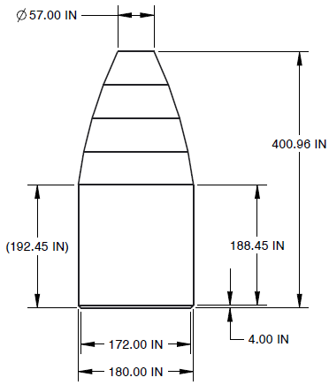

Figures 2.x Enveloping Environments (Loads, CG, Sine, Random, Acoustics, Shock)

2. a CG Load Factors
Envelope*
Lateral (g’s) | Axial (g’s)
2 | 7.4
2 | 4
3 | 4
3 | -1.5
2 | -1.5
2 | -4
-2 | -4
-2 | -1.5
-3 | -1.5
-3 | 4
-2 | 4
-2 | 7.4
2 | 7.4 | *Positive sign in axial load factor denotes compression

Note: The loads factors should be considered preliminary as a rideshare stack configuration may affect load factors. At that time a stack configuration is determined, a Coupled Loads Analysis (CLA) would be required to verify environments.
2.b Sine Vibe
Envelope
Frequency (Hz) | Axial  (g) | Frequency (Hz) | Lateral  (g)
2 | 1 | 2 | 0.8
50 | 1 | 25 | 0.8
50 | 0.8 | 25 | 0.6
82 | 0.8 | 100 | 0.6
85 | 0.9
100 | 0.9

2.c Random MPE Levels at Spacecraft Interface

Candidate LV Interface RV Design Envelope (P95/50) on LV-side
Frequency (Hz) | PSD (G^2/Hz)
20 | 0.0044
100 | 0.0044
300 | 0.01
700 | 0.01
800 | 0.03
925 | 0.03
2000 | 0.00644
GRMS = | 5.13

2.d Acoustics

Candidate LV Acoustics Design Envelope (P95/50) - Spatially Averaged
Frequency (Hz) | SPL (dB)
31 | 120.6
40 | 122.4
50 | 123.8
63 | 125.1
80 | 125.9
100 | 130.0
125 | 131.0
160 | 131.0
200 | 131.0
250 | 130.0
315 | 128.0
400 | 126.0
500 | 124.0
630 | 122.0
800 | 119.5
1000 | 117.8
1250 | 116.4
1600 | 114.5
2000 | 112.5
2500 | 111.0
3150 | 109.0
4000 | 108.0
5000 | 107.0
6300 | 106.0
8000 | 104.0
10000 | 102.0
Overall SPL (dB) | 139.4

Note: The provided acoustics design envelope covers multiple candidate LVs in one spec and is therefore very conservative.

2.e Shock MPE Levels at Spacecraft Interface
Candidate LV Interface Shock Design Envelope (P95/50, Q=10) on LV-side
Hz | SRS (g-peak)
100 | 100
625 | 2000
10000 | 2000

