Exploring Transfers between Earth-Moon Halo Orbits via Multi-Objective Reinforcement Learning

Christopher J. Sullivan Colorado Center for Astrodynamics
Smead Aerospace Engineering Sciences University of Colorado Boulder
429 UCB
Boulder, CO 80303 christopher.j.sullivan@colorado.edu
Rodney L. Anderson Jet Propulsion Laboratory
California Institute of Technology 4800 Oak Drive Dr.
Pasadena, CA 91109 rodney.l.anderson@jpl.nasa.gov
Natasha Bosanac Colorado Center for Astrodynamics
Smead Aerospace Engineering Sciences University of Colorado Boulder
429 UCB
Boulder, CO 80303 natasha.bosanac@colorado.edu
Alinda K. Mashiku Navigation and Mission Design Branch NASA Goddard Space Flight Center
8800 Greenbelt Rd.
Greenbelt, MD 20771 alinda.k.mashiku@nasa.gov

Jeffrey R. Stuart
Jet Propulsion Laboratory California Institute of Technology 4800 Oak Drive Dr.
Pasadena, CA 91109 jeffrey.r.stuart@jpl.nasa.gov

Abstract—Multi-Reward Proximal Policy Optimization, a multi- objective deep reinforcement learning algorithm, is used to ex- amine the design space of low-thrust trajectories for a SmallSat transferring between two libration point orbits in the Earth- Moon system. Using Multi-Reward Proximal Policy Optimiza- tion, multiple policies are simultaneously and efficiently trained on three distinct trajectory design scenarios. Each policy is trained to create a unique control scheme based on the trajec- tory design scenario and assigned reward function: a unique combination of weights scaling competing objectives that guide the spacecraft to the target mission orbit, incentivize faster flight times, and penalize propellant mass usage. Then, the policies are evaluated on the same set of perturbed initial conditions in each scenario to generate the propellant mass usages, flight times, and state discontinuities from a reference trajectory for each control scheme. This solution space of low-thrust trajectories for a SmallSat is used to examine the multi-objective trade space for the trajectory design scenario. By autonomously constructing the solution space, insights into the required propellant mass, flight time, and transfer geometry are rapidly achieved.

TABLE OF CONTENTS
- INTRODUCTION 1
- DYNAMICAL MODEL 2
- DEEP REINFORCEMENT LEARNING 4
- RECOVERING TRANSFERS USING MRPPO 4
- RESULTS 6
- CONCLUSION 10
ACKNOWLEDGMENTS 10
REFERENCES 11
BIOGRAPHY 12
978-1-7281-2734-7/20/$31.00 Qc 2020 IEEE
  - INTRODUCTION
Small satellites, or SmallSats, offer an enticing and low-cost platform for mission designers, scientists, and engineers de- veloping mission concepts for expanding humanity’s knowl- edge of the Solar System. Riding as secondary payloads or on smaller launch vehicles, SmallSats may provide a low-cost option for achieving a variety of targeted science, technology, and exploration objectives within and beyond low Earth orbit (LEO). For instance, the Mars Cube One (MarCO) spacecraft, two 13.5 kg SmallSats, were deployed on an interplanetary trajectory to serve critical needs on a high-profile mission as communication relays for the InSight lander, while also demonstrating the potential for spacecraft with this form factor to operate beyond LEO [1, 2]. Additional SmallSat missions planned for destinations beyond LEO include the Lunar IceCube, LunaH-Map, and NEA Scout missions, each expanding the boundaries and capabilities of SmallSat oper- ations [3–5]. Following deployment, a SmallSat equipped with a low-thrust propulsion system may adjust its trajectory to reach a variety of mission orbits in cislunar space. The propulsion system may also be used to transfer between orbits for mission concepts that leverage multiple vantage points.
Low-thrust trajectories exist as solutions to a high- dimensional, multi-objective optimization problem. Further- more, the existence and properties of feasible solutions are strongly influenced by the hardware specifications, mission objectives, deployment conditions, power limitations and other operational requirements. Understanding the design space of low-thrust trajectories for SmallSats as the space- craft and mission parameters evolve enables trades between multiple objectives such as reducing the divergence from a reference trajectory and limiting propellant mass require- ments over a reasonable flight time. The solutions to a multi- objective problem are often studied via the associated Pareto front, reflecting the set of nondominated solutions. One step towards uncovering the global Pareto front is to first develop point solutions that lie within the multi-objective solution space. These point solutions offer general insights into the

trajectory design space, and may be iterated upon to develop locally optimal solutions or even a globally optimal solution. However, designing one feasible, low-thrust trajectory in the complex gravitational environment of cislunar space may be time-consuming and computationally-intensive.
Machine learning offers a promising candidate approach for producing solutions in high-dimensional, multi-modal solu- tion spaces. Deep reinforcement learning (DRL) methods have surged in popularity within the mission design com- munity for recovering complex solutions in high-dimensional design applications [6–14]. Multi-objective deep reinforce- ment learning (MODRL) algorithms, which use DRL algo- rithms as a foundation, offer an efficient method for uncover- ing multiple solutions with varying geometries and objective prioritizations while reducing the required computational re- sources and time [6, 15, 16]. This paper focuses on using an MODRL algorithm to simultaneously train multiple policies to autonomously recover the solution space for low-thrust trajectories between halo orbits in the Earth-Moon system.
In this paper, Multi-Reward Proximal Policy Optimization (MRPPO) is used to examine the design space of low-thrust trajectories for a SmallSat transferring between two orbits in the Earth-Moon Circular Restricted Three-Body Problem (CR3BP). MRPPO is a MODRL algorithm that enables the recovery of a multitude of policies that span a multi-objective solution space. MRPPO leverages the advantages of single objective DRL algorithms while reducing the required com- putational resources and increasing the stability and perfor- mance during the training process. Using MRPPO, multiple policies, each with distinct weights scaling the competing objectives, are simultaneously trained. Each policy is trained to create a unique controls scheme based on the assigned reward function: a weighted combination of objectives that guide the spacecraft to the target mission orbit, minimize deviations from a reference trajectory, and penalize propellant mass usage. Policies are trained to guide a low-thrust-enabled SmallSat in three transfer design scenarios in the Earth-Moon CR3BP: (1) from an L₁ Lyapunov orbit to an L₂ Lyapunov orbit of equal energy, (2) from an L₁ northern halo orbit to an L₂ southern halo orbit of equal energy, and (3) from an L₁ northern halo orbit to a higher-energy L₂ southern halo orbit. The first scenario serves as a verification test due to the availability of insights from dynamical systems theory, specifically, a known natural connection between the two periodic orbits. The second and third scenarios offer more complex evaluations where no a priori solutions are known. For each trajectory design scenario, the trained policies are evaluated on a common set of perturbed initial conditions randomly drawn along the initial periodic orbit

Table 1: Earth-Moon system characteristic quantities.

Parameter | Value
Characteristic length, l∗ Characteristic time, t∗ Characteristic mass, m∗ Mass ratio, µ | 384,400 km  375,132 s  6.0477 × 10²⁴ kg  1.2151 × 10⁻²

CR3BP, fundamental dynamical structures may be recovered that describe the natural flow of motion within multi-body systems. Spacecraft trajectories may be designed to leverage these natural dynamical structures and conserve propellant mass. This section describes both the formulation of the natural and low-thrust-enabled CR3BP equations of motion, and the natural dynamical structures used in the trajectory design scenarios explored within this paper.
Circular Restricted Three-Body Problem
The natural trajectory of a spacecraft in cislunar space is studied using the CR3BP. In the CR3BP, two primary masses, denoted M₁ and M₂, govern the motion of a third body of negligible mass, e.g. the spacecraft. These two primary masses are modeled as point mass objects assumed to follow circular orbits about their mutual barycenter. Then, a rotating frame, (xˆ, yˆ, zˆ), is defined to co-rotate with the two primary bodies such that xˆ is directed from the Earth to the Moon, zˆ is aligned with the orbital angular momentum vectors of the Earth and Moon, and yˆ completes the right-handed set of axes [17]. Additionally, to aid the numerical integration scheme and convergence properties of the DRL algorithm, the state of the spacecraft is nondimensionalized using the characteristic quantities of the Earth-Moon system, summarized in Table 1. In the Earth-Moon system, the characteristic length, l∗, is
set equal to the semi-major axis of the Moon with respect
to the Earth, the characteristic time, t∗, is defined to set the orbital period of the Moon to 2π, and the sum of the mass within the system is defined as m∗ = M₁ + M₂ [18]. Using the characteristic quantities, the nondimensional state of a spacecraft in the Earth-Moon CR3BP is denoted x¯ = [d¯, v¯], where d¯ and v¯ represent the position and velocity vectors in the rotating frame with respect to the Earth-Moon barycen- ter. An additional parameter that significantly influences the
availability and geometry of the natural dynamical structures
within a multi-body system is the mass ratio, calculated as
µ = M₂/(M₁ + M₂). Then, the CR3BP equations of motion that govern the natural dynamics of a spacecraft in the Earth- Moon rotating frame are

to generate insights into the characteristics of each control
scheme. Using the maximum, minimum, and mean values of these characteristics, regions of the multi-objective space are
x: − 2y9 =
∂U ∗
∂x
y: + 2x9 =
∂U ∗
∂y
z: =
∂U ∗ (1)
∂z

studied. By autonomously constructing the multi-objective solution space, insights into the required propellant mass, flight time, and trajectory geometry are rapidly achieved; such information is valuable during spacecraft design and mission concept development.

  - DYNAMICAL MODEL
Spacecraft motion in the Earth-Moon system is often be ap- proximated using simpler dynamical models prior to higher- fidelity analyses. One model, the CR3BP, has been used extensively in trajectory design to model the natural and low- thrust-enabled motion of a spacecraft in cislunar space. In the
where the spacecraft’s distance to the primaries are d₁ = (x + µ)2 + y2 + z2 and d₂ = (x 1 + µ)2 + y2 + z2
and U ∗ = ¹ (x² + y²) + (1 µ)/d₁ + µ/d₂ is the pseudo- potential function of the system [19]. These equations of motion admit a constant of integration, denoted the Jacobi constant, CJ = 2U ∗ x9 2 y92 z92, which is an energy- type value that is theoretically constant along any natural
a a
2
−
−
− − −
trajectory in the CR3BP.
Natural Dynamical Structures
A variety of natural dynamical structures that exist in the Earth-Moon CR3BP are often incorporated into the trajec- tory design process, including equilibrium points, periodic

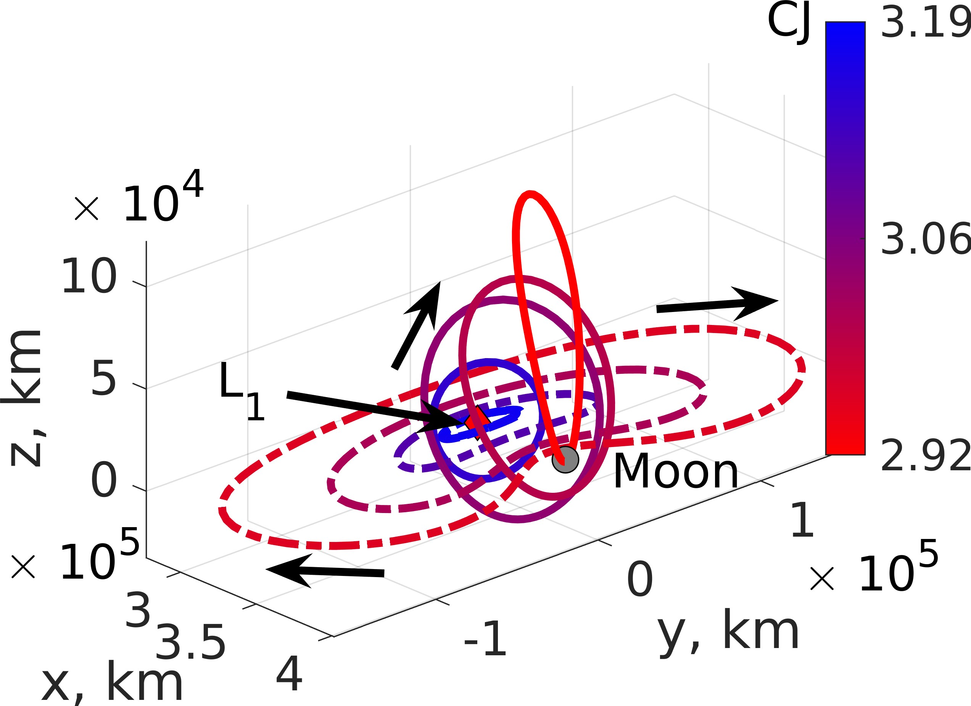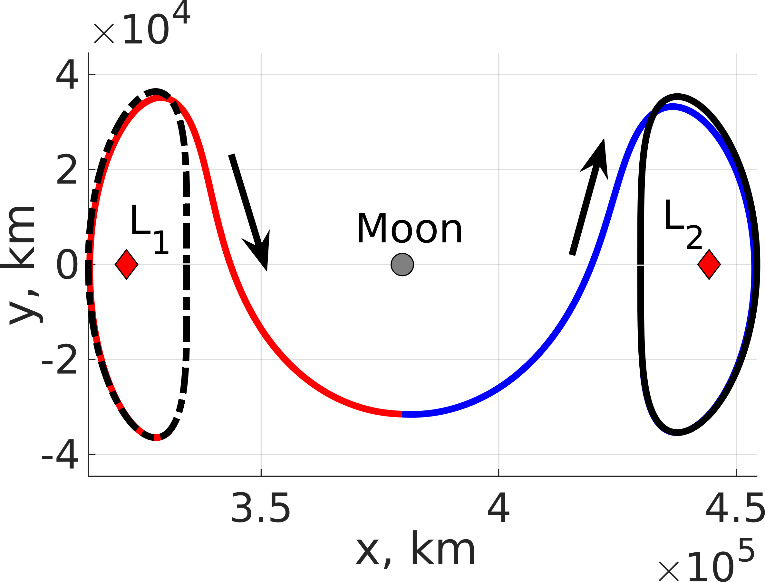

Figure 1: Members of the Earth-Moon L₁ Lyapunov and northern halo orbit families shaded by Jacobi constant.
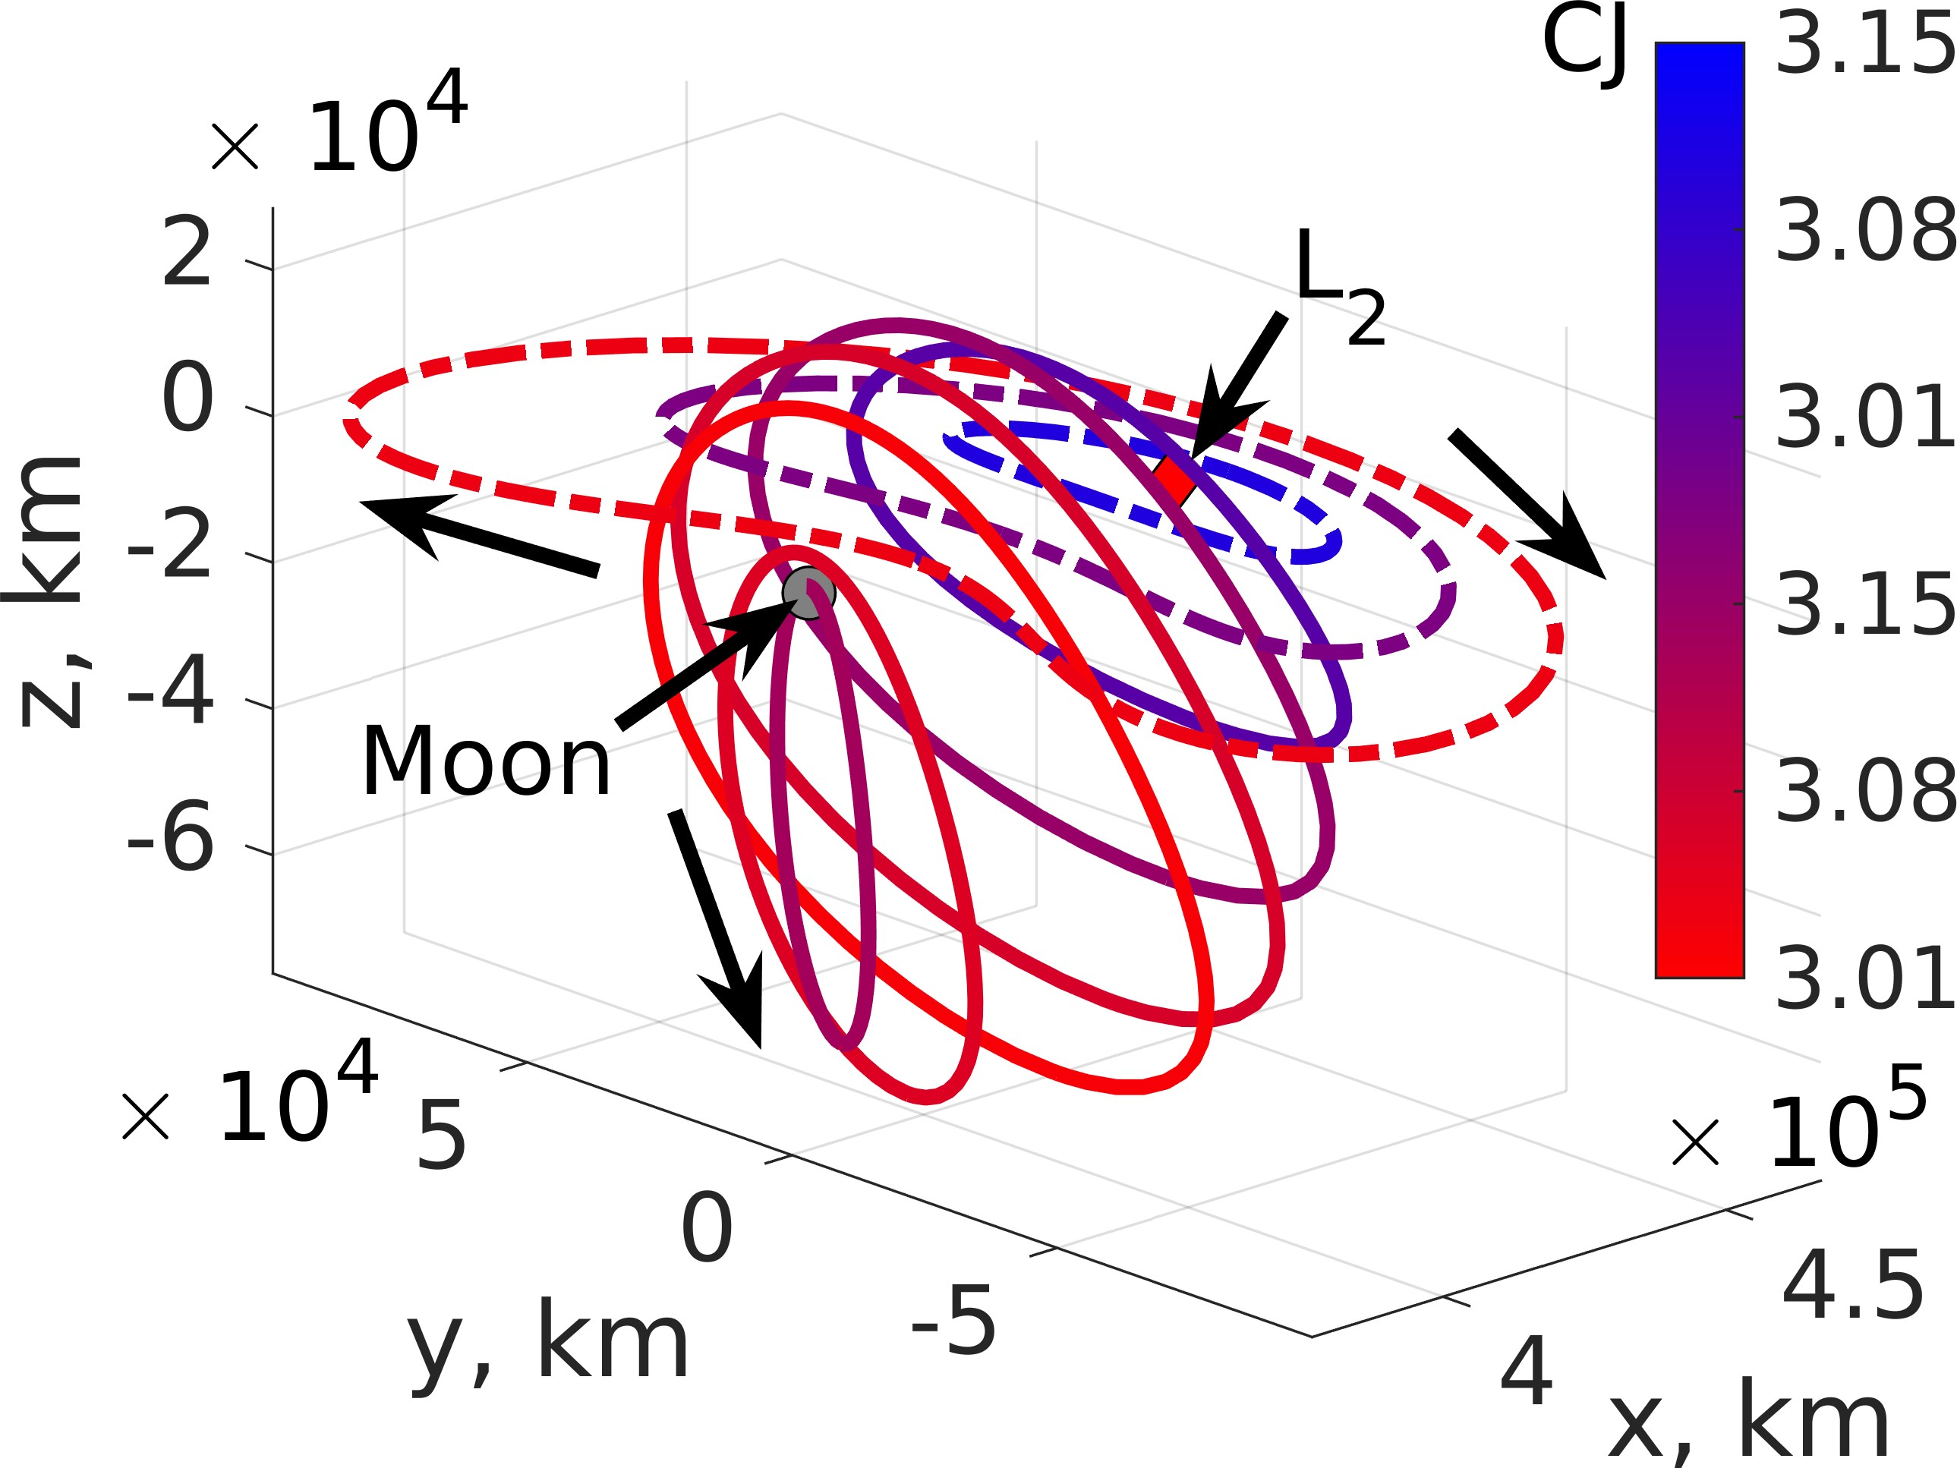

Figure 2: Members of the Earth-Moon L₂ Lyapunov and southern halo orbit families shaded by Jacobi constant.

orbits, and hyperbolic invariant manifolds [17]. A multi- body system described by the CR3BP admits five equilibrium points, denoted L₁-L₅, that exist throughout the system [19].
Figure 3: A natural, heteroclinic transfer from an L₁ Lya- punov orbit to an L₂ Lyapunov orbit.

depicted in Fig. 3 between L₁ and L₂ Lyapunov orbits with CJ = 3.15. In this figure, the initial L₁ Lyapunov orbit is displayed as a black dashed arc, the final L₂ Lyapunov orbit is plotted as a solid black arc, the trajectory on the unstable manifold associated with the L₁ Lyapunov orbit is represented in red, and the trajectory on the stable manifold of the L₂ Lyapunov orbit is shaded blue. These known solutions supply useful insight into the existence of natural transfers while manifold structures that do not exactly intersect may be postulated to lie close to a low-thrust transfer with limited propellant mass requirements.
Low-Thrust Propulsion in the CR3BP
The CR3BP equations of motion are modified to incorporate the acceleration imparted by the low-thrust propulsion system and the propellant mass usage. In this paper, the low-thrust propulsion system is modeled using three variable thrust, constant specific impulse, low-thrust engines with control authority along the xˆ, yˆ, zˆ axes. The acceleration supplied by the low-thrust engines is written as

In the CR3BP, various periodic orbit families exist near the
T
a¯ =
T
u xˆ +
x
T
u yˆ +
y
u zˆ

equilibrium points [17]. Of particular interest are the Earth-
z

ms/c ms/c

ms/c
(2)

Moon L₁ and L₂ equilibrium points, which possess favorable characteristics for the long-term placement of spacecraft;
= a_{x}xˆ + a_{y}yˆ + a_{z}zˆ

for instance, the Lunar Gateway is currently expected to be
where u¯ = [u , u , u ] is the control vector defined in the

located in a southern L₂ halo orbit [20]. In addition to
x y z

the southern L₂ halo orbit family, additional periodic orbit families of interest include the planar L₁ Lyapunov, planar L₂ Lyapunov, and northern L₁ halo families, which may serve as potential destinations for future missions operating in the cislunar regime. Figure 1 displays a subset of members from the L₁ Lyapunov and halo families using dashed and solid arcs respectively; each orbit is shaded corresponding to the orbit’s Jacobi constant. Figure 2 displays information for the associated L₂ orbit families using a similar configuration.
rotating frame; T is the thrust magnitude of each low-thrust engine, nondimensionalized using the spacecraft’s initial wet mass and system’s characteristic length and time; and m_{s/c} is the spacecraft mass, nondimensionalized by the initial wet mass [22]. The decrement in the spacecraft mass due to the propellant mass usage by the low-thrust engines is then recorded by the mass flow rate equation [22]. Then, the equations of motion for a low-thrust-enabled spacecraft in the Earth-Moon CR3BP are written as

Hyperbolic invariant manifolds of periodic orbits act as nat- ural transport mechanisms guiding trajectories approaching and departing the periodic orbits, and are often used in
∂U ∗
x: − 2y9 = ∂x + a_{x}
∂U ∗

∂U ∗
y: + 2x9 = ∂y + a_{y}
−T

(3)

trajectory design [17, 18, 21]. For a periodic orbit that pos-
sesses stable and unstable modes, trajectories on the unstable manifold asymptotically depart the orbit while trajectories on
z: =
∂z + a_{z}
m9 _{s/c} =
Ispg0

a stable manifold asymptotically approach the orbit [17]. Us- ing the stable and unstable manifold structures, heteroclinic connections may exist to connect two periodic orbits of equal energy [17]. One example of a heteroclinic connection is
where the specific impulse of the low-thrust engines is de- noted by I_{sp} and g₀ is the gravitational acceleration measured at the surface of the Earth [22]. Implementing the differential equations in a DRL environment enables policies to learn

behavior that maximizes the long-term reward for a low- thrust-enabled spacecraft subject to the dynamics of a multi- body system.

  - DEEP REINFORCEMENT LEARNING
In the astrodynamics community, DRL has recently been applied to a variety of optimization problems including within multi-body trajectory design scenarios [6–9, 14]. DRL algo- rithms are a type of RL algorithm that use deep neural net- works to learn the optimal state-action relationship for an en- vironment and set of objectives [23]. The mathematical repre- sentation for the set of objectives for a scenario is designated as the reward function, whereby higher rewards correspond to more desirable behavior. Generally, RL algorithms use an agent to explore an unknown environment by performing actions at states and collecting rewards based on those state- action pairs and a defined reward function [24, 25]. The goal of the algorithm is to maximize the long-term reward, math- ematically defined as the value function for the environment [26]. DRL methods leverage deep neural networks as uni- versal function approximators because deep neural networks are able to learn the complex, high-dimensional state-action relationships within an environment much more robustly and efficiently than traditional RL techniques [27]. As a result, DRL techniques may be applied to a variety of applications to successfully uncover optimal behavior [23, 28]. One DRL technique that demonstrates favorable convergence properties in sensitive, chaotic environments is Proximal Policy Opti- mization (PPO), which trains a single policy to map optimal actions to every state within the environment [29–31]. PPO incorporates a soft constraint on the size of the updates to the policy, which inhibits large updates from destabilizing the policy. In chaotic environments, limiting the update size pro- vides more robust and stable convergence properties. Then, MRPPO, a recently developed MODRL algorithm, uses PPO as a foundation within a multiple reward function framework. MRPPO retains PPO’s advantageous convergence properties in chaotic environments and enables multiple policies, each with distinct reward functions, to be trained simultaneously, thereby reducing the required computational resources and training time.
Multi-Reward Proximal Policy Optimization
MRPPO trains multiple policies, each assigned a distinct re- ward function corresponding to a unique prioritization of ob- jectives, by sharing the environmental data across all policies [6]. The environmental data encompasses the state-action propagation data from the dynamical model generated via numerical integration; in multi-body environments, this step often commands a significant portion of the total training time for a policy. To reduce the required computation time when training multiple policies, the propagation data generated by one policy is shared at the moment it is generated with multi- ple other policies. Then, each policy may generate the unique reward for that shared state-action pair, allowing policies to efficiently learn distinct behaviors within the environment. Sharing the propagation data aids exploration for all policies within the environment, and tends to produce more stable behavior within each policy [6]. Figure 4 depicts a conceptual representation of MRPPO. N policies, denoted π_{i} for i = [1, . . . , N ], each control k_{i} agents within the environment with reward functions r_{i,t}(s¯_{t}, u¯_{t}) [6]. At each time step, the policy receives the current state of an agent, s¯_{t} and outputs an action to perform at that state, u¯_{t}. The dynamical model, i.e. the low-thrust-enabled CR3BP, is used to propagate that state- action pair forward in time to generate a new state, s¯_{t+1}. The

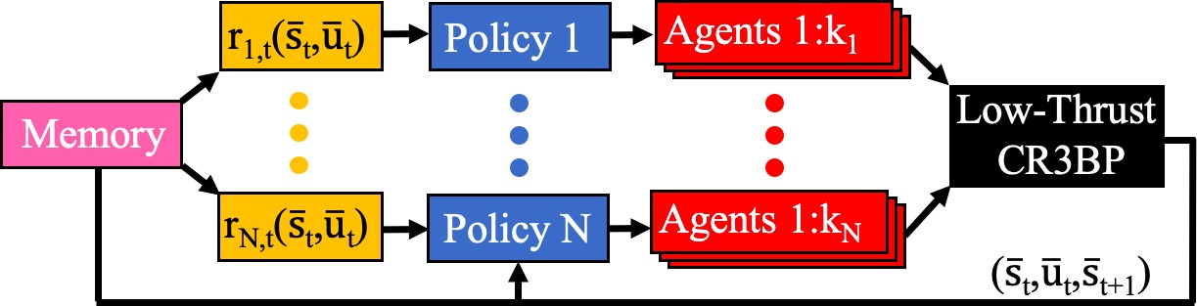
Figure 4: MRPPO training N policies with k_{i} agents and re- ward functions r_{i,t}(s¯_{t}, u¯_{t}) within a shared dynamical model.

state-action transition is saved within a shared memory for all policies and delivered back into the policies to develop a new action to perform. Once a defined number of state-action pairs have been collected, the state-action pairs are used to compute the rewards for each policy’s reward function. A policy is then updated using the unique state-action-reward experiences, and this process is continued until a termination condition is reached; in this paper, termination is defined using a specified number of updates.
Several hyperparameters govern MRPPO and influence the resulting behavior of the policies. In particular, the low- thrust-enabled CR3BP is a chaotic environment; thus, the hyperparameters must be selected to facilitate stable and steady learning for the policies while also exploring. Table 2 displays the selected hyperparameters used in this investiga- tion; these values are selected using the results of a hyper- parameter grid search conducted by Sullivan and Bosanac for MRPPO in a multi-body trajectory design scenario; these hyperparameter values demonstrated stable training behavior in a chaotic environment [6]. Additionally, the policies are modeled using two deep neural networks in an actor-critic structure. In an actor-critic structure, the actor neural network learns the optimal mapping of actions to states for the envi- ronment and defined reward function while the critic neural network learns the states in the environment that produce the highest long-term reward [32]. Further, deep neural networks act as universal function approximators possessing robust convergence properties for recovering highly abstract state- action mappings in complex dynamical environments while also guaranteeing the recovery of locally optimal behavior. The deep neural networks are initialized with no knowledge of the dynamical model nor the assigned reward function; they must update their weights using the state-action-reward experiences gathered from the environment. In this paper, the actor and critic neural networks for each policy are structured using the parameters outlined in Table 3 [6], [31]. Using MRPPO, multiple policies modeled using deep neural net- works are trained on a multi-body trajectory design scenario to produce locally optimal behavior for a set of defined reward functions.

  - RECOVERING TRANSFERS USING MRPPO
MRPPO is used to uncover a region of the the solution space for three trajectory design scenarios in the Earth-Moon CR3BP. Specifically, eight policies are trained within each scenario to guide a low-thrust-enabled SmallSat towards a target periodic orbit. In this investigation, several implemen- tation factors influence the training of the policies for each scenario, such as the state definition, action definition, re- ward function formulation, weights of conflicting objectives, SmallSat parameters, and the reference trajectory.

Table 2: Selected MRPPO Hyperparameters.

Hyperparameter | Value
Environmental Steps, τ | 4096
Epochs, E | 5
Mini Batches, M | 4
Discount Factor, γ | 0.95
GAE Factor, λ | 0.85
Clipping Parameter, ε | 2 × 10⁻³
Value Function Coefficient, c₁ | 0.5
Entropy Coefficient, c₂ | 1 × 10⁻⁴
Learning Rate, l_{r} | 1 × 10⁻⁴
Maximum Gradient Norm, c_{max} | 0.5
Table 3: Structure of the Neural Networks.
geometry, the reward function is formulated as
r_{t}(s¯_{t}, u¯_{t}) = −10κ(s¯_{t})|∆d¯t+1|−κ(s¯_{t})|∆v¯_{t+1}|
− c_{m}(m_{s/c}(t) − m_{s/c}(t + ∆t)) + Ω (5)
Using this structure, the first and second terms capture the state difference objectives, the third term measures the pro- pellant mass usage due to the most recent action, u¯_{t}, and the final term, Ω, is associated with activating the termination conditions. A reference trajectory, assembled from natural arcs in the Earth-Moon CR3BP, is used within each scenario to aid the policies in learning low-thrust, propellant-optimal paths between periodic orbits [21]. However, incorporating a reference trajectory does bias the policies to learn the given transfer geometry and precludes the policies from learning other transfer geometries. Three termination conditions and associated values of Ω exist for each scenario: (1) the space- craft drifts further than 10,000 km away from any state along the initial orbit, final orbit, or reference trajectory where Ω = 100, (2) the maximum number of time steps for a trajectory, set as 300 steps or equivalently, 39.08 days, is reached such that Ω = 0, and (3) the spacecraft approaches within 384 km and 5 m/s of the closest state in position space along the final orbit where Ω = 1, 000. The state coefficient, κ(s¯_{t}), is a piecewise function dependent upon whether the closest state to the spacecraft is along the initial orbit, reference trajectory,
−
Parameter | Value
Actor Hidden Layers | 2
Actor Hidden Nodes per Layer | 64
Critic Hidden Layers | 2
Critic Hidden Nodes per Layer | 1024
Weight Initialization Scheme | Orthogonal
Activation Function | Hyperbolic Tangent

or final orbit. This coefficient is formulated as
100 Initial Orbit

100 100(K.€−1)
K−1
κ(s¯_{t}) =
−
Reference Trajectory

State and Action Definitions
Using MRPPO, policies are trained to construct mappings for locally optimal actions at every state in the environment. The selected actions maximize the long-term reward within the environment for the assigned reward functions. First, the state is defined as
s¯_{t} = [d¯t, v¯_{t}, m_{s/c}, ∆d¯t, ∆v¯_{t}] (4)
and is composed of the spacecraft’s current state and ∆d¯ and
∆v¯, the differences in the position and velocity components between the spacecraft’s state and the closest state along the reference trajectory or periodic orbits. Then, the generated action vector, u¯_{t}, for the spacecraft is a 3 1 vector with components constrained to have a magnitude less than or equal to 1 and specifying the thrust vector for each engine in the Earth-Moon rotating frame. If the policies output an action vector with any components that possess a magnitude larger than 1, that component is scaled down to either -1 or
×
- The action vector is scaled using the maximum available thrust of each engine and assumed to be constant in the Earth- Moon rotating frame while being used as the control for the spacecraft. This state-action pair is propagated forward in time in the low-thrust-enabled CR3BP for ∆t = 3 10⁻²
×
nondimensional time units, or approximately 3 hours.
Reward Function Formulation
The reward function formulation for a trajectory design scenario must accurately capture the objectives and goals inherent to the multi-objective optimization problem. In this paper, the objectives include minimizing the position and velocity differences with respect to the initial orbit, final orbit, and potentially discontinuous reference trajectory while also minimizing propellant mass usage and flight time; these objectives often conflict [33,34]. To guide the spacecraft from the initial orbit to the final orbit using a transfer with a specific
1 Final Orbit
where the second leg of the function is an exponential-like decrease from 100 to 1, K is set to 1000, and £ is the index of the state drawn from the reference trajectory divided by the total number of states along the reference trajectory. The piecewise nature of the function encourages the SmallSats to transfer from the initial orbit to the final orbit without biasing the policies to depart immediately if the SmallSat is not in the vicinity of the reference trajectory. Further, the periodic orbits are each discretized into 1,000 states equally spaced in time while the states along the reference trajectory are drawn every 1E-4 nondimensional time units, enabling the spacecraft to measure the state differences to within a small error. This reward function formulation admits a multi- objective trade space whereby decreasing the position or velocity difference requires propellant mass usage.
To train policies that recover distinct behavior within this multi-objective solution space, the coefficient of the pro- pellant mass usage term in the reward function is varied between policies. By increasing the coefficient, the policies are encouraged to conserve propellant mass at the expense of larger position and velocity differences. Specifically, the mass coefficients for the eight policies are selected as c_{m} = [0, 4, 8, 12, 16, 20, 24, 28]. In each trajectory design scenario, Policy 1 corresponds to c_{m} = 0 with no penalty on propellant mass usage while Policy 8 corresponds to c_{m} = 28, with the highest penalty on propellant mass usage. The values for the mass coefficient are selected to approximately scale the magnitude of the propellant mass usage term in the reward function to be on the order of the other reward function terms, 10⁰. Then, the policies are trained to guide a low- thrust-enabled SmallSat from the initial orbit to the final orbit while learning behavior that maximizes their assigned reward functions, enabling exploration of the multi-objective solution space.

Table 4: Characteristics of the Transfer Design Scenarios.

Scenario | Bounding Orbits | CJ
#1 | From: L₁ Lyapunov  To:L₂ Lyapunov | 3.15  3.15
#2 | From: L₁ Northern Halo  To: L₂ Southern Halo | 3.11  3.11
#3 | From: L₁ Northern Halo  To: L₂ Southern Halo | 3.15  3.11

Spacecraft Initialization
In this paper, the spacecraft is modeled as a 180 kg ESPA-class SmallSat equipped with three low-thrust engines aligned with the axes of the Earth-Moon rotating frame. Each engine is assumed to possess variable thrust capabilities with a maximum available thrust of T = 0.5 N and a constant specific impulse of I_{sp} = 3000 s. Thus, the maximum available thrust for the spacecraft is T_{max} = 0.866 N. Additionally, throughout training, the initial conditions for the spacecraft are randomly drawn from anywhere along the initial orbit to facilitate developing robust controls schemes. Then, perturbations are drawn from a Gaussian distribution with zero mean and a standard deviation of 1E-3 nondimen- sional units; these perturbations are added to the position and velocity components of the initial condition to reflect off-nominal deployment conditions. Once the policies are trained, they are evaluated on a common set of 1,000 per- turbed initial conditions for each trajectory design scenario to facilitate comparisons between each policy and characterize each control scheme.
Trajectory Design Scenarios
Three transfer scenarios in the Earth-Moon CR3BP are de- fined using distinct combinations of initial and final periodic orbits: (1) an L₁ Lyapunov orbit to an L₂ Lyapunov orbit with equal values of the Jacobi constant, (2) an L₁ northern halo orbit to an L₂ southern halo orbit with equal values of the Jacobi constant, and (3) an L₁ northern halo orbit to an L₂ southern halo orbit with distinct values of the Jacobi constant. Table 4 displays the Jacobi constant for the initial and final periodic orbits in each transfer scenario. In the first instance, the reference trajectory uses a continuous heteroclinic connection. This reference also serves as a veri- fication for demonstrating that MRPPO may recover multiple policies with minimal propellant mass usage. In the second and third scenarios, no direct, heteroclinic connection exists. Thus, the reference trajectory is defined using a discontinuous initial guess formed using arcs along the unstable and stable manifolds associated with the initial and final orbits; these arcs intersect in position, but not in velocity at a hyperplane defined as Σ : x = 1 µ. Incorporating natural manifold arcs into the reference trajectory encourages the policies to produce paths with minimal propellant usage between the two orbits within the Earth-Moon CR3BP [21]. However, using manifold arcs to construct a reference trajectory that guides the policies does bias the resulting solutions and, therefore, limit the region of the multi-objective space that is examined.
−

5. RESULTS
Eight policies are trained using MRPPO to develop distinct controls schemes for a low-thrust-enabled SmallSat transfer-
ring between periodic orbits in the Earth-Moon system. Each policy is assigned a reward function that uniquely balances the objectives for the multi-objective solution space. Once the policies are trained, they are evaluated on a common set of 1,000 initial conditions, randomly drawn along the initial periodic orbit with additional induced perturbations in their position and velocity components. Then, the solution space is developed by computing the mean characteristics of each evaluated trajectory for each policy. Specifically, the relationship of the propellant mass usage and the position and velocity differences between the evaluation trajectory and the reference states, ∆d¯ and ∆v¯ , is examined to explore the recovered regions of the multi-objective trade space for each scenario. Additionally, the unique behavior recovered by select policies is analyzed to generate insights into the multi-modal nature of the high-dimensional, multi-objective solution space.
Lyapunov Orbit Transfers
| | | |
The first trajectory design scenario is designed to verify that MRPPO successfully trains policies that efficiently guide SmallSats along a transfer between periodic orbits in the Earth-Moon system. In this scenario, two Lyapunov orbits are connected via a heteroclinic connection, which also serves as the reference trajectory for the policies. While a natural transfer does exist between these two orbits, the policies are expected to use propellant mass to: (i) correct the state discontinuities caused by the perturbed initial conditions, (ii) transfer from the periodic orbits to and from the heteroclinic connection, and (iii) decrease the flight time when possible. Additionally, transitioning the trajectories to higher-fidelity dynamical models would likely require these small correc- tions. Then, the trained policies are evaluated on a fixed set of perturbed initial conditions. The resulting trajectories for Policies 1 and 8 are depicted in Figs. 5a and 5b. In these figures, the initial L₁ Lyapunov orbit, final L₂ Lyapunov orbit, and reference trajectory are denoted by black arcs while the evaluation trajectories are shaded in a variety of hues to aid in differentiation. The trajectories associated with Policies 1 and 8 demonstrate distinct behavior with respect to how closely the trajectories follow the reference trajectory, which is further evidenced by examining the relationship between the state discontinuities and the propellant mass usage. Figure 6a depicts the relationship between the pro- pellant mass usage and position difference of the spacecraft measured with respect to the closest state along either the initial orbit, final orbit, or reference trajectory. In this figure, the circles are shaded according to their respective policy and denote the mean propellant mass usage and mean position difference across all 1,000 evaluation trajectories while the bars represent the minimum and maximum values for any single trajectory. Across the policies, the propellant mass usage tends to decrease as the position difference increases which is attributable to the policies possessing distinct mass coefficients in their reward functions. This relationship is also exhibited in Fig. 6b, which displays the relationship between the propellant mass usage and velocity difference using the same configuration as Fig. 6a. The policies produce trajectories that require less than 1.25 kg of propellant mass to perform this transfer, but the majority of transfers require
  - kg to 2 kg of propellant mass.
The trajectory with the largest perturbation from the initial L₁ Lyapunov is selected to examine the unique behavior developed by Policies 1 and 8. The selected trajectories for Policies 1 and 8 are displayed in Figs. 7a and 7b where the trajectories are shaded blue, the thrust actions are represented by red arrows, and the initial orbit, final orbit, and reference

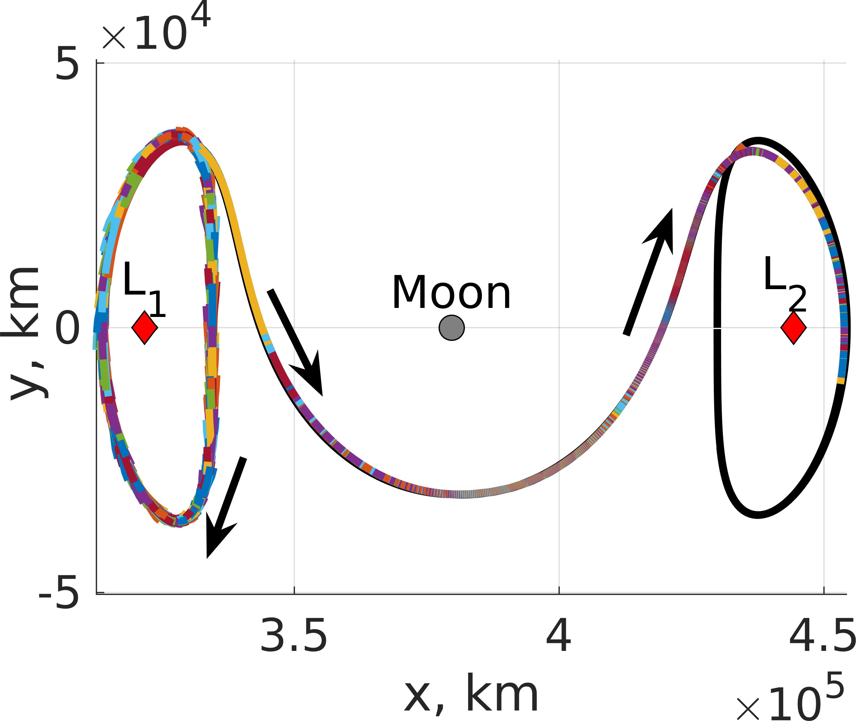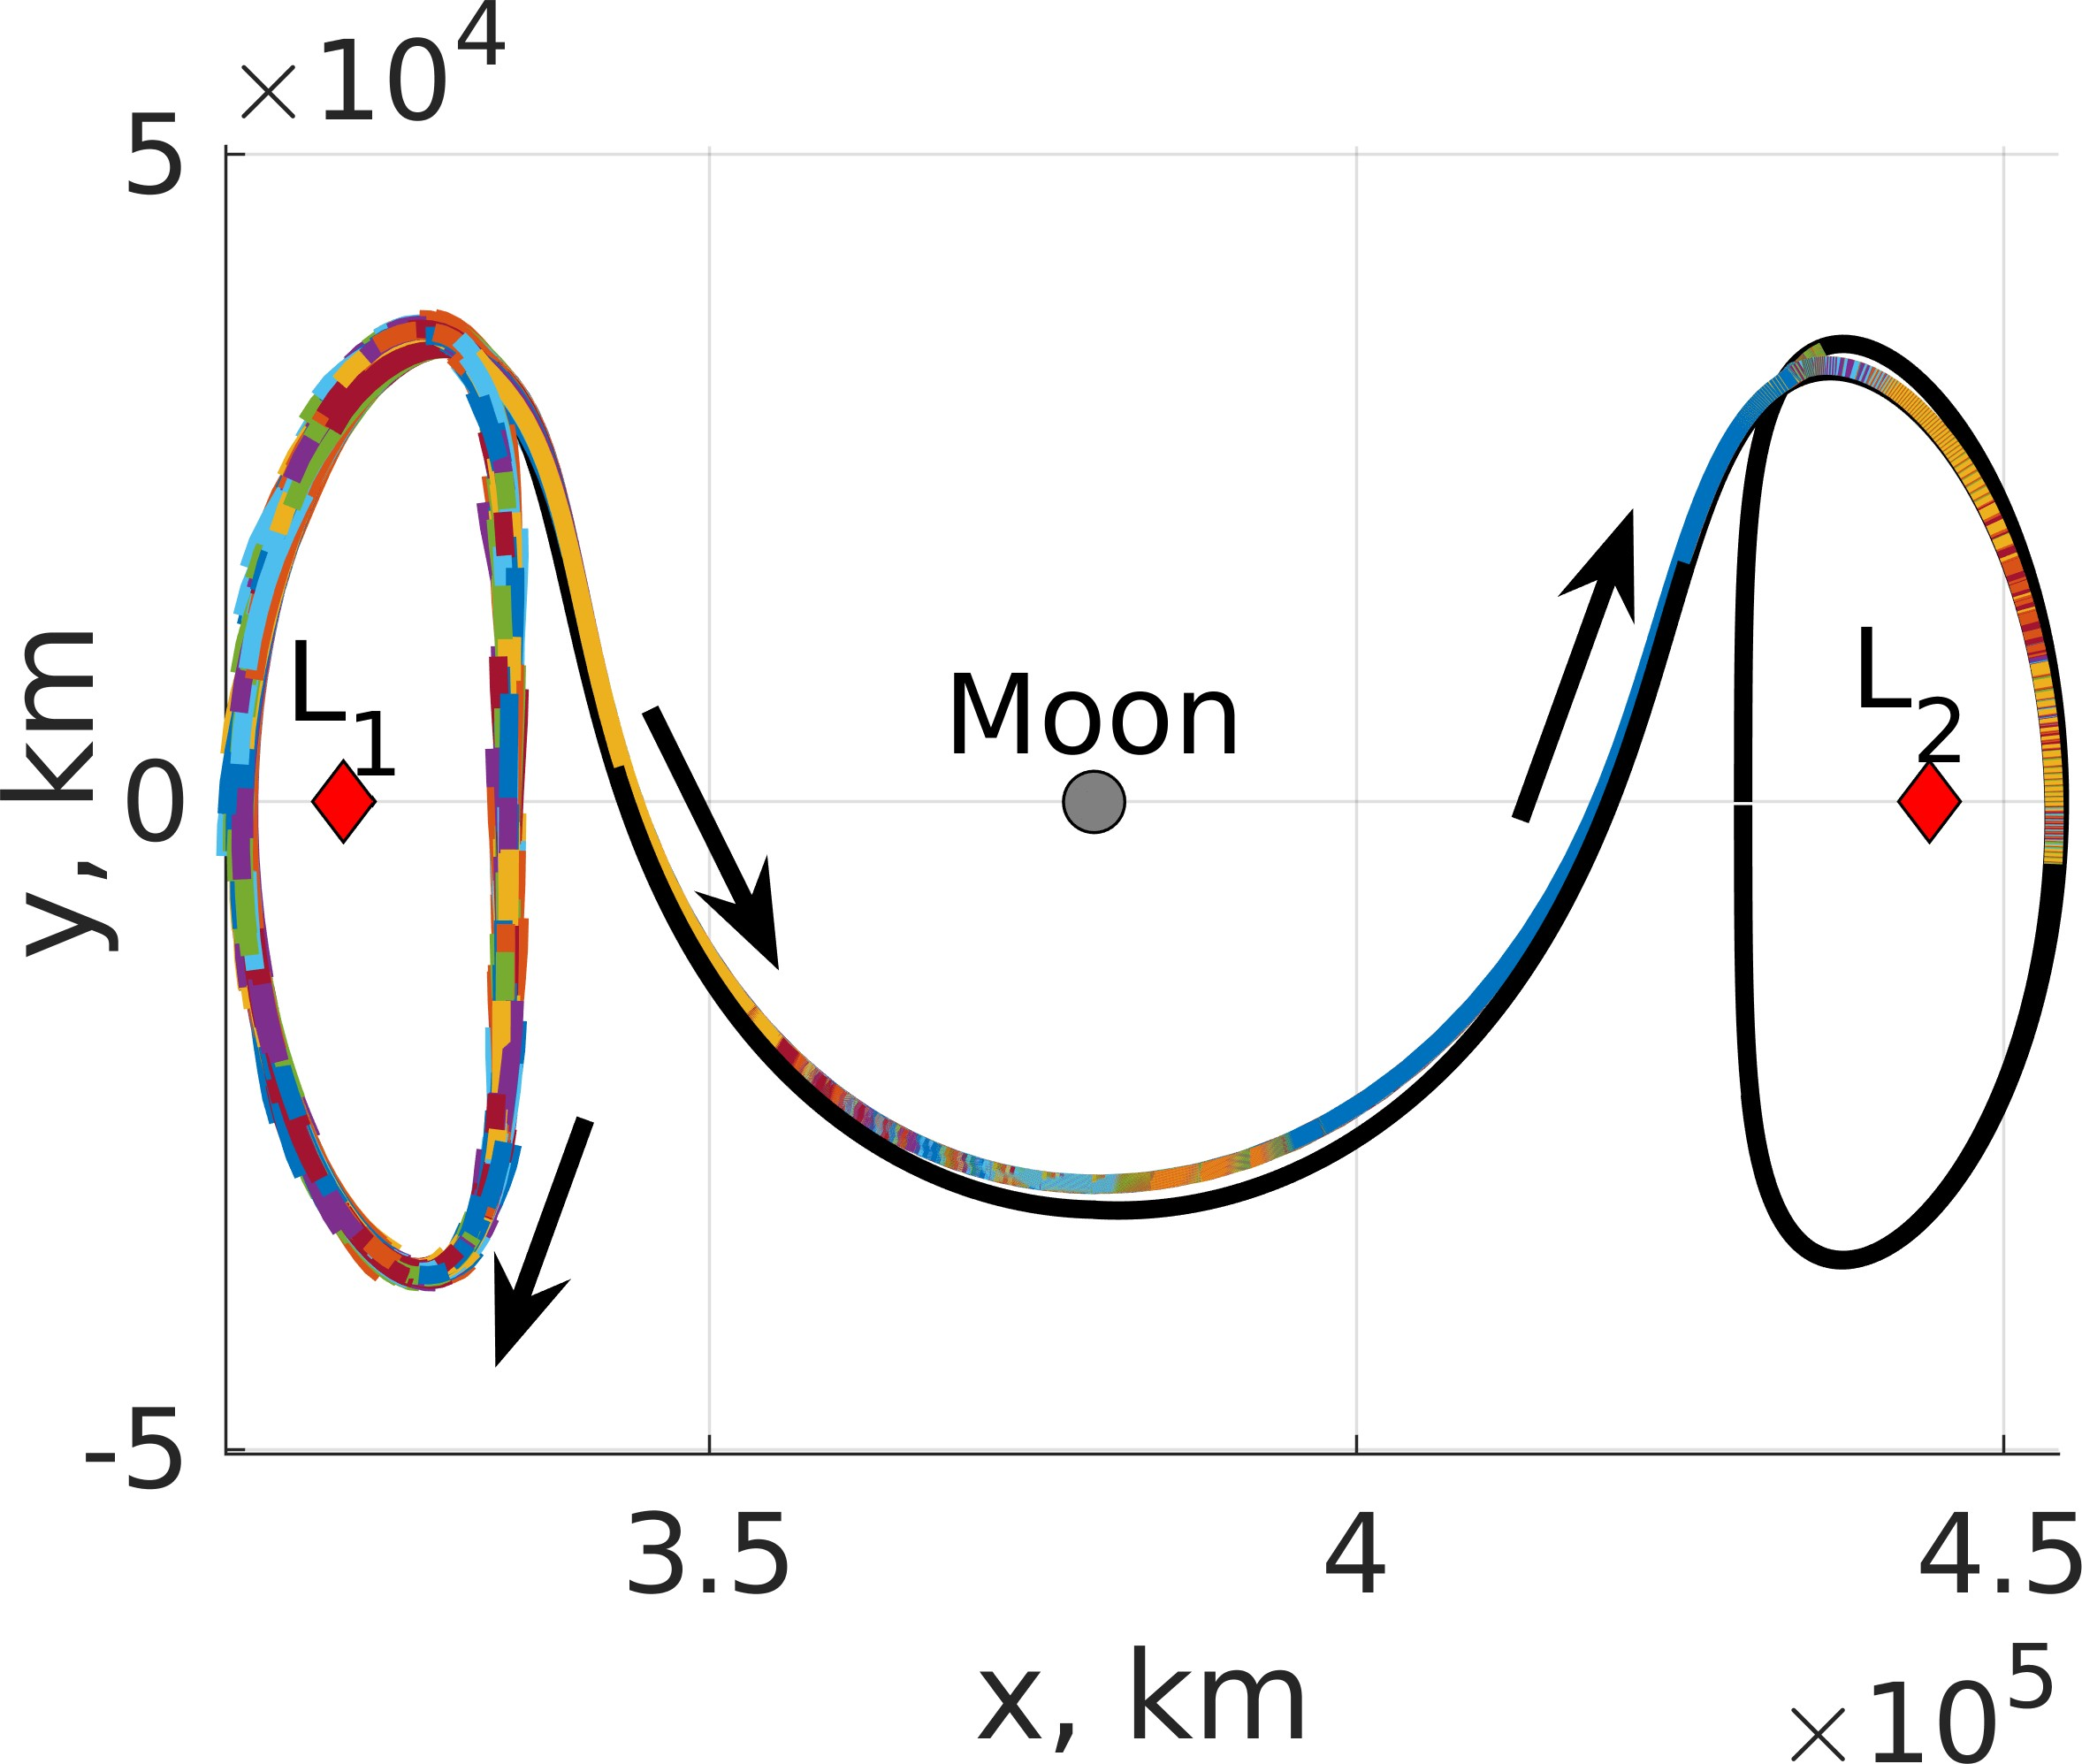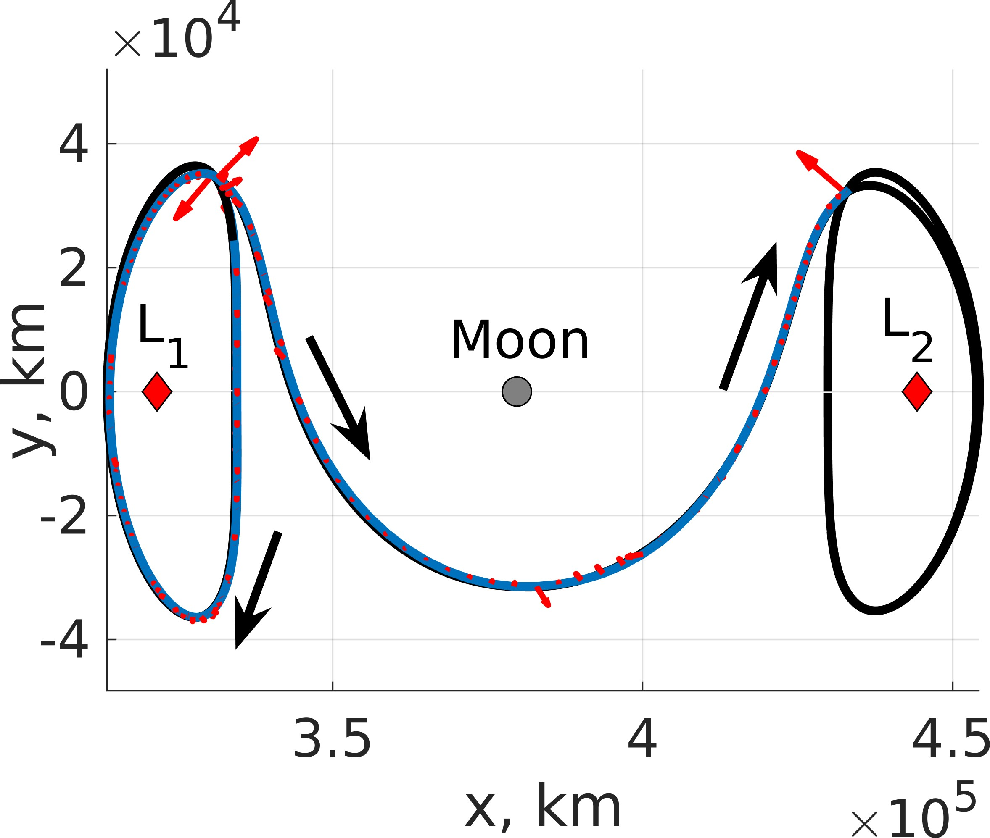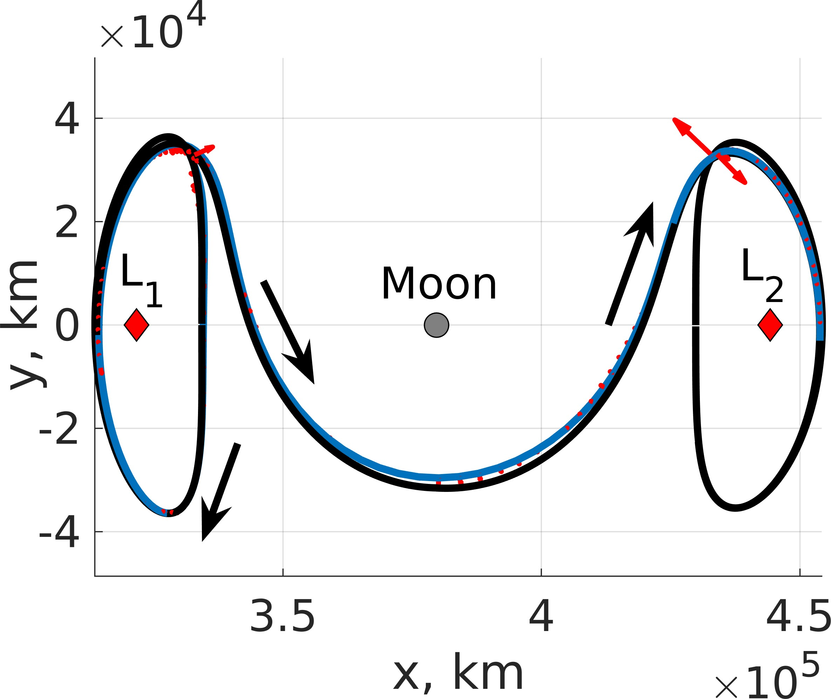

    - Policy 1 Trajectories (b) Policy 8 Trajectories

Figure 5: 1,000 evaluation trajectories departing an L₁ Lyapunov orbit to an L₂ Lyapunov orbit with an equal Jacobi constant controlled using: (a) Policy 1 and (b) Policy 8.
      - Policy 1 (b) Policy 8

Figure 7: Trajectory from a highly perturbed initial condition departing an L₁ Lyapunov orbit to an L₂ Lyapunov orbit with an equal Jacobi constant controlled using: (a) Policy 1 and (b) Policy 8.

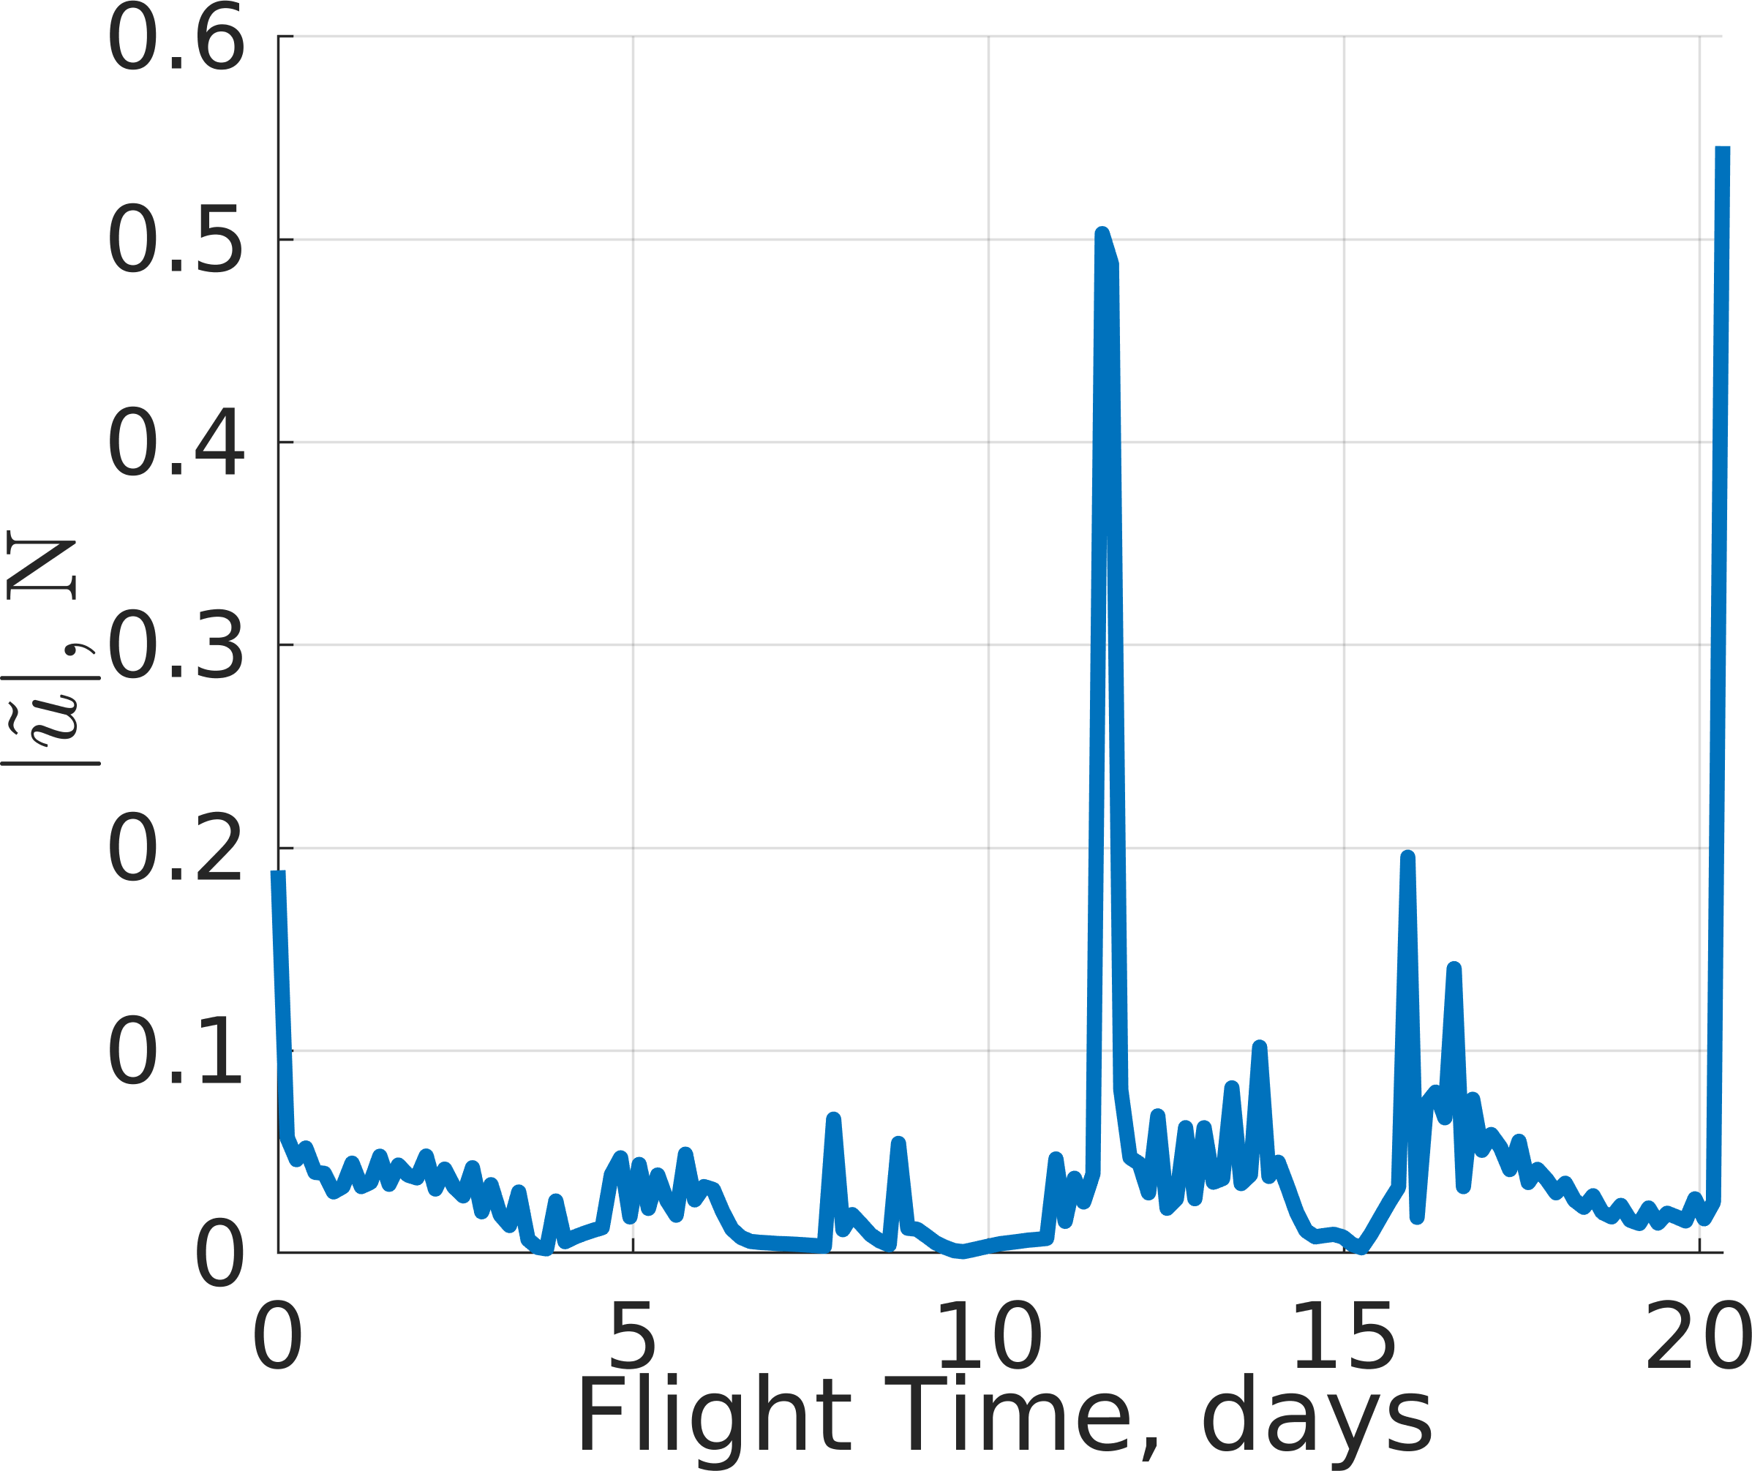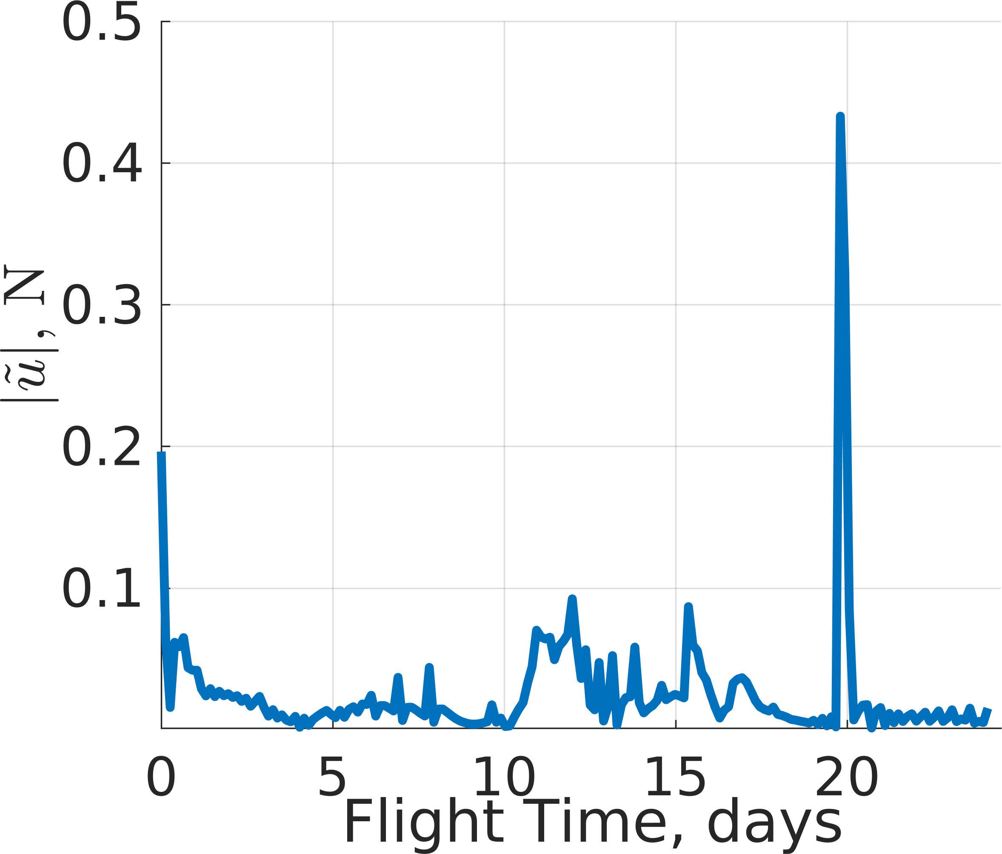

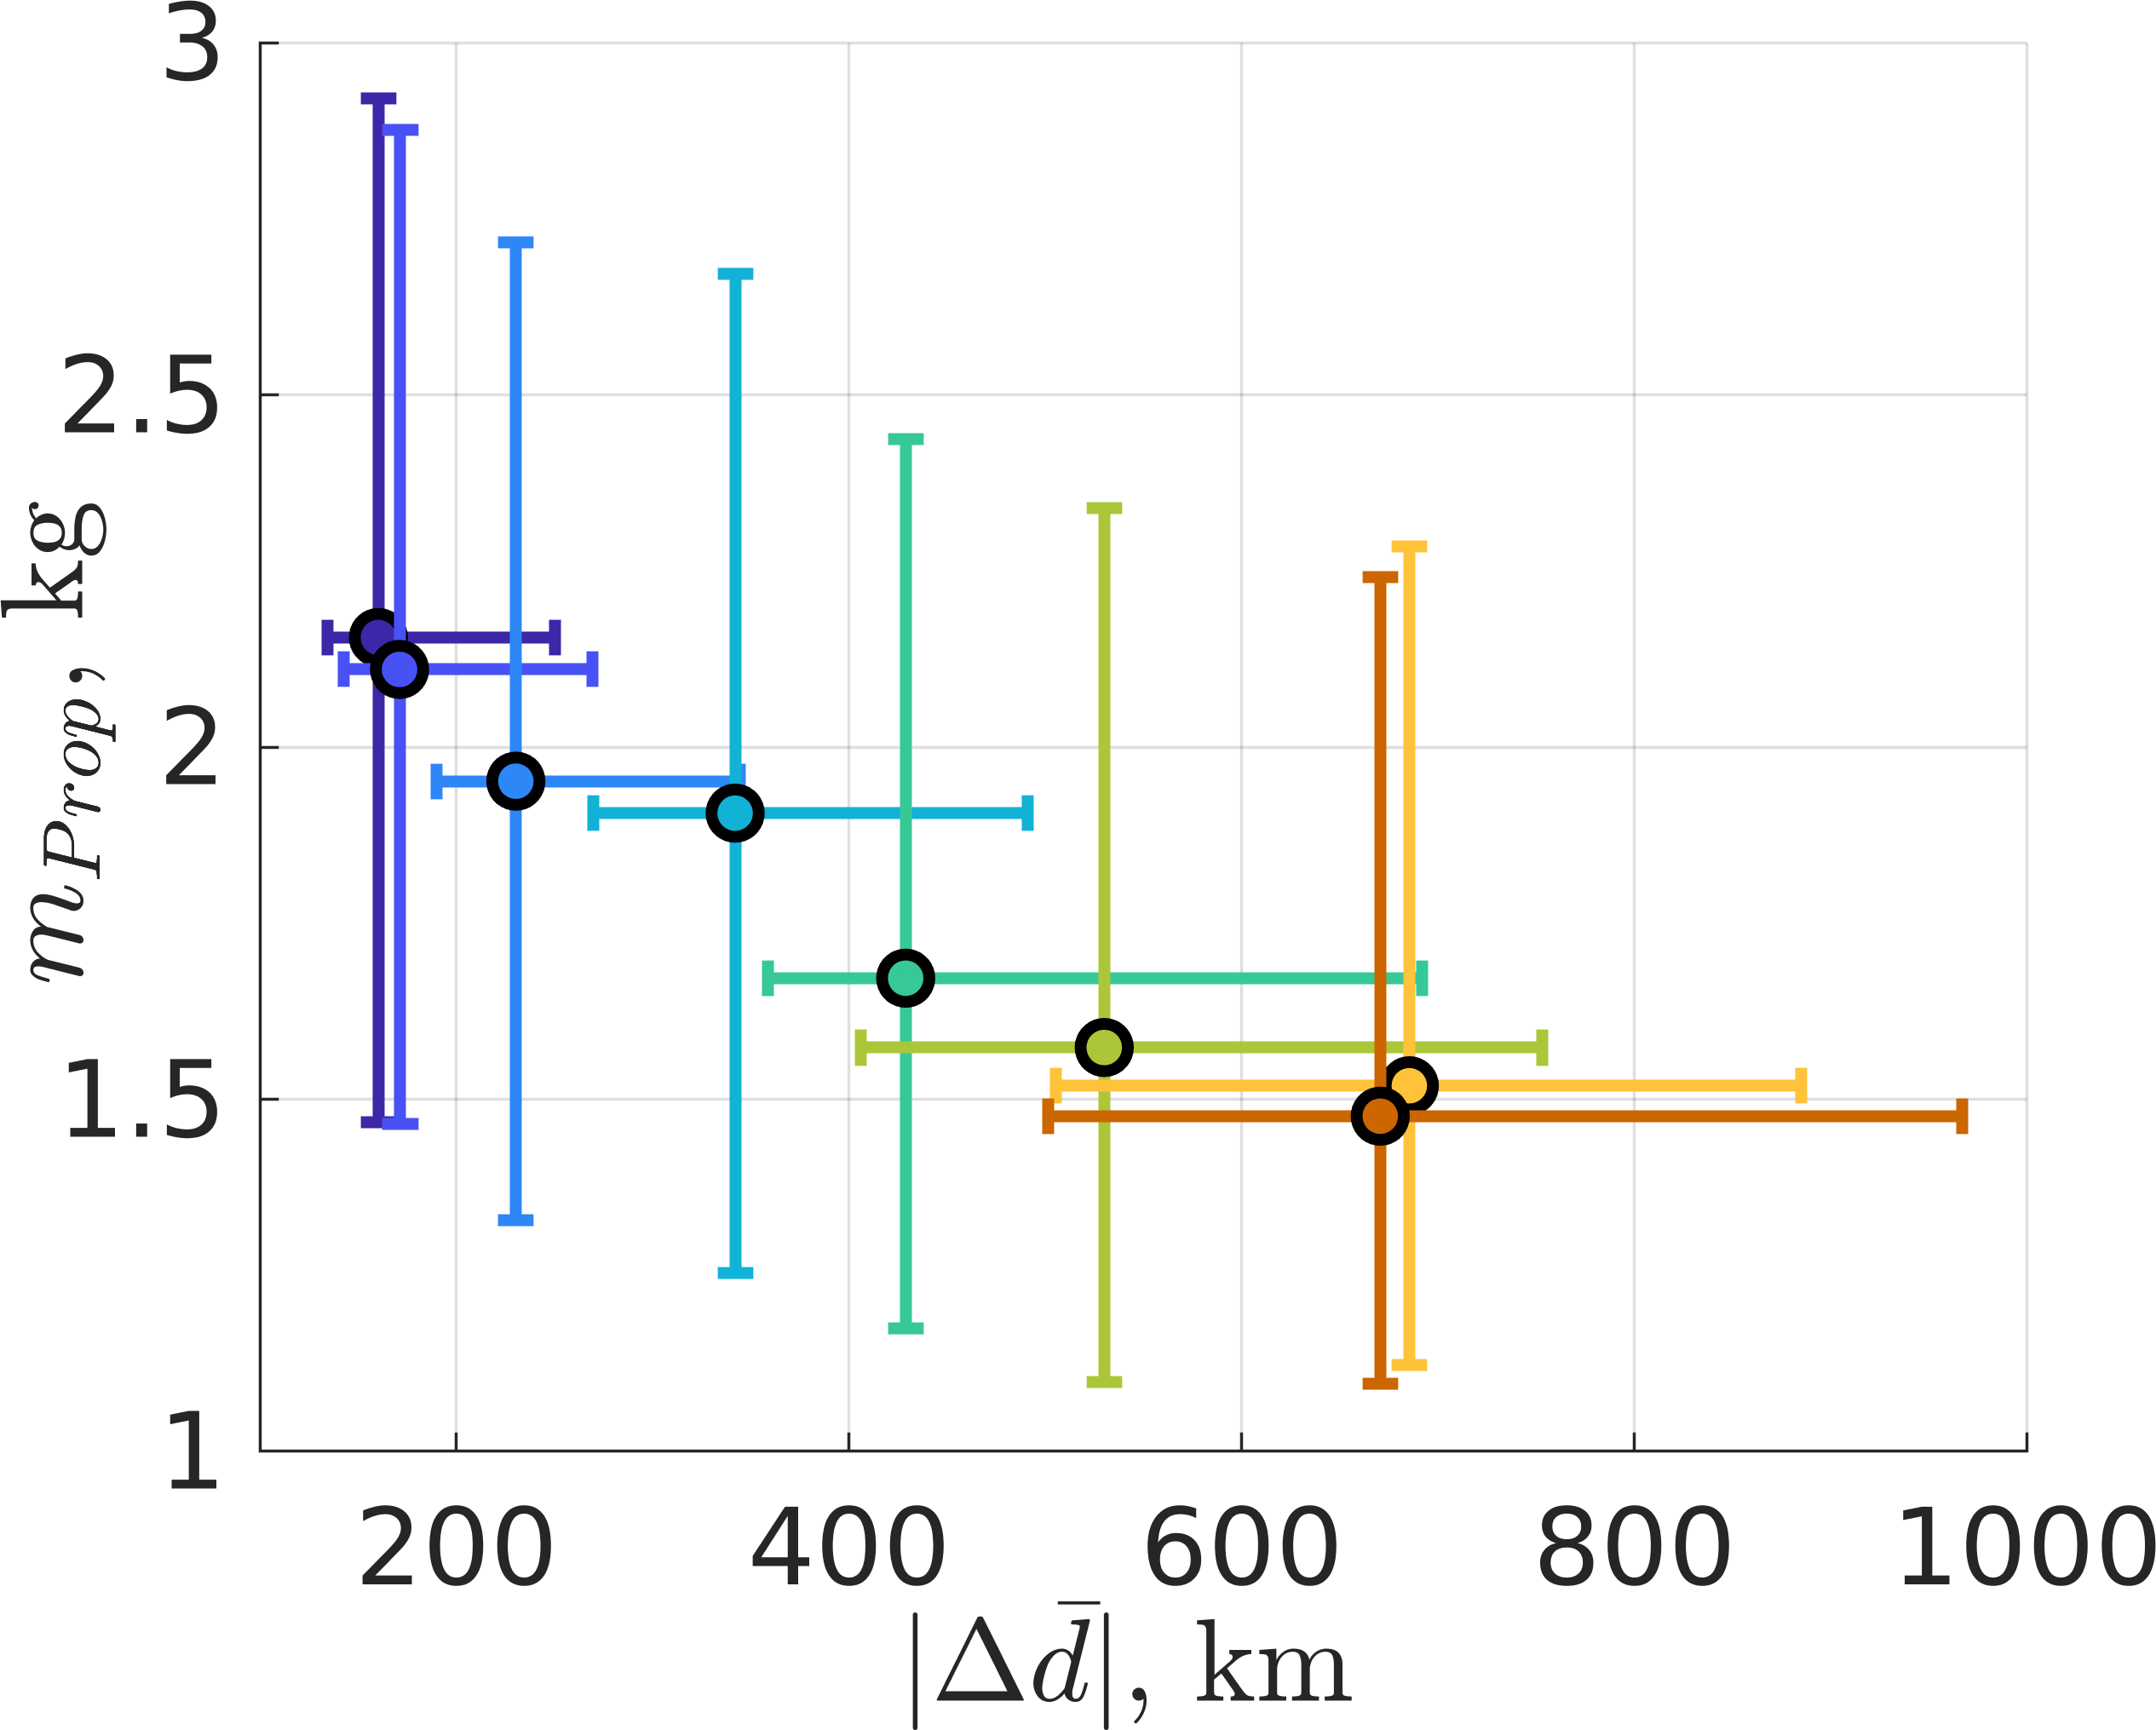
- Propellant Mass Usage vs. Position Difference

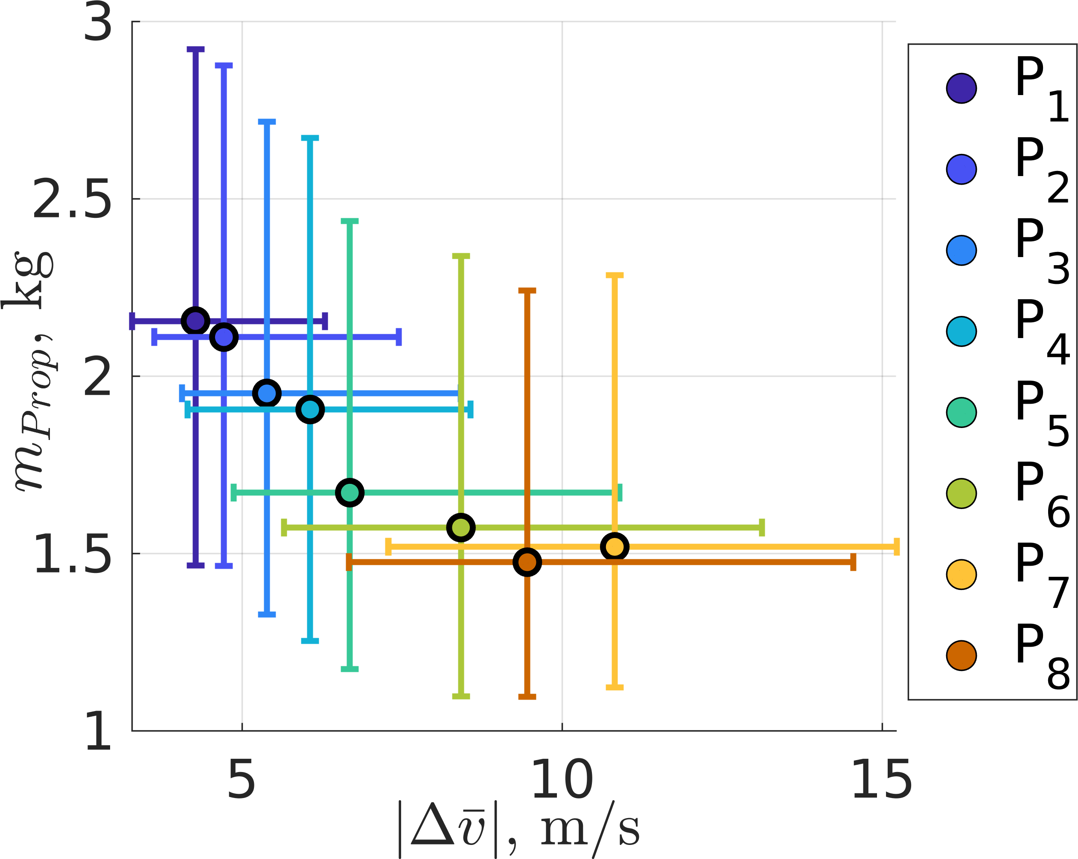
- Propellant Mass Usage vs. Velocity Difference
  - Policy 1 (b) Policy 8

Figure 8: Thrust magnitude along an evaluation trajectory

Figure 6: Relationship between the state discontinuities and propellant mass usage for the L₁ Lyapunov to L₂ Lyapunov transfer.

trajectory are denoted with black arcs. Both policies perform actions at the locations where the reference trajectory inter- sects the periodic orbits. Figures 8a and 8b depict the thrust magnitude throughout the trajectory for each policy: both policies tend to perform small actions except at the critical points along the trajectory. Further, when the spacecraft intersects the final periodic orbit in position space, Policy 1, which has no penalty for propellant mass usage, immediately performs a large action to correct the velocity difference and reach the termination hyperspheres. Conversely, Policy 8, which has the largest penalty for propellant mass usage, follows the final periodic orbit for a longer time allowing the natural dynamics and low-thrust engines to gradually decrease the state discontinuities. Figures 9 and 10 display the difference in the position and velocity components along the trajectories measured with respect to the closest state in position space along the final orbit for Policy 1 and 8, respectively. In these figures, the black dashed lines represent the values for the termination hypersphere: 384 km for the position difference and 5 m/s for the velocity difference. Both trajectories successfully intersect the termination hy- perspheres, but with distinct behavior. These figures further demonstrate that Policy 1 successfully uses a large thrust action to intercept both the position and velocity difference hyperspheres simultaneously. However, Policy 8 converges to the position difference hypersphere once before re-entering the position difference hypersphere after the natural dynamics enabled the trajectory to approach the velocity difference hypersphere without large thrust actions.
commanded using: (a) Policy 1 and (b) Policy 8.

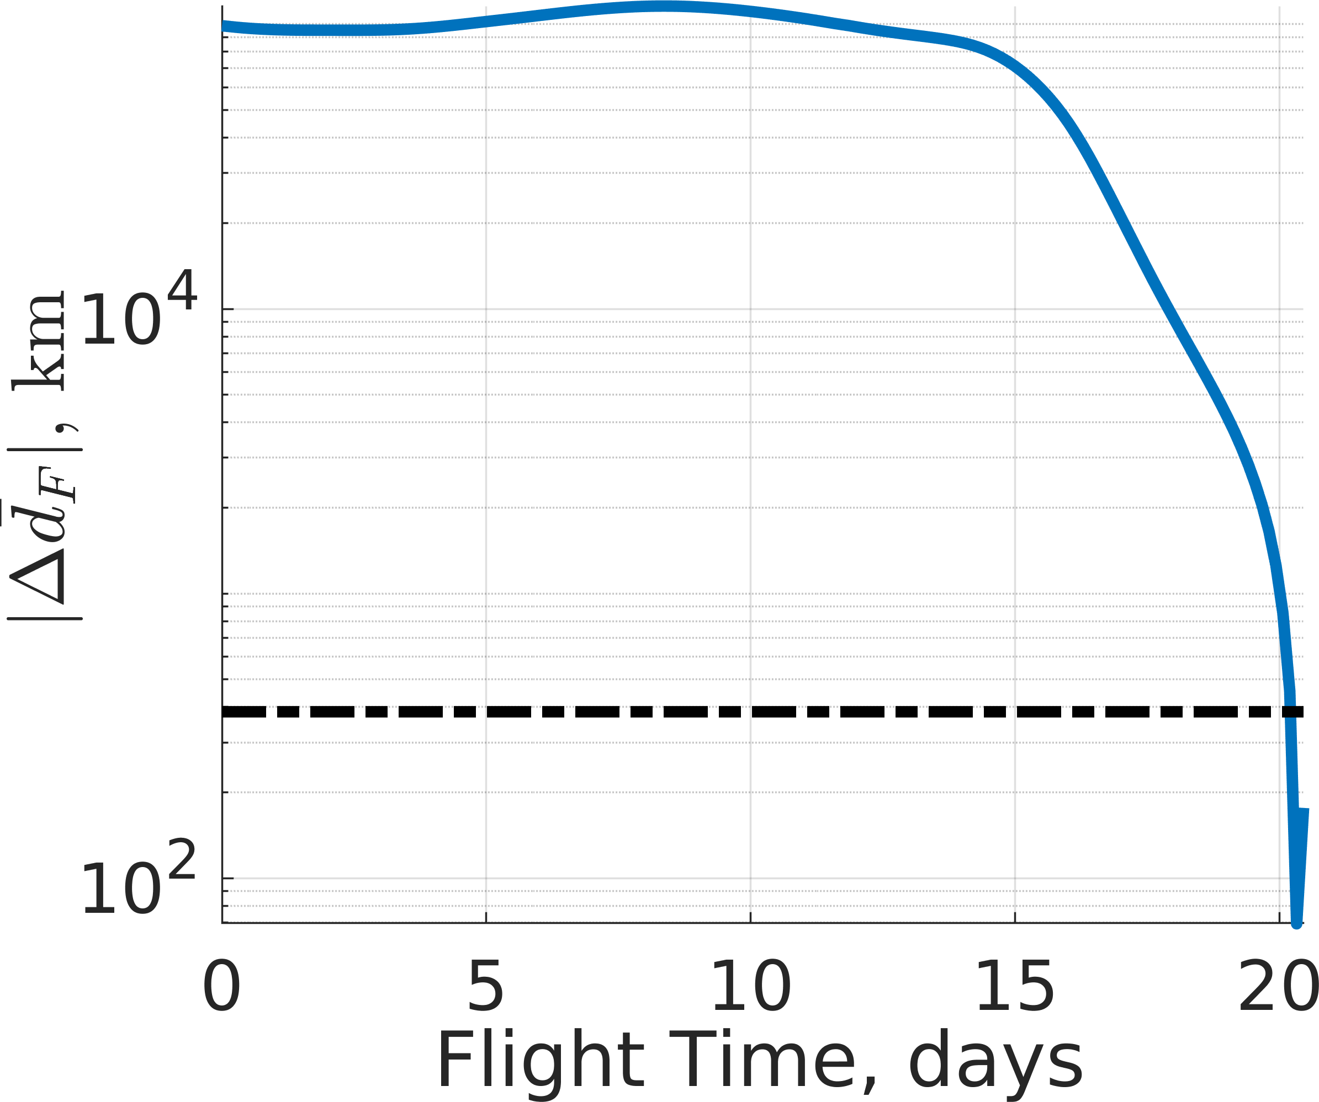
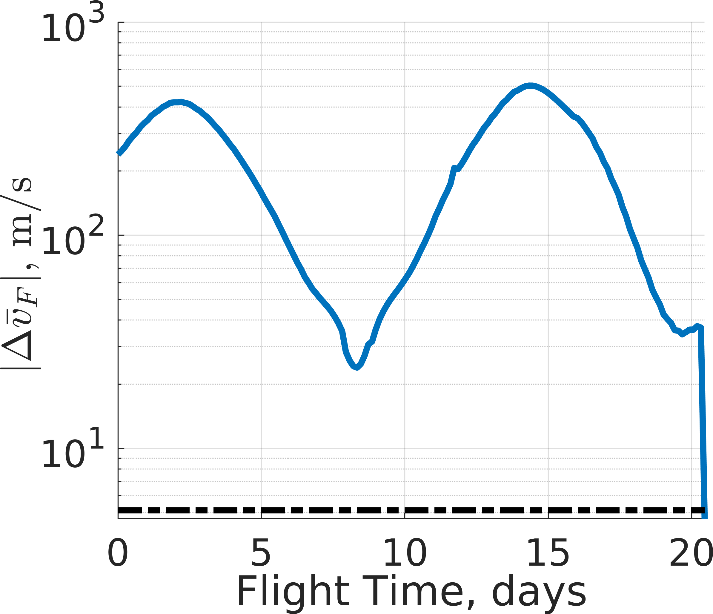
(a) Position Difference (b) Velocity Difference

Figure 9: Position and velocity differences measured with respect to the closest state on the final orbit for a single trajectory commanded by Policy 1.

Transfers between Halo Orbits with Equal Jacobi Constants
In the second example scenario, an L₁ northern halo orbit and an L₂ southern halo orbit with an equal Jacobi constant are selected to develop the multi-objective solution space for low-thrust transfers. The reference trajectory is formulated using two manifold arcs emanating from the halo orbits that intersect in position near perilune, but not in velocity. The discontinuity in the reference trajectory necessitates the ap- plication of low-thrust acceleration to correct both the initial perturbations along the initial orbit and to facilitate a contin- uous transfer between the periodic orbits. Additionally, by training the policies using MRPPO, locally optimal behavior is recovered using the same reward functions and training parameters as the previous example. Figures 11a and 11b depict a planar view of the evaluation trajectories for Policies

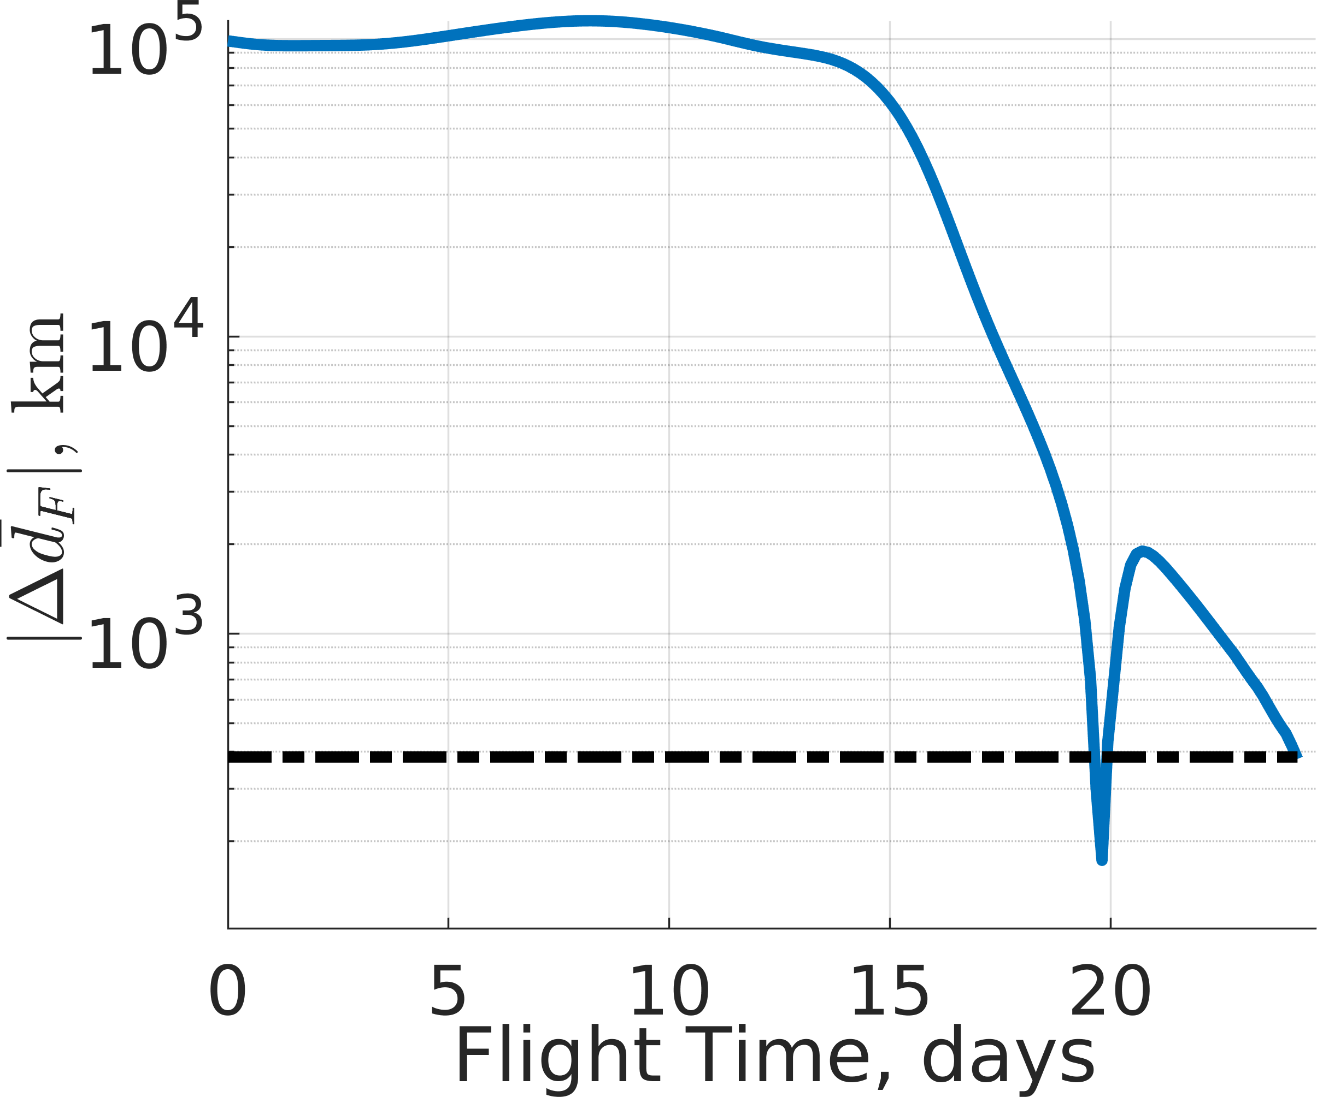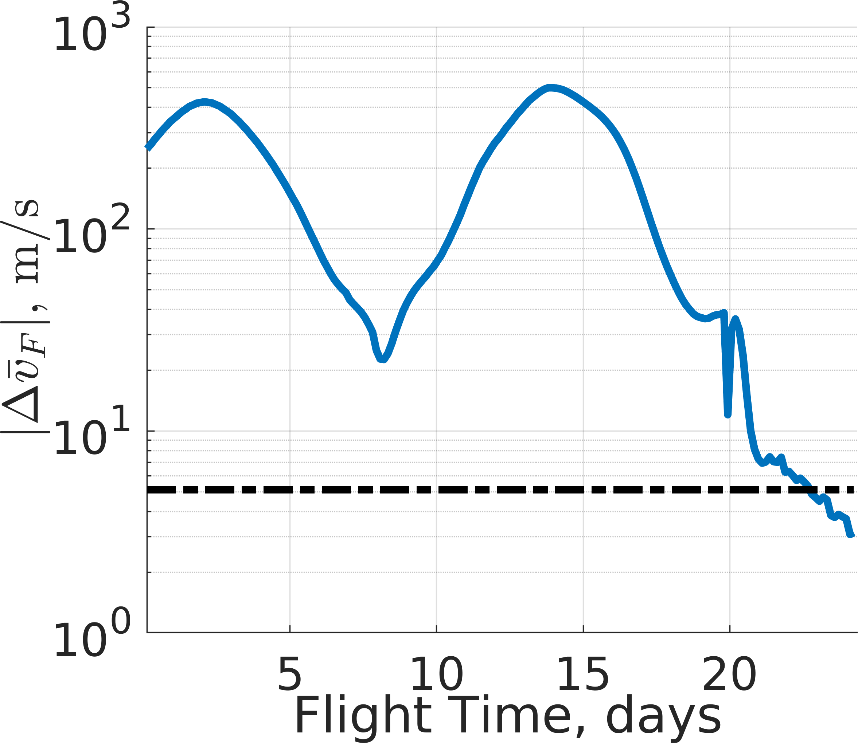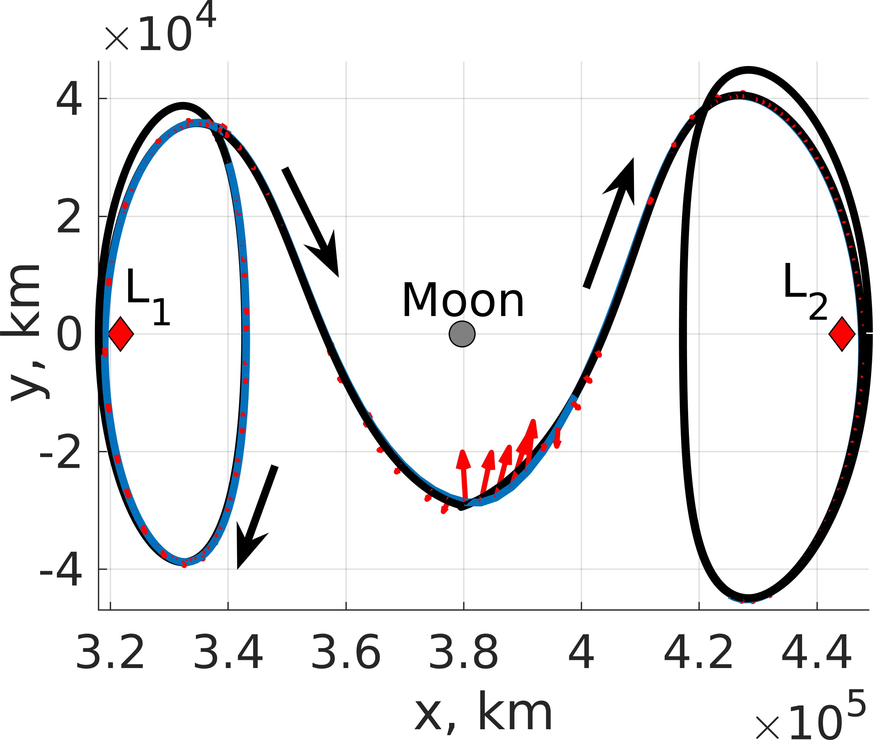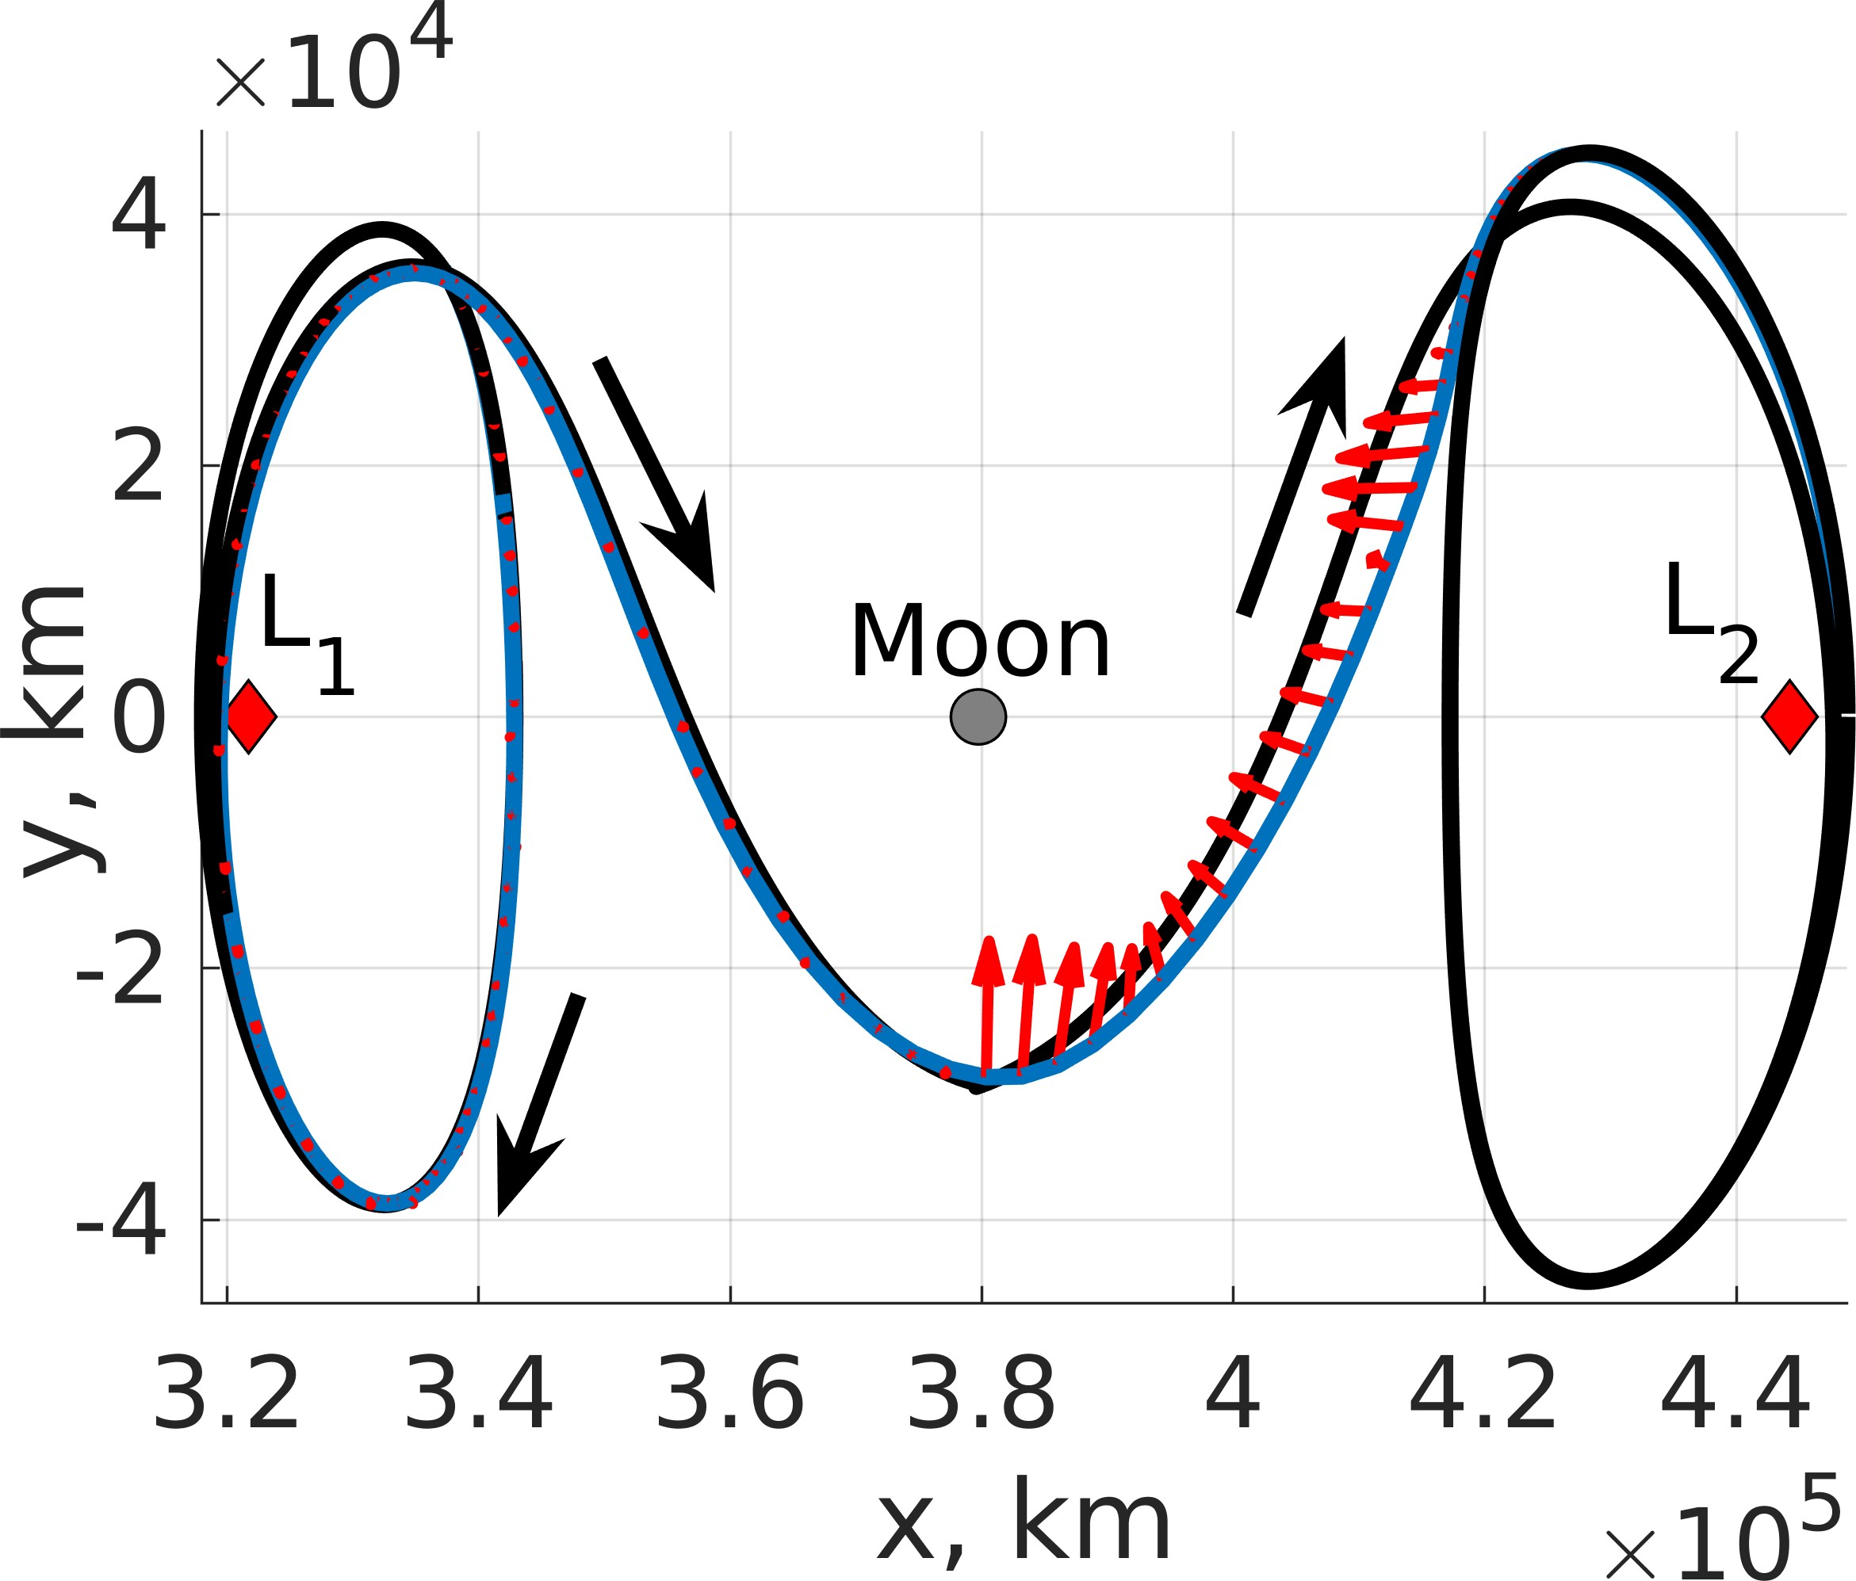

(a) Position Difference (b) Velocity Difference

Figure 10: Position and velocity differences measured with respect to the closest state on the final orbit for a single trajectory commanded by Policy 8.

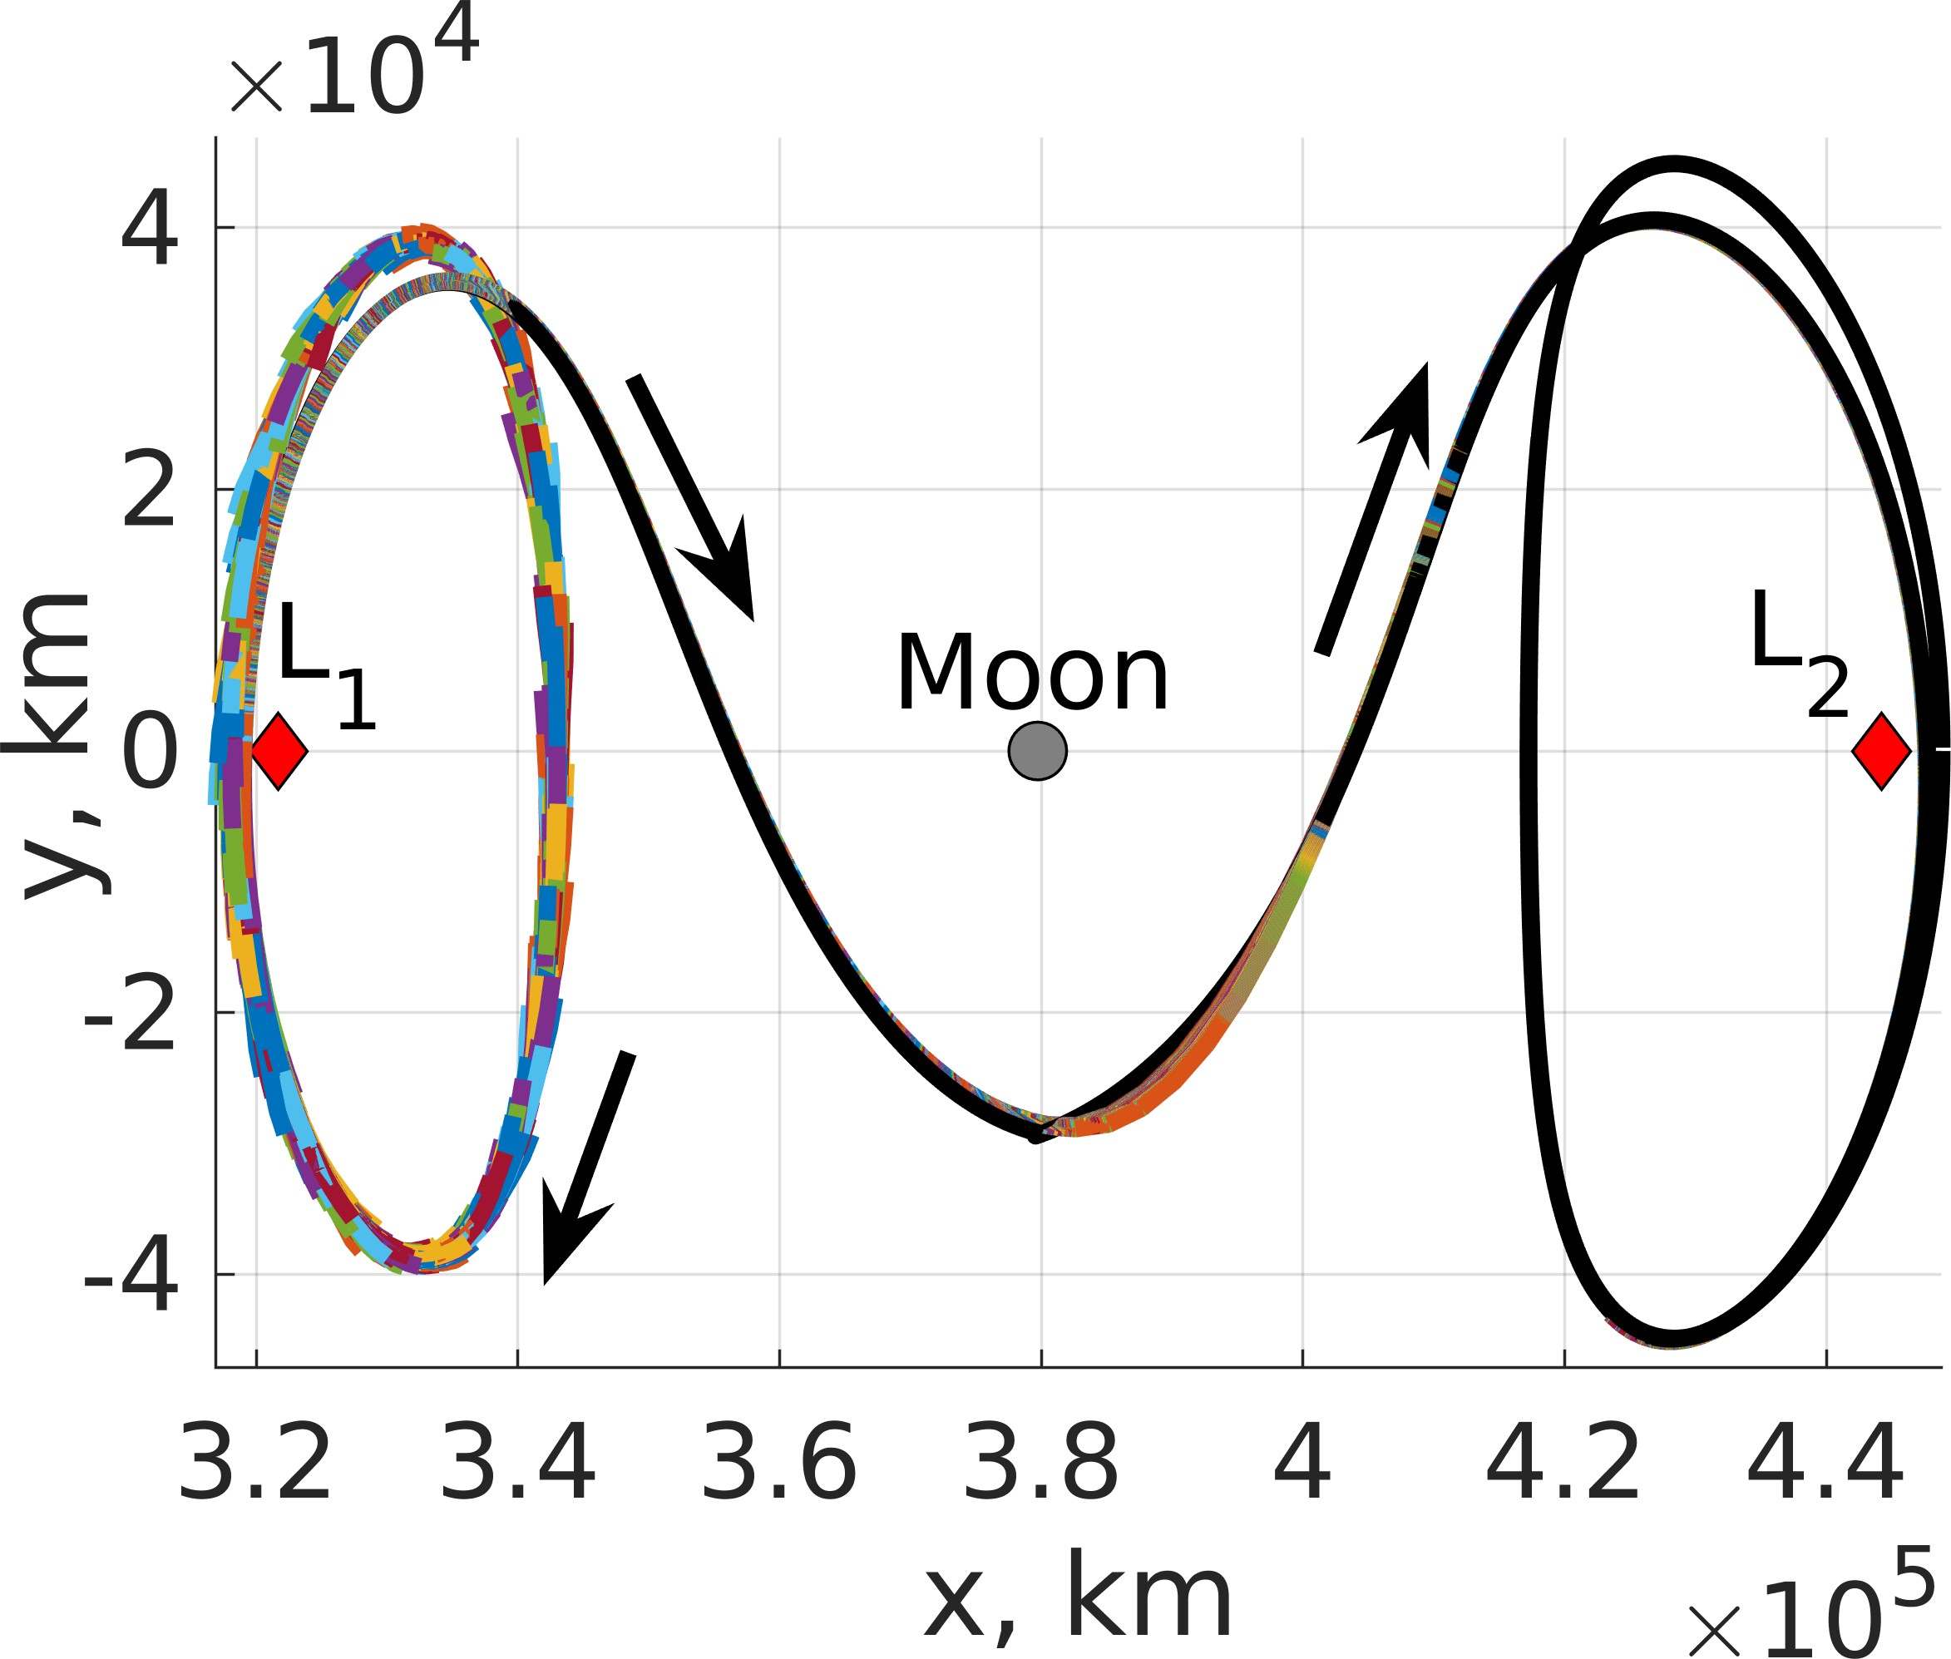
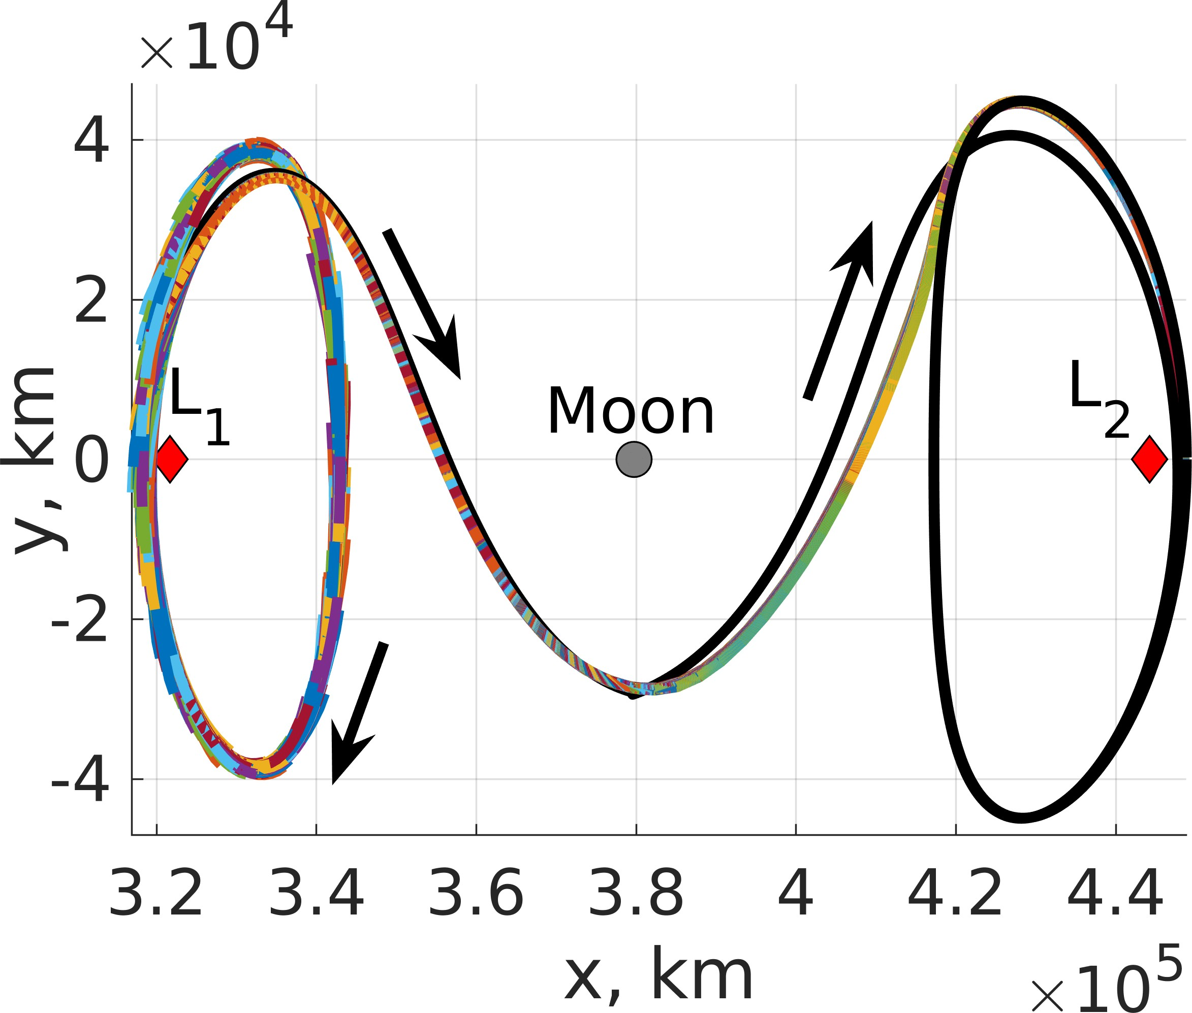
- Policy 1 Trajectories (b) Policy 8 Trajectories

Figure 11: 1,000 evaluation trajectories departing an L₁ northern halo orbit to an L₂ southern halo orbit with an equal Jacobi constant controlled using: (a) Policy 1 and (b) Policy 8.

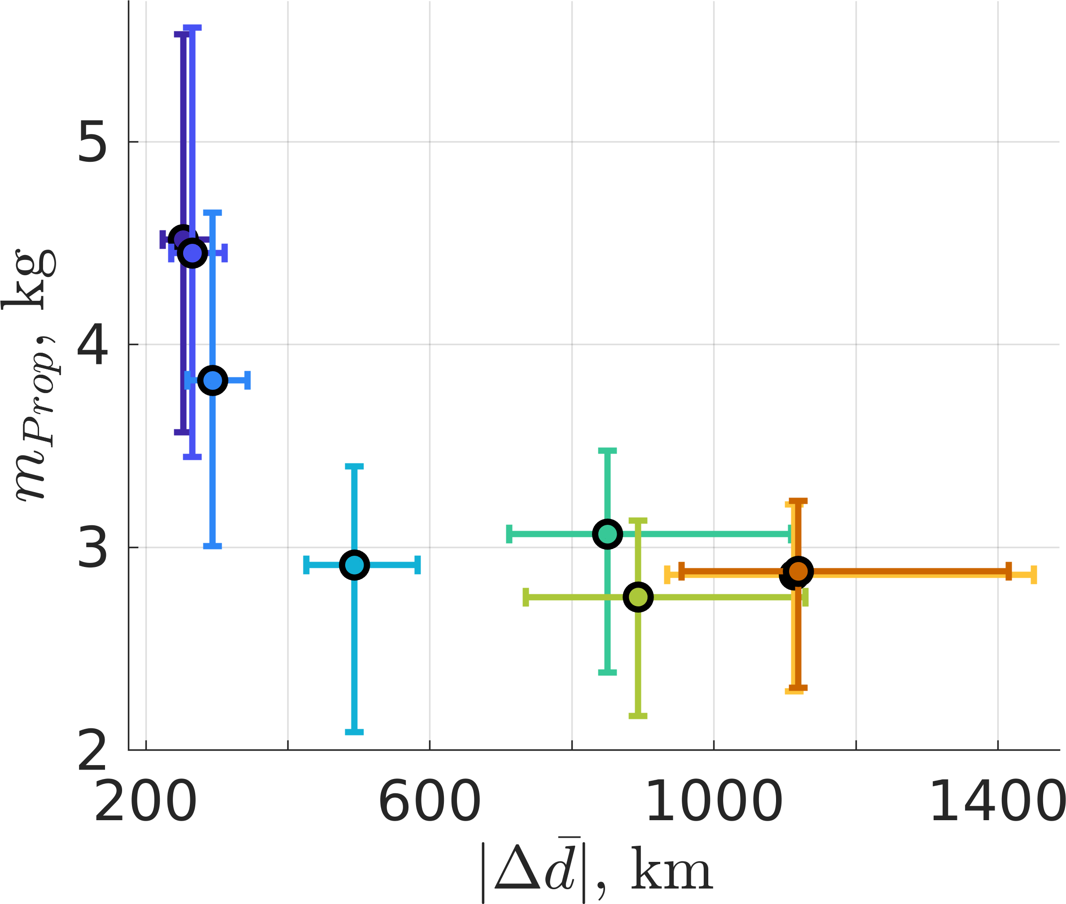
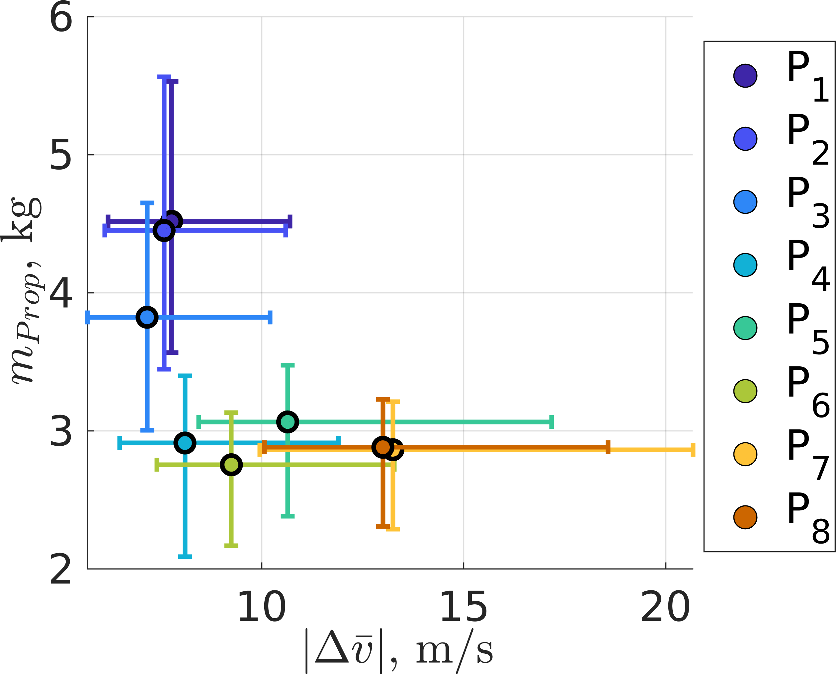
  - Policy 1 (b) Policy 8

Figure 13: Trajectory from a highly perturbed initial condition departing an L₁ northern halo orbit to an L₂ southern halo orbit with an equal Jacobi constant controlled using: (a) Policy 1 and (b) Policy 8.

Analyzing the trajectory characteristics associated with dis- tinct policies on the same highly perturbed initial condi- tion generates additional insights into the behavior of each controls scheme. Figures 13a and 13b depict the same evaluation trajectory for Policies 1 and 8 respectively, with the thrust directions illustrated using red arrows along the trajectory. The thrust magnitude at each time step is depicted in Figs. 14a and 14b. These figures demonstrate that Policy 1 consistently produces larger thrust vectors, throughout the transfer than Policy 8, a result of the distinct mass coefficients in each reward function. Additionally, the thrust magnitude for each policy resembles a bang-bang-like controller with the spacecraft performing an action with a large control magnitude at a time step followed by multiple time steps with much smaller control magnitudes. The influence of the thrust actions on the energy of the spacecraft is further indicated in the Jacobi constant along each trajectory shown in Figs. 15a and 15b where the solid black line denotes the Jacobi constant of the periodic orbits. For this initial condition, Policy 1 produces much larger changes in the Jacobi constant along the trajectory than Policy 8 reflective of the mass coefficient in each policy’s reward function. Finally, the position and velocity differences measured with respect to the final orbit are depicted in Figs. 16a and 16b on a logarithmic scale for Policy 1 where the convergence hyperspheres are represented by a dashed black line. Sim- ilarly, Figs. 17a and 17b display the position and velocity

- Propellant Mass Usage vs. Position Difference
- Propellant Mass Usage vs. Velocity Difference
differences for Policy 8. Both policies demonstrate similar
convergence to the final orbit; both policies first intersecting the velocity hypersphere prior to the position hypersphere.

Figure 12: Relationship between the state discontinuities and propellant mass usage for the L₁ northern halo to L₂ southern transfer.

1 and 8, respectively, using the same color configuration as Fig. 5. The trajectories associated with Policy 1 tend to follow the reference trajectory much more closely in position space compared to the solutions associated with Policy 8. The relationship is detailed in Fig. 12a where the policies with higher penalties on propellant mass usage possess larger dif- ferences in distance from the reference trajectory highlighting the multi-objective trade space for this scenario. Additionally, Fig. 12b displays the propellant mass usage and velocity difference relationship demonstrating a consistent trade-off between decreasing state differences from the reference tra- jectory or decreasing propellant mass usage. Further, Policies 7 and 8 exhibit smaller differences in their behavior requiring approximately 2.5 kg.
The distinct control selections and transfer geometries de- veloped by each policy may be attributed to the objectives that each policy learns to maximize in this multi-objective solution space.
Transfers between Halo Orbits of Distinct Jacobi Constants
The third trajectory design scenario requires the policies to learn to transfer from a lower-energy L₁ northern halo orbit to a higher-energy L₂ southern halo orbit using a reference orbit with a large velocity discontinuity at x = 1 µ. The eight policies are trained using the same reward functions as the previous two examples to develop multiple regions within the multi-objective solution space. The evaluation trajectories for Policies 1 and 8 are displayed in Figs. 18a and 18b using the same configuration as Fig. 5 demonstrating that both policies learned to guide the low-thrust-enabled SmallSat to the target orbit. Further, the relationships between the propellant mass usage and the position and velocity differences for all policies are depicted in Figs. 19a and 19b, respectively. Similar to
−

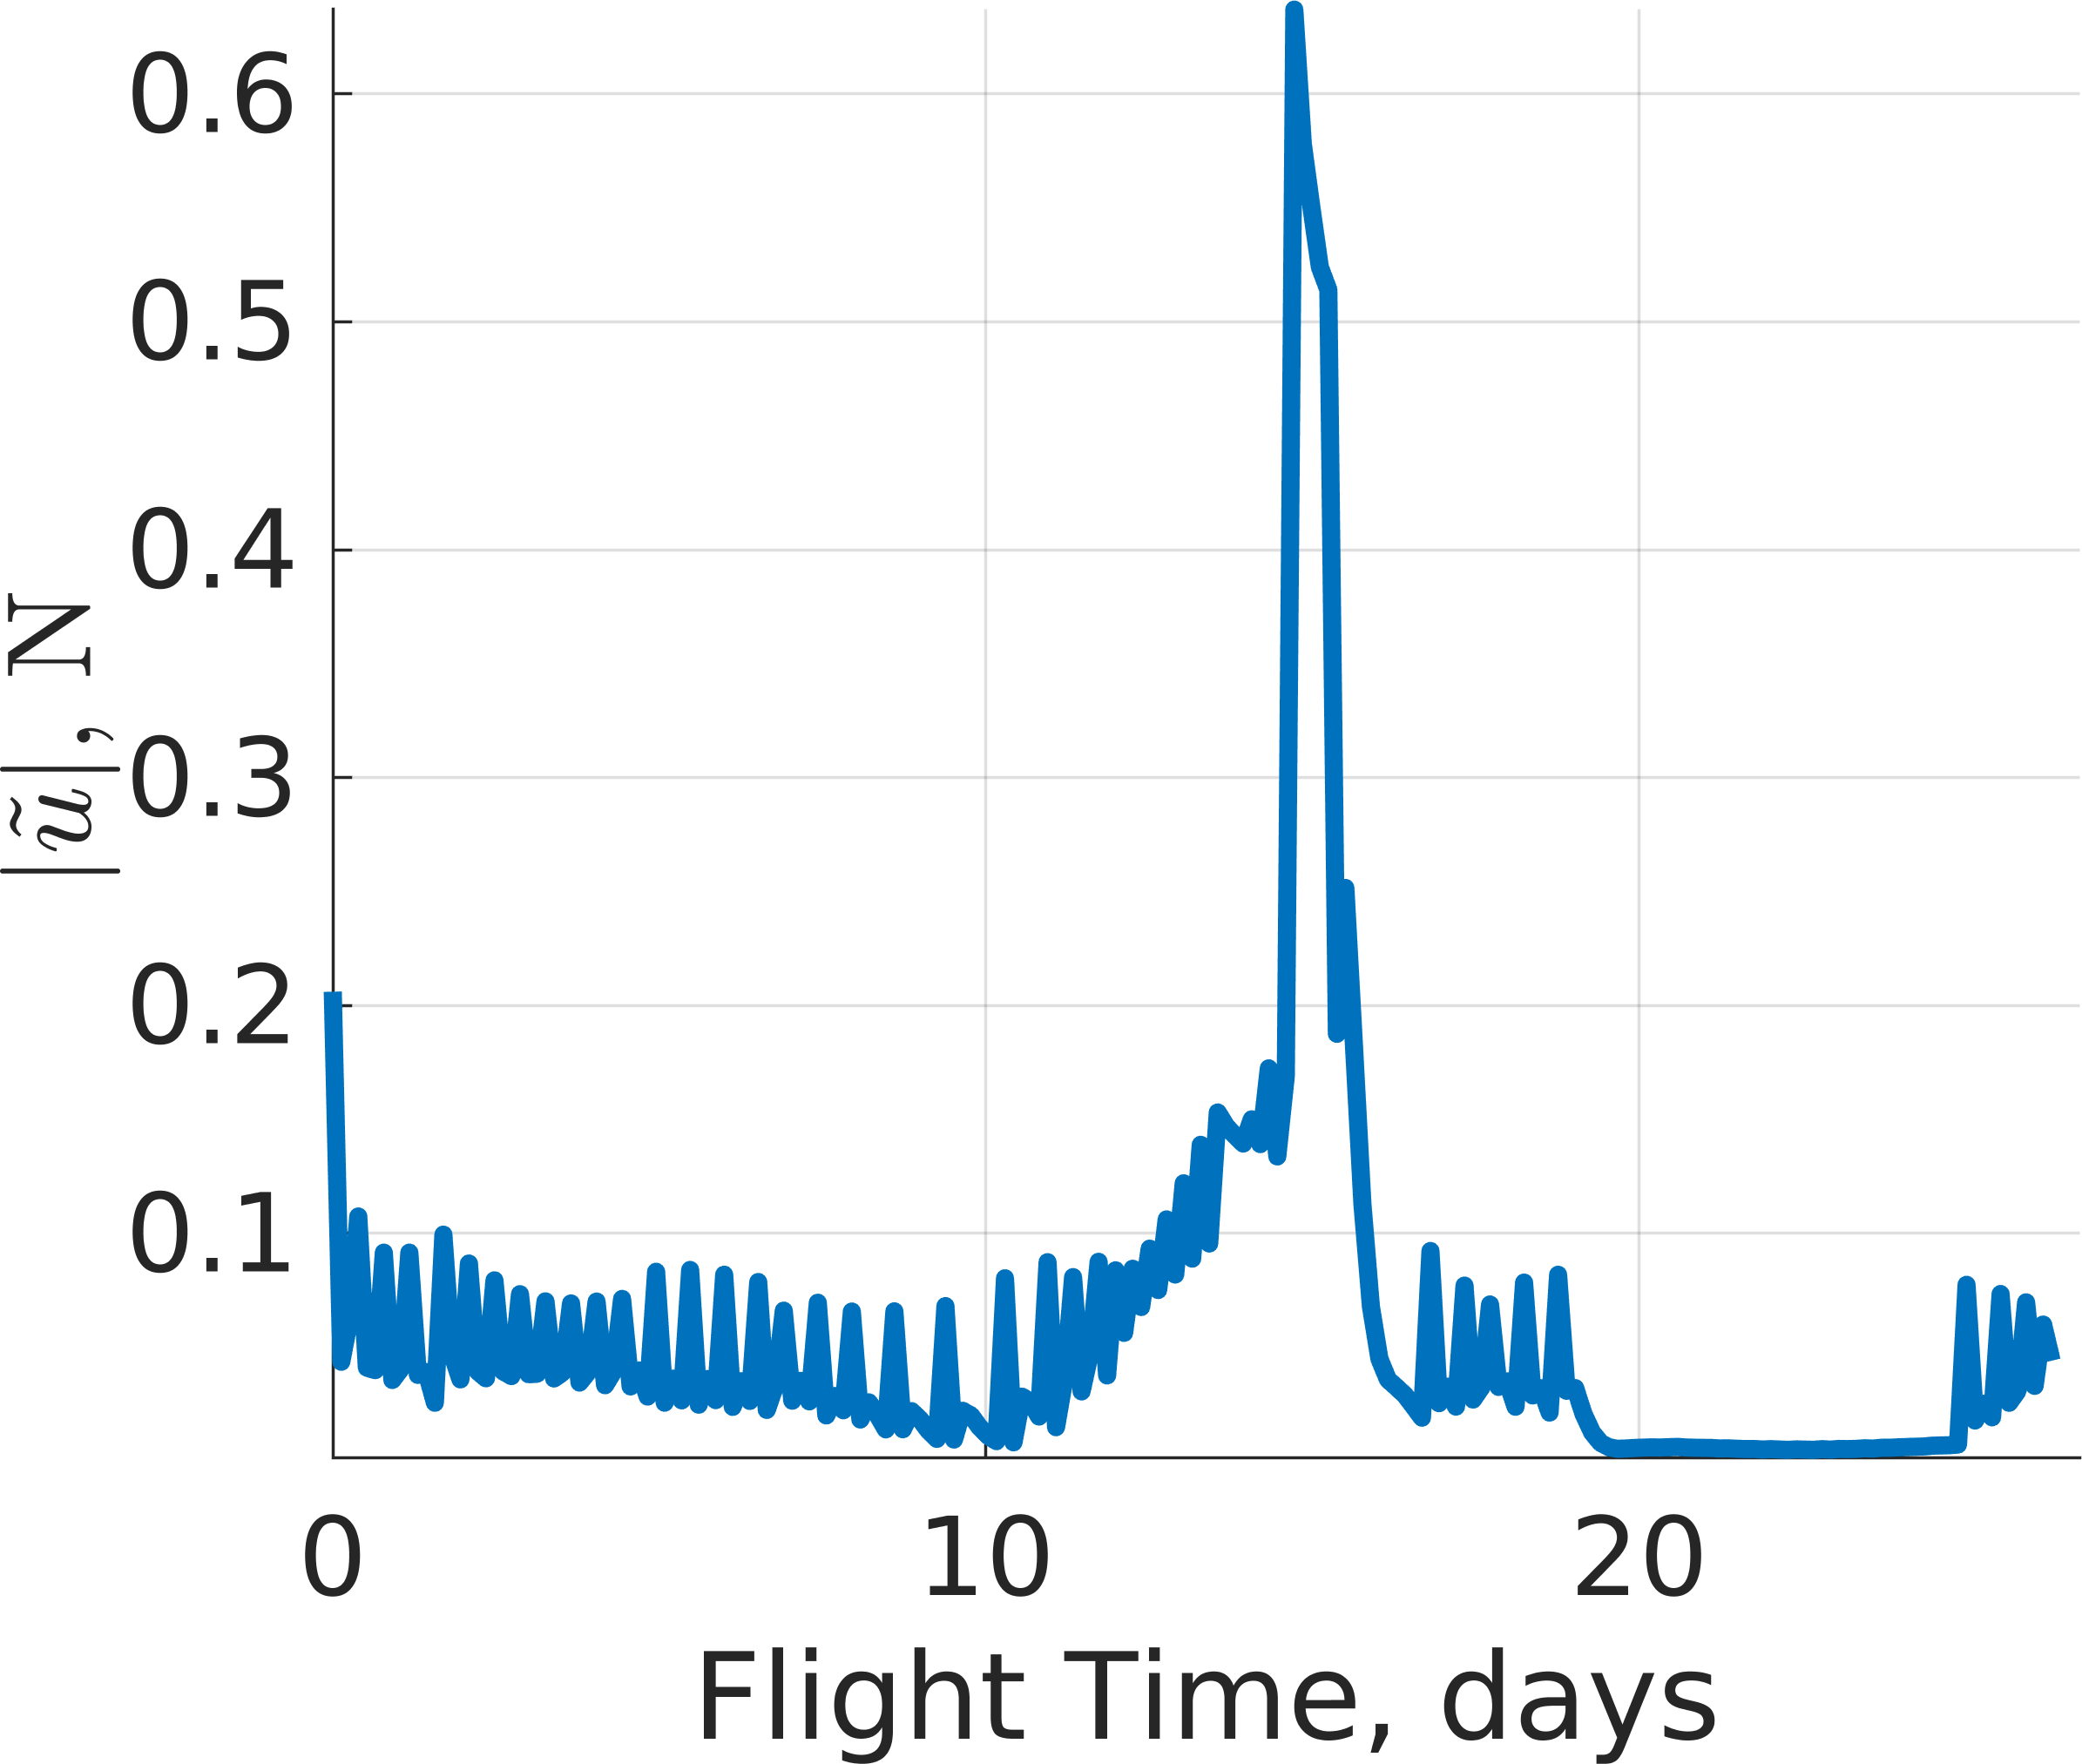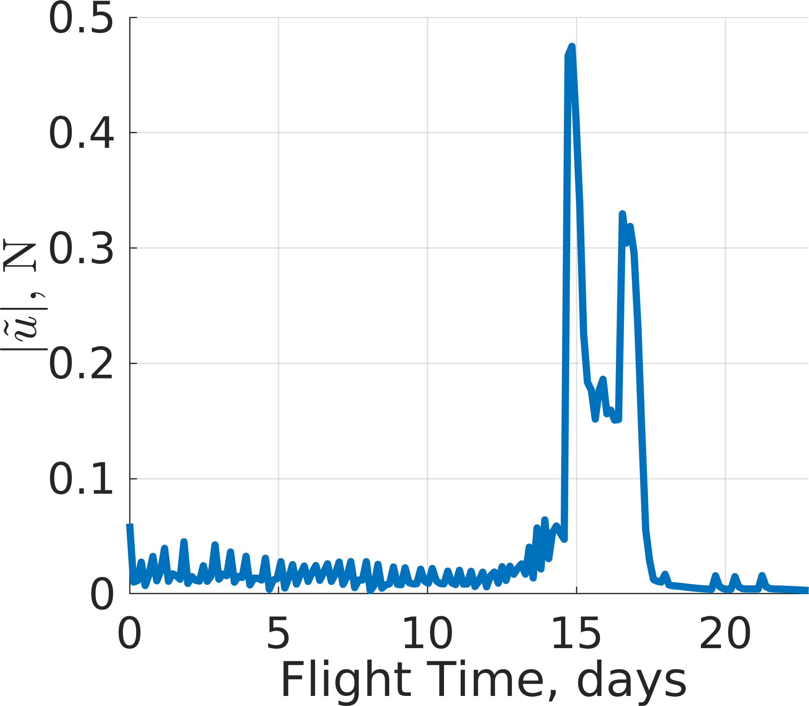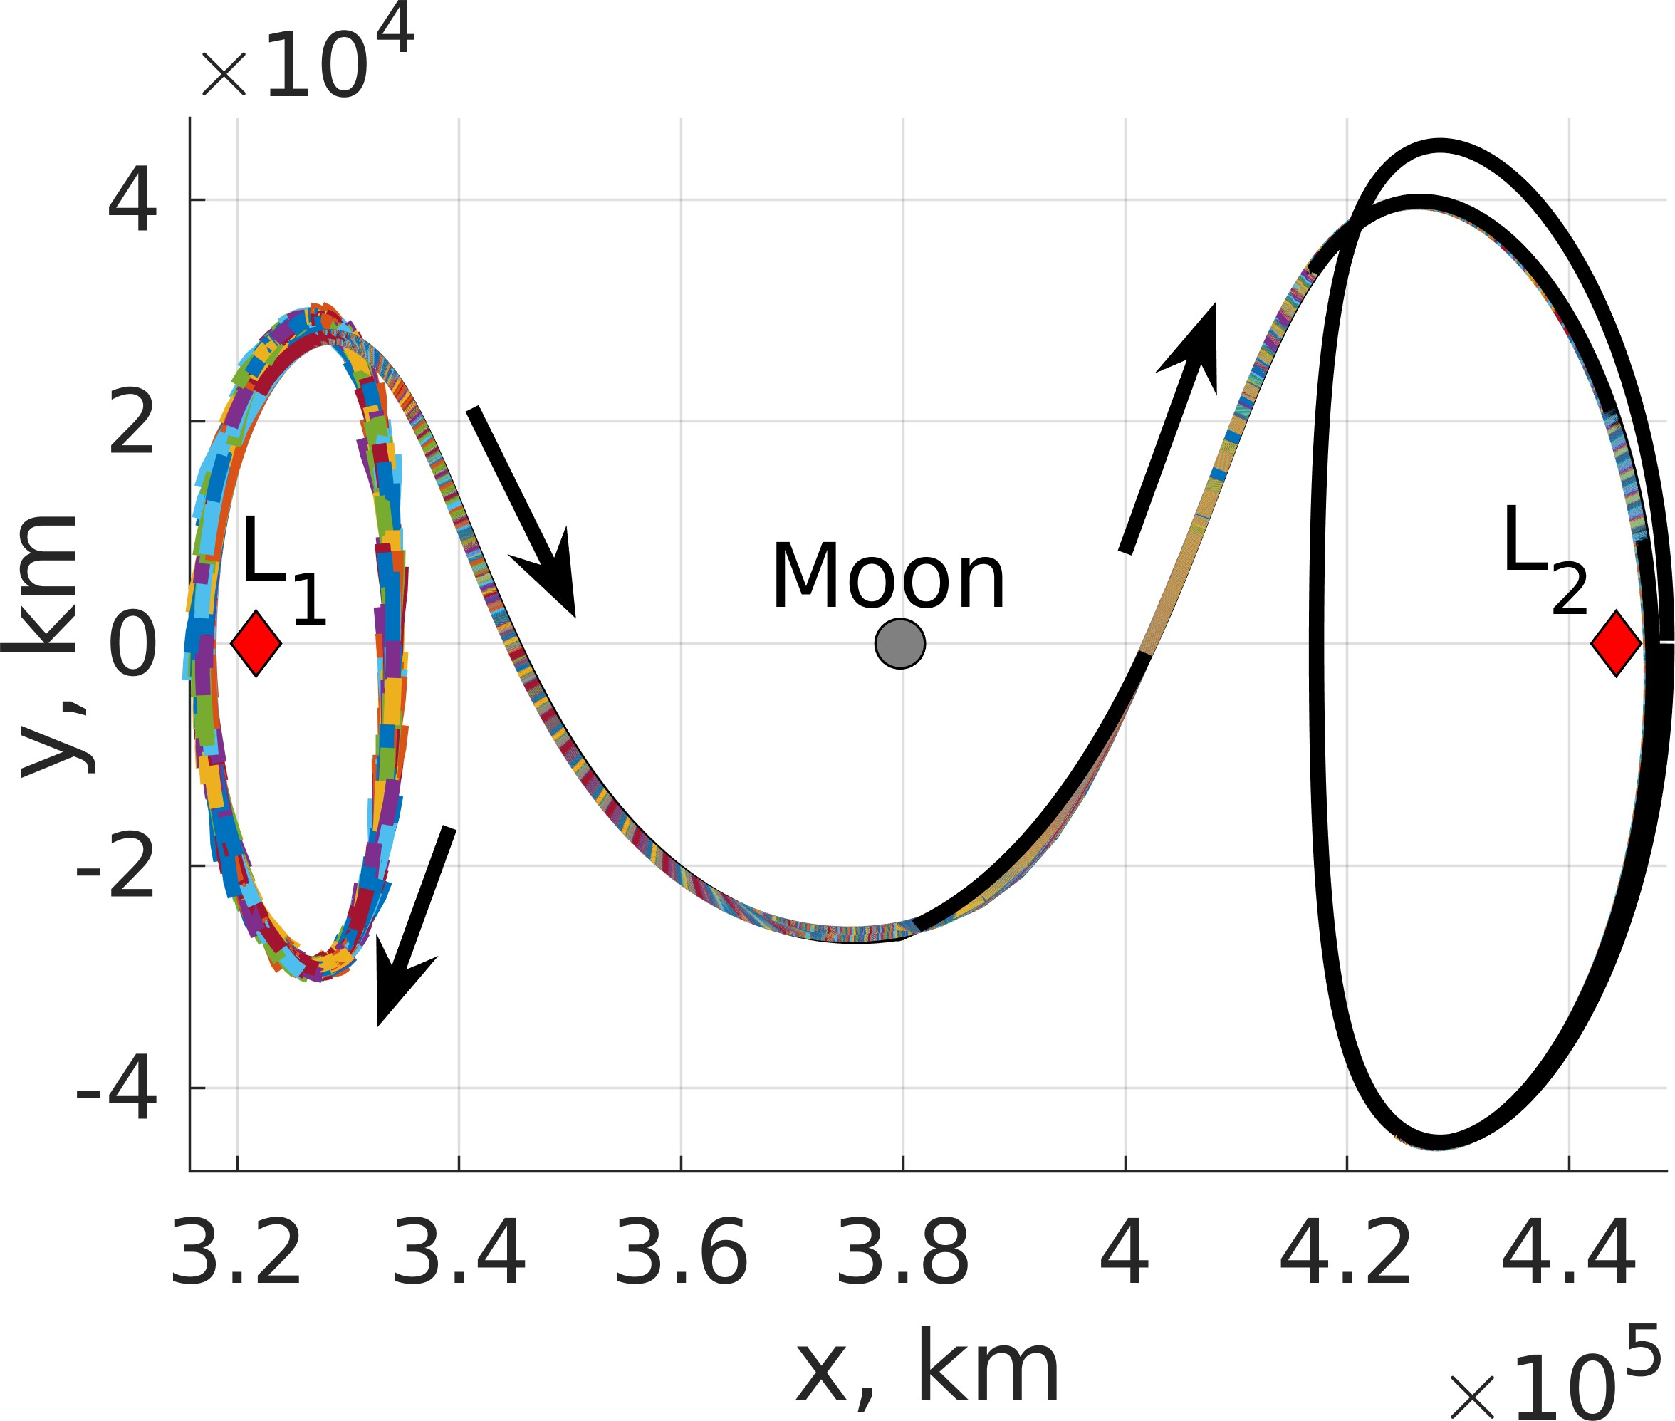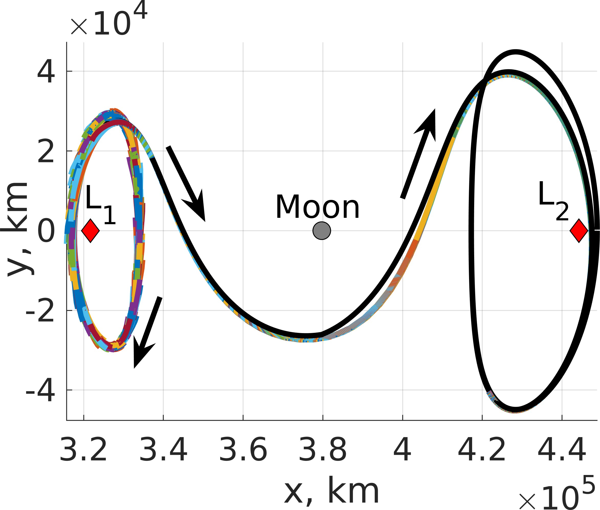

- Policy 1 (b) Policy 8

Figure 14: Thrust magnitude along an evaluation trajectory commanded using: (a) Policy 1 and (b) Policy 8.
- Policy 1 Trajectories (b) Policy 8 Trajectories

Figure 18: 1,000 evaluation trajectories departing an L₁ northern halo orbit to an L₂ southern halo orbit with a distinct Jacobi constant controlled using: (a) Policy 1 and (b) Policy 8.

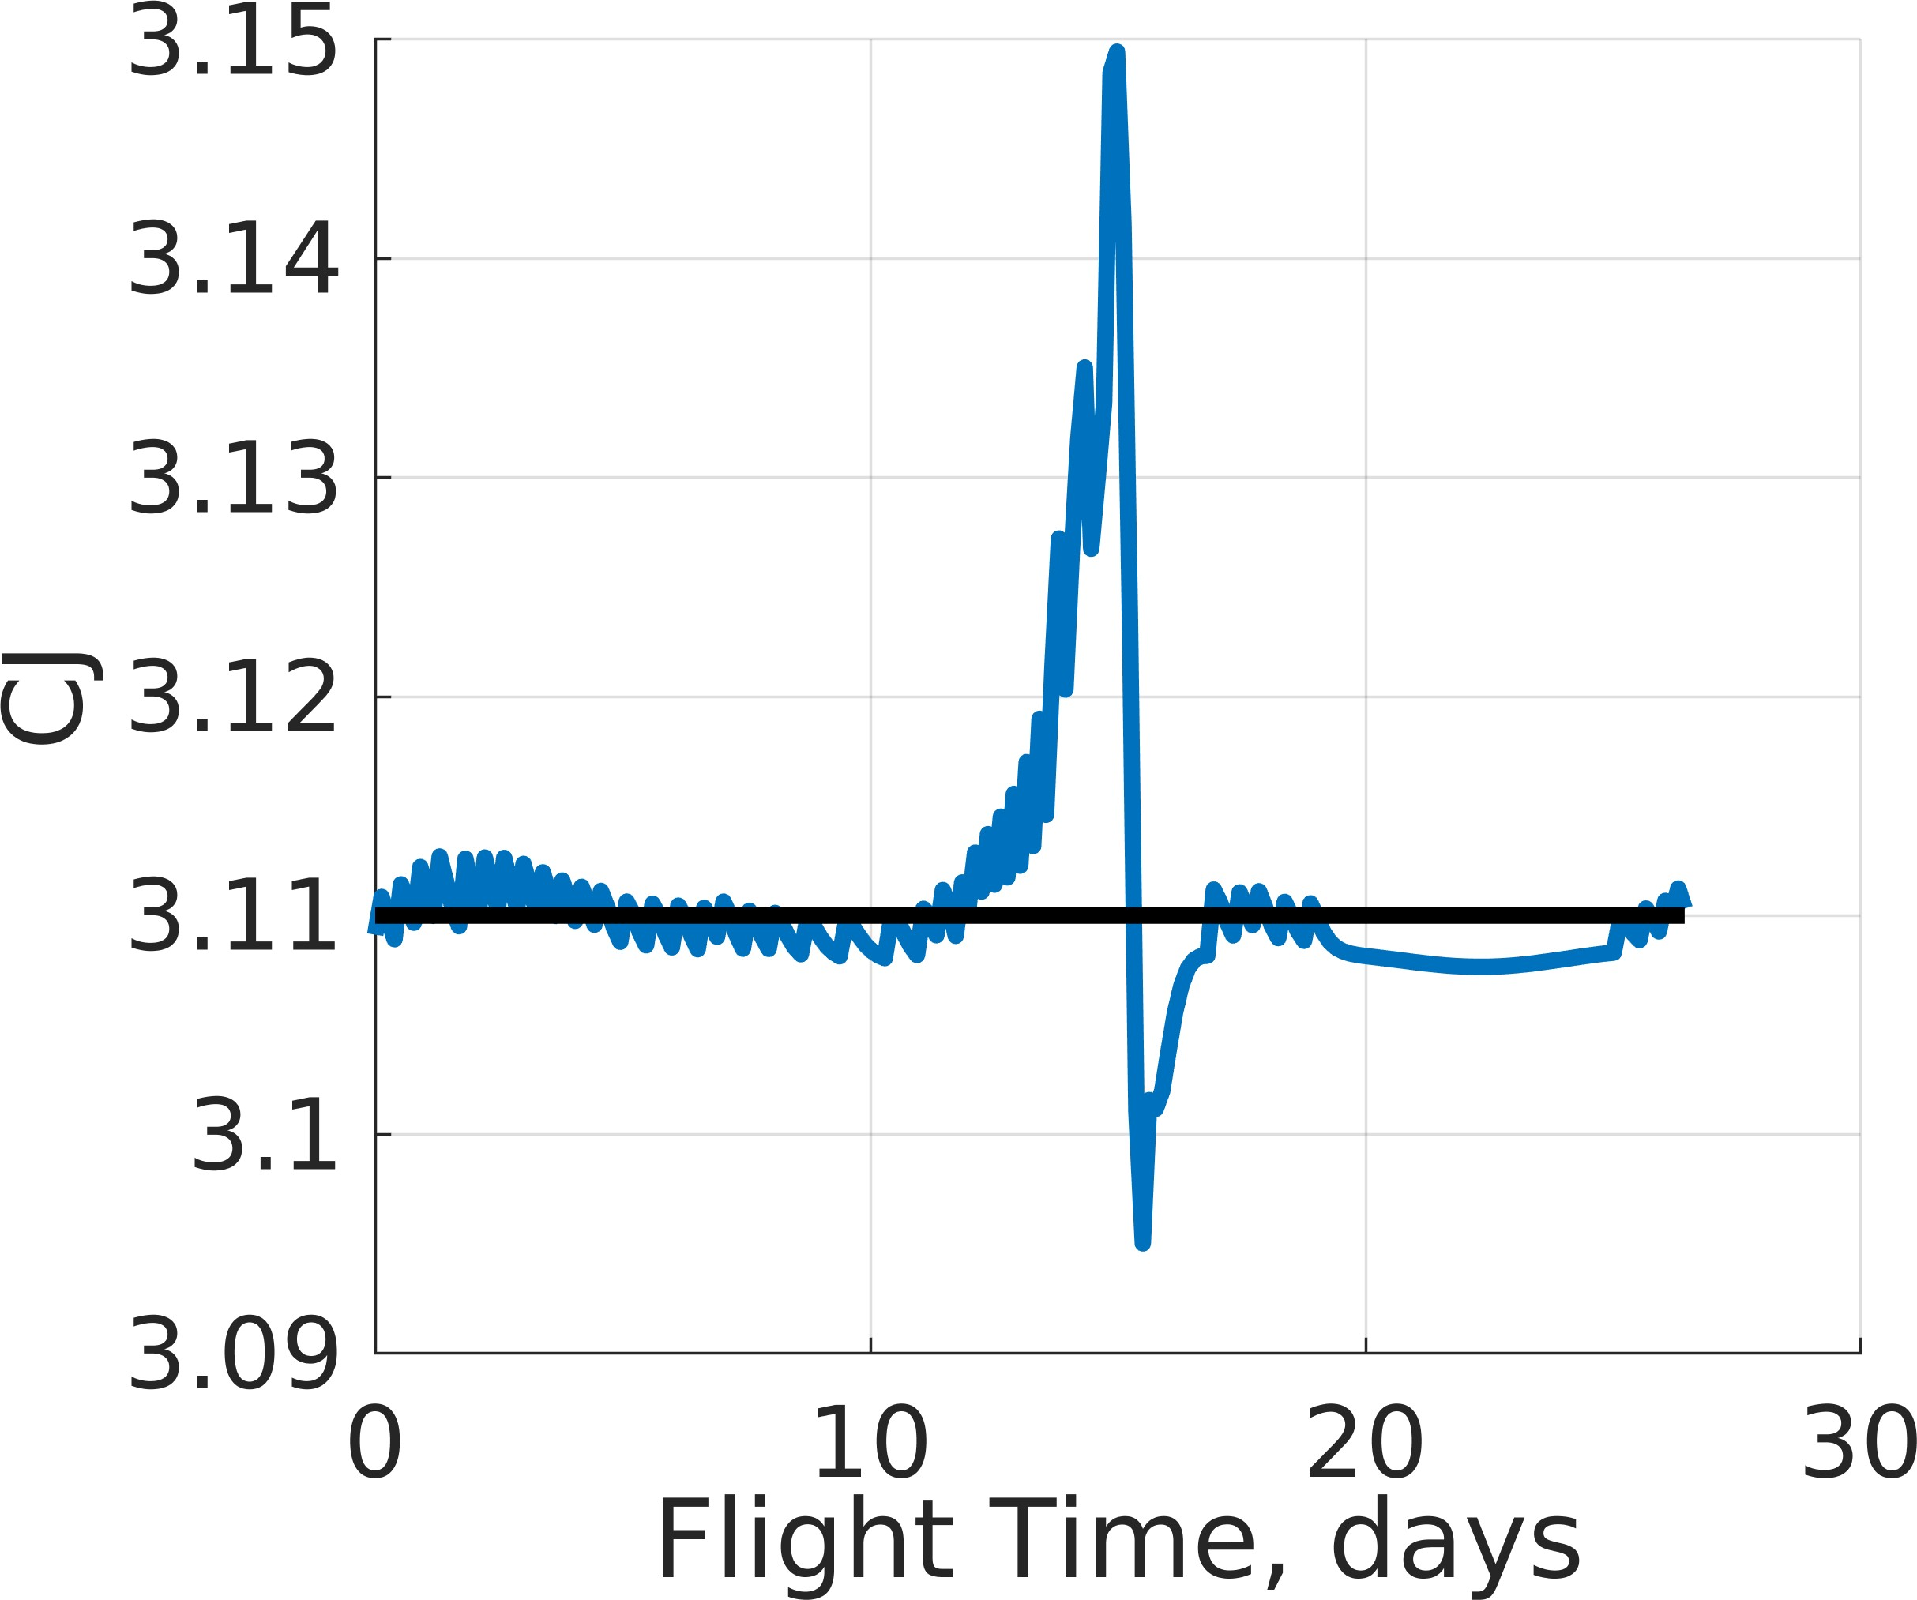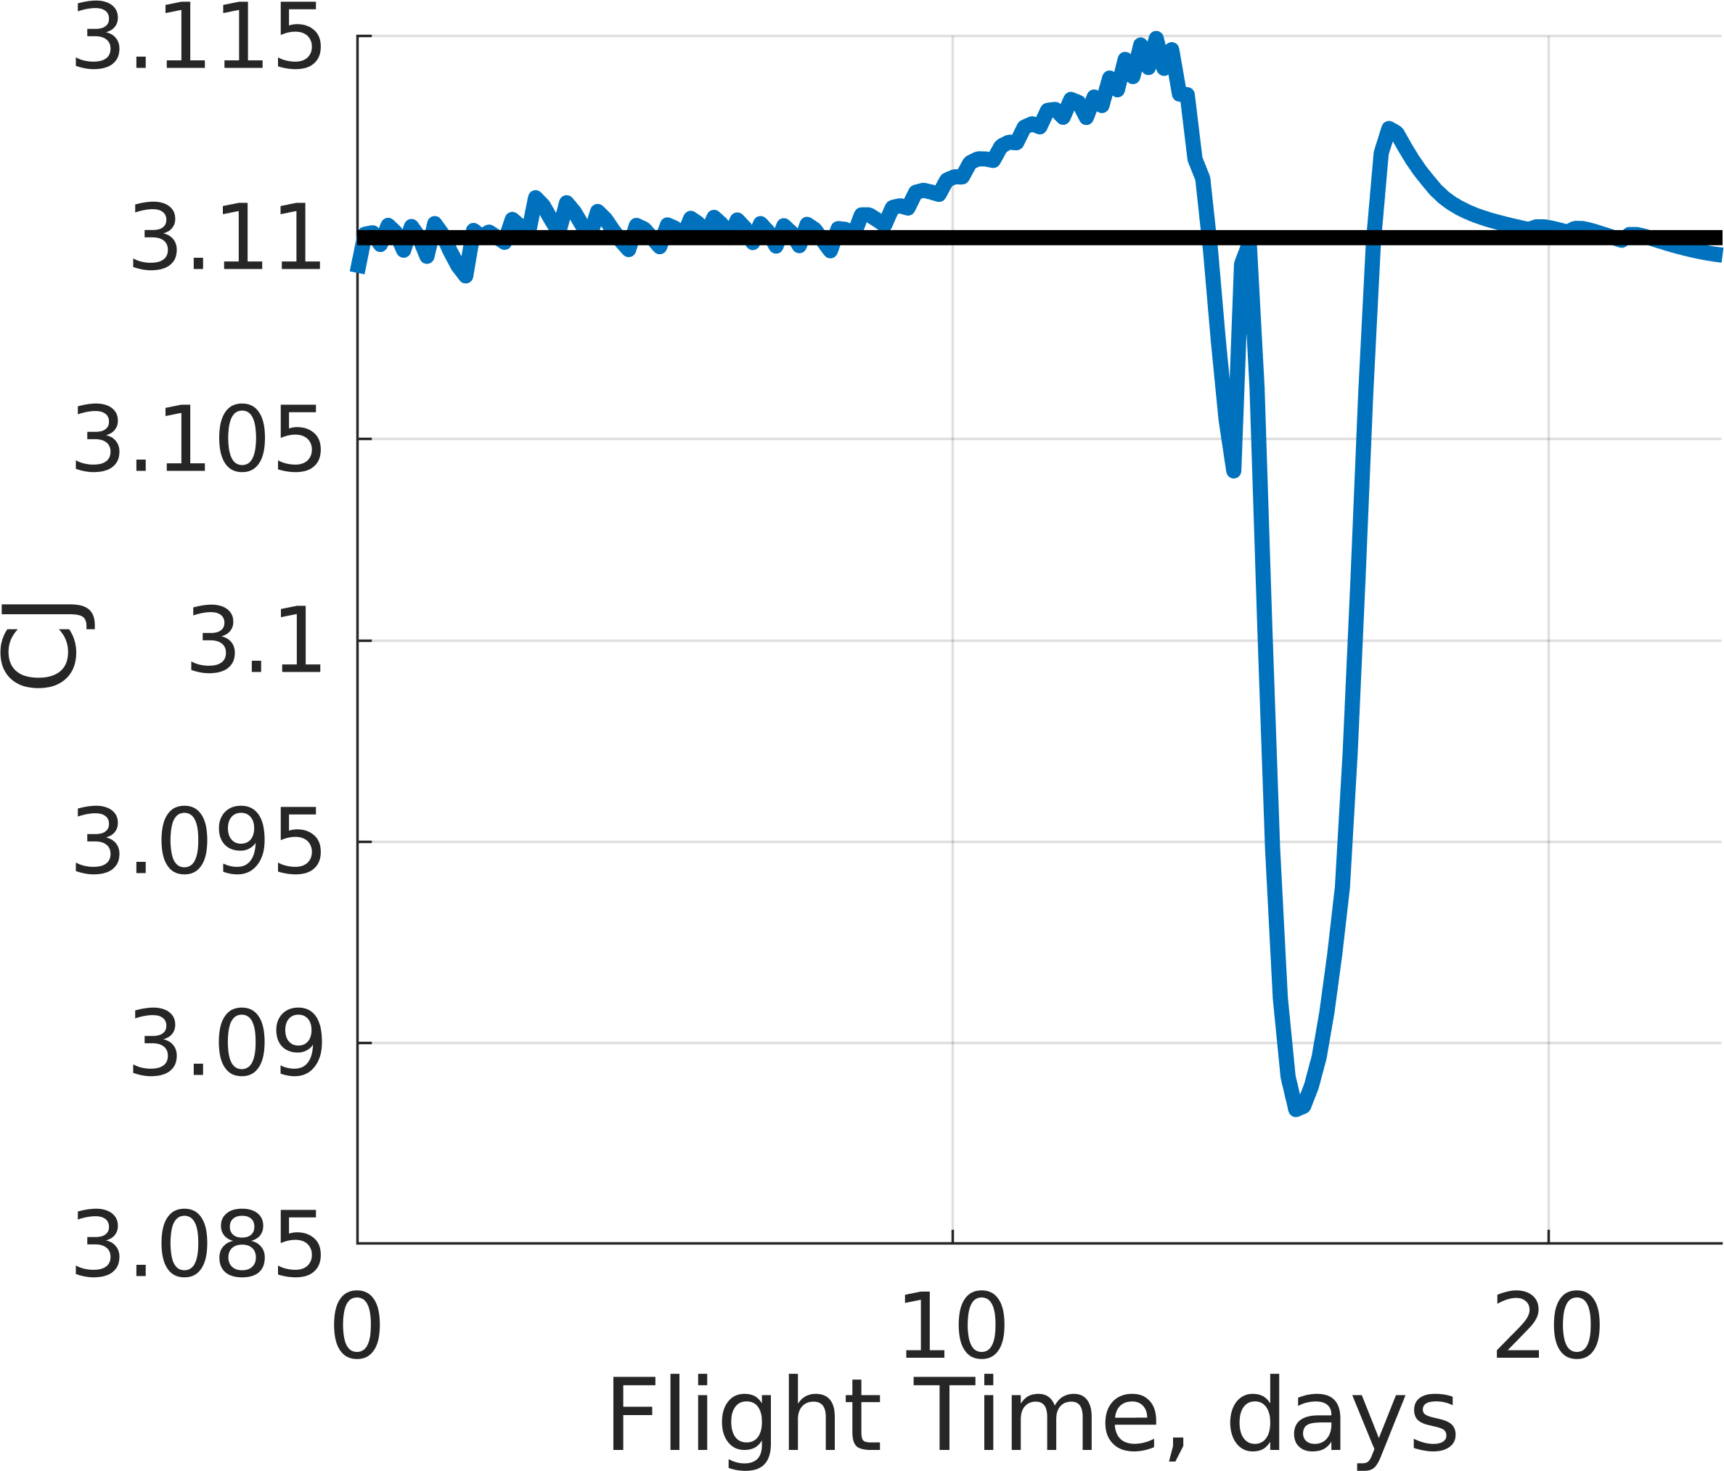

  - Policy 1 (b) Policy 8

Figure 15: Jacobi constant along an evaluation trajectory commanded using: (a) Policy 1 and (b) Policy 8.

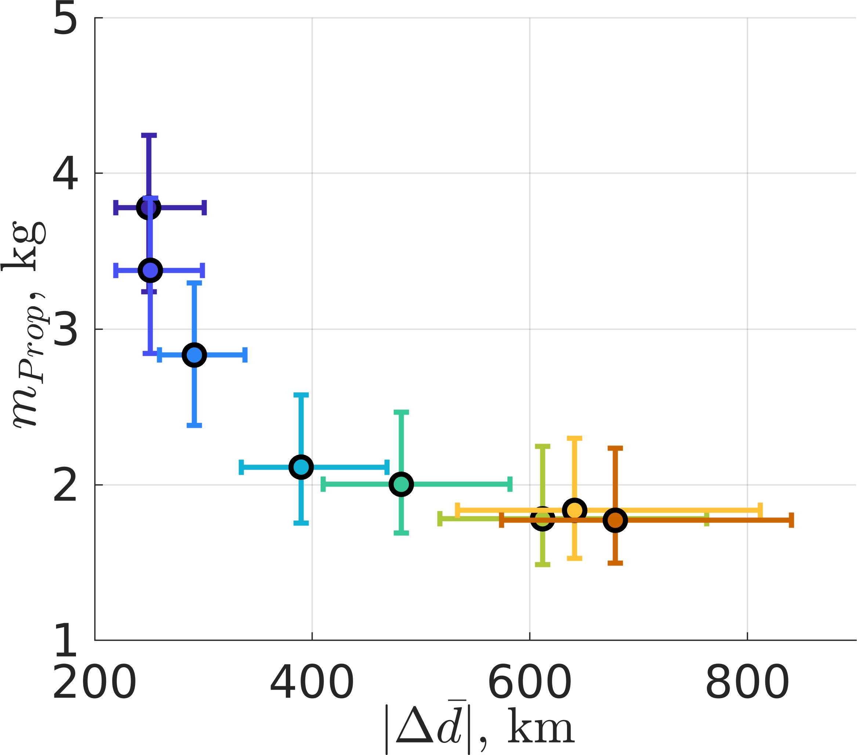
- Propellant Mass Usage vs. Position Difference

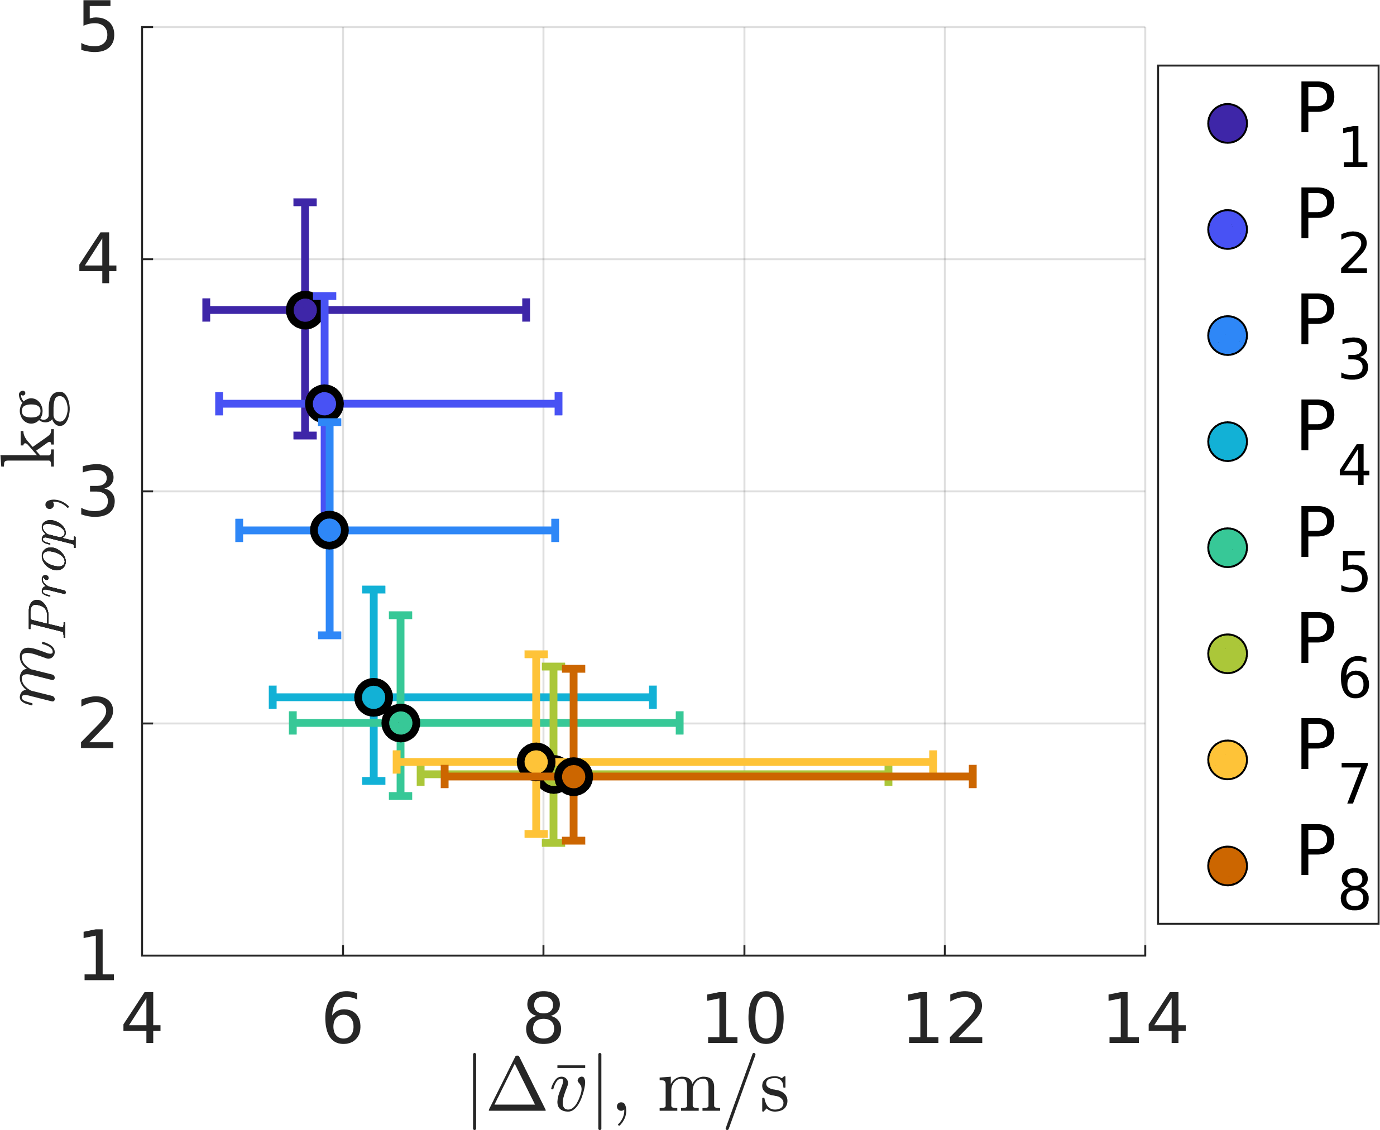
- Propellant Mass Usage vs. Velocity Difference

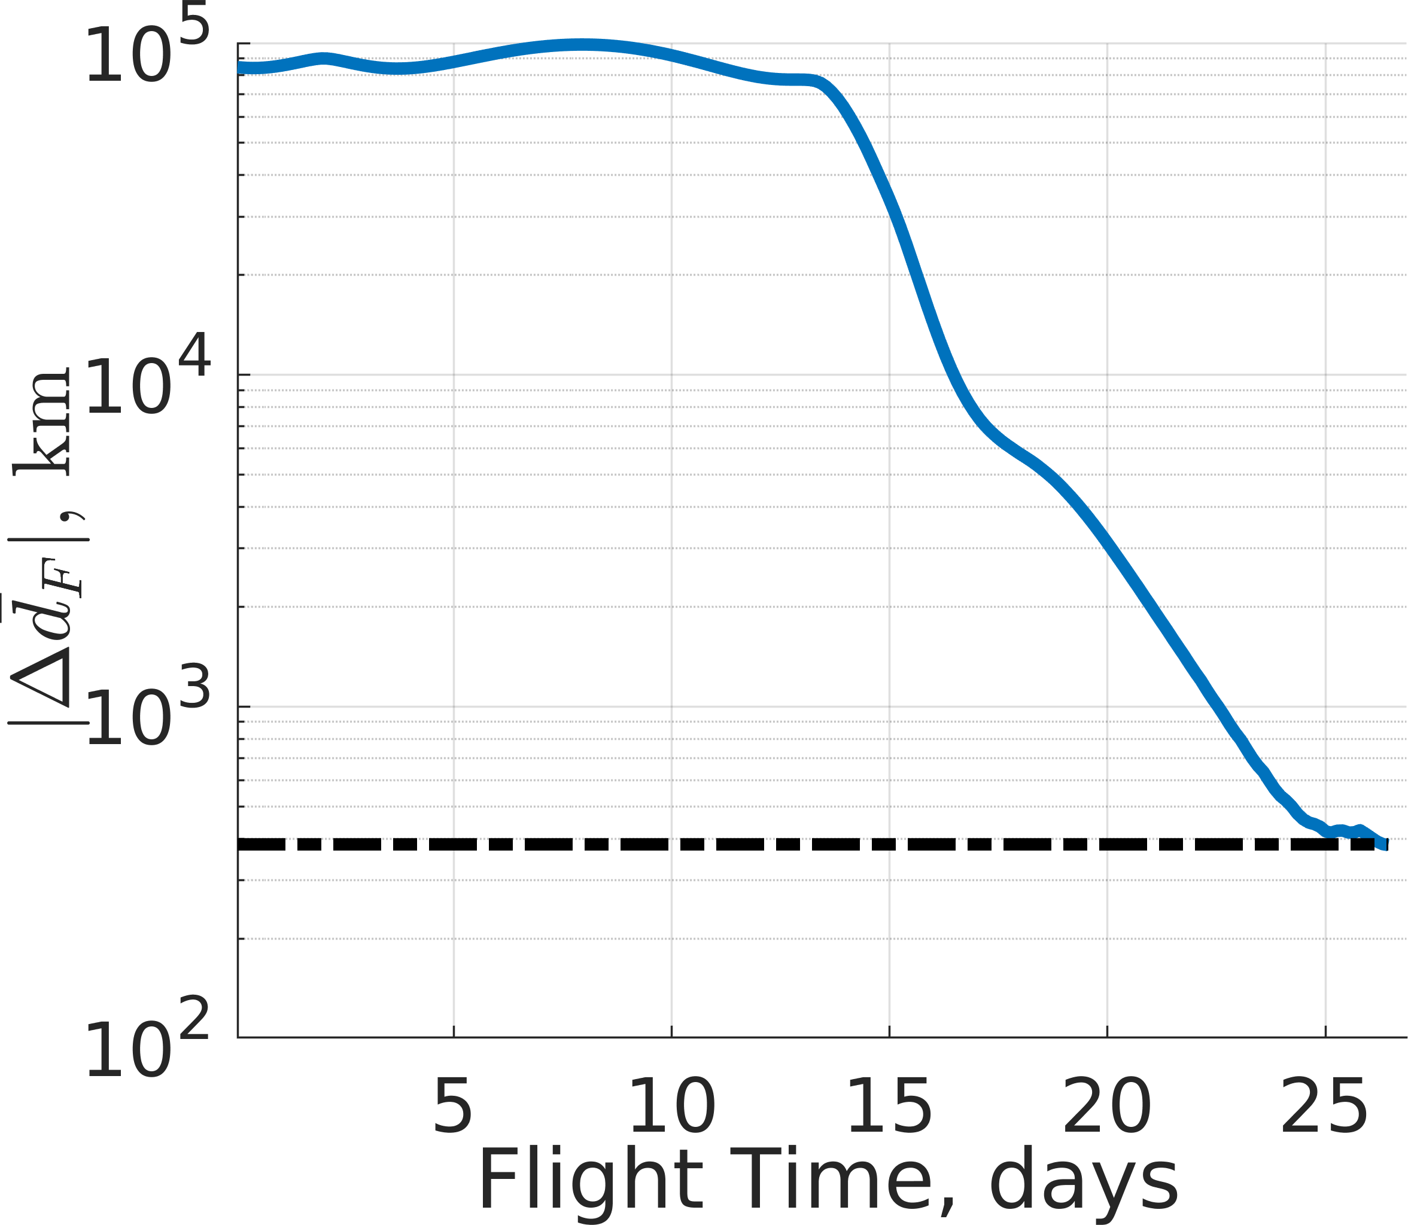
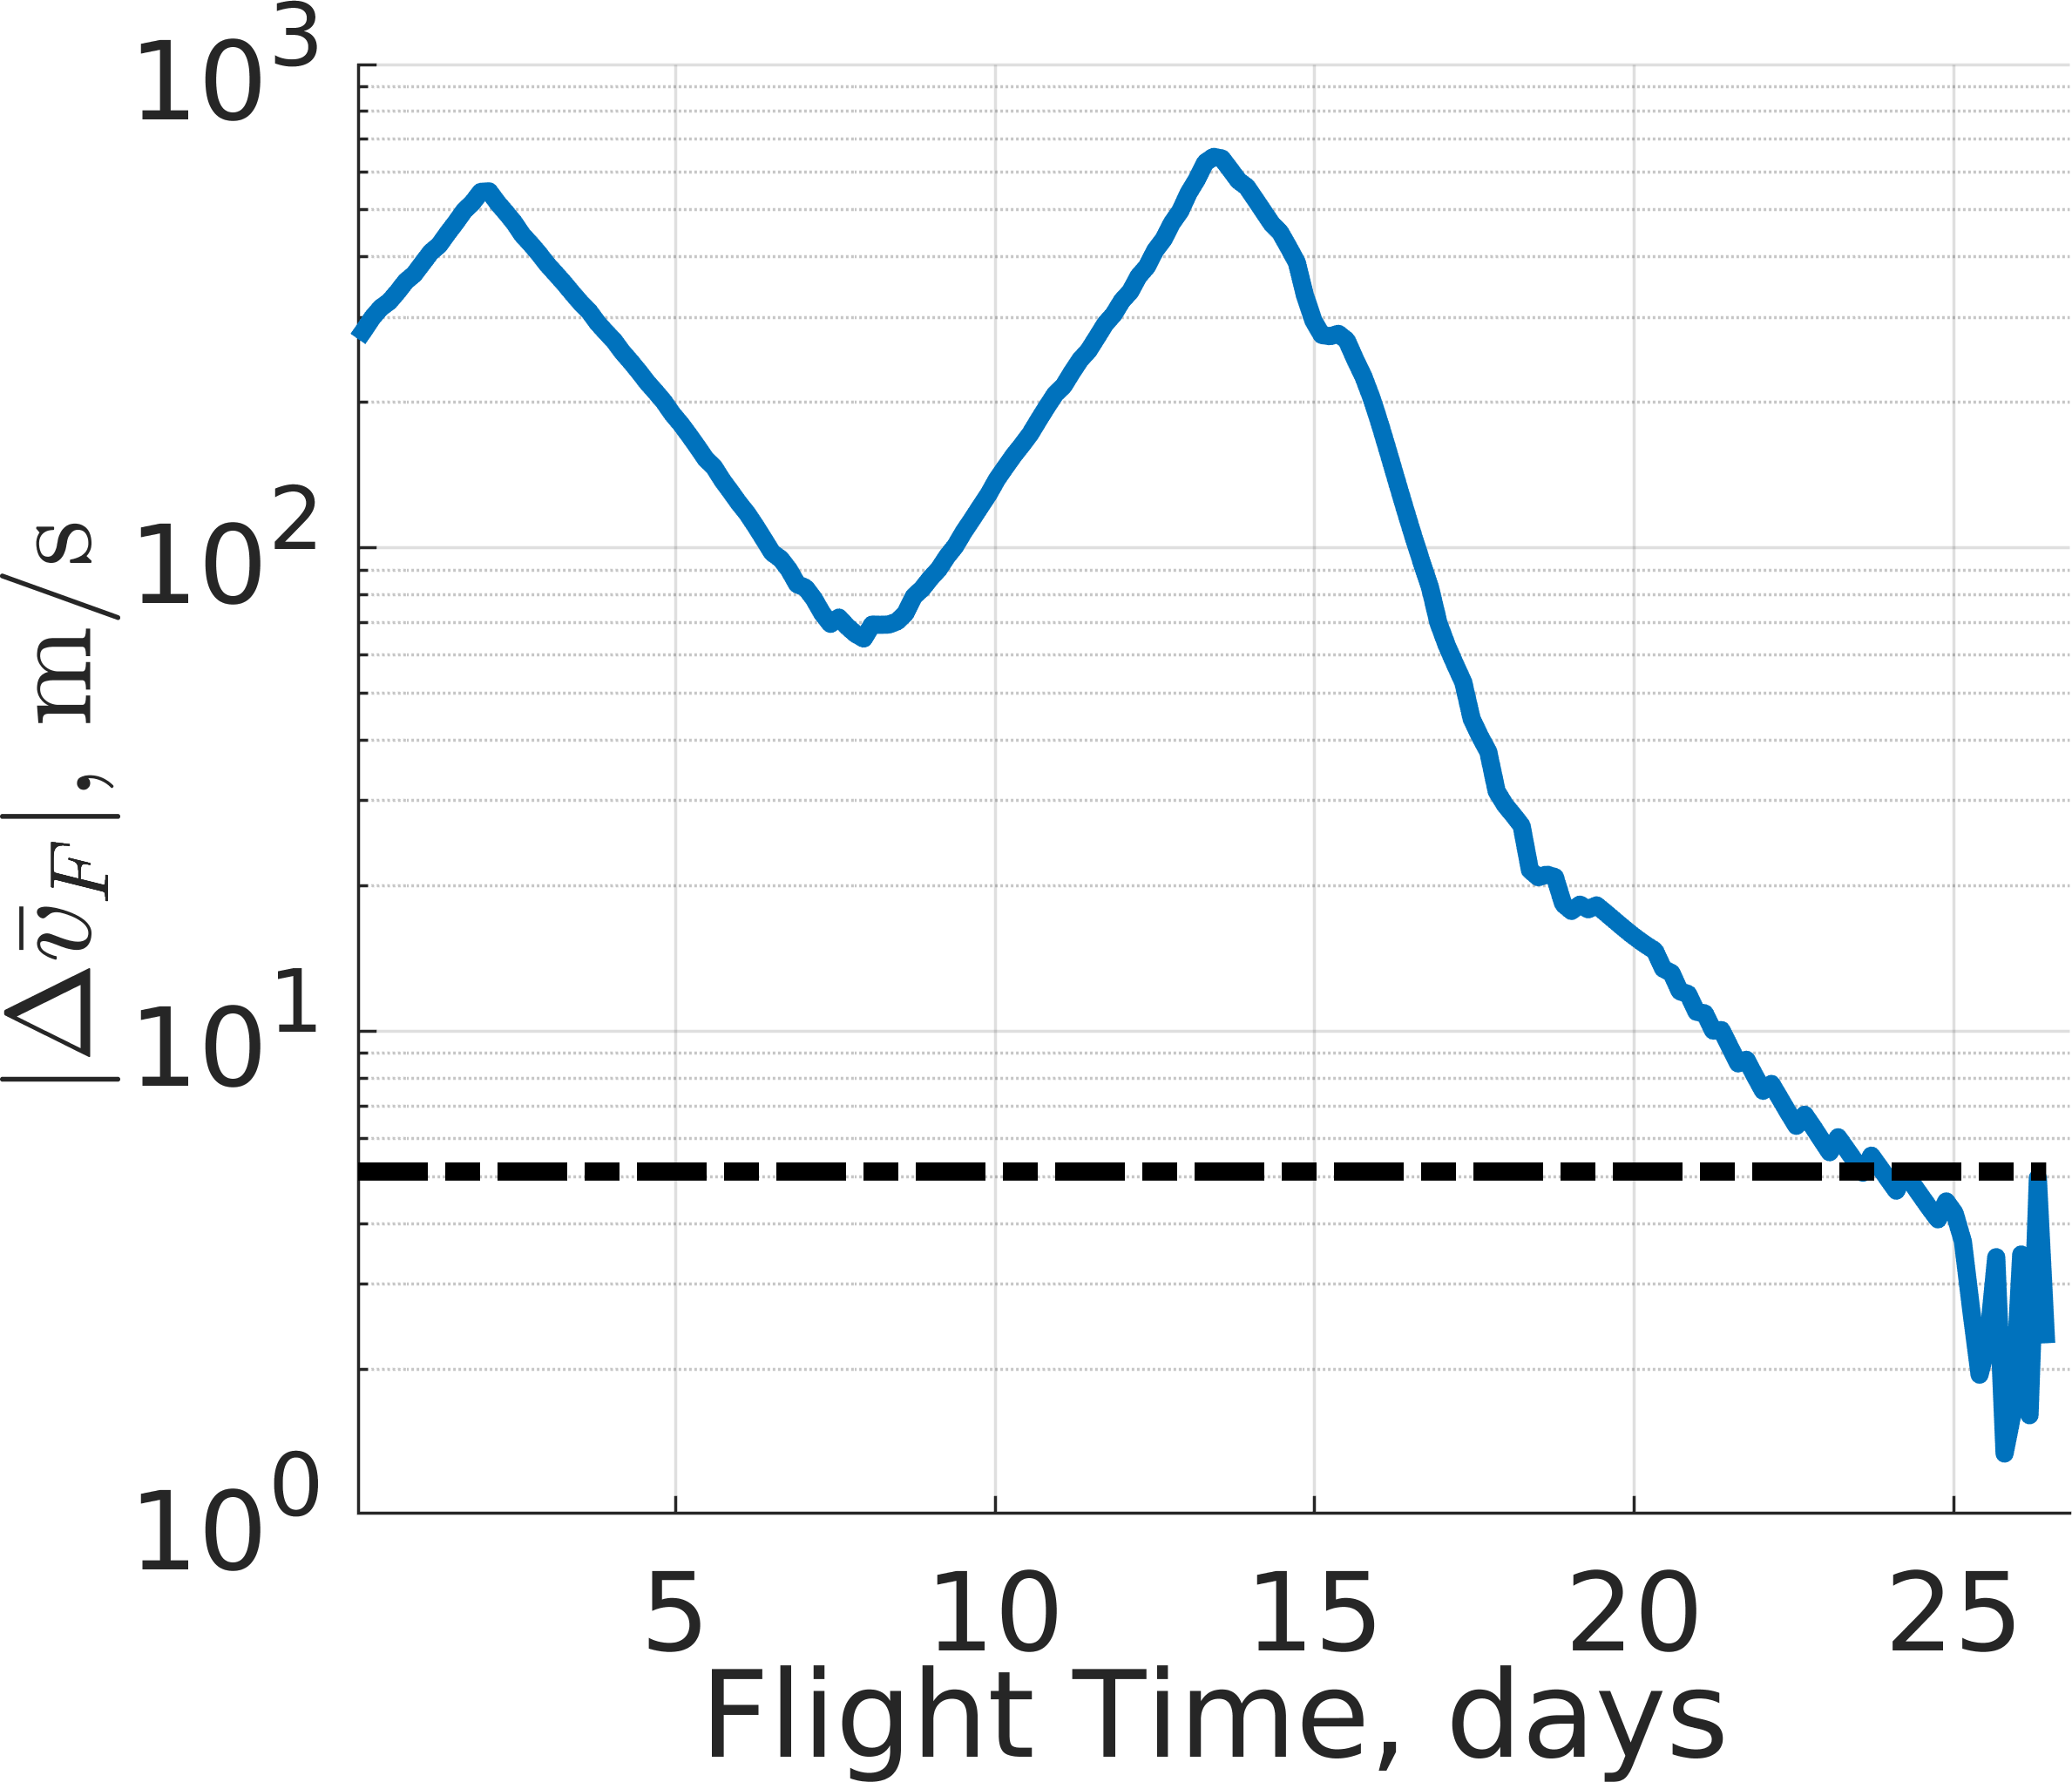
Figure 19: Relationship between the state discontinuities and propellant mass usage for the L₁ northern halo to L₂ southern halo transfer with distinct Jacobi constants.

  - Position Difference (b) Velocity Difference

Figure 16: Position and velocity differences measured with respect to the closest state on the final orbit for a single trajectory commanded by Policy 1.

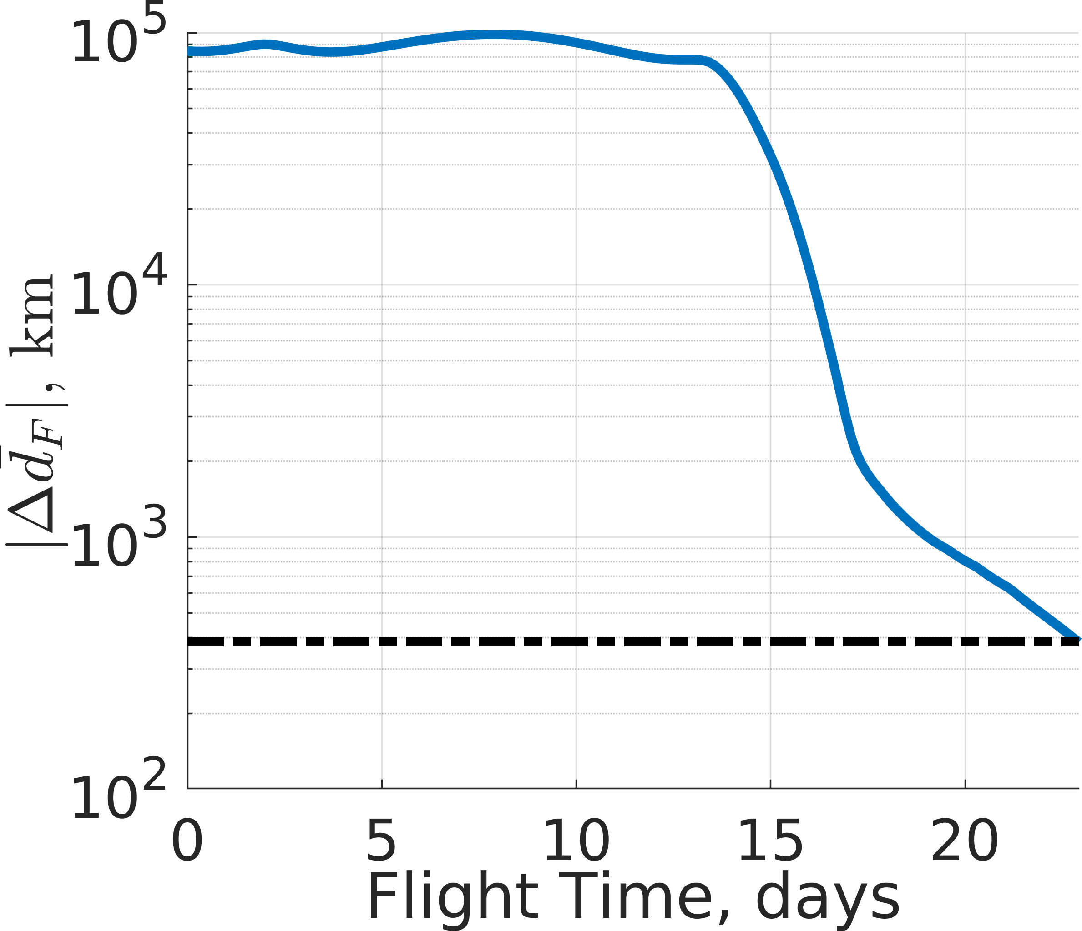
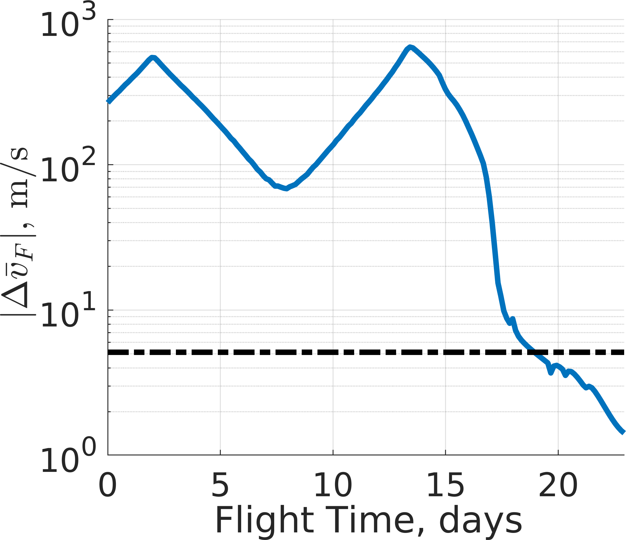
- Position Difference (b) Velocity Difference

Figure 17: Position and velocity differences measured with respect to the closest state on the final orbit for a single trajectory commanded by Policy 8.

the previous two scenarios, as the propellant mass usage increases, the policies tend to follow the reference trajectory more closely. However, in this scenario, Policies 6, 7, and 8 produce similar propellant mass usage and and state discontinuity behavior reflecting that the mass coefficients in their assigned reward functions are not encouraging ad- ditional propellant mass conservation. Further, the mean propellant mass usage across all policies is significantly less than the policies developed in the second scenario. This is due to the policies in the second scenario increasing and then immediately decreasing the spacecraft’s energy to develop the continuous transfer whereas policies in this scenario are only required to increase the energy of the spacecraft.
Examining a single evaluation trajectory for Policies 1 and 8 generates additional insights into the characteristics of this trajectory design scenario. Figures 20a and 20b display a single evaluation trajectory associated with the most highly perturbed initial condition for Policies 1 and 8, respectively. Additionally, Figs. 21a and 21b depict the Jacobi constant along the trajectory for both policies where the black dashed line represents the Jacobi constant of the initial periodic orbit and the solid black line denotes the Jacobi constant of the final periodic orbit. These figures demonstrate that the policies develop unique behavior consistent with the penalty on propellant mass usage in their assigned reward functions. Both policies maximize the flight time spent at the Jacobi constant of either periodic orbit and minimize the Jacobi constant extensions outside of the Jacobi constant bounds formed by the two periodic orbits. The thrust magnitudes along both trajectories reveal that Policy 1 generates two

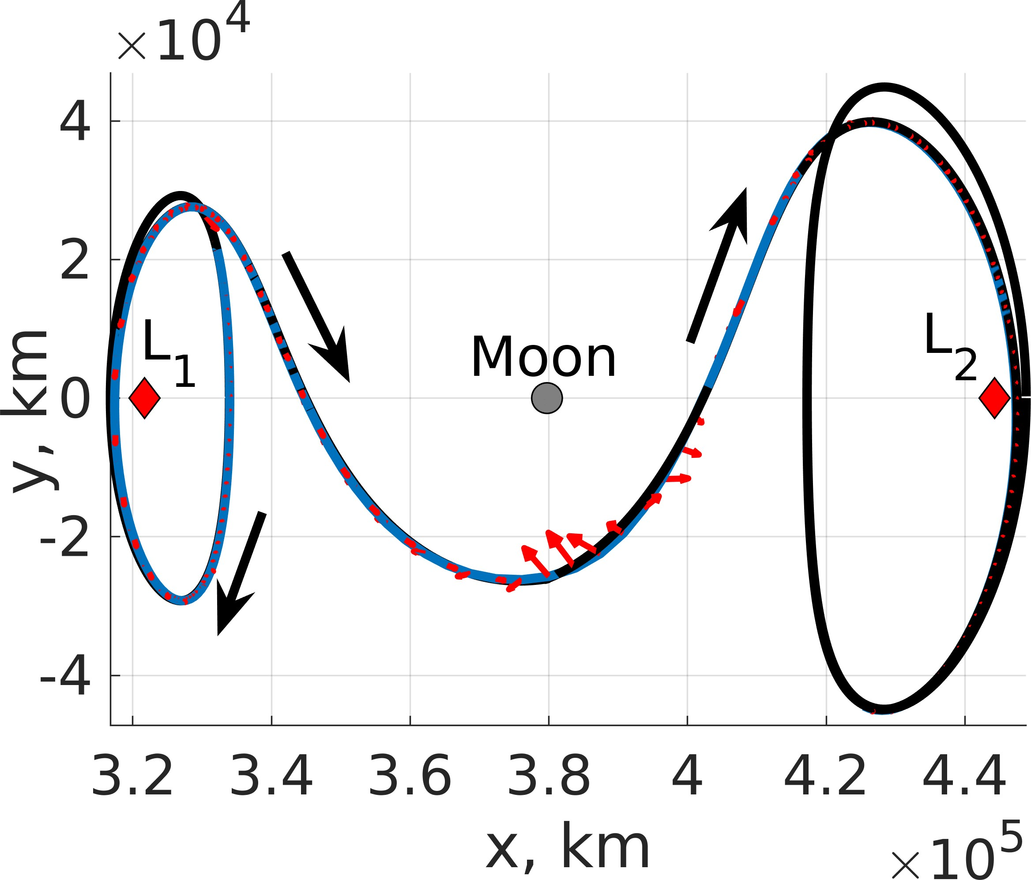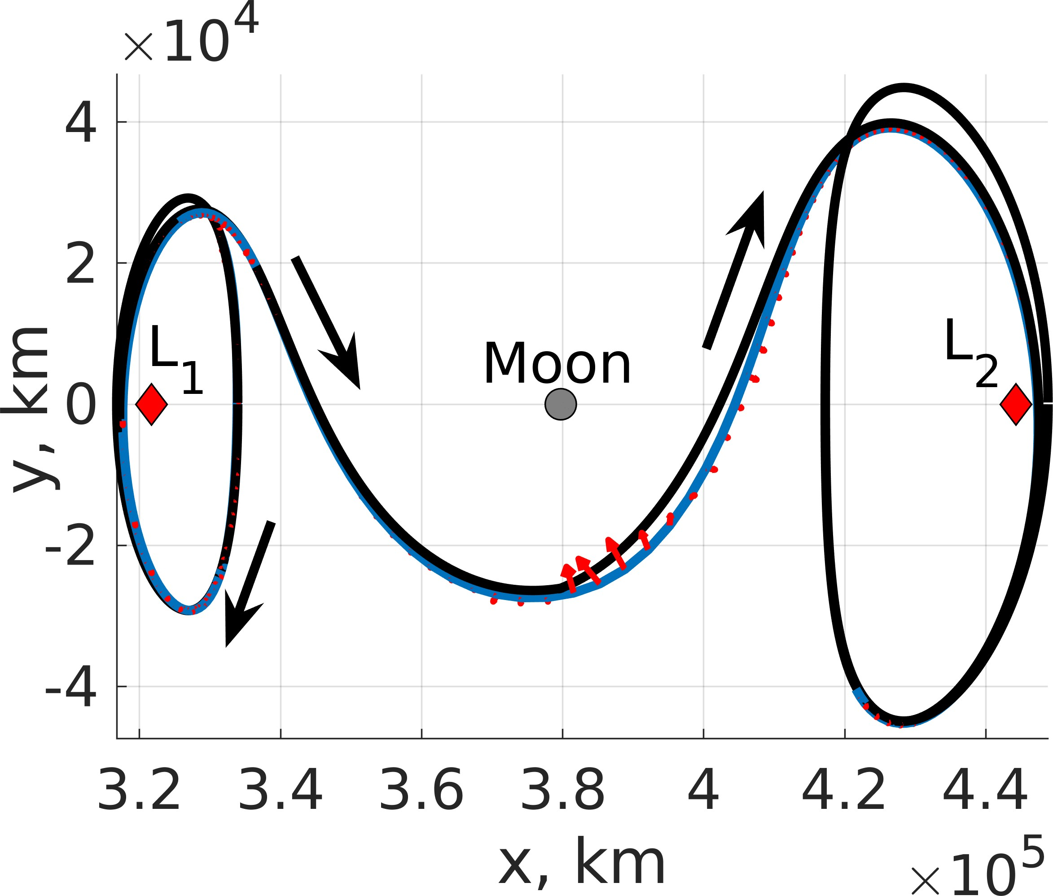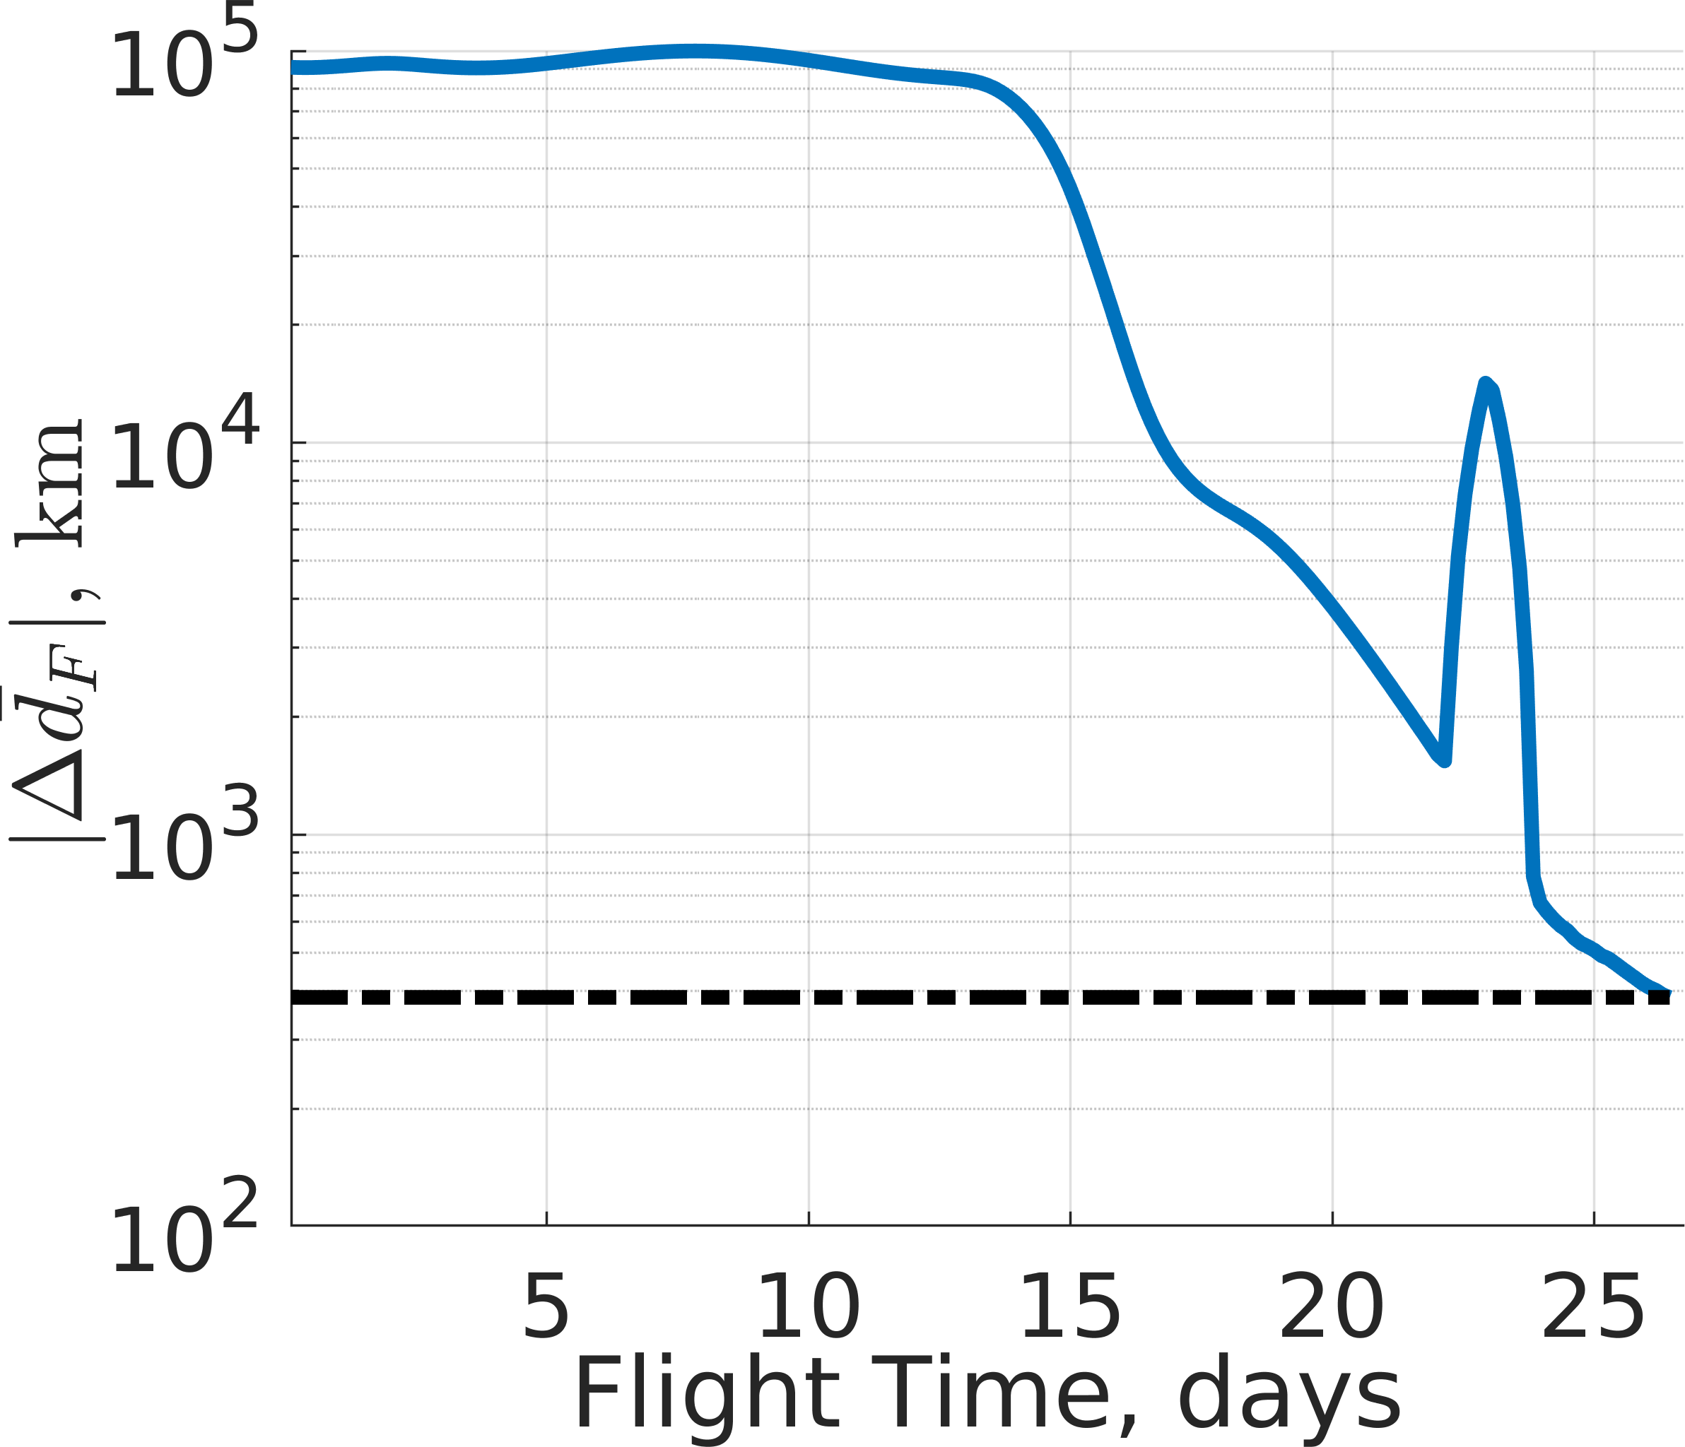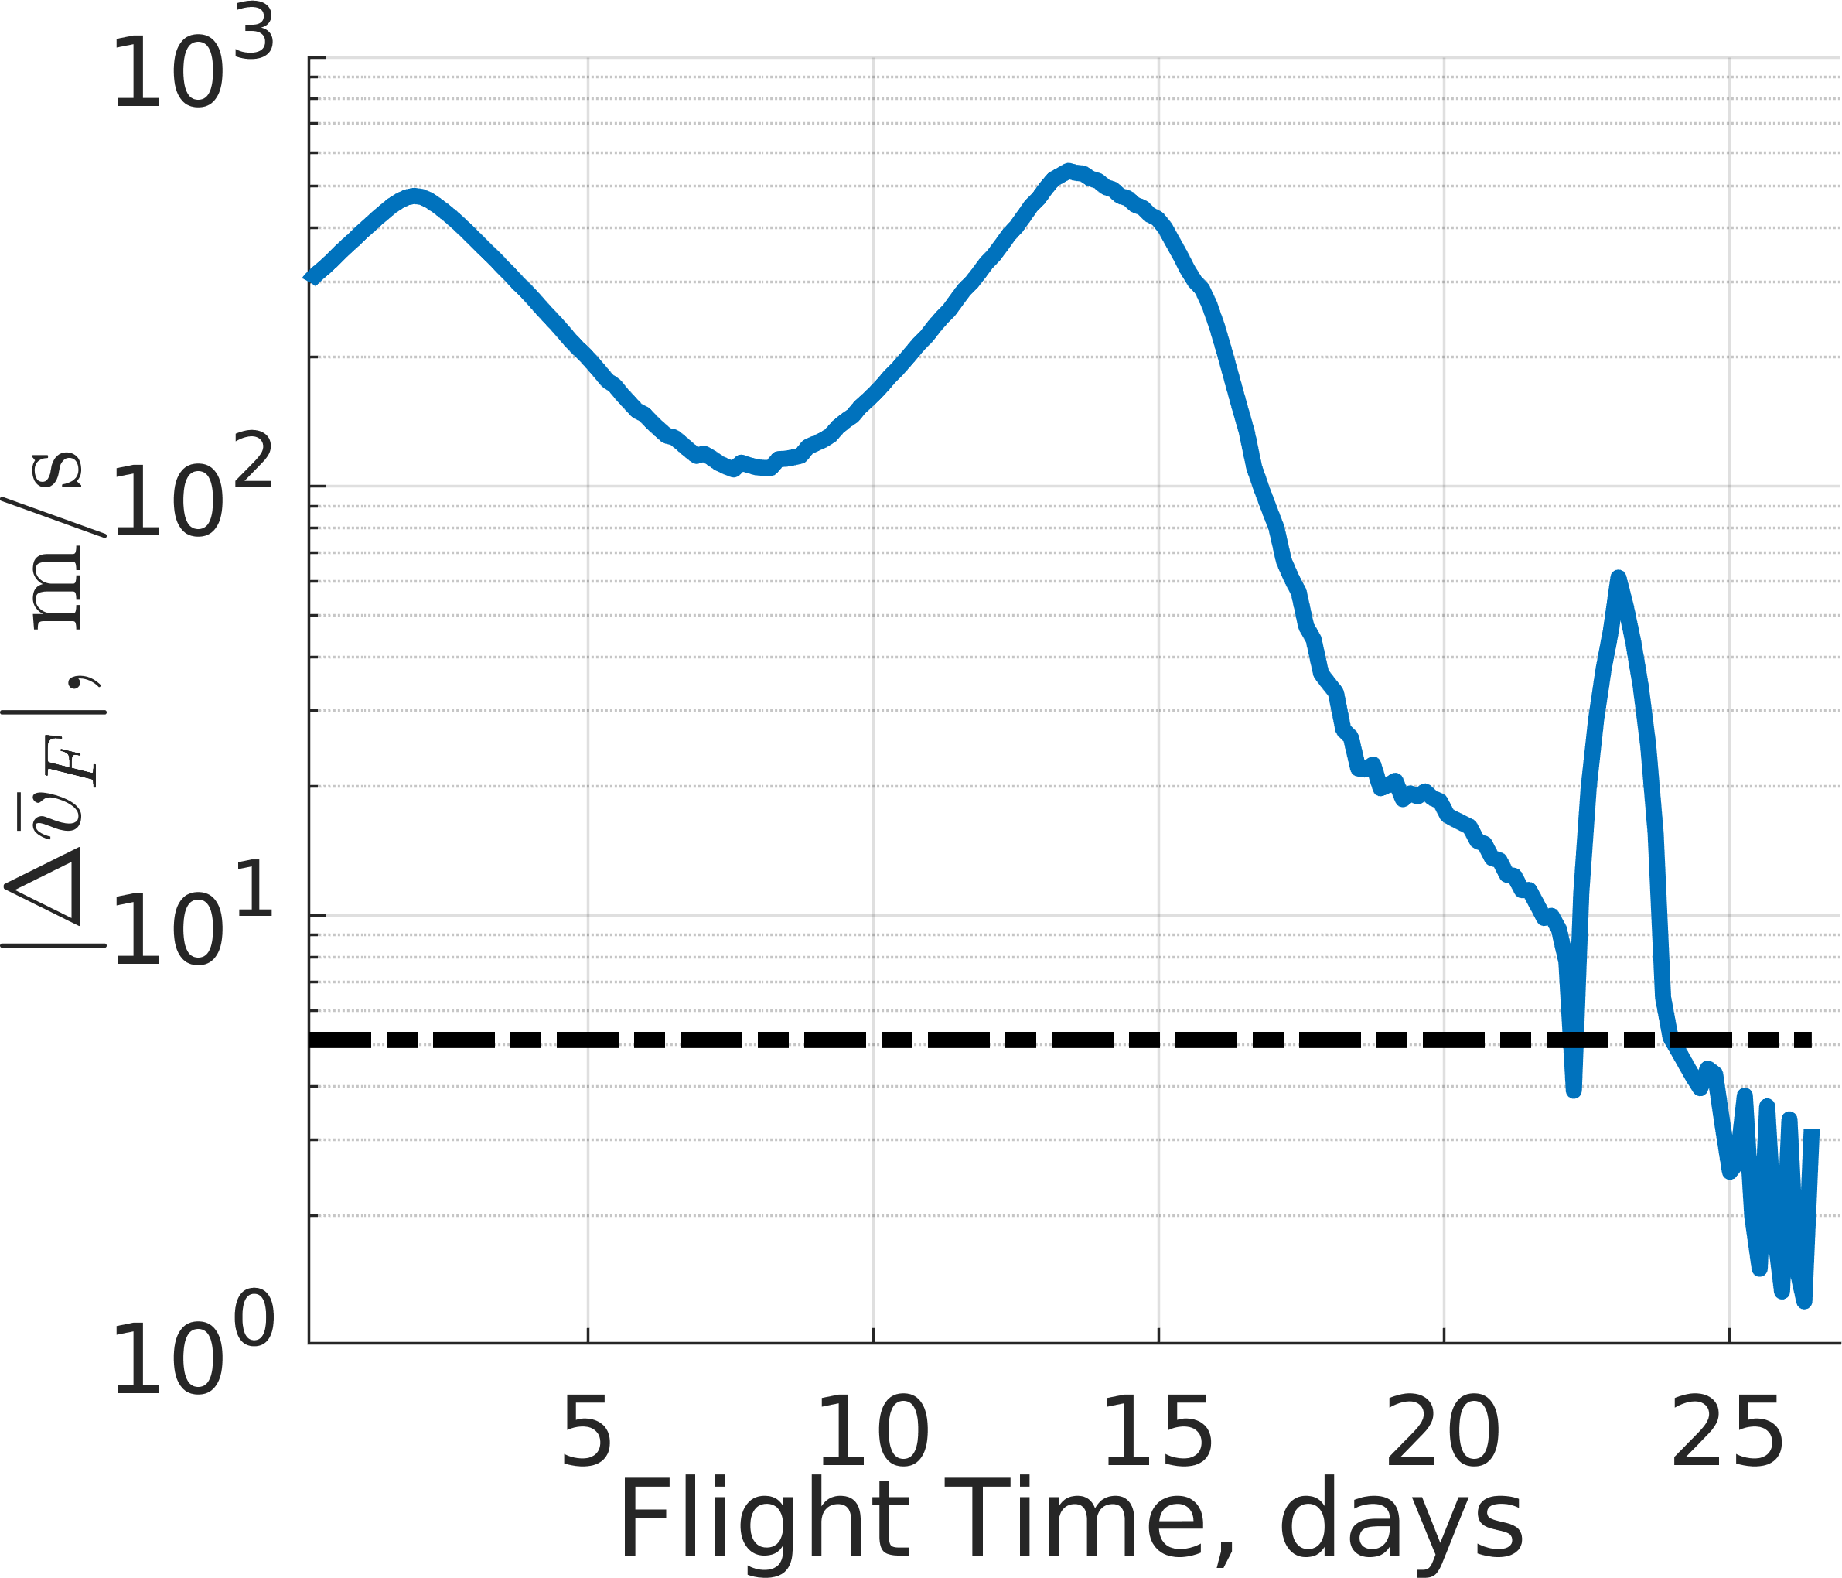

  - Policy 1 (b) Policy 8

Figure 20: Trajectory from a highly perturbed initial condition departing an L₁ northern halo orbit to an L₂ southern halo orbit with a distinct Jacobi constant controlled using: (a) Policy 1 and (b) Policy 8.

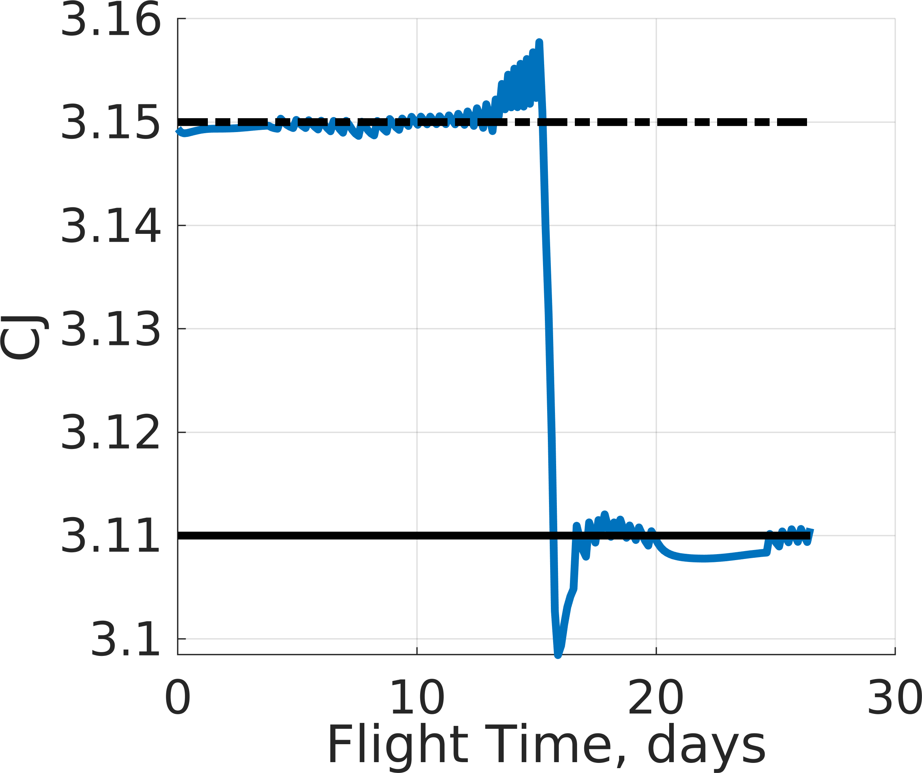
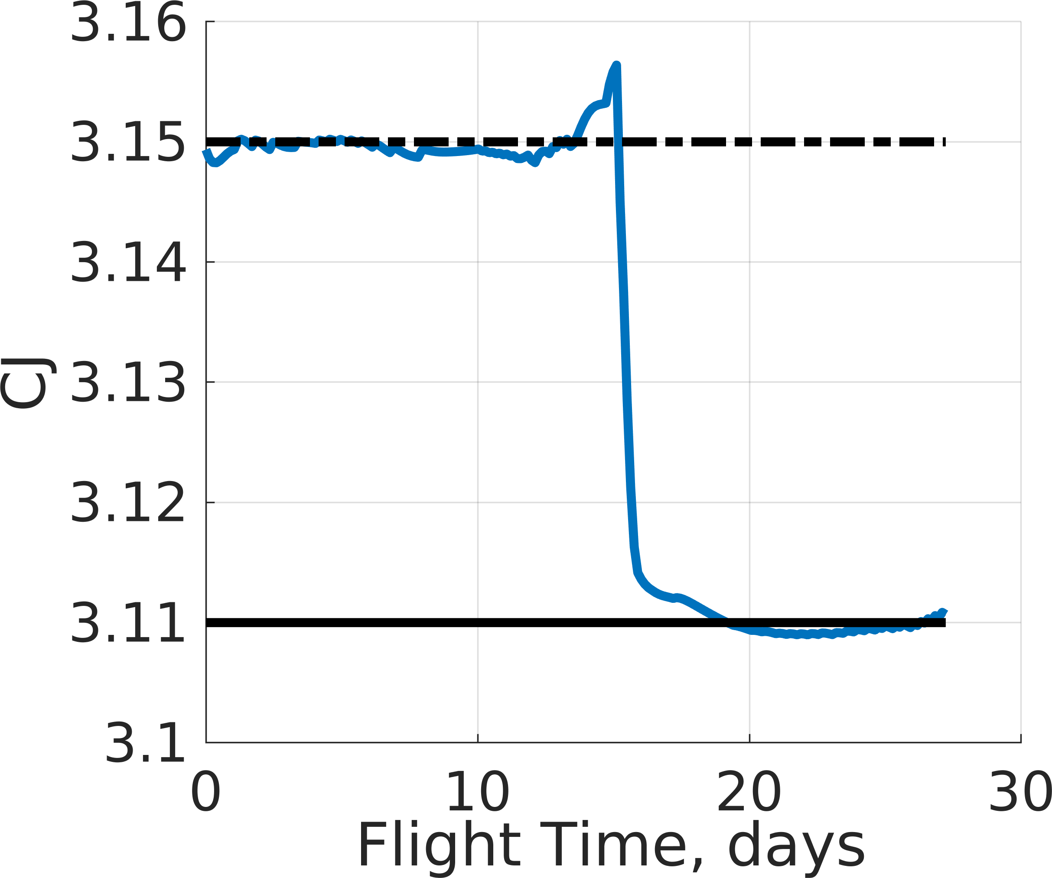
(a) Policy 1 (b) Policy 8

Figure 21: Jacobi constant along an evaluation trajectory commanded using: (a) Policy 1 and (b) Policy 8.

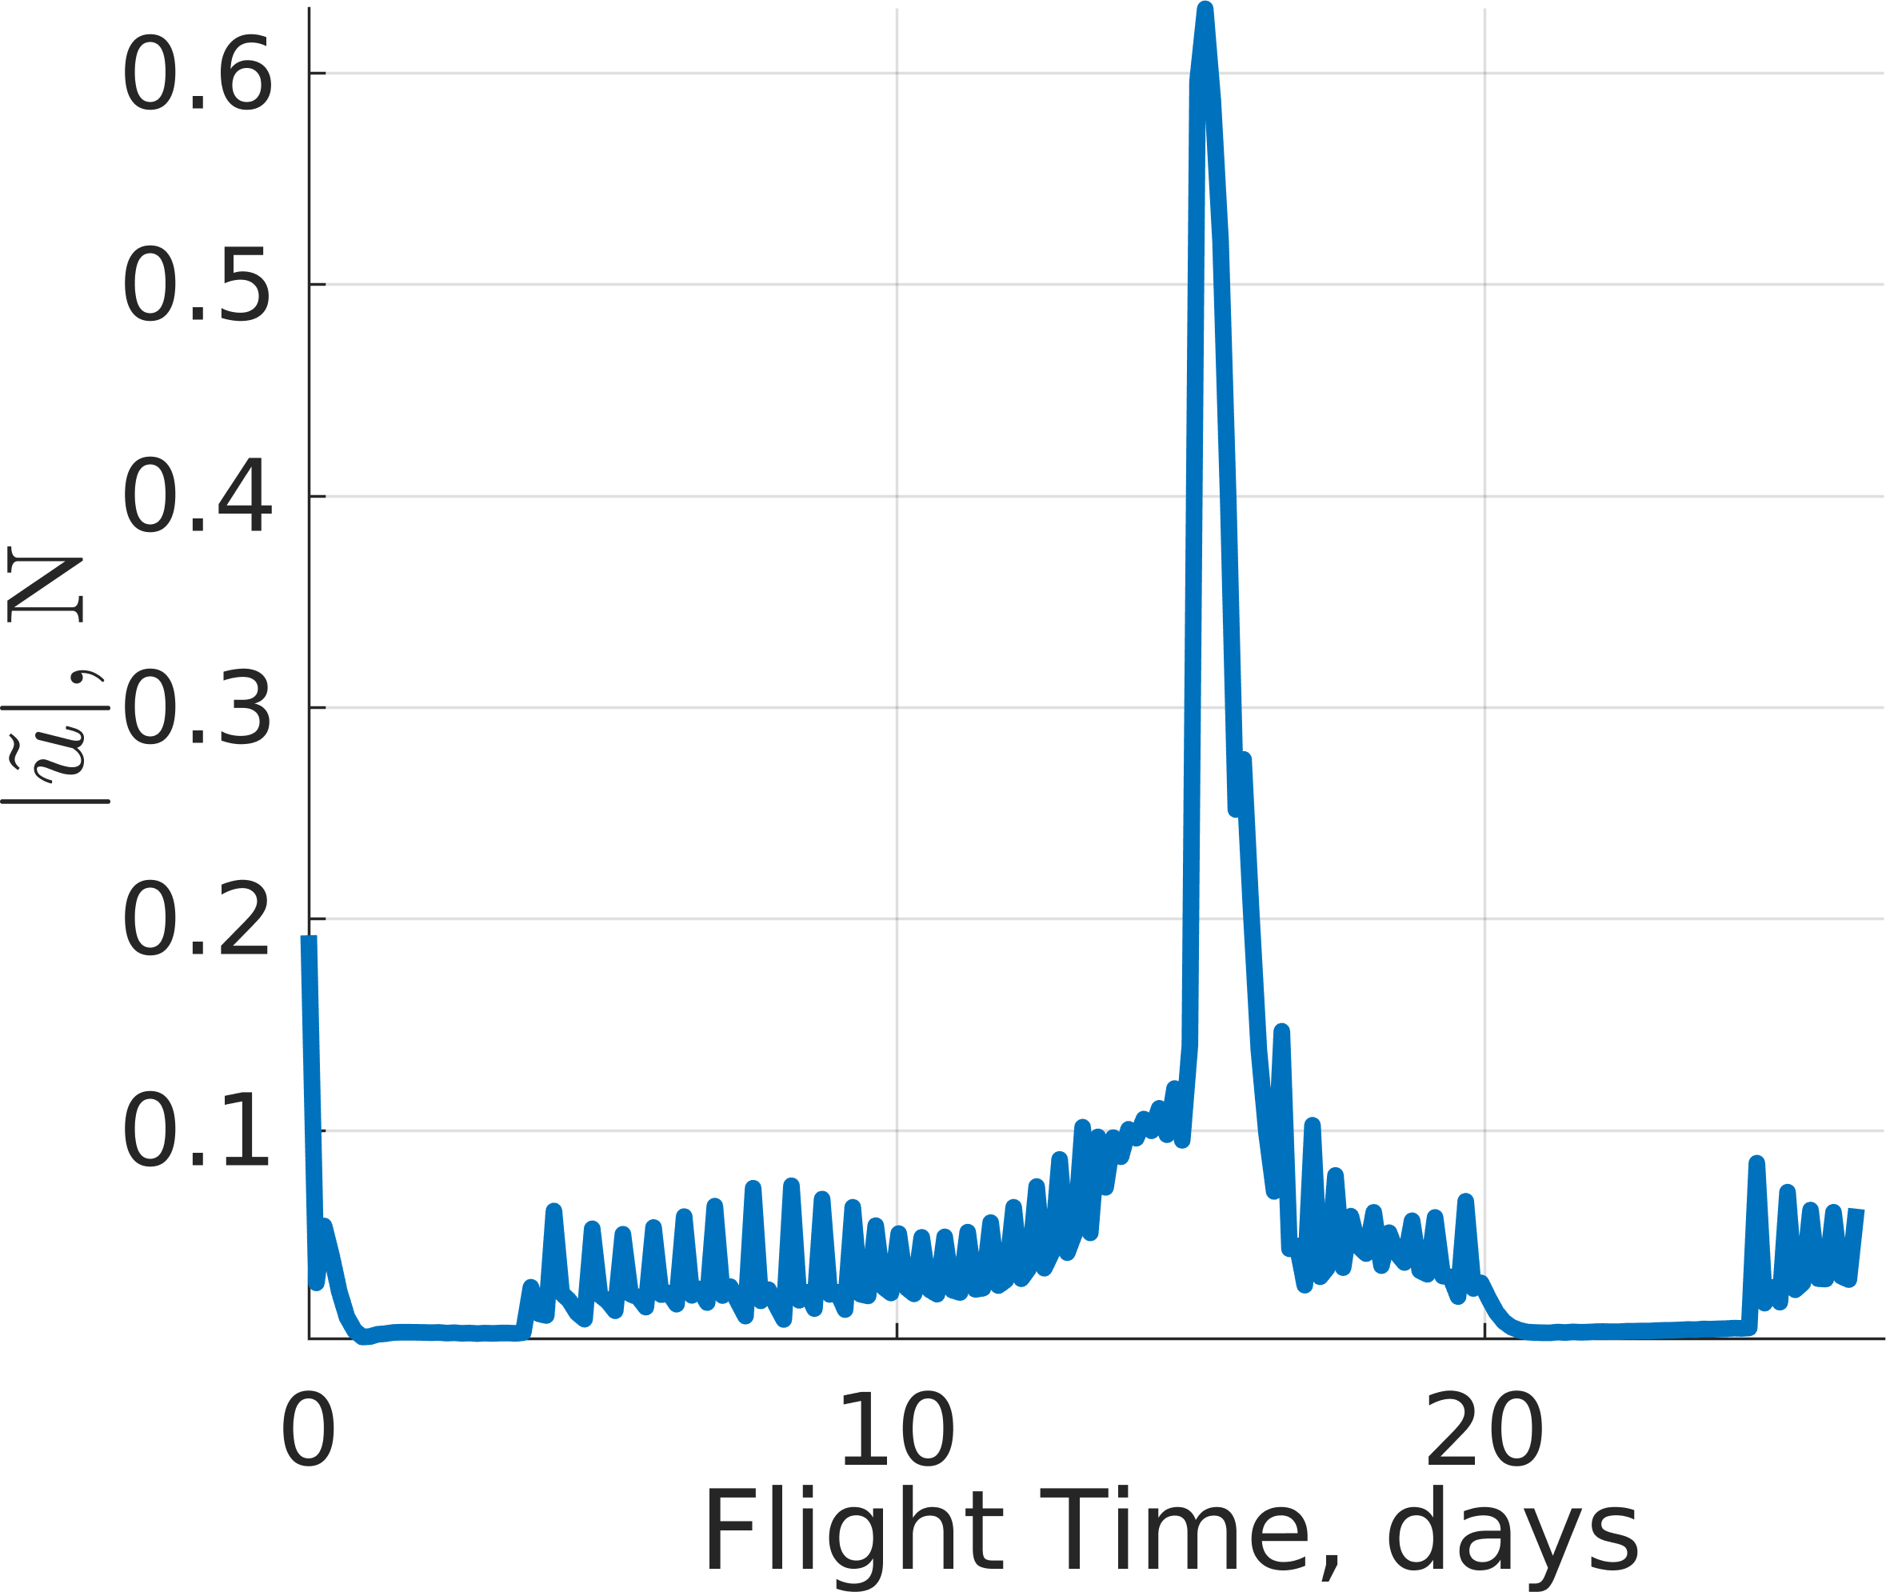
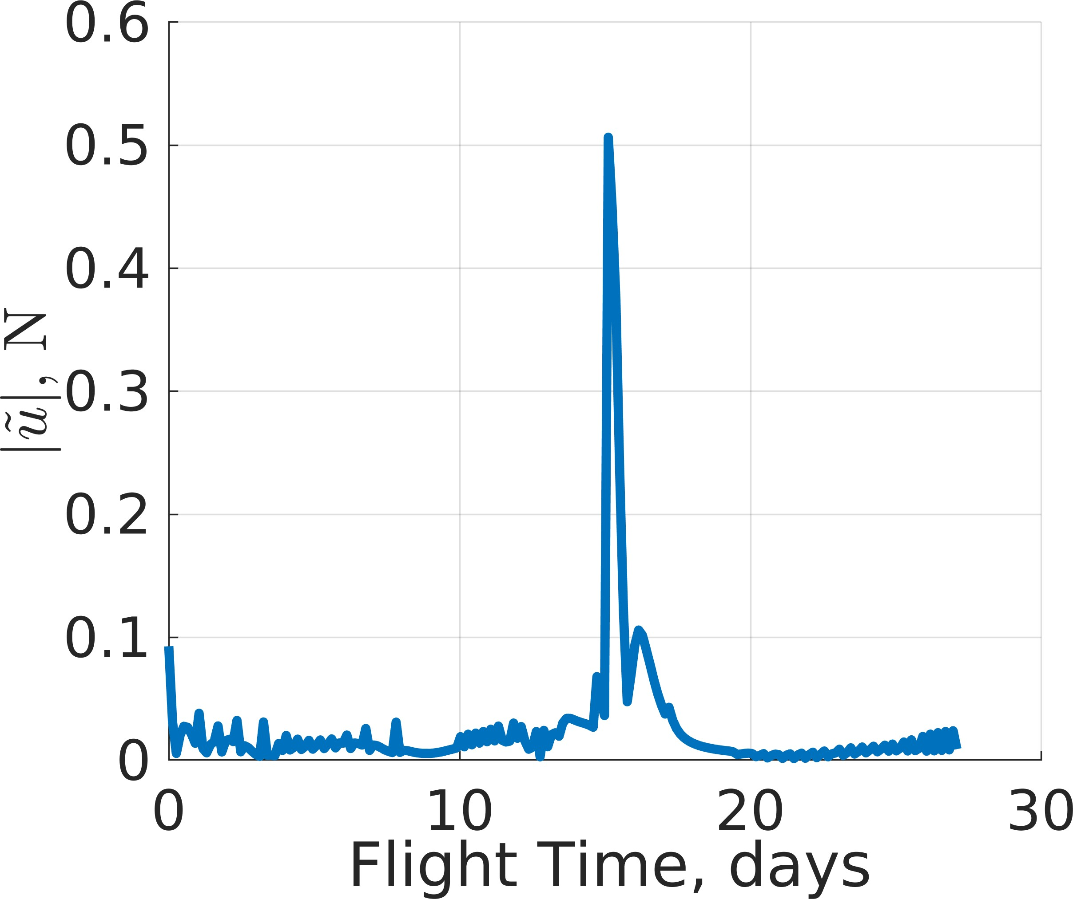
(a) Policy 1 (b) Policy 8

Figure 22: Thrust magnitude along an evaluation trajectory commanded using: (a) Policy 1 and (b) Policy 8.

long stretches of flight time with near-zero thrust magnitudes. Otherwise, Policy 1 generates bang-bang-like control vectors culminating in large control usage at the discontinuity in the reference trajectory. Similarly, Policy 8 tends to pro- duce actions with near-zero thrust magnitudes throughout the majority of the transfer except near the discontinuity in the reference trajectory. The position and velocity differences, measured with respect to the final orbit, are depicted in Figs. 23 and 24 for Policies 1 and 8, respectively. Both policies tend to intersect the velocity difference hypersphere prior to decreasing the position difference to match the final periodic orbit.
(a) Position Difference (b) Velocity Difference

Figure 23: Position and velocity differences measured with respect to the closest state on the final orbit for a single trajectory commanded by Policy 1.

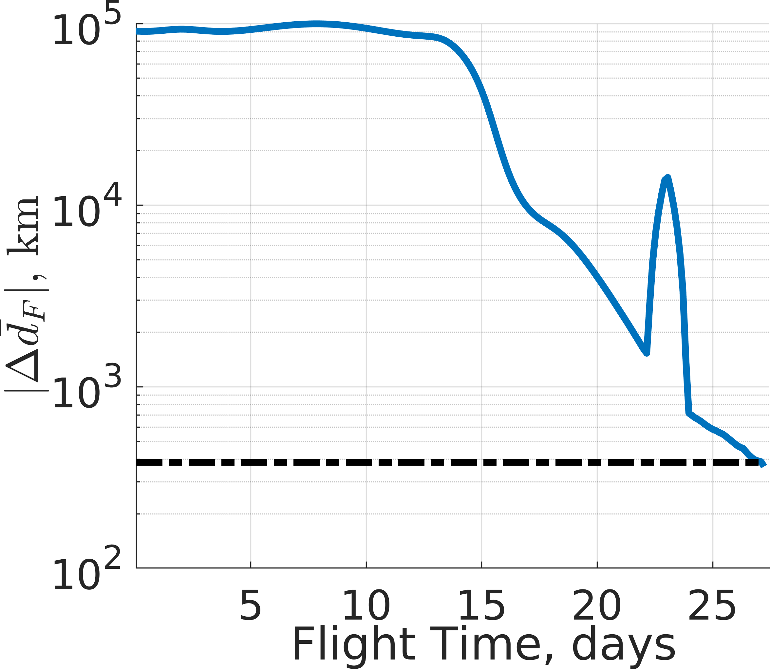
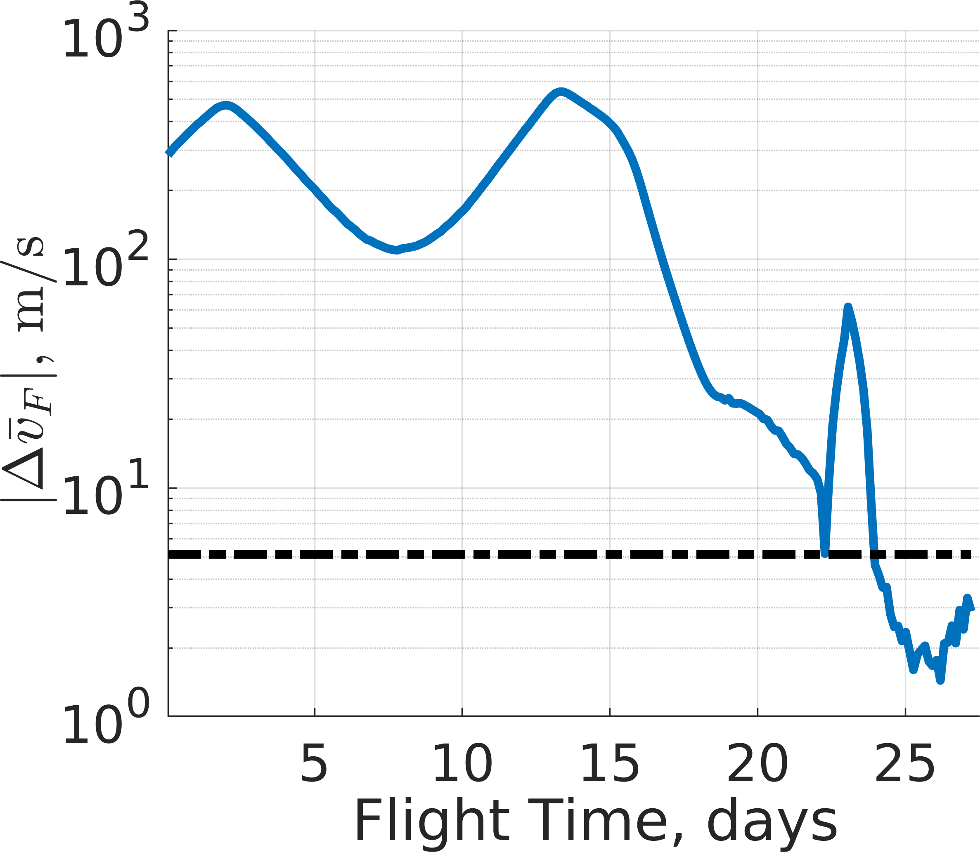
(a) Position Difference (b) Velocity Difference

Figure 24: Position and velocity differences measured with respect to the closest state on the final orbit for a single trajectory commanded by Policy 8.

6. CONCLUSION
MRPPO, an MODRL algorithm, is used to train multiple policies in three libration point orbit transfer scenarios in the Earth-Moon system to uncover the multi-objective solution space for a low-thrust-enabled SmallSat. First, eight policies are trained on an L₁ Lyapunov orbit to an L₂ Lyapunov orbit transfer as a verification for uncovering the solution space. Then, two more complex scenarios, focusing on departing an L₁ northern halo orbit and approaching an L₂ southern halo orbit, are evaluated using this approach. By varying the scaling of objectives in the assigned reward functions, the policies learn to develop unique behavior that maximizes the long-term reward in each trajectory design scenario. Once the policies are trained, they are evaluated on a common set of perturbed initial conditions to generate insights into the recovered solution spaces. This investigation demon- strates the capability of MRPPO for rapidly developing low- thrust trajectories in the vicinity of a discontinuous reference trajectory autonomously and efficiently within a multi-body trajectory design scenario.

ACKNOWLEDGMENTS
This work was supported by a NASA Space Technology Research Fellowship. Part of the research has been carried out at the Jet Propulsion Laboratory, California Institute of Technology, under a contract with the National Aeronautics and Space Administration. The High Performance Com- puting resources used in this investigation were provided by funding from the JPL Office of the Chief Information Officer. Part of this research was performed at the University

of Colorado Boulder.

REFERENCES
- J. Schoolcraft, A. Klesh, and T. Werne, “Marco: in- terplanetary mission development on a cubesat scale,” in Space Operations: Contributions from the Global Community. Springer, 2017, pp. 221–231.
- NASA, MarCO (Mars Cube One), 2020, https://solarsystem.nasa.gov/missions/mars-cube- one/in-depth/; Accessed 20 September 2020.
- N. Bosanac, A. Cox, K. Howell, and D. C. Folta, “Tra- jectory design for a cislunar cubesat leveraging dynam- ical systems techniques: The lunar icecube mission,” Acta Astronautica, pp. 283–296, 2018.
- A. L. Genova and D. W. Dunham, “Trajectory design for the lunar polar hydrogen mapper mission,” 27th AAS/AIAA Space Flight Mechanics Meeting, San Anto- nio, TX, 2017.
- L. Johnson, J. Castillo-Rogez, J. Dervan, and L. Mc- Nutt, “Near earth asteroid (nea) scout,” 4th Interna- tional Symposium on Solar Sailing, Kyoto Japan, 2017.
- C. J. Sullivan and N. Bosanac, “Using multi-objective deep reinforcement learning to uncover a pareto front in multi-body trajectory design,” in AAS/AIAA Astrody- namics Specialist Conference, 2020.
- ——, “Using reinforcement learning to design a low- thrust approach into a periodic orbit in a multi-body system,” in 30th AIAA/AAS Space Flight Mechanics Meeting, 2020.
- D. Miller and R. Linares, “Low-thrust optimal control via reinforcement learning,” in 29th AAS/AIAA Space Flight Mechanics Meeting, 2019, pp. 1–18.
- N. B. LaFarge, D. Miller, K. C. Howell, and R. Linares, “Guidance for closed-loop transfers using reinforce- ment learning with application to libration point orbits,” in AIAA Scitech 2020 Forum, 2020, p. 0458.
- A. Scorsoglio, R. Furfaro, R. Linares, M. Massari et al., “Actor-critic reinforcement learning approach to relative motion guidance in near-rectilinear orbit,” Advances in the Astronautical Sciences, pp. 1–20, 2019.
- A. Das-Stuart, K. C. Howell, and D. C. Folta, “Rapid trajectory design in complex environments enabled by reinforcement learning and graph search strategies,” Acta Astronautica, vol. 171, pp. 172–195, 2020.
- L. Cheng, Z. Wang, and F. Jiang, “Real-time control for fuel-optimal moon landing based on an interactive deep reinforcement learning algorithm,” Astrodynamics, vol. 3, no. 4, pp. 375–386, 2019.
- A. Harris, T. Teil, and H. Schaub, “Spacecraft decision- making autonomy using deep reinforcement learning,” in 29th AAS/AIAA Space Flight Mechanics Meeting, 2019, pp. 1–19.
- A. Zavoli and L. Federici, “Reinforcement learning for low-thrust trajectory design of interplanetary missions,” AAS/AIAA Astrodynamics Specialist Conference, 2020.
- T. T. Nguyen, N. D. Nguyen, P. Vamplew, S. Nahavandi,
R. Dazeley, and C. P. Lim, “A multi-objective deep reinforcement learning framework,” Engineering Appli- cations of Artificial Intelligence, vol. 96, p. 103915, 2020.
- T. Tajmajer, “Modular multi-objective deep reinforce- ment learning with decision values,” in 2018 Federated Conference on Computer Science and Information Sys- tems. IEEE, 2018, pp. 85–93.
- W. S. Koon, M. W. Lo, J. E. Marsden, and S. D. Ross, Dynamical Systems, The Three-Body Problem and Space Mission Design. Marsden Books, 2006.
- J. S. Parker and R. L. Anderson, Low-Energy Lu- nar Trajectory Design. Hoboken, New Jer- sey: John Wiley and Sons, 2014, pp. 95–113, https://doi.org/10.1002/9781118855065.
- V. Szebehely, Theory of Orbits: The Restricted Problem of Three Bodies. London, UK: Academic Press, 1967.
- D. C. Davis, S. M. Phillips, K. C. Howell, S. Vu- tukuri, and B. P. McCarthy, “Stationkeeping and trans- fer trajectory design for spacecraft in cislunar space,” 2017 AAS/AIAA Astrodynamics Specialist Conference, Stevenson, WA, 2017.
- R. L. Anderson and M. W. Lo, “Role of invari- ant manifolds in low-thrust trajectory design,” Jour- nal of Guidance, Control, and Dynamics, vol. 32, no. 6, pp. 1921–1930, November-December 2009, https://doi.org/10.2514/1.37516.
- G. Mingotti, F. Topputo, and F. Bernelli-Zazzera, “Low- energy, low-thrust transfers to the moon,” Celestial Mechanics and Dynamical Astronomy, vol. 105, no. 1-3, p. 61, 2009.
- V. Mnih, K. Kavukcuoglu, D. Silver, A. Rusu, J. Veness,
M. Bellemare, A. Graves, M. Riedmiller, A. Fidje- land, G. Ostrovski, S. Petersen, C. Beattie, A. Sadik,
I. Antonoglou, H. King, D. Kumaran, D. Wier- stra, S. Legg, and D. Hassabis, “Human-level control through deep reinforcement learning,” Nature, vol. 518, pp. 529–33, 02 2015.
- M. Minsky, “Steps toward artificial intelligence,” in Proceedings of the IRE, vol. 49, no. 1, pp. 8–30, 1961, doi: 10.1109/JRPROC.1961.287775.
- A. G. Barto, “Reinforcement learning and dynamic programming,” 6th IFAC/IFIP/IFORS/IEA Symposium on Analysis, Design and Evaluation of Man-Machine Systems, Cambridge, MA, vol. 28, no. 15, pp. 407–412, 1995.
- J. A. Boyan and A. W. Moore, “Generalization in reinforcement learning: Safely approximating the value function,” in Advances in Neural Information Processing Systems 7, G. Tesauro, D. S. Touretzky, and T. K. Leen, Eds. MIT Press, 1995, pp. 369–376. [Online]. Available: http://papers.nips.cc/paper/1018- generalization-in-reinforcement-learning-safely- approximating-the-value-function.pdf
- K. Hornik, M. Stinchcombe, H. White et al., “Multi- layer feedforward networks are universal approxima- tors.” Neural Networks, vol. 2, no. 5, pp. 359–366, 1989.
- D. Silver, A. Huang, C. J. Maddison, A. Guez,
L. Sifre, G. Van Den Driessche, J. Schrittwieser,
I. Antonoglou, V. Panneershelvam, M. Lanctot,
- Dieleman, D. Grewe1, J. Nham, N. Kalchbrenner,
- Lillicrap, M. Leach, K. Kavukcuoglu, T. Graepel, and D. Hassabis, “Mastering the game of go with deep neural networks and tree search,” Nature, vol. 529, no. 7587, pp. 484–489, 2016.
- J. Schulman, F. Wolski, P. Dhariwal, A. Radford, and

O. Klimov, “Proximal policy optimization algorithms,”
arXiv preprint arXiv:1707.06347, 2017.
- P. Henderson, R. Islam, P. Bachman, J. Pineau, D. Pre- cup, and D. Meger, “Deep reinforcement learning that matters,” in Thirty-Second AAAI Conference on Artifi- cial Intelligence, 2018.
- M. Andrychowicz, A. Raichuk, P. Stan´czyk, M. Orsini,
S. Girgin, R. Marinier, L. Hussenot, M. Geist,
O. Pietquin, M. Michalski, S. Gelly, and O. Bachem, “What matters in on-policy reinforcement learning? a large-scale empirical study,” 2020.
- V. R. Konda and J. N. Tsitsiklis, “Actor-critic algo- rithms,” Advances in Neural Information Processing Systems 12: Proceedings of the 1999 Conference, Den- ver, CO, pp. 1008–1014, 2000.
- H. Peng, B. Chen, and Z. Wu, “Multi-objective trans- fer to libration-point orbits via the mixed low-thrust and invariant-manifold approach,” Nonlinear Dynam- ics, vol. 77, no. 1-2, pp. 321–338, 2014.
- V. Shah, R. Beeson, and V. Coverstone, “A method for optimizing low-energy transfers in the earth-moon sys- tem using global transport and genetic algorithms,” in AIAA/AAS Astrodynamics Specialist Conference, 2016.

BIOGRAPHY


Christopher J. Sullivan is a fourth-year Ph.D. student in the Smead Department of Aerospace Engineering Sciences at the University of Colorado Boulder. His research focuses on leveraging multi- objective deep reinforcement learning and dynamical systems theory to ef- ficiently explore the trajectory design space for low-thrust-enabled missions in multi-body systems. He is supported by
a NASA Space Technology Research Fellowship.


Natasha Bosanac is an Assistant Pro- fessor in the Colorado Center for Astro- dynamics Research and Smead Depart- ment of Aerospace Engineering Sciences at the University of Colorado Boulder. Her research focuses on applications of dynamical systems theory and machine learning to astrodynamics and celestial mechanics. She received her Ph.D. and
M.S in Aerospace Engineering in 2012 and 2016 from Purdue University and her Bachelor’s degree from the Massachusetts Institute of Technology in 2010.


Rodney L. Anderson received his Ph.D. and M.S. in Aerospace Engineering Sci- ences from the University of Colorado at Boulder and his Bachelor’s degree from North Carolina State University. He is currently a Technologist in the Mission Design and Navigation section at the Jet Propulsion Laboratory, California Insti- tute of Technology where he has worked since 2010. His research interests are
focused on the application of dynamical systems theory to astrodynamics, mission design, navigation, and celestial me- chanics.
Alinda K. Mashiku received her un- dergraduate degree from The Ohio State University in 2007, and then both her MSAAE and PhD from Purdue Univer- sity in 2009 and 2013 consecutively. She is currently the Conjunction Analy- sis and Risk Assessment (CARA) deputy program manager and technical lead; CARA is responsible for the conjunction analysis and risk assessment by provid-

ing operations support for NASA’s non-human spacecraft in Earth Orbit. Her academic and professional background research interests are in hybrid systems estimation, nonlinear Bayesian estimation theory, statistical orbit determination, fault detection and identification, and data compression using information measures using Bayesian Machine Learning for Neural Networks.


Jeffrey R. Stuart received his B.S., M.S., and Ph.D. in Aeronautics & Astronautics from Purdue University in 2008, 2011, and 2014, respectively. He is currently technical staff in Mission Design & Nav- igation at the Jet Propulsion Laboratory, California Institute of Technology. He is the MDNav Lead for the SunRISE formation flying mission and works on a variety of projects from early formu-
lation to flight operations. His interests include automated trajectory design, advanced navigation techniques, formation flying, combinatorial optimization, and visual analytic meth- ods.

