Simulation of Lift plus Cruise Vehicle Models to Define a Full-Scale Crash Test Campaign

Justin Littell
Justin.D.Littell@nasa.gov
Research Aerospace Engineer
NASA Langley Research Center
Hampton VA, 23681
Jacob Putnam
Jacob.B.Putnam@nasa.gov
Research Aerospace Engineer
NASA Langley Research Center
Hampton VA, 23681
Megan Cooper
Mfcooper@mit.edu
Massachusetts Institute of Technology
Cambridge MA, 02139

ABSTRACT
A series of dynamic simulations were completed on the National Aeronautics and Space Administration (NASA) Lift plus Cruise (LPC) concept electric Vertical Take-off and Landing (eVTOL) vehicle in preparation for an anticipated future full-scale crash-test campaign. The crash test campaign is envisioned as a data gathering exercise with an intent generating full-scale test data to inform eVTOL crashworthiness regulations, evaluate the use of energy absorbing concepts within vehicle design, and validate finite element modeling techniques used in crashworthiness predictions. This report discusses the two main objectives for the simulation efforts: the development of a structural cabin section, and a series of analyses utilized to determine the sensitivities of impact variables.

A structural cabin section was created based from previous research efforts involving the LPC vehicle utilized for occupant response. To refine for the structural modifications, the wing and tail sections of the vehicle were removed. The tail was replaced with a representative mass at the aft of the fuselage. The overhead wing was replaced with a beam structure sized to approximate the bending response of the wing under crash loading conditions. The beam structure was fixed to the fuselage similar to the original Wingbox design in order to properly capture effects of this overhead mass on survivable volume within the vehicle. The fidelity of the fuselage frame structure within the FEM was increased to quantify the effect of frame sizing on structural response. From this an eVTOL test article design was developed, which satisfied basic crashworthiness requirements, was reconfigurable to assess the effect of various design avenues on structural response and optimized to improve manufacturability.

The impact variable sensitivity results primarily show the orientation of the impact vector played a major role in types of injuries sustained, along with their severity. The vehicle was largely insensitive to small variations in pitch attitude but highly sensitive to both impact surface at certain angles and landing gear location.

INTRODUCTION
The electric Vertical Take-off and Landing (eVTOL) industry is poised to change the paradigm of transportation in the urban environment by shifting the focus from ground based to an aerial one using small, lightweight, and quiet aircraft that are expected to operate as transportation vehicles for the on-demand ride-sharing service industry.
These eVTOL vehicles are characterized by their lightweight structures, use of non-traditional materials, and unique flight profiles. The eventual maturation of the vehicle design will lead to regulatory acceptance and accessibility to the general public. There are over 200 UAM concepts in various states of design and production, featuring multiple engines and rotors, and a combination of fixed wing and vertical lift structures, which do not resemble the General Aviation (GA) and rotorcraft fleets in use today.
A high level of safety is necessary for the vehicles to gain acceptance by the public. Among many capabilities these new vehicles must demonstrate, a major concern as it pertains to the vehicles is how they will perform in an off-nominal landing scenario such as an emergency landing. These concerns are warranted since there are no current regulatory requirements specific to eVTOL aircraft in large part because these types of vehicles are not yet in operation and operational performance is unknown. Current standards for GA [1] and Rotorcraft [2] are being tailored to fit the eVTOL market, however, questions remain to their applicability and scope. The current standards for GA and rotorcraft are based on mishap data, full-scale testing, and other historical factors from 50+ years of service that have led to a basis for the specific values in the requirements.
NASA is currently investigating the feasibility of testing full-scale eVTOL cabin designs under various impact conditions as a first step to generate eVTOL crash data. Because testing is a lengthy process that requires significant resources, the entirety of the available impact conditions, designs and situations cannot be examined. Instead, a subset of representative tests must be used. These tests can represent either nominal or most likely to be experienced impact conditions, impact conditions currently used in existing regulations, or impact conditions at the edges of the survivability envelope. Testing under these various conditions will give insight into the performance of the vehicle systems, the likelihood of injury to the onboard occupants and the efficiency of the crashworthy systems (if applicable) installed in the vehicle.
NASA’s Lift plus Cruise (LPC) vehicle architecture [3] is used the basis for the dynamic environments research since it shares design features that are commonly associated with numerous eVTOL vehicles, currently in design. These common features include a high wing design with multiple lifting sources, a large cabin capable of seating six occupants, and a composite design. Additionally, since it is a common reference architecture, it is open source and design characteristics are able to be shared with the eVTOL community. For crash and impact simulations, the LPC model has been previously developed for similar small subset of loading conditions, but with a focus on the performance of energy absorbing mechanisms and occupant protection [4]. Figure 1 shows the NASA LPC vehicle.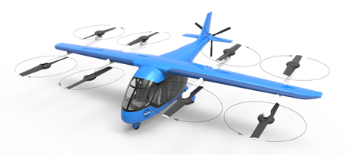
Figure 1 - NASA Lift Plus Cruise (LPC) concept vehicle
In anticipation of this test campaign, two major items were accomplished. The first was to examine design characteristics which make the LPC capable of being manufactured. The second was to determine what specific impact parameters most affected the vehicle response under off-nominal landing conditions.
The fuselage geometry of the LPC vehicle was simplified for ease of manufacturing and then evaluated under simple dynamic and static loading conditions to ensure the design met basic crashworthiness requirements. Design aspects such as frame sizing, Wingbox simplification, and structural layout were each evaluated in order to develop a test article that was realistic to basic crashworthiness expectations for the emerging eVTOL vehicle market.
The impact parameter study attempted to identify trends or patterns in the vehicle response. While the models have not been calibrated to the full-scale test data, the intent is to use the models to guide the test sequence, and then use the test data obtained to improve the response of the models, thus creating a self-feedback loop for model calibration. Ideally, the post-test calibrated models can then be used to predict other scenarios which were unable to be tested.
FABRICATION MODEL DETAILS
The crashworthiness test article of the NASA LPC vehicle was developed by first simplifying the flight design to reduce manufacturing costs. Components not considered integral to the structural response of the cabin were removed. A comparison of the flight design and preliminary test article concept is provided in Figure 2. All rotor elements were replaced with mounted masses. The vehicle tail was removed aft of the section supporting the rear landing gear and replaced with a representative mass. The Wingbox was replaced with an aluminum mounting plate over the cabin section. The wings were replaced with C-channels on which the representative rotor masses could be mounted. This was done primarily to reduce manufacturing complexity associated with producing the wing component. It also would allow for the center of gravity (CG) of the wing mass to be adjusted over cabin section in order to evaluate the relationship between overhead wing placement and survivable volume.
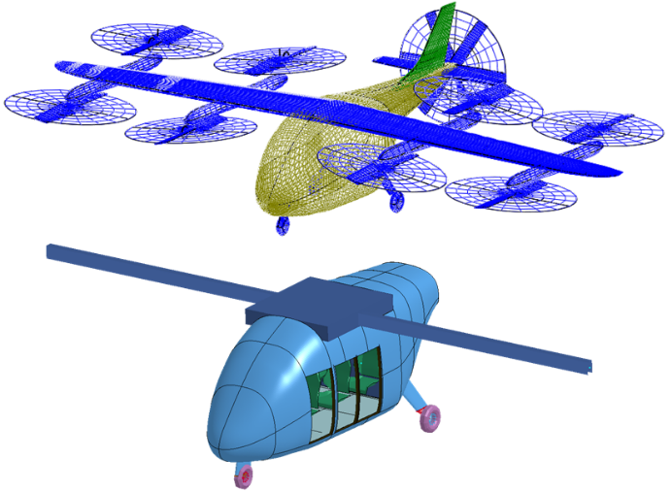
Figure 2 – LPC flight design (top) & Test Article Design (bottom)
Three openings were placed within the baseline test article design to represent forward and aft double door locations. Dimensions for these opening were selected to meet emergency exit Type I standards for rotorcraft, 24 x 48 in, currently defined under 14 CFR § 29.807 [5]. Though type I would not necessarily be required due to the low passenger count of this vehicle, they were selected as a reasonable approximation for the size needed for simple entry and exit.
After initial design simplifications of the test article concept were completed, a finite element (FE) mesh was developed. Each component of the vehicle was meshed using 1x1 in quadrilateral shell elements. The fuselage skin mesh is shown in Figure 3. Baseline material and thickness definitions were applied within LS-DYNA®. The skin was defined as a carbon composite material herein referred to as CC, the material model of which had previously been calibrated and validated against component level tests [6]. All composite part layup definitions were assigned using *PART_COMPOSITE. The composite layup for the fuselage skin was defined as 4 layers each 0.0125 in thick. The values selected for this layup are somewhat notional as this information is generally proprietary and limited information on typical composite fuselage skin thickness was found within literature. Preliminary iterations on the layup definition of the fuselage skin found it to have minimal effect on structural response compared to other components and thus was not evaluated in detail within this study.
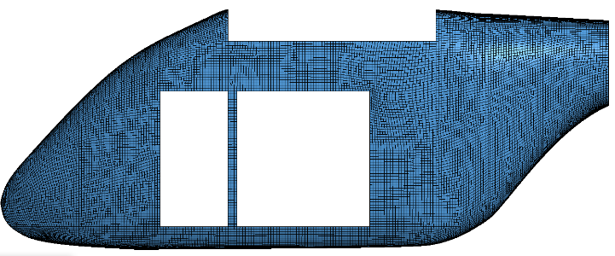
Figure 3 – Fuselage Skin Model
The initial frame design is shown in Figure 4. The layout was adapted from the preliminary flight model [4], to accommodate simplified Wingbox and the door openings. The frame design has the largest effect on cabin response, particularly survivable volume, within the crash environment. Thus, the majority of design evaluations were performed on this component. The baseline frames were defined as c-channels made of 6 layers of 0.0125 in thick the CC material. Within this study type of frames used was evaluated, looking at both c-channels and box beams within the design. The layup definition was also sized, with the number of layers used being increased until a survivable volume could be maintained within the loading conditions evaluated.
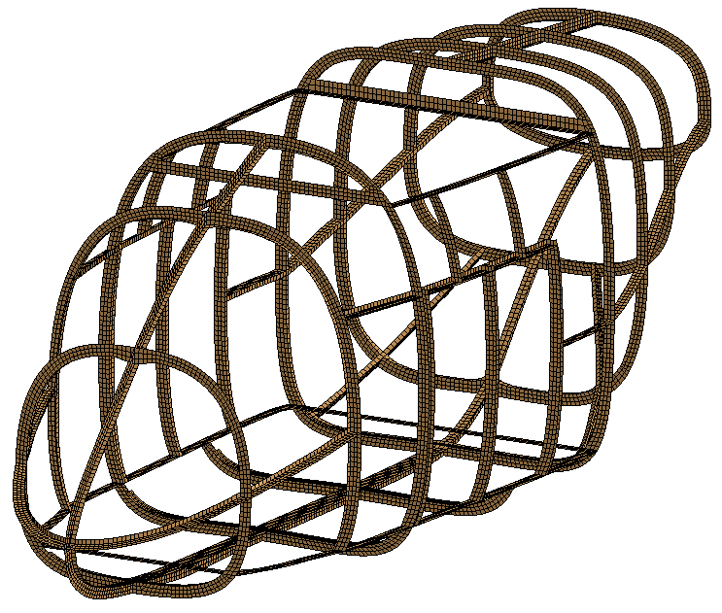
Figure 4 – Fuselage Frame Model
The Wingbox design is shown in Figure 5. The Wingbox was assigned aluminum material properties with a thickness of 0.125 in. The component was modeled as rigid and fixed to the frames using constrained nodes. The wings were modeled as beam elements with the interior rigidly constrained to the Wingbox part. The wing beam design was sized within this study to approximate the bending response of the flight wing design under similar loading conditions. This was done to define a representative beam model for the wing which could be simply approximated within the final test article.
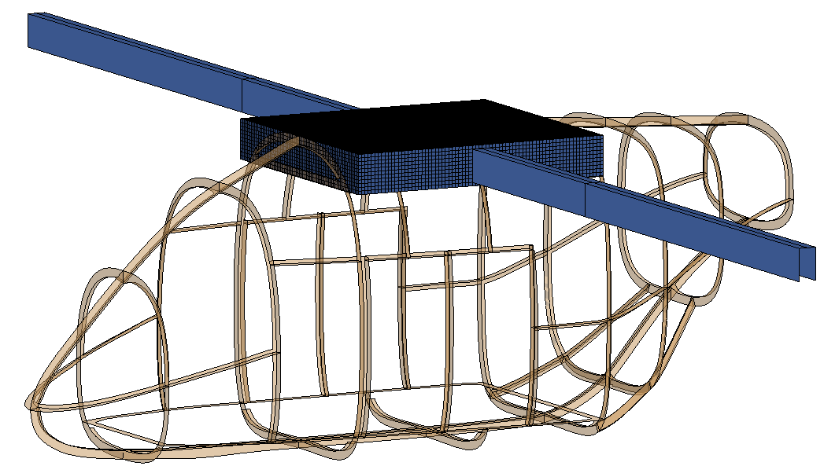
Figure 5 – Wingbox Model on Fuselage Frames
The FE model of the occupant compartment is shown in Figure 6. The seats were modeled after a simple composite racing seat design [7]. During the simulations, accelerations were measured at approximate chest location in each seat. The seats and accelerometer nodes were rigidly fixed to the floor, thus the primary use of the seat models was for visualization purposes and to quantify survivable volume. The floor was modeled as a rigid aluminum plate to simplify connections between the subfloor and seats. A simple subfloor concept composed of vertical sheets oriented between the floor and vehicle frames was used. The subfloor was modeled as 4 layers of 0.0125 in. thick Carbon-Aramid (CA) composite material [6]. The frames below the subfloor included a flat surface on which to mount a variety of subfloor design geometries which will be evaluated within this test article. The focus of this study was the design of the fuselage structure for manufacturing and thus the design of the seat, floor, and subfloor components, which would be integrated separately, were kept simple.
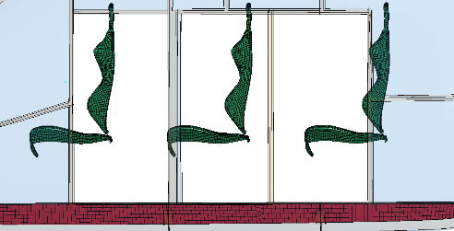
Figure 6 – Occupant Compartment Model
Though the design of the cabin was not the focus of this study, the integration of it into the fuselage structure did need to be evaluated. Two floor attachment configurations were evaluated. The first was a partially floating floor in which the floor was fixed to the subfloor through constrained nodes along the top of the subfloor but not attached to the vehicle in any other way. The second configuration attached the floor directly to the frames which ran along the perimeter of the aircraft structure through constrained nodes in addition to the subfloor attachment. A schematic of the attached frames, floor, and subfloor is provided in Figure 7. Seat level accelerations were measured in both conditions to determine the degree to which the floor attachment may affect occupant response.
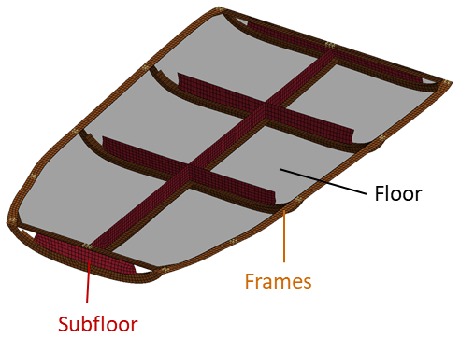
Figure 7 – Model of Floor Components
To size the composite structure the FE model of the test article was simulated under was simplified static and dynamic emergency landing conditions (14 CFR 27.561 and 27.562). Because crashworthiness regulations are not currently defined specific to eVTOL aircraft, these conditions were approximated from current rotorcraft standards to ensure the developed test article exhibited reasonable performance under realistic crashworthiness evaluation conditions. In the dynamic impact simulation, the vehicle was assigned an initial velocity of 30 ft/s downwards into a flat concrete surface. For the static condition, the landing gear was removed so the fuselage was in direct contact with the concrete surface at the onset of simulation. Gravitational acceleration was then ramped from 0 to 12 g over 1 second and then held constant at 12 g for an additional second. The dynamic simulation was ran for 0.2 seconds, while static simulation was ran for 2 seconds. Simulation were performed using LS-DYNA SMP single prevision version R10.1 on a Linux computer cluster with a run time of 6 and 50 hours, respectively. A schematic of both simulation conditions is provided in Figure 8.
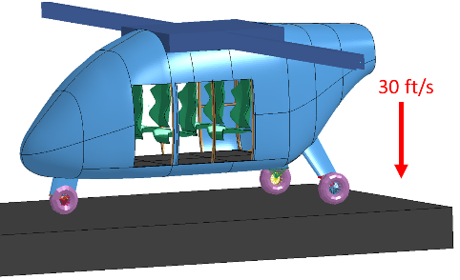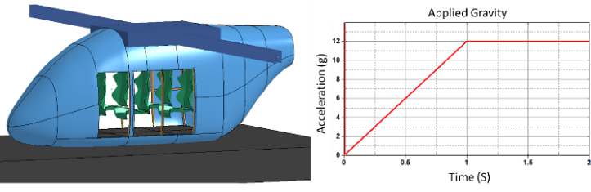
Figure 8 – Crashworthiness Simulation Setup: Dynamic (Top) & Static (Bottom)
To determine a viable structural configuration of the test article, the deformation of the cabin was evaluated throughout each simulation to ensure the cabin volume was maintained. The volume was considered survivable and the design satisfactory if the cabin volume was maintained to accommodate the anthropometry of a 95th percentile occupant in each seat. As the primary deformation was downward this constituted a maintaining the maximum Wingbox displacement of 13 in. downward into the fuselage, as shown in Figure 9.
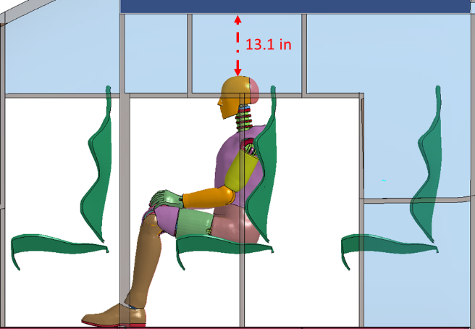
Figure 9 – Survivable Volume Measurement
FABRICATION RESULTS
The first component evaluated within the test article design was the beam used to approximate the vehicle wing. This component was evaluated first as the majority of overhead mass driving cabin intrusion was located in the wings. Capturing the approximate wing stiffness, through which the forces imparted by that mass would be carried into the test article, was essential to accurately predicting cabin intrusion. The c-channel definition used to approximate the wing was sequentially iterated upon until the wingtip displacement matched that predicted within the flight vehicle design when simulated under the dynamic impact condition. A 9x5x0.4 in. aluminum c-channel was ultimately selected to represent the wing, with a tip displacement of 24.3 in. and 24.7 in. on wing and c-channel, respectively. Figure 10 shows the flight vehicle and test article at the end of the dynamic simulation, along with wingtip displacement time histories. This c-channel definition was used to represent the wing throughout the remaining test article sizing studies. The c-channel selected is not expected to be used for testing, rather it will be used as a reference to size a more manageable parallel array of beams mounted to the Wingbox.
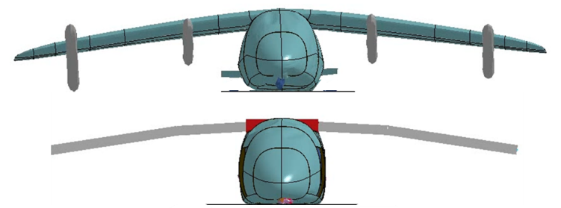
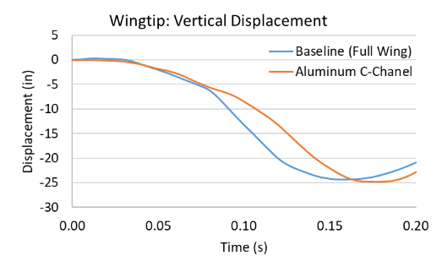
Figure 10 – Wing Sizing Results
Once the wing displacement properties were adequately represented within the model the next component evaluated was the type of frames used within the fuselage structure. The baseline design used c-channels for each frame. This design did not perform adequately under the dynamic impact condition, the simulation results of which are shown in Figure 11. The overhead wing mass collapsed the frame structure around door openings resulting in significant fuselage deformation into the occupant space.
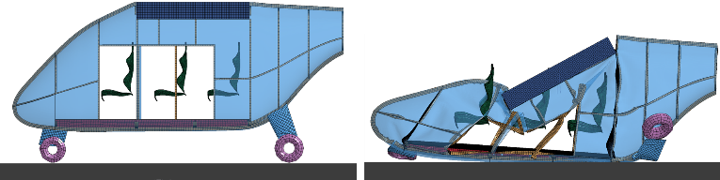
Figure 11 – Baseline Frame: Dynamic Impact
In the baseline frame design, the frames around the door openings rotated and buckled under the wing mass. To reinforce this area and limit frame buckling, the vertical frames around the openings were replaced with box beam design. The replaced frames are highlighted in Figure 12. The stiffer frame design improved the structural response of the fuselage within the dynamic impact condition but buckling of the frame between front and rear door openings did occur and survivable volume was ultimately not maintained (Figure 12-right).
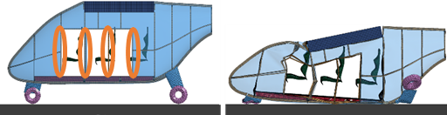
Figure 12 – Box Beam Frame: Dynamic Impact
With the geometry changes not sufficiently maintaining survivable volume, the composite layup definition for the frames was next evaluated. The original frame component was defined as 6 layers of CC material. Layers were added to this definition until volume was maintained within the cabin during the dynamic impact condition. Ultimately, 10 layers of CC material were needed to prevent the overhead wing mass from intruding into the occupant compartment. In this configuration, under the dynamic impact condition, 4.6 in. displacement from the top of the fuselage was measured vs the 13.1 in. of space available, which is shown in Figure 13, left. Design acceptability was verified within the static load condition in which no significant cabin deformation was measured using this frame design.
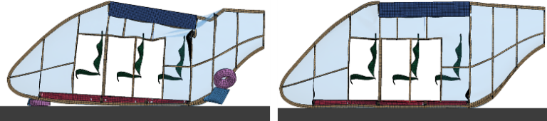
Figure 13 – 10 Layer Frame: Dynamic Impact
After sizing the test article structure, the sensitivity of the occupant compartment to the way in which the cabin floor was attached to the fuselage was evaluated. With the floor attached to the subfloor only, the subfloor bottomed out at the rear of the aircraft, crushing under the full weight of the occupant compartment from the dynamic impact condition, which is shown in Figure 13, top. As the subfloor bottomed out, accelerations spiked over 150g within the rear located seats. When the floor was attached to both the surrounding frames and subfloor, the subfloor did not bottom out, as shown in Figure 14, bottom. This resulted in reduced acceleration measured within the seat. Additionally, this reduced cabin deformation floor provided lateral rigidity to the frames surrounding it. Though both the subfloor and floor designs used in the final test article will change this behavior somewhat, these results indicate the method used to attach these components is significant and must be considered in detail within the vehicle design.
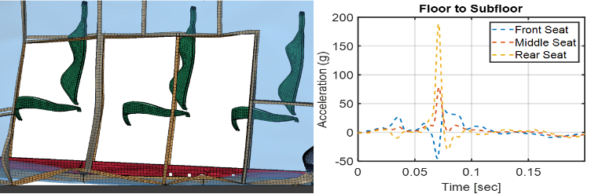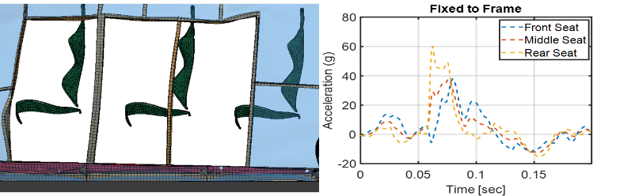
Figure 14 – Floor Attachment Comparison: Floor to Subfloor (Top) & Floor to Frames (Bottom)
After the initial sizing and sensitivity studies were performed the developed design was further evaluated to improve test functionality. The first component evaluated was the frame layout. The baseline design had a complex arrangement of frames around the door opening which would complicate manufacturing and increase cost. This layout was simplified by removing the frame placed between the rear double doors and extending the door frames up to the Wingbox. This simplified frame design is shown in Figure 15.
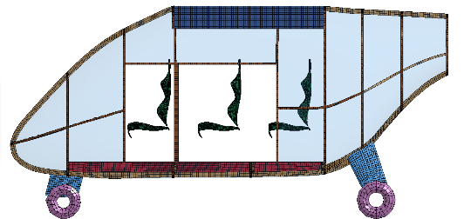
Figure 15 – Simplified Frame Design
To expand the capability of the test article the following changes were also made to the design. The Wingbox was extended backwards by one vertical frame distance to allow more variations in wing mass locations over the fuselage to be studied. In addition, a Plexiglas windscreen was included in the front of the vehicle to better represent the flight structure in this location. An updated FE model which included these changes in addition the frame simplifications was simulated in the dynamic and static impact conditions. No appreciable cabin deformation was measured, verifying the sizing performed on the original design still applicable with these updates. The updated test article design model is shown in Figure 16 and simulation results are shown in Figure 17.
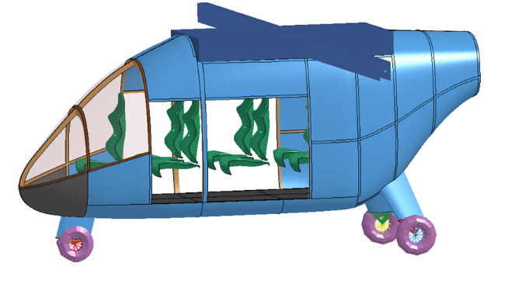Figure 16 – Final Test Article Design
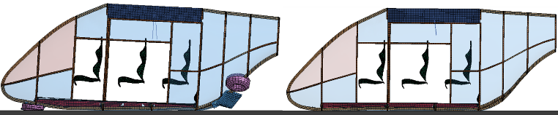
Figure 17 – Final Test Article Simulation Results: Dynamic (Left) & Static (Right)
The current methodology considered to manufacture the test article fuselage is to split it into three composite sections (Figure 18). The first section would be composed of the entire fuselage frame skeleton. Top and bottom fuselage skin sections would then be post-cure bonded to that frame. The methodology for post-cure bonding between frame and fuselage skin is an area of major research. Whether rivet, screw, or glue is selected for this assembly, the developed test article will provide data into the effectiveness of the post cure bond in retaining structure during impact. The remaining components, Wingbox, windscreen, and nose cone, would be fastened into the frame. The nose cone would be assembled separate from the other fuselage skin sections in order to examine different nose cone geometries and their effect vehicle plowing and/or submarining into soil under combined horizontal/vertical impact conditions, Example nose cone geometries currently being evaluated for this study are shown in Figure 19.
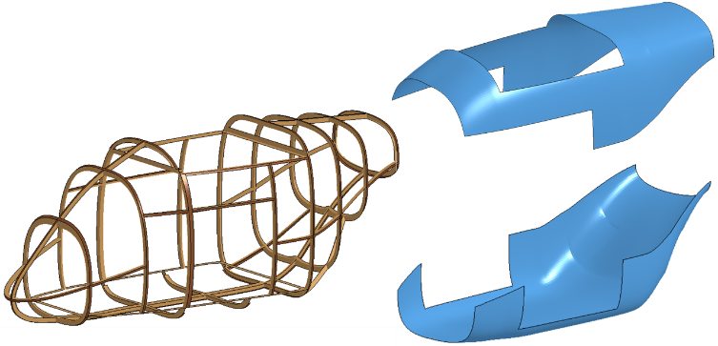
Figure 18 – Manufactured Composite Sections
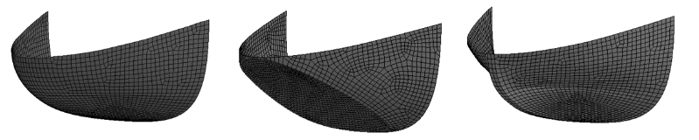
Figure 19 – Nose cone geometries
SIMULATION CASE DETAILS
The original transformation of the LPC vehicle from a concept to a fully defined simulation model has been documented by Putnam and Littell [4]. Changes were made to the simulation model in order to conduct the parameter study described herein. These changes included the removal of the energy absorbing mechanisms along with the Anthropomorphic Test Devices (ATDs, a.k.a. crash test dummies). Instead the information at the seat attachment and floor locations was extracted and used for comparisons. These changes reduced simulation runtimes to acceptable levels which were necessary due to the amount of simulations needed for result generation.
Additionally, the previous analysis from the simulations of this LPC model has focused on the examination of the occupant loads and probability of injury from a small subset of impact conditions. The data presented in this report differs in its attempts to encompass a wide range of impact scenarios by primarily using the fuselage structure and seat base results as basis for data analysis and comparison. While the occupant analysis is thought of as a better metric to evaluate specific injury in a specific circumstance, general trends can be identified using the fuselage data as a proxy. It is from this data that the results in the following section have been generated.
A set of simulations was conducted to evaluate the effect of terrain on the response of the vehicle. There were five different terrains utilized under these simulations; three of which were soil variations, while the final two were a rigid condition and a condition impacting water. The three soils chosen were from a set of previously developed soil models utilized for NASA’s Orion Program [8]. Of these reported, the three used were a hard clay soil, named Cuddeback A (CBA), a sandy/soil mix named Carson Sink Wet (CSW), and a sand/clay mixed named Gantry Unwashed Sand (GUS). These three were used to represent the extremes of an unprepared soil landing surface (hard, soft and wet), such as a field under various environmental conditions. Water [9] was used to simulate a ditching condition and a rigid surface was used to represent a prepared solid surface such as a runway, highway, or parking lot.
The simulation matrix next evaluated the effect of the impact velocity vector. The velocity vectors were a function of the angle with respect to the vertical starting at zero degrees, which represented a purely vertical drop, and sweeping through angles of 30, 45, 60 and 70.5 degrees, respectively.
All velocity magnitudes throughout the vector analyses simulations totaled 30 ft/s. Thus a 30 ft/s velocity at a zero-degree impact angle represented a purely vertical drop, while a 30 ft/s total velocity at a 70.5-degree impact angle represented a horizontal velocity of 28.3 ft/s and a vertical velocity of 10 ft/s. The rationale behind varying the angles was an attempt to impart various certification orientations into the simulations. The zero-degree angle with a 30 ft/s velocity was representative of various special conditions used for newer transport category aircraft [7][8] and also used in previous NASA testing [9]. A 30-degree angle represented the orientation of the occupant subject to certification loads in 14 CFR § 27.562 (b)(1) [10], while both 45 and 60 degree angles were added to collect additional data with a significant forward velocity. Finally, the 70.5 degree angle was used to partially represent a 14 CFR § 27.562 (b)(2) [10] orientation while attempting to keep a vertical component of velocity at impact necessary for simulation execution. Figure 20 depicts the velocity vector with respect to the vehicle motion.
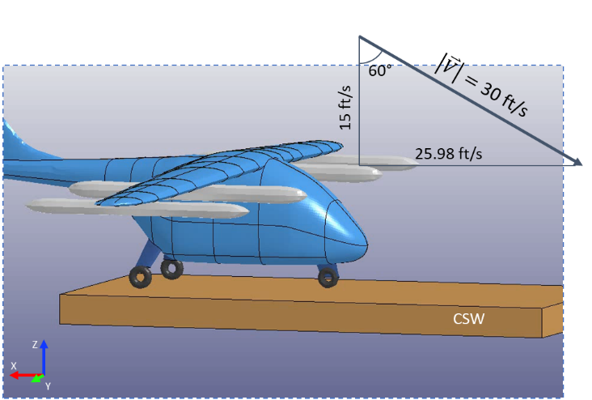
Figure 20 - LPC impact velocity orientation depiction
Two vehicle impact orientation angles also investigated – pitch and yaw. A maximum of 10 degrees was chosen for these angles which are reflected in both real world test conditions and real-world crash scenarios where vehicles do not impact with nominal zero-degree orientation. The pitch angle was adjusted to include a nose up and nose down condition. The yaw condition reflected what is currently in the 14 CFR § 27.562 (b)(2) [10] certification condition.
Next the seat position was examined to determine if aircraft structural configuration played in the response at impact. The design of all aircraft necessitates the inclusion of various structure such as the Wingbox in aircraft and engine mounts in rotorcraft, and that structural response for all seats will not be identical. Accordingly, all six of the seats were examined to see the effect of their position in the cabin. The front seats (seats labeled 1 and 2) were nearest to the nose gear and forward firewall, while the rear seats (labeled 5 and 6) were closest to the main gear and rear firewall. The middle seats (labeled 3 and 4) were in the furthest away from each of the landing gear components, however, directly underneath the Wingbox portion and potentially influenced the most by overhead mass motion. Accelerations at the forward right side of each of the seat/floor attachment locations were the basis for the response. Thus, seats on the port side of the aircraft (seats 1, 3 and 5) had attachment locations nearest to the center of the vehicle, while seats on the starboard side of the aircraft (seats 2, 4 and 6) had locations nearest to the outside of the vehicle. The seat responses were compared to a position on the floor, which was at the junction of the keel beam and the first frame behind the firewall.
Finally, a small set of simulations were run by removing the landing gear. These simulations were conducted in order to evaluate the effects of the landing gear, since the LPC model contains wheel gears, and might not be representative to all vehicles which have skids or other types of designs. Additionally, previous full-scale testing [11] has proven that the inclusion of the landing gear into soil terrain greatly affects the vehicle response due to the digging and plowing of the gear at impact. Effects on the gear, while only studied briefly in this report, are an important part of the response.
SIMULATION CASE RESULTS
All simulations were performed using LS-DYNA SMP Version R11.1.0 single precision. Simulations were run using 4-12 processors on a Linux computer cluster. Simulations were executed to a minimum of 0.2-s, with CPU run times ranging between 3 and 10 hours depending on vehicle configuration and terrain type. Simulation termination time varied based on impact condition simulated and were run to the minimum post-peak time in order to expedite the needed simulation runs. Each simulation started with the vehicle with initial velocity positioned approximately 1 inch above the impact surface. All results, unless noted, are filtered with a Butterworth forward and backward, low-pass, 4-pole filter with cutoff frequency of 20 Hz.
Variation of Terrain
The first case examined was a purely vertical impact, signified by the impact angle of zero degrees. Since there was no horizontal motion during the impact, only vertical acceleration response was examined at a location on the floor. Figure 21 shows the vertical acceleration response at the floor location.
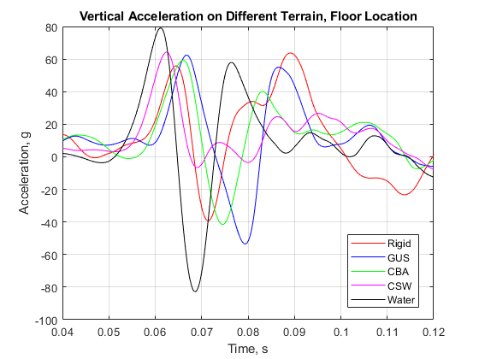
Figure 21 - Terrain variation on vertical impact results, velocity vector of zero degrees
The maximum accelerations for all terrain surfaces occurred between 0.06 and 0.07 s after simulation start. Due to various factors resulting from the initial condition definition between the soil and water models, the time to peak acceleration differed based on terrain, and should not be thought of as the onset of acceleration when comparing the two. The results were not time shifted to account for the differences in initial conditions, however timing relative to maximum accelerations are comparable. Impact into water showed the highest acceleration levels of approximately 80 g, followed by the other four surfaces. The reason that the water produced the highest magnitude is because the landing gear penetrated the surface without providing any significant attenuation. This result is shown in the time before peak response in Figure 21, noting that the acceleration stayed approximately zero prior to the maximum occurring. This response differed from the other surfaces which showed non-zero acceleration prior to reaching the peak, indicating that the landing gear interaction with the surface played a role in the response.
GUS had a maximum penetration depth of approximately 5.9 inches which was concentrated where the nose gear penetrated the soil. The penetration depth for CBA was approximately 3.3 inches, and CSW was 19.0 inches. For GUS and CBA, the deformation was localized to the landing gear areas only; however, for CSW, the penetration also showed signs of impact from vehicle keel beam and frames. It is unclear why GUS crater showed a higher penetration depth with higher acceleration than CBA, but both were sufficiently different than the CSW response. From this result, it was decided to only examine the GUS and CSW soils, because GUS soil currently resides at NASA Langley Research Center and is capable of being used for testing, and CSW could be considered a sufficiently different soil necessary to bound the analyses. In this respect, CBA soil terrain was only run for a small subset of future cases.
A condition with an impact angle of 45 degrees was simulated for the remaining four terrains. The 45-degree impact vector resulted in both horizontal and vertical velocities of 21.2 ft/s. Figure 22 shows the horizontal acceleration response.
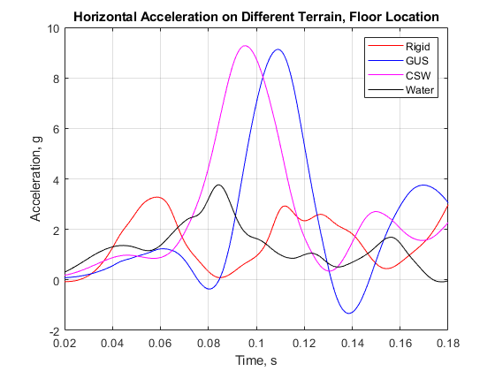
Figure 22 - Terrain variation on horizontal impact results, velocity vector of 45 degrees
In the horizontal direction, both the water and rigid surfaces demonstrated characteristics of low-friction surface interactions, causing the vehicle to essentially skim across the surface resulting in very low horizontal accelerations. In contrast, the acceleration values using the two soil terrains contained a large maximum value of approximately 9 g, which was where the belly of the vehicle contacted the soil. The two soils showed similar acceleration magnitudes and timing, even with the significantly different properties. The vertical direction was next examined and is shown in Figure 23.
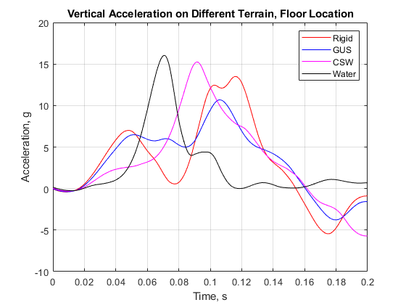
Figure 23 - Terrain variation on vertical impact results, velocity vector of 45 degrees
The three solid surfaces exhibited similar trends showing an initial peak when the landing gear impacted the surface followed by a larger peak when the fuselage impacted. The water impact did not follow this trend, as the landing gear contact did not effectively accelerate the vehicle resulting in a single acceleration peak at the time of fuselage contact. This demonstrated the same trend as the purely vertical impact; however, the rest of the results did not follow the vertical impact results.
An additional simulation was conducted by extending the time out to 0.5 seconds to examine if additional acceleration peak values resulting from secondary impacts of vehicle components occurred. The additional simulation did not show any significant events occurring after 0.2 seconds, so the peak magnitudes of acceleration are captured in the simulations presented. The soil penetration map is next shown in Figure 24.
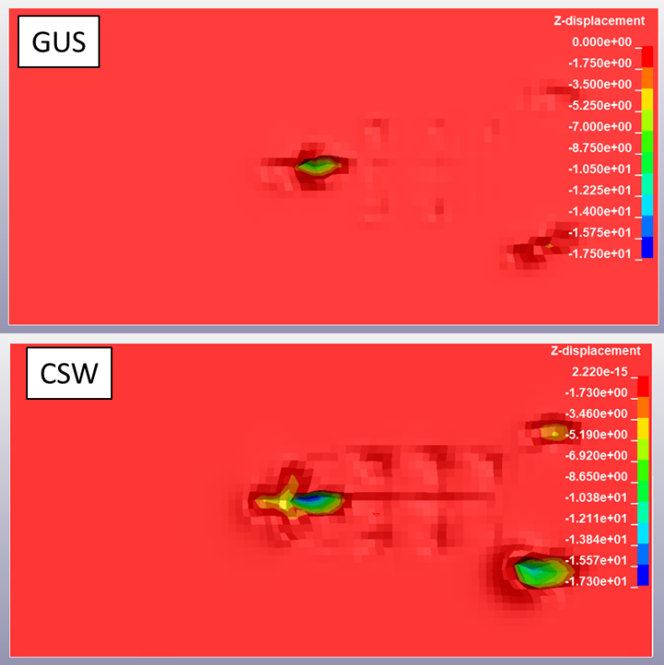
Figure 24 - Soil penetration map, 45-degree velocity vector
The soil penetration map shows how the softer CSW soil allowed for additional vehicle penetration over the GUS. The penetration depth for GUS was 8.9 inches, whereas CSW was 17.3 inches. In GUS, the landing gear and only a very small portion of the aircraft frame and keel beam sections were shown to penetrate the soil surface. In contrast, the CSW shows large amounts of penetration from both the landing gears, but also the aircraft frames and keel beam.
A final condition consisting of the impact angle of 70.5 degrees was run on the remaining four terrains. The horizontal accelerations from which are shown in Figure 7.
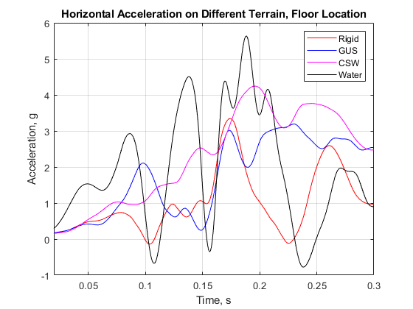
Figure 25 - Terrain variation on horizontal impact results, velocity vector of 70.5 degrees
The horizontal acceleration results on the floor of the vehicle all displayed similar trends for the rigid, soil and water cases. The water case showed the highest magnitude of acceleration at 5.6 g with the second highest acceleration occurring on CSW at 4.2 g. The two soil surfaces produced a more defined pulse shape roughly triangular in nature, reaching a maximum at approximately 0.2 s after simulation start. The rigid and the water surfaces showed higher oscillations in the data and less defined pulse shape. Figure 8 shows the vertical accelerations.
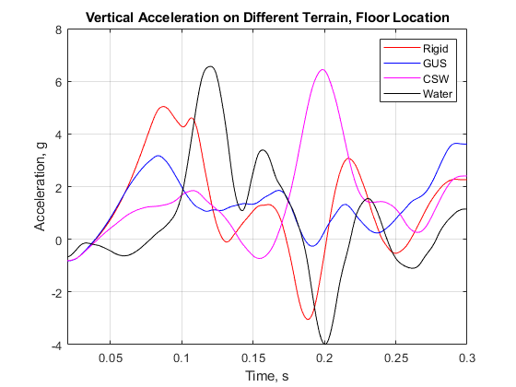
Figure 26 - Terrain variation on vertical impact results, velocity vector of 70.5 degrees
In the vertical direction, the rigid and water terrains produced the highest amount of accelerations during the early time histories of the response. In these simulations, the deformation in the airframe due to the landing gear contact caused the high magnitudes to occur without the belly of the vehicle contacting the surface. However, the CSW terrain produced a large magnitude of acceleration approximately 0.2 s after impact, which was a result of the airframe belly impact, as the landing gear penetrated and scooped the soil without significant vehicle deformation. The GUS simulation did not produce a large spike in the response but did have a small one near the time in the early time history where the rigid and water also showed a spike. This simulation produced a vehicle response that fell in the middle of these two extremes – there was some plowing into the soil, but the landing gear more affected the vehicle deformation rather than allowing the belly to contact.
Because of the differences in behavior for the two soils, the soil penetration depth was also examined. For GUS, the deformation was 8.6 inches and was localized to the landing gear components only. This result matches the acceleration data described above. However, the penetration for CSW soil was significantly higher, reaching a maximum of 16.6 inches at the nose gear location. The softness of the soil caused the landing gear to easily penetrate the soil during the impact. The softness of the soil was the main characteristic which caused the acceleration differences to happen. The differences in how the landing gear responded to the two different soil conditions warranted a study into the effect of the landing gear itself.
Variation of Landing Gear
To determine the influence of the landing gear, an additional simulation was run using the CSW impact terrain on a vehicle that did not include landing gear. Figure 9 shows the results of a landing gear and no landing gear simulation for CSW with an impact angle of 45 degrees. Note that for the landing gear case study, the data has been filtered at a 60 Hz cutoff frequency due to the softness of the CSW soil.
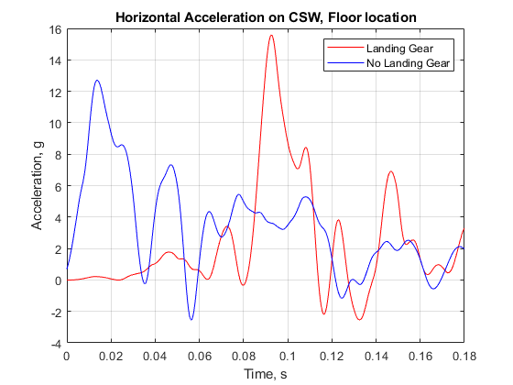
Figure 27 - CSW soil, 45-degree impact angle, gear to no gear horizontal acceleration
With the landing gear removed, the maximum acceleration was 12.6 g in the horizontal direction. The lack of the landing gear reduced the maximum accelerations, primarily due to the lack of plowing of the gear into the soil prior to belly impact. Consequently, the vehicle was free to skid across the soil surface. The maximum acceleration for the vehicle with the landing gear was 15.5 g. The response shapes were also different. The vehicle without the gear exhibited a maximum acceleration at belly impact, then after a period of oscillation, experienced sustained acceleration of approximately 4 g between 0.06 s and 0.12 s after impact, suggesting the belly impact was the major factor in the soil plowing. This shape is contrasted by simulations of the vehicle which includes the landing gear. In this simulation, there was a localized maximum occurring 0.045 s after impact due to the gear contact a second maximum acceleration occurred 0.093 s after impact. Other features in the response were difficult to extract. As with other results, the plots are not time shifted to overlay maximum accelerations, so delay in the onsets or maximums was not examined. Next the vertical acceleration was examined and plotted in Figure 28.
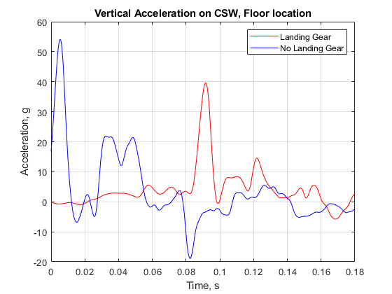
Figure 28 - CSW soil, 45-degree impact angle, gear to no gear vertical acceleration
The vertical accelerations exhibited similar trends to the horizontal accelerations. Without the aid of the gear, the vehicle belly impacted the soil with a magnitude of 53.7 g, which was significantly higher than the 39.6 g which occurred in the simulation that included the gear. Without the gear, the results showed a second plateau of approximately 20 g occurring between 0.03 s and 0.05 s. The simulation with the gear showed gear contact occurring at approximately 0.04 s, with the maximum occurring at approximately 0.092 s after simulation start. However, unlike the horizontal results, the vertical acceleration exhibited a sustained level of acceleration after the maximum, which occurred until approximately 0.16 s after simulation start. However, the shape nor magnitude were not as perceptible as the simulation without gear. The features present in the acceleration response were then checked against the deformation that occurred in the soil. Figure 29 shows the soil deformations for both simulation cases studied.
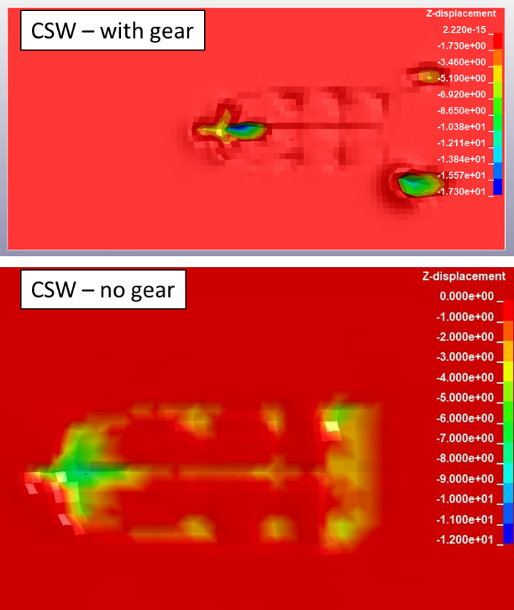
Figure 29 - Soil penetration map, gear vs. no gear, CSW, 45-degree velocity vector
The top image in Figure 29 shows the penetration map of the vehicle which included the gear. The largest penetrations occurred at the locations of gear/soil contact and reached approximately 17.3 inches maximum penetration. The shape of the frames and keel beam is also noted in the top image, however, penetrations due to these components only reached between 1 and 2 inches. In contrast, the vehicle without gear penetrations were more uniform due to the entirety of belly of the vehicle contacting the soil at approximately the same time. The penetration results were between 4 and 7 inches and were a resultant of the sustained post-maximum acceleration responses observed in the acceleration data.
Variation of Velocity Vector
Simulations results were compared for all the five velocity vector load cases. The first impact surface evaluated was the rigid surface. Horizontal acceleration results using the rigid surface are shown in Figure 31.
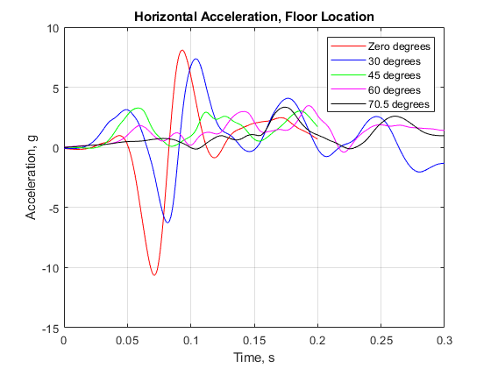
Figure 30 - Velocity vector variation on concrete, horizontal acceleration
In both the zero- and 30-degree cases, there is an abrupt acceleration jerk near the nose/gear location when the vehicle belly impacted the surface and causes a slight nose up rebound. This response was reflected in dip and spike in horizontal acceleration occurring around 0.071 s and 0.083 s. for the zero- and 30-degree cases, respectively. When examining the unfiltered data, this spike was very high magnitude and low duration, which was then exaggerated through the filtering. This response only appeared in the two lowest horizontal velocity cases and is likely caused by airframe deformation as there horizontal velocity was low in these cases. While these spikes should not be ignored entirely, they should be examined in the context of the trends from the rest of the results. All other load responses showed minimal horizontal accelerations, suggesting the vehicle skimmed across the surface with a non-zero amount of horizontal velocity. The vertical acceleration responses were next examined and are shown in Figure 13.
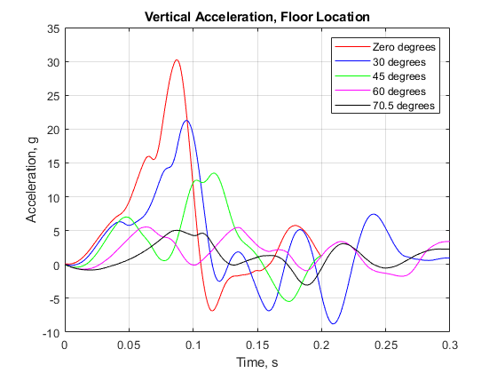
Figure 31 - Velocity vector variation on concrete, vertical acceleration
Vertical accelerations demonstrated a clear trend when comparing magnitudes to velocity vectors. The lowest velocity vector angles, signifying the highest vertical velocities, produced the highest vertical acceleration levels, which gradually decayed as the velocity vector increased. The maximum accelerations were 30.2 g, 21.1 g, and 13.5 g for zero, 30 and 45 degrees, respectively. Beyond the 45-degree vector, however, acceleration levels did not have any distinctive shape or peak value. The results for the rigid case suggested the horizontal acceleration response was not a function of velocity vector, however vertical acceleration response was.
Since the soil models all behaved similarly for the terrain variation study, only CSW and GUS were investigated for the velocity vector study. The following two figures show results for the CSW soil. The GUS soil terrain followed similar trends for both magnitudes and durations and are therefore not included in this report. Figure 32 shows the horizontal accelerations first.
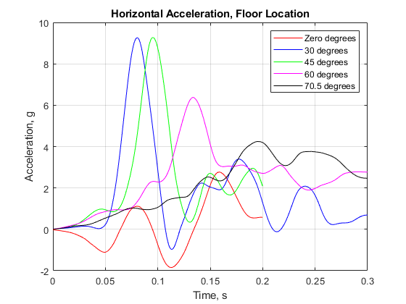
Figure 32 - Velocity vector variation on CSW, horizontal acceleration
For the CSW soil, the highest amounts of horizontal accelerations were resultant from velocity vectors with significant components of both horizontal and vertical motion. In contrast, the extreme angles of zero and 70.5 degrees did not produce significant amounts of horizontal acceleration. The results suggested a vehicle with a significant amount of vertical velocity dug into the soil, whereas the vehicle skimmed off the surface due to the low vertical velocity in the 70.5-degree case. This result was supported by the higher horizontal acceleration measured in the 30- and 45-degree angle conditions.
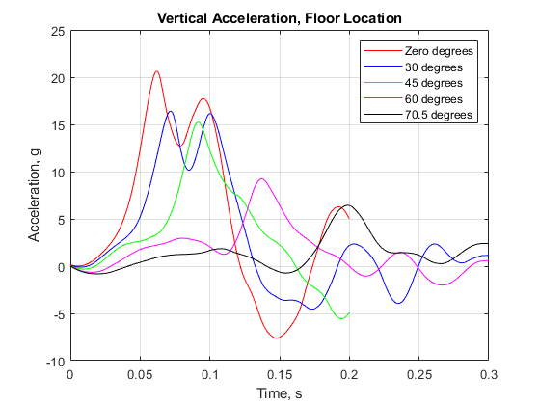
Figure 33 - Velocity vector variation on CSW, vertical acceleration
In contrast to the results shown for the rigid surface, the vertical acceleration responses from all five velocity vectors showed a distinct peak, with a gradual decay from the lowest velocity vector to the highest. When comparing the two surfaces, at low velocity vectors, the magnitudes for the CSW surface were lower than for the rigid surface and were higher at the high impact velocity vector angles of 60 and 70.5. At the 45-degree impact angle, the magnitudes were similar. Taken overall, the response in the vehicle is dependent on both the impact surface and the impact velocity vector.
Variation of Pitch Attitude
The first case examined was the 45-degree impact angle on rigid, since this was one of the two cases where both the horizontal and vertical accelerations had significant magnitude (the other being 30 degrees). When using a 45-degree impact velocity vector on a rigid surface, the vertical accelerations were largely unaffected from the pitch angle, which was varied between -10 and +10 degrees. The maximum values were of similar magnitude and duration with an initial spike occurring at approximately 0.05 s after the simulation start. Peak values were 17.3 g, 15.1 g and 13.5 g, for pitch down, pitch up and zero pitch, respectively. Responses were not time shifted to align peak values, and peak values occurred different times due to the conditions of the pitch angle. Acceleration response in the late time history were generally similar, with no significant events occurring after the peak. Figure 16 shows the vertical response.
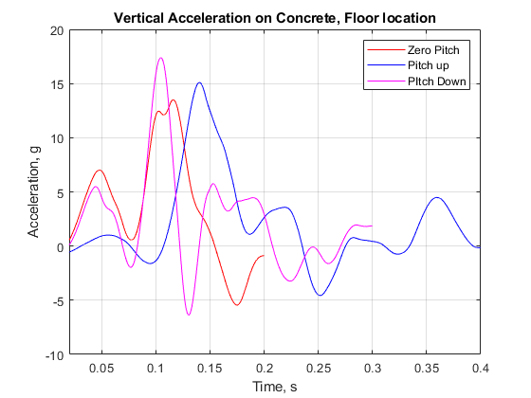
Figure 34 - Pitch angle variation on 45-degree velocity vector on concrete, vertical direction
Figure 35 shows the vehicle at the instant the maximum accelerations occurred. The pitch down conditions showed a slightly higher amount of nose deformation, but overall, the vehicle overall deformation generally exhibited similar results. This was in large part to the rigid surface allowing the vehicle to skid across the surface, keeping the horizontal component of accelerations low.
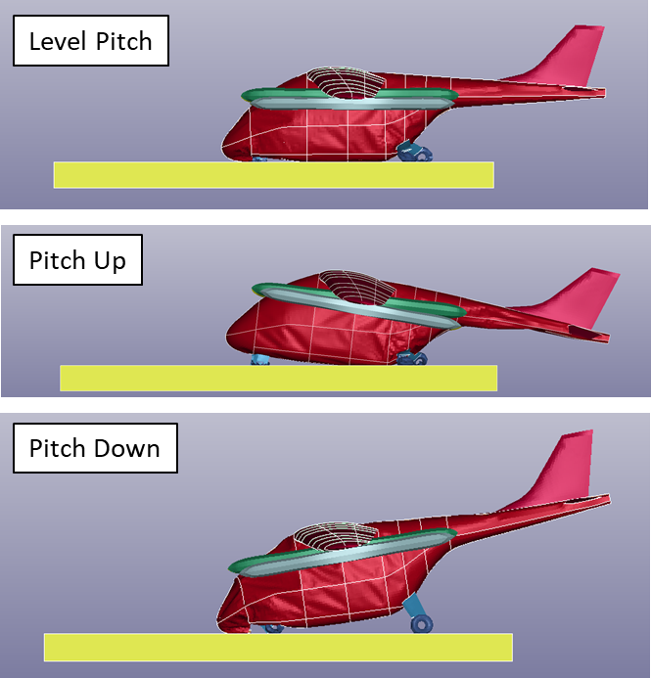
Figure 35 - Vehicle orientation at maximum vertical acceleration, rigid surface
The second pitch variation case used the CSW soil at the 70.5-degree impact angle. This case was selected due to its high horizontal velocities on a very soft surface, which acted as a contrasting case to the rigid surface simulations. The horizontal accelerations from this case are shown in Figure 18.
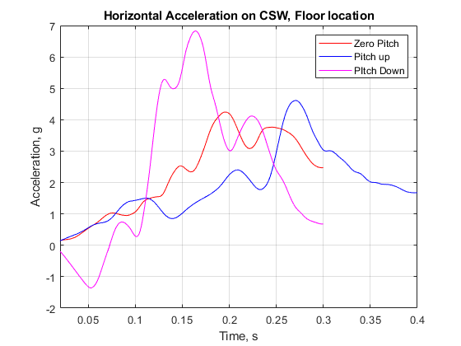
Figure 36 - Pitch angle variation on 70.5-degree velocity vector on CSW, horizontal direction
The horizonal acceleration responses were similar in nature for the zero pitch and pitch up conditions. In both cases, the response showed a general increase until a maximum value of 4.2 g in the case of the zero-degree pitch or 4.6 g in the case of the pitch up, and then generally ramped back down toward zero. While the run times were not extended out to capture the entire pulse duration, the majority portion of the response is captured. In contrast, the soil surface, along with the nose down pitch, resulted in a significant amount of nose buckling which resulted in a curve that fell out of family with the other two conditions, along with a significantly higher maximum acceleration of 6.8 g. Vertical response was examined next and is shown in Figure 19.
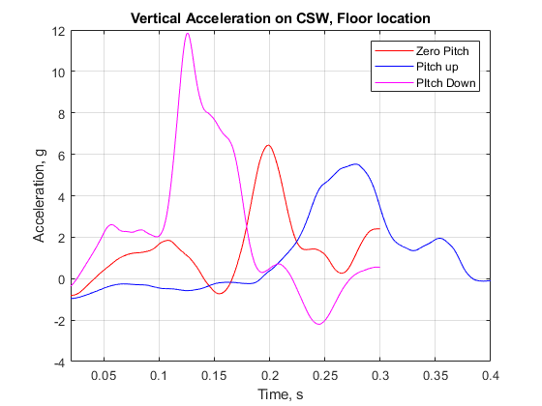
Figure 37 - Pitch angle variation of 70.5-degree velocity vector on CSW, vertical direction
The vertical responses demonstrated clear differences under the various pitched orientations. Similar to the horizontal response, the nose down orientation produced results that were out of family with the other two conditions. The nose down conditions produced a maximum acceleration of 11.9 g, whereas the zero pitch and the pitch up cases produced maximum accelerations of 6.4 g and 5.5 g, respectively.
In both studies, the pitch down condition produced the highest magnitude acceleration responses. This result was due to the nose impacting the surface, submarining into the soil, and then crushing inward. This crushing effect appears in the acceleration response both in the horizontal and vertical directions for CSW surface and the vertical direction for the rigid surface. This result is important to note when developing a test matrix.
Variation of Yaw Attitude
Impact scenarios using three surfaces – concrete, GUS and CSW - were simulated under the 70.5-degree impact angle utilizing a vehicle with a 10 deg yaw. The results showed that the yaw did not play a significant role in influencing the impact response’s magnitude or shape under any of the impact scenarios in both the horizontal and vertical directions. The results on the rigid surface were affected the most, with the horizontal acceleration pulses varying by over 0.5 g for peak values, however the overall maximums were under 3.5 g. The horizontal direction acceleration response is shown in Figure 38.
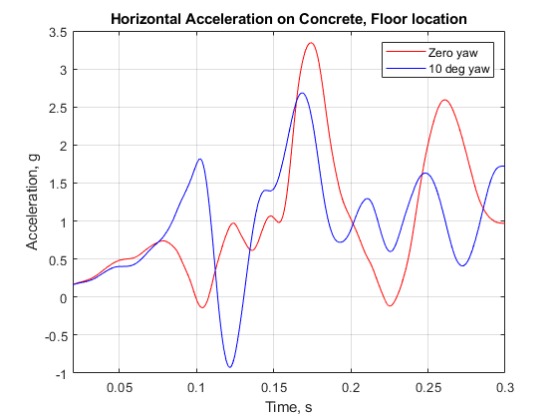
Figure 38 - Yaw angle variation on 70.5-degree velocity vector on concrete, horizontal direction
The vertical acceleration response’s peak values were essentially unaffected by the yaw condition. While some of the later time history results fell out of phase, magnitude, duration and time to peak for the response were virtually identical. Figure 39 shows the vertical accelerations.
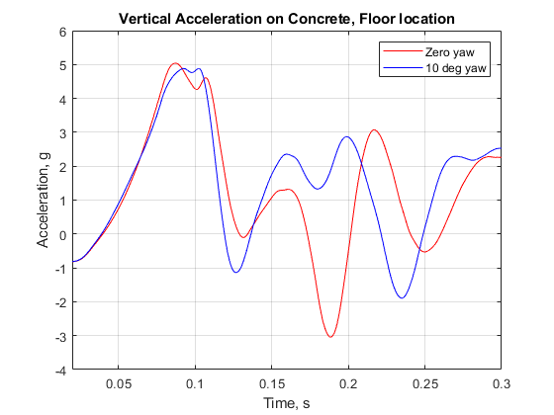
Figure 39 - Yaw angle variation on 70.5-degree velocity vector on concrete, vertical direction
When using CSW as the impact surface, in the horizontal direction, similar trends were observed with the exception of a small difference in the maximum accelerations. The zero-degree yaw case exhibited slightly higher horizontal accelerations of 4.2 g which was slightly higher than the yawed case, which showed maximum of 3.8 g. The onset rates, duration and unloading conditions were virtual identical, signifying that a slight yaw in the vehicle did not affect horizontal response to a significant extent. Figure 40 shows the horizontal acceleration response.
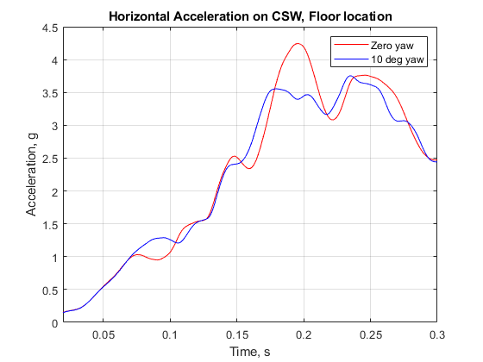
Figure 40 - Yaw angle variation on 70.5-degree velocity vector on CSW, horizontal direction
The vertical direction results exhibited similar trends to the horizontal. The onset rate and pulse shapes were very similar in nature with the magnitudes only differing at 0.2 s after impact. For the zero-degree yaw case, the maximum acceleration was 6.4 g, while the maximum acceleration for the yawed case was 5.4 g. Both occurred at the approximate same time after simulation begin. These results for both directions agree with the results from the rigid cases – generally pulse shapes, durations, and onset rates were all similar, with only minor differences in acceleration magnitudes. The results obtained from the GUS, reflected these same similarities, and are therefore not included in this report. Figure 23 shows the vertical results from the CSW impact surface.
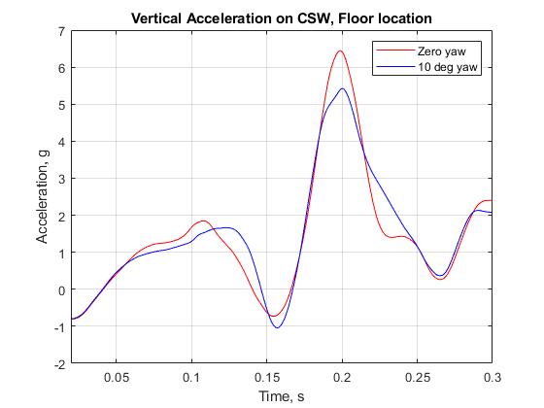
Figure 41 - Yaw angle variation on 70.5-degree velocity vector on CSW, vertical direction
Variation in Seat Position
Finally, the position of the seat inside the airframe was examined. Figure 42 shows a seat variation plot along the vertical acceleration direction for a CSW simulation with the impact velocity vector of 30 degrees.
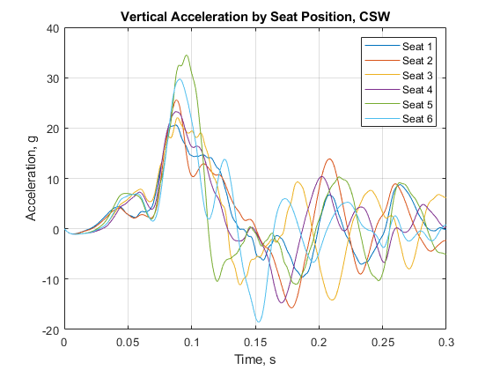
Figure 42 - Seat variation for CSW, impact vector 30 degrees, vertical direction
In this simulation, peak magnitudes of 34.4 g and 29.7 g occurred on seats 5 and 6, respectively, and were significantly higher than the other two rows of seats. While the onset rate and time to peak values were all approximately the same for the all seats, the post-peak response in the rear row deviated once the maximum value was reached. The difference was caused by the rear landing gear plowing into the soil, causing large amounts of deformation in the rear firewall, leading to increased acceleration in the rear seats. While deformation was also occurring in other areas of the vehicle, the largest amount was in the rear. The remaining four seats didn’t show clear trends with seat 2 exhibiting the next highest acceleration magnitude of 25.4 g, and seat 1 having the lowest magnitude of acceleration of 20.5 g. When examining horizontal velocities, the seat position did not make a noticeable difference in the response. Additionally, upon examination of entirety of the simulation results, the only instance where the seat position made a difference in the horizontal accelerations was when the simulation included a nose down pitch. In these cases, the seats positioned in the front row experienced higher than average accelerations when compared to the other seats in the vehicle. Figure 43 shows the results from the rigid impact terrain with a velocity vector of 70.5 degrees and a 10-degree nose down pitch.
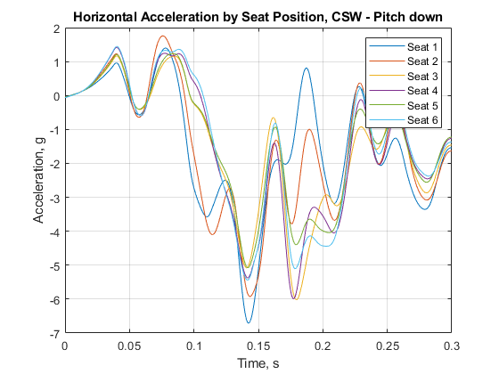
Figure 43 - Seat variation for rigid, impact vector 70.5 degrees, horizontal direction
In this simulation, the seats in the forward row experienced acceleration magnitudes higher than the average of the other seats. While the general magnitudes weren’t significantly high due to the already known condition of the vehicle skidding along the surface at this impact velocity vector, the results in Figure 25 do show that the seat position does change horizontal acceleration depending on the impact condition. The two front seats experienced higher magnitudes of accelerations along with a faster time to peak and slightly different shape. The more forward seats experienced this increased acceleration due to the impact of the nose into the soil in this condition.
CONCLUSIONS
A structural cabin section design of the NASA LPC concept vehicle was developed to be used as a crash test article for exploring crashworthiness within the eVTOL design space. This study identified simplifications to the fuselage, structural frame layout, and wing to improve manufacturability of the cabin section for crashworthiness evaluation purposes. In addition, the structural frame composition was identified as the primary design mechanism to maintain of survivable volume within the cabin under vertical loading conditions. A preliminary manufacturing process for this eVTOL test article design has also been defined. This work has been presented with the hope that it will elicit comment and discussion from industry expertise in eVTOL vehicle design and composite manufacturing.
The results of the impact condition analysis demonstrate that there are clear trends between impact condition and vehicle response. By examining these trends, the process of defining a test matrix can begin. Major findings include:
- Impact conditions into soil exhibit the highest amount of horizontal accelerations but only with the inclusion of significant vertical velocities. The addition of the vertical velocity causes the aircraft to dig into the surface, which then results in plowing and high horizontal acceleration.

- For the velocity vector analysis, the most severe impact is with a soft soil with a large amount of both horizontal and vertical velocities. The weakest impact is a smooth surface with a large amount of horizontal velocities. Impacts with similar vertical and horizontal velocities produce significant acceleration response for all surfaces investigated.
One additional item that should be included for discussion is that the root-sum-square (RSS) for all velocities used in the simulations was 30 ft/s, which may not represent an actual vehicles performance characteristic, nor the conditions specified in certification standards. The velocity was chosen to create a common kinetic energy condition at impact, with only changes in its directionality. Additionally, there are certification special conditions which specify this velocity and there is historical crash data that exists that utilizes this velocity, which can provide some test to analysis correlation methods used for calibration of the analysis results. There is an infinite amount of velocity magnitudes available, and further case studies must examine the role of increased velocity in the response of the vehicle and occupant.
- Pitch variation of 10 degrees in the upward direction did not play a significant factor in the overall response, however a pitch down condition increased the acceleration levels for the cases examined. This result is notable because it supports the idea that an aircraft nose which can be shaped to “scoop” the soil, could provide a way for the vehicle to skim along the surface. If the vehicle were able to “scoop”, horizontal accelerations would be reduced. Yaw variation might have had an effect if larger vertical velocities were present in the simulations conducted. The simulations that were conducted show there is greater variation with a large amount of vertical motion. However, since the simulations with yaw were intended to correspond to 14 CFR § 27.562 (b) (2), and horizontal was based on the intention of keeping the 30 ft/s RSS, larger vertical velocities were not run. The higher vertical condition is a candidate for future simulations.

- The landing gear affect the results in multiple ways when examining the various simulation case results. By examining the soil penetration depth, the analyses showed that landing gear played a large role in the vehicle response. The penetration depth for the simulation with gear was almost twice that for without the gear, and the shape of the crater was very different between the two. The gear played a role in the acceleration responses because with the gear removed, there is no structure available to initiate the soil contact. Additionally, the seat variation results also indicated that the inclusion of the gear can play a role in higher than average seat accelerations on seats near the gear locations.

- Seats can play a role in response based on their configuration. These results agree with results presented in other aircraft crash simulations [12], and further provide evidence that underfloor configuration will play a role in the occupant response. A large open subfloor underneath seats presents an opportunity to add some energy absorbing structure in order to attenuate the loads thus helping the occupant response, whereas placing large amounts or stiff or rigid structure such as the Wingbox or batteries will not provide ways of attenuating the loads. Seats near the front of the aircraft would experience higher than average responses under pitch down conditions due to their proximity to the front crush in the nose, while rear seats would experience a higher than average response if they were positioned near a large stiffening structure such as a firewall. The seat position in conjunction with various other factors at impact will determine the occupant response, and ultimately, chances of injury.
In closing, the case study results show that the major items affecting the response of the LPC vehicle model. While the study was not meant to provide actual vehicle performance characteristics, the study is an important step into the identification of important parameters necessary for further consideration with the goal of providing the most robust set of impact data that can be used to drive safety considerations for certification standards.
AUTHOR CONTACT
Justin Littell - justin.d.littell@nasa.gov
Jacob Putnam - Jacob.b.putnam@nasa.gov
Megan Cooper – mfcooper@mit.edu
REFERENCES
- Federal Aviation Administration. “Emergency Landing Dynamic Conditions.” 14 CFR § 23.562. Amended December 2, 2011.

- Federal Aviation Administration. “Emergency Landing Dynamic Conditions.” 14 CFR § 27.562. Amended November 13, 1989.

- Silva, C., Johnson, W., Antcliff, K.R., Patterson, M.D., “VTOL Urban Air Mobility Concept Vehicles for Technology Development”. Proceedings from the 2018 Aviation Technology, Integration, and Operations Conference. Atlanta, GA, June-25-29, 2018

- Putnam, J.B. and Littell, J.D. “Crashworthiness of a Lift plus Cruise eVTOL Vehicle Design within Dynamic Loading Environments.” Proceedings from the Vertical Flight Society 76th Annual Forum and Technology Display. October 5-8, 2020.

- Federal Aviation Administration. “Passenger emergency exits.” 14 CFR § 29.807. Amended March 6, 1990.

- Littell, J. and Putnam, J., “The Evaluation of Composite Energy Absorbers for use in UAM VTOL Vehicle Impact Attenuation”. Proceedings from the 75th American Helicopter Society Annual Forum and Technology Display. Philadelphia, PA. May 13-16, 2019.

- Maruzza, H. (2016, February 26). Racing Seat Evo. [Online] Available: https://grabcad.com/library/racing-seat-evo

- Mark, S.D. “Orion Landing Simulation Eight Soil Model Comparison.” NASA-CR-2009-215757. June 1, 2009.

- Vassilakos, G.J. and Mark, S.D. “Boilerplate Test Article (BTA) Water Impact Test Correlation,” NASA-CR-2017-219792. November 2017.

- Federal Register. “Special Conditions: Boeing 787-8 Airplane; Crashworthiness.” Vol 72. No. 183. Wednesday, September 26, 2007.

- Federal Register. “Special Conditions: Airbus A350-900 Airplane; Crashworthiness, Emergency Landing Conditions.” Vol 79. No 43. Friday, July 25, 2014.

- Littell, J.D. “A Summary of Results from Two Full-Scale Fokker F28 Fuselage Section Drop Tests.” NASA/TM-201-219829. 2018.

- Littell, J.D. “Crash Tests of Three Cessna 172 Aircraft at NASA Langley Research Center’s Landing and Impact Research Facility.” NASA TM-2015-218987. November 2015.

- Putnam, J.B. “Occupant Response Analysis of a Full-Scale Crash test of a Fokker F-28 Fellowship Aircraft.” NASA TM-2020-220571. March 2020.

