Using Systems Engineering to Develop an Integrated Crew Health and Performance System to Mitigate Risk for Human Exploration Missions

Kerry McGuire, PhD
NASA, Houston, TX 77058, USA
Benjamin Easter, MD, MBA
NASA, Houston, TX 77058, USA
Jennifer Mindock, PhD
J4 Insights LLC, League City, TX 77573, USA
Andrea Hanson, PhD
NASA, Houston, TX 77058, USA
Melinda Hailey, RN
KBR, Houston, TX 77058, USA
Leticia Vega, PhD
NASA, Houston, TX 77058, USA
Erik Antonsen, MD, PhD
NASA, Houston, TX 77058, USA
and
Kris Lehnhardt, MD
NASA, Houston, TX 77058, USA

New space exploration missions are currently being designed to take humanity beyond Low Earth Orbit (LEO) to cis-lunar space, the lunar surface, and eventually to Mars. These missions carry increased risks due to a number of factors, including distance from Earth, exposure to deep space hazards, reduced capacity, and ability to resupply and evacuate, and increased communication delays. As distance from Earth grows and mission length increases, a growing proportion of overall mission risk can be attributed to the “human system.” Almost twenty years ago, the Institute of Medicine in the United States recommended the early and complete integration of the human system into the spacecraft and mission design process to mitigate this increased risk inherent in exploration missions. Exploration missions will require increasing levels of crew self-sufficiency that will challenge the current operational paradigms established in LEO. Enabling progressive Earth independence requires management of the increasingly complex interactions among spacecraft systems and integration of all the data and functions that affect human health and performance into one coordinated system – the Crew Health and Performance (CHP) system. This system is a critical spacecraft system that is analogous to other systems such as propulsion, guidance and navigation, or avionics. Design and integration of the CHP system requires the evidence-based merger of typically disparate disciplines such as medicine, human factors, and physiological support system design, using systems engineering (SE) practices. The approach described here enables spacecraft and mission designers to align the scope of a CHP system with mission specific requirements, decrease risk to the crew, and increase the probability of mission success.

Introduction
I
N 2001, the Committee on Creating a Vision for Space Medicine During Travel Beyond Low Earth Orbit released a report entitled Safe Passage: Astronaut Care for Exploration Missions [1]. This committee acted on authority of the Institute of Medicine to assess what is known about the health effects of space travel and provide recommendations on how to approach health care during these missions. The recommendations from this report formed the conceptual basis for the current workings of the NASA Human Research Program and a roadmap for biomedical research [2]. Much work remains to fully realize the report’s vision for exploration missions, including the merging of engineering requirements and medical priorities in the context of exploration technology and operations development. As Safe Passage suggests, NASA’s exploration goals will require a comprehensive Crew Health and Performance (CHP) system to be developed as part of an exploration vehicle’s habitation systems, in addition to more traditionally considered habitation components such as the Environmental Control and Life Support System (ECLSS). A systems engineering approach is well suited to integrating engineering, life sciences, and clinical medicine needs into one CHP system. This paper will provide an example of how one of the CHP subsystems, medical, is undertaking these system engineering activities, which can then be applied to the CHP system as a whole [3,4].

Background

Exploration missions outside of Low Earth Orbit (LEO), and particularly those targeting Mars, present challenges significantly outside the current experience base of human spaceflight. Just as medical care has evolved throughout the early flight programs (Mercury, Gemini, Apollo, and Skylab), as well as the Space Shuttle and International Space Station (ISS) eras, this next venture into exploration space travel will demand a higher level of sophistication from our medical system [5]. The lack of consumables resupply, evacuation opportunities, and real-time ground support are key drivers necessitating greater autonomy. In addition, predicting the exact medical conditions that will occur during an exploration mission will not be possible (although they can be estimated in probabilistic fashion). Therefore, an exploration medical system must provide flexible capabilities to support the care of astronauts with conditions that may not have been specifically considered in advance. Medical technologies to be considered in exploration designs will continue to rapidly evolve for the foreseeable future, so the design framework must allow for new technologies to be incorporated at a later date. Limited flight resources such as mass, power, volume, data, and crew knowledge, skills, and abilities, are significant constraints that could severely limit the capabilities of a medical system; requiring the medical system to be an integrated part of flight system development is the primary solution to overcome these resource constraints. Finally, integration of medical and health data with flight software for the other vehicle systems will be needed to enable a more autonomous CHP system design, empowering the crew to manage their own health care needs while out of real-time communication with ground care personnel.

Systems Engineering Approach for the Medical System

The Human Research Program’s (HRP) Exploration Medical Capability (ExMC) Element is utilizing a Model-Based Systems Engineering (MBSE) approach to ensure timely input for the large scope of an integrated CHP system, starting with the medical system, for exploration missions [6,7,8,9]. The objective of ExMC Systems Engineering (SE) efforts is to “Define, develop, validate, and manage the technical system design needed to implement exploration medical capabilities for Mars and test the design in a progression of proving grounds.” ExMC is utilizing MBSE to support medical system definition and analyses that will inform research activity needs and prioritization. MBSE is an engineering approach used to model the life cycle activities of a project and provides an alternative to the more traditional document-based approach to engineering. Diverging from the document-based approach has the potential to be more efficient through avoidance of maintaining disparate documentation that runs the risk of becoming obsolete or inconsistent with evolving project goals. ExMC’s use of MBSE, applying the System Modeling Language (SysML) and supporting MBSE tools, is enabling technical communication across stakeholders from various professional backgrounds through the use of shared mental models of the medical system, consistent notation, and integrated data sets. Cohen et al [10] describe in more detail how ExMC designed the model to bridge communication gaps and create a common vision for all stakeholders. These system models will be necessary for successful integration of the medical system with the larger CHP system and the exploration vehicles themselves, as well as system verification and validation using terrestrial analogs and precursor exploration missions.

The use of MBSE tools helps to streamline communication, content, and system design across the ExMC team that works in different geographic locations and covers a variety of technical disciplines. These tools are being designed and selected to support meta-data exchange as integration points to crew health, crew performance, and other vehicle system and as subsystem models are identified. MBSE improves shared understanding of system needs among stakeholders, provides a common language for analysis, and helps to facilitate identification of risks. SysML is being utilized here to provide a version-controlled model of the medical system and requirements definition activities [11,12].

Stakeholders Needs and System Goals

A thorough understanding of stakeholders’ needs, and expectations is vitally important and serves as the foundation for other systems engineering activities and products. This process provides ExMC systems engineers with a way to ensure key stakeholders are in agreement and that the realized system will meet expectations. With an aim toward optimizing the human system in an engineered environment, ExMC has a particularly diverse set of stakeholders, such as the NASA Human Research Program, the NASA Office of the Chief Health and Medical Officer, and the NASA Human Health and Performance Directorate. Reaching consensus on concepts such as high level capabilities, system characteristics, behaviors and performance early in the life cycle of a system is important because it shapes customer expectations, bounds the problem/solution space, and establishes criteria to determine if the right system is built and delivered.

Working with stakeholders, a set of system goals have been developed (and are detailed below) to provide a foundation for exploration medical system development. They are based on stakeholder expectations and constraints levied or imposed on the medical system. These goals influence technical measures commonly used for insight into performance of the technical solutions and establish the basis for high-level requirements and quality attributes of the medical system.

- Comprehensive Health Management
Provide comprehensive health management capabilities to enable mission task performance and mission success. Recognizing the extended duration and distance from Earth during exploration missions, in-mission care capabilities must span prevention, diagnosis, treatment, rehabilitation, and long-term management for both the medical and well-being aspects of health. These capabilities will use resources (e.g., skillsets, software, hardware, medications) to prepare for and execute planned and unplanned medical operations, pharmacy operations, personalized medicine, training, resource management, ethics considerations, data management, and risk estimation.

- Crew Autonomy
Enable crew autonomy in medical task execution and decision-making. Although ground medical support will remain an important part of medical care, the autonomous care model necessitated by exploration environments will result in
consulting roles for ground-based personnel. Recognizing that not all explorations missions will have a physician on board, the astronaut with the highest level of medical training and experience will serve as director of care during real-time medical events and will be the primary source for in-mission medical decision-making. To support such a situation, the medical care paradigm requires comprehensive vehicle capabilities and resources in the form of onboard medical references, smart diagnostics, and clinical decision support systems.

- Ground Awareness
Maintain ground situation awareness of crew health and medical system status as flight constraints permit. The ground support system will continue to be informed on the state of the crew and medical system to assess impacts to the mission goals and objectives and to provide support as needed.

- Continual Information Application and Learning
Support medical system knowledge augmentation over the mission lifetime. It is desired to be able to use knowledge gained both in-mission and on the ground to update medical system elements, such as task training, decision support, and models for estimation and prediction of crew health and system status.

- System Flexibility and Extensibility
Balance conflicting needs for medical system resource conservation (in design and in mission) and medical system capability. Flexibility and extensibility are needed because in-mission resources will be constrained and because of the inability to definitively predict all medical conditions that will occur during the mission. Medical flexibility helps identify a resource set that, while limited, has the broadest use opportunities for clinical needs. Extensibility addresses conditions and situations outside of the target design conditions and allows for the management of clinical conditions that were not originally considered during the initial design of the medical system.

- Medical, Vehicle, and Mission Systems Integration
Integrate hardware, software, human, and operational aspects of the medical system with the mission and vehicle design. The in-mission medical system should be viewed as a component of the CHP system which is integrated into the overall vehicle system. When allowed and appropriate, medical data and information should be shared with other vehicle system components, and vice versa.

- Crew and Medical System Integration
Design the medical system to fit the needs, abilities, and limitations of the crew. A well-designed medical system minimizes training time and operations complexity and lowers mission medical risk. It accounts for the various modes of data entry, input devices, computing platforms, and user preferences employed on the vehicle and incorporates human system integration and human factors guidelines to reduce the cognitive and physical workload while using the medical system. A well-designed, usable medical system is easy to learn and operate, keeps the user informed on what is going on, reduces the number of errors and makes them easy to recover from, and assists in the timely completion of tasks. The expectation is that unobtrusive automated and manual processes are available to support crew activities.

Concept of Operations

The development of an effective medical system model must include the identification and documentation of the problems to be solved (stakeholder concerns), the expected abilities of the system (needs), and the specific ideologies by which the system will be designed (goals). This content is documented in a Concept of Operations (ConOps) document. Each ConOps uses a set of diverse medical scenarios to explore the various types of care that may be required to prevent, diagnose, treat, and provide long-term management of health during an exploration mission. By adjusting mission and system parameters, such as communication availability, biomonitoring capabilities, and the urgency of care, each scenario provides a unique use case that outlines areas of stakeholder concerns and highlights potential needs the system must fulfill. Each scenario consists of narrative text and a flow chart of expected activities. Collectively, these ConOps scenarios represent a wide range of possible medical capabilities and provide a high-level operational description of the system.

A ConOps document decomposes the overall mission into a series of mission phases (e.g., starting with Earth-based launch and concluding with Earth entry, descent, and landing). When complete, the ConOps illustrates the potential medical capabilities for each mission phase through sets of medical scenarios, involving the crew, onboard equipment and tools, and ground personnel. Each scenario consists of a context description (e.g. dental exam), a highlighted functionality list, assumptions, an activity flow chart (see Figure 1), and a narrative text to provide context for the flowchart. The following activity flowchart represents a routine interaction involving a patient, a caregiver, the medical system, the ground system, and the vehicle system in the form of a dental exam:

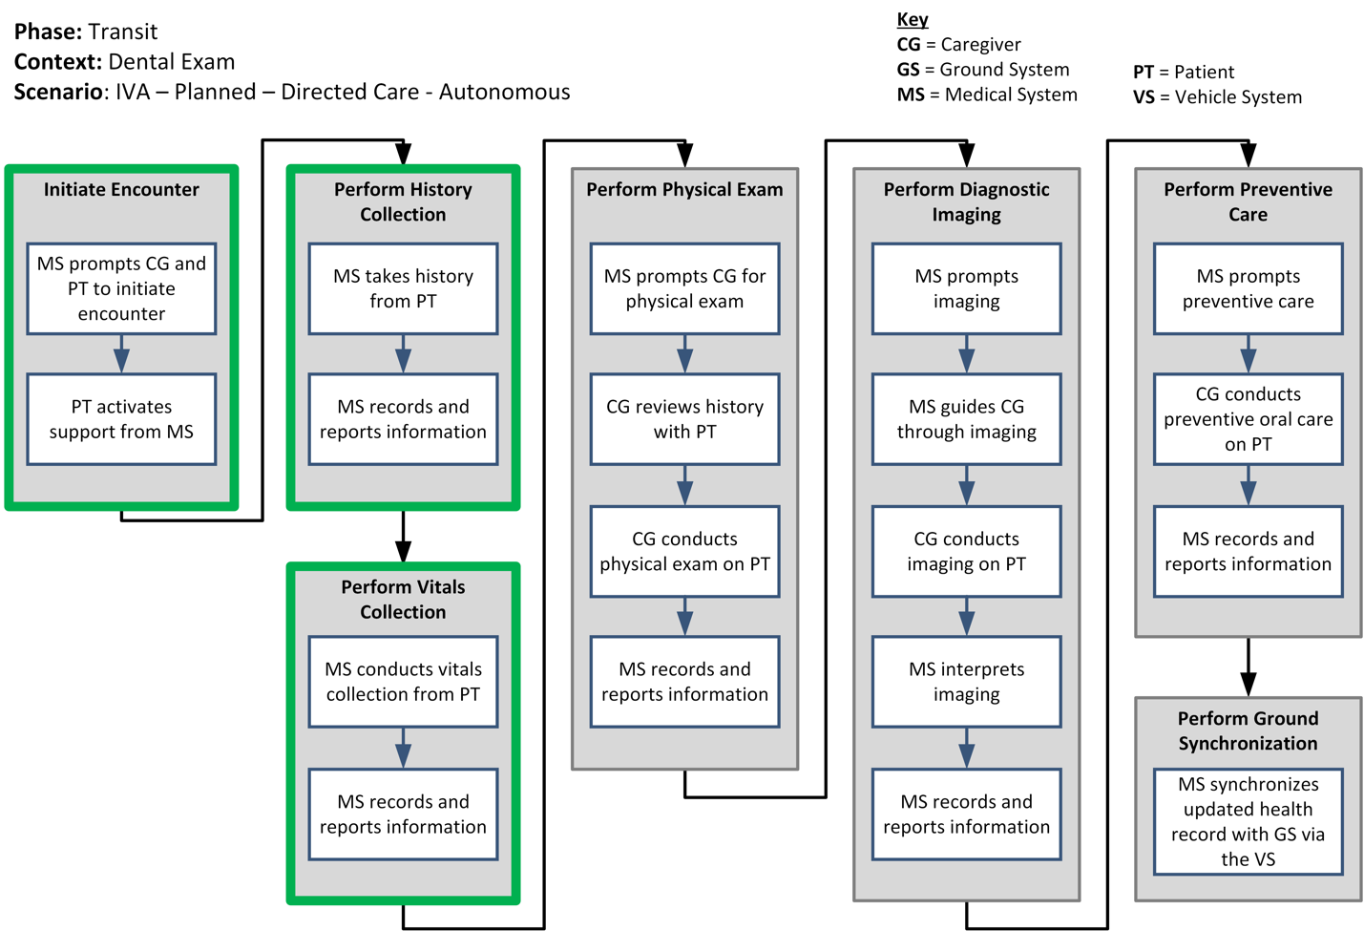

Figure 1. Flow chart of activities in the dental exam scenario. IVA = intra-vehicular activity.

The narrative text associated with the highlighted (green) boxes is provided below as an example:

The medical system sends an alert to the crew medical officer and patient that a scheduled dental exam will start in ten minutes. The patient heads over to the medical bay and picks up a display, which uses biometric analysis to identify him and grants him access to his health record in the medical system.

The medical system starts the appointment by prompting him to review his health record documentation for accuracy and update if needed. Areas of review include past medical, surgical, and dental treatment history, allergies, current medications, and then a series of questions to complete a review of systems. It then uses biosensors to collect vital signs from the patient, such as blood pressure, heart rate, oxygen saturation, temperature, and respiratory rate. These are all automatically saved to his health record and displayed back to him.

Each scenario is designed to identify and demonstrate a set of functions. For the dental exam scenario example, those functions are:
- prompt the initiation of an activity per the crewmember's schedule
- prompt the initiation of an activity based on a protocol
- retrieve information from the patient
- guide a crewmember during an activity
- interpret information gathered during an activity
- provide varying levels of support to a crewmember

Collectively, these scenarios enable ExMC to use MBSE tools for communicating, planning, designing, prototyping, and integrating medical system options for preventing, diagnosing, treating, and managing long-term the health and medical risks inherent to human exploration missions.

Modeling

Flow charts, such as illustrated in Figure 1, from the ConOps are analyzed and translated into Activity Diagrams in a SysML model. An example Activity Diagram of the first portion of the Dental Exam scenario is shown in Figure 2. This clarifies the activities expected to be performed by the medical system, each crewmember (whether in a patient or caregiver role), and the other flight or ground systems. Each horizontal swimlane represents actions performed by either the Patient (PT), Caregiver (CG), or Medical System (MS). For example, one action “Prompts CG and PT to initiate encounter,” under the “Initiate Encounter” box defined in the ConOps flow chart (Figure 2) can now be understood to be performed by the Medical System, and the other action, “Activates support from MS”, will be performed by the Patient. Capturing these activities as model elements supports subsequent analyses for derivation of functions and requirements and informs verification and validation activities later in the medical system development life cycle.

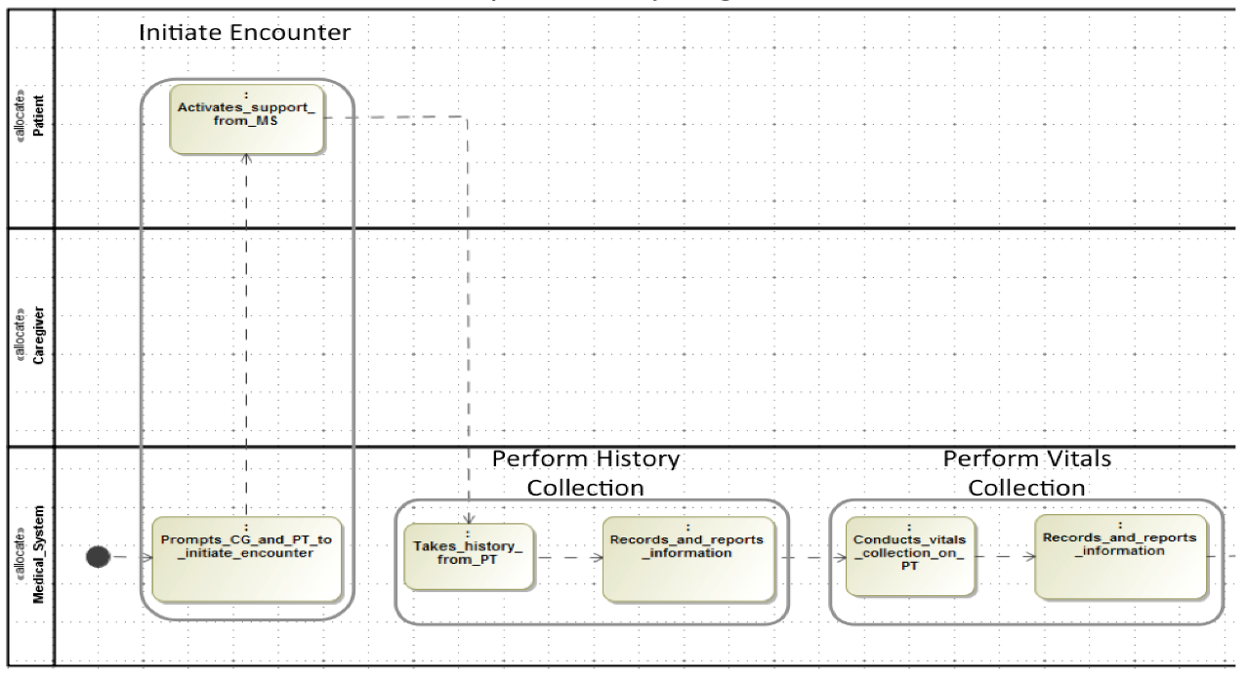
Figure 2. Portion of the dental exam scenario Activity Diagram.

Functional Decomposition
Analysis of the system behavioral content facilitated the grouping into functions. A function typically starts with a verb and describes what the system does. These functions were further decomposed until each activity was mapped to a function. Information in this functional decomposition provides a more complete representation of the medical system “problem space.” At the highest level, these functions aid in the development of the medial system architecture, which is the first foray into the “solution space.”

Figure 3 shows how the medical system functions are broken into eight sub-functions. One of these sub-functions is “Inform decisions on crew health actions.”

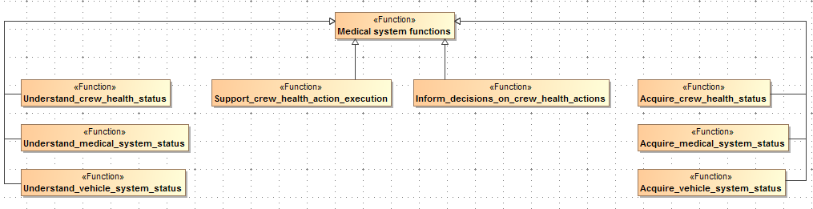
Figure 3. High-level medical system functional decomposition.

Figure 4 further breaks-down this sub-function and shows the mapping of the activities to this sub-function. The earlier mentioned activity “Prompts CG and PT to initiate encounter” maps to the function “Prompt crew” which is a sub-function of “Inform decisions on crew health actions.”

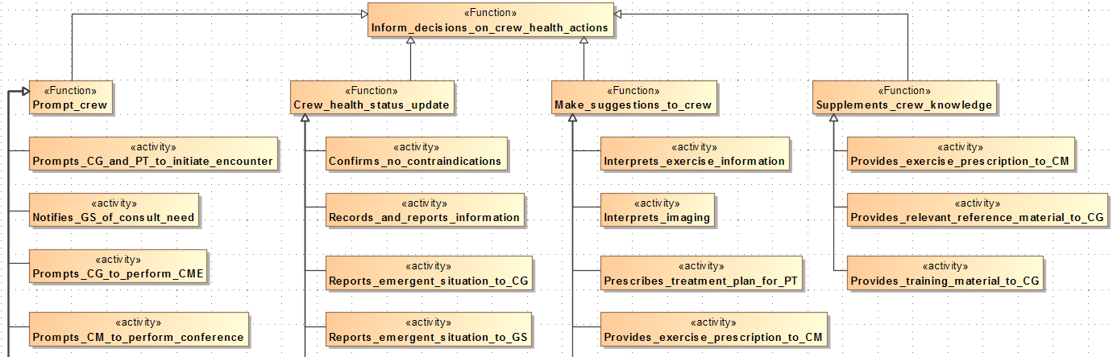
Figure 4. Sample scenario activities grouped under “Inform decisions on crew health actions.”

Medical System Architecture Description
A draft system context and architecture was developed based on expected needs, goals, and behaviors. As requirements are written, the architecture is refined, including defining lower levels of detail and eventually relating to physical components. Figure 5 presents a context architectural view centered on the Medical System as part of the CHP system and overall vehicle Habitat System. The focus of this ExMC MBSE activity is on the Medical System that will support crew for exploration missions.

Within the Flight System, traditional functional flight systems such as Structures and Avionics appear as the bottom row of blocks to provide context and awareness of future interfaces with those subsystems. For example, while certain vehicle consumables, such as water and oxygen, will be required for medical purposes, their provision is not within the scope of the Medical System; instead, they will be provided by the Environmental Control and Life Support System (ECLSS).

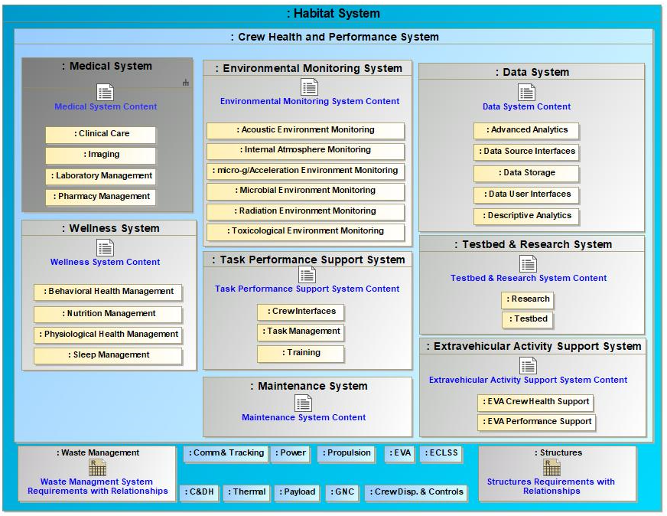
Figure 5. High-level medical system architecture and context.

Within the ExMC Crew Health and Performance (CHP) System, there are eight subsystems: medical, environmental monitoring, data, wellness, task performance, testbed & research, maintenance, and extravehicular activity support. The core functions of each of these systems are depicted in the yellow blocks in Figure 5. Blocks outside of the CHP system represent the other systems that make up the rest of the vehicle habitat. The CHP system may interface with these other systems. For example, medical system tasks may produce physical waste (i.e., used gloves or cotton swabs) and the waste management system would need to be designed to accommodate this waste. As in indicated in Figure 5, subystems with an icon and blue text can be clicked on and additional information on that subsystem is available.

Data Informed Decisions
The SysML model will be used as one tool for trade space analysis of requirements, mission risk, and physical specifications of in-flight capabilities associated with the medical system [9]. ExMC has chosen to take a quantitative approach to inform the detailed definition of a medical system. This allows for evidence based, data-informed decisions when selecting what to include in any medical system design. To execute a quantitative approach, a number of tools needed to be developed. ExMC has viewed the set of tools as a system itself, as the “black box” equivalent of various tools acting together to produce cohesive quantitative, analytical outputs. This “black box” is referred to as
Informing Mission Planning via Analysis of Complex Tradespaces (IMPACT), a trade space analysis tool suite.

The long-term goals of IMPACT are to enable systematic trade study evaluations and inform research prioritization. This would enable ExMC to quantitatively characterize the exploration medical system architecture trade space to inform mission development, vehicle and habitat requirements, and research planning. It allows stakeholders to quantify engineering impacts and risks that a potential human health and performance capability could have on crew and mission outcomes. IMPACT will follow the general information flow shown in Figure 6. In brief, a requestor will pose a query to the IMPACT operator, who will then collect and/or generate the necessary input files to run IMPACT. The results generated by IMPACT will be presented to an operator, who will compile an output report to provide back to the requestor. Clinician subject matter experts (SMEs), will be available for consultation as necessary and desired. Iterations on system options, inputs, and outputs may be required.
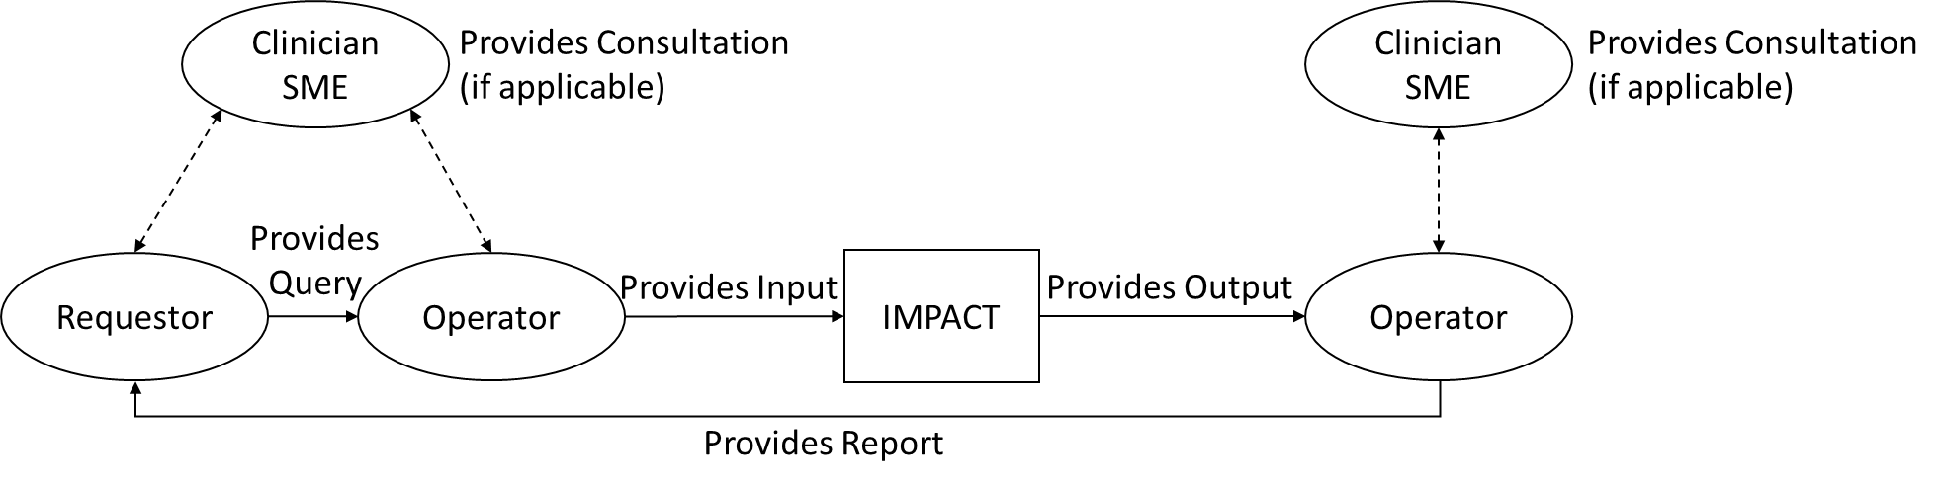

Figure 6: IMPACT Information Flow

Currently, IMPACT provides users with information on medical risk parameters; resources used such as medications, supplies, or devices; the health state of the crew; and whether relevant metrics are within acceptable limits or constraints. The IMPACT box shown in Figure 6 consists of multiple ExMC tools. The current block diagram for how this suite of tools interacts is in Figure 7. Descriptions of these tools are discussed in detail in Amador, et al. [9].

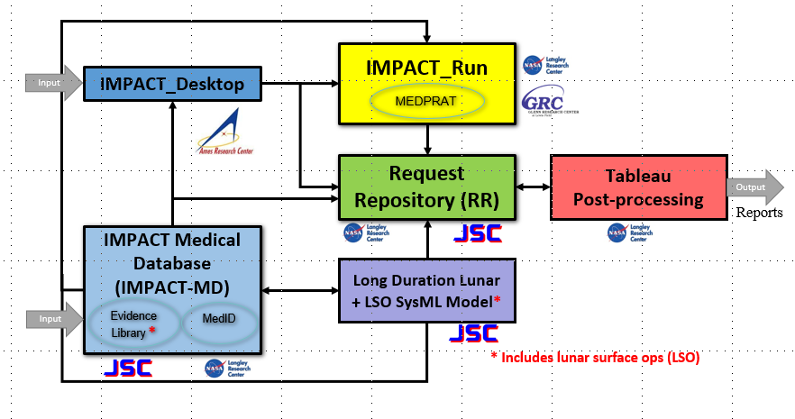
Figure 7: IMPACT Tool Interactions

IMPACT has demonstrated that, for a given design reference mission, a list of available medical resources, and a set of target values for allocation and acceptable risk, it can identify an optimized set of medical resources that meets all of the notional targets if such a solution exists. Additionally, the tool suite can identify system requirements and medical conditions and capabilities that will be met/unmet by such a medical resource set. This capability is important for mission planning, because the very worthwhile objective of maintaining crew health and safety must be balanced against the realities of limited resources available during exploration spaceflight.
IMPACT will assist ExMC to identify which medical capabilities have the potential to provide the greatest possible risk reduction benefit per resource cost, leading to an increased likelihood of their inclusion in exploration medical systems. It can additionally inform NASA mission planners regarding the prioritization of research and technology development for deep space medical capability, provided that the input evidence is of sufficient pedigree to draw conclusions regarding the efficacy and applicability of future capabilities. Perhaps most importantly, IMPACT enables CHP to be considered as early as possible in the mission planning and vehicle design process, allowing for full integration into architectures as they are conceptualized, developed, and adopted.

Future Work
Having demonstrated how using a systems engineering approach can be valuable for exploration medical system development work, ExMC intends to apply the approach outlined in this paper to the seven remaining CHP subsystems. Having an integrated, comprehensive CHP system model will enable NASA to define, develop, validate, and manage the technical system design needed to implement exploration capabilities for future missions.

Conclusion
Successful implementation of any system or subsystem in a complex project requires thoughtful and structured design from project initiation through maturation and implementation. The interdisciplinary MBSE approach is key to ensuring consistent technical communication and streamlined integration with vehicle design. Here, we describe the methods, tools, and collaborative interactions that have helped to establish team processes, infrastructure, IMPACT architecture, and an early model of the medical system being designed for exploration missions. Throughout the life cycle of an exploration program, requirements will ebb and flow, trades and resource negotiations will be made, and mission objectives will morph. A strong systems engineering foundation will enable CHP system designers to keep up with this constant vortex of change.

Acknowledgments
This work was performed by the Exploration Medical Capability Element of NASA’s Human Research Program. Thank you to all the individuals that are currently and have been part of ExMC’s efforts in this area and to all the health care providers that have supported and contributed to this work. Specifically, we would like to recognize Sarah Lumpkins, David Rubin, Jeff Reilly, Michelle Urbina, Jenny Amador, and Bill Thompson.

Acronyms in Diagrams
CG = Caregiver
CM = Crewmember
CME = Continuing Medical Education
C&DH = Command and Data Handling
ECLSS = Environmental Control and Life Support System
EVA = Extravehicular Activity
GNC = Guidance Navigation and Control
MS = Medical System
PT = Patient

References
¹Committee on Creating a Vision for Space Medicine During Travel Beyond Earth Orbit, "Safe Passage: Astronaut Care for Exploration Missions," in Institute of Medicine of the National Academies Press, 2001.
²NASA Human Research Program, "Human Research Roadmap, Risk of Adverse Health Outcomes & Decrements in Performance due to Inflight Medical Conditions," [Online]. Available: https://humanresearchroadmap.nasa.gov/Risks/risk.aspx?i=95.
³Canga, M., Shah, R., Mindock, J., Antonsen, E., A Strategic Approach to Medical Care for Exploration Missions, 67th International Astronautical Congress (IAC), Guadalajara, Mexico, 2016.
⁴Antonsen, E., Hanson, A., Shah, R., Reed, R., Canga, M., Conceptual Drivers for an Exploration Medical System, 67th International Astronautical Congress (IAC), Guadalajara, Mexico, 2016.
⁵NASA, Medical System Concept of Operation for Mars Exploration Mission-11 (EM-11), JSC 67070, 2017.
⁶Hanson, A., et al., Using A Model-Based Systems Engineering Approach For Exploration Medical System Development, 68th International Astronautical Congress (IAC), Adelaide, Australia, 2017.
⁷Mindock, J., et al., Systems Engineering for Space Exploration Medical Capabilities, AIAA SPACE Forum, Orlando, FL, September 2017. https://doi.org/102514/6.2017-5236.
⁸Hanson, A., et al., A Model-Based Systems Engineering Approach to Exploration Medical System Development, 2019 IEEE Aerospace Conference, Big Sky, MT, USA, 2019, pp. 1-19.
⁹Amador, J., et al., Enabling Space Exploration Medical System Development Using a Tool Ecosystem, 2020 IEEE Aerospace Conference, Big Sky, MT, USA, 2020, pp. 1 – 16.
¹⁰Cohen, J., et al., Presenting Model-Based Systems Engineering Information to Non-Modelers, 2021 IEEE Aerospace Conference, Big Sky, MT, USA, 2021.
¹¹NASA. “NASA Systems Engineering Handbook,” NASA/SP-2016-6105 Rev2, 2016.
¹²NASA.“NASA Systems Engineering Processes and Requirements,” NPR7123.1B, April 18, 2013.

Exploration Medical Capability (ExMC) Systems Engineering Team Lead, Human Research Program, NASA Johnson Space Center, 2101 NASA Parkway, Houston, TX, 77058, USA.
ExMC Deputy Element Scientist, Human Research Program, NASA Johnson Space Center, 2101 NASA Parkway, Houston, TX, 77058, USA. 3 President, J4 Insights LLC, 2393 Indigo Harbor Lane, League City, TX, 77573, USA. 4 Provider Lead for Human Systems Lander (HLS) integration, NASA Johnson Space Center, 2101 NASA Parkway, Houston, TX, 77058, USA.
5 Clinical & Science Team Lead, ExMC, Human Research Program, NASA Johnson Space Center, 2101 NASA Parkway, Houston, TX, 77058, USA and KBR, 2400 NASA Parkway, Houston, TX, USA 77058.
6 Associate Chief Scientist, Human Research Program, NASA Johnson Space Center, 2101 NASA Parkway, Houston, TX, 77058, USA. 7 Assistant Director, Human Systems Risk Management, NASA Johnson Space Center, 2101 NASA Parkway, Houston, TX, 77058, USA. 8 ExMC Element Scientist, Human Research Program, NASA Johnson Space Center, 2101 NASA Parkway, Houston, TX, 77058, USA.

