**Ballooning in the Earth’s Atmosphere to Understand the Impacts of Pollution, Volcanic Eruptions and Forest Fires on Climate**

**Jean-Paul Vernier**, NIA Senior Research Scientist, and **Amit Pandit,** NIA Research Scientist

As the Earth’s surface temperature continues to rise due to anthropogenic activities, climate scientists need to refine model predictions and fully understand how fine particulate matters suspended in the air, also called “aerosols,” interact with solar radiation and the formation of clouds. The role of aerosols in Earth’s climate represents a major source of uncertainty for climate prediction. Studying those aerosols is, and will continue to be, a major research endeavor as indicated in the decadal survey prepared in 2017 by the Committee on the **Decadal Survey** for Earth Science and Applications from Space (ESAS) of the National Academies of Sciences.

While satellite-borne instruments can observe the Earth as a whole on a daily basis, they primarily provide an integrated view of the atmosphere and lack the resolution to see fine-scale processes. Thus, in situ measurements are key to obtaining data to assess the properties, lifetime, and impacts of aerosols on climate. Ballooning in the Earth’s atmosphere with sensors is the option that scientists at NIA have chosen for the study of aerosols. From lightweight instruments which can be deployed quickly to study transient events such as volcanic eruptions and fires, to larger payloads to gather multiple datasets using more sophisticated instruments, scientists are constantly looking for the best options that will address their science objectives.

In May 2018, as the Kilauea volcano on Hawaii’s Big Island began to erupt, with the emergence of lava flooding streets and destroying homes, NIA scientists collaborated with the Universities of Costa Rica, Hawaii, and Colorado to rapidly deploy to Hawaii and make measurements in the volcanic plumes emitted by Kilauea.

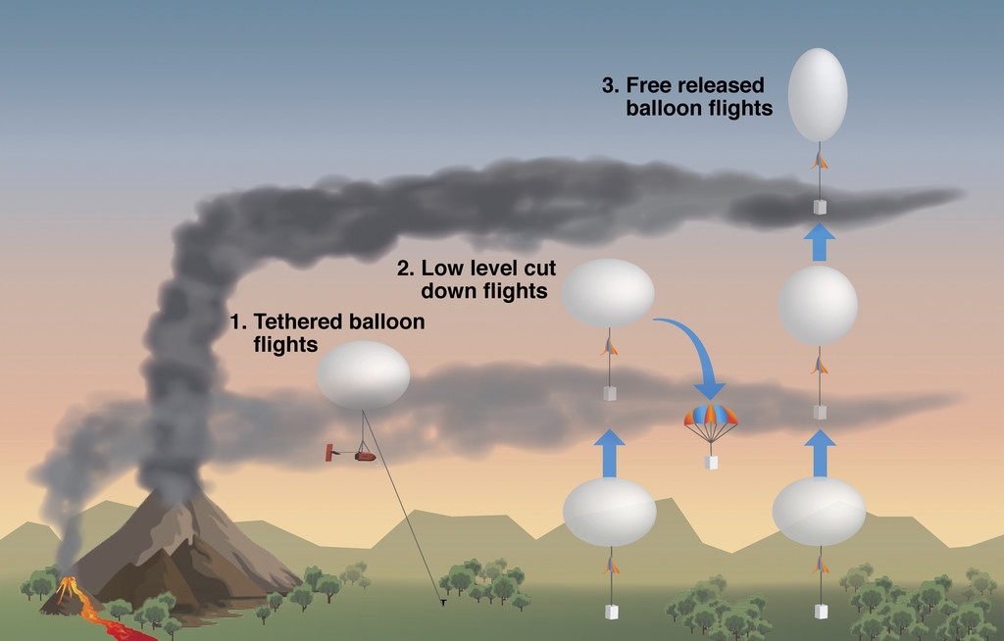

*Balloon activities during the VolKilau campaign to sample volcanic plumes emitted at low altitudes from the fissures, and at higher levels from explosive events at the Kilauea summit.*

The balloon-borne payloads included instruments to measure meteorological parameters including temperature, pressure, and relative humidity, as well as to infer the optical, physical and chemical properties of aerosols, and the presence and concentration of sulfur dioxide (SO2). These measurements enabled the NIA-led team to gather unprecedented information to study the volcanic plumes. It was discovered that sulfur dioxide can be rapidly converted into aerosols within only a few hours after being emitted, depending on the level of humidity – a humid environment prompting quicker aqueous reactions to form aerosols and deplete SO2.

In the Fall 2019, the team launched lightweight balloon payloads from NASA Langley Research Center to study the properties of a plume injected by the Raikoke volcano, located thousands of miles away on Russia’s Kuril Islands. Since the 2014 eruption of the Kelud volcano in Indonesia, whenever and wherever a volcano rumbles around the world, the NIA team, with international collaborators, attempts to rapidly respond to make the balloon measurements needed to pierce the most interesting science results. If not, their concentration is on the study of how pollution affects the Earth’s atmosphere, with a focus on the Asian Monsoon.

Satellite observations have revealed that a fraction of pollutants emanating from the Earth’s surface in the form of aerosols can reach the upper atmosphere, the stratosphere, located 10 miles above the ground. Asia is one of the most polluted regions on the Earth; and pollution from this region is transported by large thunderstorms that form during the Asian Monsoon, the rainy season. Each year since 2014, scientists from NIA have deployed to locations in India to make aerosol measurements to understand how pollution is transported into the stratosphere over India. One of the major findings of this balloon campaign was the discovery of nitrate aerosols near the tropopause. Nitrate aerosols have the potential to modify the properties of ice clouds in the upper atmosphere and amplify their radiative impacts.

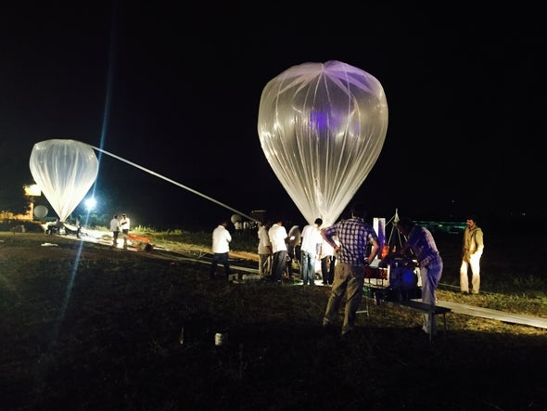

*Flight preparation at the balloon facility of the Tata Institute of Fundamental Research, Hyderabad, India, in July 2019. The main balloon is inflated on the left while a secondary balloon is used near the main payload to facilitate the launch.*

Recently, the rising concern of pyrocumulonimbus (PyroCbs) clouds formed as a result of extreme forest fires has also drawn our attention toward making additional measurements. Such measurements are very limited, but will be crucial in understanding the impact of PyroCbs on the upper troposphere and lower stratosphere aerosol load and clouds.

With the miniaturization of the atmospheric sensors and satellite communication, balloons have their place for climbing the Earth’s atmosphere to make in situ measurements. NIA scientists continually look for opportunities and partnerships to study aerosols using state-of-the art technology.