NASA Environmental Control and Life Support Technology Development for Exploration: 2020 to 2021 Overview
James Lee Broyan, Jr., Laura Shaw, Melissa McKinley, Catlin Meyer, and Michael K. Ewert
NASA Johnson Space Center, Houston, Texas 77058
Walter F Schneider
NASA Marshall Space Flight Center, Huntsville, AL, 35812
Marit Meyer, Gary A. Ruff
NASA Glenn Research Center, Cleveland, OH 44135
Andrew C. Owens
NASA Langley Research Center, Hampton, VA 23681
and
Robyn L. Gatens
NASA Headquarters, Washington, D.C. 20546
This paper provides an overview of NASA supported activities developing Environmental Control and Life Support (ECLSS) technologies in the following capability areas: life support, environmental monitoring, fire safety, and logistics. NASA has been refining technology needs for deep space missions including Gateway, lunar surface, Mars transit, and Mars surface missions. Validating technologies in relevant environments, both in low earth orbit (LEO) and ground tests is critical in understanding technology performance and long duration performance. On-orbit and ground tests inform NASA’s technology decisions to fill exploration gaps. NASA has multiple technology projects across the technology readiness spectrum with potential to fill or partially fill exploration gaps. For each capability area, this paper will describe select capability gaps, NASA technology project maturation over the past year, and how key performance parameters (KPPs) are being used to measure the degree of capability gap closure. KPPs are evolving but they still provide a useful measure in communicating progress and identifying development needs to fill exploration gaps. The intent is to provide a very high-level overview describing the strategic approach to gap closure and provide references to additional technical details, progress, and KPPs.

Nomenclature
APM = Airborne Particle Monitor
CHP = Crew Health and Performance
ECLSS = Environmental Control and Life Support System
ISS = International Space Station
KPP = key performance parameter(s)
NASA = National Aeronautics and Space Administration
Saffire = Spacecraft Fire Experiment
SCLT = System Capability Leadership Team
SOA = state-of-the-art
UWMS = Universal Waste Management System

Introduction
E
NVRIONMENTAL Control and Life Support Systems (ECLSS) technologies have continued developmental progress required for NASA’s cis-lunar and Mars exploration missions. The ECLSS-Crew Health and Performance (ECLSS-CHP) System Capability Leadership Team (SCLT) includes a wide range of capabilities to ensure a habitable safe environment and ensure crew health and ability to perform mission objectives. The SCLT capability areas are broadly grouped into ECLSS and CHP, see Figure 1. Each ‘Capability Area’ (e.g., ‘Life Support’) is composed of ‘Capabilities’ (e.g., ‘Atmosphere Management’). Figure 2 illustrates how ECLSS-CHP evolves over the mission stepping-stones to Mars. New capabilities, some illustrated in Figure 2 under the missions, are required for each step. The difference between today’s state-of-the-art (SOA) and the required exploration capability is a gap¹. These new capabilities can generally be met with a range of technologies. ECLSS-CHP is developing key performance parameters (KPPs) to allow the needs to be specifically quantified and to measure both technology development improvements and inform technology down select decisions. The ECLSS-CHP strongly supports the use of KPPs and targeted gaps for exploration mission studies. KPPs include not only traditional performance measures (e.g., kg/hr and ppm averaged over one hour), but also storage and resupply (e.g., kg consumables + limited life components/kg processed), and reliability (e.g., kgs of spares to achieve 99% probability of sufficiency).
The International Space Station (ISS) remains the primary testbed for validating technology selections and will be complemented by ground testing and ground analogs to establish reliability predictions and identify areas for improvement. Early Artemis missions will return to the moon with primarily open loop ECLSS due to the initial short lunar surface duration missions of 7 days. Gateway will support Artemis missions for both the initial short sorties and sustained lunar surface missions over a wide range of lunar latitudes. Gateway also provides access to the unique deep space radiation environment, an important parameter for some CHP systems, which will be representative of Mars transit missions. Sustained lunar and Mars surface missions that are intermittently crewed are envisioned to have partially closed ECLSS that are adapted for partial gravity. Transit missions to Mars will require greater ECLSS closure to significantly reduce water and oxygen consumable mass, and the Gateway architecture will evolve to include this Mars transit capability.
Reliable space flight hardware is always important but it becomes paramount for Mars transit missions where all spares must be launched with the transit vehicle. For this reason, long-duration testing on the ISS and follow-on LEO platforms is critical to obtain the necessary time on system to understand reliability and accurately predict spares. It is important each of these missions be used to validate technology for the next.
The main drivers in the selection of ECLSS-CHP for mission architectures include the following: presence of gravity, length of the mission, uncrewed periods (i.e., dormancy), and probability of success goals (e.g. reliability). ECLSS-CHP is not independent and relies on closure of capability gaps in related SCLTs including In-situ Propellant and Consumables Production, Autonomous Systems and Robotics, Advanced Materials, Structures, and Manufacturing, and Avionics. This paper will summarize ECLSS advances made from the prior year². In the future it is envisioned there will be companion paper summarizing the CHP advances.

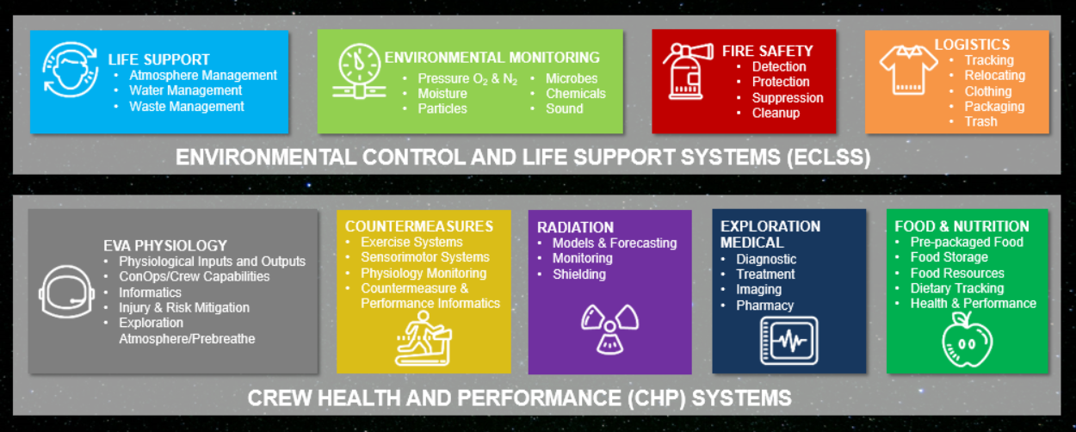
Figure 1. ECLS-CHP SCLT Capability areas and capabilities.

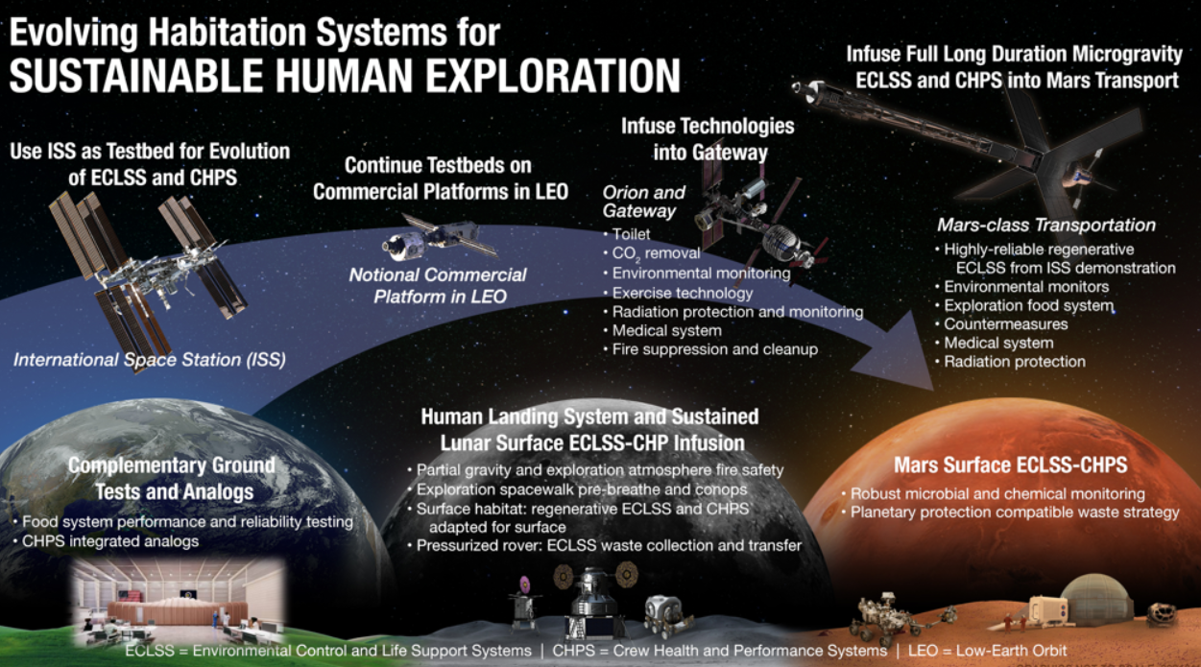
Figure 2. High level sample of required capability gaps for evolving exploration Habitation Systems.

Life Support Capability Area

Atmosphere Management Capability
Atmosphere revitalization encompasses the technologies for carbon dioxide removal, carbon dioxide reduction, oxygen generation, and particulate matter and trace contaminant control.
For carbon dioxide removal, one of the key performance parameters NASA established is to maintain the partial pressure of carbon dioxide at 2600 ppm with four crew. Capabilities under development by NASA and with NASA partners are at various phases of development and include carbon dioxide removal using thermal amines, sorbents, liquid amines, ionic liquids, and metal organic frameworks.
Carbon dioxide reduction technologies are being developed to meet a KPP of recovering greater than 75 percent of oxygen from carbon dioxide for long duration transit missions and greater than 90 percent for planetary surface missions. Technologies under development include improvements to the Sabatier state-of-the-art, recovering hydrogen by methane pyrolysis to return it to the Sabatier to create additional water which can be turned into oxygen, and developing more efficient Bosch technologies to potentially replace the Sabatier.³
Oxygen generation umbrellas various activities that include improving reliability of the current oxygen generation system on the ISS, alternate technologies to generate oxygen, providing medical oxygen, and providing high pressure oxygen to fill extravehicular activity suit tanks. Lessons learned from operating the Oxygen Generation Assembly on the ISS are being incorporated for this hardware to improve maintainability and reduce spares mass. A static vapor feed electrolysis technology is being developed as an alternate low-pressure oxygen generation system. A commercial off-the-shelf technology used as an oxygen source on military aircraft is being evaluated to deliver medical oxygen in space. Filling oxygen tanks for the extravehicular activity suits requires a 3600 psi source. Several technologies under development include a cell stack design that delivers oxygen at 3600 psi, compressor technologies that will compress ambient pressure oxygen to 3600 psi, and a technology using a solid state process and materials to compress oxygen.⁴
The KPP for atmospheric particulate control is less than 0.05 mg/m³ for lunar dust and cabin dust between 0.1 and 10 um, representing the Safe Exposure Estimate. Testing of different filtration media to determine the best candidate to meet these KPPs is on-going. Design and testing continues on a scroll filter technology that will provide clean filtration with much less frequent crew maintenance.⁵ Sorbents used on the ISS for trace contaminant control are obsolete and need replacement. NASA has been testing new sorbents and designs to meet the KPP for ammonia capacity greater than 11.9 mg/g at less than 1 ppm and volatile organic compound capacity greater than 5.4 mg/g. A catalytic oxidizer design for trace contaminant control has been undergoing life test for over a year. An exploration forward catalytic oxidizer prototype is planned to start life testing in FY22.³
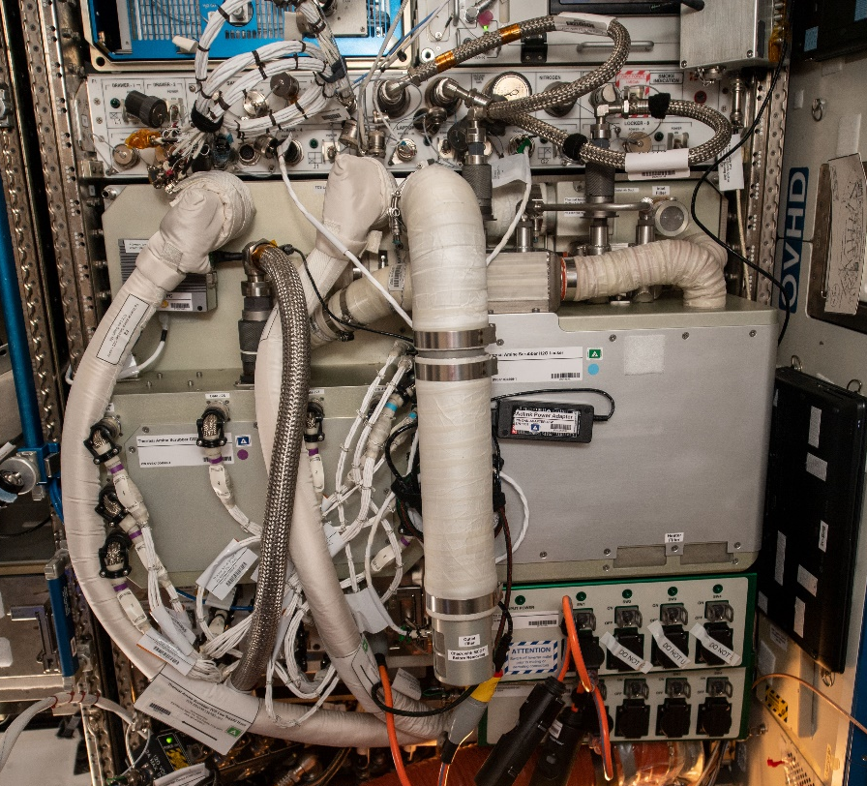
NASA’s first carbon dioxide scrubbing technology, Thermal Amine Scrubber as depicted in Figure 3, was launched to ISS in 2019 and has accumulated approximately seven months of operations run time. The Thermal Amine Scrubber has proven it is capable of removing four crew’s worth of carbon dioxide at slightly above the target carbon dioxide levels in the cabin. The system has experienced a blower and valve failure, which were resolved with return of the component to ground and replacement with a spare unit.⁶ The intention is to operate this system for at least one year of cumulative run time before it joins NASA’s other candidate, Four Bed CO₂ Scrubber, in a carbon dioxide scrubbing system down select. The system chosen out of the down select will be installed within the ISS integrated testbed for long duration testing on ISS.

Figure 3. Thermal Amine Scrubber installed on ISS.

Water Management Capability
Water management focuses on wastewater (condensate and urine) processing, urine brine processing and disinfection/ microbial control. In order to facilitate successful exploration beyond low-earth orbit, water recovery systems must be highly efficient and demonstrate a KPP of >98% water recovery from urine. On ISS, the state-of-the-art wastewater processing system relies on distillation, which is limited to ~87% water recovery from urine. Water removal from the urine distillation system is limited to prevent undesired precipitation. The water residual in urine brine is needed to achieve the water recovery KPP. Brine processing contributes to the overall water recovery goal with it own KPP to achieve >95% water recovery from urine brine.
NASA launched the Brine Processor Assembly, Figure 4, to ISS for a technology demonstration in spring 2021.⁷ Provided by Paragon Space Development Corp (Tucson, AZ), the Brine Processor Assembly uses cabin air for forced convection removal of water vapor. The core technology employs a dual-membrane bladder to contain the dewatered brine solids for disposal while selectively passing water vapor into the cabin atmosphere. The water vapor is collected by the ISS condensing heat exchanger and delivered to the ISS Water Processor Assembly.⁸ Toward the end of the year, the technology demonstration will return several bladders containing dewatered brine residual for terrestrial analysis. After the initial performance parameters are demonstrated, the Brine Processor Assembly will continue its multi-year demonstration to reduce the ISS resupply water needs and obtain long term operational data.
NASA is investing in upgrades to the Urine Processor Assembly and Water Processor Assembly based on lessons learned from their operation on the ISS.³ The Urine Processor upgrades address reliability issues that have caused shorter than expected lives in the Distillation Assembly, as well as Purge and Fluid pumps. The Water Processor Assembly has experienced shortened life due to seal leakage in the Catalytic Reactor and external contaminants have shorten the life of the Multifiltration Beds. Upgrades have been delivered to ISS to address these observed limitations.
As urine water recovery rates are increased, exploration life support programs continue their investment in potable water processing systems. The ISS employs iodine as a potable water disinfectant,⁹ but exploration disinfection systems are considering alternative disinfectants that are more compatible with human consumption, able to survive periods of dormancy up to 500 days, and are common among orbital elements and systems. Several NASA centers and commercial partners are pursuing ionic silver as a solution to these exploration goals. Silver is safe for human consumption, thus removing the current reliance on consumables for iodine removal at the point of use. In 2021, NASA will continue testing an active silver electrolysis unit intended to generate between 200 and 400ppb of silver ions in potable water for long periods.¹⁰ Passive silver dosing using controlled release silver-impregnated foam is being investigated.¹¹ Silver biocide has challenges, in both dormancy and spacesuit compatibility, due to the loss of silver from the water which reduces and biocidal effectiveness as it plates-out on water-contacting metallic surfaces which can change the surface finishes.^{12, 13} Additionally, various options for mitigating silver loss are being investigated and may lead to ISS technical demonstration in 2024.
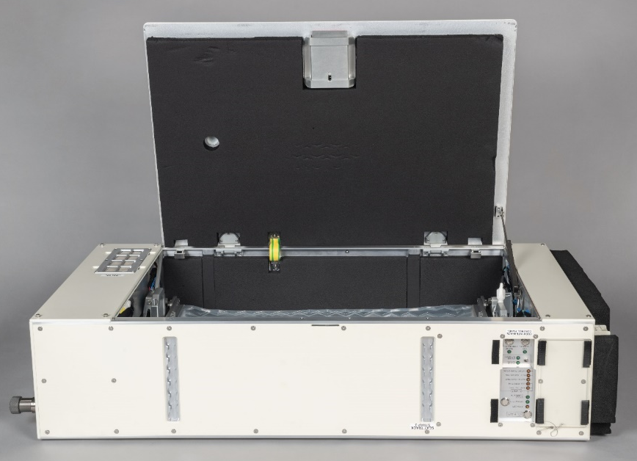
While potable water disinfection for crew consumption remains a high priority for NASA, the life support programs are similarly invested in alternative means of microbial control in wastewater processing systems. As evidenced by challenges on ISS, the overall health of the wastewater processing system requires robust methods of controlling biofilm growth to ensure reliable operation for long mission durations. In recent years, NASA has dedicated multi-center and extra-agency resources to pursing design solutions for the control and prevention of biofilm growth.^{14,15} The development efforts will continue to inform an ongoing trade study, culminating in the selection of the appropriate concept that may be evaluated as a technology demonstration on ISS.

Figure 4. Brine Processor Assembly technology demonstration prior to deployment on the ISS.

Waste Management Capability
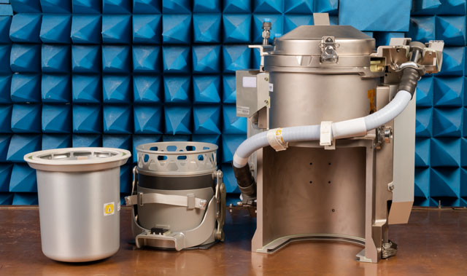
Human space mission waste management is typically broken down into human metabolic waste collection and trash collection, followed by storage, processing and/or disposal. To date, storage and disposal/destruction via cargo resupply ships has predominated, but return to Earth (Shuttle) and lunar surface disposal (Apollo) are notable exceptions.^{16,17} As closed loop ECLSS matures and mission durations increase, waste processing and resource recovery are expected to increase. The latest ECLSS-CHP capability areas, described in Figure 1, track metabolic waste under Life Support (here) and trash under Logistics (below). Capability gaps for metabolic waste are 1) compact low logistics commode and 2) fecal resource recovery. Progress toward closing these gaps is underway.
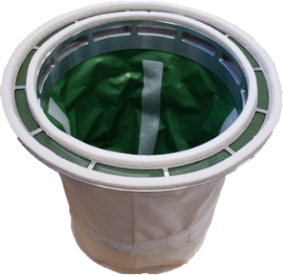
The most abundant metabolic wastes by mass are urine and feces, but also includes menses and emesis. KPP goals for the compact commode include installed mass < 70 kg and volume < 0.34 m³ for microgravity environments. The Universal Waste Management System (UWMS), Figure 5, completed development and launch of a new spaceflight toilet in late 2020,¹⁸ with ISS activation and evaluation planned for 2021. This development goes a long way toward closing the compact low logistics commode gap. UWMS has reduced mass from the SOA of 126 kg on ISS to 73 kg and reduced volume from SOA of 0.99 m³ to 0.34 m³.
Figure 5. Major Orion UWMS components (left to right): hard-sided fecal canister, fecal canister installation mechanism, and UWMS structure/core components.
The consumable mass and volume for fecal collection and storage canisters is also a target for reduction. Each UWMS canister is designed to hold ~20 defecations and has a KPP of ~0.08 kg/defecation and ~390 cm³/defecation. The Alternate Fecal Canister is under development to reduce consumable mass per defecation of ~0.06 kg/defecation and ~180 cm³/defecation, Figure 6. Because of the frequency of use, a reduction in this area will be significant for long duration exploration missions.
The KPP goal for fecal resource recovery is to recover > 80% of the water available in feces and further reduce the consumable mass per defecation. Technologies to achieve this goal are still early in development but progress is being made. Different approaches for recovering water and stabilizing the feces for storage are described by their developers in references.^{19,20} NASA is performing initial trade studies to compare fecal storage and processing technologies for short and long mission durations.²¹
Figure 6. Soft-sided Alternate Fecal Container prototype

Environmental Monitoring Capability Area
Environmental monitoring encompasses the technologies needed to have ongoing real-time data to inform stakeholders on the immediate health of the habitable spacecraft environment. Microbial, atmosphere, acoustic, water, and particulate monitoring are each featured in separate ECLSS roadmaps that address technology gaps, solutions, and timelines for accomplishing NASA’s exploration goals.
For particulate monitoring, the most significant gap is there have never been aerosol measurements recorded in space, for the purpose of quantifying air quality. Historically, gases have been monitored extensively on ISS, as high carbon dioxide and trace contaminant gases pose the greatest risks to crew health and wellbeing. However, exploration beyond low Earth orbit necessitates particulate monitoring, particularly for missions to dusty destinations (Moon, Mars, and asteroids). This technology gap has been addressed in stages, first with the ISS Aerosol Sampling Experiment,^{22,23,24} which characterized the airborne particles to be monitored (by analysis after sample return to Earth). The resulting data provided input for the design and selection of particulate monitoring technologies on the particle monitoring technology roadmap. The KPP for this gap is to “quantify total spacecraft cabin aerosols in terms of particle sizes and concentrations.” The state-of-the-art for this parameter has been advanced from zero-level to fully complete since the Airborne Particulate Monitor (APM)²⁵ began operating on ISS in November 2020, Figure 7. It has been deployed to seven different ISS locations in the US Laboratory and Nodes 1, 2 and 3, where it operates continuously, providing high-quality data showing diurnal particle concentration variations and spikes associated with different onboard activities. The APM is a reference-quality instrument, combining two different measurement technologies in one box, thus producing high fidelity data comparable to two separate bench-top-sized laboratory aerosol instruments. This resulted in a relatively large spacecraft particulate monitor, measuring ~36 cm x 28 cm x 13 cm and weighing ~8 kg, but which can measure particle concentrations between 5 nm and 3 µm, as well as a particle size distribution from 3 µm to 20 µm. This was justified because the first information on the aerosol environment should be the most accurate and encompassing data, and should avoid sacrifices associated with miniaturized instruments.
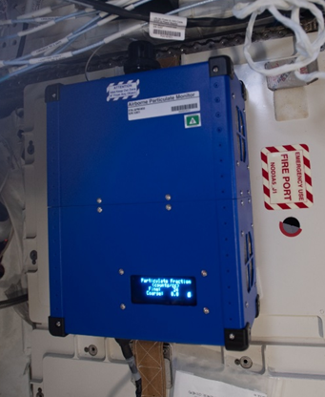
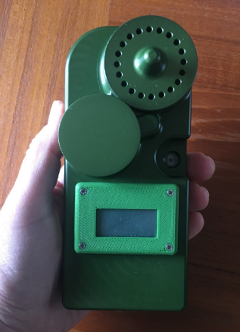
The next technology gap is the need for miniaturized mass concentration instruments which would have smaller size, weight and power needs than the APM, but through appropriate calibration, can monitor particles reasonably well. Four distinct key performance parameters are associated with this gap: 1) Measure mass concentration [mg/m³], 2) Quantify particles in different size fractions [2.5 µm and below, and 10 µm and below], 3) Hardware mass per monitor [0.4 kg], and 4) Provide a distributed network of sensors in spacecraft habitable volume [one sensor per 35 m³]. These performance parameters are all currently at level zero, but will be addressed in the Aerosol Monitors technology demonstration on ISS, which will launch in December 2021. There will be three separate Mini Aerosol Monitors²⁶ Figure 8, with different size-selective inlets to measure mass concentration of particles up to 2.5 µm, up to 4 µm, and up to 10 µm in diameter. The Mini Aerosol Monitors measure ~ 7 cm x 5 cm x 17 cm and weighs ~ 0.4 kg. Internal filters will be returned to Earth for gravimetric calibration to improve the accuracy of typical spacecraft cabin dust measurements, and the small size enables launching many monitors versus one large unit (e.g. APM).
Future missions will eventually require multiple permanently-deployed and networked sensors that will monitor the health of a vehicle or habitat. Several of the air-related ECLSS monitoring categories (microbial, atmosphere gases, and particulate) will be appropriate for such a network. Ultimately, the data would be inputs to a Spacecraft Air Quality Index,²⁷ and enable vehicle autonomy when ground support will not be available for long-duration missions and permanently inhabited distant outposts.
Figure 7 (left). Airborne Particulate Monitor deployed in Node 3 of the ISS.
Figure 8 (right). The Mini Aerosol Monitor will be flown in the Aerosol Monitors payload December 2021.

Logistics Capability Area

Trash Management
As mentioned in the Waste Management section above, trash generated from the many logistics consumables that are supplied for the crew and their habitat are tracked under Logistics rather than Life support, where human metabolic waste is tracked. Other categories of Logistics are not covered here, but information can be found in references.^{28,29}
Gaps for trash management are 1) solid waste processes that reduce volume, stabilize, and recover water and 2) in-flight waste mass jettison. The primary KPP adopted for solid waste processing is trash storage density, which has a state-of-the-art (SOA) value of 150 kg/m³ and a goal of > 400 kg/m³. The SOA value is based on hand compaction of trash, which is typical for astronauts to do as they put discarded food packaging, cleaning wipes, used clothing, etc. into bags for storage as compactly as possible. Therefore, the volume reduction compared to loose trash will be even greater than 400/150 if the goal KPP is achieved. ISS operational experience supports the need for reducing trash volume as it is a significant challenge to down manifest the volume of trash in visiting vehicles. Trash stored on ISS can sometimes adversely impacts on-board habitable volume.
The major technology development underway for trash volume reduction is the Heat Melt Compactor, which has been described in many prior publications.^{30,31} An ISS flight demonstration test unit is now being developed and referred to as Trash Compaction and Processing System. This technology also provides water recovery, and the resultant “tiles” are microbiologically-stable products that may be useful for radiation protection.
TCPS development began in FY19 with the award of two phase A contracts under NASA’s Next Space Technologies for Exploration Partnerships’ contracts with Sierra Nevada Corporation³² and Collins Aerospace.³³ Each company completed an abbreviated preliminary design review supported by ground test units to improve their designs and operational procedures. Both systems achieved NASA’s goals of 2.2 kg trash per batch, tile water activity < 0.6 and water recovery > 90%. Sierra Nevada performed over 40 test runs with an average tile density around 400 kg/m³. Collins achieved average tile density of 680 kg/m³ in several runs with a “nominal” trash mixture.
Based on lessons learned in phase A as well as prior experience with the first and second generation Heat Melt Compactors, NASA has developed requirements for the phase B development of a flight test unit. Meanwhile risk reduction activities continue at NASA Ames Research Center to test and validate contractor design concepts and study an adsorption water recovery concept that could collect product water in microgravity.

Fire Safety Capability Area
To date, the on-orbit fire events have been relatively few.³⁴ All but two of the thirteen were of limited duration overheating or electric short events. The most serious fire events on spacecraft have been open fires initiated by an oxygen generator that required active crew intervention for extinguishment. Even though this equipment may not be planned for use on a specific exploration mission, the collective history of these types of events demonstrates that fire safety is a significant concern for spacecraft and habitats during exploration missions. Venturing past low-earth orbit brings a host of additional risks with the specific fire safety procedures and equipment depending greatly on the mission details.
Historically, the fire safety gaps are divided into capability areas that include: (1) material flammability, (2) fire detection, (3) fire suppression, and (4) post-fire cleanup. While these appear to be stand alone areas that generally follow the phases of a fire event and subsequent response, it is key that these areas work together – not only with each other but with the ECLSS and other systems on the spacecraft. Developing the knowledge and technologies that allow spacecraft designers and operators to select and optimize the fire response of a specific vehicle and mission is the goal of all of the fire safety gap-closing activities. These activities are guided by the Spacecraft Fire Safety Technology Development Roadmap³⁵ that outlines the development path for all the capabilities listed above plus how they will be adapted for exploration missions to the Moon and Mars.
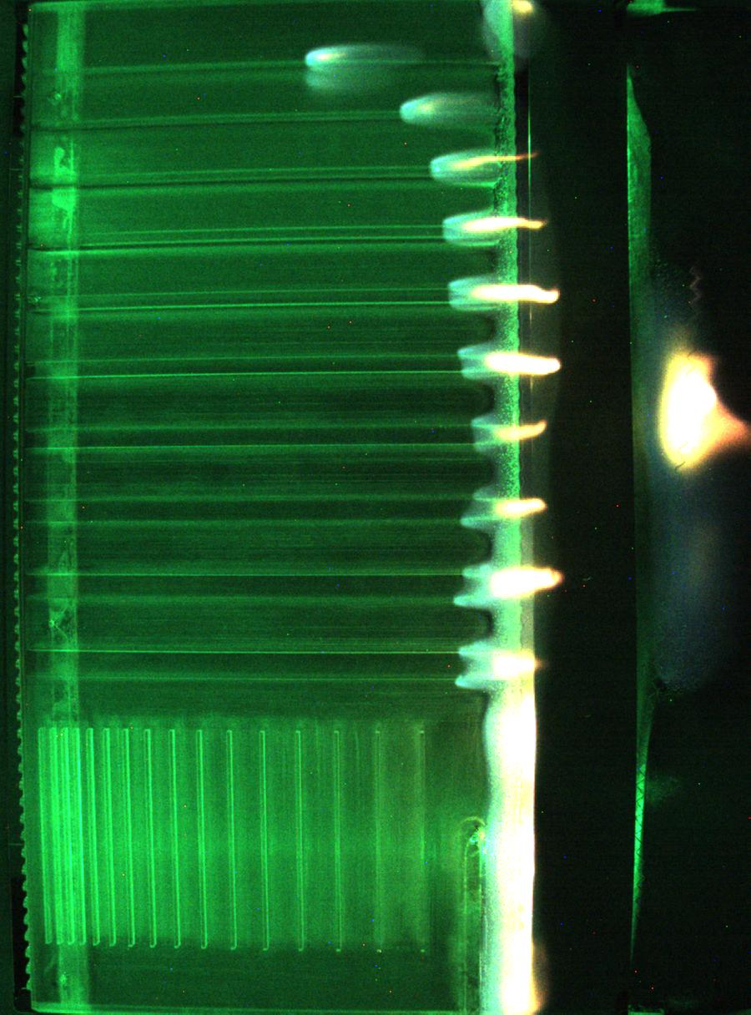
Figure 9. Structure PMMA sample from Saffire-V. Flow is 20 cm/s from lefft to right. The sample was ignited along the bright edge in the middle of the picture. Left: Flame propagating along the ribs of a thick Plexiglas sample. The flame speed is fastest on the thinner ribs. Right: The flame jumped to a downstream sample.
One of the main gap-closing activities for spacecraft fire safety is the Spacecraft Fire Experiment (Saffire) series of experiments. These experiments address many of the gaps defined above by conducting a relatively large-scale fire safety experiment in a Northrop Grumman Information Systems Cygnus re-supply vehicle after it is loaded with trash and leaves ISS. The Saffire-I, II, and III experiments were conducted in 2016-2017 and were the first to investigate material flammability and fire growth using large-scale samples.³⁶ The Saffire-IV, V, and VI experiments have expanded on the initial Saffire capabilities and will conduct tests at elevated oxygen concentrations and reduced atmospheric pressures that are likely to be used in exploration missions with frequent extravehicular activities. Additionally, Saffire-IV, V, and VI demonstrate the operation of combustion product monitoring³⁷ and post-fire cleanup³⁸ in a low-gravity fire scenario using technology prototypes of the Government Furnished Equipment being developed for Orion. The Saffire-IV and V experiments were conducted in May 2020 and January 2021, respectively.³⁹ Several significant observations from Saffire-IV and V are that (1) flames on solids can exist for an extended time in quiescent low-gravity, especially at elevated %O₂, (2) thin structures on a surface can propagate a flame even though the flame doesn’t propagate on the bulk material, shown in Fig. 9, and (3) flames can jump between flammable materials if the material is sufficiently preheated. One of the objectives of this experiment series is to obtain data on the impact of the fire on the vehicle. This data is being used to validate methodologies to model fire scenarios on future spacecraft. Saffire-VI is waiting to be manifested on an upcoming Cygnus flight.
While significant, the Saffire-I-VI experiments are only the beginning of the fire safety technology gap-closing activities. The large-scale experiments on Saffire will inform experiments in facilities on the ISS such as the Solid Fuel Ignition and Extinction insert for the Combustion Integrated Rack or the planned Microgravity Combustion Wind Tunnel facility in the Microgravity Science Glovebox. These facilities are ideal for small-scale experiments that require frequent sample changes or modification of test conditions based on previous results.
Additional Saffire experiments are being planned to quantify even more complex fire safety scenarios such as thermal run-away of a lithium-ion battery in a notebook computer, detection and suppression of that event, and the subsequent cleanup of the atmosphere. This will be an end-to-end test of the fire safety response to one of the hazardous spacecraft design fires and will make use of the most current fire safety technologies planned for exploration.
Material flammability in partial gravity remains a major gap in our preparation for exploration missions. Ground-based flammability tests have proven relatively effective for low-gravity screening of material flammability based on the decades of practice.⁴⁰ Unfortunately, there is no terrestrial facility that can confirm these results are relevant for partial gravity. Preliminary designs and testing for a partial-gravity drop tower at NASA John H. Glenn Research Center are being made. Preliminary designs are being developed for a flammability experiment to be conducted as a payload on a commercial lunar lander. None of these activities can completely address the unknowns associated with spacecraft fire safety in partial-gravity but are needed because there is no testing capability currently available.
The fire detection, monitoring, and clean-up technologies developed for ISS and Orion will, of course, be the first choice to be deployed on future exploration missions. However, mission requirements may drive other aspects of the design such that these technologies cannot be used directly and must be adapted or new technologies identified. In this case, engineers and technologists in the fire safety capability area will define the requirements and implement a strategy to develop and test the hardware for use on a specific mission. As always, this will build on the data and knowledge gained from the ground-based and flight testing of previous spacecraft fire safety equipment.

Analysis and Testing to Validate Exploration Technologies
Advanced ECLSS technology must do more than simply perform well – it must perform reliably and maintain a safe environment for the crew throughout the entire mission. In addition, the reliability, maintainability, and supportability of the system must be well-understood in order to enable informed mission planning, including risk assessment, maintenance planning, and logistics and spares allocations. ISS experience shows that initial (pre-flight, pre-test) failure rate estimates are often inaccurate, and are sometimes off by a factor of 3 or more relative to observed experience.^{41,42} In addition, even after more than a decade of on-orbit operational experience, ECLSS ORU failure rate estimates still exhibit high uncertainty. Uncertain failure rates result in higher spares mass requirements for the same level of risk reduction, due to the need to cover the possibility that failure rates are higher than expected. Overestimated failures rates also increase the perceived spares need for particular items, potentially resulting in misallocation of spares and excess spares mass. Underestimated failure rates are detrimental to crew safety because they can provide a false sense of security and lead to underestimated risk. Accurate failure rate estimates are important for crew safety, and precise failure rates are important for reducing spares mass requirements.^{41,42, 43, 44}
Testing during system development is a critical activity that provides the data required to validate and refine failure rate estimates, as well as the opportunity to identify and mitigate failure modes to improve reliability and performance. Operational experience from the ISS or other on-orbit platforms provides a valuable data source for estimating the failure rates of items with flight heritage. For example, ECLSS operational experience on the ISS has already enabled a multi-ton reduction in the spares mass required for a Mars mission by reducing uncertainty and correcting overestimated failure rates, while simultaneously reducing risk by identifying and correcting underestimated failure rates.^{42,45} Future ground test activities and on-orbit operational experience will provide similar mass and risk reduction opportunities. NASA is using modeling and optimization to identify effective test plans, along with sensitivity analysis to identify key drivers and characterize their impacts. These test plans balance resources across different items as well as different reliability growth and uncertainty reduction tests to maximize spares mass savings for future missions within cost and schedule constraints.⁴⁶
NASA is creating an integrated exploration-class ECLSS testbed on the ISS to demonstrate system performance and reduce reliability uncertainty as described above.³ The ISS provides a wholly unique environment due to the combined presence of microgravity, a closed loop spacecraft atmosphere, and crewmembers providing complex waste products while exposed to the microgravity environment over a multi-year timeframe. The ISS testbed will be a fully integrated system whereby each subsystem provides the necessary products to the relevant downstream system, matching the functions needed to enable a Mars roundtrip mission. Additionally, this integrated approach enables identifying impacts and interactions between subsystems. The integrated system will incorporate new capabilities that will improve the overall water and oxygen loops closure levels as well as upgrades to the existing ISS ECLSS based on operational lessons learned to improve reliability and robustness. In order to enable operation, ISS provides supporting utilities including power, active cooling, command and data handling, and crew presence to provide waste products, consume generated products, and perform system maintenance. The ISS rack-based architecture, provides an opportunity for reconfiguration to create the integrated ECLSS testbed, but it also limits system design flexibility that may be desirable in future vehicles. New capabilities and emerging technologies are certified as non-critical technology demonstrations which reduce cost and schedule for development and delivery. The integrated system is operated out of the Mission Control Center in Houston, TX and managed out of the ISS Vehicle Office while coordinating with NASA and commercial hardware developers.³
To supplement the ISS testbed, NASA is also pursuing ground-based testing to increase the overall data set and capitalize on the investments made in the new capabilities and upgrades. This ground-based system is intended to mimic the ISS testbed in function, with critical portions of the subsystems matching the on-orbit configuration very closely. For example, the Distillation Assembly in the Urine Processor Assembly would be a copy of the on-orbit configuration in order to match the performance and reliability as much as possible in the terrestrial environment. However, holding tanks may be low-fidelity laboratory-grade hardware that simply enable operation and do not exactly match the microgravity-compatible versions. Further, NASA intends to establish component-level testing capability that will enable direct reliability testing of wear out based components such as pumps, valves, fans, etc. While ISS is a unique capability for validation, ground testing allows operation in conditions not practical on ISS (reduced pressures, higher temperatures, or degraded modes to obtain diagnostics data signatures). It is the combined multi-year ISS technology demonstrations and ground testing that help validate both microgravity performance and long duration reliability and robustness of technologies required for exploration missions.

Conclusion
Technology gaps have been established and refined for several years but KPPs have only recently begun to receive similar refinement. KPPs related to spares mass to achieve reliability (probability of sufficiency) are evolving but it is clearly indicating the necessity of time on system, through a combination of ISS microgravity environment and ground testing of wider operational range, are required to reduce uncertainty for long duration missions. While gaps persist, progress is being made on many gaps in all capability areas. Alignment to defined gaps and estimates of KPPs are also being more rigorously applied when evaluating proposed technologies from within NASA, commercial, and academic institutions. This paper provides only a high level overview but references many of the detailed papers where performance measures and SOA can be found to inform formulation of future improvements.

Acknowledgments
This paper summarizes work that was performed by numerous NASA and contractor engineers, analysts, functional specialists, technicians, and crewmembers. While NASA provides significant funding of the activities, NASA recognizes the significant contributions of commercial partners, small businesses, and academic institutions.

References (I still need to do more formatting)
¹ Benjamin, G., Burg, A., Boggs, K. G., McVay, E., Goodliff, K., Elburn, D., “Exploration Capabilities Data Analysis: An Integrated Approach,” IEEE <need details of conference>.
² Schneider, W. F., Perry, J. L., Broyan, J. L., Macatangay, A. V., McKinley M. K., Meyer, C. E., Shaw, L. A., Owens, A. C., Toomarian, N., Gatens, R. L., “NASA Environmental Control and Life Support Technology Development and Maturation for Exploration: 2019 to 2020 Overview,” 50th(electronic only) International Conference on Environmental Systems, Lisbon, Portugal, ICES-2020-200, July 12-16, 2020.
³ Shaw, L., co-authors….” title”, 50th (virtual) International Conference on Environmental Systems, ICES-2021-XXX, July 12-15, 2021. (Submitted for publication)
⁴ Roy, R.J., Ellithorpe, C., Murdoch, K.E., Myles, T.D., Wilson, A., Graf, J.C., “Electrochemical Solutions for Advanced Life Support,” 49th International Conference on Environmental Systems, Boston, MA, ICES-2019-153, July 7-11, 2019.
⁵ Agui, Juan, “Scroll Filter System Development for Crewed Deep Space Missions,” 49th International Conference on Environmental Systems, Boston, MA, ICES-2019-295, July 7-11, 2019. <search if 2021 update>
⁶ Ranz, H.T., Dionne, S., Garr, J.D., “Thermal Amine Scrubber – Space Station Installation and Start-Up,” 50th (electronic only) International Conference on Environmental Systems, Lisbon, Portugal, ICES-2020-195, July 12-16, 2020. <search if 2021 update>
⁷ Meyer, C., Speight, G., (n.d.) “Exploration ECLSS: Brine Processor System. Retrieved from ISS Technology Development and Demonstration,” https://www.nasa.gov/mission_pages/station/research/experiments/explorer/Investigation.html?#id=8102
⁸ Kelsey, L., Pasadilla, P., & Cognata, T. (2018). Closing the Water Loop for Exploration: 2018 Status of the Brine Processor Assembly. 28th International Conference on Environmental Systems. Albuquerque.
⁹ Carter, L., Williamson, J., Gazda, D., Brown, C., Schaezler, R., Thomas, F., . . . Molina, S. (2019). Status of ISS Water Management and Recovery. 49th International Conference on Environmental Systems. Boston. Retrieved from https://ttu-ir.tdl.org/handle/2346/84720
¹⁰ Hicks, P., & Nelson, J. (2020). Preliminary Testing of Electrolytic Silver Ion Generation for Spacecraft Potable Water Systems. 50th International Conference on Environmental Systems. Virtual. Retrieved from https://ttu-ir.tdl.org/handle/2346/86469
¹¹ Irwin, T. D., Li, W., Diaz, A., Calle, L. M., & Callahan, M. (2020). Silver Foam: A Novel Approach for Long-Term Passive Dosing of Biocide in Spacecraft Potable Water Systems – Update 2020. 50th International Conference on Environmental Systems. Virtual. Retrieved from https://ttu-ir.tdl.org/handle/2346/86429
¹² Colon, H., Button-Denby, A., Steele, J., & Nelson, J. (2020). Early Results from a Broad Compatibility Study of Various Materials with Ionic Silver Biocide. 50th International Conference on Environmental Systems. Virtual. Retrieved from https://ttu-ir.tdl.org/handle/2346/86477
¹³ Vance, J., & Delzeit, L. (2020). Mitigation of Silver Ion Loss from Solution by Polymer Coating of Metal Surfaces, Part II. 50th International Conference on Environmental Systems. Virtual. Retrieved from https://ttu-ir.tdl.org/handle/2346/86414
¹⁴ Justiniano, Y.-A. V., Carter, L., Nur, M., & Angle, G. (2020). Developing Methods for Biofilm Control in Microgravity for a Water Recovery System. 50th International Conference on Environmental Systems. Virtual. Retrieved from https://ttu-ir.tdl.org/handle/2346/86332
¹⁵ Diaz, A. M., Li, W., Irwin, T., & Calle, L. M. (2020). A Preliminary Modeling Study of Biofilm Accumulation in the Water Recovery System. 50th International Conference on Environmental Systems. Virtual. Retrieved from https://ttu-ir.tdl.org/handle/2346/86418
¹⁶ Strayer, R.F., et al., “Characterization of Volume F trash from four recent STS missions: weights, categorization, water content”, 41st International Conference on Environmental Systems, AIAA 2011-5126.
¹⁷ https://www.theatlantic.com/technology/archive/2012/12/the-trash-weve-left-on-the-moon/266465/
¹⁸ D. E. Autrey, C. A. Kaufman, J. G. Kocher and J. Fuller, "Development of the Universal Waste Management System," International Conference on Environmental Systems, ICES-2020-278, 2020.
¹⁹ M. A. Serio, J. E. Cosgrove, M. A. Wójtowicz and J. Lee, "Optimization of a Spacecraft Torrefaction Processing Unit (TPU) for Human Metabolic Waste," International Conference on Environmental Systems, Vols. ICES-2020-507, 2020.
²⁰ B. L. Zimmerman, B. Huff and K. Sheets, "Results of an Ionomer Membrane Developmental Test for Water Recovery from Human Metabolic Waste," International Conference on Environmental Systems, ICES-2020-73, 2020
²¹ Powell, C.D., Waguespack, G.M., and Ewert, M.K., “A Fecal Processing Technology Trade Study for Water Recovery in Various Mission Duration Scenarios”, 50th(virtual) International Conference on Environmental Systems, ICES-2021-XXX, July 12-15, 2021.
²² Meyer, M. E. (2017) Aerosol Sampling Experiment on the International Space Station, 47th International Conference on Environmental Systems, July 17, 2017, Charleston, SC ICES-2017-74.
²³ Meyer, M. E. (2018) Results of the Aerosol Sampling Experiment on the International Space Station, 48th International Conference on Environmental Systems, July 10, 2018, Albuquerque, NM ICES-2018-100.
²⁴ Meyer, M. E. (2019) Further Characterization of Aerosols Sampled on the International Space Station, 49th International Conference on Environmental Systems, July 11, 2019, Boston, MA ICES-2019-246.
²⁵ Meyer, M. E. (2020) Airborne Particulate Monitor: A Real-time Reference-Quality Aerosol Instrument Payload for ISS Air Pollution Quantification, 50th International Conference on Environmental Systems, 2020, ICES-2020-65.
²⁶ Tryner, J., Quinn, C., Windom, B. C., & Volckens, J. (2019). Design and evaluation of a portable PM 2.5 monitor featuring a low-cost sensor in line with an active filter sampler. Environmental Science: Processes & Impacts, 21(8), 1403-1415.
²⁷ Meyer, M. E., Sorek-Hamer, M. (2020) Developing a Spacecraft Air Quality Index for Future Missions, New Space Vol. 8, No. 4, December 2020.
²⁸ Broyan, J.L., et al., “Development Status of Logistics Reduction Technologies for Exploration Missions”, International Conference on Environmental Systems, ICES-2020- 416.
²⁹ Ewert, M.K. and Broyan, J.L., “Improving Logistics and Waste Management for Deep Space Human Exploration”, Space 2018, AIAA-2018-5406.
³⁰ Lee, J., et al., “Space Mission Trash Processing Operational and Technical Limits”, 49th International Conference on Environmental Systems, ICES-2019-285.
³¹ Lee, J., et al., “Technical Risks Associated with Heat Melt Compaction Systems”, International Conference on Environmental Systems, ICES-2020-353.
³² Wetzel, J.P., Surdyk, R.J., Johnson, J.R., “Plastic Melt Waste Compactor Integration and Testing”, 45th International Conference on Environmental Systems, ICES-2015-322.
³³ Mesa, J.R., et al., “The Trash Compactor and Processing System Development”, International Conference on Environmental Systems, ICES-2020-192.
³⁴ Packham, N., Wood, B., Pate, D., (2015) Significant Incidents and Close Calls in Human Spaceflight. NASA JSC S&MA Flight Safety Office, JS-2015-004 NNJ13RA01B.
³⁵ Ruff, G. A., Urban, D. L., and Dietrich, D. L., (2020) Spacecraft Fire Safety Technology Development Plan for Exploration Missions, ICES-2020-173, 50th International Conference on Environmental Systems, Lisbon, Portugal, July 12-16, 2020.
³⁶ Ferkul, P., Olson, S., Urban, D.L., Ruff, G.A., Easton, J., T’ien, J.A., Liao, Y.-T. T., Fernandez-Pello, A.C., Torero, J.L., Eigenbrod, C., Legros, G., Smirnov, N., Fujita, O., Rouvreau, S., Toth, B., and Jomaas, G., Results of Large-Scale Spacecraft Flammability Tests, ICES-2017-224, 47th International Conference on Environmental Systems, Charleston, S.C., July 16-20, 2017.
³⁷ Mudgett, P. D., Coan Skow, M.R., Limero, T., Beck, S., Pilgrim, J.S., “Seeking the Tricorder: Evolution of the NASA Anomaly Gas Analyzer,” ICES-2019-93, 49th International Conference on Environmental Systems, Boston, MA, July 7-11, 2019.
³⁸ Casteel, M. and Graf, J.C., Development of a Carbon Dioxide Removal Bed and a Combustion Products Removal Bed for Saffire, ICES-2019-032, 49th International Conference on Environmental Systems, Boston, MA, July 7-11, 2019.
³⁹ Urban, D.L., Ruff, G.A., Ferkul, P., Easton, J., Owens, J., Olson, S., Meyer, M., Fortenberry, C., and Brooker, J., Graf, J., Casteel, M., Toth, B., Meyer, F., Eigenbrod, C., T’ien, J.A., Liao, Y.-T. T., Fernandez-Pello, A.C., Legros, G., Guibaud, A., Smirnov, N., Fujita, O., and Jomaas, G., Preliminary Results from Saffire-IV and V Experiments on Large Scale Fires, ICES-2021-266, 50th International Conference on Environmental Systems, July 12-15, 2021.
⁴⁰ NASA-STD-6001B w/Change 2, Flammability, Offgassing, and Compatibility Requirements and Test Procedures, National Aeronautics and Space Administration, 2016-04-21
⁴¹ Stromgren, C., Goodliff, K. E., Cirillo, W., and Owens, A. The Threat of Uncertainty - Why Using Traditional Approaches for Evaluating Spacecraft Reliability Are Insufficient for Future Human Mars Missions. Presented at the AIAA SPACE 2016, Long Beach, CA, 2016. AIAA 2016-5307.
⁴² Owens, A., and de Weck, O. International Space Station Operational Experience and Its Impacts on Future Mission Supportability. Presented at the International Conference on Environmental Systems, Albuquerque, NM, 2018. ICES-2018-198.
⁴³ Owens, A., Piontek, N., Cirillo, W. M., Stromgren, C., and Cho, J. More Data Needed for Failure Rate Estimation, Validation, and Uncertainty Reduction. Presented at the International Conference on Environmental Systems, 2021. ICES-2021-370 (submitted for publication).
⁴⁴ Owens, A. C., de Weck, O. L., Stromgren, C., Goodliff, K., and Cirillo, W. Accounting for Epistemic Uncertainty in Mission Supportability Assessment: A Necessary Step in Understanding Risk and Logistics Requirements. Presented at the 47th International Conference on Environmental Systems, Charleston, SC, 2017. ICES-2017-109.
⁴⁵ Owens, A., and de Weck, O. How Much Testing Is Needed to Manage Supportability Risks for Beyond-LEO Missions? Presented at the International Conference on Environmental Systems, Boston, 2019. ICES-2019-66.
⁴⁶ Owens, A., Cirillo, W. M., Piontek, N., Stromgren, C., and Cho, J. Analysis and Optimization of Test Plans for Advanced Exploration Systems Reliability and Supportability. Presented at the International Conference on Environmental Systems, 2021. ICES-2021-199 (submitted for publication).

ECLSS-CHP Systems Capability Lead Deputy, Crew & Thermal Systems Division, 2101 NASA Parkway, Mail Stop EC7, Houston, TX, 77058.
ISS Program Lead for Exploration ECLSS, NASA/Johnson Space Center, ISS Program Vehicle Office/OB, 2101 NASA Parkway, Houston, TX 77058.
AES Logistics Reduction Project Manager, Crew & Thermal Systems Division, 2101 NASA Parkway, Mail Stop EC7, Houston, TX, 77058.
Advanced Exploration Systems Life Support Systems Project Manager, Crew & Thermal Systems Division, 2101 NASA Parkway, Mail Stop EC3, Houston, TX, 77058.
AES Logistics Reduction Systems Engineering & Integration Lead, Crew & Thermal Systems Division, 2101 NASA Parkway, Mail Stop EC2, Houston, TX, 77058.
Advanced Exploration Systems Life Support Systems Project Manager, Human Exploration Development and Operations, Marshall Space Flight Center, Mail Stop HP30.
Research Aerospace Engineer, Combustion Processes and Reacting Systems Branch, 21000 Brookpark Road Mailstop 77-5, Cleveland, Ohio 44135.
Aerospace Engineer, Space Mission Analysis Branch, Mail Stop 462.
Spacecraft Fire Safety Demonstration Project Manager, Exploration Systems Office, MS 162-7, 21000 Brookpark Road, Cleveland, OH 44135.
ECLSS-CHP Systems Capability Lead, NASA Headquarters, Mail Stop CJ000, Washington, DC 20546-0001.

