A Multi-Disciplinary Analysis Framework for the Design of Small Launch Vehicles
Nikita S. Birbasov, Taylor M. Fields, Bradford Robertson, and Dimitri N. Mavris
Georgia Institute of Technology, Atlanta, Georgia, 30332, USA
Between the years of 1995 and 2014 the number of small satellites (1-500 kg) went up from 20 to 180. [1] Out of the 180 launched in 2014 66% were Nano satellites (1-10 kg). [1] With this trend of smaller satellites, one would expect a rise in number of small launch vehicles (SLVs are defined by capability to carry 1-100 kg to orbit), but this has not happened: [3] only 8% of all small satellites are launched on SLVs and the others become secondary payloads on regular launch vehicles. [1] This results in small satellites being placed into either suboptimal orbits or waiting for launch schedules to align with bigger launches, resulting in long waiting times. Dedicated SLVs could improve the responsiveness of small satellite launches, but SLV design is complicated by the large architecture space needed to be explored in order to find efficient and affordable designs.
The SLV architecture trade space contains many discrete options, e.g. solid vs. liquid fuels, air launch vs. ground launch, number of stages, etc. [2][3] Performing detailed analysis for all the options at once would be prohibitive. Thus, a sizing environment/framework that is capable of providing necessary information for conceptual-level trade studies and can rapidly explore the vast SLV architecture space is necessary.
The framework, illustrated in Figure 1, consists of four disciplines central to the sizing and synthesis of launch vehicles: propulsion, aerodynamics, structures, and trajectory. For the aerodynamics and trajectory disciplines, Missile DATCOM and POST2 are used, respectively. The propulsion and structures disciplines are represented in the framework with tools developed at ASDL Georgia Tech. For propulsion, the Solid Motor Analysis Code (SMAC) is a physics-based conceptual design tool for solid rocket motors. SMAC is capable of geometric burn simulation, ballistic analysis, and prediction of thrust performance. [4] For structures, Launch Vehicle Structural Analysis (LVSA) tool is a physics-based tool that focuses on structural dynamic analysis with sizing capability. These tools are integrated into the framework illustrated in Figure 1 with the corresponding connections described in Table 1.
The process flow is as follows: first, SMAC sizes insulation and calculates maximum operating pressures for each vehicle stage. The MEOP and insulation thickness values from SMAC are fed to LVSA which then utilizes this information to size the motor casing. This creates a feedback loop between LVSA and SMAC that converges on the radius available for fuel, casing, and insulation thickness. Once the stage sizing is converged on SMAC creates an engine deck that is passed to POST2. Next, the data from SMAC and LVSA goes into Missile DATCOM which generates an aerodynamics database for POST2. Finally, POST2 performs a targeting optimization while maximizing the payload mass to orbit. Within the framework, POST2 is automated in order to be robust to a wide variety of possible designs by performing a Monte Carlo simulation over the initialization vector of the POST2 optimization variables.
To demonstrate the capability of this framework, a sample problem of exploring the design space of an SLV capable of placing satellites into a low Earth orbit (inclination=47 deg, 196.5 by 211.3 nm) is used. This sample problem is a ground-launched SLV consisting of four in-line SRM stages. The multidisciplinary design analysis (MDA) environment is utilized to explore a design space consisting of 22 continuous and 12 discrete variables, shown by Table 1 by blocks 1,2,3. Running a full factorial design of experiments (DOE) would have been prohibitively expensive even with this reduced design space, thus a space filling design with 3,502 and then additional expansion of 2,602 cases was used. The first DOE consisted of 3,502 cases, and all of the variables were varied. These input variables are listed in blocks 1, 2, and 3 in Table 1. Most of the variables are propulsion related with stage lengths determining the delta-V split of the SLV. The expansion consisted of 2,602 cases, and the continuous variables were set to be equal to the most promising designs from the sizing of first DOE. For each set of continuous variables, the discrete variables (grain type, star points, and propellant) were to varied.
The results of the DOE can be seen in Figure 2; each of the points in this plot represents a closed launch vehicle that reaches the targeted orbit. For each of the cases, there is information on flown trajectory, structural, and propulsion properties of the SLV. For example, Figure 3 shows changes in altitude and velocity with time for a particular case. The right side of Figure 3 clearly shows the coasting (slow decrease) and burning phases (sharp increase) of the SLV mission.
LV mass is positively correlated with the optimized payload mass to orbit because heavier LVs carry more fuel and thus have more stored chemical energy. Furthermore, for any given payload mass to orbit, the most efficient design would result in the smallest LV. The results as visualized in Figure 2 shows this tradeoff, and the Pareto frontier of the efficient designs can be seen along the dotted line. Figure 2 can be divided into regions with the lowest mass vehicles corresponding to the minimum bound on radius, and the highest mass vehicles corresponding to the maximum bound on radius. Within a mass region, the discrete variables, such as propellant type and propellant grain arrangement, have the most effect on payload mass.
This paper presents an MDA framework that can perform an automated physics-based sizing of SLV designs and a corresponding methodology to utilize the MDA to explore the design space of SLVs. The proposed methodology was applied to a perform a design space exploration for a four stage SLV. The outputs show the expected pareto frontier forming and provide detailed information about the SLV performance and staging. Using the produced data, it will be possible to select a set of pareto optimal designs that can then be further explored in subsequent design cycles. This demonstration shows that automated design space exploration should be used in the early phase design of future SLV concepts.

Acknowledgements

This work was supported by NASA Marshall Spaceflight Center under the Engineering Services and Sciences Capability Augmentation contract partnered with Jacobs Engineering.

- Optional Supporting Materials
- Images, Figures, and Tables

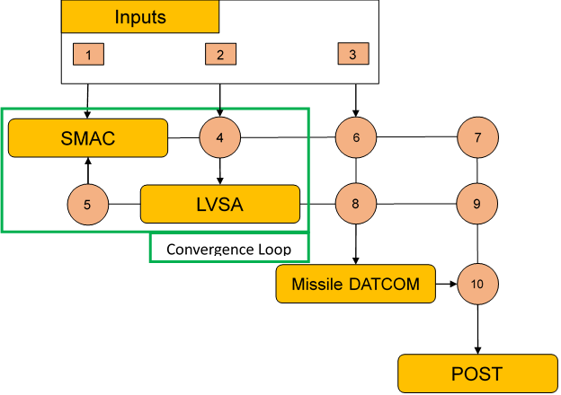
Figure 1. MDA environment
Table 1. Description of connected inputs and outputs for each tool in the MDA environment
1 | Width of Fin | 3 | Vehicle Diameter
1 | MEOP Target | 3 | Nose Shape Parameter
1 | Propellant | 4 | MEOP
1 | Grain Type | 4 | Insulation Thickness
1 | Star Points | 5 | Grain Diameter
1 | Inner Circle Diameter | 6 | Nozzle Diameter
1 | Outer Circle Diameter | 7 | Engine Deck
1 | Nozzle Length | 7 | Fuel Weight
2 | Stage Length | 8 | Complete Stage Length
2 | Vehicle Diameter | 9 | Structural Weight
2 | Nose Shape Parameter | 10 | Aerodynamic Decks

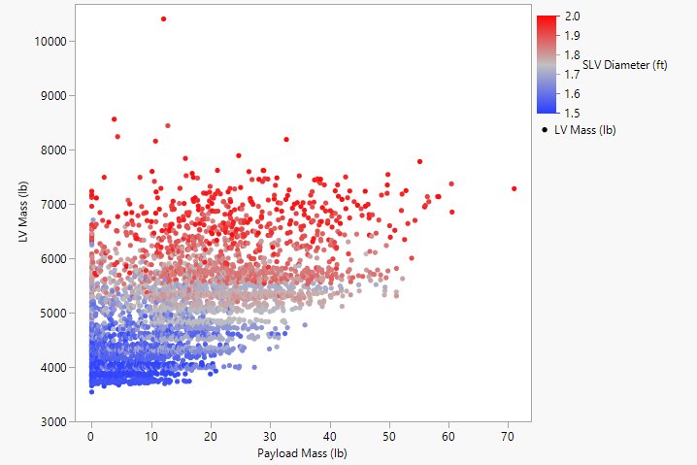
Figure 2. Sized Vehicle Mass (lb) vs Optimized Payload Mass to Orbit (lb)
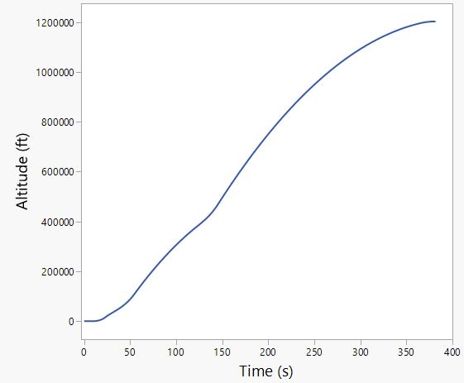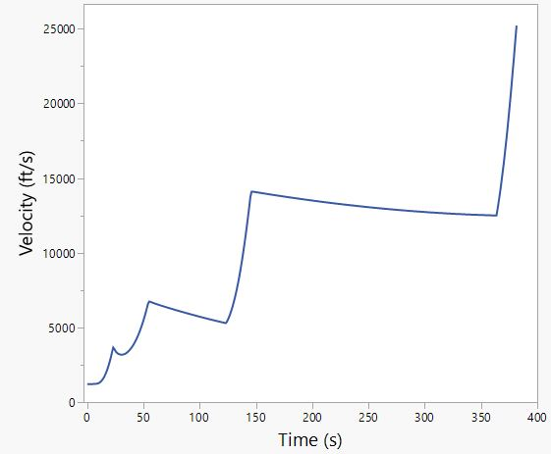
Figure 3. For SLV 2343, left: Altitude vs. Time and right: Velocity vs. Time on the right side staging, and delta V split is show by jumps in velocity which come from acceleration provided by the motor burn

- References
[1] Wekerle, T., Pessoa Filho, J. B., Costa, L. E., & Trabasso, L. G. (2017). Status and trends Of smallsats and their Status and trends Of smallsats and their launch vehicles — an Up-to-date Review. Journal of Aerospace Technology and Management, 9(3), 269-286. doi:10.5028/jatm.v9i3.853
[2] Pengcheng Wang., Hao Zhu., Luxi Xie., Minguang Xiao., Hui Tian., and Guobiao Cai., “Multi-Attribute Evaluation Approach for Small Launch Vehicle with Multi-objective Multi-discipline Design Optimization” 71th International Astronautical Congress (IAC), published online 12 October 2020.
[3] Daniel McCammon., Scott Lindsay., and Sadben Khan., “Multidisciplinary Optimization for Nano-Satellite Launch Vehicles,” 71th International Astronautical Congress (IAC), published online 12 October 2020.
[4] Rober C. Wilson., “Development and Validation of a Solid Rocket Motor Analysis Code” AE8900 Special Problems, Georgia Institute of Technology School of Aerospace Engineering, 13th December 2019.

Graduate Research Assistant, Aerospace Systems Design Laboratory, School of Aerospace Engineering, AIAA Member.
Research Engineer I, Aerospace Systems Design Laboratory, School of Aerospace Engineering, AIAA Member.
Research Engineer II, Aerospace Systems Design Laboratory, School of Aerospace Engineering, AIAA Member.
S.P. Langley Distinguished Regents Professor and ASDL Director, Aerospace Systems Design Laboratory, School of Aerospace Engineering, AIAA Fellow.

