Mapping yearly fine resolution global surface ozone through the Bayesian Maximum Entropy data fusion of observations and model output for 1990–2017
Marissa N. DeLang¹, Jacob S. Becker¹, Kai-Lan Chang^{2,3}, Marc L. Serre¹, Owen R. Cooper^{2,3}, Martin G. Schultz⁴, Sabine Schröder⁴, Xiao Lu⁵, Lin Zhang⁵, Makoto Deushi⁶, Beatrice Josse⁷, Christoph A. Keller^{8,9}, Jean-François Lamarque¹⁰, Meiyun Lin^{11,12}, Junhua Liu^{8,9}, Virginie Marécal⁷, Sarah A. Strode^{8,9}, Kengo Sudo^{13,14}, Simone Tilmes¹⁰, Li Zhang^{11,12,15}, Stephanie E. Cleland¹, Elyssa L. Collins¹, Michael Brauer^{16,17}, J. Jason West^{*,1}
¹Department of Environmental Sciences and Engineering, University of North Carolina at Chapel Hill, Chapel Hill, NC, USA
²Cooperative Institute for Research in Environmental Sciences, University of Colorado, Boulder, CO, USA
³NOAA Chemical Sciences Laboratory, Boulder, CO, USA
⁴Jülich Supercomputing Centre (JSC), Forschungszentrum Jülich, Jülich, Germany
⁵Laboratory for Climate and Ocean-Atmosphere Studies, Department of Atmospheric and Oceanic Sciences, School of Physics, Peking University, Beijing, China
⁶Meteorological Research Institute (MRI), Tsukuba, Japan
⁷Centre National de Recherches Météorologiques, Université de Toulouse, Météo-France, CNRS, Toulouse, France
⁸NASA Goddard Space Flight Center, Greenbelt, MD, USA
⁹Universities Space Research Association, Columbia, MD, USA
¹⁰National Center for Atmospheric Research, Boulder, CO, USA
¹¹NOAA Geophysical Fluid Dynamics Laboratory, Princeton, NJ, USA
¹²Program in Atmospheric and Oceanic Sciences, Princeton University, Princeton, NJ, USA
¹³Graduate School of Environmental Studies, Nagoya University, Nagoya, Japan
¹⁴Japan Agency for Marine-Earth Science and Technology (JAMSTEC), Yokosuka, Japan
¹⁵Department of Meteorology and Atmospheric Science, Pennsylvania State University, University Park, PA. USA
¹⁶Institute for Health Metrics and Evaluation, University of Washington, Seattle, Washington, USA
¹⁷School of Population and Public Health, University of British Columbia, Vancouver, British Columbia, Canada
TOC GRAPHIC
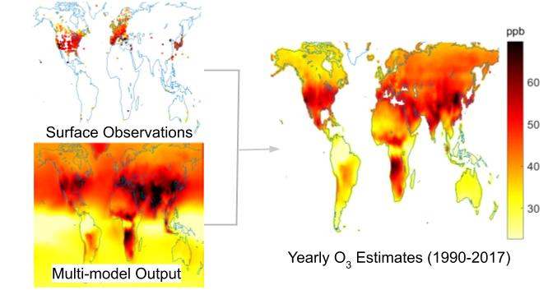
ABSTRACT
Estimates of ground-level ozone concentrations are necessary to determine the human health burden of ozone. To support the Global Burden of Disease Study, we produce yearly fine resolution global surface ozone estimates from 1990 to 2017 through a data fusion of observations and models. As ozone observations are sparse in many populated regions, we use a novel combination of the M³Fusion and Bayesian Maximum Entropy (BME) methods. With M³Fusion, we create a multi-model composite by bias-correcting and weighting nine global atmospheric chemistry models based on their ability to predict observations (8,834 sites globally) in each region and year. BME is then used to integrate observations, such that estimates match observations at each monitoring site with the observational influence decreasing smoothly across space and time until the output matches the multi-model composite. After estimating at 0.5° resolution using BME, we add fine spatial detail from an additional model, yielding estimates at 0.1° resolution. Observed ozone is predicted more accurately (R²=0.81 at test point, 0.63 at 0.1°, 0.62 at 0.5°) than the multi-model mean (R²=0.28 at 0.5°). Global ozone exposure is estimated to be increasing, driven by highly populated regions of Asia and Africa, despite decreases in the United States and Russia.

INTRODUCTION
Tropospheric ozone is harmful to human health through respiratory health effects associated with short and long term exposure.¹⁻³ Additionally, tropospheric ozone influences climate³ and damages plant growth.^{5,6} Surface ozone estimates at fine spatial resolution, which are required to determine the human health burden of ozone exposure, are typically based on two sources: monitoring networks and atmospheric chemistry models. Monitoring networks provide high spatial coverage of surface ozone observations in North America, Europe, Japan, South Korea, and recently China; however, stations are scarce elsewhere.⁷ Global atmospheric models provide concentration estimates across many years and cover all world regions; however, models have biases.⁸
The Global Burden of Disease (GBD) Study conducts a comparative risk assessment that estimates the health burden caused by specific risk factors from 1990 to present day, updated regularly. Two ambient air pollution risk factors are analyzed: fine particulate matter (PM_{2.5}) and ozone.^{9,10} GBD PM_{2.5} estimates are generated through a combination of satellite retrievals and land use information with a single atmospheric model calibrated to surface observations with a Bayesian hierarchical model.^{11,12} In contrast, global ozone estimates prior to GBD 2017¹³ were provided by a single model with no bias correction to observations.¹⁴ Satellite measurements provide PM_{2.5} estimates at fine resolution, but do not accurately detect surface ozone.^{14,15}
The recent Tropospheric Ozone Assessment Report (TOAR) collected ozone observations from thousands of sites around the world, which made it possible to incorporate surface observations into GBD estimates.^{7,16} For GBD 2017, TOAR observations were combined with six atmospheric models from phase one of the Chemistry-Climate Model Initiative (CCMI)¹⁷ using the M³Fusion method for the average of 2008 to 2014.¹⁸ In M³Fusion, the models were bias corrected and combined by finding the optimal linear combination of models in each world region, weighted based on their performance with respect to observations. Within two degrees of a monitoring station, the multi-model composite was then replaced with a spatial interpolation of observations. The 2008–2014 ozone distribution was extended backwards (1990–2008) by scaling with cubic splines relative to prior GBD ozone estimates and forwards (2014–2017) by extending the annual rate of change from 2012, for use in GBD 2017.¹³
While the M³Fusion method significantly improved upon previous GBD ozone estimates, we identify a potential for further improvements. In particular, the correction within two degrees of an observation can create discontinuities, which could be improved by using advanced geostatistical techniques that combine model output with observations using smooth weighting across space. Here we use a novel combination of the M³Fusion and Bayesian Maximum Entropy (BME) methods,¹⁹⁻²² which is uniquely suited to the challenges of mapping global ozone concentrations, as only observations and models provide useful information and observations are sparse in some world regions. The regional “large-scale” bias correction and weighting of models in the M³Fusion multi-model composite provides the best estimate of ozone far from observations. Then BME provides a local “small-scale” correction, by smoothly integrating observations in both space and time such that estimates match observations at the measurement site, and the influence of those observations decreases with distance according to the spatiotemporal covariance. Since ozone monitoring is inconsistent, allowing observations to affect predictions across time could provide more accurate estimates. Near observation locations, therefore, ozone estimates will be strongly influenced by observations. BME has previously been used to fuse ozone observations with models on state and national scales,²³⁻²⁵ but it has not been used previously globally, and apart from Chang et al.,¹⁸ we are not aware of any global data fusion of ozone observations and models.
We aim to estimate global fine resolution (0.1°) surface ozone for each year from 1990 to 2017 to support the GBD 2019 Study by combining surface observations with multiple global atmospheric models by first using M³Fusion to create multi-model composites, and then applying BME to smoothly fuse multi-model composites with observations in space and time. We improve upon the single 7-year mean ozone fields produced for GBD 2017¹⁸ by producing yearly output for 1990-2017, including additional observations and model output, smoothly weighting observations across space and time, and applying fine spatial structure based on fine resolution model output. To add fine spatial resolution for GBD, we apply the fine-scale spatial patterns from a global fine resolution model simulation.²⁶ Our annual global ozone maps were used by GBD 2019, which extrapolated to 2019 and estimated 365,000 (95% CI: 175,000-564,000) premature chronic obstructive pulmonary disease deaths globally, or 6.21 (2.99-9.63) million disability adjusted life years, from ambient ozone exposure in 2019.²⁷

MATERIALS AND METHODS
M³Fusion and BME are used in sequence to estimate global surface ozone concentrations. Other methods have been applied on smaller scales, such as neural networks using meteorological and emission variables to predict ozone,^{28,29} but those relationships may not apply elsewhere, and those methods are inappropriate where there are no observations.
GBD’s ozone metric for quantifying health outcomes from long term ozone exposure is the ozone season daily maximum 8-hour mixing ratio (OSDMA8).² OSDMA8 is calculated as the annual maximum of the six-month running mean of the monthly average daily maximum 8-hour mixing ratio, including months through March of the following year to contain the Southern Hemisphere summer. All observations, model output, and estimates are reported here as OSDMA8.
Surface Ozone Observations. We include surface ozone observations from TOAR and the Chinese National Environmental Monitoring Center (CNEMC) Network (Figure 1). TOAR is the world’s largest collection of in-situ hourly surface ozone observations covering 1970-2015.^{16,30} The database contains dense observations in North America, Europe, Japan, and South Korea, and sparse observations elsewhere.⁷ The database was updated for this project to include readily-available datasets for the years 2015–2017, but measurements were not updated for all nations previously included. CNEMC includes surface ozone observations for 2013–2017 in China,³¹ which were quality-controlled using the same algorithm that TOAR applies elsewhere. The total observations ranged from a minimum of 1,199 in 1990 to a maximum of 4,999 in 2015. The incomplete TOAR update in 2016 and 2017 yielded fewer observation sites than 2015.
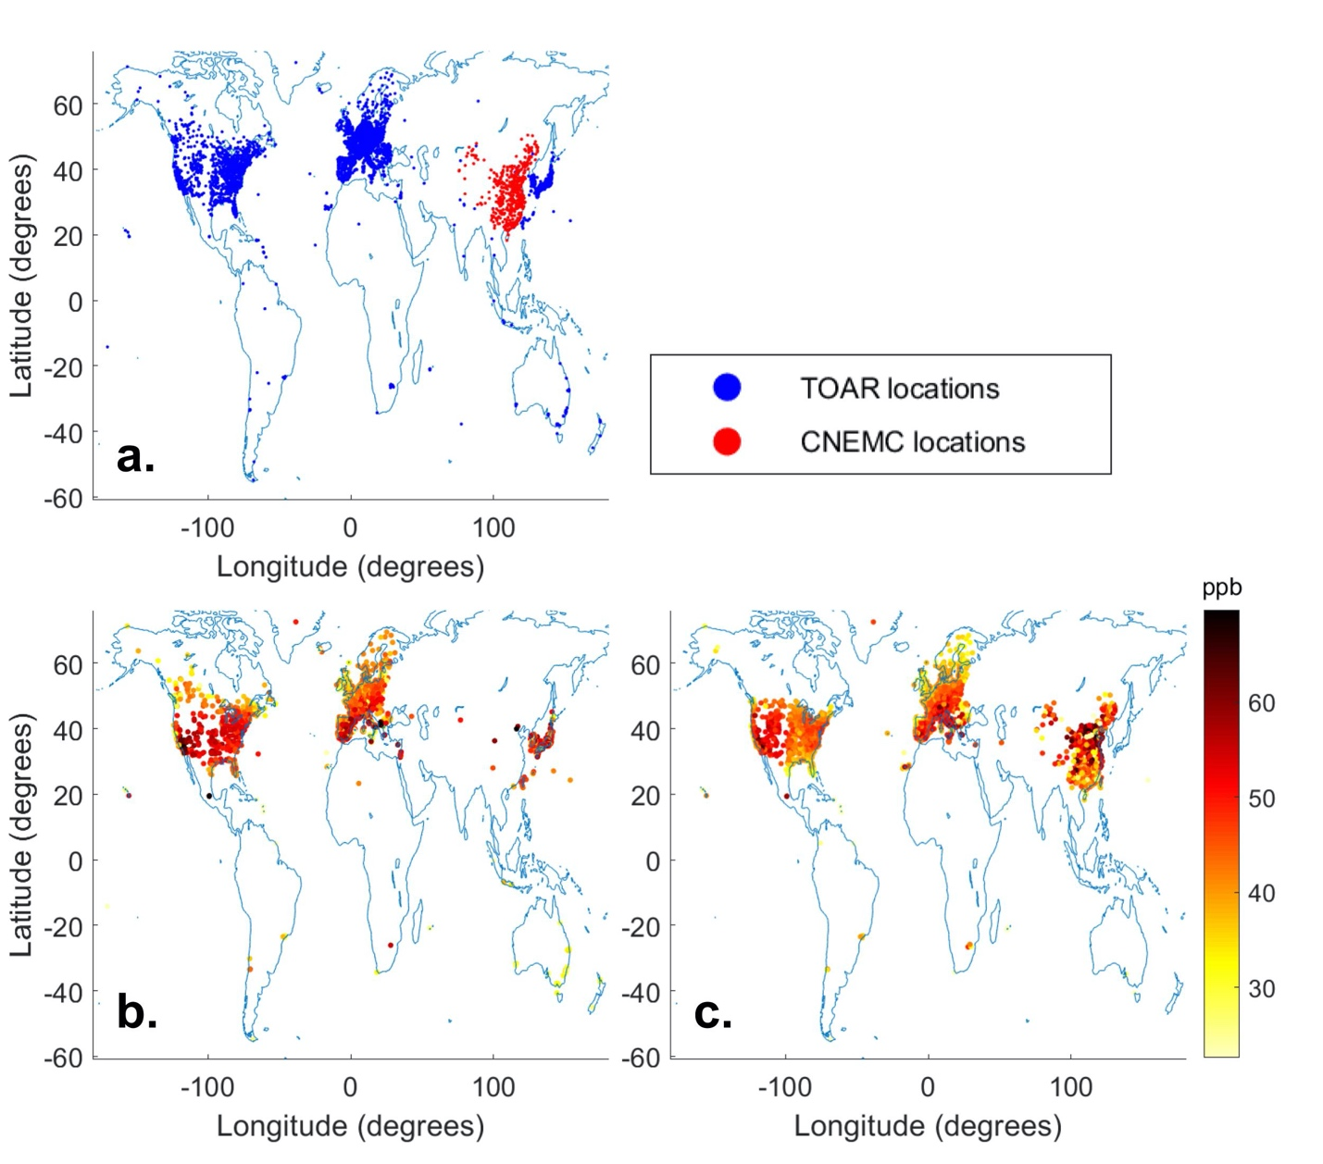
Figure 1. (a) TOAR and CNEMC monitoring locations with at least one valid yearly OSDMA8 observation over 1990–2017. In total, there are 8,834 monitoring stations, 7,269 from TOAR and 1,565 from CNEMC. (b) Surface observations as OSDMA8 in 2005, with an average of 45.5 ppb and maximum of 82.2 ppb in Mexico City, Mexico. (c) Surface observations as OSDMA8 in 2015, with an average of 46.2 ppb and maximum of 80.9 ppb in Zibo, China.
Atmospheric Chemistry Model Simulations. We incorporate modeled ozone from nine atmospheric chemistry model simulations (Table 1). The models, mostly from CCMI,¹⁷ report output for 1990–2010 from the specified dynamics REF-C1SD experiment,^{17,32} which uses annual MACCity emissions .^{33,34} Three models, MOCAGE, MERRA2-GMI, and GFDL-AM3, were extended past 2010. To increase models after 2010, we include output from the specified dynamics experiments of MRI-ESM2.0 and GFDL-AM4, for modified Coupled Model Intercomparison Project Phase 6 (CMIP6)³⁵ experiments. Hourly ozone mixing ratios were processed to OSDMA8, using the same algorithm as for observations.
Table 1. Nine atmospheric chemistry models used in this study.
Model | Years | Resolution | Experiment | Reference
CESM1 CAM4-Chem | 1990–2010 | 1.9° × 2.5° | CCMI REF-C1SD | ³⁶
CESM1 WACCM | 1990–2010 | 1.9° × 2.5° | CCMI REF-C1SD | ^{37,38}
CHASER | 1990–2010 | 2.8° × 2.8° | CCMI REF-C1SD | ³⁹⁻⁴¹
GFDL AM3 | 1990–2014 | 2° × 2.5° | CCMI REF-C1SD | ⁴²⁻⁴⁴
GFDL AM4 | 2010–2016 | 1° × 1.25° | CMIP6 nudged to NCEP windsª | ^{45,46}
MERRA2-GMI | 1990–2017 | 0.5° × 0.625° | MACCity and GFED-4s emissions^{b} | ^{47,48}
MOCAGE | 1990–2016 | 2° × 2° | CCMI REF-C1SD | ^{49,50}
MRI-ESM1r1 | 1990–2010 | 2.8° × 2.8° | CCMI REF-C1SD | ⁵¹
MRI-ESM2.0 | 2011–2017 | 2.8° × 2.8° | CMIP6 historical and ssp370^{c} | ⁴⁵²
ª Nudged to observed meteorology similar to GFDL-AM3 and uses anthropogenic emissions modified from CMIP6 to reflect recent NO_{x} trends in China and the United States⁴⁵
^{b} MACCity anthropogenic emissions with biomass burning emissions from Global Fire Emissions Dataset version 4s^{47,48}
^{c} Emissions from the CMIP6 historical (2011–2014) and ssp370 (2015–2017) experiments⁵²
Multi-model Composite. We use M³Fusion to create multi-model composites of the models available in each year from 1990–2017.¹⁸ This method corrects for model bias and finds the linear combination of models in each region and year that minimizes the mean square error as compared to observations. Since model resolution varies, we use bilinear interpolation to smooth yearly OSDMA8 to a 0.5° × 0.5° grid. We interpolate yearly observations from irregular monitoring station locations to the 0.5° grid using the stochastic partial differential equation approach.⁵³ In each of eight geographical regions (Figure S1) and each year, we weight each model to minimize the difference between the multi-model average and spatially interpolated observations based on a constrained least squares approach:
$\begin{matrix}minimize \\ \{α_{r}β_{rk};k=1,..,n\}\end{matrix}\sum_{s_{g}∈Regionr}{{\left(\hat{y}\left(s_{g}\right)-α_{r}-\sum_{k=1}^{n}{β_{rk}η_{k}\left(s_{g}\right)}\right)}^{2},}$ (1)
$$subject to \sum_{k=1}^{n}{β_{rk}=1 and β_{rk}≥0 }$$
where s_{g} is the grid cell at 0.5°resolution, ŷ(s_{g}) is the spatially interpolated observations, {$η$_{k}(s_{g}); k=1,...,n} is the model output on the same grid from the n models available, α_{r} is a constant that corrects overall bias in each region, and β_{rk} is an optimal weight for the k-th model in region r. All model weights are constrained to be positive and sum to 1. The constant offset α_{r} guarantees that the residuals from this optimization have a zero mean, through which the mean model bias is corrected in each region.¹⁸
Since M³Fusion relies on spatially interpolated observations to determine model weights, we modify the method for data sparse regions and years. In North America and Europe, we use weights based on each individual year’s models and observation values. For all other regions, we calculate individual year weights for 2000–2010, and apply weights from the aggregated 2000–2010 period to 1990–1999. For 2011–2017, East Asia uses individual year weights, while South America, Africa, South-Central Asia, Russia, and Oceania use weights from the aggregated 2011–2014 period, for which the TOAR dataset was complete.
Bayesian Maximum Entropy Methodology. BME is a geostatistical method that incorporates multiple forms of knowledge to predict an estimate of a homogenous, stationary, space-time random field.¹⁹⁻²² Using BME, we combine surface observations and annual multi-model composites to calculate an ozone estimate that matches observations at each monitoring station and the observational influence gradually diminishes across space and time until it matches the multi-model composite. BME has been described previously, including in the fusion of ozone observations with model output at state and national scales^{120-24,54}. We model the offset-removed, homogeneous space-time random field (S/TRF) X(p) at the space-time coordinate p=(s,t).²⁴ In BME, there are two forms of knowledge: site-specific and general. Site-specific knowledge can consist of hard data, with no assumed uncertainty, and soft, probabilistic data. Here we only have hard data, which is the linear limiting case of the BME data integration framework.²⁴ We remove the offset, the multi-model composite at monitoring stations (o_{z}(p₀)), from OSDMA8 observations (z₀) at monitoring station locations p₀ to obtain hard data x₀:
$x_{0}=z_{0}-o_{Z}(p_{0})$ (2)
The general knowledge base of X(p) includes the mean function m_{x}(p) = E[X], which is assumed to be zero, and the covariance function c_{x}(p,p’) = E[X(p)-m(p))(X(p’)-m(p’)],which is determined by the experimental covariance of x₀:
$\hat{c_{X}}\left(r,τ\right)≈\frac{1}{N\left(r,τ\right)}\sum_{i=1}^{N(r,τ)}{x_{head,i}x_{tail,i}-m_{X}^{2}}$ (3)
where N(r,τ) is the number of pairs of points with values (x_{head}, x_{tail}) separated by a distance r and time τ, and m_{x} is the mean of x₀. For the S/TRF X(p), we use an exponential covariance model to best fit the experimental covariance:
$c_{X}\left(r,τ\right)=C\left[γ\exp{\frac{-3r}{a_{r1}}}\exp{\frac{-3τ}{a_{t1}} }+λ\exp{\frac{-3r}{a_{r2}}}\exp{\frac{-3τ}{a_{t2}} }+\left(1-γ-λ\right)\exp{\frac{-3r}{a_{r3}}}\exp{\frac{-3τ}{a_{t3}} } \right]$ (4)
with parameters in the supporting information. The BME estimation process involves using general knowledge to obtain the maximum entropy prior probability density function (PDF) of f_{G}, updating f_{G} by integrating site-specific knowledge to obtain the epistemic Bayesian posterior PDF f_{K}, which provides a complete stochastic description of X_{k}=X(p_{k}) at the estimation point p_{k}, and computing space-time estimates based on f_{K}. The posterior PDF is defined as:
$f_{K}\left(x_{k}\right)=\left(\frac{f_{G}\left(x_{0}, x_{k}\right)}{f_{G}(x_{0})}\right)$ (5)
where x_{k} is the offset-removed estimate at points p_{k}. We define the ozone space-time random field (S/TRF), Z(p), as the sum of X(p) and the offset (multi-model composite):
$Z\left(p\right)=X\left(p\right)+o_{z}(p)$ (6)
We obtain the estimated OSDMA8 z_{k} at p_{k} by obtaining the BME estimate x_{k} for the S/TRF X(p) at p_{k}, and adding back o_{z}(p_{k}).
Fine Resolution Addition. We calculate ozone BME estimates at 0.5° resolution; however, a finer resolution is desirable for GBD to reduce spatial misalignment with population. Since neither the observations nor the models represent ozone at fine resolution, except where observations are dense, we use the spatial distribution of a fine resolution model. We use output from a NASA G5NR-Chem model²⁶ simulation from July 2013 to June 2014 at 0.125° resolution, which we regrid to 0.1° resolution, to provide the fine spatial structure within each 0.5° grid cell for each year 1990-2017. While we do not expect the modeled 2013–2014 ozone to be accurate for every year, we use the modeled spatial distribution to inform the fine-scale spatial pattern for each year, assuming the fine spatial patterns do not change. We calculate the difference between the BME estimate and the average of NASA G5NR-Chem grid cells for each 0.5°grid cell, and add this difference to each NASA G5NR-Chem grid cell at 0.1° to obtain our BME estimate at 0.1°. Consequently, the sub-grid variability of the output matches the G5NR-Chem model, and the average of each 0.5° grid cell remains the same as the BME estimate (Figures S2-3).

RESULTS
Multi-model Composite. We determine weights for each model in each region and year (Table S1). In most regions and years, the multi-model mean ozone (the simple average of all models) is biased high, as models generally overpredict ozone.^{8,18} Therefore, the M³Fusion multi-model composite (Figure 2) tends to decrease average ozone compared to the multi-model mean.
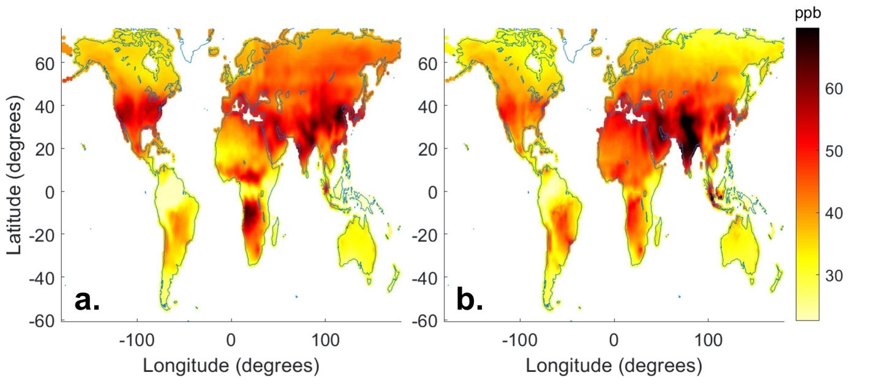
Figure 2. Multi-model composite as OSDMA8 in 2005 (a) and 2015 (b).
BME Coarse Resolution Output. We obtain yearly ozone output at 0.5° resolution, with an associated variance at each estimation point (Figure 3; Figures S4-31). The ozone output matches an observation at its space-time location, and the observation’s influence decreases in space and time according to the derived spatiotemporal covariance (Equation S3). In regions with high observational coverage, there is greater spatial variation in our output, whereas less monitored regions are smoother. Across the years, areas of low estimated ozone include the Amazon, Oceania, and southeastern Africa; while high ozone is estimated in East Asia, South-Central Asia, western North America, and central Africa. The Amazon and central Africa are unmonitored; therefore, their respective low and high ozone estimates are based on model output reflecting ozone chemical destruction over the Amazon⁵⁵ and biomass burning in Africa.⁵⁶
In BME, observations are treated as hard data with no variance; therefore, regions with the highest number of observations have the lowest variance, such as North America, Europe, and Japan in 2005 and additionally eastern China in 2015. Away from observations, the output is equal to the multi-model composite and the variance reaches a maximum of 60 ppb², equal to the variance of the offset removed observations. To visualize how BME adjusted the multi-model composite using observations, we subtract the multi-model composite from our BME estimate (Figure 3). In unmonitored regions, there is no difference between our BME output and the multi-model composite. When addingfine resolution in the final step, differences on the global scale are unnoticeable (Figures S4-31).
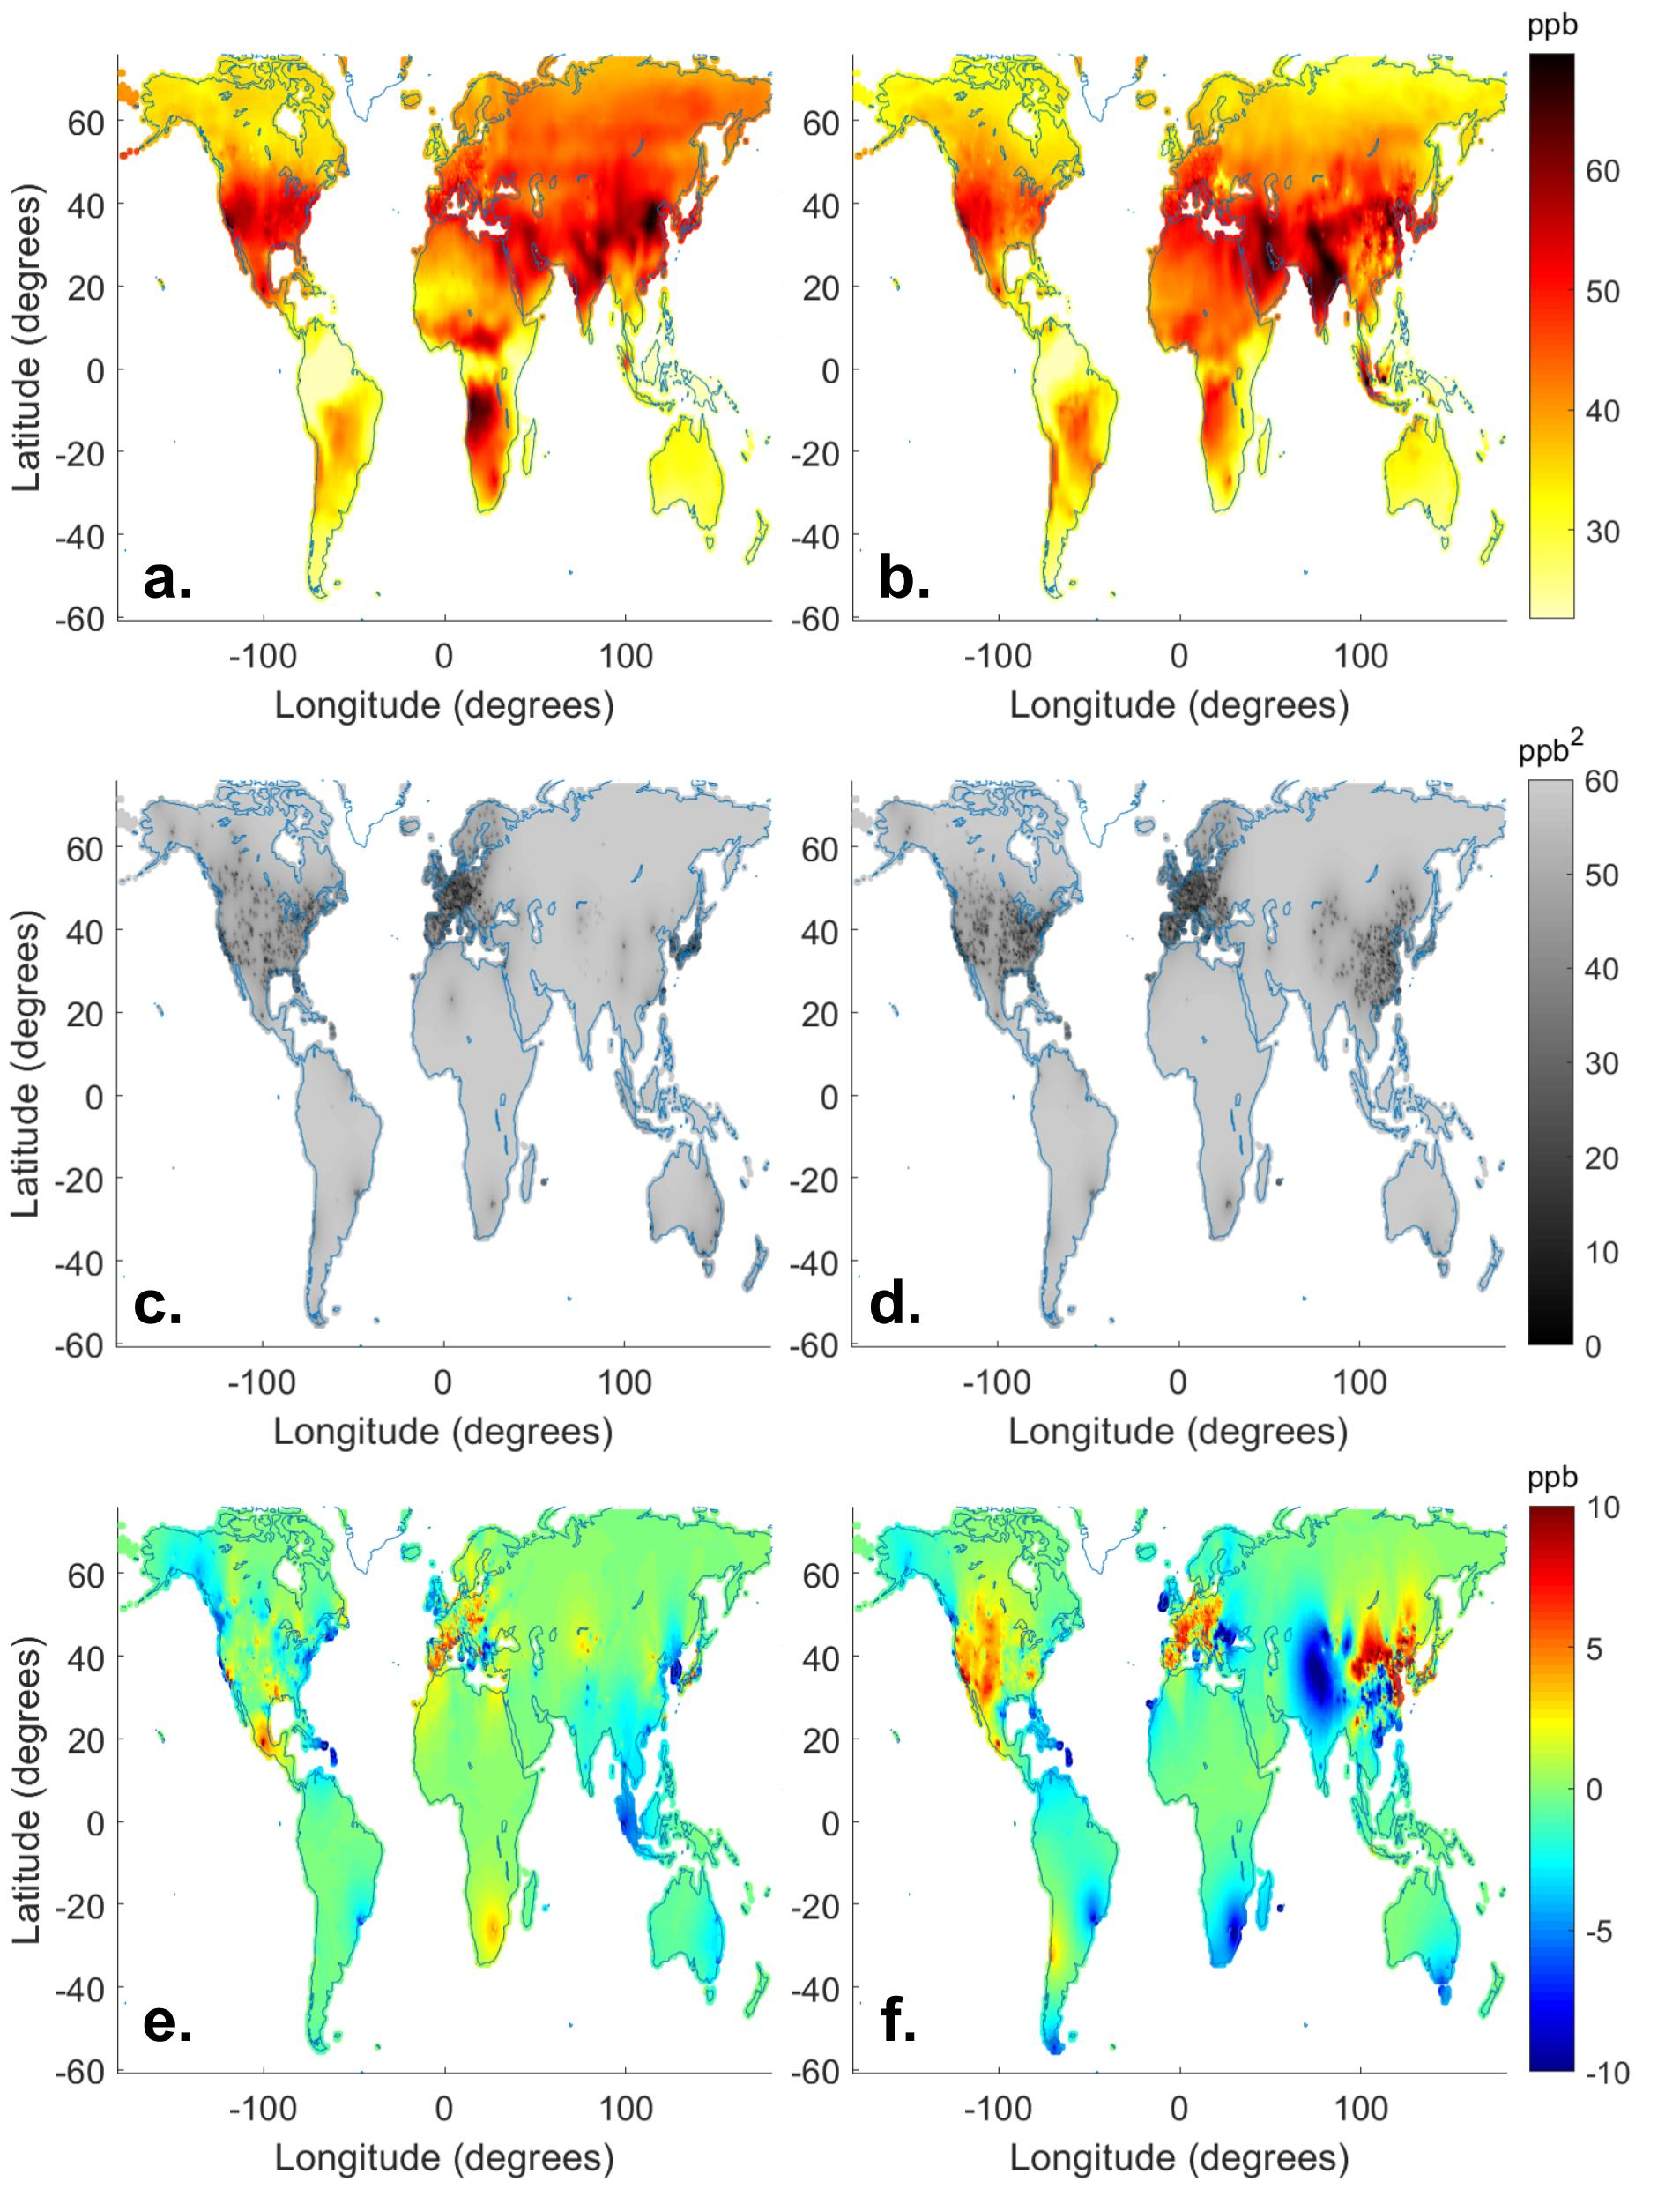
Figure 3. BME estimate as OSDMA8 for 2005 (a) and 2015 (b). BME variance for 2005 (c) and 2015 (d). Effect of BME fusion of observations (BME estimate minus multi-model composite) for 2005 (e) and 2015 (f). Positive values occur where our estimate is higher than the multi-model composite, negative values where our estimate is lower.
Influence of Observations through Time. The ability of an observation to influence other years is an important component of our method, since observational coverage changes, generally with more stations being added. The extent of an observation’s influence on other years depends on the number of nearby stations in space and time, with more remote stations having a longer temporal influence. In addition to the space-time BME estimates above, we also perform “space-only” BME, in which observations only influence ozone estimates across space in a single year.
By taking the difference between space-time and space-only results, we evaluate how observations influence other years. Since the CNEMC observations started in 2013, analyzing 2012 highlights their temporal influence (Figure 4). On the global scale, the differences between the space-time and space-only methods are difficult to distinguish, but the major differences occur across China. Most of the non-zero differences occur in areas where CNEMC observations were added in 2013–2017, showing the influences of those observations (Figure 4). Whereas Figure 4 shows that BME largely decreased ozone estimates over China in 2012, the effect of adding BME differed among years, including increasing ozone in 2015 and 2016 (Figures S29-30).
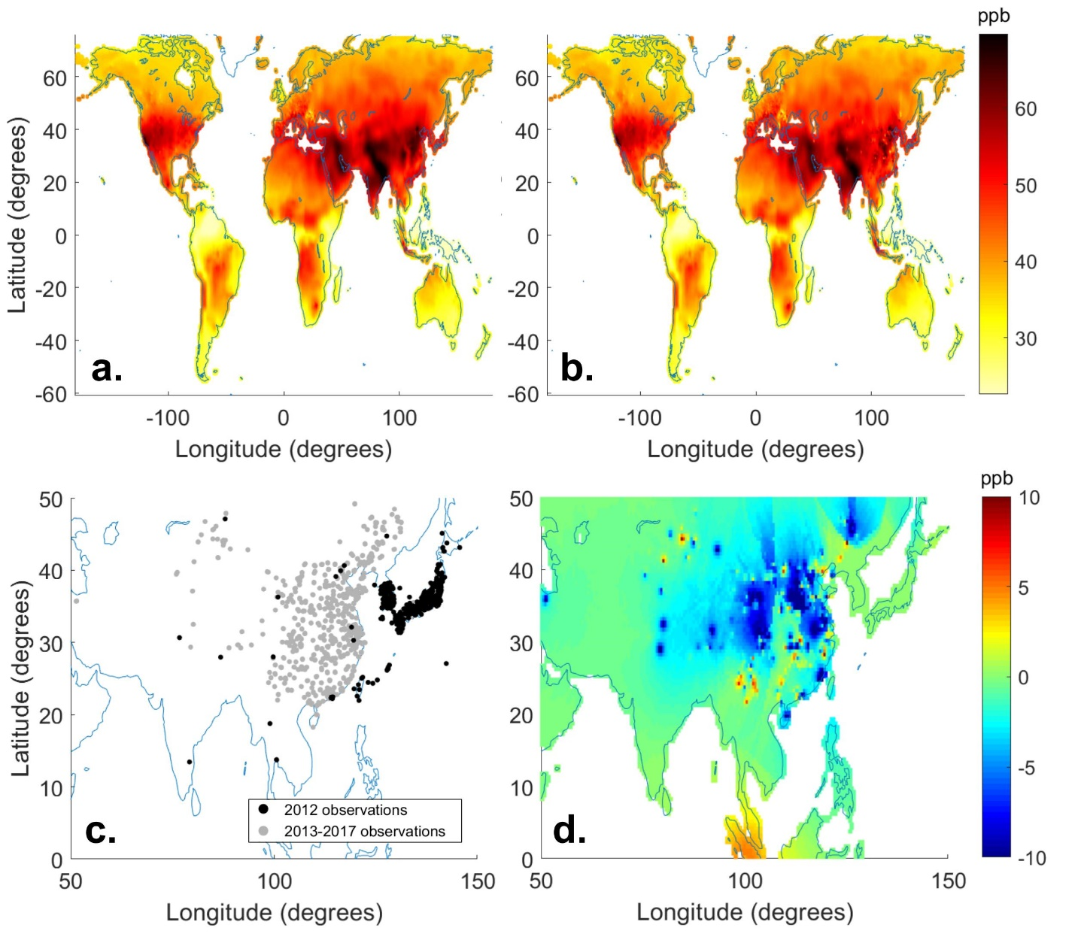
Figure 4. (a) Space-only BME result in 2012 as OSDMA8. (b) Space-time BME result in 2012 as OSDMA8. (c) Observation locations in 2012 and 2013–2017. (d) Effect of BME space-time influence of observations (space-time BME minus the space-only BME) for 2012.
Evaluation. To evaluate our results, we perform a leave one out cross validation (LOOCV), where one observation is removed and we evaluate our ability to predict this observation, in five scenarios:
- Multi-model mean: average of all model output available in a given year.
- Multi-model composite: combination of model output using M³Fusion.
- Space-only correction: BME corrected multi-model composite where observations only influence across space in a single year.
- Space-time correction: BME corrected multi-model composite where observations influence across space and time.
- Fine resolution: space-time corrected output with fine resolution from the NASA G5NR-Chem model.
LOOCV was performed using two methods: predicting ozone at the test point’s grid cell and at the test point’s specific space-time location. The grid cell prediction was performed to allow a fair comparison between scenarios, since the fine resolution addition is limited to predicting at the grid cell level, and to evaluate the benefit of increasing output resolution. When predicting at the test point’s grid cell, each subsequent scenario improved performance, as shown by the root mean square error (RMSE) (Table 2). The multi-model composite outperforms the multi-model mean across all validation statistics. Correcting the multi-model composite across space using observations improves the results, which is further amplified by correcting across both space and time. Adding fine spatial structure, which gives our final output, slightly improves performance relative to the space-time scenario. All methods overestimate ozone in comparison to observations, as shown by the mean error (Table 2), though our final product is biased high only slightly.
Table 2. LOOCV statistics,ª where results are evaluated in the 0.5 or 0.1 grid cells containing the test point, or at the test point’s space-time location.

Scenario | Prediction location | RMSE (ppb) | ME (ppb) | R² | varE (ppb²) | varZ (ppb²)
Multi-model Mean | 0.5° grid cell | 13.76 | 11.00 | 0.28 | 68.48 | 62.08
Multi-model Composite | 0.5° grid cell | 7.82 | 1.05 | 0.30 | 60.03 | 43.09
Space-only Correction | 0.5° grid cell | 6.01 | 0.42 | 0.57 | 36.00 | 60.14
Space-time Correction | 0.5° grid cell | 5.62 | 0.57 | 0.62 | 31.30 | 62.01
Fine Resolution | 0.1° grid cell | 5.54 | 0.22 | 0.63 | 30.68 | 63.24
Multi-model Composite | Test point’s location | 7.82 | 1.07 | 0.30 | 60.00 | 43.19
Space-time Correction | Test point’s location | 3.99 | 0.01 | 0.81 | 15.94 | 81.26
ª Root mean square error (RMSE), mean error (ME), R-squared (R²), variance of error (varE), and variance of the estimated ozone (varZ). The mean and variance of observed ozone are mO=45.62 ppb and varO=81.96 ppb², respectively. Statistic definitions are included in Table S2.

For comparison with other studies, we include statistics for predicting at the specific space-time location (Table 2). The addition of the space-time correction to the multi-model composite decreased RMSE from 7.82 to 3.99 ppb, a 49% reduction. In comparison, for Chang et al.¹⁸, the correction to the multi-model composite decreased the RMSE from 5.16 to 3.82 ppb, a 26% reduction. The greater relative reduction in RMSE here is attributed to the incorporation of both spatial and temporal autocorrelation, and shows our improvement to Chang et al.¹⁸.
Population-Weighted Ozone Trends. With our yearly output, we use global gridded population from GBD 2019 to analyze trends in population-weighted ozone as an indicator of exposure. The 2019 global population is used for all years, meaning that differences in exposure result from changes in ozone, not population. To determine how ozone exposure has changed from 1990–2017, we examine the percent of the global population exposed to intervals of OSDMA8 (Figure 5). Global ozone exposure increases over this period, with an increase in the global population exposed to highest concentrations (>55 ppb). In 2017, 21.3% of the global population was exposed to OSDMA8 higher than 65 ppb, more than double the percentage in any previous year. Note that the OSDMA8 metric is not compared easily with national standards or WHO guidelines, which are typically based on the daily 8-hr maximum. For perspective, the risk of all-cause, circulatory, and respiratory mortality reportedly increases by 2%, 3%, and 12% per 10 ppb increase in long-term OSDMA8, respectively, with some evidence that ozone influences mortality at concentrations above about 35 ppb.²
We analyze the population-weighted trends from 1990–2017 for each world region (Figure 5) and the most populous countries (Figure S32). Globally, there is a positive trend in population weighted ozone for 1990–2017, driven in large part by positive trends in highly populated and polluted regions of South-Central Asia, East Asia, and Africa. Low population-weighted ozone occurs in South America and Oceania. Negative trends occur in North America and Russia; Europe has a weak negative trend, with the European Union showing no change. We caution that these trends are most uncertain before 2000 and in regions with few observations; under these conditions our estimated trends mainly reflect models and a small number of observations. Year-to-year changes in ozone in regions with few observations may also result from using different model weights in individual years. These trends are supported by a previous analysis of TOAR data for 2000–2014 summertime ozone, which found a positive trend in East Asia and negative trends in North America and Europe.⁵⁷ Similarly, a study of CNEMC observations showed increases in China for 2013–2017.³¹ One study suggests that the 2013-2017 increase over China was influenced most by the decrease of PM_{2.5}, which increased HO_{x} radicals⁵⁸; therefore, a PM_{2.5} increase might explain our estimated 2007-2013 ozone decrease. Increasing trends in other regions with few observations, including Africa and South Central Asia are supported by long-term aircraft⁵⁹ and satellite column observations.⁴⁷
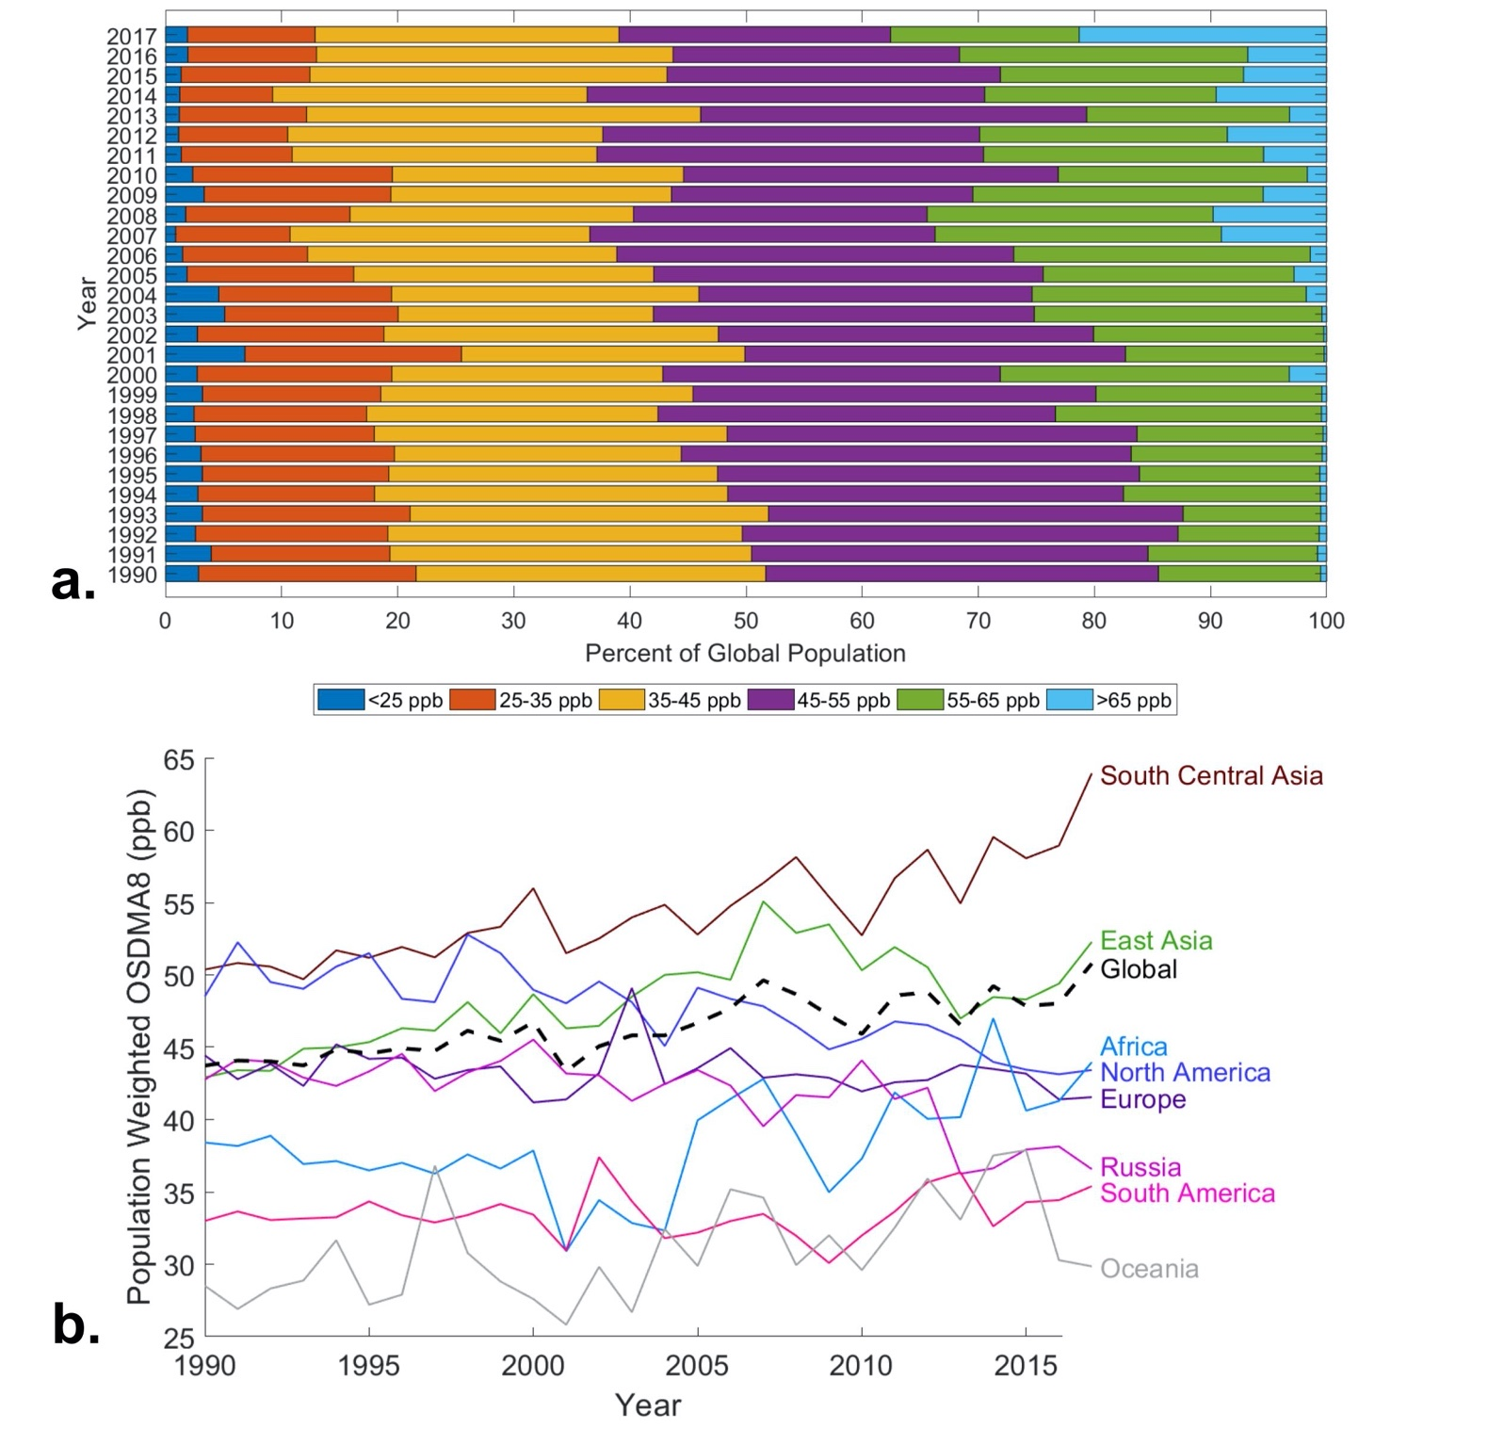
Figure 5. (a) Percent of the global population exposed to 10 ppb intervals of OSDMA8 from 1990-2017. (b) Ozone trend regionally (regions defined in Figure S1) over 1990–2017 for the metric of population weighted OSDMA8. All trends have p-values less than 0.05, except for Europe and South America (Table S3). Uncertainty intervals are included in Figures S33-46.

DISCUSSION
We create fine resolution yearly ozone distributions for 1990–2017 that incorporate surface observations and output from nine atmospheric chemistry models, using a novel combination of the M³Fusion method for creating a multi-model composite, which dominates the large-scale ozone estimates, and BME data fusion which influences ozone estimates near observation locations, smoothly integrating observations in space and time. Our analysis finds that methods incorporating observations outperform ozone estimated from models only. Additionally, the influence of an observation across multiple years in BME further improves our ozone estimate. Our method’s major strengths include the incorporation of multiple data types, the smooth weighting of observational influence across space and time, the ability to output a variance at every estimation point, and the estimation of global ozone with fine spatial structure. The improvement in model performance from using our combination of M³Fusion and BME provides a caution against using simple spatial interpolations of observations or output of a model without bias correction, to represent ozone. Although we improve upon the previous GBD ozone estimate, some limitations remain. The lack of monitoring stations in large populous regions limits our abilities to understand ozone exposure in these areas, where these uncertainties affect both the multi-model composite and BME data fusion. Our method is limited in years with fewer observations and models available; additionally, the fine resolution model output that informs the fine spatial pattern of our output is only available for a single year. Future work may apply a nonlinear bias correction, or use machine learning to correct bias,⁶⁰ to the multi-model composite to improve the global offset, and thus the overall estimation. Our work also shows the value of using multiple models in creating a multi-model composite, as output from each model was selected (weight>0) in at least some regions and years.
Our method can be applied to future years as more observations and model output become available. Additionally, our method can be used to estimate ozone metrics other than OSDMA8, including for studies of vegetation and crop impacts.⁶¹ While model output and geostatistical techniques like BME can estimate global ozone, estimates suffer from the lack of observations in some world regions. Additional observations, especially in unmonitored regions with large populations including megacities in low- and middle-income nations, are essential to improve understanding of ozone exposure and health burden.
Ozone exposure is increasing globally, with global population-weighted ozone showing a positive trend from 1990-2017, driven by strong positive trends in highly populated and polluted regions of Asia and Africa. The increasing global exposure to ozone indicates that current ozone management policies are failing to reduce ozone exposure in many regions of the world. Our results can be used by policy makers to identify regions where ozone pollution could be mitigated through reductions of ozone precursor emissions, mainly from fossil-fuel combustion, on local, national and continental scales, or through international agreements to reduce emissions, including methane, that affect global background ozone. ^{62,63}
ASSOCIATED CONTENT
Supporting Information. The supporting information includes multi-model composite model weights, covariance parameters, fine resolution addition example, yearly maps for all relevant scenarios, cross validation statistics, and national ozone trends with uncertainty intervals.
AUTHOR INFORMATION
Corresponding Author: J. Jason West, jasonwest@unc.edu, 919-843-3928.
ACKNOWLEDGEMENTS
We acknowledge support from the NASA Health and Air Quality Applied Sciences Team (#NNX16AQ30G) and the National Institute for Occupational Safety and Health (T42-OH008673). Makoto Deushi was supported by the Japan Society for the Promotion of Science (JP20K04070).

REFERENCES
(1) Jerrett, M.; Burnett, R. T.; Arden Pope, C.; Ito, K.; Thurston, G.; Krewski, D.; Shi, Y.; Calle, E.; Thun, M. Long-Term Ozone Exposure and Mortality. N. Engl. J. Med. 2009, 360 (11), 1085–1095. https://doi.org/10.1056/NEJMoa0803894.
(2) Turner, M. C.; Jerrett, M.; Pope, C. A.; Krewski, D.; Gapstur, S. M.; Diver, W. R.; Beckerman, B. S.; Marshall, J. D.; Su, J.; Crouse, D. L.; Burnett, R. T. Long-Term Ozone Exposure and Mortality in a Large Prospective Study. Am. J. Respir. Crit. Care Med. 2016, 193 (10), 1134–1142. https://doi.org/10.1164/rccm.201508-1633OC.
(3) Di, Q.; Dai, L.; Wang, Y.; Zanobetti, A.; Choirat, C.; Schwartz, J. D.; Dominici, F. Association of short-term exposure to air pollution with mortality in older adults, J. Amer. Med. Assoc. 2017, 318 (24), 2446-2456. doi: 10.1001/jama.2017.17923.(4) Myhre, G., Shindell, D., Bréon, F.-M., Collins, W., Fuglestvedt, J., Huang, J., Koch, D., Lamarque, J.-F., Lee, D., Mendoza, B., et al. Anthropogenic and Natural Radiative Forcing. In: Climate Change 2013: The Physical Science Basis. Contribution of Working Group I to the Fifth Assessment Report of the Intergovernmental Panel on Climate Change [Stocker, T.F., D. Qin, G.-K. Plattner, M. Ti; Cambridge University Press: Cambridge, United Kingdom and New York, NY, USA, 2013.
(5) U.S. EPA. Integrated Science Assessment for Ozone and Related Photochemical Oxidants; U.S. Environmental Protection Agency, Washington, DC, EPA/600/R-20/012, 2020.
(6) Emberson, L. D.; Pleijel, H.; Ainsworth, E. A.; van den Berg, M.; Ren, W.; Osborne, S.; Mills, G.; Pandey, D.; Dentener, F.; Büker, P.; et al. Ozone Effects on Crops and Consideration in Crop Models. Eur. J. Agron. 2018, 100, 19–34. https://doi.org/10.1016/j.eja.2018.06.002.
(7) Fleming, Z. L.; Doherty, R. M.; Von Schneidemesser, E.; Malley, C. S.; Cooper, O. R.; Pinto, J. P.; Colette, A.; Xu, X.; Simpson, D.; Schultz, M. G.; et al. Tropospheric Ozone Assessment Report: Present-Day Ozone Distribution and Trends Relevant to Human Health. Elementa 2018, 6 (1). https://doi.org/10.1525/elementa.273.
(8) Cooper, O. R.; Parrish, D. D.; Ziemke, J.; Balashov, N. V.; Cupeiro, M.; Galbally, I. E.; Gilge, S.; Horowitz, L.; Jensen, N. R.; Lamarque, J.-F.; et al. Global Distribution and Trends of Tropospheric Ozone: An Observation-Based Review. Elem. Sci. Anthr. 2014, 2 (0), 000029. https://doi.org/10.12952/journal.elementa.000029.
(9) Lim, S. S.; Vos, T.; Flaxman, A. D.; Danaei, G.; Shibuya, K.; Adair-Rohani, H.; Amann, M.; Anderson, H. R.; Andrews, K. G.; Aryee, M.; et al. A Comparative Risk Assessment of Burden of Disease and Injury Attributable to 67 Risk Factors and Risk Factor Clusters in 21 Regions, 1990-2010: A Systematic Analysis for the Global Burden of Disease Study 2010. Lancet 2012, 380 (9859), 2224–2260. https://doi.org/10.1016/S0140-6736(12)61766-8.
(10) Cohen, A. J.; Brauer, M.; Burnett, R.; Anderson, H. R.; Frostad, J.; Estep, K.; Balakrishnan, K.; Brunekreef, B.; Dandona, L.; Dandona, R.; et al. Estimates and 25-Year Trends of the Global Burden of Disease Attributable to Ambient Air Pollution: An Analysis of Data from the Global Burden of Diseases Study 2015. Lancet 2017, 389 (10082), 1907–1918. https://doi.org/10.1016/S0140-6736(17)30505-6.
(11) Shaddick, G.; Thomas, M. L.; Green, A.; Brauer, M.; van Donkelaar, A.; Burnett, R.; Chang, H. H.; Cohen, A.; Dingenen, R. Van; Dora, C.; et al. Data Integration Model for Air Quality: A Hierarchical Approach to the Global Estimation of Exposures to Ambient Air Pollution. J. R. Stat. Soc. Ser. C Appl. Stat. 2018, 67 (1), 231–253. https://doi.org/10.1111/rssc.12227.
(12) Shaddick, G.; Thomas, M. L.; Amini, H.; Broday, D.; Cohen, A.; Frostad, J.; Green, A.; Gumy, S.; Liu, Y.; Martin, R. V.; et al.Data Integration for the Assessment of Population Exposure to Ambient Air Pollution for Global Burden of Disease Assessment. Environ. Sci. Technol. 2018, 52 (16), 9069–9078. https://doi.org/10.1021/acs.est.8b02864.
(13) Stanaway, J. D.; Afshin, A.; Gakidou, E.; Lim, S. S.; Abate, D.; Abate, K. H.; Abbafati, C.; Abbasi, N.; Abbastabar, H.; Abd-Allah, F.; et al. Global, Regional, and National Comparative Risk Assessment of 84 Behavioural, Environmental and Occupational, and Metabolic Risks or Clusters of Risks for 195 Countries and Territories, 1990-2017: A Systematic Analysis for the Global Burden of Disease Study 2017. Lancet 2018, 392 (10159), 1923–1994. https://doi.org/10.1016/S0140-6736(18)32225-6.
(14) Brauer, M.; Freedman, G.; Frostad, J.; Van Donkelaar, A.; Martin, R. V.; Dentener, F.; Dingenen, R. Van; Estep, K.; Amini, H.; Apte, J. S.; et al. Ambient Air Pollution Exposure Estimation for the Global Burden of Disease 2013. Environ. Sci. Technol. 2016, 50 (1), 79–88. https://doi.org/10.1021/acs.est.5b03709.
(15) Gaudel, A.; Cooper, O. R.; Ancellet, G.; Barret, B.; Boynard, A.; Burrows, J. P.; Clerbaux, C.; Coheur, P. F.; Cuesta, J.; Cuevas, E.; et al. Tropospheric Ozone Assessment Report: Present-Day Distribution and Trends of Tropospheric Ozone Relevant to Climate and Global Atmospheric Chemistry Model Evaluation. Elementa 2018, 6 (1). https://doi.org/10.1525/elementa.291.
(16) Schultz, M. G.; Schröder, S.; Lyapina, O.; Cooper, O.; Galbally, I.; Petropavlovskikh, I.; Von Schneidemesser, E.; Tanimoto, H.; Elshorbany, Y.; Naja, M.; et al. Tropospheric Ozone Assessment Report: Database and Metrics Data of Global Surface Ozone Observations. Elem Sci Anth 2017, 5 (0), 58. https://doi.org/10.1525/elementa.244.
(17) Morgenstern, O.; Hegglin, M.; Rozanov, E.; O’Connor, F.; Luke Abraham, N.; Akiyoshi, H.; Archibald, A.; Bekki, S.; Butchart, N.; Chipperfield, M.; et al. Review of the Global Models Used within Phase 1 of the Chemistry-Climate Model Initiative (CCMI). Geoscientific Model Development. Copernicus GmbH February 13, 2017, pp 639–671. https://doi.org/10.5194/gmd-10-639-2017.
(18) Chang, K.-L.; Cooper, O. R.; West, J. J.; Serre, M. L.; Schultz, M. G.; Lin, M.; Marécal, V.; Josse, B.; Deushi, M.; Sudo, K.; et al. A New Method (M ³ Fusion v1) for Combining Observations and Multiple Model Output for an Improved Estimate of the Global Surface Ozone Distribution. Geosci. Model Dev. 2019, 12 (3), 955–978. https://doi.org/10.5194/gmd-12-955-2019.
(19) Christakos, G. A Bayesian/Maximum-Entropy View to the Spatial Estimation Problem. Math. Geol. 1990, 22 (7), 763–777. https://doi.org/10.1007/BF00890661.
(20) Christakos, G.; Bogaert, P.; Serre, M. L. Temporal GIS : Advanced Functions for Field-Based Applications; Springer Berlin Heidelberg, 2001.
(21) Serre, M. L.; Christakos, G. Modern Geostatistics: Computational BME Analysis in the Light of Uncertain Physical Knowledge - The Equus Beds Study. Stoch. Environ. Res. Risk Assess. 1999, 13 (1–2), 1–26. https://doi.org/10.1007/s004770050029.
(22) Christakos, G.; Kolovos, A.; Serre, M. L.; Vukovich, F. Total Ozone Mapping by Integrating Databases from Remote Sensing Instruments and Empirical Models. IEEE Trans. Geosci. Remote Sens. 2004, 42 (5), 991–1008. https://doi.org/10.1109/TGRS.2003.822751.
(23) Nazelle, A. De; Arunachalam, S.; Serre, M. L. Bayesian Maximum Entropy Integration of Ozone Observations and Model Predictions: An Application for Attainment Demonstration in North Carolina. Environ. Sci. Technol. 2010, 44 (15), 5707–5713. https://doi.org/10.1021/es100228w.
(24) Xu, Y.; Serre, M. L.; Reyes, J.; Vizuete, W. Bayesian Maximum Entropy Integration of Ozone Observations and Model Predictions: A National Application. Environ. Sci. Technol. 2016, 50 (8), 4393–4400. https://doi.org/10.1021/acs.est.6b00096.
(25) Xu, Y.; Serre, M. L.; Reyes, J. M.; Vizuete, W. Impact of Temporal Upscaling and Chemical Transport Model Horizontal Resolution on Reducing Ozone Exposure Misclassification. Atmos. Environ. 2017, 166, 374–382. https://doi.org/10.1016/j.atmosenv.2017.07.033.
(26) Hu, L.; Keller, C. A.; Long, M. S.; Sherwen, T.; Auer, B.; Da Silva, A.; Nielsen, J. E.; Pawson, S.; Thompson, M. A.; Trayanov, A. L.; et al. Global Simulation of Tropospheric Chemistry at 12.5&amp;Thinsp;Km Resolution: Performance and Evaluation of the GEOS-Chem Chemical Module (V10-1) within the NASA GEOS Earth System Model (GEOS-5 ESM). Geosci. Model Dev. 2018, 11 (11), 4603–4620. https://doi.org/10.5194/gmd-11-4603-2018.
(27) Murray, C. J. L.; Aravkin, A. Y.; Zheng, P.; Abbafati, C.; Abbas, K. M.; Abbasi-Kangevari, M.; Abd-Allah, F.; Abdelalim, A.; Abdollahi, M.; Abdollahpour, I.; et al. Global Burden of 87 Risk Factors in 204 Countries and Territories, 1990–2019: A Systematic Analysis for the Global Burden of Disease Study 2019. Lancet 2020, 396 (10258), 1223–1249. https://doi.org/10.1016/S0140-6736(20)30752-2.(28) Seltzer, K. M.; Shindell, D. T.; Kasibhatla, P.; Malley, C. S. Magnitude, Trends, and Impacts of Ambient Long-Term Ozone Exposure in the United States from 2000 to 2015. Atmos. Chem. Phys. 2020, 20 (3), 1757–1775. https://doi.org/10.5194/acp-20-1757-2020.
(29) Kleinert, F.; Leufen, L.; Schultz, M. IntelliO3-Ts v1.0: A Neural Network Approach to Predict near-Surface Ozone Concentrations in Germany. Geosci. Model Dev. Discuss. 2020, 1–69. https://doi.org/10.5194/gmd-2020-169.
(30) Schultz, Martin G; Schröder, Sabine; Lyapina, Olga; Cooper, Owen R; Galbally, Ian; Petropavlovskikh, Irina; von Schneidemesser, Erika; Tanimoto, Hiroshi; Elshorbany, Yasin; Naja, Manish; et al. Tropospheric Ozone Assessment Report, Links to Global Surface Ozone Datasets. PANGAEA 2017.
(31) Lu, X.; Hong, J.; Zhang, L.; Cooper, O. R.; Schultz, M. G.; Xu, X.; Wang, T.; Gao, M.; Zhao, Y.; Zhang, Y. Severe Surface Ozone Pollution in China: A Global Perspective. Environ. Sci. Technol. Lett. 2018, 5 (8), 487–494. https://doi.org/10.1021/acs.estlett.8b00366.
(32) Orbe, C.; Plummer, D. A.; Waugh, D. W.; Yang, H.; Jöckel, P.; Kinnison, D. E.; Josse, B.; Marecal, V.; Deushi, M.; Abraham, N. L.; et al. Description and Evaluation of the Specified-Dynamics Experiment in the Chemistry-Climate Model Initiative. Atmos. Chem. Phys. 2020, 20 (6), 3809–3840. https://doi.org/10.5194/acp-20-3809-2020.
(33) Lamarque, J.-F.; Bond, T. C.; Eyring, V.; Granier, C.; Heil, A.; Klimont, Z.; Lee, D.; Liousse, C.; Mieville, A.; Owen, B.; et al. Historical (1850–2000) Gridded Anthropogenic and Biomass Burning Emissions of Reactive Gases and Aerosols: Methodology and Application. Atmos. Chem. Phys. 2010, 10 (15), 7017–7039. https://doi.org/10.5194/acp-10-7017-2010.
(34) Granier, C.; Bessagnet, B.; Bond, T.; D’Angiola, A.; van der Gon, H. D.; Frost, G. J.; Heil, A.; Kaiser, J. W.; Kinne, S.; Klimont, Z.; et al. Evolution of Anthropogenic and Biomass Burning Emissions of Air Pollutants at Global and Regional Scales during the 1980-2010 Period. Clim. Change 2011, 109 (1), 163–190. https://doi.org/10.1007/s10584-011-0154-1.
(35) Eyring, V.; Bony, S.; Meehl, G. A.; Senior, C. A.; Stevens, B.; Stouffer, R. J.; Taylor, K. E. Overview of the Coupled Model Intercomparison Project Phase 6 (CMIP6) Experimental Design and Organization. Geosci. Model Dev. 2016, 9 (5), 1937–1958. https://doi.org/10.5194/gmd-9-1937-2016.
(36) Tilmes, S.; Lamarque, J.-F.; Emmons, L. K.; Kinnison, D. E.; Ma, P.-L.; Liu, X.; Ghan, S.; Bardeen, C.; Arnold, S.; Deeter, M.; et al. Description and Evaluation of Tropospheric Chemistry and Aerosols in the Community Earth System Model (CESM1.2). Geosci. Model Dev. 2015, 8 (5), 1395–1426. https://doi.org/10.5194/gmd-8-1395-2015.
(37) Garcia, R. R.; Smith, A. K.; Kinnison, D. E.; de la Cámara, Á.; Murphy, D. J. Modification of the Gravity Wave Parameterization in the Whole Atmosphere Community Climate Model: Motivation and Results. J. Atmos. Sci. 2017, 74 (1), 275–291. https://doi.org/10.1175/JAS-D-16-0104.1.
(38) Marsh, D. R.; Mills, M. J.; Kinnison, D. E.; Lamarque, J. F.; Calvo, N.; Polvani, L. M. Climate Change from 1850 to 2005 Simulated in CESM1(WACCM). J. Clim. 2013, 26 (19), 7372–7391. https://doi.org/10.1175/JCLI-D-12-00558.1.
(39) Sudo, K.; Takahashi, M.; Kurokawa, J.; Akimoto, H. CHASER: A Global Chemical Model of the Troposphere 1. Model Description. J. Geophys. Res. Atmos. 2002, 107 (D17), ACH 7-1-ACH 7-20. https://doi.org/10.1029/2001JD001113.
(40) Sudo, K.; Takahashi, M.; Akimoto, H. CHASER: A Global Chemical Model of the Troposphere 2. Model Results and Evaluation. J. Geophys. Res. Atmos. 2002, 107 (D21), ACH 9-1-ACH 9-39. https://doi.org/10.1029/2001JD001114.
(41) Watanabe, S.; Hajima, T.; Sudo, K.; Nagashima, T.; Takemura, T.; Okajima, H.; Nozawa, T.; Kawase, H.; Abe, M.; Yokohata, T.; et al. MIROC-ESM 2010: Model Description and Basic Results of CMIP5-20c3m Experiments. Geosci. Model Dev. 2011, 4 (4), 845–872. https://doi.org/10.5194/gmd-4-845-2011.
(42) Lin, M.; Fiore, A. M.; Horowitz, L. W.; Cooper, O. R.; Naik, V.; Holloway, J.; Johnson, B. J.; Middlebrook, A. M.; Oltmans, S. J.; Pollack, I. B.; et al. Transport of Asian Ozone Pollution into Surface Air over the Western United States in Spring. J. Geophys. Res. Atmos. 2012, 117 (4). https://doi.org/10.1029/2011JD016961.
(43) Lin, M.; Horowitz, L. W.; Oltmans, S. J.; Fiore, A. M.; Fan, S. Tropospheric Ozone Trends at Mauna Loa Observatory Tied to Decadal Climate Variability. Nat. Geosci. 2014, 7 (2), 136–143. https://doi.org/10.1038/ngeo2066.
(44) Lin, M.; Horowitz, L. W.; Payton, R.; Fiore, A. M.; Tonnesen, G. US Surface Ozone Trends and Extremes from 1980 to 2014: Quantifying the Roles of Rising Asian Emissions, Domestic Controls, Wildfires, and Climate. Atmos. Chem. Phys. 2017, 17 (4), 2943–2970. https://doi.org/10.5194/acp-17-2943-2017.
(45) Zhang, L.; Lin, M.; Langford, A.; Horowitz, L.; Senff, C.; Klovenski, E.; Wang, Y.; Alvarez II, R.; Petropavlovskikh, I.; Cullis, P.; et al. Characterizing Sources of High Surface Ozone Events in the Southwestern U.S. with Intensive Field Measurements and Two Global Models. Atmos. Chem. Phys. 2019, 1–47. https://doi.org/10.5194/acp-2019-990.
(46) Horowitz, L. W., Naik, V., Paulot, F., Ginoux, P., Dunne, J. P., Mao, J. Q., et al. The GFDL Global Atmospheric Chemistry-Climate Model AM4.1: Model Description and Simulation Characteristics. J. Adv. Model. Earth Syst. 2020, submitted.
(47) Ziemke, J. R.; Oman, L. D.; Strode, S. A.; Douglass, A. R.; Olsen, M. A.; McPeters, R. D.; Bhartia, P. K.; Froidevaux, L.; Labow, G. J.; Witte, J. C.; et al. Trends in Global Tropospheric Ozone Inferred from a Composite Record of TOMS/OMI/MLS/OMPS Satellite Measurements and the MERRA-2 GMI Simulation. Atmos. Chem. Phys. 2019, 19 (5), 3257–3269. https://doi.org/10.5194/acp-19-3257-2019.
(48) Strode, S. A.; Ziemke, J. R.; Oman, L. D.; Lamsal, L. N.; Olsen, M. A.; Liu, J. Global Changes in the Diurnal Cycle of Surface Ozone. Atmos. Environ. 2019, 199, 323–333. https://doi.org/10.1016/j.atmosenv.2018.11.028.
(49) Josse, B.; Simon, P.; Peuch, V.-H. Radon Global Simulations with the Multiscale Chemistry and Transport Model MOCAGE. Tellus B Chem. Phys. Meteorol. 2004, 56 (4), 339–356. https://doi.org/10.3402/tellusb.v56i4.16448.
(50) Teyssèdre, H.; Michou, M.; Clark, H. L.; Josse, B.; Karcher, F.; Olivié, D.; Peuch, V.-H.; Saint-Martin, D.; Cariolle, D.; Attié, J.-L.; et al. New Tropospheric and Stratospheric Chemistry and Transport Model MOCAGE-Climat for Multi-Year Studies: Evaluation of the Present-Day Climatology and Sensitivity to Surface Processes. Atmos. Chem. Phys. 2007, 7 (22), 5815–5860. https://doi.org/10.5194/acp-7-5815-2007.
(51) Adachi, Y.; Yukimoto, S.; Deushi, M.; Obata, A.; Nakano, H.; Tanaka, T. Y.; Hosaka, M.; Sakami, T.; Yoshimura, H.; Hirabara, M.; et al. Basic Performance of a New Earth System Model of the Meteorological Research Institute. Pap. Meteorol. Geophys. 2013, 64, 1–19. https://doi.org/10.2467/mripapers.64.1.
(52) Yukimoto, S.; Kawai, H.; Koshiro, T.; Oshima, N.; Yoshida, K.; Urakawa, S.; Tsujino, H.; Deushi, M.; Tanaka, T.; Hosaka, M.; et al. The Meteorological Research Institute Earth System Model Version 2.0, MRI-ESM2.0: Description and Basic Evaluation of the Physical Component. J. Meteorol. Soc. Japan 2019, 97 (5), 931–965. https://doi.org/10.2151/jmsj.2019-051.
(53) Bolin, D.; Lindgren, F. Spatial Models Generated by Nested Stochastic Partial Differential Equations, with an Application to Global Ozone Mapping. Ann. Appl. Stat. 2011, 5 (1), 523–550. https://doi.org/10.1214/10-AOAS383.
(54) Christakos, G. Modern Spatiotemporal Geostatistics; Oxford University Press: Cary, NC, 2000.
(55) Freire, L. S.; Gerken, T.; Ruiz-Plancarte, J.; Wei, D.; Fuentes, J. D.; Katul, G. G.; Dias, N. L.; Acevedo, O. C.; Chamecki, M. Turbulent Mixing and Removal of Ozone within an Amazon Rainforest Canopy. J. Geophys. Res. Atmos. 2017, 122 (5), 2791–2811. https://doi.org/10.1002/2016JD026009.
(56) Bauer, S. E.; Im, U.; Mezuman, K.; Gao, C. Y. Desert Dust, Industrialization, and Agricultural Fires: Health Impacts of Outdoor Air Pollution in Africa. J. Geophys. Res. Atmos. 2019, 124 (7), 4104–4120. https://doi.org/10.1029/2018JD029336.
(57) Chang, K.-L.; Petropavlovskikh, I.; Copper, O. R.; Schultz, M. G.; Wang, T. Regional Trend Analysis of Surface Ozone Observations from Monitoring Networks in Eastern North America, Europe and East Asia. Elem Sci Anth 2017, 5 (0), 50. https://doi.org/10.1525/elementa.243.
(58) Li, K.; Jacob, D. J.; Liao, H.; Shen, L.; Zhang, Q.; Bates, K. H. Anthropogenic Drivers of 2013–2017 Trends in Summer Surface Ozone in China. Proc. Natl. Acad. Sci. U. S. A. 2019, 116 (2), 422–427. https://doi.org/10.1073/pnas.1812168116.
(59) Gaudel, A.; Cooper, O. R.; Chang, K. L.; Bourgeois, I.; Ziemke, J. R.; Strode, S. A.; Oman, L. D.; Sellitto, P.; Nédélec, P.; Blot, R.; et al. Aircraft Observations since the 1990s Reveal Increases of Tropospheric Ozone at Multiple Locations across the Northern Hemisphere. Sci. Adv. 2020, 6 (34). https://doi.org/10.1126/sciadv.aba8272.
(60) Ivatt, P. D.; Evans, M. J. Improving the Prediction of an Atmospheric Chemistry Transport Model Using Gradient-Boosted Regression Trees. Atmos. Chem. Phys. 2020, 20 (13), 8063–8082. https://doi.org/10.5194/acp-20-8063-2020.
(61) Mills, G.; Pleijel, H.; Malley, C. S.; Sinha, B.; Cooper, O. R.; Schultz, M. G.; Neufeld, H. S.; Simpson, D.; Sharps, K.; Feng, Z.; et al. Tropospheric Ozone Assessment Report: Present-Day Tropospheric Ozone Distribution and Trends Relevant to Vegetation. Elementa 2018, 6 (1). https://doi.org/10.1525/elementa.302.
(62) West, J. J.; Fiore, A. M.; Horowitz, L. W.; Mauzerall, D. L. Global Health Benefits of Mitigating Ozone Pollution with Methane Emission Controls. Proc. Natl. Acad. Sci. U. S. A. 2006, 103 (11), 3988–3993. https://doi.org/10.1073/pnas.0600201103.
(63) Dentener, F.; Keating, T.; Akimoto, H. Hemispheric Transport of Air Pollution: Part A: Ozone and Particulate Matter; Economic Commission for Europe, Geneva, 2010.

