SpaceOps-2021, 11, x1271
ISS Payload Operations Training During the COVID-19 Pandemic: Impacts and Solutions
Craig Cruzenª*, Jeff Montgomery^{b**}

ª ISS Payload Operations Director, NASA Marshall Space Flight Center, Huntsville, Alabama, USA, craig.cruzen@nasa.gov
* Corresponding Author

^{b} Space Systems Operations Training Team Lead, Teledyne Brown Engineering, Huntsville, Alabama, USA,
jeff.montgomery-1@nasa.gov
** Presenting Author

Abstract

The onset of the COVID-19 pandemic brought a dramatic and rapid transformation to almost every aspect of humanity in 2020. The world’s space agencies and their missions were not immune to the wide-sweeping changes. One discipline principally affected was mission operations and the various groups supporting that function. Mission support teams, especially for complex and crewed missions like the International Space Station were forced to rapidly rethink how and where control center staff performed their vital work. Operations training – an essential element to mission ops, had unique hurdles to overcome.
Operations training is responsible for preparing astronaut crews for their missions, providing training to flight controllers, as well as ensuring that new team members are ready to join their colleagues. Every element of training was impacted by COVID restrictions. From orientation and introductory classes for new controllers, simulations and advanced lessons, On the Job Training and final evaluations; all aspects faced new challenges. Trainers at NASA’s Marshall Space Flight Center in Huntsville, Alabama, were forced to become more efficient with trainees and resources to continue supporting payload operations.
The pandemic started in the USA in March 2020. Immediately, NASA mandated that the support for ISS real-time operations was critical. As a result, physical access to key facilities was restricted. Trainers and trainees had to quickly shift to 100 percent remote learning. In the short term, this was not a problem. However, instructors discovered lessons that they were accustomed to delivering in a classroom environment did not translate to remote teaching. Another hurdle to operations training was the mandate that all simulations could only be held remotely. The logistics of even small simulations proved to be challenging due to IT restrictions and public internet limitations. With simulations essentially stopped, as well as the restrictions on most OJT, trainees were essentially stopped in their advancement towards certification.
Once limitations were identified, trainers prioritized new options. Transitioning to all electronic learning materials was a relatively easy fix. Teaching to large groups took additional shifts in the training paradigm. Methods for preparing astronauts for their missions were revised. Simulation supervisors found more efficient techniques to provide realistic training experience. Communication and approvals from management was essential. In every case, the payload operations instructors found novel solutions to all functions listed. This paper will discuss the factors and solutions payloads operations trainers found to keep scientific research on the ISS flying forward to mission success.

Keywords: ISS, Payloads, Training, MSFC, COVID, Pandemic

Acronyms/Abbreviations
HOSC – Huntsville Operations Support Center
ISS – International Space Station
IT – Information Technology
MSFC – Marshall Space Flight Center
NASA – National Aeronautics and Space Administration
OJT – On the Job Training
POIC – Payload Operations and Integration Center
PPE – Personal Protection Equipment
Remote IVoDS - Remote Internet Voice Distribution System
SPG – Sim Planning Group
VPN - Virtual Private Network

- Introduction

The onset and the protracted duration of the COVID-19 pandemic brought about a dramatic and rapid transformation to almost every aspect of humanity in 2020. The world’s space agencies and their missions were not immune to the unpredictable and wide-sweeping changes. One discipline principally affected was mission operations and the various groups supporting that critical function. Mission support teams, especially for complex and crewed missions like the International Space Station (ISS), were forced to rapidly rethink how and where control center staff performed their vital work.
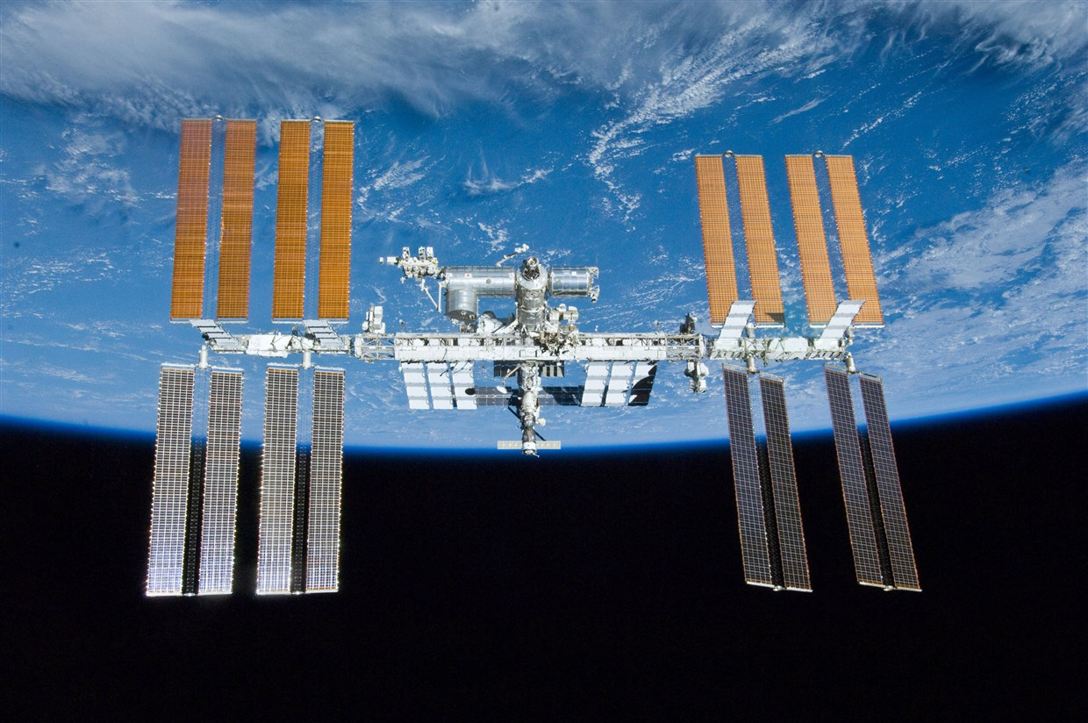
Fig. 1: The International Space Station
Flight controllers and engineers at the NASA’s Marshall Space Flight Center (MSFC) in Huntsville, Alabama are responsible for operating the vast array of scientific experiments [1]. They are also responsible for payload support equipment, including data and video systems onboard the ISS and well as a complex ground control and distribution network. This team has been supporting 24/7 real-time operation of ISS payload operations since 2001. Flight controllers, engineers, and operations professionals at the Payload Operations and Integration Center (POIC) (See Fig. 2) work in close coordination with the Mission Control Center in Houston, as well as international partners around the globe to support ongoing scientific utilization of the ISS [2].

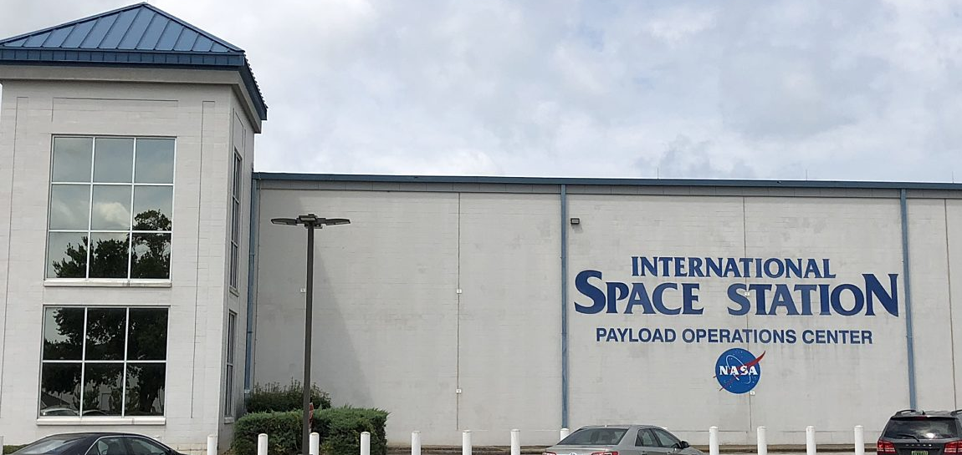
Fig. 2: NASA’s ISS Payload Operations Center in Huntsville, Alabama
The full force of the COVID-19 pandemic arrived in the United States in early March 2020. Immediately, NASA mandated that support for ISS real-time operations was critical. As a result, physical access to control centers was restricted to only those people directly supporting operations. Thus, the use of on-site NASA facilities for any non-critical operations activities was also restricted.
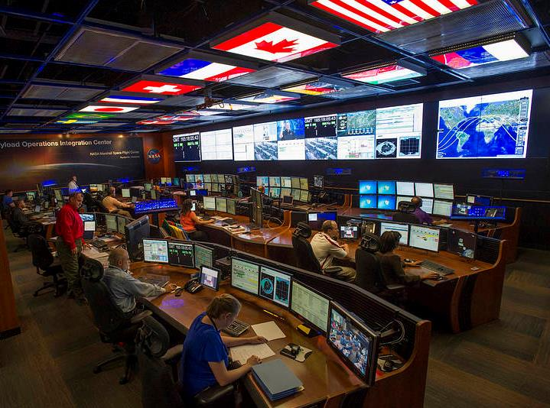
Fig. 3: ISS Payload Operations Center Prior to the COVID-19 Pandemic (NASA Social Media Photo)
Operations training is responsible for preparing astronaut crews for their missions, providing recurring proficiency and currency material to flight controllers, as well as ensuring new team members are ready to join their colleagues on console. Obviously, training is an important element to mission operations. As a result of NASA imposed restrictions, astronauts, trainees and trainers had unique hurdles to overcome during the initial months of the coronavirus pandemic. Every element of training was impacted including many specialized training facilities. In addition to these limitations, social distancing constraints were implemented and thus trainer-to-trainee, face-to-face interaction were not authorized. From orientation and introductory classes, simulations, advanced lessons, On the Job Training (OJT), and final evaluations; all aspects faced new challenges. NASA operations trainers were forced to rethink, retool, and become more efficient with trainees and training resources in order to continue supporting payload operations on the ISS.

After a short reaction period, NASA began orchestrating how mission training would be safely restarted. One critical need was astronaut training. ISS mission schedules were impacted, and astronaut preflight training was reengineered to ensure the virus was not carried to the ISS. Likewise, ground controller training adaptation was a major focus during the period of March - May 2020. Once limitations were identified and documented, ISS trainers at MSFC discussed, proposed, and prioritized new options and techniques. Transitioning to all electronic learning materials and certifications was a relatively easy fix. Teaching courses to large and diverse groups took additional shifts in the NASA training paradigm. Likewise, methods and procedures for preparing astronauts for their missions were forced to be revised. Simulation supervisors and their teams were required to find more efficient techniques to provide realistic training experiences. Communication to, and approval from management was essential. In every case, the ISS payload operations instructors found novel and efficient solutions to all functions listed above. This paper will discuss the factors and solutions that trainers found to keep scientific research on the ISS flying forward to mission success.

- Impacts and Barriers to Operations Training

2.1 March 2020: Operations with Social Distancing and Remote Ops
Upon declaration of the international COVID-19 pandemic in March of 2020, all US government facilities including the NASA field centers were restricted to only mission critical personnel. In the case of NASA and ISS operations, this meant that only astronauts, flight controllers, and engineers were authorized to go on site. In short, only those who were essential for ensuring safe mission continuation and that control center facilities were operational [3]. Initially this did not include trainers who ran simulators, nor did it include trainees who were learning how to become flight controllers. All other employees were instructed to stay at home and work remotely with NASA provided Information Technology (IT) assets. Fortunately, the space agency had been working to incorporate remote IT systems for some time, so there were very few problems with the quick transition to tele-work status.
ISS operations personnel at MSFC were only permitted to go to the Huntsville Operations Support Center (HOSC). Brief visits to offices to retrieve critical items like headsets, computers, or coffee mugs were allowed. Social distancing was instituted in the control rooms. Where previously operators had sat near each other; now they were separated by at least 6 feet between people, and in most cases 12 feet or more. See Figure 3. This was accomplished by leaving open seats in between console positions, moving some controllers to alternate rooms, and still other controllers operated remotely from their homes thru secure Virtual Private Network (VPN) technology. This use of primary flight controllers in such a widely dispersed, remote operation at non-government facilities was truly a first for human spaceflight operations.
Pandemic protocols and other considerations were documented and compulsory for control teams. These included sanitizing each workstation at the start and end of every shift. NASA provided Personal Protection Equipment (PPE) such as face masks, hand sanitizer and disinfectant wipes. Personnel were always required to stay socially distanced from each other during their shifts. If anyone was potentially exposed to the virus, they were required to quarantine at home for 14 days to ensure there was no reinfection within the control center. This consideration put extreme pressure on the workforce as sometimes these voluntary quarantines weren’t discovered until the last minute which led to a rush to find replacements.
These same pandemic protocols caused NASA training to quickly shift to 100% remote learning. As mentioned above, in the first few weeks this was not a problem since NASA had prepared IT resources that facilitated remote access to classes, documents, and teleconferences. However, instructors quickly discovered that often the lessons they were accustomed to delivering in a classroom environment did not translate well to remote learning. The lack of non-verbal communication with the class became a barrier to instruction. Trainees early in their training flows, were the hardest hit by these restrictions. New employee orientations were hindered by recently credentialed employees struggling to be assigned computers, badges and learning onboarding steps. Another hurdle was the mandate that simulations could only be held remotely (March thru May 2020). The logistics of planning and executing even small simulations proved to be challenging, almost impossible, due to IT restrictions and public internet limitations. With integrated simulations halted, as well as prohibitions on most OJT, trainees were essentially stopped in their advancement towards certification.
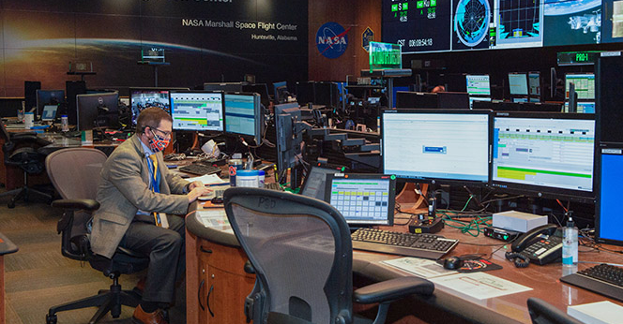
Fig. 4: ISS Payload Operations Center with Pandemic Protocols and Social Distancing (Public Release Approved)
Prior to the pandemic, a significant portion of ISS flight controller training, especially for payload operations, involved traveling to other NASA centers to utilize unique training facilities at JSC and international sites. Starting in March of 2020, that was no longer an option. In most cases, trainees were forced to make do with reviewing pictures, videos and electronic procedures without having the opportunity to put their hands on the hardware. This may have been the most significant barrier to training during the pandemic (one that persists as of May 2021). In some cases, remote video training was made available to new flight controllers, but it remains the exception.
An additional barrier was the formal tracking of curriculum progress (i.e. Individual Training Plans). Even though NASA had been transitioning to electronic documents for years, some organizations were still relying on “pen and ink” documents to formalize training completion. The logistics of implementing secure and controlled e-signature documents in a standardized, NASA approved format had to be addressed.
2.2 Spring/Summer 2020: Operations Training Begins to Adapt
As stated above, the barriers to operations training were multi-faceted and daunting. This is clearly reflected in Figure 5 which shows the number of POIC certifications from January thru May.

Fig. 5 POIC Trainee Certifications: January – May 2020
After impacts to existing training plans were identified, the next step was to determine ways to get training restarted. Following a month of standing down training due to COVID, it became obvious this was going to be a long-term issue. The POIC team recognized it was time to move from reaction mode to planning mode to begin to get critical training executed. This took on increased importance as certified cadre members began to feel the impacts of COVID. The ISS Program could not afford get to a point where there were not enough certified personnel available to continue 24/7 operations.

In April of 2020, the MSFC Training Panel, made up of management representatives and senior trainers, held an important strategy meeting with all the Training Leads to identify areas for training emphasis. This included:

- Identifying those trainees who were closest to certification. These trainees would be given priority for the remainder of their training to get them certified as quickly as possible. The remaining trainees were then grouped based on how complete their Individual Training Plans were.
- Determining how/if existing training could be done remotely.
- Identifying training that must be done in person. Rationale then would be developed on why it must be done in person along with the steps that would be taken to meet NASA COVID restrictions such as social distancing, PPE, cleaning before and after sessions.

Priorities for flight control training were identified and set as follows:
- Highest Priority: Phase 2 Training – finishing certifications for console positions where training was approximately 25% complete or more. These trainees needed the following resources:
  - Remote classroom training
  - Roundtables with mentors and managers
  - Observation OJT
  - Performance OJT

- Second Priority: Phase 1 Training – Initial training for new employees. These trainees needed the following resources:
  - Payload Academy (8-week curriculum to give new hires a common base of NASA and ISS operations fundamentals)
  - Orientation for new employees
  - After completing these, the trainees moved into the Phase 2 category

- Third Priority: Phase 3 Training – currency and proficiency training for certified cadre. To maintain proficiency and currency requirements, these resources were needed:
  - ISS emergency proficiency training
  - Flight controller critical skills proficiency training
  - Access to self-studies for new payloads

These priorities addressed the need to get trainees who were approximately three months away from certification through the remainder of their training flow so they can help the certified cadre staff real time operations. This also gave time to adapt Phase 1 training to a telework environment to allow us to begin training new hires and prepare them for Phase 2 training. Finally, setting Phase 3 training as lower priority gave our training team the ability to modify higher priority training to be executed in person following NASA COVID guidelines or to be delivered remotely while still meeting training objectives. Trainers were able to use lessons learned from modifying Phase 2 and Phase 1 to make updates to Phase 3 training more efficiently. Once the training priorities were identified, the training team began to look at Phase 2 curriculum.
Classroom Based Training: MSFC’s Training Integration team worked with discipline training leads to identify ways to make classroom-based training available using Microsoft Teams software [4] in a collaborative environment. MSFC was fortunate to have a professional Instructional Designer with experience tailoring and delivering remote training in a college environment. She used her expertise to write a guide on how to facilitate learning remotely. This was very helpful for our instructors and allowed them to master nuances of remote instruction. The Training Integration as a group assisted in optimizing existing lesson presentations into a format better suited for remote delivery. This aided the transition from face to face training to remote learning.
As instructors gained experience with Microsoft Teams, they were able to incorporate some of the software features into the lessons to increase student participation. This included using the raise hand feature for students asking questions, using the chat feature as collaboration tool during classes and using the participant list as a virtual class roster. Video was also used in some classes to provide a virtual face to face environment. Instructors used the sharing feature to show students presentations, and videos as well.
Another key training tool that received a “make over” were Roundtables. These small group meetings are used for both training and knowledge assessment. The format for roundtables prior to COVID-19 was normally face to face with either a single student and a trainer or in some cases several students and trainers. Because face to face was not an option, roundtables were adapted to use Microsoft Teams video and chat functions.
Observation OJT is an effective way for a trainee to watch a certified flight controller perform the job they are being trained to do. This is normally done in the control center so the trainees can listen in on voice loops, monitor displays, hear over the wall conversations, and ask questions to their certified counterparts. Some of our non-commanding positions adapted to a format of using remote observation OJT. Trainees would use VPN to log into console tools to monitor operations during real time. Using a software product called Remote Internet Voice Distribution System (IVoDs) software, trainees were able to listen to NASA operational voice loops from home. Microsoft Teams was available to serve as a virtual chat between the certified cadre position and the trainee. This allowed questions to be asked both ways. While face to face feedback is always best, this remote OJT mode provided an effective means to learn details of the position. Other positions adopted a modified version of face to face training to account for social distance requirements. This included having some positions located outside of the primary control room in various support rooms within the control center. This allowed additional personnel without violating social distancing constraints.
Performance OJT is the next level of training where the trainee performs the job while being supervised by a certified flight controller counterpart. Like observation OJT, this is typically done in the control center so the trainees can interact on voice loops, monitor displays, hear over the wall conversations and be in the “hot seat” while their certified counterpart evaluates their performance. During the pandemic, social distancing required us to make changes to how performance OJT occurred. NASA COVID restrictions reduced the number of flight controllers who could be in the control room. Performance OJT is a critical gate in the overall certification process. Obviously, it is important for trainers to be able to watch their trainees in the real-time environment to demonstrate readiness to certify. Because of this, changes were made to how the POIC was staffed to permit not only social distancing, but to ensure we could maintain social distancing while allowing a reduced number of personal in the control center for performance OJT. This allowed us to continue performance OJT with a limited number of participants. To accommodate other participants, some flight control positions moved operations and associated OJT personnel to support rooms located within the HOSC. This provided access to required tools to perform the job but opened a new challenge of not operating in the same room. These challenges included reduced cognizance of overall operations, missing out on “over the wall” conversations, and not being able to use visual feedback when communicating with others.

During the pandemic, it was apparent that we needed to not just maintain regular communication between trainers and trainees, but also enhance it. The first task was to replace in-person meetings with virtual meetings. Once again, Microsoft Teams proved to be an indispensable tool to facilitate virtual meetings. This product has been used for one on one meetings, branch level meetings as well as board/panel level meetings. The audiovisual capabilities, screen sharing, and chat features has made it easy for our training teams to transition from face to face meetings to a virtual meeting environment. Table 1 lists several of the ways that MSFC trainers used Microsoft Teams to augment training

Table 1: Microsoft Teams – Training Implementations
Trainer to trainee one on one meetings | Classroom lessons
Roundtable sessions | Oral evaluations
Simulation following | Real-time flight following
Sim Planning Group meetings | Training Panel meetings

Teams chat capabilities have also proven useful as an alternate communication path to email and telephone. This has permitted trainers and trainees to continue discussions and informal training that would normally have occurred in the office environment. This kind of person to person contact has been critical in keeping training moving forward to completion during the pandemic. It should also be noted that the “GIF” feature in Microsoft Teams helped to build camaraderie.

Another key to being able to successfully restart training was having a means of communicating obstacles and proposed solutions to senior managers. About two years before the pandemic, the MSFC Training Panel was chartered and established. The Training Panel’s role is to meet the training needs required by all MSFC Payload and Mission Operations Division (PMOD). This includes PMOD users, payload developers and the crew. Table 2 lists the Training Panel’s functions include:

Table 2: MSFC Payload and Mission Operations Division Training Primary Panel Functions
Ensuring completeness, quality and conduct of all training activities | Develop, review, instruct and implement training products and processes
Perform internal and external coordination to ensure required training objectives are met | Ensuring training policies, processes, and procedures are consistent across disciplines
Provide concurrence on training products prior to formal baseline or external coordination | Establish the baseline for and controls subsequent changes to training products developed in support of mission operations

The MSFC Training Panel took on a vital role in resuming training after the start of the pandemic. The panel coordinated with all Training Leads to identify issues and challenges to restarting training. It then set up a small group to define priorities and needs to restart training both in person when required and remotely when possible. The Training Panel provided this report to senior management to help define direction to Training Leads on how required in person training could be resumed while meeting COVID restrictions. The Training Panel also examined alternate ways to deliver existing training remotely. Using experience in delivering remote classes at the university level, our instructional designers suggested using Microsoft Teams to create a virtual classroom. This virtual classroom provides the capabilities listed in Table 3.
Table 3: Microsoft Teams Virtual Classroom Capabilities
Desktop sharing by the instructor to show presentations, videos and voice loop audio | Using the raise hand feature to allow students to ask questions
Sharing of video to provide a chance for new trainees to meet one another | Using the chat feature to provide discussion and alternate way to ask /respond to questions

Training Integration also developed a list of tips and techniques instructors can use to facilitate remote instruction. The team worked with instructors to update presentations as needed to be more Microsoft Teams friendly.
Training Leads for each discipline played an important role in successfully resuming training as the pandemic continued. They identified key components of their training flows to designate what must be done in person versus what could be done remotely. They worked with NASA and contractor management teams to ensure in person training could and was conducted following MSFC COVID guidelines. The guidelines are partially listed in Table 4.

Table 4: POIC Prime Guidelines for Conducting In-Person Training
Obtain management approval for the event | Identify the names of the person(s) required to be on site along with date, time and location
Report names to management team for contract tracing | Coordinate availability of location for training
Follow NASA guidelines for social distancing and personal protective equipment | Sanitize training areas before and after use

The overall team’s dedication and adherence to the NASA COVID guidelines has enabled us to not only safely resume training, but to also continue 24/7/365 ISS Payload operations. This is reflected in the gradual yet impressive increase in trainee certifications from May thru December of 2020 in figure 6. Note the drop off in December is typical due to the holiday season.

Fig. 6 POIC Certifications January – December 2020
- Impacts and Changes to Flight Control Team Simulation Training

Shortly after NASA implemented its COVID-19 pandemic response, simulations were identified as a critical training need to help trainees be ready for performance OJT and eventual certification. Simulations provide critical soft skills as well as technical training that is not possible in a real time environment. The ability to introduce various malfunctions The Sim Team, under Training Panel direction, reconvened the weekly Sim Planning Group meeting remotely using Microsoft Teams. The Sim Planning Group (SPG) is a forum chaired by the Sim Team that meets weekly to plan and script simulation-based training.

In late March of 2020, the SPG met to discuss how/if they could conduct a simulation remotely. Payload Control Area 2 (PCA-2) is the back up control room for POIC. This room is configured similarly to the primary control room (PCA-1) and is normally used for simulation training. It is important to note that early in the COVID response, PCA-2 was maintained as a hot back up in the event PCA-1, the prime Payload Operations control center needed to be disinfected. Because PCA-2 was not available to support simulations in March and April, the Sim Team and Training Leads considered how to conduct a sim remotely. The first step was to identify limitations of being fully remote. These are listed in Table 5.

Table 5: POIC Limitations of Fully Remote Simulations
Inability to have “over the wall” conversations | Lack of eye contact and other non-verbal cues
Would not have access to multiple large displays used to monitor payload systems | Would have to use Remote IVoDS with a subset of normally used communication loops
Would not have access to view simulated payload operations videos | Latency and data quality issues due to different home Internet capabilities

The second step was to determine what overall training objectives could be achieved in this constrained simulation environment. The following objectives were identified:
- Practice Failure, Impact, Workaround methodology in response to simulation events.
- Exercise voice loop protocol
- Practice situational awareness
- Use applicable Flight Rules, Standard Operating Procedures, and other mission documentation
- Execute the simulation timeline

Remote sim sessions were intended to provide a virtual integrated team environment to allow trainees to meet training objectives in the absence of simulations. We conduct a pre-brief on the main voice loop 15 minutes before starting the sim. The team executed a predetermined portion of a timeline. In all simulations, trainers expect the team to execute the timeline as realistically as possible, performing all coordination/communication required. Remote sims also had less voice loops, so we asked the participants to do all normal coordination (JSC, JAXA, ESA) on their own internal loop. For example, if the POIC Payload Rack Officer needs to call the JSC ISS Electrical Power position, they did so on the PRO loop. The external surrogates likewise responded on that loop.

ISS simulator servers were not used to support these sessions. This was decided because it was unreasonable for trainees to view data on a laptop monitor instead of larger and multiple console displays. This also meant trainees would not have access to fault summary, exception monitor and other software tools that increase situational awareness. Therefore, when malfunction cases were introduced, they will be given to the cadre via “green card” for telemetry items and/or by calls on the loops (crew calling down, reports to Flight Director, etc). The overall goal was to provide trainees an opportunity to practice payload operations team skills from remote locations.
Remote sims were executed as follows:
- One hour before the scheduled start time:
  - Trainees and surrogates sign into remote voice loops.
  - Trainers and surrogates sign into Microsoft Teams meeting, used for event coordination.
- 15 minutes before start, Sim Sup uses the prime voice loop to announce the current sim time so all participants can set their timelines. Payload Ops Director (POD) then gives a pre-sim introduction.
- At the top of the hour, Sim Sup calls session start.
- Sim Sup, trainers, and surrogates coordinate throughout the session:
  - Following script
  - Coordinating sim events
  - Monitoring cadre performance
  - Identifying debrief items
- Perform sim debrief on the prime voice loop

3.1 April 2020: fully remote simulations
The first remote simulation occurred April 16, 2020 and the results were mixed. The trainees were able to successfully coordinate and execute nominal timeline activities. They were also able to exercise many team skills elements. However, not having simulated data was an impact to commanding position training. Without displays they had to rely on surrogate descriptions of messages and displays to determine malfunctions. Trainees were also not able to practice doing normal commanding. For non-commanding positions, they were able to achieve more of their planned objectives.

3.2 May 2020: On Site Simulations Resumed with Social Distancing
Due to the mixed results of attempting to execute simulations remotely, the Sim Team began to investigate what would be required to resume in person sim execution. In consultation with the Training Leads and senior management, the following requirements were identified in Table 6.

Table 6: POIC Requirements to Restart on Site Simulation Training
Provide social distancing spacing for trainees, surrogates and the Sim Team. | Provide personal protective equipment and cleaning supplies outside designated areas.
Locate other areas in the HOSC that could support a control console with an IVoDS unit since PCA-2 use was restricted. | Identify walking paths for simulation participants clear from areas used by real time operations.
Coordination with real time support to ensure rooms used for simulations did not impact real time operations. | Since debriefs would need to be conducted over the loops identify key learning events to minimize debrief time while ensuring effectiveness.

Despite having trainees spread across several rooms, the first in person simulation was deemed highly successful. The ability to flow simulation data increased the fidelity of training for all trainees. Training Leads and trainees both felt this was a significant improvement over fully remote simulation.

By June 2020, as NASA COVID response became more routine, it was determined PCA-2 could be made available to support training again. While we still could not have the entire cadre of trainees in there at one time, it did allow us to co locate many positions together again. This allowed the trainees to take advantage of using team skills based on non-verbal cues and over the wall conversations. This also helped the Sim Team and surrogates since PCA-2 is equipped with video cameras so trainers can visually monitor trainee performance remotely. This also reduced extra work on the Sim Team in trying to coordinate multiple alternative rooms for each simulation. As of today, POIC is continuing to successfully execute simulations based on this COVID-19 response protocol.

- Impacts and Changes to Astronaut Training
For mission critical astronaut training, exposure between flight crews and trainers was cut to a bare minimum. As discussed above for flight controller training, virtual learning technology was key to minimize flight crew and instructor exposure. Briefing type lessons were a perfect fit for this and likely will continue in the post-COVID world. This type of training unfortunately loses the face to face aspect of meeting with crew but can be a cost savings and much easier to schedule [5].

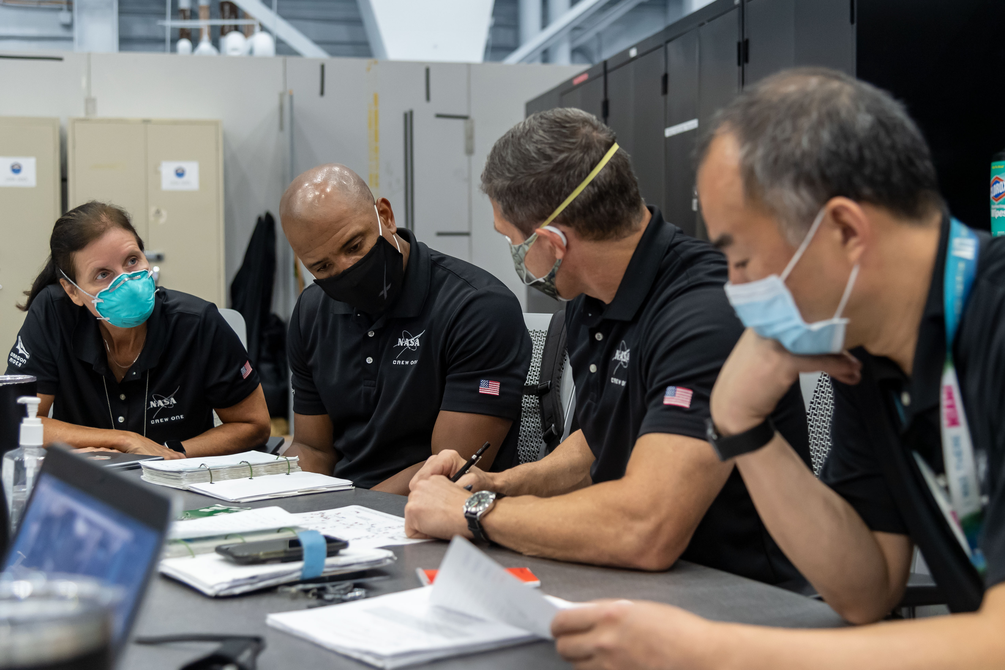
Fig. 7 ISS Crew-1 preparing for their mission during COVID-19 Pandemic (NASA Social Media Photo)

Remote learning was also successfully used with hardware demonstration lessons. In many cases, instructors sat with the hardware and taught astronauts via video at their remote location. See Fig. 8. An obvious disadvantage was the crew did not see hardware in person but did witness instructor handling hardware and pointing out vital information. This was not ideal learning but was a way to continue mission essential training while lowering risk to COVID infection. This opened the door for options of training crew who were assigned late to a mission and may not have much training time. Lessons like this can be provided while crew is at an international partner site.

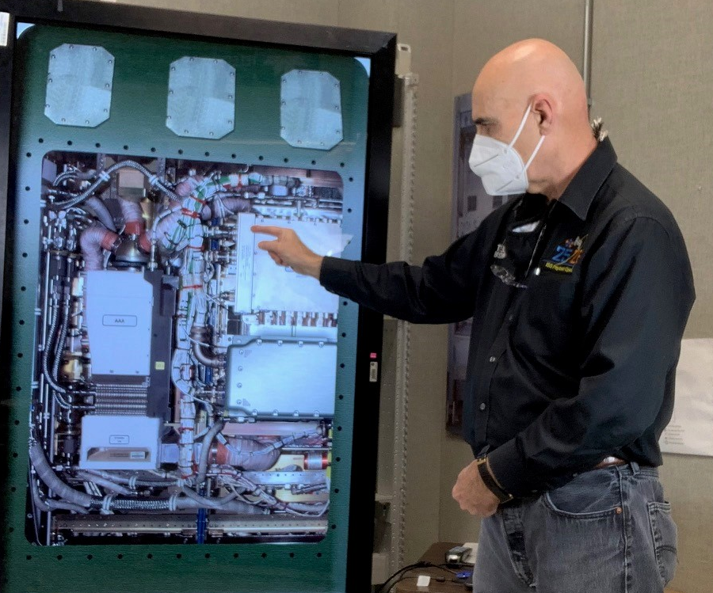
Fig. 8 ISS Payload Instructor Presenting via Video [6]

Another version of this is “double remote” instruction. In this case, instructors tied in to training from their remote location and developed videos to show and walk through training with crew (likewise at a remote location). This helped with instructors not having to travel for training. It was not ideal as it did not usually allow for complete lessons. NASA’s intent after the pandemic is to return to in person learning when safe to do so.

When in-person learning was possible and allowed, instructors still had to re-think how to teach from a distance, instead of “shoulder to shoulder” with crew. Some instructors had crew performing with hardware while the instructor observed from a safe distance and provided guidance. This only works for training where the hardware and operations are not so complex that the instructor must see precisely what the crew is doing.

Some instructors were in a different room and observed via video, explaining detailed operations while crew was following instruction via audio. This method is very similar to how on orbit ops are done for many payloads. It was a good learning experience for crew since it’s more realistic to on orbit. Some variation of this may become a norm in this type of training – example: first lessons in person; follow on lessons via video/audio instruction to provide more representative of how ops will occur on board.

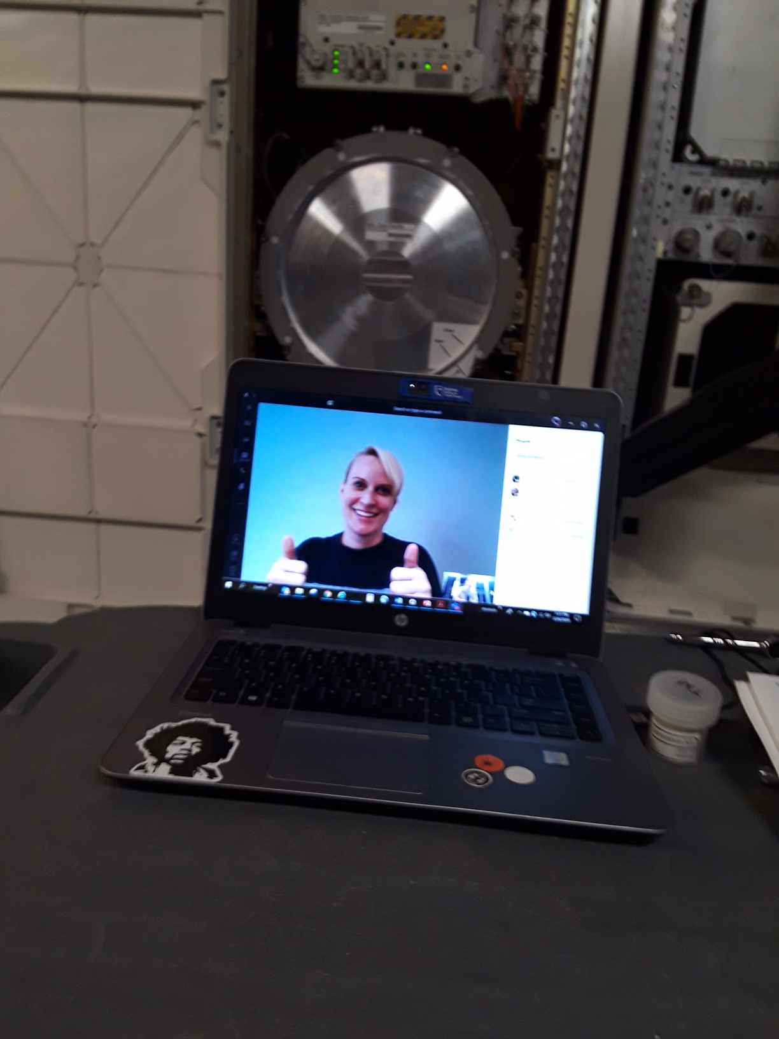
Fig. 9 Astronaut Kate Rubins successfully completes another remote ISS Payload class (photo used with permission)

Another factor that hampered preflight training was schedule constraints. Often astronaut crews had less time for training due to quarantine requirements. Travel caused some crew to quarantine post travel, only allowing for remote learning vs. in person instruction. Yet another impact to their training involved the reduced number of people involved, and increased workload on the instructors. Prior to the pandemic, instructors and training facilitators attended almost every crew training lesson as a team. The facilitator’s role was to greet the crew, assist with logistics, help the instructor stay on time, make sure distractions were minimized, and then submit a report of the training. In the report, facilitators capture actual start/stop times to determine if we are scheduling the right amount of time, capture a list of attendees, take actions from training as well as any pertinent information from training. When the pandemic started, NASA managers minimized the number of people coming to training. This was for crew and instructor safety. Without being able to send a facilitator, the instructor was required to take on the facilitator role as well. This added a burden on the instructor as they must now manage teaching and facilitating, as well as filling out the training report.

- Conclusion: Lessons Learned and Efficiencies Gained

The duration of the COVID-19 pandemic brought about a dramatic and rapid transformation to space mission operations teams and their various sub-disciplines. Mission support, especially for complex and crewed missions like the ISS were forced to rapidly rethink how and where control center staff performed their vital work throughout 2020.

Operations training is responsible for preparing astronaut crews for their missions, providing recurring proficiency and currency material to flight controllers, as well as ensuring new team members are ready to join their colleagues on console. As a result of NASA COVID-19 restrictions, astronauts, trainees and trainers had unique hurdles to overcome during the initial months of the corona virus pandemic. Every element of training was impacted including many specialized training facilities. In addition to these limitations, social distancing constraints were implemented and thus trainer-to-trainee, face-to-face interaction were not authorized. From orientation and introductory classes, simulations, advanced lessons, OJT, and final evaluations; all aspects faced new challenges. NASA operations trainers were forced to rethink, retool, and become more efficient with trainees and training resources in order to continue supporting payload operations on the ISS.

Significant barriers to ops training included facilities restricted from use, to limitations on in-person training classes, on-site simulations and restrictions to OJT. In many cases, these limitations were overcome by using new remote-training tools like Microsoft Teams and electronic documents to minimize person to person exposures. In other cases, like simulations and OJT where there is no substitute for the real thing, trainers and management worked together to find smart and safe solutions.
Astronaut pre-flight training was also drastically impacted by the COID-19 restrictions. Here it was even more important to reduce the potential for infections to the crew. In these cases, virtual learning with trainers by video or recorded lessons were utilized to meet many training requirements. These virtual training sessions also resulted in increased schedule flexibility and made training sessions highly efficient. One notable exception was when training the crew on detailed scientific tasks like dissections or plant sampling. There simply was no substitute for hands on, instructor guided training.

When the pandemic is over and NASA considers all the lessons learned from the COVID-19 era, we predict that many of the efficiencies gained from virtual training will be retained. However, it must be noted there can be no substitute for operators or astronauts gaining experience with the actual complex systems and hardware they will use in mission support.

Acknowledgements
The authors would like to acknowledge the following groups who have contributed to the success of performing science onboard the International Space Station:
- The astronauts and cosmonauts who live and work aboard the ISS and risk their lives in the pursuit of space exploration.
- The operations teams around the world who monitor and operate the ISS, scientific payloads, and ground facilities around the clock at the same time plan for future experiments.
- The training teams who work to ensure that the astronauts and ground controllers are prepared to operate the ISS for the benefit of all.
- The scientists and engineers who design the experiments and use the results to improve our way of life on earth.

References
[1] C. Cruzen, R. Gibbs, S. Dyer, J. Cech; “Expanding Remote Science Operations Capabilities Onboard the International Space Station,” IEEE Aerospace Conference, March 2005.

[2] H. Stetson, D. Deitsch, C. Cruzen, A. Haddock “Autonomous Payload Operations Onboard the International Space Station,” IEEE Aerospace Conference, March 2007.

[3] MSFC COVID-19 Safe at Work Protocol Guidelines, NASA Safety Document, NASA-MSFC, Spring 2020.

[4] Microsoft Corporation, Microsoft Teams Video Conferencing Software, https://www.microsoft.com/EN-US/microsoft-teams, 2020 (accessed March 16,.2021).

[5] N. Horvath, C. Stinson, Discussions with NASA Payload Crew Training Coordinators. Huntsville, Alabama, March 2021

[6] R. Blum, Discussions with NASA Payload Crew Training Coordinators. Houston, Texas March 2021

