SpaceOps-2021,7,x1293
Analysis of Improved Navigation Data for NASA Near Space Network (NSN) Direct-to-Earth (DTE) Ground Stations
Scott H. Schaire, Cheryl J. Gramling, Yleana Ceballos, Chitra Patel ª
Mark R. Lamberson, Timothy A. Williams ^{b}
Ryan M. Patterson, ^{c}
Philip Baldwin ^{d}
Patricia Perrotto ^{e}

ª NASA Goddard Space Flight Center, Greenbelt, MD 20771, USA, scott.h.schaire@nasa.gov
^{b} Peraton Corporation, Greenbelt, Maryland, 20771, USA, mark.r.lamberson@nasa.gov
^{c} Omitron Inc., Beltsville, MD 20705, USA, ryan.m.patterson@nasa.gov
^{d} NASA Headquarters, Washington, DC 20546, USA. philip.j.baldwin@nasa.gov
^{e} Booz Allen Hamilton, Annapolis Junction, MD 20701, USA, perrotto_trish@bah.com

Abstract

Spacecraft navigation is a complex concept that requires a collaboration between network entities and constant corrective action to be successful in the highly variable environment. NASA’s Near Space Network (NSN), Direct-to-Earth (DTE) ground station team is constantly exploring methods to provide better service to NASA spacecraft, including providing radiometric tracking data, subject to cost constraints. Navigation teams, such as the Goddard Space Flight Center (GSFC) Flight Dynamics Facility (FDF), use the tracking data to perform orbit determination to assess where a spacecraft has been, identify where a spacecraft is now, and predict where a spacecraft will be in the future.

As NASA plans for more missions beyond low Earth orbit (LEO), there is a need for improved navigation performance which can be directly achieved through improvements in the radiometric tracking data. NASA’s new DTE Ka-band antennas have finer autotrack angle resolution, and the availability of low-cost improved off-the-shelf ground station components, which are involved with producing navigation data.

NASA formed a team to provide an assessment of the current NSN, DTE spacecraft navigation service (radiometric tracking) performance baseline with the end goal of defining needed future enhancements to meet the needs for spacecraft above LEO. The communications and navigation community is deriving new techniques in an effort to better service the navigation needs of spacecraft using ground station networks. This paper provides an overview Earth-orbit, direct-to-ground navigation techniques and performance, the development of specifications for new antennas, accuracy of data, spacecraft requirements, accuracy of orbit determination, history of challenges, and considerations for improvements. The discussions in this paper may assist ground station, spacecraft, and mission design teams advance navigation capabilities and more effectively meet requirements.

Keywords: networks, navigation, communications, ground station, tracking

Acronyms:
Alaska Satellite Facility ASF
Advanced Communications Capabilities for Exploration and Science Systems ACCESS
Commercial Service CS
Earth Exploration Science Service EESS
European Space Agency ESA
Flight Dynamics Facility FDF
Geosynchronous Earth Orbit GEO
Goddard Space Flight Center GSFC
Global Positioning System GPS
Geostationary Operational Environmental Satellite GOES-R
Highly Elliptical Orbit HEO
Indian Space Research Organisation ISRO
International Telecommunication Union ITU
Low Earth Orbit LEO
Low Noise Amplifier LNA
Major Range Tone MRT
Minor Tone MT
NASA-ISRO Synthetic Aperture Radar NISAR
National Oceanic and Atmospheric Administration NOAA
Near Space Network NSN
Orbit Determination OD
Phase Modulation PM
Plankton, Aerosol, Cloud, ocean Ecosystem PACE
Point of Closest Approach PCA
Pseudo-Noise PN
Radio Frequency RF
Root Mean Square RMS
Signal-To-Noise Ratio SNR
Software-Defined Radio SDR
Terabytes TB
Tracking and Data Relay Satellite System TDRSS
Unified S-Band USB
Wallops Flight Facility WFF

1. Introduction
NASA’s NSN is a service fulfilment office that connects user missions to essential communications and radiometric tracking services, enabling the transmission of critical science and exploration data down to Earth and knowledge of the orbital position when it was observed. NSN fulfils these essential services through a blend of government owned and commercial providers for missions operating in the near-space region, from Earth to two million kilometers. The NSN provides services through both DTE networking infrastructure as well as NASA’s space-based relay system. This paper will focus on radiometric tracking methods within the DTE ground segment of the NSN.
The DTE ground segment of the NSN currently supports approximately 50 NASA missions using about 40 ground stations at 17 sites worldwide for missions within two million km of the Earth. NASA’s plan for more missions beyond low Earth orbit (LEO) drive the need for improved performance in radiometric tracking systems. Through NASA’s Artemis program, the agency is preparing for the next man and first woman to land on the Moon by 2024 and to create a sustained lunar human presence by 2028. To meet the needs of Artemis, the NSN Government owned DTE and NSN-brokered DTE Commercial Service (CS) stations utilize software-defined radio (SDR) systems with integrated telemetry and command capabilities and ranging which provide more flexibility to accommodate greater distances and range and Doppler measurements with improved accuracy.
Today, the NSN offers five types of radiometric tracking data used for orbit determination (OD) of spacecraft in various orbits. The ground system derives each of the data types pseudo-independently. The fundamental data type classifications recognized by this paper are Doppler (in one-, two-, or three-way configurations), autotrack angles, and ranging. Variations in spacecraft orbital dynamics, mission operations, and station contact frequency impact spacecraft position and velocity estimation accuracies. Orbit regime – particularly pertaining to the distance from Earth – is a major determining factor for the accuracy of orbit determination. On missions with a lower Doppler rate, such as lunar or Lagrange point (L1/L2) missions, the dynamics observed are much smaller; thus, accurate Doppler measurements are crucial to resolving the spacecraft’s velocity along the line of sight and predicting the overall velocity profile. The ability to produce accurate range measurements at lunar and L1/L2 distances are critical to ensuring orbit position estimation is correct.
NASA is applying alternate techniques in an effort to better serve the navigation needs of the ground station networks. The NASA Goddard Space Flight Center (GSFC) Flight Dynamic Facility (FDF) team is exploring the use of highly accurate Global Positioning System (GPS) OD solutions for missions such as the National Oceanic and Atmospheric Administration (NOAA) Geostationary Operational Environmental Satellite (GOES-R) series spacecraft to improve calibration of NSN S-band antenna tracking data. If successful, these calibrations will increase confidence in determining the appropriate values for various measurement biases and errors of the ground stations as well as spacecraft transponder delays and other induced error sources. These improved antenna calibrations can then be applied to other spacecraft, including LEO missions and other orbit regimes.

2. Overview of Spacecraft Tracking
Determining a spacecraft’s position and projected orbital path through space is mandatory for mission planning, communication, science data analysis, and geolocation purposes. Locating and then tracking satellites using ground stations requires multiple techniques [1]. These techniques include:
- Determining the rate of the spacecraft’s motion by measuring the Doppler shift on the spacecraft’s radio transmission.
- Identifying the distance between the ground antenna and the spacecraft by measuring the radio transmission round trip light time from ground antenna to spacecraft and back to ground antenna, which provides a sphere in space relative to the station’s geodetic location of the spacecraft’s position above the Earth.
- Using automatic closed-loop signal tracking to enable the ground antenna to precisely follow the satellite as it moves across the horizon and output the resultant elevation and azimuth angles.

These techniques vary in accuracy depending on a variety of factors, which include antenna beam width, signal time and frequency reference accuracy, and signal to noise ratio (SNR). Additionally, atmospheric conditions, mechanical limitations or dynamic forces on the antenna can affect the pointing accuracy of the antenna.
Fig. 1 draws the connection between tracking a satellite and hypothetically tracking a dragonfly. Imagine a five cm (two-inch) dragonfly, 56 meters away from you, cruising at four km per hour. You try to find the dragonfly while looking through a soda straw. The straw provides a small peek to see the dragonfly with a field of view spanning 0.05 degrees. Moving the straw greater than five hundredths of a degree could easily lose sight of the five cm dragonfly.

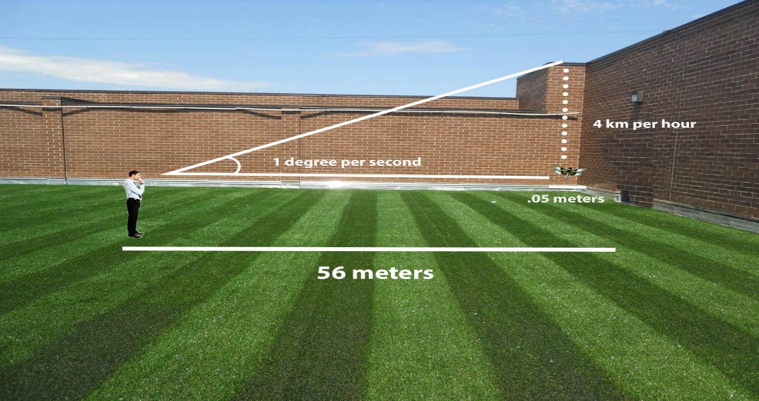
Fig. 1 Spacecraft tracking is similar to an observer looking through a straw at a 5 cm dragonfly half a football field away. This drawing is not to scale.
As the dragonfly moves in front of you, the angular rate at which you must move the straw increases to one degree per second across your line of sight. This is comparable to a spacecraft that is orbiting Earth 400 km away with a velocity of approximately 7.6 km/second (4.7 miles/ second, or 17,000 mph).
In order for a ground station antenna to receive spacecraft signals, it must accurately aim the receiver phase center at the predicted position of the spacecraft. Antennas must point the center of the narrow beam transmitted signals to a location based on a predicted position and velocity of a spacecraft. NSN ground station designs include highly accurate position control and stiffness to prevent deflections, which subtract from pointing accuracy. The higher the speed of the spacecraft relative to the ground site and the smaller the transmitted signal beamwidth of the antenna, the more difficult it becomes to initially acquire the spacecraft’s signal for autotracking. Ground antennas must be able to move quickly to keep up with the spacecraft, particularly at the spacecraft’s Point of Closest Approach (PCA) to the antenna. This is similar to observing a train from the side of a track. As the train approaches and passes, you must turn your head very quickly to keep an eye on a particular point on the train.
The NSN’s communication and navigation ground stations have the capability of moving at least as fast as required to track a spacecraft from launch to LEO. The scope of NSN ground station support extends to spacecraft within two million km of Earth. NSN ground stations must be able to track spacecraft with precision at both low altitudes with high relative velocities and high altitudes with low relative velocities.

3. FDF Overview
The NASA GSFC FDF [3] is a comprehensive multi-mission service provider for flight dynamics data for space communications networks, science and exploration programs, human spaceflight missions and expendable launch vehicle providers. The facility supports operations for over 35 satellites in various orbital regimes. This includes launch services and early orbit support through end-of-mission. Besides providing orbit knowledge estimates and orbit maneuver plans and calibration data, the facility performs advanced navigation analyses. It also identifies tracking data performance and anomalies, and certifies ground stations for radiometric and angle tracking services.
The FDF serves an integral part of the NSN navigation operational workflow. With a focus on spacecraft OD and trajectory planning, the FDF provides reference data on which ground stations, including the NSN, base their antenna tracking. Several key features of this service are the prediction of spacecraft orbital states, formatted acquisition data, and processing of tracking data measurements. Figure 2 depicts a simplified lifecycle of tracking data.
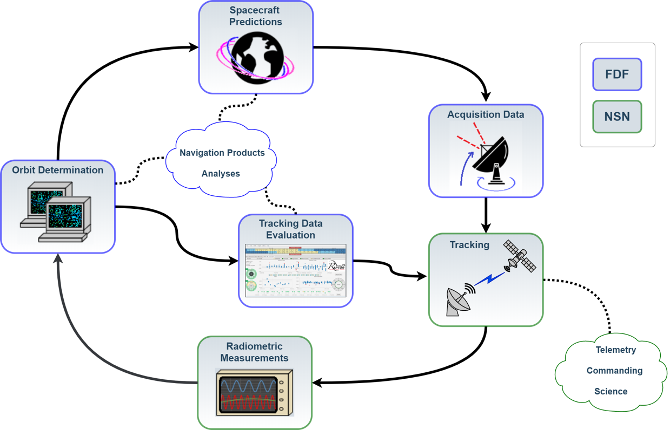
Fig. 2 Tracking Data Lifecycle
Each component of the cycle is highly reliant on the others. Ground station antennas need accurate acquisition data to successfully acquire and track spacecraft. The ground stations translate orbit vector state acquisition data to antenna pointing information to determine when and where to radiate. The FDF generates acquisition data from spacecraft predictions, derived from OD solutions. The FDF generates these solutions by processing the radiometric data taken during tracking events. Inaccuracies within a single step of this data lifecycle can be propagated throughout and cause systemic errors. Tracking data evaluation serves as an independent assessment of the system performance and aims to detect and identify possible error sources. The FDF executes additional navigation analyses and various quality checks to ensure optimal tracking operations throughout all aspects of spacecraft communication links and radiometric measurement processing. These include evaluations such as tracking profile error analysis studies and calibrating antenna pointing angle correction coefficients. The close coordination between the FDF and NSN is a key aspect in achieving exceptional navigation capabilities that support the continued expansion of human and scientific exploration.

4. NSN Overview
The NSN consists of globally-distributed tracking stations, including NASA, commercial, and partner ground stations, that are strategically located to maximize the coverage provided to a variety of orbital and suborbital missions, including those in LEO, geosynchronous Earth orbit (GEO), highly elliptical orbit (HEO), lunar orbit, and Lagrange point orbits. Additionally, the NSN provides users low latency global coverage via a space based relay subnet called Tracking and Data Relay Satellite System (TDRSS).
Fig. 3 is a diagram of the NSN Government owned DTE and NSN-brokered DTE [4]. The NSN is a world-class, highly reliable global telecommunications network supporting over 48,000 passes per year from LEO to Lagrangian orbit, delivering over 12,000 hours (or 260 Terabytes (TB)) of satellite telemetry with greater than 99.6% proficiency. Most ground stations are 11-meter class S-band and X-band, with one 18-meter dual S-band and Ka-band antenna located in White Sands, New Mexico.
The government owned DTE stations and space-based relay assets are operated and maintained by the Advanced Communications Capabilities for Exploration and Science Systems (ACCESS) project which provides those services to NSN. The NSN via ACCESS is currently in the process of developing additional Ka-band antennas for four ground station sites, and operates two 6.1-meter S-band ground stations in Florida. The primary mission of the Florida 6.1-meter stations is to support human spaceflight and other launch customers [5]. NSN missions include Earth science, astrophysics, heliophysics, lunar, human spaceflight, CubeSats, and International Space Station cargo resupply.
The NSN streamlined the planning process by maximizing reuse of ground station configurations for new missions and continues to streamline operations to lower costs.
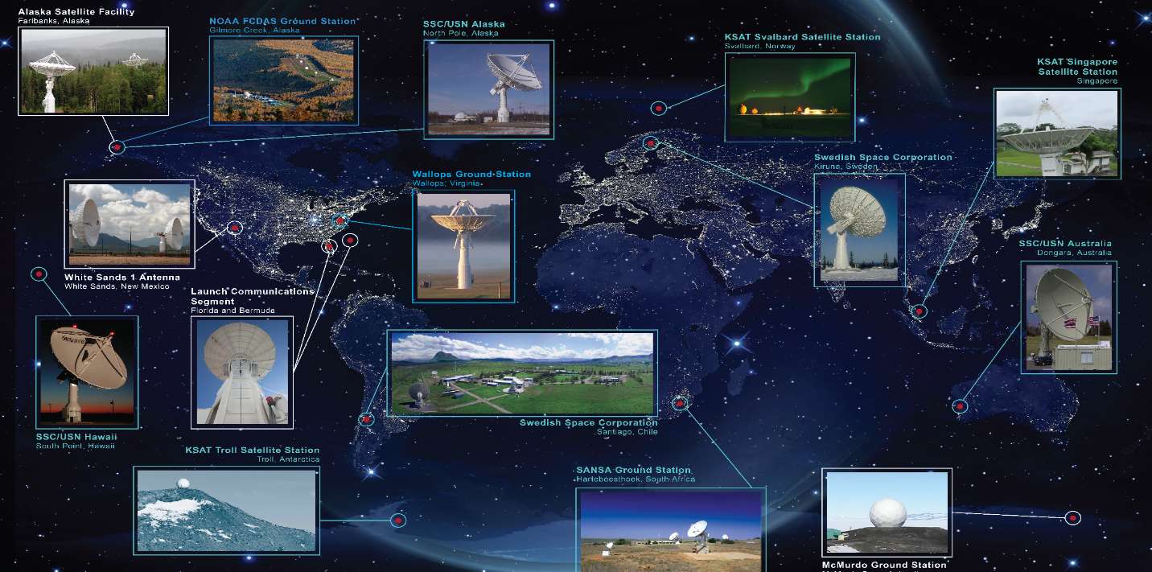
Fig. 3 NASA’s NSN Government owned DTE and NSN-brokered DTE CS Ground Station Map

5. Radiometric Tracking Data
It is important for a spacecraft to know its position and velocity in space to correlate scientific data and to plan communication supports with ground stations, science campaigns, and events that affect the spacecraft, such as eclipses. Navigation means using a series of measurements to determine the present and future position of an object [6]. It is comprised of three main aspects, which include trajectory design, flight path control, and OD; this paper focuses on OD. The measurement data under study consists of range, Doppler, and angle data from network assets that use radio frequencies for communication, collectively referred to as radiometric tracking data.

6. Auto-track Angles
As a data type for navigation, angle data from the tracking ground station antenna assists in defining the plane of sky, resolving the spherical ambiguity of range and Doppler measurements. Angle data is particularly useful in early mission or after a spacecraft maneuver to enhance the limited range and Doppler tracking data available to determine the spacecraft’s orbit. The ground station records angular data in autotrack mode, meaning an antenna will automatically follow a moving RF source provided by the spacecraft’s transmitter received through the tracking receiver. The ground station uses peaking on the signal strength to follow a spacecraft.
Ground stations typically report angles for azimuth and elevation, or X and Y axes of motion. Angle data alone is not an optimal method to determine the position of a spacecraft due to inconsistencies in accuracies. These inconsistencies arise when there are errors of alignment or dynamic errors, which include thermal effects and wind influences.
The NSN X-band angle pointing and knowledge accuracies required for tracking spacecraft are better than 0.08 degrees, while Ka-band requires accuracies of better than 0.05 degrees [2]. With these narrow beamwidths, an error in pointing the antenna may result in tracking a sidelobe of a spacecraft’s transmitter instead of the main lobe. It may lower the SNR received at the ground station from the spacecraft transmitter and lower the SNR received at the spacecraft from the ground station transmitter. The lower SNR reduces the accuracy of Doppler and range measurements.

7. Doppler Measurements
An essential data type for spacecraft navigation is Doppler shift of the reference carrier signal. Doppler shift can be a standalone measurement or can supplement ranging and angle data types. The change in the frequency of the RF carrier signal used to communicate between the ground antenna and the spacecraft directly relates to the velocity along the line of sight between these two participants. Within the OD process, FDF converts the Doppler shift to range rate. As depicted in Fig. 4 [7], NSN provides three configurations for Doppler measurements: one-way, two-way and three-way.

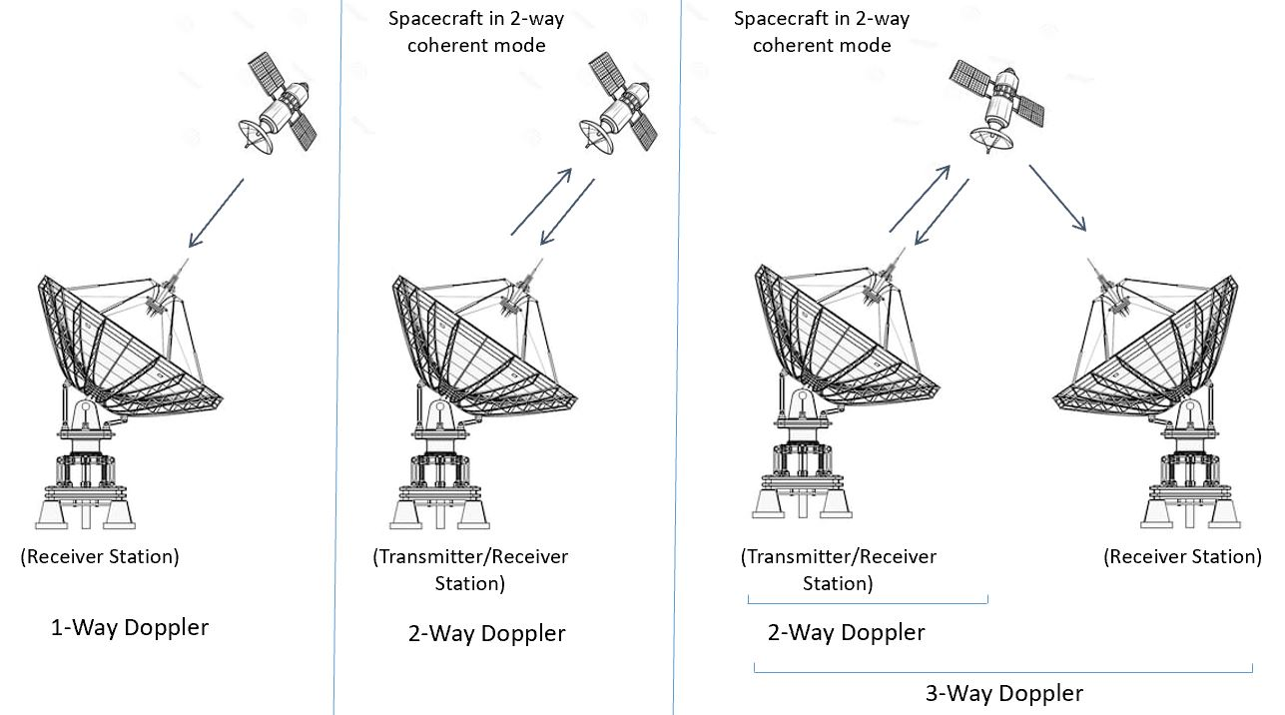
Fig. 4. One-, Two- and Three-way Link Configurations - Modified to show NSN Doppler Configurations
A mission typically selects a one-way Doppler system when the spacecraft does not need ranging or cannot support a coherent two-way service due to onboard hardware limitations. The navigational observability from one-way Doppler directly relates to the stability of the spacecraft oscillator. A highly stable oscillator can provide one-way Doppler with accuracy suitable for OD.
In a two-way Doppler configuration, the spacecraft transponder receives an uplink frequency and coherently converts the frequency following a specified turnaround ratio to a new downlink frequency, after which the spacecraft transmits the signal back to Earth. The internal oscillator in a spacecraft transponder has very little influence on the turn-around. Two different frequencies, as defined by the turnaround ratio, prevent interference with the spacecraft receiver. The two-way Doppler configuration generally provides better accuracy than a one-way Doppler measurement because the originator and the ultimate recipient use the same time and frequency reference for making the measurement on the signal.
Signals and the associated Doppler measurement are three-way when two ground stations are tracking a spacecraft and the second ground station receiving the RF carrier is not the one that sent it. In Figure 4, the single arrow from the spacecraft to the receiver station is a one-way configuration but referenced to the transmitting station. One station configures for two-way Doppler mode and the other receives the signal from the spacecraft and compares it to a frequency derived from its local time and frequency reference source. The primary reason for this method is to augment a two-way Doppler measurement with geometric diversity from the secondary antenna serving as the third leg. This additional geometry serves to increase overall accuracy and reduce convergence time of the orbit solution. Tracking geometry is vital for orbits at greater distances from Earth, such as lunar or libration points, when observability of the orbital dynamics is more limited and coupled with the Earth’s rotation. The NSN will participate in 3-way Doppler to support the Artemis missions to the Moon.
Initially, the new S/X/Ka antennas will measure and provide the Doppler at S-band to an accuracy, when translated to range-rate, of less than 40 mm/sec. The range-rate changes from up to 6,700 m/s at five degrees elevation to near zero m/s at the Point of Closest Approach (PCA). Equation 1 below relates the two-way Doppler measurement to the velocity of the spacecraft relative to the ground station.
(1)
Where: f_{D} = Doppler frequency shift
v = relative velocity
f_{o} = transmitted frequency
c = speed of light
At S-band, setting v = 40 mm/sec and solving for fD indicates the antenna system must be able to accurately measure the frequency shift to 0.6 Hz.

8. Spacecraft Ranging
The different techniques for spacecraft ranging each fundamentally measure the distance between the spacecraft and the ground station [8]. Ranging primarily relies on phase delay and Doppler. The ground station initiates the phase delay calculation, modulating a carrier with a frequency synthesizer. The ground station keeps the synthesizer in coherence to a controlled frequency standard that outputs stable phase-coherent tones in sequence along with a count frequency, which is typically 500 kHz, providing the fine range data. The transmitted signal from Earth propagates the count frequency and range tone through space to the spacecraft, which translates the uplinked frequency and transmits it back to the ground station. The received range tones stop the range counter and provide the total range as a true count of the delay as referenced to the coherent timing source that tags the start to stop of a tone sequence.
The ground station transmits a continuous wave coherent uplink. The range measurement, or count, is a representation of the phase shift between the transmitted and received tones. Range information is contained in the phase relationship between the zero crossing edges of the tones updated at any desired sampling rate. The ground station transmits the tones in a sequence of highest frequency tone to lowest frequency tone. The Major Range Tone (MRT) is the one used for accurate measurement of spacecraft range and is always being transmitted. The minor tones are sequenced on then off after being shifted in phase to the original tone. Maximum unambiguous delay results from the lowest frequency tone.
Minor Tone (MT) frequencies are sub-harmonics of the MRT, transposed to avoid being too close to the carrier in Phase Modulation (PM). Engineers must select tone frequencies to avoid interfering with telemetry and command signals as they transmit simultaneously on the same carrier.
The ground station always transmits the MRT first and remains continuous. The ground station enables the MTs in sequence and autonomously turns them off after a shift in phase of an amount equal to range, and then the ground station transmits the next lower tone. This gives a set of phase-shifted values of the Minor and Major Tones. However, the ground station measured the values at different times, over which the spacecraft has moved. This means that the phase shift of any signal is proportional to the round-trip light time (RTLT) delay and to Doppler on the signal frequency.

Equation 2 represents the governing equation for range measurement and shows the phase shift is proportional to the time delay and frequency.
(2)
Where: Φ (t) = phase shift
f_{i} = transmitted frequency

Consequently, a phase measurement on a signal component at a given instant can be extrapolated to another instant if the phase evolution of another signal component between those instants is known and the frequency ratio between the two signal components is fixed. This provides continuous range measurement of the integrated phase on the MRT.
The ground station extrapolates the MT phase measurement to the same instant as the first measurement on the MRT. The MTs are proportional to the MRT.
A signal component at a given instant can be extrapolated to another instant if the phase evolution of another signal component between those two times is known and the frequency ratio between the two signal components is fixed. This provides continuous range measurement of the integrated phase on the MRT.
The total delay involves resolving the number of integer periods of the MRT / MTs to resolve the exact delay. After ambiguity has been resolved and the MTs removed, phase shift of the MRT continuously updates the range measurement.
The NSN is considering using a number of ranging methods, including European Space Agency (ESA)-Like ranging, Unified S-Band (USB) ranging, ESA Code ranging, and Pseudo-Noise (PN) Ranging, each providing various pros and cons.
ESA-Like ranging allows user-configurable frequencies with up to six Minor Tones and is similar to the tone ranging described.
USB ranging allows user-configurable frequencies with up to eight MTs. This offers the flexibility to adapt to most spacecraft telemetry and command baseband frequencies to obtain the desired maximum range required.
ESA Code ranging uses a single user-selectable tone frequency up to 1.2 MHz that is phase modulated by codes during the ambiguity processing. The tone is the basis for accurate measurement of the range. The Code Length is user selectable based on the distance to be measured. The code rate equals the tone frequency. The maximum delay results from the tone frequency with the maximum transmitted code sequence Q = 22 and code length C up to 2^24 bits. The maximum delay with ESA code is 20.97152 seconds or 6.2 million km, well beyond L1 / L2.
The ground station first transmits a single range tone with no code. After waiting for the return signal, the phase lock loop locks on the tone and continuously measures phase until the end of the Ranging session. Once the receiver locks its loop, the code is phase modulated onto the tone. From the return signal, the correlation between the transmitted code and received code is measured. A maximum code length up to of two^24 bits in 22 sequences is possible, as determined by the maximum range to be expected. The ground station calculates the ambiguity N0 on the tone by adding the delays of each code. Since the bit rate is equal to the tone frequency, counting the code bits is equivalent to counting the full periods of the tone. After adding the fractional period of the tone measured by its phase, the ground station multiplies the result by the tone period to obtain the delay in nanoseconds.
PN Ranging can benefit missions that require higher accuracy for spacecraft orbit determination. CCSDS 414.1-B-2 [9] currently identifies two methods, transparent and regenerative PN ranging. Regenerative PN ranging presents several advantages with respect to non-regenerative ranging.
In a regenerative PN ranging system, a PN ranging code is phase modulated on the uplink carrier and transmitted from the ground station to the spacecraft. The ground station derives this ranging signal using a logical combination of a ranging clock and several component PN codes. The spacecraft then receives it, demodulates the ranging signal, and acquires the ranging code. The spacecraft then regenerates the ranging code coherently with the uplink code and phase modulates the downlink carrier with the locally generated version of the ranging code. Back at the ground station, the station receiver demodulates the downlink and correlates the received ranging signal with a local model of the range clock and component PN codes to determine the round-trip light time. The ranging signal to noise ratio (SNR) at the station is less and proportional to 1/r2 where r is the distance to be measured as opposed to a non-regenerative system where the ranging SNR at the station is proportional to 1/r4 where r is the distance to be measured. Selection of the ranging clock frequency determines the range precision. The use of PN ranging with non-regenerative on-board processing is possible with good link margins. Non-regenerative PN ranging applies to missions that do not require very accurate ranging, hence perform similarly to non-PN ranging systems.
Table 1 NSN Ranging Methods Pros and Conslists the pros and cons associated with various ranging methods used by the NSN.

Table 1 NSN Ranging Methods Pros and Cons
Method | Pro | Con
NASA Tone Ranging | - Developed to operate with an S-band phase locked transponder to provide highly accurate range with low signal strength, using sinusoidal modulation (tones) and extremely narrow band signal processing.  - Able to extract the phase delay from the tones to resolve ambiguity to distances up to 500,000km. | - Risk of false ambiguity.  - Tones are fixed, and sensitive to transponder linearity issues.  - Command and Telemetry may conflict due to fixed tone frequencies proximity to carrier in PM.  - Simultaneous ranging, commanding and telemetry is less flexible.  - To avoid range bias, it requires calibration that is more frequent.  - Cal values cannot be stored.
USB Tone Ranging | - Narrow frequency bandwidth, used in GEO.  - Lower risk of false ambiguity than NASA tone method because the transmitted minor tone frequencies are settable to minimize conflict with other signals. This offers the flexibility to adapt to most spacecraft telemetry and command baseband frequencies.  - Calibration values can be stored requiring less frequent calibration. | - Two-tone sequencing method, similar to NASA tone, has possible interference with telemetry or command, risk of Root Mean Square (RMS) errors in minor tones, and incurring a risk of using a false range measurement.  - Search range too large for the spacecraft distance resulting in excessive time to acquire range.
ESA Code Ranging | - Use of a single frequency eliminates the risk of false ambiguity; only a single transponder delay needs to be measured  - Correlation over hundreds of thousands of bits reduces the impact of BER.  - Delays up to several 10s of seconds, using a short code length makes the ambiguity processing faster | - There is currently insufficient information on ESA code ranging to know whether there is any significant cons.
PN Ranging | - High frequency (approximately 500 kHz or 1 MHz depending on chip rate).  - Excellent accuracy due to the Tone frequency being half the chip rate.  - No interference with telemetry.  - Immediate lock when the vehicle becomes visible.  - There is no ambiguity associated with the resolution delay. | - The spacecraft has the added complexity of ensuring transmitted code coherency with the received code.

Ground station calibrations are critical to accurate measurements and apply to all ranging methods. The two-way range is not simply the difference between the satellite measurement and the ground station calibration. Table 2 Ground Station Calibration Components details system and spacecraft components that factor in as part of the calibration process or post-pass processing of range data to ensure the highest accuracy. Range Zero Setting (RZS) is the technique for measuring and removing the accumulated sum of delays to get a true two-way time of flight measurement.

Table 2 Ground Station Calibration Components
Delay Factor | Ground Station Calibration | Satellite Measurement
Modem Internal Delay | Yes | Yes
Up-converter & Cable | Yes | Yes
Power Amplifier & Cable | Yes | Yes
Test Loop Translator & Cable | Yes | No
Antenna Feed Waveguide | No | Yes
RF Uplink Path (ground-to-space) | No | Yes
Satellite Transponder Delay | No | Yes
RF Downlink Path (space-to-ground) | No | Yes
Low Noise Amplifier (LNA) & Cable | Yes | Yes
Down-converter & Cable | Yes | Yes

9.0 Mechanical Accuracy
The degree of the pointing error depends on both the mechanical composition and structure of the antenna and the dynamics of the spacecraft that it is tracking. For example, a slow-moving antenna tracking a geostationary satellite may encounter less pointing error due to less dynamic interference than the same antenna moving at a faster rate to track a LEO spacecraft. Pointing error can degrade the SNR and affect Doppler and ranging measurements.
Larger ground station antennas with narrow beamwidths operating at higher frequencies require tighter surface tolerances and must be more structurally robust to maintain the dish shape. For example, an 11-meter S-X band antenna at 2-8 GHz typically has a 0.051-0.076 cm RMS surface tolerance. If this same antenna is required to support Ka-band at 27 GHz, the surface tolerance required is 0.025 cm RMS or better. If the dish surface tolerance was not improved and remained at 0.051-0.076 cm at Ka band, this would cause approximately 1.5 dB to 3 dB gain loss on an 11m reflector. It would also cause the side lobes to be several dB worse than a reflector that is specifically designed for Ka band and shaped to tolerances under 0.025 cm RMS. Fig. 5 shows the theoretical gain loss due to reflector RMS surface tolerance for a 27 GHz signal. The gain falls off rapidly after about 0.051 cm RMS. When the RMS surface tolerance is above 0.076 cm (0.03 inches), the pattern degrades exponentially.

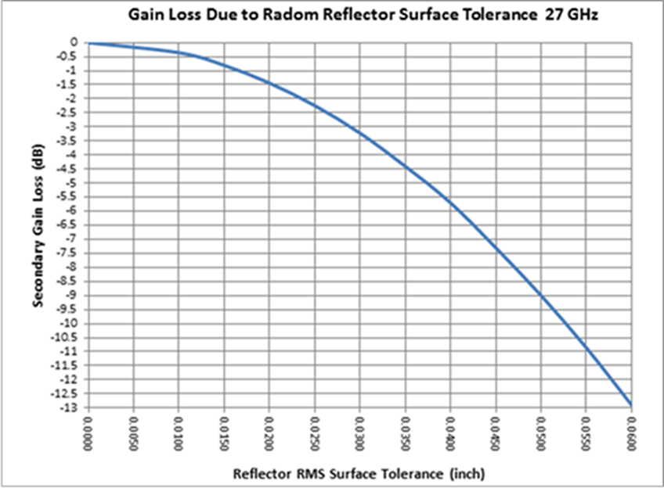

Fig. 5. Gain Loss due to Random Reflector Surface Tolerance for a 27 GHz Signal

10. NSN Ka-band Tracking
The NSN is currently developing new antenna systems to support upcoming missions operating in the International Telecommunication Union (ITU) allocated Earth Exploration Science Service (EESS) and Space Research Service, 25.5 to 27.0 GHz, Ka-band. Earth observing satellites often use high inclination LEO trajectories. With an altitude of 700 km, the orbital period is approximately 90 minutes; and as the Earth rotates underneath, this orbital configuration provides passes over the ground spaced about 22.5 degrees apart in longitude. This is useful because it allows the onboard science instruments to perform measurements over most of the Earth’s surface in a continuously repeating pattern.
To get the data from the spacecraft sensors to scientists on the ground, the high inclination orbit also enables an antenna ground station at the North Pole or South Pole fifteen to sixteen contacts a day, as the spacecraft passes over the ground station each orbit. However, in practice, the ground stations are not located precisely at the poles, and the spacecraft orbits do not traverse directly over the poles either, thus decreasing the actual number of contacts. As an example, a polar orbiting LEO satellite flies over the antenna ground station in Svalbard, Norway, at 78 degrees North latitude, up to fourteen times per day, see . The X represents the ground station. The red line shows approximately one orbit ground trace. The yellow lines show additional orbit ground traces. With each orbit, the spacecraft traverses different portions of the Earth’s surface.

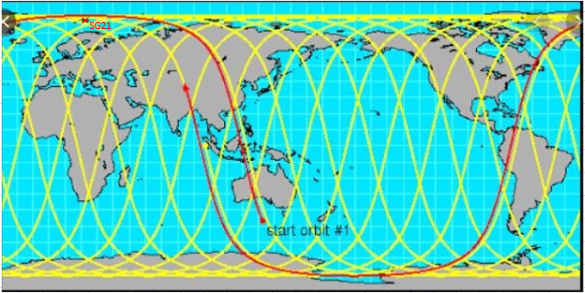
Fig. 6. Ground Tracks of a High Inclination Satellite
The Ka-band communication link was the driving factor for selecting the 11.3-meter antenna size because it provided the high gain required to close the RF link between the spacecraft and ground antenna by focusing the energy into a very narrow beamwidth. Pointing and knowledge angle accuracies typically need to be a fraction of the half power beamwidths (e.g. 0.035 degrees for Ka-band) to maintain peak signal strength.
A 700 km orbit altitude means the angular rate of motion as observed from the ground is less than five degrees per second and within the velocity capabilities of the antenna system. The exception is when the orbit passes directly overhead; the antenna will track up to zenith and then instantly spin 180 degrees to track the decent. Since it is not practical for instant rotation of an antenna system weighing over 110,000 kg while keeping the narrow beamwidth of the antenna pointed at the spacecraft, a two-axis pedestal will start rotating the azimuth prior to zenith and catch up on the descending side resulting in a keyhole type motion and loss of the downlink signal during that time.
Without a train axis, the ground station azimuth would require unrealistic speeds to maintain track for an overhead pass. High elevation passes where the maximum elevation angle is above 65 degrees are desirable because they provide the longest duration contact with the ground station, allowing higher volumes of data to be transferred from the spacecraft to the ground. In addition, this orbital configuration introduces the maximum change in the signal’s Doppler, aiding in estimating the spacecraft’s orbit.
In the three-axis pedestal configuration the train axis is typically a seven-degree wedge that can be rotated +/- 180 degrees and allows the keyhole location of the elevation over azimuth pedestal to be pointed away from the predicted spacecraft trajectory, greatly lowering the velocities and accelerations required from the pedestal. A three-axis pedestal can track any LEO orbit due to an ability to preposition prior to the pass and avoid the spacecraft flying directly over the keyhole position of the pedestal during the pass.
Fig. 7 shows the azimuth and elevation axis velocities required to track a spacecraft on a direct overhead pass with a three-axis antenna system. The maximum azimuth velocity of five degrees per second is within the antenna system capability of 15 and 10 degrees per second for the azimuth and elevation axis, respectively. It also shows how the azimuth axis must increase its velocity when the elevation exceeds 65 degrees and when the spacecraft is overhead or at PCA and the elevation axis must stop and reverse direction as the orbit begins to descend. Fig. 8 provides more detail concerning velocities of azimuth and elevation axes around the PCA.
Fig. 8 zooms in on the PCA event and a close inspection during one degree of elevation change shows it occurs over approximately 1.63 seconds and equates to 14 times the Ka-band beamwidth. The antenna system has a one Hz update rate, which means it can only make corrections twice during this time; therefore, the antenna system must predict the velocity required and utilize the correct acceleration to maintain track through PCA. A monopulse RF tracking system measures the signal strength in four quadrants to determine the direction of the highest signal strength and feeds that to the drive system filtering which performs the position commanding.

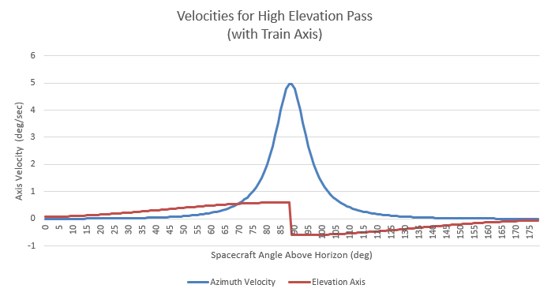
Fig. 7 Required Antenna Velocities for an Overhead Pass
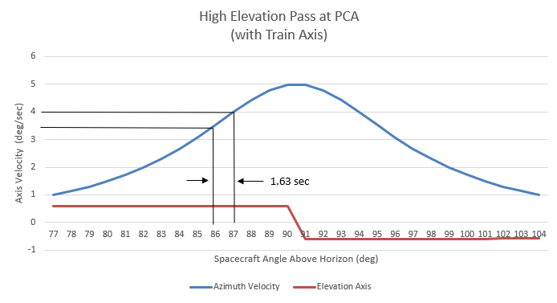
Fig. 8 Azimuth and Elevation Velocities around PCA
Accurate results are critical to NASA’s FDF for navigation of the spacecraft’s definitive and predictive orbit that are required for science data processing and planning future science and communications opportunities.

11. Global Positioning System (GPS) Calibration Solution
Every aspect of tracking faces a litany of error sources: pointing offsets, processing delays, timing discrepancies, phase noise, media perturbations, to name a few. A major struggle of evaluating tracking data and finding the source, or sources of these errors is the reference for data comparison. For example, when evaluating sequential range measurements, an FDF analyst may observe an unexpected 100-meter bias throughout the entire tracking event provided by a station. This residual offset falls outside the sigma bounds of the current filtered state; thus, the OD solution rejects the data. FDF notifies ground station personnel of this anomaly and they begin investigating the cause, which may be issues such as an antenna calibration miscalculation or timing delay in the ranging sequence. Upon receipt of another ranging event with the same spacecraft, however, FDF sees a resolution of the apparent bias to a value less than 10 meters, a nominal measurement. The supplemental event provided a necessary geometric correction to the tracking schema and updated the calculated orbital plane. This change to the OD solution removed the true error source causing the observed bias. If, however, the bias were to persist, FDF would contact the station to alert them of the error and initiate resolution.
Spacecraft orbital knowledge injects its own additive error to any tracking measurement evaluation. The accuracy of spacecraft OD provided by the FDF can vary based on orbit regime and numerous mission-specific factors [10]; however, it is heavily impacted by the quality of the received tracking data. When evaluating tracking data, the FDF must ensure a viable orbit solution for target spacecraft. Just as ground stations attempt to calibrate their systems and remove any hardware delays, FDF must properly tune orbit solutions to balance noise and uncertainty. An unstable OD can misrepresent a ground station’s measurement error, incorrectly showing degradation actually attributable to data from another antenna. It is a difficult feat to obtain sufficient OD accuracy for evaluating tracking data against hardware specification levels. This is especially true in a data-starved environment, which may be a result of orbital design, mission requirements, or spacecraft communications hardware. To solve this problem, the FDF researched alternative sources of data to supplement inadequate tracking profiles. One potential source identified was leveraging GPS data. GPS navigation has become standard practice in NASA supported spacecraft. Definitive orbit knowledge accuracies of GPS filtered point solutions can be maintained to a magnitude of several meters with appropriate modeling. Even so, early orbit checkout validates the on-board processing for GPS systems. NASA missions routinely use NSN radiometric tracking solutions during this early orbit phase for processing by the FDF for GPS validation. These radiometric measurement sources, previously calibrated, are determined to be of sufficient accuracy to provide a viable OD solution. Once the GPS navigation is validated and operational, tracking data measurements can use it as a reference. In essence, the GPS reference solution provides an independent means to certify new radiometric tracking stations or data types.
Historically, the FDF has evaluated radiometric data using OD solutions derived from other radiometric measurements. Referencing GPS presents a unique data crossover opportunity; the FDF examined use of highly accurate orbit determination solutions based on GPS to calibrate the NSN stations. The first target spacecraft identified by the FDF to investigate this evaluation technique was the NOAA GOES-R series of geosynchronous satellites. While this technique has not yet been utilized for operational evaluations, initial proof-of-concept results display promise for the methodology. GOES GPS OD provides a sustainable geosynchronous position uncertainty around five to 10 meters (3σ). At these levels, resolution of measurement characterization for radiometric data is vastly improved. Fig. 9 displays an example set of residual evaluation accuracy characteristics for GPS and radiometric ranging using a simple GPS filter reference solution. The filtered state provides consistent error bounds for the measurement residual calculations. This consistency allows for more detailed and robust characterization of the tracking performance. Radiometric-only tracking OD solutions can produce definitive accuracies comparable to that of GPS; however, achieving this consistently levies stricter requirements on measurement data, tracking schedules, and navigation operations. An inherent disadvantage of using radiometric tracking passes for validation is that they bring with them the overhead of scheduling sufficient baseline events for OD, excluding the events under validation, to produce an effective reference state, which can be costly and disruptive to mission operations.

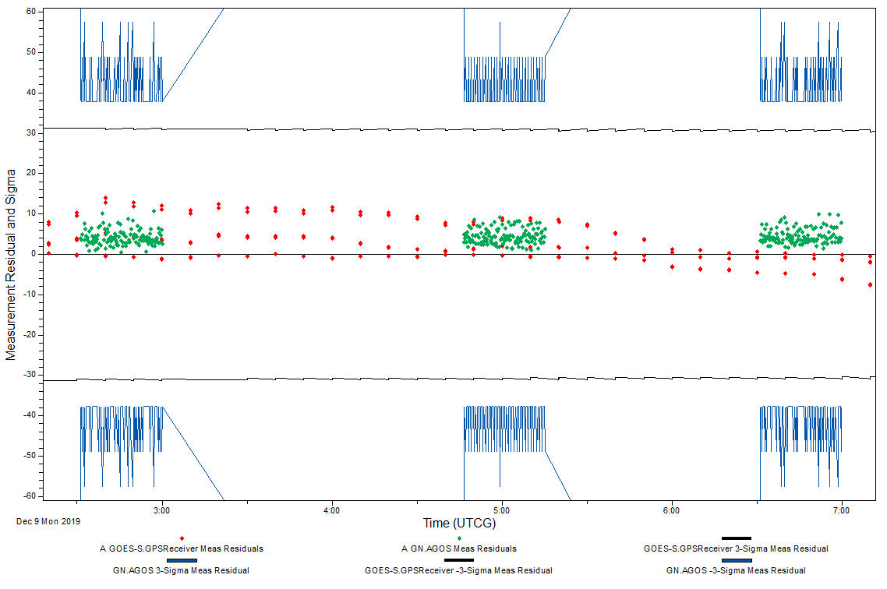
Fig. 9 GPS OD Measurement Residual Accuracies for GPS and Radiometric Range Data
Future intents for these evaluations include regular calibrations for NSN antennas. These improved antenna calibrations apply to other spacecraft, with plans to include LEO missions and other orbit regimes. Reducing orbit uncertainties from radiometric tracking performance calculations leads to more effective anomaly characterization and will assist in more precise identification and resolution of tracking errors. The reduction in these errors creates a better-calibrated tracking network. Identifying possible issues within ground tracking using GPS-enabled spacecraft could improve orbital knowledge of all subsequently tracked missions while driving antenna performance to hardware specification levels.

12. Summary
Locating and tracking spacecraft using ground stations requires multiple techniques that vary in accuracy depending on factors such as antenna beamwidth, signal time and frequency reference accuracy and stability, and SNR. Techniques described in this paper include:
- Measuring the Doppler shift of the spacecraft’s radio transmissions to determine the spacecraft’s rate of motion.
- Identifying the distance between NSN ground stations and the spacecraft as the spacecraft passes above each NSN ground station (i.e., ranging).
- Calibrating the ground station for fixed errors improves ranging accuracy through the RZS technique.
- Employing automatic tracking to adjust the ground station antenna’s elevation and azimuth angles based on the location of the signal of the spacecraft.
With the help of NASA GSFC FDF and the Navigation and Mission Design Branch, the NSN has been analyzing the accuracies achievable for ground station tracking data for new antennas with commercial off-the-shelf components. These results are being applied to future enhancements for lunar and Lagrange Point missions and will be used for verification of the new antennas. These analyses will be the foundation for significantly improving the accuracy of tracking data provided by NSN ground stations.
Acknowledgements
The authors wish to thank NASA’s Space Communications and Navigation (SCaN) program office and GSFC’s Near Space Network project for sponsoring tracking improvement studies and this paper. The authors also wish to thank NASA GSFC FDF and the Navigation and Mission Design Branch for their contributions.

References
[1] R. Bate, D. Mueller, J. White. Fundamentals of Astrodynamics. Dover Publications Inc, New York, 1971.
[2] S. Schaire. Near Earth Network User’s Guide, Revision 4. Goddard Spaceflight Center, Greenbelt, Maryland, 2019.
[3] Goddard Space Flight Center Flight Dynamics Facility. https://fdf.gsfc.nasa.gov/, (accessed 15. 01 2030.04.16)
[4] “Near Earth Network (NEN) CubeSat Communications.” NASA Technical Reports Server, January 1, 2017, https://ntrs.nasa.gov/search.jsp?R=20170000974, (accessed 20.01.07)
[5] Roberts, C., McCormick, D, Tye, R., et al. “NASA’s Launch Communications Ground Segment for the 21st Century Florida Spaceport,” Paper AIAA 2018-2529 presented at the AIAA 15th International Symposium on Space Operations, Marseille, France, May – June 1, 2018.
[6] Consultative Committee for Space Data Systems (CCSDS), “Navigation Data—Definitions and Conventions”, CCSDS 500.0-G-4, Washington, D.C November 2019.
[7] CCSDS, “Navigation Data—Definitions and Conventions”, CCSDS 500.0-G-4, Washington, D.C November 2019.
[8] A. Kwok, DSN Telecommunications Link Design Handbook, 201, Revision B. California Institute of Technology, Pasadena, California, 2009.
[9] CCSDS, “Radiometric Tracking Techniques for Deep-Space Navigation”, CCSDS 414.1-B-2, Washington, D.C November 2019
[10] Newman, C., Nicholson, A., Slojkowki, S. “Flight Dynamics Facility (FDF) Orbit Determination Accuracy from Mission Experience (Update 4),” FDSS Contract Technical Memorandum, November 29, 2010.

