Journal of Geophysical Research - Oceans
Supporting Information for

Estuarine Dissolved Organic Carbon Flux from Space: with Application to Chesapeake and Delaware Bays
Sergio. R. Signorini¹, Antonio Mannino², Marjorie A. M. Friedrichs³, Pierre St-Laurent³, John Wilkin⁴, Aboozar Tabatabai⁴, Raymond G. Najjar⁵, Eileen E. Hofmann⁶, Fei Da³, Hanqin Tian⁷, and Yuanzhi Yao⁷

¹NASA Goddard Space Flight Center and Science Applications International Corp., Greenbelt, Maryland, USA.
²NASA Goddard Space Flight Center, Greenbelt, Maryland, USA.
³Virginia Institute of Marine Science, College of William & Mary, Gloucester Point, Virginia, USA.
⁴Rutgers University, New Brunswick, New Jersey, USA.
⁵Department of Meteorology and Atmospheric Science, The Pennsylvania State University,
University Park, Pennsylvania, USA.
⁶Center for Coastal Physical Oceanography, Department of Ocean, Earth and Atmospheric Sciences, Old Dominion University, Norfolk, Virginia, USA.
⁷International Center for Climate and Global Change Research and School of Forestry and Wildlife Sciences, Auburn University, Auburn, Alabama, USA.

Corresponding author: Sergio Signorini (sergio.signorini@nasa.gov)

Contents of this file

Text S1
Figures S1 to S3

Introduction
The L2 daily MODIS reflectance were retrieved at the ROMS grid points across the mouths of CB (8 grid points) and DB (23 grid points) and used to obtain the DOC concentrations with the MLRC algorithm. These data are shown in Figure S1a, b as time series of data points for both bays. The percentage of good retrievals (cloud free, no algorithm failure) is quite similar for both bay mouths, 28% for CB and 29% for DB. The neural network fitted vertical profiles were used to extend the satellite retrievals throughout the water column. As mentioned in the main text, a temporal linear interpolation was done to obtain complete daily DOC values corresponding to ROMS water flux at each of the grid points to obtain the DOC flux. Bar charts of monthly percentage of good pixel retrievals across CB and DB are shown in Figure S1c, d. For the most part retrievals are better than 30% with a reduction during late spring and summer (May-August in CB and May-July in DB) during which there is an increase of cloudy days. So the cloud free data does not appear to significantly impact on the seasonal distribution of the data.

Text S1.
Time series plots of monthly DOC flux, water flux, and cross-section averaged DOC at the mouths of CB and DB are shown in Figure S2. Large seasonal and interannual variability are clearly shown for all three timeseries with DOC flux and water flux being much larger in CB due to the corresponding much larger input of freshwater when compared to DB. One can readily see from visual inspection of Figure S2 that the DOC flux variability is quite similar to the water flux. The dominant influence of the water flux on the DOC flux can be quantified by computing the Pearson correlation coefficient (Cp) between the two timeseries. For CB the Cp between the water flux and the DOC flux is 0.65, while Cp between DOC and the DOC flux is 0.14. The equivalent Cp values for DB are 0.56 and 0.26, respectively. Thus, the mean annual outgoing DOC flux in both bays are highly driven by changes in total freshwater inputs, and to a lesser degree by changes in DOC concentrations. Figure S2 also shows time series of mean cross-section DOC for 2007-2011 multiplied by the monthly water flux (red lines in the top tier). Note that they are quite different than the DOC flux obtained by the product of the time varying DOC and water flux. In addition, the DLEM total river discharge (RD) for CB and DB (red lines in the middle tier) are shown with the water flux (WF) time series across the bay mouths. There is a clear correlation between RD and WF but they are not identical (2007-2011 means of 2473 and 2696 m³ s⁻¹ for CB, and 792 and 613 m³ s⁻¹ for DB, respectively), probably due to effects of tides at the bay mouths and evaporation-precipitation effects at the water surface within the bays. The larger percent difference in the mean values for DB (29%) compared to CB (9%) may be due to the fact that DB ROMS used a different freshwater forcing scheme, not DLEM (see section 3.2).
Sensitivity tests were conducted by using two different methods of temporal averaging the interpolated data, an 8-day rolling averaging method and an 8-day moving averaging method. The long-term mean DOC fluxes obtained with the 8-day averaged DOC concentrations and water flux were almost identical to the daily fluxes, however, there were visible changes on the time-dependent DOC flux record at monthly to seasonal time scales. The results are shown in Figure S3.

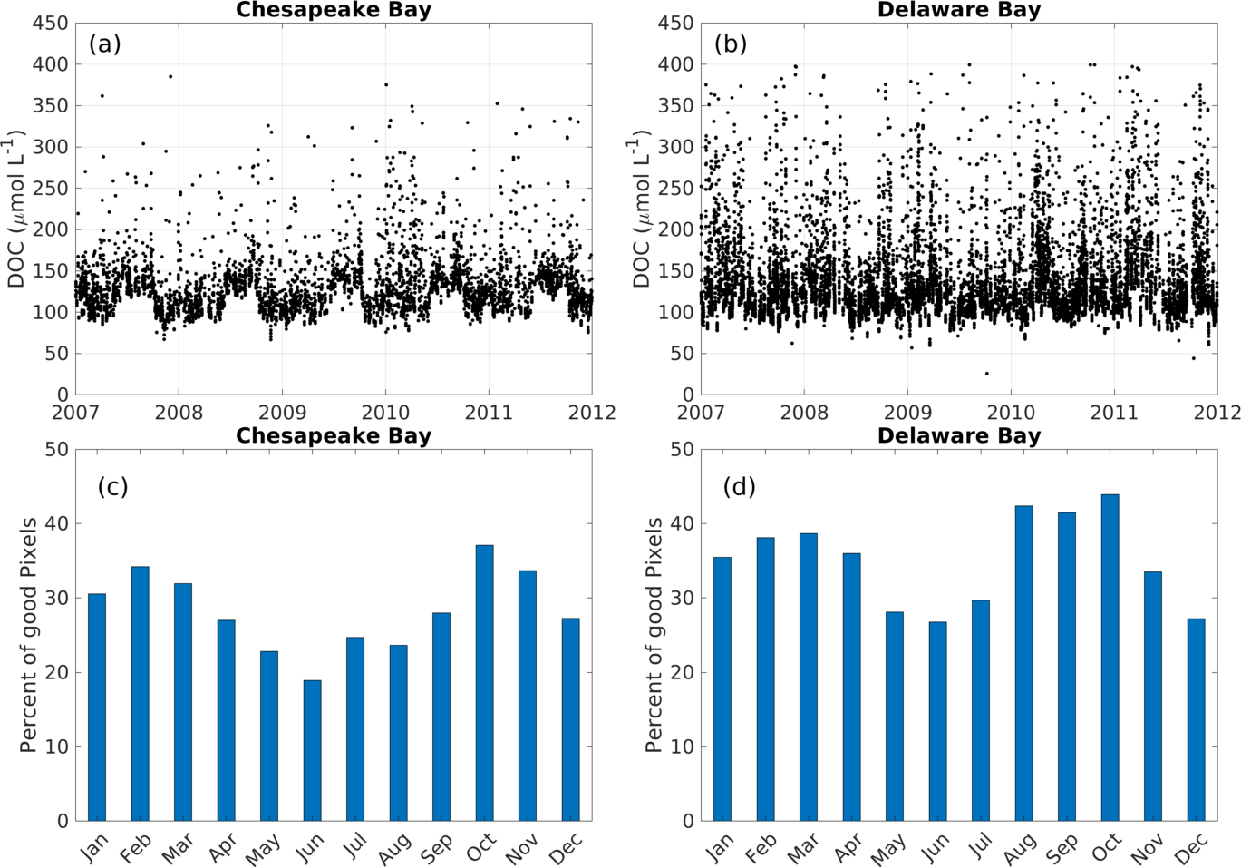

Figure S1. Time series of daily MODIS DOC retrievals at the mouths of Chesapeake (a) and Delaware (b) Bays. Corresponding bar charts of monthly percentage of good pixel retrievals are shown for Chesapeake Bay (c) and Delaware Bay (d) mouths.

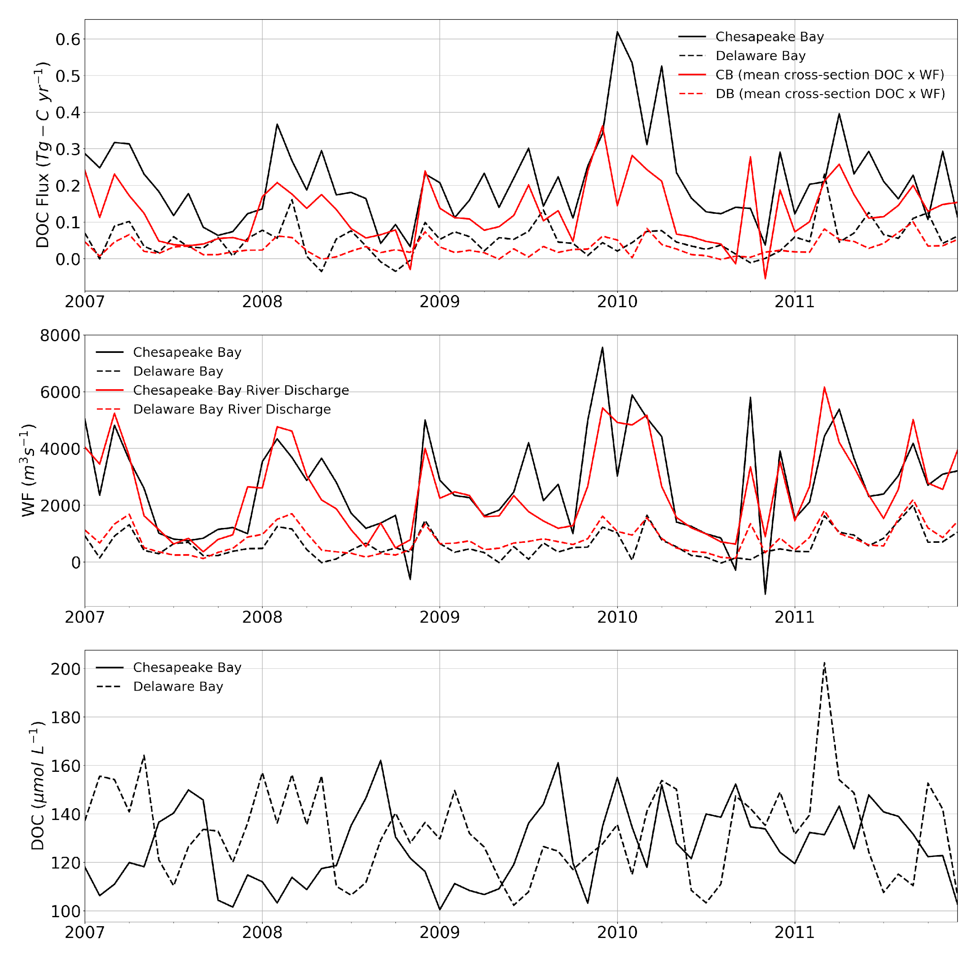Figure S2. Time series of monthly DOC flux, water flux, and cross-section averaged DOC at the mouths of CB and DB. The red lines in the top tier were obtained by multiplying the mean cross-section DOC by the water flux. The red lines in the middle tier are the DLEM monthly averaged river discharges for CB and DB.

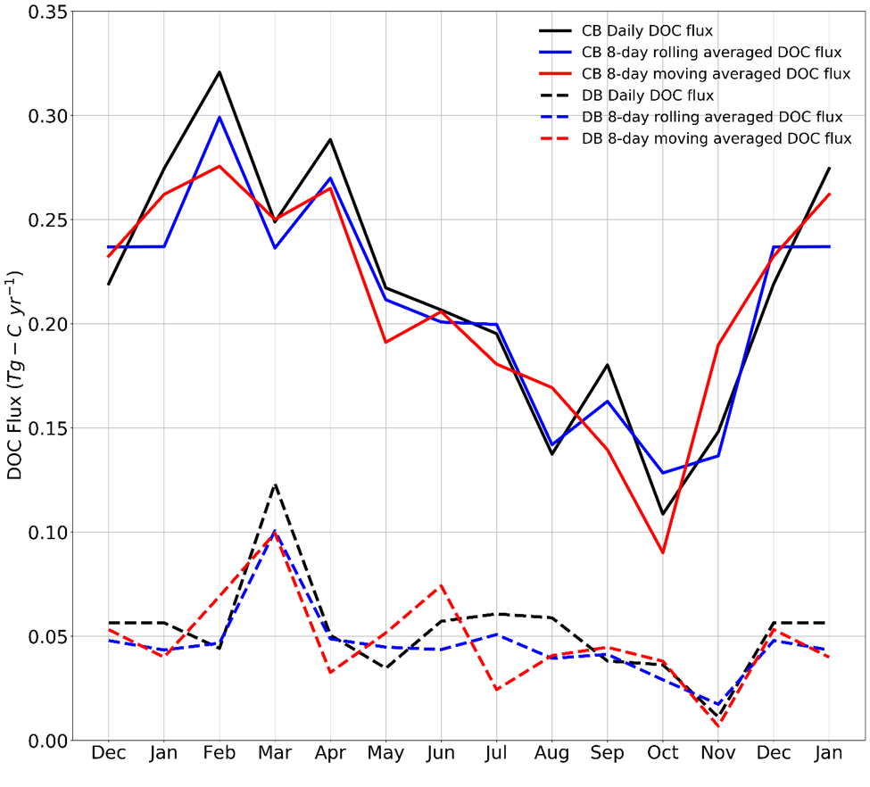

Figure S3. Seasonal (2007-2011) plots of cross-section integrated seasonal DOC flux using three different temporal resolutions for CB and DB, e. g., daily (1d), 8-day rolling (8dr) and 8-day moving (8dm) average time series of ROMS water flux and satellite DOC. The annual DOC flux for each of the three temporal resolutions (1d, 8dr, and 8dm) for CB are 0.211±0.018, 0.203±0.004, and 0.202±0.013 Tg C yr⁻¹, respectively, and 0.0525±0.0068, 0.0462±0.0037, and 0.0476±0.0105 Tg C yr⁻¹ for DB, respectively.

