SpaceOps-2021,9,x1544

Designing Autonomy into Interfaces for Long-Duration Missions
Brooke Allenª*, Haifa Moses^{b}

ª Marshall Space Flight Center, Huntsville, Alabama 35812 brooke.allen@nasa.gov
^{b} Johnson Space Center, Houston, Texas 77058 haifa.r.moses@nasa.gov
* Corresponding Author

Abstract

As NASA develops technologies for long-duration crewed missions, we must understand how communication between ground control teams and astronauts differs from the current dynamic to adapt new concepts for long-duration mission operations. Today, ground control teams support astronauts with immediate availability to answer questions, resolve issues, and manage activities. In the near future, however, extended communication delays during long-duration missions will require astronauts to become more autonomous. As many of the responsibilities shift from the ground control teams to the astronauts on-board, the concept of operations must also change from how it functions today. With increased astronaut autonomy, software tools must be developed that enable efficient completion of mission tasks without increased mental workload. Designing software tools to facilitate crew autonomy requires development teams to know which data will enhance quick decision making while providing necessary context for situational awareness of systems being managed on-board.
NASA's Autonomous Systems and Operations (ASO) team is presently developing a software interface tool, EXPRESS (EXpedite the PRocessing of Experiments for Space Station) 2.5 to enable a long-duration crew to schedule activities for and operate autonomous systems. This paper describes details of the integrated human factors approach that drove the design of the elements of the software tool, including self-managed scheduling, constraint-driven planning, autonomous system fault recovery, and recommended troubleshooting actions. Additionally, this paper will chronicle ASO modifications of the user interface after the team's first flight demonstration, how it was based on lessons learned during software development, as well as from crew feedback in order to develop the current version which will be demonstrated on ISS in 2021. In the upcoming ISS demonstration, the astronaut crew will be given scenarios for scheduling and operating autonomous system activities, including off-nominal scenarios and autonomous system recoveries. The demonstration of the EXPRESS 2.5 tool is a step towards improved levels of autonomy as our new journeys take us farther into space.

Keywords: user interface, autonomy, payloads, human factors,

Acronyms/Abbreviations
AES – Advanced Explorations Systems
AMO – Autonomous Mission Operations
ASO – Autonomous Systems and Operations
EXPRESS - EXpedite the PRocessing of Experiments for Space Station
ISS - International Space Station
JSC - Johnson Space Center
MSFC - Marshall Space Flight Center
OPTimIS – Operations Planning Timeline Integration System
PRO – Payload Rack Officer
UI - User Interface
WebPD- Web Procedure Display

- Introduction
Throughout the history of NASA's human spaceflight programs, engineers have designed systems and operations around the known constant real-time communication between Earth and crewed spacecraft. As NASA sets aggressive new mission goals to explore further into space, the constraint of growing communication delays will call for a paradigm shift in how ground control teams manage crew activities and flight systems. Crucial decisions will be made to transition specific systems that are currently controlled by numbers of ground operations experts to being managed on-board by a very small crew. The current number of complex systems involved in human spaceflight would be extremely challenging for crew to manage without the flight operations ground team working continuously throughout the mission. Adding system autonomy and crew autonomy to these missions can support reducing crew workload and improved task performance [1] potentially creating a successful new dynamic of crew and ground teams working with long-duration mission limitations. The design of these autonomous systems should be human-centered, enabling the human to successfully interact with autonomy yet minimize the obligation of human-system interaction [2]. The interface between the autonomous software and the astronaut must be designed so that the human and system are able to efficiently exchange the information needed for the system’s operational success [3]. Utilizing human factors practices throughout the design process will result in an interface focused on the user and target the information that the crew will need from the system [4]. Testing interfaces of autonomous systems on current spacecraft helps NASA realize what information successfully enables astronaut crews. ASO is utilizing EXPRESS racks on ISS to demonstrate autonomy and to develop a better understanding of what is necessary for astronauts to interface with systems in an autonomous state.
The EXPRESS rack is a system that accommodates payloads on-board the International Space Station (ISS). Currently, Payload Rack Officers (PROs) located at Marshall Space Flight Center (MSFC) in Huntsville, Alabama, operate the EXPRESS rack from the Payload Operations and Integration Center (POIC). Activation of the EXPRESS rack requires coordination between the POIC and the Mission Control Center in Houston (MCC-H) following a 40-page procedure. This involves well-choreographed and synchronized steps between the teams and various procedures for changing the state of the rack. In 2014, the ASO team executed an experiment, Autonomous Mission Operations (AMO) EXPRESS, which demonstrated that the EXPRESS rack can be configured to activate and deactivate with a single command from the ground [5] reducing the need for considerable ground-system interaction. This experiment was a significant milestone in developing technologies for future missions by demonstrating a task that can reduce the necessity of coordination with ground control teams.
AMO EXPRESS 2.0 was a follow-on experiment to AMO EXPRESS which transferred the single command capability from the ground to the crew on-board ISS. In 2016, the ASO team customized a user interface (UI) called WebPD to support the commanding capability for the crew. The WebPD UI allowed the crew to initiate the command to the EXPRESS rack and follow through the steps as they were executed. If the EXPRESS rack showed off-nominal behavior, the embedded fault detection, isolation, and recovery (FDIR) software logic provided the crew with information and recovery steps. However, because AMO EXPRESS 2.0 was operating on actual hardware on-board the ISS, there were no planned failures to inject into the software. This demonstrated the ability to transfer the capability of tasks completed by ground control teams to crewmembers on-board, a crucial element of preparing for long-duration missions.
AMO EXPRESS 2.5 is the on-going demonstration that adds additional complexities to AMO EXPRESS 2.0 by including induced failures with autonomous system fault recovery, constraint-driven planning, crew-managed activity scheduling, and recommended troubleshooting actions. AMO EXPRESS 2.5 seeks to enable more crew autonomy through this added functionality. Crew on-board will be given tasks to schedule an activation or deactivation of an EXPRESS rack; they will then have to find available time within their current schedule to complete the activity. Once the crew begins the activity, they can follow along with the system and will be prompted with feedback or instruction depending on the EXPRESS scenario they have completed. These EXPRESS scenarios will be simulations since some have induced failures and it is not ideal to purposefully induce failures on ISS hardware. The ASO team developed a strategic set of six scenarios including nominal and off-nominal activities with autonomous recoveries and some scenarios that require crew intervention. This variety of scenarios allows us to test new concepts of crew interaction with autonomous software. A timeline of EXPRESS 2.0 and EXPRESS 2.5 is included in Figure 1.

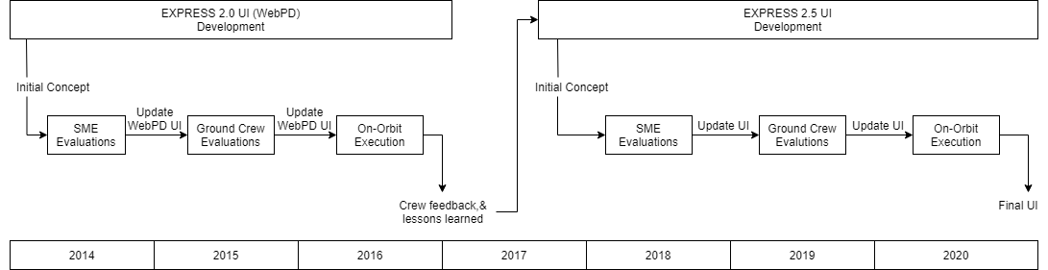

Figure 1: Timeline of EXPRESS 2.0 and EXPRESS 2.5

3. Integrated Human Factors Approach
Throughout the AMO EXPRESS project, human factors played an integral role in development. From the beginning, the human factors team established a set of goals and determined what data could be collected from the crew when using the UI. The primary research question asked was, “How does the use of this UI impact the crew's ability to interact with autonomous systems?” By collecting information from the crew, the human factors team helped design the framework of components necessary to achieve project goals. The human factors team followed the best practices of the discipline by optimizing human interaction with the autonomous system performance.
Understanding the role of human within an autonomous system is key to developing software tools that enable crew to manage their own activities and the systems with which they interact. It is vital to properly evaluate how information is processed by the user in order to successfully accomplish tasks and react to failures. Missions where crew are expected to manage on-board operations rather than rely on ground control will result in increased mental workload compared to our crewmembers today [6]. Information must be presented in a concise manner for efficient and effective processing by the crew. The human factors team considered these aspects to establish user interface criteria for the autonomous software. This ensures that the anticipated crew interactions are used as the drivers of design decisions, and that crewmembers are not simply users of a product.

3.1 Goals for the User Interface
The human factors team established a set of goals for UI development. By combining data gathered from research throughout the project with human factors best practices, these goals drove the design of the UI ensuring a human-centered and usable design.
- Learnability and memorability - no required training prior to use
- Efficiency - does not increase time to complete task
- Error tolerance - allows for easy error recovery and errors do not lead to a state that would result in harm to the system
- Satisfaction - system is enjoyable to use and crew will want to use the system for future tasks
- Situational awareness - Provides status on the state of the system and future tasks needed to be performed

4. EXPRESS 2.0
The human factors team initial development process for a UI for an autonomous system was for EXPRESS 2.0. The EXPRESS 2.0 UI allowed crew to interact with the autonomous procedure software that was developed and tested with AMO EXPRESS. This UI, called WebPD, had basic functionality allowing the crew to activate and deactivate the EXPRESS rack with a single button, which began the autonomous procedure. WebPD was intentionally built to support this task and included information needed to accompany the task. It included statuses of steps within the autonomous procedure and provided telemetry of the rack functions as the activation or deactivation of the EXPRESS rack was occurring. Procedure execution progress displayed and included optional pop-up boxes that opened to see detailed telemetry.

4.1 UI Design
Initial functions for WebPD included autonomous software procedure steps with statuses, detailed telemetry, and an active and completed procedure list shown in Figure 2. The primary goal of WebPD was to enable the crew to command autonomous software to activate and deactivate an EXPRESS rack. Capabilities of the UI focused specifically around enabling this task. When considering future missions with increased crew autonomy, the design will need to support this shift in crew workload. While crew working in our current dynamic can depend on the ground to provide them with information they need, this UI needs to provide future crews with the pertinent details only. Otherwise, crew interpretation of those details could become a task of its own. Crew need to know the status of the procedures, what is active, and what has already occurred. This information will provide situational awareness that is needed when the responsibility of managing these systems is added to their scope of work.

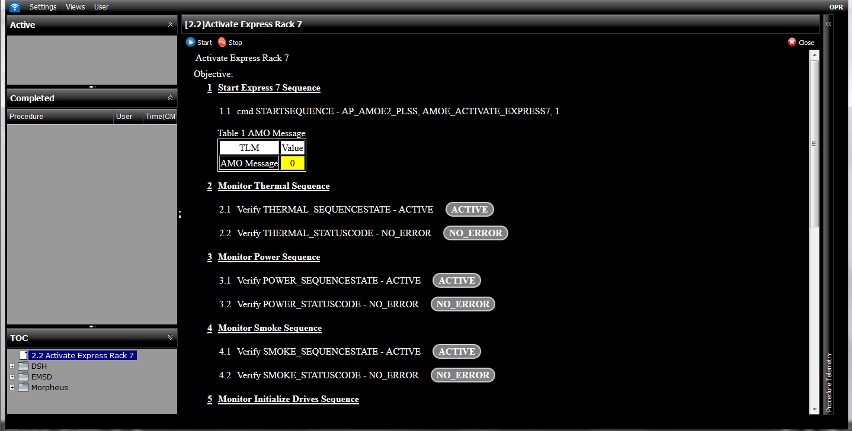
Figure 2: WebPD UI

The primary indicator of an active procedure in WebPD is the procedure list in the ‘Active’ box on the left side of Figure 3. The purple highlight in the procedure display window on the right follows the active step in the procedure. The two buttons on the far right of the first step function as a method to skip or send the first command of the procedure. For an automated procedure such as this one, the send and skip function only work for the first step since the remaining steps are completed autonomously. When steps within the procedure are active, the label in the oval shape at the end of each step only reflects off-nominal step status. The desired status for each step is in the step text immediately to the left of the oval label.

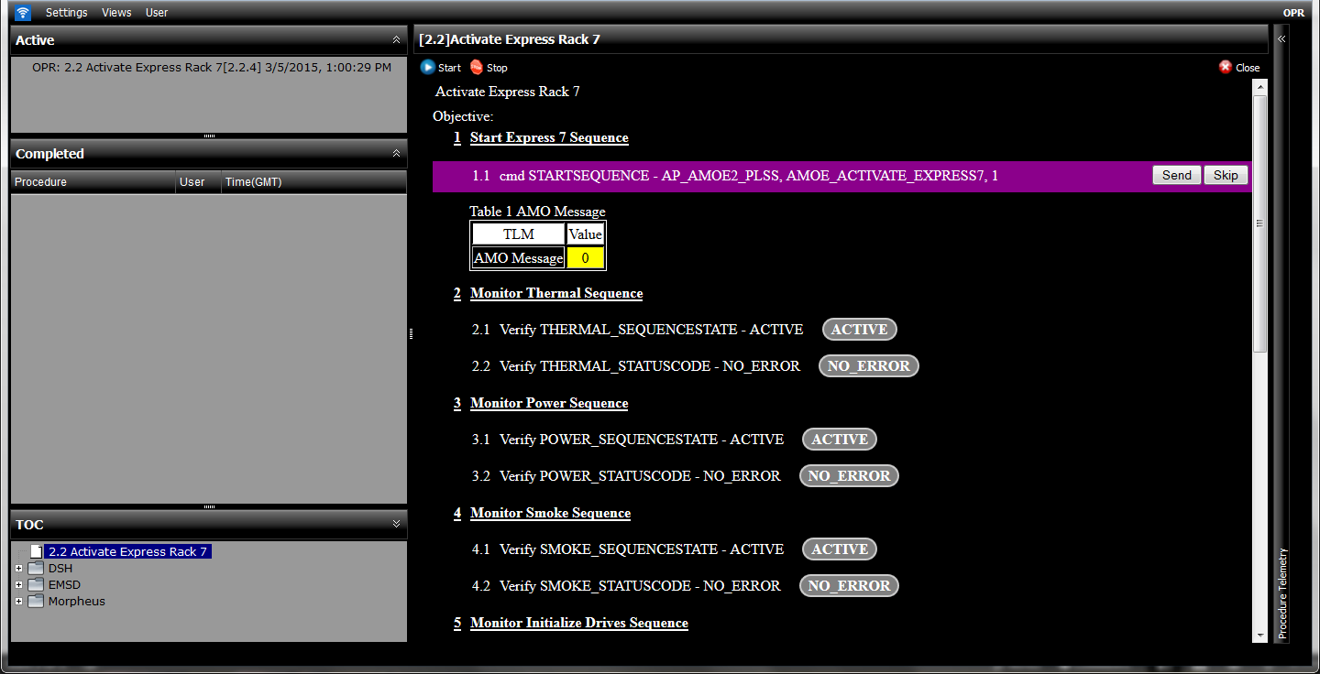
Figure 3: WebPD Active Procedure

When a step in the procedure is off-nominal, WebPD uses color and status text to indicate where the error has occurred as shown in Figure 4.

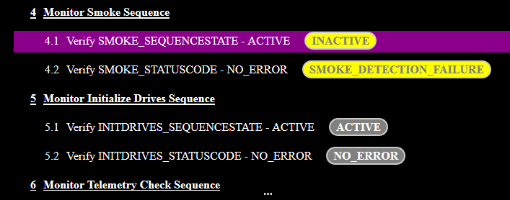
Figure 4: WebPD Off Nominal

Once a step has completed in WebPD, the step text turns from white to grey as shown in Figure 5. The procedure is also listed in the ‘Completed’ procedure box on the left side of Figure 5. On the right side of Figure 5, dynamic detailed telemetry is provided for the procedure and does not necessarily reflect the same value as the labels in the ovals. The dynamic telemetry updates with various detailed statuses as the procedure progresses while the procedure list only shows the steps status of active/inactive and the final status code when completed.

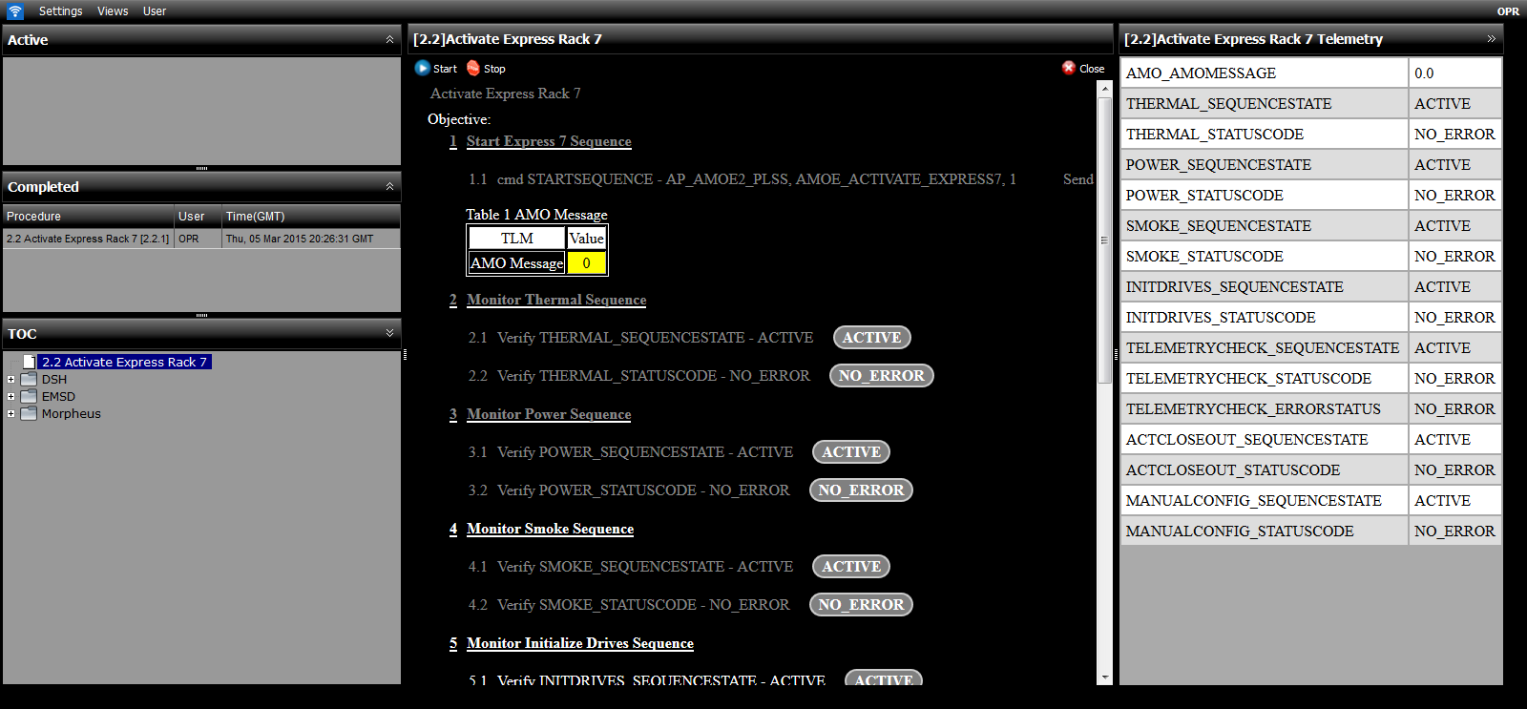
Figure 5: WebPD UI Complete

4.2 Subject Matter Experts (SME) & Ground Crew Evaluations
The initial version of WebPD went through two sets of user evaluations before being used on-board ISS. These user evaluations were focused on the usability of the user interface and the situational awareness they would provide the crew. The two types of evaluations conducted were SME evaluations and ground crew evaluations. SME evaluations consisted of six flight controllers from MSFC from various positions, including the PRO position which is the primary operator of the EXPRESS racks. Ground crew evaluations included four crew or crew office representative participants. All evaluations used a semi-structured interview technique, where evaluators asked participants to "think aloud" while conducting a series of tasks. This method of data collection created a conversational session between evaluators and participants. The SME evaluation helped to improve the interview guide used for the ground crew evaluations.
One of the significant modifications made throughout the project was the result of ISS display standards that were imposed on the UI. Although the goal of the UI was to test crew interaction with a UI for autonomous systems, the UI was still constrained to these standards. This prevented the ASO team from testing out the entire set of conceptual design elements. Conceptual features that were changed to meet existing standards include: interface colors, icon selection, button rounding, and wording limited to operational nomenclature.
Feedback received for EXPRESS 2.0 SME and ground crew evaluations was collected in preparation for on-orbit operations. The team analysed feedback to determine what information collected provided improvements to meet the UI and project goals. The following list includes changes made to the UI based on the evaluations; these changes are shown on the updated UI in Figure 6.
- At any time, once a procedure is open, it can be hidden, but not closed.
- A green highlight indicates the active step in a procedure. Status of the step is located in the dark grey bubble with desired status of the step for a nominal completion written within the text of the step. For steps completed off-nominally, an off-nominal star block will appear below the off-nominal status code step.
- For off-nominal signatures, the parent step turns orange, sub steps remain black until worked, then turn grey, and star block matches text color (black while working, dark grey when completed).
- Add a progress bar to reflect percentage complete and a timer for additional situational awareness.
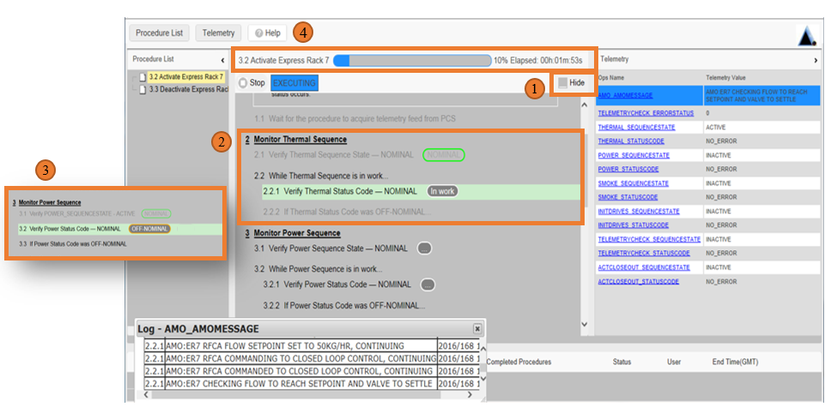
Figure 6: WebPD Updates

4.3 On-orbit Execution and Feedback
On-orbit executions were completed by three crewmembers. Feedback from the crew was received through both on-orbit feedback after the activity was completed as well as during crew debrief post-mission once the crew were back on the ground. Below is a transcript of one crewmember’s feedback on the space-to-ground communication immediately following the on-orbit execution.

CREW: In general, the flow is fairly intuitive, however during the time of execution I think it read 50% elapsed on the progress bar the entire time, so it’s not providing any useful information. So that is why I asked about the time. The timer is active I see that, and I see the in-work status, so I was presuming that it was still in work. On 1.3, it’s greyed out but it has a green circle around nominal, the word nominal, actually there is two words they both say nominal, the second one is circled. And then 1.4.1 it says verify the activation status code nominal, is that referring to the same thing? One is called a sequence state and one is called a status code, or are they to two different things?
HSV: [Crew] we believe these are two different statuses, that’s why you see two of them.
CREW: HSV Station, I assume what I am looking at is the completion of deactivation? It’s not intuitive to me.
HSV: We are just waiting for the rack to deactivate, we just need a couple more minutes of Ku
CREW: Okay, will the display give me a cue that is completed?
HSV: [Crew] you were just waiting on us, you now have a go to close that application.

It was apparent from this feedback that the crew had difficultly deciphering the different features used for the in-work and completed statuses. Additionally, technical terms, such as status code and sequence state, were used but should have been simplified into higher level terms.
Overall, the feedback received during the crew debrief indicated that the software was easy to use, they were comfortable completing the tasks, and didn't run into any major difficulties completing the task. However, there were a few issues related to the overall execution listed below.
- Titling of procedures should be clearly distinct from other procedures
- Telemetry should display a status and only be shown if crew is waiting on a process

4.4 EXPRESS 2.0 Summary
Feedback from the crew while on-orbit and during the crew debriefs was summarized to be utilized for the next iteration of the design. The next iteration would need simplified statuses during software execution to prevent confusion as there was in the design used for EXPRESS 2.0. Additionally, the displayed procedure titles must allow for differentiation especially if they are similar in name. While it would be ideal to change the names of procedures to be different, this could present a challenge to develop distinctly different names due to the technical nomenclature used for these procedures.
In addition to the feedback from the crew, lessons learned from the development process were documented with intention to make improvements for future design processes. One of the most significant lessons learned was that using a procedural format for the autonomous software was misleading because it did not operate in a linear order as it was shown on the user interface. Some of the steps were occurring in parallel, so the numbering scheme could be misleading to a crewmember. Although crewmembers would be expected to operate at a high level where this type of information might not impact them significantly, if the crew needed to troubleshoot for an emergency related to the software, it would be critical for the UI to provide concise information for the crew to process. Another lesson learned involved how the crew used the telemetry box to complete the task. The WebPD telemetry log was a separate pop-up that obscured other areas on the screen rather than integrating with the WebPD UI. Through observation, it was apparent that crewmembers had varying approaches to interacting with software. For example, some crewmembers preferred to see details of what was happening within the software while others were satisfied with viewing a high level status; therefore, the telemetry log should be an integrated frame rather than a pop-up that blocks any information.

5. EXPRESS 2.5
After completing EXPRESS 2.0, the team decided to pursue further development of the project by adding a new capability, crew self-scheduling of autonomous activities. The goals of the new project, EXPRESS 2.5, included the autonomous procedures capabilities of EXPRESS 2.0 and the additional functionality to allow crew to choose when to schedule autonomous procedures on the activities timeline. The data collected from the EXPRESS 2.0 initial evaluations, ground crew evaluations, and on-orbit evaluations were all incorporated into the design process for EXPRESS 2.5. Allowing crew to self-schedule activities required designing constraints to assist with accurate scheduling, such as preventing crew from scheduling over time critical activities These constraints were added to activities to prevent undesired or conflicting overlap of activities. In addition to the scheduling functionality, the software commanding the rack was updated to support the system autonomously recovering from an error. The UI would still allow for single-button activation and deactivation of an EXPRESS rack, but now the software could recover and provide feedback to crew for situational awareness or provide actions the crew should take to recover if the autonomous software encountered an error. When considering all of the complex additions and changes from EXPRESS 2.0 to EXPRESS 2.5, it was decided to develop a new higher fidelity UI instead building off of WebPD.

5.1 UI design
Initial development of the UI for EXPRESS 2.5 included two major components, scheduling and the EXPRESS interface. Both of these major components had subcomponents to support tasks the user was expected to complete through the UI. Beginning with the major components and the data collected in EXPRESS 2.0 evaluations, a framework was put together for EXPRESS 2.5. The flow diagram for this framework can be seen in Figure 7.

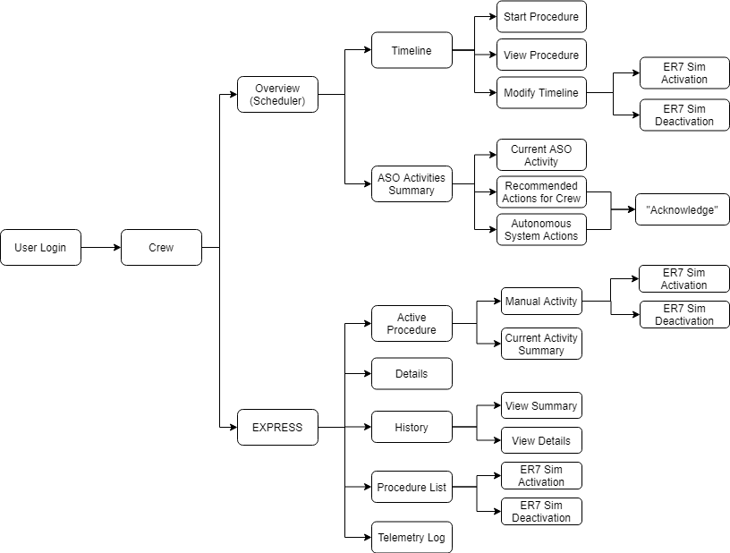

Figure 7: AMO EXPRESS 2.5 Flow Diagram

Comparable to the concept of WebPD, designers of the EXPRESS 2.5 UI strived to manage the shift in workload from ground control to the crew on-board the ISS with added scheduling capability. This put the focus on providing pertinent information to the crew without causing additional workload. When adding the activity scheduling capability, it was crucial to recognize the constraints that multiple ground control teams currently manage. As mentioned previously, an example of one of these constraints would be a time-critical activity on the timeline that cannot be scheduled over with other activities. There should be no expectation that the crew would be able to manage these constraints on their own. The constraints need to be managed within a system that assists the crew during activity scheduling. The EXPRESS 2.5 UI design team built tools that work in the background to manage those constraints within the activities in order to provide the crew with that information.
Design elements were developed to provide information that was anticipated to support crew autonomy with situational awareness and completion of the task. The intent was for the information provided to allow the crew to accomplish the task, on their own, in the same amount of time, or less, than the ground today.

5.1.1 Scheduling
To provide crew with self-scheduling capabilities, the UI included a scheduling component with a timeline to enable crewmembers managing their own activities, including scheduling new activities, deleting activities, or rescheduling activities. The timeline also provides information about availability and constraints pertinent to when the activity’s potentially scheduled time so crew can make more informed scheduling decisions. Currently the majority of this work is performed by ground control teams who frequently update schedules so that crewmembers do not need to manage schedules. A color-coding system for what was deemed “best fit” for the activities was used to aid crew decision making regarding scheduling activities. This color-coding included three options that showed availability on the timeline: green for activities with no conflicts, yellow for activities with a non-critical conflict, or grey for activities with critical conflicts or unavailable time. As different timeslots were selected to place activities, constraints were listed for awareness. Color-coding and notification of constraints can be seen in the first iteration of the design in Figure 8 below.

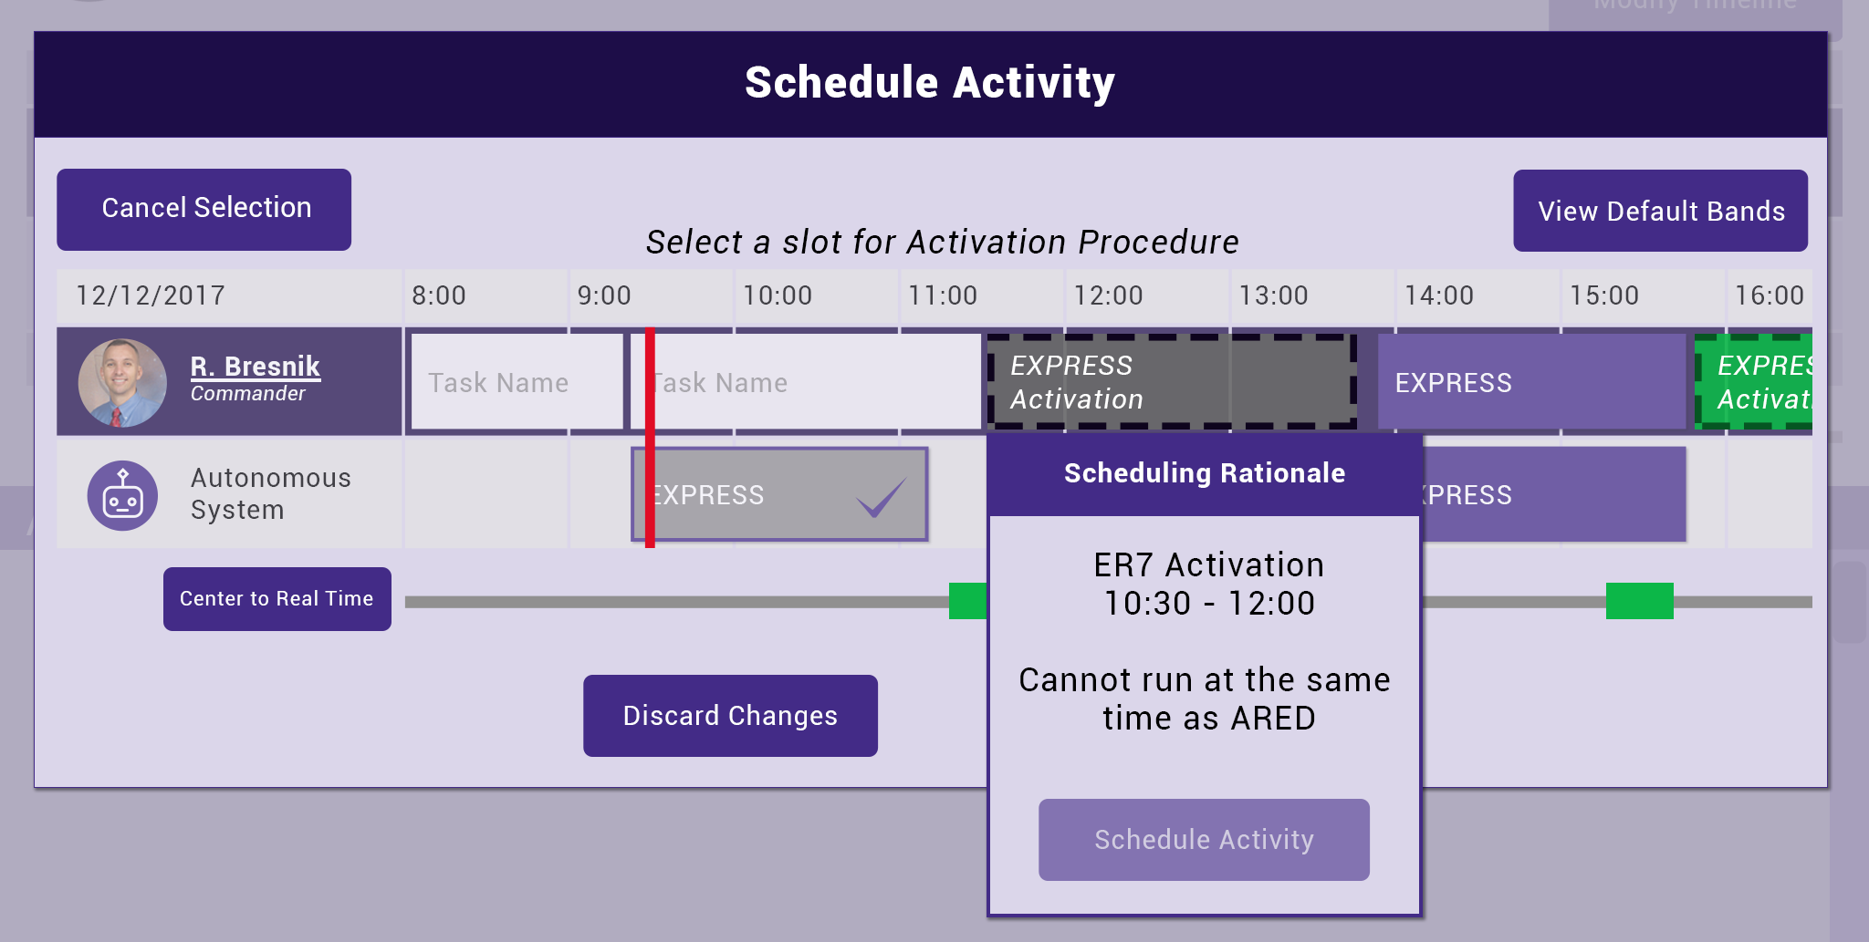
Figure 8: Initial Scheduling Component Concept

ISS currently has timeline software on-board used for crew schedules called Operations Planning Timeline Integration System (OPTimIS). An important usability principle to consider is design consistency across systems. OPTimIS includes timeline bands which show scheduled activities and resources for each crew member and some systems on-board ISS. For the timeline design for EXPRESS 2.5 it was important to incorporate some of the features the crew was already familiar with in OPTimIS. This was done strategically, and only with features that were critical to task success and situational awareness such as nomenclature for activities and current time marker (red line in figure 9 below).
Two additional features incorporated into the scheduling component were the autonomous system band and the ability to see other crewmember timeline bands. These system timeline bands show when a system is active (i.e. a resource is being used). The autonomous system band has a similar function; it populates with autonomous system activities to provide crew awareness of when these systems are active. This awareness is important, ensuring that there is no overlap of activities that cannot be completed in parallel (ex. an activation and deactivation cannot occur concurrently). The capability to expand and collapse other crewmembers’ timelines was implemented in EXPRESS 2.5, also for situational awareness. While it is designed to prevent scheduling conflicts of critical activities, the ability to view other crewmember’s timelines provides insight that allows each crewmember to schedule activities based on their personal preference based on what else is going on that day for the mission. The initial design concept for the autonomous system band and the collapse and expand feature can be seen in Figure 9.

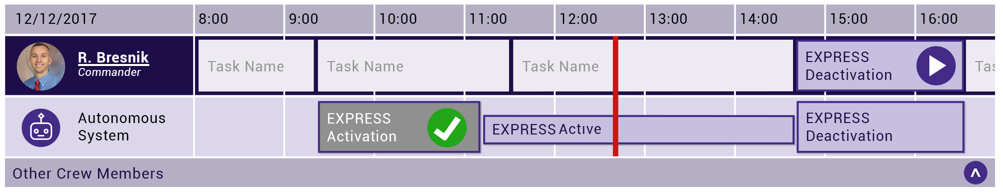
Figure 9: Timeline View

5.1.2 EXPRESS
The second major component of the UI includes the capability to command the EXPRESS rack, using the same functionality from WebPD in EXPRESS 2.0. However, the design of the EXPRESS 2.5 UI used for interaction with the EXPRESS rack looked and behaved differently than WebPD. Within the EXPRESS component, the procedure statuses are present as they were in WebPD but in a simplified format. In EXPRESS 2.0, the crew on-orbit struggled to determine the state and status of the procedure as well as misunderstanding that the autonomous procedure could have more than one active state at a time running in parallel. Learning from these two lessons resulted in a simplified design concept for EXPRESS 2.5 as shown in Figure 10. Procedure step numbers were removed and the status and sequence code simplified to one-step in a vertical line to eliminate any perceived order within the procedure.

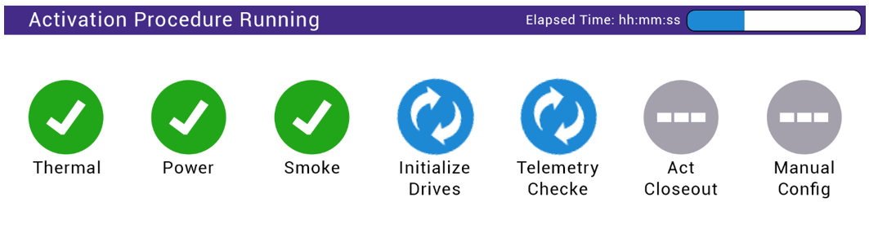
Figure 10: Updated Procedure Statuses

Within the EXPRESS component, it was also important to summarize the status of activities as well as provide feedback upon completion to provide situational awareness to crew as procedures progressed. Beneath the timeline is the ASO Activities Summary. This section is populated with current activities, completed activities, autonomous recovery information, and crew actions. Shown in Figure 11, autonomous recovery information provides insight to the crew of the result of the procedure and any autonomous recovery actions the software took to correct off-nominal signatures. Although the software autonomously recovered, it is important that the crew has this situational awareness of actions that occurred with the rack. Understanding trends of rack behavior will allow crewmembers to make appropriate judgements of the rack’s status. The design to indicate an autonomous recovery step includes a green check within only a small indicator of an issue using the caution sign, as shown on ‘Initialize Drives’ and ‘Telemetry Checked’ in Figure 11. The intent is to convey that the rack is operating nominally, but there is additional information that should be known about the current state. This information is duplicated within the UI by also being shown on the scheduling page so that the crew can continue to be aware of activity statuses while scheduling activities.

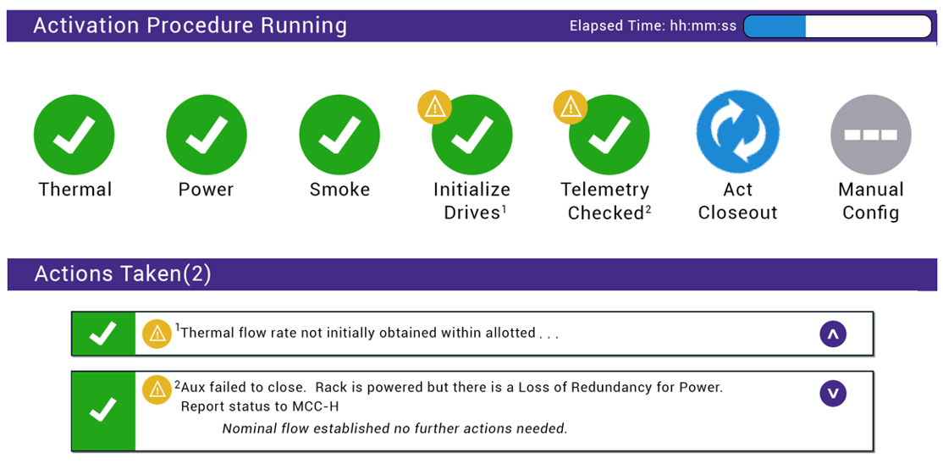
Figure 11: Autonomous Recovery

For critical issues, it is necessary to emphasize the importance of what has occurred and to convey if there is a priority to take action. Where crew action is needed, two design approaches have been implemented. The first is providing the crew an action dialog, this can be seen on the bottom left side of Figure 12 in the section ‘Recommended Actions’. Selecting the ‘Acknowledge’ button clears the notification from the screen indicating that it was viewed by the crew; a new procedure cannot begin with ‘Recommended Actions’ that have not been acknowledged to prevent causing any further issues with pending actions to be taken. The second is a pop-up with the action that needs to take place and a button to begin that action. If the action is time-critical, providing a pop-up with a button that automatically initiates the procedure potentially reduces human error, crew workload, and time when the hardware is at risk, rather than telling the crew what action is needed and requiring them to search for the correct steps to take. This pop-up can be seen on the right side of Figure 12.

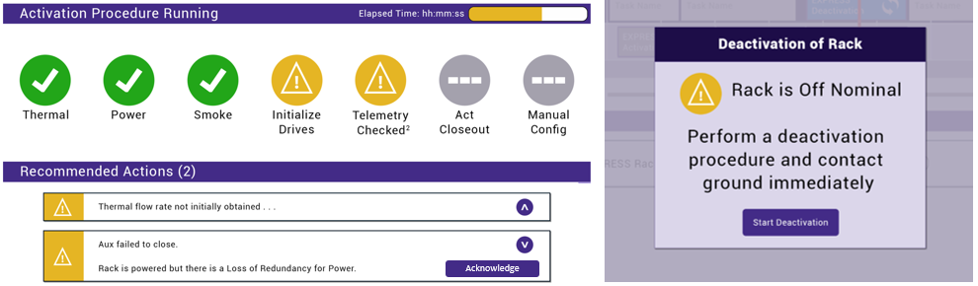
Figure 12: Crew Notifications

Another lesson learned from EXPRESS 2.0 was understanding the need to integrate detailed telemetry into the display. While the simplified single status codes may be preferred by some crewmembers, other crewmembers may desire to see more detail than the simplified single status. In addition to creating a telemetry page, a details page was provided. The details page provides a drop-down list with detailed steps beneath each single simplified status, while the telemetry page displays all of the status codes of the procedure. The details page has step numbers so that there are reference points for troubleshooting or communicating with ground control about a certain step. The details page and telemetry page initial designs can be seen side by side in Figure 13.

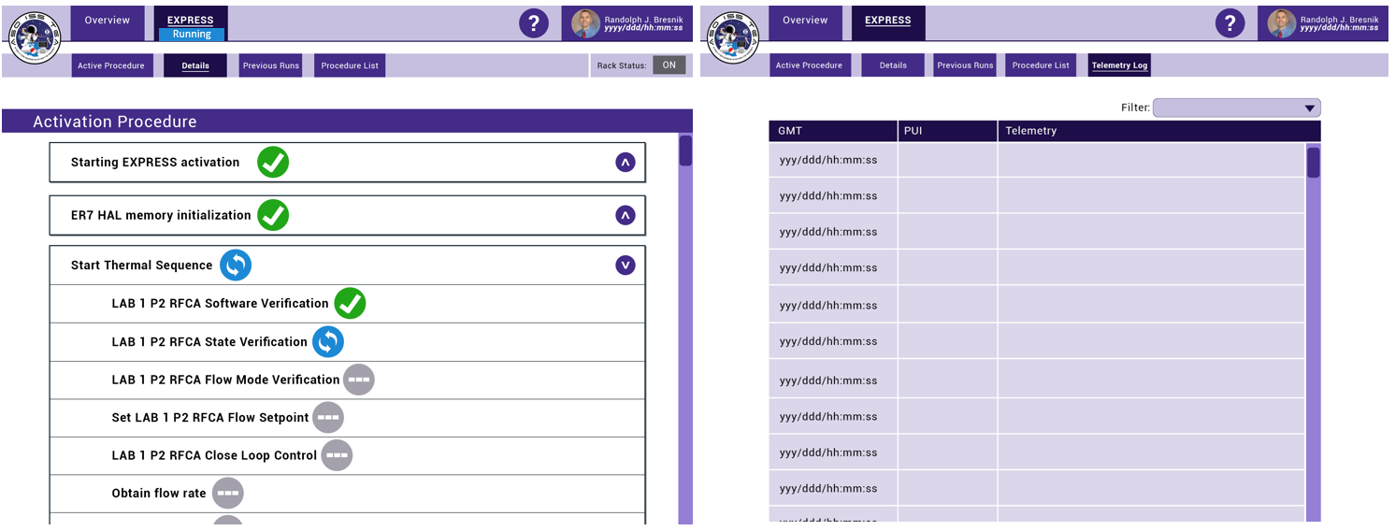
Figure 13: Details and Telemetry pages

Accessing information from past executions will be essential in future long-duration missions for understanding the state of the system. Developing a history page was a priority, not only for short-term access to ensure the task was complete, but additionally long-term to see trends of how the system has behaved over time. The history page shows the summary and the details of each execution, shown in Figure 14.

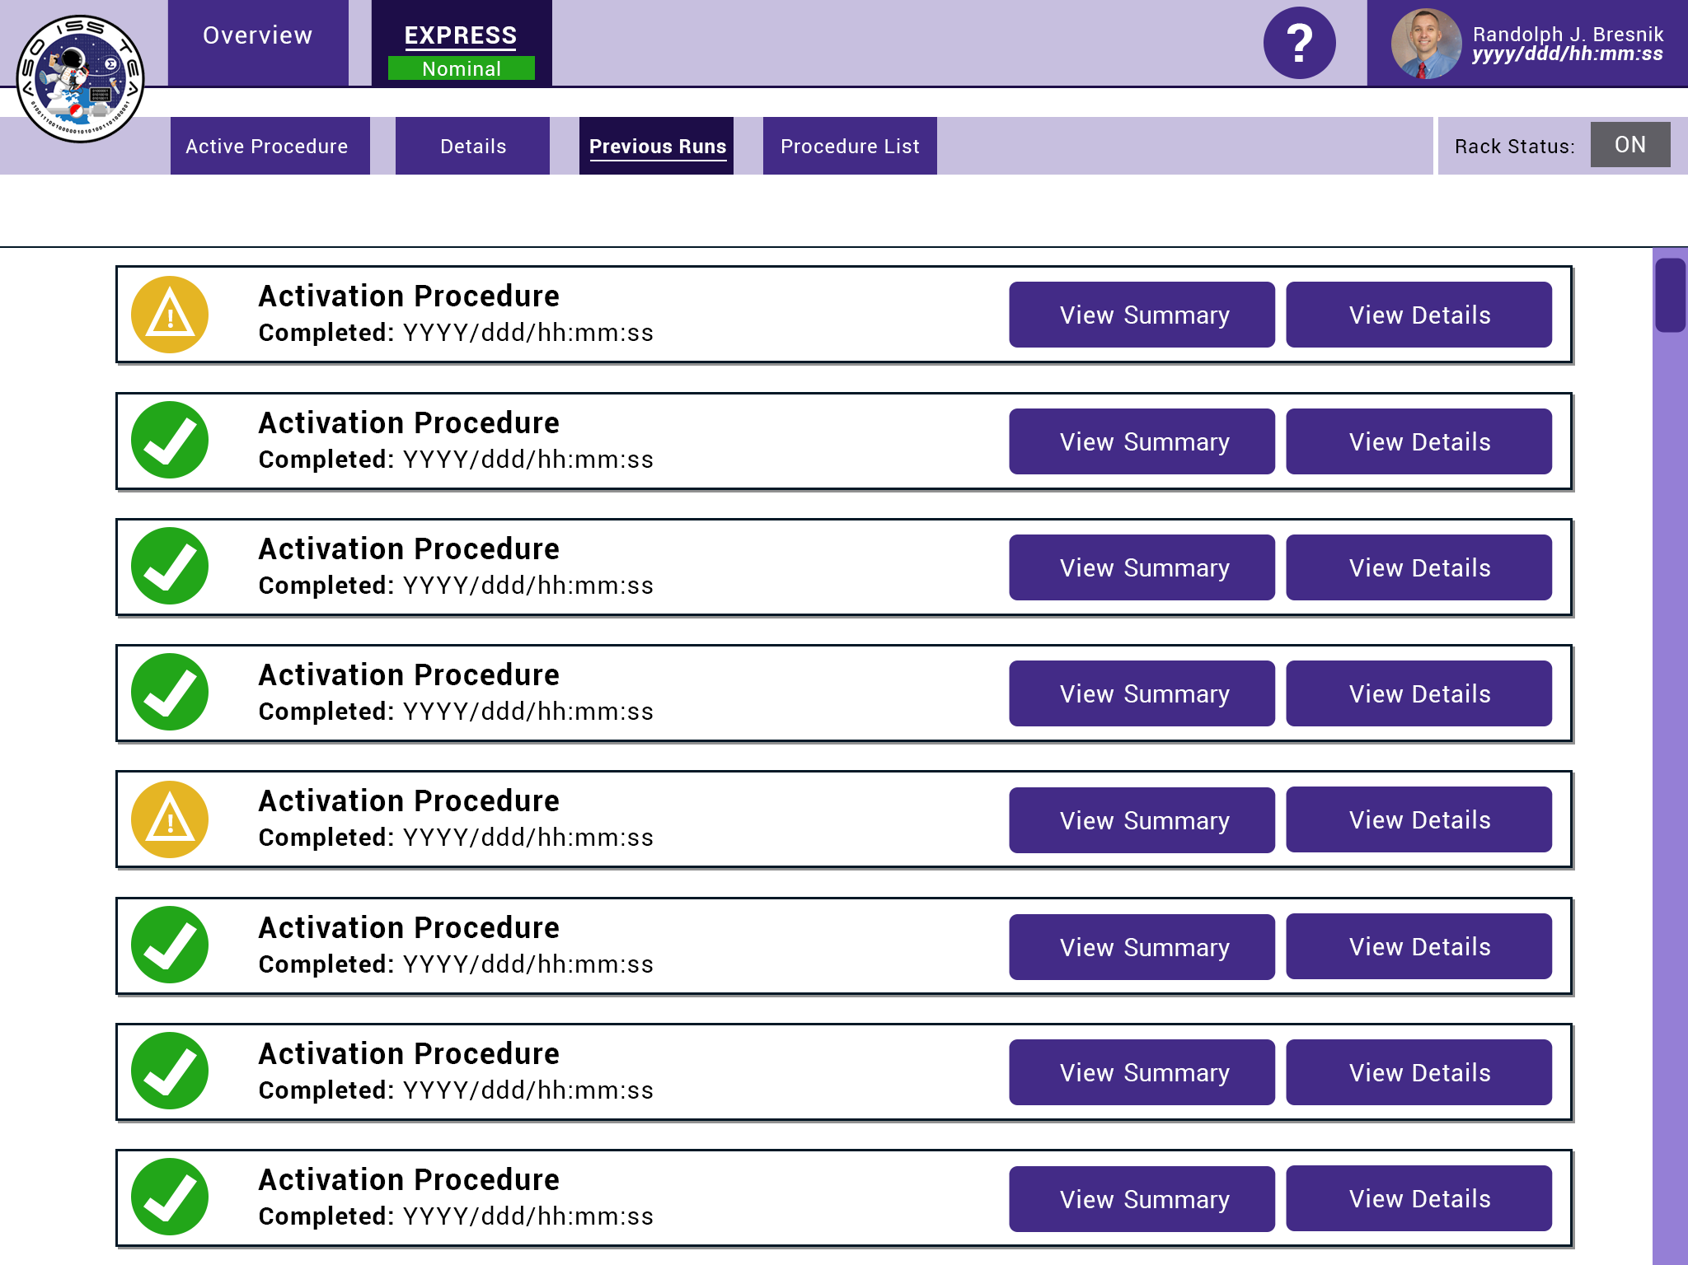
Figure 14: History page

To prepare for operations, the crew often reviews procedures prior to execution. To support this, the EXPRESS 2.5 UI includes a procedure list page where crewmembers can review procedures in a static format. The intent is that all procedures operated from this system would have a static version for review. The procedure list concept can be seen in Figure 15.

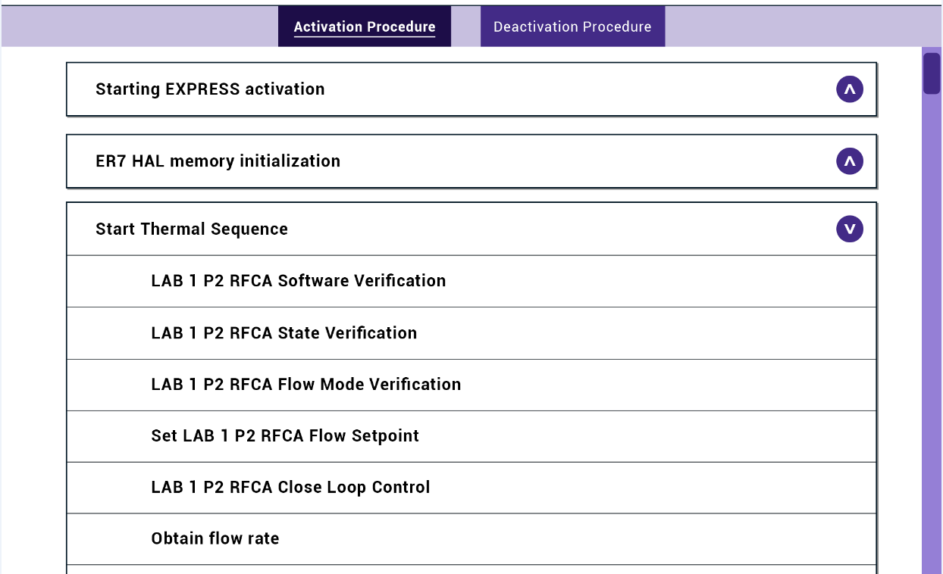
Figure 15: Procedure List

5.2 Scenario Development
Multiple rack operation scenarios were created to test the goals and functions of the UI, including four nominal and two off-nominal. Two of the four nominal scenarios included autonomous recovery by the software. In these scenarios, crew are provided with a nominal status but also information on the recovered error. The two off-nominal scenarios included non-recoverable faults that required crew intervention. By developing and testing multiple scenarios with varying outcomes, the crew had more opportunities to give feedback to the design team on different components of the UI.

5.3 SME & Ground Crew Evaluations
SME evaluations for EXPRESS 2.5 were conducted at MSFC with six participants using only a laptop, while the ground crew evaluations were conducted at JSC with seven crewmembers who were given the option to evaluate the UI on an iPad or a laptop, the same choice they will have during on-orbit execution. SME participants for EXPRESS 2.5 were again participants from MSFC that interact with EXPRESS racks regularly. A semi-structured interview guide was used for the evaluations. The guide included instructions and questions focused on collecting feedback on UI functions. Participants were encouraged to "think aloud" during the evaluation, allowing the test conductors to complete cognitive interviewing with participants.
SME evaluations resulted in a significant number of changes to the UI with many major redesign efforts; however, this was the intent of these evaluations. Many significant issues were revealed during SME evaluations and modified by the design team prior to ground evaluations. This led to improvement of the UI design and allowed the crew to evaluate a more mature product. With a more mature product, crew were able to give feedback based on their prior on-orbit experiences rather than focusing on general issues like color and nomenclature.
For ground crew evaluations, none of the participants had ever interacted with the EXPRESS 2.5 software prior to this assessment, but the majority of them were successful in accomplishing all scenario tasks. Table 1 shows the data collected regarding task success. After reviewing the data, the lower success rates were associated with scheduling activities.
Table 1: EXPRESS 2.5 Evaluation Data
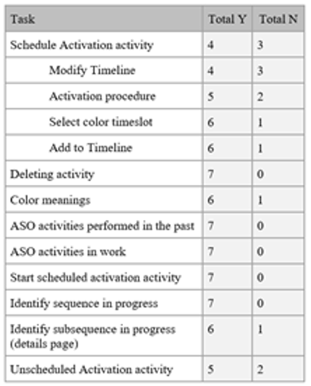

Crew provided valuable user interface feedback. The positive feedback received was just as useful as the critical, as it validated some design features. A few items that received positive feedback: simple login with no passwords for quick access, dynamic feedback when things are active or working, highly visible green check marks to validate when something has been successful, and the extensive coverage within the help content.
The data collected and feedback received for EXPRESS 2.5 SME and ground crew evaluations was collected and incorporated into the design in preparation for the on-orbit operations. Participants provided feedback regarding the overall color scheme, expressing they sought something more neutral. In Figure 16, the overall color scheme was modified from the initial designs shown in Section 5.1, EXPRESS 2.5 UI Design. Figure 16 also includes the relocation and addition of buttons or features to increase visual saliency and situational awareness. During evaluations, participants had to search the UI to find certain features or noted they didn’t think they had high visibility. Adjustments were made to the UI to remedy these concerns.

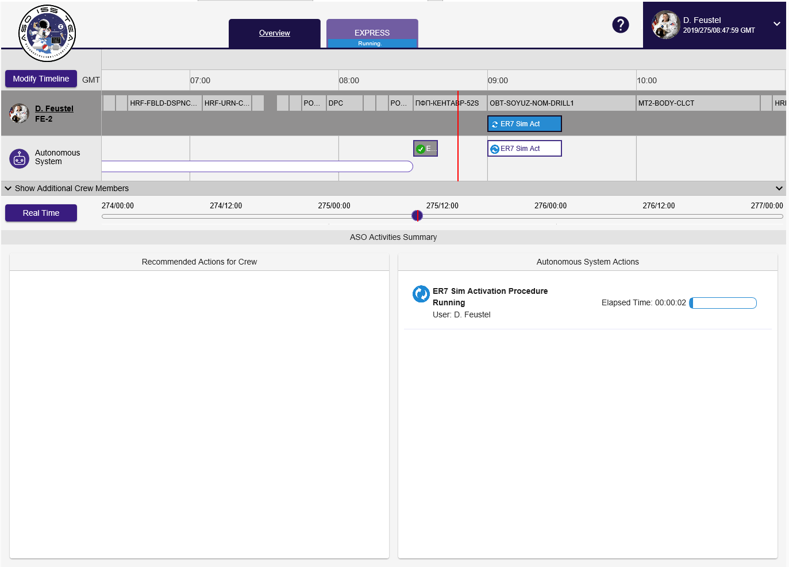
Figure 16: Updated Overview Page

Participants pointed out during the ground crew evaluations that the titles of the pages were misleading when the activity on the page only matched the title while it was active. It can be seen in Figure 17 where this was addressed by implementing a dynamic title that changes based on the state of the page, toggling between ‘Procedure’ and ‘Active Procedure’.

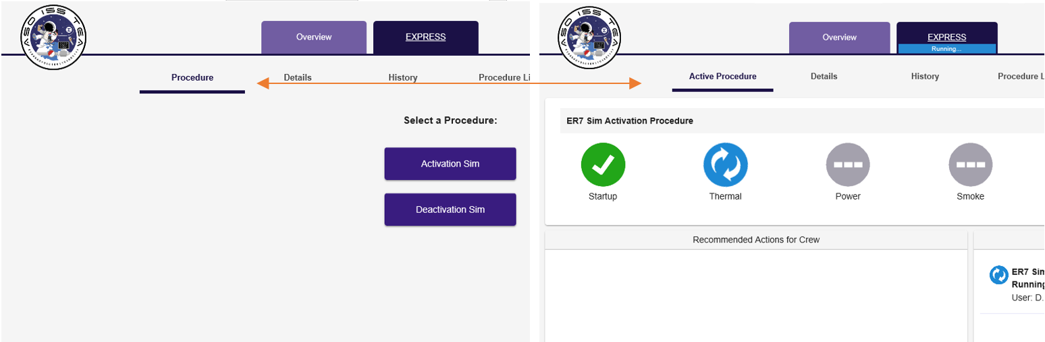
Figure 17: Dynamic Page Titles

During ground crew evaluations, crewmembers were asked to schedule activities. As noted in Table 1 above, the lower success rates were associated with scheduling activities. In addition to data collected on scheduling activities, the feedback collected indicated the need to revisit how activities were scheduled. One of the things noted by the crew about this task was the lack of flexibility within the scheduling tool. The evaluated design allowed for activities to be scheduled every 15 minutes, but the crew wanted to see smaller increments within which they could schedule. Additionally, they commented on the design for finding activity blocks which had large blocks for every hour, and once selected, the 15-minute increments were available within that hour block. This feature drew concerns stemming from the confusion of how activities are scheduled. This concern prompted significant redesign in the scheduling capability. As seen in Figure 18, once the type of procedure activity is selected, the activity block can be dragged anywhere along the timeline within 5 minute increments to be scheduled. A new panel has been added to the left side to show the constraints of the selected timeslot.

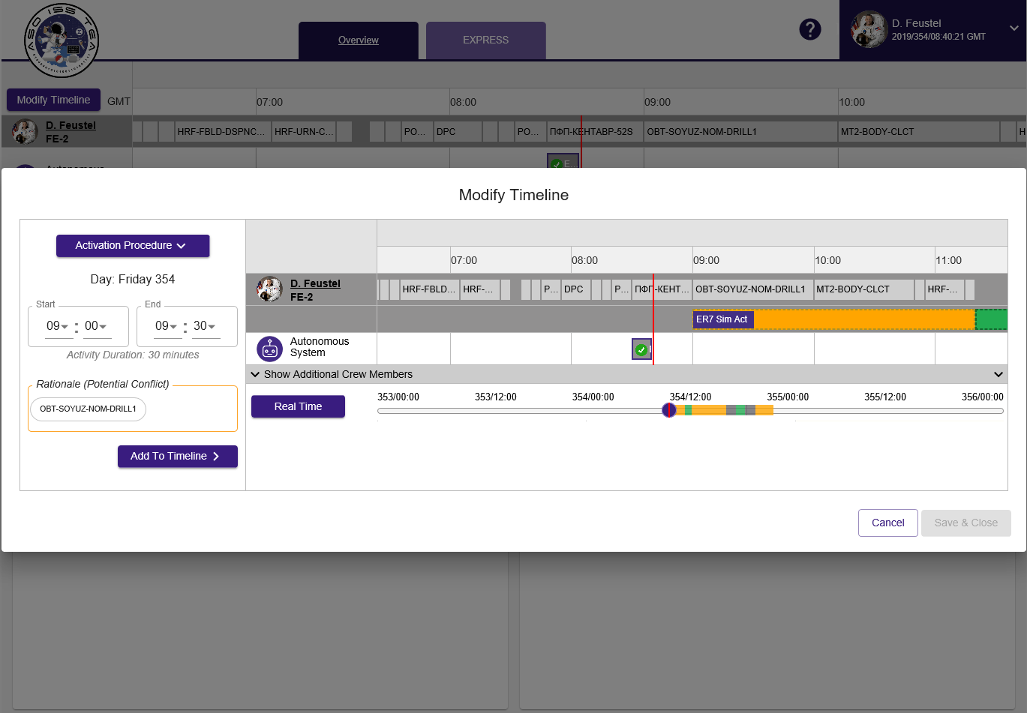
Figure 18: Updated Scheduling Capability

Feedback regarding pop-ups included ensuring information somehow remained visible once the pop-up is closed until the action is complete. In one of the EXPRESS scenarios, a resulting action is to ask the crew to report a status to the ground after completing an task within the UI to begin a deactivation scenario, shown in Figure 19. Crewmembers commented that reporting the status may be forgotten once the pop-up has closed when they begin the next task. To remedy this, the on-orbit design adds this message to the crew action list to again remind them to call the ground. Adding messages that requires crew acknowledgement reduced crew mental workload by displaying the information rather than requiring the crew to recall it.

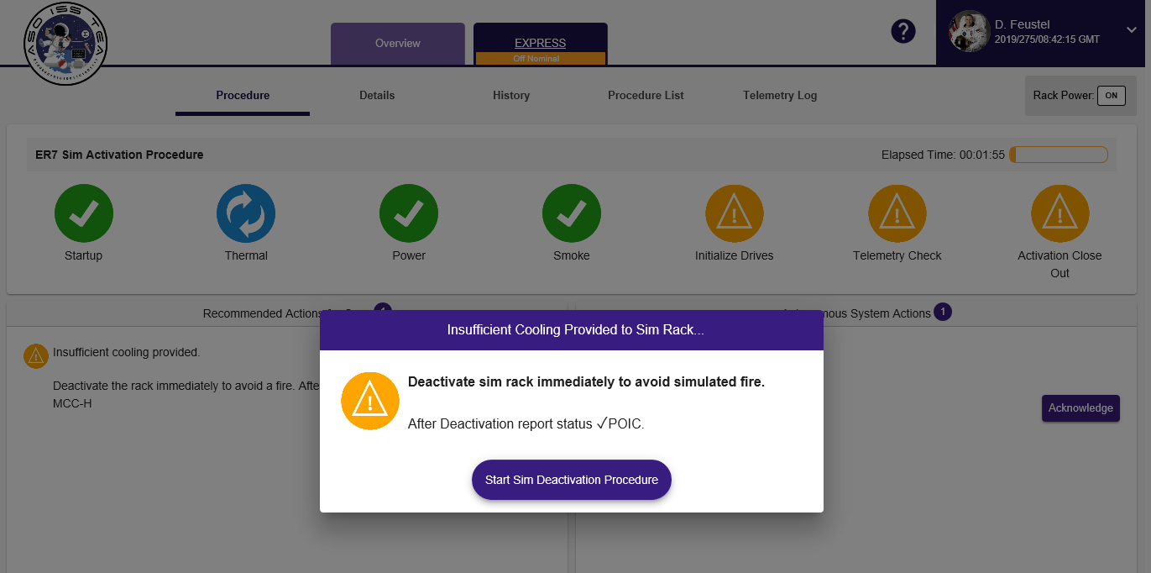
Figure 19: Critical Task Pop-up

There was some feedback not addressed in the updated design. While the feedback was valuable, it did not fit within the current scope of the project. There were comments regarding adapting the design to be more like off-the-shelf scheduling tools, such as Microsoft Office. Developing a custom UI for an experimental project such as this limits the feasibility of developing a tool with the existing capabilities of consumer products. As the project continues, this is an item to consider for further development.

5.4 On-orbit Execution and Feedback
On-orbit executions for EXPRESS 2.5 are planned for late 2021. The expectation is that crew will provide feedback regarding their execution of EXPRESS 2.5 via on-orbit evaluations and in post-mission crew debriefs. The operations will include crew scheduling activation and deactivation EXPRESS activities. In order for the crew to fully evaluate the UI, the scenarios will be pre-planned by ground teams.

- Conclusions
The need for autonomous systems for future long-duration missions is critical. New ways to manage the complex systems used for human spaceflight must be established for astronauts to successfully accomplish mission goals. The UI that is used for interacting with autonomous systems must be designed with astronaut crews in mind. These UI’s must provide appropriate situational awareness about the system so that the crew can make the decisions regarding the system and their mission. Incorporating human factors design principles and evaluation techniques into the design process keeps the human-centered focus that’s needed.
Conducting user evaluations proved to be a critical step in the design process. As seen throughout all phases of the design, significant improvements were made to the preliminary concepts following the SME and ground crew evaluations. These evaluations added tremendous value to the project process by providing insight to areas where important features were missing, causing both misunderstanding of information and excessive time to process information.
While the goal of UI is to deliver a positive user experience, the most critical steps in designing UIs for autonomy is the focus on the information that needs to be provided to the crew. Many of our findings revealed how information should be presented so that crewmembers could have full awareness of system actions. Reducing crew workload will be critical for these future missions. Time wasted trying to interpret information will hinder the crew’s ability to maintain an efficient and successful mission. The design should enable the crew to quickly process the visual information and allow them to take action.

- Future Development
Following the on-orbit evaluations of EXPRESS 2.5, the data collected will be utilized to continue to refine the UI. The next phase of the EXPRESS 2.5 project will evaluate how the crew manages scheduling and operation of multiple autonomous systems.

Acknowledgements
This work was funded by the Advanced Exploration Systems (AES) programs. The authors would like to thank their team members for the expertise and hard work they bring to this project. Additionally, the authors are grateful for the crew and ground support teams for their participation in this experiment.

Appendix A - EXPRESS 2.0 WebPD Screen Captures

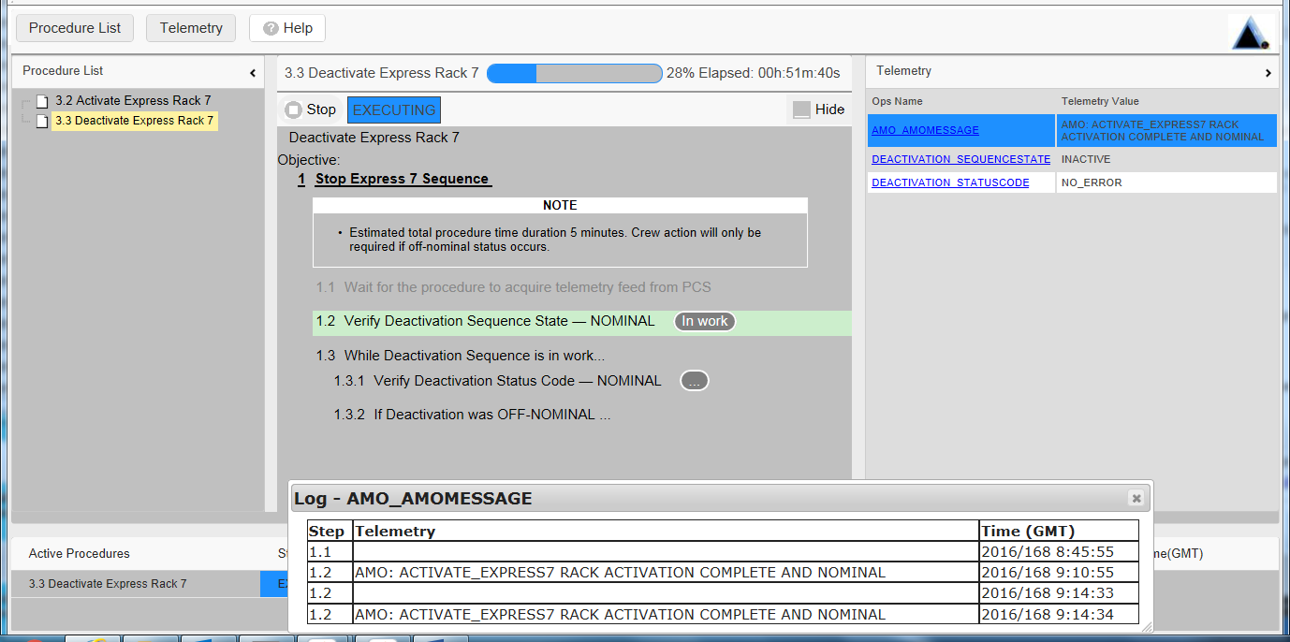
Figure A-1: WebPD In-Progress

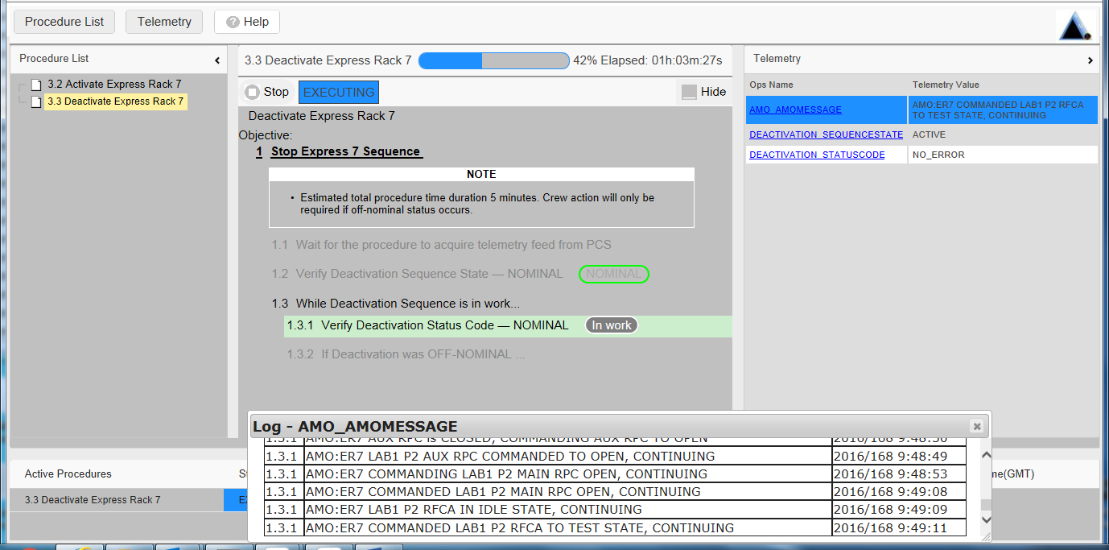
Figure A-2: WebPD In-Progress with Nominal Completed Steps

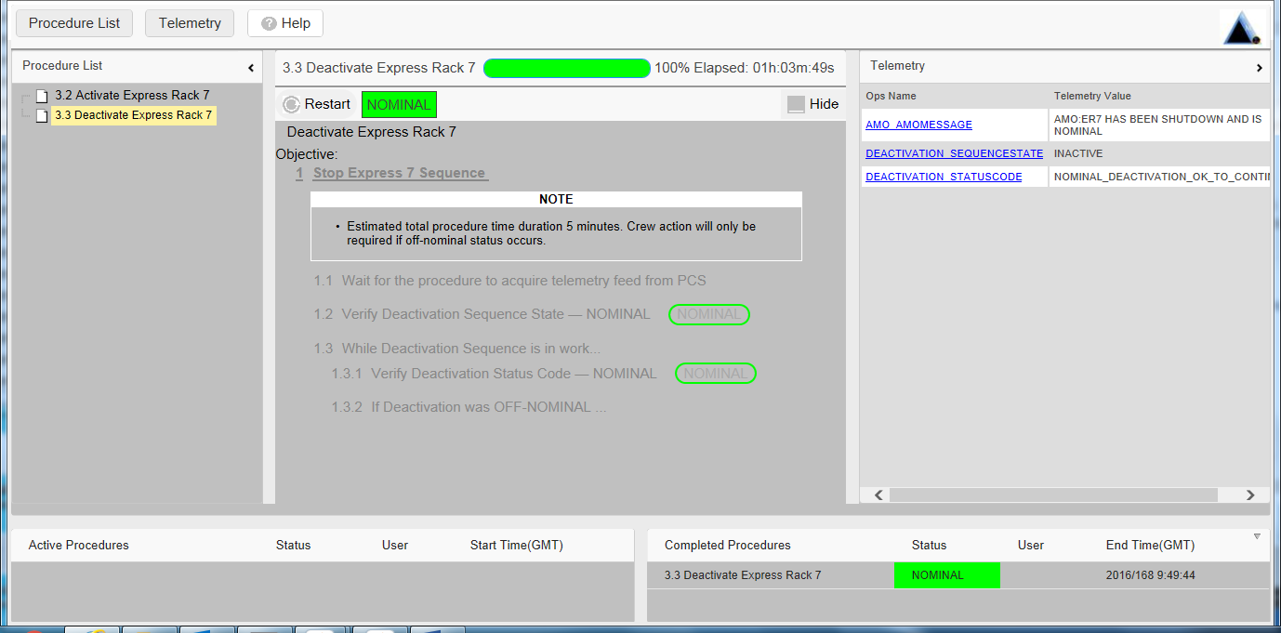
Figure A-3: WebPD Nominal Completion

Appendix B - EXPRESS 2.5 UI Screen Captures

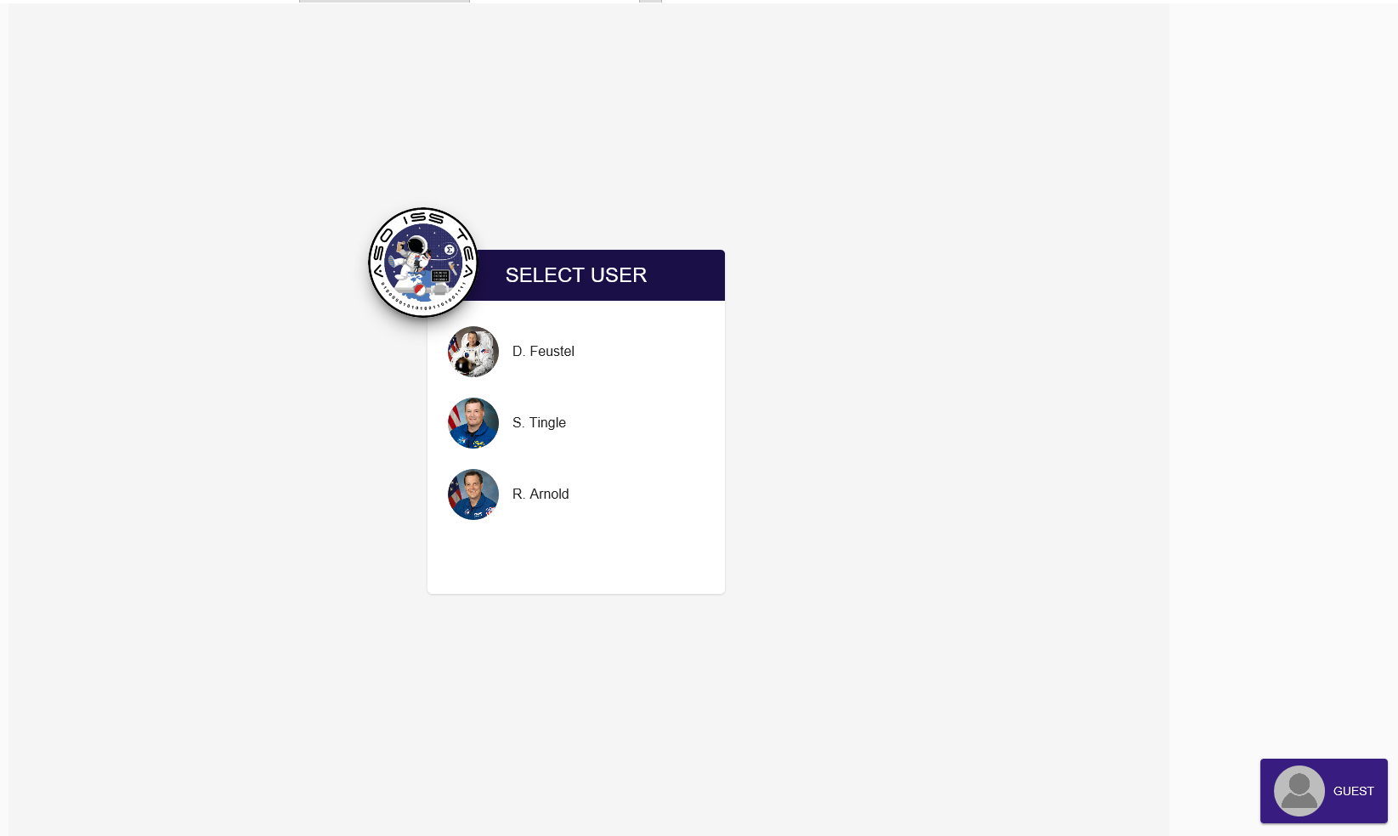
Figure B-1: EXPRESS 2.5 UI Login Screen

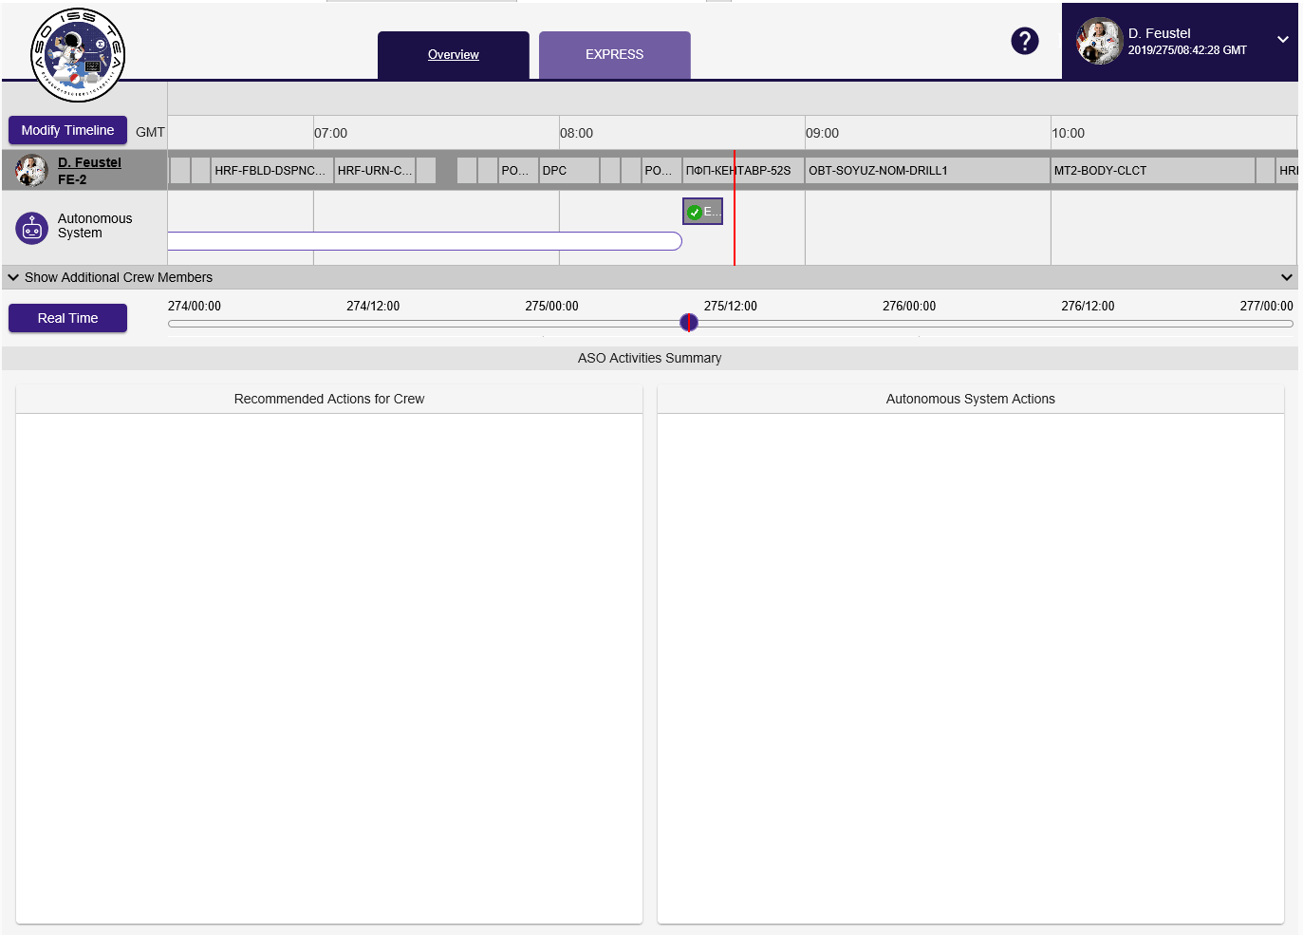
Figure B-2: EXPRESS 2.5 UI Overview/Scheduling Page

Figure B-3: EXPRESS 2.5 UI

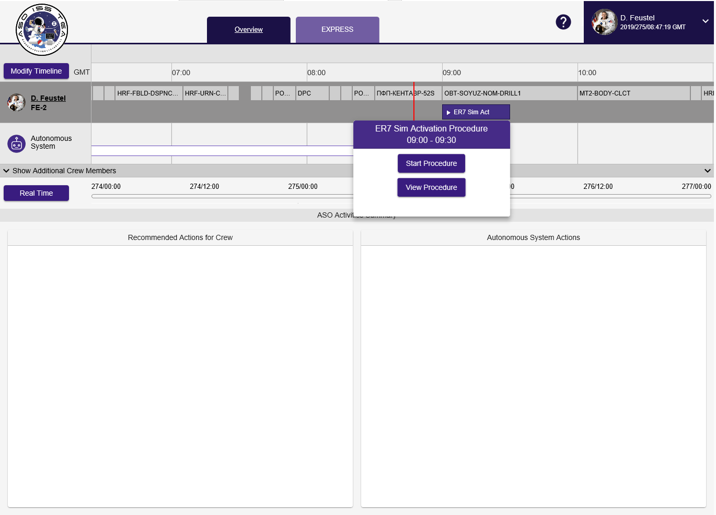
Figure B-4: EXPRESS 2.5 UI Starting Procedure
Figure B-5: EXPRESS 2.5 UI In-Work Procedure Overview/Scheduling page

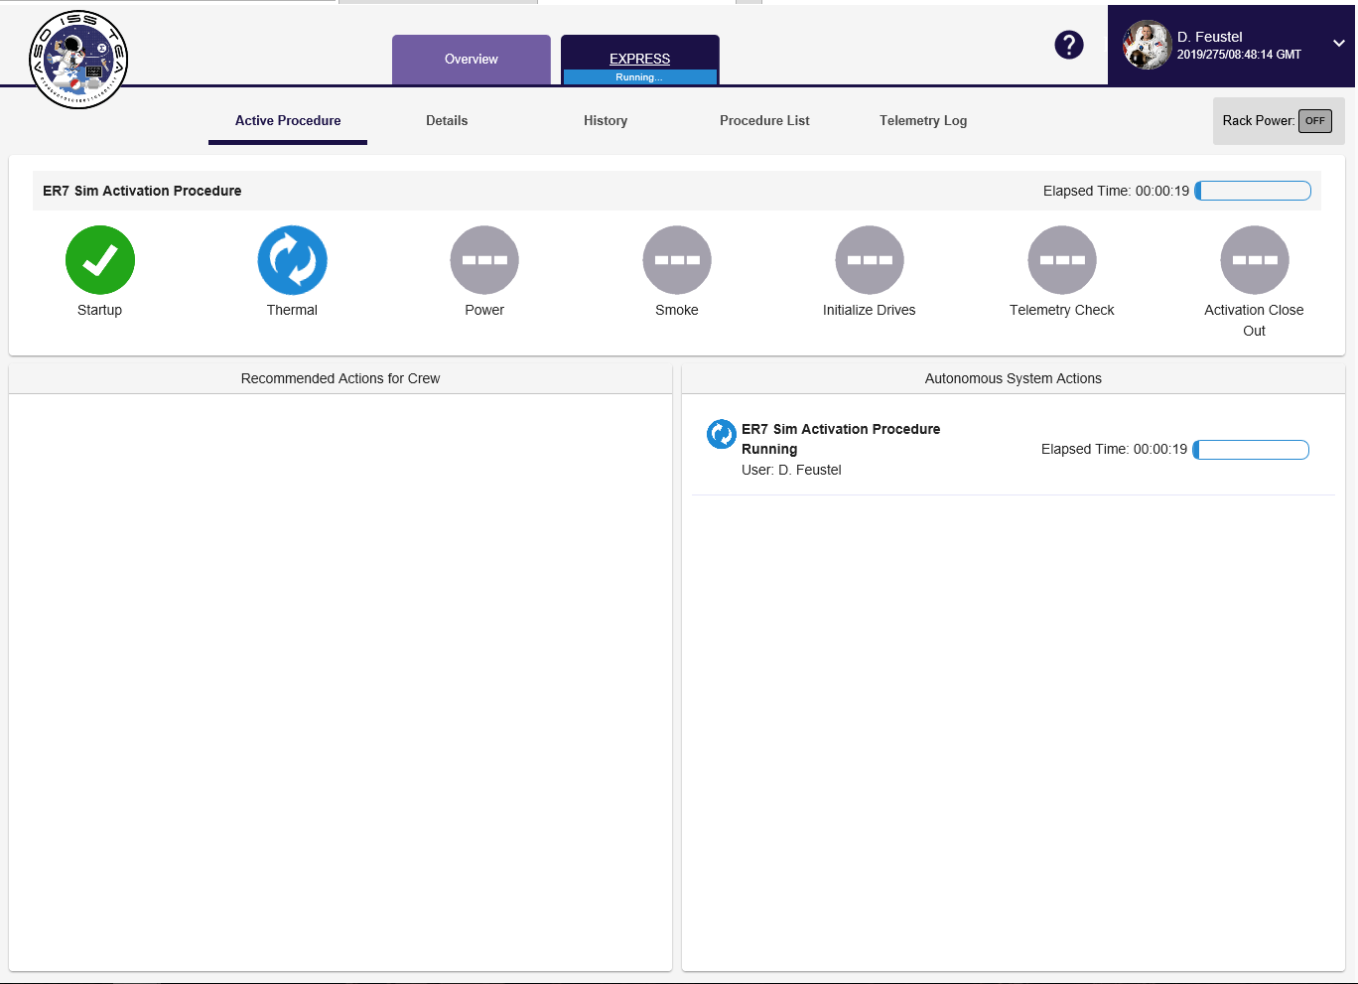
Figure B-6: EXPRESS 2.5 UI In-Work Procedure EXPRESS page

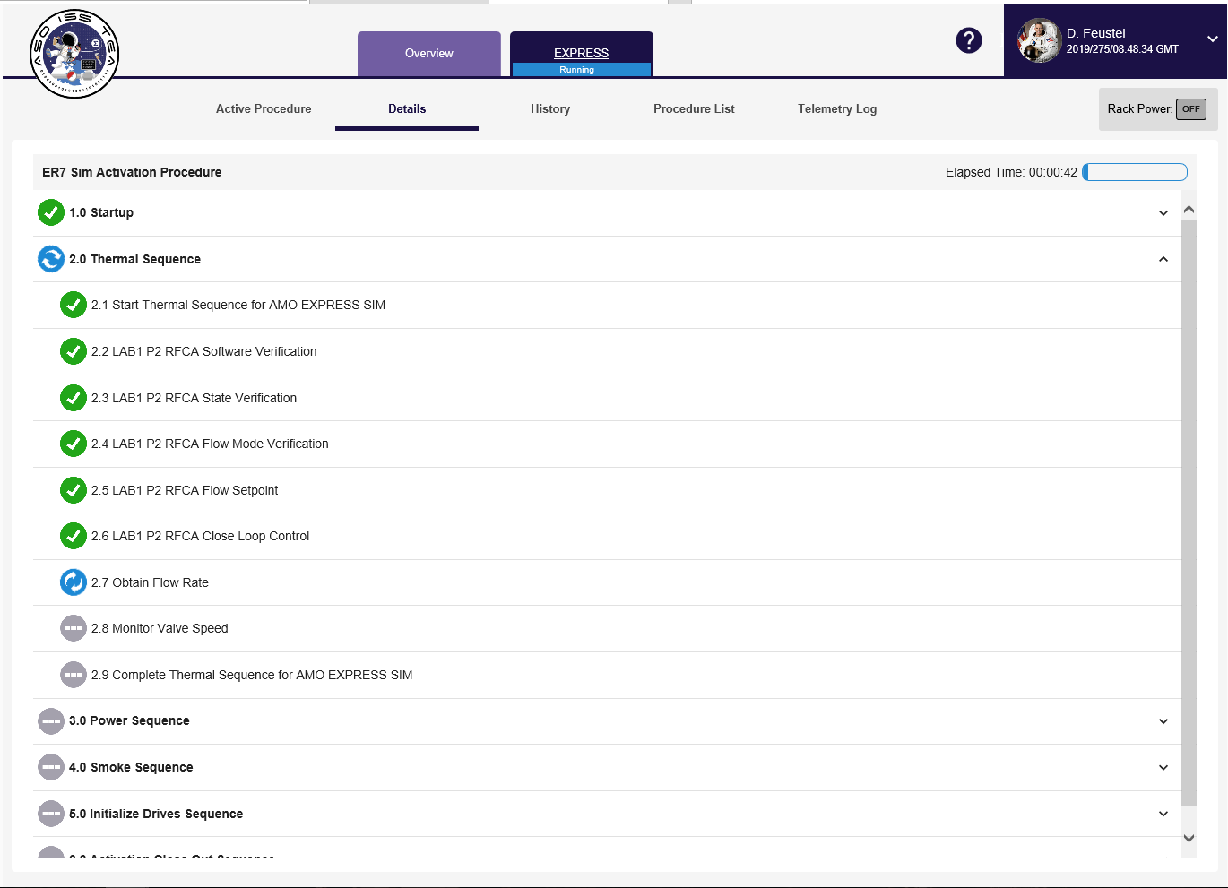
Figure B-7: EXPRESS 2.5 UI Procedure Details page

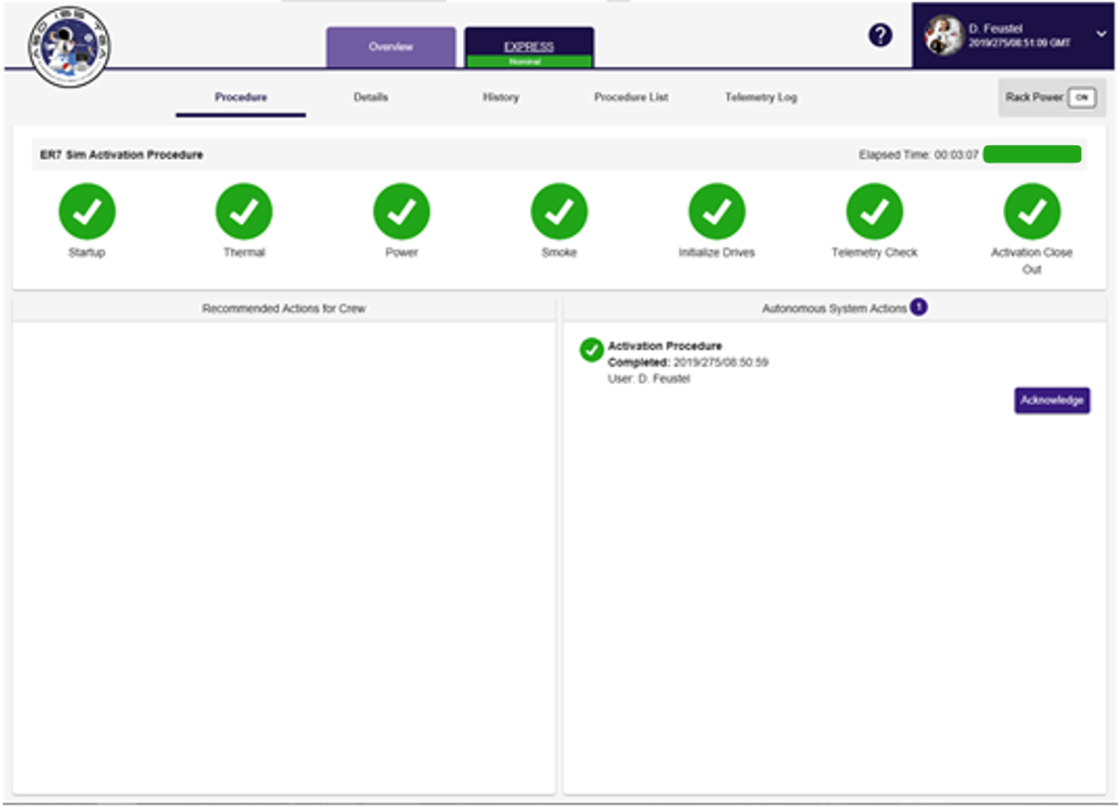
Figure B-8: EXPRESS 2.5 UI Completed Procedure

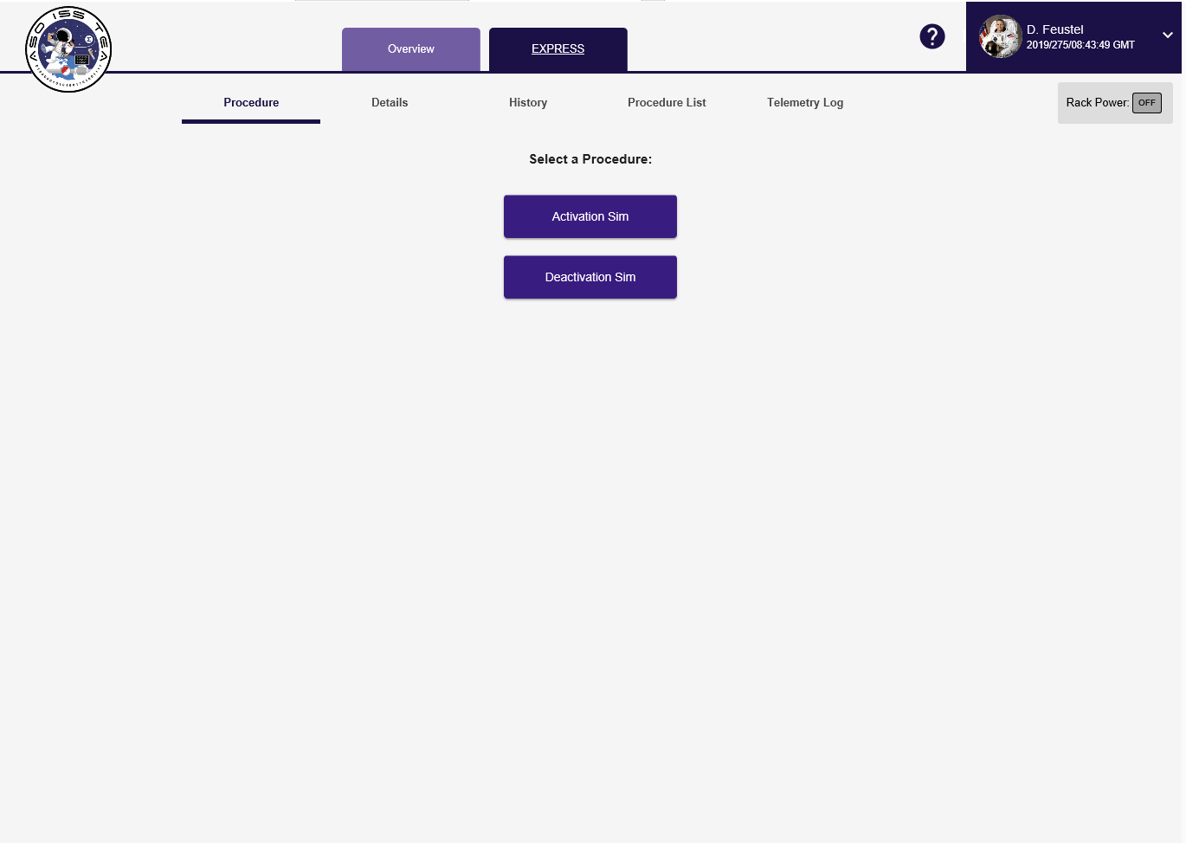
Figure B-9: EXPRESS 2.5 UI Unscheduled Procedure buttons

References
[1] P.G. Roma, S.R. Hursh, R.D. Hienz, Z.S. Brinson, E.D. Gasior, J.V. Brady, Effects of autonomous mission management on crew performance, behavior, and physiology: Insights from ground-based experiments. in D.A. Vakoch, On Orbit and Beyond: Psychological Perspectives on Human Spaceflight. Springer Berlin Heidelberg, 2013, pp. 245-266.

[2] G. Dorais, D. Kortenkamp, Designing Human-Centered Autonomous Agents. (2000) 321-324.
[3] D. Kortenkamp, R.P. Bonasso, D. Ryan, D. Schreckenghost, Traded Control with Autonomous Robots as Mixed Initiative Interaction, AAAI Technical Report SS-97-04 (1997)
[4] A. Steinfeld, Interface Lessons for Fully and Semi-Autonomous Mobile Robots, Proceedings of the 2004 IEEE International Conference on Robotics & Automation, (2004) 2752 - 2757 Vol. 3
[5] H. Stetson, A. Haddock, J. Frank, R. Cornelius, L. Wang, L. Garner, AMO EXPRESS: A Command and Control Experiment for Crew Autonomy Onboard the International Space Station, AIAA, (2015)
[6]N. Kanasa, G. Sandal, J.E. Boyd, V.I. Gushin, D. Manzey, R. North, G.R. Leon, P. Suedfeld, S. Bishop, E.R. Fiedler, N. Inoue, B. Johannes, D.J. Kealey, N. Kraft, I. Matsuzaki, D. Musson, L.A. Palinkas, V.P. Salnitskiy, W. Sipes, J. Stuster, J. Wang, Psychology and Culture During Long-Duration Space Missions, Acta Astronautica 64 (2009), 659-677

